Table1[28]. Thrombolysis in Myocardial Infarction (TIMI) flow grade
Grade 0 | No perfusion | No antegrade flow beyond the point of occlusion
Grade 1 | Penetration without perfusion | Contrast material passes beyond the area of obstruction but fails to opacify the entire coronary bed distal to the obstruction for the duration of the cineangiographic filming sequence
Grade 2★ | Partial perfusion | Partial perfusion; contrast material passes across the obstruction and opacifies the coronary artery distal to the obstruction.However, the rate of entry of contrast material into the vessel distal to the obstruction or its rate of clearance from the distal bed (or both) is perceptibly slower than its flow into or clearance from comparable areas not perfused by the previously occluded vessel
Grade 3 | Complete perfusion | Antegrade flow into the bed distal to the obstruction occurs as promptly as antegrade flow into the bed proximal to the obstruction
Table1: Coronary artery TIMI blood flow grade generally refers to the blood flow of infarct-related vessels in acute myocardial infarction, which is divided into 4 levels by coronary angiography. ★The contrast agent arrives > 3 cardiac cycles, called TIMI2 grade, meaning slow blood flow phenomenon[33].
Table2[28].Corrected TIMI Frame Count(CTFC)
Left anterior descending coronary artery( LAD) | 36.2±2.6 frames
Right coronary artery(RCA) | 20.4±3.0 frames
Circumflex artery( CX) | 22.2±4.1 frames
Table2: TIMI number of frames of blood flow was counted with the velocity of 30 frames/s .Then record the number of frames of contrast agent from entering a coronary artery to reaching the distal mark of the coronary artery. Coronary blood flow velocity is normal if velocity within 2 standard deviations compared with published blood flow velocity, and slow blood flow is >2 standard deviations.
Table3[40]. Defining a New Primary Coronary Microvascular Disorder: Proposed Criteria for Primary Coronary Slow Flow
1.Angiographic evidence of the CSFP, defined by:
a.No evidence of obstructive epicardial CAD (ie, no angiographic lesions ≥40%)
b.Delayed distal vessel contrast opacification as evidenced by either:
- TIMI-2 flow (ie, requiring ≥3 beats to opacify the vessel), or
- corrected TIMI frame count >27 frames (images acquired @ 30 frames/s)
c.The delayed distal vessel opacification is in at least 1 epicardial vessel
2.Exclusion of secondary causes of the CSFP, including:
a.No-reflow phenomenon
b.Coronary emboli
c.Coronary ectasia
d.Exogenous vasoconstrictor administration (eg, cocaine)
CSFP, coronary slow flow phenomenon; CAD, coronary artery disease; TIMI, Thrombolysis in myocardial infarction.

Table 4: Outcome evaluation time points
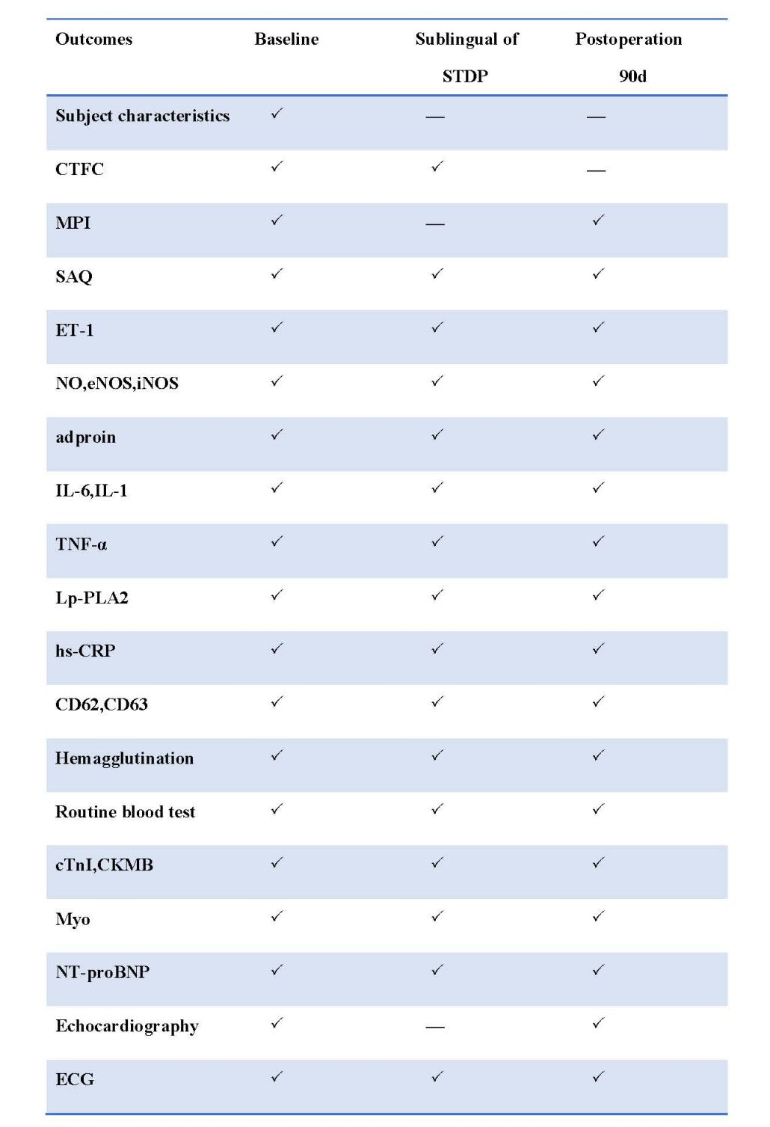
Note: √ =essential item
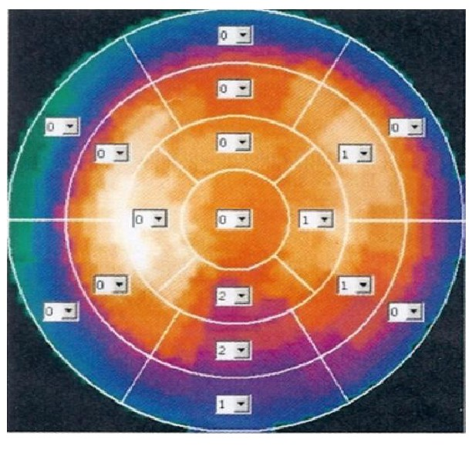
Fig1.Myocardial perfusion imaging score: it is a common method to evaluate the degree of coronary microvascular disease.Semiquantitative interpretation of 17 segments from the short axis, vertical long axis, and horizontal long axis.Each segment was visually scored using a 5-point scale: 0=normal, 1=equivocal or mild, 2=moderate, 3=severe reduction of radiotracer uptake, and 4=absence of radiotracer uptake.The scores of all 17 segments for both stress and rest images were summed to produce summed stress scores (SSS) and summed rest scores (SRS), respectively.The difference between SSS and SRS was recorded as the summed difference score (SDS).SSS score 0-3 is normal, 4-8 is mild, 9-13 is moderately abnormal, >13 is severe abnormality; SRS score<1 is normal, SRS≥1 is abnormal[31, 45].

