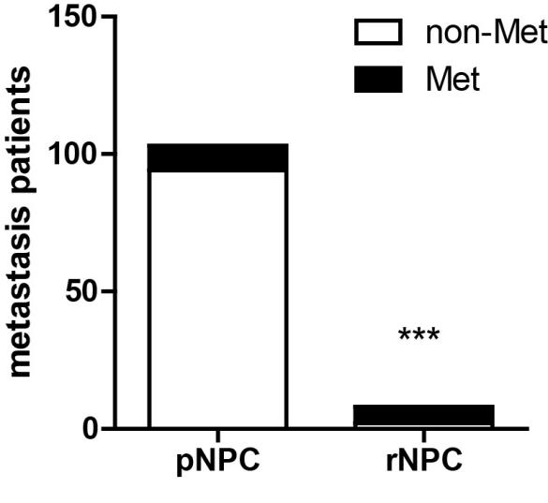
Supplementary Figure 1. The metastasis rate of patients with recurrent NPC and that of patients with primary NPC. Differences were evaluated with the χ²-test. ***P < 0.001.
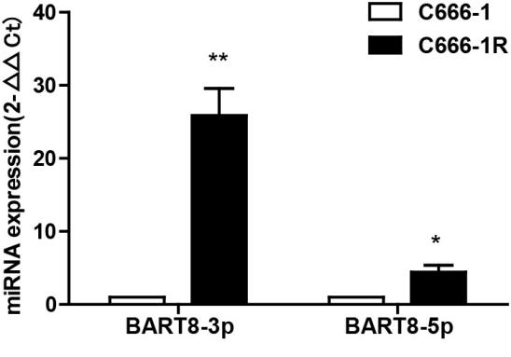
Supplementary Figure 2. The expression level of miR-BART8-3p in C666-1R cells. Student’s t-test, ***P < 0.001.
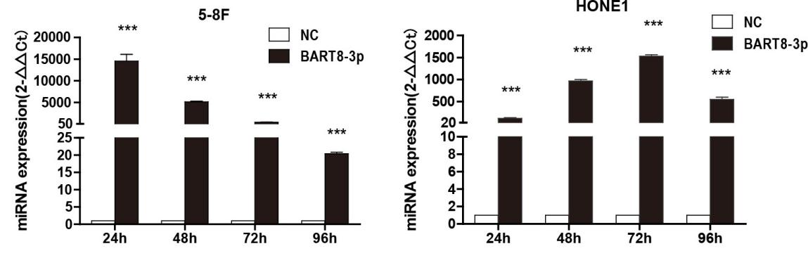
Supplementary Figure 3. The expression level of miR-BART8-3p in miR-BART8-3p transfected cell lines. Student’s t-test, ***P < 0.001.
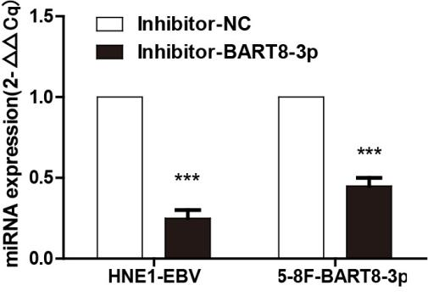
Supplementary Figure 4. The expression level of miR-BART8-3p in miR-BART8-3p inhibitor transfected cell lines. Student’s t-test, ***P < 0.001.
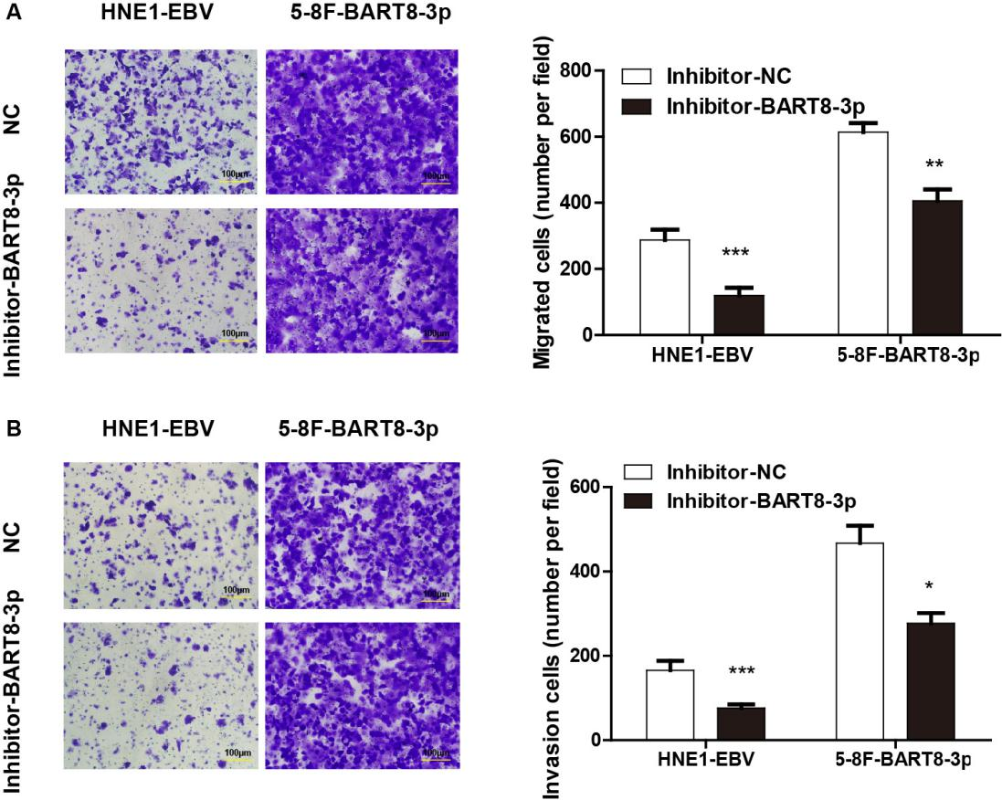
Supplementary Figure 5. Downregulation of miR-BART8-3p decreased the invasion and migration of both HNE1-EBV and 5-8F-BART8-3p cells. Scale bar, 100 μm. Student’s t-test. *P < 0.05, **P < 0.01, ***P < 0.001.
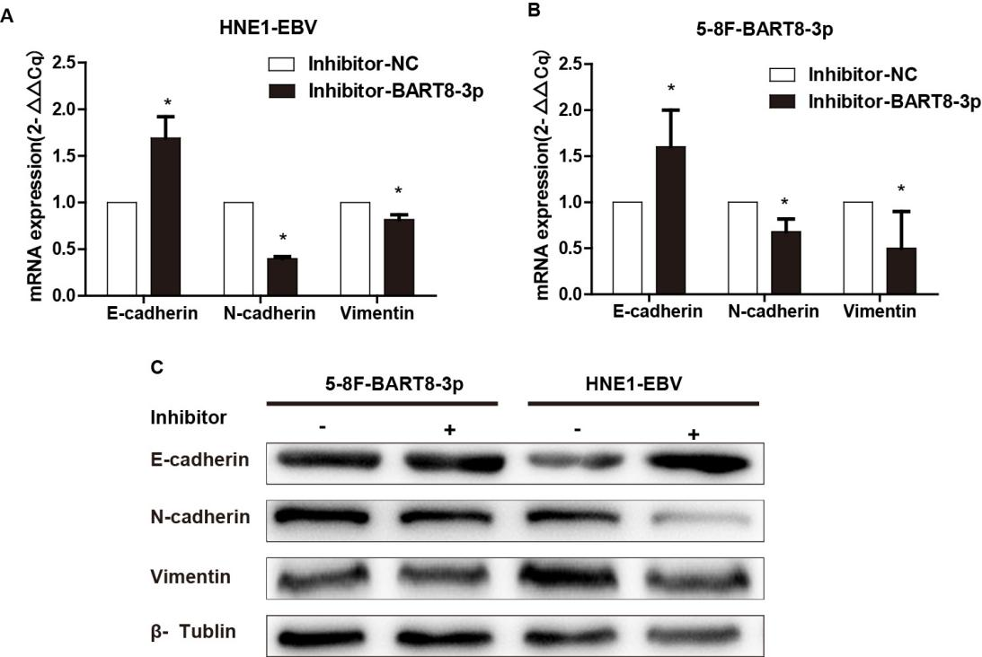
Supplementary Figure 6. Downregulation of miR-BART8-3p suppressed the EMT of NPC cells
The expression of EMT markers was evaluated by qRT-PCR and western blotting. Student’s t-test. **P < 0.01, ***P < 0.001.
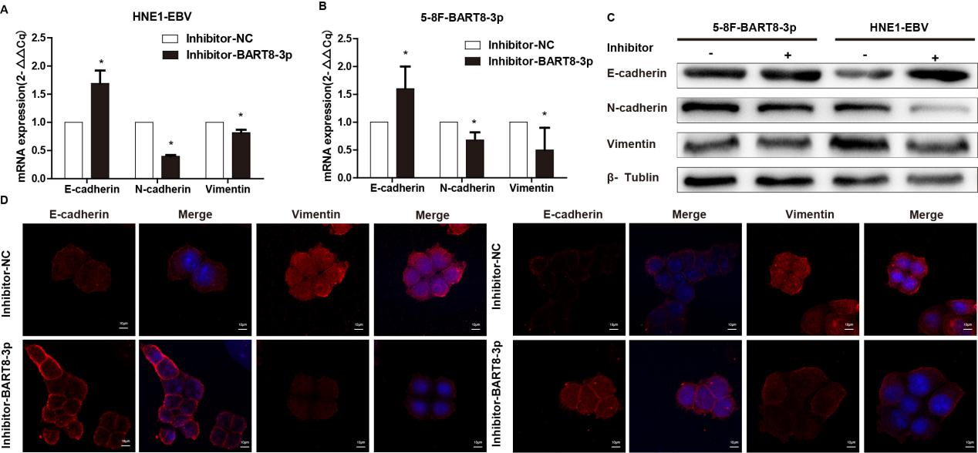
Supplementary Figure 7. Downregulation of BART8-3p modestly decreased the expression of vimentin, whereas increased the expression of E-cadherin in HNE1-EBV and 5-8F-BART8-3p cells. Scale bar, 10 μm.
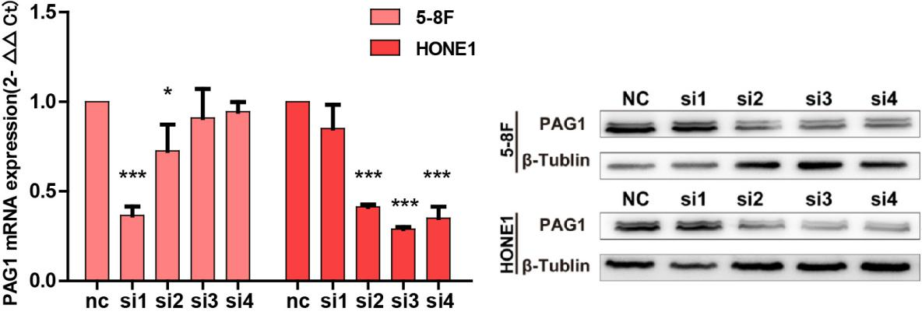
Supplementary Figure 8. The mRNA and protein expression level of PAG1 in PAG1 small interfering RNA plasmid vector transfected NPC cell lines. Student’s t-test, *P < 0.05 ***P < 0.001.

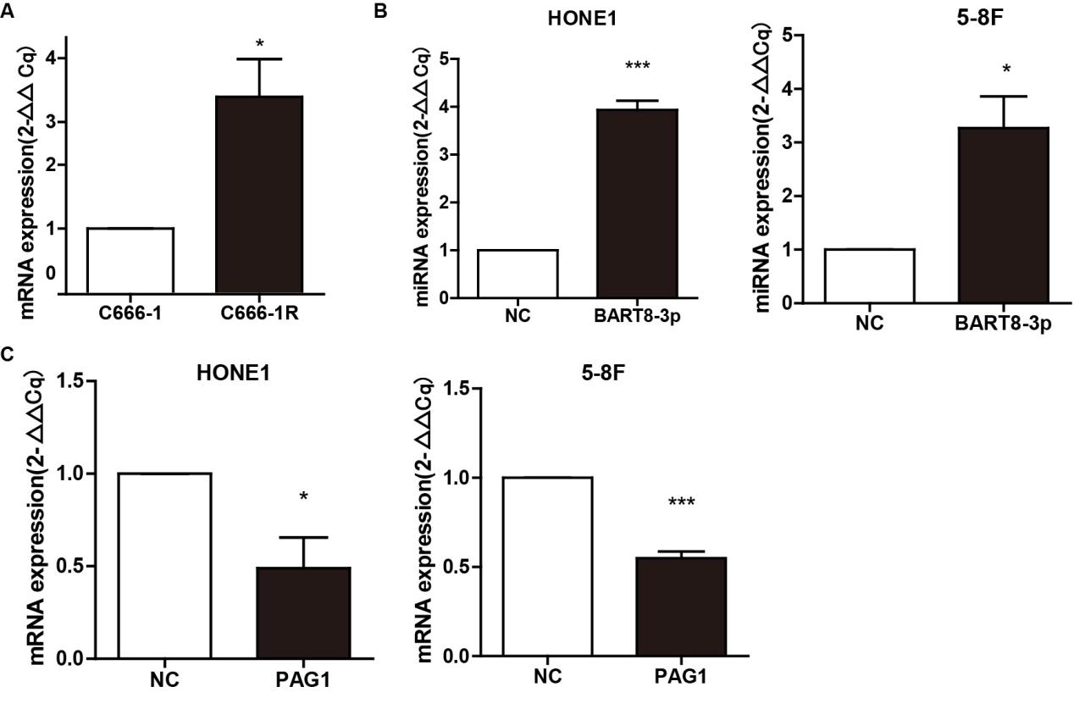
Supplementary Figure 9. The expression of ZEB1 in radioresistance, miR-BART8-3p upregulated and PAG1upregulated NPC cell lines. Student’s t-test, *P < 0.05 ***P < 0.001.

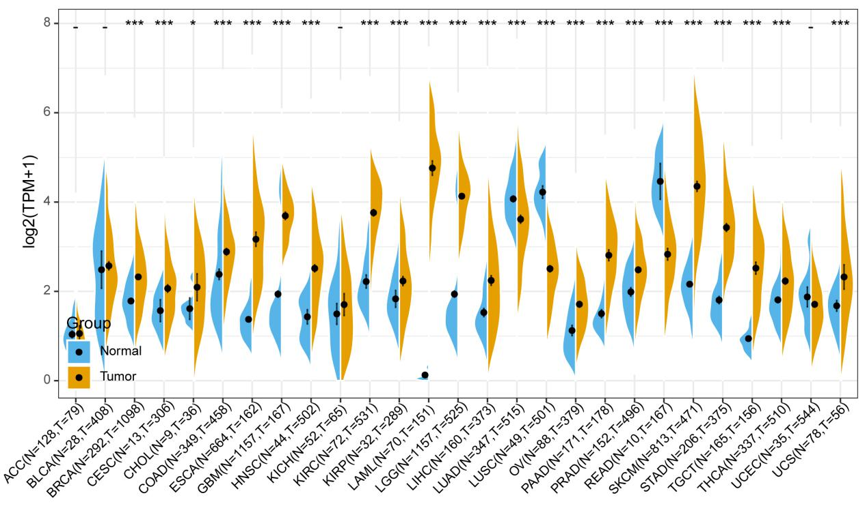
Supplementary Figure 10. The expression of PAG1 exhibited obvious organizational heterogeneity in the TCGA dataset.

