Screening for the prevention and early detection of cervical cancer: systematic reviews to inform Canadian recommendations

Pillay J, Gates A, Guitard S, Zakher B, Sim S, Vandermeer B, Hartling L.

Supplementary File 1a: Evidence for Key Question 1 on ages to start/stop screening and screening intervals
Contents:
Study characteristics of observational studies reporting on effectiveness by age (20-24, 25-29, 30-34, 60-69 & 70-79 years) or specific population groups p.2
Study characteristics of observational studies reporting on effectiveness by screening interval (<3.5 vs 5 years) p.8
Risk of bias for case-control studies reporting on screening effectiveness by age or screening interval p.15
Risk of bias for cohort studies reporting on screening effectiveness by age or screening interval p.16
Evidence sets for effectiveness of screening with cytology by age and intervals, GRADE and figures p.17

Study characteristics of observational studies reporting on effectiveness by age (20-24, 25-29, 30-34, 60-69 & 70-79 years) or specific population groups
Author & Year  Setting  Design; Length of follow-up  Funding source | Population characteristics  Sample size  Loss to follow-up | Screening strategy(ies) and programmatic details  Relevant comparison(s) | Critical outcomes
Andersson-Ellstrom 2000  Varmland, Sweden  Design: case-control  Funding: not reported | All invasive squamous cell carcinomas diagnosed in 1990-1997, as reported in the Department of Clinical Pathology data files in Karstad, Sweden. The control group contained every first following person with a cervix to a test case in the Swedish Population Register in 1998 (i.e., same age).  Exclusion: not reported.  Cases: 112  Controls: 112  Lost to follow-up: n/a | Screening strategy: Cytology testing via Pap test.  Programmatic details: Organized program whereby individuals aged 20-59 years were offered one smear every third year. Between 1994 and 1997, 90% of the female population aged 20-62 years had at least one test (either in organized program or opportunistic).  Comparisons:  Last screen in the past 3 years vs. no former screen (no screen in > 6 years). Age subgroups: 24-29, 30-39, 40-49, 50-59, 70-79, 80-98. | Incidence of invasive squamous cell cervical cancer
Azerkan 2012  Sweden  Design: prospective cohort  Funding: non-industry | Alive and resident in Sweden at some point in time between 1993 and 2005; aged 23 to 60 years at baseline.  Exclusion: date of emigration out of Sweden, death, carcinoma in situ or invasive cervical cancer before entry to the cohort; immigrant people with a cervix for whom information about birthplace or immigration data was missing.  Eligible: not reported  Enrolled: 2,621,802  Lost to follow-up: 9,530 (0.09%) | Screening strategy: Cytology testing via Pap test.  Programmatic details: Organized program whereby individuals aged 23-50 years were invited to screening every third year, and every fifth year up to the age of 60.  Comparisons:  Screened vs. not screened in the past 3 or 5 years (3 years: 23-50 years, 5 years: 50+ years).  Screened vs. not screened in the past 3 or 5 years (3 years: 23-50 years, 5 years: 50+ years) by immigrant status. | Incidence of invasive cervical cancer
Castanon 2021  England  Design: case-control  Funding: non-industry | Cases were women diagnosed with a primary invasive cervical cancer in England between April 2007 and March 2018 at ages 60-84 years who were registered with an NHS general practitioner. Controls were aged-matched random sample of all other women registered with an NHS general practitioner at the time of a case’s diagnosis without cancer (matched by date of birth, local geography, and GP)  Exclusion: women with a hysterectomy; women born prior to 1928 (i.e. age 61 or over in 1988) were excluded to account for the possibility of misclassification when looking at recorded screening between the ages of 50-59 years  Cases: 4,271  Controls: 8,437  Lost to follow-up: n/a | Screening strategy: Cytology and/or HPV testing  Programmatic details: The NHS Cervical Screening Programme invites women aged 25-49y for screening by cytology every three years and women aged 50-64y every five years. Cytology based organised cervical screening was introduced in England in 1988, HPV triage of low-grade cytological abnormalities was introduced in 2012. HPV primary testing was implemented nationally at the end of December 2019 after a pilot ran between 2013-2019.  Relevant comparisons:  Screened vs. not at 60-64, and effects based on screening status in 50-59 (combination of screening history at age 50-59 (i.e. no screening, any abnormal screening, irregularly negatively screened, well screened with at least one negative result) and screening status at age 60-64 years (i.e., screened >6 months before diagnosis vs. not screened at age 60-64 or screened within 6 months of diagnosis)) | Incidence of invasive cervical cancer
Dugue 2014  Denmark  Design: retrospective cohort  Funding: non-industry | All female residents aged 23–55 years on January 1, 1990 and who were alive on December 31, 1993 for the one-round analysis.  Excluded: individuals with gaps in residence in Denmark longer than one month; died during screening period  Eligible: 1,184,841 (1-round)  Enrolled: 1,156,671 (1-round) (335,045 used for our analysis)  Lost to follow-up: 28,170 (2.4%; 1-round) | Screening strategy: Cytology testing  Programmatic details: Organized screening whereby all persons with a cervix aged 23–59 years are personally invited every 3 years to screening, with 90% coverage by 1997. Since 2007, the guidelines have recommended 3-yearly screening at age 23–49 years, and 5-yearly screening at age 50–65 years.  Comparisons:  One-round analysis: screened in one screening round (at least once in prior 4 years) vs. non-participants | Mortality from all causes
Lonnberg 2012  Finland  Design: case-control  Funding: non-industry | Cancer cases of the uterine cervix (C53) registered in the national Finnish Cancer Registry with dates of incidence from January 2000 to December 2009. For each case, 6 controls were drawn from the population register, matched for birth year and month. People with cervix were eligible as controls if they were alive and had not been diagnosed with cervical cancer at the time of diagnosis of the case.  Exclusion: two cases of squamous cell carcinoma were excluded because access to personal data in the population register for scientific purposes had been declined.  Cases: 1,546  Controls: 9,276  Lost to follow-up: n/a | Screening strategy: Cytology testing via Pap test (predominantly, could have some HPV testing).  Programmatic details: Organized program whereby individuals aged 30 to 60 (some municipalities extended to 25 or 65, or both) are invited every 5 years. Borderline smears result in a risk-group invitation after 1 year. From the latter half of the 2000s, coverage by 5-yearly invitation of people with a cervix aged 30 to 60 has been close to 100%. Opportunistic screening also common.  Comparison:  Screened vs. not screened in the previous 5 years. | Incidence of invasive cervical cancer
Lonnberg 2013  Finland  Design: case-control  Funding: non-industry | All deaths attributed to cervical cancer during the period 2000 to 2009 in Finland were collected from the cancer register and linked to the screening register. Six controls matched for birth year and month were drawn from the population register for each of the cases. Only women alive and not diagnosed with cervical cancer at the time of diagnosis of the case were eligible as controls.  Exclusion: Screening exposure pre-dated register data  Cases: 506  Controls: 3,036  Lost to follow-up: n/a | Screening strategy: Cytology testing via Pap test (predominantly, could have some HPV testing).  Programmatic details: Organized program whereby persons with a cervix are invited for screening every 5 years within the recommended target ages of 30–60 (some municipalities invite women at the ages of 25 and 65). Opportunistic screening also common.  Comparison:  Screened vs. not screened at age 60 y | Mortality from cervical cancer
Makkonen 2017  Finland  Design: case-control  Funding: not reported | People with a cervix aged 13-99 years diagnosed with cervical cancer in 2000-2009 were identified as cases from the Finnish Cancer Registry and their age-matched controls were retrieved from the Population registry. Data were restricted to cases <40 years at the time of a preventive Pap test and their retrospective controls. Only people with a cervix with the latest invitation for organized screening in 1997 or later were included in the study due to lack of opportunistic data before that year. To ensure adequate screening history only case diagnosed from 2004 onwards and their respective controls were included.  Exclusion: not reported.  Cases: 284  Controls: 1,698  Lost to follow-up: n/a | Screening strategy: Cytology testing via Pap test.  Programmatic details: Organized program whereby individuals aged 30-60 are invited to screening every 5 years (some municipalities extending to 25 and/or 65 years). Opportunistic screening also common.  Comparison:  Screened vs. not screened in the past 5 years. | Incidence of invasive cervical cancer
Pankakoski 2019  Finland  Design: retrospective cohort  Funding: non-industry | Cohort of females born in 1926–1956 and aged 55–65 years at the beginning of follow-up was derived from the population registry. Persons with a cervix invited to screening in Helsinki (regularly invites 65-years olds to screening) were compared with those not invited elsewhere (our data was limited to Helsinki participants to include those invited to screen at age 65). Follow-up period from 1991 to 2014.  Exclusion: previous cervical cancers; missing screening data  Eligible: 59,065 (Helsinki only)  Enrolled: 59,065 (Helsinki only)  Lost to follow-up: n/a | Screening strategy: predominately cytology with Pap smear (HPV and HPV triage testing used in some areas during study period)  Programmatic details: Organized program whereby individuals aged 30-60 are invited to screening every 5 years (some municipalities extending to 65 years). Opportunistic screening also common.  Comparison:  Screened vs. not screened at age 65 y | Mortality from cervical cancer
Rosenblatt 2016  United States  Design: case-control  Funding: non-industry | Cases of invasive malignant cervical cancer diagnosed between 1991 and 1999 were identified from the SEER-Medicare program. Controls (eight per case) were matched to cases on age and location (SEER Registry area) and were randomly selected from a 5% sample of Medicare beneficiaries without cancer.  Exclusion: Cases were excluded if they were <65 years of age, received health insurance from a non-Medicare HMO during the entire period of the study, did not have both Medicare Part A and Medicare Part B during the entire duration of the study, diagnosed with “in situ” (non-invasive) cancer, or if they had cancers that were not histologically confirmed  Cases: 1,267  Controls: 10,137  Lost to follow-up: n/a | Screening strategy: Cytology with Pap smears  Programmatic details: Medicare recipients, were able to receive cervical cancer screening every 3 years  Comparison:  Pap smear during pre-invasive detectable phase (PIDP; 2-7 years prior to diagnosis) vs. no Pap smear during PIDP | Incidence of invasive cervical cancer
Rustagi 2014  United States  Design: case-control  Funding: non-industry | Cases were persons with a cervix enrolled in 1 of 2 integrated health plans who had died of cervical cancer during 1980–2010 at ages 55–79 years. Controls were females aged 55–79 years enrolled in the health plan on date of case’s tumor registry diagnosis date (reference date). Matching was based on health plan, age, and duration of health plan enrollment prior to reference date. For both cases and controls, eligibility was restricted to women with 6 or more years of enrollment prior to the reference date, with no gaps in enrollment greater than 6 months.  Exclusions: no medical records available or care outside health plan (cases); hysterectomy prior to reference date, lack of medical records, care outside health plan (controls)  Cases: 39  Controls: 80  Lost to follow-up: n/a | Screening strategy: Cytology screening.  Programmatic details: Integrated health plans with screening algorithms for cervical cancer screening  Comparison:  Screening during detectable preclinical phase (DPP; about 7 years prior to symptom onset or screen-detected diagnosis) vs. no screening during DPP | Mortality from cervical cancer
Sasieni 2009b  United Kingdom  Design: case-control  Funding: non-industry | People with a cervix diagnosed with invasive (including micro-invasive) cervical cancer identified from histology laboratory records between 1990 and 2008 and age-matched controls from the local family health services authority (FHSA). One control was selected from the same GP as case, the other from another GP in the same administrative district.  Exclusion: cases not in the call/recall system at time of diagnosis  Cases: 4,012  Controls: 7,889  Lost to follow-up: n/a | Screening strategy: Cytology testing via Pap test.  Programmatic details: National Cervical Screening Programme launched in 1988 with computerised call and recall invitation system for women aged 20 to 64 years  Comparison:  Screened within 5 years vs. screened in prior 5-8 years and not screened in prior 9 years | Incidence of invasive cervical cancer
Tanaka 2021  Germany  Design: case-control  Funding: non-industry | All incident cases of invasive cervical cancer diagnosed between 2012 and 2016 in study regions and reported to the study center (recruited through hospital gynecology departments). Cases matched with three population-based controls from population registry by age and region.  Exclusion: Controls were excluded if they had been previously diagnosed with invasive cervical cancer or had undergone a hysterectomy, though those with history of carcinoma in situ were eligible for inclusion.  Cases: 217  Controls: 652  Lost to follow up: n/a | Screening strategy: Cytology testing via Pap test  Programmatic details: Opportunistic screening whereby all persons with a cervix from the age of 20 were entitled to an annual cytological screening examination free of cost. Estimated triennial participation rate ranges from 75% to 85%.  Comparison:  Frequent (screened at least every 3 years in past 10 years with one test in 3 years before diagnosis/inclusion) vs. infrequent (screened less than every 3 years) and not screened in past 10 years | Incidence of invasive cervical cancer
Vicus 2015 (and associated paper Vicus 2014)  Ontario, Canada  Design: case-control  Funding: non-industry | Cases were required to have a first-time diagnosis of invasive cervix cancer with a diagnosis date between 1 Jan 1998 and 31 Dec 2008. The date of diagnosis of a case becomes the index date for its controls. Controls were required to have no diagnosis of cervical cancer before the date of the diagnosis of the case. Cases and controls were required to have continuous Ontario Health Insurance Plan eligibility (reflecting continuous residence in Ontario) since 1 Jan 1995. Two controls were matched to each case on year of birth and income quintile. (Vicus 2014 up to 10 controls were matched)  Exclusion: care via an identifiable physician who was not submitting cervical cytology specimens to Cytobase community laboratories during the 36 months before the index date; record of hysterectomy before the index date.  Cases: 5,047  Controls: 10,094  Lost to follow-up: n/a  Vicus 2014:  Exclusion: hysterectomy or a diagnosis of cervical cancer prior to the index date (cases); diagnosis of cervical cancer after their index data and not known to have died of cervical cancer (controls).  Cases: 1,052  Controls: 10,494  Lost to follow-up: n/a | Screening strategy: Cytology testing via Pap test.  Programmatic details: Opportunistic screening; details not described.  Comparison:  Screened 4-36 months prior vs. screened 61-120 months prior to index date and not screened >120 months prior to index date or never.  Vicus 2014:  Screened 3-36 months prior vs. not screened 3-120 months prior to index date. | Incidence of invasive cervical cancer  Vicus 2014: Mortality from cervical cancer
Wang 2017  Sweden  Design: prospective cohort  Funding: non-industry | People with a cervix born between 1 January 1919 and 31 December 1945, i.e., 51 years of age or younger in 1970 and 66 years or older by the end of 2011, resident in Sweden since age 51, and at age 51 or younger when their country of residence started to record cervical screening.  Exclusion: people with a cervix who died or emigrated before age 61 years or who had invasive cervical cancer or total hysterectomy before age 61 years (not at risk for a first diagnosis of cervical cancer at age 61+ years).  Eligible: 569,132  Enrolled: 569,132  Lost to follow-up: n/a | Screening strategy: Cytology testing via Pap test.  Programmatic details: Organized program whereby individuals are screened until age 60 (some regional programs offering until 65 years of age). Opportunistic screening also done.  Comparisons:  (1) Screen at age 61-65 years vs. no screen at age 61-65 years  (2) Adequate screen, normal (at least 1 Pap test with normal result at age 51-55 y and 1 Pap test with normal result at age 56-60 y, and the first and last test at least 1 year apart, and no abnormal result at age 51-60) vs. no screen at age 61-65 years. | Incidence of invasive cervical cancer
Abbreviations: CIN = cervical intraepithelial neoplasia; CTFPHC = Canadian Task Force on Preventive Health Care; HPV = human papillomavirus; HSIL=high grade squamous intraepithelial lesion; mos = months; y = years.

Study characteristics of observational studies reporting on effectiveness by screening interval (<3.5 vs 5 years)
Author & Year  Setting  Design; Length of follow-up  Funding source | Population characteristics  Sample size  Loss to follow-up | Screening strategy(ies) and programmatic details  Relevant comparison(s) | Critical outcomes
Andersson-Ellstrom 2000  Varmland, Sweden  Design: case-control  Funding: not reported | All invasive squamous cell carcinomas diagnosed in 1990-1997, as reported in the Department of Clinical Pathology data files in Karstad, Sweden. The control group contained every first following person with a cervix to a test case in the Swedish Population Register in 1998 (i.e., same age).  Exclusion: not reported.  Cases: 112  Controls: 112  Lost to follow-up: n/a | Screening strategy: Cytology testing via Pap test.  Programmatic details: Organized program whereby individuals aged 20-59 years were offered one smear every third year. Between 1994 and 1997, 90% of the female population aged 20-62 years had at least one test (either in organized program or opportunistic).  Relevant comparisons:  Time since last Pap smear: past 3 years vs. 3-6 years ago. | Incidence of invasive squamous cell cervical cancer
Castanon 2014  England and Wales  Design: case-control  Funding: non-industry | People with a cervix aged 65 years or older who were diagnosed with cervical cancer in England (between 1 April 2007 and 31 March 2012) and Wales (1 January 2007 and 31 December 2009) and who were registered with an NHS general practitioner. Any other person with a cervix registered with an NHS general practitioner at the time of a case diagnosis was eligible as a control for that case.  Exclusion: People with a cervix aged 60 years or older on 1 January 1988 because they may not have been invited for screening as part of the Cervical Screening Call/Recall System.  Cases: 1,341  Controls: 2,646  Loss to follow-up: n/a | Screening strategy: Cytology testing via Pap test.  Programmatic details: Organized program whereby individuals received their last screening test between the ages of 60 and 64 years.  Relevant comparisons:  Cytology screening 0-3.5 years ago vs. 3.5-5.5 years ago (at age 50-64). | Incidence of cervical cancer
Herbert 1996  United Kingdom  Design: retrospective cohort  Funding: non-industry | People with a cervix aged 25-69, registered with general practitioners in Southampton and South West Hampshire and eligible for screening  Exclusion: individuals who had had a hysterectomy  Enrolled: 116,022  Analyzed: 116,022  Lost to follow-up: none | Screening strategy: Cytology testing via Pap test.  Programmatic details: A comprehensive screening programme was implemented throughout England in 1988, The National Health Service cervical screening programme recommends a maximum screening interval of five years recall by the central family health service authority (FHSA) is at five years, though most general practitioners recall their patients earlier.  Relevant comparisons:  (1) Time since last Pap smear: past 0.5-3.5 years vs. 3.5-5.5 years ago. | Incidence of invasive cervical cancer (excluding symptomatic)
Kamineni 2013  United States  Design: case-control  Funding: non-industry | People with a cervix aged 55–79 years diagnosed with invasive cervical cancer during 1980–1999 enrolled in 1 of 2 health plans with at least 7 years of continuous enrollment in health plan prior to date of diagnosis. Controls had an intact uterus and no diagnosis of cervical cancer, but otherwise were similar to cases in terms of age and length of enrollment in the health plan. Three controls matched per case.  Exclusion: none noted.  Cases: 69  Controls: 208  Lost to follow-up: n/a | Screening strategy: Cytology testing via Pap test.  Programmatic details: integrated health care delivery systems.  Relevant comparisons:  (1) Time since last negative smear: 1-<3 years vs. 3-<5 years | Incidence of invasive cervical cancer
Landy 2020  United States  Design: case-control  Funding: non-industry and industry (stated to be unrelated to submitted work) | Cases were all cervical cancer diagnoses among in the New Mexico Tumor Registry during 2006–2016. Five controls were selected for each case, matched by date of birth and census tract of residence, from the New Mexico HPV Pap Registry. Controls were eligible if they were alive without a known hysterectomy or diagnosis of cervical cancer recorded at the date of the case’s diagnosis.  Exclusion: main analysis restricted to those aged 25-64 years with >3 years screening history  Cases: 527  Controls: 2,635  Lost to follow-up: n/a | Screening strategy: Predominately cytology (HPV, Pap cytology, and co-testing available but HPV and co-testing limited in study)  Programmatic details: opportunistic screening, though New Mexico has a complete record of all cervical screening, diagnosis, and treatment across diverse healthcare delivery settings and populations in the state  Relevant comparisons:  (1) Time since last screen: past 3 years vs. no screen in past 3 years but screening in past 5 years (>3-5y) | Incidence of cervical cancer
Makino 1995  Japan  Design: case-control  Funding: non-industry | Cases were people with a cervix with documented invasive cervical cancer within Miyagi Prefecture between April 1984 and March 1990. Two controls without invasive cervical cancer were matched for each case by age and district of residence. Controls were eligible participants closest to case on cytology file. For screen-detected cases, controls were matched from participants of mass screening and for outpatient-detected cases, controls were selected from smears collected at gynecology clinic.  Exclusion: Individuals with a history of hysterectomy or previous abnormal cytology  Cases: 198  Controls: 396  Lost to follow-up: n/a | Screening strategy: Cytology testing via Pap test.  Programmatic details: Miyagi is one of the first areas in Japan to be involved in mass screening for cervical cancer. Annual screening recommended during study period.  Relevant comparisons:  (1) Interval since last negative screening result and diagnosis (1-3 years vs. 4 years) | Incidence of invasive cervical cancer (excluding symptomatic)
Morrison 1996  British Columbia, Canada  Design: retrospective non-concurrent cohort  Funding: non-industry | People with a cervix who, before 1970, had had at least one smear, had undergone at least one gynaecological surgical procedure generating a pathology report, or had died of cervical cancer.  Exclusion: people with a cervix with records indicating only negative smears, no histology and had not had a smear taken in the previous 7 years, or known to be dead.  Enrolled: 119,153  (cohort I=52,452; cohort II=66,701)  Analyzed: 71,237 (individuals matched from younger and older cohorts)  Lost to follow-up: not reported | Screening strategy: Cytology testing.  Programmatic details: Organized program whereby in the early 1970s approximately 85% of people with a cervix aged 20 years and over in the province were enrolled in the program.  Relevant comparisons:  Interval between smears: 24-35 vs. 48-59 months. | Incidence of invasive cervical cancer or carcinoma in situ
Sasieni 2003 (and Sasieni 2009a)  United Kingdom  Design: case-control  Funding: non-industry | People with a cervix diagnosed with invasive cervical cancer between 1990 and 2001 and age-matched controls included in the local family health services authority (FHSA). One control was selected from the same GP, the other from another GP in the same administrative district.  Exclusion: Individuals aged over 69 and under 20 and those with micro-invasive cancer or unknown stage of cancer  Cases: 1,305  Controls: 2,532  Lost to follow-up: n/a  Sasieni 2009a:  Exclusion: Restricted to cases with histology recorded; maximum screening interval restricted to those aged 26-69 years and diagnosed from 1994 onwards  Cases: 3,305  Controls: 2,532  Lost to follow-up: n/a | Screening strategy: Cytology testing  Programmatic details: National Cervical Screening Programme launched in 1988 with computerised call and recall invitation system for women aged 20 to 64 years  Relevant comparisons:  Time since last adequate smear: 2.5-3.5 years vs 4.5-5.5 years  Sasieni 2009a:  Maximum screening interval: <3.5 years vs. 3.5-5.5 years | Incidence of invasive cervical cancer
Vicus 2015 (and Vicus 2014)  Ontario, Canada  Design: case-control  Funding: non-industry | Cases were required to have a first-time diagnosis of invasive cervix cancer with a diagnosis date between 1 Jan 1998 and 31 Dec 2008. The date of diagnosis of a case becomes the index date for its controls. Controls were required to have no diagnosis of cervical cancer before the date of the diagnosis of the case. Cases and controls were required to have continuous Ontario Health Insurance Plan eligibility (reflecting continuous residence in Ontario) since 1 Jan 1995. Two controls were matched to each case on year of birth and income quintile.  Exclusion: care via an identifiable physician who was not submitting cervical cytology specimens to Cytobase community laboratories during the 36 months before the index date; record of hysterectomy before the index date.  Cases: 5,047  Controls: 10,094  Lost to follow-up: n/a  Vicus 2014: Cases: 1,052  Controls: 10,494 | Screening strategy: Cytology testing via Pap test.  Programmatic details: Opportunistic screening; details not described.  Relevant comparisons:  Screened 4-36 months prior vs. screened 37-60 months prior to index date  Viscus 2014: Screened 3-36 months prior vs. screened 37-60 months prior to index date. | Incidence of invasive cervical cancer  Viscus 2014:  Mortality from invasive cervical cancer
Zappa 2004  Florence, Italy  Design: case-control  Funding: not reported | All persons with a cervix aged below 70 years registered at Tuscany Tumour Registry as having a cervical cancer diagnosed between 1994 and 1999 were considered. Four controls for each case were randomly selected from the municipality residence database matched by age (same year of birth), and who were alive at the index date of the matched case. Controls were eligible if they had been resident in the screening area for at least 5 years and if no hysterectomy was known before the index date.  Exclusion: individuals diagnosed with microinvasive carcinomas; those resident in area for less than 5 years.  Cases: 208  Controls: 832  Lost to follow-up: n/a | Screening strategy: Cytology testing via Pap test.  Programmatic details: The Centro per lo Studio e la Prevenzione Oncologica has been running organised population-based cervical screening in the Florence District since 1980.  Relevant comparisons:  (1) Time since last test: 1 to <3 years, 3 to <6 years | Incidence of invasive cervical cancer
Abbreviations: CIN=cervical intraepithelial neoplasia; n/a=not applicable; NHS=national health system.

Risk of bias for case-control studies reporting on screening effectiveness by age or screening interval
Study | Newcastle Ottawa Risk of Bias Domain
Study | Is the case definition adequate? | Are cases representative? | How were controls selected? | How were controls defined? | Does the study control for confounders (age + other)? | Does the study control for additional factors? | How is the exposure ascertained? | Was the same method of ascertainment used for cases and controls? | Non-response rate similar between groups?
Case-control studies
Andersson-Ellstrom 2000 | Y | Y | Y | NR | N | N | Y | Y | Y
Castanon 2014 | Y | Y | Y | NR | Y | Y | Y | Y | Y
Castanon 2021 | Y | Y | Y | NR | Y | Y | Y | Y | Y
Kamineni 2013 | Y | Y | Y | Y | Y | Y | Y | Y | Y
Landy 2020 | Y | Y | Y | Y | Y | Y | Y | Y | Y
Lonnberg 2012 | Y | Y | Y | Y | Y | N | Y | Y | Y
Lonnberg 2013 | Y | Y | Y | Y | Y | N | Y | Y | Y
Makino 1995 | Y | Y | Y | Y | Y | N | N | Y | Y
Makkonnen 2017 | Y | Y | Y | NR | Y | N | Y | Y | Y
Rosenblatt 2016 | Y | Y | Y | Y | Y | Y | Y | Y | Y
Rustagi 2014 | Y | Y | Y | NR | Y | Y | Y | Y | Y
Sasieni 2003/2009a | Y | Y | Y | NR | Y | Y | Y | Y | Y
Sasieni 2009b | Y | Y | Y | NR | Y | Y | Y | Y | Y
Tanaka 2021 | Y | Y | Y | Y | Y | N | N | Y | Y
Vicus 2015/2014 | Y | Y | Y | Y | Y | N | Y | Y | Y
Zappa 2004 | Y | Y | Y | NR | Y | Y | Y | Y | Y
Abbreviations: NR=not reported; N=No; Y=Yes.

Risk of bias for cohort studies reporting on screening effectiveness by age or screening interval
Study | Newcastle Ottawa Risk of Bias Domain |  |  |  |  |  |  |  |  | Applicability concerns
Study | Was the exposed cohort representative? | Was the non-exposed cohort selected appropriately? | How was the exposure ascertained? | Was the outcome of interest present at start of study? | Does the study control for confounders (age + other)? | Does the study control for additional factors? | How is the outcome assessed? | Length of follow-up sufficient for outcome? | Adequate follow-up? | Applicability concerns
Cohort studies
Azerkan 2012 | Y | Y | Y | Y | N | N | Y | Y | Y | None
Dugue 2014 | Y | Y | Y | Y | N | N | Y | Y | Y | None
Herbert 1996 | Y | Y | Y | Y | N | N | Y | Y | Y | None
Morrison 1996 | Y | Y | Y | Y | N | N | Y | Y | Y | None
Pankakoski 2019 | Y | Y | Y | Y | N | N | Y | Y | Y | Enrolled women at age 55-65 only
Wang 2017 | Y | Y | Y | Y | Y | Y | Y | Y | Y | None
Abbreviations: NR=not reported; N=No; Y=Yes.

Evidence set 1: Summary of findings for observational studies on the effect of screening for cervical cancer in younger (<35 years of age) participants to inform start ages for screening
Included reports: Case-control studies: Andersson-Ellstrom, 2000; Makkonen, 2017; Sasieni, 2009(b); Tanaka, 2021; Vicus, 2015 (and associated paper Vicus, 2014); Cohort studies: Azerkan, 2012; Dugue, 2014
Comparison | No. and design of included studies  Sample size analyzedª | Findings by study and pooled, if performed  OR (95% CI)^{b} unless otherwise indicated; age of screening (y)^{c} | GRADE^{d} | What happens?
Outcome: Incidence of invasive cervical cancer
Screening vs. no screening^{e} at age 20-24 years | 4 case-control  N=1,450  1 cohort  N=2,621,802 (entire cohort of 23-60 y; NR by age) | Case-control studies  Pooled: 1.72 (0.86 to 3.43); I²=63%  Cohort study  RR 0.33 (0.09 to 1.23); 22-25 | ⊕⊝⊝⊝  VERY LOW^{f}  due to inconsistency and indirectness | We are very uncertain about the effect of screening for cervical cancer among persons with a cervix aged 20-24 years on the incidence of invasive cervical cancer.
Screening vs. no screening^{e} at age 25-29 years | 4 case-control  N=1,513  1 cohort  N=2,621,802 (entire cohort of 23-60 y; NR by age) | Case-control studies  Pooled: 1.44 (1.06 to 1.96); I²=13%  Cohort study  RR 0.25 (0.12 to 0.54); 27-30 | ⊕⊝⊝⊝  VERY LOW^{g}  due to inconsistency and indirectness | We are very uncertain about the effect of screening for cervical cancer among persons with a cervix aged 25-29 years on the incidence of invasive cervical cancer.
Screening vs. no screening^{e} at age 30-34 years | 5 case-control  N=4,478  1 cohort  N=2,621,802 (entire cohort of 23-60 y; NR by age) | Case-control studies  Pooled: 0.85 (0.51 to 1.42); I²=88%  Cohort study  RR 0.18 (0.09 to 0.34); 32-35 | ⊕⊝⊝⊝  VERY LOW^{h} due to inconsistency and indirectness | We are very uncertain about the effect of screening for cervical cancer among persons with a cervix aged 30-34 years on the incidence of invasive cervical cancer.
Outcome: All-cause mortality
Screening vs. no screening at age 20-24 years | 1 cohort  N=52,974 | HR 0.51 (0.35 to 0.73); 23-32 | ⊕⊝⊝⊝  VERY LOW^{i} due to risk of bias, inconsistency and indirectness | We are very uncertain about the effect of screening for cervical cancer among persons with a cervix aged 20-24 years on death from any cause.
Screening vs. no screening at age 25-29 years | 1 cohort  N=115,889 | HR 0.51 (0.41 to 0.64); 23-32 | ⊕⊝⊝⊝  VERY LOW^{j} due to risk of bias and inconsistency and indirectness | We are very uncertain about the effect of screening for cervical cancer among persons with a cervix aged 25-29 years on death from any cause.
Screening vs. no screening at age 30-34 years | 1 cohort  N=186,182 | HR 0.53 (0.47 to 0.61) | ⊕⊝⊝⊝  VERY LOW^{k} due to risk of bias, inconsistency and indirectness | We are very uncertain about the effect of screening for cervical cancer among persons with a cervix aged 30-34 years on death from any cause.
Outcome: Cervical cancer mortality
Screening vs. no screening at age 20-24 years | 1 case-control  N=165 | 1.82 (0.56 to 5.91) | ⊕⊝⊝⊝  VERY LOW^{l} due to inconsistency, indirectness and imprecision | We are very uncertain about the effect of screening for cervical cancer among persons with a cervix aged 20-24 years on death from cervical cancer.
Screening vs. no screening at age 25-29 years | 1 case-control  N=461 | 0.91 (0.36 to 2.27) | ⊕⊝⊝⊝  VERY LOW^{m} due to inconsistency, indirectness and imprecision | We are very uncertain about the effect of screening for cervical cancer among persons with a cervix aged 25-29 years on death from cervical cancer.
Screening vs. no screening at age 30-34 years | 1 case-control  N=857 | 0.51 (0.31 to 0.82) | ⊕⊝⊝⊝  VERY LOW^{n} due to inconsistency and indirectness | We are very uncertain about the effect of screening for cervical cancer among persons with a cervix aged 30-34 years on death from cervical cancer.
Abbreviations: aOR=adjusted odds ratio; CI=confidence interval; HR=hazard ratio; I²=test for heterogeneity; N=number included in analysis; OR=odds ratio; RR=relative risk; vs.=versus; y=years
ªSample sizes were estimated from the proportion of years that study participants contributed to an age category of interest. For example, within the age category 20-24 years, a study with participant ages ranging from 17-24 years included 5 of 8 years relevant years for the age category of interest. Therefore, the total sample size was multiplied by 0.625 (equal to 5/8) to estimate the number of participants contributing to the age category.
^{b}Standard errors of individual studies were weighted to adjust confidence intervals to approximate the proportion of participant data that was relevant to the age category of interest (as described in the prior footnote). Weighting was applied to data from studies that included participants with more than one year outside of an age category of interest. For this analysis, assumptions were made that screened participants and odds ratios (i.e., effects) were equally distributed across the age range of the study sample.
^{c}When not reported by study, age at screening was estimated from the duration prior to age of diagnosis and, if applicable, the exclusion period (duration before diagnosis when authors assumed any diagnosis would be from symptoms and not from screening). See figures for screening ages of studies included in pooled analysis (figures also show screening ages for mortality outcomes where comparisons from a single study were combined); see table for screening ages of studies that were not pooled. For studies where there were more than one data point in an age category (e.g., Vicus 2015), the participants contributing data to each data point are unique.
^{d}We rated down by 0.5 for “some concerns”, 1 for “serious concerns”, and 2 for “very serious concerns”. When our assessment of the certainty of evidence fell between levels, we assigned the level that best represented our actual certainty in the evidence, and based our conclusions on this level of certainty. We did not apply decision thresholds with respect to an important magnitude of effect and rated our certainty about conclusions of a direction rather than magnitude of effect.
^{e”}No screening” includes persons with no screening during period of interest for study in addition to individuals with most recent screen more than 5 years from reference date.
Explanations:
Incidence of invasive cervical cancer
^{f}Screening at age 20-24 years vs. not screening: No serious concerns about risk of bias: one cohort and one case-control study had limited or no adjustment/matching; the case-control study was small and did not change direction of effect when excluded from the analysis (1.71 [95% CI, 0.82 to 3.54]), while the concerns arising from lack of adjustment in the cohort study, which may have biased findings towards benefit, were considered to contribute to inconsistency for which we rated down. Serious concerns about inconsistency: two case-control studies and one cohort study demonstrated no effect or a benefit when the pooled effect from the case-control studies indicated potential harm. Some concerns about indirectness: Although data from studies where the age of participants did not match the category of interest were weighted there were still some concerns about indirectness of age since assumptions were required (see footnotes). No serious concerns about imprecision: In pooled analysis of case-control studies that indicated potential harm, the lower limit of the 95% CI indicated little to no effect but we did not rate down because this was thought to be due mostly to inconsistency. No other serious concerns.
^{g}Screening at age 25-29 years vs. not screening: No serious concerns about risk of bias: one cohort and one case-control study had limited or no adjustment/matching; the case-control study was small and did not change direction of effect when excluded from the analysis (1.37 [95% CI, 0.92 to 2.03]), while the concerns arising from lack of adjustment in the cohort study, which may have biased findings towards benefit, were considered to contribute to inconsistency for which we rated down. Serious concerns about inconsistency: two case-control studies (three comparisons) and one cohort study demonstrated no effect or a benefit when the pooled effect from the case-control studies indicated harm. Some concerns about indirectness: Although data from studies where the age of participants did not match the category of interest were weighted there were still some concerns about indirectness of age since assumptions were required (see footnotes). Also, when comparisons that included persons 35 years of age or older were removed from analysis, direction of effect was not changed (1.56 [95% CI, 1.20 to 2.02]). No serious concerns about imprecision: The entire 95% CI was in the direction of effect. No other serious concerns.
^{h}Screening at age 30-34 years vs. not screening: No serious concerns about risk of bias: one cohort and one case-control study had limited or no adjustment/matching; the case-control study was small and did not change direction of effect when excluded from analysis (0.84 [95% CI, 0.50 to 1.41]) and the cohort study finding was in the direction of benefit, similar to the pooled effect from the case-control studies that included 4 studies with no major concerns for risk of bias. Some concerns about inconsistency: two case-control studies (three comparisons) demonstrated no effect or harm when the pooled effect from the case-control studies and one cohort indicated potential benefit. Some concerns about indirectness: Although data from studies where the age of participants did not match the category of interest were weighted there were still some concerns about indirectness of age since assumptions were required (see footnotes). Also, when comparisons that included persons 35 years of age or older were removed from analysis, direction of effect was not changed (0.91 [95% CI, 0.42 to 1.96]). No serious concerns about imprecision: overall findings from case-control and cohort studies indicated possible benefit, the upper limit of the pooled 95% CI indicated potential harm but we did not rate down because this was thought due mostly to inconsistency. No other serious concerns.

All-cause mortality
^{i}Screening at age 20-24 years vs. not screening: Serious concerns about risk of bias: only included study was concerning for lack of adjustment in analysis. Some concerns about inconsistency: only one included study therefore no demonstration of consistency. Some concerns about indirectness: Although data from studies where the age of participants did not match the category of interest were weighted there were still some concerns about indirectness of age since assumptions were required (see footnotes). No serious concerns about imprecision: entire 95% CI was in the direction of effect. No other serious concerns.
^{j}Screening at age 25-29 years vs. not screening: Serious concerns about risk of bias: only included study was concerning for lack of adjustment in analysis. Some concerns about inconsistency: only one included study therefore no demonstration of consistency. Some concerns about indirectness: Although data from studies where the age of participants did not match the category of interest were weighted there were still some concerns about indirectness of age since assumptions were required (see footnotes). No serious concerns about imprecision: entire 95% CI was in the direction of effect. No other serious concerns.
^{k}Screening at age 30-34 years vs. not screening: Serious concerns about risk of bias: only included study was concerning for lack of adjustment in analysis. Some concerns about inconsistency: only one included study therefore no demonstration of consistency. Some concerns about indirectness: Although data from studies where the age of participants did not match the category of interest were weighted there were still some concerns about indirectness of age since assumptions were required (see footnotes). No serious concerns about imprecision: entire 95% CI was in the direction of effect. No other serious concerns.

Cervical cancer mortality
^{l}Screening at age 20-24 years vs. not screening: No serious concerns about risk of bias: one included study adequately matched cases and controls. Some concerns about inconsistency: only one included study. Some concerns about indirectness: Although data from studies where the age of participants did not match the category of interest were weighted there were still some concerns about indirectness of age since assumptions were required (see footnotes). Serious concerns about imprecision: pooled analysis indicated potential harm but lower limit of 95% CI indicated little to no effect or possible benefit. No other serious concerns.
^{m}Screening at age 25-29 years vs. not screening: No serious concerns about risk of bias: one included study adequately matched cases and controls. Some concerns about inconsistency: only one included study therefore no demonstration of consistency. Some concerns about indirectness: Although data from studies where the age of participants did not match the category of interest were weighted there were still some concerns about indirectness of age since assumptions were required (see footnotes). Very serious concerns about imprecision: In pooled analysis, lower limit of 95% CI indicated benefit while upper limit indicated harm. No other serious concerns.
^{n}Screening at age 30-34 years vs. not screening: No serious concerns about risk of bias: one included study adequately matched cases and controls. Some concerns about inconsistency: only one included study therefore no demonstration of consistency. Some concerns about indirectness: Although data from studies where the age of participants did not match the category of interest were weighted there were still some concerns about indirectness of age since assumptions were required (see footnotes). No serious concerns about imprecision: entire 95% CI was in the direction of effect. No other serious concerns.
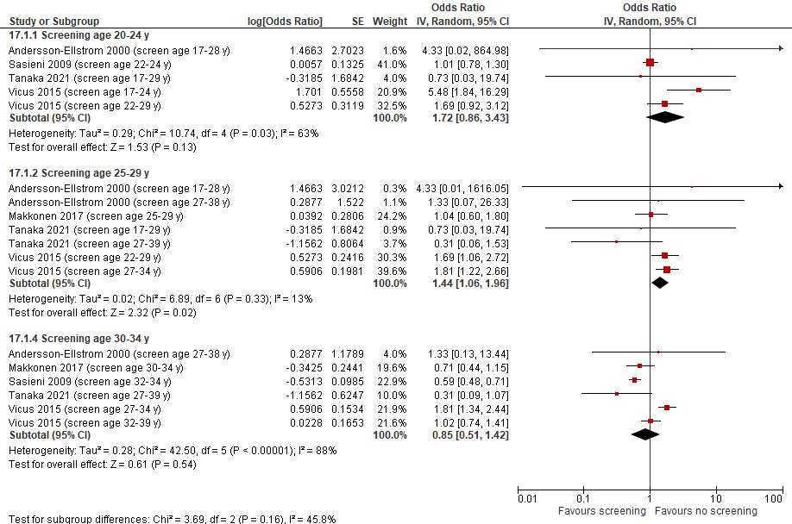

Supplementary Figure 1.1. Effect of screening for cervical cancer in younger (<35 years of age) participants on incidence of invasive cervical cancer to inform start ages for screening; case-control studies

Footnotes:
(1) Studies may contribute data more than once within a screen age category since individuals could only be a case once (i.e. data points are mutually exclusive). For studies where there are more than one data point in an age category the participants contributing data to each data point are unique.
(2) When not reported by study, age at screening was estimated from the duration prior to age of diagnosis and, if applicable, the exclusion period (duration before diagnosis when authors assumed any diagnosis would be from symptoms and not from screening).

(3) Standard errors were weighted to estimate the proportion of participants who contributed to the age category of interest. Weighting was applied to data from studies that included participants with more than one year outside of an age category of interest. For this analysis, assumptions were made that screened participants and odds ratios (i.e., effects) were equally distributed across the age range of the study sample.

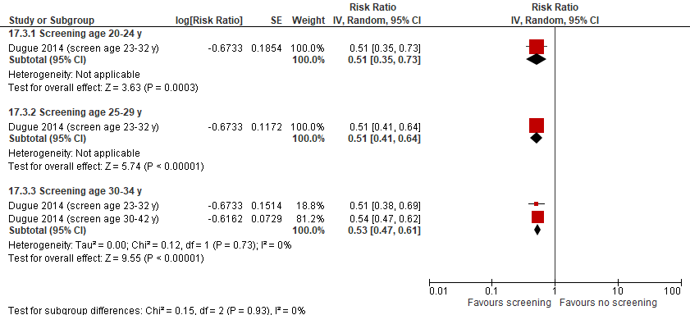

Supplementary Figure 1.2. Effect of screening for cervical cancer in younger (<35 years of age) participants on mortality from all-causes to inform start ages for screening; cohort study
Footnotes:
(1) Studies may contribute data more than once within a screen age category since individuals could only be counted towards an event once (i.e. data points are mutually exclusive). For studies where there are more than one data point in an age category the participants contributing data to each data point are unique.
(2) When not reported by study, age at screening was estimated from the duration prior to age of diagnosis and, if applicable, the exclusion period (duration before diagnosis when authors assumed any diagnosis would be from symptoms and not from screening).
(3) Standard errors were weighted to estimate the proportion of participants who contributed to the age category of interest. Weighting was applied to data from studies that included participants with more than one year outside of an age category of interest. For this analysis, assumptions were made that screened participants and odds ratios (i.e., effects) were equally distributed across the age range of the study sample.

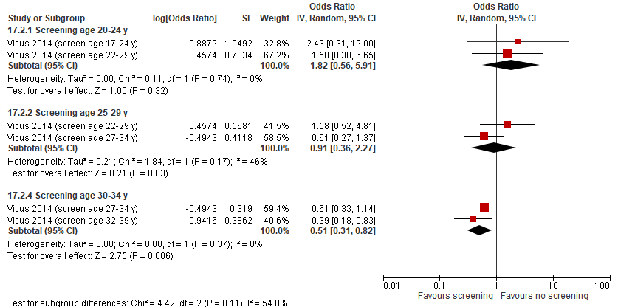

Supplementary Figure 1.3. Effect of screening for cervical cancer in younger (<35 years of age) participants on mortality from cervical cancer to inform start ages for screening; case-control studies

Footnotes:
(1) Studies may contribute data more than once within a screen age category since individuals could only be a case once (i.e. data points are mutually exclusive). For studies where there are more than one data point in an age category the participants contributing data to each data point are unique.
(2) When not reported by study, age at screening was estimated from the duration prior to age of diagnosis and, if applicable, the exclusion period (duration before diagnosis when authors assumed any diagnosis would be from symptoms and not from screening).
(3) Standard errors were weighted to estimate the proportion of participants who contributed to the age category of interest. Weighting was applied to data from studies that included participants with more than one year outside of an age category of interest. For this analysis, assumptions were made that screened participants and odds ratios (i.e., effects) were equally distributed across the age range of the study sample.

Evidence Set 2: Summary of findings for observational studies on the effect of screening for cervical cancer in older (≥60 years of age) participants to inform stop ages for screening
Included reports: Case-control: Andersson-Ellstrom, 2000; Castanon, 2021; Lonnberg, 2012; Rosenblatt, 2016; Rustagi, 2014; Tanaka, 2021; Vicus, 2015 (and associated paper Vicus, 2014).; Cohorts: Azerkan, 2012; Pankakoski, 2019; Wang, 2017
Comparison | No. and design of included studies  Sample size analyzedª; follow up for cohort studies | Findings by study and pooled, if performed  OR (95% CI)^{b} unless otherwise indicated; age of screening (years)^{c} | GRADE^{d} | What happens?
Outcome: Incidence of invasive cervical cancer
Screening vs. no screening^{e} at age 60-69 years | 6 case-control  N=16,909  2 cohorts  N=569,132; mean 10.9 year follow up and N=2,621,802 (entire cohort of 23-60 y; NR by age); maximum 12-year mean follow up  Subgroup analysis: based on screening and results in 50s  1 case-control  N=12,708  1 cohort  N=569,132 | Case-control studies  Pooled: 0.46 (0.34 to 0.62); I²=76%  Cohort studies  Pooled: RR 0.54 (0.46 to 0.62); I²=0%  Subgroup analysis:  Case-control study (screened vs not screened at age 60-64 years, stratified by groups based on screening and results in 50s):  25-year (60-84 yrs) absolute risk difference (95% CI) per 1,000 of developing cervical cancer:  • Not screened: 4.94 (3.92 to 5.96) fewer  - Abnormal screening: 4.34 (0.11 to 8.57) fewer  • Irregular negatively screened (no abnormal tests aged 50-59y and a negative test between aged 50-54y but not 55-59y, or aged 55-59y but not 50-54y): 1.29 (0.65 to 1.93) fewer  • Well screened (at least one negative result both at ages 50-54y and 55-59y and no abnormal screen aged 50-59y) at 50-59 (n=5,865): 0.63 (0.03 to 1.23) fewer  Cohort study (screening vs. no screening at 61-65 years based on results at 51-60):  Up to 20-year (mean 10.9 years) absolute risk difference (95% CI) per 1,000 of developing cervical cancer (considering hysterectomy and death as competing events) and HR (adjusted for education and birth cohort):  • Unscreened: 3.3 fewer per 1000 (2.24 to 4.41); aHR 0.42 (o.24-to 0.72)  • “Low-grade abnormality” (ASCUS or mild squamous dysplasia at least once at age 51±60: 5.84 fewer per 1000 (1.66 to 10.02); aHR 0.43 (0.25 to 0.74)  • “High-grade abnormality” (≥ASCUS once during 51-60): 7.46 fewer per 1000 (0.13 to 15.04); aHR 0.59 (0.36 to 0.96)  • Inadequately screened with normal results (1 or more Pap tests with only normal results, but only in 1 age span (51±55 or 56±60 years): 0.54 fewer per 1000 (1.42 fewer to 0.34 more); aHR 0.82 (0.56 to 1.22)  • Adequate screen, normal (at least 1 Pap test with normal result at age 51-55 y and 1 Pap test with normal result at age 56-60 y, and the first and last test at least 1 year apart, and no abnormal result at age 51-60) (n=340,703): 0.28 fewer per 1000 (0.78 fewer to 0.22 more); aHR 0.90 (0.69 to 1.17) | For those with no, abnormal, or inadequate screening in their 50s:  ⊕⊕⊕⊝  MODERATE^{f} due to rating up for effect size that clearly indicates some degree of benefit  For those adequately screened during their 50s (two normal screens 5 years apart):  ⊕⊕⊝⊝  LOW^{f} with some imprecision | Screening for cervical cancer using cytology probably reduces risk for incident invasive cervical cancer among persons with a cervix aged 60-69 years who were inadequately screened or had abnormal results in their 50s.  Screening for cervical cancer using cytology may reduce risk for incident invasive cervical cancer among persons with a cervix aged 60-69 years who were adequately screened in their 50s.
Screening vs. no screening^{e} at age 70-79 years | 3 case-control  N=4,258 | Pooled: 0.44 (0.33 to 0.57); I²=0% | For those with no, abnormal, or inadequate screening in their 50s:  ⊕⊕⊝⊝  LOW^{g} with some concerns of inconsistency/lack of consistency  For those adequately screened during their 50s (two normal screens 5 years apart):  ⊕⊝⊝⊝  VERY LOW^{g} with some concerns of inconsistency/lack of consistency and indirectness | Screening for cervical cancer using cytology may reduce risk for incident invasive cervical cancer among persons with a cervix aged 70-79 years who were inadequately screened or had abnormal results in their 50s or 60s.  We are very uncertain about the effects from screening for cervical cancer using cytology among persons with a cervix aged 60-69 years who were adequately screened in their 50s or 60s.
Outcome: Cervical cancer mortality
Screening vs. no screening at age 60-69 years | 3 case-control  N=2,582  1 cohort  N=59,065; median 11.1 year follow up | Case-control studies  Pooled: 0.50 (0.37 to 0.67); I²=0%  Cohort study  RR: 0.23 (0.10 to 0.51); 65 (age at last screen) | For those with no, abnormal, or inadequate screening in their 50s:  MODERATE^{h} due to rating up for effect size that clearly indicates some degree of benefit  For those adequately screened during their 50s (two normal screens 5 years apart):  ⊕⊕⊝⊝  LOW^{h} with some indirectness | Screening for cervical cancer using cytology probably reduces risk for cervical cancer mortality among persons with a cervix aged 60-69 years who were inadequately screened or had abnormal results in their 50s.  Screening for cervical cancer using cytology may reduce risk for cervical cancer mortality among persons with a cervix aged 60-69 years who were adequately screened in their 50s.
Screening vs. no screening at age 70-79 years | 1 case-control  N=21 | aOR: 0.47 (0.07 to 2.97); 58-79 | All individuals:  ⊕⊝⊝⊝  VERY LOW^{i} due to imprecision, lack of consistency and (for subgroup of adequately screened) indirectness | We are very uncertain about the effect of screening for cervical cancer using cytology among persons with a cervix aged 70-79 years on death from cervical cancer.

Abbreviations: aHR=adjusted hazard ratio; aOR=adjusted odds ratio; aRR=adjusted risk ratio; I²=test for heterogeneity; OR=odds ratio; RR=risk ratio; vs.=versus; y=years
ªSample sizes were estimated from the proportion of years that study participants contributed to an age category of interest. For example, within the age category 60-69 years, a study with participant ages ranging from 57-69 years included 10 of 13 years relevant years for the age category of interest. Therefore, the total sample size was multiplied by 0.769 (equal to 10/13) to estimate the number of participants contributing to the age category.
^{b}Standard errors of individual studies were weighted to adjust confidence intervals to approximate the proportion of participant data that was relevant to the age category of interest (as described in the prior footnote). Weighting was applied to data from studies that included participants with more than one year outside of an age category of interest. For this analysis, assumptions were made that screened participants and odds ratios (i.e., effects) were equally distributed across the age range of the study sample.
^{c}When not reported by study, age at screening was estimated from the duration prior to age of diagnosis and, if applicable, the exclusion period (duration before diagnosis when authors assumed any diagnosis would be from symptoms and not from screening). See figures for screening ages of studies included in pooled analysis; see table for screening ages of studies that were not pooled. For studies where there were more than one data point in an age category (e.g., Vicus 2015), the participants contributing data to each data point are unique.
^{d}We rated down by 0.5 for “some concerns”, 1 for “serious concerns”, and 2 for “very serious concerns”. When our assessment of the certainty of evidence fell between levels, we assigned the level that best represented our actual certainty in the evidence, and based our conclusions on this level of certainty.
^{e}“No screening” includes persons with no screening during period of interest for study in addition to individuals with most recent screen more than 5 years from reference date
Explanations:
Incidence of invasive cervical cancer
^{f}Screening at age 60-69 years vs. not screening: No serious concerns about risk of bias: two cohort studies and one case-control study had limited or no adjustment/matching. The case-control study was small and did not change direction of effect when excluded (0.45 [95% CI, 0.30 to 0.68]) and the cohort studies had similar findings to one another and to the case-control pooled analyses with 4 studies that had no major risk of bias concerns. No serious concerns about inconsistency: one small case-control study demonstrated possible harm when overall findings from case-control and cohort studies indicated benefit. No serious concerns about indirectness: Although data where the age of participants did not match the category of interest was weighted (see footnotes), similar to the analysis to inform ages to start screening, we had less concern for indirectness within these age categories since they spanned 10 years. Also, when comparisons that included persons under the age of 60 years were removed from analysis, direction of effect was not changed (0.68 [0.53, 0.87]). Some concerns about imprecision (for subgroup of adequately screened in their 50s): data from the subgroup analysis (with most weight given to the much larger cohort study) indicate the possibility of little-to-no reduction for those who were adequately screened in their 50s. No other serious concerns. For the subgroup of those not/abnormal/inadequately screened in their 50s, we rated up for large effect size (i.e., about 50% reduction in incidence from main analysis and at least this reduction from the subgroup findings), because we are confident that at least some degree of benefit occurs (i.e. direction of effect is beneficial) and any other concerns would not remove this.
^{g}Screening at age 70-79 years vs. not screening: No serious concerns about risk of bias: one case-control study had limited matching; excluding it from analysis did not change the direction of effect (0.34 [95% CI, 0.12 to 0.99]). Some concerns about inconsistency: Although all three point estimates were in the same direction of effect, the analysis is heavily reliant on one study (97.4% of the weight). No serious concerns about indirectness (subgroup of inadequately screened during their 50s): Although data where the age of participants did not match the category of interest was weighted (see footnotes), similar to the analysis to inform ages to start screening, we had less concern for indirectness within these age categories since they spanned 10 years. Serious concerns about indirectness (subgroup of adequately screened during their 50s): There is indirectness from lack of data on differences among individuals based on their screening results in their 50s and 60s, and indication of this based on findings of imprecise effects for incidence of invasive cancer among those in their 60s. No serious concerns about imprecision: the entire 95% CI of the pooled estimate was in the direction of a benefit. No other serious concerns.
Mortality from cervical cancer
^{h}Screening at age 60-69 years vs. not screening: No serious concerns about risk of bias: one cohort study lacked adjustment but its effect and 95% CI were in same direction as the pooled findings of case-control studies that demonstrated benefit so this was not thought to be a major risk for bias. No serious concerns about inconsistency: no study demonstrated no effect or harm when pooled findings indicated benefit. No serious concerns about indirectness (subgroup of inadequately screened during their 50s): Although data where the age of participants did not match the category of interest was weighted (see footnotes), similar to the analysis to inform ages to start screening, we had less concern for indirectness within these age categories since they spanned 10 years. Also, when comparisons that included persons under the age of 60 years were removed from analysis, direction of effect was not changed (0.53 [0.37, 0.77]). Serious concerns about indirectness (Subgroup of adequately screened during their 50s and 60s): There is indirectness from lack of data on differences among individuals based on their screening results in their 50s, and indication of this based on findings of imprecise effects for incidence of invasive cancer among those in their 60s. No serious concerns about imprecision: In the pooled analysis and the cohort study, the entire 95% CIs were in the direction of benefit. No other serious concerns. For the subgroup of inadequately screened during their 50s, we rated up for large effect size (i.e., about 50% reduction in death from cervical cancer), because we are confident that at least some degree of benefit occurs and any other concerns would not remove this.
^{i}Screening at age 70-79 years vs. not screening: No serious concerns about risk of bias: one included study had adequate matching and adjustment. Some concerns about inconsistency: only one included study therefore no demonstration of consistency. No serious concerns about indirectness: Although data where the age of participants did not match the category of interest was weighted (see footnotes), similar to the analysis to inform ages to start screening, we had less concern for indirectness within these age categories since they spanned 10 years. Also, the data included participants under the age of 60 years but as there was only one included study for this comparison, sensitivity analysis could not be done. Serious concerns about indirectness (Subgroup of adequately screened during their 50s and 60s): There is indirectness from lack of data on differences among individuals based on their screening results in their 50s and 60s, and indication of this based on findings of imprecise effects for incidence of invasive cancer among those in their 60s. Serious concerns about imprecision: one included study with small sample size for age category and 95% CI includes both beneficial and harmful effects. No other serious concerns.
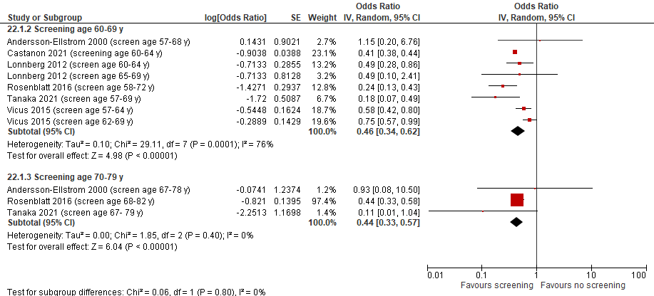

Supplementary Figure 2.1. Effect of screening for cervical cancer in older (>60 years of age) participants on incidence of invasive cervical cancer to inform stop ages for screening; case-control studies
Footnotes:

(1) Studies may contribute data more than once within a screen age category since individuals could only be a case once (i.e. data points are mutually exclusive). For studies where there are more than one data point in an age category the participants contributing data to each data point are unique.
(2) When not reported by study, age at screening was estimated from the duration prior to age of diagnosis and, if applicable, the exclusion period (duration before diagnosis when authors assumed any diagnosis would be from symptoms and not from screening).
(3) Standard errors were weighted to estimate the proportion of participants who contributed to the age category of interest. Weighting was applied to data from studies that included participants with more than one year outside of an age category of interest. For this analysis, assumptions were made that screened participants and odds ratios (i.e., effects) were equally distributed across the age range of the study sample.

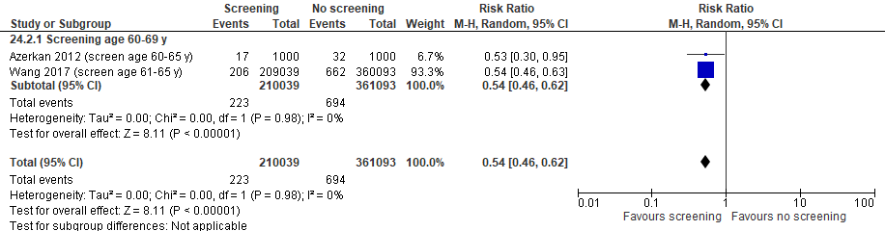

Supplementary Figure 2.2. Effect of screening for cervical cancer in older (>60 years of age) participants on incidence of invasive cervical cancer to inform stop ages for screening; cohort studies
Footnote:
(1) When not reported by study, age at screening was estimated from the duration prior to age of diagnosis and, if applicable, the exclusion period (duration before diagnosis when authors assumed any diagnosis would be from symptoms and not from screening).

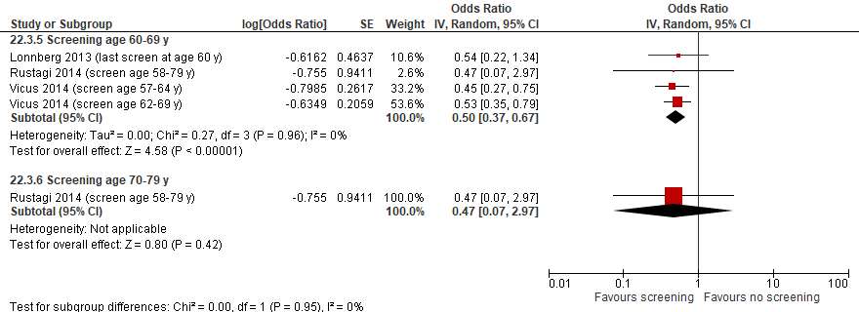

Supplementary Figure 2.3. Effect of screening for cervical cancer in older (>60 years of age) participants on mortality from cervical cancer to inform stop ages for screening; case-control studies
Footnotes:
(1) Studies may contribute data more than once within a screen age category since individuals could only be a case once (i.e. data points are mutually exclusive). For studies where there are more than one data point in an age category the participants contributing data to each data point are unique.
(2) When not reported by study, age at screening was estimated from the duration prior to age of diagnosis and, if applicable, the exclusion period (duration before diagnosis when authors assumed any diagnosis would be from symptoms and not from screening).
(3) Standard errors were weighted to estimate the proportion of participants who contributed to the age category of interest. Weighting was applied to data from studies that included participants with more than one year outside of an age category of interest. For this analysis, assumptions were made that screened participants and odds ratios (i.e., effects) were equally distributed across the age range of the study sample.

Evidence set 3: Summary of Findings for observational studies on the effect of cytology screening intervals of <3.5 versus 3.5-5.5* years on the incidence of invasive cervical cancer and cervical cancer mortality
Included reports: Case control: Andersson-Ellstrom 2000; Castanon 2014; Kamineni 2013; Landy 2020; Makino 1995; Sasieni 2003 (and associated paper Sasieni 2009a); Vicus 2015 (and associated Vicus 2014); Zappa 2004; Cohorts: Herbert 1996; Morrison 1996
Comparison | No. and design of included studies  Sample size analyzed | Findings  OR (95% CI) unless otherwise indicated | GRADE† | What happens?
Outcome: Incidence of invasive cervical cancer
Screening intervals of <3.5 years vs. 3.5-5.5 years (time since last smear) | 8 case-controls (N=20,862)  2 cohorts (Herbert 1996 N=103,491; Morrison 1996 N=NR approx. 71,000) | Case-control studies  Pooled OR: 0.87 (0.66 to 1.14); I²=82%  Cohort studies  OR: 0.70 (0.32 to 1.54)  In one cohort study, two cohorts born 15 years apart (cohort I born 1914-1918 and cohort II born 1929-1933), were followed for invasive cervical cancer or carcinoma in situ from 1970-1992.  Incidence rates per 1000 women-years for 24-35 month vs. 48-59 month (last) screening interval, cohort I, 31-78 years at diagnosis: IR 0.5 vs. 0.5 (95% CI NR)  & cohort II, 16-63 years at diagnosis: IR 1.0 vs. 0.7 (95% CI NR) | ⊕⊝⊝⊝  VERY LOWª  due to inconsistency | We are very uncertain about whether the effects on the incidence of invasive cervical cancer differ between cytology screening intervals of under 3.5 versus 3.5 to 5.5 years.
Outcome: Cervical cancer mortality
Screening interval of <3 years vs. 3-5 years (time since last smear) | 1 case-control  N=11,447 (Vicus, 2014) | OR 0.59 (0.42 to 0.83)‡ | ⊕⊝⊝⊝  VERY LOW^{b} due to lack of consistency | We are very uncertain about whether the effects on the cervical cancer mortality differ between cytology screening intervals of under 3 versus 3 to 5 years.
Abbreviations: CI=confidence interval; IR=incidence ratio; NR=not reported; OR=odds ratio.
* In the case control studies, the screening interval is the duration before the index date of invasive cervical cancer diagnosis.
† We rated down by 0.5 for “some concerns”, 1 for “serious concerns”, and 2 for “very serious concerns”. We did not apply decision thresholds with respect to an important magnitude of effect and rated our certainty about conclusions of a direction rather than magnitude of effect. When our assessment of the certainty of evidence fell between levels, we assigned the level that best represented our actual certainty in the evidence, and based our conclusions on this level of certainty.

‡ Findings from this study are from pooling the effects across age categories. Events and sample size were not reported for each result so a ratio of the ORs (versus no screening for each interval [3 to 36 months & 37 to 60 months] group) was used.

Explanations:
ª Incidence of cervical cancer from <3.5 vs 3.5-5.5 year screening intervals: No serious concerns about risk of bias: three studies (1 case-control and 2 cohort studies) were at risk of bias due to a lack of matching or adjustment for confounders; the case-control study was small and removing it from the analysis did not change conclusions (OR: 0.86 (0.65 to 1.14)), and while the potential bias from the cohort studies may have impacted findings we thought our down rating for inconsistency captured the major concern. Serious concerns about inconsistency: one cohort study (Herbert 1996) indicated a potential (though imprecise) benefit for less frequent screening, whereas another (Morrison 1996) had mixed findings in two cohorts with one showing benefit for the longer interval and one finding little-to-no difference between intervals; of the 8 case-control studies, 4 showed a potential benefit for more frequent and 2 showed potential benefit for less frequent screening. Subgroup analyses based on age and setting (opportunistic vs. programmatic screening) did not explain the heterogeneity (Supplementary Figures 3.2 to 3.4). No serious concerns about indirectness: all studies describe similar screening interval comparisons, and most studies used invasive cervical cancer as the case/outcome definition (1 case-control did not specify invasive types of cervical cancer, and 1 cohort study included invasive cervical cancer and carcinoma in situ). No serious concerns about imprecision: the lower limit of the 95% CI in the analysis shows potential benefit from more frequent screening, and there was some imprecision in the findings of the cohort study that reported a 95% CI, but the inconsistency across the case control studies was thought to contribute to the wide 95% CI so we did not rate down more for imprecision. No other serious concerns.
^{b} Cervical cancer mortality from <3 vs 3-5 year screening intervals: No serious concerns about risk of bias: no domains judged to bias the conclusions of effect. Serious concerns about lack of consistency: single study effect and some inconsistency was evident across age categories (of 8 age subgroups 2 [25-29 years and 65-69 years] favored the longer interval, though with imprecision)(see Supplementary Figure 5); findings for incidence of ICC indicate there would be inconsistency if other studies reported on this outcome. No serious concerns about indirectness: appropriate screening interval comparison and case definition was invasive cervical cancer. No serious concerns about imprecision: the entire 95% CI indicates that a shorter interval is beneficial. No other serious concerns.

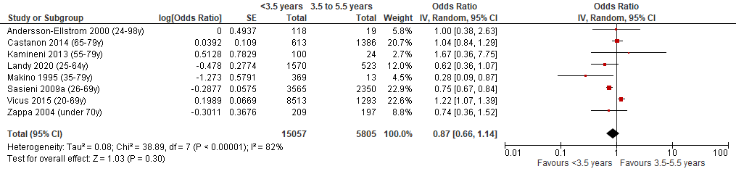

Supplementary Figure 3.1. Effect of screening intervals of <3.5 versus 3.5-5.5 years* on the incidence of invasive cervical cancer: data from case-control studies
* Screening interval is the duration before the index date of invasive cervical cancer diagnosis (year of diagnosis indicated in brackets within figure).
Footnote: Events and sample sizes per group were NR in Landy 2020 (2.5 to 3.5 years & 3.5 to 5 years versus never screened), Kamineni 2013 (1 to <3 years & 3 to <5 years vs never screened) & Zappa 2004 (1 to <3 & 3 to <6 years versus never screened): ORs for these studies were calculated using the ratio of ORs for the two different intervals, each versus never screened.

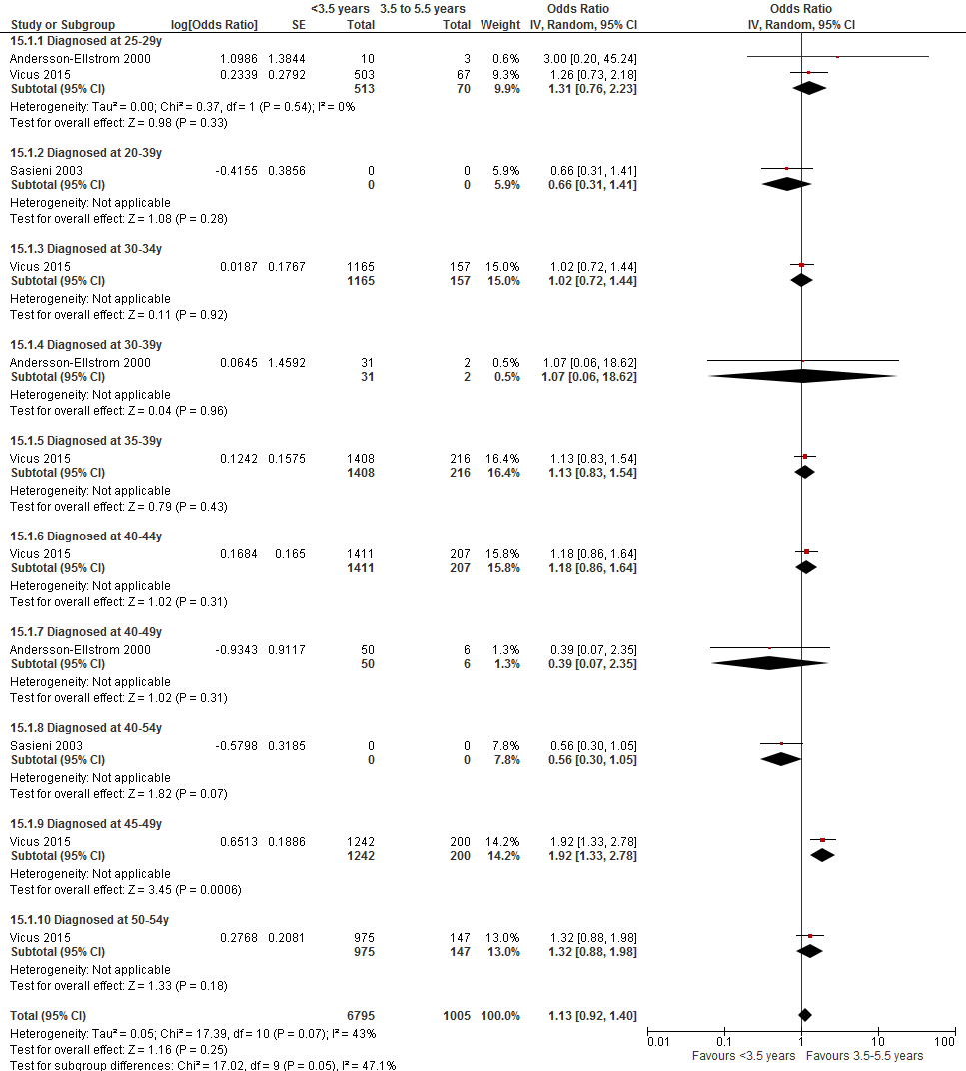

Supplementary Figure 3.2. Effect of screening intervals of <3.5 versus 3.5-5.5 years* on the incidence of invasive cervical cancer: data from case-control studies for individuals under 50 years of age
^{ⱡ} Screening interval is the duration before the index date of the invasive cervical cancer diagnosis, between ages 25 to 54. Age of screening is therefore below 50 for the large majority of women.
Footnotes: Events and sample sizes by group were NR for Sasieni 2003; ORs for this study are calculated using the ratio of ORs for 2.5 to 3.5 years and 4.5 to 5.5 years versus never screened. Data from cohort (Herbert 1996): ages 25 to 39 years at diagnosis: OR 0.59 (0.13 to 2.70); age 40-54 years at diagnosis: OR 0.65 (0.24 to 1.81).
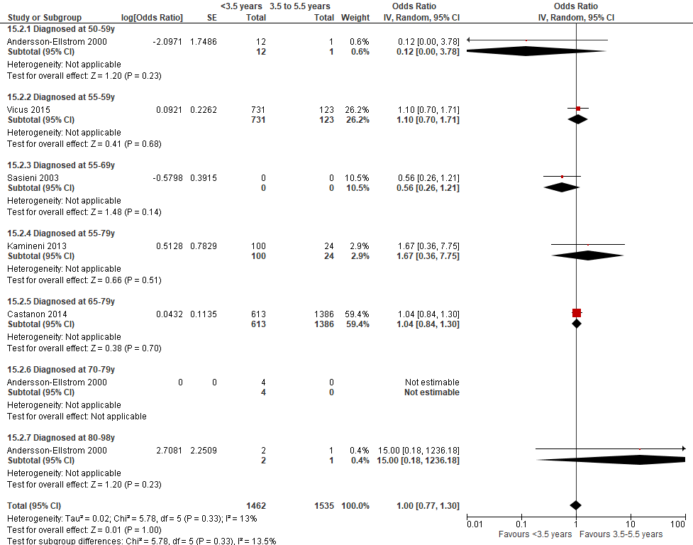

Supplementary Figure 3.3. Effect of screening intervals of <3.5 versus 3.5-5.5 years* on the incidence of invasive cervical cancer: data from case-control studies in individuals 50 years of age and older
*Screening interval is the duration before the index date of the invasive cervical cancer diagnosis, between ages 50 and 98. Age of screening is therefore above 50 for the large majority of women.
Footnotes: Events and sample sizes per group were NR in Sasieni 2003 (2.5 to 3.5 years & 4.5 to 5.5 years versus never screened) and Kamineni 2013 (1 to <3 years & 3 to <5 years vs never screened); ORs for these studies were calculated using the ratio of ORs for the two different intervals, each versus never screened. The OR in Andersson-Ellstrom 2000 (diagnosis at age 70-79 years) not estimable because of zero events in one group.
Data from cohort (Herbert 1996): ages 55 to 69 years at diagnosis: OR 1.62 (0.19 to 13.87).

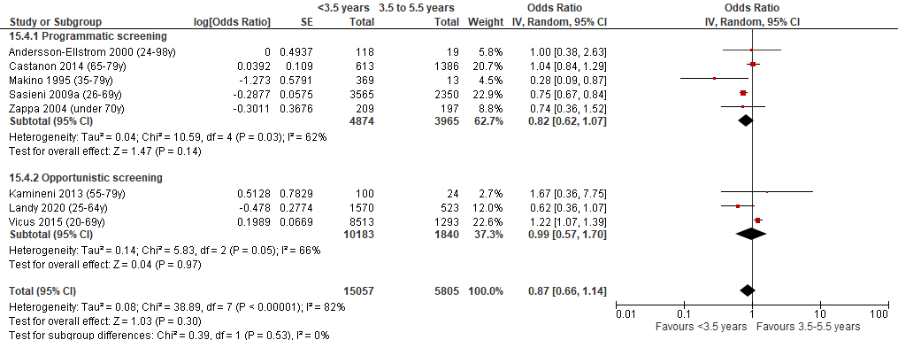

Supplementary Figure 3.4. Effect of screening intervals of <3.5 versus 3.5-5.5 years* on the incidence of invasive cervical cancer: data from case-control studies differing by type of screening program in country
* Screening interval is the duration before the index date of invasive cervical cancer diagnosis (year of diagnosis indicated in brackets within figure).
Footnote: Events and sample sizes per group were NR in Landy 2020 (2.5 to 3.5 years & 3.5 to 5 years versus never screened), Kamineni 2013 (1 to <3 years & 3 to <5 years vs never screened) & Zappa 2004 (1 to <3 & 3 to <6 years versus never screened): ORs for these studies were calculated using the ratio of ORs for the two different intervals, each versus never screened.

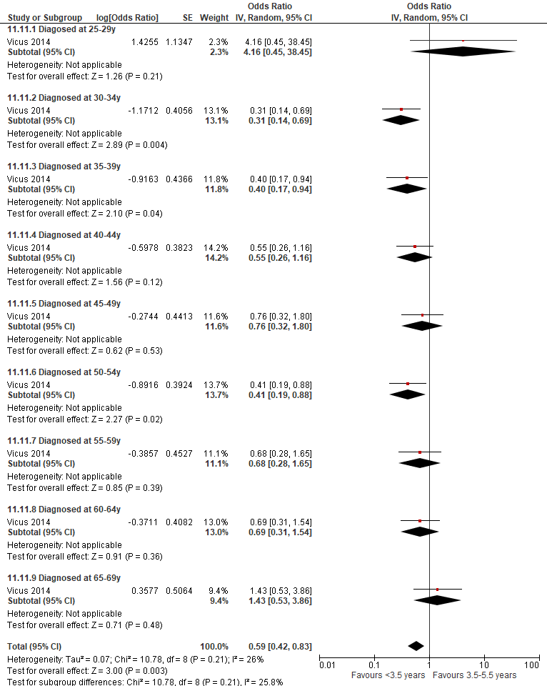

Supplementary Figure 3.5. Effect of screening intervals of <3 versus 3 to 5 years* on cervical cancer mortality: data from case-control study by age at diagnosis
* Screening interval is the duration before the index date of invasive cervical cancer diagnosis (year of diagnosis indicated in brackets within figure).
Footnotes: Vicus 2014 (3 to 36 months & 37 to 60 years versus never screened): ORs for these studies were calculated using the ratio of ORs for the two different intervals, each versus never screened.

Effectiveness of screening by other population characteristics
In studies included based on revised eligibility to focus on start/stop ages and screening intervals, between-study subgroup analyses for specific populations was not possible due to limited data.
Within-study findings from all eligible studies were sparse and not specific to the age categories examined.
One observational study (Rosenblatt et al. 2016) provided outcome data for the effect of screening on incidence of invasive cancer by race/ethnicity and one Swedish observational study (Azerkan et al. 2012) provided data for this outcome by immigrant status.
- In one case-control study (N=11,404) (Rosenblatt et al. 2016) of persons with a cervix aged 65 years or older, race (White vs. non-white) was not associated with the effect of screening (p=0.243 for interaction) when adjusted for median income by zip code and potential impact of hysterectomy.
- In one large (N=2,621,802) cohort study (Azerkan et al. 2012) that adjusted for age, there was no difference in the effect of screening on incidence of invasive cervical cancer based on immigrant status (Swedish-born vs. birth outside Sweden)
Within study findings from observational studies on the effect of screening for cervical cancer by ethnicity and immigrant status
Outcome: Incidence of invasive cervical cancer
Population | No. and design of included studies  Sample size analyzed  Follow up for cohort studies | Findings
Immigrant | 1 cohort Azerkan et al. 2012  N=2,621,802  (12-year follow up) | Incidence of invasive cervical cancer:  aIRR (95% CI) for adherent (persons with a cervix age 23 to 50 years with a smear in prior 3 years; those age 51 to 60 years with a smear in prior 5 years⁾ vs. non-adherent to screening, adjusted for age:  Swedish-born: 0.20 (0.18 to 0.21)  Immigrants (born outside Sweden): 0.19 (95% CI , 0.15 to 0.23)
Ethnicity/race | 1 case-control Rosenblatt et al. 2016  N=11,404 | Case-control study (limited to women aged 65 years or older):  aOR (95% CI) for having had a smear during the PIDP (pre-invasive detectable phase [7 to 2 years prior to diagnosis]) vs. no smear during the PIDP, adjusted for median income of zip code area and corrected for potential impact of hysterectomy:  White: 0.36 (0.29 to 0.44)  Non-white (Black and “other” race): 0.51 (0.35 to 0.75)  p=0.243 for interaction  *Adjusted for median income of zip code area and corrected for potential impact of hysterectomy.

aIRR= adjusted incident risk ratio; aOR=adjusted odds ratio; RR=risk ratio; vs.=versus.

