Screening for the prevention and early detection of cervical cancer: systematic reviews to inform Canadian recommendations

Pillay J, Gates A, Guitard S, Zakher B, Sim S, Vandermeer B, Hartling L.

Supplementary File 1b: Evidence for Key Question 1 on comparative effectiveness of screening strategies

Contents
Risk of bias for trials……………………………………………………………………………………………………………………………………………………………………2
Evidence sets for comparative effectiveness of screening strategies 8
Evidence Set 1: hrHPV screening vs. cytology screening 8
Evidence set 2.0a: hrHPV screening with cytology triage vs. cytology testing; without recall 33
Evidence set 2.0b: hrHPV screening with cytology triage vs. cytology testing; with recall 69
Evidence set 3.0a: hrHPV screening with cytology triage vs. cytology screening with hrHPV triage; without recall 103
Evidence set 3.0b: hrHPV screening with cytology triage vs. cytology screening with hrHPV triage; with recall 129
Evidence set 3.0c: one round of hrHPV screening with cytology triage vs. two rounds of cytology screening with hrHPV triage 169
Evidence set 4.0 hrHPV screening with partial genotyping (types 16/18 direct to colposcopy) and cytology triage of hrHPV type 45 vs. cytology screening with hrHPV with partial genotyping triage 187
Evidence set 5.0: hrHPV screening with cytology triage of negative tests vs. cytology screening with hrHPV triage 210
Evidence set 6.0a: hrHPV self-sampling with cytology triage vs. clinician-sampled hrHPV screening with cytology triage 236
Evidence set 6.0b: hrHPV self-screening with cytology triage vs. hrHPV clinician sampling with cytology triage (underscreened) 252
Evidence set 7.0: hrHPV self-sampling with repeat self-sampling for hrHPV⁺ vs. clinician-sampled hrHPV screening with repeat clinician sampled hrHPV⁺ 264
Evidence set 8.0: hrHPV self-sampling with cytology triage vs. cytology screening 276
Evidence set 9.0: hrHPV self-sampling with cytology triage of types other than 16/18 versus cytology with hrHPV triage 295
Evidence Set 10.0: hrHPV self-sampling vs. conventional cytology screening 307

Risk of bias for trials
KQ1. Risk of bias assessments
Study | Random sequence generation | Allocation concealment | Blinding – participants and personnel | Blinding – outcome assessment | Incomplete outcome data | Selective reporting | Other sources of bias
Referrals to colposcopy
Aarnio 2021 | High | Unclear | Unclear | Unclear | Low | Unclear | Low
Canfell 2017 | Low | Low | Unclear | Unclear | Low | Unclear | Low
Chan 2020 | Low | Unclear | Unclear | Unclear | Low | Unclear | Low
Elfstrom 2021 | High | Unclear | Unclear | Unclear | Low | Unclear | Low
Gustavsson 2019 | High | Unclear | Unclear | Unclear | Low | Unclear | Low
Lamin 2017 | High | Low | Unclear | Unclear | Low | Unclear | Low
Leinonen 2012 | Unclear | Low | Unclear | Unclear | Low | Unclear | Low
Nygard 2022 (without recall) | High | Unclear | Unclear | Unclear | Low | Unclear | Low
Nygard 2022 (with recall) | High | Unclear | Unclear | Unclear | Unclear | Unclear | Low
Ogilvie 2017 | Low | Low | Unclear | Unclear | Low | Unclear | Low
Ogilvie 2018 | Low | Low | Unclear | Unclear | Low | Unclear | Low
Polman 2019 | Unclear | Unclear | Unclear | Unclear | Low | Unclear | Low
Ronco 2008 | Low | Low | Unclear | Unclear | Low | Low | Low
Sancho-Garnier 2013 | High | Unclear | Unclear | Unclear | High | Unclear | Low
Szarewski 2011 | Unclear | Unclear | Unclear | Unclear | Low | Low | Low
Viviano 2017 | Low | Low | Unclear | Unclear | Low | Low | Low
Number of colposcopies
Aarnio 2021 | High | Unclear | Unclear | Unclear | Low | Unclear | Low
Chan 2020 | Low | Unclear | Unclear | Unclear | Low | Unclear | Low
Gustavsson 2019 | High | Unclear | Unclear | Unclear | Low | Unclear | Low
Lamin 2017 | High | Low | Unclear | Unclear | Low | Unclear | Low
Ogilvie 2017 | Low | Low | Unclear | Unclear | Low | Unclear | Low
Ogilvie 2018 | Low | Low | Unclear | Unclear | Low | Unclear | Low
Polman 2019 | Unclear | Unclear | Unclear | Unclear | Low | Unclear | Low
Ronco 2008 | Low | Low | Unclear | Unclear | Low | Low | Low
Sancho-Garnier 2013 | High | Unclear | Unclear | Unclear | High | Unclear | Low
Szarewski 2011 | Unclear | Unclear | Unclear | Unclear | Low | Low | Low
Viviano 2017 | Low | Low | Unclear | Unclear | Low | Low | Low
Number of biopsies
Elfstrom 2021 | High | Unclear | Unclear | Unclear | Low | Unclear | Low
Ronco 2008 | Low | Low | Unclear | Unclear | Low | Low | Low
Number of LEEPs
Chan 2020 | Low | Unclear | Unclear | Unclear | Low | Unclear | Low
Detection of CIN2 or CIN2+
Aarnio 2021 | High | Unclear | Unclear | Low | Low | Unclear | Low
Aasbo 2022 | High | Low | Unclear | Unclear | Low | Low | Low
Canfell 2017 | Low | Low | Unclear | Unclear | Low | Low | Low
Chan 2020 | Low | Unclear | Unclear | Low | Low | Low | Low
Elfstrom 2021 | High | Unclear | Unclear | Unclear | Low | Low | Low
Gustavsson 2019 | High | Unclear | Unclear | Unclear | Low | Unclear | Low
Lamin 2017 | High | Low | Unclear | Unclear | Low | Low | Low
Leinonen 2012 | Unclear | Low | Unclear | Unclear | Unclear | Low | Low
Nygard 2022 (without recall) | High | Unclear | Unclear | Unclear | Low | Low | Low
Nygard 2022 (with recall) | High | Unclear | Unclear | Unclear | Unclear | Low | Low
Ogilvie 2017 | Low | Low | Unclear | Low | Low | Low | Low
Ogilvie 2018 | Low | Low | Unclear | Low | Low | Low | Low
Piana 2011 | High | Unclear | Unclear | Unclear | High | Unclear | Low
Polman 2019 | Unclear | Unclear | Unclear | Unclear | Low | Low | Low
Ronco 2008 | Low | Low | Unclear | Unclear | Unclear | Low | Low
Sancho-Garnier 2013 | High | Unclear | Unclear | Unclear | High | Unclear | Low
Szarewski 2011 | Unclear | Unclear | Unclear | Unclear | Low | Unclear | Low
Viviano 2017 | Low | Low | Unclear | Unclear | Unclear | Unclear | Low
Detection of CIN3 or CIN3+
Aarnio 2021 | High | Unclear | Unclear | Low | Low | Unclear | Low
Aasbo 2022 | High | Low | Unclear | Unclear | Low | Low | Low
Canfell 2017 | Low | Low | Unclear | Unclear | Low | Low | Low
Chan 2020 | Low | Unclear | Unclear | Low | Low | Low | Low
Elfstrom 2021 | High | Unclear | Unclear | Unclear | Low | Low | Low
Gustavsson 2019 | High | Unclear | Unclear | Unclear | Low | Unclear | Low
Lamin 2017 | High | Low | Unclear | Unclear | Low | Low | Low
Leinonen 2012 | Unclear | Low | Unclear | Unclear | Unclear | Low | Low
Nygard 2022 (without recall) | High | Unclear | Unclear | Unclear | Low | Low | Low
Nygard 2022 (with recall) | High | Unclear | Unclear | Unclear | Unclear | Low | Low
Ogilvie 2017 | Low | Low | Unclear | Low | Low | Low | Low
Ogilvie 2018 | Low | Low | Unclear | Low | Low | Low | Low
Piana 2011 | High | Unclear | Unclear | Unclear | High | Unclear | Low
Polman 2019 | Unclear | Unclear | Unclear | Unclear | Low | Low | Low
Ronco 2008 | Low | Low | Unclear | Unclear | Unclear | Low | Low
Sancho-Garnier 2013 | High | Unclear | Unclear | Unclear | High | Unclear | Low
Szarewski 2011 | Unclear | Unclear | Unclear | Unclear | Low | Unclear | Low
Viviano 2017 | Low | Low | Unclear | Unclear | Unclear | Unclear | Low
Detection of invasive cervical cancer
Aasbo 2022 | High | Low | Unclear | Unclear | Low | Low | Low
Canfell 2017 | Low | Low | Unclear | Unclear | Low | Low | Low
Chan 2020 | Low | Unclear | Unclear | Low | Low | Low | Low
Elfstrom 2021 | High | Unclear | Unclear | Unclear | Low | Low | Low
Lamin 2017 | High | Low | Unclear | Unclear | Low | Low | Low
Leinonen 2012 | Unclear | Low | Unclear | Unclear | Unclear | Low | Low
Piana 2011 | High | Unclear | Unclear | Unclear | High | Unclear | Low
Polman 2019 | Unclear | Unclear | Unclear | Unclear | Low | Low | Low
Sancho-Garnier 2013 | High | Unclear | Unclear | Unclear | High | Unclear | Low
Szarewski 2011 | Unclear | Unclear | Unclear | Unclear | Low | Unclear | Low
False positives for CIN2 or CIN2+
Aarnio 2021 | High | Unclear | Unclear | Low | Low | Unclear | Low
Aasbo 2022 | High | Low | Unclear | Unclear | Low | Unclear | Low
Canfell 2017 | Low | Low | Unclear | Unclear | Low | Low | Low
Chan 2020 | Low | Unclear | Unclear | Low | Low | Low | Low
Elfstrom 2021 | High | Unclear | Unclear | Unclear | Low | Unclear | Low
Gustavsson 2019 | High | Unclear | Unclear | Unclear | Low | Unclear | Low
Lamin 2017 | High | Low | Unclear | Unclear | Low | Low | Low
Leinonen 2012 | Unclear | Low | Unclear | Unclear | Unclear | Low | Low
Nygard 2022 (without recall) | High | Unclear | Unclear | Unclear | Low | Unclear | Low
Nygard 2022 (with recall) | High | Unclear | Unclear | Unclear | Unclear | Unclear | Low
Ogilvie 2017 | Low | Low | Unclear | Low | Low | Low | Low
Ogilvie 2018 | Low | Low | Unclear | Low | Low | Low | Low
Polman 2019 | Unclear | Unclear | Unclear | Unclear | Low | Low | Low
Ronco 2008 | Low | Low | Unclear | Unclear | Unclear | Low | Low
Sancho-Garnier 2013 | High | Unclear | Unclear | Unclear | High | Unclear | Low
Szarewski 2011 | Unclear | Unclear | Unclear | Unclear | Low | Unclear | Low
Viviano 2017 | Low | Low | Unclear | Unclear | Unclear | Unclear | Low
False positives for CIN 3 or CIN+
Aarnio 2021 | High | Unclear | Unclear | Low | Low | Unclear | Low
Aasbo 2022 | High | Low | Unclear | Unclear | Low | Unclear | Low
Canfell 2017 | Low | Low | Unclear | Unclear | Low | Low | Low
Chan 2020 | Low | Unclear | Unclear | Low | Low | Low | Low
Gustavsson 2019 | High | Unclear | Unclear | Unclear | Low | Unclear | Low
Lamin 2017 | High | Low | Unclear | Unclear | Low | Low | Low
Leinonen 2012 | Unclear | Low | Unclear | Unclear | Unclear | Low | Low
Nygard 2022 (without recall) | High | Unclear | Unclear | Unclear | Low | Unclear | Low
Nygard 2022 (with recall) | High | Unclear | Unclear | Unclear | Unclear | Unclear | Low
Ogilvie 2017 | Low | Low | Unclear | Low | Low | Low | Low
Ogilvie 2018 | Low | Low | Unclear | Low | Low | Low | Low
Polman 2019 | Unclear | Unclear | Unclear | Unclear | Low | Low | Low
Ronco 2008 | Low | Low | Unclear | Unclear | Unclear | Low | Low
Sancho-Garnier 2013 | High | Unclear | Unclear | Unclear | High | Unclear | Low
Szarewski 2011 | Unclear | Unclear | Unclear | Unclear | Low | Unclear | Low
Viviano 2017 | Low | Low | Unclear | Unclear | Unclear | Unclear | Low
False positives for invasive cervical cancer
Aasbo 2022 | High | Low | Unclear | Unclear | Low | Unclear | Low
Canfell 2017 | Low | Low | Unclear | Unclear | Low | Low | Low
Chan 2020 | Low | Unclear | Unclear | Low | Low | Low | Low
Lamin 2017 | High | Low | Unclear | Unclear | Low | Low | Low
Leinonen 2012 | Unclear | Low | Unclear | Unclear | Unclear | Low | Low
Polman 2019 | Unclear | Unclear | Unclear | Unclear | Low | Low | Low
Sancho-Garnier 2013 | High | Unclear | Unclear | Unclear | High | Unclear | Low
Szarewski 2011 | Unclear | Unclear | Unclear | Unclear | Low | Unclear | Low
Incidence of CIN2 or CIN2+
Chan 2020 | Low | Unclear | Unclear | Low | High | Low | Low
Ogilvie 2018 | Low | Low | Unclear | Low | Unclear | Low | Low
Leinonen 2012 (without recall) | Unclear | Low | Unclear | Unclear | Low | High | Low
Leinonen 2012 (with recall) | Unclear | Low | Unclear | Unclear | Unclear | High | Low
Ronco 2010 | Low | Low | Unclear | Unclear | High | Low | Low
Incidence of CIN3 or CIN3+
Chan 2020 | Low | Unclear | Unclear | Low | High | Low | Low
Ogilvie 2018 | Low | Low | Unclear | Low | Unclear | Low | Low
Leinonen 2012 (without recall) | Unclear | Low | Unclear | Unclear | Low | High | Low
Leinonen 2012 (with recall) | Unclear | Low | Unclear | Unclear | Unclear | High | Low
Ronco 2010 | Low | Low | Unclear | Unclear | High | Low | Low
Incidence of invasive cervical cancer
Canfell 2017 | Low | Low | Unclear | Unclear | Low | High | Low
Chan 2020 | Low | Unclear | Unclear | Low | High | Low | Low
Leinonen 2012 (without recall) | Unclear | Low | Unclear | Unclear | Low | High | Low
Leinonen 2012 (with recall) | Unclear | Low | Unclear | Unclear | Unclear | High | Low
Overdiagnosis of non-progressive CIN3
Malila 2013 | Unclear | Low | Unclear | Unclear | Low | High | Low
All-cause mortality
Canfell 2017 | Low | Low | Low | Low | Low | Low | Low
Risk of bias assessed using the Cochrane Risk of Bias Tool, v. 2011: Higgins JPT, Altman DG, Gøtzsche PC, Jüni P, Moher D, Oxman AD, et al. The Cochrane Collaboration’s tool for assessing risk of bias in randomized trials. BMJ;2011;343:d5928.

Evidence sets for comparative effectiveness of screening strategies

Evidence Set 1: hrHPV screening (threshold 1.0 RLU) vs. conventional cytology screening (threshold ≥ASCUS or ≥LSIL)

Included report: Ronco 2008 (NTCC Phase II) (ages 25-60 [subgroups 25-34 and 35-60 years])

Evidence Set 1.1. Referrals to colposcopy
GRADE Summary of Findings Table 1.1. Referrals to colposcopy
Outcome  No. participantsª  (studies) |  | Relative effects, Peto OR and RR (95 % CI) | Anticipated absolute effects |  |  |  | Certainty of evidence (GRADE)^{b} | What happens?
 |  | Relative effects, Peto OR and RR (95 % CI) | With cytology screening |  | With hrHPV screening | Difference | Certainty of evidence (GRADE)^{b} | What happens?
People with a cervix aged 25 to 59 years (Ronco 2008 (NTCC Phase II); acceptors of screening)
Referrals to colposcopy  Follow-up: 1 round  49,196 (1 RCT) |  | Peto OR: 2.75 (2.54 to 2.97)  RR: 2.62 (2.44 to 2.82) |  | 276.7 per 10,000 | 725.9 per 10,000 | 449.2 more per 10,000 (397.5 more to 502.7 more) | NA
People with a cervix aged 25 to 29 years (Ronco 2008 (NTCC Phase II); acceptors of screening)
Referrals to colposcopy  Follow-up: 1 round  13,725 (1 RCT) | Peto OR: 3.43 (3.04 to 3.88)  RR: 3.15 (2.83 to 3.52) |  | 359.5 per 10,000 |  | 1133.9 per 10,000 | 774.4 more per 10,000 (658.6 more to 904.4 more) | MODERATE^{c}  ⊕⊕⊕⊝  due to lack of evidence of consistency | Among people with a cervix aged 25 to 29 years, offering hrHPV testing probably increases the rate of referral to colposcopy compared with offering cytology testing.
People with a cervix aged 30 to 59 years (Ronco 2008 (NTCC Phase II); acceptors of screening)
Referrals to colposcopy  Follow-up: 1 round  35,471 (1 RCT) | Peto OR: 2.33 (2.10 to 2.59)  RR: 2.26 (2.04 to 2.49) |  | 245.1 per 10,000 |  | 553.1 per 10,000 | 308.0 more per 10,000 (256.1 more to 365.9 more) | 30-59 yrs:  LOW^{d}  ⊕⊕⊝⊝  due to lack of evidence of consistency, and imprecision  60-69 yrs:  VERY LOW  ⊕⊝⊝⊝  NR | Among people with a cervix aged 30 to 59 years, offering hrHPV testing may increase the rate of referral to colposcopy compared with offering cytology testing.  Among people with a cervix aged 60 to 69 years, we are very uncertain about the effects of hrHPV testing on the rate of referral to colposcopy compared with cytology testing.
CI = confidence interval; NA= not applicable (i.e., not used for conclusions); OR = odds ratio; RCT = randomized controlled trial; RR = relative risk.
ªAcceptors of screening include participants who accepted the offer to be screened and were randomized, including those who were screened in a group different to which they were randomly assigned (73/24,638 people with a cervix in the hrHPV screening group received via cytology screening) (akin to an intention-to-screen analysis).
^{b}We rated down by 0.5 for “some concerns”, 1 “serious concerns”, and 2 for “very serious concerns”. When our assessment of the certainty of evidence fell between levels, we assigned the level that best represented our actual certainty in the evidence, and based our conclusions on this level of certainty.
Explanations:
^{c}Acceptors of screening; people with a cervix aged 25 to 29 years: No serious concerns about risk of bias: no domains judged high risk. Some concerns about inconsistency: lack of evidence for consistency due to single study. No serious concerns about indirectness: 50% of each group were screened in the organized program in the previous 4 years. No serious concerns about imprecision: 95% CI precise for increased effect. No other serious concerns.
^{d}Acceptors of screening; people with a cervix aged 30 to 59 years: No serious concerns about risk of bias: no domains judged high risk. Some concerns about inconsistency: lack of evidence for consistency due to single study. No serious concerns about indirectness: 50% of each group were screened in the organized program in the previous 4 years. Serious concerns about imprecision: lower limit of 95% CI indicates little-to-no effect. No other serious concerns.

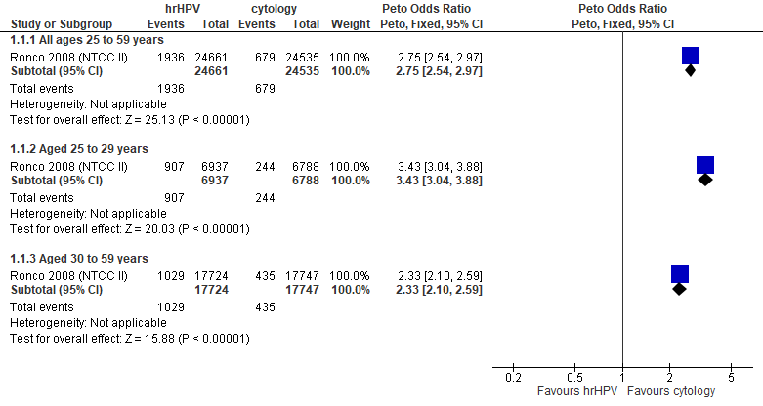
Forest plot 1.1. Referrals to colposcopy

Evidence Set 1.2. Number of colposcopies
Included report: Ronco 2008 (NTCC Phase II)
GRADE Summary of Findings Table 1.2. Number of colposcopies
Outcome  No. participantsª  (studies) |  | Relative effects, Peto OR and RR (95 % CI) | Anticipated absolute effects |  |  | Certainty of evidence (GRADE)^{b} | What happens?
 |  | Relative effects, Peto OR and RR (95 % CI) | With cytology screening | With hrHPV screening | Difference | Certainty of evidence (GRADE)^{b} | What happens?
People with a cervix aged 25 to 59 years (Ronco 2008 (NTCC Phase II); acceptors of screening)
Number of colposcopies  Follow-up: 1 round  49,196 (1 RCT) | Peto OR: 2.80 (2.58 to 3.04)  RR: 2.68 (2.48 to 2.89) |  | 251.5 per 10,000 | 673.6 per 10,000 | 422.2 more per 10,000 (372.5 more to 475.7 more) | NA
>Subgroup: people with a cervix aged 25 to 29 years (Ronco 2008 (NTCC Phase II); acceptors of screening)
Number of colposcopies  Follow-up: 1 round  13,725 (1 RCT) | Peto OR: 3.58 (3.16 to 4.06)  RR: 3.31 (2.96 to 3.70) |  | 313.8 per 10,000 | 1039.2 per 10,000 | 725.4 more per 10,000 (614.8 more to 848.6 more) | MODERATE^{c}  ⊕⊕⊕⊝  due to lack of evidence of consistency | Among people with a cervix aged 25 to 29 years, offering hrHPV testing probably increases the number of colposcopies compared with offering cytology testing.
>Subgroup: people with a cervix aged 30 to 59 years (Ronco 2008 (NTCC Phase II); acceptors of screening)
Number of colposcopies  Follow-up: 1 round  35,471 (1 RCT) | Peto OR: 2.34 (2.10 to 2.61)  RR: 2.27 (2.05 to 2.52) |  | 227.6 per 10,000 | 516.9 per 10,000 | 289.3 more per 10,000 (238.7 more to 345.5 more) | 30 to 59 yrs:  LOW^{d}  ⊕⊕⊝⊝  due to lack of evidence of consistency, and imprecision  60-69 yrs:  VERY LOW  ⊕⊝⊝⊝  NR | Among people with a cervix aged 30 to 59 years, offering hrHPV testing may make litrle to no difference in the number of colposcopies compared with offering cytology testing.  Among people with a cervix aged 60 to 69 years, we are very uncertain about the effects of hrHPV testing on the number of colposcopies compared with cytology testing.
CI = confidence interval; NA= not applicable (i.e., not used for conclusions); OR = odds ratio; RCT = randomized controlled trial; RR = relative risk.
ªAcceptors of screening include participants who accepted the offer to be screened and were randomized, including those who were screened in a group different to which they were randomly assigned (73/24,638 people with a cervix in the hrHPV screening group received via cytology screening) (akin to an intention-to-screen analysis).
^{b}We rated down by 0.5 for “some concerns”, 1 “serious concerns”, and 2 for “very serious concerns”. When our assessment of the certainty of evidence fell between levels, we assigned the level that best represented our actual certainty in the evidence, and based our conclusions on this level of certainty.
Explanations:
^{c}Acceptors of screening; people with a cervix aged 25 to 29 years: No serious concerns about risk of bias: no domains judged high risk. Some concerns about inconsistency: lack of evidence for consistency due to single study. No serious concerns about indirectness: 50% of each group were screened in the organized program in the previous 4 years. No serious concerns about imprecision: 95% CI precise for increased effect. No other serious concerns.
^{d}Acceptors of screening; people with a cervix aged 30 to 59 years: No serious concerns about risk of bias: no domains judged high risk. Some concerns about inconsistency: lack of evidence for consistency due to single study. No serious concerns about indirectness: 50% of each group were screened in the organized program in the previous 4 years. Serious concerns about imprecision: upper limit of 95% CI indicates increased effect. No other serious concerns.

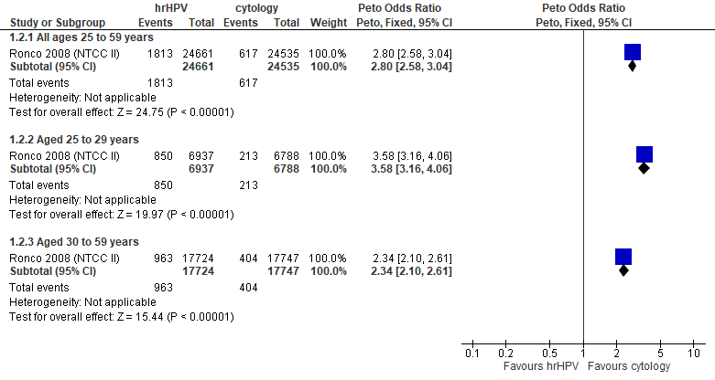
Forest plot 1.2. Number of colposcopies

Evidence Set 1.3. Number of biopsies
Included report: Ronco 2008 (NTCC Phase II)
GRADE Summary of Findings Table 1.3. Number of biopsies
Outcome  No. participants  (studies) |  | Relative effects, Peto OR and RR (95 % CI) | Anticipated absolute effects |  |  | Certainty of evidence (GRADE)^{b} | What happens?
 |  | Relative effects, Peto OR and RR (95 % CI) | With cytology screening | With hrHPV screening | Difference | Certainty of evidence (GRADE)^{b} | What happens?
People with a cervix aged 25 to 59 years (Ronco 2008 (NTCC Phase II); acceptors of screening)
Number of biopsies  Follow-up: 1 round  49,196 (1 RCT) | Peto OR: 2.34 (2.08 to 2.64)  RR: 2.30 (2.05 to 2.58) |  | 131.6 per 10,000 | 302.7 per 10,000 | 171.1 more per 10,000 (138.3 more to 208.6 more) | NA
People with a cervix aged 25 to 29 years (Ronco 2008 (NTCC Phase II); acceptors of screening)
Number of biopsies  Follow-up: 1 round  13,725 (1 RCT) | Peto OR: 3.09 (2.61 to 3.66)  RR: 2.97 (2.53 to 3.49) |  | 185.6 per 10,000 | 552.2 per 10,000 | 366.5 more per 10,000 (284.8 more to 461.8 more) | MODERATE^{c}  ⊕⊕⊕⊝  due to lack of evidence of consistency, and imprecision | Among people with a cervix aged 25 to 29 years, offering hrHPV testing probably increases the number of biopsies compared with offering cytology testing.
People with a cervix aged 30 to 59 years (Ronco 2008 (NTCC Phase II); acceptors of screening)
Number of biopsies  Follow-up: 1 round  35,471 (1 RCT) | Peto OR: 1.78 (1.50 to 2.10)  RR: 1.76 (1.49 to 2.07) |  | 111.0 per 10,000 | 195.9 per 10,000 | 84.9 more per 10,000 (54.6 more to 119.3 more) | 30-59 yrs:  MODERATE^{d}  ⊕⊕⊕⊝  due to lack of evidence of consistency  60-69 yrs:  VERY LOW  ⊕⊝⊝⊝  NR | Among people with a cervix aged 30 to 59 years, offering hrHPV testing probably has little-to-no effect on the number of biopsies compared with offering cytology testing.  Among people with a cervix aged 60 to 69 years, we are very uncertain about the effects of hrHPV testing on the number of biopsies compared with cytology testing.
CI = confidence interval; NA= not applicable (i.e., not used for conclusions); OR = odds ratio; RCT = randomized controlled trial; RR = relative risk.
ªAcceptors of screening include participants who accepted the offer to be screened and were randomized, including those who were screened in a group different to which they were randomly assigned (73/24,638 people with a cervix in the hrHPV screening group received via cytology screening) (akin to an intention-to-screen analysis).
^{b}We rated down by 0.5 for “some concerns”, 1 “serious concerns”, and 2 for “very serious concerns”. When our assessment of the certainty of evidence fell between levels, we assigned the level that best represented our actual certainty in the evidence, and based our conclusions on this level of certainty.
Explanations:
^{c}Acceptors of screening; people with a cervix aged 25 to 29 years: No serious concerns about risk of bias: no domains judged high risk. Some concerns about inconsistency: lack of evidence for consistency due to single study. No serious concerns about indirectness: 50% of each group were screened in the organized program in the previous 4 years. Some concerns about imprecision: lower limit of 95% CI indicates possibility of little-to-no effect. No other serious concerns.
^{d}Acceptors of screening; people with a cervix aged 30 to 59 years: No serious concerns about risk of bias: no domains judged high risk. Some concerns about inconsistency: lack of evidence for consistency due to single study. No serious concerns about indirectness: 50% of each group were screened in the organized program in the previous 4 years. No serious concerns about imprecision: 95% CI precise for little-to-no effect. No other serious concerns.

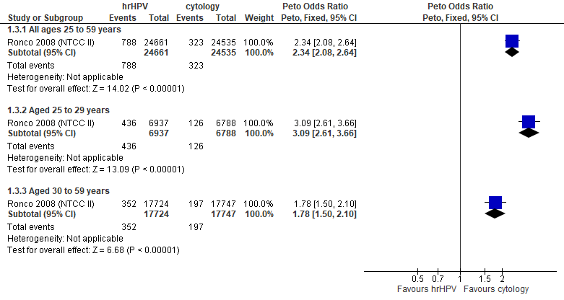
Forest plot 1.3. Number of biopsies

Evidence Set 1.4. Detection of CIN2+ (as an indirect indicator of the incidence of CIN3+)
Included report: Ronco 2008 (NTCC Phase II)
GRADE Summary of Findings Table 1.4. Detection of CIN2+ (as an indirect indicator of the incidence of CIN3+)
Outcome  No. participantsª  (studies) |  | Relative effects, Peto OR and RR (95 % CI) | Anticipated absolute effects |  |  | Certainty of evidence (GRADE)^{b} | What happens?
 |  | Relative effects, Peto OR and RR (95 % CI) | With cytology screening | With hrHPV screening | Difference | Certainty of evidence (GRADE)^{b} | What happens?
People with a cervix aged 25 to 59 years (Ronco 2008 (NTCC Phase II); acceptors of screening, select population)
Detection of CIN2+  Follow-up: 1 round  49,005 (1 RCT) | Peto OR: 2.35 (1.77 to 3.12)  RR: 2.34 (1.77 to 3.11) |  | 22.5 per 10,000 | 52.7 per 10,000 | 30.2 more per 10,000 (17.2 more to 47.3 more) | 25-29 years:  LOW^{c}  ⊕⊕⊝⊝  due to lack of evidence of consistency and indirectness  30-59 years:  LOW^{d}  ⊕⊕⊝⊝  due to lack of evidence of consistency and indirectness  60-69 yrs:  VERY LOW  ⊕⊝⊝⊝  NR | Among people with a cervix aged 25 to 59 years, hrHPV testing may have little-to-no effect on the incidence of CIN3+ compared with cytology testing.  Among people with a cervix aged 60 to 69 years, we are very uncertain about the effects of hrHPV testing on the incidence of CIN3+ compared with cytology testing.
>Subgroup: people with a cervix aged 25 to 29 years (Ronco 2008 (NTCC Phase II); acceptors of screening, select population)
Detection of CIN2+  Follow-up: 1 round  13,635 (1 RCT) | Peto OR: 3.05 (2.00 to 4.65)  RR: 3.03 (1.99 to 4.60) |  | 28.1 per 10,000 | 85.3 per 10,000 | 57.2 more per 10,000 (28.0 more to 101.3 more) | NA
>Subgroup: people with a cervix aged 30 to 59 years (Ronco 2008 (NTCC Phase II); acceptors of screening, select population)
Detection of CIN2+  Follow-up: 1 round  35,370 (1 RCT) | Peto OR: 1.88 (1.28 to 2.76)  RR: 1.88 (1.28 to 2.75) |  | 20.3 per 10,000 | 38.1 per 10,000 | 17.8 more per 10,000 (5.7 more to 35.6 more) | NA
CI = confidence interval; CIN = cervical intraepithelial neoplasia; NA= not applicable (i.e., not used for conclusions); OR = odds ratio; RCT = randomized controlled trial; RR = relative risk.
ªAcceptors of screening, select population includes all participants randomized and offered screening who attended colposcopy following a positive screening test (akin to a modified intention-to-screen analysis).
^{b}We rated down by 0.5 for “some concerns”, 1 “serious concerns”, and 2 for “very serious concerns”. When our assessment of the certainty of evidence fell between levels, we assigned the level that best represented our actual certainty in the evidence, and based our conclusions on this level of certainty.
Explanations:
^{c}Acceptors of screening, select population; people with a cervix aged 25 to 29 years: No serious concerns about risk of bias: no domains judged high risk. Some concerns about inconsistency: lack of evidence for consistency due to single study. Serious concerns about indirectness: detection is an indirect indicator of incidence. No serious concerns about imprecision: 95% CI precise for little-to-no effect. No other serious concerns.
^{d}Acceptors of screening, select population; people with a cervix aged 30 to 59 years: No serious concerns about risk of bias: no domains judged high risk. Some concerns about inconsistency: lack of evidence for consistency due to single study. Serious concerns about indirectness: detection is an indirect indicator of incidence. No serious concerns about imprecision: 95% CI precise for little-to-no effect. No other serious concerns.

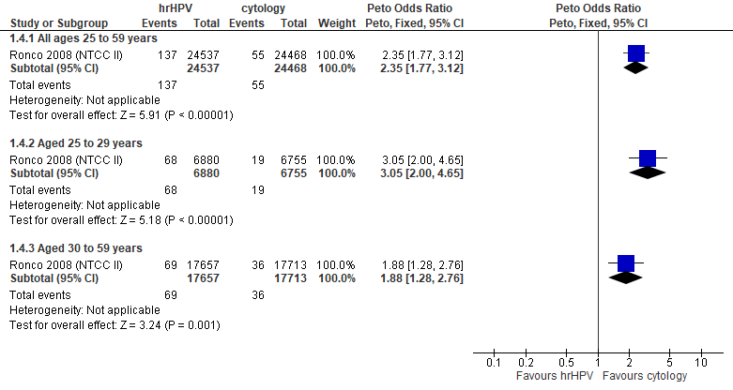
Forest Plot 1.4. Detection of CIN2+ (as an indirect indicator of the incidence of CIN3+)

Evidence Set 1.5. Detection of CIN3+ (as an indirect indicator of the incidence of ICC)
Included report: Ronco 2008 (NTCC Phase II)
GRADE Summary of Findings Table 1.5. Detection of CIN3+ (as an indirect indicator of the incidence of ICC)
Outcome  No. participantsª  (studies) |  | Relative effects, Peto OR and RR (95 % CI) | Anticipated absolute effects |  |  | Certainty of evidence (GRADE)^{b} | What happens?
 |  | Relative effects, Peto OR and RR (95 % CI) | With cytology screening | With hrHPV screening | Difference | Certainty of evidence (GRADE)^{b} | What happens?
People with a cervix aged 25 to 59 years (Ronco 2008 (NTCC Phase II); acceptors of screening, select population)
Detection of CIN3+  Follow-up: 1 round  49,005 (1 RCT) | Peto OR: 2.17 (1.42 to 3.32)  RR: 2.17 (1.42 to 3.31) |  | 10.6 per 10,000 | 23.0 per 10,000 | 12.4 more per 10,000 (4.5 more to 24.6 more) | NA
>Subgroup: people with a cervix aged 25 to 29 years (Ronco 2008 (NTCC Phase II); acceptors of screening, select population)
Detection of CIN3+  Follow-up: 1 round  13,635 (1 RCT) | Peto OR: 2.44 (1.23 to 4.84)  RR: 2.44 (1.23 to 4.82) |  | 13.3 per 10,000 | 32.4 per 10,000 | 19.1 more per 10,000 (3.1 more to 50.8 more) | VERY LOW^{c}  ⊕⊝⊝⊝  due to lack of evidence of consistency, indirectness, and imprecision | Among people with a cervix aged 25 to 29 years, we are very uncertain about the effect of hrHPV testing on the incidence of invasive cervical cancer compared with cytology testing.
>Subgroup: people with a cervix aged 30 to 59 years (Ronco 2008 (NTCC Phase II); acceptors of screening, select population)
Detection of CIN3+  Follow-up: 1 round  35,370 (1 RCT) | Peto OR: 2.01 (1.16 to 3.46)  RR: 2.01 (1.16 to 3.45) |  | 9.6 per 10,000 | 19.3 per 10,000 | 9.7 more per 10,000 (1.5 more to 23.5 more) | 30-59 yrs:  VERY LOW^{d}  ⊕⊝⊝⊝  due to lack of evidence of consistency, indirectness, and imprecision  60-69 yrs:  VERY LOW  ⊕⊝⊝⊝  NR | Among people with a cervix aged 30 to 69 years, we are very uncertain about the effect of hrHPV testing on the incidence of invasive cervical cancer compared with cytology testing.
CI = confidence interval; CIN = cervical intraepithelial neoplasia; NA= not applicable (i.e., not used for conclusions); OR = odds ratio; RCT = randomized controlled trial; RR = relative risk.
ªAcceptors of screening, select population includes all participants randomized and offered screening who attended colposcopy following a positive screening test (akin to a modified intention-to-screen analysis).
^{b}We rated down by 0.5 for “some concerns”, 1 “serious concerns”, and 2 for “very serious concerns”. When our assessment of the certainty of evidence fell between levels, we assigned the level that best represented our actual certainty in the evidence, and based our conclusions on this level of certainty.
Explanations:
^{c}Acceptors of screening, select population; people with a cervix aged 25 to 29 years: No serious concerns about risk of bias: no domains judged high risk. Some concerns about inconsistency: lack of evidence for consistency due to single study. Serious concerns about indirectness: detection is an indirect indicator of incidence. Serious concerns about imprecision: lower limit of 95% CI indicates little-to-no effect. No other serious concerns.
^{d}Acceptors of screening, select population; people with a cervix aged 30 to 59 years: No serious concerns about risk of bias: no domains judged high risk. Some concerns about inconsistency: lack of evidence for consistency due to single study. Serious concerns about indirectness: detection is an indirect indicator of incidence. Serious concerns about imprecision: upper limit of 95% CI indicates increased effect. No other serious concerns.

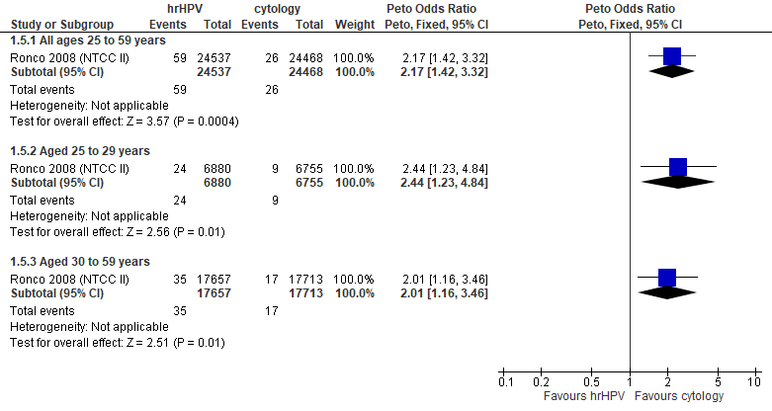
Forest Plot 1.5. Detection of CIN3+ (as an indirect indicator of the incidence of ICC)

Evidence Set 1.6. Incidence of CIN2
Included report: Ronco 2010 (NTCC Phase II)
GRADE Summary of Findings Table 1.6. Incidence of CIN2
Outcome  No. participantsª  (studies) |  | Relative effects, Peto OR and RR (95 % CI) | Anticipated absolute effects |  |  | Certainty of evidence (GRADE)^{b} | What happens?
 |  | Relative effects, Peto OR and RR (95 % CI) | With cytology screening | With hrHPV screening | Difference | Certainty of evidence (GRADE)^{b} | What happens?
People with a cervix aged 25 to 59 years (Ronco 2010 (NTCC Phase II); acceptors of screening, round 2)
Incidence of CIN2  Follow-up: 3.5 years  48,350 (1 RCT) | Peto OR: 0.49 (0.21 to 1.13)  RR: 0.49 (0.21 to 1.13) |  | 6.2 per 10,000 | 3.0 per 10,000 | 3.1 less per 10,000 (4.9 less to 0.8 more) | 25-29 yrs:  LOW^{c}  ⊕⊕⊝⊝  due to risk of bias, and lack of evidence of consistency  30-59 yrs:  LOW^{d}  ⊕⊕⊝⊝  due to risk of bias, and lack of evidence of consistency  60-69 yrs:  VERY LOW  ⊕⊝⊝⊝  NR | Among people with a cervix aged 25 to 59 years, hrHPV testing may have little-to-no effect on the incidence of CIN2 at the second round of screening (within 3.5 years) compared with cytology testing.  Among people with a cervix aged 60 to 69 years, we are very uncertain about the effect of hrHPV testing on the incidence of CIN2 at the second round of screening (within 3.5 years) compared with cytology testing.
>Subgroup: people with a cervix aged 25 to 29 years (Ronco 2010 (NTCC Phase II); acceptors of screening, round 2)
Incidence of CIN2  Follow-up: 3.5 years  13,291 (1 RCT) | Peto OR: 0.64 (0.22 to 1.91)  RR: 0.64 (0.22 to 1.91) |  | 11.9 per 10,000 | 7.6 per 10,000 | 4.3 less per 10,000 (9.3 less to 10.8 more) | NA
>Subgroup: people with a cervix aged 30 to 59 years (Ronco 2010 (NTCC Phase II); acceptors of screening, round 2)
Incidence of CIN2  Follow-up: 3.5 years  35,059 (1 RCT) | Peto OR: 0.33 (0.09 to 1.23)  RR: 0.33 (0.09 to 1.23) |  | 4.0 per 10,000 | 1.3 per 10,000 | 2.7 less per 10,000 (3.6 less to 0.9 more) | NA
CI = confidence interval; CIN = cervical intraepithelial neoplasia; NA= not applicable (i.e., not used for conclusions); OR = odds ratio; RCT = randomized controlled trial; RR = relative risk.
ªAcceptors of screening, round 2 includes histological diagnoses for all people randomized and invited to the second screening round (akin to an intention-to-screen analysis). Excluded are people with prevalent CIN or invasive cervical cancer as identified in the first round. Histological diagnoses for tests done outside of the trial were collected via database linkage. At the second round all participants were offered conventional cytology with histological confirmation of abnormal results.
^{b}We rated down by 0.5 for “some concerns”, 1 “serious concerns”, and 2 for “very serious concerns”. When our assessment of the certainty of evidence fell between levels, we assigned the level that best represented our actual certainty in the evidence, and based our conclusions on this level of certainty.
Explanations:
^{c}Acceptors of screening, round 2; people with a cervix aged 25 to 29 years: Serious concerns about risk of bias: nearly 30% of participants screened at baseline in each group did not receive a second screening within 3.5 years (second round), within or outside of the trial. Reasons for non-attendance are not specified. Some concerns about inconsistency: lack of evidence for consistency due to single study. No serious concerns about indirectness: the study provides direct evidence. No serious concerns about imprecision: 95% CI precise for little-to-no effect. No other serious concerns.
^{d}Acceptors of screening, round 2; people with a cervix aged 30 to 59 years: Serious concerns about risk of bias: nearly 30% of participants screened at baseline in each group did not receive a second screening within 3.5 years (second round), within or outside of the trial. Reasons for non-attendance are not specified. Some concerns about inconsistency: lack of evidence for consistency due to single study. No serious concerns about indirectness: the study provides direct evidence. No serious concerns about imprecision: 95% CI precise for little-to-no effect. No other serious concerns.

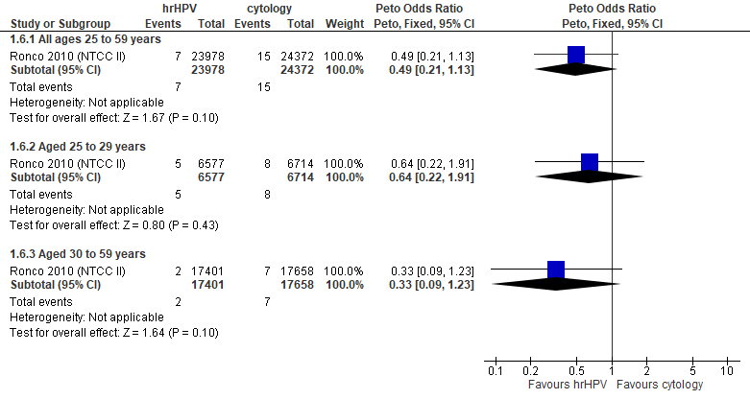
Forest plot 1.6. Incidence of CIN2

Evidence Set 1.7. Incidence of CIN3 or AIS
Included report: Ronco 2010 (NCTT Phase II)
GRADE Summary of Findings Table 1.7. Incidence of CIN3 or AIS
Outcome  No. participantsª  (studies) |  | Relative effects, Peto OR and RR (95 % CI) | Anticipated absolute effects |  |  | Certainty of evidence (GRADE)^{b} | What happens?
 |  | Relative effects, Peto OR and RR (95 % CI) | With cytology screening | With hrHPV screening | Difference | Certainty of evidence (GRADE)^{b} | What happens?
People with a cervix aged 25 to 59 years (Ronco 2010 (NTCC Phase II); acceptors of screening, round 2)
Incidence of CIN3 or AIS  Follow-up: 3.5 years  48,350 (1 RCT) | Peto OR: 0.31 (0.14 to 0.67)  RR: 0.31 (0.14 to 0.67) |  | 8.2 per 10,000 | 2.5 per 10,000 | 5.7 less per 10,000 (7.1 less to 2.7 less) | NA
>Subgroup: people with a cervix aged 25 to 29 years (Ronco 2010 (NTCC Phase II); acceptors of screening, round 2)
Incidence of CIN3 or AIS  Follow-up: 3.5 years  13,291 (1 RCT) | Peto OR: 0.27 (0.09 to 0.83)  RR: 0.27 (0.09 to 0.83) |  | 14.9 per 10,000 | 4.0 per 10,000 | 10.9 less per 10,000 (13.6 less to 2.5 less) | VERY LOW^{c}  ⊕⊝⊝⊝  due to risk of bias, lack of evidence of consistency, indirectness and imprecision | Among people with a cervix aged 25 to 29 years, we are very uncertain about the effect of offering hrHPV testing on the incidence of CIN3 or AIS within 3.5 years compared with offering cytology testing.
>Subgroup: people with a cervix aged 30 to 59 years (Ronco 2010 (NTCC Phase II); acceptors of screening, round 2)
Incidence of CIN3 or AIS  Follow-up: 3.5 years  35,059 (1 RCT) | Peto OR: 0.35 (0.12 to 1.03)  RR: 0.35 (0.12 to 1.03) |  | 5.7 per 10,000 | 2.0 per 10,000 | 3.7 less per 10,000 (5.0 less to 0.2 more) | 30-59 yrs:  VERY LOW^{d}  ⊕⊝⊝⊝  due to risk of bias, lack of evidence of consistency, and indirectness  60-69 yrs:  VERY LOW  ⊕⊝⊝⊝  NR | Among people with a cervix aged 30 to 69 years, we are very uncertain about the effect of hrHPV testing compared with cytology testing on the incidence of CIN3 or AIS.
AIS = adenocarcinoma in situ; CI = confidence interval; CIN = cervical intraepithelial neoplasia; NA= not applicable (i.e., not used for conclusions); OR = odds ratio; RCT = randomized controlled trial; RR = relative risk.
ªAcceptors of screening, round 2 includes histological diagnoses for all people randomized and invited to the second screening round (akin to an intention-to-screen analysis). Excluded are people with prevalent CIN or invasive cervical cancer as identified in the first round. Histological diagnoses for tests done outside of the trial were collected via database linkage. At the second round all participants were offered conventional cytology with histological confirmation of abnormal results.
^{b}We rated down by 0.5 for “some concerns”, 1 “serious concerns”, and 2 for “very serious concerns”. When our assessment of the certainty of evidence fell between levels, we assigned the level that best represented our actual certainty in the evidence, and based our conclusions on this level of certainty.
Explanations:
^{c}Acceptors of screening, round 2; people with a cervix aged 25 to 29 years: Serious concerns about risk of bias: nearly 30% of participants screened at baseline in each group did not receive a second screening within 3.5 years (second round), within or outside of the trial. Reasons for non-attendance are not specified. Some concerns about inconsistency: lack of evidence for consistency due to single study. Serious concerns about indirectness: The outcome is considered indirect because there are concerns that the cancer registry used for CIN3 incidence is incomplete. Serious concerns about imprecision: upper limit of 95% CI indicates little-to-no effect. No other serious concerns.
^{d}Acceptors of screening, round 2; people with a cervix aged 30 to 59 years: Serious concerns about risk of bias: nearly 30% of participants screened at baseline in each group did not receive a second screening within 3.5 years (second round), within or outside of the trial. Reasons for non-attendance are not specified. Some concerns about inconsistency: lack of evidence for consistency due to single study. Serious concerns about indirectness: The outcome is considered indirect because there are concerns that the cancer registry used for CIN3 incidence is incomplete. No serious concerns about imprecision: 95% CI precise for little-to-no effect. No other serious concerns.

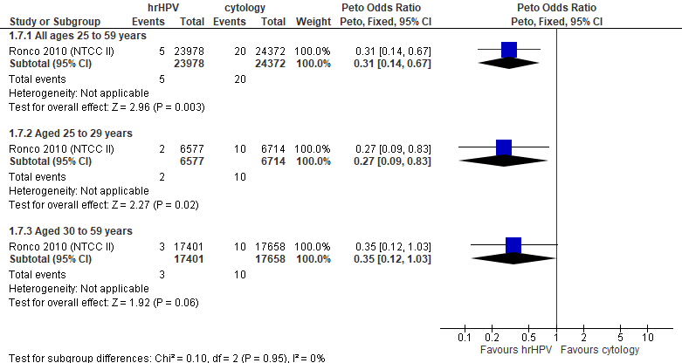
Forest Plot 1.7. Incidence of CIN3 or AIS

Evidence Set 1.8. False positives for CIN2+
Included report: Ronco 2008 (NTCC Phase II)
GRADE Summary of Findings Table 1.8. False positives for CIN2+
Outcome  No. participantsª  (studies) |  | Relative effects, Peto OR and RR (95 % CI) | Anticipated absolute effects |  |  | Certainty of evidence (GRADE)^{b} | What happens?
 |  | Relative effects, Peto OR and RR (95 % CI) | With cytology screening | With hrHPV screening | Difference | Certainty of evidence (GRADE)^{b} | What happens?
People with a cervix aged 25 to 59 years (Ronco 2008 (NTCC Phase II); acceptors of screening, select population)
False positives for CIN2+  Follow-up: 1 round  49,005 (1 RCT) | Peto OR: 2.83 (2.60 to 3.08)  RR: 2.72 (2.51 to 2.94) |  | 229.7 per 10,000 | 623.8 per 10,000 | 394.1 more per 10,000 (346.3 more to 445.5 more) | NA
>Subgroup: people with a cervix aged 25 to 29 years (Ronco 2008 (NTCC Phase II); acceptors of screening, select population)
False positives for CIN2+  Follow-up: 1 round  13,635 (1 RCT) | Peto OR: 3.59 (3.15 to 4.09)  RR: 3.34 (2.97 to 3.76) |  | 287.2 per 10,000 | 959.6 per 10,000 | 672.5 more per 10,000 (564.9 more to 791.7 more) | MODERATE^{c}  ⊕⊕⊕⊝  due to lack of evidence of consistency | Among people with a cervix aged 25 to 29 years, hrHPV testing probably increases the number of false positives for CIN2+ compared with cytology testing.
>Subgroup: people with a cervix aged 30 to 59 years (Ronco 2008 (NTCC Phase II); acceptors of screening, select population)
False positives for CIN2+  Follow-up: 1 round  35,370 (1 RCT) | Peto OR: 2.38 (2.13 to 2.66)  RR: 2.31 (2.08 to 2.57) |  | 207.8 per 10,000 | 480.7 per 10,000 | 272.9 more per 10,000 (224.6 more to 326.5 more) | 30-59 yrs:  LOW^{d}  ⊕⊕⊝⊝  due to lack of evidence of consistency, and imprecision  60-69 yrs:  VERY LOW  ⊕⊝⊝⊝  NR | Among people with a cervix aged 30 to 59 years, hrHPV testing may have little-to-no effect on the number of false positives for CIN2+ compared with cytology testing.  Among people with a cervix aged 60 to 69 years, we are very uncertain about the effects of hrHPV testing on the number of false positives for CIN2+ compared with cytology testing.
CI = confidence interval; CIN = cervical intraepithelial neoplasia; NA= not applicable (i.e., not used for conclusions); OR = odds ratio; RCT = randomized controlled trial; RR = relative risk.
ªAcceptors of screening, select population includes all participants randomized and offered screening who attended colposcopy following a positive screening test (akin to a modified intention-to-screen analysis).
^{b}We rated down by 0.5 for “some concerns”, 1 “serious concerns”, and 2 for “very serious concerns”. When our assessment of the certainty of evidence fell between levels, we assigned the level that best represented our actual certainty in the evidence, and based our conclusions on this level of certainty.
Explanations:
^{c}Acceptors of screening; people with a cervix aged 25 to 29 years: No serious concerns about risk of bias: no domains judged high risk. Some concerns about inconsistency: lack of evidence for consistency due to single study. No serious concerns about indirectness: the study provides direct evidence. No serious concerns about imprecision: 95% CI precise for increased effect. No other serious concerns.
^{d}Acceptors of screening, select population; people with a cervix aged 30 to 59 years: No serious concerns about risk of bias: no domains judged high risk. Some concerns about inconsistency: lack of evidence for consistency due to single study. No serious concerns about indirectness: the study provides direct evidence. Serious concerns about imprecision: upper limit of 95% CI indicates increased effect. No other serious concerns.

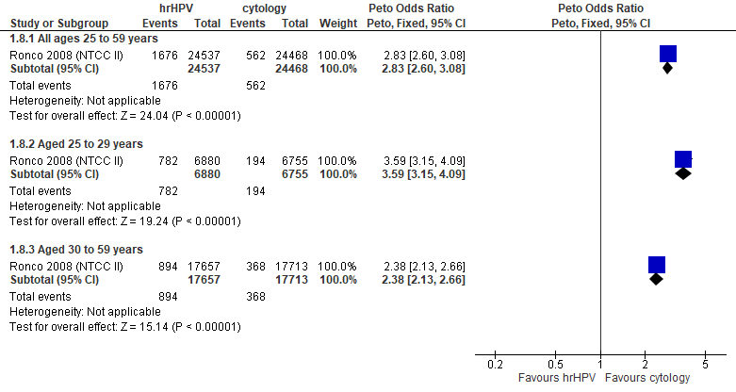
Forest Plot 1.8. False positives for CIN2+

Evidence Set 1.9. False positives for CIN3+
Included report: Ronco 2008 (NTCC Phase II)
GRADE Summary of Findings Table 1.9. False positives for CIN3+
Outcome  No. participantsª  (studies) |  | Relative effects, Peto OR and RR (95 % CI) | Anticipated absolute effects |  |  | Certainty of evidence (GRADE)^{b} | What happens?
 |  | Relative effects, Peto OR and RR (95 % CI) | With cytology screening | With hrHPV screening | Difference | Certainty of evidence (GRADE)^{b} | What happens?
People with a cervix aged 25 to 59 years (Ronco 2008 (NTCC Phase II); acceptors of screening, select population)
False positives for CIN3+  Follow-up: 1 round  49,005 (1 RCT) | Peto OR: 2.83 (2.60 to 3.07)  RR: 2.71 (2.50 to 2.92) |  | 241.5 per 10,000 | 654.6 per 10,000 | 413.1 more per 10,000 (363.1 more to 464.7 more) | NA
>Subgroup: people with a cervix aged 25 to 29 years (Ronco 2008 (NTCC Phase II); acceptors of screening, select population)
False positives for CIN3+  Follow-up: 1 round  13,635 (1 RCT) | Peto OR: 3.62 (3.19 to 4.11)  RR: 3.35 (2.99 to 3.76) |  | 302.0 per 10,000 | 1013.1 per 10,000 | 711.1 more per 10,000 (601.6 more to 832.6 more) | MODERATE^{c}  ⊕⊕⊕⊝  due to lack of evidence of consistency | Among people with a cervix aged 25 to 29 years, hrHPV testing probably increases the number of false positives for CIN3+ compared with cytology testing.
>Subgroup: people with a cervix aged 30 to 59 years (Ronco 2008 (NTCC Phase II); acceptors of screening, select population)
False positives for CIN3+  Follow-up: 1 round  35,370 (1 RCT) | Peto OR: 2.36 (2.11 to 2.63)  RR: 2.29 (2.06 to 2.54) |  | 218.5 per 10,000 | 500.7 per 10,000 | 282.3 more per 10,000 (231.6 more to 336.4 more) | 30-59 yrs:  LOW^{d}  ⊕⊕⊝⊝  due to lack of evidence of consistency, and imprecision  60-69 yrs:  VERY LOW  ⊕⊝⊝⊝  NR | Among people with a cervix aged 30 to 59 years, hrHPV testing may have little-to-no effect on the number of false positives for CIN3+ compared with cytology testing.  Among people with a cervix aged 60 to 69 years, we are very uncertain about the effects of hrHPV testing on the number of false positives for CIN3+ compared with cytology testing.
CI = confidence interval; CIN = cervical intraepithelial neoplasia; NA= not applicable (i.e., not used for conclusions); OR = odds ratio; RCT = randomized controlled trial; RR = relative risk.
ªAcceptors of screening, select population includes all participants randomized and offered screening who attended colposcopy following a positive screening test (akin to a modified intention-to-screen analysis).
^{b}We rated down by 0.5 for “some concerns”, 1 “serious concerns”, and 2 for “very serious concerns”. When our assessment of the certainty of evidence fell between levels, we assigned the level that best represented our actual certainty in the evidence, and based our conclusions on this level of certainty.
Explanations:
^{c}Acceptors of screening; people with a cervix aged 25 to 29 years: No serious concerns about risk of bias: no domains judged high risk. Some concerns about inconsistency: lack of evidence for consistency due to single study. No serious concerns about indirectness: the study provides direct evidence. No serious concerns about imprecision: 95% CI precise for increased effect. No other serious concerns.
^{d}Acceptors of screening, select population; people with a cervix aged 30 to 59 years: No serious concerns about risk of bias: no domains judged high risk. Some concerns about inconsistency: lack of evidence for consistency due to single study. No serious concerns about indirectness: the study provides direct evidence. Serious concerns about imprecision: upper limit of 95% CI indicates increased effect. No other serious concerns.

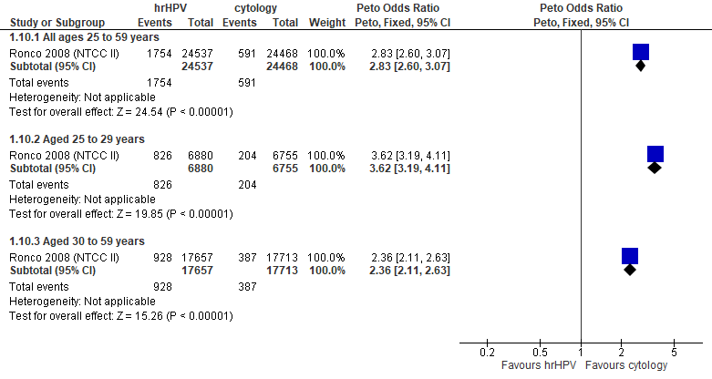
Forest Plot 1.9. False positives for CIN3+

Evidence set 2.0a: hrHPV screening (threshold 1.0 RLU) with conventional cytology triage of positive tests vs. conventional cytology testing (threshold ≥Papanicolaou class III, or ≥LSIL); without recall

Included report: Leinonen 2012 (Finnish)(ages 25-65 [subgroups 25-34 and 35-65 years]); Nygard 2022 (Norwegian)(ages 34-69 [subgroups 34-59 and 60-69 years])

Evidence Set 2.1a. Referrals to colposcopy
GRADE Summary of Findings Table 2.1a. Referrals to colposcopy
Outcome  No. participantsª  (studies) |  | Relative effects, Peto OR and RR (95 % CI) | Anticipated absolute effects |  |  | Certainty of evidence (GRADE)^{b} | What happens?
 |  | Relative effects, Peto OR and RR (95 % CI) | With cytology screening | With hrHPV screening + cytology triage | Difference | Certainty of evidence (GRADE)^{b} | What happens?
People with a cervix aged 25 to 69 years (Leinonen 2012 (Finnish); Nygard 2022 (Norwegian); acceptors of screening)
Referrals to colposcopy  Follow-up: at baseline  289,641 (2 RCTs) | Peto OR: 1.61 (1.52 to 1.71)  RR: 1.60 (1.51 to 1.70) |  | 114.9 per 10,000 | 183.7 per 10,000 | 68.8 more per 10,000 (58.7 more to 80.0 more) | 25-29 yrs:  MODERATE^{c}  ⊕⊕⊕⊝  due to risk of bias  30-59 yrs:  MODERATE^{d}  ⊕⊕⊕⊝  due to risk of bias  60-69 yrs:  MODERATE^{e}  ⊕⊕⊕⊝  due to risk of bias | Among screened people with a cervix aged 25 to 69 years, offering hrHPV testing with cytology triage probably has little-to-no effect on the rate of referral to colposcopy compared with cytology testing.
>Subgroup: people with a cervix aged 25 to 29 years (Leinonen 2012 (Finnish); acceptors of screening)
Referrals to colposcopy  Follow-up: at baseline  22,262 (1 RCT) | Peto OR: 1.37 (1.14 to 1.63)  RR: 1.36 (1.14 to 1.61) |  | 190.6 per 10,000 | 259.3 per 10,000 | 68.7 more per 10,000 (26.1 more to 116.4 more) | NA
>Subgroup: people with a cervix aged 30 to 59 years (Leinonen 2012 (Finnish); Nygard 2022 (Norwegian); acceptors of screening)
Referrals to colposcopy  Follow-up: at baseline  233,905 (2 RCTs) | Peto OR: 1.62 (1.51 to 1.73)  RR: 1.61 (1.50 to 1.72) |  | 118.0 per 10,000 | 189.8 per 10,000 | 71.8 more per 10,000 (59.1 more to 84.4 more) | NA
>Subgroup: people with a cervix aged 60 to 69 years (Nygard 2022 (Norwegian); acceptors of screening)
Referrals to colposcopy  Follow-up: at baseline  33,474 (1 RCT) | Peto OR: 2.18 (1.69 to 2.81)  RR: 2.17 (1.68 to 2.79) |  | 44.8 per 10,000 | 97.1 per 10,000 | 52.3 more per 10,000 (30.7 more to 80.0 more) | NA
CI = confidence interval; NA= not applicable (i.e., not used for conclusions); OR = odds ratio; RCT = randomized controlled trial; RR = relative risk.
ªAcceptors of screening include participants who were randomized and accepted the offer to be screened.
^{b}We rated down by 0.5 for “some concerns”, 1 “serious concerns”, and 2 for “very serious concerns”. When our assessment of the certainty of evidence fell between levels, we assigned the level that best represented our actual certainty in the evidence, and based our conclusions on this level of certainty.
Explanations:
^{c}Acceptors of screening; people with a cervix aged 25 to 29 years: Some concerns about risk of bias: one study at risk of selection bias because randomization occurred before enrollment, without adequate information about baseline characteristics across groups, but absolute effects similar between studies. No serious concerns about inconsistency: evidence of consistency. No serious concerns about indirectness: the study provides direct evidence. No serious concerns about imprecision: 95% CI precise for little-to-no effect. No other serious concerns.
^{d}Acceptors of screening; people with a cervix aged 30 to 59 years: Some concerns about risk of bias: one study at risk of selection bias because randomization occurred before enrollment, without adequate information about baseline characteristics across groups, but absolute effects similar between studies. No serious concerns about inconsistency: evidence of consistency. No serious concerns about indirectness: the study provides direct evidence. No serious concerns about imprecision: 95% CI precise for little-to-no effect. No other serious concerns.
^{e}Acceptors of screening; people with a cervix aged 60 to 69 years: Some concerns about risk of bias: one study at risk of selection bias because randomization occurred before enrollment, without adequate information about baseline characteristics across groups, but absolute effects similar between studies. No serious concerns about inconsistency: evidence of consistency. No serious concerns about indirectness: the study provides direct evidence. No serious concerns about imprecision: 95% CI precise for little-to-no effect. No other serious concerns.

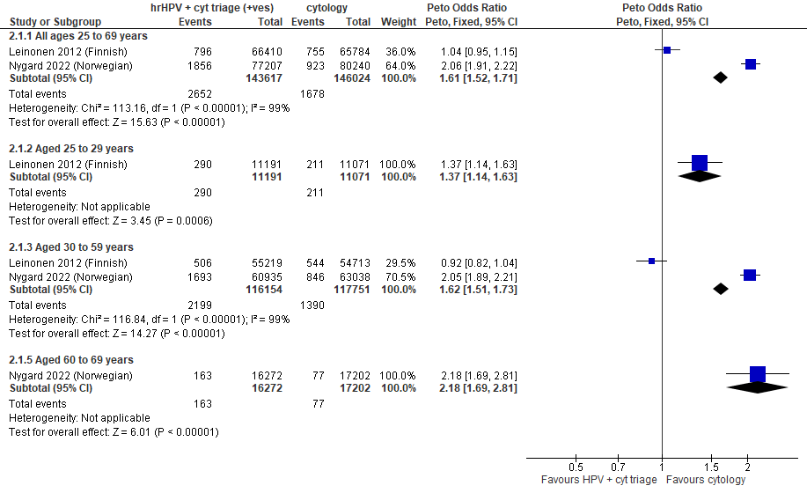
Forest Plot 2.1a. Referrals to colposcopy

Evidence Set 2.2a. Detection of CIN2+ (as an indirect indicator of the incidence of CIN3+)
Included report: Leinonen 2012 (Finnish); Nygard 2022 (Norwegian)
GRADE Summary of Findings Table 2.2a. Detection of CIN2+ (as an indirect indicator of the incidence of CIN3+)
Outcome  No. participantsª  (studies) |  | Relative effects, Peto OR and RR (95 % CI) | Anticipated absolute effects |  |  | Certainty of evidence (GRADE)^{b} | What happens?
 |  | Relative effects, Peto OR and RR (95 % CI) | With cytology screening | With hrHPV screening + cytology triage | Difference | Certainty of evidence (GRADE)^{b} | What happens?
People with a cervix aged 25 to 69 years (Leinonen 2012 (Finnish); Nygard 2022 (Norwegian); acceptors of screening)
Detection of CIN2+  Follow-up: at baseline  289,641 (2 RCT) | Peto OR: 1.74 (1.59 to 1.90)  RR: 1.73 (1.59 to 1.89) |  | 49.7 per 10,000 | 86.2 per 10,000 | 36.5 more per 10,000 (29.1 more to 44.3 more) | 25-29 yrs:  LOW^{c}  ⊕⊕⊝⊝  due to risk of bias, and indirectness  30-59 yrs:  LOW^{d}  ⊕⊕⊝⊝  due to risk of bias, and indirectness  60-69 yrs:  LOW^{e}  ⊕⊕⊝⊝  due to risk of bias, and indirectness | Among screened people with a cervix aged 25 to 69 years, hrHPV testing with cytology triage may have little-to-no effect on the incidence of CIN3+ compared with cytology testing.
>Subgroup: people with a cervix aged 25 to 29 years (Leinonen 2012 (Finnish); acceptors of screening)
Detection of CIN2+  Follow-up: at baseline  22,262 (1 RCT) | Peto OR: 1.52 (1.15 to 2.00)  RR: 1.51 (1.15 to 1.99) |  | 72.3 per 10,000 | 109.4 per 10,000 | 37.2 more per 10,000 (10.7 more to 71.2 more) | NA
>Subgroup: people with a cervix aged 30 to 59 years (Leinonen 2012 (Finnish); Nygard 2022 (Norwegian); acceptors of screening)
Detection of CIN2+  Follow-up: at baseline  233,905 (2 RCT) | Peto OR: 1.73 (1.58 to 1.91)  RR: 1.72 (1.58 to 1.90) |  | 52.9 per 10,000 | 91.2 per 10,000 | 38.3 more per 10,000 (30.4 more to 47.7 more) | NA
>Subgroup: people with a cervix aged 60 to 69 years (Nygard 2022 (Norwegian); acceptors of screening)
Detection of CIN2+  Follow-up: at baseline  33,474 (1 RCT) | Peto OR: 2.52 (1.63 to 3.89)  RR: 2.51 (1.63 to 3.88) |  | 13.4 per 10,000 | 35.6 per 10,000 | 20.3 more per 10,000 (8.4 more to 38.4 more) | NA
CI = confidence interval; CIN = cervical intraepithelial neoplasia; NA= not applicable (i.e., not used for conclusions); OR = odds ratio; RCT = randomized controlled trial; RR = relative risk.
ªAcceptors of screening include participants who were randomized and accepted the offer to be screened. Detection was calculated based on the number of cases identified based on a positive result at the index screen.
^{b}We rated down by 0.5 for “some concerns”, 1 “serious concerns”, and 2 for “very serious concerns”. When our assessment of the certainty of evidence fell between levels, we assigned the level that best represented our actual certainty in the evidence, and based our conclusions on this level of certainty.
Explanations:
^{c}Acceptors of screening; people with a cervix aged 25 to 29 years: Some concerns about risk of bias: one study at risk of selection bias because randomization occurred before enrollment, without adequate information about baseline characteristics across groups, but absolute effects similar between studies. No serious concerns about inconsistency: evidence of consistency. Serious concerns about indirectness: detection is an indirect outcome for incidence. No serious concerns about imprecision: 95% CI precise for little-to-no effect. No other serious concerns.
^{d}Acceptors of screening; people with a cervix aged 30 to 59 years: Some concerns about risk of bias: one study at risk of selection bias because randomization occurred before enrollment, without adequate information about baseline characteristics across groups, but absolute effects similar between studies. No serious concerns about inconsistency: evidence of consistency. Serious concerns about indirectness: detection is an indirect outcome for incidence. No serious concerns about imprecision: 95% CI precise for little-to-no effect. No other serious concerns.
^{e}Acceptors of screening; people with a cervix aged 60 to 69 years: Some concerns about risk of bias: one study at risk of selection bias because randomization occurred before enrollment, without adequate information about baseline characteristics across groups, but absolute effects similar between studies. No serious concerns about inconsistency: evidence of consistency. Serious concerns about indirectness: detection is an indirect outcome for incidence. No serious concerns about imprecision: 95% CI precise for little-to-no effect. No other serious concerns.

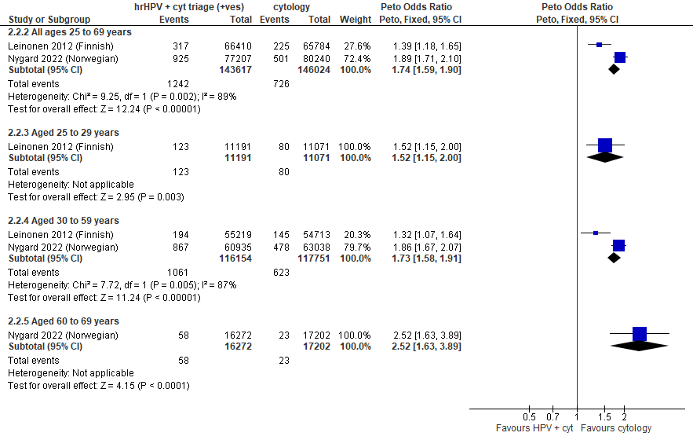
Forest plot 2.2a. Detection of CIN2+ (as an indirect indicator of the incidence of CIN3+)

Evidence Set 2.3a. Detection of CIN3+ (as an indirect indicator of the incidence of ICC)
Included report: Leinonen 2012 (Finnish); Nygard 2022 (Norwegian)
GRADE Summary of Findings Table 2.3a. Detection of CIN3+ (as an indirect indicator of the incidence of ICC)
Outcome  No. participantsª  (studies) |  | Relative effects, Peto OR and RR (95 % CI) | Anticipated absolute effects |  |  | Certainty of evidence (GRADE)^{b} | What happens?
 |  | Relative effects, Peto OR and RR (95 % CI) | With cytology screening | With hrHPV screening + cytology triage | Difference | Certainty of evidence (GRADE)^{b} | What happens?
People with a cervix aged 25 to 69 years (Leinonen 2012 (Finnish); Nygard 2022 (Norwegian); acceptors of screening)
Detection of CIN3+  Follow-up: at baseline  289,641 (2 RCTs) | Peto OR: 1.65 (1.49 to 1.83)  RR: 1.65 (1.49 to 1.82) |  | 37.4 per 10,000 | 61.5 per 10,000 | 24.2 more per 10,000 (18.2 more to 30.8 more) | 25-29 yrs:  LOW^{c}  ⊕⊕⊝⊝  due to risk of bias, inconsistency, and indirectness  30-59 yrs:  LOW^{d}  ⊕⊕⊝⊝  due to risk of bias, inconsistency, and indirectness  60-69 yrs:  LOW^{e}  ⊕⊕⊝⊝  due to risk of bias, inconsistency, and indirectness | Among screened people with a cervix aged 25 to 69 years, hrHPV testing with cytology triage may reduce the incidence of ICC compared with cytology testing.
>Subgroup: people with a cervix aged 25 to 29 years (Leinonen 2012 (Finnish); acceptors of screening)
Detection of CIN3+  Follow-up: at baseline  22,262 (1 RCT) | Peto OR: 1.76 (1.06 to 2.94)  RR: 1.76 (1.06 to 2.93) |  | 19.0 per 10,000 | 33.3 per 10,000 | 14.4 more per 10,000 (1.1 more to 36.6 more) | NA
>Subgroup: people with a cervix aged 30 to 59 years (Leinonen 2012 (Finnish); Nygard 2022 (Norwegian); acceptors of screening)
Detection of CIN3+  Follow-up: at baseline  233,905 (2 RCTs) | Peto OR: 1.62 (1.46 to 1.81)  RR: 1.62 (1.46 to 1.80) |  | 42.7 per 10,000 | 69.0 per 10,000 | 26.3 more per 10,000 (19.5 more to 34.3 more) | NA
>Subgroup: people with a cervix aged 60 to 69 years (Nygard 2022 (Norwegian); acceptors of screening)
Detection of CIN3+  Follow-up: at baseline  33,474 (1 RCT) | Peto OR: 2.10 (1.30 to 3.40)  RR: 2.10 (1.30 to 3.39) |  | 12.8 per 10,000 | 26.8 per 10,000 | 14.0 more per 10,000 (3.8 more to 30.6 more) | NA
CI = confidence interval; CIN = cervical intraepithelial neoplasia; NA= not applicable (i.e., not used for conclusions); OR = odds ratio; RCT = randomized controlled trial; RR = relative risk.
ªAcceptors of screening include participants who were randomized and accepted the offer to be screened. Detection was calculated based on the number of cases identified based on a positive result at the index screen.
^{b}We rated down by 0.5 for “some concerns”, 1 “serious concerns”, and 2 for “very serious concerns”. When our assessment of the certainty of evidence fell between levels, we assigned the level that best represented our actual certainty in the evidence, and based our conclusions on this level of certainty.
Explanations:
^{c}Acceptors of screening; people with a cervix aged 25 to 29 years: Some concerns about risk of bias: one study at risk of selection bias because randomization occurred before enrollment, without adequate information about baseline characteristics across groups, but absolute effects similar between studies. Some concerns about inconsistency: lack of evidence of consistency (85% weight from single study). Serious concerns about indirectness: detection is an indirect outcome for incidence. No serious concerns about imprecision: 95% CI precise for an increased effect. No other serious concerns.
^{d}Acceptors of screening; people with a cervix aged 30 to 59 years: Some concerns about risk of bias: one study at risk of selection bias because randomization occurred before enrollment, without adequate information about baseline characteristics across groups, but absolute effects similar between studies. Some concerns about inconsistency: lack of evidence of consistency (85% weight from single study). Serious concerns about indirectness: detection is an indirect outcome for incidence. No serious concerns about imprecision: 95% CI precise for an increased effect. No other serious concerns.
^{e}Acceptors of screening; people with a cervix aged 60 to 69 years: Some concerns about risk of bias: one study at risk of selection bias because randomization occurred before enrollment, without adequate information about baseline characteristics across groups, but absolute effects similar between studies. Some concerns about inconsistency: lack of evidence of consistency (85% weight from single study). Serious concerns about indirectness: detection is an indirect outcome for incidence. No serious concerns about imprecision: 95% CI precise for an increased effect. No other serious concerns.

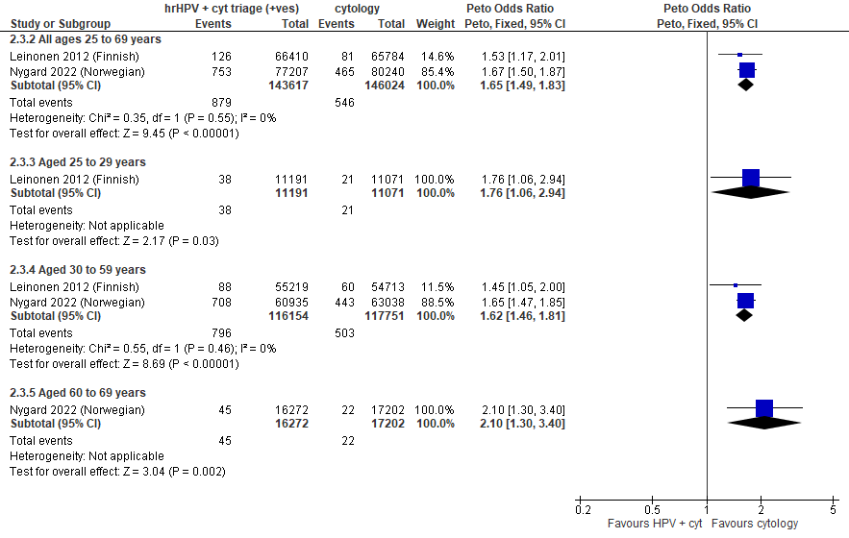
Forest plot 2.3a. Detection of CIN3+ (as an indirect indicator of the incidence of ICC)

Evidence Set 2.4a. Detection of invasive cervical cancer
Included report: Leinonen 2012 (Finnish)
GRADE Summary of Findings Table 2.4a. Detection of invasive cervical cancer
Outcome  No. participantsª  (studies) |  | Relative effects, Peto OR and RR (95 % CI) | Anticipated absolute effects |  |  | Certainty of evidence (GRADE)^{b} | What happens?
 |  | Relative effects, Peto OR and RR (95 % CI) | With cytology screening | With hrHPV screening + cytology triage | Difference | Certainty of evidence (GRADE)^{b} | What happens?
People with a cervix aged 25 to 69 years (Leinonen 2012 (Finnish); acceptors of screening)
Detection of invasive cervical cancer  Follow-up: at baseline  132,194 (1 RCT) | Peto OR: 1.27 (0.48 to 3.39)  RR: 1.27 (0.48 to 3.39) |  | 1.1 per 10,000 | 1.4 per 10,000 | 0.3 more per 10,000 (0.6 less to 2.5 more) | 25-29 yrs:  LOW^{c}  ⊕⊕⊝⊝  due to lack of evidence of consistency and indirectness  30-59 yrs:  LOW^{d}  ⊕⊕⊝⊝  due to lack of evidence of consistency and indirectness  60-69 yrs:  LOW^{e}  ⊕⊕⊝⊝  due to lack of evidence of consistency and indirectness | Among screened people with a cervix aged 25 to 69 years, hrHPV testing with cytology triage may have little-to-no effect on the detection of invasive cervical cancer compared with cytology testing.
>Subgroup: people with a cervix aged 25 to 29 years (Leinonen 2012 (Finnish); acceptors of screening)
Detection of invasive cervical cancer  Follow-up: at baseline  22,262 (1 RCT) | Peto OR: 0.99 (0.06 to 15.82)  RR: 0.99 (0.06 to 15.80) |  | 0.9 per 10,000 | 0.9 per 10,000 | No difference (0.8 less to 13.4 more) | NA
>Subgroup: people with a cervix aged 30 to 69 years (Leinonen 2012 (Finnish); acceptors of screening)
Detection of invasive cervical cancer  Follow-up: at baseline  109,932 (1 RCT) | Peto OR: 1.32 (0.46 to 3.76)  RR: 1.32 (0.46 to 3.76) |  | 1.1 per 10,000 | 1.4 per 10,000 | 0.4 more per 10,000 (0.6 less to 3.0 more) | NA
CI = confidence interval; NA= not applicable (i.e., not used for conclusions); OR = odds ratio; RCT = randomized controlled trial; RR = relative risk.
ªAcceptors of screening include participants who were randomized and accepted the offer to be screened. The analysis excludes outcomes among those who were screened in a group different to which they were randomly assigned (4,304/66,410 [6%] people with a cervix in the hrHPV screening group received cytology screening and 37/65,784 [0.06%] people in the cytology screening group received hrHPV screening) (akin to a screened per protocol analysis). Detection was calculated based on the number of cases identified based on a positive result at the index screen.
^{b}We rated down by 0.5 for “some concerns”, 1 for “serious concerns”, and 2 for “very serious concerns”. When our assessment of the certainty of evidence fell between levels, we assigned the level that best represented our actual certainty in the evidence, and based our conclusions on this level of certainty.
Explanations:
^{c}Acceptors of screening; people with a cervix aged 25 to 29 years: No serious concerns about risk of bias: no domains rated high risk. Some concerns about inconsistency: lack of evidence for consistency due to single study. Serious concerns about indirectness: detection is an indirect outcome. No serious concerns about imprecision: 95% CI precise for little-to-no effect. No other serious concerns.
^{d}Acceptors of screening; people with a cervix aged 30 to 59 years: No serious concerns about risk of bias: no domains rated high risk. Some concerns about inconsistency: lack of evidence for consistency due to single study. Serious concerns about indirectness: detection is an indirect outcome. No serious concerns about imprecision: 95% CI precise for little-to-no effect. No other serious concerns.
^{e}Acceptors of screening; people with a cervix aged 60 to 69 years: No serious concerns about risk of bias: no domains rated high risk. Some concerns about inconsistency: lack of evidence for consistency due to single study. Serious concerns about indirectness: detection is an indirect outcome, and there are some concerns of whether the sample in this age group is small (n=NR). No serious concerns about imprecision: 95% CI precise for little-to-no effect. No other serious concerns.

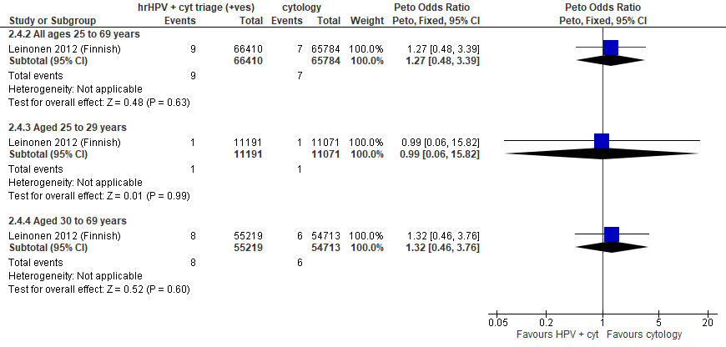
Forest plot 2.4a. Detection of invasive cervical cancer

Evidence Set 2.5a. Incidence of CIN2
Included report: Leinonen 2012 (Finnish)
GRADE Summary of Findings Table 2.5a. Incidence of CIN2
Outcome  No. participantsª  (studies) |  | Relative effects, Peto OR and RR (95 % CI) | Anticipated absolute effects |  |  | Certainty of evidence (GRADE)^{b} | What happens?
 |  | Relative effects, Peto OR and RR (95 % CI) | With cytology screening | With hrHPV screening + cytology triage | Difference | Certainty of evidence (GRADE)^{b} | What happens?
People with a cervix aged 25 to 69 years (Leinonen 2012 (Finnish); acceptors of screening at follow-up)
Incidence of CIN2  Follow-up: 5 years  131,457 (1 RCT) | Peto OR: 2.49 (1.90 to 3.27)  RR: 2.49 (1.90 to 3.26) |  | 8.7 per 10,000 | 21.6 per 10,000 | 12.9 more in 10,000 (7.8 more to 19.7 more) | 25-29 yrs:  LOW^{c}  ⊕⊕⊝⊝  due to risk of bias and lack of evidence of consistency  30-59 yrs:  LOW^{d}  ⊕⊕⊝⊝  due to risk of bias and lack of evidence of consistency  60-69 yrs:  LOW^{e}  ⊕⊕⊝⊝  due to risk of bias, lack of evidence of consistency, and indirectness | Among screened people with a cervix aged 25 to 69 years, hrHPV testing with cytology triage may have little-to-no effect on the incidence of CIN2 within 5 years compared with cytology testing.
>Subgroup: people with a cervix aged 25 to 29 years (Leinonen 2012 (Finnish); acceptors of screening at follow-up)
Incidence of CIN2  Follow-up: 5 years  21,986 (1 RCT) | Peto OR: 2.50 (1.67 to 3.73)  RR: 2.49 (1.67 to 3.71) |  | 23.7 per 10,000 | 59.1 per 10,000 | 35.4 more in 10,000 (15.8 more to 64.2 more) | NA
>Subgroup: people with a cervix aged 30 to 69 years (Leinonen 2012 (Finnish); acceptors of screening at follow-up)
Incidence of CIN2  Follow-up: 5 years  109,471 (1 RCT) | Peto OR: 2.50 (1,73 to 3.60)  RR: 2.50 (1.73 to 3.59) |  | 5.7 per 10,000 | 14.2 per 10,000 | 8.5 more per 10,000 (4.1 more to 14.8 more) | NA
CI = confidence interval; CIN = cervical intraepithelial neoplasia; NA= not applicable (i.e., not used for conclusions); OR = odds ratio; RCT = randomized controlled trial; RR = relative risk.
ªAcceptors of screening at follow-up includes histological diagnoses for all people who were randomized, accepted the offer to be screened during the first round, and were invited to the second screening round. The analysis excludes outcomes among those who were screened in a group different to which they were randomly assigned (4,304/66,410 [6%] people with a cervix in the hrHPV screening group received cytology screening and 37/65,784 [0.06%] people in the cytology screening group received hrHPV screening) (akin to a screened per protocol analysis). Excluded are people with prevalent CIN or invasive cervical cancer as identified in the first round.
^{b}We rated down by 0.5 for “some concerns”, 1 “serious concerns”, and 2 for “very serious concerns”. When our assessment of the certainty of evidence fell between levels, we assigned the level that best represented our actual certainty in the evidence, and based our conclusions on this level of certainty.
Explanations:
^{c}Acceptors of screening at follow up; people with a cervix aged 25 to 29 years: Serious concerns about risk of bias: risk of reporting bias because incidence outcomes were not ascertained actively for all participants (data linkage); some outcomes could be missing. Some concerns about inconsistency: lack of evidence for consistency due to single study. No serious concerns about indirectness: the study provides direct data. No serious concerns about imprecision: 95% CI precise for little-to-no effect. No other serious concerns.
^{d}Acceptors of screening at follow up; people with a cervix aged 30 to 59 years: Serious concerns about risk of bias: risk of reporting bias because incidence outcomes were not ascertained actively for all participants (data linkage); some outcomes could be missing. Some concerns about inconsistency: lack of evidence for consistency due to single study. No serious concerns about indirectness: the study provides direct data. No serious concerns about imprecision: 95% CI precise for little-to-no effect. No other serious concerns.
^{e}Acceptors of screening at follow up; people with a cervix aged 60 to 69 years: Serious concerns about risk of bias: risk of reporting bias because incidence outcomes were not ascertained actively for all participants (data linkage); some outcomes could be missing. Some concerns about inconsistency: lack of evidence for consistency due to single study. Some concerns about indirectness: the study provides direct data, but there are some concerns of whether the sample in this age group is small (n=NR). No serious concerns about imprecision: 95% CI precise for little-to-no effect. No other serious concerns.

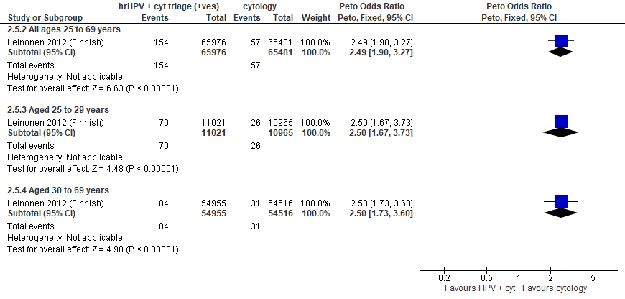
Forest plot 2.5a. Incidence of CIN2

Evidence Set 2.6a. Incidence of CIN2+
Included report: Leinonen 2012 (Finnish)
GRADE Summary of Findings Table 2.6a. Incidence of CIN2+
Outcome  No. participantsª  (studies) |  | Relative effects, Peto OR and RR (95 % CI) | Anticipated absolute effects |  |  | Certainty of evidence (GRADE)^{b} | What happens?
 |  | Relative effects, Peto OR and RR (95 % CI) | With cytology screening | With hrHPV screening + cytology triage | Difference | Certainty of evidence (GRADE)^{b} | What happens?
People with a cervix aged 25 to 69 years (Leinonen 2012 (Finnish); acceptors of screening at follow-up)
Incidence of CIN2+  Follow-up: 5 years  131,457 (1 RCT) | Peto OR: 2.24 (1.80 to 2.80)  RR: 2.24 (1.80 to 2.79) |  | 14.4 per 10,000 | 32.1 per 10,000 | 17.7 more in 10,000 (11.5 more to 25.7 more) | 25-29 yrs:  VERY LOW^{c}  ⊕⊝⊝⊝  due to risk of bias, lack of evidence of consistency, and indirectness  30-59 yrs:  VERY LOW^{d}  ⊕⊝⊝⊝  due to risk of bias, lack of evidence of consistency, and indirectness  60-69 yrs:  VERY LOW^{e}  ⊕⊝⊝⊝  due to risk of bias, lack of evidence of consistency, and indirectness | Among screened people with a cervix aged 25 to 69 years, we are very uncertain about the effects on the incidence of CIN2+ from hrHPV testing with cytology triage compared to cytology testing.
>Subgroup: people with a cervix aged 25 to 29 years (Leinonen 2012 (Finnish); acceptors of screening at follow-up)
Incidence of CIN2+  Follow-up: 5 years  21,986 (1 RCT) | Peto OR: 2.31 (1.64 to 3.24)  RR: 2.30 (1.64 to 3.21) |  | 35.6 per 10,000 | 81.8 per 10,000 | 46.2 more in 10,000 (22.6 more to 78.8 more) | NA
>Subgroup: people with a cervix aged 30 to 69 years (Leinonen 2012 (Finnish); acceptors of screening at follow-up)
Incidence of CIN2+  Follow-up: 5 years  109,471 (1 RCT) | Peto OR: 2.21 (1.65 to 2.95)  RR: 2.21 (1.65 to 2.94) |  | 10.1 per 10,000 | 22.3 per 10,000 | 12.2 more per 10,000 (6.5 more to 19.6 more) | NA
CI = confidence interval; CIN = cervical intraepithelial neoplasia; NA= not applicable (i.e., not used for conclusions); OR = odds ratio; RCT = randomized controlled trial; RR = relative risk.
ªAcceptors of screening at follow-up includes histological diagnoses for all people who were randomized, accepted the offer to be screened during the first round, and were invited to the second screening round. The analysis excludes outcomes among those who were screened in a group different to which they were randomly assigned (4,304/66,410 [6%] people with a cervix in the hrHPV screening group received cytology screening and 37/65,784 [0.06%] people in the cytology screening group received hrHPV screening) (akin to a screened per protocol analysis). Excluded are people with prevalent CIN or invasive cervical cancer as identified in the first round.
^{b}We rated down by 0.5 for “some concerns”, 1 “serious concerns”, and 2 for “very serious concerns”. When our assessment of the certainty of evidence fell between levels, we assigned the level that best represented our actual certainty in the evidence, and based our conclusions on this level of certainty.
Explanations:
^{c}Acceptors of screening at follow up; people with a cervix aged 25 to 29 years: Serious concerns about risk of bias: risk of reporting bias because incidence outcomes were not ascertained actively for all participants (data linkage); some outcomes could be missing. Some concerns about inconsistency: lack of evidence for consistency for single study. Serious concerns about indirectness: the outcome is considered indirect because outcome ascertainment ended at earliest detection of a lesion, therefore CIN2 and CIN3 lesions would not be followed up for progression. No serious concerns about imprecision: 95% CI precise for little-to-no effect. No other serious concerns.
^{d}Acceptors of screening at follow up; people with a cervix aged 30 to 59 years: Serious concerns about risk of bias: risk of reporting bias because incidence outcomes were not ascertained actively for all participants (data linkage); some outcomes could be missing. Some concerns about inconsistency: lack of evidence for consistency for single study. Serious concerns about indirectness: the outcome is considered indirect because outcome ascertainment ended at earliest detection of a lesion, therefore CIN2 and CIN3 lesions would not be followed up for progression. No serious concerns about imprecision: 95% CI precise for little-to-no effect. No other serious concerns.
^{e}Acceptors of screening at follow up; people with a cervix aged 60 to 69 years: Serious concerns about risk of bias: risk of reporting bias because incidence outcomes were not ascertained actively for all participants (data linkage); some outcomes could be missing. Some concerns about inconsistency: lack of evidence for consistency for single study. Serious concerns about indirectness: the outcome is considered indirect because outcome ascertainment ended at earliest detection of a lesion, therefore CIN2 and CIN3 lesions would not be followed up for progression, and there are some concerns of whether the sample in this age group is small (n=NR). No serious concerns about imprecision: 95% CI precise for little-to-no effect. No other serious concerns.

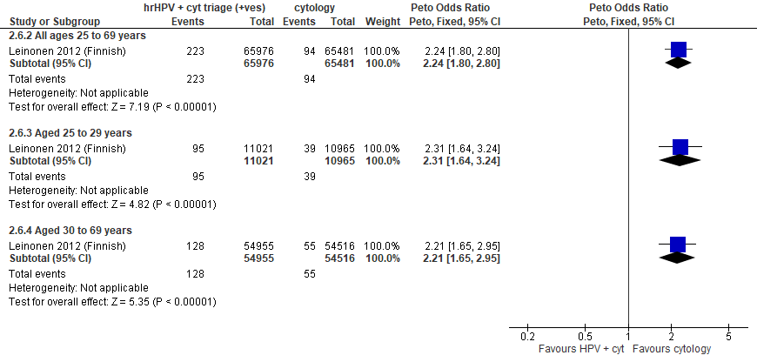
Forest plot 2.6a. Incidence of CIN2+

Evidence Set 2.7a. Incidence of CIN3 or AIS
Included report: Leinonen 2012 (Finnish)
GRADE Summary of Findings Table 2.7a. Incidence of CIN3 or AIS
Outcome  No. participantsª  (studies) |  | Relative effects, Peto OR and RR (95 % CI) | Anticipated absolute effects |  |  | Certainty of evidence (GRADE)^{b} | What happens?
 |  | Relative effects, Peto OR and RR (95 % CI) | With cytology screening | With hrHPV screening + cytology triage | Difference | Certainty of evidence (GRADE)^{b} | What happens?
People with a cervix aged 25 to 69 years (Leinonen 2012 (Finnish); acceptors of screening at follow up)
Incidence of CIN3 or AIS  Follow-up: 5 years  131,457 (1 RCT) | Peto OR: 1.71 (1.14 to 2.55)  RR: 1.71 (1.14 to 2.55) |  | 5.3 per 10,000 | 9.1 per 10,000 | 3.8 more per 10,000 (0.7 more to 8.3 more) | NA
>Subgroup: people with a cervix aged 25 to 29 years (Leinonen 2012 (Finnish); acceptors of screening at follow up)
Incidence of CIN3 or AIS  Follow-up: 5 years  21,986 (1 RCT) | Peto OR: 2.01 (1.06 to 3.83)  RR: 2.01 (1.06 to 3.82) |  | 10.9 per 10,000 | 22.0 per 10,000 | 11.0 more per 10,000 (0.7 more to 30.8 more) | VERY LOW^{c}  ⊕⊝⊝⊝  due to risk of bias, lack of evidence of consistency, (very serious) indirectness and imprecision | Among screened people with a cervix aged 25 to 29 years, we are very uncertain about the effects on the incidence of CIN3 or AIS for hrHPV testing with cytology triage compared with cytology testing.
>Subgroup: people with a cervix aged 30 to 69 years (Leinonen 2012 (Finnish); acceptors of screening at follow up)
Incidence of CIN3 or AIS  Follow-up: 5 years  109,471 (1 RCT) | Peto OR: 1.54 (0.93 to 2.57)  RR: 1.54 (0.93 to 2.57) |  | 4.2 per 10,000 | 6.5 per 10,000 | 2.3 more per 10,000 (0.3 less to 6.6 less) | 30-59 yrs:  VERY LOW^{d}  ⊕⊝⊝⊝  due to risk of bias and lack of evidence of consistency and (very serious) indirectness  60-69 yrs:  VERY LOW^{e}  ⊕⊝⊝⊝  due to risk of bias and lack of evidence of consistency and (very serious) indirectness | Among screened people with a cervix aged 30 to 69 years, we are very uncertain about the effects on the incidence of CIN3 or AIS for hrHPV testing with cytology triage compared with cytology testing.
AIS = adenocarcinoma in situ; CI = confidence interval; CIN = cervical intraepithelial neoplasia; NA= not applicable (i.e., not used for conclusions); OR = odds ratio; RCT = randomized controlled trial; RR = relative risk.
ªAcceptors of screening at follow up includes histological diagnoses for all people who were randomized, accepted the offer to be screened during the first round, and were invited to the second screening round. The analysis excludes outcomes among those who were screened in a group different to which they were randomly assigned (4,304/66,410 [6%] people with a cervix in the hrHPV screening group received cytology screening and 37/65,784 [0.06%] people in the cytology screening group received hrHPV screening (akin to a screened per protocol analysis). Excluded are people with prevalent CIN or invasive cervical cancer as identified in the first round.
^{b}We rated down by 0.5 for “some concerns”, 1 “serious concerns”, and 2 for “very serious concerns”. When our assessment of the certainty of evidence fell between levels, we assigned the level that best represented our actual certainty in the evidence, and based our conclusions on this level of certainty.
Explanations:
^{c}Acceptors of screening at follow up; people with a cervix aged 25 to 29 years: Serious concerns about risk of bias: risk of reporting bias because incidence outcomes were not ascertained actively for all participants (data linkage); some outcomes could be missing. Some concerns about inconsistency: lack of evidence for consistency due to single study. Very serious concerns about indirectness: the outcome is considered very indirect because outcome ascertainment ended at earliest detection of a lesion, therefore CIN2 and CIN3 lesions would not be followed up for progression. Serious concerns about imprecision: lower limit of 95% CI indicates little-to-no effect. No other serious concerns.
^{d}Acceptors of screening at follow up; people with a cervix aged 30 to 59 years: Serious concerns about risk of bias: risk of reporting bias because incidence outcomes were not ascertained actively for all participants (data linkage); some outcomes could be missing. Some concerns about inconsistency: lack of evidence for consistency due to single study. Very serious concerns about indirectness: the outcome is considered very indirect because outcome ascertainment ended at earliest detection of a lesion, therefore CIN2 and CIN3 lesions would not be followed up for progression. No serious concerns about imprecision: 95% CI precise for little-to-no effect. No other serious concerns.
^{e}Acceptors of screening at follow up; people with a cervix aged 60 to 69 years: Serious concerns about risk of bias: risk of reporting bias because incidence outcomes were not ascertained actively for all participants (data linkage); some outcomes could be missing. Some concerns about inconsistency: lack of evidence for consistency due to single study. Very serious concerns about indirectness: the outcome is considered very indirect because outcome ascertainment ended at earliest detection of a lesion, therefore CIN2 and CIN3 lesions would not be followed up for progression, and there are some concerns of whether the sample in this age group is small (n=NR). No serious concerns about imprecision: 95% CI precise for little-to-no effect. No other serious concerns.

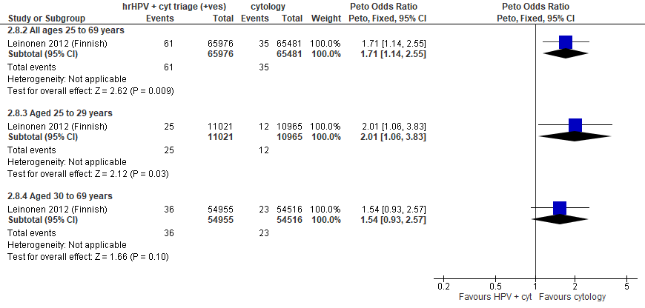
Forest Plot 2.7a. Incidence of CIN3 or AIS

Evidence Set 2.8a. Incidence of CIN3+ or AIS+
Included report: Leinonen 2012 (Finnish)
GRADE Summary of Findings Table 2.8a. Incidence of CIN3+ or AIS+
Outcome  No. participantsª  (studies) |  | Relative effects, Peto OR and RR (95 % CI) | Anticipated absolute effects |  |  | Certainty of evidence (GRADE)^{b} | What happens?
 |  | Relative effects, Peto OR and RR (95 % CI) | With cytology screening | With hrHPV screening + cytology triage | Difference | Certainty of evidence (GRADE)^{b} | What happens?
People with a cervix aged 25 to 69 years (Leinonen 2012 (Finnish); acceptors of screening at follow up)
Incidence of CIN3+ or AIS+  Follow-up: 5 years  131,457 (1 RCT) | Peto OR: 1.82 (1.24 to 2.66)  RR: 1.82 (1.24 to 2.66) |  | 5.7 per 10,000 | 10.3 per 10,000 | 4.6 more per 10,000 (1.4 more to 9.4 more) | NA
>Subgroup: people with a cervix aged 25 to 29 years (Leinonen 2012 (Finnish); acceptors of screening at follow up)
Incidence of CIN3+ or AIS+  Follow-up: 5 years  21,986 (1 RCT) | Peto OR: 1.87 (0.99 to 3.54)  RR: 1.87 (0.99 3.53) |  | 11.9 per 10,000 | 22.1 per 10,000 | 10.3 more per 10,000 (0.1 less to 30.0 more) | VERY LOW^{c}  ⊕⊝⊝⊝  due to risk of bias, lack of evidence of consistency, (very serious) indirectness, and imprecision | Among screened people with a cervix aged 25 to 29 years, we are very uncertain about the effects on the incidence of CIN3+ for hrHPV testing with cytology triage compared with cytology testing.
>Subgroup: people with a cervix aged 30 to 69 years (Leinonen 2012 (Finnish); acceptors of screening at follow up)
Incidence of CIN3+ or AIS+  Follow-up: 5 years  109,471 (1 RCT) | Peto OR: 1.79 (1.11 to 2.88)  RR: 1.79 (1.11 to 2.88) |  | 4.4 per 10,000 | 7.9 per 10,000 | 3.5 more per 10,000 (0.5 more to 8.3 more) | 30-59 yrs:  VERY LOW^{d}  ⊕⊝⊝⊝  due to risk of bias, lack of evidence of consistency, and (very serious) indirectness  60-69 yrs:  VERY LOW^{e}  ⊕⊝⊝⊝  due to risk of bias, lack of evidence of consistency, and (very serious) indirectness | Among screened people with a cervix aged 30 to 69 years, we are very uncertain about the effects on the incidence of CIN3+ for hrHPV testing with cytology triage compared with cytology testing.
AIS = adenocarcinoma in situ; CI = confidence interval; CIN = cervical intraepithelial neoplasia; NA= not applicable (i.e., not used for conclusions); OR = odds ratio; RCT = randomized controlled trial; RR = relative risk.
ªAcceptors of screening at follow up includes histological diagnoses for all people who were randomized, accepted the offer to be screened during the first round, and were invited to the second screening round. The analysis excludes outcomes among those who were screened in a group different to which they were randomly assigned (4,304/66,410 [6%] people with a cervix in the hrHPV screening group received cytology screening and 37/65,784 [0.06%] people in the cytology screening group received hrHPV screening (akin to a screened per protocol analysis). Excluded are people with prevalent CIN or invasive cervical cancer as identified in the first round.
^{b}We rated down by 0.5 for “some concerns”, 1 “serious concerns”, and 2 for “very serious concerns”. When our assessment of the certainty of evidence fell between levels, we assigned the level that best represented our actual certainty in the evidence, and based our conclusions on this level of certainty.
Explanations:
^{c}Acceptors of screening at follow up; people with a cervix aged 25 to 29 years: Serious concerns about risk of bias: risk of reporting bias because incidence outcomes were not ascertained actively for all participants (data linkage); some outcomes could be missing. Some concerns about inconsistency: lack of evidence for consistency due to single study. Very serious concerns about indirectness: the outcome is considered very indirect because outcome ascertainment ended at earliest detection of a lesion, therefore CIN2 and CIN3 lesions would not be followed up for progression. Serious concerns about imprecision: lower limit of 95% CI indicates little-to-no effect. No other serious concerns.
^{d}Acceptors of screening at follow up; people with a cervix aged 30 to 59 years: Serious concerns about risk of bias: risk of reporting bias because incidence outcomes were not ascertained actively for all participants (data linkage); some outcomes could be missing. Some concerns about inconsistency: lack of evidence for consistency due to single study. Very serious concerns about indirectness: the outcome is considered very indirect because outcome ascertainment ended at earliest detection of a lesion, therefore CIN2 and CIN3 lesions would not be followed up for progression. No serious concerns about imprecision: 95% CI precise for little-to-no effect. No other serious concerns.
^{e}Acceptors of screening at follow up; people with a cervix aged 60 to 69 years: Serious concerns about risk of bias: risk of reporting bias because incidence outcomes were not ascertained actively for all participants (data linkage); some outcomes could be missing. Some concerns about inconsistency: lack of evidence for consistency due to single study. Very serious concerns about indirectness: the outcome is considered very indirect because outcome ascertainment ended at earliest detection of a lesion, therefore CIN2 and CIN3 lesions would not be followed up for progression, and there are some concerns of whether the sample in this age group is small (n=NR). No serious concerns about imprecision: 95% CI precise for little-to-no effect. No other serious concerns.

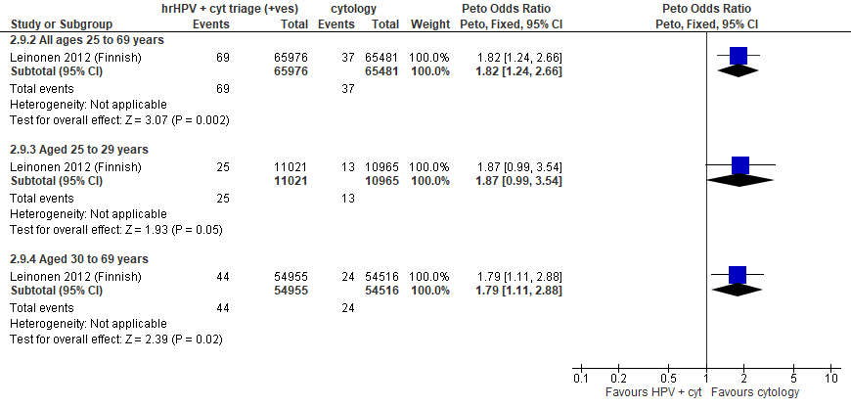
Forest Plot 2.8a. Incidence of CIN3+ or AIS+

Evidence Set 2.9a. Incidence of invasive cervical cancer
Included report: Leinonen 2012 (Finnish)
GRADE Summary of Findings Table 2.9a. Incidence of invasive cervical cancer
Outcome  No. participantsª  (studies) |  | Relative effects, Peto OR and RR (95 % CI) | Anticipated absolute effects |  |  | Certainty of evidence (GRADE)^{b} | What happens?
 |  | Relative effects, Peto OR and RR (95 % CI) | With cytology screening | With hrHPV screening + cytology triage | Difference | Certainty of evidence (GRADE)^{b} | What happens?
People with a cervix aged 25 to 69 years (Leinonen 2012 (Finnish); acceptors of screening at follow up)
Incidence of invasive cervical cancer  Follow-up: 5 years  131,457 (1 RCT) | Peto OR: 3.30 (0.95 to 11.38)  RR: 3.30 (0.95 to 11.38) |  | 0.3 per 10,000 | 1.0 per 10,000 | 0.7 more per 10,000 (0.0 more to 3.2 more) | 25-29 yrs:  VERY LOW^{c}  ⊕⊝⊝⊝  due to risk of bias, lack of evidence of consistency, and (very serious) indirectness  30-59 yrs:  VERY LOW^{d}  ⊕⊝⊝⊝  due to risk of bias, lack of evidence of consistency, and (very serious) indirectness  60-69 yrs:  VERY LOW^{e}  ⊕⊝⊝⊝  due to risk of bias, lack of evidence of consistency, and (very serious) indirectness | Among screened people with a cervix aged 25 to 69 years, we are very uncertain about the effects on the incidence of ICC for hrHPV testing with cytology triage compared with cytology testing.
>Subgroup: people with a cervix aged 25 to 29 years (Leinonen 2012 (Finnish); acceptors of screening at follow up)
Incidence of invasive cervical cancer  Follow-up: 5 years  21,986 (1 RCT) | Peto OR: 0.13 (0.00 to 6.79)  RR: 0.13 (0.00 to 6.79) |  | 0.9 per 10,000 | 0.1 per 10,000 | 0.8 less per 10,000 (0.9 less to 5.3 more) | NA
>Subgroup: people with a cervix aged 30 to 69 years (Leinonen 2012 (Finnish); acceptors of screening at follow up)
Incidence of invasive cervical cancer  Follow-up: 5 years  109,471 (1 RCT) | Peto OR: 4.70 (1.27 to 17.36)  RR: 4.70 (1.27 to 17.35) |  | 0.2 per 10,000 | 0.9 per 10,000 | 0.7 more per 10,000 (0.0 more to 3.0 more) | NA
CI = confidence interval; NA= not applicable (i.e., not used for conclusions); OR = odds ratio; RCT = randomized controlled trial; RR = relative risk.
ªAcceptors of screening at follow up includes histological diagnoses for all people who were randomized, accepted the offer to be screened during the first round, and were invited to the second screening round. The analysis excludes outcomes among those who were screened in a group different to which they were randomly assigned (4,304/66,410 [6%] people with a cervix in the hrHPV screening group received cytology screening and 37/65,784 [0.06%] people in the cytology screening group received hrHPV screening) (akin to a screened per protocol analysis). Excluded are people with prevalent CIN or invasive cervical cancer as identified in the first round.
^{b}We rated down by 0.5 for “some concerns”, 1 “serious concerns”, and 2 for “very serious concerns”. When our assessment of the certainty of evidence fell between levels, we assigned the level that best represented our actual certainty in the evidence, and based our conclusions on this level of certainty.
Explanations:
^{c}Acceptors of screening at follow up; people with a cervix aged 25 to 29 years: Serious concerns about risk of bias: risk of reporting bias because incidence outcomes were not ascertained actively for all participants (data linkage); some outcomes could be missing. Some concerns about inconsistency: lack of evidence for consistency due to single study. Very serious concerns about indirectness: the outcome is considered very indirect because outcome ascertainment ended at earliest detection of a lesion, therefore CIN2 and CIN3 lesions would not be followed up for progression. No serious concerns about imprecision: 95% CI precise for little-to-no effect. No other serious concerns.
^{d}Acceptors of screening at follow up; people with a cervix aged 30 to 59 years: Serious concerns about risk of bias: risk of reporting bias because incidence outcomes were not ascertained actively for all participants (data linkage); some outcomes could be missing. Some concerns about inconsistency: lack of evidence for consistency due to single study. Very serious concerns about indirectness: the outcome is considered very indirect because outcome ascertainment ended at earliest detection of a lesion, therefore CIN2 and CIN3 lesions would not be followed up for progression. No serious concerns about imprecision: 95% CI precise for little-to-no effect. No other serious concerns.
^{e}Acceptors of screening at follow up; people with a cervix aged 60 to 69 years: Serious concerns about risk of bias: risk of reporting bias because incidence outcomes were not ascertained actively for all participants (data linkage); some outcomes could be missing. Some concerns about inconsistency: lack of evidence for consistency due to single study. Very serious concerns about indirectness: the outcome is considered very indirect because outcome ascertainment ended at earliest detection of a lesion, therefore CIN2 and CIN3 lesions would not be followed up for progression, and there are some concerns of whether the sample in this age group is small (n=NR). No serious concerns about imprecision: 95% CI precise for little-to-no effect. No other serious concerns.

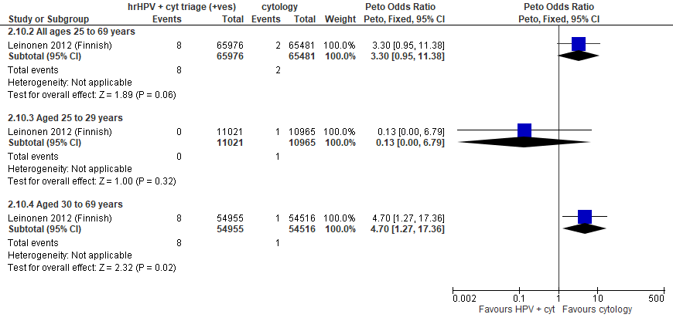
Forest Plot 2.9a. Incidence of invasive cervical cancer

Evidence Set 2.10a. False positives for CIN2+
Included report: Leinonen 2012 (Finnish); Nygard 2022 (Norwegian)
GRADE Summary of Findings Table 2.10a. False positives for CIN2+
Outcome  No. participantsª  (studies) |  | Relative effects, Peto OR and RR (95 % CI) | Anticipated absolute effects |  |  | Certainty of evidence (GRADE)^{b} | What happens?
 |  | Relative effects, Peto OR and RR (95 % CI) | With cytology screening | With hrHPV screening + cytology triage | Difference | Certainty of evidence (GRADE)^{b} | What happens?
People with a cervix aged 25 to 69 years (Leinonen 2012 (Finnish); Nygard 2022 (Norwegian); acceptors of screening)
False positives for CIN2+  Follow-up: at baseline  289,641 (2 RCTs) | Peto OR: 1.51 (1.39 to 1.63)  RR: 1.50 (1.39 to 1.62) |  | 65.2 per 10,000 | 98.1 per 10,000 | 32.9 more per 10,000 (25.2 more to 40.6 more) | 25-29 yrs:  MODERATE^{c}  ⊕⊕⊕⊝  due to risk of bias  30-59 yrs:  MODERATE^{d}  ⊕⊕⊕⊝  due to risk of bias  60-69 yrs:  MODERATE^{e}  ⊕⊕⊕⊝  due to risk of bias | Among screened people with a cervix aged 25 to 69 years, hrHPV testing with cytology triage probably has little-to-no effect on the number of false positives for CIN2+ compared with cytology testing.
>Subgroup: people with a cervix aged 25 to 29 years (Leinonen 2012 (Finnish); acceptors of screening)
False positives for CIN2+  Follow-up: at baseline  22,262 (1 RCT) | Peto OR: 1.26 (1.01 to 1.59)  RR: 1.26 (1.01 to 1.58) |  | 118.3 per 10,000 | 148.6 per 10,000 | 30.3 more per 10,000 (1.2 more to 68.5 more) | NA
>Subgroup: people with a cervix aged 30 to 59 years (Leinonen 2012 (Finnish); Nygard 2022 (Norwegian); acceptors of screening)
False positives for CIN2+  Follow-up: at baseline  233,905 (2 RCTs) | Peto OR: 1.51 (1.38 to 1.65)  RR: 1.51 (1.38 to 1.64) |  | 65.1 per 10,000 | 98.0 per 10,000 | 32.9 more per 10,000 (24.5 more to 41.9 more) | NA
>Subgroup: people with a cervix aged 60 to 69 years (Nygard 2022 (Norwegian); acceptors of screening)
False positives for CIN2+  Follow-up: at baseline  33,474 (1 RCT) | Peto OR: 2.02 (1.48 to 2.75)  RR: 2.01 (1.48 to 2.73) |  | 31.4 per 10,000 | 63.2 per 10,000 | 31.8 more per 10,000 (15.0 more to 54.5 more) | NA
CI = confidence interval; CIN = cervical intraepithelial neoplasia; NA= not applicable (i.e., not used for conclusions); OR = odds ratio; RCT = randomized controlled trial; RR = relative risk.
ªAcceptors of screening include participants who were randomized and accepted the offer to be screened. False positives were calculated based on those referred to colposcopy following the index screen (excludes intensive follow-up data).
^{b}We rated down by 0.5 for “some concerns”, 1 “serious concerns”, and 2 for “very serious concerns”. When our assessment of the certainty of evidence fell between levels, we assigned the level that best represented our actual certainty in the evidence, and based our conclusions on this level of certainty.
Explanations:
^{c}Acceptors of screening; people with a cervix aged 25 to 29 years: Some concerns about risk of bias: one study at risk of selection bias because randomization occurred before enrollment, without adequate information about baseline characteristics across groups, but absolute effects similar between studies. No serious concerns about inconsistency: evidence of consistency. No serious concerns about indirectness: the study provides direct evidence. No serious concerns about imprecision: 95% CI precise for little-to-no effect. No other serious concerns.
^{d}Acceptors of screening; people with a cervix aged 30 to 59 years: Some concerns about risk of bias: one study at risk of selection bias because randomization occurred before enrollment, without adequate information about baseline characteristics across groups, but absolute effects similar between studies. No serious concerns about inconsistency: evidence of consistency. No serious concerns about indirectness: the study provides direct evidence. No serious concerns about imprecision: 95% CI precise for little-to-no effect. No other serious concerns.
^{e}Acceptors of screening; people with a cervix aged 60 to 69 years: Some concerns about risk of bias: one study at risk of selection bias because randomization occurred before enrollment, without adequate information about baseline characteristics across groups, but absolute effects similar between studies. No serious concerns about inconsistency: evidence of consistency. No serious concerns about indirectness: the study provides direct evidence. No serious concerns about imprecision: 95% CI precise for little-to-no effect. No other serious concerns.

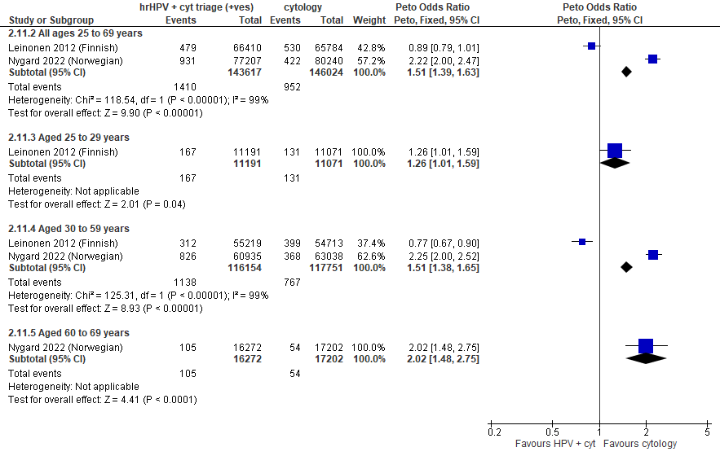
Forest plot 2.10a. False positives for CIN2+

Evidence Set 2.11a. False positives for CIN3+
Included report: Leinonen 2012 (Finnish); Nygard 2022 (Norwegian)
GRADE Summary of Findings Table 2.11a. False positives for CIN3+
Outcome  No. participantsª  (studies) |  | Relative effects, Peto OR and RR (95 % CI) | Anticipated absolute effects |  |  | Certainty of evidence (GRADE)^{b} | What happens?
 |  | Relative effects, Peto OR and RR (95 % CI) | With cytology screening | With hrHPV screening + cytology triage | Difference | Certainty of evidence (GRADE)^{b} | What happens?
People with a cervix aged 25 to 69 years (Leinonen 2012 (Finnish); Nygard 2022 (Norwegian); acceptors of screening)
False positives for CIN3+  Follow-up: at baseline  289,641 (2 RCTs) | Peto OR: 1.59 (1.48 to 1.71)  RR: 1.58 (1.47 to 1.70) |  | 77.5 per 10,000 | 122.7 per 10,000 | 45.2 more per 10,000 (36.8 more to 54.3 more) | 25-29 yrs:  MODERATE^{c}  ⊕⊕⊕⊝  due to risk of bias  30-59 yrs:  MODERATE^{d}  ⊕⊕⊕⊝  due to risk of bias  60-69 yrs:  MODERATE^{e}  ⊕⊕⊕⊝  due to risk of bias | Among screened people with a cervix aged 25 to 69 years, hrHPV testing with cytology triage probably has little-to-no effect on the number of false positives for CIN3+ compared with cytology testing.
>Subgroup: people with a cervix aged 25 to 29 years (Leinonen 2012 (Finnish); acceptors of screening)
False positives for CIN3+  Follow-up: at baseline  22,262 (1 RCT) | Peto OR: 1.32 (1.09 to 1.59)  RR: 1.31 (1.09 to 1.57) |  | 171.6 per 10,000 | 225.3 per 10,000 | 53.7 more per 10,000 (15.2 more to 98.5 more) | NA
>Subgroup: people with a cervix aged 30 to 59 years (Leinonen 2012 (Finnish); Nygard 2022 (Norwegian); acceptors of screening)
False positives for CIN3+  Follow-up: at baseline  233,905 (2 RCTs) | Peto OR: 1.60 (1.48 to 1.74)  RR: 1.59 (1.47 to 1.73) |  | 75.3 per 10,000 | 120.0 per 10,000 | 44.7 more per 10,000 (35.8 more to 55.0 more) | NA
>Subgroup: people with a cervix aged 60 to 69 years (Nygard 2022 (Norwegian); acceptors of screening)
False positives for CIN3+  Follow-up: at baseline  33,474 (1 RCT) | Peto OR: 2.20 (1.63 to 2.97)  RR: 2.19 (1.63 to 2.95) |  | 32.0 per 10,000 | 70.1 per 10,000 | 38.1 more per 10,000 (20.0 more to 62.4 more) | NA
CI = confidence interval; CIN = cervical intraepithelial neoplasia; NA= not applicable (i.e., not used for conclusions); OR = odds ratio; RCT = randomized controlled trial; RR = relative risk.
ªAcceptors of screening include participants who were randomized and accepted the offer to be screened. False positives were calculated based on those referred to colposcopy following the index screen (excludes intensive follow-up data).
^{b}We rated down by 0.5 for “some concerns”, 1 “serious concerns”, and 2 for “very serious concerns”. When our assessment of the certainty of evidence fell between levels, we assigned the level that best represented our actual certainty in the evidence, and based our conclusions on this level of certainty.
Explanations:
^{c}Acceptors of screening; people with a cervix aged 25 to 29 years: Some concerns about risk of bias: one study at risk of selection bias because randomization occurred before enrollment, without adequate information about baseline characteristics across groups, but absolute effects similar between studies. No serious concerns about inconsistency: evidence of consistency. No serious concerns about indirectness: the study provides direct evidence. No serious concerns about imprecision: 95% CI precise for little-to-no effect. No other serious concerns.
^{d}Acceptors of screening; people with a cervix aged 30 to 59 years: Some concerns about risk of bias: one study at risk of selection bias because randomization occurred before enrollment, without adequate information about baseline characteristics across groups, but absolute effects similar between studies. No serious concerns about inconsistency: evidence of consistency. No serious concerns about indirectness: the study provides direct evidence. No serious concerns about imprecision: 95% CI precise for little-to-no effect. No other serious concerns.
^{e}Acceptors of screening; people with a cervix aged 60 to 69 years: Some concerns about risk of bias: one study at risk of selection bias because randomization occurred before enrollment, without adequate information about baseline characteristics across groups, but absolute effects similar between studies. No serious concerns about inconsistency: evidence of consistency. No serious concerns about indirectness: the study provides direct evidence. No serious concerns about imprecision: 95% CI precise for little-to-no effect. No other serious concerns.

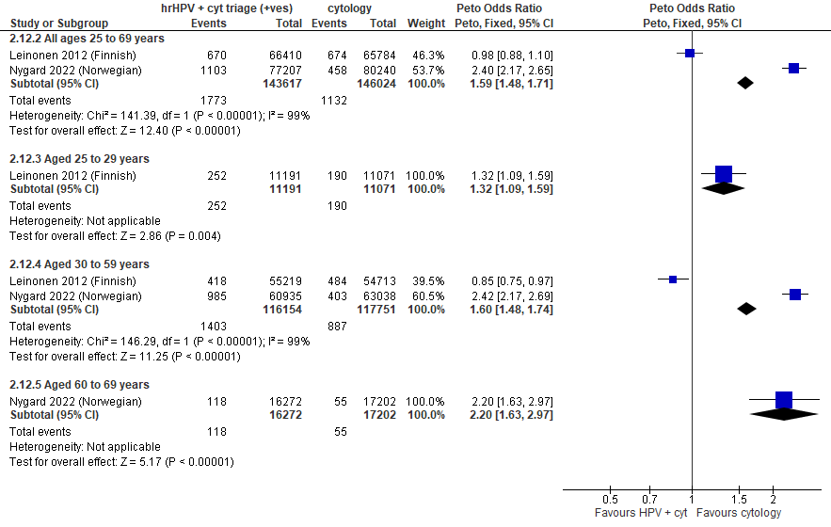
Forest plot 2.11a. False positives for CIN3+

Evidence Set 2.12a. False positives for invasive cervical cancer
Included report: Leinonen 2012 (Finnish)
GRADE Summary of Findings Table 2.12a. False positives for invasive cervical cancer
Outcome  No. participantsª  (studies) |  | Relative effects, Peto OR and RR (95 % CI) | Anticipated absolute effects |  |  | Certainty of evidence (GRADE)^{b} | What happens?
 |  | Relative effects, Peto OR and RR (95 % CI) | With cytology screening | With hrHPV screening + cytology triage | Difference | Certainty of evidence (GRADE)^{b} | What happens?
People with a cervix aged 25 to 69 years (Leinonen 2012 (Finnish); acceptors of screening)
False positives for invasive cervical cancer  Follow-up: 1 round  132,194 (1 RCT) | Peto OR: 1.04 (0.94 to 1.15)  RR: 1.04 (0.94 to 1.15) |  | 113.7 per 10,000 | 118.2 per 10,000 | 4.5 more per 10,000 (6.7 less to 16.8 more) | 25-29 yrs:  MODERATE^{c}  ⊕⊕⊕⊝  due to lack of evidence of consistency  30-59 yrs:  MODERATE^{d}  ⊕⊕⊕⊝  due to lack of evidence of consistency  60-69 yrs:  MODERATE^{e}  ⊕⊕⊕⊝  due to lack of evidence of consistency, and indirectness | Among screened people with a cervix aged 25 to 69 years, hrHPV testing with cytology triage probably has little-to-no effect on the number of false positives for invasive cervical cancer compared with cytology testing.
>Subgroup: people with a cervix aged 25 to 29 years (Leinonen 2012 (Finnish); acceptors of screening)
False positives for invasive cervical cancer  Follow-up: 1 round  22,262 (1 RCT) | Peto OR: 1.37 (1.14 to 1.63)  RR: 1.36 (1.14 to 1.61) |  | 189.7 per 10,000 | 258.1 per 10,000 | 68.4 more per 10,000 (26.0 more to 115.9 more) | NA
>Subgroup: people with a cervix aged 30 to 69 years (Leinonen 2012 (Finnish); acceptors of screening)
False positives for invasive cervical cancer  Follow-up: 1 round  109,932 (1 RCT) | Peto OR: 0.92 (0.81 to 1.04)  RR: 0.92 (0.81 to 1.04) |  | 98.3 per 10,000 | 90.5 per 10,000 | 7.8 less per 10,000 (18.5 less to 3.9 more) | NA
CI = confidence interval; NA= not applicable (i.e., not used for conclusions); OR = odds ratio; RCT = randomized controlled trial; RR = relative risk.
ªAcceptors of screening include participants who were randomized and accepted the offer to be screened. The analysis excludes outcomes among those who were screened in a group different to which they were randomly assigned (4,304/66,410 [6%] people with a cervix in the hrHPV screening group received cytology screening and 37/65,784 [0.06%] people in the cytology screening group received hrHPV screening) (akin to a screened per protocol analysis).
^{b}We rated down by 0.5 for “some concerns”, 1 “serious concerns”, and 2 for “very serious concerns”. When our assessment of the certainty of evidence fell between levels, we assigned the level that best represented our actual certainty in the evidence, and based our conclusions on this level of certainty.
Explanations:
^{c}Acceptors of screening; people with a cervix aged 25 to 29 years: No serious concerns about risk of bias: no domains judged high risk. Some concerns about inconsistency: lack of evidence for consistency due to single study. No serious concerns about indirectness: the study provides direct evidence. No serious concerns about imprecision: 95% CI precise for little-to-no effect. No other serious concerns.
^{d}Acceptors of screening; people with a cervix aged 30 to 59 years: No serious concerns about risk of bias: no domains judged high risk. Some concerns about inconsistency: lack of evidence for consistency due to single study. No serious concerns about indirectness: the study provides direct evidence. No serious concerns about imprecision: 95% CI precise for little-to-no effect. No other serious concerns.
^{e}Acceptors of screening; people with a cervix aged 60 to 69 years: No serious concerns about risk of bias: no domains judged high risk. Some concerns about inconsistency: lack of evidence for consistency due to single study. Some concerns about indirectness: and there are some concerns of whether the sample in this age group is small (n=NR). No serious concerns about imprecision: 95% CI precise for little-to-no effect. No other serious concerns.

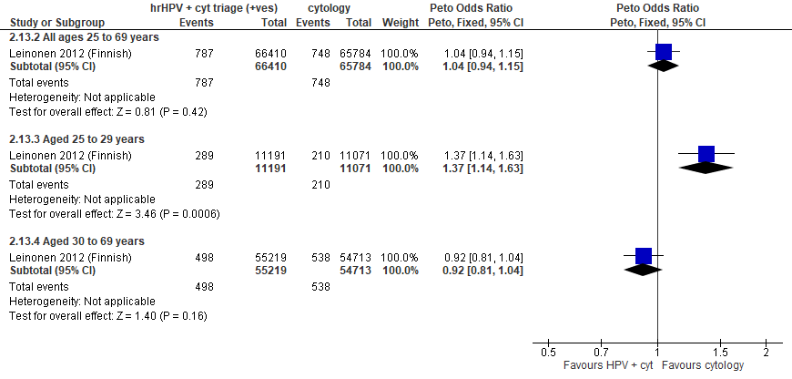
Forest plot 2.12a. False positives for invasive cervical cancer

Evidence set 2.0b: hrHPV screening (threshold 1.0 RLU) with conventional cytology triage of positive tests vs. conventional cytology testing (threshold ≥Papanicolaou class III, or ≥LSIL); with recall

Included report: Leinonen 2012 (Finnish) (ages 25-65 [subgroups 25-34 and 35-65 years])

Evidence Set 2.1b. Detection of CIN2+ (as an indirect indicator of the incidence of CIN3+)
GRADE Summary of Findings Table 2.1b. Detection of CIN2+ (as an indirect indicator of the incidence of CIN3+)
Outcome  No. participantsª  (studies) |  | Relative effects, Peto OR and RR (95 % CI) | Anticipated absolute effects |  |  | Certainty of evidence (GRADE)^{b} | What happens?
 |  | Relative effects, Peto OR and RR (95 % CI) | With cytology screening | With hrHPV screening + cytology triage | Difference | Certainty of evidence (GRADE)^{b} | What happens?
People with a cervix aged 25 to 69 years (Leinonen 2012 (Finnish); acceptors of screening)
Detection of CIN2+  Follow-up: 1 round  132,194 (1 RCT) | Peto OR: 1.85 (1.61 to 2.14)  RR: 1.84 (1.61 to 2.13) |  | 40.6 per 10,000 | 74.8 per 10,000 | 34.2 more per 10,000 (24.6 more to 45.9 more) | 25-29 yrs:  LOW^{c}  ⊕⊕⊝⊝  due to lack of evidence of consistency and indirectness  30-59 yrs:  LOW^{d}  ⊕⊕⊝⊝  due to lack of evidence of consistency and indirectness  60-69 yrs:  LOW^{e}  ⊕⊕⊝⊝  due to lack of evidence of consistency and indirectness | Among screened people with a cervix aged 25 to 69 years, hrHPV testing with cytology triage may have little-to-no effect on the incidence of CIN3+ compared with cytology testing.
>Subgroup: people with a cervix aged 25 to 29 years (Leinonen 2012 (Finnish); acceptors of screening)
Detection of CIN2+  Follow-up: 1 round  22,262 (1 RCT) | Peto OR: 2.16 (1.73 to 2.71)  RR: 2.14 (1.72 to 2.67) |  | 84.0 per 10,000 | 179.7 per 10,000 | 95.7 more in 10,000 (60.4 more to 140.4 more) | NA
>Subgroup: people with a cervix aged 30 to 69 years (Leinonen 2012 (Finnish); acceptors of screening)
Detection of CIN2+  Follow-up: 1 round  109,932 (1 RCT) | Peto OR: 1.68 (1.41 to 2.02)  RR: 1.68 (1.41 to 2.01) |  | 31.8 per 10,000 | 53.3 per 10,000 | 21.5 more per 10,000 (13.0 more to 32.2 more) | NA
CI = confidence interval; CIN = cervical intraepithelial neoplasia; NA= not applicable (i.e., not used for conclusions); OR = odds ratio; RCT = randomized controlled trial; RR = relative risk.
ªAcceptors of screening include participants who were randomized and accepted the offer to be screened. The analysis excludes outcomes among those who were screened in a group different to which they were randomly assigned (4,304/66,410 [6%] people with a cervix in the hrHPV screening group received cytology screening and 37/65,784 [0.06%] people in the cytology screening group received hrHPV screening) (akin to a screened per protocol analysis). Detection was calculated based on the number of cases identified based on a positive result at the index screen.
^{b}We rated down by 0.5 for “some concerns”, 1 “serious concerns”, and 2 for “very serious concerns”. When our assessment of the certainty of evidence fell between levels, we assigned the level that best represented our actual certainty in the evidence, and based our conclusions on this level of certainty.
Explanations:
^{c}Acceptors of screening; people with a cervix aged 25 to 29 years: No serious concerns about risk of bias: no domains rated high risk. Some concerns about inconsistency: lack of evidence for consistency due to single study. Serious concerns about indirectness: detection is an indirect indicator of incidence. No serious concerns about imprecision: 95% CI precise for little-to-no effect. No other serious concerns.
^{d}Acceptors of screening; people with a cervix aged 30 to 59 years: No serious concerns about risk of bias: no domains rated high risk. Some concerns about inconsistency: lack of evidence for consistency due to single study. Serious concerns about indirectness: detection is an indirect indicator of incidence. No serious concerns about imprecision: 95% CI precise for little-to-no effect. No other serious concerns.
^{e}Acceptors of screening; people with a cervix aged 60 to 69 years: No serious concerns about risk of bias: no domains rated high risk. Some concerns about inconsistency: lack of evidence for consistency due to single study. Serious concerns about indirectness: detection is an indirect indicator of incidence, and there are some concerns of whether the sample in this age group is small (n=NR). No serious concerns about imprecision: 95% CI precise for little-to-no effect. No other serious concerns.

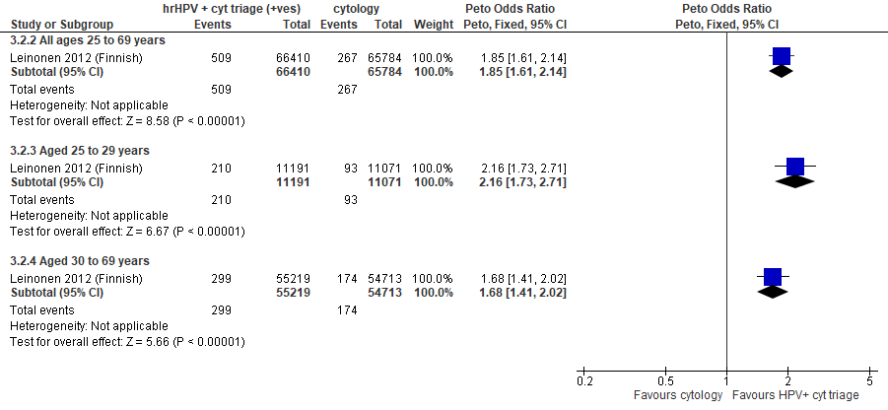
Forest plot 2.1b. Detection of CIN2+ (as an indirect indicator of the incidence of CIN3+)

Evidence Set 2.2b. Detection of CIN3+ (as an indirect indicator of the incidence of ICC)
Included report: Leinonen 2012 (Finnish)
GRADE Summary of Findings Table 2.2b. Detection of CIN3+ (as an indirect indicator of the incidence of ICC)
Outcome  No. participantsª  (studies) |  | Relative effects, Peto OR and RR (95 % CI) | Anticipated absolute effects |  |  | Certainty of evidence (GRADE)^{b} | What happens?
 |  | Relative effects, Peto OR and RR (95 % CI) | With cytology screening | With hrHPV screening + cytology triage | Difference | Certainty of evidence (GRADE)^{b} | What happens?
People with a cervix aged 25 to 69 years (Leinonen 2012 (Finnish); acceptors of screening)
Detection of CIN3+  Follow-up: 1 round  132,194 (1 RCT) | Peto OR: 1.84 (1.46 to 2.33)  RR: 1.84 (1.46 to 2.33) |  | 14.7 per 10,000 | 27.1 per 10,000 | 12.4 more per 10,000 (6.8 more to 19.5 more) | NA
>Subgroup: people with a cervix aged 25 to 29 years (Leinonen 2012 (Finnish); acceptors of screening)
Detection of CIN3+  Follow-up: 1 round  22,262 (1 RCT) | Peto OR: 2.45 (1.60 to 3.77)  RR: 2.44 (1.60 to 3.75) |  | 20.8 per 10,000 | 50.7 per 10,000 | 30.0 more per 10,000 (12.4 more to 57.1 more) | LOW^{c}  ⊕⊕⊝⊝  due to lack of evidence of consistency and indirectness | Among screened people with a cervix aged 25 to 29 years, hrHPV testing with cytology triage may reduce the incidence of invasive cervical cancer compared with cytology testing.
>Subgroup: people with a cervix aged 30 to 69 years (Leinonen 2012 (Finnish); acceptors of screening)
Detection of CIN3+  Follow-up: 1 round  109,932 (1 RCT) | Peto OR: 1.63 (1.23 to 2.16)  RR: 1.63 (1.23 to 2.16) |  | 13.5 per 10,000 | 22.0 per 10,000 | 8.5 more per 10,000 (3.1 more to 15.6 more) | 30-59 yrs:  VERY LOW^{d}  ⊕⊝⊝⊝  due to lack of evidence of consistency, indirectness and imprecision  60-69 yrs:  VERY LOW^{e}  ⊕⊝⊝⊝  due to lack of evidence of consistency, indirectness and imprecision | Among screened people with a cervix aged 30 to 69 years, we are very uncertain about the effects on the incidence of invasive cervical cancer for hrHPV testing with cytology triage compared with cytology testing.
CI = confidence interval; CIN = cervical intraepithelial neoplasia; NA= not applicable (i.e., not used for conclusions); OR = odds ratio; RCT = randomized controlled trial; RR = relative risk.
ªAcceptors of screening include participants who were randomized and accepted the offer to be screened. The analysis excludes outcomes among those who were screened in a group different to which they were randomly assigned (4,304/66,410 [6%] people with a cervix in the hrHPV screening group received cytology screening and 37/65,784 [0.06%] people in the cytology screening group received hrHPV screening) (akin to a screened per protocol analysis). Detection was calculated based on the number of cases identified based on a positive result at the index screen.
^{b}We rated down by 0.5 for “some concerns”, 1 “serious concerns”, and 2 for “very serious concerns”. When our assessment of the certainty of evidence fell between levels, we assigned the level that best represented our actual certainty in the evidence, and based our conclusions on this level of certainty.
Explanations:
^{c}Acceptors of screening; people with a cervix aged 25 to 29 years: No serious concerns about risk of bias: no domains rated high risk. Some concerns about inconsistency: lack of evidence for consistency due to single study. Serious concerns about indirectness: detection is an indirect indicator of incidence. No serious concerns about imprecision: 95% CI precise for little-to-no effect. No other serious concerns.
^{d}Acceptors of screening; people with a cervix aged 30 to 59 years: No serious concerns about risk of bias: no domains rated high risk. Some concerns about inconsistency: lack of evidence for consistency due to single study. Serious concerns about indirectness: detection is an indirect indicator of incidence. Serious concerns about imprecision: upper limit of 95% CI indicates an increase in effect. No other serious concerns.
^{e}Acceptors of screening; people with a cervix aged 60 to 69 years: No serious concerns about risk of bias: no domains rated high risk. Some concerns about inconsistency: lack of evidence for consistency due to single study. Serious concerns about indirectness: detection is an indirect indicator of incidence, and there are some concerns of whether the sample in this age group is small (n=NR). Serious concerns about imprecision: upper limit of 95% CI indicates an increase in effect. No No other serious concerns.

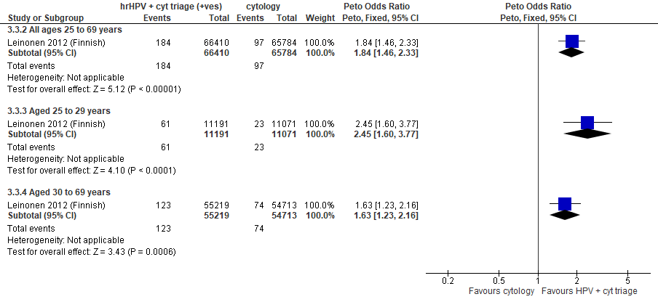
Forest plot 2.2b. Detection of CIN3+ (as an indirect indicator of the incidence of ICC)

Evidence Set 2.3b. Detection of invasive cervical cancer
Included report: Leinonen 2012 (Finnish)
GRADE Summary of Findings Table 2.3b. Detection of invasive cervical cancer
Outcome  No. participantsª  (studies) |  | Relative effects, Peto OR and RR (95 % CI) | Anticipated absolute effects |  |  | Certainty of evidence (GRADE)^{b} | What happens?
 |  | Relative effects, Peto OR and RR (95 % CI) | With cytology screening | With hrHPV screening + cytology triage | Difference | Certainty of evidence (GRADE)^{b} | What happens?
People with a cervix aged 25 to 69 years (Leinonen 2012 (Finnish); acceptors of screening)
Detection of invasive cervical cancer  Follow-up: 1 round  132,194 (1 RCT) | Peto OR: 1.68 (0.68 to 4.12)  RR: 1.68 (0.68 to 4.12) |  | 1.1 per 10,000 | 1.8 per 10,000 | 0.7 more per 10,000 (0.3 less to 3.3 more) | 25-29 yrs:  LOW^{c}  ⊕⊕⊝⊝  due to lack of evidence of consistency, and indirectness  30-59 yrs:  LOW^{d}  ⊕⊕⊝⊝  due to lack of evidence of consistency, and indirectness  60-69 yrs:  LOW^{e}  ⊕⊕⊝⊝  due to lack of evidence of consistency, and indirectness | Among screened people with a cervix aged 25 to 69 years, hrHPV testing with cytology triage may have little-to-no effect on the detection of invasive cervical cancer compared with cytology testing.
>Subgroup: people with a cervix aged 25 to 29 years (Leinonen 2012 (Finnish); acceptors of screening)
Detection of invasive cervical cancer  Follow-up: 1 round  22,262 (1 RCT) | Peto OR: 0.99 (0.06 to 15.82)  RR: 0.99 (0.06 to 15.80) |  | 0.9 per 10,000 | 0.9 per 10,000 | No difference (0.8 less to 13.4 more) | NA
>Subgroup: people with a cervix aged 30 to 69 years (Leinonen 2012 (Finnish); acceptors of screening)
Detection of invasive cervical cancer  Follow-up: 1 round  109,932 (1 RCT) | Peto OR: 1.78 (0.69 to 4.62)  RR: 1.78 (0.69 to 4.62) |  | 1.1 per 10,000 | 2.0 per 10,000 | 0.9 more per 10,000 (0.3 less to 4.0 more) | NA
CI = confidence interval; NA= not applicable (i.e., not used for conclusions); OR = odds ratio; RCT = randomized controlled trial; RR = relative risk.
ªAcceptors of screening include participants who were randomized and accepted the offer to be screened. The analysis excludes outcomes among those who were screened in a group different to which they were randomly assigned (4,304/66,410 [6%] people with a cervix in the hrHPV screening group received cytology screening and 37/65,784 [0.06%] people in the cytology screening group received hrHPV screening) (akin to a screened per protocol analysis). Detection was calculated based on the number of cases identified based on a positive result at the index screen.
^{b}We rated down by 0.5 for “some concerns”, 1 for “serious concerns”, and 2 for “very serious concerns”. When our assessment of the certainty of evidence fell between levels, we assigned the level that best represented our actual certainty in the evidence, and based our conclusions on this level of certainty.
Explanations:
^{c}Acceptors of screening; people with a cervix aged 25 to 29 years: No serious concerns about risk of bias: no domains rated high risk. Some concerns about inconsistency: lack of evidence for consistency due to single study. Serious concerns about indirectness: detection is an indirect indicator of incidence. No serious concerns about imprecision: 95% CI precise for little-to-no effect. No other serious concerns.
^{d}Acceptors of screening; people with a cervix aged 30 to 59 years: No serious concerns about risk of bias: no domains rated high risk. Some concerns about inconsistency: lack of evidence for consistency due to single study. Serious concerns about indirectness: detection is an indirect indicator of incidence. No serious concerns about imprecision: 95% CI precise for little-to-no effect. No other serious concerns.
^{e}Acceptors of screening; people with a cervix aged 60 to 69 years: No serious concerns about risk of bias: no domains rated high risk. Some concerns about inconsistency: lack of evidence for consistency due to single study. Serious concerns about indirectness: detection is an indirect indicator of incidence, and there are some concerns of whether the sample in this age group is small (n=NR). No serious concerns about imprecision: 95% CI precise for little-to-no effect. No other serious concerns.

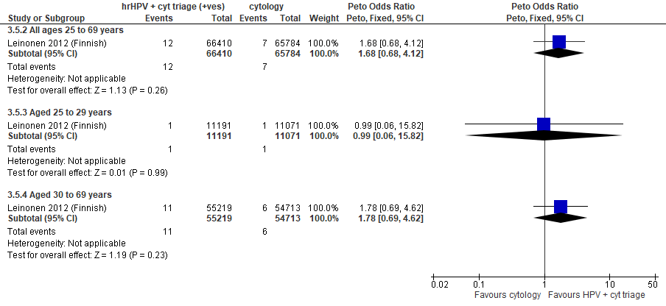
Forest plot 2.3b. Detection of invasive cervical cancer

Evidence Set 2.4b. Incidence of CIN2
Included report: Leinonen 2012 (Finnish)
GRADE Summary of Findings Table 2.4b. Incidence of CIN2
Outcome  No. participantsª  (studies) |  | Relative effects, Peto OR and RR (95 % CI) | Anticipated absolute effects |  |  | Certainty of evidence (GRADE)^{b} | What happens?
 |  | Relative effects, Peto OR and RR (95 % CI) | With cytology screening | With hrHPV screening + cytology triage | Difference | Certainty of evidence (GRADE)^{b} | What happens?
People with a cervix aged 25 to 69 years (Leinonen 2012 (Finnish); acceptors of screening at follow-up)
Incidence of CIN2  Follow-up: 5 years  130,943 (1 RCT) | Peto OR: 0.65 (0.37 to 1.12)  RR: 0.65 (0.37 to 1.12) |  | 4.7 per 10,000 | 3.1 per 10,000 | 1.7 less in 10,000 (3.0 less to 0.6 more) | 25-29 yrs:  LOW^{c}  ⊕⊕⊝⊝  due to risk of bias and lack of evidence of consistency  30-59 yrs:  LOW^{d}  ⊕⊕⊝⊝  due to risk of bias and lack of evidence of consistency  60-69 yrs:  LOW^{e}  ⊕⊕⊝⊝  due to risk of bias, lack of evidence of consistency, and indirectness | Among screened people with a cervix aged 25 to 69 years, hrHPV testing with cytology triage may have little-to-no effect on the incidence of CIN2 within 5 years compared with cytology testing.
>Subgroup: people with a cervix aged 25 to 34 years (Leinonen 2012 (Finnish); acceptors of screening at follow-up)
Incidence of CIN2  Follow-up: 5 years  21,676 (1 RCT) | Peto OR: 0.43 (0.18 to 1.02)  RR: 0.43 (0.18 to 1.02) |  | 13.7 per 10,000 | 5.9 per 10,000 | 7.8 less in 10,000 (11.2 less to 0.3 more) | NA
>Subgroup: people with a cervix aged 35 to 65 years (Leinonen 2012 (Finnish); acceptors of screening at follow-up)
Incidence of CIN2  Follow-up: 5 years  109,267 (1 RCT) | Peto OR: 0.87 (0.43 to 1.78)  RR: 0.87 (0.43 to 1.78) |  | 2.9 per 10,000 | 2.6 per 10,000 | 0.4 less per 10,000 (1.7 less to 2.3 more) | NA
CI = confidence interval; CIN = cervical intraepithelial neoplasia; NA= not applicable (i.e., not used for conclusions); OR = odds ratio; RCT = randomized controlled trial; RR = relative risk.
ªAcceptors of screening at follow-up includes histological diagnoses for all people who were randomized, accepted the offer to be screened during the first round, and were invited to the second screening round. The analysis excludes outcomes among those who were screened in a group different to which they were randomly assigned (4,304/66,410 [6%] people with a cervix in the hrHPV screening group received cytology screening and 37/65,784 [0.06%] people in the cytology screening group received hrHPV screening) (akin to a screened per protocol analysis). Excluded are people with prevalent CIN or invasive cervical cancer as identified in the first round.
^{b}We rated down by 0.5 for “some concerns”, 1 “serious concerns”, and 2 for “very serious concerns”. When our assessment of the certainty of evidence fell between levels, we assigned the level that best represented our actual certainty in the evidence, and based our conclusions on this level of certainty.
Explanations:
^{c}Acceptors of screening at follow up; people with a cervix aged 25 to 29 years: Serious concerns about risk of bias: risk of reporting bias because incidence outcomes were not ascertained actively for all participants (data linkage); some outcomes could be missing. Some concerns about inconsistency: lack of evidence for consistency due to single study. No serious concerns about indirectness: the study provides direct evidence. No serious concerns about imprecision: 95% CI precise for little-to-no effect. No other serious concerns.
^{d}Acceptors of screening at follow up; people with a cervix aged 30 to 59 years: Serious concerns about risk of bias: risk of reporting bias because incidence outcomes were not ascertained actively for all participants (data linkage); some outcomes could be missing. Some concerns about inconsistency: lack of evidence for consistency due to single study. No serious concerns about indirectness: the study provides direct evidence. No serious concerns about imprecision: 95% CI precise for little-to-no effect. No other serious concerns.
^{e}Acceptors of screening at follow up; people with a cervix aged 60 to 69 years: Serious concerns about risk of bias: risk of reporting bias because incidence outcomes were not ascertained actively for all participants (data linkage); some outcomes could be missing. Some concerns about inconsistency: lack of evidence for consistency due to single study. Some concerns about indirectness: there are some concerns of whether the sample in this age group is small (n=NR). No serious concerns about imprecision: 95% CI precise for little-to-no effect. No other serious concerns.

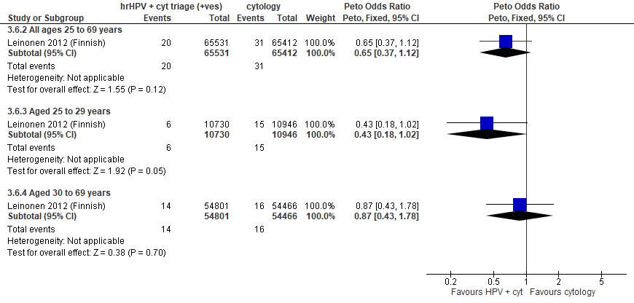
Forest plot 2.4b. Incidence of CIN2

Evidence Set 2.5b. Incidence of CIN2+
Included report: Leinonen 2012 (Finnish)
GRADE Summary of Findings Table 2.5b. Incidence of CIN2+
Outcome  No. participantsª  (studies) |  | Relative effects, Peto OR and RR (95 % CI) | Anticipated absolute effects |  |  | Certainty of evidence (GRADE)^{b} | What happens?
 |  | Relative effects, Peto OR and RR (95 % CI) | With cytology screening | With hrHPV screening + cytology triage | Difference | Certainty of evidence (GRADE)^{b} | What happens?
People with a cervix aged 25 to 69 years (Leinonen 2012 (Finnish); acceptors of screening at follow-up)
Incidence of CIN2+  Follow-up: 5 years  130,943 (1 RCT) | Peto OR: 0.60 (0.39 to 0.93)  RR: 0.60 (0.39 to 0.93) |  | 7.9 per 10,000 | 4.8 per 10,000 | 3.2 less in 10,000 (4.8 less to 0.6 less) | 25-29 yrs:  VERY LOW^{c}  ⊕⊝⊝⊝  due to risk of bias, lack of evidence of consistency, and indirectness  30-59 yrs:  VERY LOW^{d}  ⊕⊝⊝⊝  due to risk of bias, lack of evidence of consistency, and indirectness  60-69 yrs:  VERY LOW^{e}  ⊕⊝⊝⊝  due to risk of bias, lack of evidence of consistency, and indirectness | Among screened people with a cervix aged 25 to 69 years, we are very uncertain about the effects on the incidence of CIN2+ for hrHPV testing with cytology triage compared with cytology testing.
>Subgroup: people with a cervix aged 25 to 29 years (Leinonen 2012 (Finnish); acceptors of screening at follow-up)
Incidence of CIN2+  Follow-up: 5 years  21,676 (1 RCT) | Peto OR: 0.35 (0.18 to 0.69)  RR: 0.35 (0.18 to 0.69) |  | 23.8 per 10,000 | 8.3 per 10,000 | 15.4 less in 10,000 (19.5 less to 7.4 less) | NA
>Subgroup: people with a cervix aged 30 to 69 years (Leinonen 2012 (Finnish); acceptors of screening at follow-up)
Incidence of CIN2+  Follow-up: 5 years  109,267 (1 RCT) | Peto OR: 0.88 (0.50 to 1.54)  RR: 0.88 (0.50 to 1.54) |  | 4.8 per 10,000 | 4.2 per 10,000 | 0.6 less per 10,000 (2.4 less to 2.6 more) | NA
CI = confidence interval; CIN = cervical intraepithelial neoplasia; NA= not applicable (i.e., not used for conclusions); OR = odds ratio; RCT = randomized controlled trial; RR = relative risk.
ªAcceptors of screening at follow-up includes histological diagnoses for all people who were randomized, accepted the offer to be screened during the first round, and were invited to the second screening round. The analysis excludes outcomes among those who were screened in a group different to which they were randomly assigned (4,304/66,410 [6%] people with a cervix in the hrHPV screening group received cytology screening and 37/65,784 [0.06%] people in the cytology screening group received hrHPV screening) (akin to a screened per protocol analysis). Excluded are people with prevalent CIN or invasive cervical cancer as identified in the first round.
^{b}We rated down by 0.5 for “some concerns”, 1 “serious concerns”, and 2 for “very serious concerns”. When our assessment of the certainty of evidence fell between levels, we assigned the level that best represented our actual certainty in the evidence, and based our conclusions on this level of certainty.
Explanations:
^{c}Acceptors of screening at follow up; people with a cervix aged 25 to 29 years: Serious concerns about risk of bias: risk of reporting bias because incidence outcomes were not ascertained actively for all participants (data linkage); some outcomes could be missing. Some concerns about inconsistency: lack of evidence for consistency due to single study. Serious concerns about indirectness: the outcome is considered indirect because outcome ascertainment ended at earliest detection of a lesion, therefore CIN2 and CIN3 lesions would not be followed up for progression. No serious concerns about imprecision: 95% CI precise for little-to-no effect. No other serious concerns.
^{d}Acceptors of screening at follow up; people with a cervix aged 30 to 59 years: Serious concerns about risk of bias: risk of reporting bias because incidence outcomes were not ascertained actively for all participants (data linkage); some outcomes could be missing. Some concerns about inconsistency: lack of evidence for consistency due to single study. Serious concerns about indirectness: the outcome is considered indirect because outcome ascertainment ended at earliest detection of a lesion, therefore CIN2 and CIN3 lesions would not be followed up for progression. No serious concerns about imprecision: 95% CI precise for little-to-no effect. No other serious concerns.
^{e}Acceptors of screening at follow up; people with a cervix aged 60 to 69 years: Serious concerns about risk of bias: risk of reporting bias because incidence outcomes were not ascertained actively for all participants (data linkage); some outcomes could be missing. Some concerns about inconsistency: lack of evidence for consistency due to single study. Serious concerns about indirectness: the outcome is considered indirect because outcome ascertainment ended at earliest detection of a lesion, therefore CIN2 and CIN3 lesions would not be followed up for progression. , and there are some concerns of whether the sample in this age group is small (n=NR). No serious concerns about imprecision: 95% CI precise for little-to-no effect. No other serious concerns.

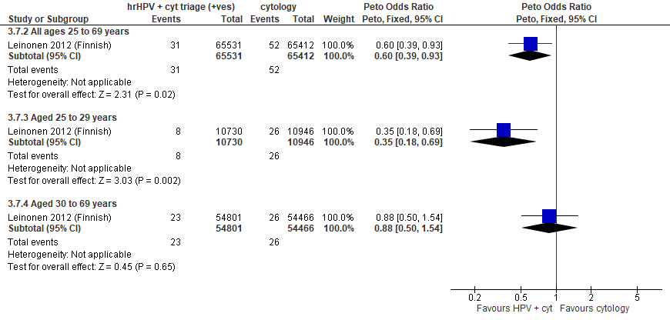
Forest plot 2.5b. Incidence of CIN2+

Evidence Set 2.6b. Incidence of CIN3 or AIS
Included report: Leinonen 2012 (Finnish)
GRADE Summary of Findings Table 2.6b. Incidence of CIN3 or AIS
Outcome  No. participantsª  (studies) |  | Relative effects, Peto OR and RR (95 % CI) | Anticipated absolute effects |  |  | Certainty of evidence (GRADE)^{b} | What happens?
 |  | Relative effects, Peto OR and RR (95 % CI) | With cytology screening | With hrHPV screening + cytology triage | Difference | Certainty of evidence (GRADE)^{b} | What happens?
People with a cervix aged 25 to 69 years (Leinonen 2012 (Finnish); acceptors of screening at follow up)
Incidence of CIN3 or AIS  Follow-up: 5 years  130,943 (1 RCT) | Peto OR: 0.35 (0.16 to 0.77)  RR: 0.35 (0.16 to 0.77) |  | 2.9 per 10,000 | 1.0 per 10,000 | 1.9 less per 10,000 (2.4 less to 0.7 less) | VERY LOW^{c}  ⊕⊝⊝⊝  due to risk of bias, lack of evidence of consistency, and (very serious) indirectness  30-59 yrs:  VERY LOW^{d}  ⊕⊝⊝⊝  due to risk of bias, lack of evidence of consistency, and (very serious) indirectness  60-69 yrs:  VERY LOW^{e}  ⊕⊝⊝⊝  due to risk of bias, lack of evidence of consistency, and (very serious) indirectness | Among screened people with a cervix aged 25 to 69 years, we are very uncertain about the effects on the incidence of CIN3 or AIS for hrHPV testing with cytology triage compared with cytology testing.
>Subgroup: people with a cervix aged 25 to 29 years (Leinonen 2012 (Finnish); acceptors of screening at follow up)
Incidence of CIN3 or AIS  Follow-up: 5 years  21,676 (1 RCT) | Peto OR: 0.27 (0.09 to 0.83)  RR: 0.27 (0.09 to 0.83) |  | 9.1 per 10,000 | 2.5 per 10,000 | 6.7 less per 10,000 (8.3 less to 1.6 less) | NA
>Subgroup: people with a cervix aged 30 to 69 years (Leinonen 2012 (Finnish); acceptors of screening at follow up)
Incidence of CIN3 or AIS  Follow-up: 5 years  109,267 (1 RCT) | Peto OR: 0.46 (0.16 to 1.37)  RR: 0.46 (0.16 to 1.37) |  | 1.7 per 10,000 | 0.8 per 10,000 | 0.9 less per 10,000 (1.4 less to 0.6 more) | NA
AIS = adenocarcinoma in situ; CI = confidence interval; CIN = cervical intraepithelial neoplasia; NA= not applicable (i.e., not used for conclusions); OR = odds ratio; RCT = randomized controlled trial; RR = relative risk.
ªAcceptors of screening at follow up includes histological diagnoses for all people who were randomized, accepted the offer to be screened during the first round, and were invited to the second screening round. The analysis excludes outcomes among those who were screened in a group different to which they were randomly assigned (4,304/66,410 [6%] people with a cervix in the hrHPV screening group received cytology screening and 37/65,784 [0.06%] people in the cytology screening group received hrHPV screening (akin to a screened per protocol analysis). Excluded are people with prevalent CIN or invasive cervical cancer as identified in the first round.
^{b}We rated down by 0.5 for “some concerns”, 1 “serious concerns”, and 2 for “very serious concerns”. When our assessment of the certainty of evidence fell between levels, we assigned the level that best represented our actual certainty in the evidence, and based our conclusions on this level of certainty.
Explanations:
^{c}Acceptors of screening at follow up; people with a cervix aged 25 to 29 years: Serious concerns about risk of bias: risk of reporting bias because incidence outcomes were not ascertained actively for all participants (data linkage); some outcomes could be missing. Some concerns about inconsistency: lack of evidence for consistency due to single study. Very serious concerns about indirectness: the outcome is considered very indirect because outcome ascertainment ended at earliest detection of a lesion, therefore CIN2 and CIN3 lesions would not be followed up for progression. No serious concerns about imprecision: 95% CI precise for little-to-no effect. No other serious concerns.
^{d}Acceptors of screening at follow up; people with a cervix aged 30 to 59 years: Serious concerns about risk of bias: risk of reporting bias because incidence outcomes were not ascertained actively for all participants (data linkage); some outcomes could be missing. Some concerns about inconsistency: lack of evidence for consistency due to single study. Very serious concerns about indirectness: the outcome is considered very indirect because outcome ascertainment ended at earliest detection of a lesion, therefore CIN2 and CIN3 lesions would not be followed up for progression. No serious concerns about imprecision: 95% CI precise for little-to-no effect. No other serious concerns.
^{e}Acceptors of screening at follow up; people with a cervix aged 60 to 69 years: Serious concerns about risk of bias: risk of reporting bias because incidence outcomes were not ascertained actively for all participants (data linkage); some outcomes could be missing. Some concerns about inconsistency: lack of evidence for consistency due to single study. Very serious concerns about indirectness: the outcome is considered very indirect because outcome ascertainment ended at earliest detection of a lesion, therefore CIN2 and CIN3 lesions would not be followed up for progression, and there are some concerns of whether the sample in this age group is small (n=NR). No serious concerns about imprecision: 95% CI precise for little-to-no effect. No other serious concerns.

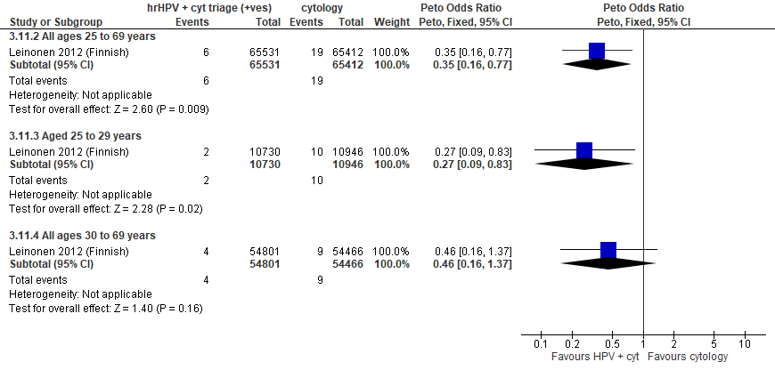
Forest Plot 2.6b. Incidence of CIN3 or AIS

Evidence Set 2.7b. Incidence of CIN3+ or AIS+
Included report: Leinonen 2012 (Finnish)
GRADE Summary of Findings Table 2.7b. Incidence of CIN3+ or AIS+
Outcome  No. participantsª  (studies) |  | Relative effects, Peto OR and RR (95 % CI) | Anticipated absolute effects |  |  | Certainty of evidence (GRADE)^{b} | What happens?
 |  | Relative effects, Peto OR and RR (95 % CI) | With cytology screening | With hrHPV screening + cytology triage | Difference | Certainty of evidence (GRADE)^{b} | What happens?
People with a cervix aged 25 to 69 years (Leinonen 2012 (Finnish); acceptors of screening at follow up)
Incidence of CIN3+ or AIS+  Follow-up: 5 years  130,943 (1 RCT) | Peto OR: 0.53 (0.27 to 1.07)  RR: 0.53 (0.27 to 1.07) |  | 3.2 per 10,000 | 1.7 per 10,000 | 1.5 less per 10,000 (2.3 less to 0.2 more) | VERY LOW^{c}  ⊕⊝⊝⊝  due to risk of bias, lack of evidence of consistency, and (very serious) indirectness  30-59 yrs:  VERY LOW^{d}  ⊕⊝⊝⊝  due to risk of bias, lack of evidence of consistency, and (very serious) indirectness  60-69 yrs:  VERY LOW^{e}  ⊕⊝⊝⊝  due to risk of bias, lack of evidence of consistency, and (very serious) indirectness | Among screened people with a cervix aged 25 to 69 years, we are very uncertain about the effects on the incidence of CIN3+ for hrHPV testing with cytology triage compared with cytology testing.
>Subgroup: people with a cervix aged 25 to 29 years (Leinonen 2012 (Finnish); acceptors of screening at follow up)
Incidence of CIN3+ or AIS+  Follow-up: 5 years  21,676 (1 RCT) | Peto OR: 0.26 (0.09 to 0.76)  RR: 0.26 (0.09 to 0.76) |  | 10.0 per 10,000 | 2.6 per 10,000 | 7.4 less per 10,000 (9.1 less to 2.4 less) | NA
>Subgroup: people with a cervix aged 30 to 69 years (Leinonen 2012 (Finnish); acceptors of screening at follow up)
Incidence of CIN3+ or AIS+  Follow-up: 5 years  109,267 (1 RCT) | Peto OR: 0.89 (0.36 to 2.20)  RR: 0.89 (0.36 to 2.20) |  | 1.8 per 10,000 | 1.6 per 10,000 | 0.2 less per 10,000 (1.2 less to 2.2 more) | NA
AIS = adenocarcinoma in situ; CI = confidence interval; CIN = cervical intraepithelial neoplasia; NA= not applicable (i.e., not used for conclusions); OR = odds ratio; RCT = randomized controlled trial; RR = relative risk.
ªAcceptors of screening at follow up includes histological diagnoses for all people who were randomized, accepted the offer to be screened during the first round, and were invited to the second screening round. The analysis excludes outcomes among those who were screened in a group different to which they were randomly assigned (4,304/66,410 [6%] people with a cervix in the hrHPV screening group received cytology screening and 37/65,784 [0.06%] people in the cytology screening group received hrHPV screening (akin to a screened per protocol analysis). Excluded are people with prevalent CIN or invasive cervical cancer as identified in the first round.
^{b}We rated down by 0.5 for “some concerns”, 1 “serious concerns”, and 2 for “very serious concerns”. When our assessment of the certainty of evidence fell between levels, we assigned the level that best represented our actual certainty in the evidence, and based our conclusions on this level of certainty.
Explanations:
^{c}Acceptors of screening at follow up; people with a cervix aged 25 to 29 years: Serious concerns about risk of bias: risk of reporting bias because incidence outcomes were not ascertained actively for all participants (data linkage); some outcomes could be missing. Some concerns about inconsistency: lack of evidence for consistency due to single study. Very serious concerns about indirectness: the outcome is considered very indirect because outcome ascertainment ended at earliest detection of a lesion, therefore CIN2 and CIN3 lesions would not be followed up for progression. No serious concerns about imprecision: 95% CI precise for little-to-no effect. No other serious concerns.
^{d}Acceptors of screening at follow up; people with a cervix aged 30 to 59 years: Serious concerns about risk of bias: risk of reporting bias because incidence outcomes were not ascertained actively for all participants (data linkage); some outcomes could be missing. Some concerns about inconsistency: lack of evidence for consistency due to single study. Very serious concerns about indirectness: the outcome is considered very indirect because outcome ascertainment ended at earliest detection of a lesion, therefore CIN2 and CIN3 lesions would not be followed up for progression. No serious concerns about imprecision: 95% CI precise for little-to-no effect. No other serious concerns.
^{e}Acceptors of screening at follow up; people with a cervix aged 60 to 69 years: Serious concerns about risk of bias: risk of reporting bias because incidence outcomes were not ascertained actively for all participants (data linkage); some outcomes could be missing. Some concerns about inconsistency: lack of evidence for consistency due to single study. Very serious concerns about indirectness: the outcome is considered very indirect because outcome ascertainment ended at earliest detection of a lesion, therefore CIN2 and CIN3 lesions would not be followed up for progression, and there are some concerns of whether the sample in this age group is small (n=NR). No serious concerns about imprecision: 95% CI precise for little-to-no effect. No other serious concerns.

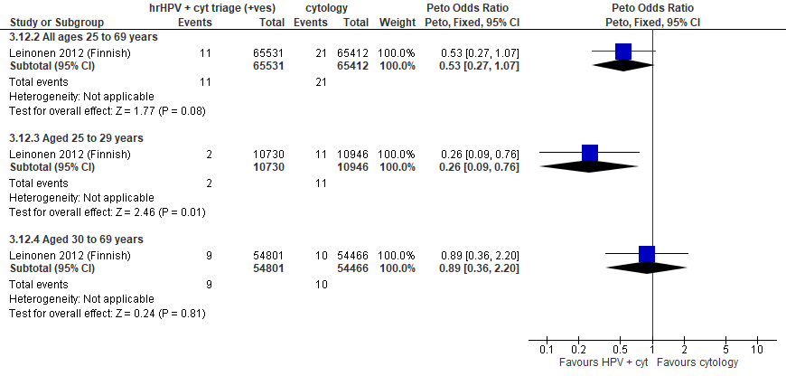
Forest Plot 2.7b. Incidence of CIN3+ or AIS+

Evidence Set 2.8b. Incidence of invasive cervical cancer
Included report: Leinonen 2012 (Finnish)
GRADE Summary of Findings Table 2.8b. Incidence of invasive cervical cancer
Outcome  No. participantsª  (studies) |  | Relative effects, Peto OR and RR (95 % CI) | Anticipated absolute effects |  |  | Certainty of evidence (GRADE)^{b} | What happens?
 |  | Relative effects, Peto OR and RR (95 % CI) | With cytology screening | With hrHPV screening + cytology triage | Difference | Certainty of evidence (GRADE)^{b} | What happens?
People with a cervix aged 25 to 69 years (Leinonen 2012 (Finnish); acceptors of screening at follow up)
Incidence of invasive cervical cancer  Follow-up: 5 years  130,943 (1 RCT) | Peto OR: 2.35 (0.53 to 10.35)  RR: 2.35 (0.53 to 10.35) |  | 0.3 per 10,000 | 0.7 per 10,000 | 0.4 more per 10,000 (0.1 less to 2.9 more) | VERY LOW^{c}  ⊕⊝⊝⊝  due to risk of bias, lack of evidence of consistency, and (very serious) indirectness  30-59 yrs:  VERY LOW^{d}  ⊕⊝⊝⊝  due to risk of bias, lack of evidence of consistency, and (very serious) indirectness  60-69 yrs:  VERY LOW^{e}  ⊕⊝⊝⊝  due to risk of bias, lack of evidence of consistency, and (very serious) indirectness | Among screened people with a cervix aged 25 to 69 years, we are very uncertain about the effects on the incidence of ICC for hrHPV testing with cytology triage of positive tests compared with cytology testing.
>Subgroup: people with a cervix aged 25 to 29 years (Leinonen 2012 (Finnish); acceptors of screening at follow up)
Incidence of invasive cervical cancer  Follow-up: 5 years  21,676 (1 RCT) | Peto OR: 0.14 (0.00 to 6.96)  RR: 0.14 (0.00 to 6.96) |  | 0.9 per 10,000 | 0.1 per 10,000 | 0.8 less per 10,000 (0.9 less to 5.4 more) | NA
>Subgroup: people with a cervix aged 30 to 69 years (Leinonen 2012 (Finnish); acceptors of screening at follow up)
Incidence of invasive cervical cancer  Follow-up: 5 years  109,267 (1 RCT) | Peto OR: 3.77 (0.76 to 18.68)  RR: 3.77 (0.76 to 18.67) |  | 0.2 per 10,000 | 0.7 per 10,000 | 0.5 more per 10,000 (0.0 less to 3.2 more) | NA
CI = confidence interval; NA= not applicable (i.e., not used for conclusions); OR = odds ratio; RCT = randomized controlled trial; RR = relative risk.
ªAcceptors of screening at follow up includes histological diagnoses for all people who were randomized, accepted the offer to be screened during the first round, and were invited to the second screening round. The analysis excludes outcomes among those who were screened in a group different to which they were randomly assigned (4,304/66,410 [6%] people with a cervix in the hrHPV screening group received cytology screening and 37/65,784 [0.06%] people in the cytology screening group received hrHPV screening) (akin to a screened per protocol analysis). Excluded are people with prevalent CIN or invasive cervical cancer as identified in the first round.
^{b}We rated down by 0.5 for “some concerns”, 1 “serious concerns”, and 2 for “very serious concerns”. When our assessment of the certainty of evidence fell between levels, we assigned the level that best represented our actual certainty in the evidence, and based our conclusions on this level of certainty.
Explanations:
^{c}Acceptors of screening at follow up; people with a cervix aged 25 to 29 years: Serious concerns about risk of bias: risk of reporting bias because incidence outcomes were not ascertained actively for all participants (data linkage); some outcomes could be missing. Some concerns about inconsistency: lack of evidence for consistency due to single study. Very serious concerns about indirectness: the outcome is considered very indirect because outcome ascertainment ended at earliest detection of a lesion, therefore CIN2 and CIN3 lesions would not be followed up for progression. No serious concerns about imprecision: 95% CI precise for little-to-no effect. No other serious concerns.
^{d}Acceptors of screening at follow up; people with a cervix aged 30 to 59 years: Serious concerns about risk of bias: risk of reporting bias because incidence outcomes were not ascertained actively for all participants (data linkage); some outcomes could be missing. Some concerns about inconsistency: lack of evidence for consistency due to single study. Very serious concerns about indirectness: the outcome is considered very indirect because outcome ascertainment ended at earliest detection of a lesion, therefore CIN2 and CIN3 lesions would not be followed up for progression. No serious concerns about imprecision: 95% CI precise for little-to-no effect. No other serious concerns.
^{e}Acceptors of screening at follow up; people with a cervix aged 60 to 69 years: Serious concerns about risk of bias: risk of reporting bias because incidence outcomes were not ascertained actively for all participants (data linkage); some outcomes could be missing. Some concerns about inconsistency: lack of evidence for consistency due to single study. Very serious concerns about indirectness: the outcome is considered very indirect because outcome ascertainment ended at earliest detection of a lesion, therefore CIN2 and CIN3 lesions would not be followed up for progression, and there are some concerns of whether the sample in this age group is small (n=NR). No serious concerns about imprecision: 95% CI precise for little-to-no effect. No other serious concerns.

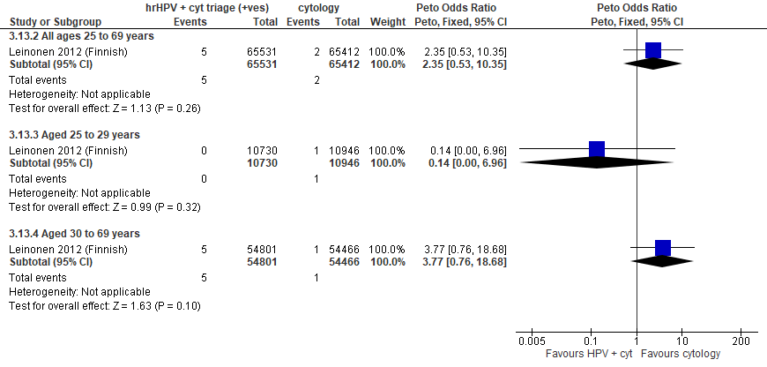
Forest Plot 2.8b. Incidence of invasive cervical cancer

Evidence Set 2.9b. False positives for CIN2+ (to recall)
Included report: Leinonen 2012 (Finnish)
GRADE Summary of Findings Table 2.9b. False positives for CIN2+ (to recall)
Outcome  No. participantsª  (studies) |  | Relative effects, Peto OR and RR (95 % CI) | Anticipated absolute effects |  |  | Certainty of evidence (GRADE)^{b} | What happens?
 |  | Relative effects, Peto OR and RR (95 % CI) | With cytology screening | With hrHPV screening + cytology triage | Difference | Certainty of evidence (GRADE)^{b} | What happens?
People with a cervix aged 25 to 69 years (Leinonen 2012 (Finnish); acceptors of screening)
False positives for CIN2+ (to recall)  Follow-up: 1 round  132,194 (1 RCT) | Peto OR: 1.11 (1.07 to 1.16)  RR: 1.10 (1.07 to 1.15) |  | 645.0 per 10,000 | 710.9 per 10,000 | 65.9 more per 10,000 (42.0 more to 95.6 more) | NA
>Subgroup: people with a cervix aged 25 to 29 years (Leinonen 2012 (Finnish); acceptors of screening)
False positives for CIN2+ (to recall)  Follow-up: 1 round  22,262 (1 RCT) | Peto OR: 2.35 (2.16 to 2.55)  RR: 2.14 (2.00 to 2.30) |  | 710.9 per 10,000 | 1524.3 per 10,000 | 813.4 more per 10,000 (707.6 more to 921.9 more) | MODERATE^{c}  ⊕⊕⊕⊝  due to lack of evidence of consistency | Among screened people with a cervix aged 25 to 29 years, hrHPV testing with cytology triage probably increases the number of false positives for CIN2+ compared with cytology testing.
>Subgroup: people with a cervix aged 30 to 69 years (Leinonen 2012 (Finnish); acceptors of screening)
False positives for CIN2+ (to recall)  Follow-up: 1 round  109,932 (1 RCT) | Peto OR: 0.84 (0.80 to 0.89)  RR: 0.85 (0.81 to 0.90) |  | 631.7 per 10,000 | 536.0 per 10,000 | 95.6 less per 10,000 (119.9 less to 65.5 less) | 30-59 yrs:  MODERATE^{d}  ⊕⊕⊕⊝  due to lack of evidence of consistency  60-69 yrs:  MODERATE^{e}  ⊕⊕⊕⊝  due to lack of evidence of consistency, and indirectness | Among screened people with a cervix aged 30 to 69 years, hrHPV testing with cytology triage probably has little-to-no effect on the number of false positives for CIN2+ compared with cytology testing.
CI = confidence interval; CIN = cervical intraepithelial neoplasia; NA= not applicable (i.e., not used for conclusions); OR = odds ratio; RCT = randomized controlled trial; RR = relative risk.
ªAcceptors of screening include participants who were randomized and accepted the offer to be screened. The analysis excludes outcomes among those who were screened in a group different to which they were randomly assigned (4,304/66,410 [6%] people with a cervix in the hrHPV screening group received cytology screening and 37/65,784 [0.06%] people in the cytology screening group received hrHPV screening) (akin to a screened per protocol analysis). False positives were calculated based on those referred to colposcopy or intensive follow-up following the index screen.
^{b}We rated down by 0.5 for “some concerns”, 1 “serious concerns”, and 2 for “very serious concerns”. When our assessment of the certainty of evidence fell between levels, we assigned the level that best represented our actual certainty in the evidence, and based our conclusions on this level of certainty.
Explanations:
^{c}Acceptors of screening; people with a cervix aged 25 to 29 years: No serious concerns about risk of bias: no domains judged high risk. Some concerns about inconsistency: lack of evidence for consistency due to single study. No serious concerns about indirectness: the study provides direct evidence. No serious concerns about imprecision: 95% CI precise for little-to-no effect. No other serious concerns.
^{d}Acceptors of screening; people with a cervix aged 30 to 59 years: No serious concerns about risk of bias: no domains judged high risk. Some concerns about inconsistency: lack of evidence for consistency due to single study. No serious concerns about indirectness: the study provides direct evidence. No serious concerns about imprecision: 95% CI precise for an increased effect. No other serious concerns.
^{e}Acceptors of screening; people with a cervix aged 60 to 69 years: No serious concerns about risk of bias: no domains judged high risk. Some concerns about inconsistency: lack of evidence for consistency due to single study. Some concerns about indirectness: there are some concerns of whether the sample in this age group is small (n=NR). No serious concerns about imprecision: 95% CI precise for little-to-no effect. No other serious concerns.

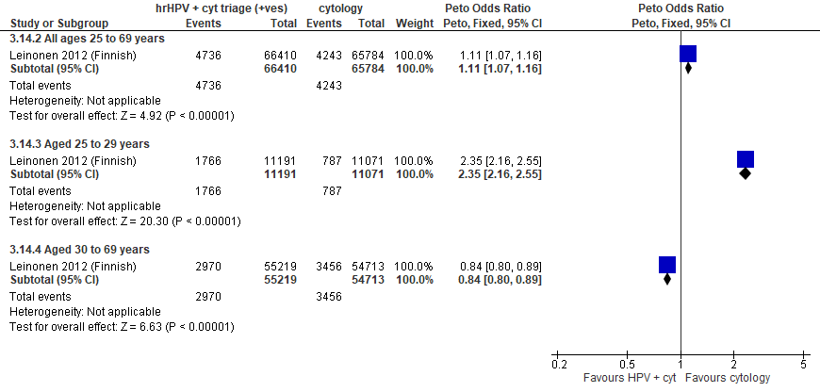
Forest plot 2.9b. False positives for CIN2+ (to recall)

Evidence Set 2.10b. False positives for CIN3+ (to recall)
Included report: Leinonen 2012 (Finnish)
GRADE Summary of Findings Table 2.10b. False positives for CIN3+ (to recall)
Outcome  No. participantsª  (studies) |  | Relative effects, Peto OR and RR (95 % CI) | Anticipated absolute effects |  |  | Certainty of evidence (GRADE)^{b} | What happens?
 |  | Relative effects, Peto OR and RR (95 % CI) | With cytology screening | With hrHPV screening + cytology triage | Difference | Certainty of evidence (GRADE)^{b} | What happens?
People with a cervix aged 25 to 69 years (Leinonen 2012 (Finnish); acceptors of screening)
False positives for CIN3+ (to recall)  Follow-up: 1 round  132,194 (1 RCT) | Peto OR: 1.15 (1.10 to 1.20)  RR: 1.14 (1.09 to 1.18) |  | 670.8 per 10,000 | 763.8 per 10,000 | 92.9 less per 10,000 (62.2 less to 123.5 less) | NA
>Subgroup: people with a cervix aged 25 to 29 years (Leinonen 2012 (Finnish); acceptors of screening)
False positives for CIN3+ (to recall)  Follow-up: 1 round  22,262 (1 RCT) | Peto OR: 2.36 (2.18 to 2.56)  RR: 2.14 (2.00 to 2.28) |  | 774.1 per 10,000 | 1,652.9 per 10,000 | 878.8 more per 10,000 (772.2 more to 994.1 more) | MODERATE^{c}  ⊕⊕⊕⊝  due to lack of evidence of consistency | Among screened people with a cervix aged 25 to 29 years, hrHPV testing with cytology triage probably increases the number of false positives for CIN3+ compared with cytology testing.
>Subgroup: people with a cervix aged 30 to 69 years (Leinonen 2012 (Finnish); acceptors of screening)
False positives for CIN3+ (to recall)  Follow-up: 1 round  109,932 (1 RCT) | Peto OR: 0.87 (0.83 to 0.91)  RR: 0.88 (0.84 to 0.92) |  | 649.9 per 10,000 | 570.3 per 10,000 | 79.7 less per 10,000 (104.5 less to 55.0 less) | 30-59 yrs:  MODERATE^{d}  ⊕⊕⊕⊝  due to lack of evidence of consistency  60-69 yrs: MODERATE^{e}  ⊕⊕⊕⊝  due to lack of evidence of consistency, and indirectness | Among screened people with a cervix aged 30 to 69 years, hrHPV testing with cytology triage probably has little-to-no effect on the number of false positives for CIN3+ compared with cytology testing.
CI = confidence interval; CIN = cervical intraepithelial neoplasia; NA= not applicable (i.e., not used for conclusions); OR = odds ratio; RCT = randomized controlled trial; RR = relative risk.
ªAcceptors of screening include participants who were randomized and accepted the offer to be screened. The analysis excludes outcomes among those who were screened in a group different to which they were randomly assigned (4,304/66,410 [6%] people with a cervix in the hrHPV screening group received cytology screening and 37/65,784 [0.06%] people in the cytology screening group received hrHPV screening) (akin to a screened per protocol analysis). False positives were calculated based on those referred to colposcopy or intensive follow-up following the index screen.
^{b}We rated down by 0.5 for “some concerns”, 1 “serious concerns”, and 2 for “very serious concerns”. When our assessment of the certainty of evidence fell between levels, we assigned the level that best represented our actual certainty in the evidence, and based our conclusions on this level of certainty.
Explanations:
^{c}Acceptors of screening; people with a cervix aged 25 to 29 years: No serious concerns about risk of bias: no domains judged high risk. Some concerns about inconsistency: lack of evidence for consistency due to single study. No serious concerns about indirectness: the study provides direct evidence. No serious concerns about imprecision: 95% CI precise for little-to-no effect. No other serious concerns.
^{d}Acceptors of screening; people with a cervix aged 30 to 59 years: No serious concerns about risk of bias: no domains judged high risk. Some concerns about inconsistency: lack of evidence for consistency due to single study. No serious concerns about indirectness: the study provides direct evidence. No serious concerns about imprecision: 95% CI precise for an increased effect. No other serious concerns.
^{e}Acceptors of screening; people with a cervix aged 60 to 69 years: No serious concerns about risk of bias: no domains judged high risk. Some concerns about inconsistency: lack of evidence for consistency due to single study. Some concerns about indirectness: there are some concerns of whether the sample in this age group is small (n=NR). No serious concerns about imprecision: 95% CI precise for little-to-no effect. No other serious concerns.

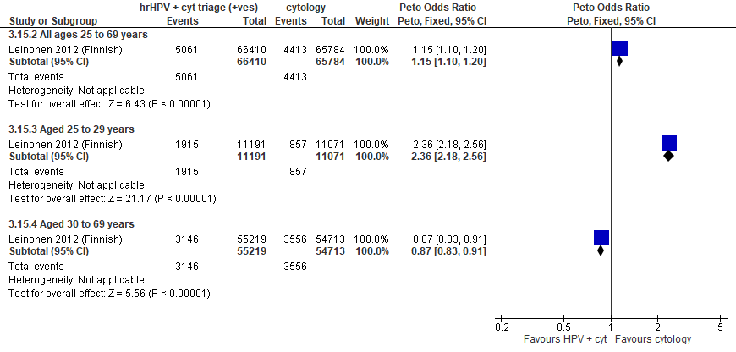
Forest plot 2.10b. False positives for CIN3+ (to recall)

Evidence Set 2.11b. False positives for invasive cervical cancer (to recall)
Included report: Leinonen 2012 (Finnish)
GRADE Summary of Findings Table 2.11b. False positives for invasive cervical cancer
Outcome  No. participantsª  (studies) |  | Relative effects, Peto OR and RR (95 % CI) | Anticipated absolute effects |  |  | Certainty of evidence (GRADE)^{b} | What happens?
 |  | Relative effects, Peto OR and RR (95 % CI) | With cytology screening | With hrHPV screening + cytology triage | Difference | Certainty of evidence (GRADE)^{b} | What happens?
People with a cervix aged 25 to 69 years (Leinonen 2012 (Finnish); acceptors of screening)
False positives for invasive cervical cancer (to recall)  Follow-up: 1 round  132,194 (1 RCT) | Peto OR: 1.16 (1.12 to 1.21)  RR: 1.15 (1.11 to 1.19) |  | 684.5 per 10,000 | 785.4 per 10,000 | 100.9 more per 10,000 (75.9 more to 132.0 more) | NA
>Subgroup: people with a cervix aged 25 to 29 years (Leinonen 2012 (Finnish); acceptors of screening)
False positives for invasive cervical cancer (to recall)  Follow-up: 1 round  22,262 (1 RCT) | Peto OR: 2.38 (2.20 to 2.58)  RR: 2.14 (2.01 to 2.29) |  | 794.0 per 10,000 | 1,703.0 per 10,000 | 909.1 more per 10,000 (800.8 more to 1026.1 more) | MODERATE^{c}  ⊕⊕⊕⊝  due to lack of evidence of consistency | Among screened people with a cervix aged 25 to 29 years, hrHPV testing with cytology triage probably increases the number of false positives for invasive cervical cancer compared with cytology testing.
>Subgroup: people with a cervix aged 30 to 69 years (Leinonen 2012 (Finnish); acceptors of screening)
False positives for invasive cervical cancer (to recall)  Follow-up: 1 round  109,932 (1 RCT) | Peto OR: 0.88 (0.84 to 0.93)  RR: 0.89 (0.85 to 0.93) |  | 662.4 per 10,000 | 587.6 per 10,000 | 74.8 less per 10,000 (100.0 less to 43.5 less) | 30-59 yrs:  MODERATE^{d}  ⊕⊕⊕⊝  due to lack of evidence of consistency  60-69 yrs:  MODERATE^{e}  ⊕⊕⊕⊝  due to lack of evidence of consistency, and indirectness | Among screened people with a cervix aged 30 to 69 years, hrHPV testing with cytology triage probably has little-to-no effect on the number of false positives for invasive cervical cancer compared with cytology testing.
CI = confidence interval; NA= not applicable (i.e., not used for conclusions); OR = odds ratio; RCT = randomized controlled trial; RR = relative risk.
ªAcceptors of screening include participants who were randomized and accepted the offer to be screened. The analysis excludes outcomes among those who were screened in a group different to which they were randomly assigned (4,304/66,410 [6%] people with a cervix in the hrHPV screening group received cytology screening and 37/65,784 [0.06%] people in the cytology screening group received hrHPV screening) (akin to a screened per protocol analysis). False positives were calculated based on those referred to colposcopy or intensive follow-up following the index screen.
^{b}We rated down by 0.5 for “some concerns”, 1 “serious concerns”, and 2 for “very serious concerns”. When our assessment of the certainty of evidence fell between levels, we assigned the level that best represented our actual certainty in the evidence, and based our conclusions on this level of certainty.
Explanations:
^{c}Acceptors of screening; people with a cervix aged 25 to 29 years: No serious concerns about risk of bias: no domains judged high risk. Some concerns about inconsistency: lack of evidence for consistency due to single study. No serious concerns about indirectness: the study provides direct evidence. No serious concerns about imprecision: 95% CI precise for little-to-no effect. No other serious concerns.
^{d}Acceptors of screening; people with a cervix aged 30 to 59 years: No serious concerns about risk of bias: no domains judged high risk. Some concerns about inconsistency: lack of evidence for consistency due to single study. No serious concerns about indirectness: the study provides direct evidence. No serious concerns about imprecision: 95% CI precise for an increased effect. No other serious concerns.
^{e}Acceptors of screening; people with a cervix aged 60 to 69 years: No serious concerns about risk of bias: no domains judged high risk. Some concerns about inconsistency: lack of evidence for consistency due to single study. Some concerns about indirectness: there are some concerns of whether the sample in this age group is small (n=NR). No serious concerns about imprecision: 95% CI precise for little-to-no effect. No other serious concerns.

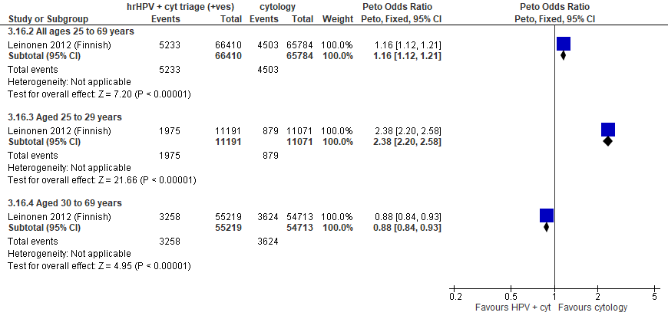
Forest plot 2.11b. False positives for invasive cervical cancer (to recall)

Evidence Set 2.12b. Overdiagnosis of non-progressive CIN3
Included report: Malila 2013 (Finnish)
Summary of trial results:
Screening intervention | Results dataª
Overdiagnosis rate (95% CI) per 1,000 person-years
hrHPV screening with conventional cytology triage of positive tests | 39.6 (31.3, 48.9)
Conventional cytology screening | 20.3 (13.6, 27.9)
Overdiagnosis benefit ratio
hrHPV screening with conventional cytology triage of positive tests | 2.3
Conventional cytology screening | 1.1
ªWhere:
Overdiagnosis = P3 – (P0 - P1) = risk of CIN3 cases that would not have progressed to invasive disease by the next screen (5 years later)
P0 = cancer incidence assuming no screening (17 per 100,000 person years) was estimated as the incidence in entire Finland in 1958–1962 and corrected for the hypothetical time trend in the absence of screening and for the cervical cancer risk in nonattenders
P1 = rate of interval cancers;
P3 = period prevalence of CIN3 lesions at screen and during the subsequent interval in all attenders of the entry screen
P0-P1 = the risk of prevented cancers in an interval ("benefit")

Outcome  No. participantsª  (studies) |  | Absolute effects, RD (95 % CI) | Anticipated absolute effects |  |  | Certainty of evidence (GRADE)^{b} | What happens?
 |  | Absolute effects, RD (95 % CI) | With cytology screening | With hrHPV screening + cytology triage | Difference | Certainty of evidence (GRADE)^{b} | What happens?
People with a cervix aged 25 to 69 years (Malila 2013 (Finnish); acceptors of screening)
Overdiagnosis of CIN3  Follow-up: 1 round  132,194 (1 RCT but using observational data) | 19.3 (95% CI not estimated) per 1,000 person years |  | 20.3 (13.6, 27.9) per 1,000 person years | 39.6 (31.3, 48.9) per 1,000 person years | 19.3 more cases of overdiagnosis per 1,000 person years from hrHPV strategy | 25-29 yrs:  VERY LOW^{c}  ⊕⊝⊝⊝  due to risk of bias, lack of consistency, and indirectness  30-59 yrs:  VERY LOW^{d}  ⊕⊝⊝⊝  due to risk of bias, lack of consistency, and indirectness  60-69 yrs:  VERY LOW^{e}  ⊕⊝⊝⊝  due to risk of bias, lack of consistency, and indirectness | Among screened people with a cervix aged 25 to 69 years, we are very uncertain about the effects on overdiagnosis of non-progressive CIN 3 from hrHPV testing with cytology triage compared with cytology testing.
CI = confidence interval; CIN = cervical intraepithelial neoplasia; OR = odds ratio; RCT = randomized controlled trial; RD = risk difference.
Explanation: This was considered observational data because the rates of CIN3 in the absence of screening for the estimations were based on population-based data.
^{c}Acceptors of screening; people with a cervix aged 25 to 29 years: Serious concerns about risk of bias: risk of reporting bias because interval cancers were not ascertained actively for all participants (data linkage); some outcomes could be missing. Some concerns about inconsistency: lack of evidence for consistency due to single study. Serious concerns about indirectness: the data for the cancer incidence assuming no screening was based on very old data. No serious concerns about imprecision: 95% CI would be precise for little-to-no effect. No other serious concerns.
^{d}Acceptors of screening; people with a cervix aged 30 to 59 years: Serious concerns about risk of bias: risk of reporting bias because interval cancers were not ascertained actively for all participants (data linkage); some outcomes could be missing. Some concerns about inconsistency: lack of evidence for consistency due to single study. Serious concerns about indirectness: the data for the cancer incidence assuming no screening was based on very old data. No serious concerns about imprecision: 95% CI would be precise for little-to-no effect. No other serious concerns.
^{e}Acceptors of screening; people with a cervix aged 60 to 69 years: Serious concerns about risk of bias: risk of reporting bias because interval cancers were not ascertained actively for all participants (data linkage); some outcomes could be missing. Some concerns about inconsistency: lack of evidence for consistency due to single study. Serious concerns about indirectness: the data for the cancer incidence assuming no screening was based on very old data, and there are some concerns of whether the sample in this age group is small (n=NR). No serious concerns about imprecision: 95% CI would be precise for little-to-no effect. No other serious concerns.

Evidence set 3.0a: hrHPV screening (threshold not reported or threshold 1.0 RLU) with liquid-based cytology triage of positive tests versus liquid-based cytology screening (threshold ≥HSIL or ≥LSIL) with hrHPV triage of ASCUS or LSIL; without recall

Included reports: Elfstrom 2021 (Sweden) (ages 30-64 [subgroups 30-59 and 60-64 years]); Lamin 2017 (Stockholm/Gotlund) (ages 56-60 [no subgroups]); Ogilvie 2017 (HPV FOCAL) (ages 25-65 [subgroups 25-29 and 30-65 years])

Evidence set 3.1a. Referrals to colposcopy
GRADE Summary of Findings Table 3.1a. Referrals to colposcopy
Outcome  No. participantsª  (studies) |  | Relative effects  Peto OR and RR (95% CI) | Anticipated absolute effects (95% CI) |  |  | Certainty of evidence (GRADE)^{b} | What happens?
 |  | Relative effects  Peto OR and RR (95% CI) | With cytology screening + hrHPV triage | With hrHPV screening + cytology triage | Difference | Certainty of evidence (GRADE)^{b} | What happens?
People with a cervix aged 25 to 69 years (Elfstrom 2021 (Swedish); Ogilvie 2017 (HPV FOCAL); acceptors of screening)
Referrals to colposcopy  Follow-up: at baseline  226,132 (2 RCTs) | Peto OR: 1.19 (1.13 to 1.26)  RR: 1.19 (1.13 to 1.26) |  | 204.6 per 10,000 | 242.5 per 10,000 | 37.9 more per 10,000 (26.0 more to 51.8 more) | 25-29 yrs:  LOW^{c}  ⊕⊕⊝⊝  due risk of bias, lack of evidence of consistency, and indirectness  30-59 yrs:  MODERATE^{d}  ⊕⊕⊕⊝  due risk of bias, and lack of evidence of consistency  60-69 yrs:  MODERATE^{e}  ⊕⊕⊕⊝  due risk of bias, and lack of evidence of consistency | Among screened people with a cervix aged 25 to 29 years, hrHPV testing with cytology triage may have little-to-no effect on the rate of referral to colposcopy compared with cytology testing with hrHPV triage.  Among screened people with a cervix aged 30 to 69 years, hrHPV testing with cytology triage probably has little-to-no effect on the rate of referral to colposcopy compared with cytology testing with hrHPV triage.
>Subgroup: People with a cervix aged 25 to 29 years (Ogilvie 2017 (HPV FOCAL); acceptors of screening)
Referrals to colposcopy  Follow-up: at baseline  2,188 (1 RCT) | Peto OR: 1.29 (0.96 to 1.74)  RR: 1.26 (0.96 to 1.64) |  | 791.4 per 10,000 | 998.0 per 10,000 | 206.6 more per 10,000 (29.2 less to 509.4 more) | NA
>Subgroup: People with a cervix aged 30 to 59 years (Elfstrom 2021 (Swedish); Lamin 2017 (Stockholm/Gotlund); Ogilvie 2017 (HPV FOCAL); acceptors of screening)
Referrals to colposcopy  Follow-up: at baseline  219,067  (3 RCTs) | Peto OR: 1.21 (1.14 to 1.28)  RR: 1.20 (1.14 to 1.27) |  | 200.3 per 10,000 | 241.4 per 10,000 | 41.1 more per 10,000 (27.4 more to 54.7 more) | NA
People with a cervix aged 60 to 69 years (Elfstrom 2021 (Swedish); acceptors of screening)
Referrals to colposcopy  Follow-up: at baseline  19,789 (1 RCT) | Peto OR: 1.34 (1.00 to 1.80)  RR: 1.34 (1.00 to 1.79) |  | 76.9 per 10,000 | 102.8 per 10,000 | 25.9 more per 10,000 (0.0 more to 60.7 more) | NA
CI = confidence interval; NA= not applicable (i.e., not used for conclusions); OR = odds ratio; RCT = randomized controlled trial; RR = relative risk.
ªAcceptors of screening include all participants who completed one round of screening via the strategy to which they were randomly assigned.
^{b}We rated down by 0.5 for “some concerns”, 1 “serious concerns”, and 2 for “very serious concerns”. When our assessment of the certainty of evidence fell between levels, we assigned the level that best represented our actual certainty in the evidence, and based our conclusions on this level of certainty.
Explanations:
^{c}Acceptors of screening; people with a cervix aged 25 to 29 years: Some concerns about risk of bias: 86% weight in analysis from single study at risk of selection bias because randomization occurred before enrollment, without adequate information about baseline characteristics across groups. Some concerns about inconsistency: lack of evidence of consistency (86% weight in analysis from single study). Serious concerns about indirectness: the data is indirect for this age group which contributed <1% of the sample population. No serious concerns about imprecision: 95% CI precise for little-to-no effect. No other serious concerns.
^{d}Acceptors of screening; people with a cervix aged 30 to 59 years: Some concerns about risk of bias: 86% weight in analysis from single study at risk of selection bias because randomization occurred before enrollment, without adequate information about baseline characteristics across groups. Some concerns about inconsistency: lack of evidence of consistency (86% weight in analysis from single study). No serious concerns about indirectness: the studies provide direct evidence. No serious concerns about imprecision: 95% CI precise for little-to-no effect. No other serious concerns.
^{e}Acceptors of screening; people with a cervix aged 60 to 69 years: Some concerns about risk of bias: 86% weight in analysis from single study at risk of selection bias because randomization occurred before enrollment, without adequate information about baseline characteristics across groups. Some concerns about inconsistency: lack of evidence of consistency (86% weight in analysis from single study). No serious concerns about indirectness: the study provides direct evidence. No serious concerns about imprecision: 95% CI precise for little-to-no effect. No other serious concerns.
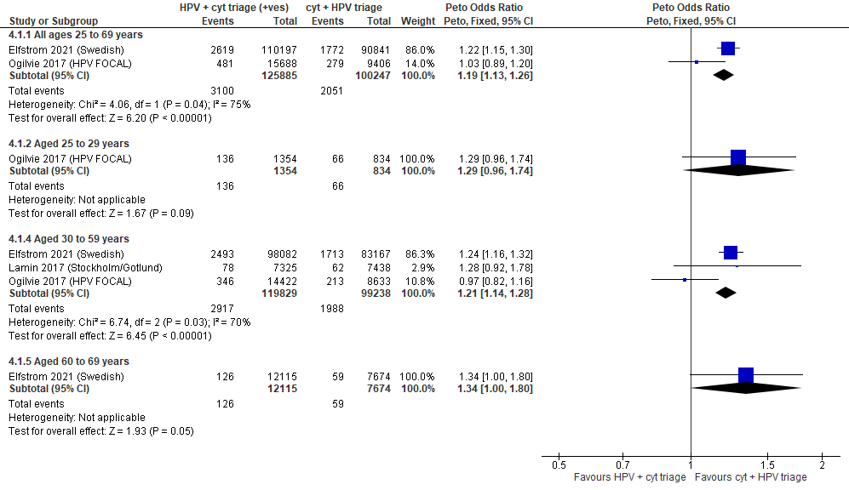
Forest Plot 3.1a. Referrals to colposcopy

Evidence set 3.2a. Number of colposcopies
Included reports: Ogilvie 2017 (HPV FOCAL)
GRADE Summary of Findings Table 3.2a. Number of colposcopies
Outcome  No. participantsª  (studies) |  | Relative effects, Peto OR and RR (95 % CI) | Anticipated absolute effects (95% CI) |  |  | Certainty of evidence (GRADE)^{b} | What happens?
 |  | Relative effects, Peto OR and RR (95 % CI) | With cytology screening + hrHPV triage | With hrHPV screening + cytology triage | Difference | Certainty of evidence (GRADE)^{b} | What happens?
People with a cervix aged 25 to 69 years (Ogilvie 2017 (HPV FOCAL); acceptors of screening)
Number of colposcopies  Follow-up: at baseline  25,094 (1 RCT) | Peto OR: 1.01 (0.87 to 1.18)  RR: 1.01 (0.87 to 1.17) |  | 286.0 per 10,000 | 288.8 per 10,000 | 2.8 more per 10,000 (36.2 less to 49.7 more) | 25-29 yrs:  LOW^{c}  ⊕⊕⊝⊝  due to lack of evidence of consistency, and indirectness  30-59 yrs:  MODERATE^{d}  ⊕⊕⊕⊝  due to lack of evidence of consistency  60-69 yrs:  MODERATE^{e}  ⊕⊕⊕⊝  due to lack of evidence of consistency, and indirectness | Among screened people with a cervix aged 25 to 29 years, hrHPV testing with cytology triage may have little-to-no effect on the number of colposcopies compared with cytology testing with hrHPV triage.  Among screened people with a cervix aged 30 to 69 years, hrHPV testing with cytology triage probably has little-to-no effect on the number of colposcopies compared with cytology testing with hrHPV triage.
CI = confidence interval; NA= not applicable (i.e., not used for conclusions); OR = odds ratio; RCT = randomized controlled trial; RR = relative risk.
ªAcceptors of screening include all participants who were screened and followed the protocol in the group to which they were randomized. Those who had a negative screening test were not referred to colposcopy, exited the study, and data on attendance at colposcopy for other indications were not collected. For the purpose of this analysis, colposcopies taken outside of the trial for purposes other than a positive screening test were not included.
^{b}We rated down by 0.5 for “some concerns”, 1 “serious concerns”, and 2 for “very serious concerns”. When our assessment of the certainty of evidence fell between levels, we assigned the level that best represented our actual certainty in the evidence, and based our conclusions on this level of certainty.
Explanations:
^{c}Acceptors of screening; people with a cervix aged 25 to 29 years: No serious concerns about risk of bias: no domains judged high risk. Some concerns about inconsistency: lack of evidence of consistency due to single study. Serious concerns about indirectness: the study data is not directly applicable for this age group due to a small sample (n=2,188 [8.7%] enrolled) and evidence from the referral outcome of differing effects. No serious concerns about imprecision: 95% CI precise for little-to-no effect. No other serious concerns.
^{d}Acceptors of screening; people with a cervix aged 30 to 59 years: No serious concerns about risk of bias: no domains judged high risk. Some concerns about inconsistency: lack of evidence of consistency due to single study. No serious concerns about indirectness: the studies provide direct evidence. No serious concerns about imprecision: 95% CI precise for little-to-no effect. No other serious concerns.
^{e}Acceptors of screening; people with a cervix aged 60 to 69 years: No serious concerns about risk of bias: no domains judged high risk. Some concerns about inconsistency: lack of evidence of consistency due to single study. Some concerns about indirectness: the study data is not directly applicable for this age group due to a small sample (n=2,094 [8.3%] enrolled) though there is some evidence from the referrals outcome of similar effects to those 30-59 years. No serious concerns about imprecision: 95% CI precise for little-to-no effect. No other serious concerns.

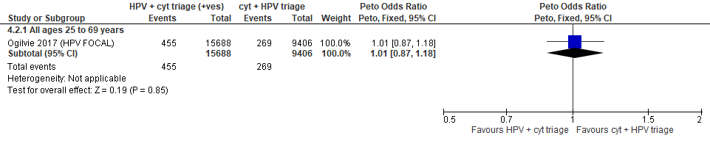
Forest Plot 3.2a. Number of colposcopies

Evidence set 3.3a. Number of biopsies
Included reports: Elfstrom 2021 (Sweden)
GRADE Summary of Findings Table 3.3a. Number of biopsies
Outcome  No. participantsª  (studies) |  | Relative effects  Peto OR and RR (95% CI) | Anticipated absolute effects (95% CI) |  |  | Certainty of evidence (GRADE)^{b} | What happens?
 |  | Relative effects  Peto OR and RR (95% CI) | With cytology screening + hrHPV triage | With hrHPV screening + cytology triage | Difference | Certainty of evidence (GRADE)^{b} | What happens?
People with a cervix aged 30 to 69 years (Elfstrom 2021 (Swedish); acceptors of screening)
Number of biopsies  Follow-up: at baseline  201,038 (1 RCT) | Peto OR: 1.24 (1.16 to 1.31)  RR: 1.23 (1.16 to 1.30) |  | 183.1 per 10,000 | 226.0 per 10,000 | 42.9 more per 10,000 (28.7 more to 55.4 more) | 25-29 yrs:  VERY LOW  ⊕⊝⊝⊝  NR  MODERATE^{c}  ⊕⊕⊕⊝  due to risk of bias, and lack of evidence of consistency  MODERATE^{d}  ⊕⊕⊕⊝  due to risk of bias, and lack of evidence of consistency | Among screened people with a cervix aged 25 to 29 years, we are very uncertain about whether hrHPV testing with cytology triage makes a difference for the number of biopsies compared with cytology testing with hrHPV.  Among screened people with a cervix aged 30 to 69 years, hrHPV testing with cytology triage probably has little-to-no effect on the number of biopsies compared with cytology testing with hrHPV triage.
>Subgroup: People with a cervix aged 30 to 59 years (Elfstrom 2021 (Swedish); acceptors of screening)
Number of biopsies  Follow-up: at baseline  181,349 (1 RCT) | Peto OR: 1.25 (1.17 to 1.33)  RR: 1.24 (1.17 to 1.32) |  | 194.7 per 10,000 | 242.2 per 10,000 | 47.5 more per 10,000 (32.3 more to 62.6 more) | NA
>Subgroup: People with a cervix aged 60 to 69 years (Elfstrom 2021 (Swedish); acceptors of screening)
Number of biopsies  Follow-up: at baseline  19,789 (1 RCT) | Peto OR: 1.48 (1.06 to 2.06)  RR: 1.48 (1.06 to 2.05) |  | 57.3 per 10,000 | 84.6 per 10,000 | 27.3 more per 10,000 (3.4 more to 60.1) | NA
CI = confidence interval; NA= not applicable (i.e., not used for conclusions); OR = odds ratio; RCT = randomized controlled trial; RR = relative risk.
ªAcceptors of screening include all participants who completed one round of screening via the strategy to which they were randomly assigned.
^{b}We rated down by 0.5 for “some concerns”, 1 “serious concerns”, and 2 for “very serious concerns”. When our assessment of the certainty of evidence fell between levels, we assigned the level that best represented our actual certainty in the evidence, and based our conclusions on this level of certainty.
Explanations:
^{c} Acceptors of screening; people with a cervix aged 30 to 59 years: Some concerns about risk of bias: at risk of selection bias because randomization occurred before enrollment, without adequate information about baseline characteristics across groups. Some concerns about inconsistency: lack of evidence of consistency due to single study. No serious concerns about indirectness: the study provides direct evidence. No serious concerns about imprecision: 95% CI precise for little-to-no effect. No other serious concerns.
^{d} Acceptors of screening; people with a cervix aged 60 to 69 years: Some concerns about risk of bias: at risk of selection bias because randomization occurred before enrollment, without adequate information about baseline characteristics across groups. Some concerns about inconsistency: lack of evidence of consistency due to single study. No serious concerns about indirectness: the study provides direct evidence. No serious concerns about imprecision: 95% CI precise for little-to-no effect. No other serious concerns.

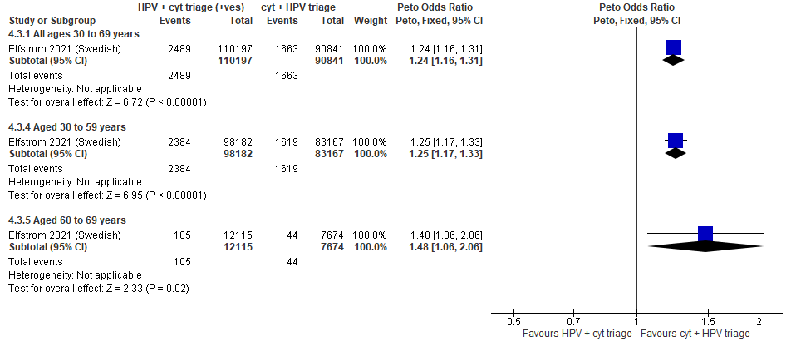
Forest Plot 3.3a. Number of biopsies

Evidence Set 3.4a. Detection of CIN2+ (as an indirect indicator of the incidence of CIN3+)
Included reports: Elfstrom 2021 (Swedish); Lamin 2017 (Stockholm/Gotlund); Ogilvie 2017 (HPV FOCAL)
GRADE Summary of Findings Table 3.4a. Detection of CIN2+ (as an indirect indicator of the incidence of CIN3+)
Outcome  No. participantsª  (studies) |  | Relative effects  Peto OR and RR (95% CI) | Anticipated absolute effects (95% CI) |  |  | Certainty of evidence (GRADE)^{b} | What happens?
 |  | Relative effects  Peto OR and RR (95% CI) | With cytology screening + hrHPV triage | With hrHPV screening + cytology triage | Difference | Certainty of evidence (GRADE)^{b} | What happens?
People with a cervix aged 25 to 69 years (Elfstrom 2021 (Swedish); Ogilvie 2017 (HPV FOCAL); acceptors of screening)
Detection of CIN2+  Follow-up: at baseline  226,132 (2 RCTs) | Peto OR: 1.10 (1.01 to 1.20)  RR: 1.10 (1.01 to 1.20) |  | 93.6 per 10,000 | 102.8 per 10,000 | 9.3 more per 10,000 (0.9 more to 18.5 more) | 25-29 yrs:  VERY LOW^{c}  ⊕⊝⊝⊝  due to risk of bias, lack of evidence of consistency, serious indirectness  30-59 yrs:  LOW^{d}  ⊕⊕⊝⊝  due to risk of bias, lack of evidence of consistency and indirectness  60-69 yrs:  LOW^{e}  ⊕⊕⊝⊝  due to risk of bias, lack of evidence of consistency and indirectness | Among screened people with a cervix aged 25 to 29 years, we are very uncertain about whether hrHPV testing with cytology triage makes a difference for the incidence of CIN3+ compared with cytology testing with hrHPV.  Among screened people with a cervix aged 30 to 69 years, hrHPV testing with cytology triage may have little-to-no effect on the incidence of CIN3+ compared with cytology testing with hrHPV triage.
>Subgroup: People with a cervix aged 25 to 29 years (Ogilvie 2017 (HPV FOCAL); acceptors of screening)
Detection of CIN2+  Follow-up: at baseline  2,188 (1 RCT) | Peto OR: 0.96 (0.58 to 1.57)  RR: 0.96 (0.59 to 1.54) |  | 323.7 per 10,000 | 311.2 per 10,000 | 12.5 less per 10,000 (133.4 less to 175.3 more) | NA
>Subgroup: People with a cervix aged 30 to 59 years (Elfstrom 2021 (Swedish); Lamin 2017 (Stockholm/Gotlund); Ogilvie 2017 (HPV FOCAL); acceptors of screening)
Detection of CIN2+  Follow-up: at baseline  219,067 (3 RCTs) | Peto OR: 1.13 (1.03 to 1.23)  RR: 1.13 (1.03 to 1.23) |  | 91.3 per 10,000 | 103.0 per 10,000 | 11.7 more per 10,000 (2.7 more to 20.8 more) | NA
People with a cervix aged 60 to 69 years (Elfstrom 2021 (Swedish); acceptors of screening)
Detection of CIN2+  Follow-up: at baseline  19,789 (1 RCT) | Peto OR: 1.15 (0.69 to 1.92)  RR: 1.15 (0.69 to 1.91) |  | 28.7 per 10,000 | 33.0 per 10,000 | 4.3 more per 10,000 (8.9 less to 26.2 more) | NA
CI = confidence interval; NA= not applicable (i.e., not used for conclusions); CIN = cervical intraepithelial neoplasia; OR = odds ratio; RCT = randomized controlled trial; RR = relative risk.
ª Acceptors of screening include all participants who completed one round of screening via the strategy to which they were randomly assigned.
^{b}We rated down by 0.5 for “some concerns”, 1 “serious concerns”, and 2 for “very serious concerns”. When our assessment of the certainty of evidence fell between levels, we assigned the level that best represented our actual certainty in the evidence, and based our conclusions on this level of certainty.
Explanations:
^{c}Acceptors of screening; people with a cervix aged 25 to 29 years: Some concerns about risk of bias: 89% weight in analysis from single study at risk of selection bias because randomization occurred before enrollment, without adequate information about baseline characteristics across groups. Some concerns about inconsistency: lack of evidence of consistency (89% weight in analysis from single study). Very serious concerns about indirectness: detection is an indirect measure of incidence and the data is indirect for this age group which contributed <1% of the sample population. No serious concerns about imprecision: upper and lower limit of 95% CI indicate little-to-no difference. No other serious concerns.
^{d}Acceptors of screening; people with a cervix aged 30 to 59 years: Some concerns about risk of bias: 89% weight in analysis from single study at risk of selection bias because randomization occurred before enrollment, without adequate information about baseline characteristics across groups. Some concerns about inconsistency: lack of evidence of consistency (89% weight in analysis from single study). Serious concerns about indirectness: detection is an indirect measure of incidence. No serious concerns about imprecision: 95% CI precise for little-to-no effect. No other serious concerns.
^{e}Acceptors of screening; people with a cervix aged 60 to 69 years: Some concerns about risk of bias: 89% weight in analysis from single study at risk of selection bias because randomization occurred before enrollment, without adequate information about baseline characteristics across groups. Some concerns about inconsistency: lack of evidence of consistency (89% weight in analysis from single study). Serious concerns about indirectness: detection is an indirect measure of incidence. No serious concerns about imprecision: 95% CI precise for little-to-no effect. No other serious concerns.

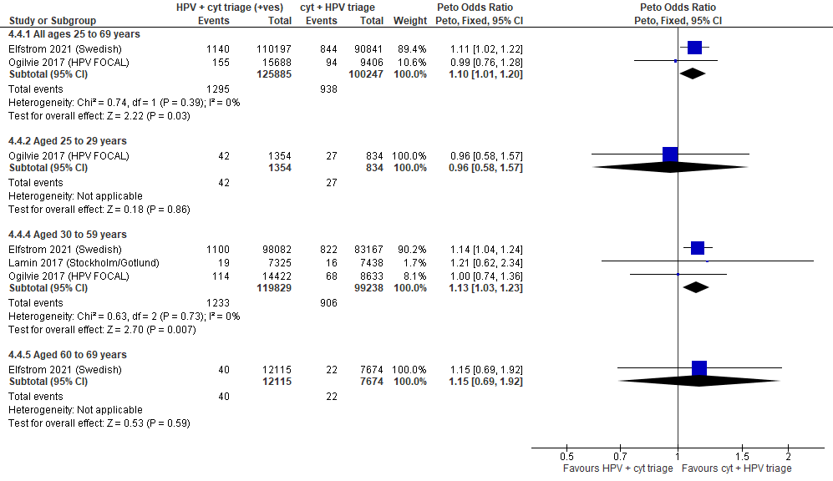
Forest Plot 3.4a. Detection of CIN2+ (as an indirect indicator of the incidence of CIN3+)

Evidence Set 3.5a. Detection of CIN3+ (as an indirect indicator of the incidence of ICC)
Included reports: Elfstrom 2021 (Swedish); Lamin 2017 (Stockholm/Gotlund); Ogilvie 2017 (HPV FOCAL)
GRADE Summary of Findings Table 3.5a. Detection of CIN3+ (as an indirect indicator of the incidence of ICC)
Outcome  No. participantsª  (studies) |  | Relative effects  Peto OR and RR (95% CI) | Anticipated absolute effects (95% CI) |  |  | Certainty of evidence (GRADE)^{b} | What happens?
 |  | Relative effects  Peto OR and RR (95% CI) | With cytology screening + hrHPV triage | With hrHPV screening + cytology triage | Difference | Certainty of evidence (GRADE)^{b} | What happens?
People with a cervix aged 25 to 69 years (Elfstrom 2021 (Swedish); Ogilvie 2017 (HPV FOCAL); acceptors of screening)
Detection of CIN3+  Follow-up: at baseline  226,132 (2 RCTs) | Peto OR: 1.03 (0.92 to 1.15)  RR: 1.03 (0.92 to 1.15) |  | 56.6 per 10,000 | 58.2 per 10,000 | 1.7 more per 10,000 (4.5 less to 8.4 more) | NA
>Subgroup: People with a cervix aged 25 to 29 years (Ogilvie 2017 (HPV FOCAL); acceptors of screening)
Detection of CIN3+  Follow-up: at baseline  2,188 (1 RCT) | Peto OR: 0.86 (0.44 to 1.69)  RR: 0.86 (0.44 to 1.67) |  | 179.9 per 10,000 | 155.1 per 10,000 | 24.8 less per 10,000 (99.9 less to 120.4 more) | VERY LOW^{c}  ⊕⊝⊝⊝  due to lack of evidence of consistency, indirectness, and imprecision | Among screened people with a cervix aged 25 to 29 years, we are very uncertain about the effects on the incidence of invasive cervical cancer for hrHPV testing with cytology triage compared with cytology testing with hrHPV triage.
>Subgroup: People with a cervix aged 30 to 59 years (Elfstrom 2021 (Swedish); Lamin 2017 (Stockholm/Gotlund); Ogilvie 2017 (HPV FOCAL); acceptors of screening)
Detection of CIN3+  Follow-up: at baseline  219,067 (3 RCTs) | Peto OR: 1.73 (1.56 to 1.92)  RR: 1.72 (1.56 to 1.91) |  | 43.5 per 10,000 | 75.1 per 10,000 | 31.5 more per 10,000 (24.2 more to 39.7 more) | MODERATE^{d}  ⊕⊕⊕⊝  due to indirectness | Among screened people with a cervix aged 30 to 59 years, hrHPV testing with cytology triage probably reduces the incidence of invasive cervical cancer compared with cytology testing with hrHPV triage.
People with a cervix aged 60 to 69 years (Elfstrom 2021 (Swedish); acceptors of screening)
Detection of CIN3+  Follow-up: at baseline  19,789 (1 RCT) | Peto OR: 0.82 (0.43 to 1.56)  RR: 0.82 (0.43 to 1.56) |  | 22.2 per 10,000 | 18.2 per 10,000 | 4.0 less per 10,000 (12.6 less to 12.4 more) | LOW^{e}  ⊕⊕⊝⊝  due to risk of bias, lack of evidence of inconsistency, indirectness, and imprecision | Among screened people with a cervix aged 60 to 69 years, hrHPV testing with cytology triage may have little-to-no effect on the incidence of invasive cervical cancer compared with cytology testing with hrHPV triage.
CI = confidence interval; CIN = cervical intraepithelial neoplasia; NA= not applicable (i.e., not used for conclusions); OR = odds ratio; RCT = randomized controlled trial; RR = relative risk.
ªAcceptors of screening include all participants who completed one round of screening via the strategy to which they were randomly assigned.
^{b}We rated down by 0.5 for “some concerns”, 1 “serious concerns”, and 2 for “very serious concerns”. When our assessment of the certainty of evidence fell between levels, we assigned the level that best represented our actual certainty in the evidence, and based our conclusions on this level of certainty.
Explanations:
^{c}Acceptors of screening; people with a cervix aged 25 to 29 years: No serious concerns about risk of bias: no domains judged high risk. Some concerns about inconsistency: lack of evidence of consistency due to single study. Serious concerns about indirectness: detection is an indirect measure of incidence. Serious concerns about imprecision: upper limit of 95% CI indicates an increased effect. No other serious concerns.
^{d}Acceptors of screening; people with a cervix aged 30 to 59 years: No serious concerns about risk of bias: one study at high risk of bias for selection bias but contributes <80% weight in the analysis and results across the larger studies do not differ with respect to our threshold. No serious concerns about inconsistency: results across the larger studies do not differ with respect to our threshold. Serious concerns about indirectness: detection is an indirect measure of incidence. No serious concerns about imprecision: 95% CI precise for increased effect. No other serious concerns.
^{e}Acceptors of screening; people with a cervix aged 60 to 69 years: Some concerns about risk of bias: at risk of selection bias because randomization occurred before enrollment, without adequate information about baseline characteristics across groups. Some concerns about inconsistency: lack of evidence of consistency due to single study. Serious concerns about indirectness: detection is an indirect measure of incidence. Some concerns about imprecision: both limits of the 95% CI are slightly over thresholds of small benefit/harm. No other serious concerns.

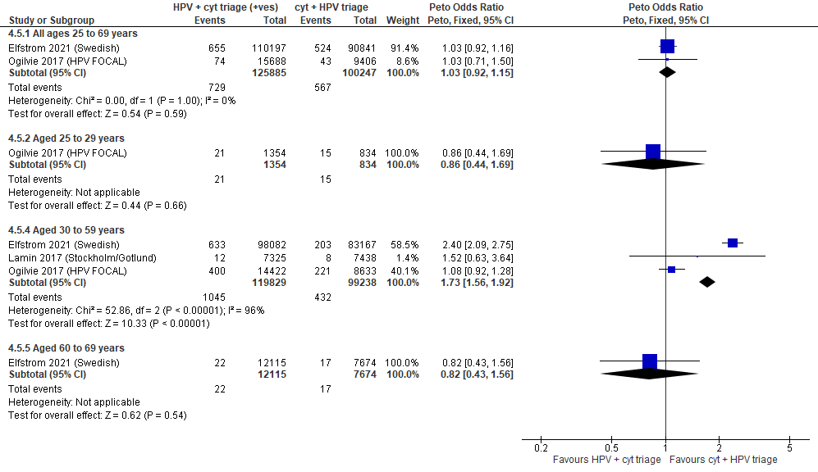

Forest Plot 3.5a. Detection of CIN3+ (as an indirect indicator of the incidence of ICC)

Evidence Set 3.6a. Detection of invasive cervical cancer
Included report: Elfstrom 2021 (Swedish); Lamin 2017 (Stockholm/Gotlund)
GRADE Summary of Findings Table 3.6a. Detection of invasive cervical cancer
Outcome  No. participantsª  (studies) |  | Relative effects,  Peto OR and RR (95 % CI) | Anticipated absolute effects |  |  | Certainty of evidence (GRADE)^{b} | What happens?
 |  | Relative effects,  Peto OR and RR (95 % CI) | With cytology screening + hrHPV triage | With hrHPV screening + cytology triage | Difference | Certainty of evidence (GRADE)^{b} | What happens?
People with a cervix aged 30 to 69 years (Elfstrom 2021 (Swedish); acceptors of screening)
Detection of invasive cervical cancer  Follow-up: at baseline  201,038 (1 RCT) | Peto OR: 0.79 (0.53 to 1.18)  RR: 0.79 (0.53 to 1.18) |  | 5.3 per 10,000 | 4.2 per 10,000 | 1.1 less per 10,000 (2.5 less to 1.0 more) | 25-29 yrs:  VERY LOW  ⊕⊝⊝⊝  NR  30-59 yrs:  LOW^{c}  ⊕⊕⊝⊝  due to risk of bias, lack of evidence of consistency, and indirectness  60-69 yrs:  LOW^{d}  ⊕⊕⊝⊝  due to risk of bias, lack of evidence of consistency, and indirectness | Among screened people with a cervix aged 25 to 29 years, we are very uncertain about the effects on the detection of invasive cervical cancer for hrHPV testing with cytology triage compared with cytology testing with hrHPV triage.  Among screened people with a cervix aged 30 to 69 years, hrHPV screening with cytology triage may have little-to-no effect on the detection of invasive cervical cancer compared with cytology screening with hrHPV triage.
>Subgroup: People with a cervix aged 30 to 59 years (Elfstrom 2021 (Sweden); Lamin 2017 (Stockholm/Gotlund); acceptors of screening)
Detection of invasive cervical cancer  Follow-up: at baseline  196,012 (2 RCTs) | Peto OR: 0.87 (0.58 to 1.30)  RR: 0.87 (0.58 to 1.30) |  | 5.1 per 10,000 | 4.4 per 10,000 | 0.7 less per 10,000 (2.1 less to 1.5 more) | NA
>Subgroup: People with a cervix aged 60 to 69 years (Elfstrom 2021 (Sweden); acceptors of screening)
Detection of invasive cervical cancer  Follow-up: at baseline  19,789 (1 RCT) | Peto OR: 0.08 (0.00 to 1.30)  RR: 0.08 (0.00 to 1.30) |  | 2.6 per 10,000 | 0.2 per 10,000 | 2.4 less per 10,000 (2.6 less to 0.8 more) | NA
CI = confidence interval; NA= not applicable (i.e., not used for conclusions); OR = odds ratio; RCT = randomized controlled trial; RR = relative risk.
ªAcceptors of screening include all participants who completed one round of screening via the strategy to which they were randomly assigned.
^{b}We rated down by 0.5 for “some concerns”, 1 “serious concerns”, and 2 for “very serious concerns”. When our assessment of the certainty of evidence fell between levels, we assigned the level that best represented our actual certainty in the evidence, and based our conclusions on this level of certainty.
Explanations:
^{c} Acceptors of screening; people with a cervix aged 30 to 59 years: Some concerns about risk of bias: at risk of selection bias because randomization occurred before enrollment, without adequate information about baseline characteristics across groups. Some concerns about inconsistency: lack of evidence of consistency due to single study. Serious concerns about indirectness: detection is an indirect outcome. No serious concerns about imprecision: 95% CI precise for little-to-no effect. No other serious concerns.
^{d} Acceptors of screening; people with a cervix aged 60 to 69 years: Some concerns about risk of bias: at risk of selection bias because randomization occurred before enrollment, without adequate information about baseline characteristics across groups. Some concerns about inconsistency: lack of evidence of consistency due to single study. Serious concerns about indirectness: detection is an indirect outcome. No serious concerns about imprecision: 95% CI precise for little-to-no effect. No other serious concerns.

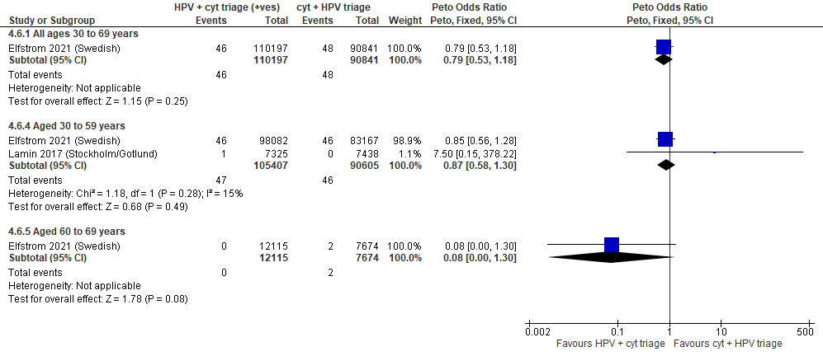
Forest Plot 3.6a. Detection of invasive cervical cancer

Evidence Set 3.7a. False positives for CIN2+ (those referred for colposcopy who did not have CIN2+)
Included reports: Elfstrom 2021 (Swedish); Lamin 2017 (Stockholm/Gotlund); Ogilvie 2017 (HPV FOCAL)
GRADE Summary of Findings Table 3.7a. False positives for CIN2+ (those referred for colposcopy who did not have CIN2+)
Outcome  No. participantsª  (studies) |  | Relative effects  Peto OR and RR (95% CI) | Anticipated absolute effects (95% CI) |  |  | Certainty of evidence (GRADE)^{b} | What happens?
 |  | Relative effects  Peto OR and RR (95% CI) | With cytology screening + hrHPV triage | With hrHPV screening + cytology triage | Difference | Certainty of evidence (GRADE)^{b} | What happens?
People with a cervix aged 25 to 69 years (Elfstrom 2021 (Swedish); Ogilvie 2017 (HPV FOCAL); acceptors of screening)
False positives for CIN2+  Follow-up: at baseline  226,132 (2 RCTs) | Peto OR: 1.27 (1.18 to 1.36)  RR: 1.27 (1.18 to 1.35) |  | 111.0 per 10,000 | 140.6 per 10,000 | 29.6 more per 10,000 (19.7 more to 39.4 more) | 25-29 yrs:  LOW^{c}  ⊕⊕⊝⊝  due to risk of bias, lack of evidence of consistency, and indirectness  30-59 yrs:  MODERATE^{d}  ⊕⊕⊕⊝  due to risk of bias, lack of evidence of consistency  60-69 yrs:  MODERATE^{e}  ⊕⊕⊕⊝  due to risk of bias, lack of evidence of consistency | Among screened people with a cervix aged 25 to 29 years, hrHPV screening with cytology triage may have little-to-no effect on the number of false positives for CIN2+ compared with cytology screening with hrHPV triage.  Among screened people with a cervix aged 30 to 69 years, hrHPV screening with cytology triage probably has little-to-no effect on the number of false positives for CIN2+ compared with cytology screening with hrHPV triage.
>Subgroup: People with a cervix aged 25 to 29 years (Ogilvie 2017 (HPV FOCAL); acceptors of screening)
False positives for CIN2+  Follow-up: at baseline  2,188 (1 RCT) | Peto OR: 1.49 (1.04 to 2.13)  RR: 1.46 (1.04 to 2.02) |  | 467.6 per 10,000 | 681.2 per 10,000 | 213.5 more per 10,000 (17.8 more to 478.4 more) | NA
>Subgroup: People with a cervix aged 30 to 59 years (Elfstrom 2021 (Swedish); Lamin 2017 (Stockholm/Gotlund); Ogilvie 2017 (HPV FOCAL); acceptors of screening)
False positives for CIN2+  Follow-up: at baseline  219,067 (3 RCTs) | Peto OR: 1.27 (1.18 to 1.37)  RR: 1.27 (1.18 to 1.36) |  | 109.0 per 10,000 | 138.1 per 10,000 | 29.0 more per 10,000 (19.4 more to 39.7 more) | NA
>Subgroup: People with a cervix aged 60 to 69 years (Elfstrom 2021 (Swedish); acceptors of screening)
False positives for CIN2+  Follow-up: at baseline  19,789 (1 RCT) | Peto OR: 1.45 (1.00 to 2.08)  RR: 1.45 (1.00 to 2.07) |  | 48.2 per 10,000 | 69.8 per 10,000 | 21.5 more per 10,000 (0.00 more to 51.6 more) | NA
CI = confidence interval; CIN = cervical intraepithelial neoplasia; NA= not applicable (i.e., not used for conclusions); OR = odds ratio; RCT = randomized controlled trial; RR = relative risk.
ªAcceptors of screening include all participants who completed one round of screening via the strategy to which they were randomly assigned.
^{b}We rated down by 0.5 for “some concerns”, 1 “serious concerns”, and 2 for “very serious concerns”. When our assessment of the certainty of evidence fell between levels, we assigned the level that best represented our actual certainty in the evidence, and based our conclusions on this level of certainty.
Explanations:
^{c}Acceptors of screening; people with a cervix aged 25 to 29 years: Some concerns about risk of bias: 83% weight in analysis from single study at risk of selection bias because randomization occurred before enrollment, without adequate information about baseline characteristics across groups. Some concerns about inconsistency: lack of evidence of consistency (83% weight in analysis from single study). Serious concerns about indirectness: the data is indirect for this age group which contributed <1% of the sample population. No serious concerns about imprecision: 95% CI precise for little-to-no effect. No other serious concerns.
^{d}Acceptors of screening; people with a cervix aged 30 to 59 years: Some concerns about risk of bias: 83% weight in analysis from single study at risk of selection bias because randomization occurred before enrollment, without adequate information about baseline characteristics across groups. Some concerns about inconsistency: lack of evidence of consistency (83% weight in analysis from single study). No serious concerns about indirectness: the studies provide direct evidence. No serious concerns about imprecision: 95% CI precise for little-to-no effect. No other serious concerns.
^{e}Acceptors of screening; people with a cervix aged 60 to 69 years: Some concerns about risk of bias: 83% weight in analysis from single study at risk of selection bias because randomization occurred before enrollment, without adequate information about baseline characteristics across groups. Some concerns about inconsistency: lack of evidence of consistency (83% weight in analysis from single study at risk of selection bias). No serious concerns about indirectness: the studies provide direct evidence. No serious concerns about imprecision: 95% CI precise for little-to-no effect. No other serious concerns.

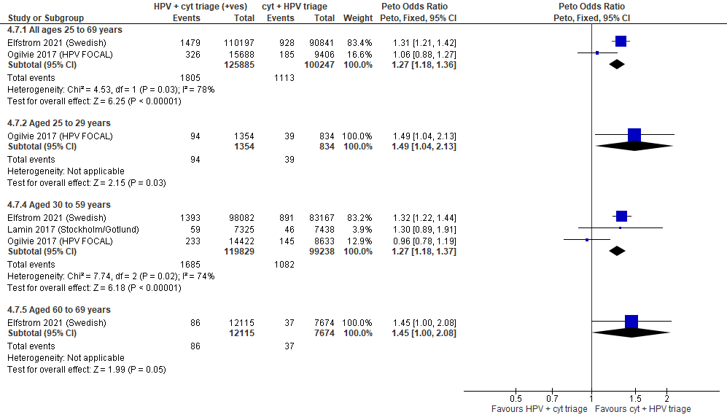
Forest Plot 3.7a. False positives for CIN2+

Evidence Set 3.8a. False positives for CIN3+ (those referred for colposcopy who did not have CIN3+)
Included reports: Elfstrom 2021 (Swedish); Lamin 2017 (Stockholm/Gotlund); Ogilvie 2017 (HPV FOCAL)
GRADE Summary of Findings Table 3.8a. False positives for CIN3+ (those referred for colposcopy who did not have CIN3+)
Outcome  No. participantsª  (studies) |  | Relative effects  Peto OR and RR (95% CI) | Anticipated absolute effects (95% CI) |  |  | Certainty of evidence (GRADE)^{b} | What happens?
 |  | Relative effects  Peto OR and RR (95% CI) | With cytology screening + hrHPV triage | With hrHPV screening + cytology triage | Difference | Certainty of evidence (GRADE)^{b} | What happens?
People with a cervix aged 25 to 69 years (Elfstrom 2021 (Swedish); Ogilvie 2017 (HPV FOCAL); acceptors of screening)
False positives for CIN3+  Follow-up: at baseline  226,132 (2 RCTs) | Peto OR: 1.25 (1.17 to 1.33)  RR: 1.25 (1.17 to 1.32) |  | 148.0 per 10,000 | 184.4 per 10,000 | 36.3 more per 10,000 (24.7 more to 47.9 more) | 25-29 yrs:  LOW^{c}  ⊕⊕⊝⊝  due to risk of bias, lack of evidence of consistency, and indirectness  30-59 yrs:  MODERATE^{d}  ⊕⊕⊕⊝  due to risk of bias, lack of evidence of consistency  60-69 yrs:  MODERATE^{e}  ⊕⊕⊕⊝  due to risk of bias, lack of evidence of consistency | Among screened people with a cervix aged 25 to 29 years, hrHPV screening with cytology triage may have little-to-no effect on the number of false positives for CIN3+ compared with cytology screening with hrHPV triage.  Among screened people with a cervix aged 30 to 69 years, hrHPV screening with cytology triage probably has little-to-no effect on the number of false positives for CIN3+ compared with cytology screening with hrHPV triage.
>Subgroup: People with a cervix aged 25 to 29 years (Ogilvie 2017 (HPV FOCAL); acceptors of screening)
False positives for CIN3+  Follow-up: at baseline  2,188 (1 RCT) | Peto OR: 1.38 (1.00 to 1.91)  RR: 1.35 (1.00 to 1.81) |  | 623.5 per 10,000 | 840.5 per 10,000 | 217.0 more per 10,000 (0.0 more to 503.4 more) | NA
>Subgroup: People with a cervix aged 30 to 59 years (Elfstrom 2021 (Swedish); Lamin 2017 (Stockholm/Gotlund); Ogilvie 2017 (HPV FOCAL); acceptors of screening)
False positives for CIN3+  Follow-up: at baseline  219,067 (3 RCTs) | Peto OR: 1.26 (1.18 to 1.34)  RR: 1.26 (1.18 to 1.33) |  | 145.5 per 10,000 | 182.7 per 10,000 | 37.1 more per 10,000 (25.7 more to 48.5 more) | NA
>Subgroup: People with a cervix aged 60 to 69 years (Elfstrom 2021 (Swedish); acceptors of screening)
False positives for CIN3+  Follow-up: at baseline  19,789 (1 RCT) | Peto OR: 1.53 (1.09 to 2.14)  RR: 1.53 (1.09 to 2.13) |  | 54.7 per 10,000 | 83.5 per 10,000 | 28.8 more per 10,000 (4.9 more to 61.7 more) | NA
CI = confidence interval; CIN = cervical intraepithelial neoplasia; NA= not applicable (i.e., not used for conclusions); OR = odds ratio; RCT = randomized controlled trial; RR = relative risk.
ªAcceptors of screening include all participants who completed one round of screening via the strategy to which they were randomly assigned.
^{b}We rated down by 0.5 for “some concerns”, 1 “serious concerns”, and 2 for “very serious concerns”. When our assessment of the certainty of evidence fell between levels, we assigned the level that best represented our actual certainty in the evidence, and based our conclusions on this level of certainty.
Explanations:
^{c}Acceptors of screening; people with a cervix aged 25 to 29 years: Some concerns about risk of bias: 84% weight in analysis from single study at risk of selection bias because randomization occurred before enrollment, without adequate information about baseline characteristics across groups. Some concerns about inconsistency: lack of evidence of consistency (84% weight in analysis from single study). Serious concerns about indirectness: the data is indirect for this age group which contributed <1% of the sample population. No serious concerns about imprecision: 95% CI precise for little-to-no effect. No other serious concerns.
^{d}Acceptors of screening; people with a cervix aged 30 to 59 years: Some concerns about risk of bias: 84% weight in analysis from single study at risk of selection bias because randomization occurred before enrollment, without adequate information about baseline characteristics across groups. Some concerns about inconsistency: lack of evidence of consistency (84% weight in analysis from single study). No serious concerns about indirectness: the studies provide direct evidence. No serious concerns about imprecision: 95% CI precise for little-to-no effect. No other serious concerns.
^{e}Acceptors of screening; people with a cervix aged 60 to 69 years: Some concerns about risk of bias: 84% weight in analysis from single study at risk of selection bias because randomization occurred before enrollment, without adequate information about baseline characteristics across groups. Some concerns about inconsistency: lack of evidence of consistency (84% weight in analysis from single study). No serious concerns about indirectness: the studies provide direct evidence. No serious concerns about imprecision: 95% CI precise for little-to-no effect. No other serious concerns.
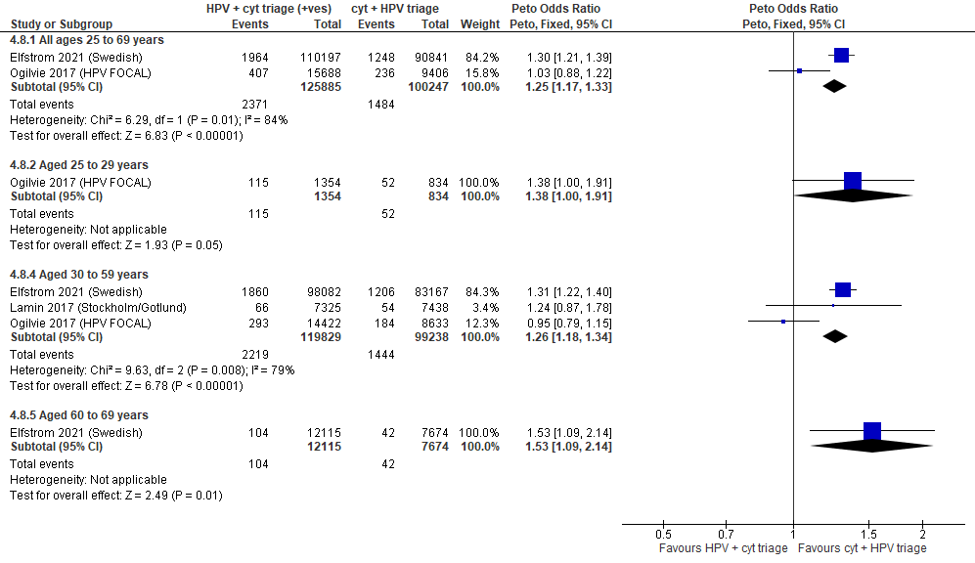

Forest Plot 3.8a. False positives for CIN3+

Evidence Set 3.9a. False positives for invasive cervical cancer (those referred for colposcopy who did not have ICC)
Included reports: Elfstrom 2021 (Swedish); Lamin 2017 (Stockholm/Gotlund)
GRADE Summary of Findings Table 3.9a. False positives for invasive cervical cancer (those referred for colposcopy who did not have ICC)
Outcome  No. participantsª  (studies) |  | Relative effects  Peto OR and RR (95% CI) | Anticipated absolute effects (95% CI) |  |  | Certainty of evidence (GRADE)^{b} | What happens?
 |  | Relative effects  Peto OR and RR (95% CI) | With cytology screening + hrHPV triage | With hrHPV screening + cytology triage | Difference | Certainty of evidence (GRADE)^{b} | What happens?
People with a cervix aged 30 to 69 years (Elfstrom 2021 (Swedish); acceptors of screening)
False positives for ICC  Follow-up: at baseline  201,038 (1 RCT) | Peto OR: 1.23 (1.16 to 1.31)  RR: 1.22 (1.16 to 1.30) |  | 189.8 per 10,000 | 232.4 per 10,000 | 42.6 more per 10,000 (29.7 more to 57.4 more) | 25-29 yrs:  VERY LOW  ⊕⊝⊝⊝  NR  30-59 yrs:  MODERATE^{c}  ⊕⊕⊕⊝  due to risk of bias, and lack of evidence of consistency  60-69 yrs:  MODERATE^{d}  ⊕⊕⊕⊝  due to risk of bias, and lack of evidence of consistency | Among screened people with a cervix aged 25 to 29 years, we are very uncertain about the effects on the number of false positives for invasive cervical cancer for hrHPV testing with cytology triage compared with cytology testing with hrHPV triage.  Among screened people with a cervix aged 30 to 69 years, hrHPV screening with cytology triage probably has little-to-no effect on the number of false positives for invasive cervical cancer compared with cytology screening with hrHPV triage.
>Subgroup: People with a cervix aged 30 to 59 years (Elfstrom 2021 (Swedish); Lamin 2017 (Stockholm/Gotlund); acceptors of screening)
False positives for ICC  Follow-up: at baseline  196,012 (2 RCTs) | Peto OR: 1.25 (1.17 to 1.33)  RR: 1.24 (1.17 to 1.32) |  | 190.8 per 10,000 | 237.4 per 10,000 | 46.6 more per 10,000 (31.7 more to 61.4 more) | NA
>Subgroup: People with a cervix aged 60 to 69 years (Elfstrom 2021 (Swedish); acceptors of screening)
False positives for ICC  Follow-up: at baseline  19,789 (1 RCT) | Peto OR: 1.38 (1.03 to 1.86)  RR: 1.38 (1.03 to 1.85) |  | 74.3 per 10,000 | 102.2 per 10,000 | 27.9 more per 10,000 (2.2 more to 63.0 more) | NA
CI = confidence interval; NA= not applicable (i.e., not used for conclusions); OR = odds ratio; RCT = randomized controlled trial; RR = relative risk.
ªAcceptors of screening include all participants who completed one round of screening via the strategy to which they were randomly assigned.
^{b}We rated down by 0.5 for “some concerns”, 1 “serious concerns”, and 2 for “very serious concerns”. When our assessment of the certainty of evidence fell between levels, we assigned the level that best represented our actual certainty in the evidence, and based our conclusions on this level of certainty.
Explanations:
^{c}Acceptors of screening; people with a cervix aged 30 to 59 years: Some concerns about risk of bias: at risk of selection bias because randomization occurred before enrollment, without adequate information about baseline characteristics across groups. Some concerns about inconsistency: lack of evidence of consistency due to single study. No serious concerns about indirectness: the study provides direct evidence. No serious concerns about imprecision: 95% CI precise for little-to-no effect. No other serious concerns.
^{d}Acceptors of screening; people with a cervix aged 60 to 69 years: Some concerns about risk of bias: at risk of selection bias because randomization occurred before enrollment, without adequate information about baseline characteristics across groups. Some concerns about inconsistency: lack of evidence of consistency due to single study. No serious concerns about indirectness: the study provides direct evidence. No serious concerns about imprecision: 95% CI precise for little-to-no effect. No other serious concerns.

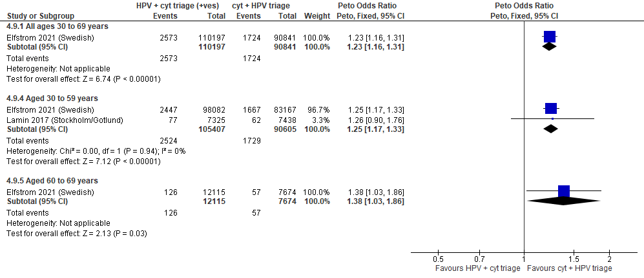
Forest Plot 3.9a. False positives for invasive cervical cancer

Evidence set 3.0b: hrHPV screening (threshold not reported) with liquid-based cytology triage of positive tests versus liquid-based cytology screening (threshold ≥LSIL) with hrHPV triage of ASCUS or LSIL; with recall

Included reports: Nygard 2022 (Norwegian) (ages 34-69 [subgroups 34-59 and 60-69 years]); Ogilvie 2017 (HPV FOCAL) (ages 25-65 [subgroups 25-29 and 30-65 years]); Rebolj 2022 (UK observational) (ages 24-69 [subgroups 24-29 and 30-59 years])

Evidence set 3.1b. Referrals to colposcopy
GRADE Summary of Findings Table 3.1b. Referrals to colposcopy
Outcome  No. participantsª  (studies) |  | Relative effects  Peto OR and RR (95% CI) | Anticipated absolute effects (95% CI) |  |  | Certainty of evidence (GRADE)^{b} | What happens?
 |  | Relative effects  Peto OR and RR (95% CI) | With cytology screening + hrHPV triage | With hrHPV screening + cytology triage | Difference | Certainty of evidence (GRADE)^{b} | What happens?
People with a cervix aged 25 to 69 years (Nygard 2022 (Norwegian); Ogilvie 2017 (HPV FOCAL); acceptors of screening)
Referrals to colposcopy  Follow-up: 1 round  182,541 (2 RCTs) | Peto OR: 2.13 (2.02 to 2.25)  RR: 2.09 (1.98 to 2.20) |  | 190.1 per 10,000 | 396.4 per 10,000 | 206.3 more per 10,000 (186.6 more to 227.7 more) | NA
>Subgroup: People with a cervix aged 25 to 29 years (Ogilvie 2017 (HPV FOCAL); acceptors of screening)
Referrals to colposcopy  Follow-up: 1 round  2,188 (1 RCT) | Peto OR: 2.46 (1.93 to 3.12)  RR: 2.20 (1.79 to 2.66) |  | 815.3 per 10,000 | 1792.4 per 10,000 | 977.0 more per 10,000 (647.4 more to 1353.6 more) | MODERATE^{c}  ⊕⊕⊕⊝  due to lack of evidence of consistency | Among screened people with a cervix aged 25 to 29 years, hrHPV testing with cytology triage probably increases the rate of referral to colposcopy compared with cytology testing with hrHPV triage.
>Subgroup: People with a cervix aged 30 to 59 years (Nygard 2022 (Norwegian); Ogilvie 2017 (HPV FOCAL); acceptors of screening)
Referrals to colposcopy  Follow-up: 1 round  147,027 (2 RCTs) | Peto OR: 2.05 (1.94 to 2.17)  RR: 2.01 (1.90 to 2.12) |  | 212.4 per 10,000 | 425.8 per 10,000 | 213.5 more per 10,000 (191.6 more to 237.3 more) | MODERATE^{d}  ⊕⊕⊕⊕  due to risk of bias, and lack of evidence of consistency | Among screened people with a cervix aged 30 to 59 years, hrHPV testing with cytology triage probably has little-to-no effect on the rate of referral to colposcopy compared with cytology testing with hrHPV triage.
>Subgroup: People with a cervix aged 60 to 69 years (Nygard 2022 (Norwegian); acceptors of screening)
Referrals to colposcopy  Follow-up: 1 round  33,474 (1 RCT) | Peto OR: 3.09 (2.58 to 3.69)  RR: 3.05 (2.55 to 3.62) |  | 67.4 per 10,000 | 205.5 per 10,000 | 138.0 more per 10,000 (104.7 more to 177.0 more) | MODERATE^{e}  ⊕⊕⊕⊝  due to risk of bias, and lack of evidence of consistency | Among screened people with a cervix aged 60 to 69 years, hrHPV testing with cytology triage probably has little-to-no effect on the rate of referral to colposcopy compared with cytology testing with hrHPV triage.
CI = confidence interval; NA= not applicable (i.e., not used for conclusions); OR = odds ratio; RCT = randomized controlled trial; RR = relative risk.
ªAcceptors of screening include all participants who completed one round of screening via the strategy to which they were randomly assigned.
^{b}We rated down by 0.5 for “some concerns”, 1 “serious concerns”, and 2 for “very serious concerns”. When our assessment of the certainty of evidence fell between levels, we assigned the level that best represented our actual certainty in the evidence, and based our conclusions on this level of certainty.
Explanations:
^{c}Acceptors of screening; people with a cervix aged 25 to 29 years: No serious concerns about risk of bias: no domains judged high risk. Some concerns about inconsistency: lack of evidence of consistency due to single study. No serious concerns about indirectness: the study provides direct evidence. No serious concerns about imprecision: 95% CI precise for increased effect. No other serious concerns.
^{d}Acceptors of screening; people with a cervix aged 30 to 59 years: Some concerns about risk of bias: 83% weight from study at risk of selection bias because randomization occurred before enrollment, without adequate information about baseline characteristics across groups. Some concerns about inconsistency: lack of evidence of consistency (83% weight from single study). No serious concerns about indirectness: the study provides direct evidence. No serious concerns about imprecision: 95% CI precise for little-to-no effect. No other serious concerns.
^{e}Acceptors of screening; people with a cervix aged 60 to 69 years: Some concerns about risk of bias: at risk of selection bias because randomization occurred before enrollment, without adequate information about baseline characteristics across groups. Some concerns about inconsistency: lack of evidence of consistency due to single study. No serious concerns about indirectness: the study provides direct evidence. No serious concerns about imprecision: 95% CI precise for little-to-no effect. No other serious concerns.

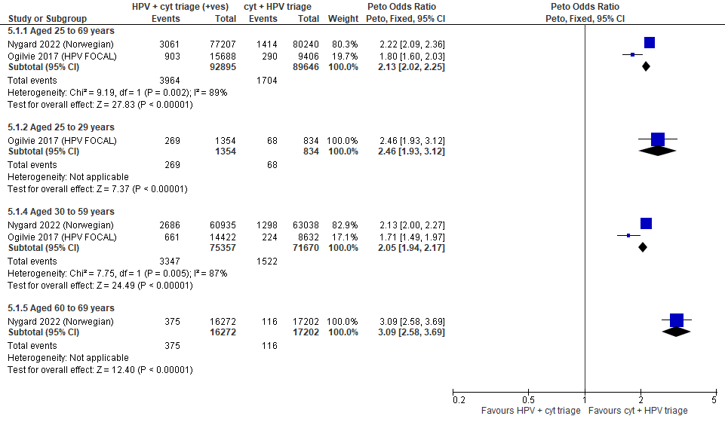
Forest Plot 3.1b. Referrals to colposcopy

Evidence set 3.2b. Number of colposcopies
Included reports: Ogilvie 2017 (HPV FOCAL)
GRADE Summary of Findings Table 3.2b. Number of colposcopies
Outcome  No. participantsª  (studies) |  | Relative effects Peto OR and RR (95 % CI) | Anticipated absolute effects (95% CI) |  |  | Certainty of evidence (GRADE)^{b} | What happens?
 |  | Relative effects Peto OR and RR (95 % CI) | With cytology screening + hrHPV triage | With hrHPV screening + cytology triage | Difference | Certainty of evidence (GRADE)^{b} | What happens?
People with a cervix aged 25 to 69 years (Ogilvie 2017 (HPV FOCAL); acceptors of screening)
Number of colposcopies  Follow-up: 1 round  25,094 (1 RCT) | Peto OR: 1.80 (1.59 to 2.03)  RR: 1.76 (1.56 to 1.97) |  | 297.7 per 10,000 | 523.4 per 10,000 | 225.7 more per 10,000 (167.5 more to 288.6 more) | 25-29 yrs:  VERY LOW^{c}  ⊕⊝⊝⊝  due to lack of evidence of consistency, and (very serious) indirectness  30-59 yrs:  MODERATE^{d}  ⊕⊕⊕⊝  due to lack of evidence of consistency  60-69 yrs:  MODERATE^{e}  ⊕⊕⊕⊝  due to lack of evidence of consistency, and indirectness | Among screened people with a cervix aged 25 to 29 years, we are very uncertain about the effects on referrals to colposcopy for hrHPV testing with cytology triage compared with cytology testing with hrHPV triage.  Among screened people with a cervix aged 30 to 69 years,  hrHPV testing with cytology triage probably has little-to-no effect on the rate of referral to colposcopy compared with cytology testing with hrHPV triage.
CI = confidence interval; OR = odds ratio; RCT = randomized controlled trial; RR = relative risk.
ªAcceptors of screening include all participants who completed one round of screening via the strategy to which they were randomly assigned.
^{b}We rated down by 0.5 for “some concerns”, 1 “serious concerns”, and 2 for “very serious concerns”. When our assessment of the certainty of evidence fell between levels, we assigned the level that best represented our actual certainty in the evidence, and based our conclusions on this level of certainty.
Explanations:
^{c}Acceptors of screening; people with a cervix aged 25 to 29 years: No serious concerns about risk of bias: no domains judged high risk. Some concerns about inconsistency: lack of evidence of consistency due to single study. Very serious concerns about indirectness: the study data is not directly applicable for this age group due to a small sample (n=2,188 [8.7%] enrolled) and evidence from other outcomes of differing effects. No serious concerns about imprecision: 95% CI precise for little-to-no effect. No other serious concerns.
^{d}Acceptors of screening; people with a cervix aged 30 to 59 years: No serious concerns about risk of bias: no domains judged high risk. Some concerns about inconsistency: lack of evidence of consistency due to single study. No serious concerns about indirectness: the study data is directly applicable. No serious concerns about imprecision: 95% CI precise for little-to-no effect. No other serious concerns.
^{e}Acceptors of screening; people with a cervix aged 60 to 69 years: No serious concerns about risk of bias: no domains judged high risk. Some concerns about inconsistency: lack of evidence of consistency due to single study. Some concerns about indirectness: the study data is not directly applicable for this age group due to a small sample (n=2,094 [8.3%] enrolled) though there is some evidence from the referrals outcome of similar effects. No serious concerns about imprecision: 95% CI precise for little-to-no effect. No other serious concerns.

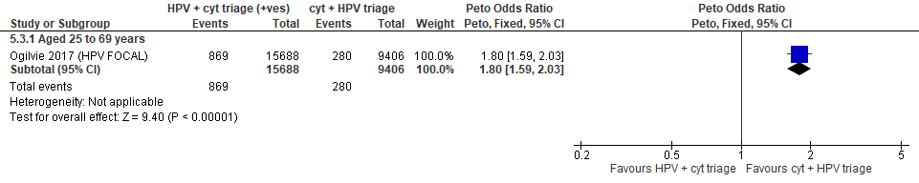
Forest Plot 3.2b. Number of colposcopies

Evidence Set 3.3b. Detection of CIN2+ (as an indirect indicator of the incidence of CIN3+)
Included reports: Nygard 2022 (Norwegian); Ogilvie 2017 (HPV FOCAL)
GRADE Summary of Findings Table 3.3b. Detection of CIN2+ (as an indirect indicator of the incidence of CIN3+)
Outcome  No. participantsª  (studies) |  | Relative effects  Peto OR and RR (95% CI) | Anticipated absolute effects (95% CI) |  |  | Certainty of evidence (GRADE)^{b} | What happens?
 |  | Relative effects  Peto OR and RR (95% CI) | With cytology screening + hrHPV triage | With hrHPV screening + cytology triage | Difference | Certainty of evidence (GRADE)^{b} | What happens?
People with a cervix aged 25 to 69 years (Nygard 2022 (Norwegian); Ogilvie 2017 (HPV FOCAL); acceptors of screening)
Detection of CIN2+  Follow-up: 1 round  182,541 (2 RCTs) | Peto OR: 1.70 (1.57 to 1.85)  RR: 1.69 (1.56 to 1.84) |  | 89.9 per 10,000 | 151.9 per 10,000 | 62.0 more per 10,000 (50.5 more to 75.2 more) | NA
>Subgroup^{c}: People with a cervix aged 25 to 29 years (Ogilvie 2017 (HPV FOCAL); acceptors of screening)
Detection of CIN2+  Follow-up: 1 round  2,188 (1 RCT) | Peto OR: 1.89 (1.28 to 2.79)  RR: 1.84 (1.27 to 2.64) |  | 323.7 per 10,000 | 594.7 per 10,000 | 271.0 more per 10,000 (86.9 more to 530.0 more) | LOW^{c}  ⊕⊕⊝⊝  due to lack of evidence of consistency, indirectness, and imprecision | Among screened people with a cervix aged 25 to 29 years, hrHPV testing with cytology triage may reduce the incidence of CIN3+ compared with cytology testing with hrHPV triage.
>Subgroup: People with a cervix aged 30 to 59 years (Nygard 2022 (Norwegian); Ogilvie 2017 (HPV FOCAL); acceptors of screening)
Detection of CIN2+  Follow-up: 1 round  147,028 (2 RCTs) | Peto OR: 1.67 (1.53 to 1.82)  RR: 1.66 (1.52 to 1.80) |  | 103.7 per 10,000 | 171.9 per 10,000 | 68.3 more per 10,000 (54.1 more to 83.4 more) | LOW^{d}  ⊕⊕⊝⊝  due to risk of bias,  lack of consistency, and indirectness | Among screened people with a cervix aged 30 to 59 years, hrHPV testing with cytology triage may have little-to-no effect on the incidence of CIN3+ compared with cytology testing with hrHPV triage.
>Subgroup: People with a cervix aged 60 to 69 years (Nygard 2022 (Norwegian); acceptors of screening)
Detection of CIN2+  Follow-up: 1 round  33,474 (1 RCT) | Peto OR: 2.29 (1.59 to 3.29)  RR: 2.28 (1.59 to 3.27) |  | 20.9 per 10,000 | 47.8 per 10,000 | 26.9 more per 10,000 (12.3 more to 47.6 more) | LOW^{e}  ⊕⊕⊝⊝  due to risk of bias, lack of evidence of consistency and indirectness | Among screened people with a cervix aged 60 to 69 years, hrHPV testing with cytology triage may have little-to-no effect on the incidence of CIN3+ compared with cytology testing with hrHPV triage.
CI = confidence interval; CIN = cervical intraepithelial neoplasia; NA= not applicable (i.e., not used for conclusions); OR = odds ratio; RCT = randomized controlled trial; RR = relative risk.
ªAcceptors of screening include all participants who completed one round of screening via the strategy to which they were randomly assigned.
^{b}We rated down by 0.5 for “some concerns”, 1 “serious concerns”, and 2 for “very serious concerns”. When our assessment of the certainty of evidence fell between levels, we assigned the level that best represented our actual certainty in the evidence, and based our conclusions on this level of certainty.
Explanations:
^{c}Acceptors of screening; people with a cervix aged 25 to 29 years: No serious concerns about risk of bias: no domains judged high risk. Some concerns about inconsistency: lack of evidence of consistency due to single study. Serious concerns about indirectness: detection is an indirect measure of incidence. Some concerns about imprecision: lower limit of 95% CI indicates possibility of little-to-no effect. No other serious concerns.
^{d}Acceptors of screening; people with a cervix aged 30 to 59 years: Some concerns about risk of bias: 85% weight in analysis from single study at risk of selection bias because randomization occurred before enrollment, without adequate information about baseline characteristics across groups. Some concerns about inconsistency: 85% of weight comes from single study. Serious concerns about indirectness: detection is an indirect measure of incidence. No serious concerns about imprecision: 95% CI precise for little-to-no effect. No other serious concerns.
^{e}Acceptors of screening; people with a cervix aged 60 to 69 years: Some concerns about risk of bias: at risk of selection bias because randomization occurred before enrollment, without adequate information about baseline characteristics across groups. Some concerns about inconsistency: lack of evidence of consistency due to single study. Serious concerns about indirectness: detection is an indirect measure of incidence. No serious concerns about imprecision: 95% CI precise for little-to-no effect. No other serious concerns.

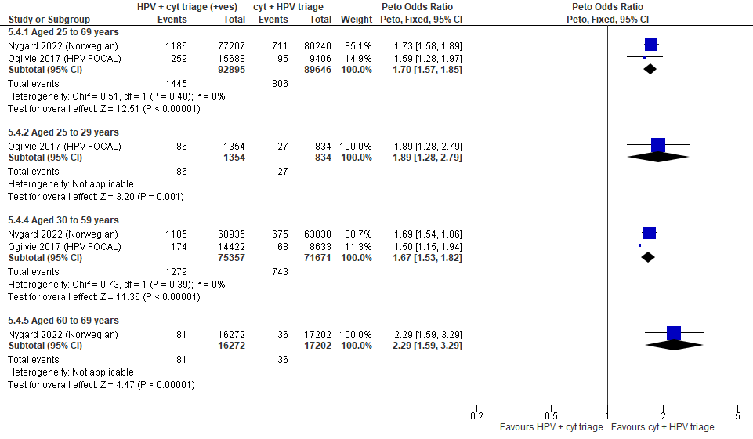
Forest Plot 3.3b. Detection of CIN2+ (as an indirect indicator of the incidence of CIN3+)

Evidence Set 3.4b. Detection of CIN3+ (as an indirect indicator of the incidence of ICC)
Included reports: Nygard 2022 (Norwegian); Ogilvie 2017 (HPV FOCAL)
GRADE Summary of Findings Table 3.4b. Detection of CIN3+ (as an indirect indicator of the incidence of ICC)
Outcome  No. participantsª  (studies) |  | Relative effects  Peto OR and RR (95% CI) | Anticipated absolute effects (95% CI) |  |  | Certainty of evidence (GRADE)^{b} | What happens?
 |  | Relative effects  Peto OR and RR (95% CI) | With cytology screening + hrHPV triage | With hrHPV screening + cytology triage | Difference | Certainty of evidence (GRADE)^{b} | What happens?
People with a cervix aged 25 to 69 years (Nygard 2022 (Norwegian); Ogilvie 2017 (HPV FOCAL); acceptors of screening)
Detection of CIN3+  Follow-up: 1 round  182,541 (2 RCTs) | Peto OR: 1.56 (1.42 to 1.72)  RR: 1.55 (1.42 to 1.71) |  | 74.2 per 10,000 | 115.2 per 10,000 | 41.1 more per 10,000 (30.8 more to 52.7 more) | NA
>Subgroup: People with a cervix aged 25 to 29 years (Ogilvie 2017 (HPV FOCAL); acceptors of screening)
Detection of CIN3+  Follow-up: 1 round  2,188 (1 RCT) | Peto OR: 1.64 (0.95 to 2.83)  RR: 1.62 (0.95 to 2.74) |  | 179.9 per 10,000 | 291.6 per 10,000 | 111.8 more per 10,000 (8.8 less to 312.9 more) | VERY LOW^{c}  ⊕⊝⊝⊝  due to lack of evidence of consistency, indirectness, and imprecision | Among screened people with a cervix aged 25 to 29 years, we are very uncertain about the effects on the incidence of invasive cervical cancer for hrHPV testing with cytology triage compared with cytology testing with hrHPV triage.
>Subgroup: People with a cervix aged 30 to 59 years (Nygard 2022 (Norwegian); Ogilvie 2017 (HPV FOCAL); acceptors of screening)
Detection of CIN3+  Follow-up: 1 round  147,028 (2 RCTs) | Peto OR: 1.54 (1.39 to 1.70)  RR: 1.53 (1.39 to 1.69) |  | 86.4 per 10,000 | 132.4 per 10,000 | 46.0 more per 10,000 (33.3 more to 59.6 more) | MODERATE^{d}  ⊕⊕⊕⊝  due to lack of consistency, and indirectness | Among screened people with a cervix aged 30 to 59 years, hrHPV testing with cytology triage probably reduces the incidence of invasive cervical cancer compared with cytology testing with hrHPV triage.
>Subgroup: People with a cervix aged 60 to 69 years (Nygard 2022 (Norwegian); acceptors of screening)
Detection of CIN3+  Follow-up: 1 round  33,474 (1 RCT) | Peto OR: 1.92 (1.27 to 2.89)  RR: 1.92 (1.27 to 2.88) |  | 18.6 per 10,000 | 35.7 per 10,000 | 17.1 more per 10,000 (5.0 more to 35.0 more) | VERY LOW^{e}  ⊕⊝⊝⊝  due to risk of bias, lack of evidence of consistency, indirectness, and imprecision | Among screened people with a cervix aged 60 to 69 years, we are very uncertain about the effects on the incidence of invasive cervical cancer for hrHPV testing with cytology triage compared with cytology testing with hrHPV triage.
CI = confidence interval; CIN = cervical intraepithelial neoplasia; NA= not applicable (i.e., not used for conclusions); OR = odds ratio; RCT = randomized controlled trial; RR = relative risk.
ªAcceptors of screening include all participants who completed one round of screening via the strategy to which they were randomly assigned.
^{b}We rated down by 0.5 for “some concerns”, 1 “serious concerns”, and 2 for “very serious concerns”. When our assessment of the certainty of evidence fell between levels, we assigned the level that best represented our actual certainty in the evidence, and based our conclusions on this level of certainty.
Explanations:
^{c}Acceptors of screening; people with a cervix aged 25 to 29 years: No serious concerns about risk of bias: no domains judged high risk. Some concerns about inconsistency: lack of evidence of consistency due to single study. Serious concerns about indirectness: detection is an indirect measure of incidence. Serious concerns about imprecision: lower limit of 95% CI indicates little-to-no effect. No other serious concerns.
^{d}Acceptors of screening; people with a cervix aged 30 to 59 years: No serious concerns about risk of bias: no domains judged high risk. Some concerns about inconsistency: 93% weight comes from one study, though results are consistent. Serious concerns about indirectness: detection is an indirect measure of incidence. No serious concerns about imprecision: 95% CI precise for increased effect. No other serious concerns.
^{e}Acceptors of screening; people with a cervix aged 60 to 69 years: Some concerns about risk of bias: at risk of selection bias because randomization occurred before enrollment, without adequate information about baseline characteristics across groups. Some concerns about inconsistency: lack of evidence of consistency due to single study. Serious concerns about indirectness: detection is an indirect measure of incidence. Serious concerns about imprecision: lower limit of 95% CI indicates little-to-no effect. No other serious concerns.

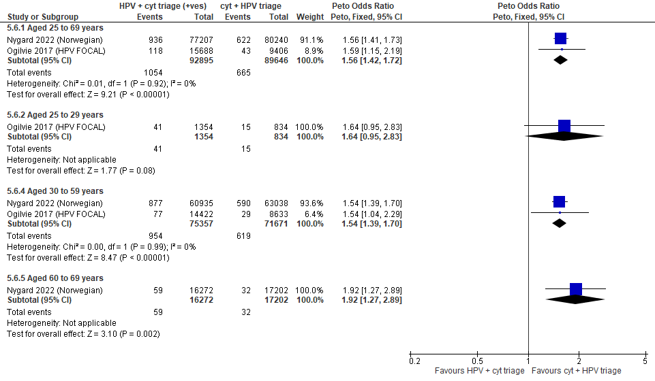

Forest Plot 3.4b. Detection of CIN3+ (as an indirect indicator of the incidence of ICC)

Evidence Set 3.5b. Detection of invasive cervical cancer
Included report: Nygard 2022 (Norwegian)
GRADE Summary of Findings Table 3.5b. Detection of invasive cervical cancer
Outcome  No. participantsª  (studies) |  | Relative effects, Peto OR and RR (95 % CI) | Anticipated absolute effects |  |  | Certainty of evidence (GRADE)^{b} | What happens?
 |  | Relative effects, Peto OR and RR (95 % CI) | With cytology screening + hrHPV triage | With hrHPV screening + cytology triage | Difference | Certainty of evidence (GRADE)^{b} | What happens?
People with a cervix aged 30 to 69 years (Nygard 2022 (Norwegian); acceptors of screening
Detection of invasive cervical cancer  Follow-up: 1 round  157,447 (1 RCT) | Peto OR: 1.43 (0.99 to 2.06)  RR: 1.43 (0.99 to 2.06) |  | 6.0 per 10,000 | 8.6 per 10,000 | 2.6 more per 10,000 (0.1 less to 6.3 more) | 25-29 yrs:  VERY LOW  ⊕⊝⊝⊝  NR  30-59 yrs:  VERY LOW^{c}  ⊕⊝⊝⊝  due to risk of bias, lack of evidence of consistency, indirectness and imprecision  60-69 yrs:  VERY LOW^{d}  ⊕⊝⊝⊝  due to risk of bias, lack of evidence of consistency, indirectness and imprecision | Among screened people with a cervix aged 25 to 69 years, we are very uncertain about the effects on the detection of invasive cervical cancer for hrHPV testing with cytology triage of positive tests compared with cytology testing with hrHPV triage.
>Subgroup: People with a cervix aged 30 to 59 years (Nygard 2022 (Norwegian); acceptors of screening
Detection of invasive cervical cancer  Follow-up: 1 round  123,973 (1 RCT) | Peto OR: 1.38 (0.94 to 2.04)  RR: 1.38 (0.94 to 2.04) |  | 7.0 per 10,000 | 9.6 per 10,000 | 2.6 per 10,000 (0.4 less to 7.2 more) | NA
>Subgroup: People with a cervix aged 60 to 69 years (Nygard 2022 (Norwegian); acceptors of screening
Detection of invasive cervical cancer  Follow-up: 1 round  33,474 (1 RCT) | Peto OR: 1.83 (0.56 to 5.95)  RR: 1.83 (0.56 to 5.94) |  | 2.3 per 10,000 | 4.3 per 10,000 | 1.9 per 10,000 (1.0 less to 11.5 more) | NA
CI = confidence interval; NA= not applicable (i.e., not used for conclusions); OR = odds ratio; RCT = randomized controlled trial; RR = relative risk.
ªAcceptors of screening include all participants who completed one round of screening via the strategy to which they were randomly assigned.
^{b}We rated down by 0.5 for “some concerns”, 1 “serious concerns”, and 2 for “very serious concerns”. When our assessment of the certainty of evidence fell between levels, we assigned the level that best represented our actual certainty in the evidence, and based our conclusions on this level of certainty.
Explanations:
^{c}Acceptors of screening; people with a cervix aged 30 to 59 years: Some concerns about risk of bias: at risk of selection bias because randomization occurred before enrollment, without adequate information about baseline characteristics across groups. Some concerns about inconsistency: lack of evidence of consistency due to single study. Serious concerns about indirectness: detection is an indirect outcome. Serious concerns about imprecision: upper limit of 95% CI indicates increased effect. No other serious concerns.
^{d}Acceptors of screening; people with a cervix aged 60 to 69 years: Some concerns about risk of bias: at risk of selection bias because randomization occurred before enrollment, without adequate information about baseline characteristics across groups. Some concerns about inconsistency: lack of evidence of consistency due to single study. Serious concerns about indirectness: detection is an indirect outcome. Serious concerns about imprecision: upper limit of 95% CI indicates increased effect. No other serious concerns.

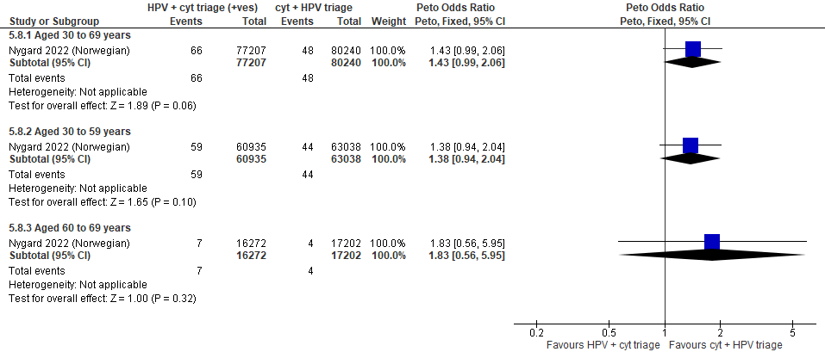
Forest Plot 3.5b. Detection of invasive cervical cancer

Evidence Set 3.6b. Incidence of CIN2
Included report: Ogilvie 2018 (HPV FOCAL)
GRADE Summary of Findings Table 3.6b. Incidence of CIN2
Outcome  No. participantsª  (studies) |  | Relative effects, Peto OR and RR (95 % CI) | Anticipated absolute effects* |  |  | Certainty of evidence (GRADE)^{b} | What happens?
 |  | Relative effects, Peto OR and RR (95 % CI) | With cytology screening + hrHPV triage | With hrHPV screening + cytology triage | Difference | Certainty of evidence (GRADE)^{b} | What happens?
People with a cervix aged 25 to 69 years (Ogilvie 2018 (HPV FOCAL); acceptors of screening at follow up)
Incidence of CIN2  Follow-up: 48 months  18,711 (1 RCT) | Peto OR: 0.55 (0.35 to 0.86)  RR: 0.55 (0.35 to 0.86) |  | 51.5 per 10,000 | 28.4 per 10,000 | 23.1 less per 10,000 (33.4 less to 7.2 less) | 25-29 yrs:  LOW^{c}  ⊕⊕⊝⊝  due to lack of evidence of consistency, and indirectness  30-59 yrs:  MODERATE^{d}  ⊕⊕⊕⊝  due to lack of evidence of consistency  60-69 yrs:  LOW^{e}  ⊕⊕⊝⊝  due to lack of evidence of consistency, and indirectness | Among screened people with a cervix aged 25 to 29 years, hrHPV screening with cytology triage may have little-to-no effect on the incidence of CIN2 compared with cytology screening with hrHPV triage.  Among screened people with a cervix aged 30 to 59 years, hrHPV screening with cytology triage probably has little-to-no effect on the incidence of CIN2 compared with cytology screening with hrHPV triage.  Among screened people with a cervix aged 60 to 69 years, hrHPV screening with cytology triage may have little-to-no effect on the incidence of CIN2 compared with cytology screening with hrHPV triage.
>Subgroup: People with a cervix aged 25 to 29 years (Ogilvie 2018 (HPV FOCAL); acceptors of screening at follow up)
Incidence of CIN2  Follow-up: 48 months  1,654 (1 RCT) | Peto OR: 0.67 (0.28 to 1.62)  RR: 0.67 (0.28 to 1.61) |  | 144.9 per 10,000 | 97.6 per 10,000 | 47.4 less per 10,000 (103.9 less to 87.8 more) | NA
>Subgroup: People with a cervix aged 30 to 69 years (Ogilvie 2018 (HPV FOCAL); acceptors of screening at follow up)
Incidence of CIN2  Follow-up: 48 months  17,294 (1 RCT) | Peto OR: 0.50 (0.30 to 0.86)  RR: 0.50 (0.30 to 0.86) |  | 42.0 per 10,000 | 21.0 per 10,000 | 20.9 less per 10,000 (29.3 less to 5.9 less) | NA
CI = confidence interval; CIN = cervical intraepithelial neoplasia; NA= not applicable (i.e., not used for conclusions); OR = odds ratio; RCT = randomized controlled trial; RR = relative risk.
ªAcceptors of screening at follow up includes all randomized participants who completed the screening protocol and attended the second round of screening (i.e., round two for the cytology arm and in both arms the 48-month follow up testing via hrHPV and cytology co-testing). The denominator excludes those who tested positive and were histologically diagnosed with CIN2+ before the 48-month exit screen in the hrHPV arm and before round 2 in the cytology arm. The numerators were taken from Table 2 and included cases detected during round 2 (in the cyolotgy arm) and during the 48-month exit round (both arms). Those who attended follow-up testing for a positive screening result but were histologically confirmed negative or CIN1 are included.
^{b}We rated down by 0.5 for “some concerns”, 1 “serious concerns”, and 2 for “very serious concerns”. When our assessment of the certainty of evidence fell between levels, we assigned the level that best represented our actual certainty in the evidence, and based our conclusions on this level of certainty.
Explanations:
^{c}Acceptors of screening at follow up; people with a cervix aged 25 to 29 years: No serious concerns about risk of bias: no domains judged high risk. Some concerns about inconsistency: lack of evidence for consistency due to single study. Serious concerns about indirectness: the study data is not directly applicable for this age group due to a small sample (n=1,654 [8.8%]) and evidence from other outcomes of differing effects. No serious concerns about imprecision: 95% CI precise for little-to-no effect. No other serious concerns.
^{d}Acceptors of screening at follow up; people with a cervix aged 30 to 59 years: No serious concerns about risk of bias: no domains judged high risk. Some concerns about inconsistency: lack of evidence for consistency due to single study. No serious concerns about indirectness: the study provides direct evidence. Serious concerns about imprecision: 95% CI precise for little-to-no effect. No other serious concerns.
^{e}Acceptors of screening at follow up; people with a cervix aged 60 to 69 years: No serious concerns about risk of bias: no domains judged high risk. Some concerns about inconsistency: lack of evidence for consistency due to single study. Serious concerns about indirectness: the study data is not directly applicable for this age group due to a small sample (n=2,094 [8.3%]) enrolled). No serious concerns about imprecision: 95% CI precise for little-to-no effect. No other serious concerns.

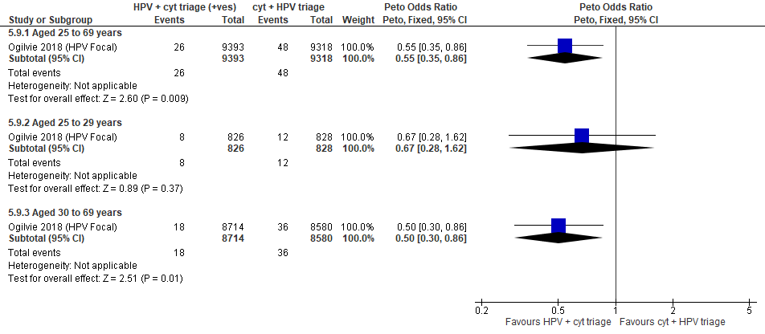
Forest Plot 3.6b. Incidence of CIN2

Evidence Set 3.7b. Incidence of CIN2+
Included report: Ogilvie 2018 (HPV FOCAL)
GRADE Summary of Findings Table 3.7b. Incidence of CIN2+
Outcome  No. participantsª  (studies) |  | Relative effects, Peto OR and RR (95 % CI) | Anticipated absolute effects* |  |  | Certainty of evidence (GRADE)^{b} | What happens?
 |  | Relative effects, Peto OR and RR (95 % CI) | With cytology screening + hrHPV triage | With hrHPV screening + cytology triage | Difference | Certainty of evidence (GRADE)^{b} | What happens?
People with a cervix aged 25 to 69 years (Ogilvie 2018 (HPV FOCAL); acceptors of screening at follow up)
Incidence of CIN2+  Follow-up: 48 months  18,711 (1 RCT) | Peto OR: 0.49 (0.35 to 0.68)  RR: 0.49 (0.35 to 0.68) |  | 107.3 per 10,000 | 52.9 per 10,000 | 54.4 less per 10,000 (69.5 less to 34.1 less) | NA
>Subgroup: People with a cervix aged 25 to 29 years (Ogilvie 2018 (HPV FOCAL); acceptors of screening at follow up)
Incidence of CIN2+  Follow-up: 48 months  1,654 (1 RCT) | Peto OR: 0.52 (0.28 to 0.97)  RR: 0.53 (0.29 to 0.97) |  | 326.1 per 10,000 | 172.3 per 10,000 | 153.8 less per 10,000 (232.6 less to 9.5 less) | VERY LOW^{c}  ⊕⊝⊝⊝  due to lack of evidence of consistency, indirectness and imprecision | Among screened people with a cervix aged 25 to 29 years, we are very uncertain about the effects on the incidence of CIN2+ for hrHPV screening with cytology triage compared with cytology screening with hrHPV triage.
>Subgroup: People with a cervix aged 30 to 69 years (Ogilvie 2018 (HPV FOCAL); acceptors of screening at follow up)
Incidence of CIN2+  Follow-up: 48 months  17,294 (1 RCT) | Peto OR: 0.47 (0.32 to 0.69)  RR: 0.47 (0.32 to 0.69) |  | 85.1 per 10,000 | 40.2 per 10,000 | 44.9 less per 10,000 (57.7 less to 26.2 less) | 30-59 yrs:  LOW^{d}  ⊕⊕⊝⊝  due to lack of evidence of consistency, and indirectness  60-69 yrs:  VERY LOW^{e}  ⊕⊝⊝⊝  due to lack of evidence of consistency, and (very serious) indirectness | Among screened people with a cervix aged 30 to 59 years, hrHPV screening with cytology triage of positive tests may have little-to-no effect on the incidence of CIN2+ compared with cytology screening with hrHPV triage.  Among screened people with a cervix aged 60 to 69 years, we are very uncertain about the effects on the incidence of CIN2+ for hrHPV screening with cytology triage compared with cytology screening with hrHPV triage.
CI = confidence interval; CIN = cervical intraepithelial neoplasia; NA= not applicable (i.e., not used for conclusions); OR = odds ratio; RCT = randomized controlled trial; RR = relative risk.
ªAcceptors of screening at follow up includes all randomized participants who completed the screening protocol and attended the second round of screening (i.e., round two for the cytology arm and in both arms the 48-month follow up testing via hrHPV and cytology co-testing). The denominator excludes those who tested positive and were histologically diagnosed with CIN2+ before the 48-month exit screen in the hrHPV arm and before round 2 in the cytology arm. The numerators were taken from Table 2 and included cases detected during round 2 (in the cyolotgy arm) and during the 48-month exit round (both arms). Those who attended follow-up testing for a positive screening result but were histologically confirmed negative or CIN1 are included.
^{b}We rated down by 0.5 for “some concerns”, 1 “serious concerns”, and 2 for “very serious concerns”. When our assessment of the certainty of evidence fell between levels, we assigned the level that best represented our actual certainty in the evidence, and based our conclusions on this level of certainty.
Explanations:
^{c}Acceptors of screening at follow up; people with a cervix aged 25 to 29 years: No serious concerns about risk of bias: no domains judged high risk. Some concerns about inconsistency: lack of evidence for consistency due to single study. Serious concerns about indirectness: the outcome is considered indirect because only those with normal results at baseline received follow-up thus the outcome does not capture cases of CIN2 or CIN 3 that progressed during follow-up, and incidence ascertainment does not capture cases, especially for ICC, detected clinically. Serious concerns about imprecision: upper limit of 95% CI indicates little-to-no effect. No other serious concerns.
^{d}Acceptors of screening at follow up; people with a cervix aged 30 to 59 years: No serious concerns about risk of bias: no domains judged high risk. Some concerns about inconsistency: lack of evidence for consistency due to single study. Serious concerns about indirectness: the outcome is considered indirect because only those with normal results at baseline received follow-up thus the outcome does not capture cases of CIN2 or CIN3 that progressed during follow-up, and incidence ascertainment does not capture cases, especially for ICC, detected clinically. No serious concerns about imprecision: 95% CI precise for little-to-no effect. No other serious concerns.
^{e}Acceptors of screening at follow up; people with a cervix aged 60 to 69 years: No serious concerns about risk of bias: no domains judged high risk. Some concerns about inconsistency: lack of evidence for consistency due to single study. Very serious concerns about indirectness: the outcome is considered indirect because only those with normal results at baseline received follow-up thus the outcome does not capture cases of CIN2 or CIN3 that progressed during follow-up, and incidence ascertainment does not capture cases, especially for ICC, detected clinically. The study data is not directly applicable for this age group due to a small sample (n=2,094 [8.3%]) enrolled). No serious concerns about imprecision: 95% CI precise for little-to-no effect. No other serious concerns.

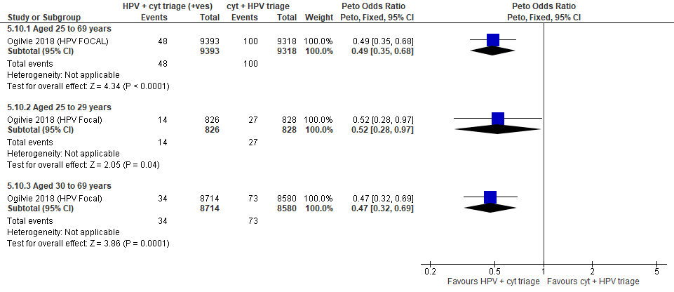
Forest Plot 3.7b. Incidence of CIN2+

Evidence Set 3.8b. Incidence of CIN3+
Included report: Ogilvie 2018 (HPV FOCAL)
GRADE Summary of Findings Table 3.8b. Incidence of CIN3+
Outcome  No. participantsª  (studies) |  | Relative effects, Peto OR and RR (95 % CI) | Anticipated absolute effects |  |  | Certainty of evidence (GRADE)^{b} | What happens?
 |  | Relative effects, Peto OR and RR (95 % CI) | With cytology screening + hrHPV triage | With hrHPV screening + cytology triage | Difference | Certainty of evidence (GRADE)^{b} | What happens?
People with a cervix aged 25 to 69 years (Ogilvie 2018 (HPV FOCAL); acceptors of screening at follow up)
Incidence of CIN3+  Follow-up: 48 months  18,711 (1 RCT) | Peto OR: 0.44 (0.28 to 0.69)  RR: 0.44 (0.28 to 0.69) |  | 55.8 per 10,000 | 24.6 per 10,000 | 31.2 less per 10,000 (40.1 less to 17.2 less) | NA
People with a cervix aged 25 to 29 years (Ogilvie 2018 (HPV FOCAL); acceptors of screening at follow up)
Incidence of CIN3+  Follow-up: 48 months  1,654 (1 RCT) | Peto OR: 0.42 (0.18 to 1.00)  RR: 0.42 (0.18 to 1.00) |  | 181.2 per 10,000 | 72.9 per 10,000 | 104.3 less per 10,000 (148.1 less to 0.0 less) | VERY LOW^{c}  ⊕⊝⊝⊝  due to lack of evidence of consistency, (very serious) indirectness, and imprecision | Among screened people with a cervix aged 25 to 29 years, we are very uncertain about the effects on the incidence of CIN3+ for hrHPV screening with cytology triage compared with cytology screening with hrHPV triage.
People with a cervix aged 30 to 69 years (Ogilvie 2018 (HPV FOCAL); acceptors of screening at follow up)
Incidence of CIN3+  Follow-up: 48 months  17,294 (1 RCT) | Peto OR: 0.44 (0.26 to 0.76)  RR: 0.44 (0.26 to 0.76) |  | 43.1 per 10,000 | 19.0 per 10,000 | 24.1 less per 10,000 (31.9 less to 10.3 less) | 30-59 yrs:  VERY LOW^{d}  ⊕⊝⊝⊝  due to lack of evidence of consistency, (very serious) indirectness  60-69 yrs:  VERY LOW^{e}  ⊕⊝⊝⊝  due to lack of evidence of consistency, (very serious) indirectness | Among screened people with a cervix aged 30 to 69 years, we are very uncertain about the effects on the incidence of CIN3+ for hrHPV screening with cytology triage compared with cytology screening with hrHPV triage.
CI = confidence interval; CIN = cervical intraepithelial neoplasia; NA= not applicable (i.e., not used for conclusions); OR = odds ratio; RCT = randomized controlled trial; RR = relative risk.
ªAcceptors of screening at follow up includes all randomized participants who completed the screening protocol and attended the second round of screening (i.e., round two for the cytology arm and in both arms the 48-month follow up testing via hrHPV and cytology co-testing). The denominator excludes those who tested positive and were histologically diagnosed with CIN2+ before the 48-month exit screen in the hrHPV arm and before round 2 in the cytology arm. The numerators were taken from Table 2 and included cases detected during round 2 (in the cyolotgy arm) and during the 48-month exit round (both arms). Those who attended follow-up testing for a positive screening result but were histologically confirmed negative or CIN1 are included.
^{b}We rated down by 0.5 for “some concerns”, 1 “serious concerns”, and 2 for “very serious concerns”. When our assessment of the certainty of evidence fell between levels, we assigned the level that best represented our actual certainty in the evidence, and based our conclusions on this level of certainty.
Explanations:
^{c}Acceptors of screening at follow up; people with a cervix aged 25 to 29 years: No serious concerns about risk of bias: no domains judged high risk. Some concerns about inconsistency: lack of evidence for consistency due to single study. Very serious concerns about indirectness: the outcome is considered very indirect because only those with normal results received follow-up thus the outcome does not capture cases of CIN2 or CIN3 that progressed during follow-up, and incidence ascertainment does not capture cases, especially for ICC, detected clinically. Serious concerns about imprecision: upper limit of 95% CI indicates little-to-no effect. No other serious concerns.
^{d}Acceptors of screening at follow up; people with a cervix aged 30 to 59 years: No serious concerns about risk of bias: no domains judged high risk. Some concerns about inconsistency: lack of evidence for consistency due to single study. Very serious concerns about indirectness: the outcome is considered very indirect because only those with normal results received follow-up thus the outcome does not capture cases of CIN2 or CIN3 that progressed during follow-up, and incidence ascertainment does not capture cases, especially for ICC, detected clinically. No serious concerns about imprecision: the 95% CI is precise for fewer events. No other serious concerns.
^{e}Acceptors of screening at follow up; people with a cervix aged 60 to 69 years: No serious concerns about risk of bias: no domains judged high risk. Some concerns about inconsistency: lack of evidence for consistency due to single study. Very serious concerns about indirectness: the outcome is considered very indirect because only those with normal results received follow-up thus the outcome does not capture cases of CIN2 or CIN3 that progressed during follow-up, and incidence ascertainment does not capture cases, especially for ICC, detected clinically. The study data is not directly applicable for this age group due to a small sample (n=2,094 [8.3%]) enrolled). No serious concerns about imprecision: the 95% CI is precise for fewer events. No other serious concerns.

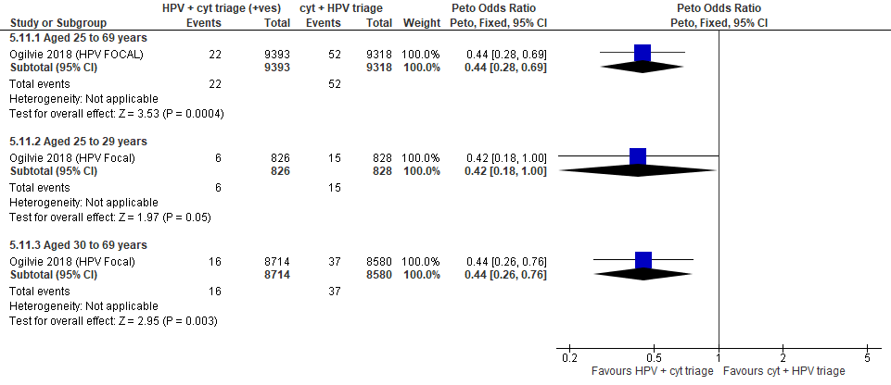
Forest Plot 3.8b. Incidence of CIN3+

Evidence Set 3.9b. Incidence of invasive cervical cancer
Included report: Rebolj 2022 (UK observational)
GRADE Summary of Findings Table 3.9b. Incidence of invasive cervical cancer
Outcome  No. participantsª  (studies) |  | Relative effects, Peto OR and RR (95 % CI) | Anticipated absolute effects* |  |  | Certainty of evidence (GRADE)^{b} | What happens?
 |  | Relative effects, Peto OR and RR (95 % CI) | With cytology screening + hrHPV triage | With hrHPV screening + cytology triage | Difference | Certainty of evidence (GRADE)^{b} | What happens?
People with a cervix aged 25 to 59 years (Rebolj 2022 (UK observational; acceptors of screening at follow up)
Incidence of ICC  Follow-up: 3-3.8 years  1,171,192 (1 observational) | Peto OR: 0.41 (0.29 to 0.58)  RR: 0.41 (0.29 to 0.58) |  | 1.6 per 10,000 | 0.7 per 10,000 | 0.9 less per 10,000 (1.1 less to 0.7 less) | NA
People with a cervix aged 25 to 29 years (Rebolj 2021 (UK observational); acceptors of screening at follow up)
Incidence of ICC  Follow-up: 3-3.8 years  115,197 (1 observational) | Peto OR: 0.29 (0.15 to 0.56)  RR: 0.29 (0.15 to 0.56) |  | 4.7 per 10,000 | 1.4 per 10,000 | 3.3 less per 10,000 (4.0 less to 2.1 less) | VERY LOW^{c}  ⊕⊝⊝⊝  due to risk of bias, lack of evidence of consistency and imprecision | Among screened people with a cervix aged 25 to 29 years, we are very uncertain about the effects on incidence of invasive cervical cancer for hrHPV screening with cytology triage compared with cytology screening.
People with a cervix aged 30 to 59 years (Rebolj 2021 (UK observational); acceptors of screening at follow up)
Incidence of ICC  Follow-up: 3-3.8 years  673,619 (1 observational) | Peto OR: 0.32 (0.21 to 0.49)  RR: 0.32 (0.21 to 0.49) |  | 2.0 per 10,000 | 0.6 per 10,000 | 1.3 less per 10,000 (1.5 less to 1.0 less) | 30-59 yrs:  VERY LOW^{d}  ⊕⊝⊝⊝  due to risk of bias, and lack of evidence of consistency  60-69 yrs:  VERY LOW  ⊕⊝⊝⊝  NR | Among screened people with a cervix aged 30 to 69 years, we are very uncertain about the effects on incidence of invasive cervical cancer within 3.8 years for hrHPV screening with cytology triage compared with cytology screening with hrHPV triage.
CI = confidence interval; NA= not applicable (i.e., not used for conclusions); OR = odds ratio; RCT = randomized controlled trial; RR = relative risk.
ªAcceptors of screening at follow up includes all participants who completed the screening protocol and second round of screening. The denominator excludes those positive and diagnosed with CIN2+ on the baseline screening round.
^{b}We rated down by 0.5 for “some concerns”, 1 “serious concerns”, and 2 for “very serious concerns”. When our assessment of the certainty of evidence fell between levels, we assigned the level that best represented our actual certainty in the evidence, and based our conclusions on this level of certainty.
Explanations:
^{c}Acceptors of screening at follow up; people with a cervix aged 25 to 29 years: Serious concerns about risk of bias: not a randomized trial or adjusted anaysis, and outcomes were not actively ascertained (mainly data linkage), possibility of missing outcomes. Some concerns about inconsistency: lack of evidence of consistency due to single study. No serious concerns about indirectness: the study provides direct evidence. Serious concerns about imprecision: upper limit of 95% CI indicates little-to-no effect. No other serious concerns.
^{d}Acceptors of screening at follow up; people with a cervix aged 30 to 59 years: Serious concerns about risk of bias: not a randomized trial or adjusted analysis, and outcomes were not actively ascertained (mainly data linkage), possibility of missing outcomes. Some concerns about inconsistency: lack of evidence of consistency due to single study. No serious concerns about indirectness: the study provides direct evidence. No serious concerns about imprecision: 95% CI precise for little-to-no effect. No other serious concerns.

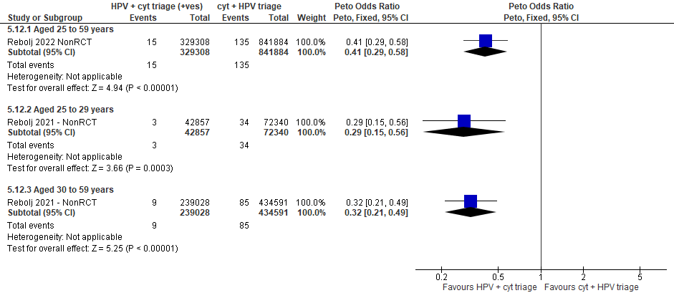
Forest Plot 3.9b. Incidence of invasive cervical cancer

Evidence Set 3.10b. False positives for CIN2+ (those referred for colposcopy who did not have CIN2+)
Included reports: Nygard 2022 (Norwegian); Ogilvie 2017 (HPV FOCAL)
GRADE Summary of Findings Table 3.10b. False positives for CIN2+ (those referred for colposcopy who did not have CIN2+)
Outcome  No. participantsª  (studies) |  | Relative effects  Peto OR and RR (95% CI) | Anticipated absolute effects (95% CI) |  |  | Certainty of evidence (GRADE)^{b} | What happens?
 |  | Relative effects  Peto OR and RR (95% CI) | With cytology screening + hrHPV triage | With hrHPV screening + cytology triage | Difference | Certainty of evidence (GRADE)^{b} | What happens?
People with a cervix aged 25 to 69 years (Nygard 2022 (Norwegian); Ogilvie 2017 (HPV FOCAL); acceptors of screening)
False positives for CIN2+  Follow-up: 1 round  182,541 (2 RCTs) | Peto OR: 2.43 (2.27 to 2.60)  RR: 2.40 (2.24 to 2.56) |  | 100.2 per 10,000 | 240.0 per 10,000 | 139.8 more per 10,000 (124.4 more to 156.2 more) | NA
>Subgroup: People with a cervix aged 25 to 29 years (Ogilvie 2017 (HPV FOCAL); acceptors of screening)
False positives for CIN2+  Follow-up: 1 round  2,188 (1 RCT) | Peto OR: 2.55 (1.92 to 3.39)  RR: 2.37 (1.84 to 3.03) |  | 491.6 per 10,000 | 1164.8 per 10,000 | 673.2 more per 10,000 (411.4 more to 999.7 more) | MODERATE^{c}  ⊕⊕⊕⊝  due to lack of evidence of consistency | Among screened people with a cervix aged 25 to 29 years, hrHPV screening with cytology triage probably increases the number of false positives for CIN2+ compared with cytology screening with hrHPV triage.
>Subgroup: People with a cervix aged 30 to 59 years (Nygard 2022 (Norwegian); Ogilvie 2017 (HPV FOCAL); acceptors of screening)
False positives for CIN2+  Follow-up: 1 round  147,028 (2 RCTs) | Peto OR: 2.33 (2.17 to 2.51)  RR: 2.30 (2.14 to 2.47) |  | 108.7 per 10,000 | 249.6 per 10,000 | 141.0 more per 10,000 (124.2 more to 159.7 more) | MODERATE^{d}  ⊕⊕⊕⊝  due to risk of bias, and lack of evidence of consistency | Among screened people with a cervix aged 30 to 59 years, hrHPV screening with cytology triage probably have little-to-no effect on the number of false positives for CIN2+ compared with cytology screening with hrHPV triage.
>Subgroup: People with a cervix aged 60 to 69 years (Nygard 2022 (Norwegian); acceptors of screening)
False positives for CIN2+  Follow-up: 1 round  33,474 (1 RCT) | Peto OR: 3.37 (2.75 to 4.13)  RR: 3.33 (2.73 to 4.07) |  | 46.5 per 10,000 | 155.0 per 10,000 | 108.5 more per 10,000 (80.4 more to 142.8 more) | MODERATE^{e}  ⊕⊕⊕⊝  due to risk of bias, and lack of evidence of consistency | Among screened people with a cervix aged 60 to 69 years, hrHPV screening with cytology triage probably has little-to-no effect on the number of false positives for CIN2+ compared with cytology screening with hrHPV triage.
CI = confidence interval; CIN = cervical intraepithelial neoplasia; NA= not applicable (i.e., not used for conclusions); OR = odds ratio; RCT = randomized controlled trial; RR = relative risk.
ªAcceptors of screening include all participants who completed one round of screening via the strategy to which they were randomly assigned.
^{b}We rated down by 0.5 for “some concerns”, 1 “serious concerns”, and 2 for “very serious concerns”. When our assessment of the certainty of evidence fell between levels, we assigned the level that best represented our actual certainty in the evidence, and based our conclusions on this level of certainty.
Explanations:
^{c}Acceptors of screening; people with a cervix aged 25 to 29 years: No serious concerns about risk of bias: no domains judged high risk. Some concerns about inconsistency: lack of evidence of consistency due to single study. No serious concerns about indirectness: the study provides direct evidence. No serious concerns about imprecision: 95% CI precise for increased effect. No other serious concerns.
^{d}Acceptors of screening; people with a cervix aged 30 to 59 years: Some concerns about risk of bias: ~80% weight in analysis from single study at risk of selection bias because randomization occurred before enrollment, without adequate information about baseline characteristics across groups. Some concerns about inconsistency: ~80% weight in analysis from single study due to single study. No serious concerns about indirectness: the study provides direct evidence. No serious concerns about imprecision: 95% CI precise for little-to-no effect. No other serious concerns.
^{e}Acceptors of screening; people with a cervix aged 60 to 69 years: Some concerns about risk of bias: at risk of selection bias because randomization occurred before enrollment, without adequate information about baseline characteristics across groups. Some concerns about inconsistency: lack of evidence of consistency due to single study. No serious concerns about indirectness: the study provides direct evidence. No serious concerns about imprecision: 95% CI precise for little-to-no effect. No other serious concerns.

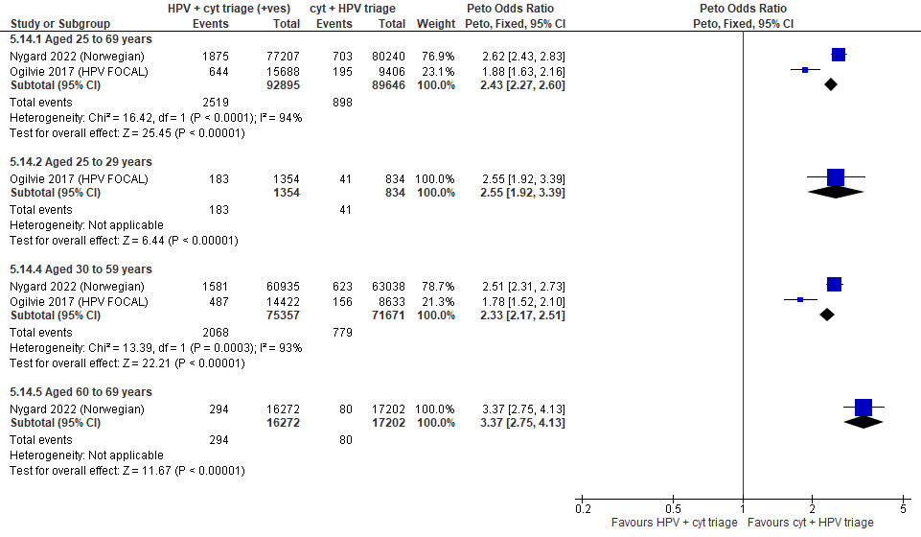
Forest Plot 3.10b. False positives for CIN2+

Evidence Set 3.11b. False positives for CIN2+ (to recall)
Included reports: Nygard 2022 (Norwegian); Ogilvie 2017 (HPV FOCAL)
GRADE Summary of Findings Table 3.11b. False positives for CIN2+ (to recall)
Outcome  No. participantsª  (studies) |  | Relative effects  Peto OR and RR (95% CI) | Anticipated absolute effects (95% CI) |  |  | Certainty of evidence (GRADE)^{b} | What happens?
 |  | Relative effects  Peto OR and RR (95% CI) | With cytology screening + hrHPV triage | With hrHPV screening + cytology triage | Difference | Certainty of evidence (GRADE)^{b} | What happens?
People with a cervix aged 25 to 69 years (Nygard 2022 (Norwegian); Ogilvie 2017 (HPV FOCAL); acceptors of screening)
False positives for CIN2+ (to recall)  Follow-up: 1 round  182,541 (2 RCTs) | Peto OR: 2.93 (2.78 to 3.08)  RR: 2.85 (2.71 to 2.99) |  | 149.7 per 10,000 | 426.3 per 10,000 | 276.6 more per 10,000 (255.7 more to 297.5 more) | NA
>Subgroup: People with a cervix aged 25 to 29 years (Ogilvie 2017 (HPV FOCAL); acceptors of screening)
False positives for CIN2+ (to recall)  Follow-up: 1 round  2,188 (1 RCT) | Peto OR: 3.02 (2.34 to 3.89)  RR: 2.72 (2.18 to 3.37) |  | 539.6 per 10,000 | 1,469.3 per 10,000 | 929.8 more per 10,000 (637.9 more to 1,276.2 more) | MODERATE^{c}  ⊕⊕⊕⊝  due to lack of evidence of consistency | Among screened people with a cervix aged 25 to 29 years, hrHPV screening with cytology triage probably increases the number of false positives for CIN2+ compared with cytology screening with hrHPV triage.
>Subgroup: People with a cervix aged 30 to 69 years (Nygard 2022 (Norwegian); Ogilvie 2017 (HPV FOCAL); acceptors of screening)
False positives for CIN2+ (to recall)  Follow-up: 1 round  180,502 (2 RCTs) | Peto OR: 2.93 (2.78 to 3.09)  RR: 2.85 (2.71 to 3.00) |  | 145.9 per 10,000 | 415.9 per 10,000 | 269.9 more per 10,000 (249.5 more to 291.7 more) | 30-59 yrs:  MODERATE^{d}  ⊕⊕⊕⊝  due to risk of bias, and lack of evidence of consistency  60-69 yrs:  MODERATE^{e}  ⊕⊕⊕⊝  due to risk of bias, and lack of evidence of consistency | Among screened people with a cervix aged 30 to 69 years, hrHPV screening with cytology triage probably has little-to-no effect on the number of false positives for CIN2+ compared with cytology screening with hrHPV triage.
CI = confidence interval; CIN = cervical intraepithelial neoplasia; NA= not applicable (i.e., not used for conclusions); OR = odds ratio; RCT = randomized controlled trial; RR = relative risk.
ªAcceptors of screening include all participants who completed one round of screening via the strategy to which they were randomly assigned. False positives were calculated based on those with a positive screening result and any referral for follow-up.
^{b}We rated down by 0.5 for “some concerns”, 1 “serious concerns”, and 2 for “very serious concerns”. When our assessment of the certainty of evidence fell between levels, we assigned the level that best represented our actual certainty in the evidence, and based our conclusions on this level of certainty.
Explanations:
^{c}Acceptors of screening; people with a cervix aged 25 to 29 years: No serious concerns about risk of bias: no domains judged high risk. Some concerns about inconsistency: lack of evidence of consistency due to single study. No serious concerns about indirectness: the study provides direct evidence. No serious concerns about imprecision: 95% CI precise for increased effect. No other serious concerns.
^{d}Acceptors of screening; people with a cervix aged 30 to 59 years: Some concerns about risk of bias: at risk of selection bias because randomization occurred before enrollment, without adequate information about baseline characteristics across groups. Some concerns about inconsistency: lack of evidence of consistency due to single study. No serious concerns about indirectness: the study provides direct evidence. No serious concerns about imprecision: 95% CI precise for little-to-no effect. No other serious concerns.
^{e}Acceptors of screening; people with a cervix aged 60 to 69 years: Some concerns about risk of bias: at risk of selection bias because randomization occurred before enrollment, without adequate information about baseline characteristics across groups. Some concerns about inconsistency: lack of evidence of consistency due to single study. No serious concerns about indirectness: the study data is highly applicable to this age group. No serious concerns about imprecision: 95% CI precise for little-to-no effect. No other serious concerns.

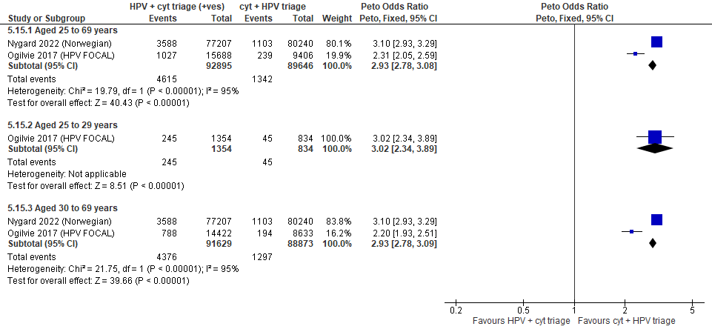
Forest Plot 3.11b. False positives for CIN2+ (to recall)

Evidence Set 3.12b. False positives for CIN3+ (those referred for colposcopy who did not have CIN3+)
Included reports: Nygard 2022 (Norwegian); Ogilvie 2018 (HPV FOCAL)
GRADE Summary of Findings Table 3.12b. False positives for CIN3+ (those referred for colposcopy who did not have CIN3+)
Outcome  No. participantsª  (studies) |  | Relative effects  Peto OR and RR (95% CI) | Anticipated absolute effects (95% CI) |  |  | Certainty of evidence (GRADE)^{b} | What happens?
 |  | Relative effects  Peto OR and RR (95% CI) | With cytology screening + hrHPV triage | With hrHPV screening + cytology triage | Difference | Certainty of evidence (GRADE)^{b} | What happens?
People with a cervix aged 25 to 69 years (Nygard 2022 (Norwegian); Ogilvie 2017 (HPV FOCAL); acceptors of screening)
False positives for CIN3+  Follow-up: 1 round  182,541 (2 RCTs) | Peto OR: 2.41 (2.26 to 2.57)  RR: 2.37 (2.23 to 2.52) |  | 115.9 per 10,000 | 274.8 per 10,000 | 158.9 more per 10,000 (142.3 more to 176.6 more) | NA
>Subgroup: People with a cervix aged 25 to 29 years (Ogilvie 2017 (HPV FOCAL); acceptors of screening)
False positives for CIN3+  Follow-up: 1 round  2,188 (1 RCT) | Peto OR: 2.55 (1.97 to 3.30)  RR: 2.32 (1.86 to 2.88) |  | 635.5 per 10,000 | 1,475.2 per 10,000 | 839.7 more per 10,000 (543.7 more to 1,194.2 more) | MODERATE^{c}  ⊕⊕⊕⊝  due to lack of evidence of consistency | Among screened people with a cervix aged 25 to 29 years, hrHPV screening with cytology triage probably increases the number of false positives for CIN3+ compared with cytology screening with hrHPV triage.
>Subgroup: People with a cervix aged 30 to 59 years (Nygard 2022 (Norwegian); Ogilvie 2017 (HPV FOCAL); acceptors of screening)
False positives for CIN3+  Follow-up: 1 round  147,028 (2 RCTs) | Peto OR: 2.32 (2.17 to 2.49)  RR: 2.28 (2.14 to 2.44) |  | 126.0 per 10,000 | 287.5 per 10,000 | 161.5 more per 10,000 (143.4 more to 181.9 more) | MODERATE^{d}  ⊕⊕⊕⊝  due to risk of bias, lack of evidence of consistency | Among screened people with a cervix aged 30 to 59 years, hrHPV screening with cytology triage probably has little-to-no effect on the number of false positives for CIN3+ compared with cytology screening with hrHPV triage.
>Subgroup: People with a cervix aged 60 to 69 years (Nygard 2022 (Norwegian); acceptors of screening)
False positives for CIN3+  Follow-up: 1 round  33,474 (1 RCT) | Peto OR: 3.37 (2.77 to 4.10)  RR: 3.33 (2.75 to 4.04) |  | 50.0 per 10,000 | 166.5 per 10,000 | 116.5 more per 10,000 (87.3 more to 151.9 more) | MODERATE^{e}  ⊕⊕⊕⊝  due to risk of bias, and lack of evidence of consistency | Among screened people with a cervix aged 60 to 69 years, hrHPV screening with cytology triage probably has little-to-no effect in the number of false positives for CIN3+ compared with cytology screening with hrHPV triage.
CI = confidence interval; CIN = cervical intraepithelial neoplasia; NA= not applicable (i.e., not used for conclusions); OR = odds ratio; RCT = randomized controlled trial; RR = relative risk.
ªAcceptors of screening include all participants who completed one round of screening via the strategy to which they were randomly assigned.
^{b}We rated down by 0.5 for “some concerns”, 1 “serious concerns”, and 2 for “very serious concerns”. When our assessment of the certainty of evidence fell between levels, we assigned the level that best represented our actual certainty in the evidence, and based our conclusions on this level of certainty.
Explanations:
^{c}Acceptors of screening; people with a cervix aged 25 to 29 years: No serious concerns about risk of bias: no domains judged high risk. Some concerns about inconsistency: lack of evidence of consistency due to single study. No serious concerns about indirectness: the study provides direct evidence. No serious concerns about imprecision: 95% CI precise for increased effect. No other serious concerns.
^{d}Acceptors of screening; people with a cervix aged 30 to 59 years: Some concerns about risk of bias: ~80% weight in analysis from single study at risk of selection bias because randomization occurred before enrollment, without adequate information about baseline characteristics across groups. Some concerns about inconsistency: ~80% weight in analysis from single study. No serious concerns about indirectness: the study provides direct evidence. No serious concerns about imprecision: 95% CI precise for little-to-no effect. No other serious concerns.
^{e}Acceptors of screening; people with a cervix aged 60 to 69 years: Some concerns about risk of bias: at risk of selection bias because randomization occurred before enrollment, without adequate information about baseline characteristics across groups. Some concerns about inconsistency: lack of evidence of consistency due to single study. No serious concerns about indirectness: the study provides direct evidence. No serious concerns about imprecision: 95% CI precise for little-to-no effect. No other serious concerns.

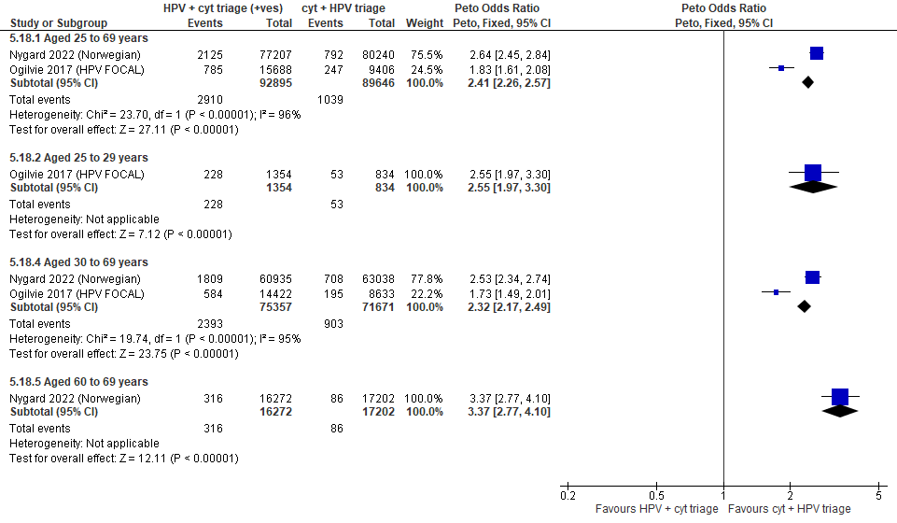

Forest Plot 3.12b. False positives for CIN3+

Evidence Set 3.13b. False positives for CIN3+ (to recall)
Included reports: Nygard 2022 (Norwegian); Ogilvie 2018 (HPV FOCAL)
GRADE Summary of Findings Table 3.13. False positives for CIN3+ (to recall)
Outcome  No. participantsª  (studies) |  | Relative effects  Peto OR and RR (95% CI) | Anticipated absolute effects (95% CI) |  |  | Certainty of evidence (GRADE)^{b} | What happens?
 |  | Relative effects  Peto OR and RR (95% CI) | With cytology screening + hrHPV triage | With hrHPV screening + cytology triage | Difference | Certainty of evidence (GRADE)^{b} | What happens?
People with a cervix aged 25 to 69 years (Nygard 2022 (Norwegian); Ogilvie 2017 (HPV FOCAL); acceptors of screening)
False positives for CIN3+ (to recall)  Follow-up: 1 round  182,541 (2 RCTs) | Peto OR: 2.88 (2.74 to 3.03)  RR: 2.79 (2.66 to 2.93) |  | 165.7 per 10,000 | 462.7 per 10,000 | 297.0 more per 10,000 (275.5 more to 319.9 more) | NA
>Subgroup: People with a cervix aged 25 to 29 years (Ogilvie 2017 (HPV FOCAL); acceptors of screening)
False positives for CIN3+ (to recall)  Follow-up: 1 round  2,188 (1 RCT) | Peto OR: 2.98 (2.35 to 3.78)  RR: 2.62 (2.15 to 3.18) |  | 683.5 per 10,000 | 1,793.9 per 10,000 | 1,110.5 more per 10,000 (787.0 more to 1,487.5 more) | MODERATE^{c}  ⊕⊕⊕⊝  due to lack of evidence of consistency | Among screened people with a cervix aged 25 to 29 years, hrHPV screening with cytology triage probably increases the number of false positives for CIN3+ compared with cytology screening with hrHPV triage.
>Subgroup: People with a cervix aged 30 to 69 years (Nygard 2022 (Norwegian); Ogilvie 2017 (HPV FOCAL); acceptors of screening)
False positives for CIN3+ (to recall)  Follow-up: 1 round  180,502 (2 RCTs) | Peto OR: 2.89 (2.75 to 3.04)  RR: 2.80 (2.67 to 2.94) |  | 160.6 per 10,000 | 450.4 per 10,000 | 289.8 more per 10,000 (268.9 more to 312.1 more) | 30-59 yrs:  LOW^{d}  ⊕⊕⊝⊝  due to risk of bias, lack of evidence of consistency, and imprecision  60-69 yrs:  LOW^{e}  ⊕⊕⊝⊝  due to risk of bias, lack of evidence of consistency, and imprecision | Among screened people with a cervix aged 30 to 69 years, hrHPV screening with cytology triage may have little-to-no effect on the number of false positives for CIN3+ compared with cytology screening with hrHPV triage.
CI = confidence interval; CIN = cervical intraepithelial neoplasia; NA= not applicable (i.e., not used for conclusions); OR = odds ratio; RCT = randomized controlled trial; RR = relative risk.
ªAcceptors of screening include all participants who completed one round of screening via the strategy to which they were randomly assigned. False positives were calculated based on those with a positive screening result and any referral for follow-up.
^{b}We rated down by 0.5 for “some concerns”, 1 “serious concerns”, and 2 for “very serious concerns”. When our assessment of the certainty of evidence fell between levels, we assigned the level that best represented our actual certainty in the evidence, and based our conclusions on this level of certainty.
Explanations:
^{c}Acceptors of screening; people with a cervix aged 25 to 29 years: No serious concerns about risk of bias: no domains judged high risk. Some concerns about inconsistency: lack of evidence of consistency due to single study. No serious concerns about indirectness: the study provides direct evidence. No serious concerns about imprecision: 95% CI precise for increased effect. No other serious concerns.
^{d}Acceptors of screening; people with a cervix aged 30 to 59 years: Some concerns about risk of bias: ~80% weight in analysis from single study at risk of selection bias because randomization occurred before enrollment, without adequate information about baseline characteristics across groups. Some concerns about inconsistency: lack of evidence of consistency (~80% weight in analysis from single study). No serious concerns about indirectness: the study provides direct evidence. Serious concerns about imprecision: upper limit of 95% CI indicates increased effect. No other serious concerns.
^{e}Acceptors of screening; people with a cervix aged 60 to 69 years: Some concerns about risk of bias: ~80% weight in analysis from single study at risk of selection bias because randomization occurred before enrollment, without adequate information about baseline characteristics across groups. Some concerns about inconsistency: lack of evidence of consistency (~80% weight in analysis from single study). No serious concerns about indirectness: the study data is highly applicable to this age group. Serious concerns about imprecision: upper limit of 95% CI indicates increased effect. No other serious concerns.

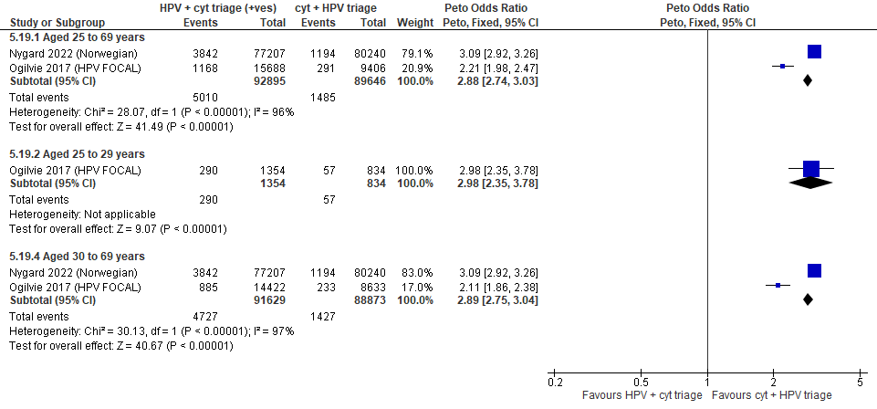

Forest Plot 3.13b. False positives for CIN3+ (to recall)

Evidence Set 3.14b. False positives for invasive cervical cancer (to recall)
Included report: Nygard 2022 (Norwegian)
GRADE Summary of Findings Table 3.14b. False positives for invasive cervical cancer
Outcome  No. participantsª  (studies) |  | Relative effects, Peto OR and RR (95 % CI) | Anticipated absolute effects* |  |  | Certainty of evidence (GRADE)^{b} | What happens?
 |  | Relative effects, Peto OR and RR (95 % CI) | With cytology screening + hrHPV triage | With hrHPV screening + cytology triage | Difference | Certainty of evidence (GRADE)^{b} | What happens?
People with a cervix aged 30 to 69 years (Nygard 2022 (Norwegian); acceptors of screening)
False positives for invasive cervical cancer (to recall)  Follow-up: 1 round  157,447 (1 RCT) | Peto OR: 2.66 (2.53 to 2.80)  RR: 2.56 (2.45 to 2.69) |  | 223.5 per 10,000 | 573.1 per 10,000 | 349.7 more per 10,000 (323.2 more to 378.0 more) | 25-29 yrs:  VERY LOW  ⊕⊝⊝⊝  NR  30-59 yrs:  MODERATE^{c}  ⊕⊕⊕⊝  due to risk of bias and lack of evidence of consistency  60-69 yrs:  MODERATE^{d}  ⊕⊕⊕⊝  due to risk of bias and lack of evidence of consistency | Among screened people with a cervix aged 25 to 29 years, we are very uncertain about the effects of hrHPV screening with cytology triage on the number of false positives for invasive cervical cancer compared with cytology screening with hrHPV triage.  Among screened people with a cervix aged 30 to 69 years, hrHPV screening with cytology triage probably increases the number of false positives for invasive cervical cancer compared with cytology screening with hrHPV triage.
CI = confidence interval; OR = odds ratio; RCT = randomized controlled trial; RR = relative risk.
ªAcceptors of screening include all participants who completed one round of screening via the strategy to which they were randomly assigned. False positives were calculated based on those with a positive screening result and any referral for follow-up.
^{b}We rated down by 0.5 for “some concerns”, 1 “serious concerns”, and 2 for “very serious concerns”. When our assessment of the certainty of evidence fell between levels, we assigned the level that best represented our actual certainty in the evidence, and based our conclusions on this level of certainty.
Explanations:
^{c}Acceptors of screening; people with a cervix aged 30 to 59 years: Some concerns about risk of bias: at risk of selection bias because randomization occurred before enrollment, without adequate information about baseline characteristics across groups. Some concerns about inconsistency: lack of evidence of consistency due to single study. No serious concerns about indirectness: the study provides direct evidence. No serious concerns about imprecision: 95% CI precise for an increased effect. No other serious concerns.
^{d}Acceptors of screening; people with a cervix aged 60 to 69 years: Some concerns about risk of bias: at risk of selection bias because randomization occurred before enrollment, without adequate information about baseline characteristics across groups. Some concerns about inconsistency: lack of evidence of consistency due to single study. No serious concerns about indirectness: the study provides direct evidence. No serious concerns about imprecision: 95% CI precise for an increased effect. No other serious concerns.

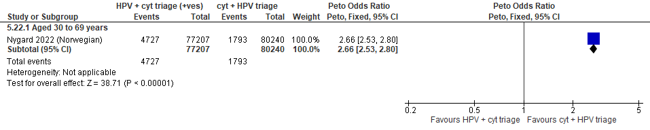
Forest Plot 3.14b. False positives for invasive cervical cancer (to recall)

Evidence set 3.0c: hrHPV screening (threshold 1.0 RLU) with liquid-based cytology triage of positive tests versus two rounds of liquid-based cytology screening (threshold ≥LSIL) with hrHPV triage of ASCUS

Included reports: Ogilvie 2018 (HPV FOCAL) (ages 25-65 [subgroups 25-29 and 30-65 years])

Evidence set 3.1c. Referrals to colposcopy
GRADE Summary of Findings Table 3.1c. Referrals to colposcopy
Outcome  No. participantsª  (studies) |  | Relative effects,  Peto OR and RR (95% CI) | Anticipated absolute effects (95% CI) |  |  | Certainty of evidence (GRADE)^{b} | What happens?
 |  | Relative effects,  Peto OR and RR (95% CI) | With cytology screening + hrHPV triage | With hrHPV screening + cytology triage | Difference | Certainty of evidence (GRADE)^{b} | What happens?
People with a cervix aged 25 to 69 years (Ogilvie 2018 (HPV FOCAL); acceptors of screening)
Referrals to colposcopy  Follow-up: 1 round hrHPV and 2 cytology arms  18,948 (1 RCT) | Peto OR: 1.24 (1.09 to 1.41)  RR: 1.23 (1.09 to 1.38) |  | 464.5 per 10,000 | 569.6 per 10,000 | 105.1 more per 10,000 (39.7 more to 178.2 more) | 25-29 yrs:  LOW^{c}  ⊕⊕⊝⊝  due to lack of evidence of consistency, and indirectness  30-59 yrs:  MODERATE^{d}  ⊕⊕⊕⊝  due to lack of evidence of consistency  60-69 yrs:  MODERATE^{e}  ⊕⊕⊕⊝  due to lack of evidence of consistency, and indirectness | Among screened people with a cervix aged 25 to 29 years, one round of hrHPV screening with cytology triage may have little-to-no effect on the referrals to colposcopy compared with two rounds of cytology screening with hrHPV triage.  Among screened people with a cervix aged 30 to 69 years, one round of hrHPV screening with cytology triage probably has little-to-no effect on the referrals to colposcopy compared with two rounds of cytology screening with hrHPV triage.
CI = confidence interval; NA= not applicable (i.e., not used for conclusions); OR = odds ratio; RCT = randomized controlled trial; RR = relative risk.
ªAcceptors of screening include all participants who completed one round of screening via the strategy to which they were randomly assigned.
^{b}We rated down by 0.5 for “some concerns”, 1 “serious concerns”, and 2 for “very serious concerns”. When our assessment of the certainty of evidence fell between levels, we assigned the level that best represented our actual certainty in the evidence, and based our conclusions on this level of certainty.
Explanations:
^{c}Acceptors of screening; people with a cervix aged 25 to 29 years: No serious concerns about risk of bias: no domains judged high risk. Some concerns about inconsistency: lack of evidence of consistency due to single study. Serious concerns about indirectness: the study data is not directly applicable for this age group due to a small sample (n=2,188 [8.7%] enrolled) and evidence from other outcomes of differing effects from 3b. No serious concerns about imprecision: 95% CI precise for little-to-no effect. No other serious concerns.
^{d}Acceptors of screening; people with a cervix aged 30 to 59 years: No serious concerns about risk of bias: no domains judged high risk. Some concerns about inconsistency: lack of evidence of consistency due to single study. No serious concerns about indirectness: the study data is directly applicable. No serious concerns about imprecision: 95% CI precise for little-to-no effect. No other serious concerns.
^{e}Acceptors of screening; people with a cervix aged 60 to 69 years: No serious concerns about risk of bias: no domains judged high risk. Some concerns about inconsistency: lack of evidence of consistency due to single study. Some concerns about indirectness: there are some concerns about the small sample size in the study for this age group (n=2,094 [8.3%] enrolled). No serious concerns about imprecision: 95% CI precise for little-to-no effect. No other serious concerns.

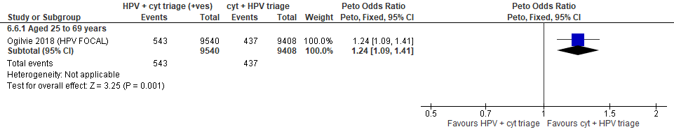
Forest Plot 3.1c. Referrals to colposcopy

Evidence set 3.2c. Number of colposcopies
Included reports: Ogilvie 2018 (HPV FOCAL)
GRADE Summary of Findings Table 3.2c. Number of colposcopies
Outcome  No. participantsª  (studies) |  | Relative effects,  Peto OR and RR (95 % CI) | Anticipated absolute effects (95% CI) |  |  | Certainty of evidence (GRADE)^{b} | What happens?
 |  | Relative effects,  Peto OR and RR (95 % CI) | With cytology screening + hrHPV triage | With hrHPV screening + cytology triage | Difference | Certainty of evidence (GRADE)^{b} | What happens?
People with a cervix aged 25 to 69 years (Ogilvie 2018 (HPV FOCAL); acceptors of screening)
Number of colposcopies  Follow-up: 1 round hrHPV and 2 cytology arms  18,948 (1 RCT) | Peto OR: 1.22 (1.07 to 1.39)  RR: 1.21 (1.07 to 1.37) |  | 453.9 per 10,000 | 548.2 per 10,000 | 94.4 more per 10,000 (30.2 more to 166.0 more) | 25-29 yrs:  LOW^{c}  ⊕⊕⊝⊝  due to lack of evidence of consistency, and indirectness  30-59 yrs:  MODERATE^{d}  ⊕⊕⊕⊝  due to lack of evidence of consistency  60-69 yrs:  MODERATE^{e}  ⊕⊕⊕⊝  due to lack of evidence of consistency, and indirectness | Among screened people with a cervix aged 25 to 29 years, one round of hrHPV screening with cytology triage may have little-to-no effect on the number of colposcopies compared with two rounds of cytology screening with hrHPV triage.  Among screened people with a cervix aged 30 to 69 years, one round of hrHPV screening with cytology triage probably has little-to-no effect on the number of colposcopies compared with two rounds of cytology screening with hrHPV triage.
CI = confidence interval; NA= not applicable (i.e., not used for conclusions); OR = odds ratio; RCT = randomized controlled trial; RR = relative risk.
ªAcceptors of screening include all participants who completed one round of screening via the strategy to which they were randomly assigned.
^{b}We rated down by 0.5 for “some concerns”, 1 “serious concerns”, and 2 for “very serious concerns”. When our assessment of the certainty of evidence fell between levels, we assigned the level that best represented our actual certainty in the evidence, and based our conclusions on this level of certainty.
Explanations:
^{c}Acceptors of screening; people with a cervix aged 25 to 29 years: No serious concerns about risk of bias: no domains judged high risk. Some concerns about inconsistency: lack of evidence of consistency due to single study. Serious concerns about indirectness: the study data is not directly applicable for this age group due to a small sample (n=2,188 [8.7%] enrolled) and evidence from other outcomes of differing effects from 3b. No serious concerns about imprecision: 95% CI precise for little-to-no effect. No other serious concerns.
^{d}Acceptors of screening; people with a cervix aged 30 to 59 years: No serious concerns about risk of bias: no domains judged high risk. Some concerns about inconsistency: lack of evidence of consistency due to single study. No serious concerns about indirectness: the study data is directly applicable. No serious concerns about imprecision: 95% CI precise for little-to-no effect. No other serious concerns.
^{e}Acceptors of screening; people with a cervix aged 60 to 69 years: No serious concerns about risk of bias: no domains judged high risk. Some concerns about inconsistency: lack of evidence of consistency due to single study. Some concerns about indirectness: there are some concerns about the small sample size in the study for this age group (n=2,094 [8.3%] enrolled). No serious concerns about imprecision: 95% CI precise for little-to-no effect. No other serious concerns.

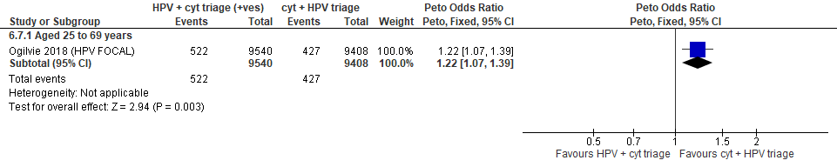
Forest Plot 3.2c. Number of colposcopies

Evidence Set 3.3c. Detection of CIN2+ (as an indirect indicator of the incidence of CIN3+)
Included reports: Ogilvie 2018 (HPV FOCAL)
GRADE Summary of Findings Table 3.3c. Detection of CIN2+ (as an indirect indicator of the incidence of CIN3+)
Outcome  No. participantsª  (studies) |  | Relative effects,  Peto OR and RR (95% CI) | Anticipated absolute effects (95% CI) |  |  | Certainty of evidence (GRADE)^{b} | What happens?
 |  | Relative effects,  Peto OR and RR (95% CI) | With cytology screening + hrHPV triage | With hrHPV screening + cytology triage | Difference | Certainty of evidence (GRADE)^{b} | What happens?
People with a cervix aged 25 to 69 years (Ogilvie 2018 (HPV FOCAL); acceptors of screening)
Detection of CIN2+  Follow-up: 1 round hrHPV and 2 cytology arms  18,948 (1 RCT) | Peto OR: 1.27 (1.00 to.163)  RR: 1.27 (1.00 to 1.62) |  | 121.2 per 10,000 | 153.4 per 10,000 | 32.2 more per 10,000 (0.0 more to 74.8 more) | 25-29 yrs:  VERY LOW^{c}  ⊕⊝⊝⊝  due to lack of evidence of consistency, and (very serious) indirectness  30-59 yrs:  LOW^{d}  ⊕⊕⊝⊝  due to lack of evidence of consistency and indirectness  60-69 yrs:  LOW^{e}  ⊕⊕⊝⊝  due to lack of evidence of consistency and indirectness | Among screened people with a cervix aged 25 to 29 years, we are very uncertain about the effect on the incidence of CIN3+ from one round of hrHPV screening with cytology triage compared with two rounds of cytology screening with hrHPV triage.  Among screened people with a cervix aged 30 to 69 years, one round of hrHPV screening with cytology triage compared with two rounds of cytology screening with hrHPV may have little-to-no effect in the incidence of CIN3+.
CI = confidence interval; NA= not applicable (i.e., not used for conclusions); CIN = cervical intraepithelial neoplasia; OR = odds ratio; RCT = randomized controlled trial; RR = relative risk.
ªAcceptors of screening include all participants who completed one round of screening via the strategy to which they were randomly assigned.
^{b}We rated down by 0.5 for “some concerns”, 1 “serious concerns”, and 2 for “very serious concerns”. When our assessment of the certainty of evidence fell between levels, we assigned the level that best represented our actual certainty in the evidence, and based our conclusions on this level of certainty.
Explanations:
^{c}Acceptors of screening; people with a cervix aged 25 to 29 years: No serious concerns about risk of bias: no domains judged high risk. Some concerns about inconsistency: lack of evidence of consistency due to single study. Very serious concerns about indirectness: detection is an indirect measure of incidence, and the study data is not directly applicable for this age group due to a small sample (n=2,188 [8.7%] enrolled). No serious concerns about imprecision: 95% CI precise for little-to-no effect. No other serious concerns.
^{d}Acceptors of screening; people with a cervix aged 30 to 59 years: No serious concerns about risk of bias: no domains judged high risk. Some concerns about inconsistency: lack of evidence of consistency due to single study. Serious concerns about indirectness: detection is an indirect measure of incidence. No serious concerns about imprecision: 95% CI precise for little-to-no effect. No other serious concerns.
^{e}Acceptors of screening; people with a cervix aged 60 to 69 years: No serious concerns about risk of bias: no domains judged high risk. Some concerns about inconsistency: lack of evidence of consistency due to single study. Serious concerns about indirectness: detection is an indirect measure of incidence, and there are some concerns about the small sample size in the study for this age group (n=2,094 [8.3%] enrolled). No serious concerns about imprecision: 95% CI precise for little-to-no effect. No other serious concerns.

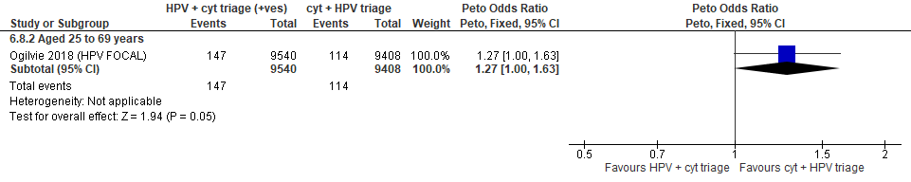

Forest Plot 3.3c. Detection of CIN2+ (as an indirect indicator of the incidence of CIN3+)

Evidence Set 3.4c. Detection of CIN3+ (as an indirect indicator of the incidence of ICC)
Included reports: Ogilvie 2018 (HPV FOCAL)
GRADE Summary of Findings Table 3.4c. Detection of CIN3+ (as an indirect indicator of the incidence of ICC)
Outcome  No. participantsª  (studies) |  | Relative effects,  Peto OR and RR (95% CI) | Anticipated absolute effects (95% CI) |  |  | Certainty of evidence (GRADE)^{b} | What happens?
 |  | Relative effects,  Peto OR and RR (95% CI) | With cytology screening + hrHPV triage | With hrHPV screening + cytology triage | Difference | Certainty of evidence (GRADE)^{b} | What happens?
People with a cervix aged 25 to 69 years (Ogilvie 2018 (HPV FOCAL); acceptors of screening)
Detection of CIN3+  Follow-up: 1 round hrHPV and 2 cytology arms  18,948 (1 RCT) | Peto OR: 1.03 (0.73 to 1.46)  RR: 1.03 (0.73 to 1.46) |  | 68.0 per 10,000 | 70.1 per 10,000 | 2.0 more per 10,000 (18.3 less to 31.0 more) | 25-29 yrs:  VERY LOW^{c}  ⊕⊝⊝⊝  due to lack of evidence of consistency, (very serious) indirectness, and imprecision  30-59 yrs:  VERY LOW^{d}  ⊕⊝⊝⊝  due to lack of evidence of consistency, indirectness, and imprecision  60-69 yrs:  VERY LOW^{e}  ⊕⊝⊝⊝  due to lack of evidence of consistency, indirectness and imprecision | Among screened people with a cervix aged 25 to 69 years, we are very uncertain about the effect on the incidence of CIN3+ from one round of hrHPV screening with cytology triage compared with two rounds of cytology screening with hrHPV triage.
CI = confidence interval; CIN = cervical intraepithelial neoplasia; NA= not applicable (i.e., not used for conclusions); OR = odds ratio; RCT = randomized controlled trial; RR = relative risk.
ªAcceptors of screening include all participants who completed one round of screening via the strategy to which they were randomly assigned.
^{b}We rated down by 0.5 for “some concerns”, 1 “serious concerns”, and 2 for “very serious concerns”. When our assessment of the certainty of evidence fell between levels, we assigned the level that best represented our actual certainty in the evidence, and based our conclusions on this level of certainty.
Explanations:
^{c}Acceptors of screening; people with a cervix aged 25 to 29 years: No serious concerns about risk of bias: no domains judged high risk. Some concerns about inconsistency: lack of evidence of consistency due to single study. Very serious concerns about indirectness: detection is an indirect measure of incidence, and the study data is not directly applicable for this age group due to a small sample (n=2,188 [8.7%] enrolled). Serious concerns about imprecision: upper and lower limit of 95% CI indicate a reduction and increase in effect. No other serious concerns.
^{d}Acceptors of screening; people with a cervix aged 30 to 59 years: No serious concerns about risk of bias: no domains judged high risk. Some concerns about inconsistency: lack of evidence of consistency due to single study. Serious concerns about indirectness: detection is an indirect measure of incidence. Serious concerns about imprecision: upper and lower limit of 95% CI indicate a reduction and increase in effect. No other serious concerns.
^{e}Acceptors of screening; people with a cervix aged 60 to 69 years: No serious concerns about risk of bias: no domains judged high risk. Some concerns about inconsistency: lack of evidence of consistency due to a single study. Serious concerns about indirectness: detection is an indirect measure of incidence, and there are some concerns about the small sample size in the study for this age group (n=2,094 [8.3%] enrolled). Serious concerns about imprecision: upper and lower limit of 95% CI indicate a reduction and increase in effect. No other serious concerns.

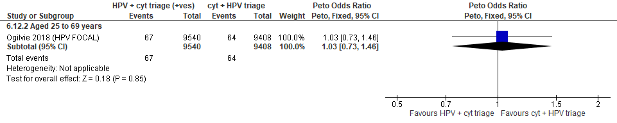

Forest Plot 3.4c. Detection of CIN3+ (as an indirect indicator of the incidence of ICC)

Evidence Set 3.5c. Incidence of CIN2
Included report: Ogilvie 2018 (HPV FOCAL)
GRADE Summary of Findings Table 3.5c. Incidence of CIN2
Outcome  No. participantsª  (studies) |  | Relative effects,  Peto OR and RR (95 % CI) | Anticipated absolute effects* |  |  | Certainty of evidence (GRADE)^{b} | What happens?
 |  | Relative effects,  Peto OR and RR (95 % CI) | With cytology screening + hrHPV triage | With hrHPV screening + cytology triage | Difference | Certainty of evidence (GRADE)^{b} | What happens?
People with a cervix aged 25 to 69 years (Ogilvie 2018 (HPV FOCAL); acceptors of screening at follow up)
Incidence of CIN2  Follow-up: 48 months  18,673 (1 RCT) | Peto OR: 0.78 (0.47 to 1.30)  RR: 0.78 (0.47 to 1.30) |  | 35.6 per 10,000 | 27.8 per 10,000 | 7.8 less per 10,000 (18.8 less to 10.2 more) | 25-29 yrs:  LOW^{c}  ⊕⊕⊝⊝  due to lack of evidence of consistency, and indirectness  30-59 yrs:  MODERATE^{d}  ⊕⊕⊕⊝  due to lack of evidence of consistency  60-69 yrs:  MODERATE^{e}  ⊕⊕⊕⊝  due to lack of evidence of consistency, and indirectness | Among screened people with a cervix aged 25 to 29 years, one round of hrHPV screening with cytology triage may have little-to-no effect on the incidence of CIN2 compared with two rounds of cytology screening with hrHPV triage.  Among screened people with a cervix aged 30 to 69 years, one round of hrHPV screening with cytology triage probably has little-to-no effect on the incidence of CIN2 compared with two rounds of cytology screening with hrHPV triage.
CI = confidence interval; CIN = cervical intraepithelial neoplasia; NA= not applicable (i.e., not used for conclusions); OR = odds ratio; RCT = randomized controlled trial; RR = relative risk.
ªAcceptors of screening at follow up includes all randomized participants who completed the screening protocol and attended the second round of screening (i.e., 48-month follow up testing via hrHPV and cytology co-testing). The denominator excludes those who tested positive and were histologically diagnosed with CIN2+ before the 48-month exit screen. The numerator was calculated from Table 2 and Figure 1, by subtracting all CIN2+ detected from round 2 in the cytology arm. Those who attended follow-up testing for a positive screening result but were histologically confirmed negative or CIN1 are included.
^{b}We rated down by 0.5 for “some concerns”, 1 “serious concerns”, and 2 for “very serious concerns”. When our assessment of the certainty of evidence fell between levels, we assigned the level that best represented our actual certainty in the evidence, and based our conclusions on this level of certainty.
Explanations:
^{c}Acceptors of screening at follow up; people with a cervix aged 25 to 29 years: No serious concerns about risk of bias: no domains judged high risk. Some concerns about inconsistency: lack of evidence for consistency due to single study. Serious concerns about indirectness: the study data is not directly applicable for this age group due to a small sample (n=2,188 [8.7%] enrolled). No serious concerns about imprecision: 95% CI precise for little-to-no effect. No other serious concerns.
^{d}Acceptors of screening at follow up; people with a cervix aged 30 to 59 years: No serious concerns about risk of bias: no domains judged high risk. Some concerns about inconsistency: lack of evidence for consistency due to single study. No serious concerns about indirectness: the study provides direct evidence. Serious concerns about imprecision: 95% CI precise for little-to-no effect. No other serious concerns.
^{e}Acceptors of screening at follow up; people with a cervix aged 60 to 69 years: No serious concerns about risk of bias: no domains judged high risk. Some concerns about inconsistency: lack of evidence for consistency due to single study. Some concerns about indirectness: there are some concerns about the small sample size in the study for this age group (n=2,094 [8.3%] enrolled). No serious concerns about imprecision: 95% CI precise for little-to-no effect. No other serious concerns.

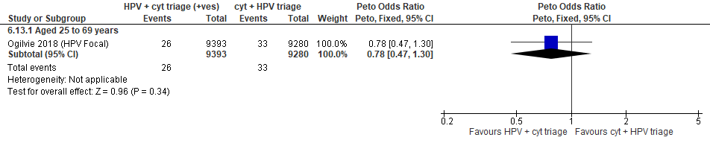
Forest Plot 3.5c. Incidence of CIN2

Evidence Set 3.6c. Incidence of CIN2+
Included report: Ogilvie 2018 (HPV FOCAL)
GRADE Summary of Findings Table 3.6c. Incidence of CIN2+
Outcome  No. participantsª  (studies) |  | Relative effects,  Peto OR and RR (95 % CI) | Anticipated absolute effects* |  |  | Certainty of evidence (GRADE)^{b} | What happens?
 |  | Relative effects,  Peto OR and RR (95 % CI) | With cytology screening + hrHPV triage | With hrHPV screening + cytology triage | Difference | Certainty of evidence (GRADE)^{b} | What happens?
People with a cervix aged 25 to 69 years (Ogilvie 2018 (HPV FOCAL); acceptors of screening at follow up)
Incidence of CIN2+  Follow-up: 48 months  18,673 (1 RCT) | Peto OR: 0.76 (0.53 to 1.11)  RR: 0.76 (0.53 to 1.11) |  | 66.8 per 10,000 | 50.9 per 10,000 | 16.0 less per 10,000 (31.3 less to 7.3 more) | 25-29 yrs:  VERY LOW^{c}  ⊕⊝⊝⊝  due to lack of evidence of consistency and (very serious) indirectness  30-59 yrs:  LOW^{d}  ⊕⊕⊝⊝  due to lack of evidence of consistency and indirectness  60-69 yrs:  LOW^{e}  ⊕⊕⊝⊝  due to lack of evidence of consistency and indirectness | Among screened people with a cervix aged 25 to 29 years, we are very uncertain about the effects of one round of hrHPV screening with cytology triage compared with two rounds of cytology screening with hrHPV triage.  Among screened people with a cervix aged 30 to 69 years, one round of hrHPV screening with cytology triage may have little-to-no effect on the incidence of CIN2+ compared with two rounds of cytology screening with hrHPV triage.
CI = confidence interval; CIN = cervical intraepithelial neoplasia; NA= not applicable (i.e., not used for conclusions); OR = odds ratio; RCT = randomized controlled trial; RR = relative risk.
ªAcceptors of screening at follow up includes all randomized participants who completed the screening protocol and attended the 48-month follow up testing via hrHPV and cytology co-testing). The denominator excludes those who tested positive and were histologically diagnosed with CIN2+ before the 48-month exit screen. The numerator was calculated from Table 2 and Figure 1, by subtracting all CIN2+ detected from round 2 in the cytology arm. Those who attended follow-up testing for a positive screening result but were histologically confirmed negative or CIN1 are included.
^{b}We rated down by 0.5 for “some concerns”, 1 “serious concerns”, and 2 for “very serious concerns”. When our assessment of the certainty of evidence fell between levels, we assigned the level that best represented our actual certainty in the evidence, and based our conclusions on this level of certainty.
Explanations:
^{c}Acceptors of screening at follow up; people with a cervix aged 25 to 29 years: No serious concerns about risk of bias: no domains judged high risk. Some concerns about inconsistency: lack of evidence for consistency due to single study. Very serious concerns about indirectness: the outcome is considered indirect because only those with normal results received follow-up thus the outcome does not capture cases of CIN2 or CIN3 that progressed during follow-up, and incidence ascertainment does not capture cases, especially for ICC, detected clinically. The study data is not directly applicable for this age group due to a small sample (n=2,188 [8.7%] enrolled) and evidence from other outcomes of differing effects. No serious concerns about imprecision: 95% CI precise for little-to-no effect. No other serious concerns.
^{d}Acceptors of screening at follow up; people with a cervix aged 30 to 59 years: No serious concerns about risk of bias: no domains judged high risk. Some concerns about inconsistency: lack of evidence for consistency due to single study. Serious concerns about indirectness: the outcome is considered indirect because only those with normal results received follow-up thus the outcome does not capture cases of CIN2 or CIN3 that progressed during follow-up, and incidence ascertainment does not capture cases, especially for ICC, detected clinically. Serious concerns about imprecision: 95% CI precise for little-to-no effect. No other serious concerns.
^{e}Acceptors of screening at follow up; people with a cervix aged 60 to 69 years: No serious concerns about risk of bias: no domains judged high risk. Some concerns about inconsistency: lack of evidence for consistency due to single study. Serious concerns about indirectness: the outcome is considered indirect because only those with normal results received follow-up thus the outcome does not capture cases of CIN2 or CIN3 that progressed during follow-up, and incidence ascertainment does not capture cases, especially for ICC, detected clinically. The study data is not directly applicable for this age group due to a small sample (n=2,094 [8.3%] enrolled). No serious concerns about imprecision: 95% CI precise for little-to-no effect. No other serious concerns.

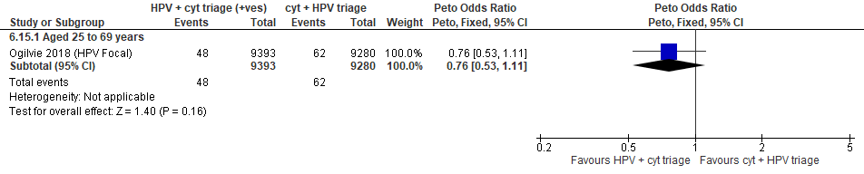
Forest Plot 3.6c. Incidence of CIN2+

Evidence Set 3.7c. Incidence of CIN3+
Included report: Ogilvie 2018 (HPV FOCAL)
GRADE Summary of Findings Table 3.7c. Incidence of CIN3+
Outcome  No. participantsª  (studies) |  | Relative effects,  Peto OR and RR (95 % CI) | Anticipated absolute effects* |  |  | Certainty of evidence (GRADE)^{b} | What happens?
 |  | Relative effects,  Peto OR and RR (95 % CI) | With cytology screening + hrHPV triage | With hrHPV screening + cytology triage | Difference | Certainty of evidence (GRADE)^{b} | What happens?
People with a cervix aged 25 to 69 years (Ogilvie 2018 (HPV FOCAL); acceptors of screening at follow up)
Incidence of CIN3+  Follow-up: 48 months  18,673 (1 RCT) | Peto OR: 0.75 (0.43 to 1.30)  RR: 0.75 (0.43 to 1.30) |  | 31.3 per 10,000 | 23.5 per 10,000 | 7.8 less per 10,000 (17.8 less to 9.3 more) | 25-29 yrs:  VERY LOW^{c}  ⊕⊝⊝⊝  due to lack of evidence of consistency, (very serious) indirectness, and imprecision  30-59 yrs:  VERY LOW^{d}  ⊕⊝⊝⊝  due to lack of evidence of consistency, (very serious) indirectness, and imprecision  60-69 yrs:  VERY LOW^{e}  ⊕⊝⊝⊝  due to lack of evidence of consistency, (very serious) indirectness, and imprecision | Among screened people with a cervix aged 25 to 69 years, we are very uncertain about the effects the incidence of CIN3+ from one round of hrHPV screening with cytology triage compared with two rounds of cytology screening with hrHPV triage.
CI = confidence interval; CIN = cervical intraepithelial neoplasia; NA= not applicable (i.e., not used for conclusions); OR = odds ratio; RCT = randomized controlled trial; RR = relative risk.
ªAcceptors of screening at follow up includes all randomized participants who completed the screening protocol and attended the second round of screening (i.e., 48-month follow up testing via hrHPV and cytology co-testing). The denominator excludes those who tested positive and were histologically diagnosed with CIN2+ before the 48-month exit screen. The numerator was calculated from Table 2 and Figure 1, by subtracting all CIN2+ detected from round 2 in the cytology arm. Those who attended follow-up testing for a positive screening result but were histologically confirmed negative or CIN1 are included.
^{b}We rated down by 0.5 for “some concerns”, 1 “serious concerns”, and 2 for “very serious concerns”. When our assessment of the certainty of evidence fell between levels, we assigned the level that best represented our actual certainty in the evidence, and based our conclusions on this level of certainty.
Explanations:
^{c}Acceptors of screening at follow up; people with a cervix aged 25 to 29 years: No serious concerns about risk of bias: no domains judged high risk. Some concerns about inconsistency: lack of evidence for consistency due to single study. Very serious concerns about indirectness: the outcome is considered very indirect because only those with normal results received follow-up thus the outcome does not capture cases of CIN2 or CIN3 that progressed during follow-up, and incidence ascertainment does not capture cases, especially for ICC, detected clinically. The study data is not directly applicable for this age group due to a small sample (n=2,188 [8.7%] enrolled). Serious concerns about imprecision: lower limit of 95% CI indicates a reduced effect. No other serious concerns.
^{d}Acceptors of screening at follow up; people with a cervix aged 30 to 59 years: No serious concerns about risk of bias: no domains judged high risk. Some concerns about inconsistency: lack of evidence for consistency due to single study. Very serious concerns about indirectness: the outcome is considered very indirect because only those with normal results received follow-up thus the outcome does not capture cases of CIN2 or CIN3 that progressed during follow-up, and incidence ascertainment does not capture cases, especially for ICC, detected clinically. Serious concerns about imprecision: lower limit of 95% CI indicates a reduced effect. No other serious concerns.
^{e}Acceptors of screening at follow up; people with a cervix aged 60 to 69 years: No serious concerns about risk of bias: no domains judged high risk. Some concerns about inconsistency: lack of evidence for consistency due to single study. Very serious concerns about indirectness: the outcome is considered very indirect because only those with normal results received follow-up thus the outcome does not capture cases of CIN2 or CIN3 that progressed during follow-up, and incidence ascertainment does not capture cases, especially for ICC, detected clinically. The study data is not directly applicable for this age group due to a small sample (n=2,094 [8.3%] enrolled). Serious concerns about imprecision: lower limit of 95% CI indicates a reduced effect. No other serious concerns.

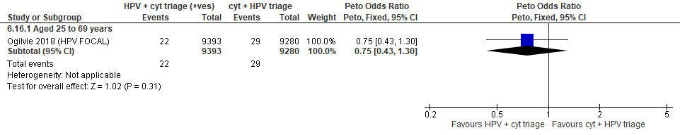
Forest Plot 3.7c. Incidence of CIN3+

Evidence Set 3.8c. False positives for CIN2+ (those referred for colposcopy who did not have CIN2+)
Included reports: Ogilvie 2018 (HPV FOCAL)
GRADE Summary of Findings Table 3.8c. False positives for CIN2+ (those referred for colposcopy who did not have CIN2+)
Outcome  No. participantsª  (studies) |  | Relative effects,  Peto OR and RR (95% CI) | Anticipated absolute effects (95% CI) |  |  | Certainty of evidence (GRADE)^{b} | What happens?
 |  | Relative effects,  Peto OR and RR (95% CI) | With cytology screening + hrHPV triage | With hrHPV screening + cytology triage | Difference | Certainty of evidence (GRADE)^{b} | What happens?
People with a cervix aged 25 to 69 years (Ogilvie 2018 (HPV FOCAL); acceptors of screening)
False positives for CIN2+  Follow-up: 1 round hrHPV and 2 cytology arms  18,948 (1 RCT) | Peto OR: 1.42 (1.23 to 1.64)  RR: 1.40 (1.22 to 1.60) |  | 343.3 per 10,000 | 480.6 per 10,000 | 137.3 more per 10,000 (75.7 more to 207.6 more) | 25-29 yrs:  LOW^{c}  ⊕⊕⊝⊝  due to lack of evidence of consistency, and indirectness  30-59 yrs:  MODERATE^{d}  ⊕⊕⊕⊝  due to lack of evidence of consistency  60-69 yrs:  MODERATE^{e}  ⊕⊕⊕⊝  due to lack of evidence of consistency, and indirectness | Among screened people with a cervix aged 25 to 29 years, one round of hrHPV screening with cytology triage may have little-to-no effect on false positives for CIN2+ compared with two rounds of cytology screening with hrHPV triage.  Among screened people with a cervix aged 30 to 69 years, one round of hrHPV screening with cytology triage probably has little-to-no effect on false positives for CIN2+ compared with two rounds of cytology screening with hrHPV triage.
CI = confidence interval; CIN = cervical intraepithelial neoplasia; NA= not applicable (i.e., not used for conclusions); OR = odds ratio; RCT = randomized controlled trial; RR = relative risk.
ªAcceptors of screening include all participants who completed one round of screening via the strategy to which they were randomly assigned.
^{b}We rated down by 0.5 for “some concerns”, 1 “serious concerns”, and 2 for “very serious concerns”. When our assessment of the certainty of evidence fell between levels, we assigned the level that best represented our actual certainty in the evidence, and based our conclusions on this level of certainty.
Explanations:
^{c}Acceptors of screening; people with a cervix aged 25 to 29 years: No serious concerns about risk of bias: no domains judged high risk. Some concerns about inconsistency: lack of evidence of consistency due to single study. Serious concerns about indirectness: the study data is not directly applicable for this age group due to a small sample (n=2,188 [8.7%] enrolled) and findings of a large increase in CIN2+ false positives from the hrHPV strategy before the second round of cytology. No serious concerns about imprecision: 95% CI precise for little-to-no effect. No other serious concerns.
^{d}Acceptors of screening; people with a cervix aged 30 to 59 years: No serious concerns about risk of bias: no domains judged high risk. Some concerns about inconsistency: lack of evidence of consistency due to single study. No serious concerns about indirectness: the study data is directly applicable. No serious concerns about imprecision: 95% CI precise for little-to-no effect. No other serious concerns.
^{e}Acceptors of screening; people with a cervix aged 60 to 69 years: No serious concerns about risk of bias: no domains judged high risk. Some concerns about inconsistency: lack of evidence of consistency due to single study. Some concerns about indirectness: there are some concerns that the study data is not directly applicable for this age group due to a small sample (n=2,094 [8.3%] enrolled). No serious concerns about imprecision: 95% CI precise for little-to-no effect. No other serious concerns.

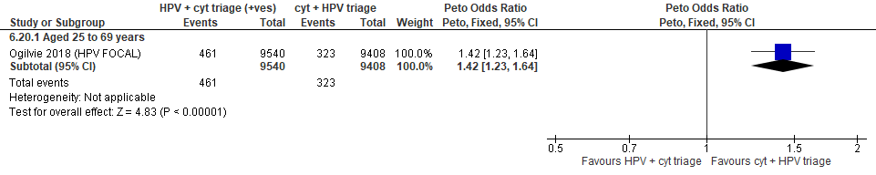
Forest Plot 3.8c. False positives for CIN2+

Evidence Set 3.9c. False positives for CIN3+ (those referred for colposcopy who did not have CIN3+)
Included reports: Ogilvie 2018 (HPV FOCAL)
GRADE Summary of Findings Table 3.9c. False positives for CIN3+ (those referred for colposcopy who did not have CIN3+)
Outcome  No. participantsª  (studies) |  | Relative effects,  Peto OR and RR (95% CI) | Anticipated absolute effects (95% CI) |  |  | Certainty of evidence (GRADE)^{b} | What happens?
 |  | Relative effects,  Peto OR and RR (95% CI) | With cytology screening + hrHPV triage | With hrHPV screening + cytology triage | Difference | Certainty of evidence (GRADE)^{b} | What happens?
People with a cervix aged 25 to 69 years (Ogilvie 2018 (HPV FOCAL); acceptors of screening)
False positives for CIN3+  Follow-up: 1 round hrHPV and 2 cytology arms  18,948 (1 RCT) | Peto OR: 1.24 (1.09 to 1.41)  RR: 1.23 (1.09 to 1.38) |  | 464.5 per 10,000 | 569.6 per 10,000 | 105.1 more per 10,000 (39.7 more to 178.2 more) | 25-29 yrs:  LOW^{c}  ⊕⊝⊝⊝  due to lack of evidence of consistency, and indirectness  30-59 yrs:  MODERATE^{d}  ⊕⊕⊕⊝  due to lack of evidence of consistency  60-69 yrs:  MODERATE^{e}  ⊕⊕⊕⊝  due to lack of evidence of consistency, and indirectness | Among screened people with a cervix aged 25 to 29 years, one round of HRHPV with cytology triage may have little-to-no effect on the number of fasle positives for CIN3+ compared with two rounds of cytology screening with hrHPV triage.  Among screened people with a cervix aged 30 to 69 years, one round of HRHPV with cytology triage probably has little-to-no effect on the number of fasle positives for CIN3+ compared with two rounds of cytology screening with hrHPV triage.
CI = confidence interval; CIN = cervical intraepithelial neoplasia; NA= not applicable (i.e., not used for conclusions); OR = odds ratio; RCT = randomized controlled trial; RR = relative risk.
ªAcceptors of screening include all participants who completed one round of screening via the strategy to which they were randomly assigned.
^{b}We rated down by 0.5 for “some concerns”, 1 “serious concerns”, and 2 for “very serious concerns”. When our assessment of the certainty of evidence fell between levels, we assigned the level that best represented our actual certainty in the evidence, and based our conclusions on this level of certainty.
Explanations:
^{c}Acceptors of screening; people with a cervix aged 25 to 29 years: No serious concerns about risk of bias: no domains judged high risk. Some concerns about inconsistency: lack of evidence of consistency due to single study. Serious concerns about indirectness: the study data is not directly applicable for this age group due to a small sample (n=2,188 [8.7%] enrolled) and findings of a large increase in CIN3+ false positives from the hrHPV strategy before the second round of cytology. No serious concerns about imprecision: 95% CI precise for little-to-no effect. No other serious concerns.
^{d}Acceptors of screening; people with a cervix aged 30 to 59 years: No serious concerns about risk of bias: no domains judged high risk. Some concerns about inconsistency: lack of evidence of consistency due to single study. No serious concerns about indirectness: the study data is directly applicable. No serious concerns about imprecision: 95% CI precise for little-to-no effect. No other serious concerns.
^{e}Acceptors of screening; people with a cervix aged 60 to 69 years: No serious concerns about risk of bias: no domains judged high risk. Some concerns about inconsistency: lack of evidence of consistency due to single study. Some concerns about indirectness: there are some concerns that the study data is not directly applicable for this age group due to a small sample (n=2,094 [8.3%] enrolled). No serious concerns about imprecision: 95% CI precise for little-to-no effect. No other serious concerns.

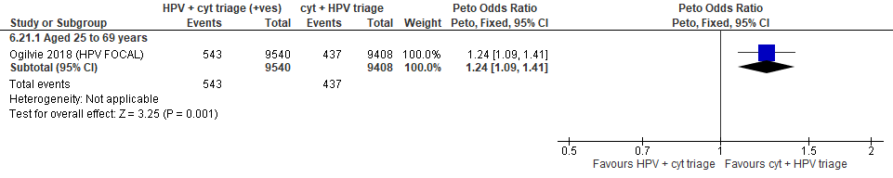
Forest Plot 3.9c. False positives for CIN3+

Evidence set 4.0 hrHPV screening with partial genotyping and liquid-based cytology triage of hrHPV type 45 versus liquid-based cytology screening (threshold ASC-H or HSIL) with hrHPV with partial genotyping triage of ASCUS or LSIL

Included report: Canfell 2017 (COMPASS) (ages 25-64 [subgroups 25-33 and 34-64 years])

Evidence Set 4.1. Referrals to colposcopy
GRADE Summary of Findings Table 4.1. Referrals to colposcopy
Outcome  No. participantsª  (studies) |  | Relative effects, Peto OR and RR (95 % CI) | Anticipated absolute effects |  |  | Certainty of evidence (GRADE)^{b} | What happens?
 |  | Relative effects, Peto OR and RR (95 % CI) | With cytology screening + hrHPV partial genotyping triage | With hrHPV partial genotyping + cytology triage | Difference | Certainty of evidence (GRADE)^{b} | What happens?
People with a cervix aged 25 to 69 years (Canfell 2017 (COMPASS); acceptors of screening)
Referrals to colposcopy  Follow-up: 1 round  2,987 (1 RCT) | Peto OR: 1.38 (0.90 to 2.09)  RR: 1.37 (0.90 to 2.03) |  | 271.4 per 10,000 | 370.7 per 10,000 | 99.3 more per 10,000 (26.5 less to 279.5 more) | 25-29 yrs:  LOW^{c}  ⊕⊕⊝⊝  due to lack of evidence of consistency, and indirectness  30-59 yrs:  MODERATE^{d}  ⊕⊕⊕⊝  due to lack of evidence of consistency  60-69 yrs:  LOW^{e}  ⊕⊕⊝⊝  due to lack of evidence of consistency, and indirectness | Among screened people with a cervix aged 25 to 29 years, hrHPV testing with partial genotyping and cytology triage of those with genotype 45 may have little-to-no effect on the rate of referral to colposcopy compared with cytology testing with hrHPV partial genotyping triage.  Among screened people with a cervix aged 30 to 59 years, hrHPV testing with partial genotyping and cytology triage of those with genotype 45 probably has little-to-no effect on the rate of referral to colposcopy compared with cytology testing with hrHPV partial genotyping triage.  Among screened people with a cervix aged 60 to 69 years, hrHPV testing with partial genotyping and cytology triage of those with genotype 45 may have little-to-no effect on the rate of referral to colposcopy compared with cytology testing with hrHPV partial genotyping triage.
>Subgroup: people with a cervix aged 25 to 29 years (Canfell 2017 (COMPASS); acceptors of screening)
Referrals to colposcopy  Follow-up: 1 round  629 (1 RCT) | Peto OR: 1.68 (0.88 to 3.22)  RR: 1.63 (0.89 to 2.91) |  | 473.9 per 10,000 | 771.3 per 10,000 | 297.4 more per 10,000 (54.5 less to 906.9 more) | NA
>Subgroup: people with a cervix aged 30 to 69 years (Canfell 2017 (COMPASS); acceptors of screening)
Referrals to colposcopy  Follow-up: 1 round  2,358 (1 RCT) | Peto OR: 1.20 (0.69 to 2.09)  RR: 1.19 (0.69 to 2.04) |  | 216.8 per 10,000 | 259.1 per 10,000 | 42.2 more per 10,000 (66.2 less to 225.9 more) | NA
CI = confidence interval; NA= not applicable (i.e., not used for conclusions); OR = odds ratio; RCT = randomized controlled trial; RR = relative risk.
ªAcceptors of screening include all participants who were randomized and completed one round of the screening via the strategy to which they were randomly assigned.
^{b}We rated down by 0.5 for “some concerns”, 1 “serious concerns”, and 2 for “very serious concerns”. When our assessment of the certainty of evidence fell between levels, we assigned the level that best represented our actual certainty in the evidence, and based our conclusions on this level of certainty.
Explanations:
^{c}Acceptors of screening; people with a cervix aged 25 to 29 years: No serious concerns about risk of bias: no domains judged as high risk. Some concerns about inconsistency: lack of evidence for consistency due to single study. Serious concerns about indirectness: concerns due to small sample for this age group (n=629). No serious concerns about imprecision: 95% CI precise for little-to-no effect. No other serious concerns.
^{d}Acceptors of screening; people with a cervix aged 30 to 59 years: No serious concerns about risk of bias: no domains judged as high risk. Some concerns about inconsistency: lack of evidence for consistency due to single study. No serious concerns about indirectness: the study provides direct evidence. No serious concerns about imprecision: 95% CI precise for little-to-no effect. No other serious concerns.
^{e}Acceptors of screening; people with a cervix aged 60 to 69 years: No serious concerns about risk of bias: no domains judged as high risk. Some concerns about inconsistency: lack of evidence for consistency due to single study. Serious concerns about indirectness: concerns due to small sample for this age group (n=NR). No serious concerns about imprecision: 95% CI precise for little-to-no effect. No other serious concerns.

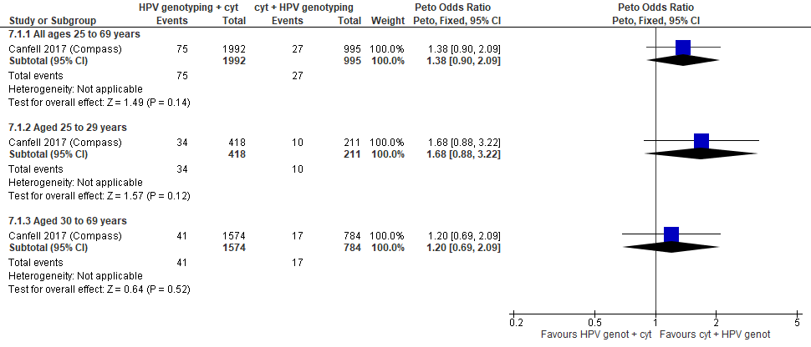
Forest Plot 4.1. Referrals to colposcopy

Evidence Set 4.2. Detection of CIN2+ (as an indirect indicator of the incidence of CIN3+)
Included report: Canfell 2017 (COMPASS)
GRADE Summary of Findings Table 4.2. Detection of CIN2+ (as an indirect indicator of the incidence of CIN3+)
Outcome  No. participantsª  (studies) |  | Relative effects, Peto OR and RR (95 % CI) | Anticipated absolute effects |  |  | Certainty of evidence (GRADE)^{b} | What happens?
 |  | Relative effects, Peto OR and RR (95 % CI) | With cytology screening + hrHPV partial genotyping triage | With hrHPV partial genotyping + cytology triage | Difference | Certainty of evidence (GRADE)^{b} | What happens?
People with a cervix aged 25 to 69 years (Canfell 2017 (COMPASS); acceptors of screening)
Detection of CIN2+  Follow-up: 1 round  2,987 (1 RCT) | Peto OR: 3.65 (1.47 to 9.06)  RR: 3.64 (1.47 to 8.99) |  | 10.1 per 10,000 | 36.6 per 10,000 | 26.5 more per 10,000 (4.7 more to 80.3 more) | NA
>Subgroup: people with a cervix aged 25 to 29 years (Canfell 2017 (COMPASS); acceptors of screening)
Detection of CIN2+  Follow-up: 1 round  629 (1 RCT) | Peto OR: 3.16 (0.94 to 10.59)  RR: 3.13 (0.94 to 10.13) |  | 47.4 per 10,000 | 148.2 per 10,000 | 100.9 more per 10,000 (2.8 less to 432.7 more) | VERY LOW^{c}  ⊕⊝⊝⊝  due to lack of evidence of consistency, indirectness, and imprecision | Among screened people with a cervix aged 25 to 29 years, we are very uncertain about the effect of hrHPV testing with partial genotyping and cytology triage of those with genotype 45 on the incidence of CIN3+ compared with cytology testing with hrHPV partial genotyping triage.
>Subgroup: people with a cervix aged 30 to 69 years (Canfell 2017 (COMPASS); acceptors of screening)
Detection of CIN2+  Follow-up: 1 round  2,358 (1 RCT) | Peto OR: 4.50 (1.12 to 18.04)  RR: 4.50 (1.12 to 18.04) |  | 0.0 per 10,000 | 0.0 per 10,000 | No difference | 30-59 yrs:  LOW^{d}  ⊕⊕⊝⊝  due to lack of evidence of consistency, and indirectness  60-69 yrs:  VERY LOW^{e}  ⊕⊝⊝⊝  due to lack of evidence of consistency, and (very serious) indirectness | Among screened people with a cervix aged 30 to 59 years, hrHPV testing with partial genotyping and cytology triage of those with genotype 45 may have little-to-no effect on the incidence of CIN3+ compared with cytology testing with hrHPV partial genotyping triage.  Among screened people with a cervix aged 60 to 69 years, we are very uncertain about the effect of hrHPV testing with partial genotyping and cytology triage of those with genotype 45 on the incidence of CIN3+ compared with cytology testing with hrHPV partial genotyping triage.
CI = confidence interval; CIN = cervical intraepithelial neoplasia; NA= not applicable (i.e., not used for conclusions); OR = odds ratio; RCT = randomized controlled trial; RR = relative risk.
ªAcceptors of screening include all participants who were randomized and completed one round of the screening via the test to which they were randomly assigned. Ninety-eight percent of participants who were referred to colposcopy attended; however, it is unclear how many attended from each group.
^{b}We rated down by 0.5 for “some concerns”, 1 “serious concerns”, and 2 for “very serious concerns”. When our assessment of the certainty of evidence fell between levels, we assigned the level that best represented our actual certainty in the evidence, and based our conclusions on this level of certainty.

Explanations:
^{c}Acceptors of screening; people with a cervix aged 25 to 29 years: No serious concerns about risk of bias: the study was open label; however, knowledge of group allocation is unlikely to have affected the outcome. The outcome was not listed in the trial register, but is expected to be reported as a part of the screening process. Some concerns about inconsistency: lack of evidence for consistency due to single study. Serious concerns about indirectness: detection is an indirect measure of incidence. Serious concerns about imprecision: lower limit of 95% CI indicates little-to-no effect. No other serious concerns.
^{d}Acceptors of screening; people with a cervix aged 30 to 59 years: No serious concerns about risk of bias: the study was open label; however, knowledge of group allocation is unlikely to have affected the outcome. The outcome was not listed in the trial register, but is expected to be reported as a part of the screening process. Some concerns about inconsistency: lack of evidence for consistency due to single study. Serious concerns about indirectness: detection is an indirect measure of incidence. No serious concerns about imprecision: 95% CI precise for little-to-no effect. No other serious concerns.
^{e}Acceptors of screening; people with a cervix aged 60 to 69 years: No serious concerns about risk of bias: the study was open label; however, knowledge of group allocation is unlikely to have affected the outcome. The outcome was not listed in the trial register, but is expected to be reported as a part of the screening process. Some concerns about inconsistency: lack of evidence for consistency due to single study. Very serious concerns about indirectness: detection is an indirect measure of incidence, concerns due to small sample for this age group (n=NR). No serious concerns about imprecision: 95% CI precise for little-to-no effect. No other serious concerns.

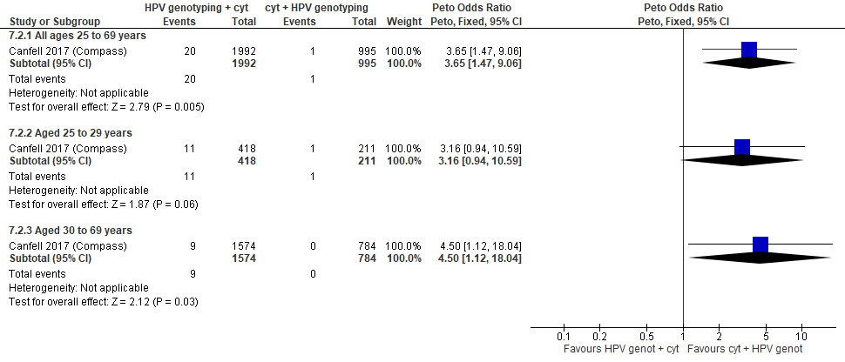
Forest Plot 4.2. Detection of CIN2+ (as an indirect indicator of the incidence of CIN3+)

Evidence Set 4.3. Detection of CIN3+ (as an indirect indicator of the incidence of ICC)
Included report: Canfell 2017 (COMPASS)
GRADE Summary of Findings Table 4.3. Detection of CIN3+ (as an indirect indicator of the incidence of ICC)
Outcome  No. participantsª  (studies) |  | Relative effects, Peto OR and RR (95 % CI) | Anticipated absolute effects |  |  | Certainty of evidence (GRADE)^{b} | What happens?
 |  | Relative effects, Peto OR and RR (95 % CI) | With cytology screening + hrHPV partial genotyping triage | With hrHPV partial genotyping + cytology triage | Difference | Certainty of evidence (GRADE)^{b} | What happens?
People with a cervix aged 25 to 69 years (Canfell 2017 (COMPASS); acceptors of screening)
Detection of CIN3+  Follow-up: 1 round  2,987 (1 RCT) | Peto OR: 3.26 (1.07 to 9.94)  RR: 3.25 (1.07 to 9.85) |  | 10.1 per 10,000 | 32.7 per 10,000 | 22.6 more per 10,000 (0.70 more to 89.0 more) | NA
>Subgroup: people with a cervix aged 25 to 29 years (Canfell 2017 (COMPASS); acceptors of screening)
Detection of CIN3+  Follow-up: 1 round  629 (1 RCT) | Peto OR: 2.92 (0.78 to 10.95)  RR: 2.89 (0.78 to 10.46) |  | 47.4 per 10,000 | 137.1 per 10,000 | 89.7 more per 10,000 (10.4 more to 448.2 more) | VERY LOW^{c}  ⊕⊝⊝⊝  due to lack of evidence of consistency, imprecision, and indirectness | Among screened people with a cervix aged 25 to 29 years, we are very uncertain about the effect of hrHPV testing with partial genotyping and cytology triage of those with genotype 45 on the incidence of invasive cervical cancer compared with cytology testing with hrHPV partial genotyping triage.
>Subgroup: people with a cervix aged 30 to 69 years (Canfell 2017 (COMPASS); acceptors of screening)
Detection of CIN3+  Follow-up: 1 round  2,358 (1 RCT) | Peto OR: 4.48 (0.56 to 35.93)  RR: 4.48 (0.56 to 35.93) |  | 0.0 per 10,000 | 0.0 per 10,000 | No difference | 30-59 yrs:  VERY LOW^{d}  ⊕⊝⊝⊝  due to lack of evidence of consistency, imprecision, and indirectness  60-69 yrs:  VERY LOW^{e}  ⊕⊝⊝⊝  due to lack of evidence of consistency, and (very serious) indirectness | Among screened people with a cervix aged 30 to 69 years, we are very uncertain about the effect of hrHPV testing with partial genotyping and cytology triage of those with genotype 45 on the incidence of invasive cervical cancer compared with cytology testing with hrHPV partial genotyping triage.
CI = confidence interval; CIN = cervical intraepithelial neoplasia; NA= not applicable (i.e., not used for conclusions); OR = odds ratio; RCT = randomized controlled trial; RR = relative risk.
ªAcceptors of screening include all participants who were randomized and completed one round of the screening via the test to which they were randomly assigned. Ninety-eight percent of participants who were referred to colposcopy attended; however, it is unclear how many attended from each group.
^{b}We rated down by 0.5 for “some concerns”, 1 “serious concerns”, and 2 for “very serious concerns”. When our assessment of the certainty of evidence fell between levels, we assigned the level that best represented our actual certainty in the evidence, and based our conclusions on this level of certainty.
Explanations:
^{c}Acceptors of screening; people with a cervix aged 25 to 29 years: No serious concerns about risk of bias: the study was open label; however, knowledge of group allocation is unlikely to have affected the outcome. The outcome was not listed in the trial register, but is expected to be reported as a part of the screening process. Some concerns about inconsistency: lack of evidence for consistency due to single study. Serious concerns about indirectness: detection is an indirect indicator of incidence. Serious concerns about imprecision: concerns due to small sample for this age group (n=629). No other serious concerns.
^{d}Acceptors of screening; people with a cervix aged 30 to 59 years: No serious concerns about risk of bias: the study was open label; however, knowledge of group allocation is unlikely to have affected the outcome. The outcome was not listed in the trial register, but is expected to be reported as a part of the screening process. Some concerns about inconsistency: lack of evidence for consistency due to single study. Serious concerns about indirectness: detection is an indirect indicator of incidence. Serious concerns about imprecision: concerns due to small sample. No other serious concerns.
^{e}Acceptors of screening; people with a cervix aged 60 to 69 years: No serious concerns about risk of bias: the study was open label; however, knowledge of group allocation is unlikely to have affected the outcome. The outcome was not listed in the trial register, but is expected to be reported as a part of the screening process. Some concerns about inconsistency: lack of evidence for consistency due to single study. Very serious concerns about indirectness: detection is an indirect indicator of incidence, and concerns due to small sample (n=NR). No serious concerns about imprecision: 95% CI precise for little-to-no effect. No other serious concerns.

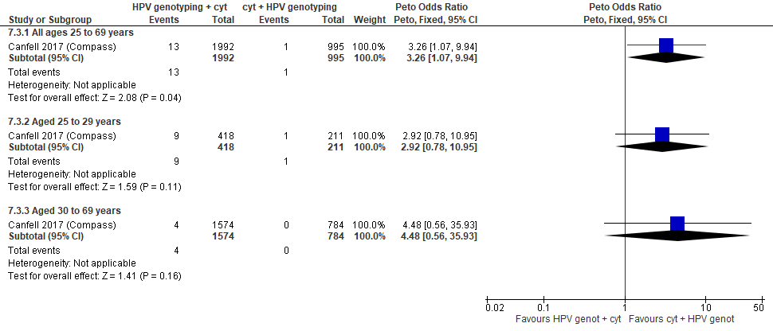
Forest Plot 4.3. Detection of CIN3+ (as an indirect indicator of the incidence of ICC)

Evidence Set 4.4. Detection of invasive cervical cancer
Included report: Canfell 2017 (COMPASS)
GRADE Summary of Findings Table 4.4. Detection of invasive cervical cancer
Outcome  No. participantsª  (studies) |  | Relative effects, Peto OR and RR (95 % CI) | Anticipated absolute effects |  |  | Certainty of evidence (GRADE)^{b} | What happens?
 |  | Relative effects, Peto OR and RR (95 % CI) | With cytology screening + hrHPV partial genotyping triage | With hrHPV partial genotyping + cytology triage | Difference | Certainty of evidence (GRADE)^{b} | What happens?
People with a cervix aged 25 to 69 years (Canfell 2017 (COMPASS); acceptors of screening)
Detection of invasive cervical cancer  Follow-up: 1 round  2,987 (1 RCT) | Peto OR: 4.47 (0.07 to 286.71)  RR: 4.47 (0.07 to 286.7) |  | 0.0 per 10,000 | 0.0 per 10,000 | No difference | 25-29 yrs:  VERY LOW^{c}  ⊕⊝⊝⊝  due to lack of evidence of consistency, and (very serious) indirectness  30-59 yrs:  VERY LOW^{d}  ⊕⊝⊝⊝  due to lack of evidence of consistency, indirectness, and imprecision  60-69 yrs:  VERY LOW^{e}  ⊕⊝⊝⊝  due to lack of evidence of consistency, and (very serious) indirectness | Among screened people with a cervix aged 25 to 69 years, we are very uncertain about the effect of hrHPV testing with partial genotyping and cytology triage of those with genotype 45 on the detection of invasive cervical cancer compared with cytology testing with hrHPV partial genotyping triage.
CI = confidence interval; NA= not applicable (i.e., not used for conclusions); OR = odds ratio; RCT = randomized controlled trial; RR = relative risk.
ªAcceptors of screening include all participants who were randomized and completed one round of the screening via the test to which they were randomly assigned. Ninety-eight percent of participants who were referred to colposcopy attended; however, it is unclear how many attended from each group.
^{b}We rated down by 0.5 for “some concerns”, 1 “serious concerns”, and 2 for “very serious concerns”. When our assessment of the certainty of evidence fell between levels, we assigned the level that best represented our actual certainty in the evidence, and based our conclusions on this level of certainty.
Explanations:
^{c}Acceptors of screening; people with a cervix aged 25 to 29 years: No serious concerns about risk of bias: no domains judged as high risk. Some concerns about inconsistency: lack of evidence for consistency due to single study. Very serious concerns about indirectness: detection is an indirect outcome, and concerns due to small sample for this age group (n=629). No serious concerns about imprecision: 95% CI precise for little-to-no effect. No other serious concerns.
^{d}Acceptors of screening; people with a cervix aged 30 to 59 years: No serious concerns about risk of bias: no domains judged as high risk. Some concerns about inconsistency: lack of evidence for consistency due to single study. Serious concerns about indirectness: detection is an indirect outcome. Serious concerns about imprecision: concerns due to small sample for this age group. No other serious concerns.
^{e}Acceptors of screening; people with a cervix aged 60 to 69 years: No serious concerns about risk of bias: no domains judged as high risk. Some concerns about inconsistency: lack of evidence for consistency due to single study. Very serious concerns about indirectness: detection is an indirect outcome, and concerns due to small sample for this age group (n=NR). No serious concerns about imprecision: 95% CI precise for little-to-no effect. No other serious concerns.

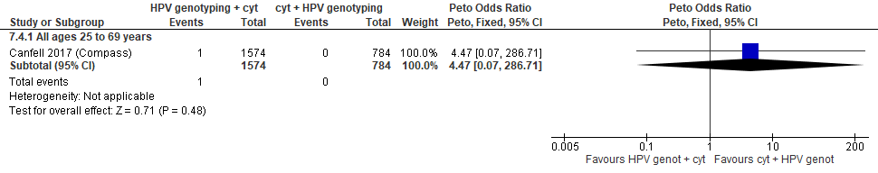
Forest Plot 4.4. Detection of invasive cervical cancer

Evidence Set 4.5. Incidence of invasive cervical cancer
Included report: Canfell 2017 (COMPASS)
GRADE Summary of Findings Table 4.5. Incidence of invasive cervical cancer
Outcome  No. participantsª  (studies) |  | Relative effects, Peto OR and RR (95 % CI) | Anticipated absolute effects |  |  | Certainty of evidence (GRADE)** | What happens?
 |  | Relative effects, Peto OR and RR (95 % CI) | With cytology screening + hrHPV partial genotyping triage | With hrHPV partial genotyping + cytology triage | Difference | Certainty of evidence (GRADE)** | What happens?
People with a cervix aged 25 to 69 years (Canfell 2017 (COMPASS); acceptors of screening)
Incidence of invasive cervical cancer  Follow-up: 18 months  2,987 (1 RCT) | Peto OR: not estimable  RR: not estimable |  | 0.0 per 10,000 | Not estimable | Not estimable | 25-29 yrs:  VERY LOW^{c}  ⊕⊝⊝⊝  due to risk of bias, lack of evidence of consistency, and (very serious) indirectness  30-59 yrs:  VERY LOW^{d}  ⊕⊝⊝⊝  due to risk of bias, lack of evidence of consistency, (very serious) indirectness, and imprecision  60-69 yrs:  VERY LOW^{e}  ⊕⊝⊝⊝  due to risk of bias, lack of evidence of consistency, and (very serious) indirectness | Among screened people with a cervix aged 25 to 69 years, we are very uncertain about the effect of hrHPV testing with partial genotyping and cytology triage of those with genotype 45 on the incidence of invasive cervical cancer within 18 months compared with cytology testing with hrHPV partial genotyping triage.
CI = confidence interval; OR = odds ratio; RCT = randomized controlled trial; RR = relative risk.
ªAcceptors of screening include all participants who were randomized and completed 1 round of the screening via the test to which they were randomly assigned.
^{b}We rated down by 0.5 for “some concerns”, 1 “serious concerns”, and 2 for “very serious concerns”. When our assessment of the certainty of evidence fell between levels, we assigned the level that best represented our actual certainty in the evidence, and based our conclusions on this level of certainty.
Explanations:
^{c}Acceptors of screening; people with a cervix aged 25 to 29 years: Serious concerns about risk of bias: risk of reporting bias because the incidence of cervical cancer was not ascertained systematically among all participants (via safety monitoring); cases may have been missed. Some concerns about inconsistency: lack of evidence for consistency due to single study. Very serious concerns about indirectness: the outcome is considered indirect as incidence was only ascertained by safety monitoring, not active follow-up for all participants. There were also concerns due to small sample for this age group (n=629). No serious concerns about imprecision: 95% CI precise for little-to-no effect. No other serious concerns.
^{d}Acceptors of screening; people with a cervix aged 30 to 59 years: Serious concerns about risk of bias: risk of reporting bias because the incidence of cervical cancer was not ascertained systematically among all participants (via safety monitoring); cases may have been missed. Some concerns about inconsistency: lack of evidence for consistency due to single study. Very serious concerns about indirectness: the outcome is considered indirect as incidence was only ascertained by safety monitoring, not active follow-up for all participants. Serious concerns about imprecision: concerns due to small sample for this age group. No other serious concerns.
^{e}Acceptors of screening; people with a cervix aged 60 to 69 years: Serious concerns about risk of bias: risk of reporting bias because the incidence of cervical cancer was not ascertained systematically among all participants (via safety monitoring); cases may have been missed. Some concerns about inconsistency: lack of evidence for consistency due to single study. Very serious concerns about indirectness: the outcome is considered indirect as incidence was only ascertained by safety monitoring, not active follow-up for all participants, and concerns due to small sample for this age group (n=NR). No serious concerns about imprecision: 95% CI precise for little-to-no effect. No other serious concerns.

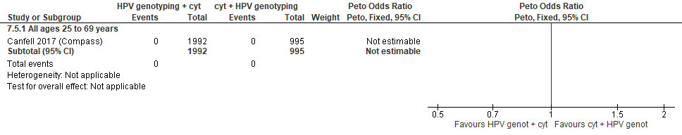
Forest Plot 4.5. Incidence of invasive cervical cancer

Evidence Set 4.6. All-cause mortality
Included report: Canfell 2017 (COMPASS)
GRADE Summary of Findings Table 4.6. All-cause mortality
Outcome  No. participantsª  (studies) |  | Relative effects, Peto OR and RR (95 % CI) | Anticipated absolute effects |  |  | Certainty of evidence (GRADE)^{b} | What happens?
 |  | Relative effects, Peto OR and RR (95 % CI) | With cytology screening + hrHPV partial genotyping triage | With hrHPV partial genotyping + cytology triage | Difference | Certainty of evidence (GRADE)^{b} | What happens?
People with a cervix aged 25 to 69 years (Canfell 2017 (COMPASS); acceptors of screening)
All-cause mortality  Follow-up: 18 months  2,987 (1 RCT) | Peto OR: 4.48 (0.24 to 84.85)  RR: 4.48 (0.24 to 84.85) |  | 0.0 per 10,000 | 0.0 per 10,000 | No difference | 25-29 yrs:  VERY LOW^{c}  ⊕⊝⊝⊝  due to lack of evidence of consistency, and (very serious) indirectness  30-59 yrs:  VERY LOW^{d}  ⊕⊝⊝⊝  due to lack of evidence of consistency, indirectness, and imprecision  60-69 yrs:  VERY LOW^{e}  ⊕⊝⊝⊝  due to lack of evidence of consistency, and (very serious) indirectness | Among screened people with a cervix aged 25 to 69 years, we are very uncertain about the effect of hrHPV testing with genotyping and cytology triage of those with genotype 45 on the number of deaths from all causes compared with cytology testing with hrHPV partial genotyping triage.
CI = confidence interval; OR = odds ratio; RCT = randomized controlled trial; RR = relative risk.
ªAcceptors of screening include all participants who were randomized and completed one round of the screening via the strategy to which they were randomly assigned.
^{b}We rated down by 0.5 for “some concerns”, 1 “serious concerns”, and 2 for “very serious concerns”. When our assessment of the certainty of evidence fell between levels, we assigned the level that best represented our actual certainty in the evidence, and based our conclusions on this level of certainty.
Explanations:
^{c}Acceptors of screening; people with a cervix aged 25 to 29 years: No serious concerns about risk of bias: no domains judged as high risk. Some concerns about inconsistency: lack of evidence for consistency due to single study. Very serious concerns about indirectness: length of follow-up insufficient to capture mortality (18 months), and concerns due to small sample for this age group (n=629). Serious concerns about imprecision: concerns due to small sample. No other serious concerns.
^{d}Acceptors of screening; people with a cervix aged 30 to 59 years: No serious concerns about risk of bias: no domains judged as high risk. Some concerns about inconsistency: lack of evidence for consistency due to single study. Serious concerns about indirectness: length of follow-up insufficient to capture mortality (18 months). Serious concerns about imprecision: concerns due to small sample. No other serious concerns.
^{e}Acceptors of screening; people with a cervix aged 60 to 69 years: No serious concerns about risk of bias: no domains judged as high risk. Some concerns about inconsistency: lack of evidence for consistency due to single study. Serious concerns about indirectness: length of follow-up insufficient to capture mortality (18 months), and concerns due to small sample for this age group (n=NR). Serious concerns about imprecision: concerns due to small sample. No other serious concerns.

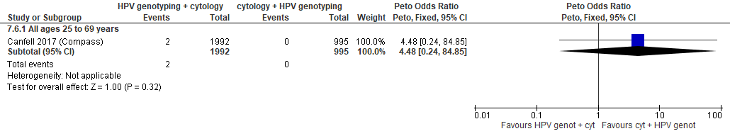
Forest plot 4.6. All-cause mortality

Evidence Set 4.7. False positives for CIN2+
Included report: Canfell 2017 (COMPASS)
GRADE Summary of Findings Table 4.7. False positives for CIN2+
Outcome  No. participantsª  (studies) |  | Relative effects, Peto OR and RR (95 % CI) | Anticipated absolute effects |  |  | Certainty of evidence (GRADE)^{b} | What happens?
 |  | Relative effects, Peto OR and RR (95 % CI) | With cytology screening + hrHPV partial genotyping triage | With hrHPV partial genotyping + cytology triage | Difference | Certainty of evidence (GRADE)^{b} | What happens?
People with a cervix aged 25 to 69 years (Canfell 2017 (COMPASS); acceptors of screening)
False positives for CIN2+  Follow-up: 1 round  2,987 (1 RCT) | Peto OR: 1.06 (0.66 to 1.69)  RR: 1.06 (0.67 to 1.66) |  | 261.3 per 10,000 | 276.6 per 10,000 | 15.2 more per 10,000 (87.3 less to 172.5 more) | 25-29 yrs:  LOW^{c}  ⊕⊕⊝⊝  due to lack of evidence of consistency, and indirectness  30-59 yrs:  MODERATE^{d}  ⊕⊕⊕⊝  due to lack of evidence of consistency  60-69 yrs:  LOW^{e}  ⊕⊕⊝⊝  due to lack of evidence of consistency, and indirectness | Among screened people with a cervix aged 25 to 29 years, hrHPV testing with partial genotyping and cytology triage of those with genotype 45 may have little-to-no effect on the number of false positives for CIN2+ compared with cytology testing with hrHPV partial genotyping triage.  Among screened people with a cervix aged 30 to 59 years, hrHPV testing with partial genotyping and cytology triage of those with genotype 45 probably has little-to-no effect on the number of false positives for CIN2+ compared with cytology testing with hrHPV partial genotyping triage.  Among screened people with a cervix aged 60 to 69 years, hrHPV testing with partial genotyping and cytology triage of those with genotype 45 may have little-to-no effect on the number of false positives for CIN2+ compared with cytology testing with hrHPV partial genotyping triage.
>Subgroup: people with a cervix aged 25 to 29 years (Canfell 2017 (COMPASS); acceptors of screening)
False positives for CIN2+  Follow-up: 1 round  629 (1 RCT) | Peto OR: 1.29 (0.61 to 2.74)  RR: 1.27 (0.62 to 2.55) |  | 426.5 per 10,000 | 543.5 per 10,000 | 117.0 more per 10,000 (161.9 less to 661.4 more) | NA
>Subgroup: people with a cervix aged 30 to 69 years (Canfell 2017 (COMPASS); acceptors of screening)
False positives for CIN2+  Follow-up: 1 round  2,358 (1 RCT) | Peto OR: 0.94 (0.51 to 1.71)  RR: 0.94 (0.52 to 1.68) |  | 216.8 per 10,000 | 204.1 per 10,000 | 12.7 less per 10,000 (105.1 less to 148.3 more) | NA
CI = confidence interval; CIN = cervical intraepithelial neoplasia; NA= not applicable (i.e., not used for conclusions); OR = odds ratio; RCT = randomized controlled trial; RR = relative risk.
ªAcceptors of screening include all participants who were randomized and completed one round of the screening via the test to which they were randomly assigned. Ninety-eight per cent of participants who were referred to colposcopy attended; however, it is unclear how many attended from each group.
^{b}We rated down by 0.5 for “some concerns”, 1 “serious concerns”, and 2 for “very serious concerns”. When our assessment of the certainty of evidence fell between levels, we assigned the level that best represented our actual certainty in the evidence, and based our conclusions on this level of certainty.
Explanations:
^{c}Acceptors of screening; people with a cervix aged 25 to 29 years: No serious concerns about risk of bias: the study was open label; however, knowledge of group allocation is unlikely to have affected the outcome. The outcome was not listed in the trial register, but is expected to be reported as a part of the screening process. Some concerns about inconsistency: lack of evidence for consistency due to single study. Serious concerns about indirectness: concerns due to small sample for this age group (n=629). No serious concerns about imprecision: 95% CI precise for little-to-no effect. No other serious concerns.
^{d}Acceptors of screening; people with a cervix aged 30 to 59 years: No serious concerns about risk of bias: the study was open label; however, knowledge of group allocation is unlikely to have affected the outcome. The outcome was not listed in the trial register, but is expected to be reported as a part of the screening process. Some concerns about inconsistency: lack of evidence for consistency due to single study. No serious concerns about indirectness: the study provides direct evidence. No serious concerns about imprecision: 95%CI precise for little-to-no effect. No other serious concerns.
^{e}Acceptors of screening; people with a cervix aged 60 to 69 years: No serious concerns about risk of bias: the study was open label; however, knowledge of group allocation is unlikely to have affected the outcome. The outcome was not listed in the trial register, but is expected to be reported as a part of the screening process. Some concerns about inconsistency: lack of evidence for consistency due to single study. Serious concerns about indirectness: concerns due to small sample for this age group (n=NR). No serious concerns about imprecision: 95% CI precise for little-to-no effect. No other serious concerns.

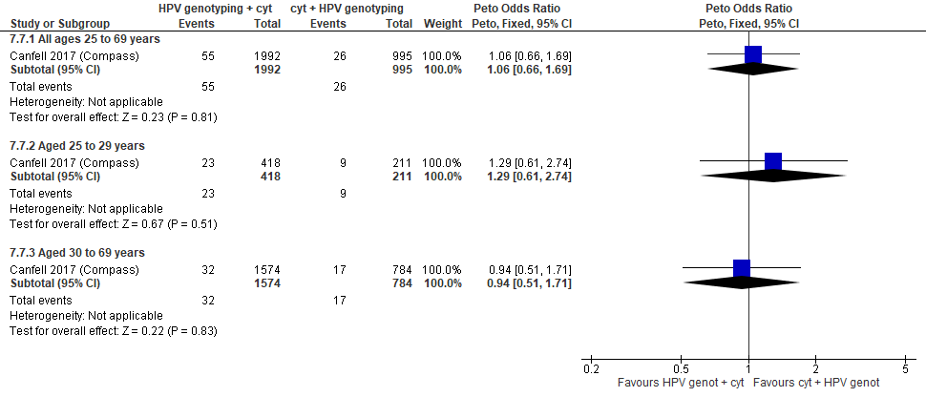
Forest Plot 4.7. False positives for CIN2+

Evidence Set 4.8. False positives for CIN3+
Included report: Canfell 2017 (COMPASS)
GRADE Summary of Findings Table 4.8. False positives for CIN3+
Outcome  No. participantsª  (studies) |  | Relative effects, Peto OR and RR (95 % CI) | Anticipated absolute effects |  |  | Certainty of evidence (GRADE)^{b} | What happens?
 |  | Relative effects, Peto OR and RR (95 % CI) | With cytology screening + hrHPV partial genotyping triage | With hrHPV partial genotyping + cytology triage | Difference | Certainty of evidence (GRADE)^{b} | What happens?
People with a cervix aged 25 to 69 years (Canfell 2017 (COMPASS); acceptors of screening)
False positives for CIN3+  Follow-up: 1 round  2,987 (1 RCT) | Peto OR: 1.19 (0.76 to 1.87)  RR: 1.18 (0.76 to 1.83) |  | 261.3 per 10,000 | 309.4 per 10,000 | 48.1 more per 10,000 (61.5 less to 216.5 more) | 25-29 yrs:  LOW^{c}  ⊕⊕⊝⊝  due to lack of evidence of consistency, and indirectness  30-59 yrs:  MODERATE^{d}  ⊕⊕⊕⊝  due to lack of evidence of consistency  60-69 yrs:  LOW^{e}  ⊕⊕⊝⊝  due to lack of evidence of consistency, and indirectness | Among screened people with a cervix aged 25 to 29 years, hrHPV testing with partial genotyping and cytology triage of those with genotype 45 may have little-to-no effect on the number of false positives for CIN3+ compared with cytology testing with hrHPV partial genotyping triage.  Among screened people with a cervix aged 30 to 59 years, hrHPV testing with partial genotyping and cytology triage of those with genotype 45 probably has little-to-no effect on the number of false positives for CIN3+ compared with cytology testing with hrHPV partial genotyping triage.  Among screened people with a cervix aged 60 to 69 years, hrHPV testing with partial genotyping and cytology triage of those with genotype 45 may have little-to-no effect on the number of false positives for CIN3+ compared with cytology testing with hrHPV partial genotyping triage.
>Subgroup: people with a cervix aged 25 to 29 years (Canfell 2017 (COMPASS); acceptors of screening)
False positives for CIN3+  Follow-up: 1 round  629 (1 RCT) | Peto OR: 1.40 (0.67 to 2.90)  RR: 1.38 (0.68 to 2.68) |  | 426.5 per 10,000 | 587.1 per 10,000 | 160.6 more per 10,000 (136.7 less to 717.7 more) | NA
>Subgroup: people with a cervix aged 30 to 69 years (Canfell 2017 (COMPASS); acceptors of screening)
False positives for CIN3+  Follow-up: 1 round  2,358 (1 RCT) | Peto OR: 1.08 (0.61 to 1.92)  RR: 1.08 (0.62 to 1.88) |  | 216.8 per 10,000 | 233.8 per 10,000 | 16.9 more per 10,000 (83.4 less to 191.3 more) | NA
CI = confidence interval; NA= not applicable (i.e., not used for conclusions); OR = odds ratio; RCT = randomized controlled trial; RR = relative risk.
ªAcceptors of screening include all participants who were randomized and completed one round of the screening via the test to which they were randomly assigned. Ninety-eight per cent of participants who were referred to colposcopy attended; however, it is unclear how many attended from each group.
^{b}We rated down by 0.5 for “some concerns”, 1 “serious concerns”, and 2 for “very serious concerns”. When our assessment of the certainty of evidence fell between levels, we assigned the level that best represented our actual certainty in the evidence, and based our conclusions on this level of certainty.
Explanations:
^{c}Acceptors of screening; people with a cervix aged 25 to 29 years: No serious concerns about risk of bias: the study was open label; however, knowledge of group allocation is unlikely to have affected the outcome. The outcome was not listed in the trial register, but is expected to be reported as a part of the screening process. Some concerns about inconsistency: lack of evidence for consistency due to single study. Serious concerns about indirectness: concerns due to small sample for this age group (n=629). No serious concerns about imprecision: 95% CI precise for little-to-no effect. No other serious concerns.
^{d}Acceptors of screening; people with a cervix aged 30 to 59 years: No serious concerns about risk of bias: the study was open label; however, knowledge of group allocation is unlikely to have affected the outcome. The outcome was not listed in the trial register, but is expected to be reported as a part of the screening process. Some concerns about inconsistency: lack of evidence for consistency due to single study. No serious concerns about indirectness: the study provides direct evidence. No serious concerns about imprecision: 95%CI precise for little-to-no effect. No other serious concerns.
^{e}Acceptors of screening; people with a cervix aged 60 to 69 years: No serious concerns about risk of bias: the study was open label; however, knowledge of group allocation is unlikely to have affected the outcome. The outcome was not listed in the trial register, but is expected to be reported as a part of the screening process. Some concerns about inconsistency: lack of evidence for consistency due to single study. Serious concerns about indirectness: concerns due to small sample for this age group (n=NR). No serious concerns about imprecision: 95% CI precise for little-to-no effect. No other serious concerns.

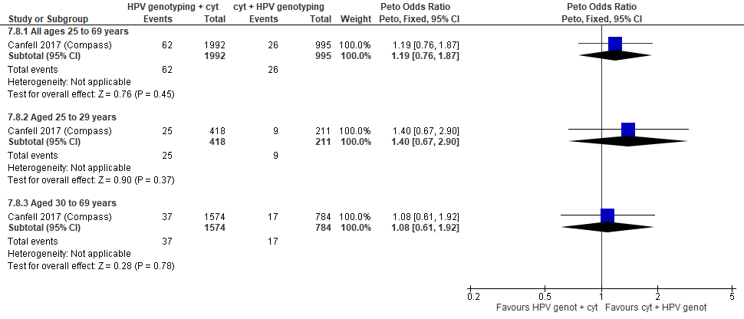
Forest Plot 4.8. False positives for CIN3+

Evidence Set 4.9. False positives for invasive cervical cancer
Included report: Canfell 2017 (COMPASS)
GRADE Summary of Findings Table 4.9. False positives for invasive cervical cancer
Outcome  No. participantsª  (studies) |  | Relative effects, Peto OR and RR (95 % CI) | Anticipated absolute effects |  |  | Certainty of evidence (GRADE)^{b} | What happens?
 |  | Relative effects, Peto OR and RR (95 % CI) | With cytology screening + hrHPV partial genotyping triage | With hrHPV partial genotyping + cytology triage | Difference | Certainty of evidence (GRADE)^{b} | What happens?
People with a cervix aged 25 to 69 years (Canfell 2017 (COMPASS); acceptors of screening)
False positives for invasive cervical cancer  Follow-up: 1 round  2,987 (1 RCT) | Peto OR: 1.36 (0.89 to 2.07)  RR: 1.35 (0.89 to 2.01) |  | 271.4 per 10,000 | 365.5 per 10,000 | 94.1 more per 10,000 (29.1 less to 274.5 more) | 25-29 yrs:  LOW^{c}  ⊕⊕⊝⊝  due to lack of evidence of consistency, and indirectness  30-59 yrs:  MODERATE^{d}  ⊕⊕⊕⊝  due to lack of evidence of consistency  60-69 yrs:  LOW^{e}  ⊕⊕⊝⊝  due to lack of evidence of consistency, and indirectness | Among screened people with a cervix aged 25 to 29 years, hrHPV testing with partial genotyping and cytology triage of those with genotype 45 may have little-to-no effect on the number of false positives for invasive cervical cancer compared with cytology testing with hrHPV partial genotyping triage.  Among screened people with a cervix aged 30 to 59 years, hrHPV testing with partial genotyping and cytology triage of those with genotype 45 probably has little-to-no effect on the number of false positives for invasive cervical cancer compared with cytology testing with hrHPV partial genotyping triage.  Among screened people with a cervix aged 60 to 69 years, hrHPV testing with partial genotyping and cytology triage of those with genotype 45 may have little-to-no effect on the number of false positives for invasive cervical cancer compared with cytology testing with hrHPV partial genotyping triage.
CI = confidence interval; NA= not applicable (i.e., not used for conclusions); OR = odds ratio; RCT = randomized controlled trial; RR = relative risk.
ªAcceptors of screening include all participants who were randomized and completed one round of the screening via the test to which they were randomly assigned. Ninety-eight per cent of participants who were referred to colposcopy attended; however, it is unclear how many attended from each group.
^{b}We rated down by 0.5 for “some concerns”, 1 “serious concerns”, and 2 for “very serious concerns”. When our assessment of the certainty of evidence fell between levels, we assigned the level that best represented our actual certainty in the evidence, and based our conclusions on this level of certainty.
Explanations:
^{c}Acceptors of screening; people with a cervix aged 25 to 29 years: No serious concerns about risk of bias: the study was open label; however, knowledge of group allocation is unlikely to have affected the outcome. The outcome was not listed in the trial register, but is expected to be reported as a part of the screening process. Some concerns about inconsistency: lack of evidence for consistency due to single study. Serious concerns about indirectness: concerns due to small sample for this age group (n=629). No serious concerns about imprecision: 95% CI precise for little-to-no effect. No other serious concerns.
^{d}Acceptors of screening; people with a cervix aged 30 to 59 years: No serious concerns about risk of bias: the study was open label; however, knowledge of group allocation is unlikely to have affected the outcome. The outcome was not listed in the trial register, but is expected to be reported as a part of the screening process. Some concerns about inconsistency: lack of evidence for consistency due to single study. No serious concerns about indirectness: the study provides direct evidence. No serious concerns about imprecision: 95%CI precise for little-to-no effect. No other serious concerns.
^{e}Acceptors of screening; people with a cervix aged 60 to 69 years: No serious concerns about risk of bias: the study was open label; however, knowledge of group allocation is unlikely to have affected the outcome. The outcome was not listed in the trial register, but is expected to be reported as a part of the screening process. Some concerns about inconsistency: lack of evidence for consistency due to single study. Serious concerns about indirectness: concerns due to small sample for this age group (n=NR). No serious concerns about imprecision: 95% CI precise for little-to-no effect. No other serious concerns.

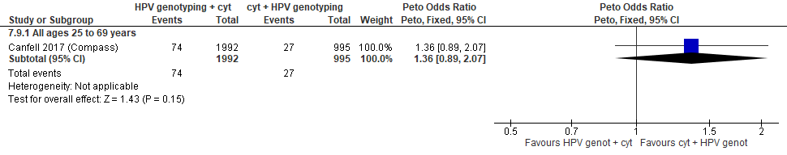
Forest Plot 4.9. False positives for invasive cervical cancer

Evidence set 5.0: hrHPV screening (threshold 1.0 RLU) with liquid-based cytology triage of negative tests versus liquid-based cytology screening (threshold ≥LSIL) with hrHPV triage of ASCUS

Included report: Chan 2020 (Hong Kong)(ages 30-60 [no age subgroups])

Evidence Set 5.1. Referrals to colposcopy
GRADE Summary of Findings Table 5.1. Referrals to colposcopy
Outcome  No. participantsª  (studies) |  | Relative effects, Peto OR and RR (95 % CI) | Anticipated absolute effects |  |  | Certainty of evidence (GRADE) | What happens?
 |  | Relative effects, Peto OR and RR (95 % CI) | With cytology screening + hrHPV triage | With hrHPV screening + cytology triage of negatives | Difference | Certainty of evidence (GRADE) | What happens?
People with a cervix aged 30 to 59 years (Chan 2020 (Hong Kong); acceptors of screening)
Referrals to colposcopy  Follow-up: 1 round  15,833 (1 RCT) | Peto OR: 3.95 (3.45 to 4.52)  RR: 3.73 (3.29 to 4.22) |  | 198.5 per 10,000 | 740.6 per 10,000 | 542.1 more per 10,000 (454.5 more to 640.0 more) | 25-29 yrs:  VERY LOW  ⊕⊝⊝⊝  NR  MODERATE^{c}  ⊕⊕⊕⊝  due to lack of evidence of consistency  60-69 yrs:  VERY LOW  ⊕⊝⊝⊝  NR | Among screened people with a cervix aged 25 to 29 years, we are very uncertain about the effects of hrHPV testing with cytology triage of those with negative tests on the rate of referral to colposcopy compared with cytology screening with hrHPV triage.  Among screened people with a cervix aged 30 to 59 years, hrHPV testing with cytology triage of those with negative tests probably increases the rate of referral to colposcopy compared with cytology screening with hrHPV triage.  Among screened people with a cervix aged 60 to 69 years, we are very uncertain about the effects of hrHPV testing with cytology triage of those with negative tests on the rate of referral to colposcopy compared with cytology screening with hrHPV triage.
CI = confidence interval; OR = odds ratio; RCT = randomized controlled trial; RR = relative risk.
ªAcceptors of screening include all randomized participants who completed 1 round of the screening via the strategy to which they were randomly assigned.
^{b}We rated down by 0.5 for “some concerns”, 1 “serious concerns”, and 2 for “very serious concerns”. When our assessment of the certainty of evidence fell between levels, we assigned the level that best represented our actual certainty in the evidence, and based our conclusions on this level of certainty.
Explanations:
^{c}Screened, modified per protocol; people with a cervix aged 30 to 59 years: No serious concerns about risk of bias: no domains judged as high risk. Some concerns about inconsistency: lack of evidence for consistency due to single study. No serious concerns about indirectness: the study provides direct evidence. No serious concerns about imprecision: 95% CI precise for increased effect. No other serious concerns.

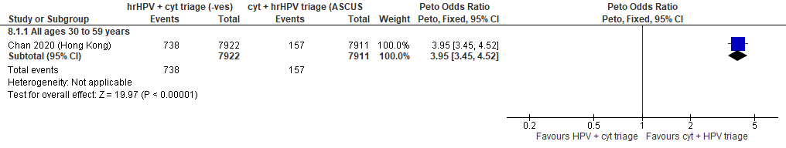
Forest Plot 5.1. Referrals to colposcopy

Evidence Set 5.2. Number of colposcopies
Included report: Chan 2020 (Hong Kong)
GRADE Summary of Findings Table 5.2. Number of colposcopies
Outcome  No. participantsª  (studies) |  | Relative effects, Peto OR and RR (95 % CI) | Anticipated absolute effects |  |  | Certainty of evidence (GRADE)^{b} | What happens?
 |  | Relative effects, Peto OR and RR (95 % CI) | With cytology screening + hrHPV triage | With hrHPV screening + cytology triage of negatives | Difference | Certainty of evidence (GRADE)^{b} | What happens?
People with a cervix aged 30 to 59 years (Chan 2020 (Hong Kong); acceptors of screening)
Number of colposcopies  Follow-up: 1 round  15,833 (1 RCT) | Peto OR: 3.78 (3.28 to 4.36)  RR: 3.60 (3.15 to 4.11) |  | 184.6 per 10,000 | 663.6 per 10,000 | 479.0 more per 10,000 (396.3 more to 573.1 more) | 25-29 yrs:  VERY LOW  ⊕⊝⊝⊝  NR  MODERATE^{c}  ⊕⊕⊕⊝  due to lack of evidence of consistency  60-69 yrs:  VERY LOW  ⊕⊝⊝⊝  NR | Among screened people with a cervix aged 25 to 29 years, we are very uncertain about the effects of hrHPV testing with cytology triage of those with negative tests on the number of colposcopies compared with cytology screening with hrHPV triage.  Among screened people with a cervix aged 30 to 59 years, hrHPV testing with cytology triage of those with negative tests probably increases the number of colposcopies compared with cytology screening with hrHPV triage.  Among screened people with a cervix aged 60 to 69 years, we are very uncertain about the effects of hrHPV testing with cytology triage of those with negative tests on the number of colposcopies compared with cytology screening with hrHPV triage.
CI = confidence interval; OR = odds ratio; RCT = randomized controlled trial; RR = relative risk.
ªAcceptors of screening include all randomized participants who completed 1 round of the screening via the strategy to which they were randomly assigned.
^{b}We rated down by 0.5 for “some concerns”, 1 “serious concerns”, and 2 for “very serious concerns”. When our assessment of the certainty of evidence fell between levels, we assigned the level that best represented our actual certainty in the evidence, and based our conclusions on this level of certainty.
Explanations:
^{c}Screened, modified per protocol; people with a cervix aged 30 to 59 years: No serious concerns about risk of bias: no domains judged as high risk. Some concerns about inconsistency: lack of evidence for consistency due to single study. No serious concerns about indirectness: the study provides direct evidence. No serious concerns about imprecision: 95% CI precise for increased effect. No other serious concerns.

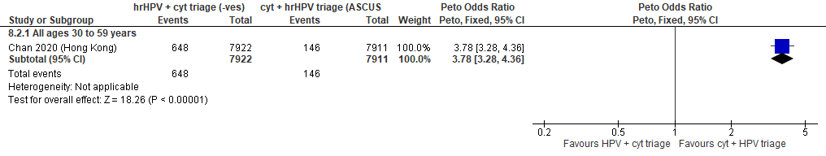
Forest Plot 5.2. Number of colposcopies

Evidence Set 5.3. Number of LEEPs
Included report: Chan 2020 (Hong Kong)
GRADE Summary of Findings Table 5.3. Number of LEEPs
Outcome  No. participantsª  (studies) |  | Relative effects, Peto OR and RR (95 % CI) | Anticipated absolute effects |  |  | Certainty of evidence (GRADE)** | What happens?
 |  | Relative effects, Peto OR and RR (95 % CI) | With cytology screening + hrHPV triage | With hrHPV screening + cytology triage of negatives | Difference | Certainty of evidence (GRADE)** | What happens?
People with a cervix aged 30 to 59 years (Chan 2020 (Hong Kong); acceptors of screening)
Number of LEEPs  Follow-up: 1 round  15,833 (1 RCT) | Peto OR: 1.79 (1.30 to 2.47)  RR: 1.78 (1.30 to 2.45) |  | 67.0 per 10,000 | 119.3 per 10,000 | 52.3 more per 10,000 (19.9 more to 96.9 more) | 25-29 yrs:  VERY LOW  ⊕⊝⊝⊝  NR  MODERATE^{c}  ⊕⊕⊕⊝  due to lack of evidence of consistency  60-69 yrs:  VERY LOW  ⊕⊝⊝⊝  NR | Among screened people with a cervix aged 25 to 29 years, we are very uncertain about the effects of hrHPV testing with cytology triage of those with negative tests on the number of LEEP procedures compared with cytology screening with hrHPV triage.  Among screened people with a cervix aged 30 to 59 years, hrHPV testing with cytology triage of those with negative tests probably has little-to-no effect on the number of LEEP procedures compared with cytology screening with hrHPV triage.  Among screened people with a cervix aged 60 to 69 years, we are very uncertain about the effects of hrHPV testing with cytology triage of those with negative tests on the number of LEEP procedures compared with cytology screening with hrHPV triage.
CI = confidence interval; LEEP = loop electrosurgical excision procedure; OR = odds ratio; RCT = randomized controlled trial; RR = relative risk.
ªAcceptors of screening include all randomized participants who completed 1 round of the screening via the strategy to which they were randomly assigned.
^{b}We rated down by 0.5 for “some concerns”, 1 “serious concerns”, and 2 for “very serious concerns”. When our assessment of the certainty of evidence fell between levels, we assigned the level that best represented our actual certainty in the evidence, and based our conclusions on this level of certainty.
Explanations:
^{c}Screened, modified per protocol; people with a cervix aged 30 to 59 years: No serious concerns about risk of bias: no domains judged as high risk. Some concerns about inconsistency: lack of evidence for consistency due to single study. No serious concerns about indirectness: the study provides direct evidence. No serious concerns about imprecision: 95% CI precise for little-to-no effect. No other serious concerns.
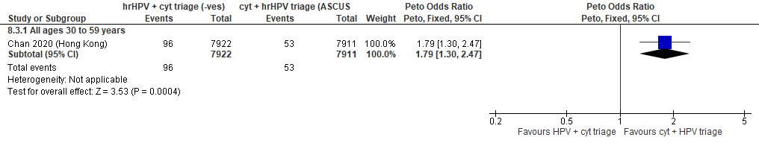
Forest Plot 5.3. Number of LEEPs

Evidence Set 5.4. Detection of CIN2+ (as an indirect indicator of the incidence of CIN3+)
Included report: Chan 2020 (Hong Kong)
GRADE Summary of Findings Table 5.4. Detection of CIN2+ (as an indirect indicator of the incidence of CIN3+)
Outcome  No. participantsª  (studies) |  | Relative effects, Peto OR and RR (95 % CI) | Anticipated absolute effects |  |  | Certainty of evidence (GRADE)^{b} | What happens?
 |  | Relative effects, Peto OR and RR (95 % CI) | With cytology screening + hrHPV triage | With hrHPV screening + cytology triage of negatives | Difference | Certainty of evidence (GRADE)^{b} | What happens?
People with a cervix aged 30 to 59 years (Chan 2020 (Hong Kong); acceptors of screening, select population)
Detection of CIN2+  Follow-up: 1 round  15,760 (1 RCT) | Peto OR: 2.38 (1.62 to 3.50)  RR: 2.37 (1.62 to 3.47) |  | 38.0 per 10,000 | 89.9 per 10,000 | 51.9 more per 10,000 (23.4 more to 93.7 more) | 25-29 yrs:  VERY LOW  ⊕⊝⊝⊝  NR  30-59 yrs:  LOW^{c}  ⊕⊕⊝⊝  due lack of evidence of consistency and indirectness  60-69 yrs:  VERY LOW  ⊕⊝⊝⊝  NR | Among screened people with a cervix aged 25 to 29 years, we are very uncertain about the effects of hrHPV testing with cytology triage of those with negative tests on the incidence of CIN3+ compared with cytology screening with hrHPV triage.  Among screened people with a cervix aged 30 to 59 years, hrHPV screening with cytology triage of negative tests may have little-to-no effect on the incidence of CIN3+ compared with cytology screening with hrHPV triage.  Among screened people with a cervix aged 60 to 69 years, we are very uncertain about the effects of hrHPV testing with cytology triage of those with negative tests on the incidence of CIN3+ compared with cytology screening with hrHPV triage.
CI = confidence interval; CIN = cervical intraepithelial neoplasia; OR = odds ratio; RCT = randomized controlled trial; RR = relative risk.
ªAcceptors of screening, select population includes all randomized participants who completed the screening protocol and attended colposcopy follow-up, as needed, following a positive test. The denominator excludes 90 participants in the experimental group and 11 in the control group who did not attend colposcopy following a positive test.
^{b}We rated down by 0.5 for “some concerns”, 1 “serious concerns”, and 2 for “very serious concerns”. When our assessment of the certainty of evidence fell between levels, we assigned the level that best represented our actual certainty in the evidence, and based our conclusions on this level of certainty.
Explanations:
^{c}Screened, modified per protocol; people with a cervix aged 30 to 59 years: No serious concerns about risk of bias: no domains judged as high risk. Some concerns about inconsistency: lack of evidence for consistency due to single study. Serious concerns about indirectness: detection is an indirect measure for incidence. No serious concerns about imprecision: 95% CI precise for little-to-no effect. No other serious concerns.
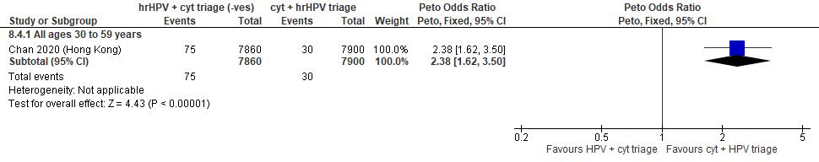
Forest Plot 5.4. Detection of CIN2+ (as an indirect indicator of the incidence of CIN3+)

Evidence Set 5.5. Detection of CIN3+ (as an indirect indicator of the incidence of ICC)
Included report: Chan 2020 (Hong Kong)
GRADE Summary of Findings Table 5.5. Detection of CIN3+ (as an indirect indicator of the incidence of ICC)
Outcome  No. participantsª  (studies) |  | Relative effects, Peto OR and RR (95 % CI) | Anticipated absolute effects |  |  | Certainty of evidence (GRADE)^{b} | What happens?
 |  | Relative effects, Peto OR and RR (95 % CI) | With cytology screening + hrHPV triage | With hrHPV screening + cytology triage of negatives | Difference | Certainty of evidence (GRADE)^{b} | What happens?
People with a cervix aged 30 to 59 years (Chan 2020 (Hong Kong); acceptors of screening, select population)
Detection of CIN3+  Follow-up: 1 round  15,760 (1 RCT) | Peto OR: 2.79 (1.71 to 4.54)  RR: 2.78 (1.71 to 4.51) |  | 20.3 per 10,000 | 56.3 per 10,000 | 36.0 more per 10,000 (14.3 more to 71.0 more) | 25-29 yrs:  VERY LOW  ⊕⊝⊝⊝  NR  30-59 yrs:  LOW^{c}  ⊕⊕⊝⊝  due lack of evidence of consistency and indirectness  60-69 yrs:  VERY LOW  ⊕⊝⊝⊝  NR | Among screened people with a cervix aged 25 to 29 years, we are very uncertain about the effects of hrHPV testing with cytology triage of those with negative tests on the incidence of invasive cervical cancer compared with cytology screening with hrHPV triage.  Among screened people with a cervix aged 30 to 59 years, hrHPV screening with cytology triage of negative tests may reduce the incidence of invasive cervical cancer compared with cytology screening with hrHPV triage.  Among screened people with a cervix aged 60 to 69 years, we are very uncertain about the effects of hrHPV testing with cytology triage of those with negative tests on the incidence of invasive cervical cancer compared with cytology screening with hrHPV triage.
CI = confidence interval; CIN = cervical intraepithelial neoplasia; OR = odds ratio; RCT = randomized controlled trial; RR = relative risk.
ªAcceptors of screening, select population includes all randomized participants who completed the screening protocol and attended colposcopy follow-up, as needed, following a positive test. The denominator excludes 90 participants in the experimental group and 11 in the control group who did not attend colposcopy following a positive test.
^{b}We rated down by 0.5 for “some concerns”, 1 “serious concerns”, and 2 for “very serious concerns”. When our assessment of the certainty of evidence fell between levels, we assigned the level that best represented our actual certainty in the evidence, and based our conclusions on this level of certainty.
Explanations:
^{c}Screened, modified per protocol; people with a cervix aged 30 to 59 years: No serious concerns about risk of bias: no domains judged as high risk. Some concerns about inconsistency: lack of evidence for consistency due to single study. Serious concerns about indirectness: detection is an indirect measure for incidence. No serious concerns about imprecision: 95% CI precise for increased effect. No other serious concerns.

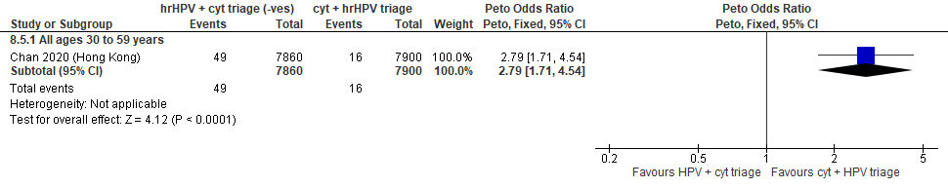
Forest Plot 5.5. Detection of CIN3+ (as an indirect indicator of the incidence of ICC)

Evidence Set 5.6. Detection of invasive cervical cancer
Included report: Chan 2020 (Hong Kong)
GRADE Summary of Findings Table 5.6. Detection of invasive cervical cancer
Outcome  No. participantsª  (studies) |  | Relative effects, Peto OR and RR (95 % CI) | Anticipated absolute effects |  |  | Certainty of evidence (GRADE)^{b} | What happens?
 |  | Relative effects, Peto OR and RR (95 % CI) | With cytology screening + hrHPV triage | With hrHPV screening + cytology triage of negatives | Difference | Certainty of evidence (GRADE)^{b} | What happens?
People with a cervix aged 30 to 59 years (Chan 2020 (Hong Kong); acceptors of screening, select population)
Detection of invasive cervical cancer  Follow-up: 1 round  15,760 (1 RCT) | Peto OR: 1.96 (0.20 to 18.82)  RR: 1.96 (0.20 to 18.78) |  | 1.3 per 10,000 | 2.5 per 10,000 | 1.2 more per 10,000 (1.0 less to 22.5 more) | 25-29 yrs:  VERY LOW  ⊕⊝⊝⊝  NR  30-59 yrs:  VERY LOW^{c}  ⊕⊝⊝⊝  due lack of evidence of consistency, indirectness, and imprecision  VERY LOW  ⊕⊝⊝⊝  NR | Among screened people with a cervix aged 25 to 29 years, we are very uncertain about the effects of hrHPV testing with cytology triage of those with negative tests on the detection of invasive cervical cancer compared with cytology screening with hrHPV triage.  Among screened people with a cervix aged 30 to 59 years, we are very uncertain about the effect of hrHPV screening with cytology triage of negative tests on the detection of invasive cervical cancer compared with cytology screening with hrHPV triage.  Among screened people with a cervix aged 60 to 69 years, we are very uncertain about the effects of hrHPV testing with cytology triage of those with negative tests on the detection of invasive cervical cancer compared with cytology screening with hrHPV triage.
CI = confidence interval; OR = odds ratio; RCT = randomized controlled trial; RR = relative risk.
ªAcceptors of screening, select population includes all randomized participants who completed the screening protocol and attended colposcopy follow-up, as needed, following a positive test. The denominator excludes 90 participants in the experimental group and 11 in the control group who did not attend colposcopy following a positive test.
^{b}We rated down by 0.5 for “some concerns”, 1 “serious concerns”, and 2 for “very serious concerns”. When our assessment of the certainty of evidence fell between levels, we assigned the level that best represented our actual certainty in the evidence, and based our conclusions on this level of certainty.
Explanations:
^{c}Acceptors of screening, select population; people with a cervix aged 30 to 59 years: No serious concerns about risk of bias: no domains judged high risk. Some concerns about inconsistency: lack of evidence of consistency due to single study. Serious concerns about indirectness: detection is an indirect measure for incidence. Serious concerns about imprecision: upper limit of 95% CI indicates reduced and increased effect. No other serious concerns.
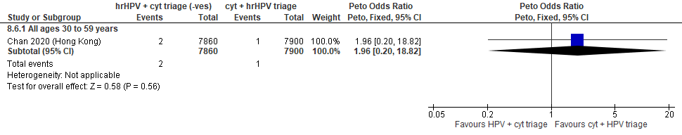
Forest Plot 5.6. Detection of invasive cervical cancer

Evidence Set 5.7. Incidence of CIN2
Included report: Chan 2020 (Hong Kong)
GRADE Summary of Findings Table 5.7. Incidence of CIN2
Outcome  No. participantsª  (studies) |  | Relative effects, Peto OR and RR (95 % CI) | Anticipated absolute effects |  |  | Certainty of evidence (GRADE)^{b} | What happens?
 |  | Relative effects, Peto OR and RR (95 % CI) | With cytology screening + hrHPV triage | With hrHPV screening + cytology triage of negatives | Difference | Certainty of evidence (GRADE)^{b} | What happens?
People with a cervix aged 30 to 59 years (Chan 2020 (Hong Kong); acceptors of screening at follow up)
Incidence of CIN2  Follow-up: 36 months  12,221 (1 RCT) | Peto OR: 0.23 (0.06 to 0.92)  RR: 0.23 (0.06 to 0.92) |  | 11.3 per 10,000 | 2.6 per 10,000 | 8.7 less per 10,000 (10.6 less to 0.9 less) | 25-29 yrs:  VERY LOW  ⊕⊝⊝⊝  NR  30-59 yrs:  VERY LOW^{c}  ⊕⊝⊝⊝  due to risk of bias, lack of evidence of consistency, and indirectness  60-69 yrs:  VERY LOW  ⊕⊝⊝⊝  NR | Among screened people with a cervix aged 25 to 69 years who attend follow-up testing, we are very uncertain about the effects on the incidence of CIN2 from hrHPV screening with cytology triage of negative tests compared with cytology screening with hrHPV triage.
CI = confidence interval; CIN = cervical intraepithelial neoplasia; OR = odds ratio; RCT = randomized controlled trial; RR = relative risk.
ªAcceptors of screening at follow up includes all randomized participants who completed the screening protocol and attended the second round of screening (i.e., 3-year follow up testing via liquid-based cytology). Cases of CIN2 were tabulated from the reported cases of CIN2+ and CIN3+ (there were no cancer cases) as CIN2 = CIN2+ - CIN3+. The denominator excludes those who tested positive during the first round of screening (i.e., prevalent cases).
^{b}We rated down by 0.5 for “some concerns”, 1 “serious concerns”, and 2 for “very serious concerns”. When our assessment of the certainty of evidence fell between levels, we assigned the level that best represented our actual certainty in the evidence, and based our conclusions on this level of certainty.
Explanations:
^{c}Acceptors of screening at follow up; people with a cervix aged 30 to 59 years: Serious concerns about risk of bias: risk of attrition bias because outcome data were missing for ~20% of participants in each group (per protocol analysis). Some concerns about inconsistency: lack of evidence for consistency due to single study. Serious concerns about indirectness: incidence was measured by cytology screening alone and may have missed cases. No serious concerns about imprecision: 95% CI precise for little-to-no effect. No other serious concerns.

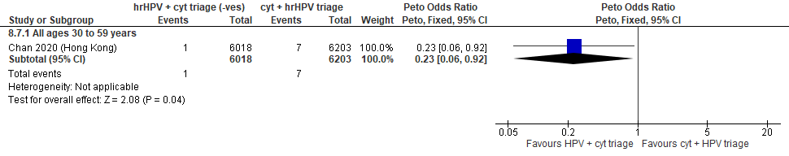
Forest Plot 5.7. Incidence of CIN2

Evidence Set 5.8. Incidence of CIN2+
Included report: Chan 2020 (Hong Kong)
GRADE Summary of Findings Table 5.8. Incidence of CIN2+
Outcome  No. participantsª  (studies) |  | Relative effects, Peto OR and RR (95 % CI) | Anticipated absolute effects* |  |  | Certainty of evidence (GRADE)** | What happens?
 |  | Relative effects, Peto OR and RR (95 % CI) | With cytology screening + hrHPV triage | With hrHPV screening + cytology triage of negatives | Difference | Certainty of evidence (GRADE)** | What happens?
People with a cervix aged 30 to 59 years (Chan 2020 (Hong Kong); acceptors of screening at follow up)
Incidence of CIN2+  Follow-up: 36 months  12,221 (1 RCT) | Peto OR: 0.29 (0.14 to 0.62)  RR: 0.29 (0.14 to 0.62) |  | 35.5 per 10,000 | 10.3 per 10,000 | 25.2 less per 10,000 (30.5 less to 13.4 less) | 25-29 yrs:  VERY LOW  ⊕⊝⊝⊝  NR  VERY LOW^{c}  ⊕⊝⊝⊝  due to risk of bias, lack of evidence of consistency, and (very serious) indirectness  60-69 yrs:  VERY LOW  ⊕⊝⊝⊝  NR | Among screened people with a cervix aged 25 to 69 years, we are very uncertain about the effects on incidence on CIN2+ from hrHPV screening with cytology triage of negative tests compared with cytology screening with hrHPV triage.
CI = confidence interval; CIN = cervical intraepithelial neoplasia; OR = odds ratio; RCT = randomized controlled trial; RR = relative risk.
ªAcceptors of screening at follow up includes all randomized participants who completed the screening protocol and attended the second round of screening (i.e., 3-year follow up testing via liquid-based cytology). The denominator excludes those who tested positive during the first round of screening (i.e., prevalent cases).
^{b}We rated down by 0.5 for “some concerns”, 1 “serious concerns”, and 2 for “very serious concerns”. When our assessment of the certainty of evidence fell between levels, we assigned the level that best represented our actual certainty in the evidence, and based our conclusions on this level of certainty.
Explanations:
^{c}Acceptors of screening at follow up; people with a cervix aged 30 to 59 years: Serious concerns about risk of bias: risk of attrition bias because outcome data were missing for ~20% of participants in each group (per protocol analysis). Some concerns about inconsistency: lack of evidence for consistency due to single study. Very serious concerns about indirectness: the outcome is considered indirect because only those with normal results at baseline received follow-up thus the outcome does not capture cases of CIN2 or CIN 3 that progressed during follow-up, and incidence ascertainment via cytology does not capture cases, especially for ICC, detected clinically. In addition, incidence was measured by cytology screening alone and may have missed cases. No serious concerns about imprecision: 95% CI precise for little-to-no effect. No other serious concerns.

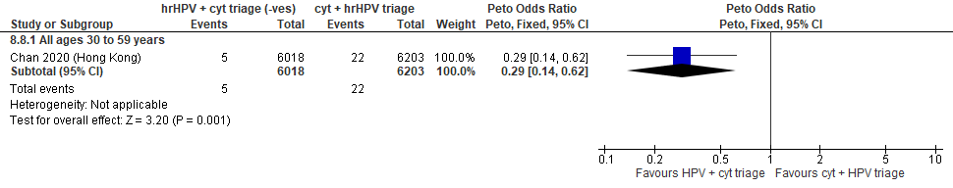
Forest Plot 5.8. Incidence of CIN2+

Evidence Set 5.9. Incidence of CIN3
Included report: Chan 2020 (Hong Kong)
GRADE Summary of Findings Table 5.9. Incidence of CIN3
Outcome  No. participantsª  (studies) |  | Relative effects, Peto OR and RR (95 % CI) | Anticipated absolute effects |  |  | Certainty of evidence (GRADE)^{b} | What happens?
 |  | Relative effects, Peto OR and RR (95 % CI) | With cytology screening + hrHPV triage | With hrHPV screening + cytology triage of negatives | Difference | Certainty of evidence (GRADE)^{b} | What happens?
People with a cervix aged 30 to 59 years (Chan 2020 (Hong Kong); acceptors of screening at follow up)
Incidence of CIN3  Follow-up: 36 months  12,221 (1 RCT) | Peto OR: 0.32 (0.13 to 0.79)  RR: 0.32 (0.13 to 0.79) |  | 24.2 per 10,000 | 7.8 per 10,000 | 16.4 less per 10,000 (21.0 less to 5.1 less) | 25-29 yrs:  VERY LOW  ⊕⊝⊝⊝  NR  30-59 yrs:  VERY LOW^{c}  ⊕⊝⊝⊝  due to risk of bias, lack of evidence of consistency, (very serious) indirectness, and imprecision  60-69 yrs:  VERY LOW  ⊕⊝⊝⊝  NR | Among screened people with a cervix aged 25 to 69 years, we are very uncertain about the effect on the incidence of CIN3 from hrHPV screening with cytology triage of negative tests compared with cytology screening with hrHPV triage.
CI = confidence interval; CIN = cervical intraepithelial neoplasia; OR = odds ratio; RCT = randomized controlled trial; RR = relative risk.
ªAcceptors of screening at follow up includes all randomized participants who completed the screening protocol and attended the second round of screening (i.e., 3-year follow up testing via liquid-based cytology). Cases of CIN3 were tabulated from the reported cases of CIN3+ because there were no cancer cases. The denominator excludes those who tested positive during the first round of screening (i.e., prevalent cases).
^{b}We rated down by 0.5 for “some concerns”, 1 “serious concerns”, and 2 for “very serious concerns”. When our assessment of the certainty of evidence fell between levels, we assigned the level that best represented our actual certainty in the evidence, and based our conclusions on this level of certainty.
Explanations:
^{c}Acceptors of screening at follow up; people with a cervix aged 30 to 59 years: Serious concerns about risk of bias: risk of attrition bias because outcome data were missing for ~20% of participants in each group (per protocol analysis). Some concerns about inconsistency: lack of evidence for consistency due to single study. Very serious concerns about indirectness: the outcome is considered indirect because only those with normal results at baseline received follow-up thus the outcome does not capture cases of CIN2 that progressed during follow-up, and incidence ascertainment via cytology does not capture cases, especially for ICC, detected clinically. In addition, incidence was measured by cytology screening alone and may have missed cases. Serious concerns about imprecision: upper limit of 95% CI indicates little-to-no effect. No other serious concerns.

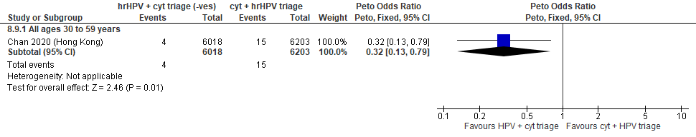
Forest Plot 5.9. Incidence of CIN3

Evidence Set 5.10. Incidence of invasive cervical cancer
Included report: Chan 2020 (Hong Kong)
GRADE Summary of Findings Table 5.10. Incidence of invasive cervical cancer
Outcome  No. participantsª  (studies) |  | Relative effects, Peto OR and RR (95 % CI) | Anticipated absolute effects |  |  | Certainty of evidence (GRADE)^{b} | What happens?
 |  | Relative effects, Peto OR and RR (95 % CI) | With cytology screening + hrHPV triage | With hrHPV screening + cytology triage of negatives | Difference | Certainty of evidence (GRADE)^{b} | What happens?
People with a cervix aged 30 to 59 years (Chan 2020 (Hong Kong); acceptors of screening at follow up)
Incidence of invasive cervical cancer  Follow-up: 36 months  12,221 (1 RCT) | Peto OR: not estimable  RR: not estimable |  | 0.0 per 10,000 | Not estimable | Not estimable | 25-29 yrs:  VERY LOW  ⊕⊝⊝⊝  NR  30-59 yrs:  VERY LOW^{c}  ⊕⊝⊝⊝  due to risk of bias, lack of evidence of consistency, (very serious) indirectness  60-69 yrs:  VERY LOW  ⊕⊝⊝⊝  NR | Among screened people with a cervix aged 25 to 69 years who attend follow-up testing, we are very uncertain about the effect of hrHPV screening with cytology triage of negative tests on the incidence of cervical cancer within 36 months compared with cytology screening with hrHPV triage.
CI = confidence interval; OR = odds ratio; RCT = randomized controlled trial; RR = relative risk.
ªAcceptors of screening at follow up includes all randomized participants who completed the screening protocol and attended the second round of screening (i.e., 3-year follow up testing via liquid-based cytology).
^{b}We rated down by 0.5 for “some concerns”, 1 “serious concerns”, and 2 for “very serious concerns”. When our assessment of the certainty of evidence fell between levels, we assigned the level that best represented our actual certainty in the evidence, and based our conclusions on this level of certainty.
Explanations:
^{c}Acceptors of screening at follow up; people with a cervix aged 30 to 59 years: Serious concerns about risk of bias: risk of attrition bias because outcome data were missing for ~20% of participants in each group (per protocol analysis). Some concerns about inconsistency: lack of evidence for consistency due to single study. Very serious concerns about indirectness: the outcome is considered indirect because only those with normal results at baseline received follow-up thus the outcome does not capture cases of CIN2 or CIN 3 that progressed during follow-up, and incidence ascertainment does not capture cases detected clinically. In addition, incidence was measured by cytology screening alone and may have missed cases. No serious concerns about imprecision: 95% CI precise for little-to-no effect. No other serious concerns.

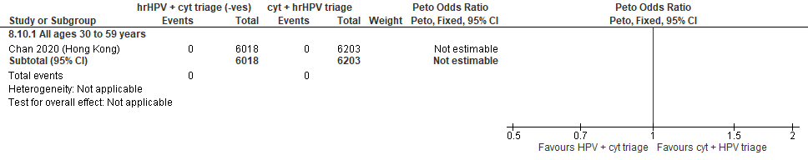
Forest Plot 5.10. Incidence of invasive cervical cancer

Evidence Set 5.11. False positives for CIN2+
Included report: Chan 2020 (Hong Kong)
GRADE Summary of Findings Table 5.11. False positives for CIN2+
Outcome  No. participantsª  (studies) |  | Relative effects, Peto OR and RR (95 % CI) | Anticipated absolute effects |  |  | Certainty of evidence (GRADE)^{b} | What happens?
 |  | Relative effects, Peto OR and RR (95 % CI) | With cytology screening + hrHPV triage | With hrHPV screening + cytology triage of negatives | Difference | Certainty of evidence (GRADE)^{b} | What happens?
People with a cervix aged 30 to 59 years (Chan 2020 (Hong Kong); acceptors of screening, select population)
False positives for CIN2+  Follow-up: 1 round  15,760 (1 RCT) | Peto OR: 4.02 (3.45 to 4.69)  RR: 3.85 (3.33 to 4.45) |  | 146.8 per 10,000 | 565.2 per 10,000 | 418.4 more per 10,000 (342.2 more to 506.4 more) | 25-29 yrs:  VERY LOW  ⊕⊝⊝⊝  NR  30-59 yrs:  MODERATE^{c}  ⊕⊕⊕⊝  due lack of evidence of consistency  60-69 yrs:  VERY LOW  ⊕⊝⊝⊝  NR | Among screened people with a cervix aged 25 to 29 years who attend follow-up testing, we are very uncertain about the effect of hrHPV screening with cytology triage of negative tests on the number of false positives for CIN2+ compared with cytology screening with hrHPV triage.  Among screened people with a cervix aged 30 to 59 years, hrHPV screening with cytology triage of negative tests probably increases the number of false positives for CIN2+ compared with cytology screening with hrHPV triage.  Among screened people with a cervix aged 60 to 69 years who attend follow-up testing, we are very uncertain about the effect of hrHPV screening with cytology triage of negative tests on the number of false positives for CIN2+ compared with cytology screening with hrHPV triage.
CI = confidence interval; CIN = cervical intraepithelial neoplasia; OR = odds ratio; RCT = randomized controlled trial; RR = relative risk.
ªAcceptors of screening, select population includes all randomized participants who completed the screening protocol and attended colposcopy follow-up, as needed, following a positive test. The denominator excludes 90 participants in the experimental group and 11 in the control group who did not attend colposcopy following a positive test.
^{b}We rated down by 0.5 for “some concerns”, 1 “serious concerns”, and 2 for “very serious concerns”. When our assessment of the certainty of evidence fell between levels, we assigned the level that best represented our actual certainty in the evidence, and based our conclusions on this level of certainty.
Explanations:
^{c}Acceptors of screening, select population; people with a cervix aged 30 to 59 years: No serious concerns about risk of bias: no domains judged high risk. Some concerns about inconsistency: lack of evidence of consistency due to single study. No serious concerns about indirectness: the study provides direct evidence. No concerns about imprecision: 95% CI precise for increased effect. No other serious concerns.

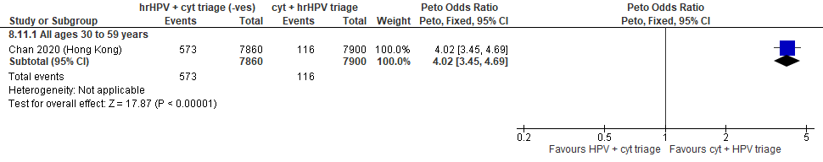
Forest Plot 5.11. False positives for CIN2+

Evidence Set 5.12. False positives for CIN3+
Included report: Chan 2020 (Hong Kong)
GRADE Summary of Findings Table 5.12. False positives for CIN3+
Outcome  No. participantsª  (studies) |  | Relative effects, Peto OR and RR (95 % CI) | Anticipated absolute effects |  |  | Certainty of evidence (GRADE)^{b} | What happens?
 |  | Relative effects, Peto OR and RR (95 % CI) | With cytology screening + hrHPV triage | With hrHPV screening + cytology triage of negatives | Difference | Certainty of evidence (GRADE)^{b} | What happens?
People with a cervix aged 30 to 59 years (Chan 2020 (Hong Kong); acceptors of screening, select population)
False positives for CIN3+  Follow-up: 1 round  15,760 (1 RCT) | Peto OR: 3.87 (3.34 to 4.50)  RR: 3.70 (3.22 to 4.25) |  | 164.6 per 10,000 | 608.1 per 10,000 | 443.6 more per 10,000 (364.7 more to 535.6 more) | 25-29 yrs:  VERY LOW  ⊕⊝⊝⊝  NR  30-59 yrs:  MODERATE^{c}  ⊕⊕⊕⊝  due lack of evidence of consistency  60-69 yrs:  VERY LOW  ⊕⊝⊝⊝  NR | Among screened people with a cervix aged 25 to 29 years who attend follow-up testing, we are very uncertain about the effect of hrHPV screening with cytology triage of negative tests on the number of false positives for CIN3+ compared with cytology screening with hrHPV triage.  Among screened people with a cervix aged 30 to 59 years, hrHPV screening with cytology triage of negative tests probably increases the number of false positives for CIN3+ compared with cytology screening with hrHPV triage.  Among screened people with a cervix aged 60 to 69 years who attend follow-up testing, we are very uncertain about the effect of hrHPV screening with cytology triage of negative tests on the number of false positives for CIN3+ compared with cytology screening with hrHPV triage.
CI = confidence interval; CIN = cervical intraepithelial neoplasia; OR = odds ratio; RCT = randomized controlled trial; RR = relative risk.
ªAcceptors of screening, select population includes all randomized participants who completed the screening protocol and attended colposcopy follow-up, as needed, following a positive test. The denominator excludes 90 participants in the experimental group and 11 in the control group who did not attend colposcopy following a positive test.
^{b}We rated down by 0.5 for “some concerns”, 1 “serious concerns”, and 2 for “very serious concerns”. When our assessment of the certainty of evidence fell between levels, we assigned the level that best represented our actual certainty in the evidence, and based our conclusions on this level of certainty.
Explanations:
^{c}Acceptors of screening, select population; people with a cervix aged 30 to 59 years: No serious concerns about risk of bias: no domains judged high risk. Some concerns about inconsistency: lack of evidence of consistency due to single study. No serious concerns about indirectness: the study provides direct evidence. No concerns about imprecision: 95% CI precise for increased effect. No other serious concerns.

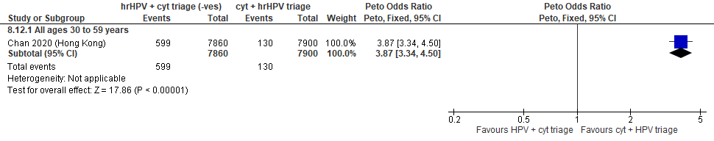
Forest Plot 5.12. False positives for CIN3+

Evidence Set 5.13. False positives for invasive cervical cancer
Included report: Chan 2020 (Hong Kong)
GRADE Summary of Findings Table 5.13. False positives for invasive cervical cancer
Outcome  No. participantsª  (studies) |  | Relative effects, Peto OR and RR (95 % CI) | Anticipated absolute effects |  |  | Certainty of evidence (GRADE)^{b} | What happens?
 |  | Relative effects, Peto OR and RR (95 % CI) | With cytology screening + hrHPV triage | With hrHPV screening + cytology triage of negatives | Difference | Certainty of evidence (GRADE)^{b} | What happens?
People with a cervix aged 30 to 59 years (Chan 2020 (Hong Kong); acceptors of screening, select population)
False positives for invasive cervical cancer  Follow-up: 1 round  15,760 (1 RCT) | Peto OR: 3.82 (3.31 to 4.40)  RR: 3.63 (3.18 to 4.14) |  | 183.5 per 10,000 | 666.6 per 10,000 | 483.1 more per 10,000 (399.3 more to 576.6 more) | 25-29 yrs:  VERY LOW  ⊕⊝⊝⊝  NR  30-59 yrs:  MODERATE^{c}  ⊕⊕⊕⊝  due lack of evidence of consistency  60-69 yrs:  VERY LOW  ⊕⊝⊝⊝  NR | Among screened people with a cervix aged 25 to 29 years who attend follow-up testing, we are very uncertain about the effect of hrHPV screening with cytology triage of negative tests on the number of false positives for invasive cervical cancer compared with cytology screening with hrHPV triage.  Among screened people with a cervix aged 30 to 59 years, hrHPV screening with cytology triage of negative tests probably increases the number of false positives for invasive cervical cancer compared with cytology screening with hrHPV triage.  Among screened people with a cervix aged 60 to 69 years who attend follow-up testing, we are very uncertain about the effect of hrHPV screening with cytology triage of negative tests on the number of false positives for invasive cervical cancer compared with cytology screening with hrHPV triage.
CI = confidence interval; OR = odds ratio; RCT = randomized controlled trial; RR = relative risk.
ªAcceptors of screening, select population includes all randomized participants who completed the screening protocol and attended colposcopy follow-up, as needed, following a positive test. The denominator excludes 90 participants in the experimental group and 11 in the control group who did not attend colposcopy following a positive test.
^{b}We rated down by 0.5 for “some concerns”, 1 “serious concerns”, and 2 for “very serious concerns”. When our assessment of the certainty of evidence fell between levels, we assigned the level that best represented our actual certainty in the evidence, and based our conclusions on this level of certainty.
Explanations:
^{c}Acceptors of screening, select population; people with a cervix aged 30 to 59 years: No serious concerns about risk of bias: no domains judged high risk. Some concerns about inconsistency: lack of evidence of consistency due to single study. No serious concerns about indirectness: the study provides direct evidence. No concerns about imprecision: 95% CI precise for increased effect. No other serious concerns.

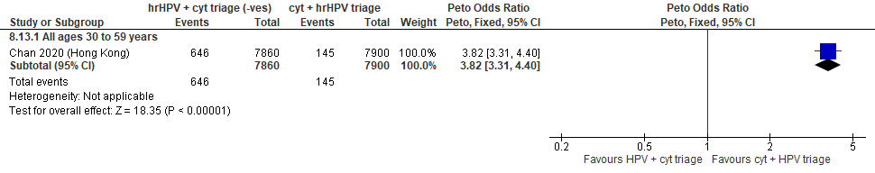
Forest Plot 5.13. False positives for invasive cervical cancer

Evidence set 6.a: hrHPV screening via self-sampling (threshold not reported) with liquid-based cytology triage of positive tests versus clinician-sampled hrHPV screening (threshold not reported) with liquid-based cytology triage of positive tests

Included report: Polman 2019 (IMPROVE) (ages 29 to 61 [no age subgroups])

Evidence Set 6.1a. Referrals to colposcopy
GRADE Summary of Findings Table 6.1a. Referrals to colposcopy
Outcome  No. participantsª  (studies) |  | Relative effects, Peto OR and RR (95 % CI) | Anticipated absolute effects* |  |  | Certainty of evidence (GRADE)^{b} | What happens?
 |  | Relative effects, Peto OR and RR (95 % CI) | With hrHPV clinician sampling + cytology triage | With hrHPV self-sampling + cytology triage | Difference | Certainty of evidence (GRADE)^{b} | What happens?
People with a cervix aged 30 to 59 years (Polman 2019 (IMPROVE); acceptors of screening)
Referrals to colposcopy  Follow-up: 1 round  13,842 (1 RCT) | Peto OR: 0.83 (0.70 to 0.99)  RR: 0.84 (0.71 to 0.99) |  | 401.3 per 10,000 | 335.3 per 10,000 | 65.9 less per 10,000 (117.0 less to 3.9 less) | 25-29 yrs:  VERY LOW  ⊕⊝⊝⊝  NR  30-59 yrs:  MODERATE^{c}  ⊕⊕⊕⊝  due to lack of evidence of consistency  60-69 yrs:  VERY LOW  ⊕⊝⊝⊝  NR | Among screened people with a cervix aged 25 to 29 years, we are very uncertain about the effects of hrHPV testing via self-sampling with cytology triage on the rate of referral to colposcopy compared with clinician-sampling hrHPV testing with cytology triage.  Among screened people with a cervix aged 30 to 59 years, hrHPV testing via self-sampling with cytology triage probably has little-to-no effect on the rate of referral to colposcopy compared with clinician-sampling hrHPV testing with cytology triage.  Among screened people with a cervix aged 60 to 69 years, we are very uncertain about the effects of hrHPV testing via self-sampling with cytology triage on the rate of referral to colposcopy compared with clinician-sampling hrHPV testing with cytology triage.
CI = confidence interval; OR = odds ratio; RCT = randomized controlled trial; RR = relative risk.
ªAcceptors of screening include participants who were randomized and accepted the offer to be screened in the group to which they were randomly assigned (akin to a per protocol analysis). Those who did not complete the screening protocol are excluded.
^{b}We rated down by 0.5 for “some concerns”, 1 “serious concerns”, and 2 for “very serious concerns”. When our assessment of the certainty of evidence fell between levels, we assigned the level that best represented our actual certainty in the evidence, and based our conclusions on this level of certainty.
Explanations:
^{c}Acceptors of screening; people with a cervix aged 30 to 59 years: No serious concerns about risk of bias: no domains judged as high risk. Some concerns about inconsistency: lack of evidence for consistency due to single study. No serious concerns about indirectness: the study provides direct evidence. No serious concerns about imprecision: 95% CI precise for little-to-no effect. No other serious concerns.

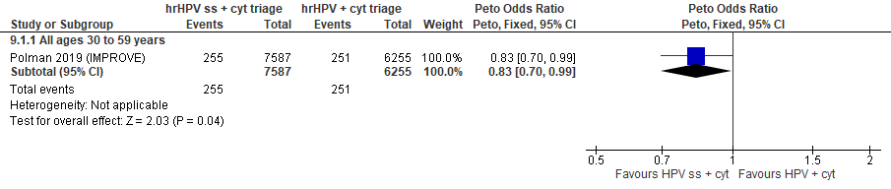
Forest Plot 6.1a. Referrals to colposcopy

Evidence Set 6.2a. Number of colposcopies
Included report: Polman 2019 (IMPROVE)
GRADE Summary of Findings Table 6.2a. Number of colposcopies
Outcome  No. participantsª  (studies) |  | Relative effects, Peto OR and RR (95 % CI) | Anticipated absolute effects |  |  | Certainty of evidence (GRADE)^{b} | What happens?
 |  | Relative effects, Peto OR and RR (95 % CI) | With hrHPV clinician sampling + cytology triage | With hrHPV self-sampling + cytology triage | Difference | Certainty of evidence (GRADE)^{b} | What happens?
People with a cervix aged 30 to 59 years (Polman 2019 (IMPROVE); acceptors of screening)
Number of colposcopies  Follow-up: 1 round  13,842 (1 RCT) | Peto OR: 0.84 (0.70 to 1.02)  RR: 0.84 (0.71 to 1.02) |  | 364.5 per 10,000 | 308.0 per 10,000 | 56.5 less in 10,000 (106.5 less to 7.0 more) | 25-29 yrs:  VERY LOW  ⊕⊝⊝⊝  NR  30-59 yrs:  MODERATE^{c}  ⊕⊕⊕⊝  due to lack of evidence of consistency  60-69 yrs:  VERY LOW  ⊕⊝⊝⊝  NR | Among screened people with a cervix aged 25 to 29 years, we are very uncertain about the effects of hrHPV testing via self-sampling with cytology triage on the number of colposcopies compared with clinician-sampling hrHPV testing with cytology triage.  Among screened people with a cervix aged 30 to 59 years, hrHPV testing via self-sampling with cytology triage of positive tests probably has little-to-no effect on the number of colposcopies compared with clinician-sampling hrHPV testing with cytology triage.  Among screened people with a cervix aged 60 to 69 years, we are very uncertain about the effects of hrHPV testing via self-sampling with cytology triage on the number of colposcopies compared with clinician-sampling hrHPV testing with cytology triage.
CI = confidence interval; OR = odds ratio; RCT = randomized controlled trial; RR = relative risk.
ªAcceptors of screening include participants who were randomized and accepted the offer to be screened in the group to which they were randomly assigned (akin to a per protocol analysis). Those who did not complete the screening protocol are excluded.
^{b}We rated down by 0.5 for “some concerns”, 1 “serious concerns”, and 2 for “very serious concerns”. When our assessment of the certainty of evidence fell between levels, we assigned the level that best represented our actual certainty in the evidence, and based our conclusions on this level of certainty.
Explanations:
^{c}Acceptors of screening; people with a cervix aged 30 to 59 years: No serious concerns about risk of bias: no domains judged as high risk. Some concerns about inconsistency: lack of evidence for consistency due to single study. No serious concerns about indirectness: the study provides direct evidence. No serious concerns about imprecision: 95% CI precise for little-to-no effect. No other serious concerns.

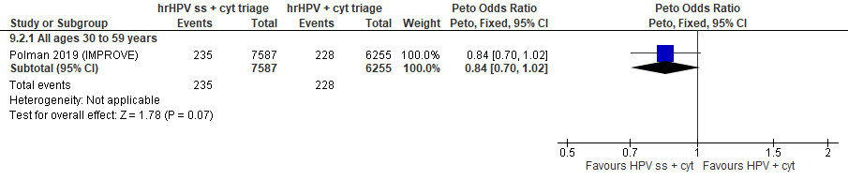
Forest Plot 6.2a. Number of colposcopies

Evidence Set 6.3a. Detection of CIN2+ (as an indirect indicator of the incidence of CIN3+)
Included report: Polman 2019 (IMPROVE)
GRADE Summary of Findings Table 6.3a. Detection of CIN2+ (as an indirect indicator of the incidence of CIN3+)
Outcome  No. participantsª  (studies) |  | Relative effects, Peto OR and RR (95 % CI) | Anticipated absolute effects |  |  | Certainty of evidence (GRADE)^{b} | What happens?
 |  | Relative effects, Peto OR and RR (95 % CI) | With hrHPV clinician sampling + cytology triage | With hrHPV self-sampling + cytology triage | Difference | Certainty of evidence (GRADE)^{b} | What happens?
People with a cervix aged 30 to 59 years (Polman 2019 (IMPROVE); acceptors of screening, select population)
Detection of CIN2+  Follow-up: 1 round  13,799 (1 RCT) | Peto OR: 0.99 (0.75 to 1.31)  RR: 0.99 (0.75 to 1.30) |  | 147.6 per 10,000 | 146.2 per 10,000 | 1.5 less per 10,000 (36.5 less to 44.9 more) | 25-29 yrs:  VERY LOW  ⊕⊝⊝⊝  NR  30-59 yrs:  LOW^{c}  ⊕⊕⊝⊝  due to lack of evidence of consistency and indirectness  60-69 yrs:  VERY LOW  ⊕⊝⊝⊝  NR | Among screened people with a cervix aged 25 to 29 years, we are very uncertain about the effects of hrHPV testing via self-sampling with cytology triage on the incidence of CIN3+ compared with clinician-sampling hrHPV testing with cytology triage.  Among screened people with a cervix aged 30 to 59 years, hrHPV testing via self-sampling with cytology triage of positive tests may have little-to-no effect on the incidence of CIN3+ compared with clinician-sampled hrHPV testing with cytology triage.  Among screened people with a cervix aged 60 to 69 years, we are very uncertain about the effects of hrHPV testing via self-sampling with cytology triage on the incidence of CIN3+ compared with clinician-sampling hrHPV testing with cytology triage.
CI = confidence interval; CIN = cervical intraepithelial neoplasia; OR = odds ratio; RCT = randomized controlled trial; RR = relative risk.
ªAcceptors of screening, select population includes participants who were randomized and accepted the offer to be screened in the group to which they were randomly assigned (akin to a per protocol analysis). Those who did not complete the screening protocol are excluded. The denominator excludes 20 participants from the self-sampling group and 23 from the assisted sampling group who did not attend the recommended colposcopy.
^{b}We rated down by 0.5 for “some concerns”, 1 “serious concerns”, and 2 for “very serious concerns”. When our assessment of the certainty of evidence fell between levels, we assigned the level that best represented our actual certainty in the evidence, and based our conclusions on this level of certainty.
Explanations:
^{c}Acceptors of screening; people with a cervix aged 30 to 59 years: No serious concerns about risk of bias: no domains judged as high risk. Some concerns about inconsistency: lack of evidence for consistency due to single study. Serious concerns about indirectness: detection is an indirect measure of incidence. No serious concerns about imprecision: 95% CI precise for little-to-no effect. No other serious concerns.

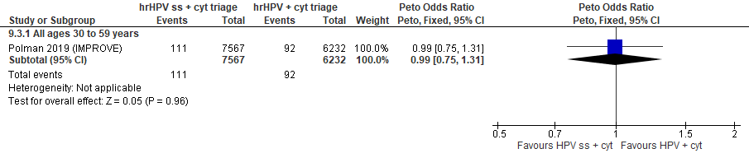
Forest Plot 6.3a. Detection of CIN2+ (as an indirect indicator of the incidence of CIN3+)

Evidence Set 6.4a. Detection of CIN3+ (as an indirect indicator of the incidence of ICC)
Included report: Polman 2019 (IMPROVE)
GRADE Summary of Findings Table 6.4a. Detection of CIN3+ (as an indirect indicator of the incidence of ICC)
Outcome  No. participantsª  (studies) |  | Relative effects, Peto OR and RR (95 % CI) | Anticipated absolute effects |  |  | Certainty of evidence (GRADE)^{b} | What happens?
 |  | Relative effects, Peto OR and RR (95 % CI) | With hrHPV clinician sampling + cytology triage | With hrHPV self-sampling + cytology triage | Difference | Certainty of evidence (GRADE)^{b} | What happens?
People with a cervix aged 30 to 59 years (Polman 2019 (IMPROVE); acceptors of screening, select population)
Detection of CIN3+  Follow-up: 1 round  13,799 (1 RCT) | Peto OR: 1.33 (0.93 to 1.92)  RR: 1.33 (0.93 to 1.91) |  | 72.2 per 10,000 | 95.8 per 10,000 | 23.6 more per 10,000 (5.0 less to 65.5 more) | 25-29 yrs:  VERY LOW  ⊕⊝⊝⊝  NR  30-59 yrs:  VERY LOW^{c}  ⊕⊝⊝⊝  due to lack of evidence of consistency, indirectness, and imprecision  60-69 yrs:  VERY LOW  ⊕⊝⊝⊝  NR | Among screened people with a cervix aged 25 to 29 years, we are very uncertain about the effects of hrHPV testing via self-sampling with cytology triage on the incidence of invasive cervical cancer compared with clinician-sampling hrHPV testing with cytology triage.  Among screened people with a cervix aged 30 to 59 years, we are very uncertain about the effect of hrHPV testing via self-sampling with cytology triage of positive tests on the incidence of invasive cervical cancer compared with clinician-sampled hrHPV testing with cytology triage.  Among screened people with a cervix aged 60 to 69 years, we are very uncertain about the effects of hrHPV testing via self-sampling with cytology triage on the incidence of invasive cervical cancer compared with clinician-sampling hrHPV testing with cytology triage.
CI = confidence interval; CIN = cervical intraepithelial neoplasia; OR = odds ratio; RCT = randomized controlled trial; RR = relative risk.
ªAcceptors of screening, select population includes participants who were randomized and accepted the offer to be screened in the group to which they were randomly assigned (akin to a per protocol analysis). Those who did not complete the screening protocol are excluded. The denominator excludes 20 participants from the self-sampling group and 23 from the assisted sampling group who did not attend the recommended colposcopy.
^{b}We rated down by 0.5 for “some concerns”, 1 “serious concerns”, and 2 for “very serious concerns”. When our assessment of the certainty of evidence fell between levels, we assigned the level that best represented our actual certainty in the evidence, and based our conclusions on this level of certainty.
Explanations:
^{c}Acceptors of screening; people with a cervix aged 30 to 59 years: No serious concerns about risk of bias: no domains judged as high risk. Some concerns about inconsistency: lack of evidence for consistency due to single study. Serious concerns about indirectness: detection is an indirect measure of incidence. Serious concerns about imprecision: lower limit of 95% CI indicates little-to-no effect. No other serious concerns.

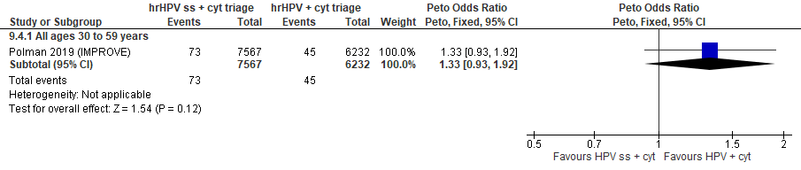
Forest Plot 6.4a. Detection of CIN3+ (as an indirect indicator of the incidence of ICC)

Evidence Set 6.5a. Detection of invasive cervical cancer
Included report: Polman 2019 (IMPROVE)
GRADE Summary of Findings Table 6.5a. Detection of invasive cervical cancer
Outcome  No. participantsª  (studies) |  | Relative effects, Peto OR and RR (95 % CI) | Anticipated absolute effects |  |  | Certainty of evidence (GRADE)^{b} | What happens?
 |  | Relative effects, Peto OR and RR (95 % CI) | With hrHPV clinician sampling + cytology triage | With hrHPV self-sampling + cytology triage | Difference | Certainty of evidence (GRADE)^{b} | What happens?
People with a cervix aged 30 to 59 years (Polman 2019 (IMPROVE); acceptors of screening, select population)
Detection of invasive cervical cancer  Follow-up: 1 round  13,799 (1 RCT) | Peto OR: 1.23 (0.21 to 7.17)  RR: 1.23 (0.21 to 7.16) |  | 3.2 per 10,000 | 3.9 per 10,000 | 0.7 more per 10,000 (2.5 less to 19.8 more) | 25-29 yrs:  VERY LOW  ⊕⊝⊝⊝  NR  30-59 yrs:  VERY LOW^{c}  ⊕⊝⊝⊝  due to lack of evidence of consistency, indirectness, and imprecision  60-69 yrs:  VERY LOW  ⊕⊝⊝⊝  NR | Among screened people with a cervix aged 25 to 29 years, we are very uncertain about the effects of hrHPV testing via self-sampling with cytology triage on the detection of invasive cervical cancer compared with clinician-sampling hrHPV testing with cytology triage.  Among screened people with a cervix aged 30 to 59 years, we are very uncertain about the effect of hrHPV testing via self-sampling with cytology triage on the detection of invasive cervical cancer compared with clinician-sampled hrHPV testing with cytology triage.  Among screened people with a cervix aged 60 to 69 years, we are very uncertain about the effects of hrHPV testing via self-sampling with cytology triage on the detection of invasive cervical cancer compared with clinician-sampling hrHPV testing with cytology triage.
CI = confidence interval; OR = odds ratio; RCT = randomized controlled trial; RR = relative risk.
ªAcceptors of screening, select population includes participants who were randomized and accepted the offer to be screened in the group to which they were randomly assigned (akin to a per protocol analysis). Those who did not complete the screening protocol are excluded. The denominator excludes 20 participants from the self-sampling group and 23 from the assisted sampling group who did not attend the recommended colposcopy.
^{b}We rated down by 0.5 for “some concerns”, 1 “serious concerns”, and 2 for “very serious concerns”. When our assessment of the certainty of evidence fell between levels, we assigned the level that best represented our actual certainty in the evidence, and based our conclusions on this level of certainty.
Explanations:
^{c}Acceptors of screening; people with a cervix aged 30 to 59 years: No serious concerns about risk of bias: no domains judged as high risk. Some concerns about inconsistency: lack of evidence for consistency due to single study. Serious concerns about indirectness: detection is an indirect measure of incidence. Serious concerns about imprecision: upper limit of 95% CI indicates increased effect. No other serious concerns.

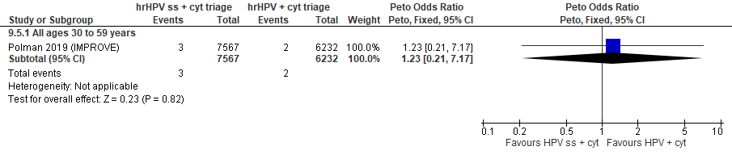
Forest Plot 6.5a. Detection of invasive cervical cancer

Evidence Set 6.6a. False positives for CIN2+
Included report: Polman 2019 (IMPROVE)
GRADE Summary of Findings Table 6.6a. False positives for CIN2+
Outcome  No. participantsª  (studies) |  | Relative effects, Peto OR and RR (95 % CI) | Anticipated absolute effects |  |  | Certainty of evidence (GRADE)^{b} | What happens?
 |  | Relative effects, Peto OR and RR (95 % CI) | With hrHPV clinician sampling + cytology triage | With hrHPV self-sampling + cytology triage | Difference | Certainty of evidence (GRADE)^{b} | What happens?
People with a cervix aged 30 to 59 years (Polman 2019 (IMPROVE); acceptors of screening, select population)
False positives for CIN2+  Follow-up: 1 round  13,799 (1 RCT) | Peto OR: 0.75 (0.58 to 0.95)  RR: 0.75 (0.59 to 0.95) |  | 218.2 per 10,000 | 164.6 per 10,000 | 53.7 less per 10,000 (90.5 less to 10.7 less) | 25-29 yrs:  VERY LOW  ⊕⊝⊝⊝  NR  30-59 yrs:  MODERATE^{c}  ⊕⊕⊕⊝  due to lack of evidence of consistency  60-69 yrs:  VERY LOW  ⊕⊝⊝⊝  NR | Among screened people with a cervix aged 25 to 29 years, we are very uncertain about the effects of hrHPV testing via self-sampling with cytology triage on the number of false positives for CIN2+ compared with clinician-sampling hrHPV testing with cytology triage.  Among screened people with a cervix aged 30 to 59 years, hrHPV testing via self-sampling with cytology triage of positive tests probably has little-to-no effect on the number of false positives for CIN2+ compared with clinician-sampled hrHPV testing with cytology triage.  Among screened people with a cervix aged 60 to 69 years, we are very uncertain about the effects of hrHPV testing via self-sampling with cytology triage on the number of false positives for CIN2+ compared with clinician-sampling hrHPV testing with cytology triage.
CI = confidence interval; CIN = cervical intraepithelial neoplasia; OR = odds ratio; RCT = randomized controlled trial; RR = relative risk.
ªAcceptors of screening, select population includes participants who were randomized and accepted the offer to be screened in the group to which they were randomly assigned (akin to a per protocol analysis). Those who did not complete the screening protocol are excluded. The denominator excludes 20 participants from the self-sampling group and 23 from the assisted sampling group who did not attend the recommended colposcopy.
^{b}We rated down by 0.5 for “some concerns”, 1 “serious concerns”, and 2 for “very serious concerns”. When our assessment of the certainty of evidence fell between levels, we assigned the level that best represented our actual certainty in the evidence, and based our conclusions on this level of certainty.
Explanations:
^{c}Acceptors of screening; people with a cervix aged 30 to 59 years: No serious concerns about risk of bias: no domains judged as high risk. Some concerns about inconsistency: lack of evidence for consistency due to single study. No serious concerns about indirectness: the study provides direct evidence. No serious concerns about imprecision: 95% CI precise for little-to-no effect. No other serious concerns.

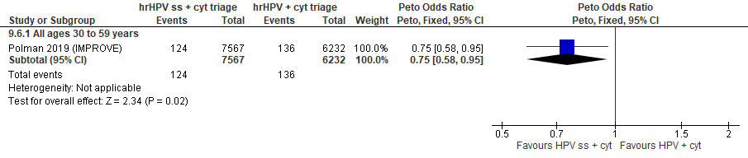
Forest Plot 6.6a. False positives for CIN2+

Evidence Set 6.7a. False positives for CIN3+
Included report: Polman 2019 (IMPROVE)
GRADE Summary of Findings Table 6.7a. False positives for CIN3+
Outcome  No. participantsª  (studies) |  | Relative effects, Peto OR and RR (95 % CI) | Anticipated absolute effects |  |  | Certainty of evidence (GRADE)^{b} | What happens?
 |  | Relative effects, Peto OR and RR (95 % CI) | With hrHPV clinician sampling + cytology triage | With hrHPV self-sampling + cytology triage | Difference | Certainty of evidence (GRADE)^{b} | What happens?
People with a cervix aged 30 to 59 years (Polman 2019 (IMPROVE); acceptors of screening, select population)
False positives for CIN3+  Follow-up: 1 round  13,799 (1 RCT) | Peto OR: 0.72 (0.58 to 0.89)  RR: 0.73 (0.59 to 0.89) |  | 293.6 per 10,000 | 213.2 per 10,000 | 80.5 less per 10,000 (121.2 less to 31.5 less) | 25-29 yrs:  VERY LOW  ⊕⊝⊝⊝  NR  30-59 yrs:  MODERATE^{c}  ⊕⊕⊕⊝  due to lack of evidence of consistency  60-69 yrs:  VERY LOW  ⊕⊝⊝⊝  NR | Among screened people with a cervix aged 25 to 29 years, we are very uncertain about the effects of hrHPV testing via self-sampling with cytology triage on the number of false positives for CIN3+ compared with clinician-sampling hrHPV testing with cytology triage.  Among screened people with a cervix aged 30 to 59 years, hrHPV testing via self-sampling with cytology triage of positive tests probably has little-to-no effect on the number of false positives for CIN3+ compared with clinician-sampled hrHPV testing with cytology triage of positive tests.  Among screened people with a cervix aged 60 to 69 years, we are very uncertain about the effects of hrHPV testing via self-sampling with cytology triage on the number of false positives for CIN3+ compared with clinician-sampling hrHPV testing with cytology triage.
CI = confidence interval; CIN = cervical intraepithelial neoplasia; OR = odds ratio; RCT = randomized controlled trial; RR = relative risk.
ªAcceptors of screening, select population includes participants who were randomized and accepted the offer to be screened in the group to which they were randomly assigned (akin to a per protocol analysis). Those who did not complete the screening protocol are excluded. The denominator excludes 20 participants from the self-sampling group and 23 from the assisted sampling group who did not attend the recommended colposcopy.
^{b}We rated down by 0.5 for “some concerns”, 1 “serious concerns”, and 2 for “very serious concerns”. When our assessment of the certainty of evidence fell between levels, we assigned the level that best represented our actual certainty in the evidence, and based our conclusions on this level of certainty.
Explanations:
^{c}Acceptors of screening; people with a cervix aged 30 to 59 years: No serious concerns about risk of bias: no domains judged as high risk. Some concerns about inconsistency: lack of evidence for consistency due to single study. No serious concerns about indirectness: the study provides direct evidence. No serious concerns about imprecision: 95% CI precise for little-to-no effect. No other serious concerns.

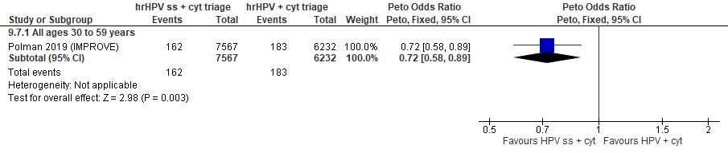
Forest Plot 6.7a. False positives for CIN3+

Evidence Set 6.8a. False positives for invasive cervical cancer
Included report: Polman 2019 (IMPROVE)
GRADE Summary of Findings Table 6.8a. False positives for invasive cervical cancer
Outcome  No. participantsª  (studies) |  | Relative effects, Peto OR and RR (95 % CI) | Anticipated absolute effects |  |  | Certainty of evidence (GRADE)^{b} | What happens?
 |  | Relative effects, Peto OR and RR (95 % CI) | With hrHPV clinician sampling + cytology triage | With hrHPV self-sampling + cytology triage | Difference | Certainty of evidence (GRADE)^{b} | What happens?
People with a cervix aged 30 to 59 years (Polman 2019 (IMPROVE); acceptors of screening)
False positives for ICC  Follow-up: 1 round  13,799 (1 RCT) | Peto OR: 0.84 (0.70 to 1.01)  RR: 0.84 (0.71 to 1.01) |  | 362.6 per 10,000 | 306.4 per 10,000 | 56.2 less per 10,000 (106.0 less to 3.5 more) | 25-29 yrs:  VERY LOW  ⊕⊝⊝⊝  NR  30-59 yrs:  MODERATE^{c}  ⊕⊕⊕⊝  due to lack of evidence of consistency  60-69 yrs:  VERY LOW  ⊕⊝⊝⊝  NR | Among screened people with a cervix aged 25 to 29 years, we are very uncertain about the effects of hrHPV testing via self-sampling with cytology triage on the number of false positives for invasive cervical cancer compared with clinician-sampling hrHPV testing with cytology triage.  Among screened people with a cervix aged 30 to 59 years, hrHPV testing via self-sampling with cytology triage of positive tests probably has little-to-no effect on the number of false positives for invasive cervical cancer compared with clinician-sampled hrHPV testing with cytology triage of positive tests.  Among screened people with a cervix aged 60 to 69 years, we are very uncertain about the effects of hrHPV testing via self-sampling with cytology triage on the number of false positives for invasive cervical cancer compared with clinician-sampling hrHPV testing with cytology triage.
CI = confidence interval; OR = odds ratio; RCT = randomized controlled trial; RR = relative risk.
ªAcceptors of screening, select population includes participants who were randomized and accepted the offer to be screened in the group to which they were randomly assigned (akin to a per protocol analysis). Those who did not complete the screening protocol are excluded. The denominator excludes 20 participants from the self-sampling group and 23 from the assisted sampling group who did not attend the recommended colposcopy.
^{b}We rated down by 0.5 for “some concerns”, 1 “serious concerns”, and 2 for “very serious concerns”. When our assessment of the certainty of evidence fell between levels, we assigned the level that best represented our actual certainty in the evidence, and based our conclusions on this level of certainty.
Explanations:
^{c}Acceptors of screening; people with a cervix aged 30 to 59 years: No serious concerns about risk of bias: no domains judged as high risk. Some concerns about inconsistency: lack of evidence for consistency due to single study. No serious concerns about indirectness: the study provides direct evidence. No serious concerns about imprecision: 95% CI precise for little-to-no effect. No other serious concerns.

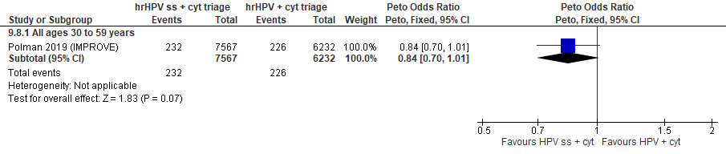
Forest Plot 6.8. False positives for invasive cervical cancer

Evidence set 6.b: hrHPV self-screening (threshold NR) with cytology triage of positive tests vs. hrHPV clinician sampling (threshold NR) with cytology triage (underscreened)
Included report: Aasbo 2022 (Norwegian HPV self-sampling) (ages 35-69 [no age subgroups])

Evidence Set 6.1b. Detection of CIN2+ (as an indirect indicator of the incidence of CIN3+)
GRADE Summary of Findings Table 6.1b. Detection of CIN2+ (as an indirect indicator of the incidence of CIN3+)
Outcome  No. participantsª  (studies) |  | Relative effects, Peto OR and RR (95 % CI) | Anticipated absolute effects |  |  | Certainty of evidence (GRADE)^{b} | What happens?
 |  | Relative effects, Peto OR and RR (95 % CI) | With hrHPV clinician screening + cytology triage | With hrHPV self-sampling + cytology triage | Difference | Certainty of evidence (GRADE)^{b} | What happens?
People with a cervix aged 30 to 69 years (Aasbo 2022 (Norwegian HPV self-sampling); acceptors of screening)
Detection of CIN2+  Follow-up: 1 round  933 (1 RCT) | Peto OR: 2.19 (0.68 to 7.11)  RR: 2.16 (0.68 to 6.66) |  | 111.1 per 10,000 | 240.2 per 10,000 | 129.0 more per 10,000 (35.3 less to 628.7 more) | 25-29 yrs:  VERY LOW  ⊕⊝⊝⊝  NR  30-59 yrs:  VERY LOW^{c}  ⊕⊝⊝⊝  due to risk of bias, lack of evidence of consistency, (very serious) indirectness and imprecision  60-69 yrs:  VERY LOW^{d}  ⊕⊝⊝⊝  due to risk of bias, lack of evidence of consistency, (very serious) indirectness and imprecision | Among screened people with a cervix aged 25 to 69 years, we are very uncertain about the effects on the incidence of CIN3+ for hrHPV self-sampling with cytology triage compared with hrHPV clinician testing with cytology triage.
CI = confidence interval; CIN = cervical intraepithelial neoplasia; OR = odds ratio; RCT = randomized controlled trial; RR = relative risk.
ªAcceptors of screening include participants who were randomized and accepted the offer to be screened.
^{b}We rated down by 0.5 for “some concerns”, 1 “serious concerns”, and 2 for “very serious concerns”. When our assessment of the certainty of evidence fell between levels, we assigned the level that best represented our actual certainty in the evidence, and based our conclusions on this level of certainty.
Explanations:
^{c}Acceptors of screening; people with a cervix aged 30 to 59 years: Serious concerns about risk of bias: at serious risk of selection bias because randomization occurred before enrollment (only 4.8%, 17.0% and 27.7% of participants randomized in each arm attended), with evidence of imbalances in baseline characteristics across groups. Some concerns about inconsistency: lack of evidence of consistency due to single study. Very serious concerns about indirectness: detection is an indirect measure of incidence; the study included people who had not attended screening for at least 10 years. Serious concerns about imprecision: lower limit of 95% CI indicates little-to-no effect. No other serious concerns.
^{d}Acceptors of screening; people with a cervix aged 60 to 69 years: Serious concerns about risk of bias: at serious risk of selection bias because randomization occurred before enrollment (only 4.8%, 17.0% and 27.7% of participants randomized in each arm attended), with evidence of imbalances in baseline characteristics across groups. Some concerns about inconsistency: lack of evidence of consistency due to single study. Very serious concerns about indirectness: detection is an indirect measure of incidence; the study included people who had not attended screening for at least 10 years; concerns due to small sample in this age group (n=NR). Serious concerns about imprecision: lower limit of 95% CI indicates little-to-no effect. No other serious concerns.

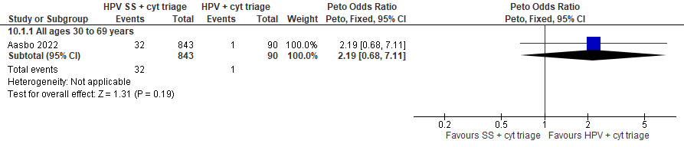

Forest Plot 6.1b. Detection of CIN2+

Evidence Set 6.2b. Detection of CIN3+ (as an indirect indicator of the incidence of ICC)
Included report: Aasbo 2022 (Norwegian HPV self-sampling)
GRADE Summary of Findings Table 6.2b. Detection of CIN3+ (as an indirect indicator of the incidence of ICC)
Outcome  No. participantsª  (studies) |  | Relative effects, Peto OR and RR (95 % CI) | Anticipated absolute effects |  |  | Certainty of evidence (GRADE)^{b} | What happens?
 |  | Relative effects, Peto OR and RR (95 % CI) | With hrHPV clinician screening + cytology triage | With hrHPV self-sampling + cytology triage | Difference | Certainty of evidence (GRADE)^{b} | What happens?
People with a cervix aged 30 to 69 years (Aasbo 2022 (Norwegian HPV self-sampling); acceptors of screening)
Detection of CIN3+  Follow-up: 1 round  933 (1 RCT) | Peto OR: 2.14 (0.64 to 7.19)  RR: 2.11 (0.64 to 6.73) |  | 111.1 per 10,000 | 234.8 per 10,000 | 123.7 more per 10,000 (39.7 less to 636.4 more) | 25-29 yrs:  VERY LOW  ⊕⊝⊝⊝  NR  30-59 yrs:  VERY LOW^{c}  ⊕⊝⊝⊝  due to risk of bias, lack of evidence of consistency, (very serious) indirectness and imprecision  60-69 yrs:  VERY LOW^{d}  ⊕⊝⊝⊝  due to risk of bias, lack of evidence of consistency, (very serious) indirectness and imprecision | Among screened people with a cervix aged 25 to 69 years, we are very uncertain about the effects on the incidence of invasive cervical cancer for hrHPV self-sampling with cytology triage compared with hrHPV clinician testing with cytology triage.
CI = confidence interval; CIN = cervical intraepithelial neoplasia; OR = odds ratio; RCT = randomized controlled trial; RR = relative risk.
ªAcceptors of screening include participants who were randomized and accepted the offer to be screened.
^{b}We rated down by 0.5 for “some concerns”, 1 “serious concerns”, and 2 for “very serious concerns”. When our assessment of the certainty of evidence fell between levels, we assigned the level that best represented our actual certainty in the evidence, and based our conclusions on this level of certainty.
Explanations:
^{c}Acceptors of screening; people with a cervix aged 30 to 59 years: Serious concerns about risk of bias: at serious risk of selection bias because randomization occurred before enrollment (only 4.8%, 17.0% and 27.7% of participants randomized in each arm attended), with evidence of imbalances in baseline characteristics across groups. Some concerns about inconsistency: lack of evidence of consistency due to single study. Very serious concerns about indirectness: detection is an indirect measure of incidence; the study included people who had not attended screening for at least 10 years. Serious concerns about imprecision: lower limit of 95% CI indicates little-to-no effect. No other serious concerns.
^{d}Acceptors of screening; people with a cervix aged 60 to 69 years: Serious concerns about risk of bias: at serious risk of selection bias because randomization occurred before enrollment (only 4.8%, 17.0% and 27.7% of participants randomized in each arm attended), with evidence of imbalances in baseline characteristics across groups. Some concerns about inconsistency: lack of evidence of consistency due to single study. Very serious concerns about indirectness: detection is an indirect measure of incidence; the study included people who had not attended screening for at least 10 years; concerns due to small sample in this age group (n=NR). Serious concerns about imprecision: lower limit of 95% CI indicates little-to-no effect. No other serious concerns.

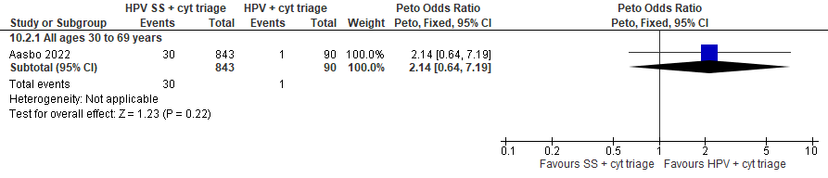
Forest Plot 6.2b. Detection of CIN3+

Evidence Set 6.3b. Detection of invasive cervical cancer
Included report: Aasbo 2022 (Norwegian HPV self-sampling)
GRADE Summary of Findings Table 6.3b. Detection of invasive cervical cancer
Outcome  No. participantsª  (studies) |  | Relative effects, Peto OR and RR (95 % CI) | Anticipated absolute effects |  |  | Certainty of evidence (GRADE)^{b} | What happens?
 |  | Relative effects, Peto OR and RR (95 % CI) | With hrHPV clinician screening + cytology triage | With hrHPV self-sampling + cytology triage | Difference | Certainty of evidence (GRADE)^{b} | What happens?
People with a cervix aged 30 to 69 years (Aasbo 2022 (Norwegian HPV self-sampling); acceptors of screening)
Detection of ICC  Follow-up: 1 round  933 (1 RCT) | Peto OR: 3.06 (0.41 to 22.90)  RR: 3.06 (0.41 to 22.90) |  | 0.0 per 10,000 | 0.0 per 10,000 | No difference | 25-29 yrs:  VERY LOW  ⊕⊝⊝⊝  NR  30-59 yrs:  VERY LOW^{c}  ⊕⊝⊝⊝  due to risk of bias, lack of evidence of consistency, (very serious) indirectness, and imprecision  60-69 yrs:  VERY LOW^{d}  ⊕⊝⊝⊝  due to risk of bias, lack of evidence of consistency, (very serious) indirectness | Among screened people with a cervix aged 25 to 69 years, we are very uncertain about the effects on the detection of invasive cervical cancer for hrHPV self-sampling with cytology triage compared with hrHPV clinician testing with cytology triage.
CI = confidence interval; OR = odds ratio; RCT = randomized controlled trial; RR = relative risk.
ªAcceptors of screening include participants who were randomized and accepted the offer to be screened.
^{b}We rated down by 0.5 for “some concerns”, 1 “serious concerns”, and 2 for “very serious concerns”. When our assessment of the certainty of evidence fell between levels, we assigned the level that best represented our actual certainty in the evidence, and based our conclusions on this level of certainty.
Explanations:
^{c}Acceptors of screening; people with a cervix aged 30 to 59 years: Serious concerns about risk of bias: at serious risk of selection bias because randomization occurred before enrollment (only 4.8%, 17.0% and 27.7% of participants randomized in each arm attended), with evidence of imbalances in baseline characteristics across groups. Some concerns about inconsistency: lack of evidence of consistency due to single study. Very serious concerns about indirectness: detection is an indirect outcome; the study included people who had not attended screening for at least 10 years. Serious concerns about imprecision: concerns due to small sample. No other serious concerns.
^{d}Acceptors of screening; people with a cervix aged 60 to 69 years: Serious concerns about risk of bias: at serious risk of selection bias because randomization occurred before enrollment (only 4.8%, 17.0% and 27.7% of participants randomized in each arm attended), with evidence of imbalances in baseline characteristics across groups. Some concerns about inconsistency: lack of evidence of consistency due to single study. Very serious concerns about indirectness: detection is an indirect outcome; the study included people who had not attended screening for at least 10 years; concerns due to small sample in this age group (n=NR). No serious concerns about imprecision: 95% CI precise for little-to-no effect. No other serious concerns.

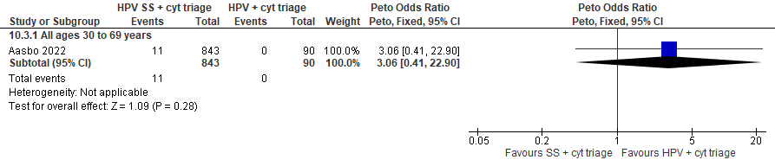
Figure 6.3b. Detection of invasive cervical cancer

Evidence Set 6.4b. False positives for CIN2+
Included report: Aasbo 2022 (Norwegian HPV self-sampling)
GRADE Summary of Findings Table 6.4b. False positives for CIN2+
Outcome  No. participantsª  (studies) |  | Relative effects, Peto OR and RR (95 % CI) | Anticipated absolute effects |  |  | Certainty of evidence (GRADE)^{b} | What happens?
 |  | Relative effects, Peto OR and RR (95 % CI) | With hrHPV clinician screening + cytology triage | With hrHPV self-sampling + cytology triage | Difference | Certainty of evidence (GRADE)^{b} | What happens?
People with a cervix aged 30 to 69 years (Aasbo 2022 (Norwegian HPV self-sampling); acceptors of screening)
False positives for CIN2+  Follow-up: 1 round  933 (1 RCT) | Peto OR: 2.15 (0.88 to 5.25)  RR: 2.10 (0.88 to 4.80) |  | 222.2 per 10,000 | 465.9 per 10,000 | 243.6 more per 10,000 (26.1 less to 843.8 more) | 25-29 yrs:  VERY LOW  ⊕⊝⊝⊝  NR  30-59 yrs:  VERY LOW^{c}  ⊕⊝⊝⊝  due to risk of bias, lack of evidence of consistency, indirectness, and imprecision  60-69 yrs:  VERY LOW^{d}  ⊕⊝⊝⊝  due to risk of bias, lack of evidence of consistency, (very serious) indirectness, and imprecision | Among screened people with a cervix aged 25 to 69 years, we are very uncertain about the effects on the number of false positives for CIN2+ for hrHPV self-sampling with cytology triage compared with hrHPV clinician testing with cytology triage.
CI = confidence interval; CIN = cervical intraepithelial neoplasia; OR = odds ratio; RCT = randomized controlled trial; RR = relative risk.
ªAcceptors of screening include participants who were randomized and accepted the offer to be screened.
^{b}We rated down by 0.5 for “some concerns”, 1 “serious concerns”, and 2 for “very serious concerns”. When our assessment of the certainty of evidence fell between levels, we assigned the level that best represented our actual certainty in the evidence, and based our conclusions on this level of certainty.
Explanations:
^{c}Acceptors of screening; people with a cervix aged 30 to 59 years: Serious concerns about risk of bias: at serious risk of selection bias because randomization occurred before enrollment (only 4.8%, 17.0% and 27.7% of participants randomized in each arm attended), with evidence of imbalances in baseline characteristics across groups. Some concerns about inconsistency: lack of evidence of consistency due to single study. Serious concerns about indirectness: the study included people who had not attended screening for at least 10 years. Serious concerns about imprecision: upper limit of 95% CI indicates increased effect. No other serious concerns.
^{d}Acceptors of screening; people with a cervix aged 60 to 69 years: Serious concerns about risk of bias: at serious risk of selection bias because randomization occurred before enrollment (only 4.8%, 17.0% and 27.7% of participants randomized in each arm attended), with evidence of imbalances in baseline characteristics across groups. Some concerns about inconsistency: lack of evidence of consistency due to single study. Very serious concerns about indirectness: the study included people who had not attended screening for at least 10 years; concerns about small sample in this age group (n=NR). Serious concerns about imprecision: upper limit of 95% CI indicates increased effect. No other serious concerns.

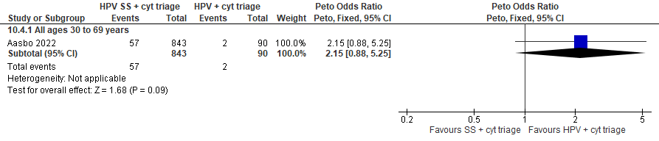
Figure 6.4b. False positives for CIN2+

Evidence Set 6.5b. False positives for CIN3+
Included report: Aasbo 2022 (Norwegian HPV self-sampling)
GRADE Summary of Findings Table 6.5b. False positives for CIN3+
Outcome  No. participantsª  (studies) |  | Relative effects, Peto OR and RR (95 % CI) | Anticipated absolute effects |  |  | Certainty of evidence (GRADE)^{b} | What happens?
 |  | Relative effects, Peto OR and RR (95 % CI) | With hrHPV clinician screening + cytology triage | With hrHPV self-sampling + cytology triage | Difference | Certainty of evidence (GRADE)^{b} | What happens?
People with a cervix aged 30 to 69 years (Aasbo 2022 (Norwegian HPV self-sampling); acceptors of screening)
False positives for CIN3+  Follow-up: 1 round  933 (1 RCT) | Peto OR: 2.18 (0.91 to 5.26)  RR: 2.12 (0.91 to 4.81) |  | 222.2 per 10,000 | 472.1 per 10,000 | 249.8 more per 10,000 (19.6 less to 845.6 more) | 25-29 yrs:  VERY LOW  ⊕⊝⊝⊝  NR  30-59 yrs:  VERY LOW^{c}  ⊕⊝⊝⊝  due to risk of bias, lack of evidence of consistency, indirectness and imprecision  60-69 yrs:  VERY LOW^{d}  ⊕⊝⊝⊝  due to risk of bias, lack of evidence of consistency, (very serious) indirectness, and imprecision | Among screened people with a cervix aged 25 to 69 years, we are very uncertain about the effects on the number of false positives for CIN3+ for hrHPV self-sampling with cytology triage compared with hrHPV clinician testing with cytology triage.
CI = confidence interval; CIN = cervical intraepithelial neoplasia; OR = odds ratio; RCT = randomized controlled trial; RR = relative risk.
ªAcceptors of screening include participants who were randomized and accepted the offer to be screened.
^{b}We rated down by 0.5 for “some concerns”, 1 “serious concerns”, and 2 for “very serious concerns”. When our assessment of the certainty of evidence fell between levels, we assigned the level that best represented our actual certainty in the evidence, and based our conclusions on this level of certainty.
Explanations:
^{c}Acceptors of screening; people with a cervix aged 30 to 59 years: Serious concerns about risk of bias: at serious risk of selection bias because randomization occurred before enrollment (only 4.8%, 17.0% and 27.7% of participants randomized in each arm attended), with evidence of imbalances in baseline characteristics across groups. Some concerns about inconsistency: lack of evidence of consistency due to single study. Serious concerns about indirectness: the study included people who had not attended screening for at least 10 years. Serious concerns about imprecision: upper limit of 95% CI indicates increased effect. No other serious concerns.
^{d}Acceptors of screening; people with a cervix aged 60 to 69 years: Serious concerns about risk of bias: at serious risk of selection bias because randomization occurred before enrollment (only 4.8%, 17.0% and 27.7% of participants randomized in each arm attended), with evidence of imbalances in baseline characteristics across groups. Some concerns about inconsistency: lack of evidence of consistency due to single study. Very serious concerns about indirectness: the study included people who had not attended screening for at least 10 years; concerns about small sample in this age group (n=NR). Serious concerns about imprecision: upper limit of 95% CI indicates increased effect. No other serious concerns.

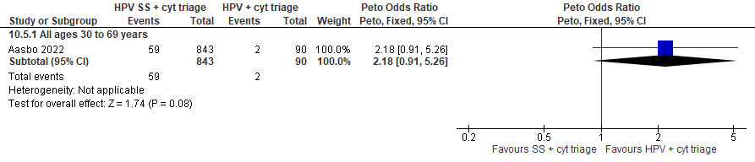
Figure 6.5b. False positives for CIN3+

Evidence Set 6.6b. False positives for invasive cervical cancer
Included report: Aasbo 2022 (Norwegian HPV self-sampling)
GRADE Summary of Findings Table 6.6b. False positives for ICC
Outcome  No. participantsª  (studies) |  | Relative effects, Peto OR and RR (95 % CI) | Anticipated absolute effects |  |  | Certainty of evidence (GRADE)^{b} | What happens?
 |  | Relative effects, Peto OR and RR (95 % CI) | With hrHPV clinician screening + cytology triage | With hrHPV self-sampling + cytology triage | Difference | Certainty of evidence (GRADE)^{b} | What happens?
People with a cervix aged 30 to 69 years (Aasbo 2022 (Norwegian HPV self-sampling); acceptors of screening)
False positives for ICC  Follow-up: 1 round  933 (1 RCT) | Peto OR: 2.11 (0.97 to 4.56)  RR: 2.03 (0.97 to 4.08) |  | 333.3 per 10,000 | 678.2 per 10,000 | 344.9 more per 10,000 (9.7 less to 1025.4 more) | 25-29 yrs:  VERY LOW  ⊕⊝⊝⊝  NR  30-59 yrs:  VERY LOW^{c}  ⊕⊝⊝⊝  due to risk of bias, lack of evidence of consistency, indirectness and imprecision  60-69 yrs:  VERY LOW^{d}  ⊕⊝⊝⊝  due to risk of bias, lack of evidence of consistency, (very serious) indirectness, and imprecision | Among screened people with a cervix aged 25 to 69 years, we are very uncertain about the effects on the number of false positives for invasive cervical cancer for hrHPV self-sampling with cytology triage compared with hrHPV clinician testing with cytology triage.
CI = confidence interval; OR = odds ratio; RCT = randomized controlled trial; RR = relative risk.
ªAcceptors of screening include participants who were randomized and accepted the offer to be screened.
^{b}We rated down by 0.5 for “some concerns”, 1 “serious concerns”, and 2 for “very serious concerns”. When our assessment of the certainty of evidence fell between levels, we assigned the level that best represented our actual certainty in the evidence, and based our conclusions on this level of certainty.
Explanations:
^{c}Acceptors of screening; people with a cervix aged 30 to 59 years: Serious concerns about risk of bias: at serious risk of selection bias because randomization occurred before enrollment (only 4.8%, 17.0% and 27.7% of participants randomized in each arm attended), with evidence of imbalances in baseline characteristics across groups. Some concerns about inconsistency: lack of evidence of consistency due to single study. Serious concerns about indirectness: the study included people who had not attended screening for at least 10 years. Serious concerns about imprecision: lower limit of 95% CI indicates little-to-no effect. No other serious concerns.
^{d}Acceptors of screening; people with a cervix aged 60 to 69 years: Serious concerns about risk of bias: at serious risk of selection bias because randomization occurred before enrollment (only 4.8%, 17.0% and 27.7% of participants randomized in each arm attended), with evidence of imbalances in baseline characteristics across groups. Some concerns about inconsistency: lack of evidence of consistency due to single study. Very serious concerns about indirectness: the study included people who had not attended screening for at least 10 years; concerns about small sample in this age group (n=NR). Serious concerns about imprecision: lower limit of 95% CI indicates little-to-no effect. No other serious concerns.

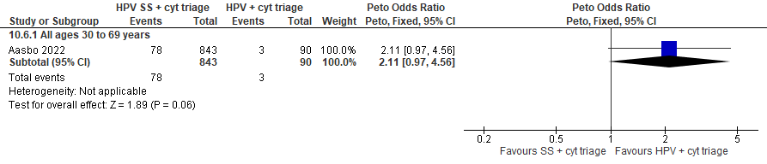
Figure 6.6b. False positives for invasive cervical cancer

Evidence set 7.0: hrHPV screening via self-sampling (threshold not reported) with repeat self-sampling for hrHPV for those with positive tests versus clinician-sampled hrHPV screening (threshold not reported) with repeat clinician sampled hrHPV screening for those with positive tests

Included reports: Gustavsson 2019 (Uppsala I) (ages 50-60 [no age subgroups]); Aarnio 2021 (Uppsala II) (ages 30-60 [no age subgroups])

Evidence Set 7.1. Referrals to colposcopy
Included reports: Gustavsson 2019 (Uppsala I); Aarnio 2021 (Uppsala II)
GRADE Summary of Findings Table 7.1. Referrals to colposcopy
Outcome  No. participantsª  (studies) |  | Relative effects, Peto OR and RR (95 % CI) | Anticipated absolute effects |  |  | Certainty of evidence (GRADE)^{b} | What happens?
 |  | Relative effects, Peto OR and RR (95 % CI) | With hrHPV clinician sampling + repeat triage | With hrHPV self-sampling + repeat triage | Difference | Certainty of evidence (GRADE)^{b} | What happens?
People with a cervix aged 30 to 59 years (Gustavsson 2019 (Uppsala I); Aarnio 2021 (Upsalla II); acceptors of screening)
Referrals to colposcopy  Follow-up: 1 round  11,414 (2 RCTs) | Peto OR: 1.00 (0.81 to 1.23)  RR: 1.00 (0.82 to 1.22) |  | 345.7 per 10,000 | 345.7 per 10,000 | No difference (63.8 less to 76.2 more) | 25-29 yrs:  VERY LOW  ⊕⊝⊝⊝  NR  30-59 yrs:  LOW^{c}  ⊕⊕⊝⊝  due to risk of bias, and indirectness  60-69 yrs:  VERY LOW  ⊕⊝⊝⊝  NR | Among screened people with a cervix aged 25 to 29 years, we are very uncertain about the effect of hrHPV testing via self-sampling with repeat screening of those with positive tests on the rate of referral to colposcopy compared with hrHPV testing via clinician-sampling with repeat screening of those with positive tests.  Among screened people with a cervix aged 30 to 59 years, hrHPV testing via self-sampling with repeat screening of those with positive tests may have little-to-no effect on the rate of referral to colposcopy compared with hrHPV testing via clinician-sampling with repeat screening of those with positive tests.  Among screened people with a cervix aged 60 to 69 years, we are very uncertain about the effect of hrHPV testing via self-sampling with repeat screening of those with positive tests on the rate of referral to colposcopy compared with hrHPV testing via clinician-sampling with repeat screening of those with positive tests.
CI = confidence interval; OR = odds ratio; RCT = randomized controlled trial; RR = relative risk.
ªAcceptors of screening include all randomized participants who completed one round screening via the strategy to which they were randomly assigned. Included in the report by Gustavsson et al. are 10/4,884 participants in the self-sampling group and 13/2,575 in the clinician-sampling group who were referred to colposcopy despite not receiving a repeat test. Included in the report by Aarnio et al. are 10/2,466 participants in the self-sampling group and 5/1,519 in the clinician-sampling group who were referred to colposcopy despite not receiving a repeat test. Those who withdrew are excluded (no data available).
^{b}We rated down by 0.5 for “some concerns”, 1 “serious concerns”, and 2 for “very serious concerns”. When our assessment of the certainty of evidence fell between levels, we assigned the level that best represented our actual certainty in the evidence, and based our conclusions on this level of certainty.
Explanations:
^{c}Acceptors of screening; people with a cervix aged 30 to 59 years: Serious concerns about risk of bias: risk of selection bias because in both studies randomization occurred before assessment of eligibility and enrollment; inadequate evidence of balance in characteristics across groups. No serious concerns about inconsistency: evidence of consistency. Some concerns about indirectness: the study by Gustavsson et al. included only participants aged 50 years or older, so this age group is overrepresented in the analysis. No serious concerns about imprecision: 95% CI precise for little-to-no effect. No other serious concerns.

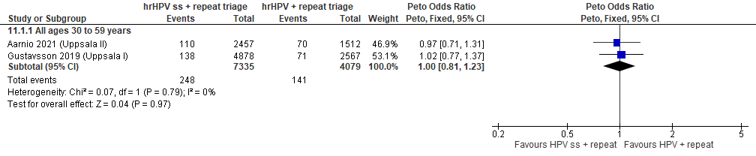
Forest Plot 7.1. Referrals to colposcopy

Evidence Set 7.2. Number of colposcopies
Included reports: Gustavsson 2019 (Uppsala I); Aarnio 2021 (Uppsala II)
GRADE Summary of Findings Table 7.2. Number of colposcopies
Outcome  No. participantsª  (studies) |  | Relative effects, Peto OR and RR (95 % CI) | Anticipated absolute effects |  |  | Certainty of evidence (GRADE)^{b} | What happens?
 |  | Relative effects, Peto OR and RR (95 % CI) | With hrHPV clinician sampling + repeat triage | With hrHPV self-sampling + repeat triage | Difference | Certainty of evidence (GRADE)^{b} | What happens?
People with a cervix aged 30 to 59 years (Gustavsson 2019 (Uppsala I); Aarnio 2021 (Upsalla II); acceptors of screening)
Number of colposcopies  Follow-up: 1 round  11,414 (2 RCTs) | Peto OR: 1.07 (0.86 to 1.34)  RR: 1.07 (0.85 to 1.33) |  | 286.8 per 10,000 | 306.3 per 10,000 | 19.5 more per 10,000 (42.0 less to 93.8 more) | 25-29 yrs:  VERY LOW  ⊕⊝⊝⊝  NR  30-59 yrs:  LOW^{c}  ⊕⊕⊝⊝  due to risk of bias and indirectness  60-69 yrs:  VERY LOW  ⊕⊝⊝⊝  NR | Among screened people with a cervix aged 25 to 29 years, we are very uncertain about the effect of hrHPV testing via self-sampling with repeat screening of those with positive tests on the number of colposcopies compared with hrHPV testing via clinician-sampling with repeat screening of those with positive tests.  Among screened people with a cervix aged 30 to 59 years, hrHPV testing via self-sampling with repeat screening of those with positive tests may have little-to-no effect on the number of colposcopies compared with hrHPV testing via clinician-sampling with repeat screening of those with positive tests.  Among screened people with a cervix aged 60 to 69 years, we are very uncertain about the effect of hrHPV testing via self-sampling with repeat screening of those with positive tests on the number of colposcopies compared with hrHPV testing via clinician-sampling with repeat screening of those with positive tests.
CI = confidence interval; OR = odds ratio; RCT = randomized controlled trial; RR = relative risk.
ªAcceptors of screening include all randomized participants who completed one round screening via the strategy to which they were randomly assigned. Included in the report by Gustavsson et al. are 10/4,884 participants in the self-sampling group and 13/2,575 in the clinician-sampling group who were referred to colposcopy despite not receiving a repeat test. Included in the report by Aarnio et al. are 10/2,466 participants in the self-sampling group and 5/1,519 in the clinician-sampling group who were referred to colposcopy despite not receiving a repeat test. Those who withdrew are excluded (no data available).
^{b}We rated down by 0.5 for “some concerns”, 1 “serious concerns”, and 2 for “very serious concerns”. When our assessment of the certainty of evidence fell between levels, we assigned the level that best represented our actual certainty in the evidence, and based our conclusions on this level of certainty.
Explanations:
^{c}Acceptors of screening; people with a cervix aged 30 to 59 years: Serious concerns about risk of bias: risk of selection bias because in both studies randomization occurred before assessment of eligibility and enrollment; inadequate evidence of balance in characteristics across groups. No serious concerns about inconsistency: evidence of consistency. Some concerns about indirectness: the study by Gustavsson et al. included only participants aged 50 years or older, so this age group is overrepresented in the analysis. No serious concerns about imprecision: 95% CI precise for little-to-no effect. No other serious concerns.

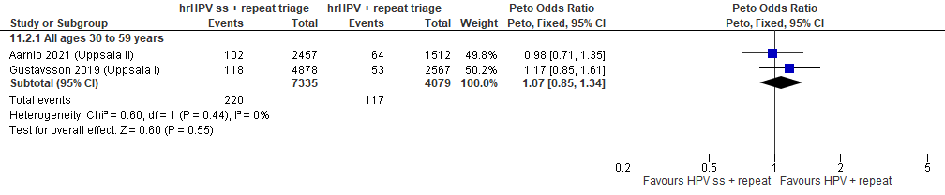
Forest Plot 7.2. Number of colposcopies

Evidence Set 7.3. Detection of CIN2+ (as an indirect indicator of the incidence of CIN3+)
Included reports: Gustavsson 2019 (Uppsala I); Aarnio 2021 (Uppsala II)
GRADE Summary of Findings Table 7.3. Detection of CIN2+ (as an indirect indicator of the incidence of CIN3+)
Outcome  No. participantsª  (studies) |  | Relative effects, Peto OR and RR (95 % CI) | Anticipated absolute effects |  |  | Certainty of evidence (GRADE)^{b} | What happens?
 |  | Relative effects, Peto OR and RR (95 % CI) | With hrHPV clinician sampling + repeat triage | With hrHPV self-sampling + repeat triage | Difference | Certainty of evidence (GRADE)^{b} | What happens?
People with a cervix aged 30 to 59 years (Gustavsson 2019 (Uppsala I); Aarnio 2021 (Upsalla II); acceptors of screening)
Detection of CIN2+  Follow-up: 1 round  11,366 (2 RCTs) | Peto OR: 0.77 (0.54 to 1.09)  RR: 0.77 (0.54 to 1.09) |  | 143.0 per 10,000 | 110.5 per 10,000 | 32.5 less per 10,000 (65.3 less to 12.7 more) | 25-29 yrs:  VERY LOW  ⊕⊝⊝⊝  NR  30-59 yrs:  LOW^{c}  ⊕⊕⊝⊝  due to risk of bias, and indirectness  60-69 yrs:  VERY LOW  ⊕⊝⊝⊝  NR | Among screened people with a cervix aged 25 to 29 years, we are very uncertain about the effect of hrHPV testing via self-sampling with repeat screening of those with positive tests on the incidence of CIN3+ compared with hrHPV testing via clinician-sampling with repeat screening of those with positive tests.  Among screened people with a cervix aged 30 to 59 years, hrHPV testing via self-sampling with repeat screening of those with positive tests may have little-to-no effect on the incidence of CIN3+ compared with hrHPV testing via clinician-sampling with repeat screening of those with positive tests.  Among screened people with a cervix aged 60 to 69 years, we are very uncertain about the effect of hrHPV testing via self-sampling with repeat screening of those with positive tests on the incidence of CIN3+ compared with hrHPV testing via clinician-sampling with repeat screening of those with positive tests.
CI = confidence interval; CIN = cervical intraepithelial neoplasia; OR = odds ratio; RCT = randomized controlled trial; RR = relative risk.
ªAcceptors of screening, select population include all randomized participants who completed one round screening via the strategy to which they were randomly assigned. Included in the report by Gustavsson et al. are 10/4,884 participants in the self-sampling group and 13/2,575 in the clinician-sampling group who were referred to colposcopy despite not receiving a repeat test. Included in the report by Aarnio et al. are 10/2,466 participants in the self-sampling group and 5/1,519 in the clinician-sampling group who were referred to colposcopy despite not receiving a repeat test. The denominator excludes those who did not attend colposcopy for confirmation of a positive test, and those who withdrew are excluded (no data available).
^{b}We rated down by 0.5 for “some concerns”, 1 “serious concerns”, and 2 for “very serious concerns”. When our assessment of the certainty of evidence fell between levels, we assigned the level that best represented our actual certainty in the evidence, and based our conclusions on this level of certainty.
Explanations:
^{c}Acceptors of screening, select population; people with a cervix aged 30 to 59 years: Serious concerns about risk of bias: risk of selection bias because in both studies, randomization occurred before assessment of eligibility and enrollment; inadequate evidence of balance in characteristics across groups. No serious concerns about inconsistency: evidence of consistency. Serious concerns about indirectness: the study by Gustavsson et al. included only participants aged 50 years or older, so this age group is overrepresented in the analysis. Detection is an indirect measure of incidence. No serious concerns about imprecision: 95% CI precise for little-to-no effect. No other serious concerns.

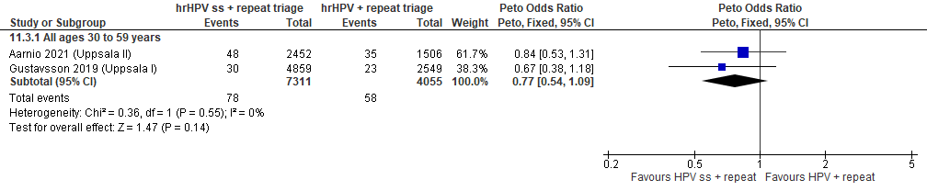
Forest Plot 7.3. Detection of CIN2+ (as an indirect indicator of the incidence of CIN3+)

Evidence Set 7.4. Detection of CIN3+ (as an indirect indicator of the incidence of invasive cervical cancer)
Included reports: Gustavsson 2019 (Uppsala I); Aarnio 2021 (Uppsala II)
GRADE Summary of Findings Table 7.4. Detection of CIN3+ (as an indirect indicator of the incidence of ICC)
Outcome  No. participantsª  (studies) |  | Relative effects, Peto OR and RR (95 % CI) | Anticipated absolute effects |  |  | Certainty of evidence (GRADE)^{b} | What happens?
 |  | Relative effects, Peto OR and RR (95 % CI) | With hrHPV clinician sampling + repeat triage | With hrHPV self-sampling + repeat triage | Difference | Certainty of evidence (GRADE)^{b} | What happens?
People with a cervix aged 30 to 59 years (Gustavsson 2019 (Uppsala I); Aarnio 2021 (Upsalla II); acceptors of screening)
Detection of CIN3+  Follow-up: 1 round  11,366 (2 RCTs) | Peto OR: 0.80 (0.51 to 1.24)  RR: 0.80 (0.51 to 1.24) |  | 88.8 per 10,000 | 71.1 per 10,000 | 17.6 less per 10,000 (43.3 less to 21.1 more) | 25-29 yrs:  VERY LOW  ⊕⊝⊝⊝  NR  30-59 yrs:  VERY LOW^{c}  ⊕⊝⊝⊝  due to risk of bias, indirectness, and imprecision  60-69 yrs:  VERY LOW  ⊕⊝⊝⊝  NR | Among screened people with a cervix aged 25 to 69 years, we are very uncertain about the effect of hrHPV testing via self-sampling with repeat screening of those with positive tests on the incidence of invasive cervical cancer compared with hrHPV testing via clinician-sampling with repeat screening of those with positive tests.
CI = confidence interval; CIN = cervical intraepithelial neoplasia; OR = odds ratio; RCT = randomized controlled trial; RR = relative risk.
ªAcceptors of screening, select population include all randomized participants who completed one round screening via the strategy to which they were randomly assigned. Included in the report by Gustavsson et al. are 10/4,884 participants in the self-sampling group and 13/2,575 in the clinician-sampling group who were referred to colposcopy despite not receiving a repeat test. Included in the report by Aarnio et al. are 10/2,466 participants in the self-sampling group and 5/1,519 in the clinician-sampling group who were referred to colposcopy despite not receiving a repeat test. The denominator excludes those who did not attend colposcopy for confirmation of a positive test, and those who withdrew are excluded (no data available).
^{b}We rated down by 0.5 for “some concerns”, 1 “serious concerns”, and 2 for “very serious concerns”. When our assessment of the certainty of evidence fell between levels, we assigned the level that best represented our actual certainty in the evidence, and based our conclusions on this level of certainty.
Explanations:
^{c}Acceptors of screening, select population; people with a cervix aged 30 to 59 years: Serious concerns about risk of bias: risk of selection bias because in both studies, randomization occurred before assessment of eligibility and enrollment; inadequate evidence of balance in characteristics across groups. No serious concerns about inconsistency: evidence of consistency in absolute effects. Serious concerns about indirectness: the study by Gustavsson et al. included only participants aged 50 years or older, so this age group is overrepresented in the analysis. Detection is an indirect measure of incidence. Serious concerns about imprecision: upper limit of 95% CI indicates increased effect. No other serious concerns.

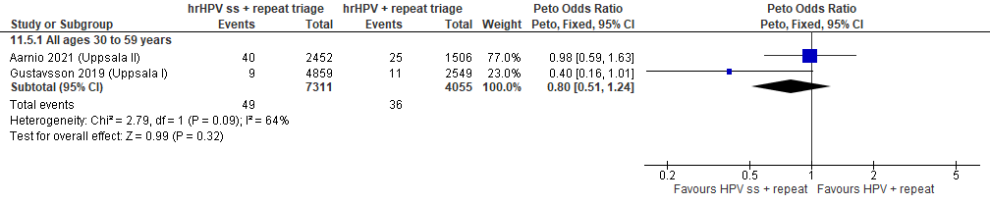
Forest Plot 7.4. Detection of CIN3+ (as an indirect indicator of the incidence of ICC)

Evidence Set 7.5. False positives for CIN2+
Included reports: Gustavsson 2019 (Uppsala I); Aarnio 2021 (Uppsala II)
GRADE Summary of Findings Table 7.5. False positives for CIN2+
Outcome  No. participantsª  (studies) |  | Relative effects, Peto OR and RR (95 % CI) | Anticipated absolute effects |  |  | Certainty of evidence (GRADE)^{b} | What happens?
 |  | Relative effects, Peto OR and RR (95 % CI) | With hrHPV clinician sampling + repeat triage | With hrHPV self-sampling + repeat triage | Difference | Certainty of evidence (GRADE)^{b} | What happens?
People with a cervix aged 30 to 59 years (Gustavsson 2019 (Uppsala I); Aarnio 2021 (Upsalla II); acceptors of screening)
False positives for CIN2+  Follow-up: 1 round  11,366 (2 RCTs) | Peto OR: 1.34 (1.00 to 1.79)  RR: 1.33 (1.00 to 1.77) |  | 145.5 per 10,000 | 194.0 per 10,000 | 48.5 more per 10,000 (0.0 more to 112.0 more) | 25-29 yrs:  VERY LOW  ⊕⊝⊝⊝  NR  30-59 yrs:  LOW^{c}  ⊕⊕⊝⊝  due to risk of bias and indirectness  60-69 yrs:  VERY LOW  ⊕⊝⊝⊝  NR | Among screened people with a cervix aged 25 to 29 years, we are very uncertain about the effect of hrHPV testing via self-sampling with repeat screening of those with positive tests on the number of false positives for CIN2+ compared with hrHPV testing via clinician-sampling with repeat screening of those with positive tests.  Among screened people with a cervix aged 30 to 59 years, hrHPV testing via self-sampling with repeat screening of those with positive tests may have little-to-no effect on the number of false positives for CIN2+ compared with hrHPV testing via clinician-sampling with repeat screening of those with positive tests.  Among screened people with a cervix aged 60 to 69 years, we are very uncertain about the effect of hrHPV testing via self-sampling with repeat screening of those with positive tests on the number of false positives for CIN2+ compared with hrHPV testing via clinician-sampling with repeat screening of those with positive tests.
CI = confidence interval; CIN = cervical intraepithelial neoplasia; OR = odds ratio; RCT = randomized controlled trial; RR = relative risk.
ªAcceptors of screening, select population include all randomized participants who completed one round screening via the strategy to which they were randomly assigned. Included in the report by Gustavsson et al. are 10/4,884 participants in the self-sampling group and 13/2,575 in the clinician-sampling group who were referred to colposcopy despite not receiving a repeat test. Included in the report by Aarnio et al. are 10/2,466 participants in the self-sampling group and 5/1,519 in the clinician-sampling group who were referred to colposcopy despite not receiving a repeat test. The denominator excludes those who did not attend colposcopy for confirmation of a positive test, and those who withdrew are excluded (no data available).
^{b}We rated down by 0.5 for “some concerns”, 1 “serious concerns”, and 2 for “very serious concerns”. When our assessment of the certainty of evidence fell between levels, we assigned the level that best represented our actual certainty in the evidence, and based our conclusions on this level of certainty.
Explanations:
^{c}Acceptors of screening, select population; people with a cervix aged 30 to 59 years: Serious concerns about risk of bias: risk of selection bias because in both studies, randomization occurred before assessment of eligibility and enrollment; inadequate evidence of balance in characteristics across groups. No serious concerns about inconsistency: evidence of consistency in absolute effects. Some concerns about indirectness: the study by Gustavsson et al. included only participants aged 50 years or older, so this age group is overrepresented in the analysis. No serious concerns about imprecision: 95% CI precise for little-to-no effect. No other serious concerns.

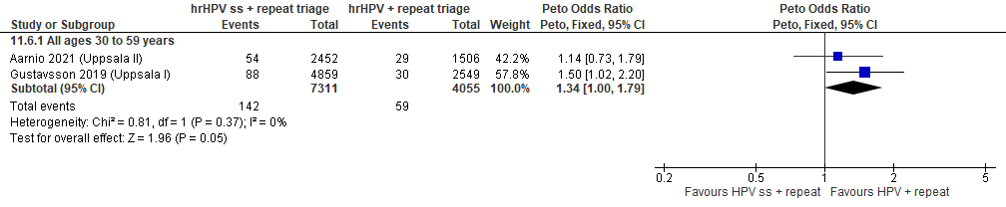
Forest Plot 7.5. False positives for CIN2+

Evidence Set 7.6. False positives for CIN3+
Included report: Gustavsson 2019 (Uppsala I); Aarnio 2021 (Uppsala II)
GRADE Summary of Findings Table 7.6. False positives for CIN3+
Outcome  No. participantsª  (studies) |  | Relative effects, Peto OR and RR (95 % CI) | Anticipated absolute effects |  |  | Certainty of evidence (GRADE)^{b} | What happens?
 |  | Relative effects, Peto OR and RR (95 % CI) | With hrHPV clinician sampling + repeat triage | With hrHPV self-sampling + repeat triage | Difference | Certainty of evidence (GRADE)^{b} | What happens?
People with a cervix aged 30 to 59 years (Gustavsson 2019 (Uppsala I); Aarnio 2021 (Upsalla II); acceptors of screening)
False positives for CIN3+  Follow-up: 1 round  11,366 (2 RCTs) | Peto OR: 1.18 (0.91 to 1.53)  RR: 1.18 (0.91 to 1.51) |  | 199.8 per 10,000 | 234.9 per 10,000 | 35.1 more per 10,000 (17.7 less to 102.7 more) | 25-29 yrs:  VERY LOW  ⊕⊝⊝⊝  NR  30-59 yrs:  LOW^{c}  ⊕⊕⊝⊝  due to risk of bias  and indirectness  60-69 yrs:  VERY LOW  ⊕⊝⊝⊝  NR | Among screened people with a cervix aged 25 to 29 years, we are very uncertain about the effect of hrHPV testing via self-sampling with repeat screening of those with positive tests on the number of false positives for CIN3+ compared with hrHPV testing via clinician-sampling with repeat screening of those with positive tests.  Among screened people with a cervix aged 30 to 59 years, hrHPV testing via self-sampling with repeat screening of those with positive tests may have little-to-no effect on the number of false positives for CIN3+ compared with hrHPV testing via clinician-sampling with repeat screening of those with positive tests.  Among screened people with a cervix aged 60 to 69 years, we are very uncertain about the effect of hrHPV testing via self-sampling with repeat screening of those with positive tests on the number of false positives for CIN3+ compared with hrHPV testing via clinician-sampling with repeat screening of those with positive tests.
CI = confidence interval; CIN = cervical intraepithelial neoplasia; OR = odds ratio; RCT = randomized controlled trial; RR = relative risk.
ªAcceptors of screening, select population include all randomized participants who completed one round screening via the strategy to which they were randomly assigned. Included in the report by Gustavsson et al. are 10/4,884 participants in the self-sampling group and 13/2,575 in the clinician-sampling group who were referred to colposcopy despite not receiving a repeat test. Included in the report by Aarnio et al. are 10/2,466 participants in the self-sampling group and 5/1,519 in the clinician-sampling group who were referred to colposcopy despite not receiving a repeat test. The denominator excludes those who did not attend colposcopy for confirmation of a positive test, and those who withdrew are excluded (no data available).
^{b}We rated down by 0.5 for “some concerns”, 1 “serious concerns”, and 2 for “very serious concerns”. When our assessment of the certainty of evidence fell between levels, we assigned the level that best represented our actual certainty in the evidence, and based our conclusions on this level of certainty.
Explanations:
^{c}Acceptors of screening, select population; people with a cervix aged 30 to 59 years: Serious concerns about risk of bias: risk of selection bias because in both studies, randomization occurred before assessment of eligibility and enrollment; inadequate evidence of balance in characteristics across groups. No serious concerns about inconsistency: evidence of consistency. Some concerns about indirectness: the study by Gustavsson et al. included only participants aged 50 years or older, so this age group is overrepresented in the analysis. No serious concerns about imprecision: 95% CI precise for little-to-no effect. No other serious concerns.

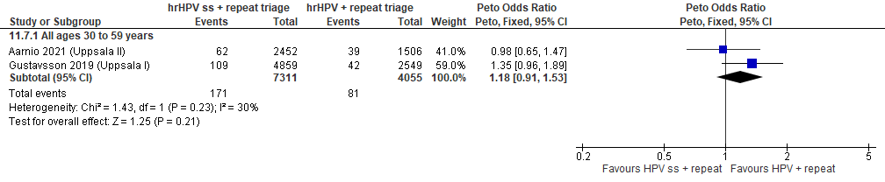
Forest Plot 7.6. False positives for CIN3+

Evidence set 8.0: hrHPV screening via self-sampling (mailed kit; threshold not reported) with cytology triage of positive tests vs. cytology screening (threshold ≥LSIL)
Included reports: Piana 2011 (ARCADES I) (ages 35-69 [no age subgroups]); Sancho-Garnier 2013 (ARCADES II) (ages 35-69 [no age subgroups])

Evidence Set 8.1. Referrals to colposcopy
Included reports: Sancho-Garnier 2013 (ARCADES)
GRADE Summary of Findings Table 8.1. Referrals to colposcopy
Outcome  No. participantsª  (studies) |  | Relative effects, Peto OR and RR (95 % CI) | Anticipated absolute effects |  |  | Certainty of evidence (GRADE)^{b} | What happens?
 |  | Relative effects, Peto OR and RR (95 % CI) | With cytology screening | With hrHPV screening via self-sampling + cytology triage | Difference | Certainty of evidence (GRADE)^{b} | What happens?
People with a cervix aged 30 to 69 years (Sancho-Garnier 2013 (ARCADES); acceptors of screening)
Referrals to colposcopy  Follow-up: 1 round  1,635 (1 RCT) | Peto OR: 0.16 (0.05 to to 0.50)  RR: 0.17 (0.05 to 0.51) |  | 454.5 per 10,000 | 75.6 per 10,000 | 378.9 less per 10,000 (430.8 less to 222.0 less) | 25-29 yrs:  VERY LOW  ⊕⊝⊝⊝  NR  30-59 yrs:  VERY LOW^{c}  ⊕⊝⊝⊝  due to risk of bias, lack of evidence of consistency, indirectness, and imprecision  60-69 yrs:  VERY LOW^{d}  ⊕⊝⊝⊝  due to risk of bias, lack of evidence of consistency, (very serious) indirectness, and imprecision | Among screened people with a cervix aged 25 to 69 years, we are very uncertain about the effect of hrHPV self-sampling with cytology triage on the rate of referral to colposcopy compared with cytology screening.
CI = confidence interval; OR = odds ratio; RCT = randomized controlled trial; RR = relative risk.
ªAcceptors of screening include participants who were randomized and accepted the offer to be screened (akin to a per protocol analysis).
^{b}We rated down by 0.5 for “some concerns”, 1 “serious concerns”, and 2 for “very serious concerns”. When our assessment of the certainty of evidence fell between levels, we assigned the level that best represented our actual certainty in the evidence, and based our conclusions on this level of certainty.
Explanations:
^{c}Acceptors of screening; people with a cervix aged 30 to 59 years: Serious concerns about risk of bias: risk of selection bias because randomization occurred before enrollment, without adequate information about baseline characteristics across groups. Participation rates were 2% in the cytology group and 82% in the hrHPV self-sampling group. Risk of attrition bias because 59% of participants in the self-sampling group did not complete the screening protocol compared with all of those in the cytology group (no triage required). Some concerns about inconsistency: lack of evidence for consistency due to single study. Serious concerns about indirectness: the study included only people who were of low socioeconomic status and who had not been screened in 2+ years, or had not responded to a first invitation for cytology screening. Serious concerns about imprecision: upper limit of 95% CI indicates little-to-no effect. No other serious concerns.
^{d}Acceptors of screening; people with a cervix aged 60 to 69 years: Serious concerns about risk of bias: risk of selection bias because randomization occurred before enrollment, without adequate information about baseline characteristics across groups. Participation rates were 2% in the cytology group and 82% in the hrHPV self-sampling group. Risk of attrition bias because 59% of participants in the self-sampling group did not complete the screening protocol compared with all of those in the cytology group (no triage required). Some concerns about inconsistency: lack of evidence for consistency due to single study. Very serious concerns about indirectness: the study included only people who were of low socioeconomic status and who had not been screened in 2+ years, or had not responded to a first invitation for cytology screening; concerns due to small sample in this age group (n=181/1,812 [10.0%] enrolled). Serious concerns about imprecision: upper limit of 95% CI indicates little-to-no effect. No other serious concerns.

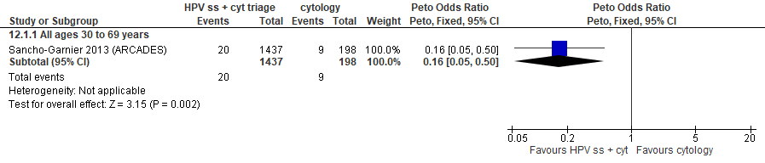
Forest plot 8.1. Referrals to colposcopy

Evidence Set 8.2. Number of colposcopies
Included report: Sancho-Garnier 2013 (ARCADES)
GRADE Summary of Findings Table 8.2. Number of colposcopies
Outcome  No. participantsª  (studies) |  | Relative effects, Peto OR and RR (95 % CI) | Anticipated absolute effects |  |  | Certainty of evidence (GRADE)^{b} | What happens?
 |  | Relative effects, Peto OR and RR (95 % CI) | With cytology screening | With hrHPV screening via self-sampling + cytology triage | Difference | Certainty of evidence (GRADE)^{b} | What happens?
People with a cervix aged 30 to 69 years (Sancho-Garnier 2013 (ARCADES); acceptors of screening)
Number of colposcopies  Follow-up: 1 round  1,635 (1 RCT) | Peto OR: 0.47 (0.14 to 1.58)  RR: 0.48 (0.14 to 1.56) |  | 252.5 per 10,000 | 120.3 per 10,000 | 132.2 less per 10,000 (216.4 less to 140.7 more) | 25-29 yrs:  VERY LOW  ⊕⊝⊝⊝  NR  30-59 yrs:  VERY LOW^{c}  ⊕⊝⊝⊝  due to risk of bias, lack of evidence of consistency, and indirectness  60-69 yrs:  VERY LOW^{d}  ⊕⊝⊝⊝  due to risk of bias, lack of evidence of consistency, and (very serious) indirectness | Among screened people with a cervix aged 25 to 69 years, we are very uncertain about the effect of hrHPV self-sampling with cytology triage on the number of colposcopies compared with cytology screening.
CI = confidence interval; OR = odds ratio; RCT = randomized controlled trial; RR = relative risk.
ªAcceptors of screening include participants who were randomized and accepted the offer to be screened (akin to a per protocol analysis).
^{b}We rated down by 0.5 for “some concerns”, 1 “serious concerns”, and 2 for “very serious concerns”. When our assessment of the certainty of evidence fell between levels, we assigned the level that best represented our actual certainty in the evidence, and based our conclusions on this level of certainty.
Explanations:
^{c}Acceptors of screening; people with a cervix aged 30 to 59 years: Serious concerns about risk of bias: risk of selection bias because randomization occurred before enrollment, without adequate information about baseline characteristics across groups. Participation rates were 2% in the cytology group and 82% in the hrHPV self-sampling group. Risk of attrition bias because 59% of participants in the self-sampling group did not complete the screening protocol compared with all of those in the cytology group (no triage required). Some concerns about inconsistency: lack of evidence for consistency due to single study. Serious concerns about indirectness: the study included only people who were of low socioeconomic status and who had not been screened in 2+ years, or had not responded to a first invitation for cytology screening. No serious concerns about imprecision: 95% CI precise for little-to-no effect. No other serious concerns.
^{d}Acceptors of screening; people with a cervix aged 60 to 69 years: Serious concerns about risk of bias: risk of selection bias because randomization occurred before enrollment, without adequate information about baseline characteristics across groups. Participation rates were 2% in the cytology group and 82% in the hrHPV self-sampling group. Risk of attrition bias because 59% of participants in the self-sampling group did not complete the screening protocol compared with all of those in the cytology group (no triage required). Some concerns about inconsistency: lack of evidence for consistency due to single study. Very serious concerns about indirectness: the study included only people who were of low socioeconomic status and who had not been screened in 2+ years, or had not responded to a first invitation for cytology screening; concerns due to small sample in this age group (n=181/1,812 [10.0%] enrolled). No serious concerns about imprecision: 95% CI precise for little-to-no effect. No other serious concerns.

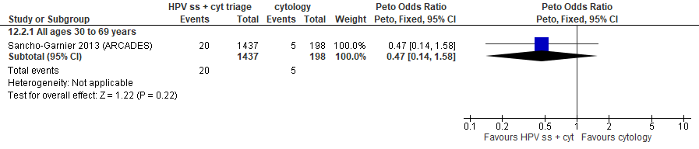
Forest plot 8.2. Number of colposcopies

Evidence Set 8.3. Detection of CIN2+ (as an indirect indicator of the incidence of CIN3+)
Included reports: Piana 2011 and Sancho-Garnier 2013 (ARCADES)
GRADE Summary of Findings Table 8.3. Detection of CIN2+ (as an indirect indicator of the incidence of CIN3+)
Outcome  No. participantsª  (studies) |  | Relative effects, Peto OR and RR (95 % CI) | Anticipated absolute effects |  |  | Certainty of evidence (GRADE)^{b} | What happens?
 |  | Relative effects, Peto OR and RR (95 % CI) | With cytology screening | With hrHPV screening via self-sampling + cytology triage | Difference | Certainty of evidence (GRADE)^{b} | What happens?
People with a cervix aged 30 to 69 years (Piana 2011; Sancho-Garnier 2013 (ARCADES); acceptors of screening, select population)
Detection of CIN2+  Follow-up: 1 round  2,841 (2 RCTs) | Peto OR: 0.61 (0.19 to 1.94)  RR: 0.61 (0.19 to 1.92) |  | 99.8 per 10,000 | 61.1 per 10,000 | 38.7 less per 10,000 (80.7 less to 92.0 more) | 25-29 yrs:  VERY LOW  ⊕⊝⊝⊝  NR  30-59 yrs:  VERY LOW^{c}  ⊕⊝⊝⊝  due to risk of bias, and (very serious) indirectness  60-69 yrs:  VERY LOW^{d}  ⊕⊝⊝⊝  due to risk of bias, and (very serious) indirectness | Among screened people with a cervix aged 25 to 69 years, we are very uncertain about the effect of hrHPV self-sampling with cytology triage on the incidence of CIN3+ compared with cytology screening.
>Subgroup: People with a cervix aged 30 to 69 years of low socioeconomic status (Sancho-Garnier 2013 (ARCADES); acceptors of screening, select population)
Detection of CIN2+  Follow-up: 1 round  1,631 (1 RCT) | Peto OR: 0.71 (0.13 to 3.86)  RR: 0.71 (0.13 to 3.75) |  | 103.1 per 10,000 | 73.4 per 10,000 | 29.7 less per 10,000 (89.6 less to 283.4 more) | NA
>Subgroup: People with a cervix aged 30 to 69 years of moderate socioeconomic status (Piana 2011 (ARCADES); acceptors of screening, select population)
Detection of CIN2+  Follow-up: 1 round  1,210 (1 RCT) | Peto OR: 0.53 (0.11 to 2.59)  RR: 0.53 (0.11 to 2.55) |  | 97.7 per 10,000 | 52.0 per 10,000 | 45.7 less per 10,000 (86.9 less to 151.5 more) | NA
CI = confidence interval; CIN = cervical intraepithelial neoplasia; NA= not applicable (i.e., not used for conclusions); OR = odds ratio; RCT = randomized controlled trial; RR = relative risk.
ªAcceptors of screening, select population include participants who were randomized and accepted the offer to be screened, and attended colposcopy following a positive test (akin to a screened per protocol analysis).
^{b}We rated down by 0.5 for “some concerns”, 1 “serious concerns”, and 2 for “very serious concerns”. When our assessment of the certainty of evidence fell between levels, we assigned the level that best represented our actual certainty in the evidence, and based our conclusions on this level of certainty.
Explanations:
^{c}Acceptors of screening, select population; people with a cervix aged 30 to 59 years: Serious concerns about risk of bias: risk of selection bias because randomization occurred before enrollment, without adequate information about baseline characteristics across groups. Participation rates were imbalanced between groups. Risk of attrition bias because not all participants positive on either test attended for follow-up. No serious concerns about inconsistency: evidence of consistency. Very serious concerns about indirectness: the study included only people who had not been screened in 2+ years, or had not responded to a first invitation for cytology screening; majority of participants are those with low socioeconomic status; detection is an indirect indicator of incidence. No serious concerns about imprecision: 95% CI precise for little-to-no effect. No other serious concerns.
^{d}Acceptors of screening, select population; people with a cervix aged 60 to 69 years: Serious concerns about risk of bias: risk of selection bias because randomization occurred before enrollment, without adequate information about baseline characteristics across groups. Participation rates were imbalanced between groups. Risk of attrition bias because not all participants positive on either test attended for follow-up. Some concerns about inconsistency: lack of evidence for consistency due to single study. Very serious concerns about indirectness: the study included only people who had not been screened in 2+ years, or had not responded to a first invitation for cytology screening; majority of participants are those with low socioeconomic status; detection is an indirect indicator of incidence; concerns due to small sample in this age group (n=439/3,036 [14.5%] enrolled). No serious concerns about imprecision: 95% CI precise for little-to-no effect. No other serious concerns.

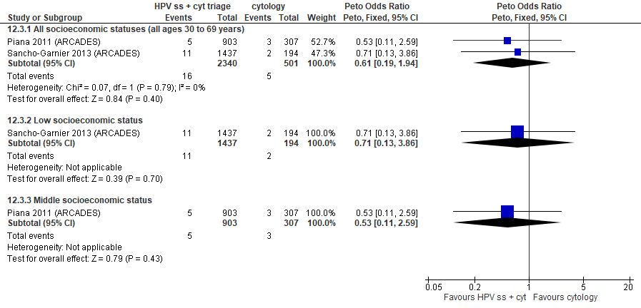
Forest plot 8.3. Detection of CIN2+ (as an indirect indicator of the incidence of CIN3+)

Evidence Set 8.4. Detection of CIN3+ (as an indirect indicator of the incidence of invasive cervical cancer)
Included reports: Piana 2011 and Sancho-Garnier 2013 (ARCADES)
GRADE Summary of Findings Table 8.4. Detection of CIN3+ (as an indirect indicator of the incidence of ICC)
Outcome  No. participantsª  (studies) |  | Relative effects, Peto OR and RR (95 % CI) | Anticipated absolute effects |  |  | Certainty of evidence (GRADE)^{b} | What happens?
 |  | Relative effects, Peto OR and RR (95 % CI) | With cytology screening | With hrHPV screening via self-sampling + cytology triage | Difference | Certainty of evidence (GRADE)^{b} | What happens?
People with a cervix aged 30 to 69 years (Piana 2011; Sancho-Garnier 2013 (ARCADES); acceptors of screening, select population)
Detection of CIN3+  Follow-up: 1 round  2,841 (2 RCTs) | Peto OR: 0.41 (0.10 to 1.74)  RR: 0.41 (0.10 to 1.73) |  | 79.8 per 10,000 | 32.9 per 10,000 | 47.0 less per 10,000 (71.8 less to 58.3 more) | 25-29 yrs:  VERY LOW  ⊕⊝⊝⊝  NR  30-59 yrs:  VERY LOW^{c}  ⊕⊝⊝⊝  due to risk of bias, (very serious) indirectness, and imprecision  60-69 yrs:  VERY LOW^{d}  ⊕⊝⊝⊝  due to risk of bias, (very serious) indirectness, and imprecision | Among screened people with a cervix aged 25 to 69 years, we are very uncertain about the effect of hrHPV self-sampling with cytology triage on the incidence of invasive cervical cancer compared with cytology screening.
>Subgroup: People with a cervix aged 30 to 69 years of low socioeconomic status (Sancho-Garnier 2013 (ARCADES); acceptors of screening, select population)
Detection of CIN3+  Follow-up: 1 round  1,631 (1 RCT) | Peto OR: 0.20 (0.02 to 2.00)  RR: 0.20 (0.02 to 1.98) |  | 103.1 per 10,000 | 20.8 per 10,000 | 82.3 less per 10,000 (101.0 less to 101.0 more) | NA
>Subgroup: People with a cervix aged 30 to 69 years of moderate socioeconomic status (Piana 2011 (ARCADES); acceptors of screening, select population)
Detection of CIN3+  Follow-up: 1 round  1,210 (1 RCT) | Peto OR: 0.66 (0.10 to 4.14)  RR: 0.66 (0.10 to 4.06) |  | 65.1 per 10,000 | 43.1 per 10,000 | 22.1 less per 10,000 (58.6 less to 199.2 more) | NA
CI = confidence interval; CIN = cervical intraepithelial neoplasia; NA= not applicable (i.e., not used for conclusions); OR = odds ratio; RCT = randomized controlled trial; RR = relative risk.
ªAcceptors of screening, select population include participants who were randomized and accepted the offer to be screened, and attended colposcopy following a positive test (akin to a screened per protocol analysis).
^{b}We rated down by 0.5 for “some concerns”, 1 “serious concerns”, and 2 for “very serious concerns”. When our assessment of the certainty of evidence fell between levels, we assigned the level that best represented our actual certainty in the evidence, and based our conclusions on this level of certainty.
Explanations:
^{c}Acceptors of screening, select population; people with a cervix aged 30 to 59 years: Serious concerns about risk of bias: risk of selection bias because randomization occurred before enrollment, without adequate information about baseline characteristics across groups. Participation rates were imbalanced between groups. Risk of attrition bias because not all participants positive on either test attended for follow-up. No serious concerns about inconsistency: evidence of consistency. Very serious concerns about indirectness: the study included only people who had not been screened in 2+ years, or had not responded to a first invitation for cytology screening; majority of participants are those with low socioeconomic status; detection is an indirect indicator of incidence. Serious concerns about imprecision: upper limit of 95% CI indicates increased effect. No other serious concerns.
^{d}Acceptors of screening, select population; people with a cervix aged 60 to 69 years: Serious concerns about risk of bias: risk of selection bias because randomization occurred before enrollment, without adequate information about baseline characteristics across groups. Participation rates were imbalanced between groups. Risk of attrition bias because not all participants positive on either test attended for follow-up. No serious concerns about inconsistency: evidence of consistency. Very serious concerns about indirectness: the study included only people who had not been screened in 2+ years, or had not responded to a first invitation for cytology screening; majority of participants are those with low socioeconomic status; detection is an indirect indicator of incidence; concerns due to small sample in this age group (n=439/3,036 [14.5%] enrolled). Serious concerns about imprecision: upper limit of 95% CI indicates increased effect. No other serious concerns.

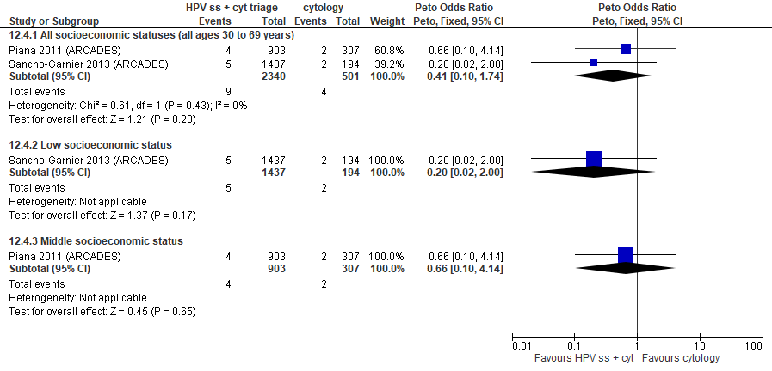
Forest plot 8.4. Detection of CIN3+ (as an indirect indicator of the incidence of ICC)

Evidence Set 8.5. Detection of invasive cervical cancer
Included reports: Piana 2011 and Sancho-Garnier 2013 (ARCADES)
GRADE Summary of Findings Table 8.5. Detection of invasive cervical cancer
Outcome  No. participantsª  (studies) |  | Relative effects, Peto OR and RR (95% CI) | Anticipated absolute effects |  |  | Certainty of evidence (GRADE)^{b} | What happens?
 |  | Relative effects, Peto OR and RR (95% CI) | With cytology screening | With hrHPV screening via self-sampling + cytology triage | Difference | Certainty of evidence (GRADE)^{b} | What happens?
People with a cervix aged 30 to 69 years (Piana 2011; Sancho-Garnier 2013 (ARCADES); acceptors of screening, select population)
Detection of ICC  Follow-up: 1 round  2,841 (2 RCTs) | Peto OR: 3.11 (0.04 to 225.46)  RR: 3.11 (0.04 to 225.46) |  | 0.0 per 10,000 | 0.0 per 10,000 | No difference | 25-29 yrs:  VERY LOW  ⊕⊝⊝⊝  NR  30-59 yrs:  VERY LOW^{c}  ⊕⊝⊝⊝  due to risk of bias, and (very serious) indirectness  60-69 yrs:  VERY LOW^{d}  ⊕⊝⊝⊝  due to risk of bias, and (very serious) indirectness | Among screened people with a cervix aged 25 to 69 years, we are very uncertain about the effect of hrHPV self-sampling with cytology triage of positive tests on the detection of invasive cervical cancer compared with cytology screening.
>Subgroup: People with a cervix aged 30 to 69 years of low socioeconomic status (Sancho-Garnier 2013 (ARCADES); acceptors of screening, select population)
Detection of ICC  Follow-up: 1 round  1,631 (1 RCT) | Peto OR: 3.11 (0.04 to 225.46)  RR: 3.11 (0.04 to 225.46) |  | 0.0 per 10,000 | 0.0 per 10,000 | No difference | NA
>Subgroup: People with a cervix aged 30 to 69 years of moderate socioeconomic status (Piana 2011 (ARCADES); acceptors of screening, select population)
Detection of ICC  Follow-up: 1 round  1,210 (1 RCT) | Peto OR: not estimable  RR: not estimable |  | 0.0 per 10,000 | Not estimable | Not estimable (no events reported in either arm) | NA
CI = confidence interval; NA= not applicable (i.e., not used for conclusions); OR = odds ratio; RCT = randomized controlled trial; RR = relative risk.
ªAcceptors of screening, select population include participants who were randomized and accepted the offer to be screened, and attended colposcopy following a positive test (akin to a screened per protocol analysis).
^{b}We rated down by 0.5 for “some concerns”, 1 “serious concerns”, and 2 for “very serious concerns”. When our assessment of the certainty of evidence fell between levels, we assigned the level that best represented our actual certainty in the evidence, and based our conclusions on this level of certainty.
Explanations:
^{c}Acceptors of screening, select population; people with a cervix aged 30 to 59 years: Serious concerns about risk of bias: risk of selection bias because randomization occurred before enrollment, without adequate information about baseline characteristics across groups. Participation rates were imbalanced between groups. Risk of attrition bias because not all participants positive on either test attended for follow-up. No serious concerns about inconsistency: evidence of consistency. Very serious concerns about indirectness: the study included only people who had not been screened in 2+ years, or had not responded to a first invitation for cytology screening; majority of participants are those with low socioeconomic status; detection is an indirect indicator of incidence. No serious concerns about imprecision: 95% CI precise for little-to-no effect. No other serious concerns.
^{d}Acceptors of screening, select population; people with a cervix aged 60 to 69 years: Serious concerns about risk of bias: risk of selection bias because randomization occurred before enrollment, without adequate information about baseline characteristics across groups. Participation rates were imbalanced between groups. Risk of attrition bias because not all participants positive on either test attended for follow-up. No serious concerns about inconsistency: evidence of consistency. Very serious concerns about indirectness: the study included only people who had not been screened in 2+ years, or had not responded to a first invitation for cytology screening; majority of participants are those with low socioeconomic status; detection is an indirect indicator of incidence; concerns due to small sample in this age group (n=439/3,036 [14.5%] enrolled). No serious concerns about imprecision: 95% CI precise for little-to-no effect. No other serious concerns.

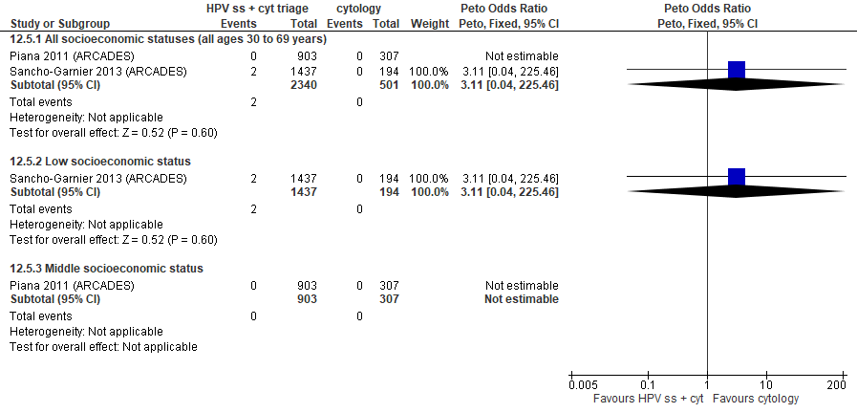
Forest plot 8.5. Detection of invasive cervical cancer

Evidence Set 8.6. False positives for CIN2+
Included report: Sancho-Garnier 2013 (ARCADES)
GRADE Summary of Findings Table 8.6. False positives for CIN2+
Outcome  No. participantsª  (studies) |  | Relative effects, Peto OR and RR (95 % CI) | Anticipated absolute effects |  |  | Certainty of evidence (GRADE)^{b} | What happens?
 |  | Relative effects, Peto OR and RR (95 % CI) | With cytology screening | With hrHPV screening via self-sampling + cytology triage | Difference | Certainty of evidence (GRADE)^{b} | What happens?
People with a cervix aged 30 to 69 years (Sancho-Garnier 2013 (ARCADES); acceptors of screening, select population)
False positives for CIN2+  Follow-up: 1 round  1,631 (1 RCT) | Peto OR: 0.28 (0.05 to 1.64)  RR: 0.28 (0.05 to 1.62) |  | 154.6 per 10,000 | 43.8 per 10,000 | 110.9 less per 10,000 (146.8 less to 96.5 more) | 25-29 yrs:  VERY LOW  ⊕⊝⊝⊝  NR  30-59 yrs:  VERY LOW^{c}  ⊕⊝⊝⊝  due to risk of bias, lack of evidence of consistency, and indirectness  60-69 yrs:  VERY LOW^{d}  ⊕⊝⊝⊝  due to risk of bias, lack of evidence of consistency, and (very serious) indirectness | Among screened people with a cervix aged 25 to 69 years, we are very uncertain about the effect of hrHPV self-sampling with cytology triage on the number of false positives for CIN2+ compared with cytology screening.
CI = confidence interval; CIN = cervical intraepithelial neoplasia; OR = odds ratio; RCT = randomized controlled trial; RR = relative risk.
ªAcceptors of screening, select population include participants who were randomized and accepted the offer to be screened, and attended colposcopy following a positive test (akin to a screened per protocol analysis).
^{b}We rated down by 0.5 for “some concerns”, 1 “serious concerns”, and 2 for “very serious concerns”. When our assessment of the certainty of evidence fell between levels, we assigned the level that best represented our actual certainty in the evidence, and based our conclusions on this level of certainty.
Explanations:
^{c}Acceptors of screening, select population; people with a cervix aged 30 to 59 years: Serious concerns about risk of bias: risk of selection bias because randomization occurred before enrollment, without adequate information about baseline characteristics across groups. Participation rates were 2% in the cytology group and 82% in the hrHPV self-sampling group. Risk of attrition bias because 59% of participants in the self-sampling group did not complete the screening protocol compared with all of those in the cytology group (no triage required). Some concerns about inconsistency: lack of evidence for consistency due to single study. Serious concerns about indirectness: the study included only people who were of low socioeconomic status and who had not been screened in 2+ years, or had not responded to a first invitation for cytology screening. No serious concerns for imprecision: 95% CI precise for little-to-no effect. No other serious concerns.
^{d}Acceptors of screening, select population; people with a cervix aged 60 to 69 years: Serious concerns about risk of bias: risk of selection bias because randomization occurred before enrollment, without adequate information about baseline characteristics across groups. Participation rates were 2% in the cytology group and 82% in the hrHPV self-sampling group. Risk of attrition bias because 59% of participants in the self-sampling group did not complete the screening protocol compared with all of those in the cytology group (no triage required). Some concerns about inconsistency: lack of evidence for consistency due to single study. Very serious concerns about indirectness: the study included only people who were of low socioeconomic status and who had not been screened in 2+ years, or had not responded to a first invitation for cytology screening; concerns due to small sample in this age group (n=181/1,812 [10.0%] enrolled). No serious concerns for imprecision: 95% CI precise for little-to-no effect. No other serious concerns.

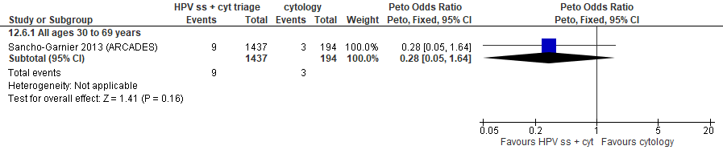
Forest plot 8.6. False positives for CIN2+

Evidence Set 8.7. False positives for CIN3+
Included report: Sancho-Garnier 2013 (ARCADES)
GRADE Summary of Findings Table 8.7. False positives for CIN3+
Outcome  No. participantsª  (studies) |  | Relative effects, Peto OR and RR (95 % CI) | Anticipated absolute effects |  |  | Certainty of evidence (GRADE)^{b} | What happens?
 |  | Relative effects, Peto OR and RR (95 % CI) | With cytology screening | With hrHPV screening via self-sampling + cytology triage | Difference | Certainty of evidence (GRADE)^{b} | What happens?
People with a cervix aged 30 to 69 years (Sancho-Garnier 2013 (ARCADES); acceptors of screening, select population)
False positives for CIN3+  Follow-up: 1 round  1,631 (1 RCT) | Peto OR: 0.63 (0.15 to 2.65)  RR: 0.63 (0.15 to 2.58) |  | 154.6 per 10,000 | 98.0 per 10,000 | 56.7 less per 10,000 (131.1 less to 245.0 more) | 25-29 yrs:  VERY LOW  ⊕⊝⊝⊝  NR  30-59 yrs:  VERY LOW^{c}  ⊕⊝⊝⊝  due to risk of bias, lack of evidence of consistency, and indirectness  60-69 yrs:  VERY LOW^{d}  ⊕⊝⊝⊝  due to risk of bias, lack of evidence of consistency, and (very serious) indirectness | Among screened people with a cervix aged 25 to 69 years, we are very uncertain about the effect of hrHPV self-sampling with cytology triage on the number of false positives for CIN3+ compared with cytology screening.
CI = confidence interval; CIN = cervical intraepithelial neoplasia; OR = odds ratio; RCT = randomized controlled trial; RR = relative risk.
ªAcceptors of screening, select population include participants who were randomized and accepted the offer to be screened, and attended colposcopy following a positive test (akin to a screened per protocol analysis).
^{b}We rated down by 0.5 for “some concerns”, 1 “serious concerns”, and 2 for “very serious concerns”. When our assessment of the certainty of evidence fell between levels, we assigned the level that best represented our actual certainty in the evidence, and based our conclusions on this level of certainty.
Explanations:
^{c}Acceptors of screening, select population; people with a cervix aged 30 to 59 years: Serious concerns about risk of bias: risk of selection bias because randomization occurred before enrollment, without adequate information about baseline characteristics across groups. Participation rates were 2% in the cytology group and 82% in the hrHPV self-sampling group. Risk of attrition bias because 59% of participants in the self-sampling group did not complete the screening protocol compared with all of those in the cytology group (no triage required). Some concerns about inconsistency: lack of evidence for consistency due to single study. Serious concerns about indirectness: the study included only people who were of low socioeconomic status and who had not been screened in 2+ years, or had not responded to a first invitation for cytology screening. No serious concerns for imprecision: 95% CI precise for little-to-no effect. No other serious concerns.
^{d}Acceptors of screening, select population; people with a cervix aged 60 to 69 years: Serious concerns about risk of bias: risk of selection bias because randomization occurred before enrollment, without adequate information about baseline characteristics across groups. Participation rates were 2% in the cytology group and 82% in the hrHPV self-sampling group. Risk of attrition bias because 59% of participants in the self-sampling group did not complete the screening protocol compared with all of those in the cytology group (no triage required). Some concerns about inconsistency: lack of evidence for consistency due to single study. Very serious concerns about indirectness: the study included only people who were of low socioeconomic status and who had not been screened in 2+ years, or had not responded to a first invitation for cytology screening; concerns due to small sample in this age group (n=181/1,812 [10.0%] enrolled). No serious concerns for imprecision: 95% CI precise for little-to-no effect. No other serious concerns.

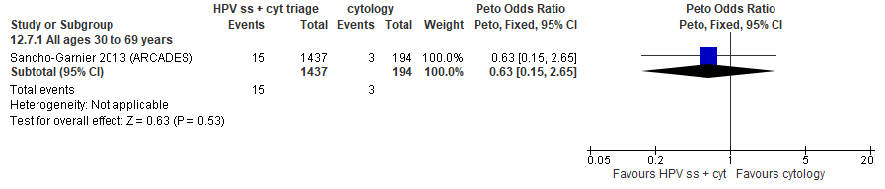
Forest plot 8.7. False positives for CIN3+

Evidence Set 8.8. False positives for invasive cervical cancer
Included report: Sancho-Garnier 2013 (ARCADES)
GRADE Summary of Findings Table 8.8. False positives for invasive cervical cancer
Outcome  No. participantsª  (studies) |  | Relative effects, Peto OR and RR (95 % CI) | Anticipated absolute effects |  |  | Certainty of evidence (GRADE)^{b} | What happens?
 |  | Relative effects, Peto OR and RR (95 % CI) | With cytology screening | With hrHPV screening via self-sampling + cytology triage | Difference | Certainty of evidence (GRADE)^{b} | What happens?
People with a cervix aged 30 to 69 years (Sancho-Garnier 2013 (ARCADES); acceptors of screening, select population)
False positives for invasive cervical cancer  Follow-up: 1 round  1,631 (1 RCT) | Peto OR: 0.39 (0.11 to 1.38)  RR: 0.40 (0.11 to 1.37) |  | 257.7 per 10,000 | 102.1 per 10,000 | 155.6 less per 10,000 (228.7 less to 94.5 more) | 25-29 yrs:  VERY LOW  ⊕⊝⊝⊝  NR  30-59 yrs:  VERY LOW^{c}  ⊕⊝⊝⊝  due to risk of bias, lack of evidence of consistency, indirectness  60-69 yrs:  VERY LOW^{d}  ⊕⊝⊝⊝  due to risk of bias, lack of evidence of consistency, and (very serious) indirectness | Among screened people with a cervix aged 25 to 69 years, we are very uncertain about the effect of hrHPV self-sampling with cytology triage on the number of false positives for invasive cervical cancer compared with cytology screening.
CI = confidence interval; OR = odds ratio; RCT = randomized controlled trial; RR = relative risk.
ªAcceptors of screening, select population include participants who were randomized and accepted the offer to be screened, and attended colposcopy following a positive test (akin to a screened per protocol analysis).
^{b}We rated down by 0.5 for “some concerns”, 1 “serious concerns”, and 2 for “very serious concerns”. When our assessment of the certainty of evidence fell between levels, we assigned the level that best represented our actual certainty in the evidence, and based our conclusions on this level of certainty.
Explanations:
^{c}Acceptors of screening, select population; people with a cervix aged 30 to 59 years: Serious concerns about risk of bias: risk of selection bias because randomization occurred before enrollment, without adequate information about baseline characteristics across groups. Participation rates were 2% in the cytology group and 82% in the hrHPV self-sampling group. Risk of attrition bias because 59% of participants in the self-sampling group did not complete the screening protocol compared with all of those in the cytology group (no triage required). Some concerns about inconsistency: lack of evidence for consistency due to single study. Serious concerns about indirectness: the study included only people who were of low socioeconomic status and who had not been screened in 2+ years, or had not responded to a first invitation for cytology screening. No serious concerns for imprecision: 95% CI precise for little-to-no effect. No other serious concerns.
^{d}Acceptors of screening, select population; people with a cervix aged 60 to 69 years: Serious concerns about risk of bias: risk of selection bias because randomization occurred before enrollment, without adequate information about baseline characteristics across groups. Participation rates were 2% in the cytology group and 82% in the hrHPV self-sampling group. Risk of attrition bias because 59% of participants in the self-sampling group did not complete the screening protocol compared with all of those in the cytology group (no triage required). Some concerns about inconsistency: lack of evidence for consistency due to single study. Very serious concerns about indirectness: the study included only people who were of low socioeconomic status and who had not been screened in 2+ years, or had not responded to a first invitation for cytology screening; concerns due to small sample in this age group (n=181/1,812 [10.0%] enrolled). No serious concerns for imprecision: 95% CI precise for little-to-no effect. No other serious concerns.

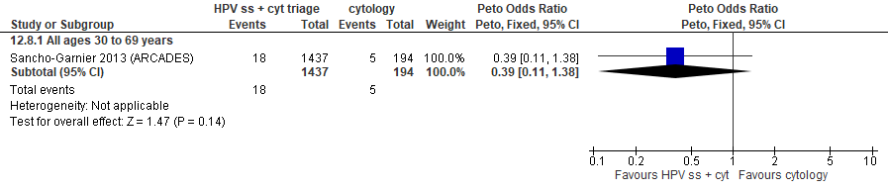
Forest plot 8.8. False positives for invasive cervical cancer

Evidence set 9.0: hrHPV screening via self-sampling (threshold NR) with liquid-based cytology triage of types other than 16/18 versus liquid-based cytology with hrHPV triage of ≥ASCUS
Included report: Viviano 2017 (Geneva) (ages 25-69 [no additional subgroups])

Evidence Set 9.1. Referrals to colposcopy
GRADE Summary of Findings Table 9.1. Referrals to colposcopy
Outcome  No. participantsª  (studies) |  | Relative effects, Peto OR and RR (95 % CI) | Anticipated absolute effects |  |  | Certainty of evidence (GRADE)^{b} | What happens?
 |  | Relative effects, Peto OR and RR (95 % CI) | With cytology screening + hrHPV triage of ≥ASCUS | With hrHPV self-sampling + cytology triage of types other than 16/18 | Difference | Certainty of evidence (GRADE)^{b} | What happens?
People with a cervix aged 25 to 69 years (Viviano 2017 (Geneva); acceptors of screening)
Referrals to colposcopy  Follow-up: 1 round  618 (1 RCT) | Peto OR: 1.21 (0.73 to 2.01)  RR: 1.19 (0.75 to 1.83) |  | 977.2 per 10,000 | 1158.6 per 10,000 | 181.4 more per 10,000 (244.5 less to 810.5 more) | 25-29 yrs:  VERY LOW^{c}  ⊕⊝⊝⊝  due to lack of evidence of consistency, (very serious) indirectness, and imprecision  30-59yrs:  VERY LOW^{d}  ⊕⊝⊝⊝  due to lack of evidence of consistency, indirectness, and imprecision  60-69yrs:  VERY LOW^{e}  ⊕⊝⊝⊝  due to lack of evidence of consistency, (very serious) indirectness, and imprecision | Among people with a cervix aged 25 to 69 years, we are very uncertain about the effect of hrHPV testing via self-sampling with liquid-based cytology triage of genotypes other than 16/18 on the rate of referral to colposcopy compared with liquid-based cytology testing with hrHPV triage.
CI = confidence interval; OR = odds ratio; RCT = randomized controlled trial; RR = relative risk.
ªAcceptors of screening include all participants who were randomized and completed one round of the screening via the strategy to which they were randomly assigned.
^{b}We rated down by 0.5 for “some concerns”, 1 “serious concerns”, and 2 for “very serious concerns”. When our assessment of the certainty of evidence fell between levels, we assigned the level that best represented our actual certainty in the evidence, and based our conclusions on this level of certainty.
Explanations:
^{c}Acceptors of screening; people with a cervix aged 25 to 29 years: No serious concerns about risk of bias: no domains judged as high risk. Some concerns about inconsistency: lack of evidence for consistency due to single study. Very serious concerns about indirectness: all participants were underscreened (had not undergone cervical screening in the previous 3 years or had never been screened); concerns due to small sample for this age group (n=NR). Serious concerns about imprecision: upper limit of 95% CI indicate an increased effect. No other serious concerns.
^{d}Acceptors of screening; people with a cervix aged 30 to 59 years: No serious concerns about risk of bias: no domains judged as high risk. Some concerns about inconsistency: lack of evidence for consistency due to single study. Serious concerns about indirectness: all participants were underscreened (had not undergone cervical screening in the previous 3 years or had never been screened). Serious concerns about imprecision: upper limit of 95% CI indicate an increased effect. No other serious concerns.
^{e}Acceptors of screening; people with a cervix aged 60 to 69 years: No serious concerns about risk of bias: no domains judged as high risk. Some concerns about inconsistency: lack of evidence for consistency due to single study. Very serious concerns about indirectness: all participants were underscreened (had not undergone cervical screening in the previous 3 years or had never been screened); concerns due to small sample for this age group (n=NR). Serious concerns about imprecision: upper limit of 95% CI indicate an increased effect. No other serious concerns.

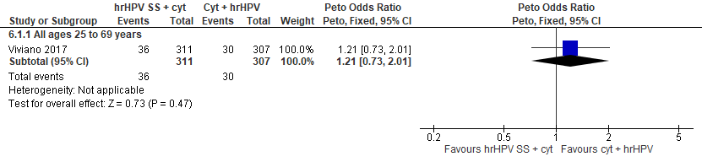
Forest Plot 9.1. Referrals to colposcopy

Evidence Set 9.2. Number of colposcopies
Included report: Viviano 2017 (Geneva)
GRADE Summary of Findings Table 9.2. Number of colposcopies
Outcome  No. participantsª  (studies) |  | Relative effects, Peto OR and RR (95 % CI) | Anticipated absolute effects |  |  | Certainty of evidence (GRADE)^{b} | What happens?
 |  | Relative effects, Peto OR and RR (95 % CI) | With cytology screening + hrHPV triage of ≥ASCUS | With hrHPV self-sampling + cytology triage of types other than 16/18 | Difference | Certainty of evidence (GRADE)^{b} | What happens?
People with a cervix aged 25 to 69 years (Viviano 2017 (Geneva); acceptors of screening)
Number of colposcopies  Follow-up: 1 round  618 (1 RCT) | Peto OR: 1.20 (0.69 to 2.09)  RR: 1.18 (0.71 to 1.92) |  | 814.3 per 10,000 | 961.5 per 10,000 | 147.2 more per 10,000 (237.9 less to 748.9 more) | 25-29 yrs:  VERY LOW^{c}  ⊕⊝⊝⊝  due to lack of evidence of consistency, (very serious) indirectness, and imprecision  30-59yrs:  VERY LOW^{d}  ⊕⊝⊝⊝  due to lack of evidence of consistency, indirectness, and imprecision  60-69 yrs:  VERY LOW^{e}  ⊕⊝⊝⊝  due to lack of evidence of consistency, (very serious) indirectness, and imprecision | Among people with a cervix aged 25 to 69 years, we are very uncertain about the effect of hrHPV testing via self-sampling with liquid-based cytology triage of genotypes other than 16/18 on the number of colposcopies compared with liquid-based cytology testing with hrHPV triage.
CI = confidence interval; OR = odds ratio; RCT = randomized controlled trial; RR = relative risk.
ªAcceptors of screening include all participants who were randomized and completed one round of the screening via the strategy to which they were randomly assigned.
^{b}We rated down by 0.5 for “some concerns”, 1 “serious concerns”, and 2 for “very serious concerns”. When our assessment of the certainty of evidence fell between levels, we assigned the level that best represented our actual certainty in the evidence, and based our conclusions on this level of certainty.
Explanations:
^{c}Acceptors of screening; people with a cervix aged 25 to 29 years: No serious concerns about risk of bias: no domains judged as high risk. Some concerns about inconsistency: lack of evidence for consistency due to single study. Very serious concerns about indirectness: all participants were underscreened (had not undergone cervical screening in the previous 3 years or had never been screened); concerns due to small sample for this age group (n=NR). Serious concerns about imprecision: upper limit of 95% CI indicate an increased effect. No other serious concerns.
^{d}Acceptors of screening; people with a cervix aged 30 to 59 years: No serious concerns about risk of bias: no domains judged as high risk. Some concerns about inconsistency: lack of evidence for consistency due to single study. Serious concerns about indirectness: all participants were underscreened (had not undergone cervical screening in the previous 3 years or had never been screened). Serious concerns about imprecision: upper limit of 95% CI indicate an increased effect. No other serious concerns.
^{e}Acceptors of screening; people with a cervix aged 60 to 69 years: No serious concerns about risk of bias: no domains judged as high risk. Some concerns about inconsistency: lack of evidence for consistency due to single study. Very serious concerns about indirectness: all participants were underscreened (had not undergone cervical screening in the previous 3 years or had never been screened); concerns due to small sample for this age group (n=NR). Serious concerns about imprecision: upper limit of 95% CI indicate an increased effect. No other serious concerns.

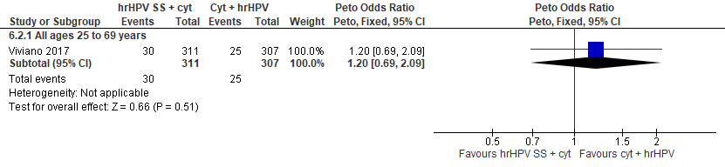
Forest Plot 9.2. Number of colposcopies

Evidence Set 9.3. Detection of CIN2+ (as an indirect indicator of the incidence of CIN3+)
Included report: Viviano 2017 (Geneva)
GRADE Summary of Findings Table 9.3. Detection of CIN2+ (as an indirect indicator of the incidence of CIN3+)
Outcome  No. participantsª  (studies) |  | Relative effects, Peto OR and RR (95 % CI) | Anticipated absolute effects |  |  | Certainty of evidence (GRADE)^{b} | What happens?
 |  | Relative effects, Peto OR and RR (95 % CI) | With cytology screening + hrHPV triage of ≥ASCUS | With hrHPV self-sampling + cytology triage of types other than 16/18 | Difference | Certainty of evidence (GRADE)^{b} | What happens?
People with a cervix aged 25 to 69 years (Viviano 2017 (Geneva); acceptors of screening, select population)
Detection of CIN2+  Follow-up: 1 round  602 (1 RCT) | Peto OR: 2.40 (0.83 to 6.93)  RR: 2.36 (0.83 to 6.42) |  | 132.9 per 10,000 | 313.1 per 10,000 | 180.2 more per 10,000 (22.3 less to 720.8 more) | 25-29 yrs:  VERY LOW^{c}  ⊕⊝⊝⊝  due to lack of evidence of consistency, (very serious) indirectness, and imprecision  30-59 yrs:  VERY LOW^{d}  ⊕⊝⊝⊝  due to lack of evidence of consistency, (very serious) indirectness, and imprecision  60-69 yrs:  VERY LOW^{e}  ⊕⊝⊝⊝  due to lack of evidence of consistency, (very serious) indirectness, and imprecision | Among people with a cervix aged 25 to 69 years, we are very uncertain about the effect of hrHPV testing via self-sampling with liquid-based cytology triage of genotypes other than 16/18 on the incidence of CIN3+ compared with liquid-based cytology testing with hrHPV triage.
CI = confidence interval; CIN = cervical intraepithelial neoplasia; OR = odds ratio; RCT = randomized controlled trial; RR = relative risk.
ªAcceptors of screening, select population include all participants who were randomized and completed one round of the screening via the strategy to which they were randomly assigned, including colposcopy following a positive test.
^{b}We rated down by 0.5 for “some concerns”, 1 “serious concerns”, and 2 for “very serious concerns”. When our assessment of the certainty of evidence fell between levels, we assigned the level that best represented our actual certainty in the evidence, and based our conclusions on this level of certainty.
Explanations:
^{c}Acceptors of screening, select population; people with a cervix aged 25 to 29 years: No serious concerns about risk of bias: no domains judged as high risk. Some concerns about inconsistency: lack of evidence for consistency due to single study. Very serious concerns about indirectness: all participants were underscreened (had not undergone cervical screening in the previous 3 years or had never been screened); detection is an indirect measure of incidence; concerns due to small sample for this age group (n=NR). Serious concerns about imprecision: lower limit of 95% CI indicates little-to-no effect. No other serious concerns.
^{d}Acceptors of screening, select population; people with a cervix aged 30 to 59 years: No serious concerns about risk of bias: no domains judged as high risk. Some concerns about inconsistency: lack of evidence for consistency due to single study. Very serious concerns about indirectness: all participants were underscreened (had not undergone cervical screening in the previous 3 years or had never been screened); detection is an indirect measure of incidence. Serious concerns about imprecision: lower limit of 95% CI indicates little-to-no effect. No other serious concerns.
^{e}Acceptors of screening, select population; people with a cervix aged 60 to 69 years: No serious concerns about risk of bias: no domains judged as high risk. Some concerns about inconsistency: lack of evidence for consistency due to single study. Very serious concerns about indirectness: all participants were underscreened (had not undergone cervical screening in the previous 3 years or had never been screened); detection is an indirect measure of incidence; concerns due to small sample for this age group (n=NR). Serious concerns about imprecision: lower limit of 95% CI indicates little-to-no effect. No other serious concerns.

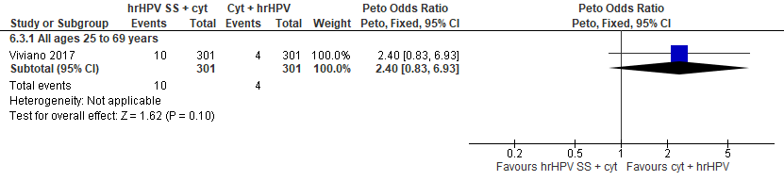
Forest Plot 9.3. Detection of CIN2+ (as an indirect indicator of the incidence of CIN3+)

Evidence Set 9.4. Detection of CIN3 (as an indirect indicator of the incidence of ICC)
Included report: Viviano 2017 (Geneva)
GRADE Summary of Findings Table 9.4. Detection of CIN3 (as an indirect indicator of the incidence of ICC)
Outcome  No. participantsª  (studies) |  | Relative effects, Peto OR and RR (95 % CI) | Anticipated absolute effects |  |  | Certainty of evidence (GRADE)^{b} | What happens?
 |  | Relative effects, Peto OR and RR (95 % CI) | With cytology screening + hrHPV triage of ≥ASCUS | With hrHPV self-sampling + cytology triage of types other than 16/18 | Difference | Certainty of evidence (GRADE)^{b} | What happens?
People with a cervix aged 25 to 69 years (Viviano 2017 (Geneva); acceptors of screening, select population)
Detection of CIN3  Follow-up: 1 round  602 (1 RCT) | Peto OR: 1.50 (0.43 to 5.23)  RR: 1.49 (0.43 to 4.95) |  | 132.9 per 10,000 | 198.0 per 10,000 | 65.1 more per 10,000 (75.3 less to 525.1 more) | 25-29 yrs:  VERY LOW^{c}  ⊕⊝⊝⊝  due to lack of evidence of consistency, (very serious) indirectness, and imprecision  30-59 yrs:  VERY LOW^{d}  ⊕⊝⊝⊝  due to lack of evidence of consistency, (very serious) indirectness, and imprecision  60-69 yrs:  VERY LOW^{e}  ⊕⊝⊝⊝  due to lack of evidence of consistency, (very serious) indirectness, and imprecision | Among people with a cervix aged 25 to 69 years, we are very uncertain about the effect of hrHPV testing via self-sampling with liquid-based cytology triage of genotypes other than 16/18 on the incidence of invasive cervical cancer compared with liquid-based cytology testing with hrHPV triage.
CI = confidence interval; CIN = cervical intraepithelial neoplasia; OR = odds ratio; RCT = randomized controlled trial; RR = relative risk.
ªAcceptors of screening, select population include all participants who were randomized and completed one round of the screening via the strategy to which they were randomly assigned, including colposcopy following a positive test.
^{b}We rated down by 0.5 for “some concerns”, 1 “serious concerns”, and 2 for “very serious concerns”. When our assessment of the certainty of evidence fell between levels, we assigned the level that best represented our actual certainty in the evidence, and based our conclusions on this level of certainty.
Explanations:
^{c}Acceptors of screening, select population; people with a cervix aged 25 to 29 years: No serious concerns about risk of bias: no domains judged as high risk. Some concerns about inconsistency: lack of evidence for consistency due to single study. Very serious concerns about indirectness: all participants were underscreened (had not undergone cervical screening in the previous 3 years or had never been screened); detection is an indirect measure of incidence; concerns due to small sample for this age group (n=NR). Serious concerns about imprecision: lower limit of 95% CI indicates reduced effect. No other serious concerns.
^{d}Acceptors of screening, select population; people with a cervix aged 30 to 59 years: No serious concerns about risk of bias: no domains judged as high risk. Some concerns about inconsistency: lack of evidence for consistency due to single study. Very serious concerns about indirectness: all participants were underscreened (had not undergone cervical screening in the previous 3 years or had never been screened); detection is an indirect measure of incidence. Serious concerns about imprecision: lower limit of 95% CI indicates reduced effect. No other serious concerns.
^{e}Acceptors of screening, select population; people with a cervix aged 60 to 69 years: No serious concerns about risk of bias: no domains judged as high risk. Some concerns about inconsistency: lack of evidence for consistency due to single study. Very serious concerns about indirectness: all participants were underscreened (had not undergone cervical screening in the previous 3 years or had never been screened); detection is an indirect measure of incidence; concerns due to small sample for this age group (n=NR). Serious concerns about imprecision: lower limit of 95% CI indicates reduced effect. No other serious concerns.

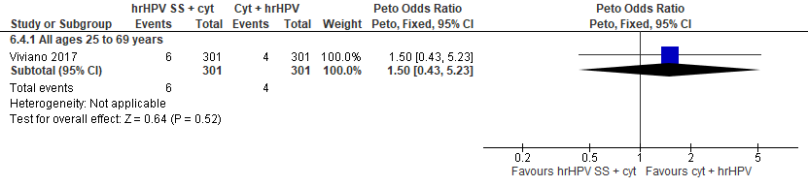
Forest Plot 9.4. Detection of CIN3 (as an indirect indicator of the incidence of ICC)

Evidence Set 9.5. False positives for CIN2+
Included report: Viviano 2017 (Geneva)
GRADE Summary of Findings Table 9.5. False positives for CIN2+
Outcome  No. participantsª  (studies) |  | Relative effects, Peto OR and RR (95 % CI) | Anticipated absolute effects |  |  | Certainty of evidence (GRADE)^{b} | What happens?
 |  | Relative effects, Peto OR and RR (95 % CI) | With cytology screening + hrHPV triage of ≥ASCUS | With hrHPV self-sampling + cytology triage of types other than 16/18 | Difference | Certainty of evidence (GRADE)^{b} | What happens?
People with a cervix aged 25 to 69 years (Viviano 2017 (Geneva); acceptors of screening, select population)
False positives for CIN2+  Follow-up: 1 round  602 (1 RCT) | Peto OR: 0.95 (0.50 to 1.79)  RR: 0.95 (0.52 to 1.70) |  | 697.7 per 10,000 | 665.1 per 10,000 | 32.6 less per 10,000 (336.2 less to 485.9 more) | 25-29 yrs:  VERY LOW^{c}  ⊕⊝⊝⊝  due to lack of evidence of consistency, (very serious) indirectness, and imprecision  30-59 yrs:  VERY LOW^{d}  ⊕⊝⊝⊝  due to lack of evidence of consistency, indirectness, and imprecision  60-69 yrs:  VERY LOW^{e}  ⊕⊝⊝⊝  due to lack of evidence of consistency, (very serious) indirectness, and imprecision | Among people with a cervix aged 25 to 69 years, we are very uncertain about the effect of hrHPV testing via self-sampling with liquid-based cytology triage of genotypes other than 16/18 on the number of false positives for CIN2+ compared with liquid-based cytology testing with hrHPV triage.
CI = confidence interval; CIN = cervical intraepithelial neoplasia; OR = odds ratio; RCT = randomized controlled trial; RR = relative risk.
ªAcceptors of screening, select population include all participants who were randomized and completed one round of the screening via the strategy to which they were randomly assigned, including colposcopy following a positive test.
^{b}We rated down by 0.5 for “some concerns”, 1 “serious concerns”, and 2 for “very serious concerns”. When our assessment of the certainty of evidence fell between levels, we assigned the level that best represented our actual certainty in the evidence, and based our conclusions on this level of certainty.
Explanations:
^{c}Acceptors of screening, select population; people with a cervix aged 25 to 29 years: No serious concerns about risk of bias: no domains judged as high risk. Some concerns about inconsistency: lack of evidence for consistency due to single study. Very serious concerns about indirectness: all participants were underscreened (had not undergone cervical screening in the previous 3 years or had never been screened); concerns due to small sample for this age group (n=NR). Serious concerns about imprecision: lower and upper limit of 95% CI indicates reduced and increased effect. No other serious concerns.
^{d}Acceptors of screening, select population; people with a cervix aged 30 to 59 years: No serious concerns about risk of bias: no domains judged as high risk. Some concerns about inconsistency: lack of evidence for consistency due to single study. Serious concerns about indirectness: all participants were underscreened (had not undergone cervical screening in the previous 3 years or had never been screened). Serious concerns about imprecision: lower and upper limit of 95% CI indicates reduced and increased effect. No other serious concerns.
^{e}Acceptors of screening, select population; people with a cervix aged 60 to 69 years: No serious concerns about risk of bias: no domains judged as high risk. Some concerns about inconsistency: lack of evidence for consistency due to single study. Very serious concerns about indirectness: all participants were underscreened (had not undergone cervical screening in the previous 3 years or had never been screened); concerns due to small sample for this age group (n=NR). Serious concerns about imprecision: lower and upper limit of 95% CI indicates reduced and increased effect. No other serious concerns.

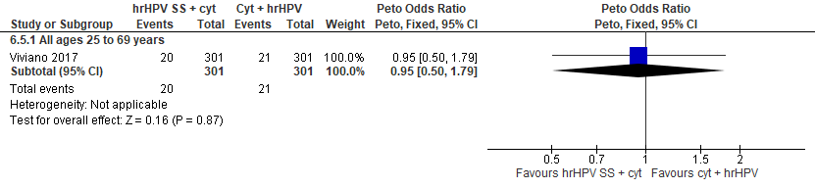
Forest Plot 9.5. False positives for CIN2+

Evidence Set 9.6. False positives for CIN3
Included report: Viviano 2017 (Geneva)
GRADE Summary of Findings Table 9.6. False positives for CIN3
Outcome  No. participantsª  (studies) |  | Relative effects, Peto OR and RR (95 % CI) | Anticipated absolute effects |  |  | Certainty of evidence (GRADE)^{b} | What happens?
 |  | Relative effects, Peto OR and RR (95 % CI) | With cytology screening + hrHPV triage of ≥ASCUS | With hrHPV self-sampling + cytology triage of types other than 16/18 | Difference | Certainty of evidence (GRADE)^{b} | What happens?
People with a cervix aged 25 to 69 years (Viviano 2017 (Geneva); acceptors of screening, select population)
False positives for CIN3  Follow-up: 1 round  602 (1 RCT) | Peto OR: 1.15 (0.63 to 2.12)  RR: 1.14 (0.65 to 1.97) |  | 697.7 per 10,000 | 794.0 per 10,000 | 96.3 more per 10,000 (246.5 less to 674.2 more) | 25-29 yrs:  VERY LOW^{c}  ⊕⊝⊝⊝  due to lack of evidence of consistency, (very serious) indirectness, and imprecision  30-59 yrs:  VERY LOW^{d}  ⊕⊝⊝⊝  due to lack of evidence of consistency, indirectness, and imprecision  60-69 yrs:  VERY LOW^{e}  ⊕⊝⊝⊝  due to lack of evidence of consistency, (very serious) indirectness, and imprecision | Among people with a cervix aged 25 to 69 years, we are very uncertain about the effect of hrHPV testing via self-sampling with liquid-based cytology triage of genotypes other than 16/18 on the number of false positives for CIN3 compared with liquid-based cytology testing with hrHPV triage.
CI = confidence interval; CIN = cervical intraepithelial neoplasia; OR = odds ratio; RCT = randomized controlled trial; RR = relative risk.
ªAcceptors of screening, select population include all participants who were randomized and completed one round of the screening via the strategy to which they were randomly assigned, including colposcopy following a positive test.
^{b}We rated down by 0.5 for “some concerns”, 1 “serious concerns”, and 2 for “very serious concerns”. When our assessment of the certainty of evidence fell between levels, we assigned the level that best represented our actual certainty in the evidence, and based our conclusions on this level of certainty.
Explanations:
^{c}Acceptors of screening, select population; people with a cervix aged 25 to 29 years: No serious concerns about risk of bias: no domains judged as high risk. Some concerns about inconsistency: lack of evidence for consistency due to single study. Very serious concerns about indirectness: all participants were underscreened (had not undergone cervical screening in the previous 3 years or had never been screened); concerns due to small sample for this age group (n=NR). Serious concerns about imprecision: upper limit of 95% CI indicates increased effect. No other serious concerns.
^{d}Acceptors of screening, select population; people with a cervix aged 30 to 59 years: No serious concerns about risk of bias: no domains judged as high risk. Some concerns about inconsistency: lack of evidence for consistency due to single study. Serious concerns about indirectness: all participants were underscreened (had not undergone cervical screening in the previous 3 years or had never been screened). Serious concerns about imprecision: upper limit of 95% CI indicates increased effect. No other serious concerns.
^{e}Acceptors of screening, select population; people with a cervix aged 60 to 69 years: No serious concerns about risk of bias: no domains judged as high risk. Some concerns about inconsistency: lack of evidence for consistency due to single study. Very serious concerns about indirectness: all participants were underscreened (had not undergone cervical screening in the previous 3 years or had never been screened); concerns due to small sample for this age group (n=NR). Serious concerns about imprecision: upper limit of 95% CI indicates increased effect. No other serious concerns.

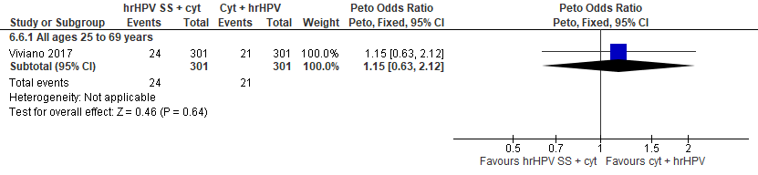
Forest Plot 9.6. False positives for CIN3

Evidence Set 10.0: hrHPV screening via self-sampling (threshold 1.0 RLU) vs. conventional cytology screening (threshold ≥mild dyskaryosis)
Included report: Szarewski 2011 (Westminster) (ages 25-64 [no additional subgroups])

Evidence Set 10.1. Referrals to colposcopy
GRADE Summary of Findings Table 10.1. Referrals to colposcopy
Outcome  No. participantsª  (studies) |  | Relative effects, Peto OR and RR (95 % CI) | Anticipated absolute effects |  |  | Certainty of evidence (GRADE)^{b} | What happens?
 |  | Relative effects, Peto OR and RR (95 % CI) | With cytology screening | With hrHPV screening | Difference | Certainty of evidence (GRADE)^{b} | What happens?
People with a cervix aged 25 to 69 years (Szarewski 2011(Westminster); acceptors of screening)
Referrals to colposcopy  Follow-up: 1 round  164 (1 RCT) | Peto OR: 3.73 (0.96 to 14.51)  RR: 3.59 (0.96 to 12.11) |  | 147.1 per 10,000 | 527.4 per 10,000 | 380.3 more per 10,000 (5.8 less to 1633.1 more) | 25-29 yrs:  VERY LOW^{c}  ⊕⊝⊝⊝  due to lack of evidence of consistency, indirectness and (very serious) imprecision  30-59 yrs:  VERY LOW^{d}  ⊕⊝⊝⊝  due to lack of evidence of consistency, indirectness and imprecision  60-69 yrs:  VERY LOW^{e}  ⊕⊝⊝⊝  due to lack of evidence of consistency, (very serious) indirectness and imprecision | Among people with a cervix aged 25 to 69 years, we are very uncertain about the effect of hrHPV testing via self-sampling on the rate of referral to colposcopy compared with cytology testing.
CI = confidence interval; OR = odds ratio; RCT = randomized controlled trial; RR = relative risk.
ªAcceptors of screening include participants who were randomized and accepted the offer to be screened.
^{b}We rated down by 0.5 for “some concerns”, 1 “serious concerns”, and 2 for “very serious concerns”. When our assessment of the certainty of evidence fell between levels, we assigned the level that best represented our actual certainty in the evidence, and based our conclusions on this level of certainty.
Explanations:
^{c}Acceptors of screening; people with a cervix aged 25 to 29 years: No serious concerns about risk of bias: no domains judged high risk. Some concerns about inconsistency: lack of evidence for consistency due to single study. Very serious concerns about indirectness: all participants were non-responders had not responded to at least two invitations to attend for screening); concerns due to small sample for this age group (n=NR). Serious concerns about imprecision: lower limit of 95% CI indicates little-to-no effect. No other serious concerns.
^{d}Acceptors of screening; people with a cervix aged 30 to 59 years: No serious concerns about risk of bias: no domains judged high risk. Some concerns about inconsistency: lack of evidence for consistency due to single study. Serious concerns about indirectness: all participants were non-responders had not responded to at least two invitations to attend for screening). Serious concerns about imprecision: lower limit of 95% CI indicates little-to-no effect. No other serious concerns.
^{e}Acceptors of screening; people with a cervix aged 60 to 69 years: No serious concerns about risk of bias: no domains judged high risk. Some concerns about inconsistency: lack of evidence for consistency due to single study. Very serious concerns about indirectness: all participants were non-responders had not responded to at least two invitations to attend for screening); concerns due to small sample for this age group (n=NR). Serious concerns about imprecision: lower limit of 95% CI indicates little-to-no effect. No other serious concerns.

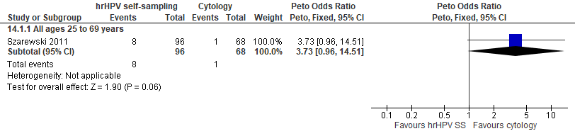
Forest plot 10.1. Referrals to colposcopy

Evidence Set 10.2. Number of colposcopies
Included report: Szarewski 2011 (Westminster)
GRADE Summary of Findings Table 10.2. Number of colposcopies
Outcome  No. participantsª  (studies) |  | Relative effects, Peto OR and RR (95 % CI) | Anticipated absolute effects |  |  | Certainty of evidence (GRADE)^{b} | What happens?
 |  | Relative effects, Peto OR and RR (95 % CI) | With cytology screening | With hrHPV screening | Difference | Certainty of evidence (GRADE)^{b} | What happens?
People with a cervix aged 25 to 69 years (Szarewski 2011(Westminster); acceptors of screening)
Number of colposcopies  Follow-up: 1 round  164 (1 RCT) | Peto OR: 3.48 (0.83 to 14.65)  RR: 3.36 (0.83 to 12.20) |  | 147.1 per 10,000 | 493.8 per 10,000 | 346.7 more per 10,000 (24.7 less to 1647.2 more) | 25-29 yrs:  VERY LOW^{c}  ⊕⊝⊝⊝  due to lack of evidence of consistency, (very serious) indirectness, and imprecision  30-59 yrs:  VERY LOW^{d}  ⊕⊝⊝⊝  due to lack of evidence of consistency, indirectness, and imprecision  60-69 yrs:  VERY LOW^{e}  ⊕⊝⊝⊝  due to lack of evidence of consistency, (very serious) indirectness, and imprecision | Among people with a cervix aged 25 to 69 years, we are very uncertain about the effect of hrHPV testing via self-sampling on the number of colposcopies compared with cytology testing.
CI = confidence interval; OR = odds ratio; RCT = randomized controlled trial; RR = relative risk.
ªAcceptors of screening include participants who were randomized and accepted the offer to be screened.
^{b}We rated down by 0.5 for “some concerns”, 1 “serious concerns”, and 2 for “very serious concerns”. When our assessment of the certainty of evidence fell between levels, we assigned the level that best represented our actual certainty in the evidence, and based our conclusions on this level of certainty.
Explanations:
^{c}Acceptors of screening; people with a cervix aged 25 to 29 years: No serious concerns about risk of bias: no domains judged high risk. Some concerns about inconsistency: lack of evidence for consistency due to single study. Very serious concerns about indirectness: all participants were non-responders had not responded to at least two invitations to attend for screening); concerns due to small sample for this age group (n=NR). Serious concerns about imprecision: lower limit of 95% CI indicates little-to-no effect. No other serious concerns.
^{d}Acceptors of screening; people with a cervix aged 30 to 59 years: No serious concerns about risk of bias: no domains judged high risk. Some concerns about inconsistency: lack of evidence for consistency due to single study. Serious concerns about indirectness: all participants were non-responders had not responded to at least two invitations to attend for screening). Serious concerns about imprecision: lower limit of 95% CI indicates little-to-no effect. No other serious concerns.
^{e}Acceptors of screening; people with a cervix aged 60 to 69 years: No serious concerns about risk of bias: no domains judged high risk. Some concerns about inconsistency: lack of evidence for consistency due to single study. Very serious concerns about indirectness: all participants were non-responders had not responded to at least two invitations to attend for screening); concerns due to small sample for this age group (n=NR). Serious concerns about imprecision: lower limit of 95% CI indicates little-to-no effect. No other serious concerns.

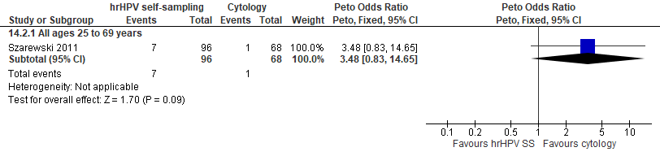
Forest plot 10.2. Number of colposcopies

Evidence Set 10.3. Detection of CIN2+ (as an indirect indicator of the incidence of CIN3+)
Included report: Szarewski 2011 (Westminster)
GRADE Summary of Findings Table 10.3. Detection of CIN2+ (as an indirect indicator of the incidence of CIN3+)
Outcome  No. participantsª  (studies) |  | Relative effects, Peto OR and RR (95 % CI) | Anticipated absolute effects |  |  | Certainty of evidence (GRADE)^{b} | What happens?
 |  | Relative effects, Peto OR and RR (95 % CI) | With cytology screening | With hrHPV screening | Difference | Certainty of evidence (GRADE)^{b} | What happens?
People with a cervix aged 25 to 69 years (Szarewski 2011(Westminster); acceptors of screening)
Detection of CIN2+  Follow-up: 1 round  163 (1 RCT) | Peto OR: 2.01 (0.27 to 14.98)  RR: 1.98 (0.27 to 12.43) |  | 147.1 per 10,000 | 291.3 per 10,000 | 144.2 more per 10,000 (106.9 less to 1680.2 more) | 25-29 yrs yrs:  VERY LOW^{c}  ⊕⊝⊝⊝  due to lack of evidence of consistency, (very serious) indirectness, and imprecision  30-59 yrs:  VERY LOW^{d}  ⊕⊝⊝⊝  due to lack of evidence of consistency, (very serious) indirectness, and imprecision  60-69 yrs:  25-29 yrs yrs:  VERY LOW^{e}  ⊕⊝⊝⊝  due to lack of evidence of consistency, (very serious) indirectness, and imprecision | Among people with a cervix aged 25 to 69 years, we are very uncertain about the effect of hrHPV testing via self-sampling on incidence of CIN3+ compared with cytology testing.
CI = confidence interval; CIN = cervical intraepithelial neoplasia; OR = odds ratio; RCT = randomized controlled trial; RR = relative risk.
ªAcceptors of screening, select population include participants who were randomized, accepted the offer to be screened, and completed the screening protocol (including those who attended colposcopy following a positive test).
^{b}We rated down by 0.5 for “some concerns”, 1 “serious concerns”, and 2 for “very serious concerns”. When our assessment of the certainty of evidence fell between levels, we assigned the level that best represented our actual certainty in the evidence, and based our conclusions on this level of certainty.
Explanations:
^{c}Acceptors of screening; people with a cervix aged 25 to 29 years: No serious concerns about risk of bias: no domains judged high risk. Some concerns about inconsistency: lack of evidence for consistency due to single study. Very serious concerns about indirectness: all participants were non-responders (had not responded to at least two invitations to attend for screening); detection is an indirect measure of incidence; concerns due to small sample for this age group (n=NR). Serious concerns about imprecision: lower limit of 95% CI indicates a reduced effect. No other serious concerns.
^{d}Acceptors of screening; people with a cervix aged 30 to 59 years: No serious concerns about risk of bias: no domains judged high risk. Some concerns about inconsistency: lack of evidence for consistency due to single study. Very serious concerns about indirectness: all participants were non-responders (had not responded to at least two invitations to attend for screening). Detection is an indirect measure of incidence. Serious concerns about imprecision: lower limit of 95% CI indicates a reduced effect. No other serious concerns.
^{e}Acceptors of screening; people with a cervix aged 60 to 69 years: No serious concerns about risk of bias: no domains judged high risk. Some concerns about inconsistency: lack of evidence for consistency due to single study. Very serious concerns about indirectness: all participants were non-responders (had not responded to at least two invitations to attend for screening); detection is an indirect measure of incidence; concerns due to small sample for this age group (n=NR). Serious concerns about imprecision: lower limit of 95% CI indicates a reduced effect. No other serious concerns.

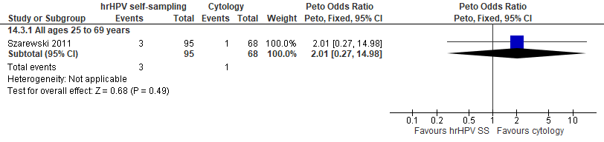
Forest plot 10.3. Detection of CIN2+ (as an indirect indicator of the incidence of CIN3+)

Evidence Set 10.4. Detection of CIN3+ (as an indirect indicator of the incidence of ICC)
Included report: Szarewski 2011 (Westminster)
GRADE Summary of Findings Table 10.4. Detection of CIN3+ (as an indirect indicator of the incidence of ICC)
Outcome  No. participantsª  (studies) |  | Relative effects, Peto OR and RR (95 % CI) | Anticipated absolute effects |  |  | Certainty of evidence (GRADE)^{b} | What happens?
 |  | Relative effects, Peto OR and RR (95 % CI) | With cytology screening | With hrHPV screening | Difference | Certainty of evidence (GRADE)^{b} | What happens?
People with a cervix aged 25 to 69 years (Szarewski 2011(Westminster); acceptors of screening)
Detection of CIN3+  Follow-up: 1 round  163 (1 RCT) | Peto OR: 1.42 (0.14 to 14.27)  RR: 1.41 (0.14 to 11.94) |  | 147.1 per 10,000 | 207.5 per 10,000 | 60.5 more per 10,000 (126.2 less to 1,608.8 more) | 25-29 yrs:  VERY LOW^{c}  ⊕⊝⊝⊝  due to lack of evidence of consistency, (very serious) indirectness, and imprecision  30-59 yrs:  VERY LOW^{d}  ⊕⊝⊝⊝  due to lack of evidence of consistency, (very serious) indirectness, and imprecision  60-69 yrs:  VERY LOW^{e}  ⊕⊝⊝⊝  due to lack of evidence of consistency, (very serious) indirectness, and imprecision | Among people with a cervix aged 25 to 69 years, we are very uncertain about the effect of hrHPV testing via self-sampling on incidence of invasive cervical cancer compared with cytology testing.
CI = confidence interval; CIN = cervical intraepithelial neoplasia; OR = odds ratio; RCT = randomized controlled trial; RR = relative risk.
ªAcceptors of screening, select population include participants who were randomized, accepted the offer to be screened, and completed the screening protocol (including those who attended colposcopy following a positive test).
^{b}We rated down by 0.5 for “some concerns”, 1 “serious concerns”, and 2 for “very serious concerns”. When our assessment of the certainty of evidence fell between levels, we assigned the level that best represented our actual certainty in the evidence, and based our conclusions on this level of certainty.
Explanations:
^{c}Acceptors of screening; people with a cervix aged 25 to 29 years: No serious concerns about risk of bias: no domains judged high risk. Some concerns about inconsistency: lack of evidence for consistency due to single study. Very serious concerns about indirectness: all participants were non-responders (had not responded to at least two invitations to attend for screening); detection is an indirect measure of incidence; concerns due to small sample for this age group (n=NR). Serious concerns about imprecision: lower limit of 95% CI indicates a reduced effect. No other serious concerns.
^{d}Acceptors of screening; people with a cervix aged 30 to 59 years: No serious concerns about risk of bias: no domains judged high risk. Some concerns about inconsistency: lack of evidence for consistency due to single study. Very serious concerns about indirectness: all participants were non-responders (had not responded to at least two invitations to attend for screening). Detection is an indirect measure of incidence. Serious concerns about imprecision: lower limit of 95% CI indicates a reduced effect. No other serious concerns.
^{e}Acceptors of screening; people with a cervix aged 60 to 69 years: No serious concerns about risk of bias: no domains judged high risk. Some concerns about inconsistency: lack of evidence for consistency due to single study. Very serious concerns about indirectness: all participants were non-responders (had not responded to at least two invitations to attend for screening); detection is an indirect measure of incidence; concerns due to small sample for this age group (n=NR). Serious concerns about imprecision: lower limit of 95% CI indicates a reduced effect. No other serious concerns.

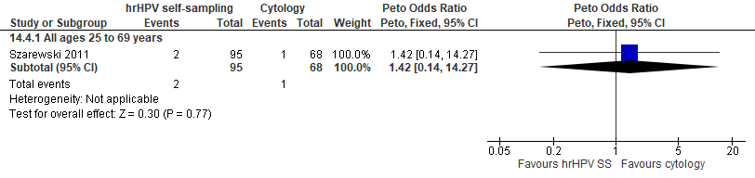
Forest plot 10.4. Detection of CIN3+ (as an indirect indicator of the incidence of ICC)

Evidence Set 10.5. Detection of invasive cervical cancer
Included report: Szarewski 2011 (Westminster)
GRADE Summary of Findings Table 10.5. Detection of invasive cervical cancer
Outcome  No. participantsª  (studies) |  | Relative effects, Peto OR and RR (95 % CI) | Anticipated absolute effects |  |  | Certainty of evidence (GRADE)^{b} | What happens?
 |  | Relative effects, Peto OR and RR (95 % CI) | With cytology screening | With hrHPV screening | Difference | Certainty of evidence (GRADE)^{b} | What happens?
People with a cervix aged 25 to 69 years (Szarewski 2011(Westminster); acceptors of screening)
Detection of invasive cervical cancer  Follow-up: 1 round  163 (1 RCT) | Peto OR: 5.56 (0.10 to 296.08)  RR: 5.56 (0.10 to 296.08) |  | 0.0 per 10,000 | 0.0 per 10,000 | No difference | 25-29 yrs:  VERY LOW^{c}  ⊕⊝⊝⊝  due to lack of evidence of consistency, (very serious) indirectness  30-59 yrs:  VERY LOW^{d}  ⊕⊝⊝⊝  due to lack of evidence of consistency, (very serious) indirectness, and imprecision  60-69 yrs:  VERY LOW^{e}  ⊕⊝⊝⊝  due to lack of evidence of consistency, (very serious) indirectness | Among people with a cervix aged 25 to 69 years, we are very uncertain about the effect of hrHPV testing via self-sampling on the detection of invasive cervical cancer compared with cytology testing.
CI = confidence interval; OR = odds ratio; RCT = randomized controlled trial; RR = relative risk.
ªAcceptors of screening, select population include participants who were randomized, accepted the offer to be screened, and completed the screening protocol (including those who attended colposcopy following a positive test).
^{b}We rated down by 0.5 for “some concerns”, 1 “serious concerns”, and 2 for “very serious concerns”. When our assessment of the certainty of evidence fell between levels, we assigned the level that best represented our actual certainty in the evidence, and based our conclusions on this level of certainty.
Explanations:
^{c}Acceptors of screening; people with a cervix aged 25 to 29 years: No serious concerns about risk of bias: no domains judged high risk. Some concerns about inconsistency: lack of evidence for consistency due to single study. Very serious concerns about indirectness: all participants were non-responders (had not responded to at least two invitations to attend for screening); detection is an indirect measure of incidence; concerns due to small sample for this age group (n=NR). No serious concerns about imprecision: 95% CI precise for little-to-no effect. No other serious concerns.
^{d}Acceptors of screening; people with a cervix aged 30 to 59 years: No serious concerns about risk of bias: no domains judged high risk. Some concerns about inconsistency: lack of evidence for consistency due to single study. Very serious concerns about indirectness: all participants were non-responders (had not responded to at least two invitations to attend for screening). Detection is an indirect measure of incidence. Serious concerns about imprecision: concerns due to small sample. No other serious concerns.
^{e}Acceptors of screening; people with a cervix aged 60 to 69 years: No serious concerns about risk of bias: no domains judged high risk. Some concerns about inconsistency: lack of evidence for consistency due to single study. Very serious concerns about indirectness: all participants were non-responders (had not responded to at least two invitations to attend for screening); detection is an indirect measure of incidence; concerns due to small sample for this age group (n=NR). No serious concerns about imprecision: 95% CI precise for little-to-no effect. No other serious concerns.

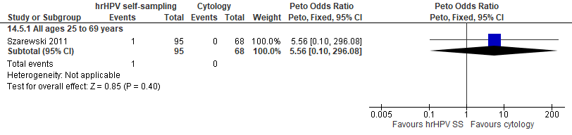
Forest plot 10.5. Detection of invasive cervical cancer

Evidence Set 10.6. False positives for CIN2+
Included report: Szarewski 2011 (Westminster)
GRADE Summary of Findings Table 10.6. False positives for CIN2+
Outcome  No. participantsª  (studies) |  | Relative effects, Peto OR and RR (95 % CI) | Anticipated absolute effects |  |  | Certainty of evidence (GRADE)^{b} | What happens?
 |  | Relative effects, Peto OR and RR (95 % CI) | With cytology screening | With hrHPV screening | Difference | Certainty of evidence (GRADE)^{b} | What happens?
People with a cervix aged 25 to 69 years (Szarewski 2011(Westminster); acceptors of screening)
False positives for CIN2+  Follow-up: 1 round  164 (1 RCT) | Peto OR: 5.70 (0.77 to 42.44)  RR: 5.70 (0.77 to 42.44) |  | 0.0 per 10,000 | 0.0 per 10,000 | No difference | 25-29 yrs:  VERY LOW^{b}  ⊕⊝⊝⊝  due to lack of evidence of consistency, and (very serious) indirectness  30-59 yrs:  VERY LOW^{d}  ⊕⊝⊝⊝  due to lack of evidence of consistency, indirectness, and imprecision  60-69 yrs:  VERY LOW^{e}  ⊕⊝⊝⊝  due to lack of evidence of consistency, and (very serious) indirectness | Among people with a cervix aged 25 to 69 years, we are very uncertain about the effect of hrHPV testing via self-sampling on false positives for CIN2+ compared with cytology testing.
CI = confidence interval; CIN = cervical intraepithelial neoplasia; OR = odds ratio; RCT = randomized controlled trial; RR = relative risk.
ªAcceptors of screening, select population include participants who were randomized, accepted the offer to be screened, and completed the screening protocol (including those who attended colposcopy following a positive test).
^{b}We rated down by 0.5 for “some concerns”, 1 “serious concerns”, and 2 for “very serious concerns”. When our assessment of the certainty of evidence fell between levels, we assigned the level that best represented our actual certainty in the evidence, and based our conclusions on this level of certainty.
Explanations:
^{c}Acceptors of screening; people with a cervix aged 25 to 29 years: No serious concerns about risk of bias: no domains judged high risk. Some concerns about inconsistency: lack of evidence for consistency due to single study. Very serious concerns about indirectness: all participants were non-responders (had not responded to at least two invitations to attend for screening); concerns due to small sample for this age group (n=NR). No serious concerns about imprecision: 95% CI precise for little-to-no effect. No other serious concerns.
^{d}Acceptors of screening; people with a cervix aged 30 to 59 years: No serious concerns about risk of bias: no domains judged high risk. Some concerns about inconsistency: lack of evidence for consistency due to single study. Serious concerns about indirectness: all participants were non-responders (had not responded to at least two invitations to attend for screening). Serious concerns about imprecision: concerns due to small sample. No other serious concerns.
^{e}Acceptors of screening; people with a cervix aged 60 to 69 years: No serious concerns about risk of bias: no domains judged high risk. Some concerns about inconsistency: lack of evidence for consistency due to single study. Very serious concerns about indirectness: all participants were non-responders (had not responded to at least two invitations to attend for screening); concerns due to small sample for this age group (n=NR). No serious concerns about imprecision: 95% CI precise for little-to-no effect. No other serious concerns.

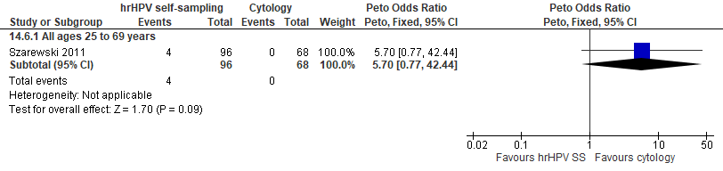
Forest plot 10.6. False positives for CIN2+

Evidence Set 10.7. False positives for CIN3+
Included report: Szarewski 2011 (Westminster)
GRADE Summary of Findings Table 10.7. False positives for CIN3+
Outcome  No. participantsª  (studies) |  | Relative effects, Peto OR and RR (95 % CI) | Anticipated absolute effects |  |  | Certainty of evidence (GRADE)^{b} | What happens?
 |  | Relative effects, Peto OR and RR (95 % CI) | With cytology screening | With hrHPV screening | Difference | Certainty of evidence (GRADE)^{b} | What happens?
People with a cervix aged 25 to 69 years (Szarewski 2011(Westminster); acceptors of screening)
False positives for CIN3+  Follow-up: 1 round  164 (1 RCT) | Peto OR: 5.76 (0.95 to 34.91)  RR: 5.76 (0.95 to 34.91) |  | 0.0 per 10,000 | 0.0 per 10,000 | No difference | 25-29 yrs:  VERY LOW^{c}  ⊕⊝⊝⊝  due to lack of evidence of consistency, (very serious) indirectness  30-59 yrs:  VERY LOW^{d}  ⊕⊝⊝⊝  due to lack of evidence of consistency, indirectness, and imprecision  60-69 yrs:  VERY LOW^{e}  ⊕⊝⊝⊝  due to lack of evidence of consistency, (very serious) indirectness | Among people with a cervix aged 25 to 69 years, we are very uncertain about the effect of hrHPV testing via self-sampling on false positives for CIN3+ compared with cytology testing.
CI = confidence interval; CIN = cervical intraepithelial neoplasia; OR = odds ratio; RCT = randomized controlled trial; RR = relative risk.
ªAcceptors of screening, select population include participants who were randomized, accepted the offer to be screened, and completed the screening protocol (including those who attended colposcopy following a positive test).
^{b}We rated down by 0.5 for “some concerns”, 1 “serious concerns”, and 2 for “very serious concerns”. When our assessment of the certainty of evidence fell between levels, we assigned the level that best represented our actual certainty in the evidence, and based our conclusions on this level of certainty.
Explanations:
^{c}Acceptors of screening; people with a cervix aged 25 to 29 years: No serious concerns about risk of bias: no domains judged high risk. Some concerns about inconsistency: lack of evidence for consistency due to single study. Very serious concerns about indirectness: all participants were non-responders (had not responded to at least two invitations to attend for screening); concerns due to small sample for this age group (n=NR). No serious concerns about imprecision: 95% CI precise for little-to-no effect. No other serious concerns.
^{d}Acceptors of screening; people with a cervix aged 30 to 59 years: No serious concerns about risk of bias: no domains judged high risk. Some concerns about inconsistency: lack of evidence for consistency due to single study. Serious concerns about indirectness: all participants were non-responders (had not responded to at least two invitations to attend for screening). Serious concerns about imprecision: concerns due to small sample. No other serious concerns.
^{e}Acceptors of screening; people with a cervix aged 60 to 69 years: No serious concerns about risk of bias: no domains judged high risk. Some concerns about inconsistency: lack of evidence for consistency due to single study. Very serious concerns about indirectness: all participants were non-responders (had not responded to at least two invitations to attend for screening); concerns due to small sample for this age group (n=NR). No serious concerns about imprecision: 95% CI precise for little-to-no effect. No other serious concerns.

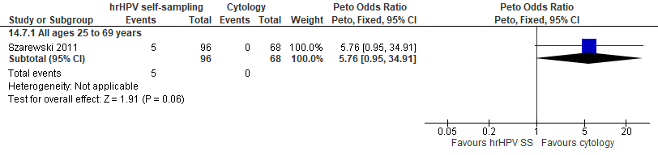
Forest plot 10.7. False positives for CIN3+

Evidence Set 10.8. False positives for invasive cervical cancer
Included report: Szarewski 2011 (Westminster)
GRADE Summary of Findings Table 10.8. False positives for invasive cervical cancer
Outcome  No. participantsª  (studies) |  | Relative effects, Peto OR and RR (95 % CI) | Anticipated absolute effects |  |  | Certainty of evidence (GRADE)^{b} | What happens?
 |  | Relative effects, Peto OR and RR (95 % CI) | With cytology screening | With hrHPV screening | Difference | Certainty of evidence (GRADE)^{b} | What happens?
People with a cervix aged 25 to 69 years (Szarewski 2011(Westminster); acceptors of screening)
False positives for invasive cervical cancer  Follow-up: 1 round  164 (1 RCT) | Peto OR: 3.20 (0.69 to 14.80)  RR: 3.10 (0.69 to 12.30) |  | 147.1 per 10,000 | 455.8 per 10,000 | 308.8 more per 10,000 (45.1 less to 1,662.2 more) | 25-29 yrs:  VERY LOW^{c}  ⊕⊝⊝⊝  due to lack of evidence of consistency, (very serious) indirectness, and imprecision  30-59 yrs:  VERY LOW^{d}  ⊕⊝⊝⊝  due to lack of evidence of consistency, indirectness, and imprecision  60-69 yrs:  VERY LOW^{e}  ⊕⊝⊝⊝  due to lack of evidence of consistency, (very serious) indirectness, and imprecision | Among people with a cervix aged 25 to 69 years, we are very uncertain about the effect of hrHPV testing via self-sampling on false positives for invasive cervical cancer compared with cytology testing.
CI = confidence interval; OR = odds ratio; RCT = randomized controlled trial; RR = relative risk.
ªAcceptors of screening, select population include participants who were randomized, accepted the offer to be screened, and completed the screening protocol (including those who attended colposcopy following a positive test).
^{b}We rated down by 0.5 for “some concerns”, 1 “serious concerns”, and 2 for “very serious concerns”. When our assessment of the certainty of evidence fell between levels, we assigned the level that best represented our actual certainty in the evidence, and based our conclusions on this level of certainty.
Explanations:
^{c}Acceptors of screening; people with a cervix aged 25 to 29 years: No serious concerns about risk of bias: no domains judged high risk. Some concerns about inconsistency: lack of evidence for consistency due to single study. Very serious concerns about indirectness: all participants were non-responders (had not responded to at least two invitations to attend for screening); concerns due to small sample for this age group (n=NR). Serious concerns about imprecision: lower limit of 95% CI indicates little-to-no effect. No other serious concerns.
^{d}Acceptors of screening; people with a cervix aged 30 to 59 years: No serious concerns about risk of bias: no domains judged high risk. Some concerns about inconsistency: lack of evidence for consistency due to single study. Serious concerns about indirectness: all participants were non-responders (had not responded to at least two invitations to attend for screening). Serious concerns about imprecision: lower limit of 95% CI indicates little-to-no effect. No other serious concerns.
^{e}Acceptors of screening; people with a cervix aged 60 to 69 years: No serious concerns about risk of bias: no domains judged high risk. Some concerns about inconsistency: lack of evidence for consistency due to single study. Very serious concerns about indirectness: all participants were non-responders (had not responded to at least two invitations to attend for screening); concerns due to small sample for this age group (n=NR). Serious concerns about imprecision: lower limit of 95% CI indicates little-to-no effect. No other serious concerns.

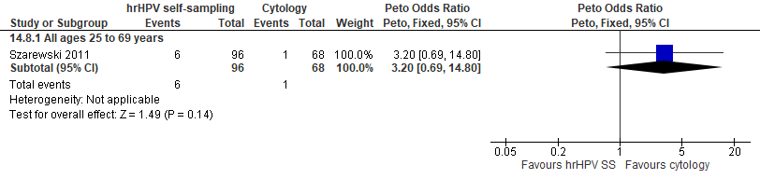
Forest plot 10.8. False positives for invasive cervical cancer

