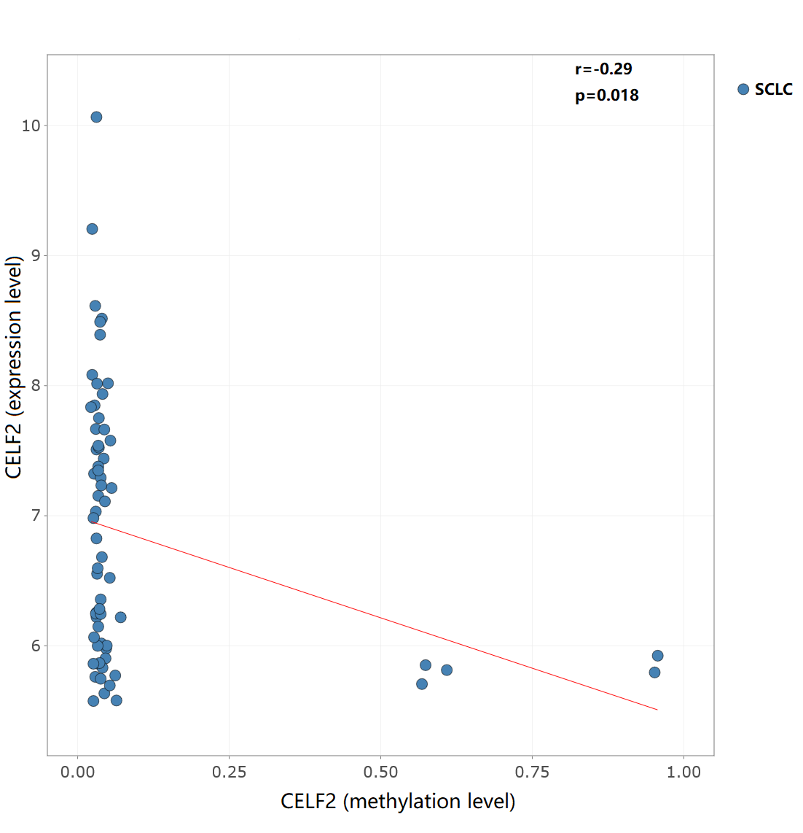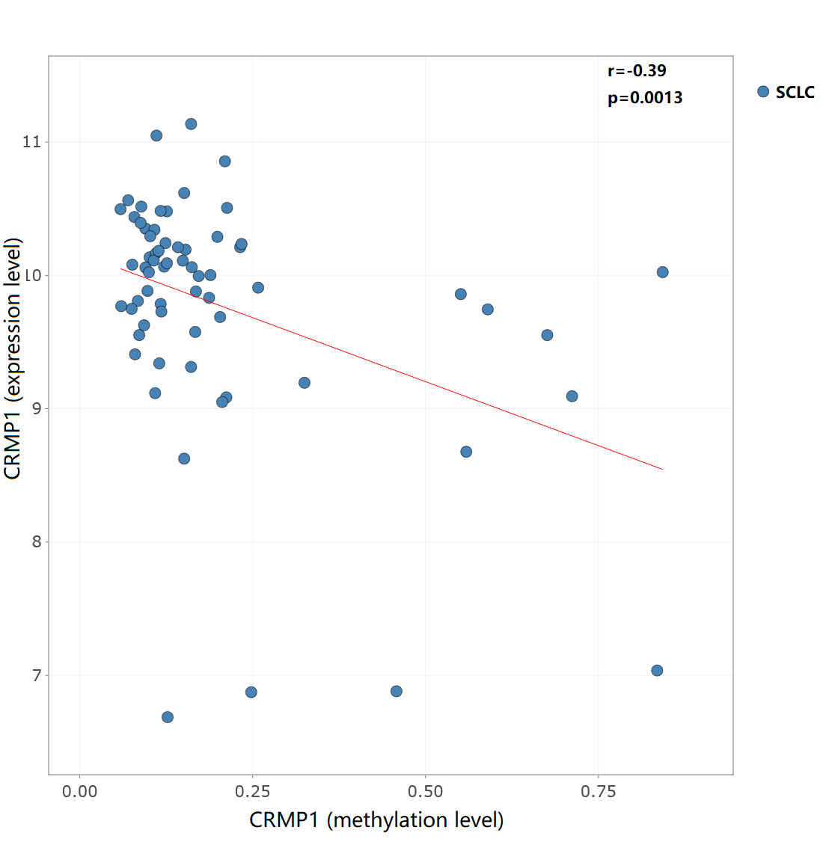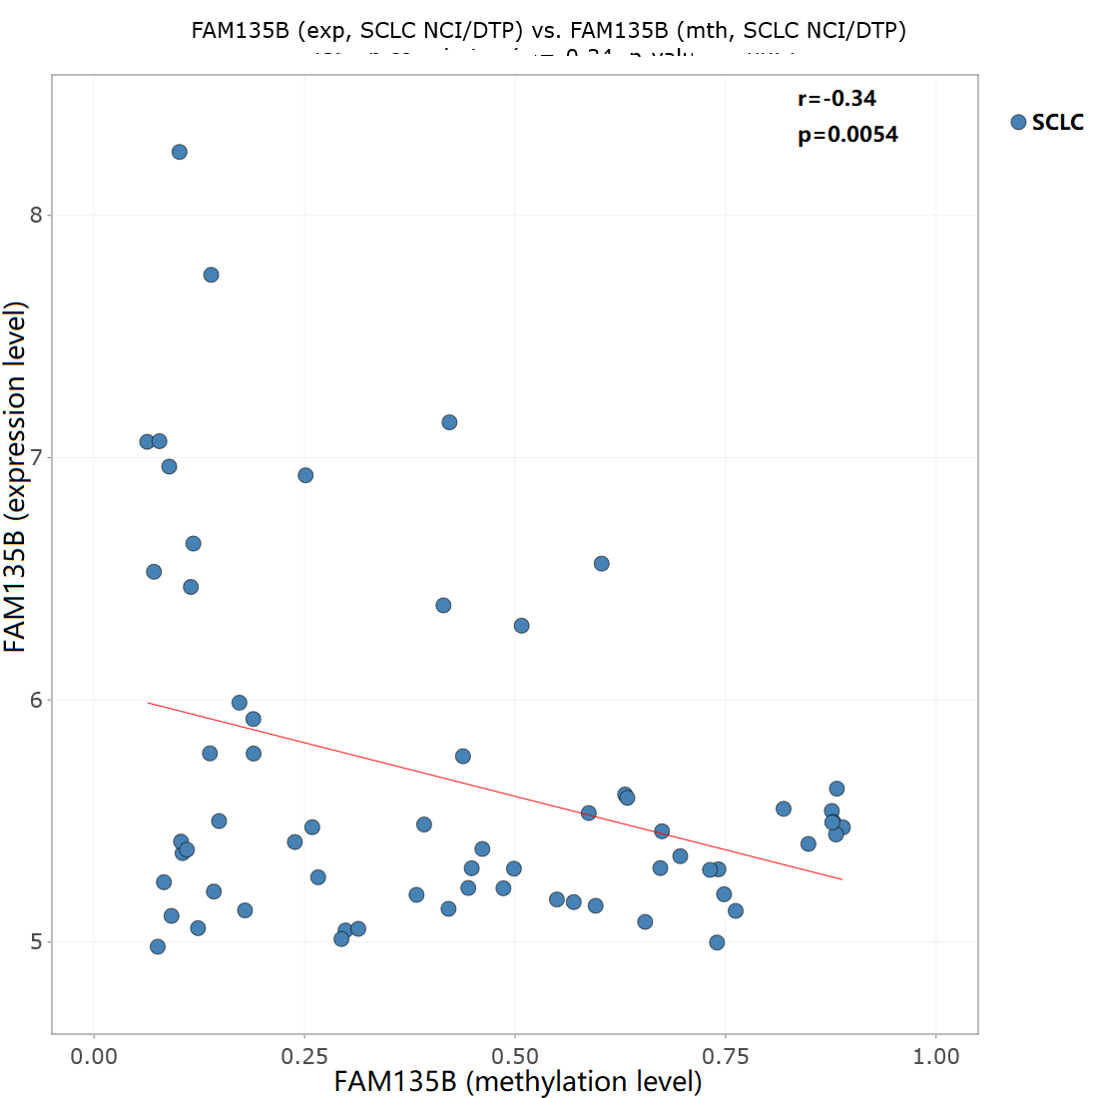
E
D
C
B
A
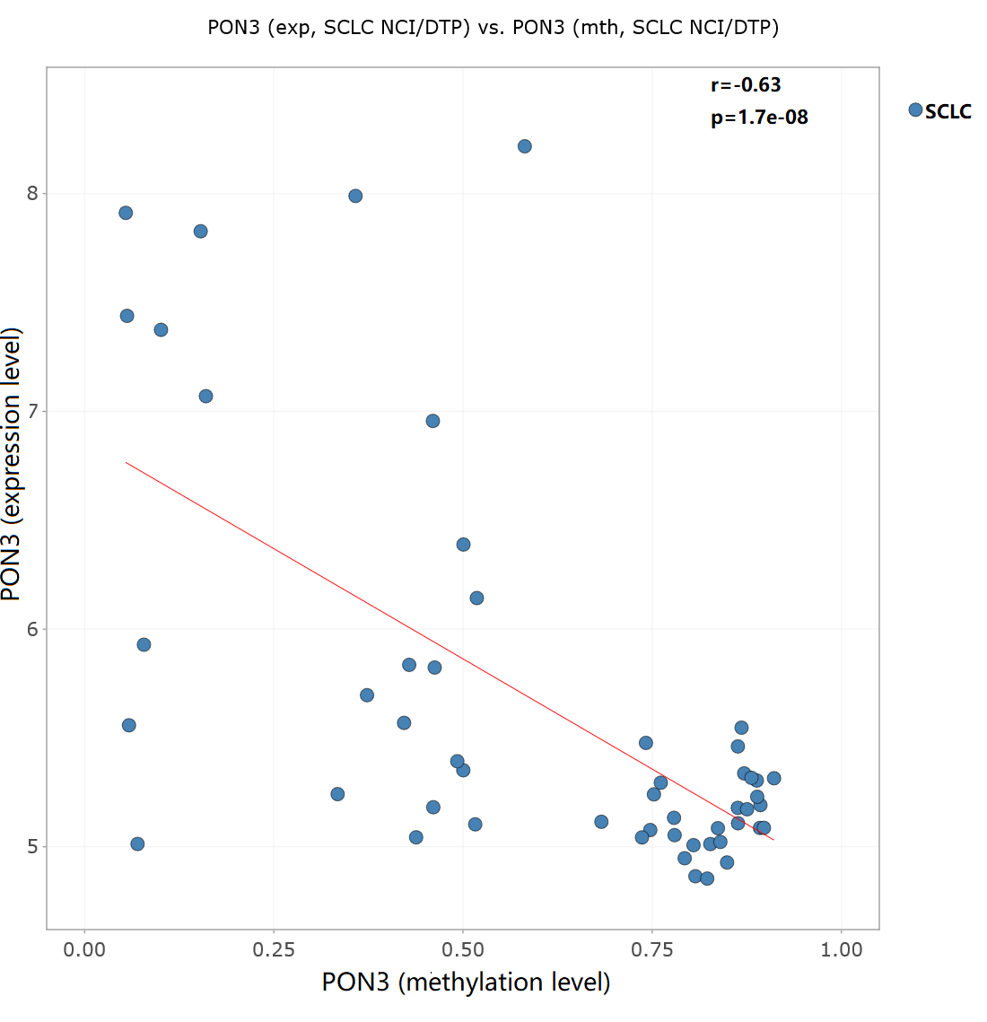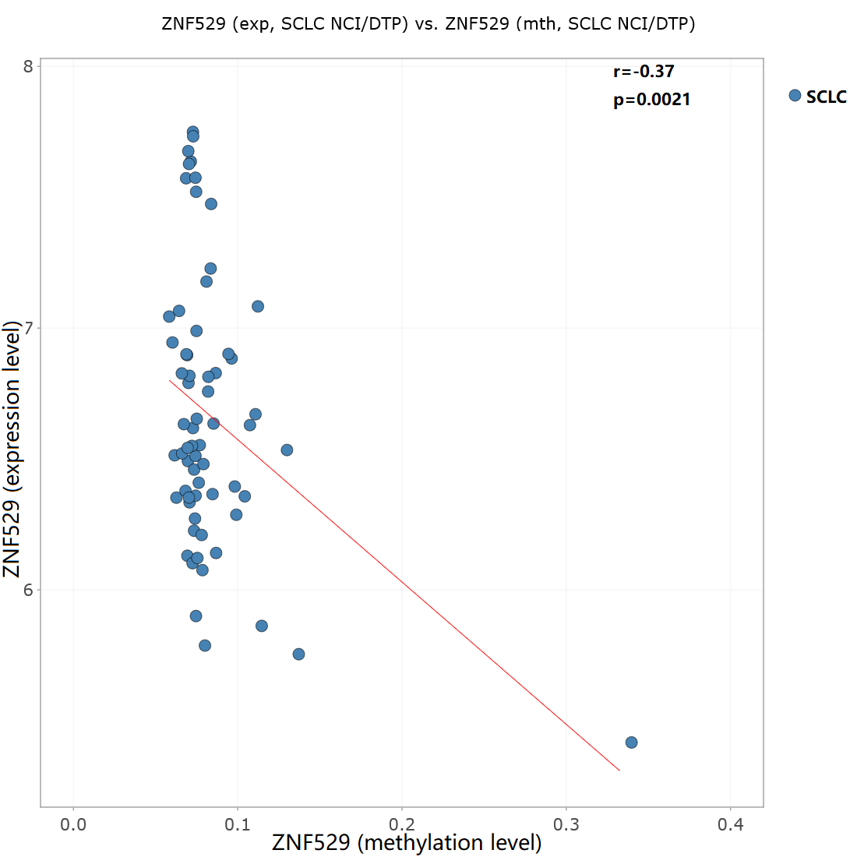
Figure S1. Validation of relationship between methylation level and gene expression level in 65 SCLC cell lines. A-E) Negative correlations between the methylation levels of chemotherapy efficacy-related genes and gene expression were shown in scatterplots. Abbreviation: SCLC, small cell lung cancer; r, Pearson’s correlation coefficients; p, p value for whole.

