Supplementary Materials for
Dehydration-Induced Supralithostatic Fluid Overpressure in Metapelites from Northern Korea
Yi Zou*, Xu Chu*, Ross N. Mitchell, Qiuli Li, Lei Zhao, Mingguo Zhai

This file includes:
Supplementary Text:
A1. MINERAL COMPOSITIONS
A2. METAMORPHIC P‒T CONDITIONS AND TIMESCALES
Supplementary Figures S1‒S5
Supplementary Tables T1‒T12

A1. MINERAL COMPOSITIONS
Representative mineral compositions are given in Supplementary Tables T1–T6. The description of garnet and monazite chemical zonation is given in main text. Compositions of other minerals are summarized below. All the studied metapelites show nearly identical mineral assemblages and compositions to those studied by our previous study¹. Compositional parameters used are: An for plagioclase; X_{Mg} for biotite, chlorite, staurolite, and muscovite. They are defined in mole ratios as follows: An=Ca/(K + Na + Ca) and X_{Mg}= Mg/(Mg + Fe), where Fe is ferrous. The silicon (Si), calcium (Ca), and titanium (Ti) mole contents per formula unit (p.f.u) are based on 22-oxygen for mica minerals and 23-oxygen for amphibole.

Plagioclase and staurolite
Plagioclase has two types: minor tiny inclusions enclosed within bulk garnet domains; large matrix grains. The tiny inclusion-type has An contents of ~0.35, while matrix-type has An contents generally in the range of 0.33‒0.40. In most cases, the core of matrix plagioclase has An contents lower than the rim, being 0.33‒0.36 and 0.37‒0.40, respectively (Supplementary Table T2).

Staurolite has three types: tiny inclusions within garnet chemical dykes (Fig. 3e‒f); large matrix-type associated with kyanite porphyroblasts (Supplementary Fig. S1A); relatively small matrix grains associated with brecciated garnet in domains where kyanite is absent (Supplementary Fig. S1A and D). The inclusion-type staurolite has similar X_{Mg} values with the small matrix grains, broadly in the range of 0.23‒0.27. The large matrix staurolite has slightly higher X_{Mg} values of 0.26‒0.30 (Supplementary Table T3).

Micas and biotite
Compositions of muscovite and biotite vary with microtextures. We identify four kinds of muscovite: inclusions within bulk garnet (Fig. 3e‒f and l); inclusions within garnet chemical dykes (Fig. 3e‒f and l); relatively coarse-grained matrix muscovite (Supplementary Fig. S1B); fine-grained muscovite grains which grow inside matrix biotite or develop along garnet physical cracks (Fig. 3a; Supplementary Fig. S1F). The muscovite inclusions within bulk garnet have a wide range of X_{Mg} values of 0.43‒0.58. We note that in most cases isolated muscovite inclusions within core domains of bulk garnet have lower Ti contents than those enclosed within rim domains of bulk garnet, being 0.05‒0.06 and 0.10‒0.15 p.f.u, respectively (Supplementary Table T4). Given the Ti content in muscovite reflects temperature², the Ti content increase of muscovite inclusions within bulk garnet from core to rim domains likely record a prograde metamorphism. Inclusion-type muscovite within garnet chemical dykes has lower Ti contents (0.06‒0.07 p.f.u) than those enclosed within bulk garnet domains. Coarse-grained matrix muscovite has higher Ti contents in core domains than in rims, being 0.09‒0.10 vs. 0.05‒0.06. The fine-grained muscovite that grows inside matrix biotite or occurs along garnet physical cracks is compositionally similar to the rims of coarse-grained matrix muscovite.

We identify three kinds of biotite: biotite inclusions within bulk garnet (Fig. 3e‒f and k‒l); biotite inclusions within garnet chemical dykes (Fig. 3e‒f and k‒l); matrix-type biotite (Supplementary Fig. S1A). The inclusions within bulk garnet have lower X_{Mg} values (0.44‒0.49) than the other two types. We also observe an increase in Ti contents of isolated biotite inclusions from core to rim domains of bulk garnet, being 0.15‒0.16 vs. 0.24‒0.26 p.f.u (Supplementary Table T5). Biotite inclusions within garnet chemical dykes have X_{Mg} values of 0.53‒0.55 and Ti contents of 0.22‒0.25 p.f.u. Matrix-type biotite has higher Ti contents and lower X_{Mg} values in cores than in rims, being 0.22‒0.33 vs. 0.18‒0.22 p.f.u and 0.51‒0.52 vs. 0.55‒0.56, respectively.

Chlorite, margarite, and amphibole
Chlorite is minor, and grows inside garnet embayed rims or occurs along physical cracks of garnet or replaces biotite margins in association with fine-grained muscovite (Fig. 3a; Supplementary Fig. S1F), implying a late retrograde origin. Regardless these textural positions, chlorite lacks inter-crystalline compositional variations and is featured by a narrow X_{Mg} range of 0.53‒0.55 (Supplementary Table T5). Margarite is also minor, and only occurs as inclusions enclosed within garnet chemical dykes (Fig. 3e‒f and k‒l), and has Si and Ca contents of 4.25‒4.34 and 1.49‒1.50 p.f.u, respectively (Supplementary Table T4). Amphibole from the porphyritic intrusions (Supplementary Fig. S1G‒H) has variable Ti contents of 0.11‒0.16 p.f.u and Al contents of 0.90‒0.130 p.f.u (Supplementary Table T6), with cores of larger grains having higher Ti and Al contents than rims or smaller amphibole grains.

A2. METAMORPHIC P‒T CONDITIONS AND TIMESCALES

Metamorphic P‒T path for the ca. 1850 Ma event
The phase equilibria modeling calculated using measured bulk-rock compositions are shown in Supplementary Fig. S5A‒B. Bulk garnet core domains enclose sillimanite inclusions that likely reflect a prograde P‒T path from the sillimanite stability field. We also note that the Ti content increase of muscovite inclusions within bulk garnet from core to rim domains likely records a prograde metamorphism. We thus use the Ti-in-Muscovite thermometer² applied to isolated muscovite inclusions within core domains of bulk garnet to constrain the prograde path (Supplementary Fig. S5A). The observed peak mineral assemblage is well predicted in the fields of bt-pl-grt-ky-rt and bt-pl-grt-st-ky-rt (Supplementary Fig. S5A). Within the fields, bulk garnet compositions (grossular and X_{Mg} values) and An contents from cores of matrix plagioclase define P‒T conditions of ~8 kbar and ~690 °C (the red circle in Supplementary Fig. S5B). Besides, we use the garnet-biotite (GB) thermometer³ and garnet-aluminosilicate-plagioclase (GASP) barometer⁴ applied to bulk garnet domains and cores of matrix biotite and plagioclase, the garnet-biotite-plagioclase-quartz (GBPQ) geothermobarometer^{3,5} applied to bulk garnet and cores of matrix biotite and plagioclase, and the Ti-in-Zircon thermometer⁶ and Ca-Fe-in-Garnet barometer⁷ applied to bulk garnet. These conventional geothermobarometers estimate the peak P‒T conditions at 6.8‒8.5 kbar and 675‒720 °C (Supplementary Table T11 and Fig. S5B), and are consistent with the phase equilibria modeling results and our previous study¹. The retrograde path of the Paleoproterozoic metamorphism has been constrained as decompression cooling to <4 kbar and <500 °C by ca. 1830 Ma^{1,8}.

Metamorphic P‒T conditions of the ca. 110 Ma thermal event
The phase equilibria modeling calculated using measured bulk-rock compositions with bulk-garnet removed are shown in Figure 4a and Supplementary Fig. S5C‒D. The observed mineral assemblage of the ca. 110 Ma thermal event is well predicted in the ms-bt-pl-grt-st-rt or chl-ms-bt-pl-grt-st-rt (-H₂O) field (Fig. 4a; Supplementary Fig. S5C). Within the filed, predicted garnet grossular and X_{Mg} values and An contents of plagioclase are consistent with those measured from garnet chemical dykes and rims of matrix plagioclase, and collectively define P‒T conditions mainly at 7.5‒8.5 kbar and 600‒640 °C (Fig. 4a; Supplementary Fig. S5D). The minor temperature estimations below 600 ℃ are from garnet chemical dykes that show a close association with fine-grained chlorite (Fig. 3a‒d), and thus reflect retrograde metamorphism. Geothermobarometers estimate P‒T conditions of 7.0‒9.0 kbar and 600‒640 °C for the ca. 110 Ma thermal event (Supplementary Tables T11–T12), in a well agreement with the phase equilibria modeling results (Fig. 4a and b).

Metamorphic timescales and uncertainty quantification
The detailed procedures for the multicomponent (Ca-Mn-Mg-Fe) diffusion modeling of garnet are given in the main text and method section. Compositional profiles across garnet chemical dykes in different domains yield best-fit timescales of 0.1‒0.3 kyr (Fig. 4c; Supplementary Fig. S2). It is important to note that these durations should be viewed as upper limit estimates: (i) any more gradual initial profile than the step-function profile we used would yield a shorter timescale; (ii) if the garnet was not center-cut and profiles were inclined, our model assumption would exaggerate the diffusion length scales and thus the timescale; (iii) we used a conservative P‒T condition of 7.5 kbar and 600 °C, and higher P‒T conditions would yield a shorter duration; (iv) we used the minimum H₂O contents of garnet chemical dykes to calculate self-diffusion coefficient, and higher water contents in garnet enhance the diffusivities of the divalent elements⁹, and thus shorten the timescales.

The best-fit results have uncertainties primarily deriving from the diffusion model¹⁰, the temperature estimate (±10 ℃; ref. ¹¹), and garnet H₂O content (a relative uncertainty of 15 % at 1σ; ref. ⁹). To propagate these uncertainties, we follow the methodology outlined in Chu and Ague (2015)¹⁰ to generate 1000 sets of randomly varied diffusion models with Arrhenius parameters within likely ranges and temperature randomly selected within 600 ± 10 °C. The pre-exponential factors are rescaled using the formalism of Chu and Ague (2015)¹⁰ with the garnet water factor from the ref. ⁹. The resulting sets of best-fit timescales for compositional profiles Pro 1, Pro 2, and Pro 3 yield geometric means and 1σ uncertainties of ${0.3}_{-0.10}^{+0.64}$, ${0.3}_{-0.16}^{+0.71}$, and ${0.1}_{-0.05}^{+0.23}$kyr, respectively. Thus, propagating these uncertainties leads to a relative uncertainty within ± 0.4 orders of magnitude (1σ). Moreover, for the garnet compositions we studied and at the fixed P‒T of 7.5 kbar and 600 °C, the diffusion model of Chakraborty and Ganguly (1992)¹² predicts faster Mn self-diffusion coefficient, and the models of Carlson (2006)¹³ and Borinski et al. (2012)¹⁴ give faster Ca self-diffusion coefficient than the model of Chu and Ague (2015)¹⁰. Consequently, garnet multicomponent diffusion modeling utilizing these diffusion models¹²⁻¹⁴ would yield shorter timescales. In conclusion, the thermal overprint at ca. 110 Ma is transient within 0.1‒0.3 kyr, with a relative uncertainty likely falling within ± 0.4 orders of magnitude (1σ).

Supplementary Figures S1-S5
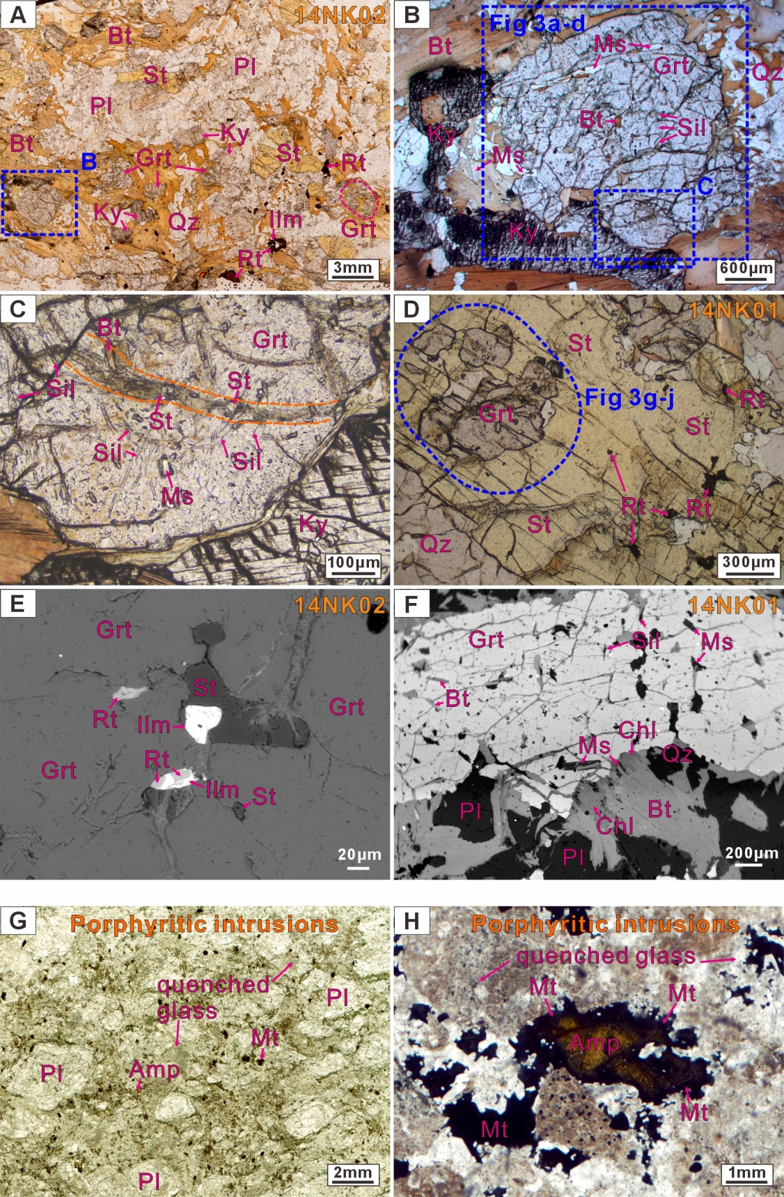
Fig. S1. Photomicrographs and back-scattered electron (BSE) images of the metapelites and porphyritic intrusions. (A) Thin section scanning image of the representative sample 14NK02 showing garnet porphyroblasts in the matrix comprising of kyanite, staurolite, plagioclase, biotite, and rutile. Note some garnet porphyroblasts are brecciated and closely associated with staurolite. The dashed blue rectangle denotes the microdomain shown in Supplementary Fig. S1B. (B) Inclusions of needle-like sillimanite, muscovite and biotite within core domains of the largest garnet observed in thin sections. Minor small muscovite flakes are observed along cleavages of biotite near garnet rim. The dashed blue rectangles mark the locations of X-Ray mapping of garnet shown in Figure 3a‒d and the microdomain in Supplementary Fig. S1C. (C) Staurolite inclusions appear to distribute along a curved belt of different garnet plane-polarized color (garnet chemical dyke) that cuts the orientation of sillimanite inclusions. (D) Subhedral garnet and rutile grains enclosed within staurolite. The blue circle represents the site of garnet X-ray mapping shown in Figure 3g‒j. (E) Staurolite, rutile, and ilmenite enclosed within garnet (chemical dykes). (F) Chlorite and muscovite develop near biotite margins, and grow into garnet rims. (G–H) Andesitic porphyritic intrusions are comprised of plagioclase phenocryst and a matrix of quenched glass, amphibole, and magnetite. Some amphiboles are rimmed by magnetite. Mineral abbreviations follow the ref. ¹⁵.
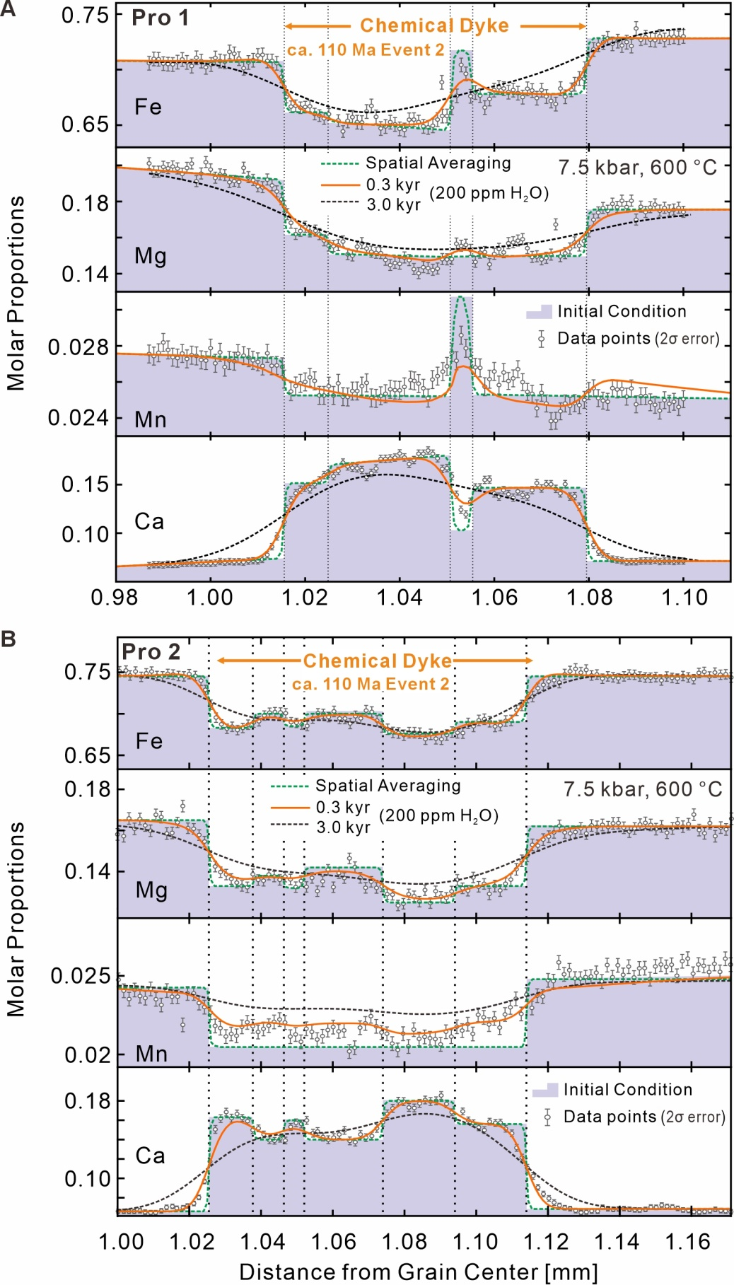
Fig. S2. Measured garnet compositional profiles Pro 1 and Pro 2, and best-fit timescales (orange solid curves) of garnet multicomponent diffusion simulation. Initial step-function profiles are shown with gray areas. See texts for details.
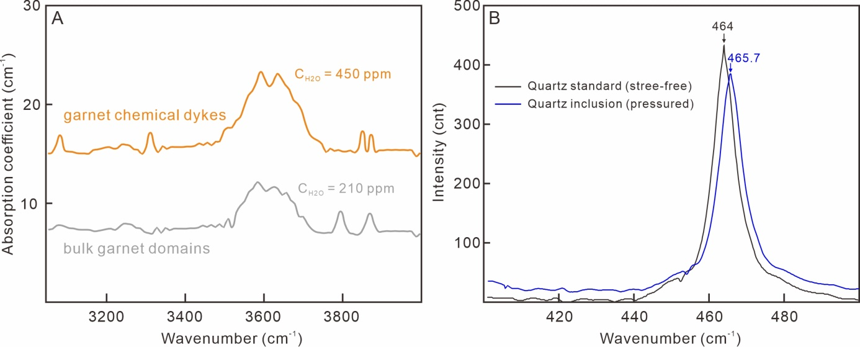
Fig. S3. (A) Representative unpolarized FTIR spectra for bulk garnet domains and garnet chemical dykes, and the corresponding measured C_{H2O} contents. (B) Representative Raman spectra showing the wavenumber shift of pressured quartz inclusion relative to stress-free quartz reference. The spectral range is cut to 400‒500 cm⁻¹ to highlight the wavenumber shift, while the actual measurement range is from 100 to 1000 cm⁻¹.
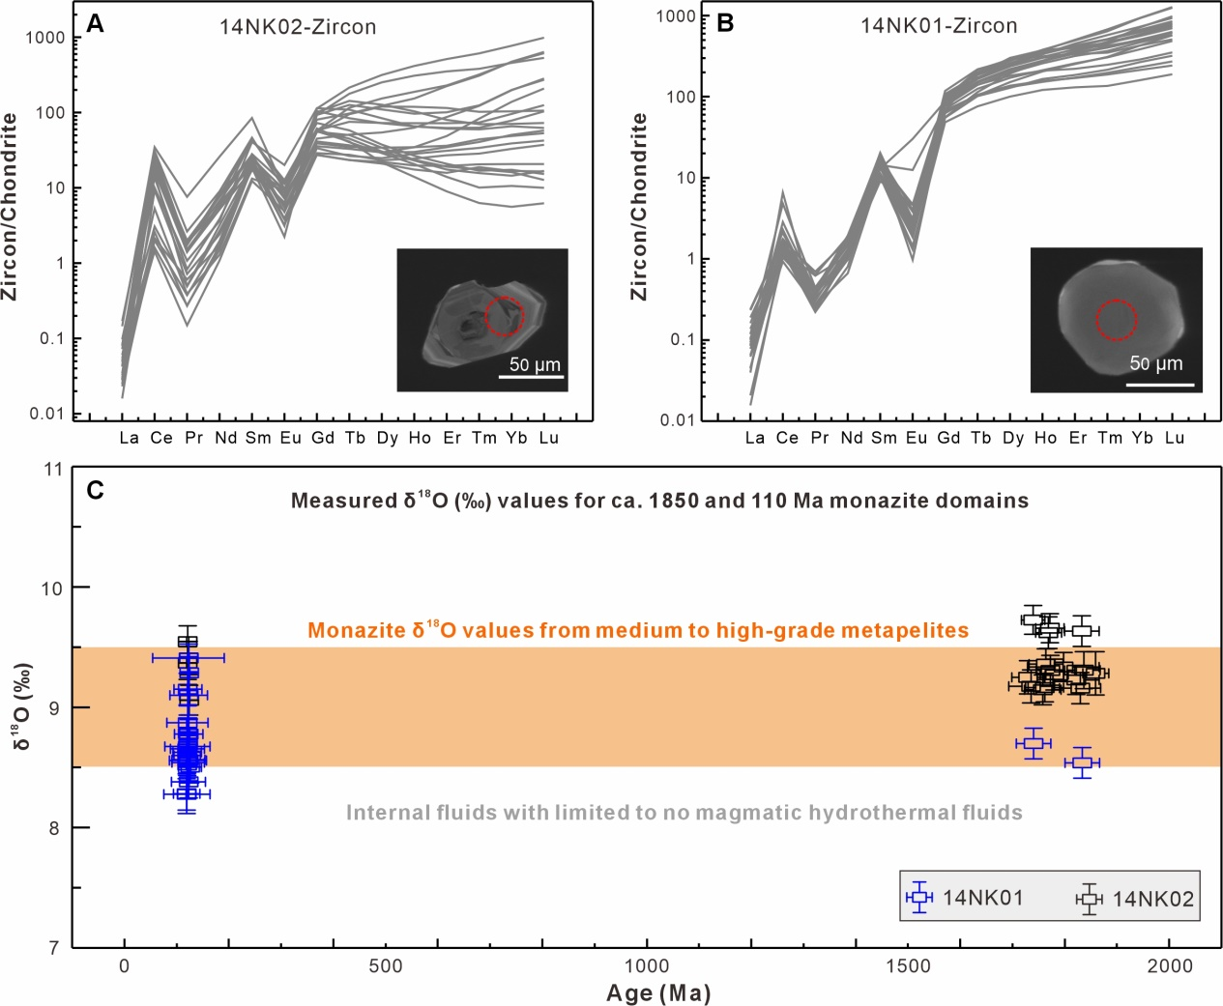
Fig. S4. (A, B) Chondrite-normalized REE patterns of zircon from samples 14NK02 and 14NK01. The chondrite REE values follow the ref. ¹⁶. Inserts show representative CL images of metamorphic zircons and analyzed spots. (C) Measured δ¹⁸O (‰) values for different monazite domains. Monazite δ¹⁸O values from medium to high-grade metapelites follow the refs. ^{17,18}. Error bars show 2 sigma errors in ages and isotope values.
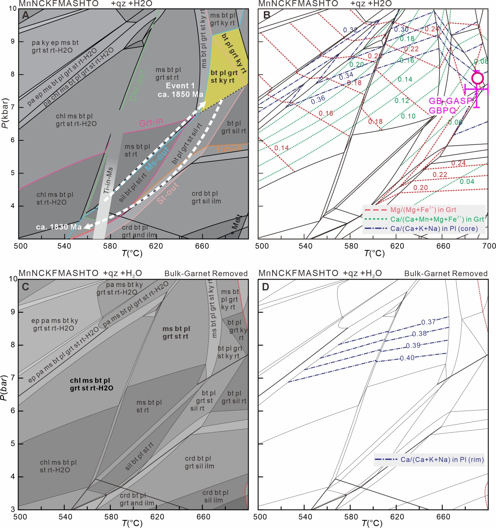
Fig. S5. (A) P‒T phase diagram calculated using the measured bulk-rock compositions (Supplementary Table T10). White dashed lines represent an inferred P‒T path of the Paleoproterozoic metamorphism. The retrograde decompression-cooling P‒T path is from our previous studies^{1,8}. The observed peak mineral assemblages are labeled in bold with yellow background. Also shown are Ti-in-Ms thermometric² results from isolated muscovite inclusions within core domains of bulk garnet. (B) P‒T phase diagram countered with isopleths of mineral chemistries. The red circle denotes intersection of garnet grossular and X_{Mg} values from bulk garnet domains, and An contents from cores of matrix plagioclase. The purple cross shows the peak P‒T conditions determined by the conventional geothermobarometers GB-GASP^{3,4} and GBPQ^{3,5}. (C) P‒T phase diagram calculated using the measured bulk-rock composition with bulk garnet removed. Observed mineral assemblages of the ca. 110 Ma thermal event is marked in bold. (D) P‒T phase diagram countered with isopleths of An contents from rims of matrix plagioclase. See text for details.

Supplementary Tables T1-T12
Table T1 Representative compositions of garnet
Table T2 Representative compositions of plagioclase
Table T3 Representative compositions of staurolite
Table T4 Representative compositions of muscovite
Table T5 Representative compositions of biotite and chlorite
Table T6 Representative compositions of amphibole in porphyritic intrusions
Table T7 Zircon U-Pb isotopes, trace elements and Ti-in-zircon results
Table T8 Monazite U-Pb-O isotopes and trace elements
Table T9 Representative rare earth element compositions of garnet
Table T10 Bulk-rock compositions used for phase equilibria modeling (mol. %)
Table T11 Summary of P‒T conditions determined by conventional geothermobarometers for the two thermal events and andesitic porphyritic intrusions
Table T12 Quartz-in-garnet elastic barometric results

All the Tables T1‒T12 are provided as a separated Excel spreadsheet.

References
1. Chen, M. D.. et al. Zircon and monazite petrochronology studies reveal Mesozoic amphibolite-facies metamorphism overprinting Paleoproterozoic granulite-facies metamorphism: A case study from Rangnim Massif, North Korea. Lithos 398, (2021).

2. Wu, C. M. & Chen, H. X. Calibration of a Ti-in-muscovite geothermometer for ilmenite- and Al2SiO5-bearing metapelites. Lithos 212, 122-127 (2015).

3. Holdaway, M. J. Application of new experimental and garnet Margules data to the garnet-biotite geothermometer. American Mineralogist 85, 881-892 (2000).

4. Holdaway, M. J. Recalibration of the GASP geobarometer in light of recent garnet and plagioclase activity models and versions of the garnet-biotite geothermometer. American Mineralogist 86, 1117-1129 (2001).

5. Wu, C. M., Zhang, J. & Ren, L. D. Empirical garnet-biotite-plagioclase-quartz (GBPQ) geobarometry in medium- to high-grade metapelites. J Petrol 45, 1907-1921 (2004).

6. Ferry, J. M. & Watson, E. B. New thermodynamic models and revised calibrations for the Ti-in-zircon and Zr-in-rutile thermometers. Contrib Mineral Petr 154, 429-437 (2007).

7. Wu, C. M. Original Calibration of a Garnet Geobarometer in Metapelite. Minerals-Basel 9, 540 (2019).

8. Li, Q. L., Zhao, L., Zhang, Y. B., Yang, J. H., Kim, J. N. & Han, R. H. Zircon-titanite-rutile U-Pb system from metamorphic rocks of Jungshan "Group" in Korea: Implications of tectono-thermal events from Paleoproterozoic to Mesozoic. Acta Petrol Sin 32, 3019-3032 (2016).

9. Zhang, B. H., Li, B. W., Zhao, C. C. & Yang, X. Z. Large effect of water on Fe-Mg interdiffusion in garnet Earth Planet Sc Lett 505, 20-29 (2019).

10. Chu, X. & Ague, J. J. Analysis of experimental data on divalent cation diffusion kinetics in aluminosilicate garnets with application to timescales of peak Barrovian metamorphism, Scotland. Contrib Mineral Petr 170, 1-27 (2015).

11. Palin, R. M., Weller, O. M., Waters, D. J. & Dyck, B. Quantifying geological uncertainty in metamorphic phase equilibria modelling; a Monte Carlo assessment and implications for tectonic interpretations. Geoscience Frontiers 7, 591-607 (2016).

12. Chakraborty, S. & Ganguly, J. Cation Diffusion in Aluminosilicate Garnets - Experimental-Determination in Spessartine-Almandine Diffusion Couples, Evaluation of Effective Binary Diffusion-Coefficients, and Applications. Contrib Mineral Petr 111, 74-86 (1992).

13. Carlson, W. D. Rates of Fe, Mg, Mn, and Ca diffusion in garnet. American Mineralogist 91, 1-11 (2006).

14. Borinski, S. A., Hoppe, U., Chakraborty, S., Ganguly, J. & Bhowmik, S. K. Multicomponent diffusion in garnets I: general theoretical considerations and experimental data for Fe-Mg systems. Contrib Mineral Petr 164, 571-586 (2012).

15. Whitney, D. L. & Evans, B. W. Abbreviations for names of rock-forming minerals. American Mineralogist 95, 185-187 (2010).

16. Sun, S. S. & Mcdonough, W. F. Chemical and isotopic systematics of oceanic basalts: Implications for mantle composition and processe. In: Saunders A D and Norry M J [eds] Magmatism in the Ocean Basins Geological Society, London, Special Publications 42, 313-345 (1989).

17. Rubatto, D., Putlitz, B., Gauthiez-Putallaz, L., Crépisson, C., Buick, I. S. & Zheng, Y.-F. Measurement of in-situ oxygen isotope ratios in monazite by SHRIMP ion microprobe: Standards, protocols and implications. Chem Geol 380, 84-96 (2014).

18. Wu, L.-G.. et al. Rapid and accurate SIMS microanalysis of monazite oxygen isotopes. J Anal Atom Spectrom 35, 1607-1613 (2020).

