Supplementary Material

Table S1 Coefficient estimates from generalized additive model analysis of multivariate influences on cystatin C.
 | Estimate | Std. Error | t value | P
(Intercept) | 0.61311358 | 0.03599162 | 17.035 | <0.001
Urea nitrogen | 0.01793930 | 0.00112644 | 15.926 | <0.001
Uric_acid | 0.01283223 | 0.00307055 | 4.179 | <0.001
MetSYes | -0.18702528 | 0.03297075 | -5.672 | <0.001
HDL | -0.05696340 | 0.00509833 | -11.173 | <0.001
Age | 0.00283293 | 0.00011390 | 24.871 | <0.001
SexMale | -0.02693463 | 0.00401089 | -6.715 | <0.001
EthnicsNon-Hispanic Black | 0.02826895 | 0.00534763 | 5.286 | <0.001
EthnicsNon-Hispanic White | 0.06315653 | 0.00452453 | 13.959 | <0.001
EthnicsOther Race | 0.00735664 | 0.00650131 | 1.132 | 0.258
EducationCollege or above | :-0.00451602 | 0.00492195 | -0.918 | <0.001
EducationHigh school or equivalent | -0.02124154 | 0.00622936 | -3.410 | 0.359
Poverty | -0.011312155 | 0.00113573 | -9.960 | <0.001
DMYes | 0.01531172 | 0.00548052 | 2.794 | 0.005
HypertensionYes | 0.03966532 | 0.00375104 | 10.574 | <0.001
HyperlipidemiaYes | -0.01965849 | 0.00385013 | -5.106 | <0.001
BMI | -0.00241649 | 0.00029884 | -8.086 | <0.001
SmokeNever | 0.00887737 | 0.00383541 | 2.315 | 0.021
SmokeNow | 0.06757771 | 0.00470351 | 14.368 | <0.001
AST | -0.000384436 | 0.00006932 | -5.546 | <0.001
TBIL | 0.02302788 | 0.00525643 | 4.381 | <0.001
TBIL | 0.00087235 | 0.00005630 | 15.493 | <0.001
TP | 0.040614115 | 0.00381824 | 10.637 | <0.001
ALB | -0.13562575 | 0.00587807 | -23.073 | <0.001
GGT | 0.00118679 | 0.00017741 | 6.690 | 0.003
Urea_nitrogen:Uric_acid | 0.01790714 | 0.00173841 | 10.301 | <0.001
Urea nitrogen:MetSYes | -0.00010307 | 0.00003465 | -2.974 | <0.001
Uric acid:MetSYes | 0.01965528 | 0.00478272 | 4.110 | <0.001
MetSYes:HDL | -0.02439507 | 0.01045757 | -2.333 | 0.020
Urea_nitrogen:Uric acid:MetSYes | -0.00177805 | 0.00025703 | -6.918 | <0.001
Abbreviations: PIR family poverty income ratio, BMI body mass index, DM diabetes mellitus, ALT Alanine Aminotransferase, AST Aspartate Aminotransferase, TBIL Total Bilirubin, ALP Alkaline Phosphatase, TP Total Protein, ALB Albumin, HDL High-Density Lipoprotein.
Legends: This subheading communicates that a generalized additive model (GAM) approach was used to analyze how multiple variables influence cystatin C, providing insights into the complexity and interplay of different factors.
Residual standard error: 0.2868 on 35016 degrees of freedom (19509 observations deleted due to missingness) Multiple R-squared: 0. 4085.Adjusted R-squared: 0.408, F-statistic: 833.7 on 29 and 35016 DF, P-value:<0.001.

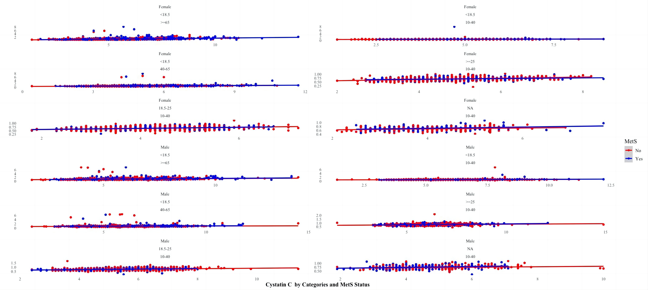
Fig S1 Stratified analysis of cystatin C levels in relation to urea nitrogen, HDL, and uric acid across sex, BMI, and Mets
Legends: The top figure illustrates the relationship between urea nitrogen, HDL, uric acid, and cystatin C levels, stratified by the presence of MetS. In the first plot (left), the x-axis represents urea nitrogen (mg/dL) and the y-axis represents cystatin C (mg/L). The data points are color-coded, with red indicating individuals without MetS and blue indicating those with MetS. The regression lines for both groups show a positive correlation between urea nitrogen and cystatin C, with the blue line (MetS) having a steeper slope, suggesting a stronger relationship in individuals with MetS. The second plot (middle) shows the relationship between HDL (mg/dL) and cystatin C (mg/L). Here, the regression lines for both groups are relatively flat, indicating a weak or negligible relationship between HDL levels and cystatin C, regardless of MetS status. The third plot (right) depicts the relationship between uric acid (μmol/L) and cystatin C (mg/L). Like the HDL plot, the regression lines are nearly flat, suggesting a weak association between uric acid levels and cystatin C, with minimal differences between the MetS and non-MetS groups.
This below figure presents a stratified analysis of the relationships between different metabolic variables and cystatin C levels, categorized by gender, BMI, and age. Each row of plots corresponds to a specific subgroup: females and males are separated, and further divided based on BMI categories (<18.5, 18.5-25, ≥25) and age groups (10-40, 40-65, ≥65). The x-axes represent various metabolic variables, and the y-axes represent cystatin C levels (mg/L). In each plot, the data points are color-coded by the presence of MetS, with red indicating individuals without MetS and blue indicating those with MetS. The regression lines within each plot show the relationship between the metabolic variables and cystatin C levels for the respective subgroups. The plots reveal that the relationships between the metabolic variables and cystatin C levels vary across different gender, BMI, and age subgroups. For example, in females with a BMI <18.5 aged 10-40, there appears to be little variation in cystatin C levels regardless of metabolic status. In contrast, in males with a BMI of 18.5-25 aged 40-65, there seems to be a more noticeable relationship between certain metabolic variables and cystatin C levels.

