Supplementary Materials
Table S1: Antibodies details
 | Antibody | Dilution | Company | Cat # | RRID
Pluripotency markers | Mouse anti-OCT3/4- conjugated | 1:100 | BD Biosciences | 561556 | AB_10714783
Pluripotency markers | Mouse anti-SOX2 - conjugated | 1:100 | BD Biosciences | 560301 | AB_1645308
Pluripotency markers | Mouse anti-NANOG - conjugated | 1:100 | BD Biosciences | 560791 | AB_1937305
Differentiation markers | Mouse anti-Smooth muscle Actin (SMA) | 1:400 | DAKO | M0851 | AB_2313736
Differentiation markers | Rabbit anti Alpha-1-fetoprotein (AFP) | 1:100 | DAKO | A0008 | AB_2650473
Differentiation markers | Mouse anti-β-Tubulin III (TUJ-1) | 1:1000 | Sigma | T8660 | AB_477590
Secondary antibodies | Goat anti-mouse 647 | 1:800 | Invitrogen | A-21235 | AB_2535804
Secondary antibodies | Goat anti-Mouse 488 | 1:800 | Invitrogen | A-21042 | AB_2535711
Secondary antibodies | Donkey anti-Rabbit 488 | 1:800 | Invitrogen | A-21206 | AB_2535792

Table S2 Primer details
Target |  | Fragment size (bp) | Forward (F) / Reverse (R)  5’- 3'
Pluripotency markers  (RT-qPCR) | OCT3/4 | 64 | F: CAAAGCAGAAACCCTCGTGC  R: TCTCACTCGGTTCTCGATACTG
Pluripotency markers  (RT-qPCR) | NANOG | 97 | F: CCCCAGCCTTTACTCTTCCTA  R: CCAGGTTGAATTGTTCCAGGTC
Pluripotency markers  (RT-qPCR) | SOX2 | 110 | F: TACAGCATGTCCTACTCGCAG  R: GAGGAAGAGGTAACCACAGGG
Endogenous (RT-qPCR) | GAPDH | 264 | F: GCCAGCATCGCCCCACTTG  R: GTGAAGGTCGGAGTCAACGGAT
Embryonic leaflets markers | AFP | 281 | F: TGGCATTCAAGA GGGTTTTCAGTCTGGA  R: GAATGCTGCAAACTGACCACGCTGGAAC
Embryonic leaflets markers | TUBB3 | 148 | F: TTTTCACACTCCTTCCGCACCACATC  R: GCTCAGGGGCCTTTGGACATCTCTT
Embryonic leaflets markers | MSX1 | 307 | F: GGCGGCCATCTTCAGCTTCTCCAG  R: CGAGAGGACCCCGTGGATGCAGAG
Endogenous | GAPDH | 452 | F: ACCACAGTCCATGCCATCAC  R: TCCACCACCCTGTTGCTGTA
Episomal vector marker | EBNA1 | 244 | F: TTTAATACGATTGAGGGCGTCT  R: GGTTTTGAAGGATGCGATTAAG
Target mutation sequencing | SCN2A  (Asd16c26, Asd16c27) | 1500 | F: CTCCTTTGGGTCACTTTGATGC  R: AGGGTTTGTGTGGATTACAATGG
Target mutation sequencing | SCN2A  (Asd16c26, Asd16c27) | 576 | F: TGCTCTATGGTAGCAAGTCACTGC  R: CATGGTCTCTATCCACTCTCC
Target mutation sequencing | SCN2A  (Asd17c7, Asd17c9) | 264 | F: GGACCAACCTGGAAGTGTCT  R: TAGGCTCCCACCAGTGATTT
Mycoplasma sp |  | 271 | F: GGGAGC AAA CAG GAT TAG ATA CCC T  R: TGC ACC ATC TGT CAC TCT GTT AAC CTC

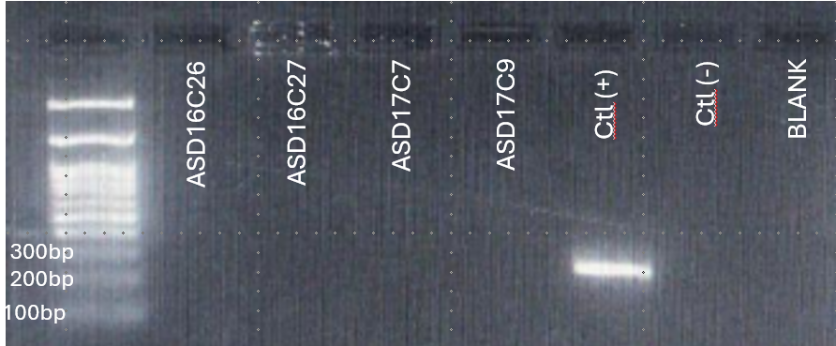
Figure S1. Polymerase Chain Reaction (PCR) results for Mycoplasma sp detection.
Lane 1-4: Lineages, Lane 5: Positive control, Lane 6: Negative control, Lane 7: Blank control.

