Supplementary Material

Imitation of object manipulation underlying shape exploration - A graph theory analysis of finger gaiting as studied by fMRI

Werner Krammer, John H. Missimer, Manuela Pastore-Wapp, Vanessa Vallesi, Roland Wiest, Bruno J. Weder

Table of content:

ST1. Sensorimotor cohort data (n=26) 2
ST2. Activation areas according to SPM during manipulation of the cuboids 3
ST3. Activation areas according to SPM during observation of the cuboid manipulation task 4
ST4. 0.45 thresholded 60-ROI WU graph based on areas of high strength and high participation coefficient 5
ST5. MRI acquisition parameters 6
ST6. Tactile object manipulation related to cortical networks: determination of regions of interest 7
SF1. Adjacency matrices of the unthresholded weighted undirected 60 ROI graphs for each condition 8
SF2. Stimulation paradigm (see also video in the repository). 10

ST1. Sensorimotor cohort data (n=26)
 | left hand |  | right hand |  | p-value
 |  |  |  |  | left vs right
 |  |  |  |  | (Mann-Whitney-U-Test)
Sensori-motor-parameters | median | IQR (25-75) | median | IQR (25-75)
power grip (kg) | 30.00 | 26.5 – 37.5 | 32.00 | 30 – 42.5 | 0.16792
power grip (z-score) woman* | 1.15 | 0.28 – 1.59 | 1.09 | -0.61 – 1.66 | 0.32814
power grip (z-score) man* | 0.35 | -0.41 – 1.65 | 0.36 | 0.66 – 1.53 | 0.87769
precision grip (kg) | 7.50 | 6.25 – 9.5 | 8.50 | 7.5 – 10.5 | 0.14607
precision grip (z-score) woman* | 0.23 | -0.59 – 0.73 | 0.38 | -0.42 – 0.81 | 0.40821
precision grip (z-score) man* | -0.59 | -1.11 – 0.50 | -0.01 | -0.12– 0.38 | 0.60746
PSO | 6.20 | 5.18 – 7.18 | 6.20 | 5.53 – 7.35 | 0.67351
PSO (z-score) women** | -0.43 | -1.12 – 0.55 | -0.74 | -1.08 – 0.85 | 0.87763
PSO (z-score) man** | 0.55 | 0.06– 1.44 | -0.17 | -0.4 – 1.08 | 0.50455
two point discrimination (mm) | 4.00 | 3 – 4 | 3.00 | 3 – 4 | 0.16934
two point discrimination (z-score) woman*** | -2.75 | -3.40 – -2.09 | -1.22 | -1.22 – -0.45 | 0.00001
two point discrimination (z-score) man*** | -0.53 | -1.55 – -0.53 | -1.22 | -1.22 – -0.45 | 0.42876
TOR (no. objects) | 28.00 | 27 - 28 | 29.00 | 28 – 30 | 0.13110
TOR (no. objects, z-score) woman*** | -0.05 | -1.36 – 0.71 | -0.55 | -0.55 – 0.47 | 0.43492
TOR (no. objects, z-score) man*** | -0.71 | -0.71– 0.60 | -1.58 | -1.58 – -0.55 | 0.75637
Legends:
* in comparison with Mathiowetz et al. 1985
** in comparison with Jebsen et al. 1969
*** in comparison with Abela et al. 2019
(PSO, Picking Small Objects; TOR, Tactile object recognition; IQR, interquartile range)

ST2. Activation areas according to SPM during manipulation of the cuboids

Manipulation right |  |  |  |  |  |  | Manipulation left
Anatomical localization | Cytoarchitectonic or functional area | x | y | z | T value* |  | Anatomical localization | Cytoarchitectonic or functional area | x | y | z | T value*
Precentral g. L | Area 4a,4p | -38 | -30 | 60 | 14.0 |  | Precentral g. L | Area 4p | -37 | -27 | 51 | 7.1
Precentral g. R | Area 4a,4p | 37 | -29 | 57 | 8.2 |  | Precentral g. R | Area 4a, 4p | 44 | -28 | 60 | 14.8
Postcentral g. L | Area 3b,1,2 | -46 | -28 | 56 | 17.2 |  | Postcentral g. L | Area 3b,1,2 | -36 | -34 | 52 | 7.8
Postcentral g. R | Area 3b,1,2 | 50 | -22 | 40 | 13.1 |  | Postcentral g. R | Area 3b,1,2 | 44 | -28 | 60 | 14.8
Sup. frontal g. L | Dorsal premotor cortex (6d1,6d2,6d3) | -34 | -12 | 60 | 15.8 |  | Sup. frontal g. L | Dorsal premotor cortex | -38 | -12 | 60 | 13.6
Sup. frontal g. R | Dorsal premotor cortex | 39 | -6 | 57 | 9.1 |  | Sup. frontal g. R | Dorsal premotor cortex (6d1,6d2,6d3) | 30 | -12 | 66 | 14.3
Sup. front g. L | SMA | -8 | -4 | 60 | 14.9 |  | Sup. front g. L | SMA, preSMA | -2 | -6 | 62 | 10.5
Sup. front g. R | SMA, preSMA | 4 | -4 | 58 | 13.4 |  | Sup. front g. R | SMA | 6 | -1 | 61 | 6.8
Inferior frontal g. L | Inferior-posterior Broca area | -54 | 4 | 36 | 8.0 |  | Inferior frontal g. R | Inferior-posterior Broca area | 56 | 6 | 34 | 9.8
Inferior frontal g. R | Inferior-posterior Broca area | 58 | 8 | 32 | 12.0
Cingulate motor area L | Dorsal anterior cingulate cortex | -2 | 2 | 42 | 7.7
Cingulate motor area R | Dorsal anterior cingulate cortex | 2 | 4 | 43 | 7.2
Parietal operculum L | OP 1 | -55 | -22 | 15 | 7.1 |  | Parietal operculum L | OP1 | -54 | -19 | 24 | 6.8
Parietal Operculum | OP1 | -62 | -16 | 23 | 7.5 |  | Parietal operculum R | OP1, OP 4 | 54 | -18 | 18 | 10.3
Parietal operculum R | OP 4 | 64 | -10 | 12 | 6.7 |  | Intraparietal sulcus L | hIP2
Superior parietal lobule L | 5L,7PC,7A | -23 | -44 | 27 | 8.7 |  | Intraparietal sulcus R | hIP2 | 44 | -35 | 43 | 7.0
Superior parietal lobule R | 5L | 21 | -55 | 67 | 7.3 |  | Inferior parietal lobule L | PFt | 55 | -22 | 25 | 7.16
Intraparietal sulcus L | IPS hIP2 | -45 | -44 | 44 | 6.7 |  | Inferior parietal lobule R | PFt | 56 | -22 | 37 | 9.2
Intraparietal sulcus R | IPS hIP2 | 45 | -39 | 49 | 7.1 |  | Inferior parietal lobule R | Pfop | 57 | -22 | 25 | 7.1
Inferior parietal lobule L | PF, PFcm, Pfop, PFt | 56 | -16 | 34 | 14.0 |  | Visual Cortex L | FG3 | -23 | -56 | -14 | 7.3
Inferior parietal lobule R | PF, Pfop, PFt | 56 | -20 | 36 | 13.5 |  | Visual Cortex R | FG3 | 28 | -55 | -18 | 7.3
Cerebellum L | Lobule V (Hem) | -30 | -54 | -24 | 13.6 |  | Cerebellum L | Lobule V(Hem),VI(Hem),VI(Verm) | -20 | -56 | -22 | 13.9
Cerebellum R | Lobule V(Hem),VI,(Hem),VIIa (Hem) | 24 | -54 | -22 | 15.6 |  | Cerebellum R | Lobule V(Hem),VI(Hem),VIIa(Hem) | 24 | -52 | -26 | 11.9

p (FWEcorr.) <0.01
Extension threshold 20 voxels (1 Resel)
Probability exceedance under cluster vs. entire map >1

ST3. Activation areas according to SPM during observation of the cuboid manipulation task

Observation right |  |  |  |  |  |  | Observation left
Anatomical localization | Cytoarchitectonic or functional area | x | y | z | T value* |  | Anatomical localization | Cytoarchitectonic or functional area | x | y | z | T value*
Sup. frontal g. L | Dorsal premotor cortex (6d1) | -30 | -12 | 68 | 11.5 |  | Sup. frontal gyrus g. L | Dorsal premotor cortex | -36 | -14 | 58 | 8.2
Sup. frontal g. R | Dorsal premotor cortex | 36 | -10 | 68 | 9.6 |  | Sup. frontal gyrus R | Dorsal premotor cortex | 34 | -10 | 70 | 10.7
Precentral g. L | Area 4p | -34 | -36 | 48 | 9.6 |  | Precentral g. R | Area 4a, 4p | 38 | -34 | 56 | 11.6
Postcentral g. L | Area 3b,1,2 | -48 | -24 | 42 | 11.0 |  | Postcentral g. R | Area 3b,1,2 | 38 | -34 | 56 | 11.6
Superior parietal lobule L | 5L, 7A, 7PC | -30 | -48 | 58 | 10.4
Intraparietal sulcus L | IPS hIp3 | -33 | -50 | 53 | 8.5
Intraparietal sulcus R | IPS hIp3 | 28 | -57 | 21 | 6.8 |  | Superior parietal lobule R | Area hIp3 | 37 | -34 | 53 | 8.4
Inferior parietal lobule L | PFt | -51 | -26 | 35 | 7.8
Angular gyrus | Area PGp | 52 | -56 | 4 | 8.1
Lat. occ. cortex L | Area hOc5 (V5,MTG), hOc4la | -24 | -96 | 0 | 9.6 |  | Lat. occ. cortex L | Area hOc5 (V5,MTG), hOc4la | -44 | -80 | -2 | 11.9
Lat. occ. cortex R | Area hOc4v, hOc4lp,hOv3v,hOc1 | 48 | -68 | 6 | 14 |  | Lat. occ. cortex R | Area hOc5 (V5,MTG), hOc4la | 52 | -75 | 0 | 10.5
Lat. occ. cortex R | Area hOc5 (V5,MTG), hOc4la, FG2 | 52 | -68 | 0 | 9.3 |  | Lat. occ. cortex L | Area hOc4lp | -29 | -92 | 0 | 10.5
Lat. occ. cortex R | Area FG2, FG4, hOc4la | 44 | -66 | -10 | 9.1 |  | Lat. occ. cortex R | Area hOc4lp, hOc3v | 30 | -91 | 0 | 9.5

p (FWEcorr.) <0.01
Extension threshold 20 voxels (1 Resel)
Probability exceedance under cluster vs. entire map >1

ST4. 0.45 thresholded 60-ROI WU graph based on areas of high strength and high participation coefficient
Areas of high strength
 | left Hemisphere |  |  |  |  |  |  | right Hemisphere
Area | ROI Nr | MNI coordinates | Surface mm2 | Strength MAN lt | Strength  MAN rt | Strength OBS lt | Strength OBS rt | ROI Nr | MNI coordinates | Surface mm2 | Strength MAN lt | Strength MAN rt | Strength OBS lt | Strength OBS rt
SMA | 34 | -8 -8.7 62.9 | 267.7 | 27.81 | 27.165 | 30.710 | 23.060 | 196 | 8 -6.2 63.7 | 213.3 | 24.920 | 26.699 | 29.767 | 24.489
Premotor | 48 | -17.2 -8.6 67.9 | 124.8 | 23.54 | 25.456 | 26.610 | 22.012 | 207 | 20.9 -6.4 65 | 144.0 | 24.448 | 25.542 | 27.656 | 23.925
Motor 4a | 46 | -20.5 -24.9 64.5 | 110.9 | 23.51 | 24.651 | 27.993 | 22.945 | 202 | 19.7 -25 65.2 | 140.7 | 22.362 | 24.234 | 27.022 | 26.547
Motor 4p | 45 | 36.8 -22.8 61.9 | 387.9 | 23.71 | 11.587 | 27.598 | 21.589 | 216 | 37.3 -25.9 50.9 | 550.2 | 17.804 | 29.607 | 23.260 | 24.839
PSC 3a | 57 | -27.5 -37.2 61.4 | 205.6 | 25.02 | 25.513 | 28.155 | 23.605 | 214 | 28 -34.8 63.1 | 221.7 | 22.374 | 31.067 | 29.295 | 26.682
PSC 3b | 35 | -10.8 -41.1 64.9 | 240.9 | 29.95 | 31.376 | 32.159 | 28.698 | 193 | 11.9 -40.7 67 | 182.6 | 25.714 | 29.729 | 30.322 | 27.997
PSC 1 | 58 | -47.2 -31.4 54.8 | 228.0 | 18.13 | 15.178 | 23.598 | 20.608 | 217 | 48.7 -26.1 52.2 | 208.7 | 13.416 | 24.272 | 22.565 | 22.039
PSC 2 | 50 | -28.6 -44.7 61.7 | 176.8 | 25.43 | 27.076 | 26.139 | 23.359 | 209 | 29.5 -42.5 60.4 | 117.8 | 22.986 | 31.074 | 24.621 | 25.022
Precuneus | 36 | -5 -28.2 60.4 | 349.3 | 29.64 | 32.420 | 31.353 | 31.463 | 191 | 4.8 -27.1 64.8 | 479.5 | 29.974 | 31.610 | 28.967 | 28.185
SPL 7A,7P | 87 | -20.4 -64.6 51.4 | 429.2 | 30.81 | 33.725 | 31.482 | 26.394 | 252 | 23 -66.4 51.8 | 362.1 | 28.853 | 33.335 | 27.325 | 23.469
SPL 7A,5M | 91 | -9.9 -56.9 59.8 | 259.3 | 29.72 | 33.200 | 33.495 | 31.818 | 189 | 10.3 -57.3 58.3 | 381.2 | 29.738 | 34.403 | 32.920 | 31.619
IPS hIp1 | 51 | -31.1 -48.9 47.1 | 317.0 | 30.23 | 29.844 | 30.315 | 23.887 | 262 | 33.5 -48.2 49.4 | 157.0 | 26.280 | 30.357 | 26.378 | 24.403
dorsal ACC | 27 | -8.4 14.6 33.8 | 293.0 | 30.59 | 30.300 | 29.887 | 24.097 | 188 | 6 21.8 32.4 | 175.6 | 25.481 | 29.790 | 28.365 | 20.097
paralimbic motor ACC | 22 | -9.4 -0.1 42.9 | 508.2 | 31.22 | 32.805 | 34.869 | 28.693 | 185 | 8.6 4.2 40.1 | 494.8 | 32.606 | 34.037 | 36.113 | 30.648

Areas of high participation coefficient
 | left Hemisphere |  |  |  |  |  |  | right Hemisphere
Area | ROI Nr | MNI coordinates |  | PartCoeff MAN lt | PartCoeff MAN rt | PartCoeff OBS lt | PartCoeff OBS rt | ROI Nr | MNI coordinates | Surface mm2 | PartCoeff MAN lt | PartCoeff MAN rt | PartCoeff OBS lt | PartCoeff OBS rt
IPS hIp3 | 88 | -25.8 -65 32.2 | 259.5 | 0.836 | 0.832 | 0.827 | 0.812 | 253 | 32.3 -63.6 33.8 | 265.5 | 0.802 | 0.813 | 0.795 | 0.770
IFG BA 44, ve PMCx | 112 | -48.6 7.5 11.1 | 375.5 | 0.796 | 0.692 | 0.778 | 0.800 | 275 | 46.6 7.8 19.3 | 846.9 | 0.803 | 0.804 | 0.785 | 0.737
ant DLPFC | 153 | -28.8 38.3 28.2 | 162.4 | 0.800 | 0.798 | 0.789 | 0.780 | 318 | 31.3 39.7 25.6 | 300.3 | 0.804 | 0.792 | 0.785 | 0.776
OP1 | 103 | -55.1 -32.3 23 | 219.2 | 0.740 | 0.708 | 0.778 | 0.788 | 223 | 54.9 -27 29.6 | 1236.7 | 0.773 | 0.788 | 0.771 | 0.744
OP4 | 105 | -58.8 -23.9 31 | 316.6 | 0.765 | 0.759 | 0.763 | 0.763 | 269 | 54.2 -13.6 16.9 | 158.6 | 0.686 | 0.742 | 0.708 | 0.623
SPL 7P | 93 | -10.9 -73.4 42.9 | 214.9 | 0.813 | 0.803 | 0.801 | 0.788 | 254 | 15.6 -69.5 39.6 | 287.8 | 0.799 | 0.806 | 0.790 | 0.805
ventral ACC | 29 | -10 33.9 21.5 | 104.9 | 0.800 | 0.800 | 0.780 | 0.752 | 183 | 8.4 34.7 22.6 | 103.7 | 0.715 | 0.786 | 0.713 | 0.758
post. DLPFC | 155 | -35.7 33.1 32 | 150.9 | 0.787 | 0.779 | 0.797 | 0.766 | 272 | 37.8 28.7 35.6 | 168.7 | 0.774 | 0.787 | 0.774 | 0.753
IFG BA 45 | 109 | -40.2 23.6 23.3 | 275.4 | 0.783 | 0.714 | 0.775 | 0.779 | 273 | 41.8 29.1 21.6 | 357.0 | 0.773 | 0.804 | 0.773 | 0.734
Visual hOc3d | 137 | -5.4 -88 30.1 | 482.8 | 0.725 | 0.750 | 0.828 | 0.756 | 256 | 7.7 -85.6 31.6 | 100.2 | 0.806 | 0.792 | 0.820 | 0.794
Visual hOc4d | 5 | -18.4 -85.5 21.6 | 870.9 | 0.772 | 0.791 | 0.825 | 0.793 | 166 | 22 -84.6 23.7 | 593.5 | 0.747 | 0.798 | 0.768 | 0.759
IPL PGa | 6 | -47.2 -58 30.8 | 1083.7 | 0.830 | 0.822 | 0.821 | 0.808 | 220 | 48.9 -53 28.6 | 658.6 | 0.811 | 0.822 | 0.812 | 0.786
IPL PGp | 94 | -39.3 -73.9 38.3 | 485.8 | 0.791 | 0.799 | 0.811 | 0.808 | 259 | 46.5 -67.3 36.2 | 710.0 | 0.815 | 0.810 | 0.818 | 0.778
med BA9 | 25 | -5.6 42.2 35.1 | 200.9 | 0.781 | 0.781 | 0.761 | 0.747 | 325 | 6.8 44.5 34.8 | 251.6 | 0.783 | 0.767 | 0.761 | 0.746
Forebrain Fp1, Fp2 | 150 | -6.5 54.7 18.1 | 685.1 | 0.746 | 0.785 | 0.768 | 0.747 | 322 | 8.2 53.8 14 | 494.2 | 0.738 | 0.724 | 0.721 | 0.736
Th prefrontal | 338 | -10.6 -15.4 8.0 | 2739.8 | 0.755 | 0.656 | 0.804 | 0.717 | 339 | 10.9 -13.8 7.3 | 2331.2 | 0.777 | 0.767 | 0.639 | 0.727

 | Communities
 | 16 |  | SM Hand |  | 2 |  |  | Salience
 | 10 |  | dorsal Attn |  | 3 |  |  | Fronto-Parietal
 | 12 |  | Cingulo-Operc |  | 4 |  |  | Visual
 | 1 |  | Auditory |  | 8 |  |  | Default
 | 2 |  | Cingulo-Parietal |  | 2 |  |  | Thalamus
Sum | 41 |  |  |  | 19
Sum Total |  |  |  |  |  |  | 60

Abbreviations:
lt = left; rt = right; MAN = manipulation; OBS = observation of object manipulation;

ST5. MRI acquisition parameters

T2*-weighted echo planar images with blood oxygen level-dependent (BOLD) contrast and anatomical T1-weighted images were acquired using a 3 Tesla Siemens MAGNETOM Prisma Scanner (Siemens Healthcare, Erlangen, Germany).

Anatomical Images | BOLD Images
T1 MPRAGE (saggital) | T2*, echo planar, BOLD
- voxel size 1.0 × 1.0 × 1.0 mm³  - Slice thickness: 1 mm  - TR 2300 ms  - TE 2.26 ms  - Coil elements HE1-4; NE1,2  - field of view (FOV) read = 256 mm  - Slices per slab: 176  - Flip angle: 8 degree  - Multi-slice mode: Single shot  - Scan time: 404 seconds | - voxel size 2.0 × 2.0 × 2.0 mm³  - Slice thickness: 2 mm  - TR 3000 ms  - TE 30 ms  - Coil elements HE1-4; NE1,2  - field of view (FOV) read = 192 mm  - Measurements: 144  - Flip angle: 90 degree  - Multi-slice mode: Interleaved  - Scan time: 432 seconds

ST6. Tactile object manipulation related to cortical networks: determination of regions of interest

Topic | Tactile manipulation in young adults | Tactile manipulation in older people | Tactile exploration in older people post-stroke
Object | Spheres | Cuboids | Cuboids
Movements | Repetitive object manipulation | Repetitive object manipulation | Tactual exploration
 | using transitive movements | using transitive movements | using transitive movements
Publication | Behavioral and Brain | Brain and Behavior. | Cortex, 2019 ; 115 : 264-279.
 | Functions, 2010 ; 6:71. | 2018;e00975.
Method | Object manipulation in | Object manipulation in | Tactile object exploration in
 | normal volunteers using fMRI, | normal volunteers using fMRI | patients post-stroke
Statistical analysis | Image analysis based on PCA | Image analysis based on PCA | Lesion analysis in structural MRI referencing
 |  |  | to metanalytic network from literature
Areas involved | Motor: Area 4a,4p, dors. premotor c., SMA | Motor: Area 4a,4p, premotor c. | Motor:Area 4a, dors. premotor c.
 | PSC: Area 3a,3b,1,2 | PSC: Area 3b,1,2 | PSC: Area 1
 | Precuneus | Precuneus | IPS: hIP2
 | Cingulate c.: pACC, middle ACC | Cingulate c.: pACC, middle ACC | IPL: Area PFt
 | dlPFC |  | Parietal Operculum: SII
 | Medial prefrontal c. | Forebrain: Fp1,Fp2 | IFG, BA44
 | SPL | SPL: Area 5M,7A | Insula
 | IPL | IPL: Area PGa,PGp
 | Parietal Operculum: SII
 | Visual c.; lingual gyrus | Visual: hOc1,hOc2,hOc3d,hOc4

SF1. Adjacency matrices of the unthresholded weighted undirected 60 ROI graphs for each condition
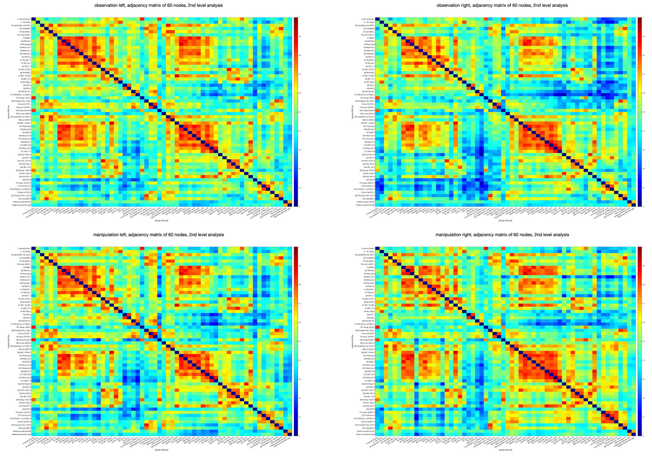

SF1. The 60 predefined ROIs are shown on the X and Y axis of the adjacency matrices for each condition, i.e. observation of manipulation by the left (1) and right hand (2) in the upper row, and manipulation of the object with the left (3) and right hand (4) in the lower row. The matrix retains the connections of the nodes and the weights of edges in-between, in our study based on Pearson’s correlation coefficient. A higher correlation coefficient between two ROIs indicate higher connection strength which is represented according to the colorbar on the right of each matrix. The correlation coefficients did not fall below zero, which indicates that there is no negative (inverse) correlation between any specified ROI. The diagonal entries of the adjacency matrix represent self-connections of ROIs and are set to zero by default. Note that the adjacency matrix is symmetric, which indicates that the network is undirected (the correlation coefficient of the connection between node x and node y is the same as the correlation coefficient of the connection between node y and node x).

SF2. Stimulation paradigm (see also video in the repository).

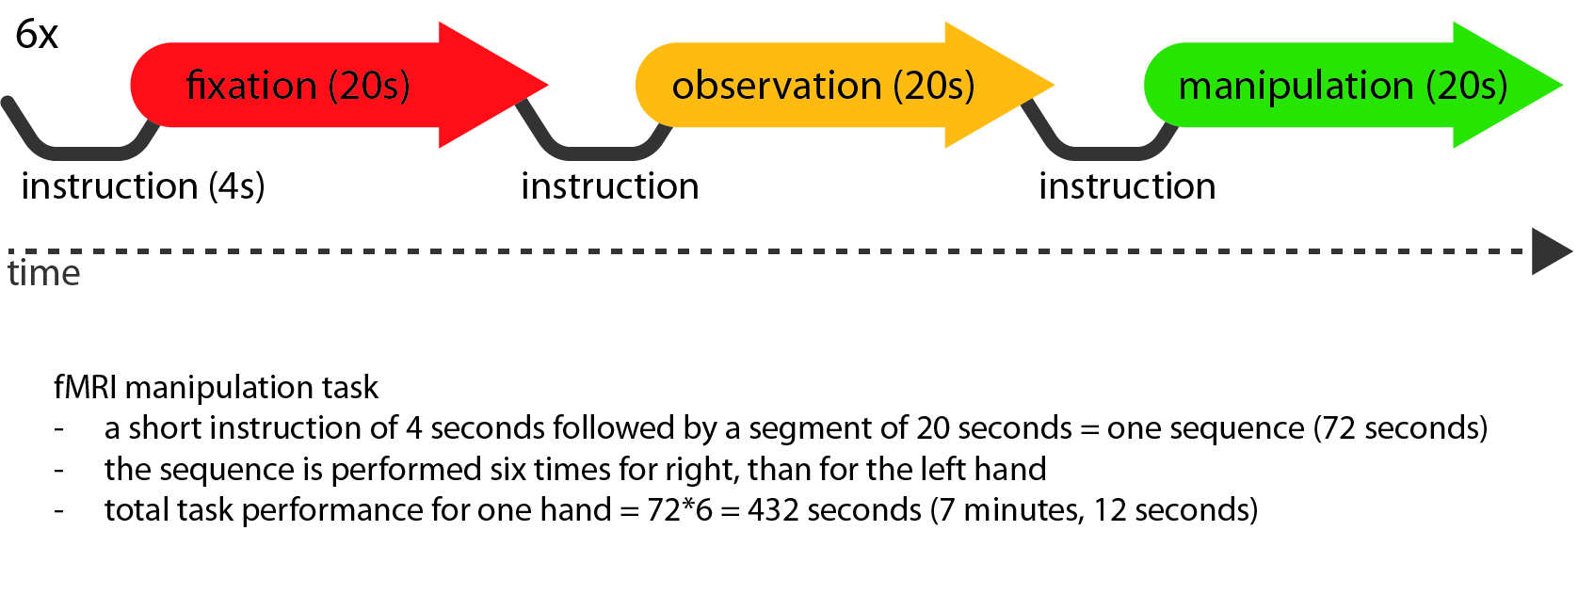

The temporal onsets of the conditions in seconds:
(1) instruction 0, 24, 48, 72, 96, 120, 144, 168, 192, 216, 240, 264, 288, 312, 336, 360, 384, 408.
(2) fixation 4, 76, 148, 220, 292, 364.
(3) observation of object manipulation 28, 100, 172, 244, 316, 388.
(4) manipulation 52, 124, 196, 268, 340, 412.

