Supplementary Information

Rapid detection of Impatiens necrotic spot virus from thrips vectors using reverse transcription-recombinase polymerase amplification

Shulu Zhang, Laura Jenkins Hladky, and Daniel K. Hasegawa*
United States Department of Agriculture – Agricultural Research Service, 1636 East Alisal Street, Salinas, California 93905.

*Corresponding author: Daniel K. Hasegawa, Email: daniel.hasegawa@usda.gov

Legends
Figure S1. Sequence alignments of the target region of the INSV S RNA from 24 representative strains and isolates (also see Table S2). The INSV isolates were chosen based on their availability of complete S RNA nucleotide sequences in the NCBI database. The nucleotide numbers 1-168 (1-84, top; 85-168, bottom) correspond to the nucleotide numbers 2,591 to 2,758 from NCBI database NC_003624. Differences in nucleotides are highlighted in red and the locations of the primers (RPA-F5 and RPA R2-2) and probe (RPA exo-P1) used for the RT-RPA assay are indicated by arrows.

Figure S2. Detection of INSV from crude extracts of thrips prepared in various extraction buffers using RT-RPA. RLC, broken blue line; 1x PBS, broken orange line; 1x TEB1, solid yellow line, 0.2x TEB1, broken grey line.

Figure S3. Detection of INSV from in vitro transcribed RNA using the RT-RPA assay. The RNA was serially diluted from 10 ng to 100 ag. RT-RPA amplification onset times were used for producing the standard curve (see Fig. S4). NTC, no template control.

Figure S4. Standard curve of RT-RPA from serial dilutions of the in vitro transcribed RNA. Amounts of the RNA per reaction are given on the right side of Fig. S3. The linear relationship was established using logarithms of the template concentrations (ng) against their amplification onset times (min).

Table S1. List of the primers and probes used for RT-RPA, RT-qPCR, and RT-PCR assays in the study. The names, nucleotide (Nt) sequences, and locations on the INSV S RNA segment (NCBI Reference Sequence: NC_003624.1) are given in the table.

Table S2. List of 24 INSV strains and isolates used for the sequence alignments in this study. The NCBI database accession numbers (Sequence ID), virus strain/isolate names, countries of virus origin, and host plant species are provided.

Figure S1. Sequence alignments of the target region of the INSV S RNA from 24 representative strains and isolates.
RPA-F5

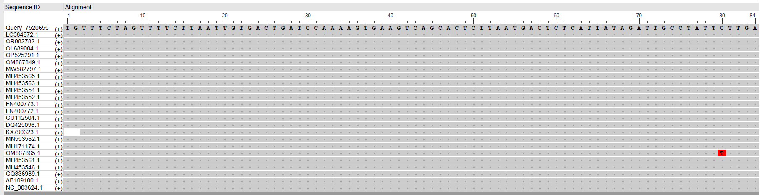
RPA exo-P1 exo P1be
RPA R2-2

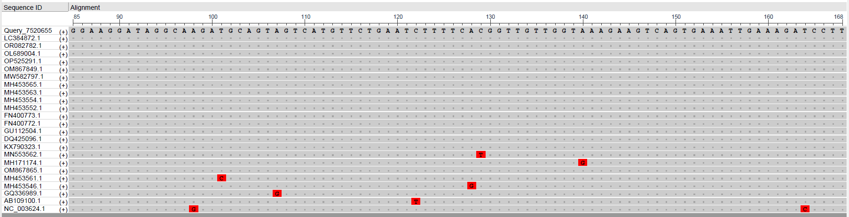

Figure S2. Detection of INSV from crude extracts of thrips prepared in various extraction buffers using RT-RPA.

Figure S3. Detection of INSV from in vitro transcribed RNA using RT-RPA.

Figure S4. Standard curve of RT-RPA from serial dilutions of the in vitro transcribed RNA.

Table S1. List of the primers and probes used for RT-RPA, RT-qPCR, and RT-PCR assays in the study.

Assay | Name | Nucleotide sequence (5′ to 3′) |  | Location
RT-RPA | INSV RPA-F5 | GTTTCTAGTTTTCTTAATTGTGACTGATCCA | Nt #2591-2622
RT-RPA | INSV RPA-R2-2 | AAGGATCTTTCAATTTCACTGACTTCTTTA | Nt #2729-2758
RT-RPA | INSV RPA exo-P1 | AAGGATAGGCAAGATGCAGTAGTCATGT/iFluorT//idSp/T/ZEN/GAATCTTTTCACGGTTGTTG/3IABkFQ | Nt #2677-2727
RT-qPCR | INSV qPCR-F | GAGGGTGACTTGGAAGGCTAT | Nt #2456-2476
RT-qPCR | INSV qPCR-R | TGATGCAATGGTGAGAGTTCA | Nt #2527-2547
RT-qPCR | INSV qPCR-P1 | FAM-AGCTTCAGTCAGAGCAGATCCATTGTC-BHQ1 | Nt #2481-2507
RT-PCR | INSV PCR-F | ACACCCAAGACACAGGATTT | Nt #2401-2420
RT-PCR | INSV PCR-R | CCAAATACTACTTTAACCGCAAGT | Nt #2901-2924

Table S2. List of 24 INSV strains and isolates used for the sequence alignments in this study.

Sequence ID | Strain/Isolate | Country of origin | Host plant species
NC_003624 | Strain NL-07 | The Netherlands | Impatiens sp.
LC384872 | Pepe | South Korea | Peperomia obtusifolia
OR082782 | DSMZ PV-1189 | Germany-Bayern | Ocimum basilicum
OL689004 | ND | China | Fatsia japonica
OP525291 | DSMZ PV-0485 | Unknown | Gloxinia sp.
OM867849 | DSMZ PV-0281 | Germany | Anemone coronaria
MW582797 | DSMZ PV-0280 | USA-East Coast | Hippeastrum sp.
MH453567 | Lisianthus | USA-CA | Eustoma sp.
MH453565 | Impatiens | USA-WA | Impatiens sp.
MH453563 | Green trick | USA-CA | Dianthus sp.
MH453554 | 16-153 | USA-NY | Hosta sp.
MH453552 | 16-149 | USA-NY | Digitalis sp.
FN400773 | YSMi-SH | China-Yunnan | Dendrobium sp.
FN400772 | YSMi-WX | China-Yunnan | Oncidium sp.
GU112504 | HDL | China | Hymenocallis littoralis
DQ425096 | Tomato | Italy-Apulia | Tomato
KX790323 | Basil-A | USA-WA | Ocimum basilicum
MN553562 | L7075Gr | Greece | Lettuce
MH171174 | UP01 | USA-PA | Impatiens sp.
OM867865 | DSMZ PV-1097 | Taiwan | Nicotiana benthamiana (lab)
MH453561 | Begonia | USA-WA | Begonia x tuberhybrida
MH453546 | 14-283 | USA-NY | Hoya wayetii
GQ336989 | Phalaenopsis | China | Phalaenopsis amabilis
AB109100 | Strain J | Japan | Verbena sp.

