Supplementary Materials

Large volumes of microplastics are transported to the deep sea by turbidity currents
Peng Chen¹, Ian A. Kane¹, Michael A. Clare², Euan L. Soutter¹, Furu Mienis³, Roy A. Wogelius¹, Edward Keavney⁴

¹Department of Earth and Environmental Sciences, University of Manchester, Manchester, UK
²OceanBioGeoscience, National Oceanography Centre, Southampton, UK
³Department of Ocean Systems, Royal Netherlands Institute for Sea Research (NIOZ-Texel), Den Burg, The Netherlands
⁴School of Earth and Environmental Sciences, University of Leeds, Leeds, UK
*Corresponding author: ian.kane@manchester.ac.uk

Materials and Methods

Bathymetry data
The bathymetry for the North-East Atlantic Ocean is derived from the Esri Ocean Basemap (https://www.arcgis.com/apps/mapviewer/index.html?webmap=67ab7f7c535c4687b6518e6d2343e8a2). The Digital Terrain Model data for the Whittard Canyon is based on the 2022 EMODnet digital terrain model (DTM) (https://doi.org/10.12770/ff3aff8a-cff1-44a3-a2c8-1910bf109f85), which has a resolution of 1/16 * 1/16 arc minute of longitude and latitude (ca 115 * 115 meters). The bathymetry for the eastern branch of the Whittard Canyon is derived from the GEBCO_2023 Grid, GEBCO Compilation Group (2023) GEBCO 2023 Grid (https://www.gebco.net/data_and_products/gridded_bathymetry_data/gebco_2023/). The superimposed bathymetric contour at 100m is obtained from National Oceanography Centre, Southampton, UK. All the bathymetry data is analysed using QGIS software to mark the moorings and sample locations, and to construct the longitudinal profile and the cross-sections of the canyon (Fig. S1).

Two moorings and sediment trap sample
In this study, Acoustic Doppler Current Profilers (ADCPs) deployed on two moorings (M1 and M2) were used to record ocean hydrodynamics along the thalweg of the eastern branch of the Whittard Canyon (33). M1 was located at 1591 m water depth (26 km downstream of the canyon head) at 48.626° N, 10.004° W, and M2 was located 21 km downstream from M1 at 2259 m water depth at 48.490° N, 9.936° W. M1 was in addition equipped with a McLane Parflux sediment trap (ST) mounted at 10 m above the seafloor (Fig. 1, C and D). This ST consists of an upward-facing funnel overlying a mechanical carousel that turns every 18 days to present a new 500 ml sampling bottle. The sediment collected from the first sampling bottle, representing the sedimentation of the first turbidity current within the first 18 days (33), is weighed 553.2 g; a 58.5 g subsample was taken for microplastic extraction and grain-size analysis.

Seafloor sediment samples
A mono corer was suspended 7 m beneath the Conductivity–Temperature–Depth rosette (CTD) instrument during all CTD casts. After retrieval cores were immediately sliced in cm slices. Half of the slice was stored for sedimentological analysis at −20℃, and the other half was preserved for plastic analysis and samples were stored at 4℃ in aluminium foils. A total of 63 sub-samples were collected from seven mono-cores in the eastern branch of the Whittard Canyon. The seven mono-core locations were numbered C1 to C7 from below the head of the canyon to just north of the eastern branch of the Whittard Canyon (Fig. 1C). Only C3 contains 3 sub-samples, the other six mono-cores each have 10 sub-samples, with a sampling interval of 1 cm (see Table S1).

Microplastic extraction, identification and quantification
The 1 cm sediment core horizons had variable weights and water content, so samples were dried overnight in a drying oven set to 50℃. The dried samples were weighed and for comparative purposes, the weight and microplastic content quoted are normalized to 50.0 g (original data in Table S2). Sediment samples were then stored in glass beakers and covered with aluminum foil. Samples were added to a 1 L glass beaker with approximately 700 ml of a dense ZnCl₂ solution (1.7 g cm⁻³) and disaggregated using a magnetic stirrer, and mixed until the sediment/ZnCl₂ solution was homogenized. The microplastics were extracted from the sediment using a Sediment Microplastic Isolation (SMI) unit following a protocol developed for microplastic extraction (51) and modified following (52). The solution was added to the SMI unit, and the beaker was rinsed with ZnCl₂ solution to flush any remaining sediment/microplastic. Prior to each use, the SMI unit was disassembled and thoroughly rinsed with Class 1 Milli-Q de-ionized water. Following settling overnight, the headspace supernatant was isolated by closing the ball valve of the SMI unit and rinsing with extra ZnCl₂ solution to flush any remaining microplastics before vacuum filtering over a Whatman 541, 22 µm filter paper. The filter paper was then placed in a labelled petri dish and covered. Throughout the duration of the microplastic extraction procedure, all individuals wore white, cotton laboratory coats and latex gloves. All the microplastic extraction stages were performed in a clean laboratory in a fume cupboard. When the sediment samples were mixing in the 1 L glass beaker, and settling in the SMI units they were covered with aluminum foil to limit airborne microplastic contamination. When it was not possible during the sample preparation to cover the sediment sample with aluminum foil, an opened petri dish with a blank, Whatman 541, 22 µm, filter paper was placed in the fume cupboard and used as a contamination control procedural blank. The contamination control procedural blank data can be provided on request to the corresponding author.

The prepared filter papers, both from the sediment extraction process and the airborne contamination control blanks were analyzed in a clean microscopy laboratory using a Zeiss Axio Zoom, V16 stereomicroscope at 20-50x magnification. Filter papers were traversed systematically to identify microplastics based on the following criterion: (1) no visible cellular or organic structures; (2) a positive reaction to the hot needle test (53, 54); (3) maintenance of structural integrity when touched or moved. Microplastics were categorized based on their color and type, including, whether they were microfibers, microplastic fragments (including films), or microbeads (Fig. S2). The percentage of different microplastic shapes (e.g., fibers, fragments) in each sample, and the mean microplastic concentration of each sample location (i.e., ST, C1–7) were also calculated and presented (see Table S2).

Polymer identification
Industry produces a wide variety of plastic polymers that break down when exposed to weathering processes. A key reaction in this breakdown is the oxidation of reduced carbon, which increases the quantity of oxygen-bearing functional groups in the plastics. This increase can serve as an indicator of degradation: the more oxygen present, the more degraded the plastic (55). This degradation process is similar to how natural organic carbon materials in sedimentary rocks break down, where oxidative processes convert pristine reduced carbon compounds like collagen or keratin into more oxidized, less polymerized fragments (56). However, plastics have a wide range of compositions and structures, analytical methods are therefore required to characterize such material and determine the degree of their degradation accurately. Infrared methods are particularly useful for identifying diagnostic functional groups, determining the most likely original plastic type, and providing information about the degree of degradation based on compositional differences between the probable original material and the recovered sample from the field (55). A subset (n = 42) of the extracted microfibers was analyzed using a PerkinElmer Spotlight 400 Fourier transform infrared (FTIR) spectrometer equipped with a diamond Attenuated Total Reflectance accessory, to confirm a polymer (or other) origin and to assess the degree of degradation. Some of these samples were taken from push-cores of the same age stratigraphy in adjacent core locations (Fig. 1C). The FTIR spectrum range was set at 4,000–650 cm⁻¹, with a resolution of 4 cm⁻¹ at a rate of 16 scans per analysis. Data were processed and diagnostic functional groups were identified using the PerkinElmer Spectrum IR and Spectrum IMAGE software with a standard reference library to assign polymer type and assess degree of degradation. Microplastic polymers were consequently confirmed based on the library comparison results with >70% confidence (Fig. S3).

Grain-size analysis
All sediment samples were analysed using Malvern Mastersizer 3000 equipped with an automated wet dispersion unit (Hydro LV). The samples were subjected to a small amount of ultrasonic and pre-measurement dispersion. Three aliquots were analysed to ensure that each sample was completely dispersed. Each measurement was replicated five times with a coefficient of variance (COV) below 3% for D₅₀, and below 5% for D₁₀ and D₉₉, and the average of the five valid results was finally reported. The grain-size distribution (Fig. S4), indicating the volume percentage of grains in a certain size interval, was constructed. Some grain-size percentiles, such as D₁₀, D₅₀ and D₉₉, were exported from the software. Four grain-size parameters, including mean, standard deviation, skewness and kurtosis, were calculated. Further statistical analysis between microplastic concentration, grain-size percentiles and grain-size parameters was also conducted.

Relating microplastics to seafloor shear stress
Bed shear stress (τ) determines which sediment the flow can transport, and whether the flow will pick up additional sediment from the bed or sediment will settle out of the flow (56). The bed shear stress (τ) is assumed to only relate to bed roughness and will be constant for a fixed location during the flow (57), and thus can be calculated by (58):
τ = ρ_{w}u*² (1)
where ρ_{w} is the sea water density (1029 kg m⁻³), u* is the bed shear velocity (21). In this study, the bed shear velocity (u*) generated by the turbidity current at the seafloor can be determined by its velocity profile, which is logarithmic between the bed and the maximum velocity (59, 60):
u* = U_{max}κ[ln($\frac{{\text{h}}_{\text{max}}}{{\text{0.1D}}_{\text{90}}}$)]⁻¹ (2)
where U_{max} is the maximum velocity, h_{max} is the height of the maximum velocity, κ is the von Kármán constant with a value of 0.4 (61), and D₉₀ is derived from the grain-size distribution in the turbidity current. The bed shear velocity (u*) and the resultant bed shear stress (τ) are then used to calculate Shields parameter (60-64) (τ*, also called dimensionless shear stress) and boundary Reynolds number (R*) for different particles using (21, 59, 60):
τ* = $\frac{\text{τ}}{\text{(}\text{ρ}\text{s} - ρ\text{w}\text{)}\text{gD}}$ (3)
R* = $\frac{\text{u*D}}{\text{ν}}$ (4)
where ρ_{s} is the particle density [quartz with 2650 kg m⁻³, polytetrafluoroethylene (PTFE) with 2200 kg m⁻³, polystyrene (PS) with 1050 kg m⁻³], g is acceleration due to gravity (9.81 m s⁻²) (58), ν is kinematic viscosity of seawater at 20℃ (1.0508×10⁻⁶m² s⁻¹) (https://ittc.info/), and D is the particle diameter. By plotting the results on a Shields diagram (Fig. 4A), it can be seen that, even during waning flow (Fig. 2D), all sediments (including quartzes and microplastics) are prone to be transported in suspension by the turbidity currents in the Whittard Canyon with a shear stress >1.70 N m⁻² (Fig. 4A and Table S3).

Sedimentation rate of seafloor sediments
The ²¹⁰Pb dating technique is based on alpha-spectrometry from ²¹⁰Po and is used to infer particle accumulation rates over the past 100 years (for methodology, see 65). The ²¹⁰Pb dating results are analyzed by a two-layer, 1D vertical eddy diffusion model assuming a constant input of ²¹⁰Pb and steady sedimentation rates (64-66). ²¹⁰Pb samples are chosen as such to avoid sandy intervals as they generally hold lower ²¹⁰Pb signatures than finer grained intervals (67). Therefore, the finer sediments (silt with normally graded successions) of box-core 65 in the Whittard Canyon are suitable and are selected for ²¹⁰Pb dating. The box-core 65, located at 1105.5 m water depth at 48.6391° N, 10.036° W, is near the mono-core C1 (Fig. 1C). The total length of box-core 65 is 41.3 cm, with 12 intervals (0–0.5 cm, 0.5–1 cm, 1–1.5 cm, 2–2.5 cm, 3–4 cm, 5–6 cm, 9–10 cm, 13–14 cm, 17–18 cm, 24–25 cm, 31–32 cm, 38–39 cm) sampled. ²¹⁰Pb activity of the sediments in box-core 65 varies from 400–530 mBq g⁻¹ at the surface to a background activity of ~25 mBq g⁻¹ with depth. The shape of the ²¹⁰Pb profile varies as a function of accumulation rate, diffusive mixing constant and bioturbated mixing depth. The ²¹⁰Pb profile is gently sloped, suggesting a sedimentation rate (ω) of approximately 0.22 cm yr⁻¹ (46) (Fig. S5).

Mapping of global submarine canyons and comparison of their microplastic concentrations
We map previous geomorphological dataset of submarine canyons worldwide (42) that includes a total of 5849 submarine canyons by QGIS (Fig. S6). These submarine canyons can be sub-divided into three main types: Type 1, shelf-incising submarine canyons having heads with a clear bathymetric connection to a major river system; Type 2, shelf-incising submarine canyons with no clear bathymetric connection to a major river system; and Type 3, blind submarine canyons incised onto the continental slope (42). Here we define land-detached submarine canyons as submarine canyons that are not connected to a major river system, so Type 2 and Type 3 can both be included with a total number of 5696 (Fig. S6). There is a 45–55% increase in potentially active submarine canyons from just land-attached submarine canyons to land-detached submarine canyons, so the number of land-detached submarine canyons will be higher than this value. Most new potentially active submarine canyons are located along the eastern margins of North America and South America, southern and western Australia and the Celtic Margin (Fig. S6). To compare measured microplastic concentrations from the samples in the Whittard Canyon with other submarine canyons worldwide, we compiled data from publications that provided details on the mean and maximum microplastic concentrations of ten submarine canyons (25, 41, 67, 68) (Fig. 1E and Table S4).
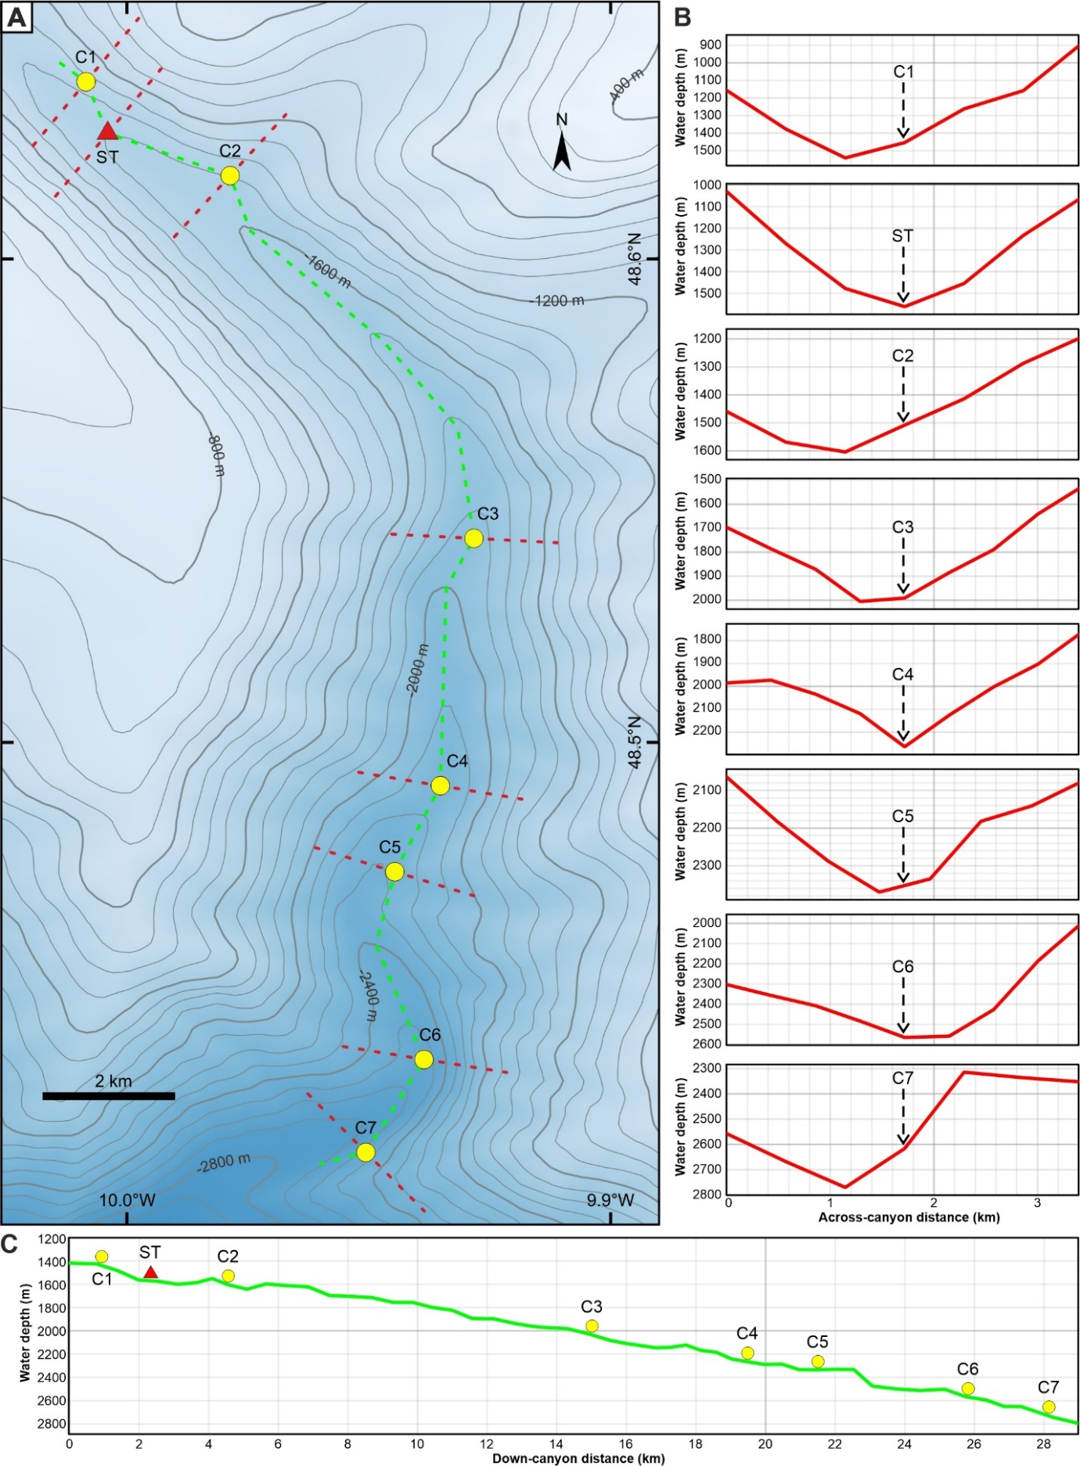
Fig. S1. Cross sectional and longitudinal profiles of the canyon. (A) Position of the cross sections and the longitudinal profile. (B) Cross sectional geometry of the canyon at each mono-core location (C1–7) and the sediment trap (ST). Note that the mono-core locations are not always at the deepest part of the canyon. (C) Longitudinal profile showing the ST and mono-core locations along the canyon.
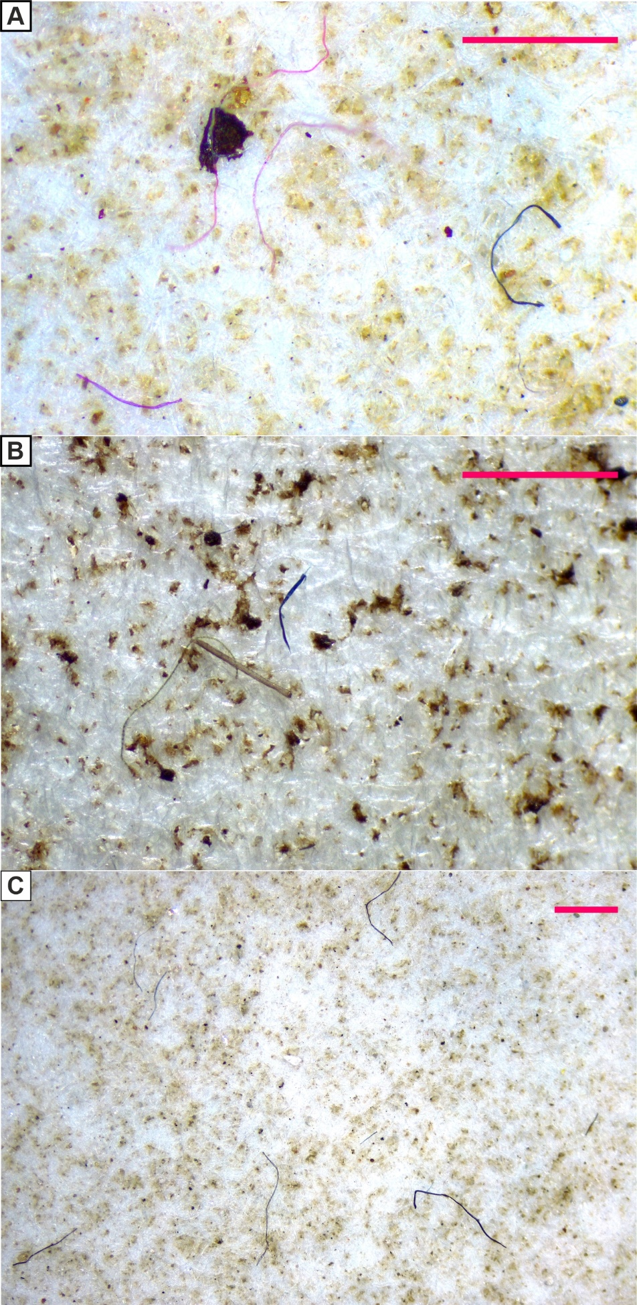
Fig. S2. Representative photos taken by stereomicroscope showing different microfibers and microplastic fragments from the sediment trap. Note the background sediments are mainly composed of quartz grains. Scale bar 1 mm. (A) Pink and blue microfibers, and pink microplastic fragments. (B) Blue and gray microfibers, with phytobenthos and organics also shown. (C) Blue, gray and purple microfibers.
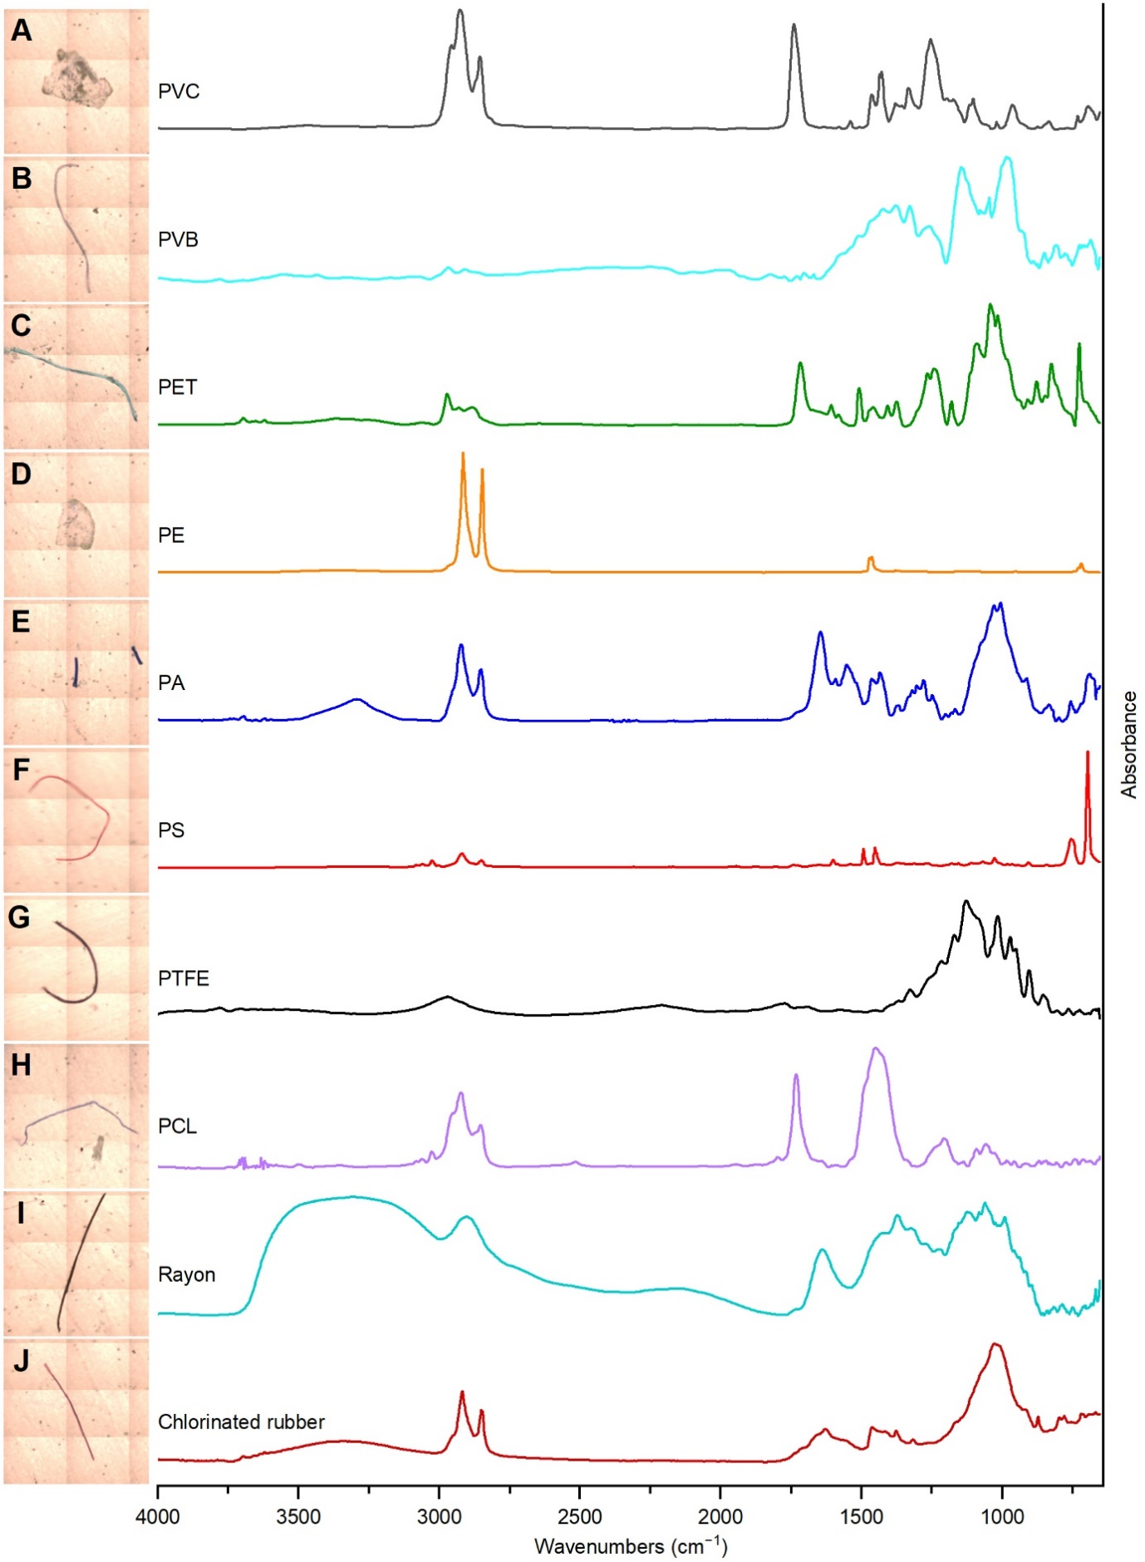
Fig. S3. Representative photos of microfibers and microplastic fragments taken by micro-FTIR (scale: 1 mm side length of a square) and their corresponding polymer types interpreted by FTIR spectra. (A) PVC (polyvinyl chloride). (B) PVB (polyvinyl butyral). (C) PET (polyethylene terephthalate). (D) PE (polyethylene). (E) PA (polyamide). (F) PS (polystyrene). (G) PTFE (polytetrafluoroethylene). (H) PCL (polycaprolactone). (I) Rayon. (J) Chlorinated rubber.

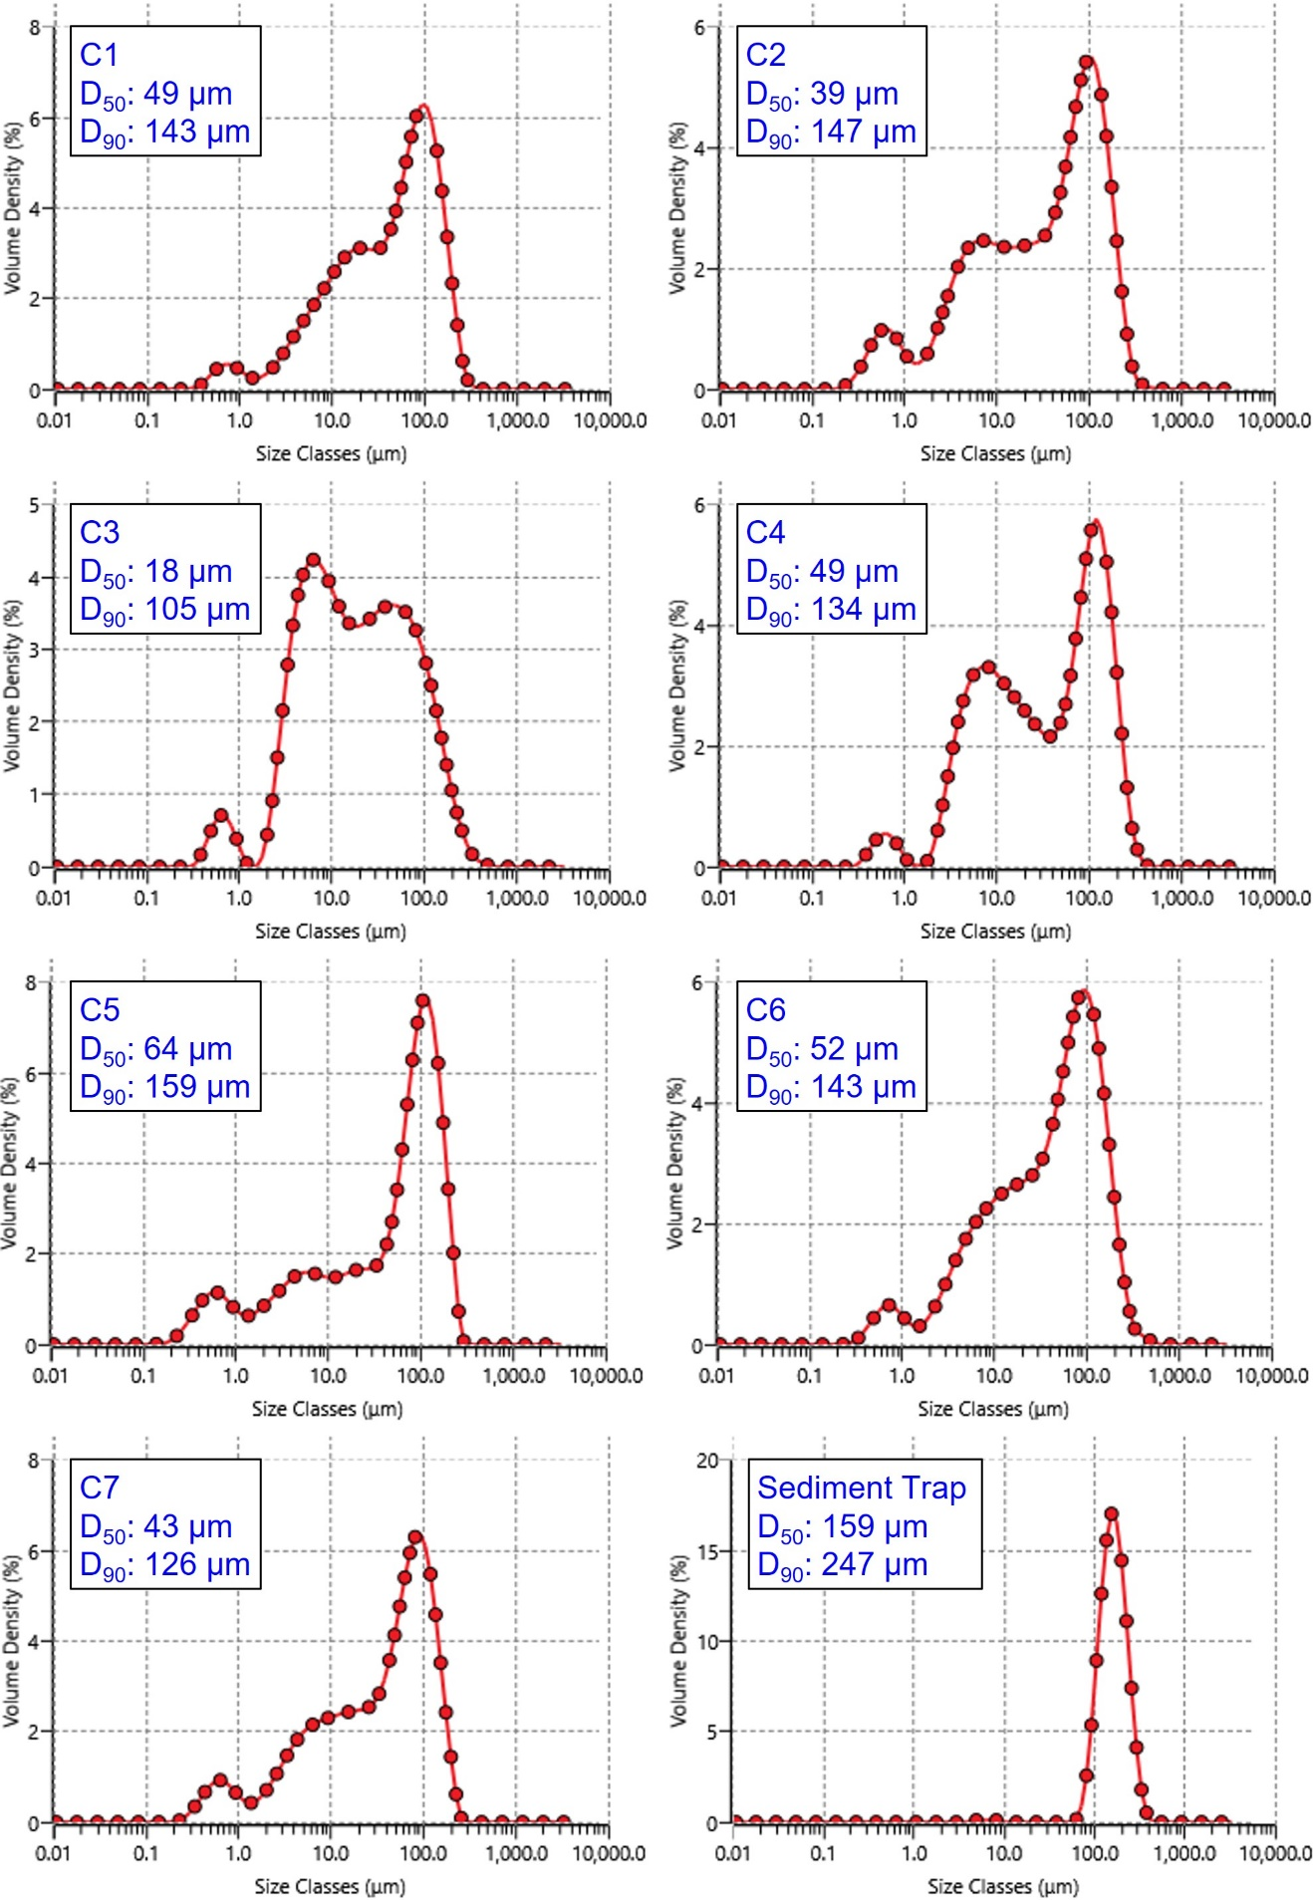
Fig. S4. Grain size distribution of sediment samples from the seven mono-cores (C1–7) and the sediment trap. Their mean D₅₀ and D₉₀ values are shown.
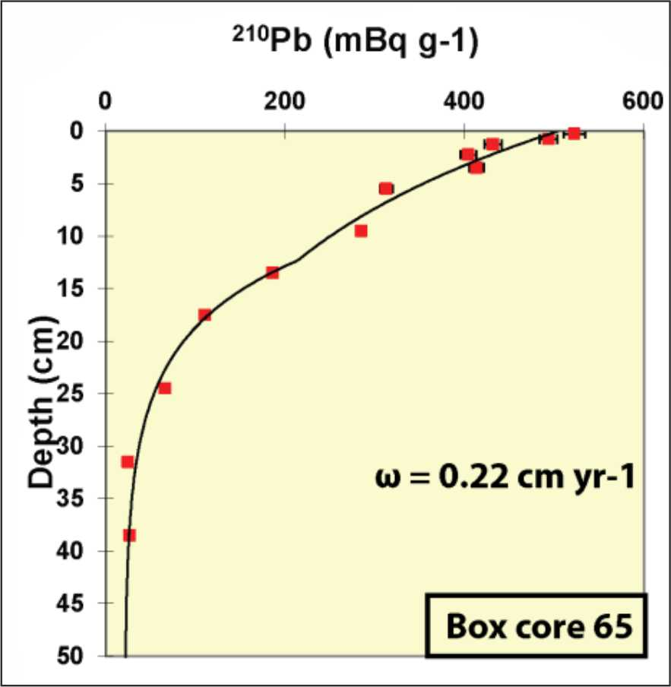
Fig. S5. ²¹⁰Pb activity as a function of depth for box-core 65. Red squares represent the measured ²¹⁰Pb activities per sediment depth interval, and the black profile line represents the modelled ²¹⁰Pb activity. Sediment accumulation rate is expressed as ω with a value of 0.22 cm yr⁻¹ (46), indicating the 10 cm sample depth is likely to be deposited entirely within the time range since the first production of plastic in the 1950s.
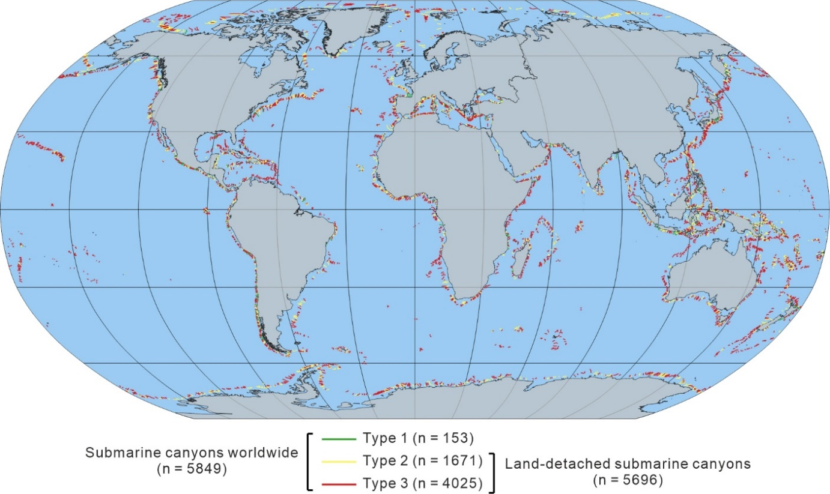
Fig. S6. Distribution of the 5849 submarine canyons worldwide as mapped by previous study (42). Land-detached submarine canyons are defined as those are not connected to a major river system (Type 2 and Type 3) and account for 97% (n = 5696). Note we exclude canyons on the Antarctic shelf from this analysis as they may be fed in different ways (i.e. by cascading dense cold water, rather than sediment flows).

Table S1. Details of the seafloor sediment samples, including their core numbers, coordinates, water and sediment depths, original sample and dry weights.
Number | Core | Latitude (°) | Longitude (°) | Water depth (m) | Sediment depth (cm) | Original sample weight (g) | Dry weight (g)
1 | C1 | 48.63664 | −10.0085 | 1421 | 1 | 21.452 | 14.2
2 | C1 | 48.63664 | −10.0085 | 1421 | 2 | 21.368 | 14
3 | C1 | 48.63664 | −10.0085 | 1421 | 3 | 28.381 | 24.2
4 | C1 | 48.63664 | −10.0085 | 1421 | 4 | 36.381 | 30
5 | C1 | 48.63664 | −10.0085 | 1421 | 5 | 27.041 | 22.4
6 | C1 | 48.63664 | −10.0085 | 1421 | 6 | 32.744 | 26.8
7 | C1 | 48.63664 | −10.0085 | 1421 | 7 | 45.221 | 34.7
8 | C1 | 48.63664 | −10.0085 | 1421 | 8 | 34.436 | 24.5
9 | C1 | 48.63664 | −10.0085 | 1421 | 9 | 29.409 | 19.2
10 | C1 | 48.63664 | −10.0085 | 1421 | 10 | 31.257 | 20.9
11 | C2 | 48.61722 | −9.97869 | 1569 | 1 | 16.196 | 9.6
12 | C2 | 48.61722 | −9.97869 | 1569 | 2 | 23.644 | 10.7
13 | C2 | 48.61722 | −9.97869 | 1569 | 3 | 22.591 | 12.2
14 | C2 | 48.61722 | −9.97869 | 1569 | 4 | 25.958 | 16.2
15 | C2 | 48.61722 | −9.97869 | 1569 | 5 | 26.954 | 14.6
16 | C2 | 48.61722 | −9.97869 | 1569 | 6 | 22.639 | 14
17 | C2 | 48.61722 | −9.97869 | 1569 | 7 | 25.98 | 16
18 | C2 | 48.61722 | −9.97869 | 1569 | 8 | 21.771 | 12.3
19 | C2 | 48.61722 | −9.97869 | 1569 | 9 | 27.508 | 17.5
20 | C2 | 48.61722 | −9.97869 | 1569 | 10 | 20.791 | 13.5
21 | C3 | 48.54217 | −9.92827 | 2044 | 1 | 22.285 | 22.6
22 | C3 | 48.54217 | −9.92827 | 2044 | 2 | 19.191 | 16.6
23 | C3 | 48.54217 | −9.92827 | 2044 | 3 | 15.383 | 12.5
24 | C4 | 48.49102 | −9.9352 | 2270 | 1 | 15.23 | 13
25 | C4 | 48.49102 | −9.9352 | 2270 | 2 | 23.925 | 18.998
26 | C4 | 48.49102 | −9.9352 | 2270 | 3 | 29.711 | 24.4
27 | C4 | 48.49102 | −9.9352 | 2270 | 4 | 23.897 | 19.8
28 | C4 | 48.49102 | −9.9352 | 2270 | 5 | 23.7 | 17.7
29 | C4 | 48.49102 | −9.9352 | 2270 | 6 | 25.069 | 18.951
30 | C4 | 48.49102 | −9.9352 | 2270 | 7 | 23.638 | 15
31 | C4 | 48.49102 | −9.9352 | 2270 | 8 | 35.874 | 28.9
32 | C4 | 48.49102 | −9.9352 | 2270 | 9 | 38.629 | 32.6
33 | C4 | 48.49102 | −9.9352 | 2270 | 10 | 29.696 | 26.2
34 | C5 | 48.47323 | −9.94462 | 2338 | 1 | 37.888 | 28.6
35 | C5 | 48.47323 | −9.94462 | 2338 | 2 | 29.795 | 20
36 | C5 | 48.47323 | −9.94462 | 2338 | 3 | 33.316 | 27.3
37 | C5 | 48.47323 | −9.94462 | 2338 | 4 | 39.354 | 31.5
38 | C5 | 48.47323 | −9.94462 | 2338 | 5 | 48.513 | 40.5
39 | C5 | 48.47323 | −9.94462 | 2338 | 6 | 33.273 | 23
40 | C5 | 48.47323 | −9.94462 | 2338 | 7 | 32.534 | 22
41 | C5 | 48.47323 | −9.94462 | 2338 | 8 | 37.167 | 29
42 | C5 | 48.47323 | −9.94462 | 2338 | 9 | 46.885 | 40.4
43 | C5 | 48.47323 | −9.94462 | 2338 | 10 | 30.776 | 27
44 | C6 | 48.43438 | −9.9386 | 2590 | 1 | 13.094 | 7
45 | C6 | 48.43438 | −9.9386 | 2590 | 2 | 12.692 | 5.8
46 | C6 | 48.43438 | −9.9386 | 2590 | 3 | 14.696 | 8
47 | C6 | 48.43438 | −9.9386 | 2590 | 4 | 20.189 | 9.5
48 | C6 | 48.43438 | −9.9386 | 2590 | 5 | 21.035 | 10
49 | C6 | 48.43438 | −9.9386 | 2590 | 6 | 16.765 | 11.7
50 | C6 | 48.43438 | −9.9386 | 2590 | 7 | 32.125 | 19.2
51 | C6 | 48.43438 | −9.9386 | 2590 | 8 | 32.161 | 19.6
52 | C6 | 48.43438 | −9.9386 | 2590 | 9 | 29.764 | 19.3
53 | C6 | 48.43438 | −9.9386 | 2590 | 10 | 36.744 | 24.3
54 | C7 | 48.41516 | −9.95061 | 2683 | 1 | 27.001 | 15.5
55 | C7 | 48.41516 | −9.95061 | 2683 | 2 | 34.449 | 24.1
56 | C7 | 48.41516 | −9.95061 | 2683 | 3 | 31.075 | 27.2
57 | C7 | 48.41516 | −9.95061 | 2683 | 4 | 35.305 | 29.9
58 | C7 | 48.41516 | −9.95061 | 2683 | 5 | 31.764 | 26.3
59 | C7 | 48.41516 | −9.95061 | 2683 | 6 | 34.188 | 27.2
60 | C7 | 48.41516 | −9.95061 | 2683 | 7 | 37.706 | 34
61 | C7 | 48.41516 | −9.95061 | 2683 | 8 | 37.105 | 32.3
62 | C7 | 48.41516 | −9.95061 | 2683 | 9 | 34.347 | 28.6
63 | C7 | 48.41516 | −9.95061 | 2683 | 10 | 29.081 | 21.7

Table S2. Details of microfibers and microplastic fragments identified in the seafloor sediment samples.
Core | Depth (cm) | Type | Concentration (items 50 g⁻¹ of dried sediment) | Percentage (fibers/fragments) | Mean concentration in core | Mean percentage (fibers/fragments) in core
C1 | 1 | Fibers | 39 | 100.0% | 41 | 100.0%  0.0%
C1 | 1 | Fragments | 0 | 0.0% | 41 | 100.0%  0.0%
C1 | 2 | Fibers | 46 | 100.0% | 41 | 100.0%  0.0%
C1 | 2 | Fragments | 0 | 0.0% | 41 | 100.0%  0.0%
C1 | 3 | Fibers | 43 | 100.0% | 41 | 100.0%  0.0%
C1 | 3 | Fragments | 0 | 0.0% | 41 | 100.0%  0.0%
C1 | 4 | Fibers | 48 | 100.0% | 41 | 100.0%  0.0%
C1 | 4 | Fragments | 0 | 0.0% | 41 | 100.0%  0.0%
C1 | 5 | Fibers | 36 | 100.0% | 41 | 100.0%  0.0%
C1 | 5 | Fragments | 0 | 0.0% | 41 | 100.0%  0.0%
C1 | 6 | Fibers | 52 | 100.0% | 41 | 100.0%  0.0%
C1 | 6 | Fragments | 0 | 0.0% | 41 | 100.0%  0.0%
C1 | 7 | Fibers | 24 | 100.0% | 41 | 100.0%  0.0%
C1 | 7 | Fragments | 0 | 0.0% | 41 | 100.0%  0.0%
C1 | 8 | Fibers | 49 | 100.0% | 41 | 100.0%  0.0%
C1 | 8 | Fragments | 0 | 0.0% | 41 | 100.0%  0.0%
C1 | 9 | Fibers | 36 | 100.0% | 41 | 100.0%  0.0%
C1 | 9 | Fragments | 0 | 0.0% | 41 | 100.0%  0.0%
C1 | 10 | Fibers | 33 | 100.0% | 41 | 100.0%  0.0%
C1 | 10 | Fragments | 0 | 0.0% | 41 | 100.0%  0.0%
C2 | 1 | Fibers | 57 | 100.0% | 43 | 100.0%  0.0%
C2 | 1 | Fragments | 0 | 0.0% | 43 | 100.0%  0.0%
C2 | 2 | Fibers | 51 | 100.0% | 43 | 100.0%  0.0%
C2 | 2 | Fragments | 0 | 0.0% | 43 | 100.0%  0.0%
C2 | 3 | Fibers | 33 | 100.0% | 43 | 100.0%  0.0%
C2 | 3 | Fragments | 0 | 0.0% | 43 | 100.0%  0.0%
C2 | 4 | Fibers | 37 | 100.0% | 43 | 100.0%  0.0%
C2 | 4 | Fragments | 0 | 0.0% | 43 | 100.0%  0.0%
C2 | 5 | Fibers | 58 | 100.0% | 43 | 100.0%  0.0%
C2 | 5 | Fragments | 0 | 0.0% | 43 | 100.0%  0.0%
C2 | 6 | Fibers | 32 | 100.0% | 43 | 100.0%  0.0%
C2 | 6 | Fragments | 0 | 0.0% | 43 | 100.0%  0.0%
C2 | 7 | Fibers | 34 | 100.0% | 43 | 100.0%  0.0%
C2 | 7 | Fragments | 0 | 0.0% | 43 | 100.0%  0.0%
C2 | 8 | Fibers | 53 | 100.0% | 43 | 100.0%  0.0%
C2 | 8 | Fragments | 0 | 0.0% | 43 | 100.0%  0.0%
C2 | 9 | Fibers | 40 | 100.0% | 43 | 100.0%  0.0%
C2 | 9 | Fragments | 0 | 0.0% | 43 | 100.0%  0.0%
C2 | 10 | Fibers | 30 | 100.0% | 43 | 100.0%  0.0%
C2 | 10 | Fragments | 0 | 0.0% | 43 | 100.0%  0.0%
C3 | 1 | Fibers | 71 | 100.0% | 68 | 100.0%  0.0%
C3 | 1 | Fragments | 0 | 0.0% | 68 | 100.0%  0.0%
C3 | 2 | Fibers | 66 | 100.0% | 68 | 100.0%  0.0%
C3 | 2 | Fragments | 0 | 0.0% | 68 | 100.0%  0.0%
C3 | 3 | Fibers | 68 | 100.0% | 68 | 100.0%  0.0%
C3 | 3 | Fragments | 0 | 0.0% | 68 | 100.0%  0.0%
C4 | 1 | Fibers | 73 | 100.0% | 44 | 92.8%  7.2%
C4 | 1 | Fragments | 0 | 0.0% | 44 | 92.8%  7.2%
C4 | 2 | Fibers | 58 | 91.7% | 44 | 92.8%  7.2%
C4 | 2 | Fragments | 5 | 8.3% | 44 | 92.8%  7.2%
C4 | 3 | Fibers | 51 | 100.0% | 44 | 92.8%  7.2%
C4 | 3 | Fragments | 0 | 0.0% | 44 | 92.8%  7.2%
C4 | 4 | Fibers | 56 | 91.7% | 44 | 92.8%  7.2%
C4 | 4 | Fragments | 5 | 8.3% | 44 | 92.8%  7.2%
C4 | 5 | Fibers | 51 | 90.0% | 44 | 92.8%  7.2%
C4 | 5 | Fragments | 6 | 10.0% | 44 | 92.8%  7.2%
C4 | 6 | Fibers | 42 | 84.2% | 44 | 92.8%  7.2%
C4 | 6 | Fragments | 8 | 15.8% | 44 | 92.8%  7.2%
C4 | 7 | Fibers | 37 | 84.6% | 44 | 92.8%  7.2%
C4 | 7 | Fragments | 7 | 15.4% | 44 | 92.8%  7.2%
C4 | 8 | Fibers | 22 | 100.0% | 44 | 92.8%  7.2%
C4 | 8 | Fragments | 0 | 0.0% | 44 | 92.8%  7.2%
C4 | 9 | Fibers | 14 | 90.0% | 44 | 92.8%  7.2%
C4 | 9 | Fragments | 2 | 10.0% | 44 | 92.8%  7.2%
C4 | 10 | Fibers | 8 | 100.0% | 44 | 92.8%  7.2%
C4 | 10 | Fragments | 0 | 0.0% | 44 | 92.8%  7.2%
C5 | 1 | Fibers | 52 | 100.0% | 40 | 95.9%  4.1%
C5 | 1 | Fragments | 0 | 0.0% | 40 | 95.9%  4.1%
C5 | 2 | Fibers | 40 | 94.1% | 40 | 95.9%  4.1%
C5 | 2 | Fragments | 3 | 5.9% | 40 | 95.9%  4.1%
C5 | 3 | Fibers | 38 | 100.0% | 40 | 95.9%  4.1%
C5 | 3 | Fragments | 0 | 0.0% | 40 | 95.9%  4.1%
C5 | 4 | Fibers | 38 | 100.0% | 40 | 95.9%  4.1%
C5 | 4 | Fragments | 0 | 0.0% | 40 | 95.9%  4.1%
C5 | 5 | Fibers | 49 | 88.9% | 40 | 95.9%  4.1%
C5 | 5 | Fragments | 6 | 11.1% | 40 | 95.9%  4.1%
C5 | 6 | Fibers | 41 | 95.0% | 40 | 95.9%  4.1%
C5 | 6 | Fragments | 2 | 5.0% | 40 | 95.9%  4.1%
C5 | 7 | Fibers | 27 | 100.0% | 40 | 95.9%  4.1%
C5 | 7 | Fragments | 0 | 0.0% | 40 | 95.9%  4.1%
C5 | 8 | Fibers | 33 | 100.0% | 40 | 95.9%  4.1%
C5 | 8 | Fragments | 0 | 0.0% | 40 | 95.9%  4.1%
C5 | 9 | Fibers | 24 | 100.0% | 40 | 95.9%  4.1%
C5 | 9 | Fragments | 0 | 0.0% | 40 | 95.9%  4.1%
C5 | 10 | Fibers | 37 | 87.0% | 40 | 95.9%  4.1%
C5 | 10 | Fragments | 6 | 13.0% | 40 | 95.9%  4.1%
C6 | 1 | Fibers | 50 | 100.0% | 47 | 93.6%  6.4%
C6 | 1 | Fragments | 0 | 0.0% | 47 | 93.6%  6.4%
C6 | 2 | Fibers | 78 | 100.0% | 47 | 93.6%  6.4%
C6 | 2 | Fragments | 0 | 0.0% | 47 | 93.6%  6.4%
C6 | 3 | Fibers | 50 | 100.0% | 47 | 93.6%  6.4%
C6 | 3 | Fragments | 0 | 0.0% | 47 | 93.6%  6.4%
C6 | 4 | Fibers | 42 | 80.0% | 47 | 93.6%  6.4%
C6 | 4 | Fragments | 11 | 20.0% | 47 | 93.6%  6.4%
C6 | 5 | Fibers | 50 | 100.0% | 47 | 93.6%  6.4%
C6 | 5 | Fragments | 0 | 0.0% | 47 | 93.6%  6.4%
C6 | 6 | Fibers | 43 | 90.9% | 47 | 93.6%  6.4%
C6 | 6 | Fragments | 4 | 9.1% | 47 | 93.6%  6.4%
C6 | 7 | Fibers | 39 | 100.0% | 47 | 93.6%  6.4%
C6 | 7 | Fragments | 0 | 0.0% | 47 | 93.6%  6.4%
C6 | 8 | Fibers | 33 | 92.9% | 47 | 93.6%  6.4%
C6 | 8 | Fragments | 3 | 7.1% | 47 | 93.6%  6.4%
C6 | 9 | Fibers | 39 | 78.9% | 47 | 93.6%  6.4%
C6 | 9 | Fragments | 10 | 21.1% | 47 | 93.6%  6.4%
C6 | 10 | Fibers | 14 | 87.5% | 47 | 93.6%  6.4%
C6 | 10 | Fragments | 2 | 12.5% | 47 | 93.6%  6.4%
C7 | 1 | Fibers | 52 | 69.6% | 50 | 83.3%  16.7%
C7 | 1 | Fragments | 23 | 30.4% | 50 | 83.3%  16.7%
C7 | 2 | Fibers | 58 | 90.3% | 50 | 83.3%  16.7%
C7 | 2 | Fragments | 6 | 9.7% | 50 | 83.3%  16.7%
C7 | 3 | Fibers | 42 | 85.2% | 50 | 83.3%  16.7%
C7 | 3 | Fragments | 7 | 14.8% | 50 | 83.3%  16.7%
C7 | 4 | Fibers | 37 | 84.6% | 50 | 83.3%  16.7%
C7 | 4 | Fragments | 7 | 15.4% | 50 | 83.3%  16.7%
C7 | 5 | Fibers | 42 | 81.5% | 50 | 83.3%  16.7%
C7 | 5 | Fragments | 10 | 18.5% | 50 | 83.3%  16.7%
C7 | 6 | Fibers | 40 | 75.9% | 50 | 83.3%  16.7%
C7 | 6 | Fragments | 13 | 24.1% | 50 | 83.3%  16.7%
C7 | 7 | Fibers | 34 | 92.0% | 50 | 83.3%  16.7%
C7 | 7 | Fragments | 3 | 8.0% | 50 | 83.3%  16.7%
C7 | 8 | Fibers | 39 | 86.2% | 50 | 83.3%  16.7%
C7 | 8 | Fragments | 6 | 13.8% | 50 | 83.3%  16.7%
C7 | 9 | Fibers | 31 | 81.8% | 50 | 83.3%  16.7%
C7 | 9 | Fragments | 7 | 18.2% | 50 | 83.3%  16.7%
C7 | 10 | Fibers | 41 | 94.7% | 50 | 83.3%  16.7%
C7 | 10 | Fragments | 2 | 5.3% | 50 | 83.3%  16.7%

Table S3. Data used for plotting Shield’s diagram. This includes the maximum velocity (U_{max}) and its corresponding height (h_{max}) of the nine recorded turbidity currents from the ADCP in Fig. 2D. The particle diameter (D), bed shear stress (τ), Shields parameter (τ*) and boundary Reynolds number (R*) of different sediments or plastics are also shown.
Sediment/plastic type | U_{max} (m s⁻¹) | h_{max} (mm) | D (m) | τ (N m⁻²) | τ* | R*
Quartz | 3 | 4000 | 2.47E-04 | 10.30 | 2.62 | 23.52
Quartz | 2.4 | 5000 | 2.47E-04 | 6.35 | 1.62 | 18.47
Quartz | 2.1 | 3000 | 2.47E-04 | 5.30 | 1.35 | 16.87
Quartz | 1.9 | 7000 | 2.47E-04 | 3.77 | 0.96 | 14.23
Quartz | 1.6 | 1500 | 2.47E-04 | 3.47 | 0.88 | 13.66
Quartz | 1.6 | 9000 | 2.47E-04 | 2.57 | 0.65 | 11.75
Quartz | 1.3 | 1000 | 2.47E-04 | 2.47 | 0.63 | 11.52
Quartz | 1.1 | 1000 | 2.47E-04 | 1.77 | 0.45 | 9.75
Quartz | 1.3 | 9000 | 2.47E-04 | 1.70 | 0.43 | 9.54
Quartz | 3 | 4000 | 1.59E-04 | 10.30 | 4.07 | 15.14
Quartz | 2.4 | 5000 | 1.59E-04 | 6.35 | 2.51 | 11.89
Quartz | 2.1 | 3000 | 1.59E-04 | 5.30 | 2.10 | 10.86
Quartz | 1.9 | 7000 | 1.59E-04 | 3.77 | 1.49 | 9.16
Quartz | 1.6 | 1500 | 1.59E-04 | 3.47 | 1.37 | 8.79
Quartz | 1.6 | 9000 | 1.59E-04 | 2.57 | 1.02 | 7.56
Quartz | 1.3 | 1000 | 1.59E-04 | 2.47 | 0.98 | 7.42
Quartz | 1.1 | 1000 | 1.59E-04 | 1.77 | 0.70 | 6.28
Quartz | 1.3 | 9000 | 1.59E-04 | 1.70 | 0.67 | 6.14
Polystyrene (PS) | 3 | 4000 | 1.00E-03 | 10.30 | 49.99 | 95.21
Polystyrene (PS) | 3 | 4000 | 1.00E-04 | 10.30 | 499.91 | 9.52
Polystyrene (PS) | 1.3 | 9000 | 1.00E-03 | 1.70 | 8.24 | 38.64
Polystyrene (PS) | 1.3 | 9000 | 1.00E-04 | 1.70 | 82.36 | 3.86
Polytetrafluoroethylene (PTFE) | 3 | 4000 | 1.00E-03 | 10.30 | 0.90 | 95.21
Polytetrafluoroethylene (PTFE) | 3 | 4000 | 1.00E-04 | 10.30 | 8.97 | 9.52
Polytetrafluoroethylene (PTFE) | 1.3 | 9000 | 1.00E-03 | 1.70 | 0.15 | 38.64
Polytetrafluoroethylene (PTFE) | 1.3 | 9000 | 1.00E-04 | 1.70 | 1.48 | 3.86

Table S4. Comparison of microplastic abundance (items 50 g⁻¹ of dried sediment) in different submarine canyons worldwide.
Canyon type | Location | Mean | Standard error of the mean | Maximum
Land-detached | Norfolk (25) | 0.76625 | 0.35655 | 2.95
Land-attached | Gaoping (67) | 9.9 |  | 9.9
Land-attached | Black Sea (41) | 20 |  | 20
Land-attached | Penghu (67) | 7.983333 | 6.05835 | 20.1
Land-attached | Formosa (67) | 20.4 |  | 20.4
Land-attached | Mediterranean (68) | 22.5 | 12.5 | 35
Land-attached | NE Atlantic (68) | 23 | 17 | 40
Land-attached | Alboran Sea (41) | 32.5 | 4.78714 | 50
Land-attached | Cantabrian Sea (41) | 55 | 15 | 70
Land-attached | Catalan Sea (41) | 47.5 | 7.27438 | 75
Land-detached | Whittard (This Study) | 45.19162 | 1.87418 | 78

References
1. M. L. Taylor, C. Gwinnett, L. F. Robinson, L. C. Woodall, Plastic microfibre ingestion by deep-sea organisms. Sci. Rep. 6, 33997 (2016). doi:10.1038/srep33997
2. M. Eriksen, L. C. M. Lebreton, H. S. Carson, M. Thiel, C. J. Moore, J. C. Borerro, F. Galgani, P. G. Ryan, J. Reisser, Plastic pollution in the world’s oceans: More than 5 trillion plastic pieces weighing over 250,000 tons afloat at sea. PLOS ONE 9, e111913 (2014). doi:10.1371/journal.pone.0111913
3. E. van Sebille, C. Wilcox, L. Lebreton, N. Maximenko, B. D. Hardesty, J. A. van Franeker, M. Eriksen, D. Siegel, F. Galgani, K. L. Law, A global inventory of small floating plastic debris. Environ. Res. Lett. 10, 124006 (2015). doi:10.1088/1748-9326/10/12/124006
4. J. R. Jambeck, R. Geyer, C. Wilcox, T. R. Siegler, M. Perryman, A. Andrady, R. Narayan, K. L. Law, Marine pollution. Plastic waste inputs from land into the ocean. Science 347, 768–771 (2015). doi:10.1126/science.1260352
5. R. Geyer, J. R. Jambeck, K. L. Law, Production, use, and fate of all plastics ever made. Sci. Adv. 3, e1700782 (2017). doi:10.1126/sciadv.1700782
6. L. C. M. Lebreton, J. van der Zwet, J.-W. Damsteeg, B. Slat, A. Andrady, J. Reisser, River plastic emissions to the world’s oceans. Nat. Commun. 8, 15611 (2017). doi:10.1038/ncomms15611
7. A. A. Koelmans, M. Kooi, K. L. Law, E. van Sebille, All is not lost: Deriving a top-down mass budget of plastic at sea. Environ. Res. Lett. 12, 114028 (2017). doi:10.1088/1748-9326/aa9500
8. M. A. Browne, P. Crump, S. J. Niven, E. Teuten, A. Tonkin, T. Galloway, R. Thompson, Accumulation of microplastic on shorelines woldwide: Sources and sinks. Environ. Sci. Technol. 45, 9175–9179 (2011). doi:10.1021/es201811s
9. L. Van Cauwenberghe, L. Devriese, F. Galgani, J. Robbens, C. R. Janssen, Microplastics in sediments: A review of techniques, occurrence and effects. Mar. Environ. Res. 111, 5–17 (2015). doi:10.1016/j.marenvres.2015.06.007
10. A. Vianello, A. Boldrin, P. Guerriero, V. Mooschino, R. Rella, A. Sturaro, L. Da Ros, Microplastic particles in sediments of Lagoon of Venice, Italy: First observations on occurrence, spatial patterns and identification. Estuar. Coast. Shelf Sci. 130, 54–61 (2013). doi:10.1016/j.ecss.2013.03.022
11. V. Zitko, M. Hanlon, Another source of pollution by plastics: Skin cleaners with plastic scrubbers. Mar. Pollut. Bull. 22, 41–42 (1991). doi:10.1016/0025-326X(91)90444-W
12. S. A. Mason, D. Garneau, R. Sutton, Y. Chu, K. Ehmann, J. Barnes, P. Fink, D. Papazissimos, D. L. Rogers, Microplastic pollution is widely detected in US municipal wastewater treatment plant effluent. Environ. Pollut. 218, 1045–1054 (2016). doi:10.1016/j.envpol.2016.08.056
13. A. L. Andrady, Microplastics in the marine environment. Mar. Pollut. Bull. 62, 1596–1605 (2011). doi:10.1016/j.marpolbul.2011.05.030
14. A. M. D. Finnegan, R. Süsserott, S. E. Gabbott, C. Gouramanis, Man-made natural and regenerated cellulosic fibers greatly outnumber microplastic fibers in the atmosphere. Environ. Pollut. 310, 119808 (2022). doi:10.1016/j.envpol.2022.119808
15. R. C. Thompson, Y. Olsen, R. P. Mitchell, A. Davis, S. J. Rowland, A. W. G. John, D. McGonigle, A. E. Russell, Lost at sea: Where is all the plastic? Science 304, 838–838 (2004). doi:10.1126/science.1094559
16. B. Sulaiman, J. C. Woodward, H. A. Shiels, Riverine microplastics and their interaction with freshwater fish. Water Biology and Security 2, 100192 (2023). doi:10.1016/j.watbs.2023.100192
17. A. Ballent, A. Purser, P. de Jesus Mendes, S. Pando, L. Thomsen, Physical transport properties of marine microplastic pollution. Biogeosciences Discuss. 9, 18755–18798 (2012). doi:10.5194/bgd-9-18755-2012
18. V. Fischer, N. O. Elsner, N. Brenke, E. Schwabe, A. Brandt, Plastic pollution of the Kuril–Kamchatka Trench area (NW pacific). Deep Sea Res. Part II Top. Stud. Oceanogr. 111, 399–405 (2015). doi:10.1016/j.dsr2.2014.08.012
19. I. A. Kane, M. A. Clare, Dispersion, accumulation, and the ultimate fate of microplastics in deep-marine environments: A review and future directions. Front. Earth Sci. 7, 80 (2019). doi:10.3389/feart.2019.00080
20. D. Zhang, X. Liu, W. Huang, J. Li, C. Wang, D. Zhang, C. Zhang, Microplastic pollution in deep-sea sediments and organisms of the Western Pacific Ocean. Environ. Pollut. 259, 113948 (2020). doi:10.1016/j.envpol.2020.113948
21. I. A. Kane, M. A. Clare, E. Miramontes, R. Wogelius, J. R. Rothwell, P. Garreau, F. Pohl, Seafloor microplastic hotspots controlled by deep-sea circulation. Science 368, 1140–1145 (2022). doi:10.1126/science.aba5899
22. F. Pohl, J. T. Eggenhuisen, I. A. Kane, M. A. Clare, Transport and Burial of Microplastics in Deep-Marine Sediments by Turbidity Currents. Environ. Sci. Technol. 54, 4180–4189 (2020). doi:10.1021/acs.est.9b07527
23. D. Bell, E. L. Soutter, Z. A. Cumberpatch, R. A. Ferguson, Y. T. Spychala, I. A. Kane, J. T. Eggenhuisen, Flow‐process controls on grain type distribution in an experimental turbidity current deposit: implications for detrital signal preservation and microplastic distribution in submarine fans. The Depositional Record 7, 392–415 (2021). doi:10.1002/dep2.153
24. P. J. Talling, M. L. Baker, E. L. Pope, S. C. Ruffell, R. S. Jacinto, M. S. Heijnen, S. Hage, S. M. Simmons, M. Hasenhündl, C. J. Heerema, C. McGhee, R. Apprioual, A. Ferrant, M. J. B. Cartigny, D. R. Parsons, M. A. Clare, R. M. Tshimanga, M. A. Trigg, C. A. Cula, R. Faria, A. Gaillot, G. Bola, D. Wallance, A. Griffiths, R. Nunny, M. Urlaub, C. Peirce, R. Burnett, J. Neasham, R. J. Hilton, Longest sediment flows yet measured show how major rivers connect efficiently to deep sea. Nat. Commun. 13, 4193 (2022). doi:10.1038/s41561-022-01017-x
25. E. S. Jones, S. W. Ross, C. M. Robertson, C. M., Young, C. M., Distributions of microplastics and larger anthropogenic debris in Norfolk Canyon, Baltimore Canyon, and the adjacent continental slope (Western North Atlantic Margin, USA). Mar. Pollut. Bull. 174, 113047 (2022). doi:10.1016/j.marpolbul.2021.113047
26. D. K. Barnes, F. Galgani, R. C. Thompson, M. Barlaz, Accumulation and fragmentation of plastic debris in global environments. Philos. Trans. R. Soc. Lond. B Biol. Sci. 364, 1985–1998 (2009). doi:10.1098/rstb.2008.0205
27. A. Ballent, S. Pando, A. Purser, M. F. Juliano, L. Thomsen, Modelled transport of benthic marine microplastic pollution in the Nazaré Canyon. Biogeosciences 10, 7957–7970 (2013). doi:10.5194/bg-10-7957-2013
28. X. Peng, M. Chen, S. Chen, S. Dasgupta, H. Xu, K. Ta, M. Du, J. Li, Z. Guo, S. Bai, Microplastics contaminate the deepest part of the world’s ocean. Geochem. Perspect. Lett. 9, 1–5 (2018). doi:10.7185/geochemlet.1829
29. I. Hernandez, J. S. Davies, V.A. Huvenne, A. Dissanayake, Marine litter in submarine canyons: A systematic review and critical synthesis. Front. Mar. Sci. 9, 965612 (2022). doi:10.3389/fmars.2022.965612
30. K. Waldschläger, M. Z. Brückner, B. C. Almroth, C. R. Hackney, T. M. Adyel, O. S. Alimi, S. L. Belontz, W. Cowger, D. Doyle, A, Gray, I. Kane, Learning from natural sediments to tackle microplastics challenges: A multidisciplinary perspective. Earth-Science Reviews 228, 104021 (2022). doi:10.1016/j.earscirev.2022.104021
31. S. Hage, V. V. Galy, M. J. B. Cartigny, S. Acikalin, M. A. Clare, D. R. Gröcke, R. G. Hilton, J. E. Hunt, D. G. Lintern, C. A. McGhee, D. R. Parsons, C. D. Stacey, E. J. Sumner, P. J. Talling, Efficient preservation of young terrestrial organic carbon in sandy turbidity-current deposits. Geology 48, 882–887 (2020). doi:10.1130/G47320.1
32. C.K. Paull, H.G. Greene, W. Ussler, P.J. Mitts, Pesticides as tracers of sediment transport through Monterey Canyon. Geo-Mar. Lett. 22, 121–126 (2002). doi:10.1007/s00367-002-0110-1
33. M. S. Heijnen, F. Mienis, A. R. Gates, B. J. Bett, R. A. Hall, J. Hunt, I. A. Kane, C. Pebody, V. A. I. Huvenne, E. L. Soutter, M. A. Clare, Challenging the highstand-dormant paradigm for land-detached submarine canyons. Nat. Commun. 13, 3448 (2022). doi:10.1038/s41467-022-31114-9
34. G. Zhong, X. Peng, Transport and accumulation of plastic litter in submarine canyons—The role of gravity flows. Geology 49, 581–586 (2021). doi:10.1130/G48536.1
35. M. Pierdomenico, A. Bernhardt, J. T. Eggenhuisen, M. A. Clare, C. L. Iacono, D. Casalbore, J. S. Davies, I. Kane, V. A. Huvenne, P. T. Harris, Transport and accumulation of litter in submarine canyons: a geoscience perspective. Front. Mar. Sci. 10, 1224859 (2023). doi:10.3389/fmars.2023.1224859
36. S. Toucanne, S. Zaragosi, J. F. Bourillet, F. Naughton, M. Cremer, F. Eynaud, B. Dennielou, Activity of the turbidite levees of the Celtic–Armorican margin (Bay of Biscay) during the last 30,000 years: imprints of the last European deglaciation and Heinrich events. Mar. Geol. 247, 84–103 (2008). doi:10.1016/j.margeo.2007.08.006
37. M. J. Cunningham, S. Hodgson, D. G. Masson, and L. M. Parson, An evaluation of along-and down-slope sediment transport processes between Goban Spur and Brenot Spur on the Celtic Margin of the Bay of Biscay. Sed. Geol. 179, 99–116 (2005). doi:10.1016/j.sedgeo.2005.04.014
38. A. T. Kukkola, G. Senior, T. Maes, B. Silburn, A. Bakir, S. Kröger and A. G. Mayes, A large-scale study of microplastic abundance in sediment cores from the UK continental shelf and slope. Mar. Pollut. Bull. 178, 113554 (2022). doi:10.1016/j.marpolbul.2022.113554
39. T. Amaro, V. A. I. Huvenne, A. L. Allcock, T. Aslam, J. S. Davies, R. Danovaro, H. C. De Stigter, G. C. A. Duineveld, C. Gambi, A. J. Gooday, L. M. Gunton, The Whittard Canyon–A case study of submarine canyon processes. Prog. Oceanogr. 146, 38–57 (2016). doi:10.1016/j.pocean.2016.06.003
40. X. Zhang, Z. Liu, Y. Zhao, P. Ma, C. Colin, A.T. Lin, Distribution and controlling factors of microplastics in surface sediments of typical deep-sea geomorphological units in the northern South China Sea. Front. Mar. Sci. 9, 1047078 (2022). doi:10.3389/fmars.2022.1047078
41. A. Sanchez-Vidal, R.C. Thompson, M. Canals, W.P. De Haan, The imprint of microfibres in southern European deep seas. PLOS ONE 13, e0207033 (2018). doi:10.1371/journal.pone.0207033
42. P. T. Harris, T. Whiteway, Global distribution of large submarine canyons: Geomorphic differences between active and passive continental margins. Mar. Geol. 285, 69–86 (2011). doi:org/10.1016/j.margeo.2011.05.008
43. F. Mendrik, R.Fernández, C.R. Hackney, C. Waller D. Parsons et al. Non-buoyant microplastic settling velocity varies with biofilm growth and ambient water salinity. Commun. Earth Environ. 4, 30 (2023). doi:10.1038/s43247-023-00690-z
44. P. Möhlenkamp, A. Purser, L. Thomsen, L. Plastic microbeads from cosmetic products: an experimental study of their hydrodynamic behaviour, vertical transport and resuspension in phytoplankton and sediment aggregates. Elem. Sci. Anth. 6, 61 (2018). doi:10.1525/elementa.317
45. I. E. Chubarenko, I. E. Esiukova, A. Bagaev, I. Isachenko, N. Demchenko, M. Zobkov, I. Efimova, M. Bagaeva, L. Khatmullina, Behavior of Microplastics in Coastal Zones. In Microplastic Contamination in Aquatic Environments (pp. 175–223). Elsevier (2018). doi:10.1016/B978-0-12-813747-5.00006-0
46. J. Kranenburg, F. Mienis, J. H. J. L. van der Lubbe, “The Unknown Role of Whittard Canyon: Pathway or Sink for Organic Carbon.” thesis, Royal Netherlands Institute for Sea Research, (2018).
47. E. L. Soutter, I. A. Kane, J. E. Hunt, V. A. I. Huvenne, M. S. J. Charidemou, R. Garnett, M. Edwards, B. J. Bett, F. Mienis, R. A. Hall, A. R. Gates, M. Wolfe, M. A. Clare, Interactions between internal tides and turbidity currents: an under-recognized process in deep-marine stratigraphy? ESS Open Archive. March 18, 2024. doi:10.22541/essoar.171078101.18643908/v1
48. A. Cera, M. Pierdomenico, A. Sodo, M. Scalici, Spatial distribution of microplastics in volcanic lake water and sediments: relationships with depth and sediment grain size. Sci. Total Environ. 829, 154659 (2022). doi:10.1016/j.scitotenv.2022.154659
49. K. Waldschläger, H. Schüttrumpf, Infiltration behavior of microplastic particles with different densities, sizes, and shapes—from glass spheres to natural sediments. Environ. Sci. Technol. 54, 9366–9373 (2020). doi:10.1021/acs.est.0c01722
50. K. Enders, A. Käppler, O. Biniasch, P. Feldens, N. Stollberg, X. Lange, D. Fischer, K. J. Eichhorn, F. Pollehne, S. Oberbeckmann, M. Labrenz, Tracing microplastics in aquatic environments based on sediment analogies. Sci. Rep. 9, 15207 (2019). doi:10.1038/s41598-019-50508-2

Supplementary Materials References
51. R. L. Coppock, M. Cole, P. K. Lindeque, A. M. Queirós, T. S. Galloway, A small-scale, portable method for extracting microplastics from marine sediments. Environ. Pollut. 230, 829–837 (2017). doi:10.1016/j.envpol.2017.07.017
52. H. Nel, S. Krause, G. H. S. Smith, I. Lynch, Simple yet effective modifications to the operation of the Sediment Isolation Microplastic unit to avoid polyvinyl chloride (PVC) contamination. MethodsX 6, 2656–2661 (2019). doi:10.1016/j.mex.2019.11.007

53. R. Hurley, J. Woodward, J. J. Rothwell, Microplastic contamination of river beds significantly reduced by catchment-wide flooding. Nat. Geosci. 11, 251–257 (2018). doi:10.1038/s41561-018-0080-1
54. B. De Witte, L. Devriese, K. Bekaert, S. Hoffman, G. Vandermeersch, K. Cooreman, J. Robbens, Quality assessment of the blue mussel (Mytilus edulis): Comparison between commercial and wild types. Mar. Pollut. Bull. 85, 146–155 (2014). doi:10.1016/j.marpolbul.2014.06.006
55. M. R. Jung, F. D. Horgen, S. V. Orski, V. Rodriguez C., K. L. Beers, G. H. Balazs, T. T. Jones, T. M. Work, K. C. Brignac, S.-J. Royer, K. D. Hyrenbach, B. A. Jensen, J. M. Lynch, Validation of ATR FT-IR to identify polymers of plastic marine debris, including those ingested by marine organisms. Mar. Pollut. Bull. 127, 704–716 (2018). doi:10.1016/j.marpolbul.2017.12.061
56. R. C. Thompson, Y. Olsen, R. P. Mitchell, A. Davis, S. J. Rowland, A. W. G. John, D. McGonigle, A. E. Russell, Lost at sea: Where is all the plastic? Science 304, 838–838 (2004). doi:10.1126/science.1094559
57. M. Azpiroz-Zabala, M. J. B. Cartigny, P. J. Talling, D. R. Parsons, E. J. Sumner, M. A. Clare, S. M. Simmons, C. Cooper, E. L. Pope, Newly recognized turbidity current structure can explain prolonged flushing of submarine canyons. Sci. Adv. 3, e1700200 (2017). doi:10.1126/sciadv.1700200
58. A. Vianello, A. Boldrin, P. Guerriero, V. Mooschino, R. Rella, A. Sturaro, L. Da Ros, Microplastic particles in sediments of Lagoon of Venice, Italy: First observations on occurrence, spatial patterns and identification. Estuar. Coast. Shelf Sci. 130, 54–61 (2013). doi:10.1016/j.ecss.2013.03.022
59. J. de Leeuw, J. T. Eggenhuisen, M. J. Cartigny, Morphodynamics of submarine channel inception revealed by new experimental approach. Nat. Commun. 7, 10886 (2016).
60. F. Pohl, J. T. Eggenhuisen, M. Tilston, M. J. B. Cartigny, New flow relaxation mechanism explains scour fields at the end of submarine channels. Nat. Commun. 10, 4425 (2019). doi:10.1038/s41467-019-12389-x
61. H. Schlichting, K. Gersten, Boundary-Layer Theory (Springer, 2016).
62. A. Shields, “Anwendung der Aehnlichkeitsmechanik und der Turbulenzforschung auf die Geschiebebewegung,” thesis, Technische Universität Berlin (Preussischen Versuchsanstalt für Wasserbau, 1936).
63. L. C. van Rijn, Sediment transport, part II: Suspended load transport. J. Hydraul. Eng. 110, 1613–1641 (1984). doi:10.1061/(ASCE)0733-9429(1984)110:11(1613)
64. Y. Niño, F. Lopez, M. Garcia, Threshold for particle entrainment into suspension. Sedimentology 50, 247–263 (2003). doi:10.1046/j.1365-3091.2003.00551.x
65. H. C. de Stigter, W. Boer, P. A. de Jesus Mendes, C. C. Jesus, L. Thomsen, G. D. van den Bergh, T. C. van Weering, Recent sediment transport and deposition in the Nazaré Canyon, Portuguese continental margin. Mar. Geol. 246, 144–164 (2007). doi:10.1016/j.margeo.2007.04.011
64. R. Carpenter, M. L. Peterson, J. T. Bennett, ²¹⁰Pb-derived sediment accumulation and mixing rates for the Washington continental slope. Mar. Geol. 48, 135–164 (1982). doi:10.1016/0025-3227(82)90133-5
65. C. A. Nittrouer, D. J. Demaster, B. A. Mckee, N. H. Cutshall, I. L. Larsen, The effect of sediment mixing on Pb-210 accumulation rates for the Washington continental shelf. Mar. Geol. 54, 201–221 (1984). doi:10.1016/0025-3227(84)90038-0
66. W. Boer, G. D. Van den Bergh, H. De Haas, H. C. De Stigter, R. Gieles, T. C. Van Weering, Validation of accumulation rates in Teluk Banten (Indonesia) from commonly applied ²¹⁰Pb models, using the 1883 Krakatau tephra as time marker. Mar. Geol. 227, 263–277 (2006). doi:10.1016/j.margeo.2005.12.002
67. Z. Long, Z. Pan, X. Jin, Q. Zou, J. He, W. Li, C.N. Waters, S.D. Turner, J.A.I. Do Sul, X. Yu, Anthropocene microplastic stratigraphy of Xiamen Bay, China: A history of plastic production and waste management. Water Res. 226, 119215 (2022). doi:10.1016/j.watres.2022.119215
68. L. C. Woodall, A. Sanchez-Vidal, M. Canals, G. L. Paterson, R. Coppock, V. Sleight, A. Calafat, A. D. Rogers, B. E. Narayanaswamy, R. C. Thompson, The deep sea is a major sink for microplastic debris. R. Soc. Open Sci. 1, 140317 (2014). doi:10.1098/rsos.140317

