Supporting Information

On the Energy Transfer in Bi₂WO₆: E_{RedOx} Assisted Radiative Recombination in O₂ and ROS Sensing. Prospective

Oswaldo Núñez,*[a], Lorean Madriz [b], and Ronald Vargas [b]

[a] Laboratorio de Fisicoquímica Orgánica y Química Ambiental, Departamento de Procesos y Sistemas. Universidad Simón Bolívar (USB), Apartado 89000, Caracas 1080ª, Venezuela.
E-mail: onunez@usb.ve
[b] Departamento de Química, Universidad Simón Bolívar (USB), Caracas, Venezuela.

Figure SI-1 illustrates key characteristics of the synthesized Bi₂WO_{6.} The SEM image (A) reveals nanoflakes from the hydrothermal synthesis, with a B.E.T. surface area is 48 m²/g. EDX microanalysis (B) confirms the atomic ratio. The FTIR spectrum (C) indicates Bi-O and W-O stretching vibrations. XRD patterns (D) are consistent with the orthorhombic crystal structure. The UV-Vis reflectance spectrum (E) exhibits a strong absorption band between 200 and 500 nm. The band gap calculated as 2.53 eV using Kubelka-Munk theory is shown in the Tauc plot (F).
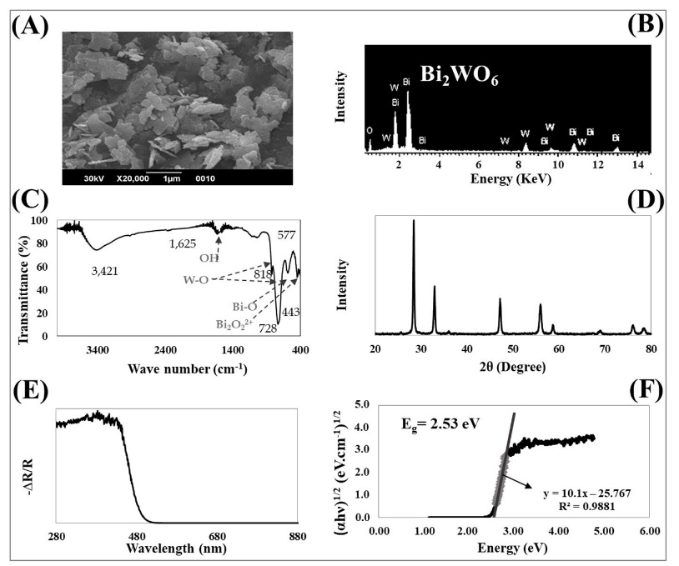

Figure SI-1. Characterization of synthesized Bi₂WO₆. (A) SEM image, (B) EDX analysis, (C) FTIR spectra, (D) XRD diffractogram, (E) UV-Vis reflectance spectra and (F) Tauc plot. Permission must be requested to reproduce Figure 1 from: Madriz, L. et. al, Renewable Energy, 152 (2020) 974-983.
Figure SI-2 shows emission spectra acquired consecutively at different wavelengths, considering the suspension with dissolved oxygen and that in which the oxygen was displaced by bubbling with nitrogen. The spectroscopic signal and the decrease in intensity are reproduced in the presence of electron acceptors.
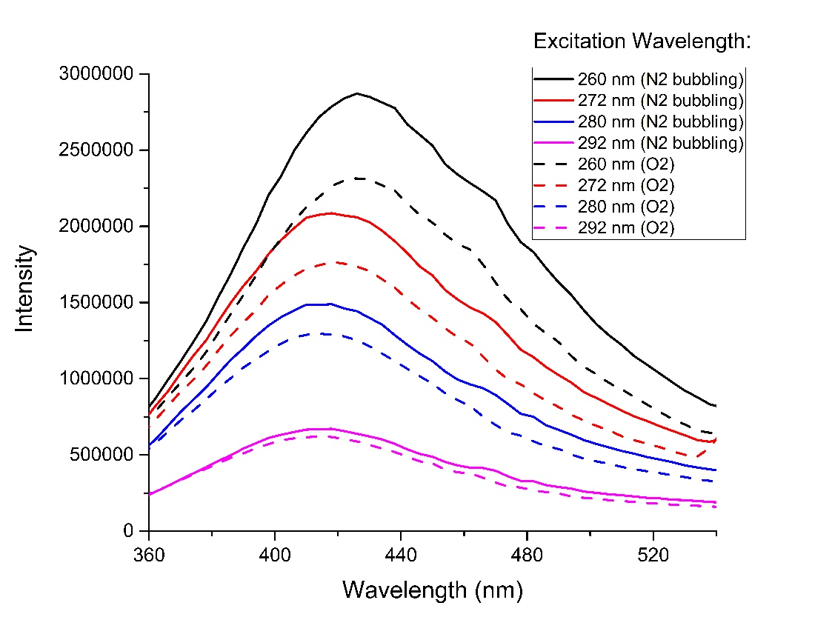

Figure SI-2. Emission spectra of Bi2WO₆-Water suspension at different excitation wavelength.

