Supplementary Tables and Figures
Table 1s. Characteristics of patients dependent on the level of FLC-R
 | Normal FLC-R result (n=6,446) | Slightly abnormal FLC-R (2,090) | Moderately abnormal FLC-R (65) | Significantly abnormal FLC-R (60) | P-value
Gender (Male), n(%) | 2,910 (45.14%) | 1,072 (51.3%) | 36 (55.4%) | 37 (61.67%) | <0.001
Age (years) at index date, median (SD) | 64.2(13.2) | 68.6(12) | 71.2 (11.6) | 70.3 (9.23) | <0.001
Anemia, n (%) | 309 (4.8%) | 196 (9.4%) | 8 (12.3%) | 6 (10%) | <0.001
Abnormal MCV, n(%) | 325 (5%) | 110 (5.3%) | 2 (3.1%) | 4 (6.7%) | 0.8
ARF, n(%) | 222 (4.05%) | 127 (8.1%) | 3 (6.2%) | 1 (2%) | <0.001
Hypercalcemia, n(%) | 71 (1.23%) | 28 (1.5%) | 2 (3.4%) | 0 (0%) | 0.36
Decreased albumin, n(%) | 266 (4.7%) | 116 (6.3%) | 7 (12.9%) | 2 (3.9%) | 0.004
Diabetes, n(%) | 1,807 (28%) | 860 (41.4%) | 21 (32.3%) | 15 (25%) | <0.001
CHF, n(%) | 203 (3.1%) | 124 (5.9%) | 3 (4.6%) | 3 (5%) | <0.001
HTN, n(%) | 3,673 (56.9%) | 1,438 (68.8%) | 43 (66.1%) | 32 (53.3%) | <0.001
Osteoporosis, n(%) | 1,788 (27.7%) | 629 (30.1%) | 15 (23.1%) | 16 (26.7%) | 0.15
COPD, n(%) | 590 (9.1%) | 191 (9.1%) | 6 (9.2%) | 5 (8.3%) | 0.99
CVA, n(%) | 167 (2.6%) | 75 (3.6%) | 3 (4.6%) | 2 (3.3%) | 0.055
Increased Ig, any type, n(%) | 889 (19.7%) | 275 (19.9%) | 21 (42.8%) | 23 (50%) | <0.001
Decreased IgG, n(%) | 334 (7.33%) | 87 (6.2%) | 9 (18%) | 10 (20.83%) | <0.001
Increased IgG, n(%) | 299 (6.56%) | 147(10.7%) | 11 (22%) | 9 (18.75%) | <0.001
Decreased IgM, n(%) | 358 (7.92%) | 142(10.3%) | 9 (18.37%) | 10 (23.83%) | <0.001
Increased IgM, n(%) | 502 (11.1%) | 111(8.04%) | 9 (18.37%) | 7 (16.67%) | <0.001
Decreased IgA, n(%) | 176 (3.65%) | 44 (2.96%) | 6 (12.24%) | 16 (32.65%) | <0.001
Increased IgA, n(%) | 171 (3.54%) | 46 (3.01%) | 3 (6.12%) | 7 (14.3%) | <0.001
Follow-up time of FLC tests, months (median, range) | 54 (6-60) | 49 (6-60) | 33 (6-60) | 21 (6-60) | <0.001
ARF, Acute Renal Failure; CHF, Congestive Heart Failure; COPD, Chronic Obstructive Pulmonary Disease; CVA, Cerebrovascular Accident; FLC-R, Free Light Chain Ratio; HTN, Hypertension; Ig, immunoglobulin; IgA, Immunoglobulin A; IgG, Immunoglobulin G; IgM, Immunoglobulin M, MCV, Mean Corpuscular Volume.
Table 2s. Univariate analysis for factors associated with a diagnosis of PCD/ LPD
 | HR (non-adjusted) | 95% CI | P-value
Abnormal ratio | 2.17 | 1.9-2.5 | <0.001
Abnormal ratio & increased Ig | 3.22 | 2.6-4 | <0.001
Slightly abnormal FLC-R | 1.87 | 1.64-2.14 | <0.001
Moderately abnormal FLC-R | 6.89 | 4.8-9.89 | <0.001
Significantly abnormal FLC-R | 11.68 | 8.51-16.04 | <0.001
Gender (Male) | 1.1 | 0.97-1.25 | 0.13
Age 51-75 | 1.8 | 1.42-2.25 | <0.001
Age >75 | 2.37 | 1.85-3.04 | <0.001
Anemia | 0.74 | 0.55-1 | 0.055
ARF | 0.84 | 0.6-1.18 | 0.3
Hypercalcemia | 0.8 | 0.41-1.53 | 0.5
Abnormal MCV | 0.98 | 0.76-1.27 | 0.9
Decreased Albumin | 1.03 | 0.75-1.4 | 0.85
Decreased IgG | 1.25 | 0.96-1.63 | 0.1
Increased IgG | 1.34 | 1.04-1.71 | 0.02
Decreased IgM | 1.5 | 1.19-1.9 | <0.001
Increased IgM | 1.61 | 1.3-1.99 | <0.001
Decreased IgA | 1.62 | 1.2-2.22 | 0.002
Increased IgA | 1.98 | 1.48-2.65 | <0.001
Diabetes | 0.98 | 0.86-1.12 | 0.82
CHF | 1.42 | 1.06-1.9 | 0.02
HTN | 1.28 | 1.12-1.46 | <0.001
Osteoporosis | 1.35 | 1.18-1.54 | <0.001
COPD | 1.1 | 0.9-1.37 | 0.3
Increased kappa | 1.21 | 1.05-1.4 | 0.007
Increased lambda | 1.3 | 1.15-1.5 | <0.001
FLC-K abnormal and normal Ratio | 0.65 | 0.57-0.73 | <0.001
FLC-L abnormal and normal Ratio | 1.04 | 0.88-1.23 | 0.57
Abbreviations are explained in Table 1s.

Table 3s. Univariate analysis for factors associated with the diagnosis of MM, amyloidosis and plasmacytoma
 | HR (non-adjusted) | 95% CI | P-value
Any abnormal FLC-R | 2.45 | 1.75-3.5 | <0.001
Abnormal ratio & increased Ig | 5.7 | 3.4-9.6 | <0.001
Slightly abnormal FLC-R | 1.4 | 0.9-2.1 | 0.12
Moderately abnormal FLC-R | 26.7 | 14.1-50.3 | <0.001
Significantly abnormal FLC-R | 53.4 | 30.1-94.8 | <0.001
Gender (Male) | 1.41 | 0.99-1.99 | 0.055
Age 51-75 | 2.12 | 1.06-4.22 | 0.03
Age >75 | 2.86 | 1.37-5.9 | 0.005
Anemia | 1.38 | 0.73-2.6 | 0.32
Abnormal MCV | 1.6 | 1.02-2.6 | 0.04
ARF | 1.6 | 0.7-3.4 | 0.23
Hypercalcemia | 0.72 | 0.1-5.2 | 0.75
Decreased Albumin | 2.34 | 1.26-4.4 | 0.75
Decreased IgG | 3.6 | 2.1-6.1 | <0.001
Increased IgG | 2.9 | 1.6-5.3 | <0.001
Decreased IgM | 1.6 | 0.8-3.1 | 0.2
Increased IgM | 0.7 | 0.3-1.7 | 0.4
Decreased IgA | 5.3 | 2.8-9.8 | <0.001
Increased IgA | 5.9 | 3.3-10.9 | <0.001
Diabetes | 1.12 | 0.78-1.6 | 0.54
CHF | 3.15 | 1.8-5.6 | <0.001
HTN | 2.2 | 1.5-3.3 | <0.001
Osteoporosis | 1.3 | 0.9-1.9 | 0.18
COPD | 1.25 | 0.7-2.1 | 0.42
Increased FLC-K* | 1.5 | 0.9-2.3 | 0.054
Increased FLC-L* | 1.8 | 1.3-3.2.6 | <0.001
Abbreviations are explained in Table 1s.

Table 4s. Multi-variate (adjusted) analysis for factors associated with MM, amyloidosis and plasmacytoma
 | HR (adjusted) | 95% CI | P-value
Slightly abnormal FLC-R | 1.1 | 0.6-1.9 | 0.74
Moderately abnormal FLC-R | 27.2 | 12.6-58.7 | <0.001
Significantly abnormal FLC-R | 52.8 | 25.1-111.3 | <0.001
Decreased IgG | 2.7 | 1.5-5.1 | 0.001
Increased IgG | 1.85 | 0.9-3.4 | 0.05
Decreased IgA | 1.54 | 0.7-3.3 | 0.3
Increased IgA | 3.6 | 1.85-6.9 | <0.001
HTN | 2.3 | 1.4-3.9 | 0.001
CHF | 3.6 | 1.7-7.7 | <0.001
Abbreviations are explained in Table 1s.

Table 5s. Univariate analysis for factors associated with the diagnosis of LPD
 | HR (non-adjusted) | 95% CI | p-value
Any abnormal FLC-R | 1.16 | 0.62-2.2 | 0.64
Abnormal FLC-R & increased Ig | 5.96 | 2.8-12.8 | <0.001
Slightly abnormal FLC-R | 0.75 | 0.35-1.61 | 0.46
Moderately abnormal FLC-R | 3.8 | 0.52-27.79 | 0.19
Significantly abnormal FLC-R | 19.93 | 7.06-56.28 | <0.001
Gender (Male) | 1.14 | 0.65-2.01 | 0.64
Age 51-75 (years) | 1.2 | 0.5-2.8 | 0.72
Age >75 (years) | 1.31 | 0.5-3.55 | 0.59
Anemia | 0.74 | 0.17-3.05 | 0.67
Increased MCV | 1.5 | 0.66-3.3 | 0.34
Decreased albumin | 1.5 | 0.46-4.83 | 0.5
Hypercalcemia | 1.76 | 0.24-12.75 | 0.58
Decreased IgG | 1.15 | 0.35-3.8 | 0.8
Increased IgG | 1.03 | 0.32-3.37 | 0.9
Decreased IgM | 2.5 | 0.94-6.68 | 0.06
Increased IgM | 4.86 | 2.38-9.95 | <0.001
Decreased IgA | 1.45 | 1.8-10.17 | <0.001
Diabetes | 0.73 | 0.4-1.4 | 0.34
CHF | 1.92 | 0.6-6.2 | 0.27
HTN | 1.65 | 0.88-3.07 | 0.11
Osteoporosis | 1.22 | 0.66-2.25 | 0.52
COPD | 0.44 | 0.1-1.8 | 0.25
Abbreviations are explained in Table 1s.

Table 6s. Multi-variate (adjusted) analysis for factors associated with LPD.
 | HR (adjusted) | 95% CI | p-value
Slightly abnormal FLC-R | 0.65 | 0.25-1.7 | 0.38
Moderately abnormal FLC-R | 3.44 | 0.46-25.45 | 0.22
Significantly abnormal | 16.38 | 4.93-54.42 | <0.001
Decreased IgM | 2.5 | 0.93-6.7 | 0.07
Increased IgM | 4.48 | 2.18-9.2 | <0.001
Abbreviations are explained in Table 1s.

Table 7s . Univariate analysis for factors affecting Overall Survival
 | HR (non-adjusted) | 95% CI | P-value
Abnormal FLC-R | 1.76 | 1.56-1.98 | <0.001
Slightly abnormal FLC-R | 1.75 | 1.55-1.97 | <0.001
Moderately or significantly abnormal FLC-R | 1.97 | 1.36-2.85 | <0.001
Abnormal FLC-R+ increased Ig | 1.65 | 1.28-2.12 | <0.001
Gender (Male) | 1.7 | 1.5-1.9 | <0.001
Age 51-75 (years) | 9.45 | 5.66-15.8 | <0.001
Age >75 (years) | 35.7 | 21.37-59.6 | <0.001
Anemia | 3.5 | 3.0-4.1 | <0.001
ARF | 2.8 | 2.24-3.43 | <0.001
Hypercalcemia | 1.42 | 0.92-2.2 | 0.19
Decreased Albumin | 4.01 | 3.43-4.9 | <0.001
Decreased IgG | 1.67 | 1.32-2.1 | <0.001
Increased IgG | 1.61 | 1.3-1.98 | <0.001
Decreased IgM | 1.41 | 1.13-1.77 | 0.002
Increased IgM | 0.88 | 0.68-1.12 | 0.29
Decreased IgA | 1.05 | 0.74-1.5 | 0.78
Increased IgA | 1.35 | 1.0-1.84 | 0.049
Diabetes | 2.07 | 1.86-2.32 | <0.001
CHF | 4.67 | 3.95-5.52 | <0.001
HTN | 4.02 | 3.42-4.7 | <0.001
Osteoporosis | 1.53 | 1.36-1.72 | <0.001
COPD | 1.98 | 1.7-2.3 | <0.001
All PCD, including MGUS | 1.1 | 0.94-1.3 | 0.22
PCD/LPD excluding MGUS | 2.07 | 1.57-2.7 | <0.001
Only MGUS | 0.9 | 0.74-1.09 | 0.3
MM diagnosis | 2.12 | 1.5-3.1 | <0.001
LPD diagnosis | 1.21 | 0.63-2.34 | 0.56
ARF- Acute Renal Failure; CHF- Congestive Heart Failure; COPD- Chronic Obstructive Pulmonary Disease; FLC- Free Light Chain; FLC-; FLC-R- Free Light Chain Ratio; HTN- Hypertension; IgA- Immunoglobulin A; IgG- Immunoglobulin G; IgM- Immunoglobulin M; LPD- Lymphoproliferative Disorder; MGUS- Monoclonal Gammopathy of Undetermined significance; MM- Multiple Myeloma; PCD- Plasma Cell Dyscrasia.

Supplementary Figures

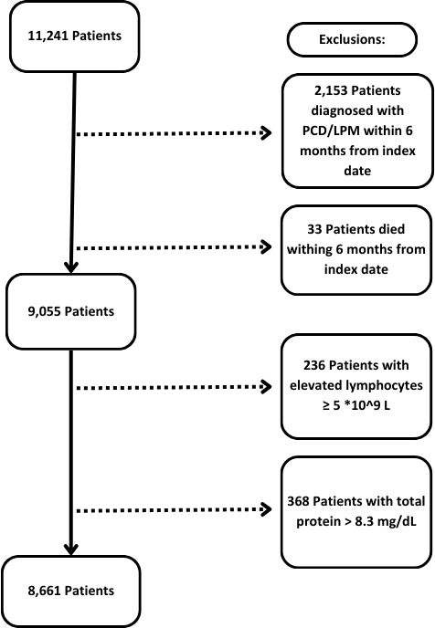

Figure 1s. Cohort of patients included in the study. In total, 11,241 patients with no prior diagnosis of PCD/LPD underwent FLC tests during the study period. 2,153 were excluded after being diagnosed with PCD/LPD within the first 6m after the index date and 33 excluded after dying of unrelated causes. 368 additional patients were excluded due to a concomitant finding of increased total protein level (>8.3 mg/d), and 236 patients were excluded due to an elevated lymphocyte count (≥5X10⁹/L).

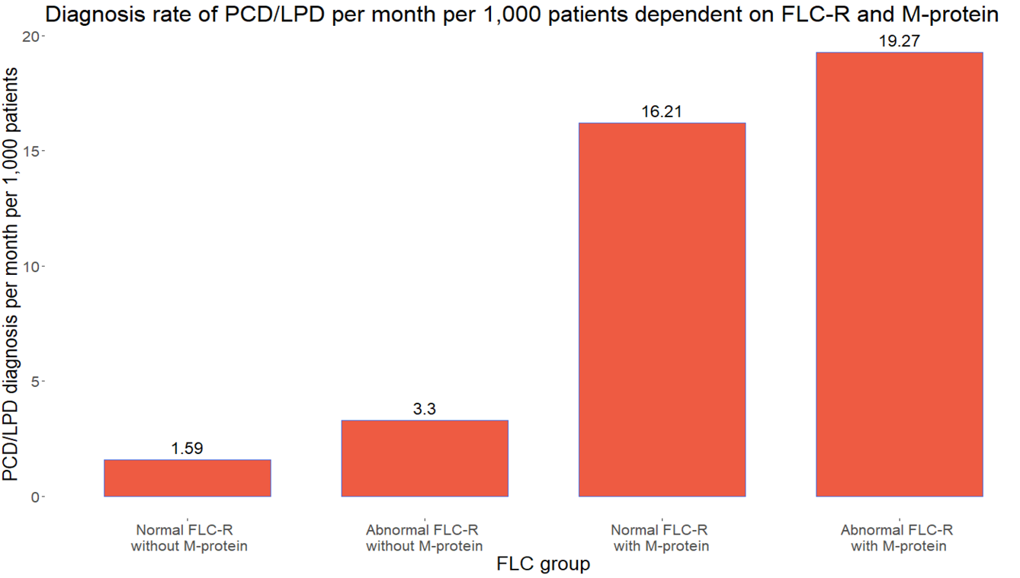
Figure 2s. Diagnosis rate of PCD/LPD per month per 1,000 patients dependent on FLC-R and M-protein.

