FIGURE S1. Effects of hyperuricemia, serum UA and UA/Cr ratio on risk of developing moderate/severe periodontitis (vs. non/mild periodontitis)
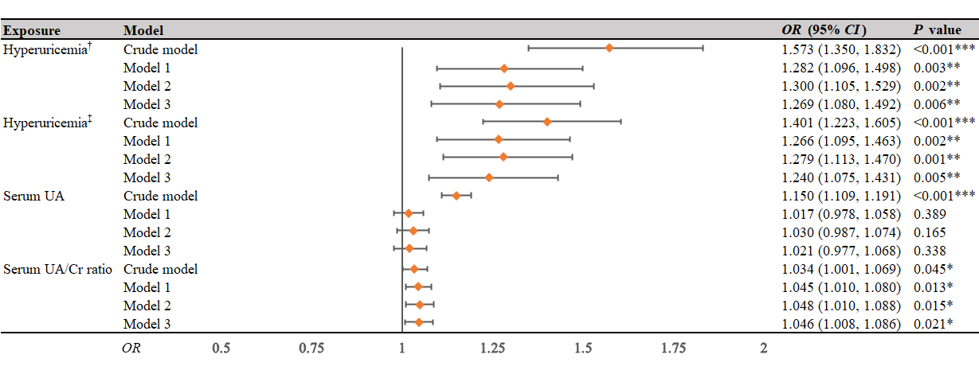
†, hyperuricemia was defined as serum uric acid levels > 7.0 mg/dL regardless of sex; ‡, hyperuricemia defined as serum uric acid levels > 6.0 mg/dL in females and serum uric acid levels > 7.0 mg/dL in males; ***, P < 0.001; **, P < 0.01; *, P < 0.05; CI, confidence interval; OR, odds ratio; UA, uric acid; UA/Cr ratio, uric acid to creatinine ratio; Model 1, adjusted for demographic factors, including sex, age, ethnicity, poverty to income ratio, educational attainment; Model 2, adjusted for smoking status, alcohol consumption, body mass index and the aforementioned demographic factors; Model 3, adjusted for cerebra-cardiovascular conditions (including congestive heart failure, coronary heart disease, angina, heart attack, stroke and hypertension), hyperlipidemia, diabetes, cancer, kidney conditions, periodontal treatment and urate-lowering therapy on the basis of model 2.

FIGURE S2 Effects of hyperuricemia, serum UA and UA/Cr ratio on risk of developing periodontitis (non-periodontitis vs. periodontitis)
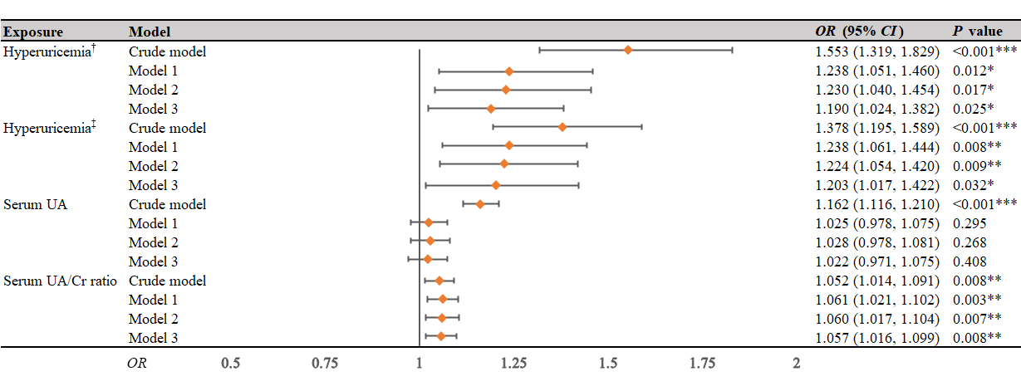
†, hyperuricemia was defined as serum uric acid levels > 7.0 mg/dL regardless of sex; ‡, hyperuricemia defined as serum uric acid levels > 6.0 mg/dL in females and serum uric acid levels > 7.0 mg/dL in males; ***, P < 0.001; **, P < 0.01; *, P < 0.05; CI, confidence interval; OR, odds ratio; UA, uric acid; UA/Cr ratio, uric acid to creatinine ratio; Model 1, adjusted for demographic factors, including sex, age, ethnicity, poverty to income ratio, educational attainment; Model 2, adjusted for smoking status, alcohol consumption, body mass index and the aforementioned demographic factors; Model 3, adjusted for cerebra-cardiovascular conditions (including congestive heart failure, coronary heart disease, angina, heart attack, stroke and hypertension), hyperlipidemia, diabetes, cancer, kidney conditions, periodontal treatment and urate-lowering therapy on the basis of model 2.

FIGURE S3 Effects of hyperuricemia, serum UA and UA/Cr ratio on risk of developing periodontitis (non-periodontitis vs. mild periodontitis)
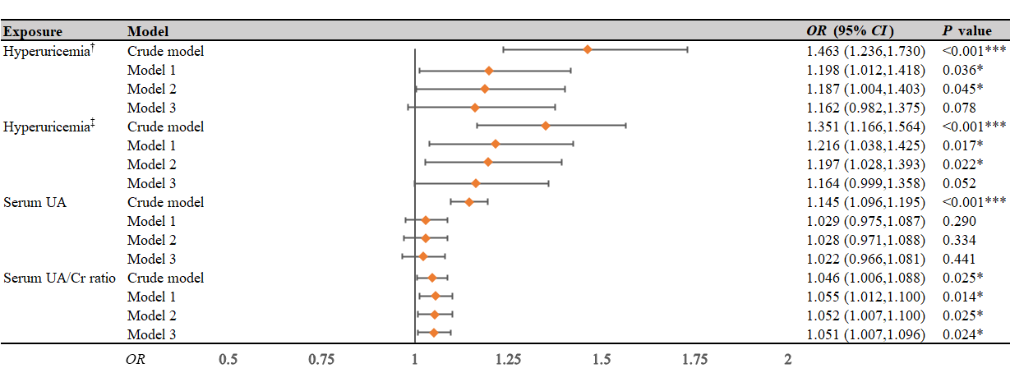
†, hyperuricemia was defined as serum uric acid levels > 7.0 mg/dL regardless of sex; ‡, hyperuricemia defined as serum uric acid levels > 6.0 mg/dL in females and serum uric acid levels > 7.0 mg/dL in males; ***, P < 0.001; **, P < 0.01; *, P < 0.05; CI, confidence interval; OR, odds ratio; UA, uric acid; UA/Cr ratio, uric acid to creatinine ratio; Model 1, adjusted for demographic factors, including sex, age, ethnicity, poverty to income ratio, educational attainment; Model 2, adjusted for smoking status, alcohol consumption, body mass index and the aforementioned demographic factors; Model 3, adjusted for cerebra-cardiovascular conditions (including congestive heart failure, coronary heart disease, angina, heart attack, stroke and hypertension), hyperlipidemia, diabetes, cancer, kidney conditions, periodontal treatment and urate-lowering therapy on the basis of model 2.
2.

FIGURE S4 Effects of hyperuricemia, serum UA and UA/Cr ratio on risk of developing periodontitis (non-periodontitis vs. severe periodontitis)
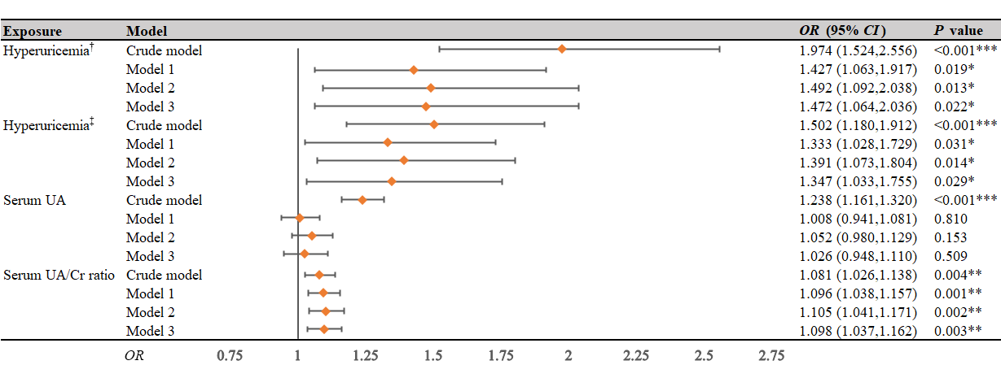
†, hyperuricemia was defined as serum uric acid levels > 7.0 mg/dL regardless of sex; ‡, hyperuricemia defined as serum uric acid levels > 6.0 mg/dL in females and serum uric acid levels > 7.0 mg/dL in males; ***, P < 0.001; **, P < 0.01; *, P < 0.05; CI, confidence interval; OR, odds ratio; UA, uric acid; UA/Cr ratio, uric acid to creatinine ratio; Model 1, adjusted for demographic factors, including sex, age, ethnicity, poverty to income ratio, educational attainment; Model 2, adjusted for smoking status, alcohol consumption, body mass index and the aforementioned demographic factors; Model 3, adjusted for cerebra-cardiovascular conditions (including congestive heart failure, coronary heart disease, angina, heart attack, stroke and hypertension), hyperlipidemia, diabetes, cancer, kidney conditions, periodontal treatment and urate-lowering therapy on the basis of model 2.

FIGURE S5 Subgroup analyses of the effects of hyperuricemia on periodontitis
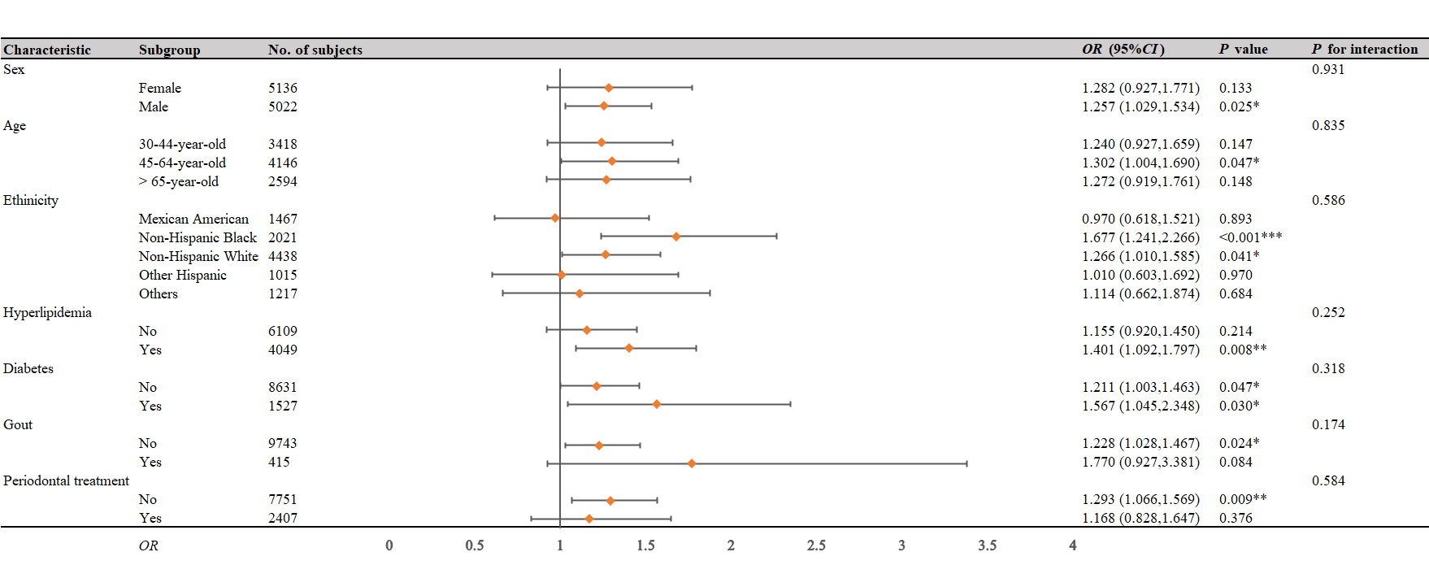
This forest plot displayed the effects of hyperuricemia (defined as serum uric acid levels > 7.0 ml/dL regardless of sex) on periodontitis (no/mild vs. moderate/severe) in diverse subgroups; The logistic regression models adjusted for sex, age, ethnicity, poverty to income ratio, educational attainment smoking status, alcohol consumption, body mass index cerebra-cardiovascular conditions (including congestive heart failure, coronary heart disease, angina, heart attack, stroke and hypertension), hyperlipidemia, diabetes, cancer, kidney conditions, periodontal treatment and urate-lowering therapy; ***, P < 0.001; **, P < 0.01; *, P < 0.05; CI, confidence interval; OR, odds ratio;

TABLE S1 Subgroup analyses of the effects of hyperuricemia on periodontitis
Characteristic | Subgroup | No. of subjects | OR (95% CI) | P value | P for interaction
ULT |  |  |  |  | < 0.001***
 | Non-ULT | 10030 | 1.209 (1.017,1.437) | 0.032*
 | ULT | 128 | 19.488 (3.898,97.444) | < 0.001***
This table displayed the effects of hyperuricemia (defined as serum uric acid levels > 7.0 mg/dL regardless of sex) on periodontitis (no/mild vs. moderate/severe) in ULT-stratified subgroups; The logistic regression models adjusted for sex, age, ethnicity, poverty to income ratio, educational attainment smoking status, alcohol consumption, body mass index cerebra-cardiovascular conditions (including congestive heart failure, coronary heart disease, angina, heart attack, stroke and hypertension), hyperlipidemia, diabetes, cancer, kidney conditions, periodontal treatment and urate-lowering therapy; ***, P < 0.001; **, P < 0.01; *, P < 0.05; CI, confidence interval; OR, odds ratio; ULT, urate-lowering therapy;

