Supplementary Materials

Table S1- Summary of the features considered for the analysis.

Feature | Description
Age | -
Sex | -
BMI | Body mass index
Hb1AC | Glycated hemoglobin
G₀₋₃₀₀ | Plasma glucose at time 0’, 30’, 60’, 90’, 120’, 150’, 180’, 210’, 240’, 270’, and 300’ during OGTT
Max_{Gluc} | Maximum glucose peak value during the OGTT
AUC_{Gluc} | Area under the glucose curve
Skewness_{Gluc} | Degree of asymmetry in the OGTT curve
AUC_{Ins-Gluc} 0-30 | Area under the glucose curve corrected for glucose  early phase insulin secretion
Acquis_{Gluc} | Number of acquisitions
Hypo Tot | Overall hypoglycemia events during the OGTT
IGI | Early glucose-stimulated insulin response  ß cell function
GUTT | Gutt index  insulin sensitivity
Stumvoll ISI | Stumvoll insulin sensitivity index  insulin sensitivity adjusted for age, and BMI
Matsuda index | Matsuda dynamic index  hepatic and peripheral tissue sensitivity to insulin
HOMA-IR | homeostatic model assessment insulin resistance
HEI | Hepatic Insulin Extraction index  insulin synthesis/degradation
AUC_{Ins-Gluc} 0-30 ((I₀ + I₃₀ )/( G_{0 (mmol/l)} + G_{30 (mmol/l)})); BMI (weight_{kg}/height*height_{m}); GUTT (75 000 + (G₀ - G₁₂₀) (mg/dL) × 0.19 × body weight/120 × G mean₀₋₁₂₀ (mmol/L) × Log [I mean₀₋₁₂₀] (mU/L)); HEI (Pept C _{nmol/L}/I₀); HOMA-IR (I₀ _{(mmol/l)} × G₀ (_{mmol/l)}/22,5); IGI (I₃₀-I₀)/(G₃₀-G₀); Matsuda index (10 000/ √ (I₀ × G₀ )× (G mean₀₋₁₂₀ × I mean₀₋₁₂₀)); Skewness_{Gluc} (3*(mean-median)/std); Stumvoll ISI (0.222 - 0.00333 × BMI - 0.0000779 × I₁₂₀ - 0.000422 × Age)

Table S2 – Machine Learning algorithms used in the analysis.

 | Description
Decision Tree (DT) | One of the most popular methods of ML and data mining (DT). Enables the extraction of a model capable of predicting a target variable, from several input values, represented through nodes of a tree.
Random Forest Classifier (RFC) | It works by generating a large number of DTs; the final output is the class selected by the majority of the DTs.
Extra Tree (ET) | Meta estimator that fits various randomly selected extra DTs on several subsets of data and use the averaging to improve the accuracy and to prevent the overfitting.
Support Vector Machine Classifier (SVC) | The most popular and robust method for ML. It works by maximizing the margin, i.e., the distance between the decision boundary and the points close to it (called support vectors). This classifier was tested by using a “linear” and a “polynomial” kernel.
Logistic Regression (LR) | Statistical model that predicts the probability of an event by combining one or more independent variables linearly with the log odds for the event.
DM: data mining; ML: machine learning.

Table S3 - Metrics for the evaluation of the classifier’s performance.

Name | Formula
Accuracy | (TP + TN) / (TP + FN + TN + FP)
Sensitivity | TP / (TP + FN)
Specificity | TN / (TN + FP)
F₁ score | TP / (TP + (FN+FP)/2)
TP: true positives; TN: true negatives; FN: false negatives; FP: false positives.

Figure S1 – Model 1. Results of the sensitivity-based analysis conducted for all the 15 selected features, and for all the tested classifiers.

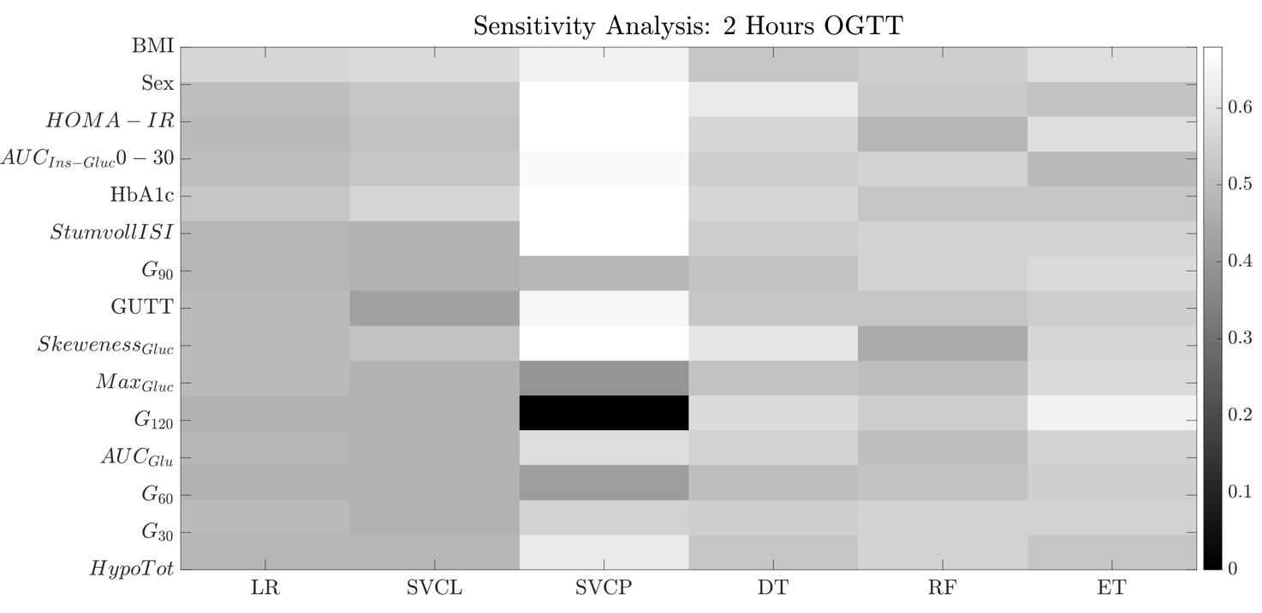

Figure S2 – Model 2. Results of the sensitivity-based analysis conducted for all the 15 selected features, and for all the tested classifiers.

