Supplementary Materials

Satellite-Enhanced Groundwater Prospect Assessment in a Crystalline Basement Terrain Using Landsat Imageries and DEM Data Around Ilorin Metropolis and Adjacent Areas, Southwest Nigeria
Ajibola Ayoola Michael¹, Olorunfemi Martins Olusola¹, Osotuyi Abayomi Gaius^{1,2,3*}, Falana Babatope Johnson¹, Adesinaoye Segun¹

- Department of Geology, Obafemi, Awolowo University, Ile – Ife, Nigeria
- Southern University of Science and Technology, Shenzhen, China
- University of Science and Technology of China, Hefei, China
*Corresponding Author e-mail: yomigaius@mail.ustc.edu.cn

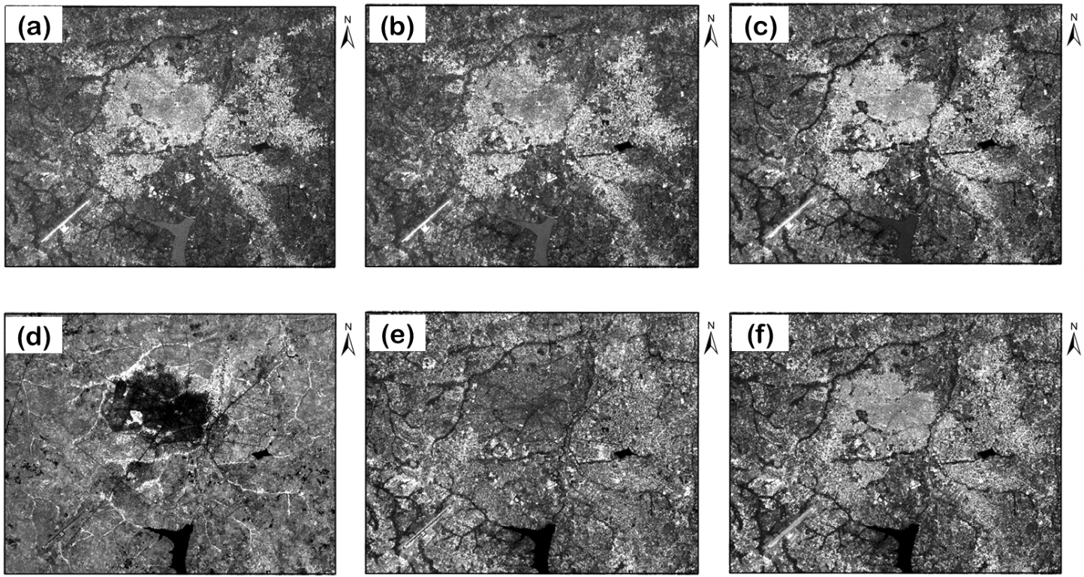

Figure S1. Visible and Infrared Bands of Landsat ETM+ for the study area. (a) Band 1 (Blue), (b) Band 2 (Green), (c) Band 3 (Red), (d) Band 4 (Near Infrared), (e) Band 5 (Middle Infrared), and (f) Band 7 (Middle Infrared)

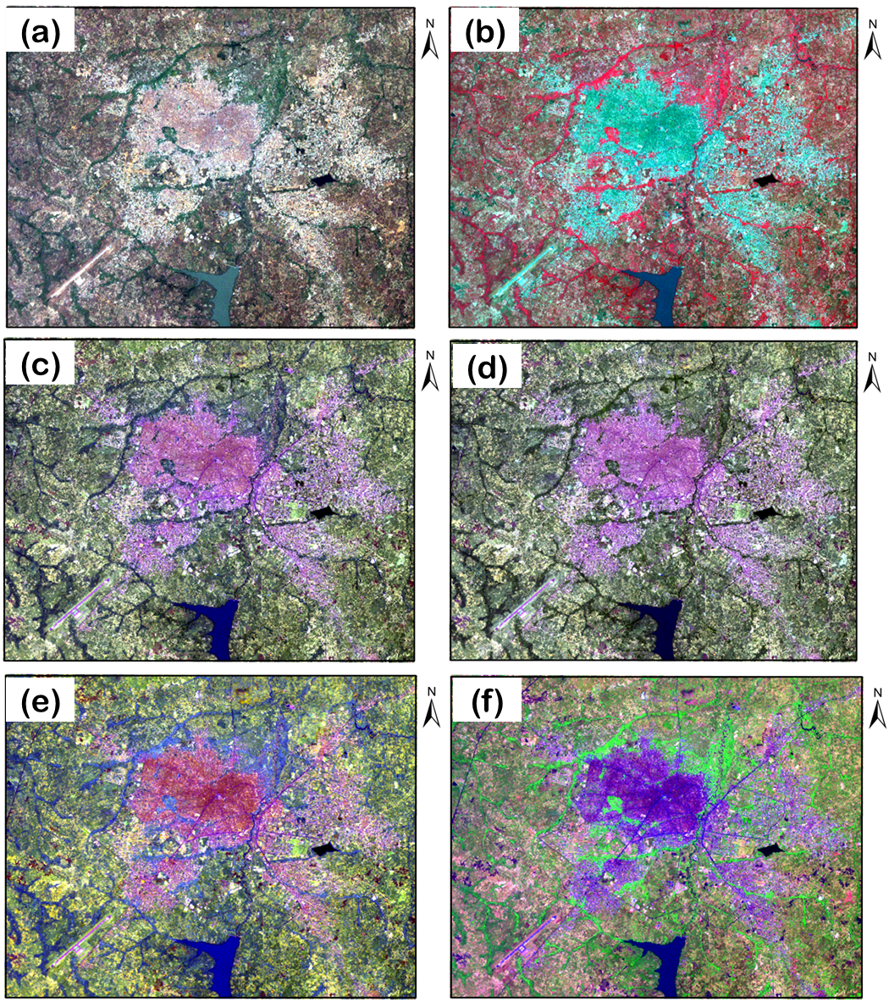
Figure S2. Landsat ETM+ Composites Bands of the Study Area
(a) Band 321 (True Colour), (b) Band 432 (false Colour), (c) Band 752 (false Colour), (d) Band 753 (false Colour) (e) Pan Sharpened Band 752 (false), and (f) Band 541 (false Colour)

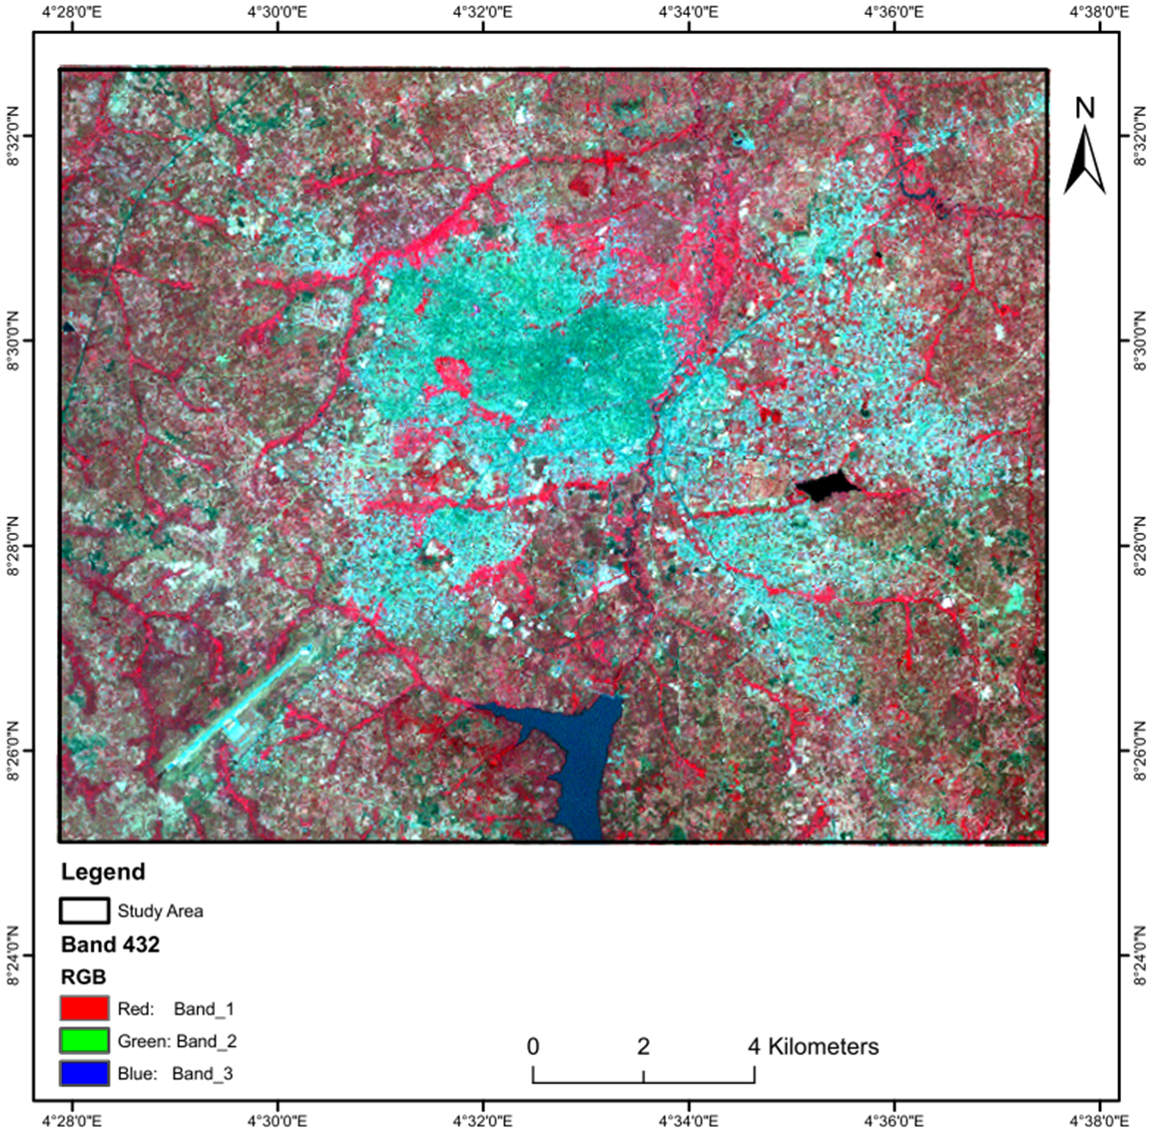
Figure S3. A Typical False Colour (Band 432) of the Study Area.
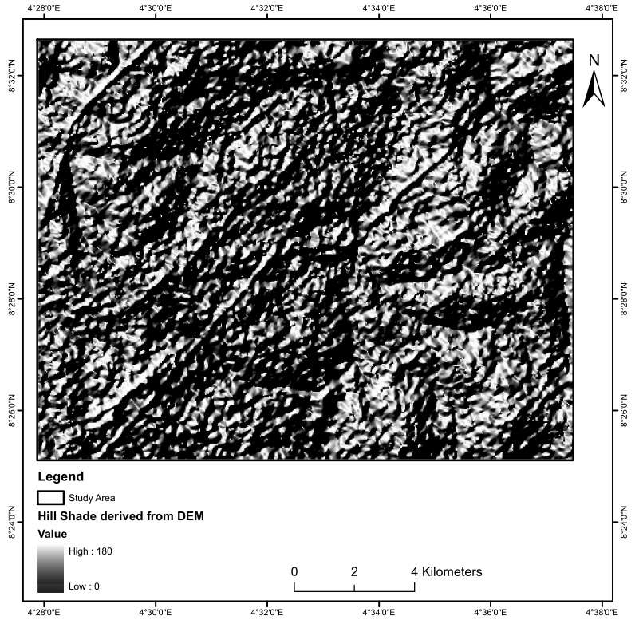
Figure S4. Hill shade derived from DEM

