Supplementary data
Synthesis, Characterization, Antimicrobial Assessments, Potential Antioxidant and Molecular Docking Studies of Polyfunctional Substituted Azoles, Azines, and their Analogs linked Sulfamethoxazole moiety.
I. A. Mousaª, A. M. Elmaghrabyª, Abdallah M. A. Hassane^{b}, Hatem E. Gaffer^{c}, M. E. Yahya^{d} and Abdel Haleem. M. Hussein^{e}

a- Chemistry Department, Faculty of Science, South Valley University, Qena, 83523, Egypt.
b- Botany and Microbiology Department, Faculty of Science, Al-Azhar University, Assiut, 71524, Egypt.
c- Dyeing, Printing and Auxiliaries Department, Textile Research Institute, National Research Centre, Cairo 12622, Egypt.
d- Chemist, El-Nasr Company for intermediated chemicals, El Sokhna, Egypt.
e- Chemistry Department, Faculty of Science, Al-Azhar University, Assiut, 71524, Egypt.

- Methods and materials:
  - Chemistry
All spectral analyses were carried out at South Valley, Mansoura, Sohag, Cairo Universities, and Nawah Scientific Research Center. Uncorrected melting points were measured on an electrothermal melting apparatus. For IR spectra the prepared compounds were mixed with potassium bromide and examined as disks by a Shimadzu FT-IR 8101 PC spectrometer. The FT-IR spectra were recorded in the wavenumber range of 4000-400 cm⁻¹. The ¹H NMR and ¹³C NMR spectra were recorded by Bruker (400MHz) and (100MHz) spectrometers using TMS as an internal reference. The chemical shifts were measured in ppm as a unit of measurement. The MS spectra were determined using a Davion Compact Mass Spectrometer (CMS) (Probe/TLC-MS) at Nawah Scientific Research Center, Cairo, Egypt. Elemental analyses were determined at the microanalytical unit. Cairo University and was calc. as; C = 12.011, H = 1.008, and N = 14.007. Spectrophotometric apparatus (Spekol 11 spectrophotometer, analytic Jena AG, Jena, Germany). UV lamp (Vilber Lourmat-6.LC, VILBER Smart Imaging, Marne-la-Vallée, France). 1,1-Diphenyl-2-picrylhydrazyl (DPPH•), methanol, and DMSO were purchased from Sigma Aldrich (St. Louis, USA).

Praparation of compounds 2 a,b.
General procedure: A mixture of 1 (0.01 mol), malononitrile (0.01 mol) or ethyl cyanoacetate, and (0.01 mol) of elemental sulfur was refluxed in ethanol with a catalytic amount of TEA for 6 hours, left to cool. The reaction mixture was poured onto crushed ice and acidified with a few drops of HCl. The solid product so formed was filtered off and recrystallized from benzene.

5-amino-4-cyano-3-methyl-N-(4-(N-(5-methylisoxazol-3-yl) sulfamoyl)phenyl)thiophene-2-carboxamide (2a)
It was collected as brown crystals, yield = 70%, m.p = 225-227 ºC. (FTIR; KBr, υ, cm⁻¹) = 3371, 3317, 3205 (NH₂ and 2NH), 3083 (Ar-CH), 2212 (CN), 1636 (CONH); ¹H NMR (400 MHz, DMSO-d₆, δ, ppm) = 2.30 (s, 3H, CH₃), 2.37 (s, 3H, CH₃), 6.14 (s, 1H, isoxazole proton), 7.79-7.87 (m, 6H, aromatic protons and NH₂), 9.99 (s, NH), 11.35 (s, NH); ¹³C NMR (100 MHz, DMSO-d₆, δ, ppm) = 12.44 (q), 15.45(q), 66.80(d), 88.94(s), 95.86(d), 112.78(s), 115,69(q, CN), 120.44(d), 120.44(d), 128.28(d), 128.28(d), 133.72(s), 142.42(s), 143.79(s), 157.98(s), 161.04(s), 170.79(s). MS (Atmospheric-pressure chemical ionization) [APCI]): m/z (%) = 416.2 [M⁻¹]⁻ Anal. calcd (%) for C₁₇H₁₅N₅O₄S₂: C, 48.91; H, 3.62; N, 16.78, S, 15.36; found: C, 48.92; H, 3.63; N, 16.78, S, 15.36.

Ethyl-2-amino-4-methyl-5-((4-(N-(5-methylisoxazol-3-yl)sulfamoyl)phenyl)-carbamoyl)thiophene-3-carboxylate (2b)
It was collected as brown crystals, yield = 77%, m.p = 221-223 ºC. (FTIR; KBr, υ, cm⁻¹) = 3076 (CH aromatic), 2978 (CH aliphatic), 1711 (CO₂Et), 1649 (CONH); ¹H NMR (400 MHz, DMSO-d₆, δ, ppm) = 1.28-1.34 (t, 3H, CH_{3,} J = 6 Hz)), 2.30 (s, 3H, CH₃), 2.50 (s, 3H, CH₃), 4.24-4.26 (q, 2H, CH2, J = 2.7 Hz), 6.14 (s, 1H, isoxazole proton),7.8-7.9 (m, 4H, aromatic protons), 11.03 (s, NH), 11.27 (s, NH); MS (Atmospheric-pressure chemical ionization) [APCI]): m/z (%) = 465.1 [M⁺¹]⁺ Anal. calcd (%) for C₁₉H₂₀N₄O₆S₂: C, 49.13; H, 4.34; N, 12.06, S, 13.81; found: C, 49.14; H, 4.35; N, 12.10, S, 13.82.

5-Cyano-4-(4-methoxyphenyl)-2, methyl-N-(4-(N-(5-methylisoxazol-3-yl)sulfamoyl)phenyl)-6-thioxo-1,6-dihydropyridine-3-carboxamide (5)
A mixture of β-oxobutanilide 1 (0.01 mol) and 2-cyano-2-(4-methoxyphenyl)-thioacetamide (0.01 mol) was refluxed in dioxane with a few drops of catalytic pip. The reaction followed using TLC and was completed after 15 min. The product formed as yellow oily drops, was let to be cooled, then formed as a solid product, and was recrystallized in benzene as an off-white powder. Yield = 65%, m.p. = 208-210 ºC. (FTIR; KBr, υ, cm⁻¹) = 3539-3300 (3 NH), 3092 (CH aromatic), 2966 (CH aliphatic.), 2230(CN), 1677(CONH); ¹H NMR (400 MHz, DMSO-d₆, δ, ppm) = 2.26 (s, 3H, CH₃), 2.44 (s,3H, CH₃), 3.70 (s, 3H, OCH₃), 6.11 (s, 1H, isoxazole proton), 7.00-7.90 (m, 8H, aromatic protons), 10.90 (s, NH), 11.20 (s, NH), 14.40 (s, SH); Anal. calcd for Chemical Formula: C₂₅H₂₁N₅O₅S2; C, 56.06; H, 3.95; N, 13.08, S, 11.97; found: C, 56.17; H, 3.99; N, 13.27, S, 11.99.

4-methyl-N-(4-(N-(5-methylisoxazol-3-yl)sulfamoyl)phenyl)-3-phenyl-2-thioxo-2,3-dihydrothiazole-5-carboxamide (7)
A mixture of (0.015 mol) of 1, (0.01 mol) of phenyl isothiocyanate and (0.01 mol) of elemental sulfur, was refluxed in DMF with a catalytic amount of TEA for 2 hours. The reaction mixture was followed by TLC when all amounts of phenyl isothiocyanate were consumed, the mixture let to cool then poured onto acidified ice with HCl. The PPT recrystallized from methanol as a pure product with a deep black color. Yield = 55%, m.p = 169-171 ºC. (FTIR; KBr, υ, cm⁻¹) = 3475-3348 (2 NH), 3063 (CH aromatic.), 2966 (CH aliphatic.), 1693(CONH); ¹H NMR (400 MHz, DMSO-d₆, δ, ppm) =2.26 (s, 3H, CH₃), 2.44 (s, 3H, CH₃), 6.14 (s, 1H, isoxazole proton), 6.90-7.87 (m, 9H, aromatic protons), 10.90(s, 1H, NH), 14.40(s, 1H, NH); MS (Atmospheric-pressure chemical ionization) [APCI]): m/z (%) = 486; Anal. calcd (%) for C₂₁H₁₈N₄O₄S₃: C, 51.84; H, 3.73; N, 11.51, S, 19.77, found: C, 51.85; H, 3.75; N, 11.51, S, 19.78.

(E)-N-(4-(N-(5-methylisoxazol-3-yl)sulfamoyl)phenyl)-3-(2-phenyl-hydrazono)butanamide (8)
A mixture of (0.01 mol) of 1 and (0.02 mol) of phenylhydrazine in 20 ml MeOH was refluxed for 10 min. ppt formed on hot, filtered off then washed by MeOH, and recrystallized from methanol as an off-white powder. Yield = 70%, m.p = 170-172 ºC. (FTIR; KBr, υ, cm⁻¹) = 3264, 3235 and 3104 (3 NH), 1650 (CONH); ¹H NMR (400 MHz, DMSO-d₆, δ, ppm) = 1.95 (s, 3H, CH₃), 2.30 (s,3H, CH₃), 3.35 (s, 2H, CH₂), 6.13 (s, 1H, isoxazole proton), 7.05-7.13 (m, 9H, aromatic protons), 8.85 (s, 1H, NH), 10.7 (s, 1H, NH), 11.60 (s, 1H, NH); MS (Atmospheric pressure chemical ionization [APCI]): m/z (%) = 427.6 [M-H]⁻; Anal. calcd for C₂₀H₂₁N₅O₄S (%): C, 56.19; H, 4.95; N, 16.38; S, 7.50; found: C, 56.21; H, 4.97; N, 16.40; S, 7.52.

General procedures for the synthesis of (11a,b)
Aryl hydrazone 10a or 10b (0.01 mol) dissolved in a mixture of EtOH/EtONa, (0.01 mol) of ethyl chloroformate was added gradually. The mixture was refluxed for 1 hour. ppt Formed on hot during the reaction was filtered off, washed with water and recrystallized from ethanol as off-white ppt, yield= 60-70 %,

4-(6-acetyl-3,5-dioxo-2-(p-tolyl)-2,3-dihydro-1,2,4-triazin-4(5H)-yl)-N-(5-methylisoxazol-3-yl)benzenesulfonamide (11a)
Compound 11a was collected as white crystals, m.p = 280-282 ºC (FTIR; KBr, υ, cm⁻¹) = 3445 (NH), 3080 (CH aromatic), 1755 (COCH₃), 1660 (CON-); ¹H NMR (400 MHz, DMSO-d₆, δ, ppm) = 2.30 (s, 3H, CH₃), 2.49 (s, 3H, CH3), 2.55 (s, 3H, CH3), 6.67 (s, 1H, isoxazole proton), 7.48-7.55 (d, 2H, aromatic proton, J = 8.6Hz), 7.57-7.60 (d, 2H, aromatic proton, J = 8.6Hz), 7.88-7.90 (d, 2H, aromatic proton, J = 9.6Hz), 7.99-8.01 (d, 2H, aromatic proton, J = 9.6Hz), 12.25 (s, NH); ¹³C NMR spectrum (100 MHz, DMSO-d₆, δ, ppm) revealed signals at 14.25 (q), 21.00(q), 26.20(q), 64.74(d), 95.92(s), 103.34(s), 116.42(s), 120.47(d), , 127.52(d), 128.63(d), 130.52(d), 132.40(d), 135.00(s), 140.04(d), 143.56(s), 150.86(s), 156.86(d), 162.80(s), 169.80(s), 170.69(s, CO), 172.96(s, CO), 198.45(s, CO); MS (Electron ionization) [EI]): m/z (%) = 482 [M]⁺ Anal. Calcd. (%) for C₂₂H₁₉N₅O₆S: C, 54.88; H, 3.98; N, 14.55; S, 6.66, found: C, 54.90; H, 3.98; N, 14.57; S, 6.67.

4-(6-acetyl-2-(4-chlorophenyl)-3,5-dioxo-2,3-dihydro-1,2,4-triazin-4(5H)-yl)-N-(5-methylisoxazol-3-yl)benzenesulfonamide (11b)
Compound 11b was collected as white crystals, m.p = 190-192 ºC, (FTIR; KBr, υ, cm⁻¹) = 3425 (NH), 1744 (COCH₃), 1666 (CONH); ¹H-NMR (400 MHz, DMSO-d₆, δ, ppm) = 2.29 (s, 3H, CH₃), 2.31 (s, 3H, CH₃), 6.67 (s, 1H, isoxazole proton), 7.24-7.26 (d, 1H, aromatic proton, J = 8.4Hz), 7.47-7.49 (d, 1H, aromatic proton, J = 8.4Hz), 7.97-8.00 (d, 1H, aromatic proton, J = 9.2Hz), 8.01-8.03 (d, 1H, aromatic proton, J = 9.2Hz), 11.50 (s, NH); ¹³C-NMR spectrum (100 MHz, DMSO-d₆, δ, ppm) revealed signals at 12.96 (q), 26.09(q), 64.74(d), 117.85 (s), 117.89(s),128.60(d), 129.88(d), 130.59(d), 132.47(d), 141.61(d), 142.21(s), 143.66(s), 150.41(s), 156.86(s), 162.45(s), 170.64(s, CO), 172.95(s, CO), 197.97(s, CO);MS (Electron ionization) [EI]): m/z (%) = 502 [M] ⁺ Anal. calcd. (%) for C₂₁H₁₆ClN₅O₆S: C, 50.25; H, 3.21; N, 13.95, S, 6.39; found: C, 50.25; H, 3.22; N, 13.97, S, 6.40.

(E)-2-((dimethylamino)methylene)-N-(4-(N-(5-methylisoxazol-3-yl)
sulfamoyl)phenyl)-3-oxobutanamide (12)
A mixture of 1 (0.01 mol) and DMF-DMA (0.01 mol) in dry benzene was refluxed for 1 hour. The reaction mixture started colorless and then turned orange, and when the mixture was poured into a flask containing 20 ml of n-hexane, yellow crystals gradually formed. The formed product was filtered off and recrystallized from methanol Yield = 98%, m.p. 163-165 ºC. (FTIR; KBr, υ, cm⁻¹) 3258-3122 (2 NH), 3076 (CH arom.), 2975 (CH aliph.), 1659 (COCH₃), 1640 (CONH); ¹H NMR (400 MHz, CDCl₃, δ, ppm) = 1.66 (s, 3H, CH₃),2.32 (s, 3H, CH₃), 2.39 (s, 3H, CH₃), 3.27 (s, 6H, 2CH₃) 6.50 (s, 1H, isoxazole proton), 7.28-7.78 (m, 5H, aromatic, olifinic and NH protons), 11.43 (s, 1H, NH); ¹³C NMR (100 MHz, DMSO-d₆, δ, ppm) = 12.56, 12.56, 31.24(q), 35.50 (q) 97.50(d), 107.87(d), 121.68(d), 121.68(d), 128.77(d), 128.77(d), 128.77(d), 129.85(s), 144.85(s), 155.25(s), 158.39(s), 16.73(s) 165.66(s, CO), 186.80(s, COCH3); MS (electron spray ionization) [ESI]): m/z (%) = 391 [M-H]⁻; Anal. calcd for C₁₇H₂₀N₄O₅S: C, 52.03; H, 5.14; N, 14.28, S, 8.17; found: C, 52.05; H, 5.16; N, 14.30, S, 8.18.

(E)-2-(ethoxymethylene)-N-(4-(N-(5-methylisoxazol-3-yl)sulfamoyl)phenyl)-3-oxobutanamide (14)
A mixture of 1 (0.01 mol) and triethyl orthoformate (0.03 mol) in acetic acid was refluxed for 6 hours, The ppt formed was filtered off, washed by ethanol, collected as a white powder and recrystallized from ethanol. Yield = 45%, m.p. = 210-212 ºC. (FTIR; KBr, υ, cm⁻¹) = 3077 (CH aromatic), 2987 (CH aliphatic), 1709 (COCH₃), 1652 (CONH); ¹H NMR (400 MHz, DMSO-d₆, δ, ppm) =1.06 (t, 3H, CH₃), 1.91 (s, 3H, CH₃), 2.30 (s, 3H, CH₃), 3.36 (q, 2H, CH₂), 6.15 (s, 1H, isoxazole proton), 7.74-7.89 (m, 4H, aromatic protons), 8.65 (s, H, olefinic CH), 12.11 (s, 1H, SH), 12.37 (s, 1H, NH)); MS (Atmospheric pressure chemical ionization) [APCI]): m/z (%) = 392.3 [M⁻¹]⁻ Anal. calcd (%) for C₁₇H₁₉N₃O₆S: C, 51.90; H, 4.87; N, 10.68; S, 8.15, found: C, 51.90; H, 4.88; N, 10.69; S, 8.17.

4-(3-acetyl-6-amino-5-cyano-2-oxopyridin-1(2H)-yl)-N-(5-methylisoxazol-3-yl)benzenesulfonamide (16)
For a (0.01 mol) of 12 in 20 ml dioxane with a catalytic amount of piperidine, (0.01 mol) of malononitrile was added. The reaction mixture started with an orange color and then converted to red. The reaction was completed after 20 minutes. The reaction mixture was poured into a flask containing crushed ice acidified with a few drops of HCl. Orange ppt was collected, washed and recrystallized from ethanol to yield = 80%; m.p = 269-270 ºC. (FTIR; KBr, υ, cm⁻¹) = 3383, 3274 (NH₂, and NH), 3003 (CH aromatic), 2213 (CN), 1679 (COCH₃), 1647 (CON-); ¹H NMR (400 MHz, DMSO-d₆, δ, ppm) = 2.37 (s, 3H, CH₃), 2.51 (s, 3H, CH₃), 6.61 (s, 1H, isoxazole proton), 7.63-7.65 (d, 2H, aromatic protons, J= 8Hz), 7.99(s, 2H, NH₂), 8.01-8.18 (d, 2H, aromatic protons, J = 12Hz); MS (Atmospheric pressure chemical ionization [APCI]): m/z (%) = 414 [M⁺¹]; Anal. calcd for C₁₈H₁₅N₅O₅S: C, 52.30; H, 3.66; N, 16.94, S, 7.76; found: C, 52.20; H, 3.76; N, 16.84, S, 7.81.

4-(3,5-diacetyl-6-hydroxy-2-oxopyridin-1(2H)-yl)-N-(5-methylisoxazol-3-yl)benzenesulfonamide (21)
A mixture of 12 (0.01 mol) and EAA (0.02 mol) was refluxed in 20 ml methanol with a catalytic amount of piperidine for 1 hour, after reaction completion the mixture was poured into a flask containing crushed ice with a few drops of HCl. A pale yellow PPT was collected and recrystallized from benzene. Yield = 45%, m.p. 140-142 ºC. (FTIR; KBr, υ, cm⁻¹) = 3437 (NH and OH), 3091 (CH arom), 1679 (COCH₃), 1645 (CON-); ¹H-NMR (400 MHz, CDCl₃, δ, ppm) = 1.27 (s, 3H, CH₃), 2.39 (s, 3H, CH₃), 3.28 (s, 3H, CH₃), 6.48 (s, 1H, isoxazole proton), 7.5-8.80 (m, 4H, aromatic protons), 9.90 (s, 1H, pyridine-4H), 11.60 (s, NH), 11.70 (s, OH); MS (Atmospheric-pressure chemical ionization) [APCI]): m/z (%) = 432 [M⁺¹]; Anal. calcd for C₁₉H₁₇N₃O₇S: C, 52.90; H, 3.97; N, 9.74, S, 7.43; found: C, 52.92; H, 3.95; N, 9.76, S, 7.44.

4-((4-acetyl-1-phenyl-1H-pyrazol-5-yl)amino)-N-(5-methylisoxazol-3-yl)benzenesulfonamide (22)
A mixture of (0.01 mol) of 12 and (0.01mole) of phenylhydrazine was refluxed in 20 ml of methanol with a catalytic amount of piperidine, the reaction was completed after 30 minutes, and the solvent was left to volatile. The collected ppt dissolved in ethanol and poured into a flask containing crushed ice with a few drops of HCl. The product formed immediately and was isolated as a pure product. Yield = 65%, m.p. 82 ºC. (FTIR; KBr, υ, cm⁻¹) = 3367-3322 (2 NH), 3072 (CH arom.), 1676 (COCH₃); ¹H NMR (400 MHz, CDCl₃, δ, ppm) = 2.39 (s, 3H, CH₃), 3.27 (s, 3H, CH₃), 6.48 (s, 1H, isoxazole proton), 7.42-7.82 (m, 10H, aromatic protons and C-3H pyrazole), 8.30 and 8.5 (s, 2NH); ¹³C NMR (100 MHz, DMSO-d₆, δ, ppm) = 12.04 (q), 12.56(q), 97.51(d), 119.30(d), 120.32(d), 120.32(d), 125.78(d), 125.78(d), 128.66(d), 128.66(d), 129.04(d), 129.04(d), 129.76(d), 129.76(d), 139.94(s), 140.00(s), 144.00(s), 147.00 (s), 161.00(s), 163.00(s), 172.00(s); Anal. calcd (%) for C₂₁H₁₉N₅O₄S: C, 57.66; H, 4.38; N, 16.01, S, 7.33; found: C, 57.64; H, 4.38; N, 16.04, S, 7.40.

4-methyl-N-(4-(N-(5-methylisoxazol-3-yl)sulfamoyl)phenyl)-2-oxo-1,2-dihydropyrimidine-5-carboxamide (23)
Refluxing of compound 12(0.01 mol) and urea (0.01 mol) in 20 ml methanol with a catalytic amount of sodium bicarbonate, the reaction took 4 hours to complete. After the reaction complete was poured in acidified crushed ice with HCl, and pale yellow ppt was collected and recrystallized from ethanol. Yield = 55%, m.p. 175-177 ºC. (FTIR; KBr, υ, cm⁻¹) = 3255-3210 (3 NH), 1642 (CONH); ¹H NMR (400 MHz, CDCl₃, δ, ppm) = 2.40 (s, 3H, CH₃), 2.52 (s, 3H, CH₃), 6.50 (s, 1H, isoxazole proton), 7.73-7.90 (m, 4H, aromatic protons), 9.56 (s,1H, CH-pyrimidinone), 11.74 (s, 1H, NH), 11.84 (s, 1H, pyrimidine-NH); MS (Atmospheric-pressure chemical ionization) [APCI]: m/z (%) = 388 [M⁻¹]⁻; Anal. Calcd. for C₁₆H₁₅N₅O₅S: C, 49.35; H, 3.88; N, 17.99, S, 8.23; found: C, 49.37; H, 3.88; N, 17.98, S, 8.26.

1-carbamothioyl-3-methyl-N-(4-(N-(5-methylisoxazol-3-yl) sulfamoyl)phenyl)-1H-pyrazole-4-carboxamide (24)
A mixture of (0.01 mol) of 12 and (0.01 mol) of thiosemicarbazide was refluxed in 20 ml methanol with a catalytic amount of sodium bicarbonate, the reaction took 30 minutes to complete. The reaction mixture was poured into acidified crushed ice with HCl. Yellow ppt was collected as a pure product and recrystallized from methanol. Yield = 45%, m.p. 177-179 ºC. (FTIR; KBr, υ, cm⁻¹) = 3434, 3371, 3227 (NH₂ and 2NH), 1647 (CONH); ¹H NMR (400 MHz, CDCl₃, δ, ppm) = 2.29 (s, 3H, CH₃), 3.19 (s, 3H, CH₃), 6.55 (s, 1H, isoxazole proton), 7.71-7.73 (d, 2H, aromatic protons), 7.79-7.81 (d, 2H, aromatic protons), 9.75 (br., 2H, NH₂), 12.35 (s, 1H, NH) and 12.50 (s, 1H, NH); ¹³C NMR (100 MHz, DMSO-d₆, δ, ppm) 12.45 (q), 26.37(q), 97.41(d), 97.41(d), 101.49(d), 119.93(s), 119.93(s), 128.84(d), 128.84(d), 129.56(s), 144.17(s), 161.00(s), 162.33(s), 162.33(s), 167.72(s), 197.11(s, CS); Anal. calcd (%) for C₁₆H₁₆N₆O₄S₂: C, 45.70; H, 3.84; N, 19.99, S, 15.25; found: C, 45.71; H, 3.86; N, 20.00, S, 15.27.

2-Methyl-N-(4-(N-(5-methylisoxazol-3-yl)sulfamoyl)phenyl)-benzo[4,5]imidazo[1,2-a]pyrimidine-3-carboxamide (25)
To a solution of compound 12 (0.01 mol), (0.01 mol) of 2-aminobenzimidazole was added and the mixture was refluxed in ethanolic piperidine. The ppt formed on hot, isolated after reaction completion after 6 hours. The product washed with ethanol, dried, pale yellow ppt was collected and recrystallized from ethanol; yield of 60% and m.p = 270-272 ºC. (FTIR; KBr, υ, cm⁻¹) = 3369-3293 (2 NH), 3090 (CH aromatic.), 1690 (CONH);¹H NMR (400 MHz, CDCl₃, δ, ppm) = 2.39 (s, 3H, CH₃), 3.27 (s, 3H, CH₃), 6.53 (s, 1H, isoxazole proton), 7.50-8.02 (m, 9H, aromatic protons and pyrimidine-1H), 8.98 and 11.30 (s, 2H, 2NH); MS (Atmospheric-pressure chemical ionization) [APCI]): m/z (%) = 461 [M^{-H}]⁻ Anal. calcd (%) for C₂₂H₁₈N₆O₄S: C, 57.13; H, 3.92; N, 18.17, S, 6.93; found: C, 57.14; H, 3.95; N, 18.18, S, 6.94.

2. Tables
Table 1. The antioxidant results (% remaining DPPH, % scavenging activity, and IC₅₀ (mg/mL)) of the investigated samples.
Sample | Concentrations (mg/ml) | % Remaining DPPH | % Scavenging activity | IC₅₀ (mg/mL)
1 | 1.259 | 17.45 | 82.55 | 0.4083
1 | 0.63 | 40.47 | 59.53
1 | 0.315 | 54.25 | 45.75
1 | 0.157 | 67.45 | 32.55
2a | 0.061 | 42.38 | 57.62 | 0.0373
2a | 0.031 | 46.63 | 53.37
2a | 0.015 | 59.24 | 40.76
2a | 0.008 | 74.05 | 25.95
2b | 0.266 | 28.89 | 71.11 | 0.0971
2b | 0.133 | 35.19 | 64.81
2b | 0.066 | 57.04 | 42.96
2b | 0.033 | 71.11 | 28.89
11a | 1.015 | 29.77 | 70.23 | 0.5455
11a | 0.507 | 49.27 | 50.73
11a | 0.254 | 69.5 | 30.5
11a | 0.127 | 84.9 | 15.1
11b | 0.37 | 13.93 | 86.07 | 0.1807
11b | 0.185 | 67.89 | 32.11
11b | 0.092 | 87.39 | 12.61
11b | 0.046 | 90.18 | 9.824
12 | 0.983 | 42.82 | 57.18 | 0.6565
12 | 0.492 | 48.24 | 51.76
12 | 0.246 | 63.49 | 36.51
12 | 0.123 | 81.67 | 18.33
14 | 2.9 | 46.19 | 53.81 | 1.2833
14 | 1.45 | 65.98 | 34.02
14 | 0.725 | 77.71 | 22.29
14 | 0.363 | 89.44 | 10.56
23 | 1.167 | 28.89 | 71.11 | 0.4951
23 | 0.583 | 44.72 | 55.28
23 | 0.292 | 58.8 | 41.2
23 | 0.146 | 69.06 | 30.94
24 | 0.35 | 19.21 | 80.79 | 0.1378
24 | 0.175 | 43.4 | 56.6
24 | 0.088 | 59.24 | 40.76
24 | 0.044 | 78.89 | 21.11
Ascorbic acid | 0.062 | 15.267 | 85.19 | 0.0222
Ascorbic acid | 0.031 | 39.084 | 62.07
Ascorbic acid | 0.016 | 61.069 | 40.74
Ascorbic acid | 0.008 | 74.809 | 27.41

Table 2. Antimicrobial activity of the tested sample (1% w/v) against tested bacteria and Candida expressed as inhibition diameter zones in millimeters (mm) using the well-diffusion method.
Sample | The mean diameter of the inhibition zone (Mean±SD) (mm)
Sample | B. subtilis | S. aureus | E. coli | K. pneumonia | C. albicans
1 | 32.67±2.52ª | 12.67±0.58^{b} | 12.00±0.00^{bc} | 13.67±0.58^{b} | 9.67±0.58e
12 | 0.00±0.00 | 0.00±0.00 | 13.00±1.00^{b} | 13.33±0.58^{bc} | 9.00±0.00e
16 | 12.67±0.58^{d} | 0.00±0.00 | 11.67±0.58^{cd} | 13.00±0.00^{bc} | 12.33±0.58^{cd}
21 | 16.00±1.00^{c} | 0.00±0.00 | 11.33±0.58^{cd} | 12.33±0.58^{bc} | 13.00±0.00^{bc}
22 | 0.00±0.00 | 0.00±0.00 | 9.33±0.58e | 11.00±0.00de | 14.00±0.00^{b}
23 | 15.33±0.58^{c} | 0.00±0.00 | 12.33±0.58^{bc} | 10.67±0.58e | 12.33±0.58^{cd}
24 | 11.67±058^{d} | 0.00±0.00 | 11.33±0.58^{cd} | 13.67±1.15^{b} | 11.67±0.58^{d}
25 | 0.00±0.00 | 0.00±0.00 | 10.67±0.58^{d} | 12.00±1.00^{cd} | 10.00±1.00e
Chloramphenicol | 18.33±0.58^{b} | 14.33±0.58ª | 15.33±0.58ª | 16.00±1.00ª | -
Clotrimazole | - | - | - | - | 18.67±0.58ª

3. Figures
Fig. 1. Comparison of the antioxidant results expressed as IC₅₀ in mg/mL of the tested samples relative to the antioxidant standard.
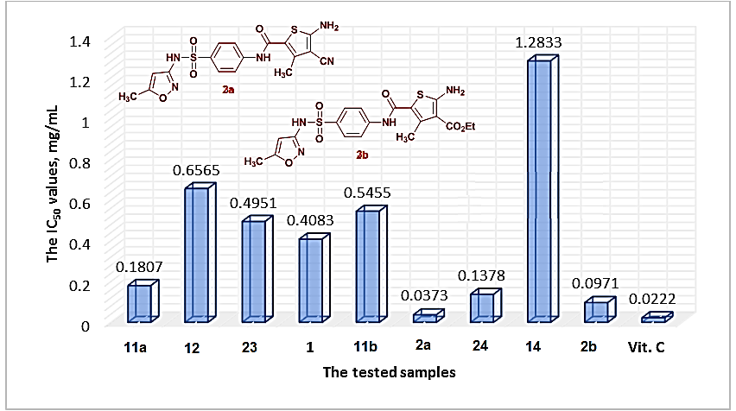

Fig. 2. Images of interactions for 1 with (PDB: 1aj0).
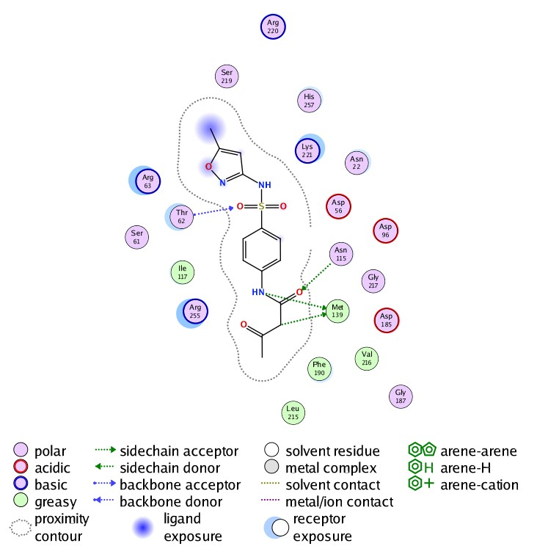 | 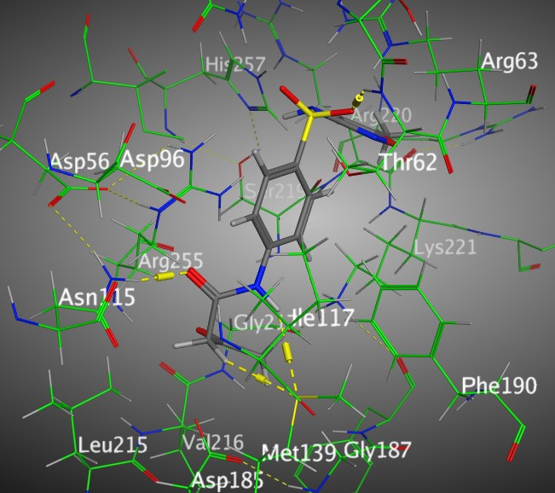 | 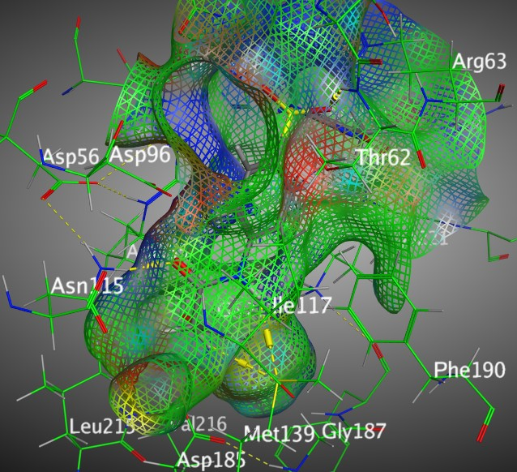
2D | 3D | Surface Map

Fig. 3. Images of interactions for 12 with (PDB: 1aj0).
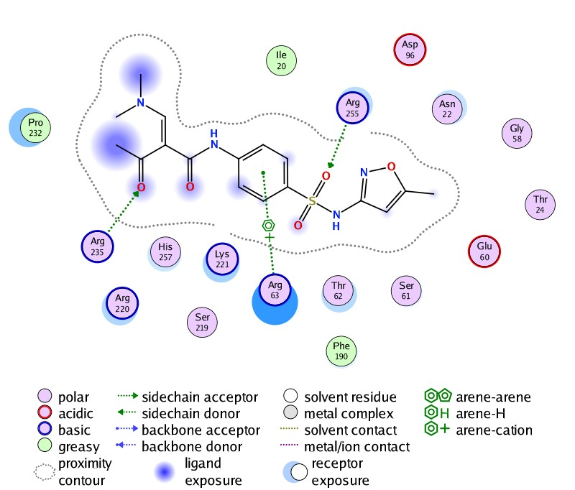 | 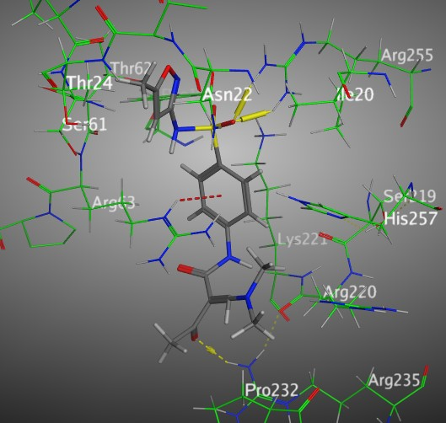 | 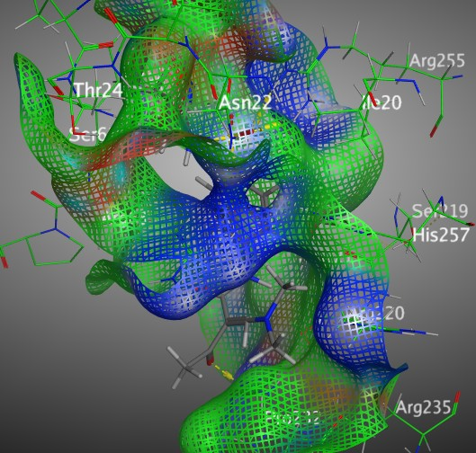
2D | 3D | Surface Map

Fig. 4. Images of interactions for 16 with (PDB: 1aj0).
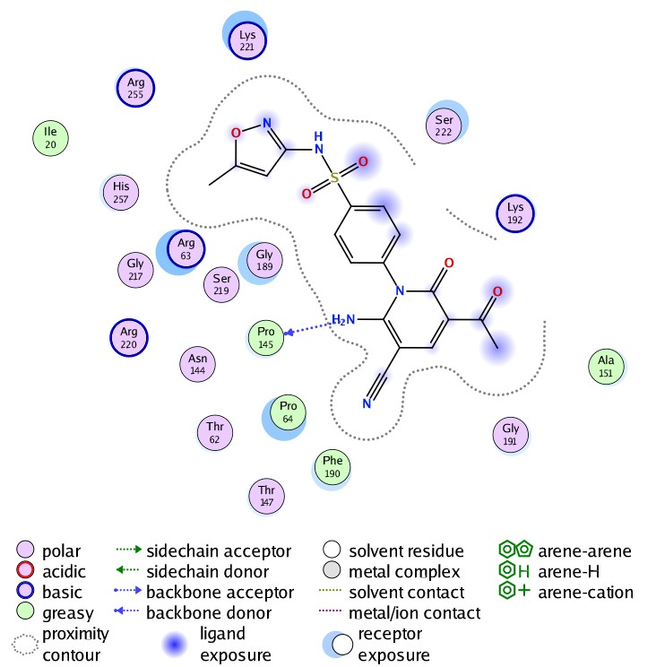 | 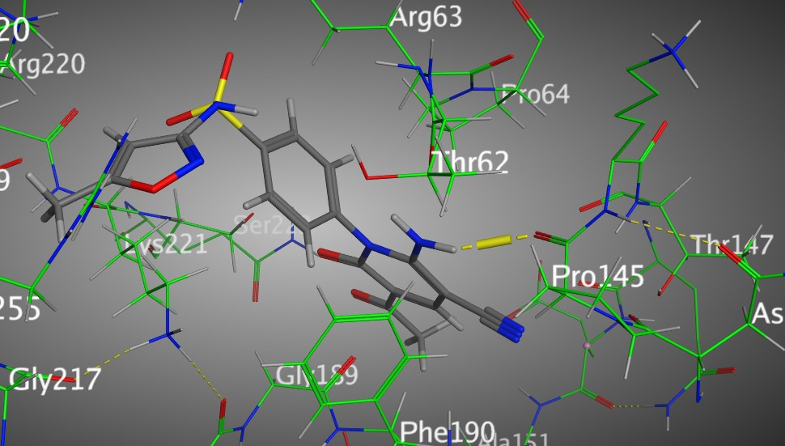 | 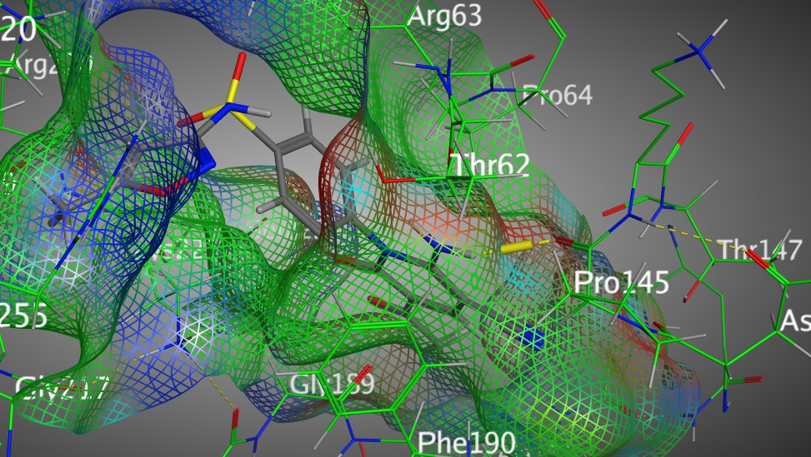
2D | 3D | Surface Map

Fig. 5. Images of interactions for 21 with (PDB: 1aj0).
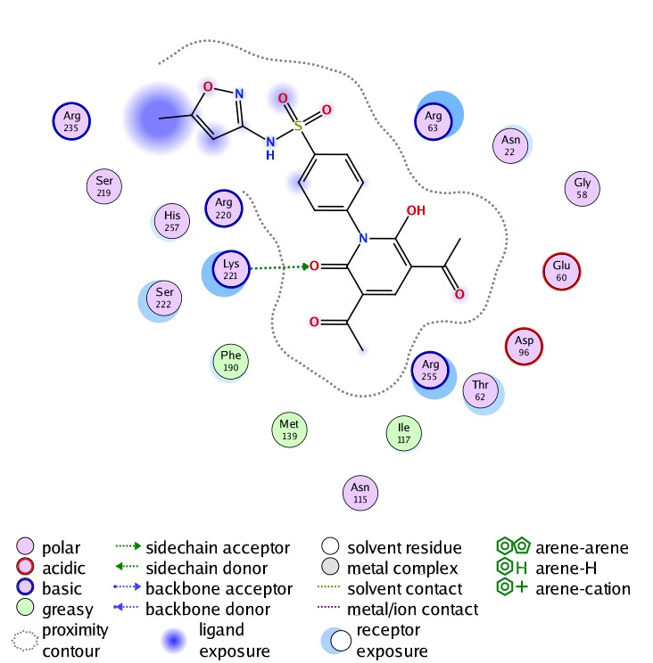 | 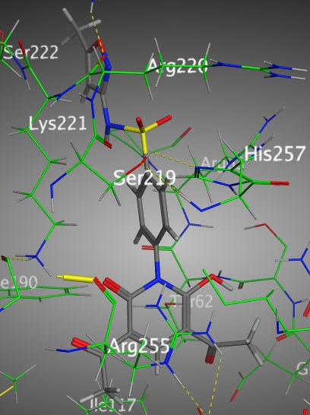 | 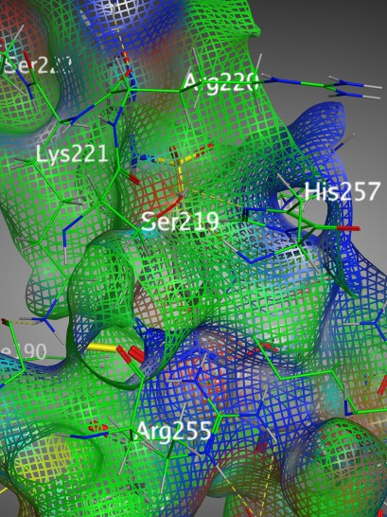
2D | 3D | Surface Map

Fig. 6. Images of interactions for 22 with (PDB: 1aj0).
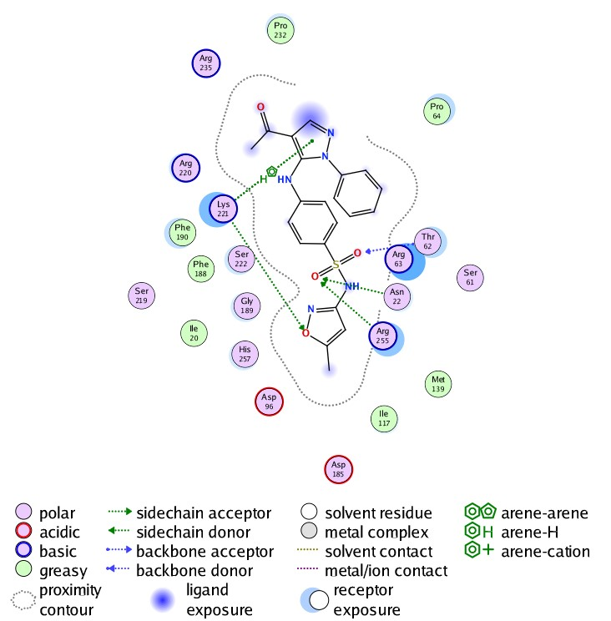 | 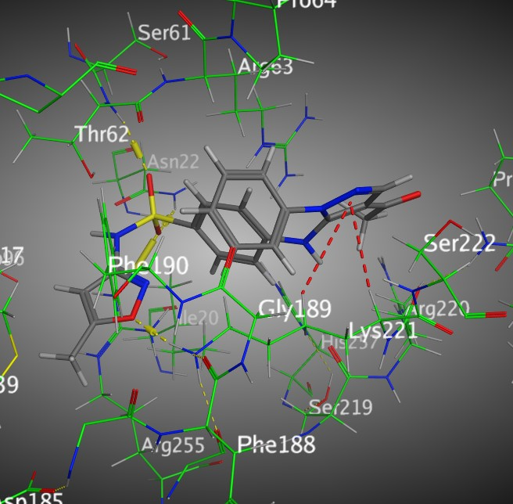 | 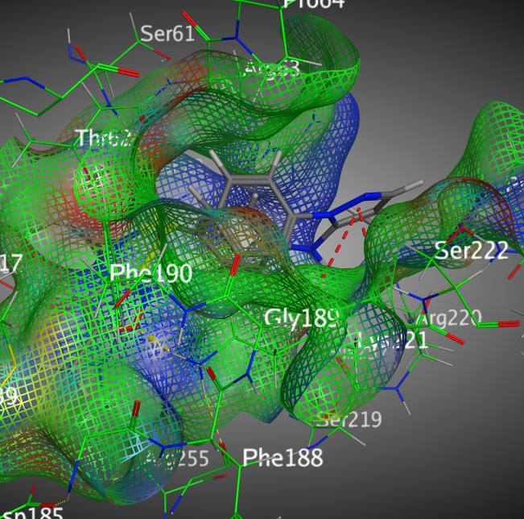
2D | 3D | Surface Map

Fig. 7. Images of interactions for 23 with (PDB: 1aj0).
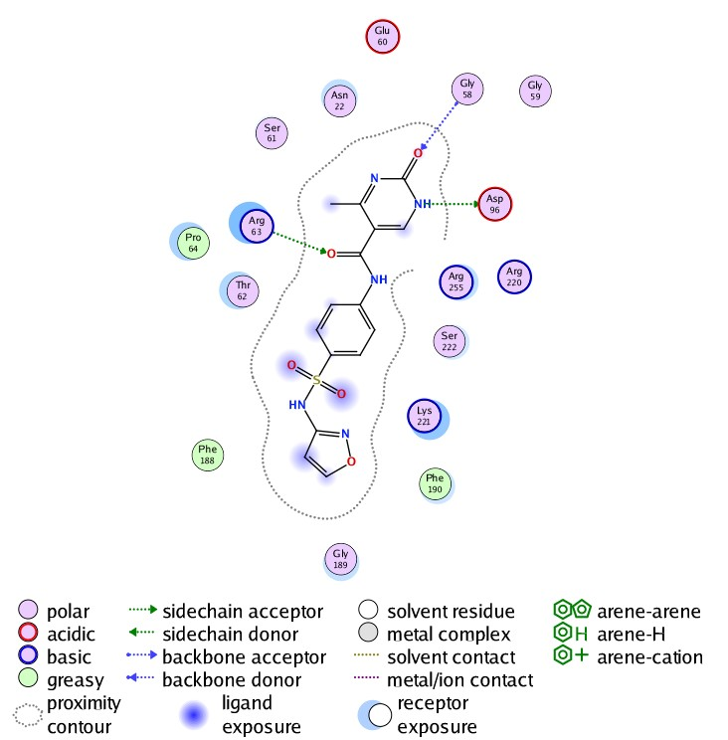 | 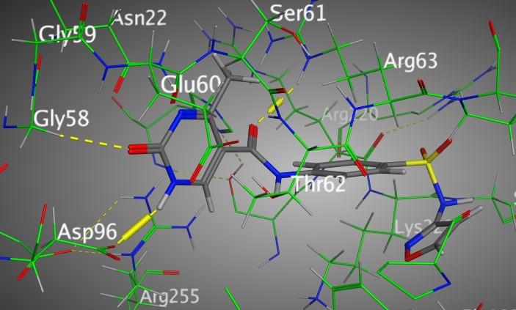 | 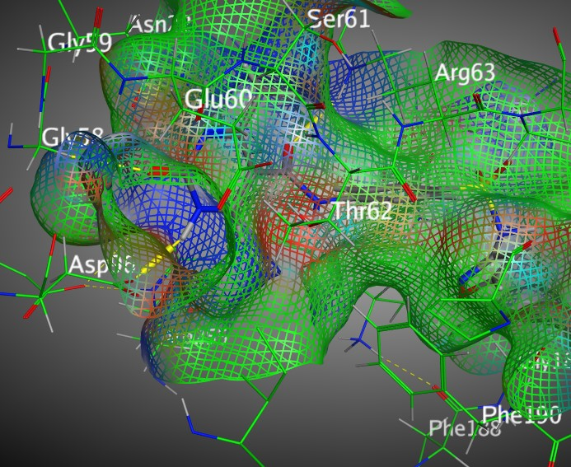
2D | 3D | Surface Map

Fig. 8 Images of interactions for 24 with (PDB: 1aj0).
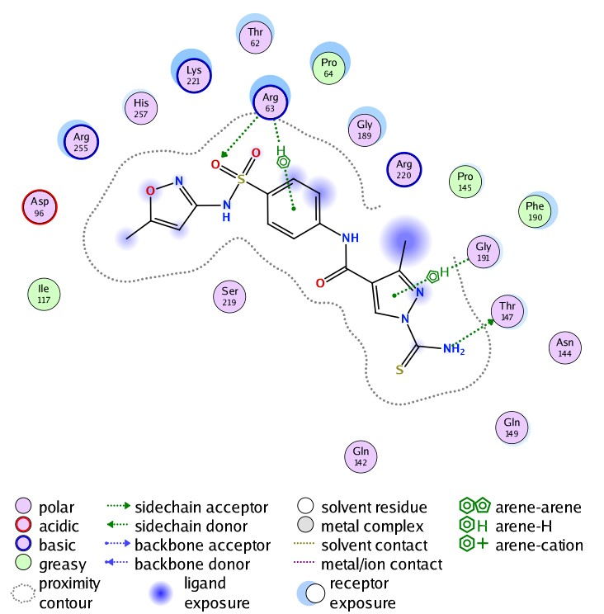 | 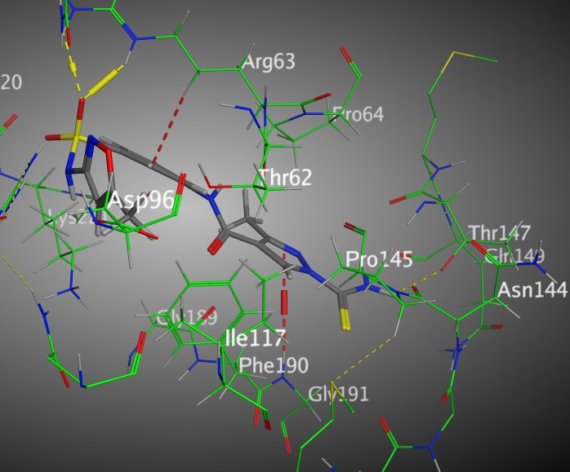 | 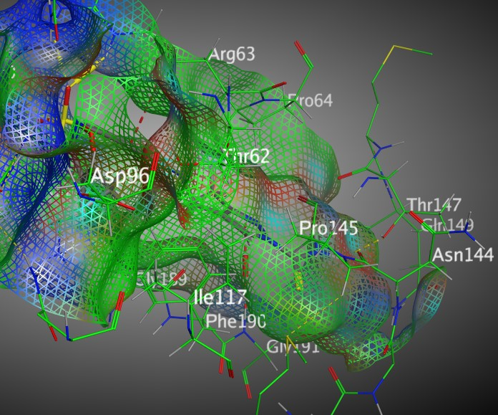
2D | 3D | Surface Map

Fig. 9. Images of interactions for 25 with (PDB: 1aj0).
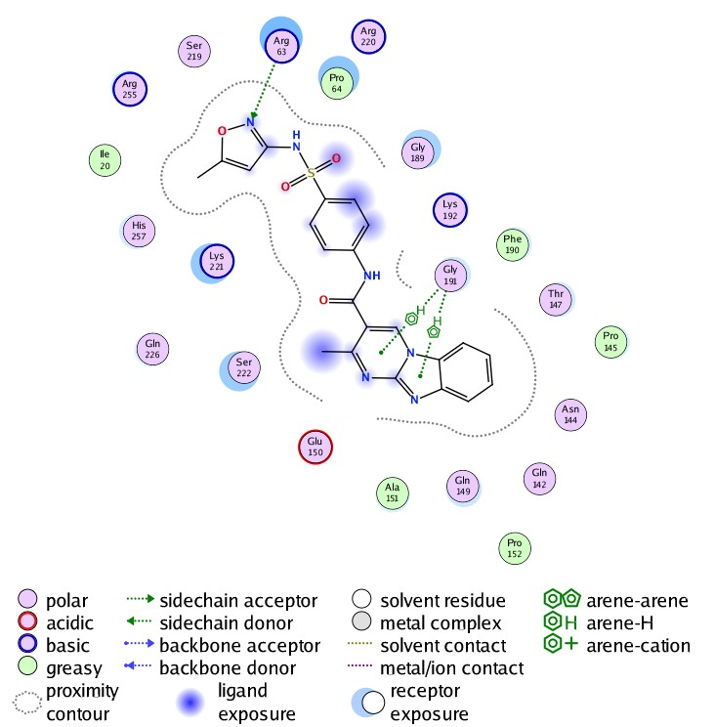 | 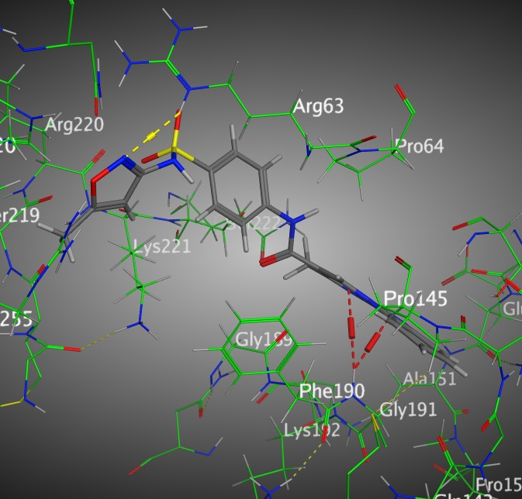 | 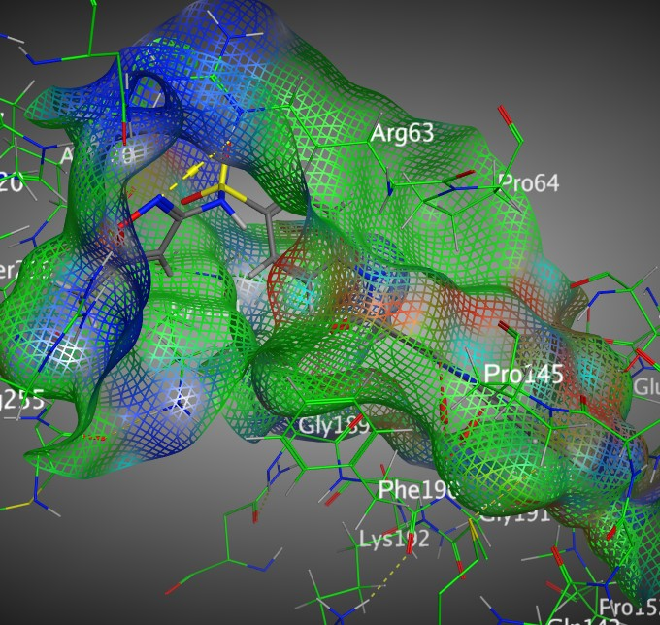
2D | 3D | Surface Map

Fig. 10. Images of interactions for Chloramphenicol with (PDB: 1aj0).
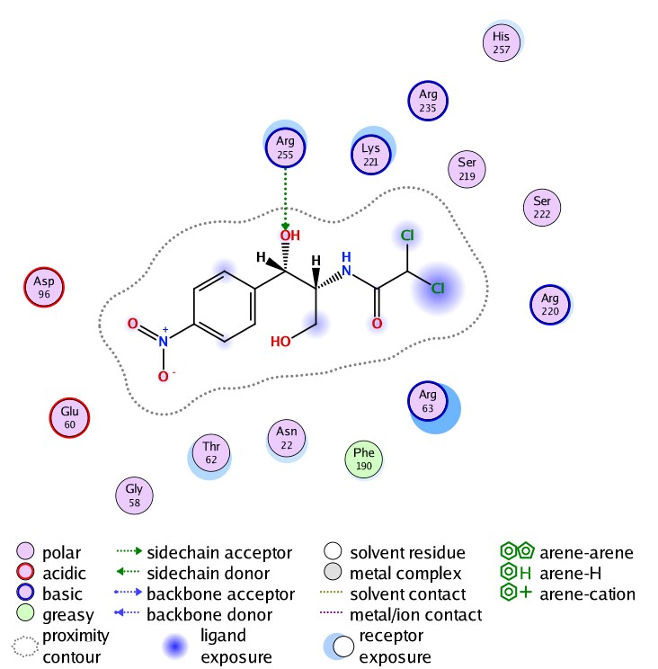 | 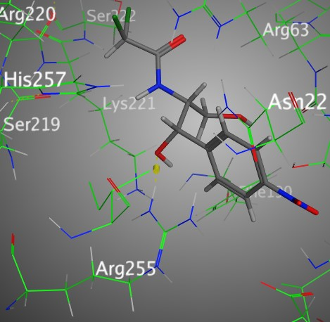 | 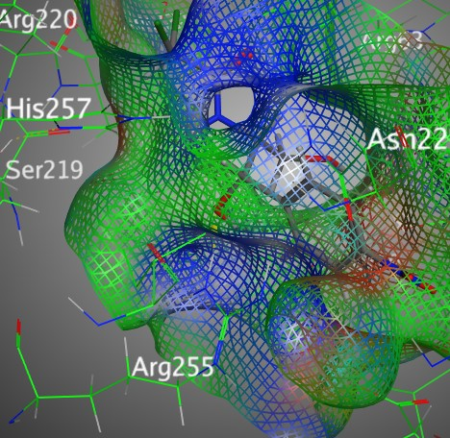
2D | 3D | Surface Map

4. Spectral charts

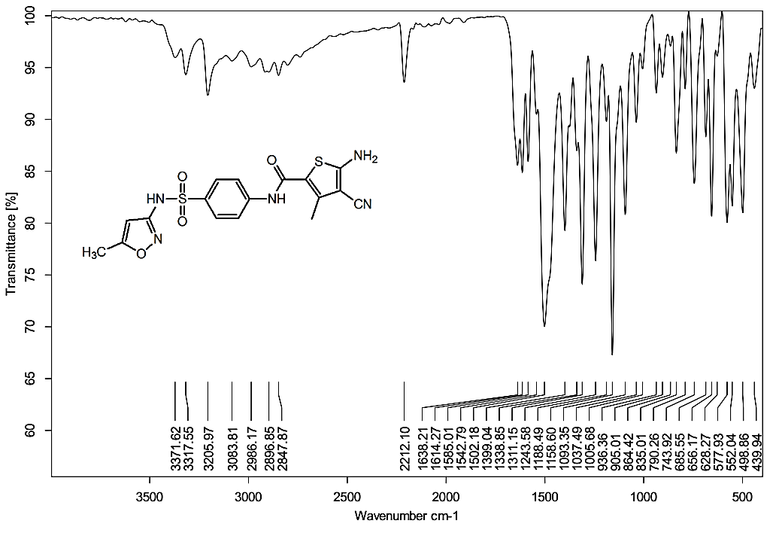

Fig. 11. IR spectrum of compound 2a

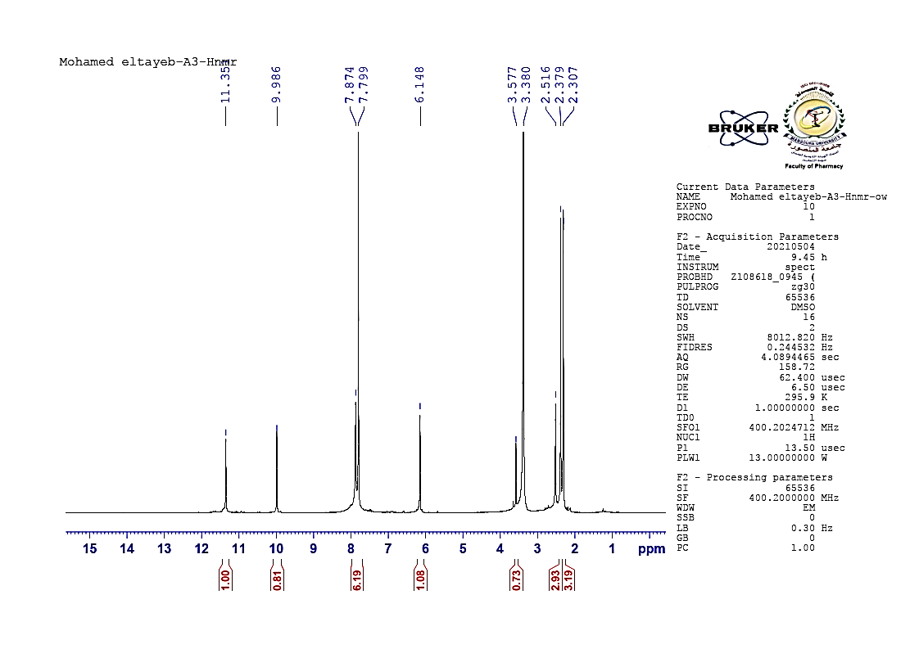

Fig. 12. ¹H-NMR of compound 2a

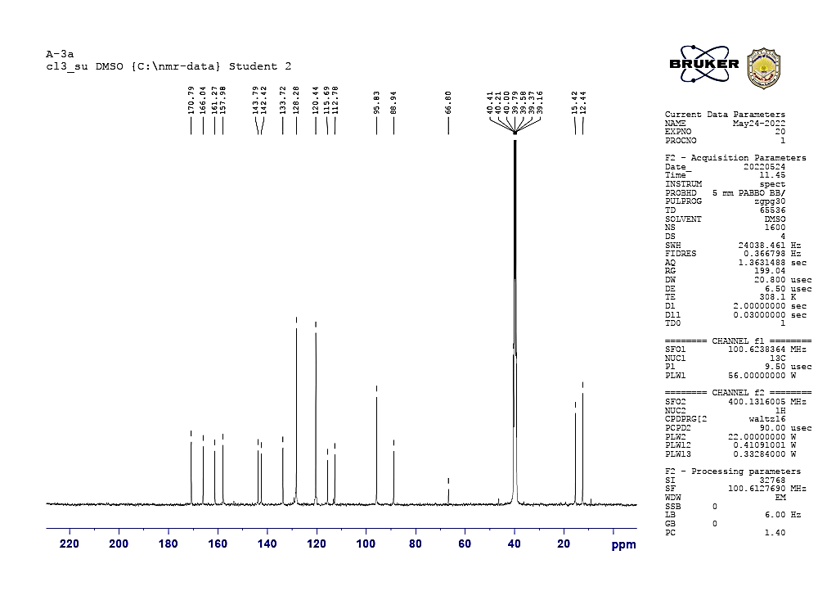

Fig. 13. ¹³C-NMR of compound 2a

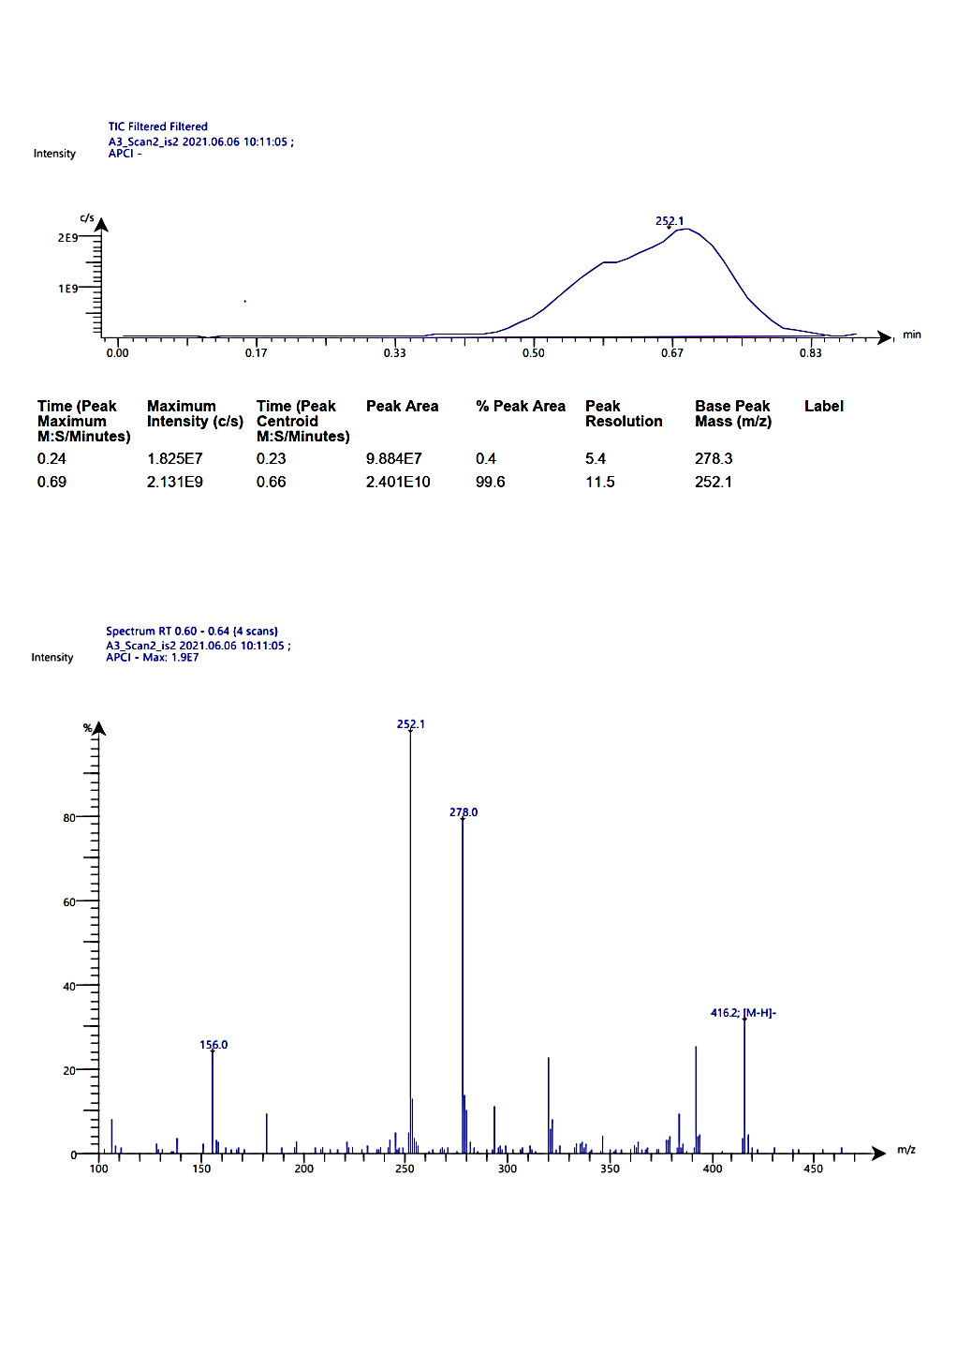
Fig. 14. MS spectrum of 2a

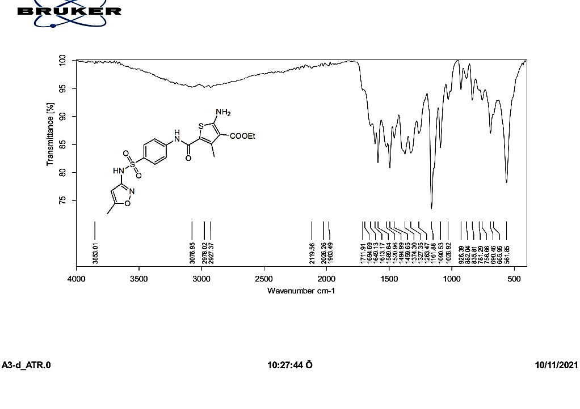

Fig. 15. IR spectrum of compound 2b.

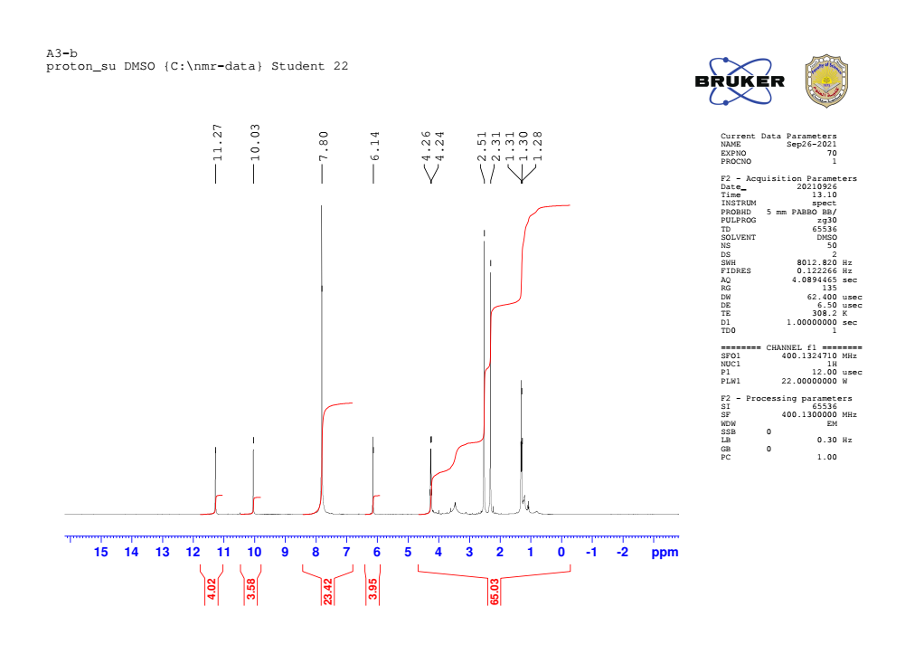

Fig. 16. ¹H-NMR spectrum of compound 2b.

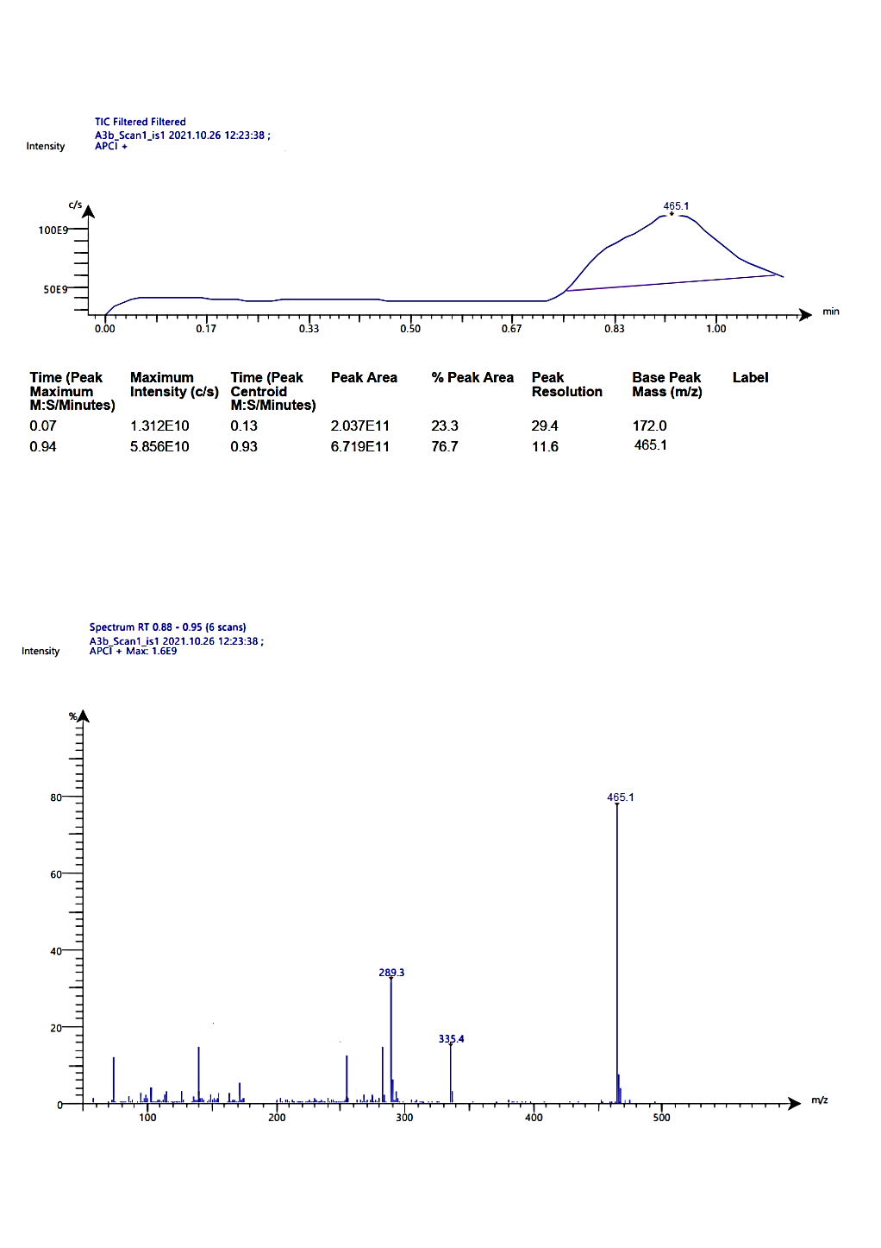

Fig. 17. MS spectrum of compound 2b

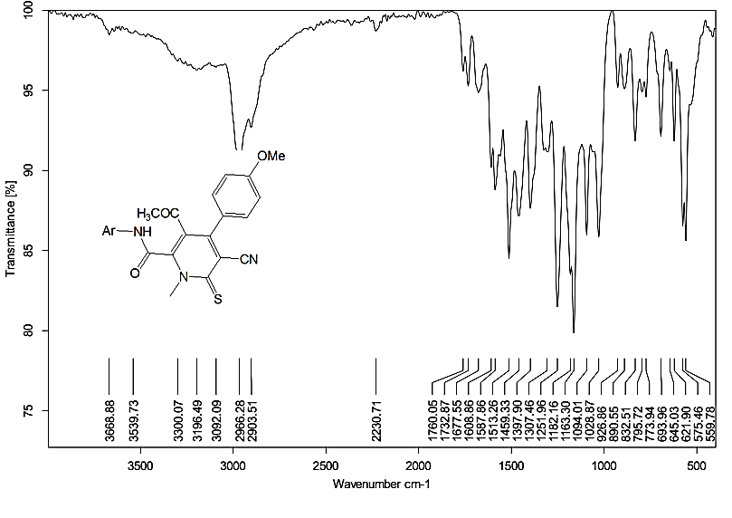

Fig. 18. IR spectrum of compound 5

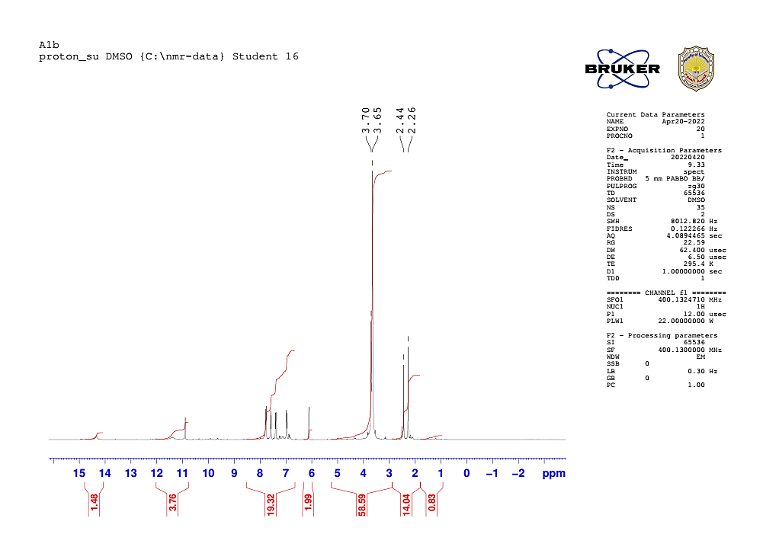

Fig. 19. ¹HNMR of compound 5.

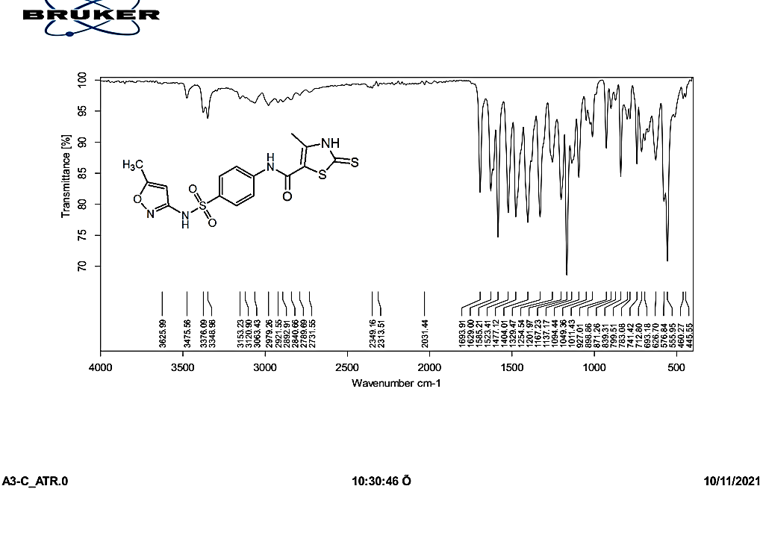

Fig. 20. IR of compound 7

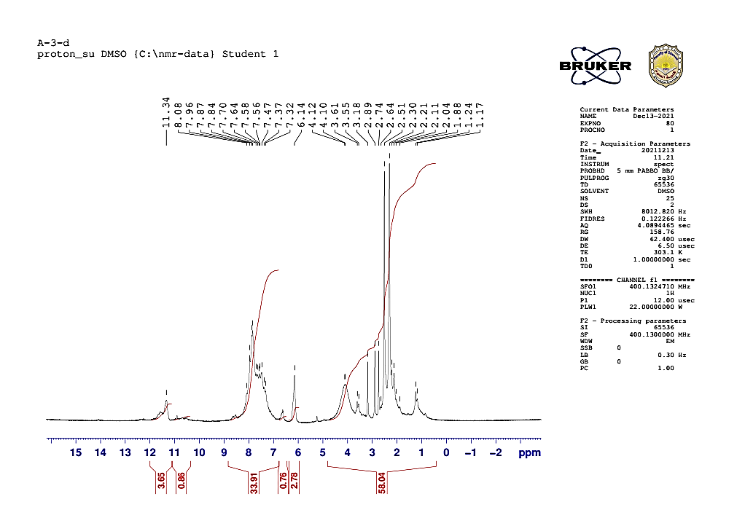

Fig. 21. ¹HNMR of compound 7

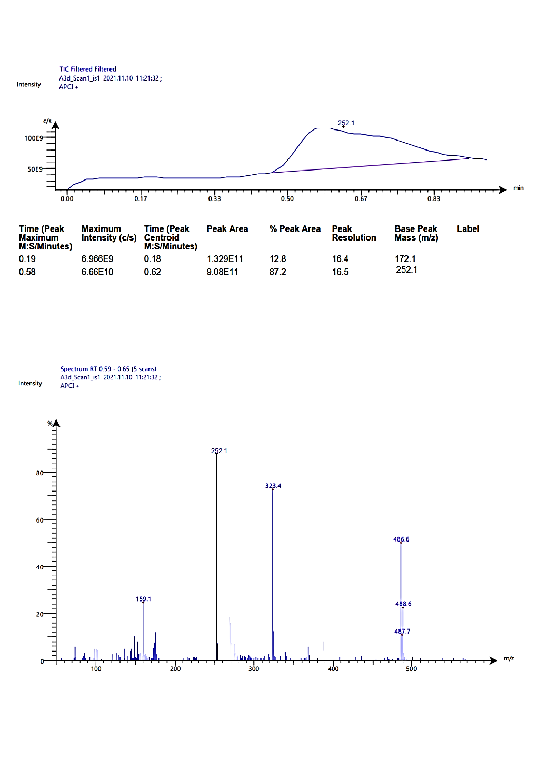

Fig. 22. MS spectrum of compound 7

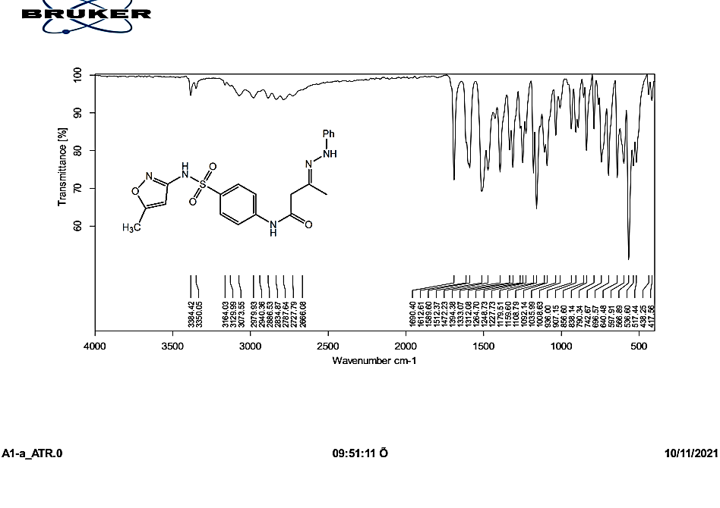

Fig. 23. IR of compound 8.

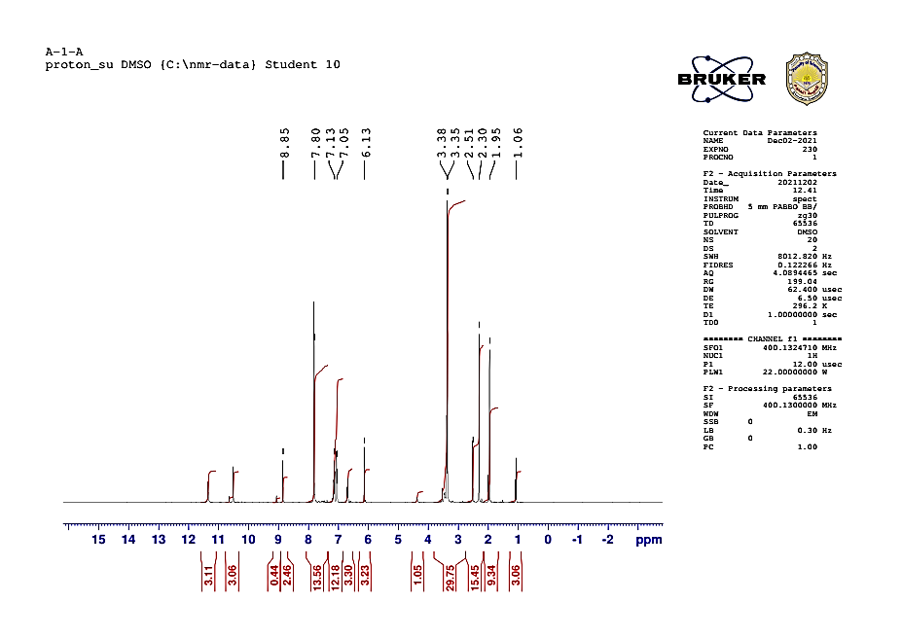

Fig. 24. ¹HNMR of compound 8.

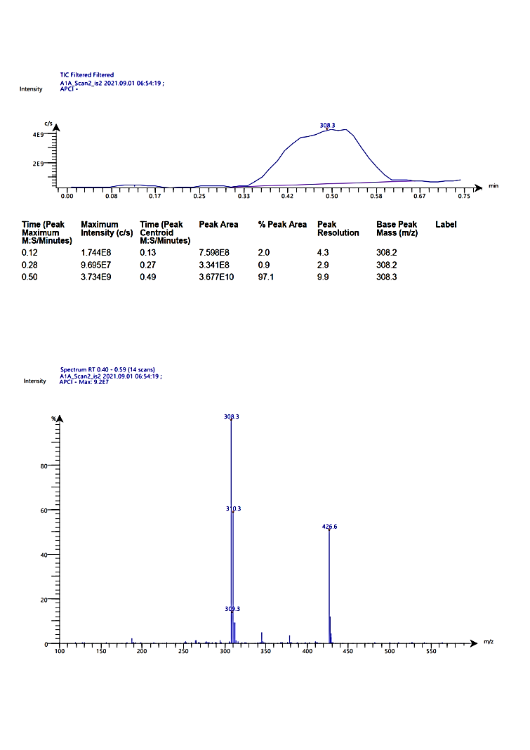

Fig. 25. MS spectrum of compound 8.

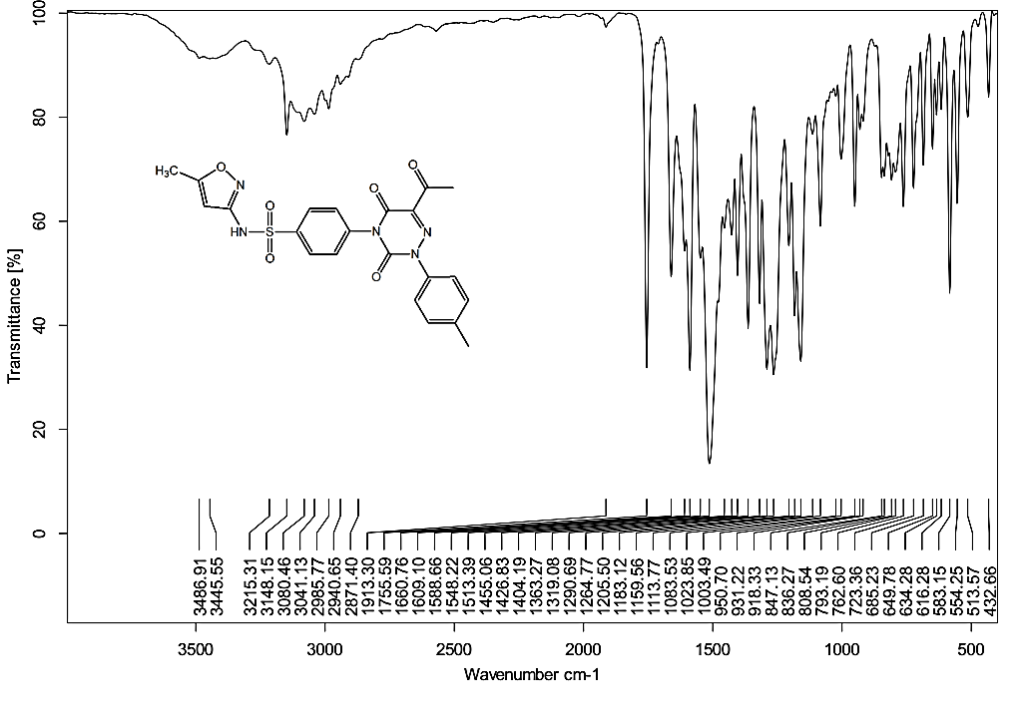

Fig. 26. IR of compound 11a

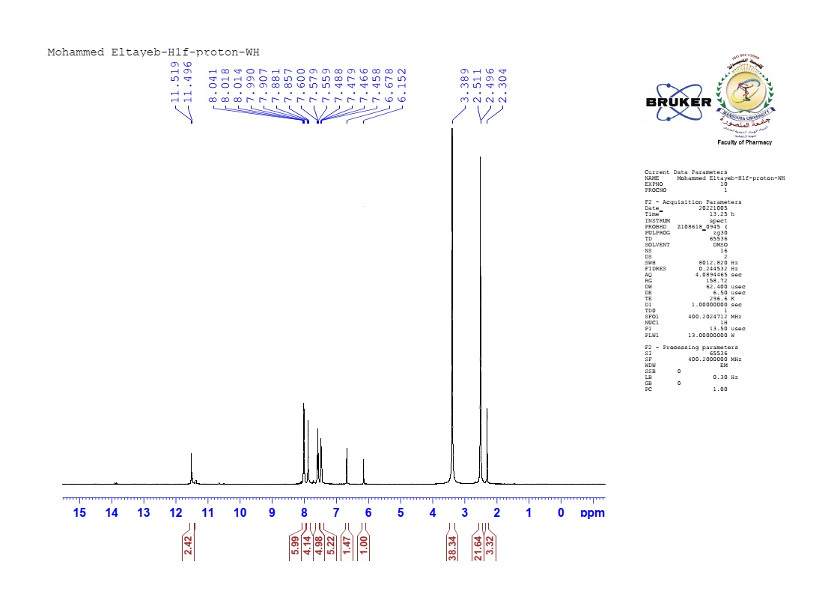

Fig. 27. 1HNMR spectrum of compound 11a

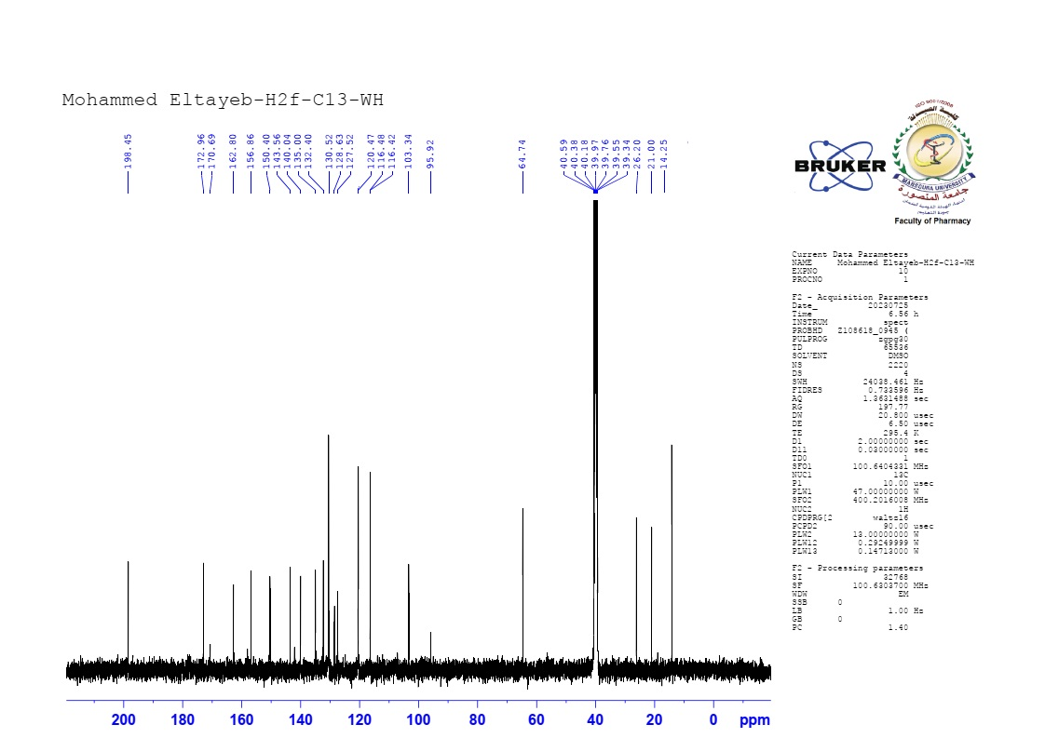

Fig. 28. ¹³CNMR of compound 11a

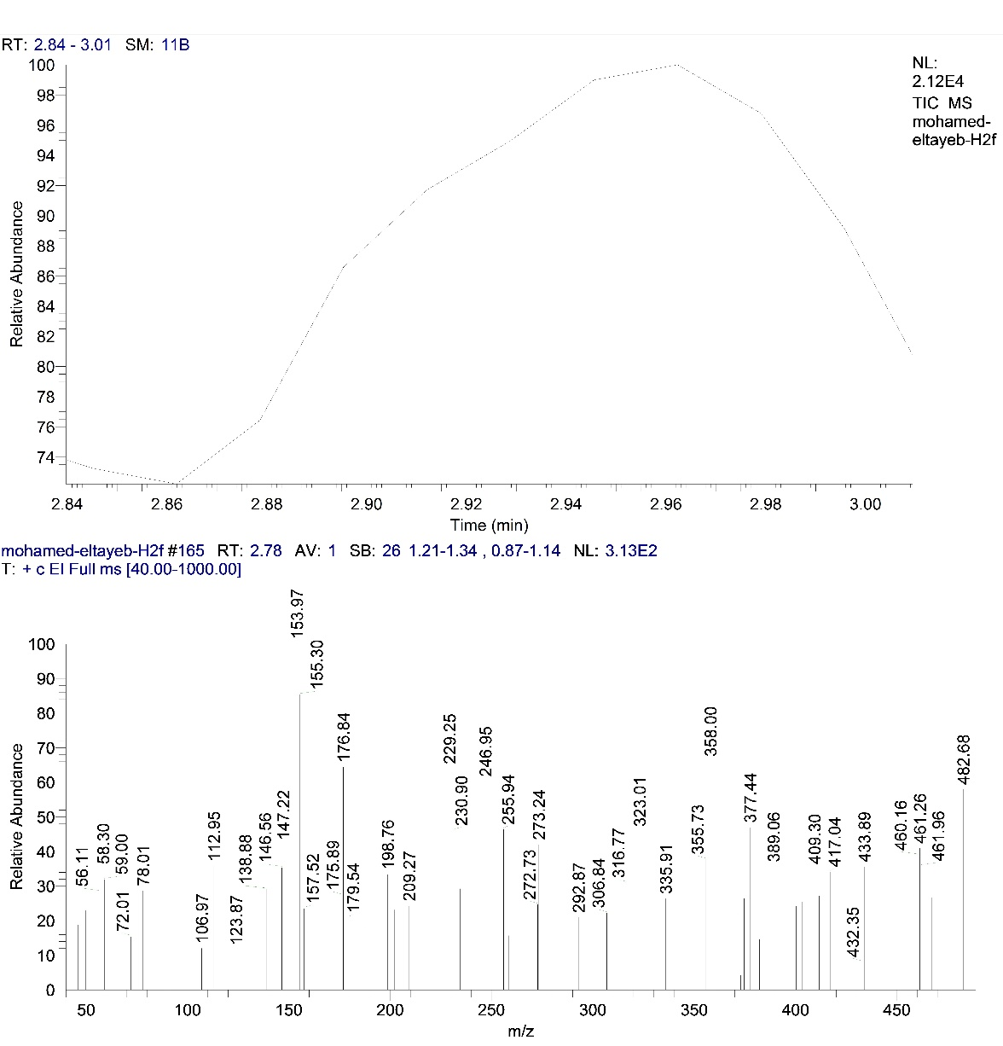

Fig. 29. MS spectrum of compound 11a.

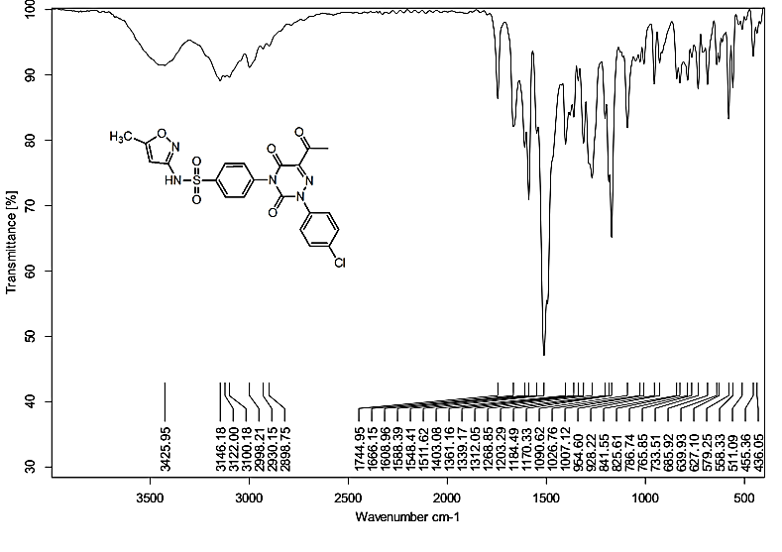

Fig. 30. IR of compound 11b

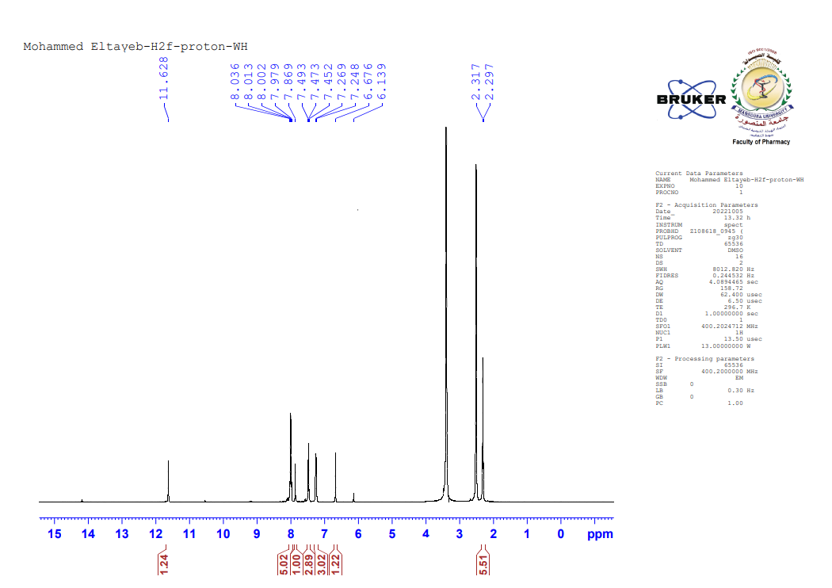

Fig. 31. ¹HNMR spectrum of compound 11b

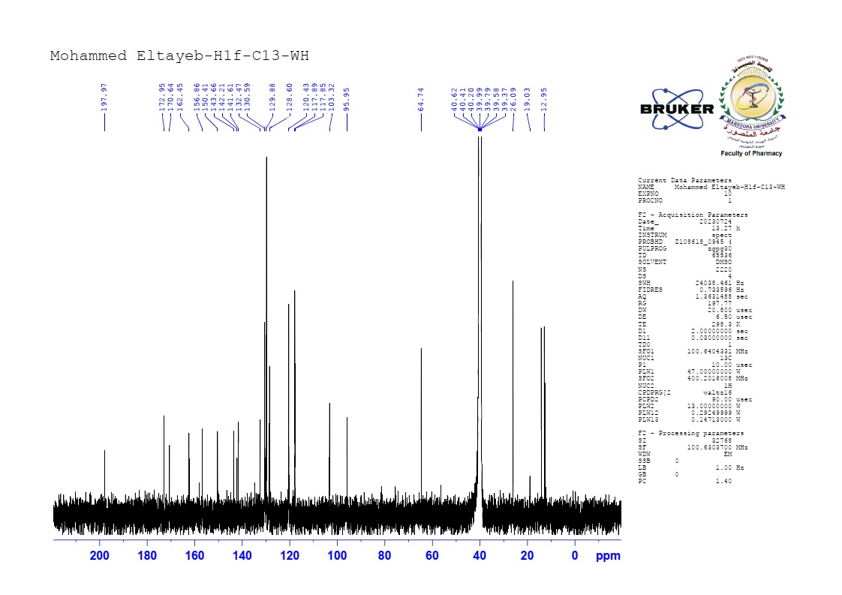

Fig. 32. ¹³CNMR of compound 11b

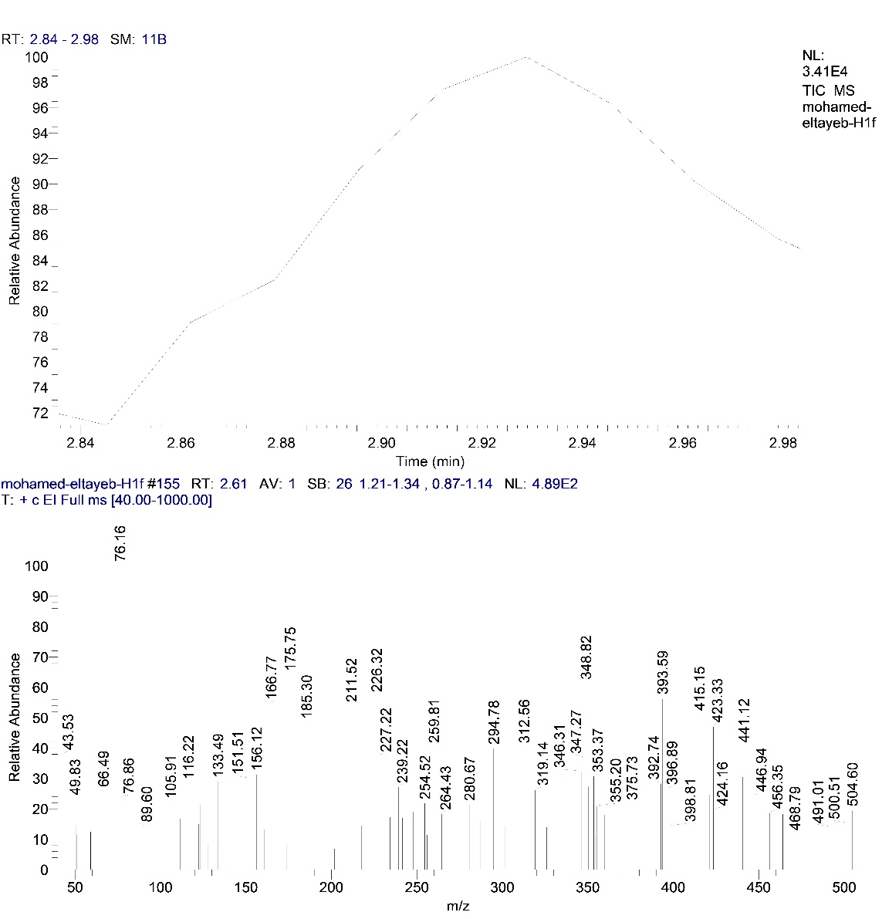

Fig. 33. MS spectrum of compound 11b.

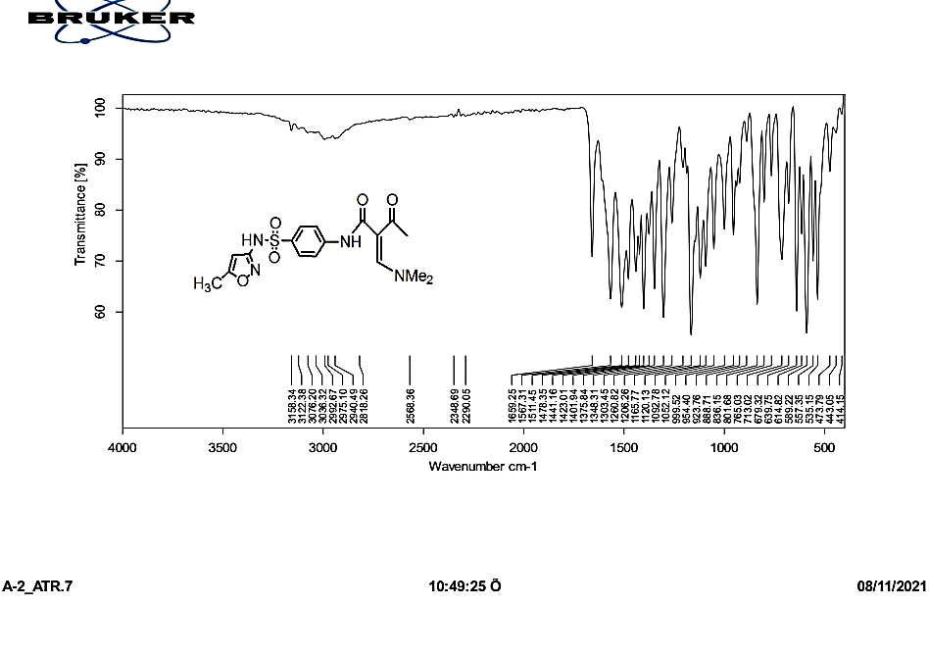

Fig. 34. IR of Compound 12.

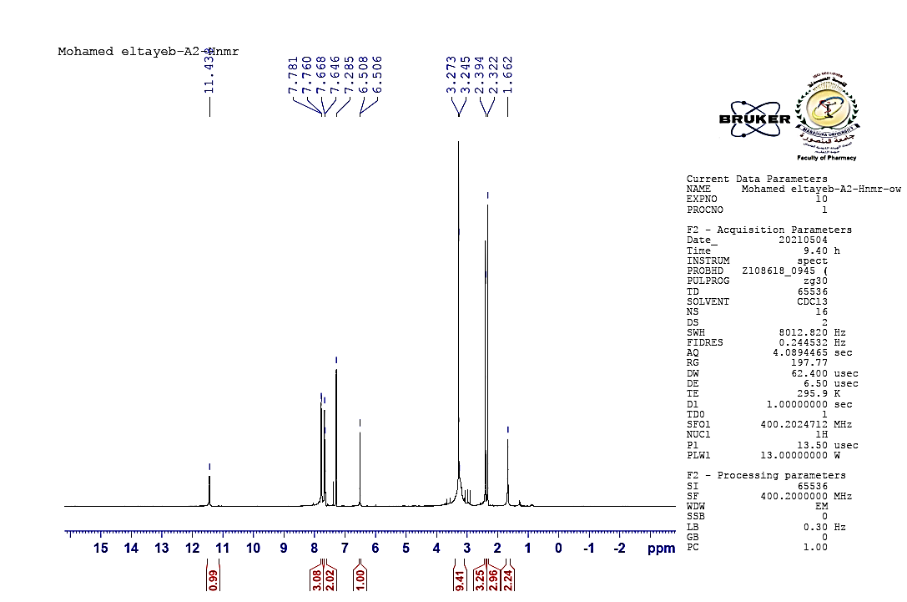

Fig. 35. ¹HNMR of compound 12.

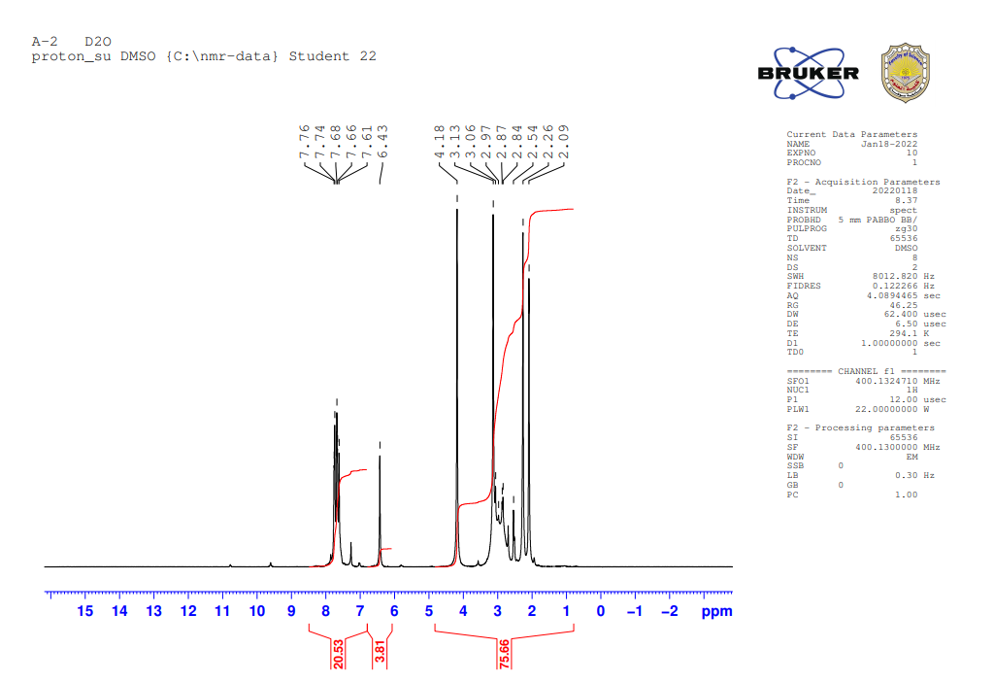

Fig. 36. ¹HNMR (D₂O) of compound 12.
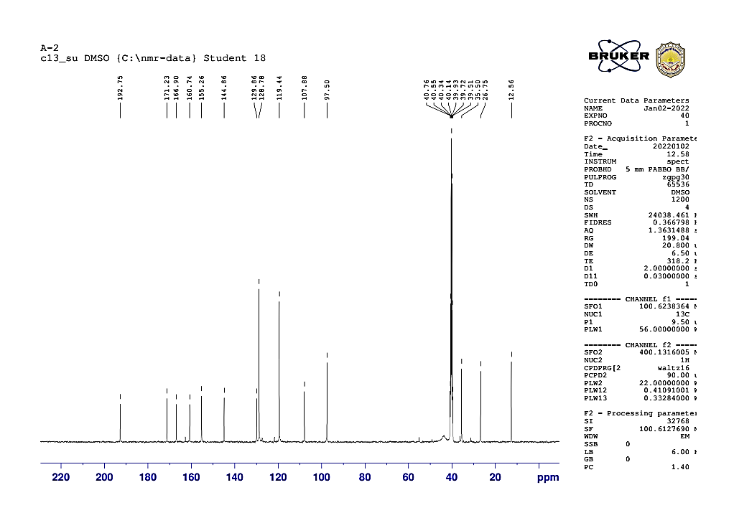

Fig. 37. ¹³CNMR of compound 12.

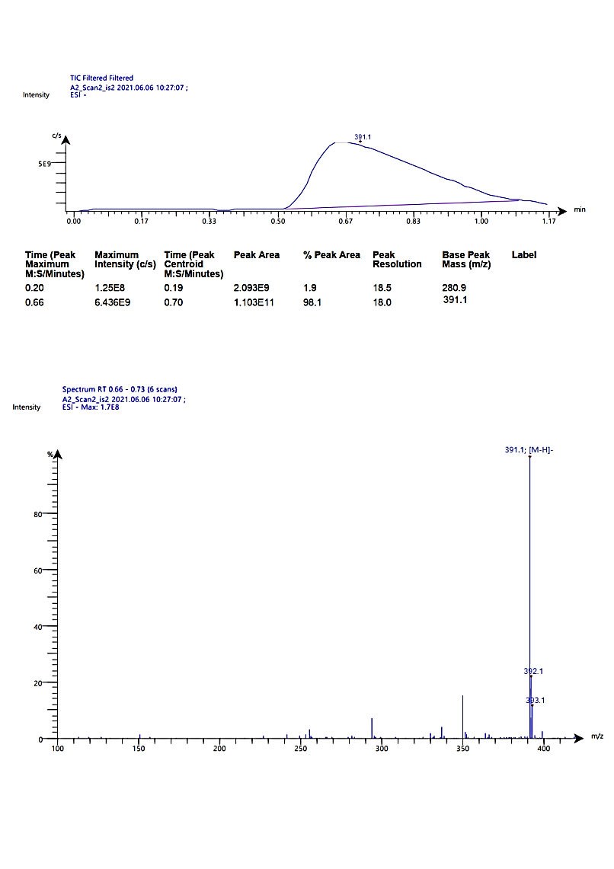
Fig. 38. MS spectrum of compound 12.

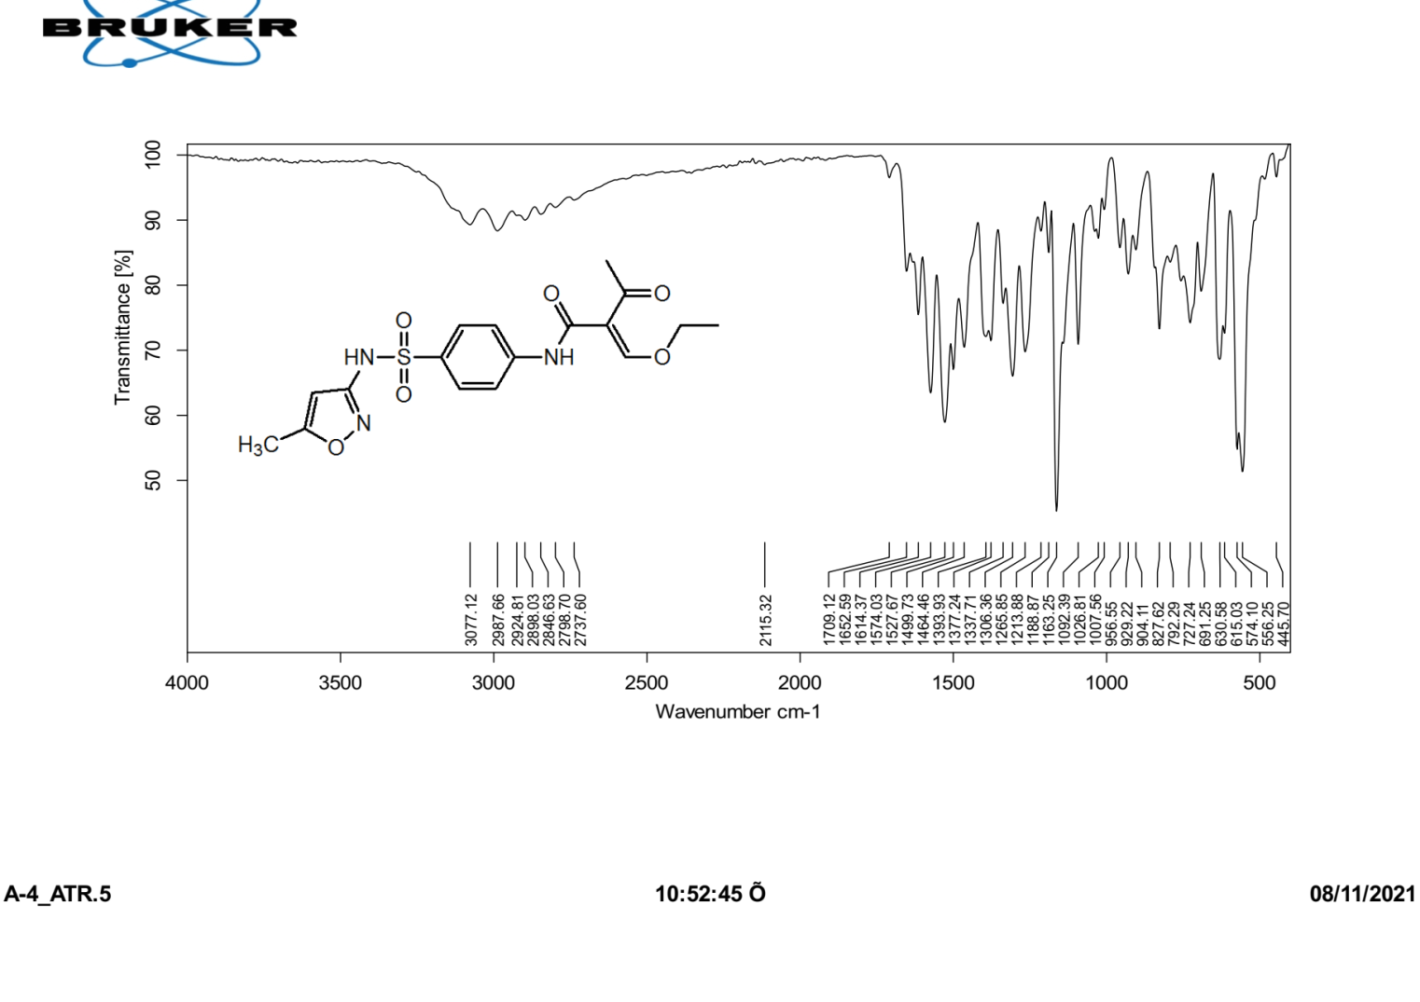

Fig. 39. IR spectrum of compound 14.

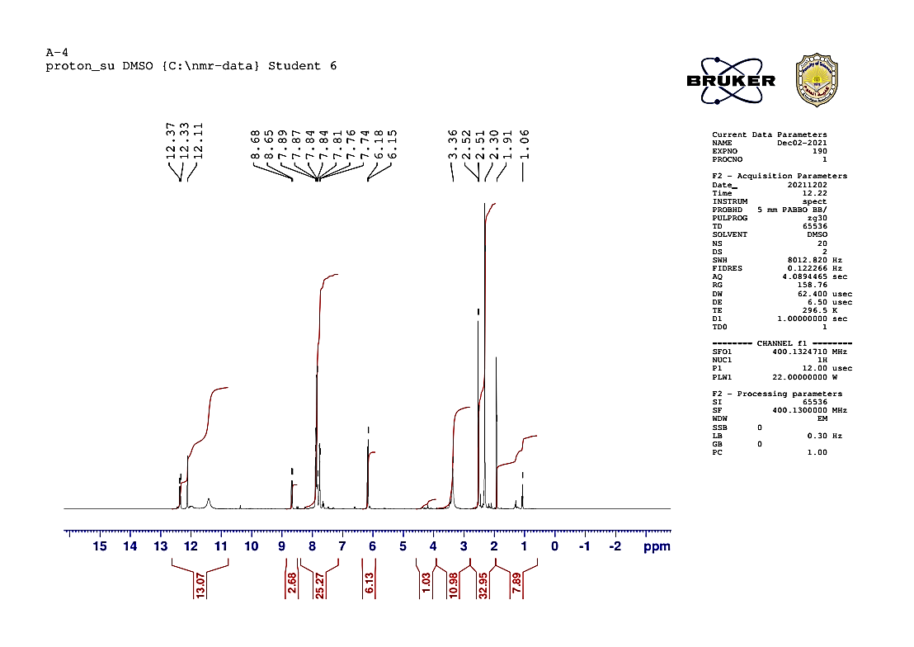

Fig. 40. ¹HNMR spectrum of compound 14.

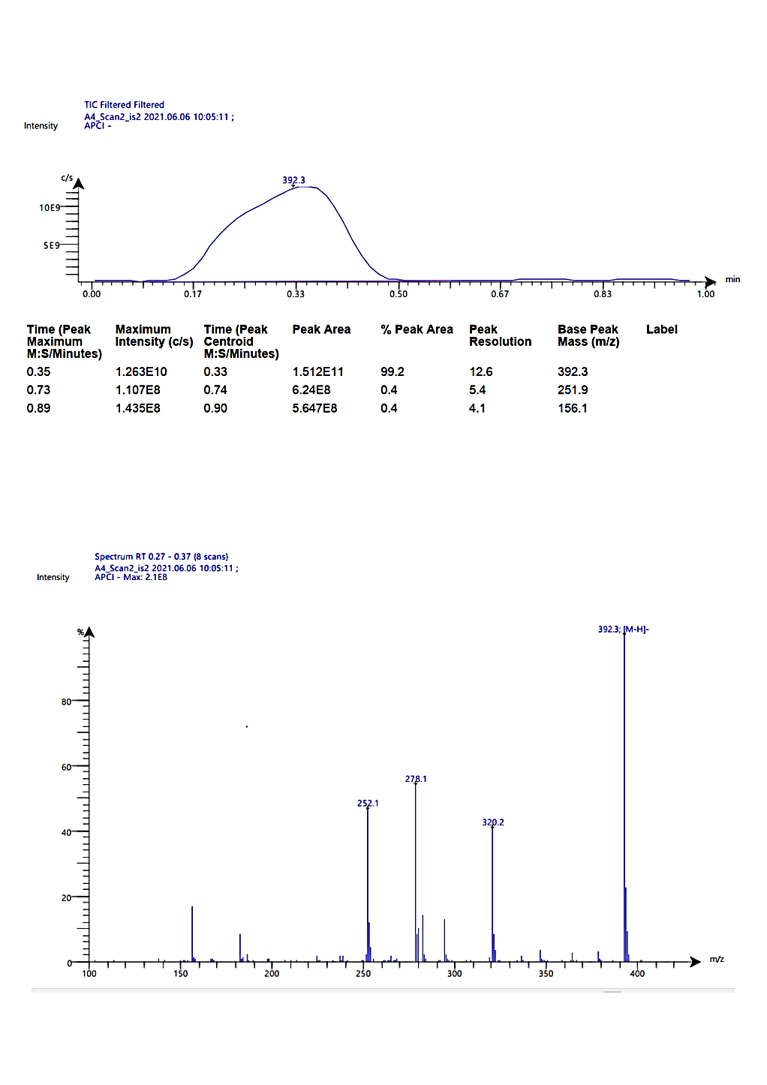

Fig. 41. MS spectrum of compound 14.

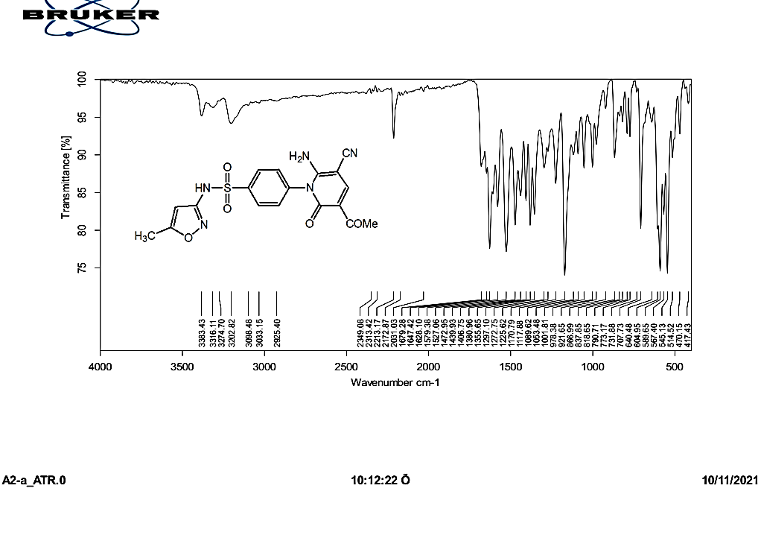

Fig. 42. IR of compound 16

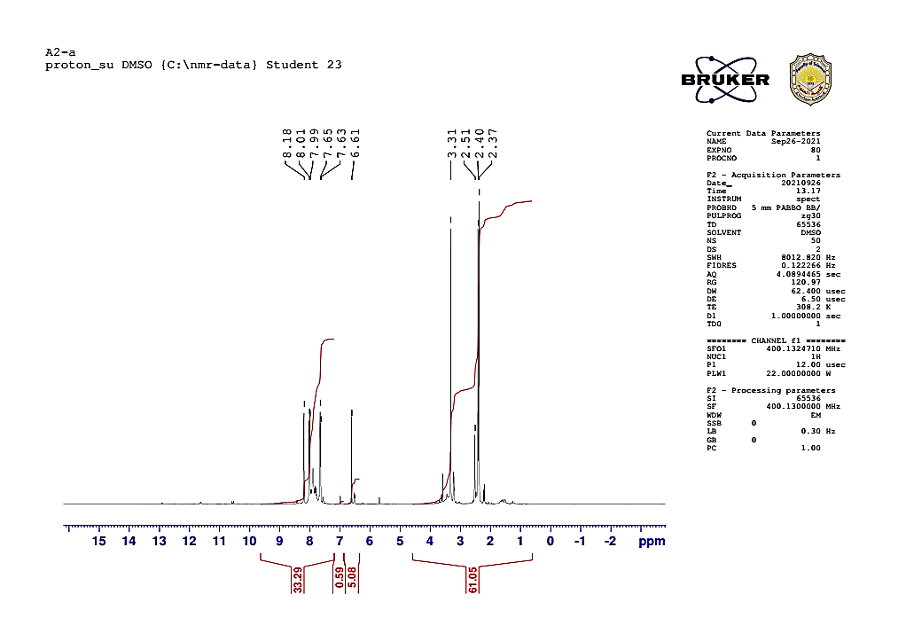

Fig. 43. ¹HNMR of compound 16

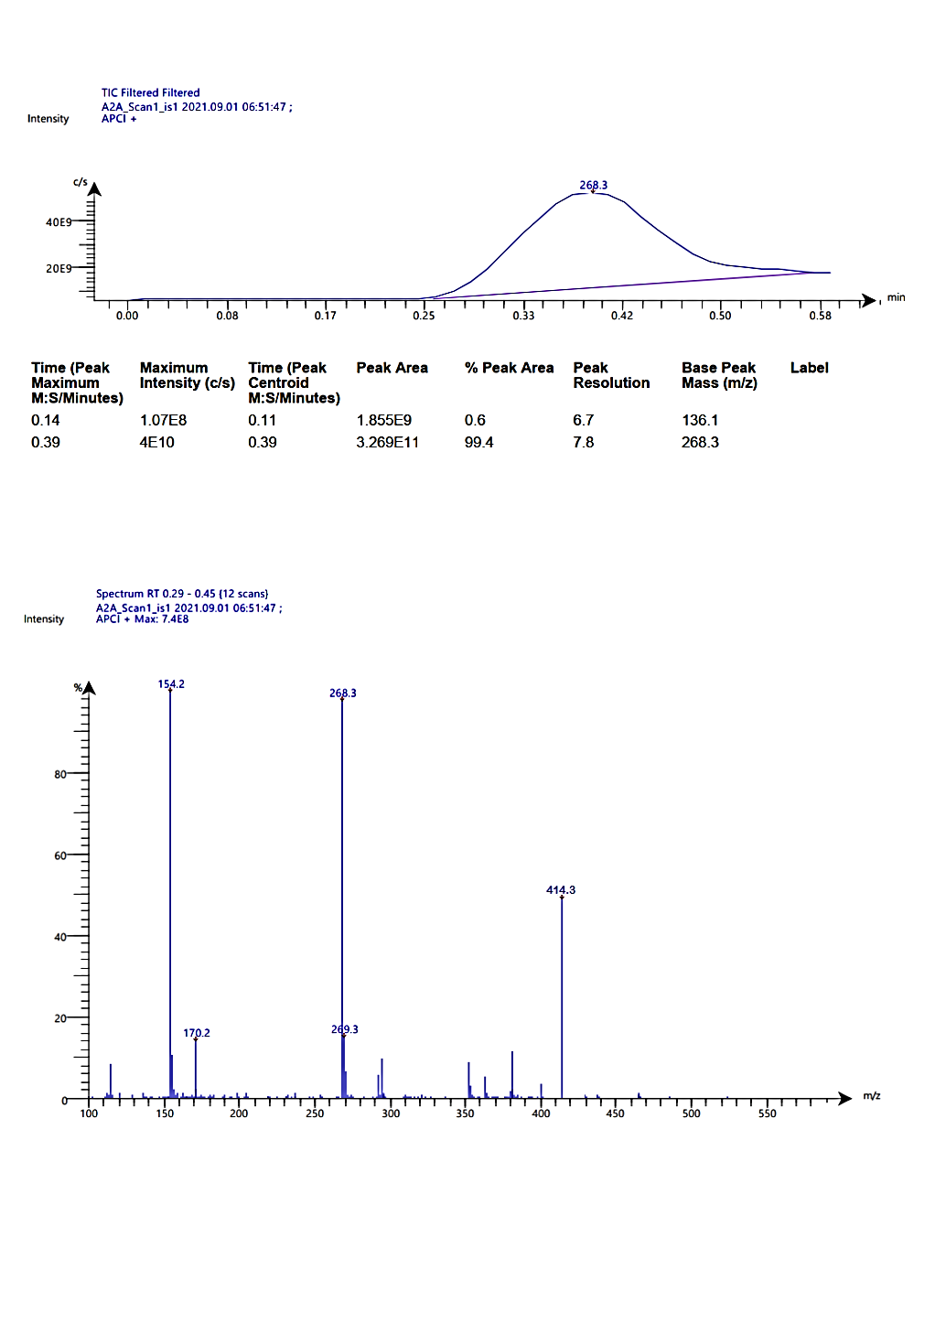

Fig. 44. MS spectrum of compound 16.

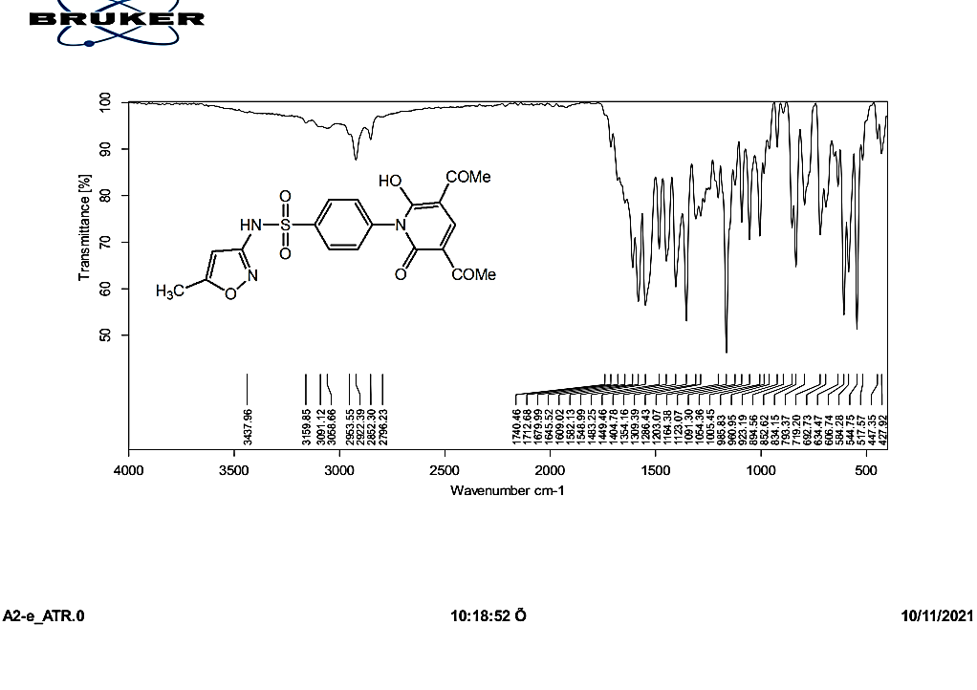

Fig. 45. IR spectrum of compound 21.

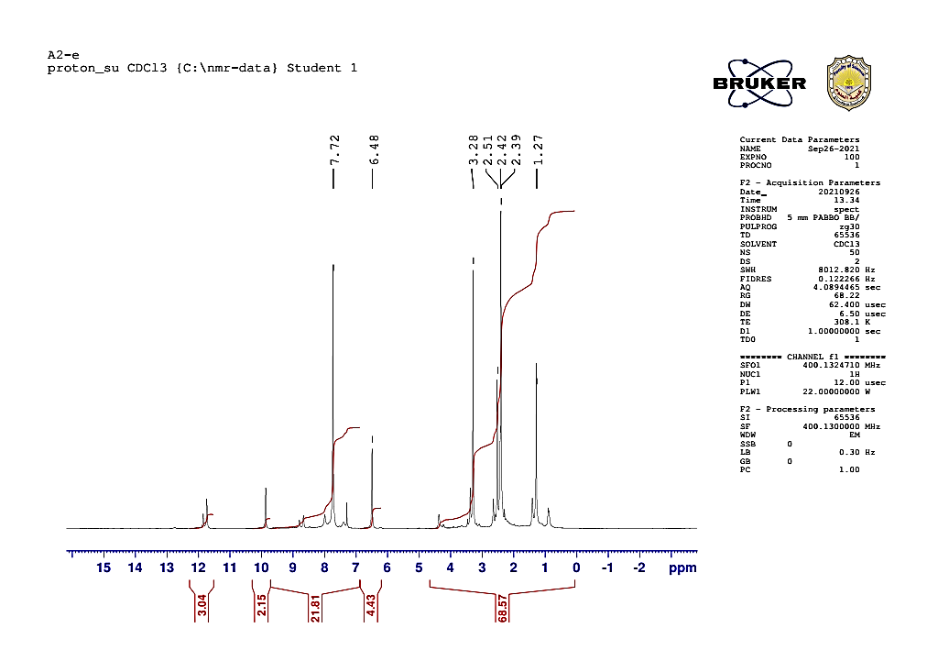

Fig. 46. ¹HNMR of compound 21.

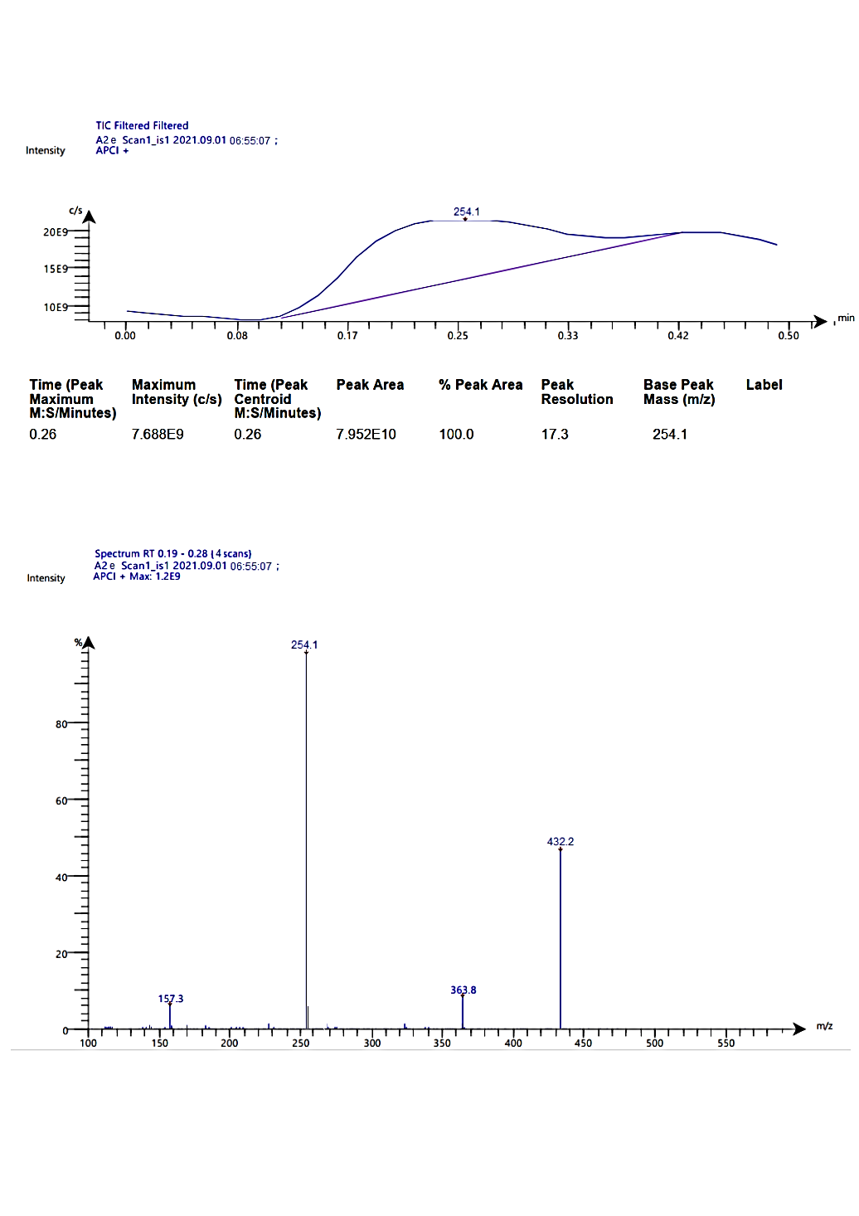

Fig. 47. MS spectrum of compound 21.

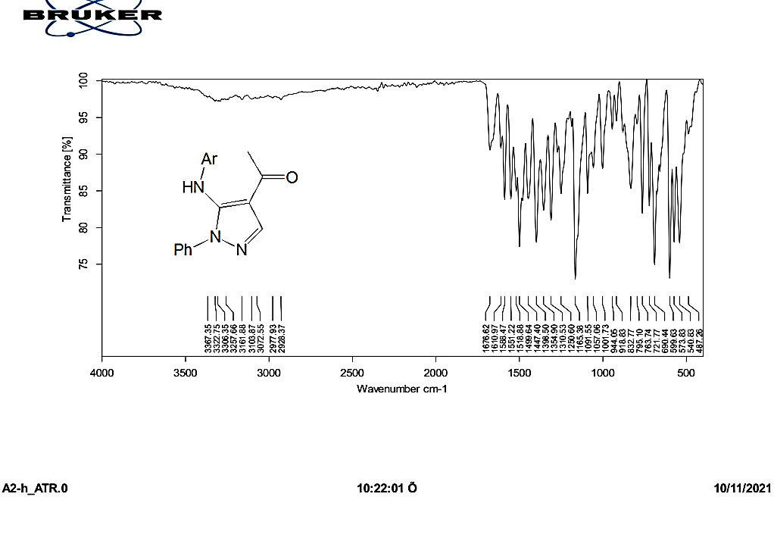

Fig. 48. IR spectrum of compound 22.

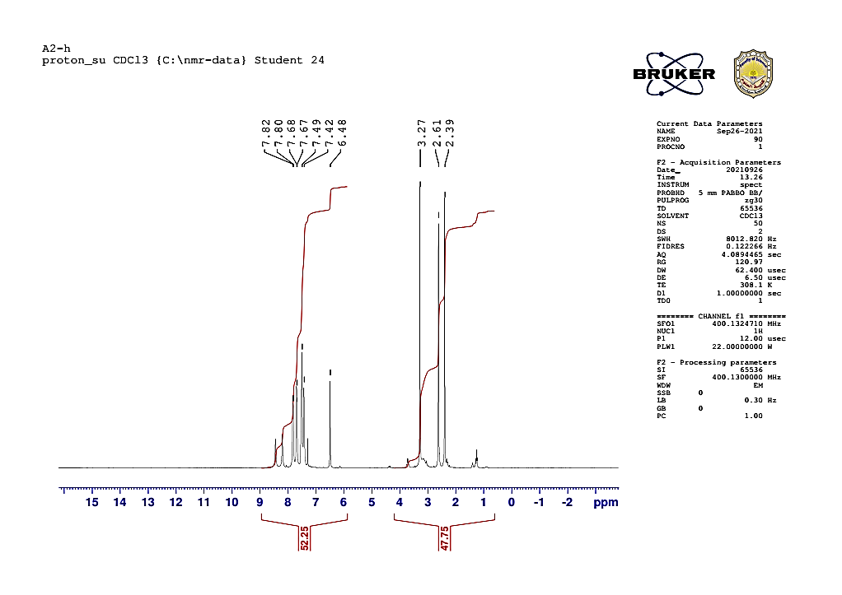

Fig. 49. ¹HNMR of compound 22.

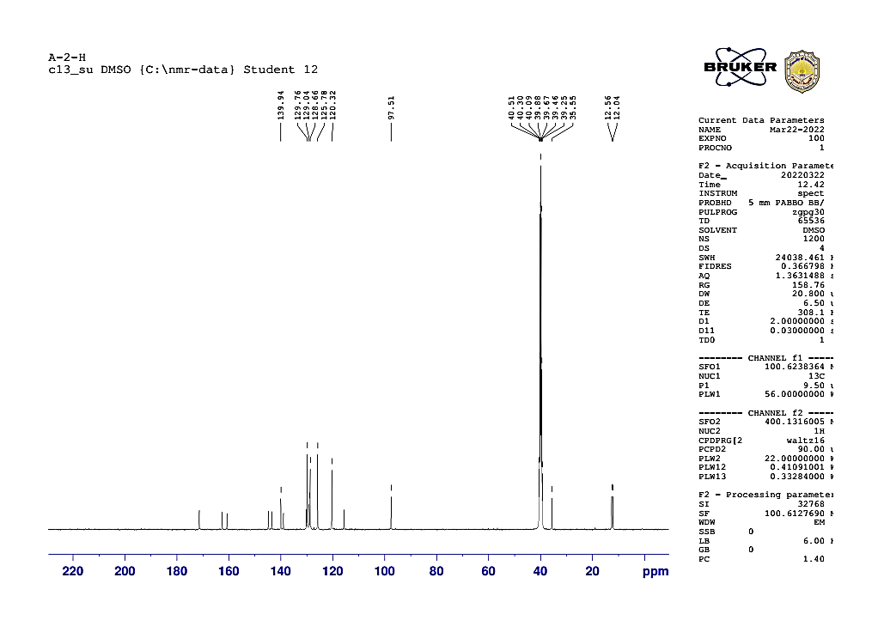

Fig. 50. ¹³CNMR of compound 22

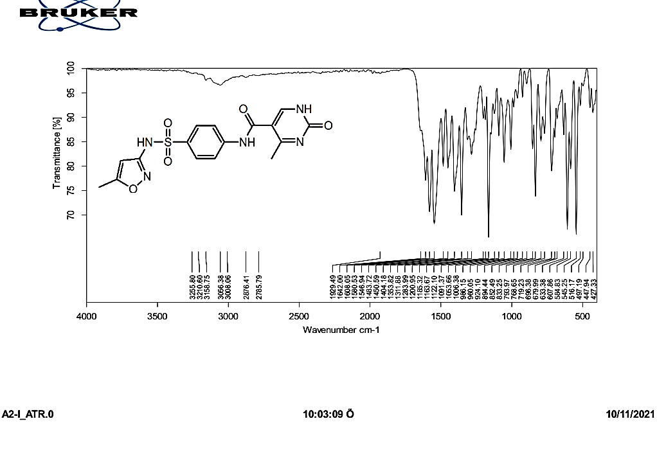

Fig. 51. IR spectrum of compound 23.

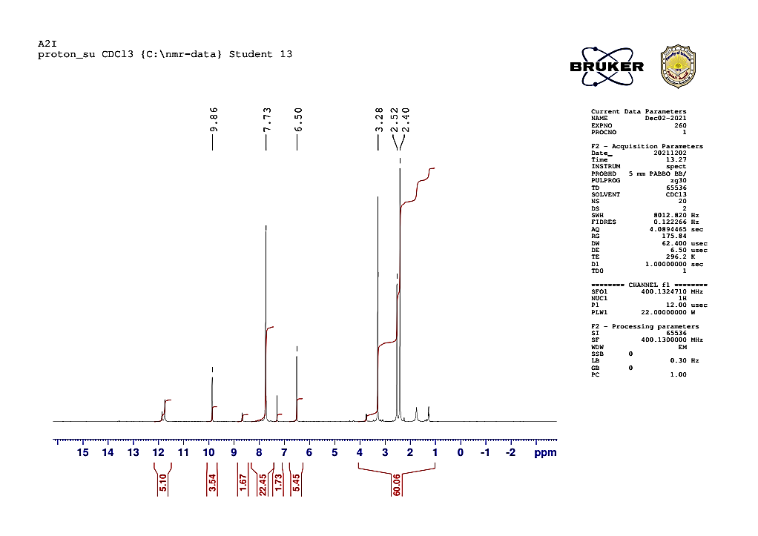

Fig. 52. ¹HNMR spectrum of compound 23.

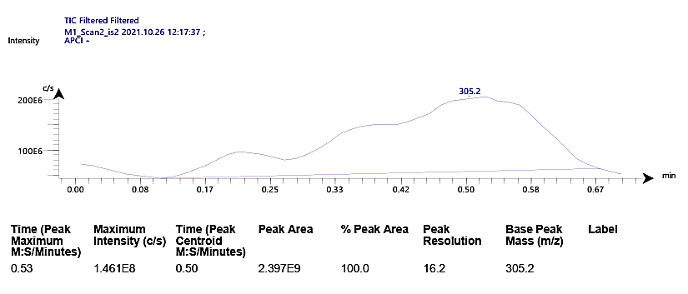

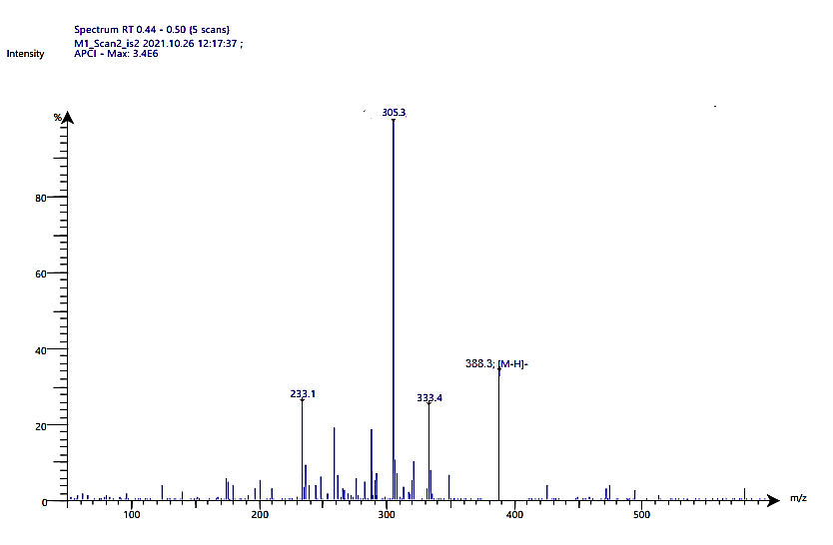

Fig. 53. MS spectrum of compound 23.

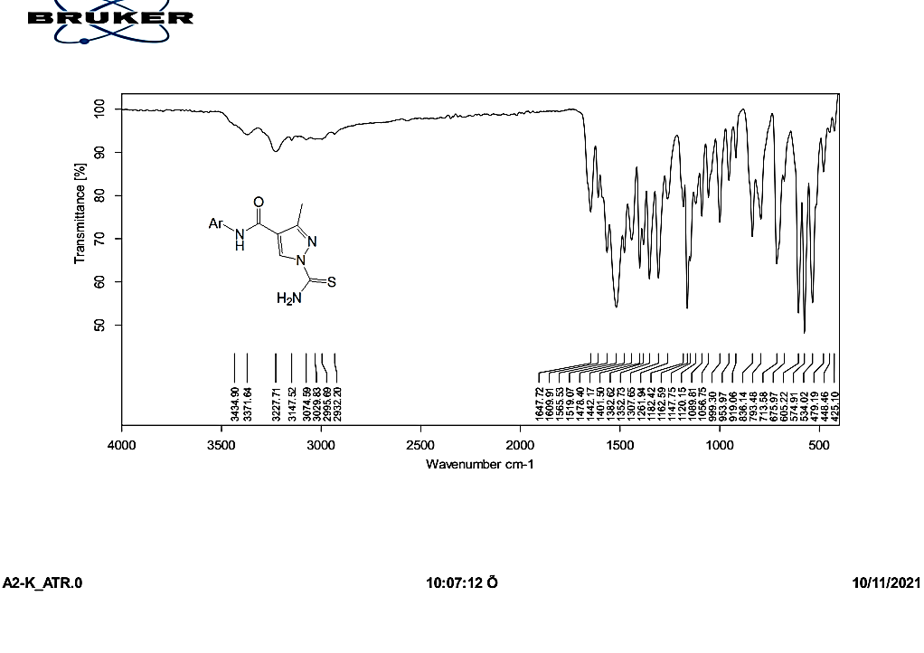

Fig. 54. IR spectrum of compound 24

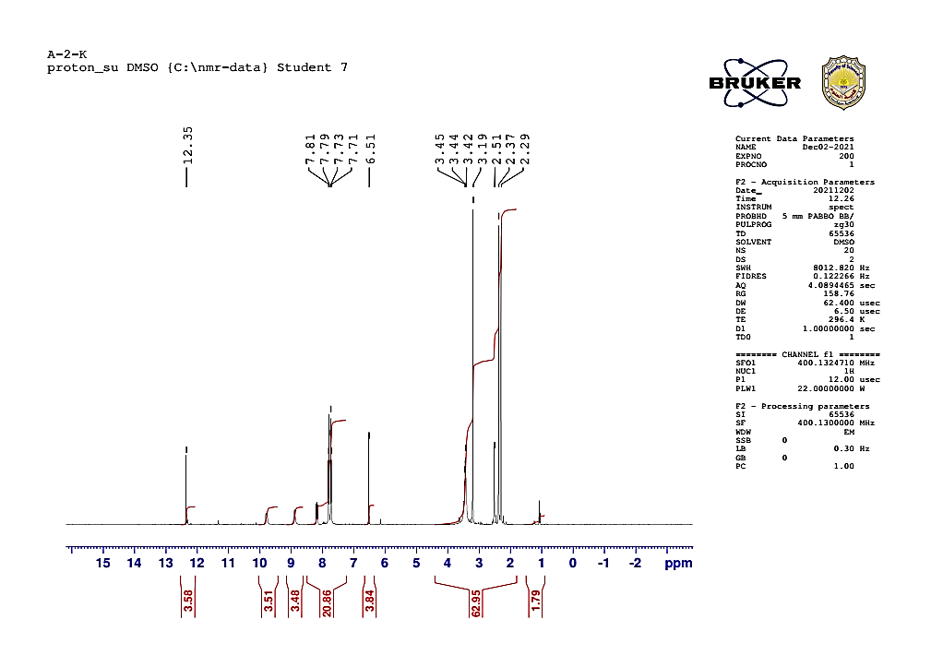

Fig. 55. ¹HNMR spectrum of comound 24.

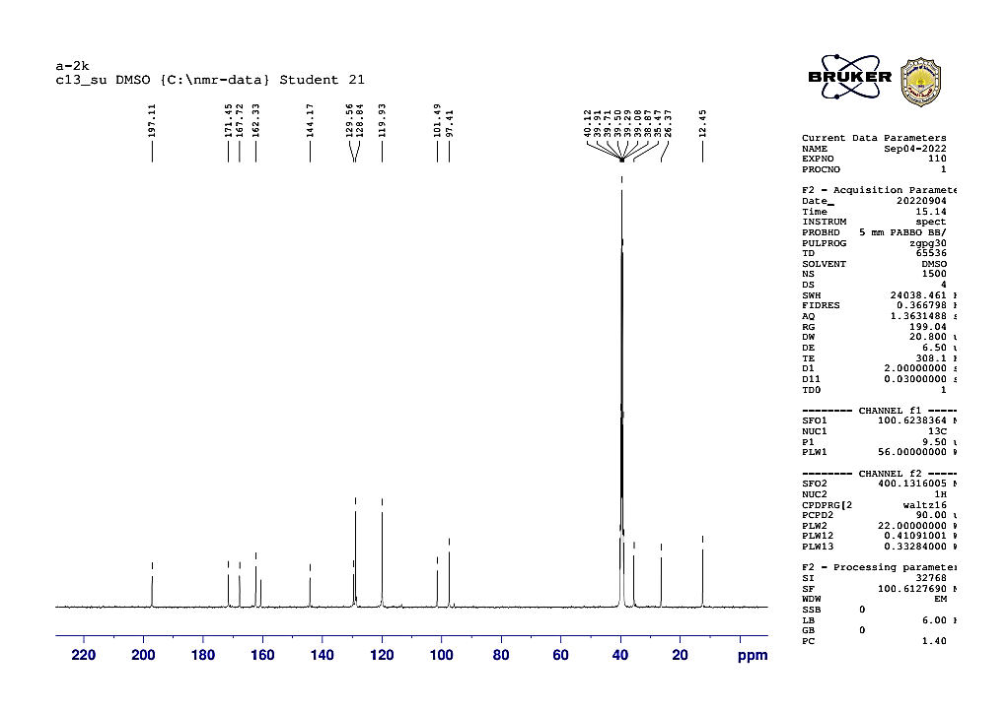

Fig. 56. ¹³CNMR spectrum of compound 24.

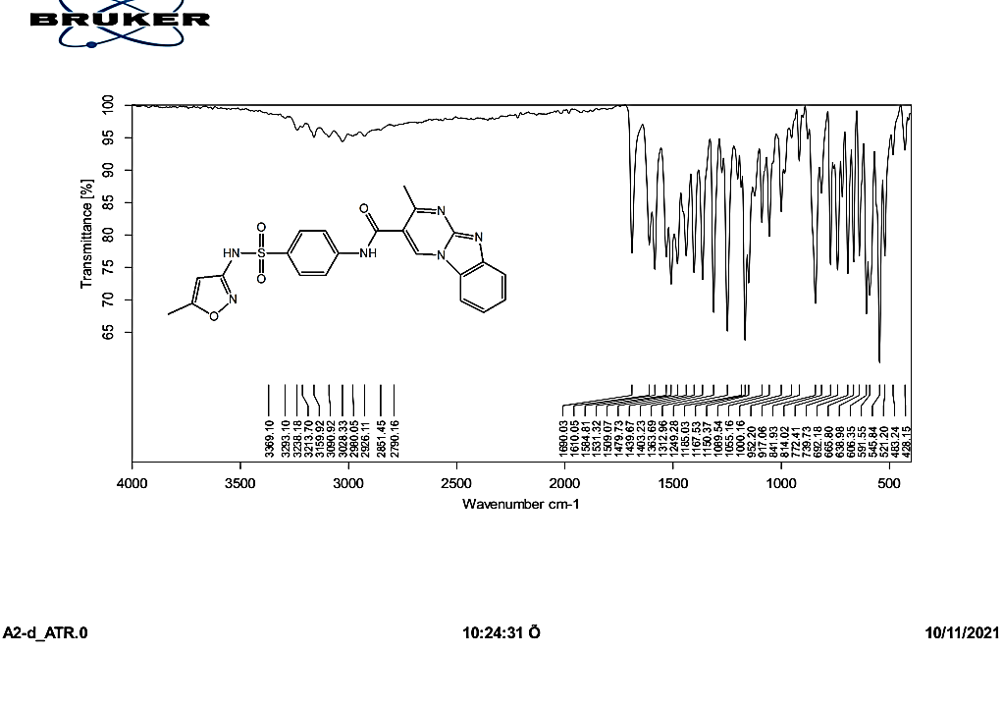

Fig. 57. IR spectrum of compound 25.

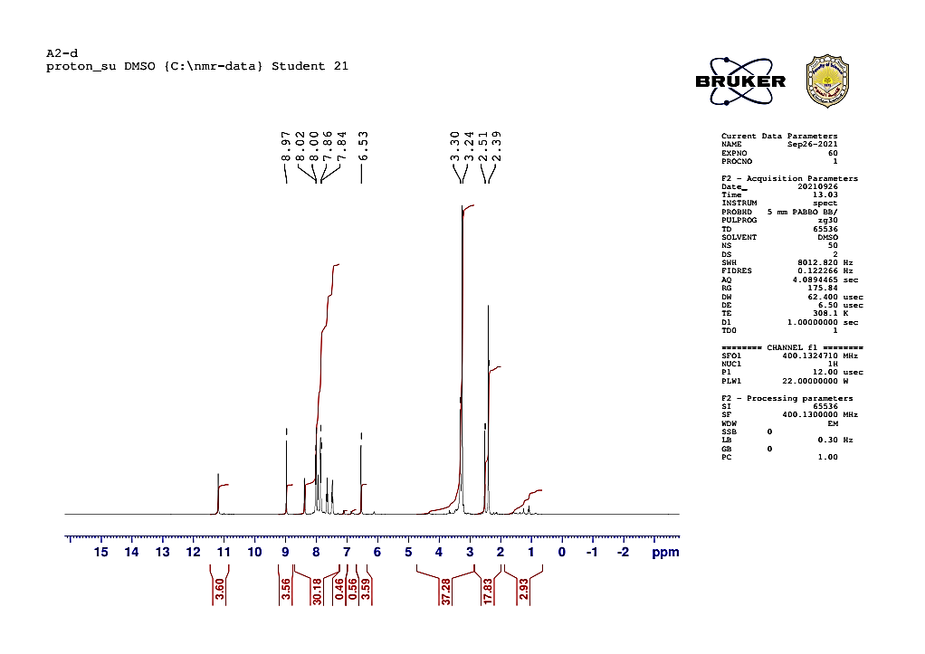

Fig. 58. ¹HNMR of compound 25

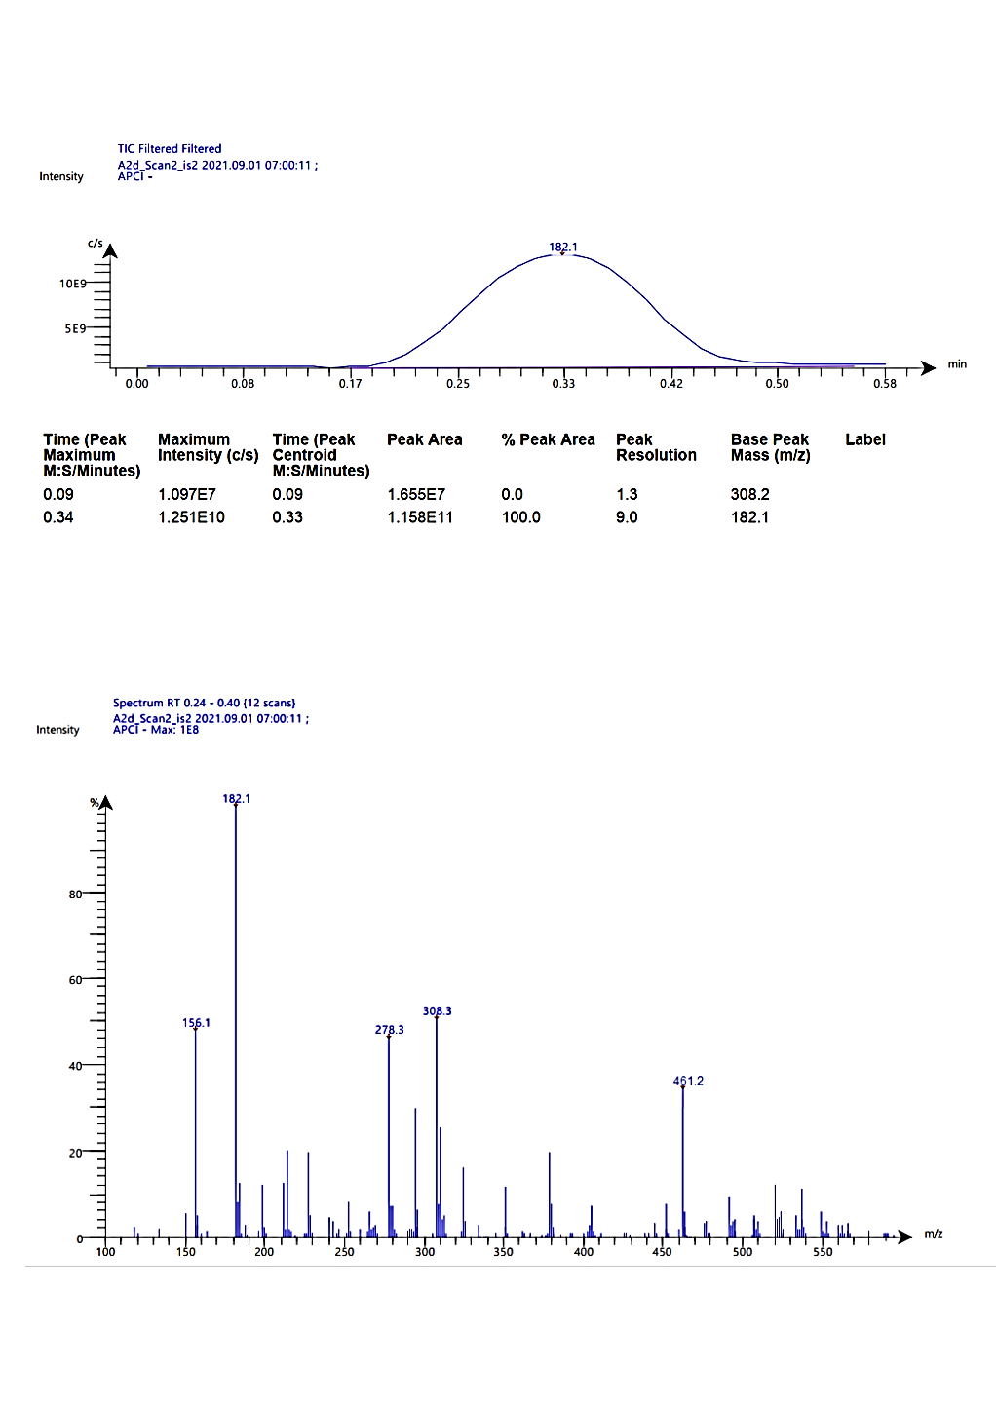

Fig. 59. MS spectrum of compound 25

