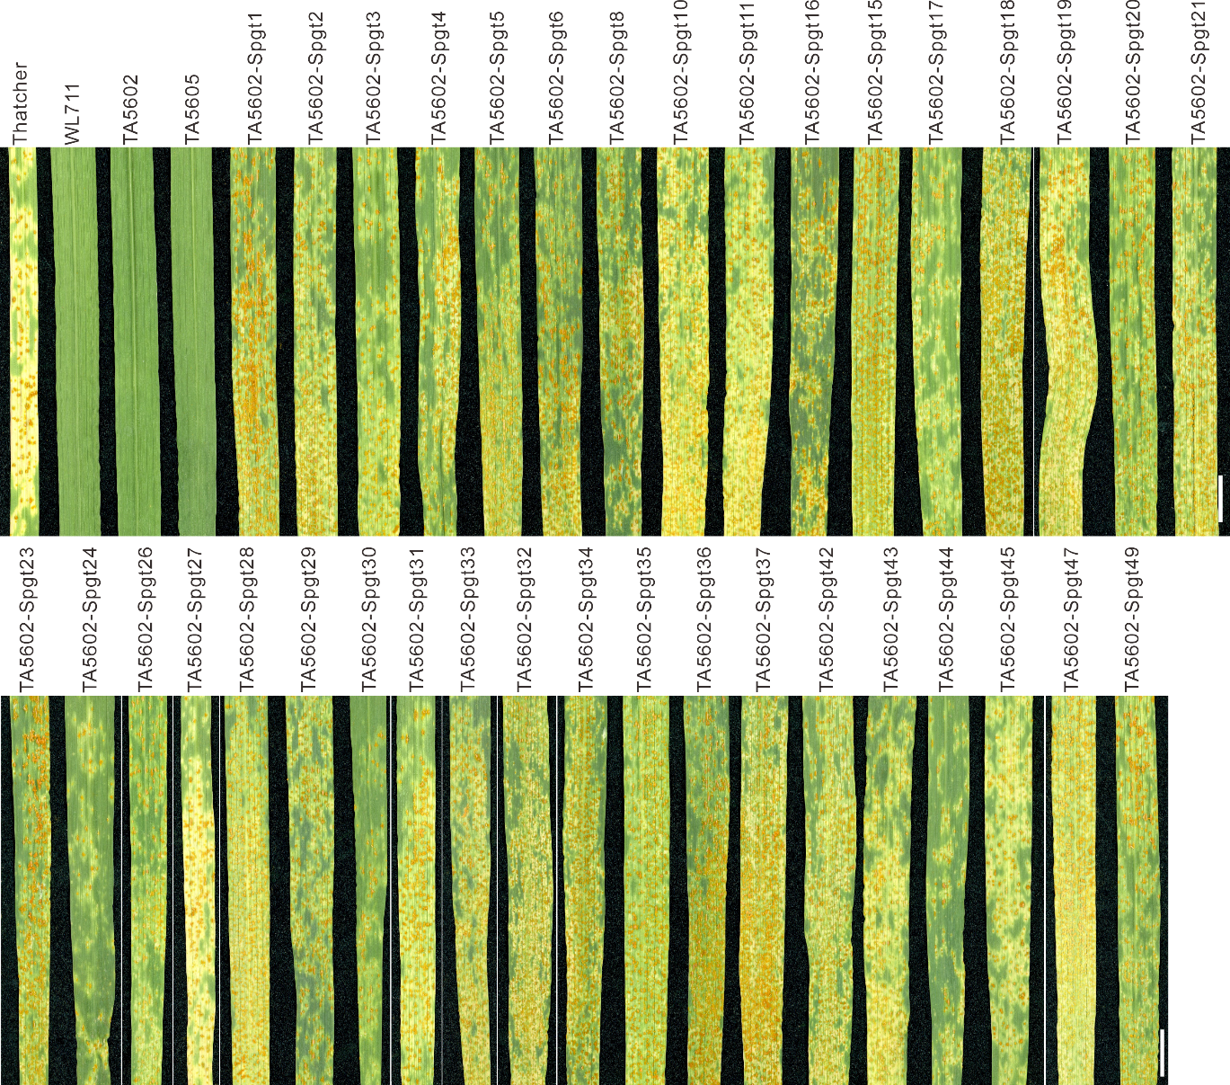
Supplementary Fig. 1. Representative images showing stem rust symptoms on loss-of-function TA5602 EMS mutants. TA5602 M3 mutants were inoculated with Pgt isolate H3. Shown are leaves 12 days after inoculation. Spgt = Suceptible to Puccinia graminis f. sp. tritici. Scale bar = 1 cm. Experiment was repeated independently three times with similar results.
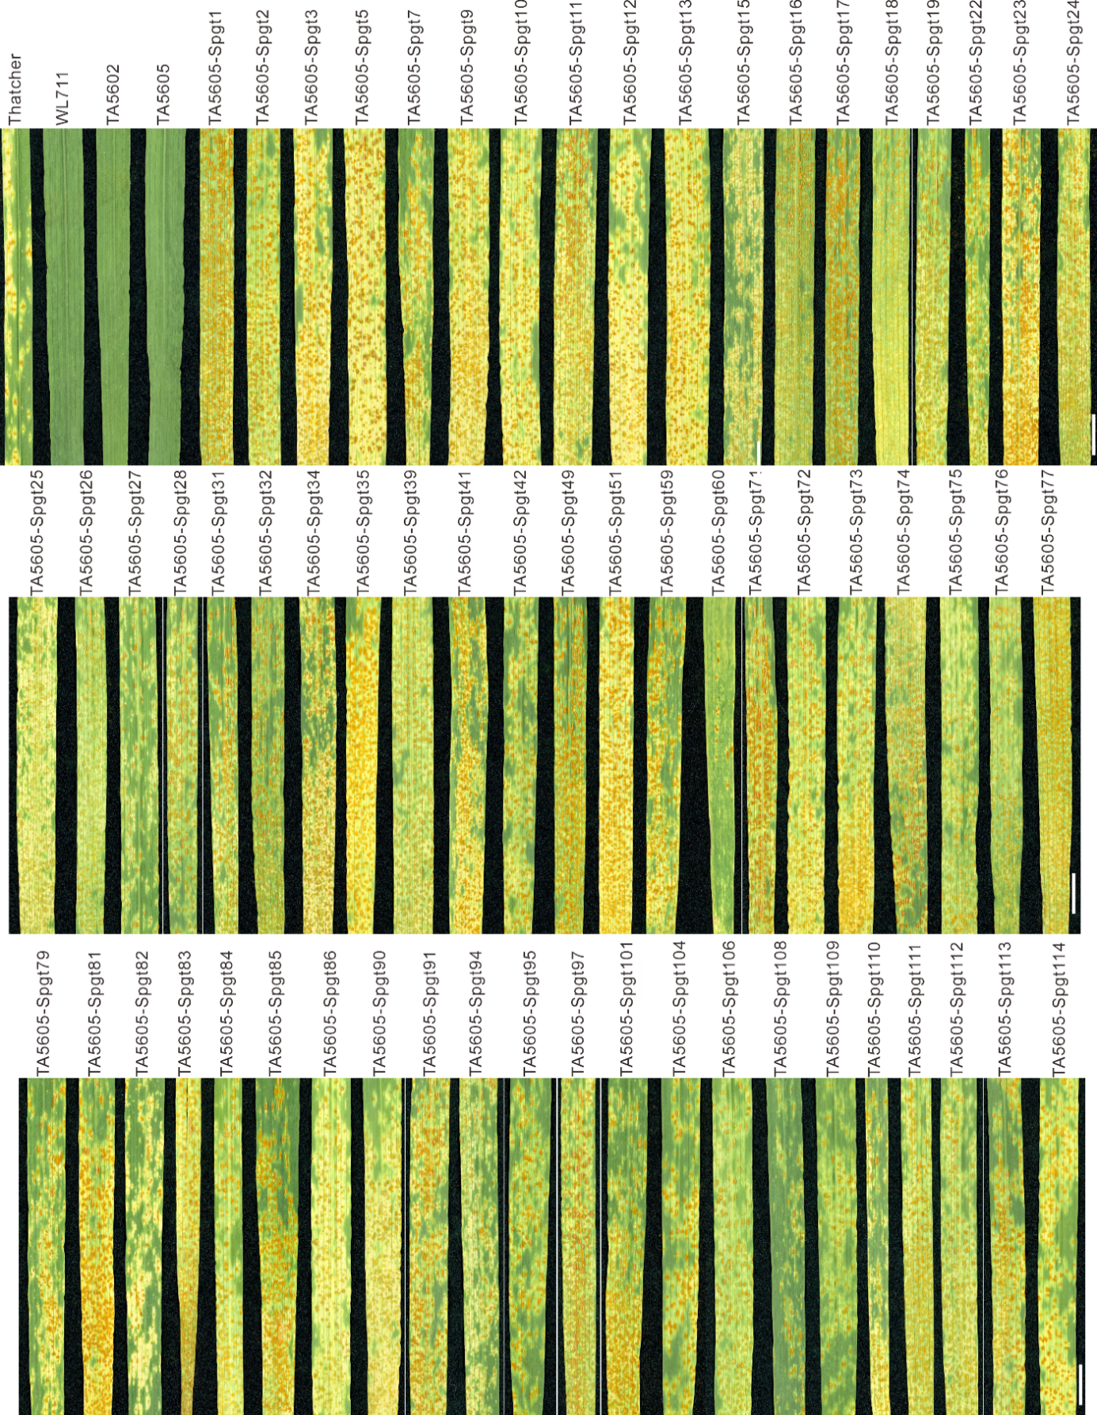
Supplementary Fig.2. Representative images showing stem rust symptoms on loss-of-function TA5605 EMS mutants. TA5605 M3 mutants were inoculated with Pgt isolate H3. Shown are leaves 12 days after inoculation. Spgt = Suceptible to Puccinia graminis f. sp. tritici. Scale bar = 1 cm. Experiment was repeated independently three times with similar results.
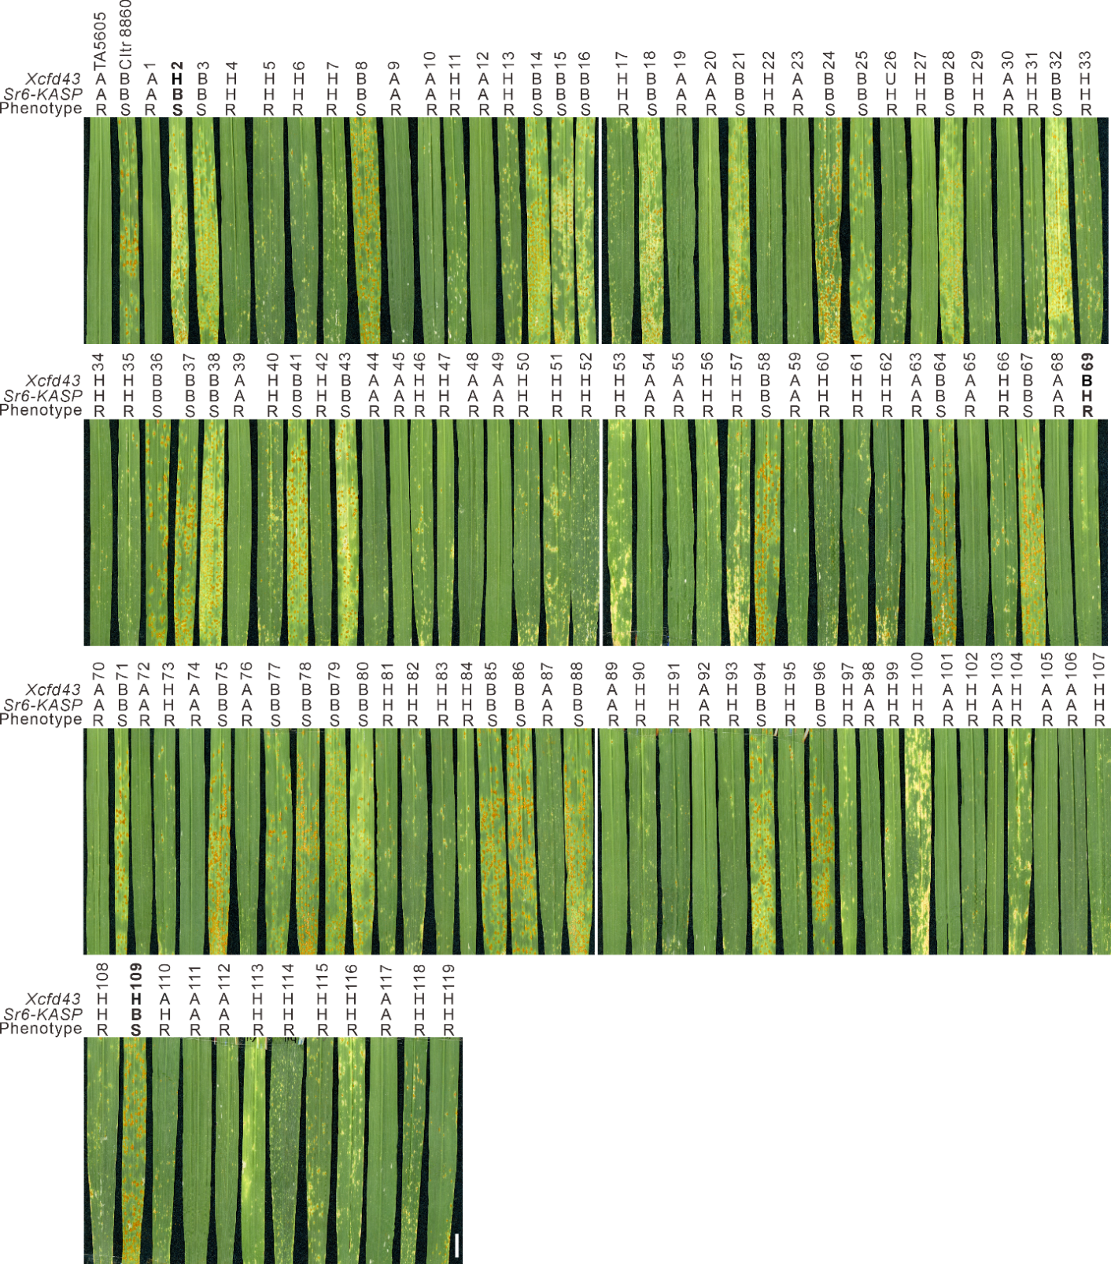
Supplementary Fig. 3. BED-NLR co-segregated with stem rust resistance and is closely linked with a published Sr6 marker. Shown are representative images of an F₂ population derived from a cross between TA5605 and CItr 8860 inoculated with the Pgt isolate H3. Sr6-KASP represents a KASP marker developed from the BED-NLR coding sequence. Xcfd43 is a SSR marker reported to be closely linked with Sr6. Markers were genotyped as A (TA5605 haplotype), B (Cltr 8860 haplotype) or H (heterozygous haplotype). R = resistant, S = susceptible. Images were taken 12 days after inoculation. Scale bar = 1 cm. The three informative recombinants between Xcfd43 and the resistance phenotype are marked in bold.
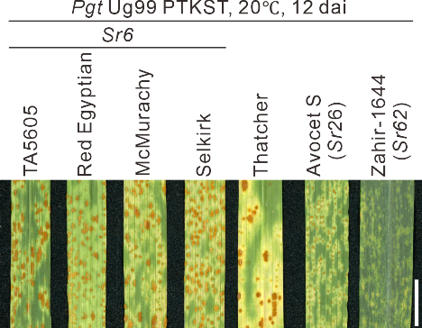
Supplementary Fig. 4. TA5605 is susceptible to the Sr6-virulent Pgt isolate PTKST. Representative images showing the results of TA5605 together with Sr6-positive, Sr26-positive, Sr62-positive bread wheat lines and Thatcher inocuated with Sr6-virulent Pgt isolate H3 at 20⁰C. Images were taken 12 days after inoculation. Scale bar = 1 cm. Experiment was repeated independently twice with similar results.

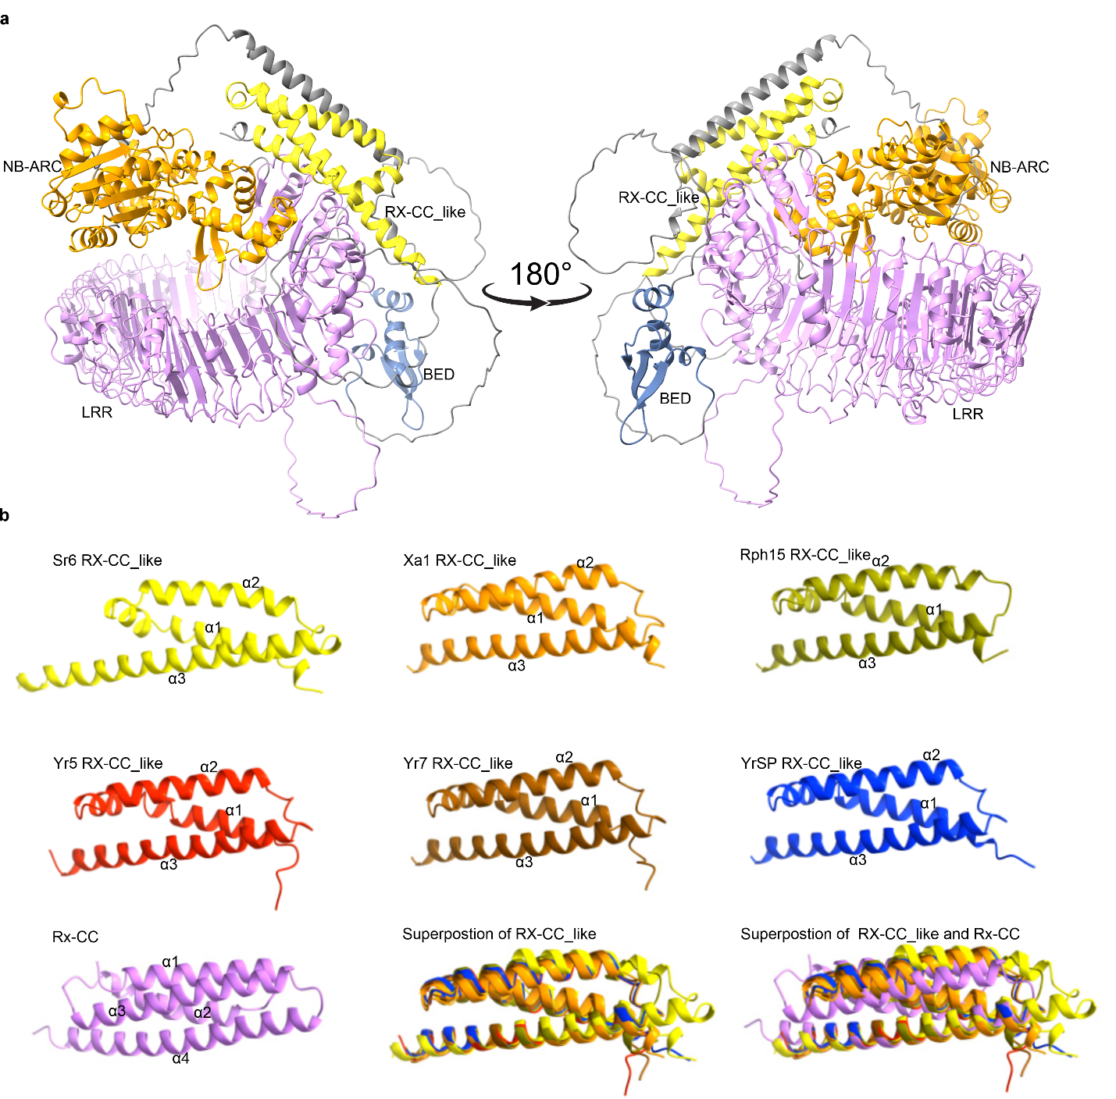 Supplementary Fig. 5. Protein structure prediction of BED-NLRs. a, The protein structure of Sr6 as predicted by AlphaFold2. Rx-CC_like, ZF-BED, NB-ARC, and LRR domains are indicated by yellow, blue, orange and purple colors, respectively. b, The structure of Rx-CC_like domains from BED-NLRs and the Rx-CC domain from the potato virus X resistance protein (Rx) as predicted by AlphaFold2.

