SUPPLEMENTARY APPENDIX MARKISIO

- DEFINITIONS
  - Definition of AKI stage 3 of KDIGO classification
- NON-INCLUSION CRITERIA in AKIKI2 study

- ADVERSE EVENTS POTENTIALLY RELATED TO AKI OR RRT

- Emergency criteria that made considering RRT initiation in AKIKI2 study

- Biomarkers distribution across the cohort

- Vitamin B3 and its metabolites dosage techniques

Distribution of the occurrence of RRT initiation criteria within 72 hours of AKI across the concerned cohort

Area under the ROC curve (AUC) for prediction the need for RRT within 72h in each sub populations of AKI cause

Definitions

DEFINITION OF AKI STAGE 3 OF KDIGO CLASSIFICATION

AKI stage 3 of KDIGO classification is defined by at least one of the following criteria: serum creatinine concentration of more than 4 mg/dl (354 µmol/liter) or greater than 3 times the baseline creatinine level, anuria (urine output of 100 ml/day or less) for more than 12 hours, oliguria (urine output below 0.3 ml/kg/h or below 500 ml/day) for more than 24 hours.

Non -inclusion criteria in AKIKI2 study

Patients presenting one of the urgent indications for immediate RRT were not included. Other non-inclusion criteria were: blood urea nitrogen level greater than 140 mg/dL; severe chronic renal failure (creatinine clearance < 30 ml/min); patients with inclusion criteria already present for more than 24 hours (to avoid delayed inclusions); AKI caused by urinary tract obstruction or renal vessel obstruction or tumour lysis syndrome or thrombotic microangiopathy or acute glomerulopathy; poisoning by a dialyzable agent; child C liver cirrhosis; cardiac arrest without awakening; moribund state (patient likely to die within 24h); patient having already received RRT for the current episode of AKI; renal transplant; treatment limitation (withholding or withdrawal); previous inclusion in this study; subject deprived of freedom, subject under a legal protective measure; pregnant or breastfeeding woman. These non-inclusion criteria should not be present at the time of inclusion in the observational stage of the study and should not have appeared secondarily at the time of randomization.

Emergency criteria that made considering RRT in AKIKI2 study

Table S1

Serum potassium concentration >6 mmol/l
Serum potassium concentration >5.5 mmol/l persisting despite medical treatment
Arterial blood pH <7.15 in a context of pure metabolic acidosis (PaCO₂ <35 mmHg) or in a context of mixed acidosis with a PaCO₂ >50 mmHg without possibility of increasing alveolar ventilation
Acute pulmonary edema due to fluid overload despite diuretic therapy leading to severe hypoxemia requiring oxygen flow rate >5 l/min to maintain SpO₂>95% or FiO₂>50% under invasive or non- invasive mechanical ventilation

Biomarkers distribution across the cohort

Figure S1

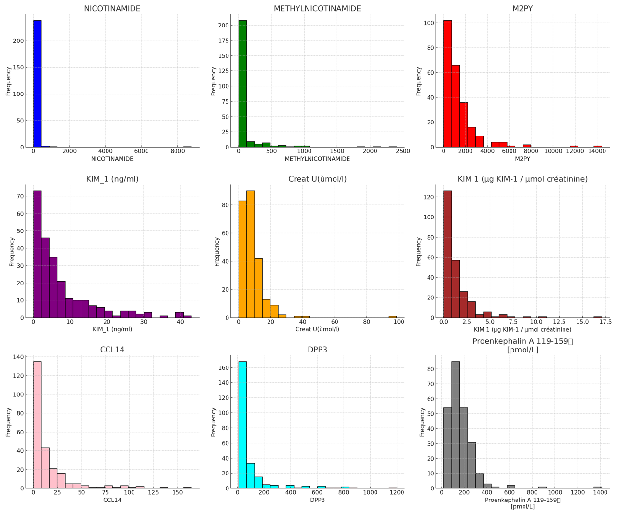
NA, MNA and M2PY dosage techniques

50 µL of the internal standards (deuterated NA and deuterated MNA) were added to 50 µL of the sample. Protein precipitation was then performed by adding 400 µL of methanol. The resulting mixture was then centrifuged and 400 µL of the supernatant was evaporated to dryness under a stream of nitrogen. The dry residue was then reconstituted with 150 µL of water:methanol (90:10), and 10 µL were injected into the chromatographic system. The chromatographic separation was performed on a Waters Spherisorb CNRP column (4.6 x 150 mm, 5 µm) with a mobile phase consisting in a mixture of acetonitrile and water containing 0.1 % of formic acid, at a flow rate of 0.8 ml/min and in gradient elution mode. The detection was performed by positive electrospray ionization and the following mass transitions were detected: 123 80 (NA), 137 94.1 (MNA), 153 108 (M2PY). Intra- and inter-day imprecision and inaccuracy were < 15 % (20 % for the lower limit of quantification) over the calibration ranges: 1 – 1000 ng/ml for NA and MNA, 20 – 2000 ng/ml for M2PY.

Distribution of the occurrence of RRT initiation criteria within 72 hours of AKI across the cohort

Initiation Criteria | Population (101 patients)
Severe hyperkaliemia | 16/101 (15.8%)
Severe metabolic acidosis | 21/101 (20.8%)
Severe pulmonary edema | 13/101 (12.9%)
Oligo-anuria for more than 72h and/or BUN>112mg/dl | 51/101 (50.4%)

Area under the ROC curve (AUC) for prediction the need for RRT within 72h in each sub populations of AKI cause

Table S2

Sepsis

Biomarkers | AUC | 95%CI
pH | 0.62 | 0.53-0.71
K+ | 0.60 | 0.52-0.68
Serum creatinine | 0.63 | 0.54-0.72
CCL14 | 0.67 | 0.58-0.74
KIM 1 (µg KIM-1 / µmol créatinine) | 0.56 | 0.46-0.64
DPP3 | 0.64 | 0.55-0.72
PenKid | 0.59 | 0.51-0.67
NICOTINAMIDE | 0.60 | 0.52-0.69
METHYLNICOTINAMIDE | 0.60 | 0.51-0.68
M2PY | 0.56 | 0.48-0.65
(MNA+M2PY)/NICO | 0.48 | 0.39-0.56

Rhabdomyolysis

Biomarkers | AUC | 95%CI
pH | 0.58 | 0.30-0.84
K+ | 0.69 | 0.41-0.91
Serum creatinine | 0.83 | 0.35-0.86
CCL14 | 0.62 | 0.35-0.86
KIM 1 (µg KIM-1 / µmol créatinine) | 0.55 | 0.30-0.79
DPP3 | 0.72 | 0.49-0.92
PenKid | 0.70 | 0.45-0.92
NICOTINAMIDE | 0.59 | 0.33-0.81
METHYLNICOTINAMIDE | 0.76 | 0.52-0.95
M2PY | 0.67 | 0.41-0.89
(MNA+M2PY)/NICO | 0.60 | 0.33-0.85

Nephrotoxicity

Biomarkers | AUC | 95%CI
pH | 0.51 | 0.29-0.73
K+ | 0.55 | 0.33-0.74
Serum creatinine | 0.56 | 0.36-0.76
CCL14 | 0.74 | 0.56-0.90
KIM 1 (µg KIM-1 / µmol créatinine) | 0.52 | 0.33-0.72
DPP3 | 0.67 | 0.48-0.85
PenKid | 0.67 | 0.49-0.84
NICOTINAMIDE | 0.46 | 0.28-0.67
METHYLNICOTINAMIDE | 0.64 | 0.45-0.82
M2PY | 0.55 | 0.35-0.74
(MNA+M2PY)/NICO | 0.50 | 0.30-0.70

