Additional information
Extended data
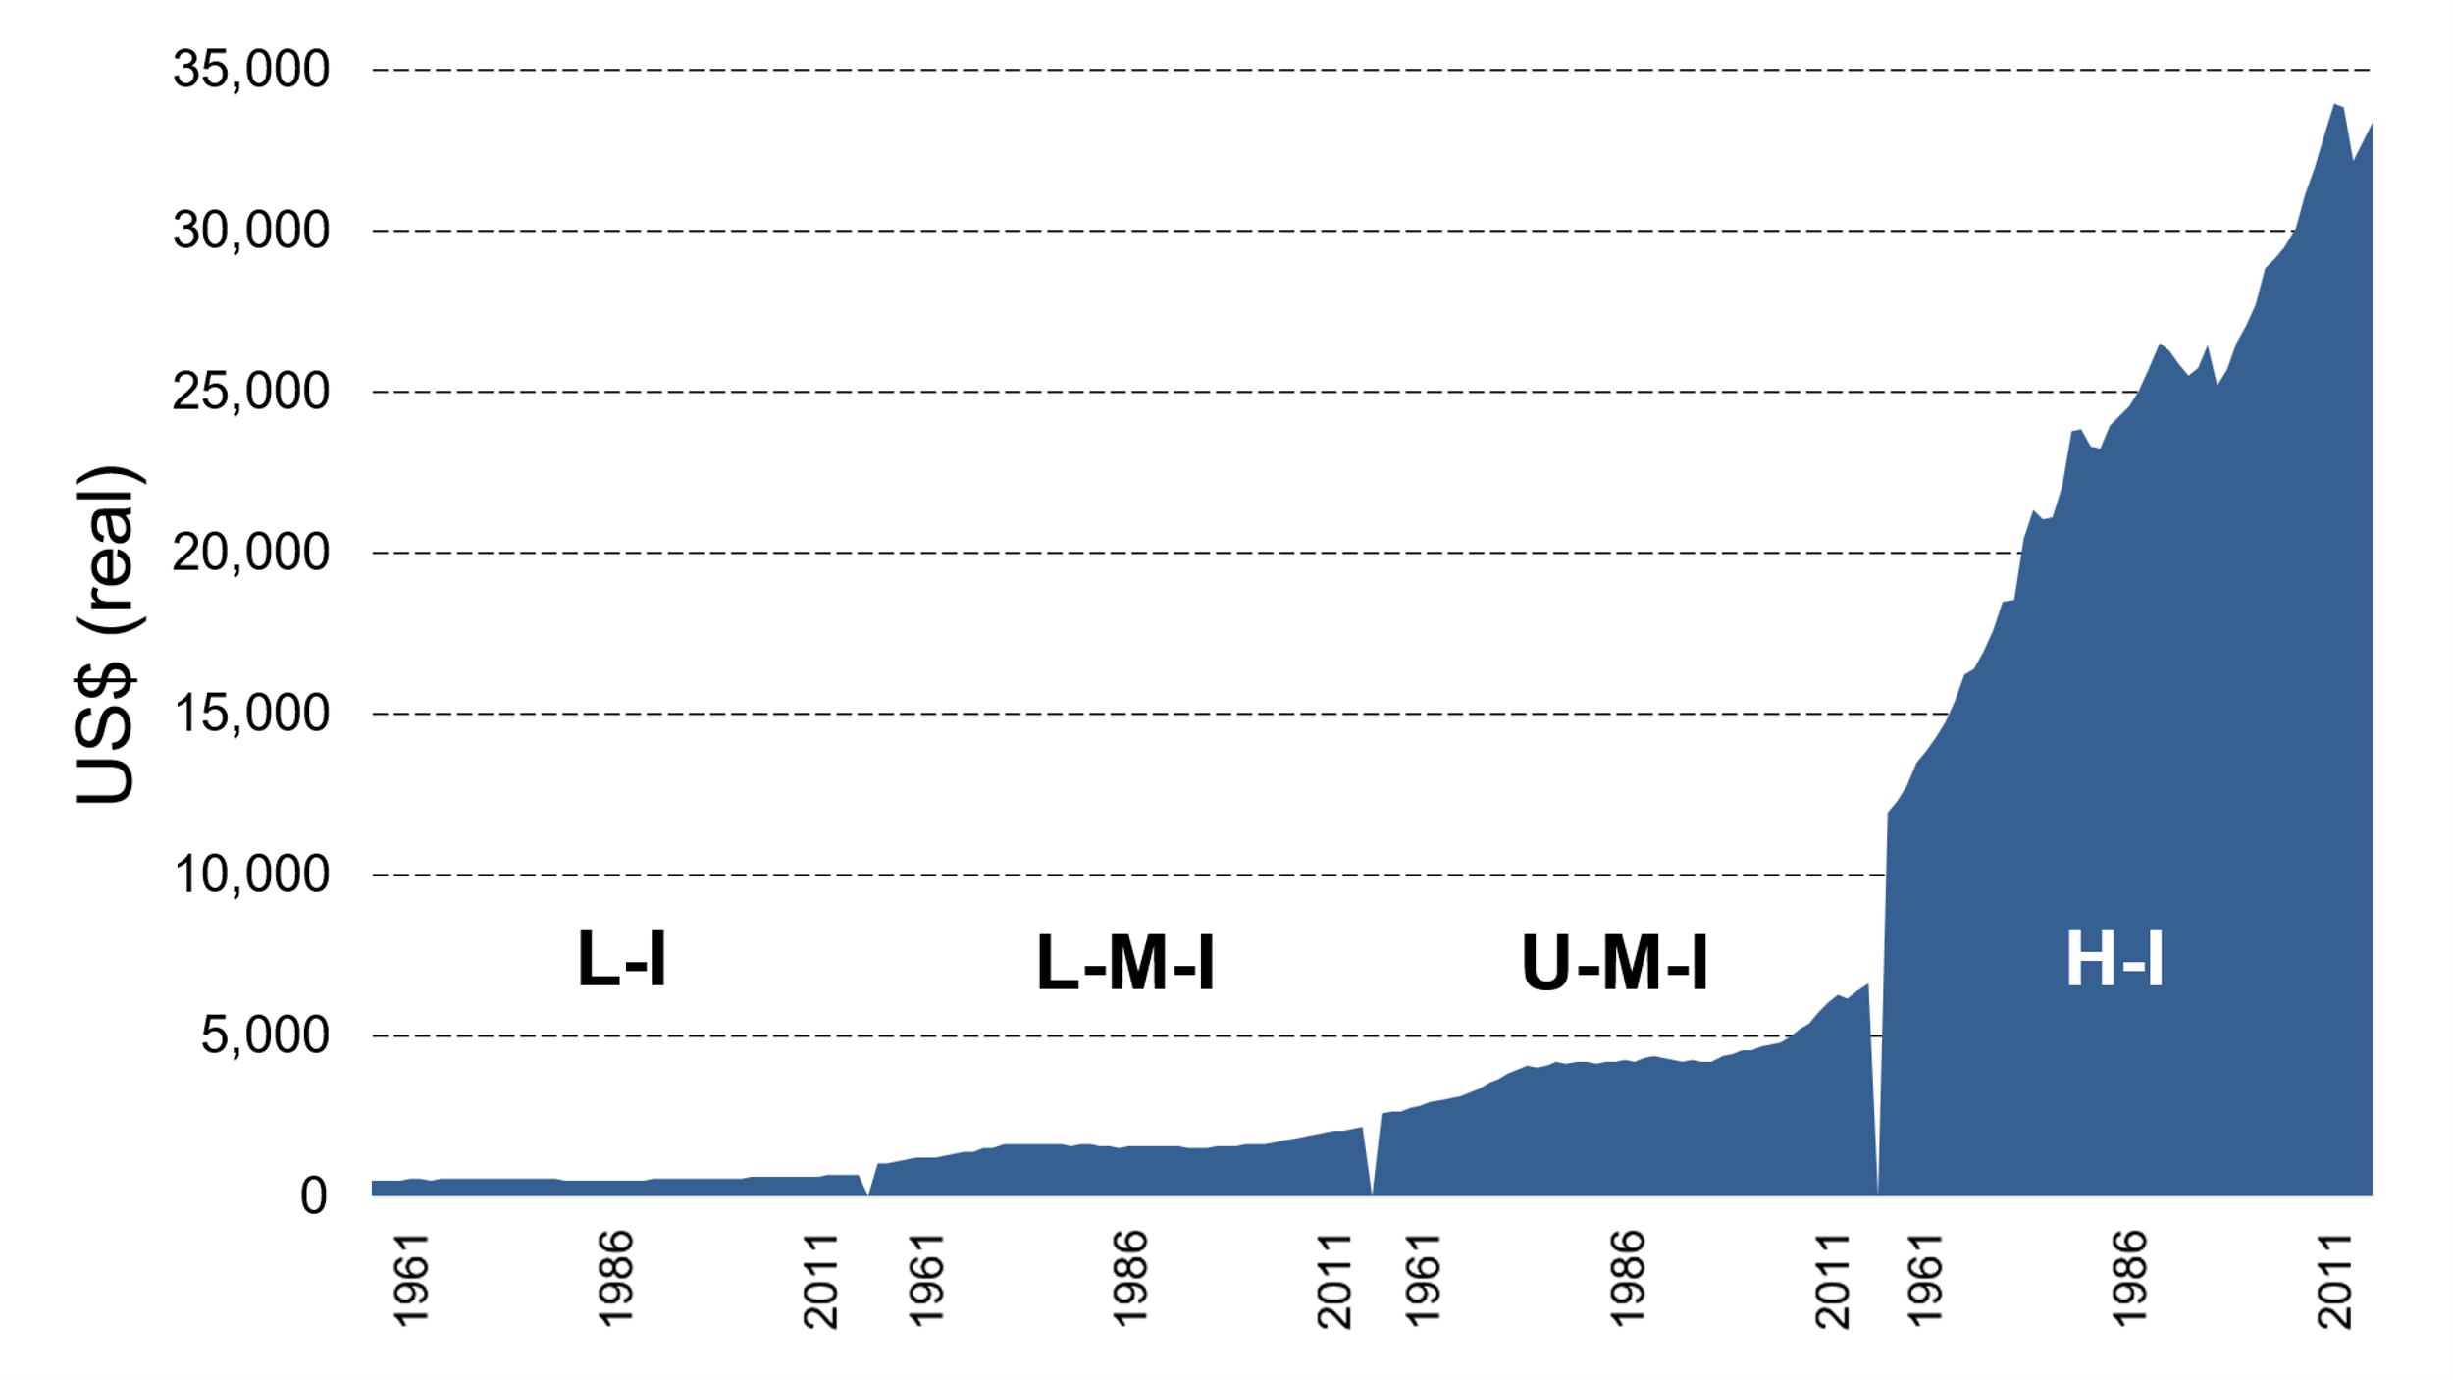
Extended Data Fig1. Per capita real GDP development 1961–2011 by income group. L-I > low income, L-M-I > lower-middle income, U-M-I > upper-middle-income and H-I > high-income. Source: World Bank.

