Fine and dynamic tuning the glycolytic flux ratio of an artificial carbon saving pathway for high yield of mevalonate in Escherichia coli
Ying Li^{1†}, He Xian^{3†}, Ya Xu¹, Yuan Zhu¹, Zhijie Sun^{2*}, Qian Wang^{1*}, Qingsheng Qi¹.

¹National Glycoengineering Research Center, State Key Laboratory of Microbial Technology, Shandong University, Qingdao, PR China
²Marine Biology Institute, Shantou University, Shantou, PR China
³School of Chemistry and Molecular Biosciences, Faculty of Science, The University of Queensland, Australia.

Supplementary figures and tables

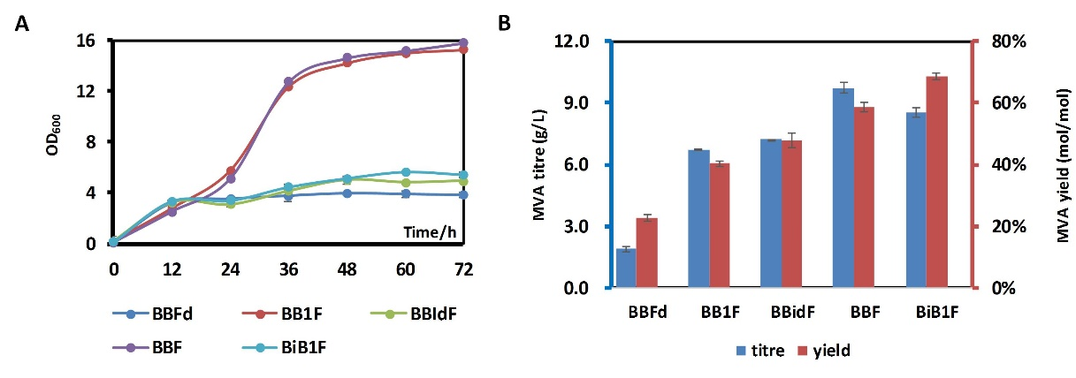
Figure S1 Fermentation of a series of CRISPRi-control strains.
A: OD₆₀₀ of CRISPRi-control strains. B: MVA titre and yield of CRISPRi-control strains
BB1F：BW25113 zwf-23100 pBSA pFF-dCas9,
BBFd：BW25113 zwf-23100 pBSA pFF-dCas9,
BB1dF：BW25113 zwf-23100 pBSA-sgRNA1-dCas9 pFF,
BBF：BW25113 zwf-23100 pBSA pFF,
BiB1F：BW25113 zwf-23100 pBSA-sgRNA1 pFF-dCas9.

Table S1 Primers used in this study.
Primer name | Sequence
homoarm-F | 5'-CGCGGTTGATGGCAGATTTAT-3'
homoarm-cm-R | 5'-AGACGTGTAATGCTGCAATCTCTGACACTGATCATGTTATG-3'
cm-23110-F | 5'-CATAACATGATCAGTGTCAGAGATTGCAGCATTACACGTCT-3'
23110-cm-R | 5'-GCGCGCAAAGTGCGGCAAAACTGATAAAAAAATCATCGTTTTCCATTGGGTAAAAACATGGGAATTAGCCATGGTCC-3'
23110-zwf-F1 | 5'-CACGGGTGGATAAGCGTTTGACGGCTAGCTCAGTCCTAGGTACAGTGCTAGCGTAAGAAAATTACAAGTATACCCTGGC-3'
23110-zwf-F2 | 5'-CGATGATTTTTTTATCAGTTTTGCCGCACTTTGCGCGCTTTTCCCGTAATCGCACGGGTGGATAAGCGTTTGAC-3'
zwf-R | 5'-GTTATTCACAAACAGGGAGTTAGC-3'
TESTp-F1 | 5'-AGAACTTATTCATCGCATCGTGG-3'
TESTp-R1 | 5'-CTCCTTAAGTTAACTAACCCGGTAC-3'
TESTp-F2 | 5'-CCGGTATCAACAGGGACACC-3'
TESTp-R2 | 5'-ATCAATGTCGACGCGGATCGC-3'
23104-zwf-F1 | 5'-CACGGGTGGATAAGCGTTTGACAGCTAGCTCAGTCCTAGGTATTGTGCTAGCGTAAGAAAATTACAAGTATACCCTGGC-3'
23105-zwf-F1 | 5'-CACGGGTGGATAAGCGTTTTACGGCTAGCTCAGTCCTAGGTACTATGCTAGCGTAAGAAAATTACAAGTATACCCTGGC-3'
23105-zwf-F2 | 5'-CGATGATTTTTTTATCAGTTTTGCCGCACTTTGCGCGCTTTTCCCGTAATCGCACGGGTGGATAAGCGTTTTAC-3'
23108-zwf-F1 | 5'-CACGGGTGGATAAGCGTCTGACAGCTAGCTCAGTCCTAGGTATAATGCTAGCGTAAGAAAATTACAAGTATACCCTGGC-3'
23108-zwf-F2 | 5'-CGATGATTTTTTTATCAGTTTTGCCGCACTTTGCGCGCTTTTCCCGTAATCGCACGGGTGGATAAGCGTCTGAC-3'
23114-zwf-F1 | 5'-CACGGGTGGATAAGCGTTTTATGGCTAGCTCAGTCCTAGGTACAATGCTAGCGTAAGAAAATTACAAGTATACCCTGGC-3'
23114-zwf-F2 | 5'-CGATGATTTTTTTATCAGTTTTGCCGCACTTTGCGCGCTTTTCCCGTAATCGCACGGGTGGATAAGCGTTTTAT-3'
CUT-sGFP-F | 5'-ACCATGGAATTCGAGCTCGGTACCCGGTTACGCCGCCAGCGCATAG-3'
23110-sGFP-R | 5'-TGAAAATCTTCTCTCATCCGCCAAAACAGCCTTGACGGCTAGCTCAGTCCTAGG-3'
23104-sGFP-R | 5'-TGAAAATCTTCTCTCATCCGCCAAAACAGCCTTGACAGCTAGCTCAGTCCTAGG-3'
23105-sGFP-R | 5'-TGAAAATCTTCTCTCATCCGCCAAAACAGCCTTTACGGCTAGCTCAGTCCTAGG-3'
23108-sGFP-R | 5'-TGAAAATCTTCTCTCATCCGCCAAAACAGCCCTGACAGCTAGCTCAGTCCTAGG-3'
23114-sGFP-R | 5'-TGAAAATCTTCTCTCATCCGCCAAAACAGCCTTTATGGCTAGCTCAGTCCTAGG-3'
zwf O -sGFP-R2 | 5'-TTCGCAAGCTCGTAAAAGCAGTACAGTGCACCACTAGTGATTAAAGAGGAGAAATACTAG -3'
PCR-vector-F | 5'-GGCTGTTTTGGCGGATGAGAGAAGATTTTCA-3'
PCR-vector-R | 5'-CCGGGTACCGAGCTCGAATTCCATGGT-3'
GFP-test-F | 5'-TCATCGACTGCACGGTGCAC-3'
GFP-test-R | 5'-TGCCTGGCAGTTCCCTACTCT-3'
PKD3-cm-F | 5'-TTGAGCGATTGTGTAGGCTGGAGCTGCTTC-3'
PKD3-cm-R | 5'-CATATGAATATCCTCCTTAGTTCCTATTCC-3'
pcr-23118-F | 5'-TTGACGGCTAGCTCAGTCCTAGGTATTGTGCTAGCTGTGGAATTGTGAGCGGATAACAATTTCAC-3'
pcr-23118-R | 5'-GCTAGCACAATACCTAGGACTGAGCTAGCCGTCAACAGCTCATTTCAGAATATTTGCCAGAACC-3'
pcr-23102-F | 5'-TTGACAGCTAGCTCAGTCCTAGGTACTGTGCTAGCTGTGGAATTGTGAGCGGATAACAATTTCAC-3'
pcr-23102-R | 5'-GCTAGCACAGTACCTAGGACTGAGCTAGCTGTCAACAGCTCATTTCAGAATATTTGCCAGAACC-3'
pcr-23104-F | 5'-TTGACAGCTAGCTCAGTCCTAGGTATTGTGCTAGCTGTGGAATTGTGAGCGGATAACAATTTCAC-3'
pcr-23104-R | 5'-GCTAGCACAATACCTAGGACTGAGCTAGCTGTCAACAGCTCATTTCAGAATATTTGCCAGAACC-3'
pcr-23100-F | 5'-TTGACGGCTAGCTCAGTCCTAGGTACAGTGCTAGCTGTGGAATTGTGAGCGGATAACAATTTCAC-3'
pcr-23100-R | 5'-GCTAGCACTGTACCTAGGACTGAGCTAGCCGTCAACAGCTCATTTCAGAATATTTGCCAGAACCG-3'
pcr-23119-F | 5'-TTGACAGCTAGCTCAGTCCTAGGTATAATGCTAGCTGTGGAATTGTGAGCGGATAACAATTTC-3'
pcr-23119-R | 5'-GCTAGCATTATACCTAGGACTGAGCTAGCTGTCAACAGCTCATTTCAGAATATTTGCCAGAACC-3'
dCas9FF-F | 5'-CCGTAGCGCCGATGGTAGTGTGGGGTCTCCCCATGCGAGAGTAGGG-3'
dCas9FF-R | 5'-TTATCCGCTCACAATTCCACAGCTAGCATTGTACCAAGGGCTGAGCTAGCTATAAACGTTTCACTTCTGAGTTCGGCAT-3'
dCas9-F | 5'-AGCTGTGGAATTGTGAGCGGATAACAATTTCACACAGGAAACAGACATGGATAAGAAATACTCAATAGGCTTAGCTATC-3'
dCas9-R | 5'-CCCCACACTACCATCGGCGCTACGGTCAGTCACCTCCTAGCTGACTC-3'
sgRNA-F1 | 5'-AGGCTAGTCCGTTATCAACTTGAAAAAGTGGCACCGAGTCGGTGCTTTTTTTGGAGCAGGACGCCCGCCATAAAC-3'
sgRNA-F2 | 5'-GTTTTAGAGCTAGAAATAGCAAGTTAAAATAAGGCTAGTCCGTTATCAACTTG-3'
sgRNA-R | 5'-CCGTTGGCTAGCATTATACCTAGGACTGAGCTAGCTGTCAGCTTCGCAACGTTCAAATCCG-3'
sgRNA3-R | 5'-CTAGCCTTATTTTAACTTGCTATTTCTAGCTCTAAAACTATGGTACAGCTAGACCGTTCCGTTGGCTAGCATTATACCT-3'
sgRNA2-R | 5'-CTAGCCTTATTTTAACTTGCTATTTCTAGCTCTAAAACCAATTCGCGGGGTTGTTCGTCCGTTGGCTAGCATTATACCT-3'
sgRNA1-R | 5'-CTAGCCTTATTTTAACTTGCTATTTCTAGCTCTAAAACAAGTTCAGAGGTAGTCATGACCGTTGGCTAGCATTATACCT-3'
BSA-sgRNA-test-F | 5'-GAAGTGAAACGCCGTAGCGC-3'
FF-dCas9-test-F | 5'-CTCTACCCAAGCACCGCCAG-3'
test-sgRNA-R | 5'-GTCGGCAACGACCATATGGTTG-3'
test-sgRNA-F | 5'-GCAGTGTGACCGTGTGCTTC-3'

