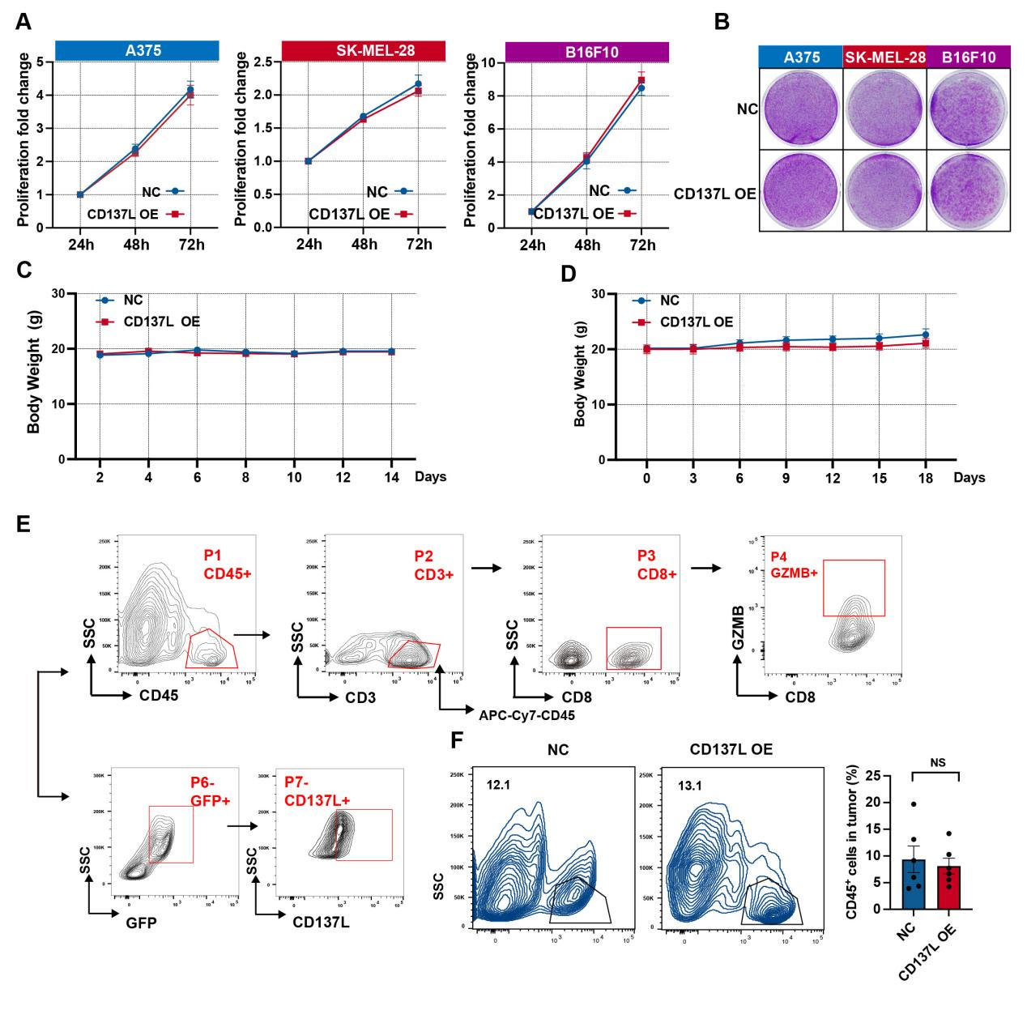Figure S1. (related to Figure 2) Overexpression of CD137L in tumor cells did not affect in vitro cell growth and flow of flow-cytometer assay analysis .
（A） Overexpression CD137L in A375, SK-MEL-28, and B16F10 cells and checked the cell growth by MTT assay. Data represent mean ± SD. n = 3. (B) Representative images showing the long-term effect on cell growth of exogenous cell lines with stable expression CD137L were evaluated by clone formation assay and subjected to crystal violet staining. (C) B16F10 cells with CD137L stable expression and negative control cells were injected into BALB/c nude mice (n = 6 mice per group) on day 0, Body weight was measured on the indicated time points, and Data represent mean±SD. (D) B16F10 cells with CD137L stable expression and negative control cells were injected into C57BL/6 mice (n = 6 mice per group) on day 0, Body weight was measured on the indicated time points, and Data represent mean±SD. (E) Flow cytometry analysis flow of immune cells in mouse tumors. CD137L+ cells, CD45+ cells, CD3+ T cells , CD8+ T cells, and GZMB+CD8+ T cells were analyzed in mouse tumors by flow cytometry. (F)The CD137L stably expressed B16F10 cells were injected into C57BL/6 immunocompetent mice, CD137L+ cells were analyzed by flow cytometry. ^{NS}p > 0.05.

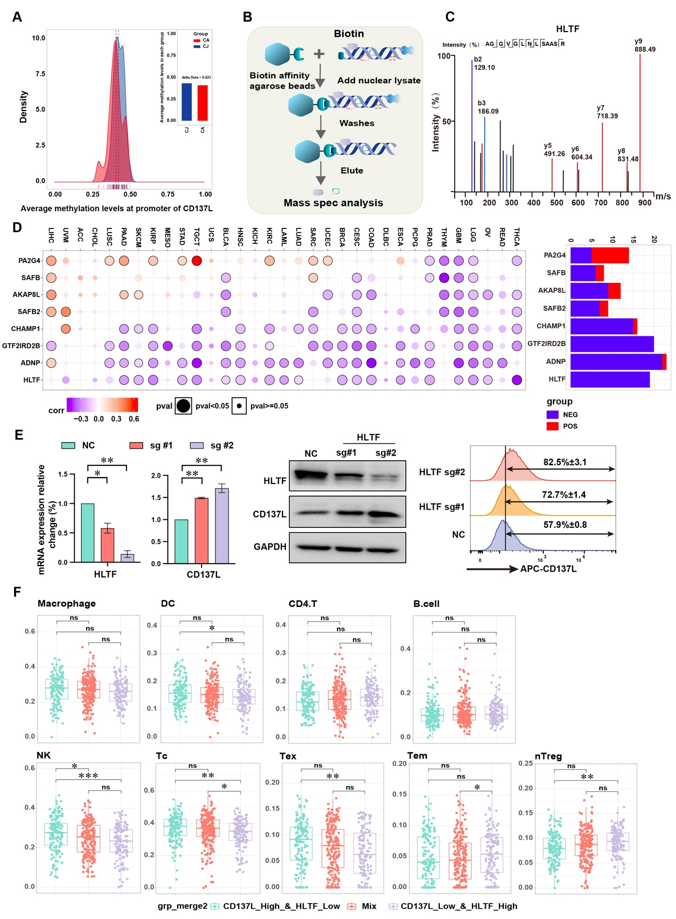

Figure S2. (related to Figure 3) HLTF control the CTL activity to anti-tumor in vivo and in vitro. (A) No significant difference of average DNA methylation level at promoter of CD137L between tumor and normal samples. Density plot showed the distribution of average DNA methylation level at promoter. Bar plot showed the average average DNA methylation level in two groups. Wilcoxon rank sum test was performed. (B) Schematic of the DNA-pull Down reaction used for the detection of CD137L promoter binding proteins. (C) Secondary mass spectral profile of the HLTF in the bands for LSC/MS analysis. (D) Expression level of CD137L in melanoma using single cell transcriptomic data. The annotation of each cell cluster, and expression levels of CD137Lin different cell types were shown using VlnPlot. (E) mRNA level of HLTF and CD137L with different sgRNA mediated knockout HLTF in A375 cells, Data represent mean ± SD. The protein level of HLTF and CD137L in sgRNA knockout HLTF cells. GAPDH sever as the loading control. The Membrane CD137L expression by flow cytometric analysis after sgRNA knockout HLTF, Data represent mean ± SD. (F) Boxplots represent the infiltration of immune cells across different groups. Samples were divided into two groups based on the gene expression of HLTF or CD137L. Wilcoxon rank-sum test were performed. ^{NS}p > 0.05 ,*p < 0.05,**p < 0.01, ***p < 0.001.

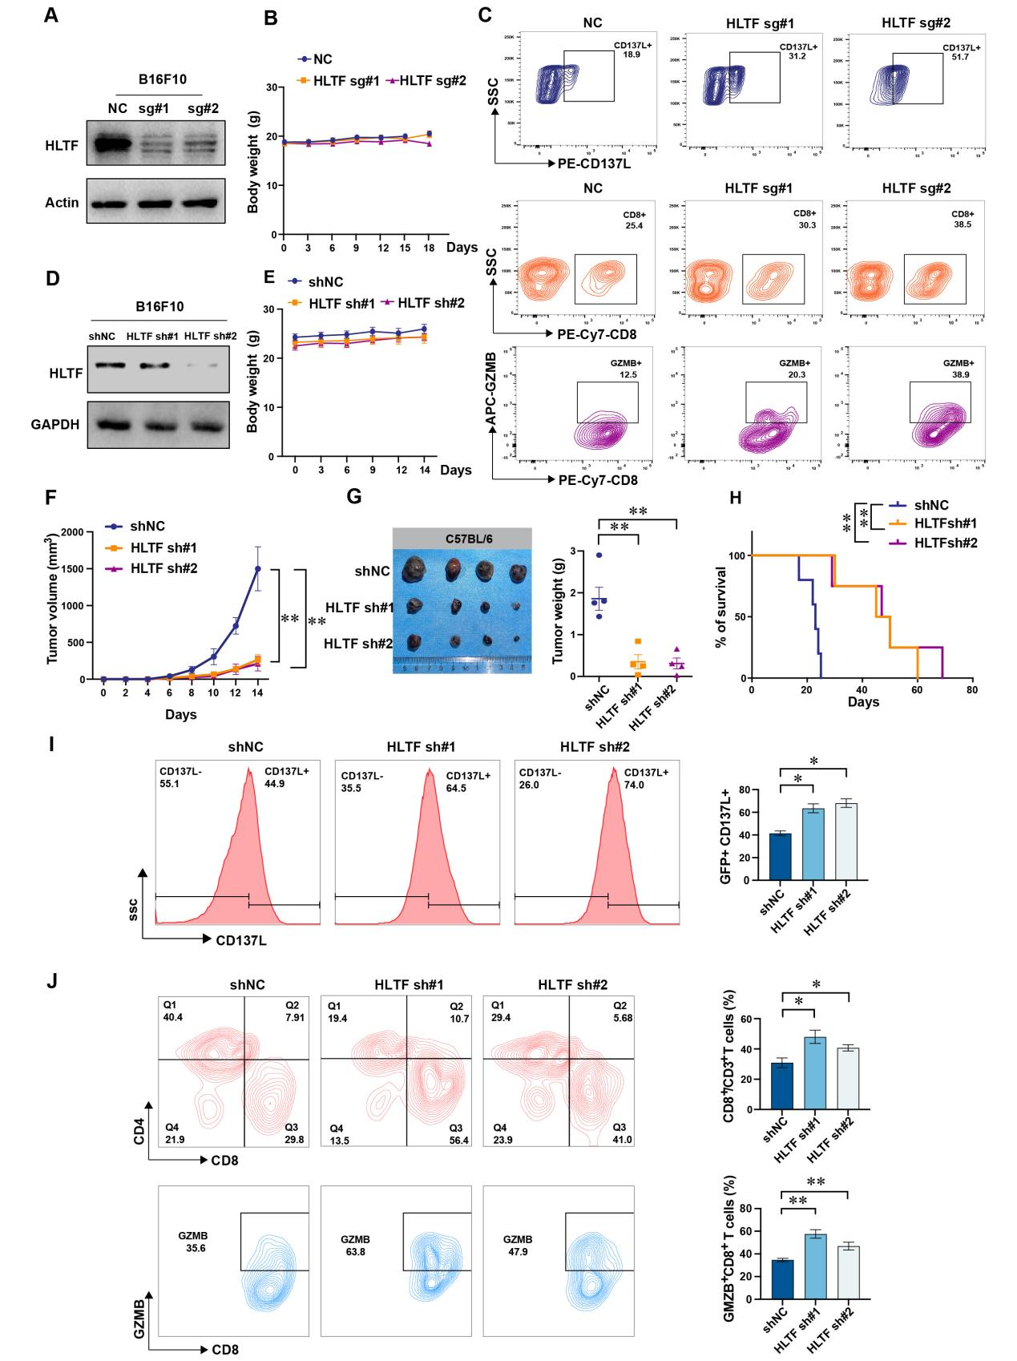
Figure S3. (related to Figure 3) Knockdown HLTF enhance the CTL activity to anti-tumor in vivo.
(A) The representative Western Blotting for CRISPR/Cas9 mediated HLTF knockout and shRNA mediated HLTF knockdwon, in B16F10 cells. (B) HLTF knockout B16F10 cells were implanted in C57BL/6 mice. Body weight was measured in indicated time points. (C) Representative flow staining of CD45⁻ CD137L⁺ cells, CD3⁺ CD8 ⁺ T cells and CD8⁺GZMB⁺ T cells in tumor xenograft of indicated groups Data represent mean ± SD. (D) The representative Western Blotting for CRISPR/Cas9 mediated HLTF knockout and shRNA mediated HLTF knockdwon, in B16F10 cells. . (E) shRNA knockdown HLTF and control cells were implanted in C57BL/6 mice. Body weight was measured on indicated time points. （F）The tumor volume was measured on indicated time points. Data represent mean ± SD. （G） Representative images of the endpoint tumors in C57BL/6 mice. Tumor weight plotted as means ± SD. (n= 4 per group), Data represent mean ± SD. (H) Kaplan–Meier survival curves for the survival of mice bearing HLTF knockdown by different shRNA or NC tumors. Significance was determined by the log-rank test (n = 5 mice per group). (I) Representative flow staining (left panel) and frequency (right panel) of CD45- CD137L+ cells in tumor xenograft of indicated groups. (J) Representative images of flow staining (left panel) and frequency (right panel) of CD45+CD3+ CD8+ and GZMB+ CD8+ cells in tumor xenograft of indicated groups. Data represent mean ± SD . *p < 0.05; **p < 0.01

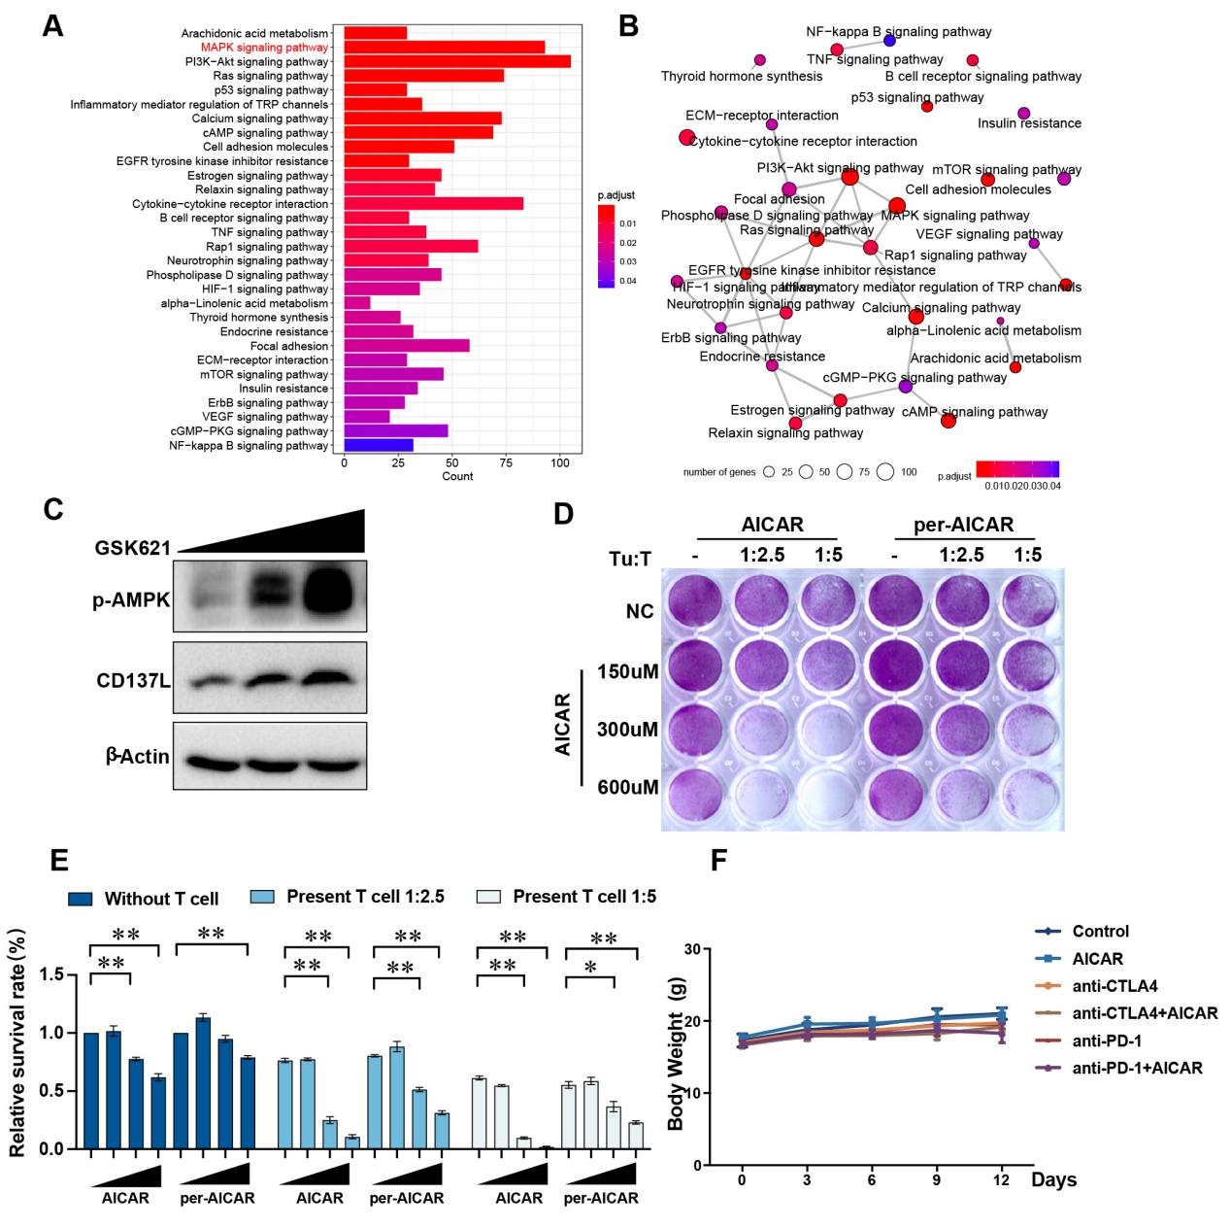
Figure S4. (related to Figure 4) RNA-seq analysis of AICAR-treated cells and the effect of AMPK agonists on CD137L and T-cell killing.
(A) Function enrichment analysis revealed downstream pathway of AMPK using differential expressed genes between tumor cellline treated with and without AICAR. Color represent the significance level (BH-adjusted p<0.05). (B) Network visualization of enriched pathways genrated with considering term similarity by R package clusterProfiler. (C) The A375 cells were treated with different dosages of AMPK agonist GSK621 (10 to 20 μM) for 24 hr, then the CD137L and p-AMPK were detected by western blotting. GAPDH server as the loading control. (D-E) A375 cells co-cultured with activated T cells with or without AICAR (0.1-0.5 mM) for 24 hr, or per-treated AICAR (0.1-0.5 mM) for 24 hr, then change to the fresh medium co-cultered with acitivated T cells were subjected to crystal violet staining. A375 cells to T- cell ratio, 1:2.5. n = 3 independent experiments. Data represent mean ± SD. (*p < 0.05; **p < 0.01), Student’s t test. (F) Body weight of mice bearing tumors treated with control, AICAR, anti-CTLA4, and anti-PD-1 or the combination.

