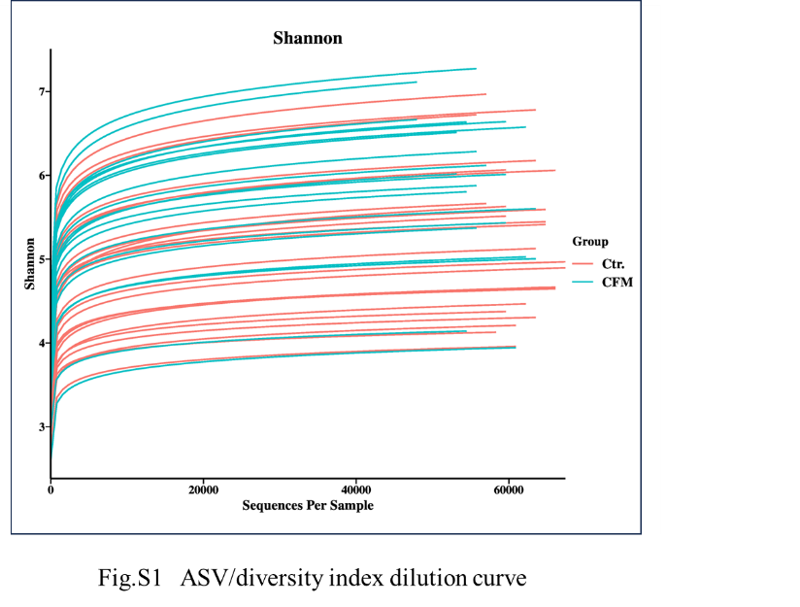
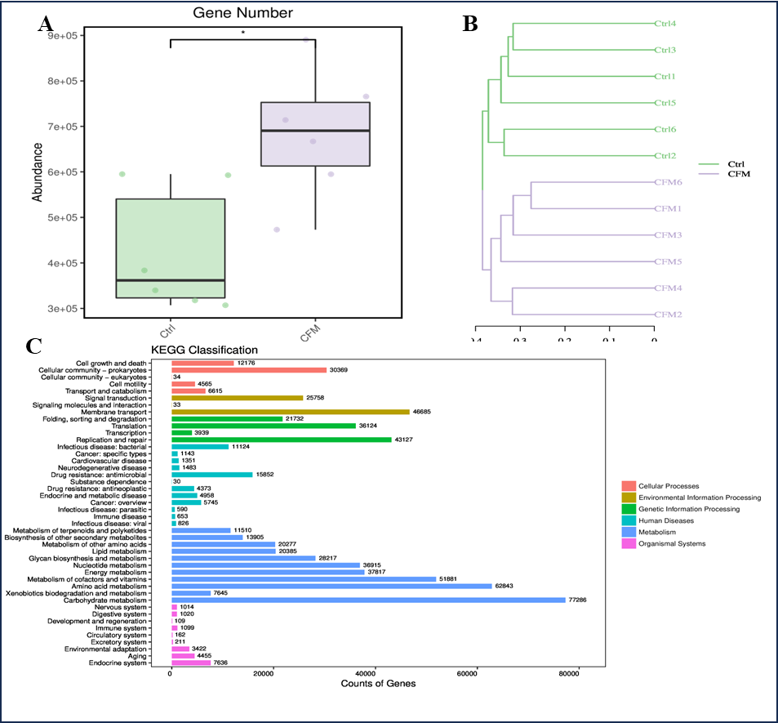
Fig.S2 A Boxplot of the gene number between group CFM and Ctrl. B Cluster diagram of sample similarity. C Statistics of the number of annotated genes based on the KEGG database.

