Supplementary materials
Genomic subtypes and cellular phenotypes of high-grade endometrial carcinoma

Supplementary figures
Supplementary results and discussion

Supplementary Figures

Figure S1
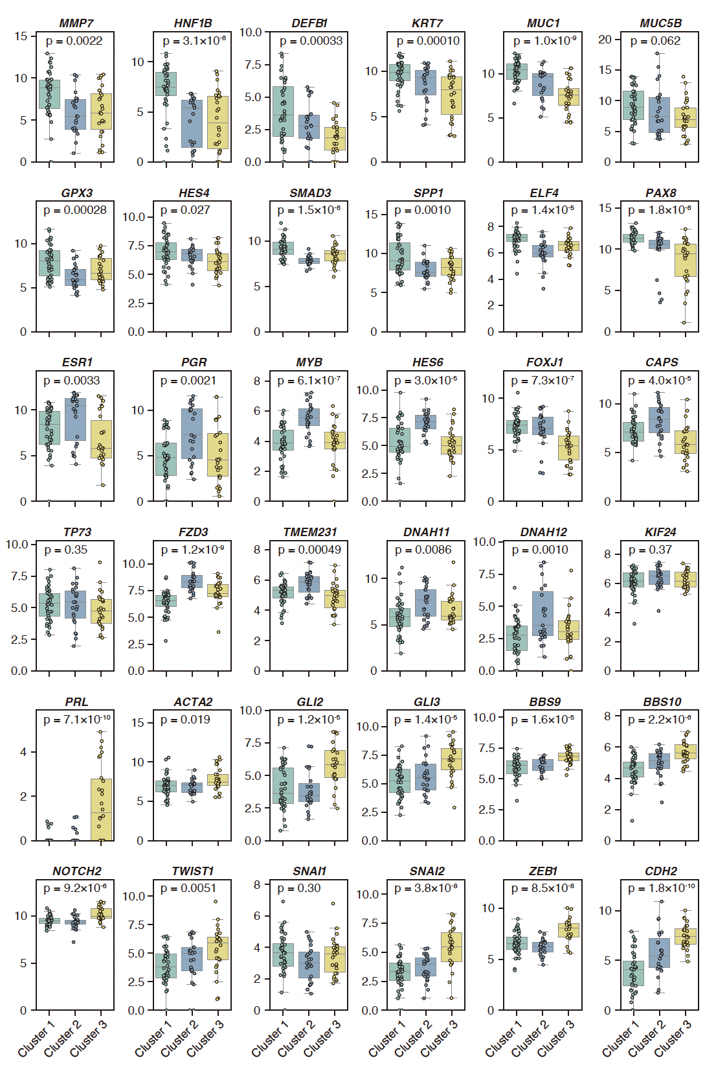
Figure S1. Gene expression profiles across different RNA clusters in this study cohort
Box plots showing the expression levels of various genes across different RNA clusters in this study cohort. The y-axis represents the log₂(normalized count + 1) of gene expression. Analysis of variance p-values are provided.
Figure S2
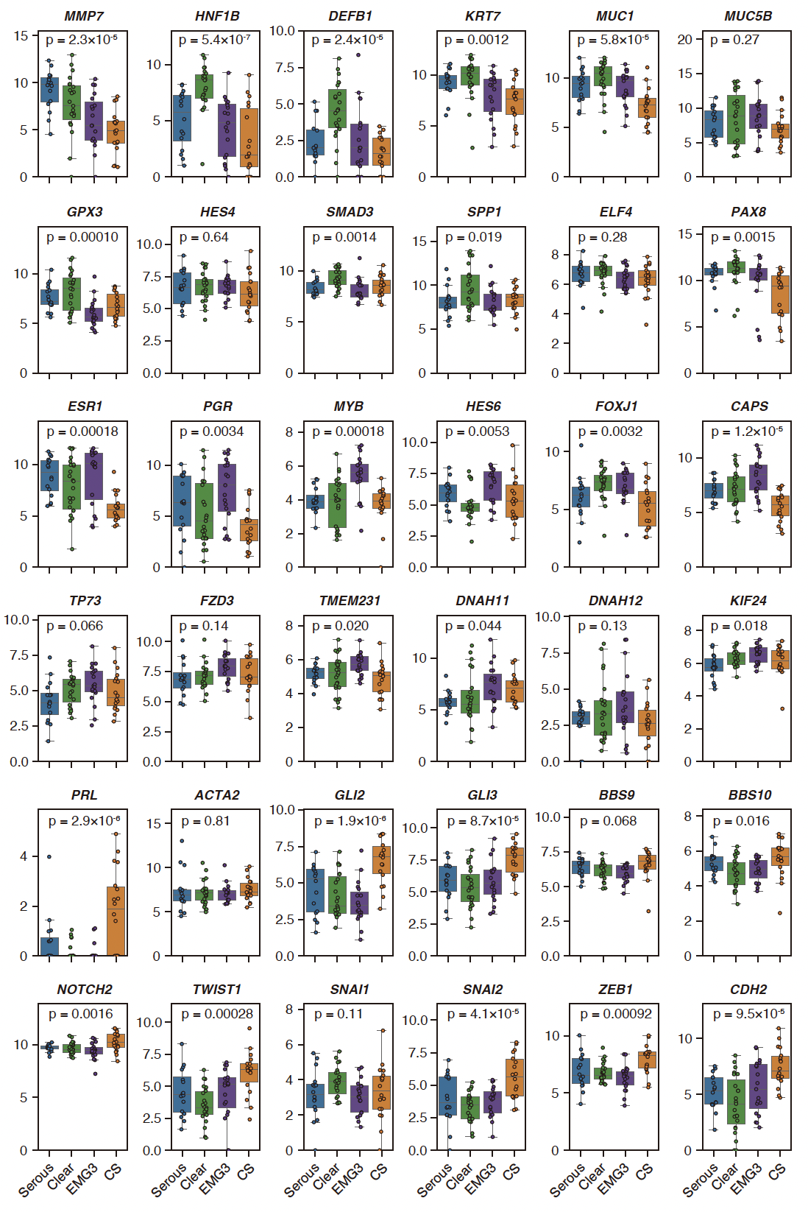
Figure S2. Gene expression profiles across different histological classifications in this study cohort
Box plots showing the expression levels of various genes across different histological classifications in this study cohort. The y-axis represents the log₂(normalized count + 1) of gene expression. Analysis of variance p-values are provided. EMG3, grade 3 endometroid; CS, carcinosarcoma.
Figure S3
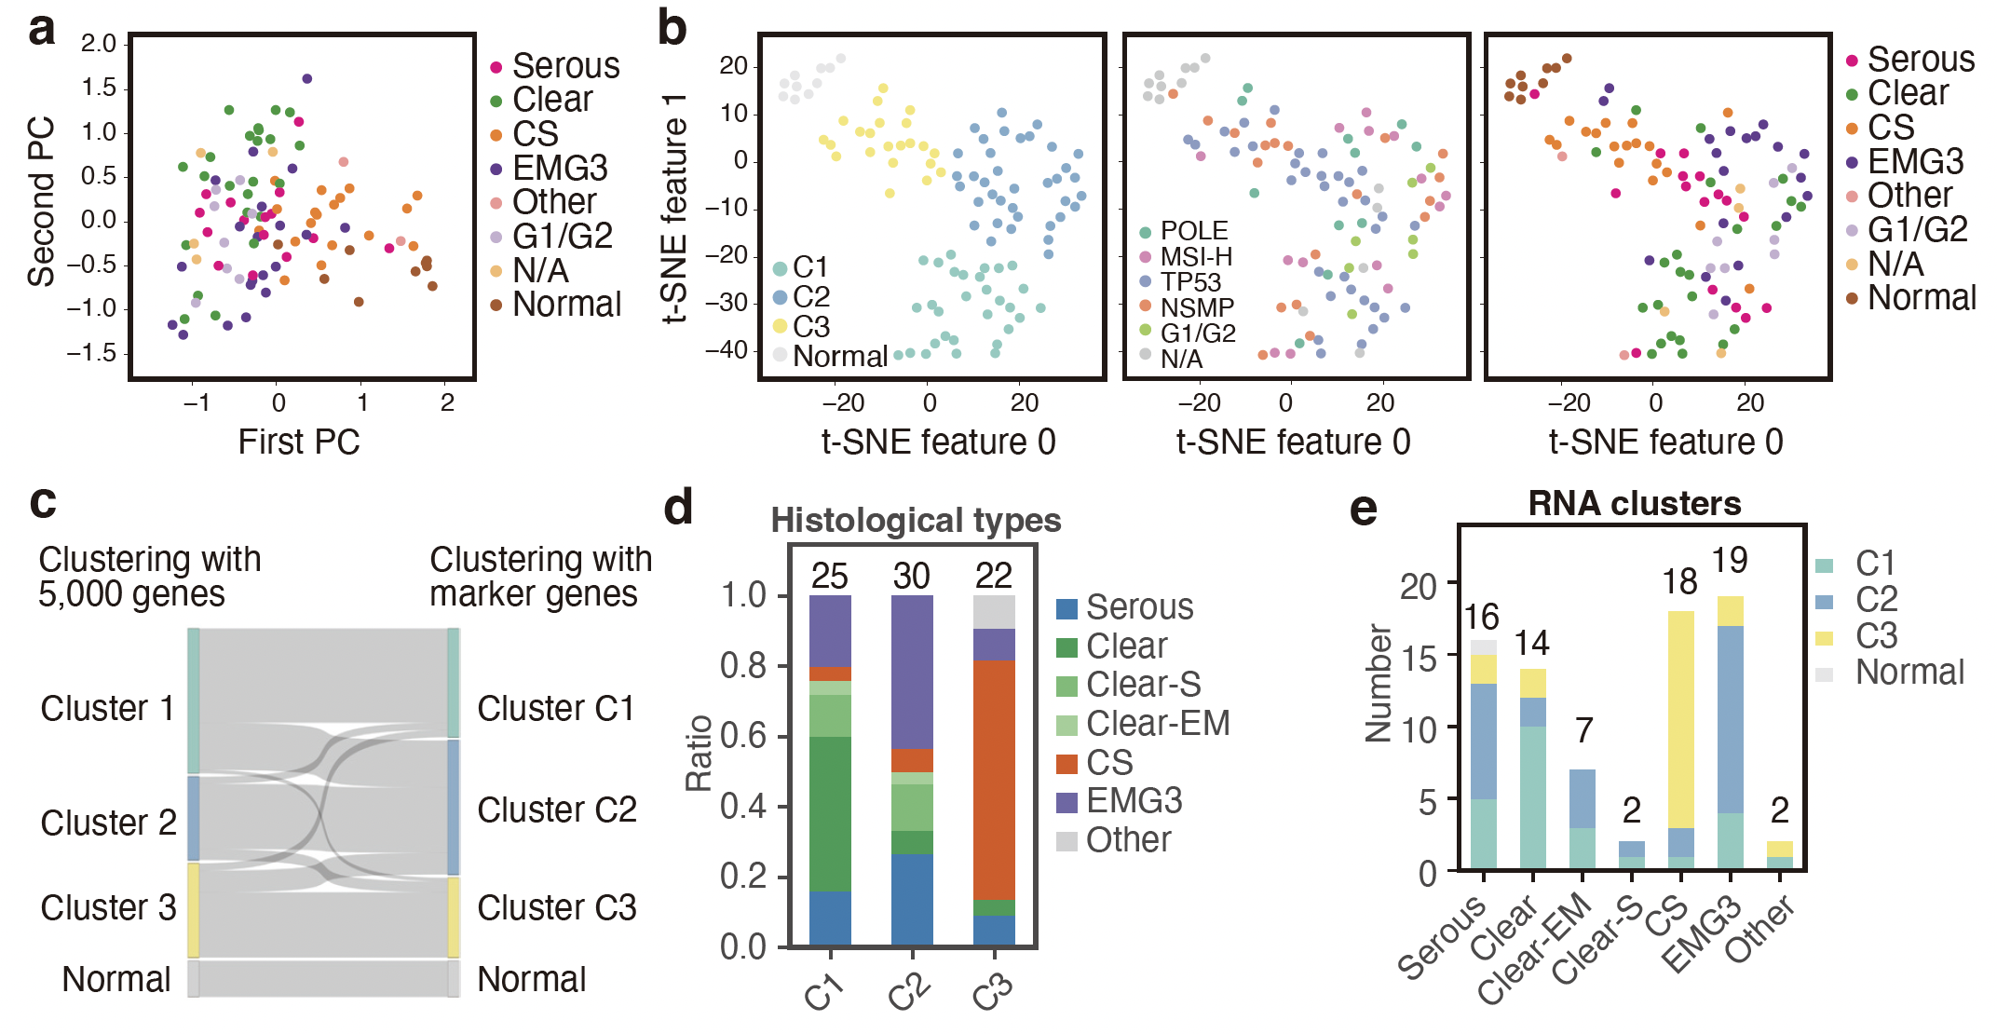
Figure S3. Clustering analysis based on expression profiles of selected genes
a: Principal component analysis plot showing the distribution of samples based on selected gene expression profiles, with each color indicating a different histological type.
b: The left t-SNE plot shows the results of hierarchical clustering, indicating RNA cluster classifications. The middle t-SNE plot shows the distribution of samples across different genomic subtypes. The right t-SNE plot shows the distribution of samples across different histological types.
c: Sankey diagram illustrating the relationship between RNA clusters as described in the text (Cluster 1, Cluster 2, Cluster 3, Normal) and RNA clusters identified in this supplementary figure (C1, C2, C3, Normal) based on selected genes.
d: Bar plots showing the distribution of histological types across RNA clusters (C1, C2, C3, Normal).
e: Bar plots showing the number of samples of each histological type (right) across RNA clusters (C1, C2, C3, Normal).
Clear-EM, clear cell carcinoma mixed with endometrioid endometrial carcinoma; Clear-S, clear cell carcinoma mixed with serous carcinoma; CS, carcinosarcoma; EMG3, grade 3 endometroid; G1/G2, grade 1–2 endometroid; MSI-H, microsatellite instability–high; N/A, not available; PC, principal component; t-SNE, t-distributed stochastic neighbor embedding.

Figure S4
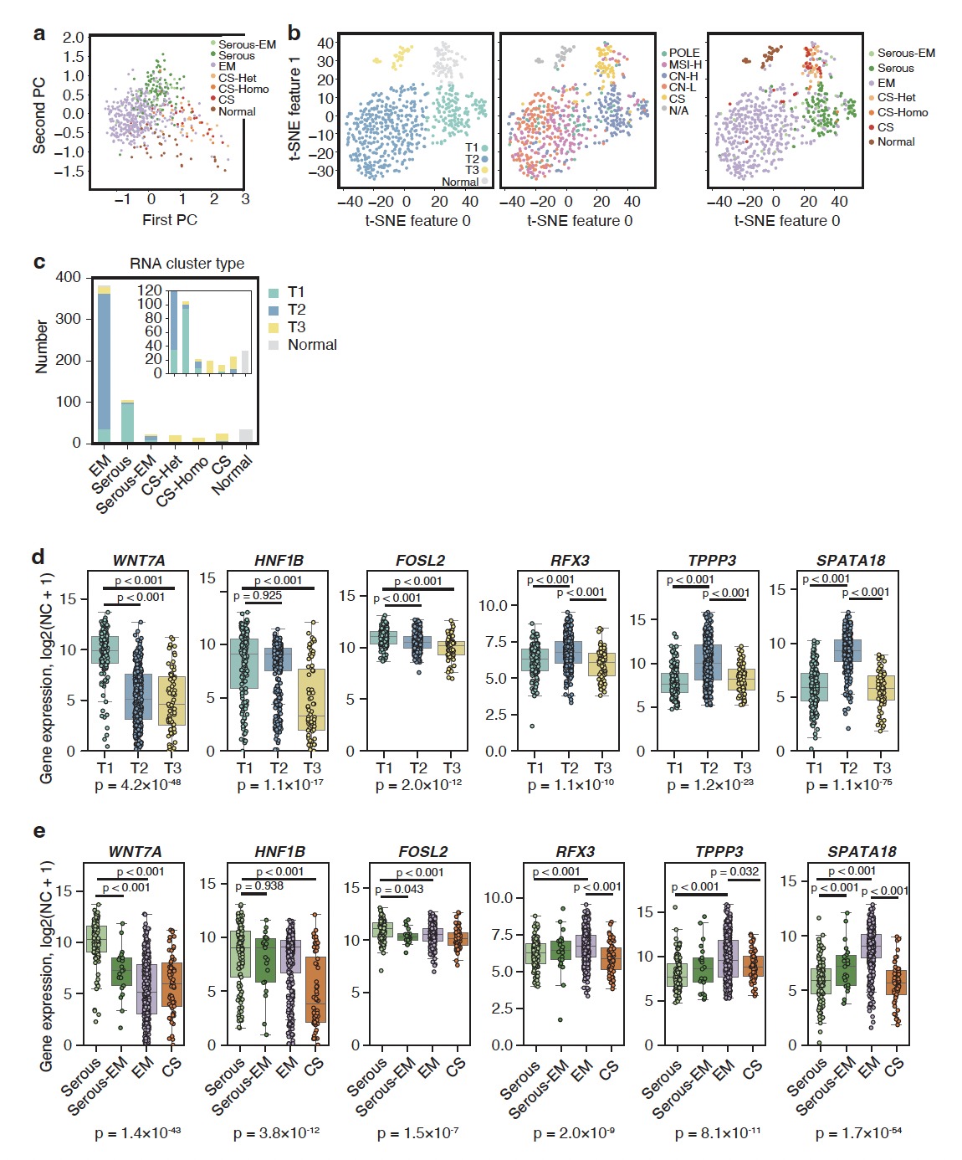
Figure S4. Clustering analysis based on gene expression in the TCGA dataset
a: Principal component analysis plot showing the distribution of samples in the TCGA dataset based on gene expression profile.
b: The left t-SNE plot shows the results of spectral clustering, indicating the RNA cluster classification in the TCGA dataset (T1, T2, T3, Normal). The middle t-SNE plot shows the distribution of samples across different genomic subtypes. The right t-SNE plot shows the distribution of samples across different histological types.
c: Bar plots showing the number of samples of each histological type across RNA clusters (T1, T2, T3, Normal). The inset plot adjusts the y-axis to highlight areas with smaller values, making it easier to visualize the differences in the distribution of histological types with fewer samples.
d: Box plots showing the expression levels of representative genes across different RNA clusters (T1, T2, T3) in the TCGA dataset. The y-axis represents the log2(normalized count + 1) of gene expression. P-values are provided for comparisons using ANOVA followed by Tukey’s post hoc analysis.
e: Box plots showing the expression levels of representative genes across different histological subtypes in the TCGA dataset limited to endometroid carcinoma. The y-axis represents the log₂(normalized count + 1) of gene expression. P-values are provided for comparisons using ANOVA followed by Tukey’s post hoc analysis.
ANOVA, analysis of variance; Clear-EM, clear cell carcinoma mixed with endometrioid endometrial carcinoma; Clear-S, clear cell carcinoma mixed with serous carcinoma; CS, carcinosarcoma; EMG3, grade 3 endometroid; G1/G2, grade 1–2 endometroid; MSI-H, microsatellite instability–high; N/A, not available; PC, principal component; TCGA, The Cancer Genome Atlas program; t-SNE, t-distributed stochastic neighbor embedding.
Figure S5
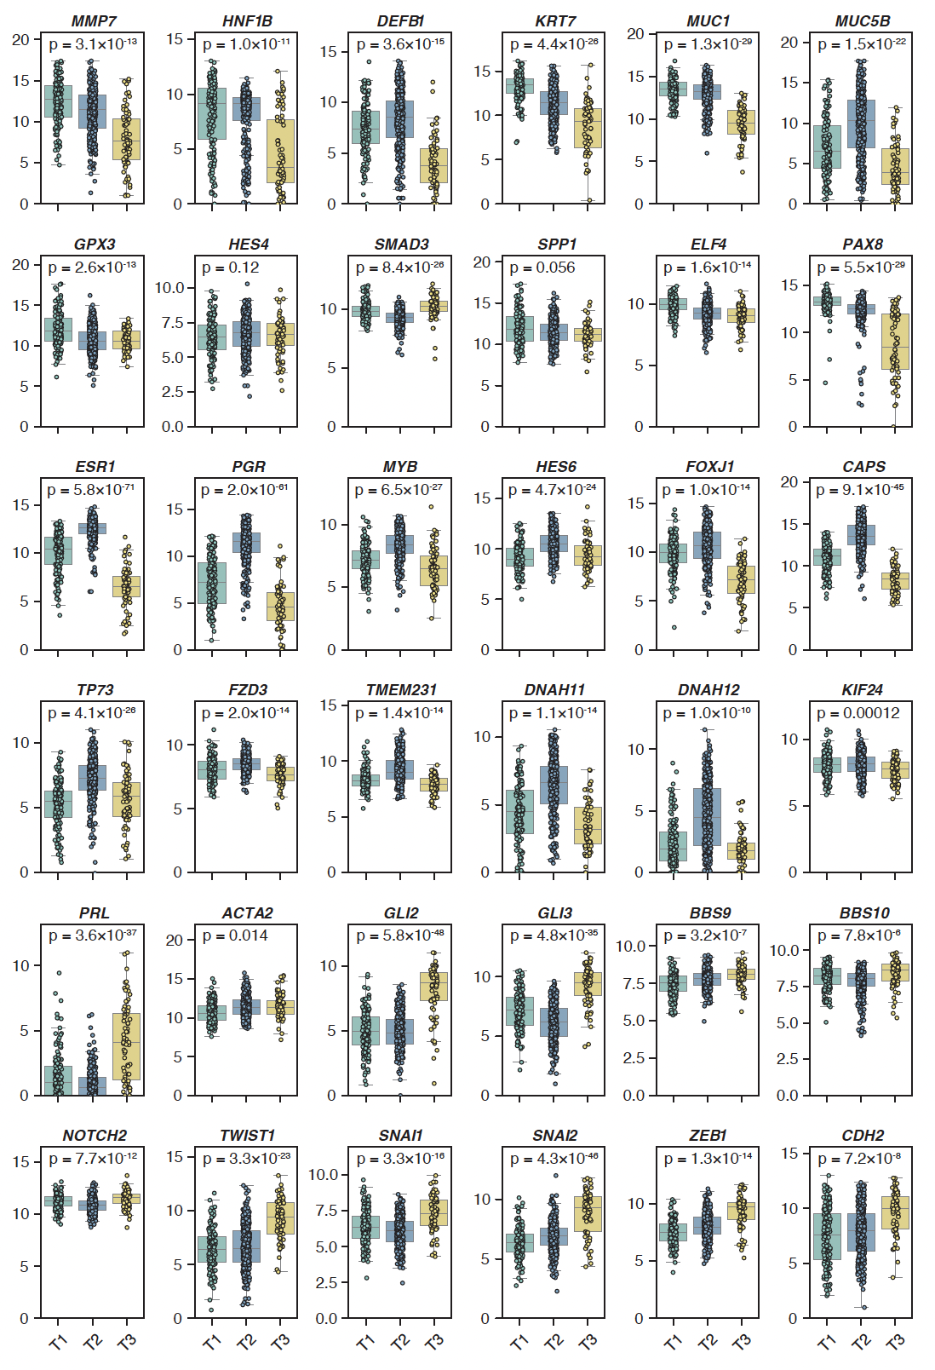
Figure S5. Gene expression profiles across different RNA clusters in The Cancer Genome Atlas Program dataset
Box plots showing the expression levels of various genes across different RNA clusters in The Cancer Genome Atlas Program dataset. The y-axis represents the log₂(normalized count + 1) of gene expression. Analysis of variance p-values are provided.

Figure S6
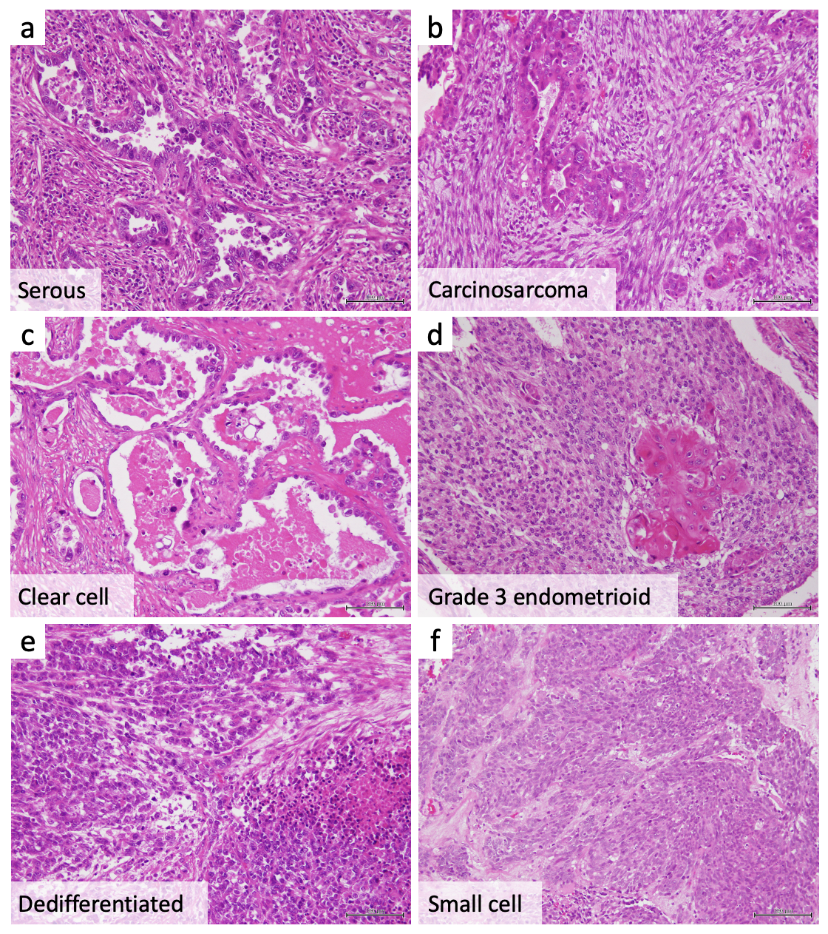
Figure S6. Histology of high-grade endometrial carcinomas
a: Serous carcinoma. Tumor cells with marked nuclear atypia have irregularly shaped glands.
b: Carcinosarcoma. Both high-grade adenocarcinoma components resembling serous carcinoma and sarcomatous components composed of pleomorphic spindle cells are observed.
c: Clear cell carcinoma. Cuboidal tumor cells with clear to eosinophilic cytoplasm have a tubulocystic pattern and papillary structures.
d: Grade 3 endometrioid carcinoma. Solid tumor nests with focal squamous differentiation are observed.
e: Dedifferentiated carcinoma. Undifferentiated carcinoma components are composed of monotonous discohesive tumor cells.
f: Small cell carcinoma. Tumor cells with enlarged nuclei are arranged in solid nests. These tumor cells express neuroendocrine markers.
(a–f, hematoxylin and eosin stain, ×200, scale bars indicate 100 μm)

Figure S7
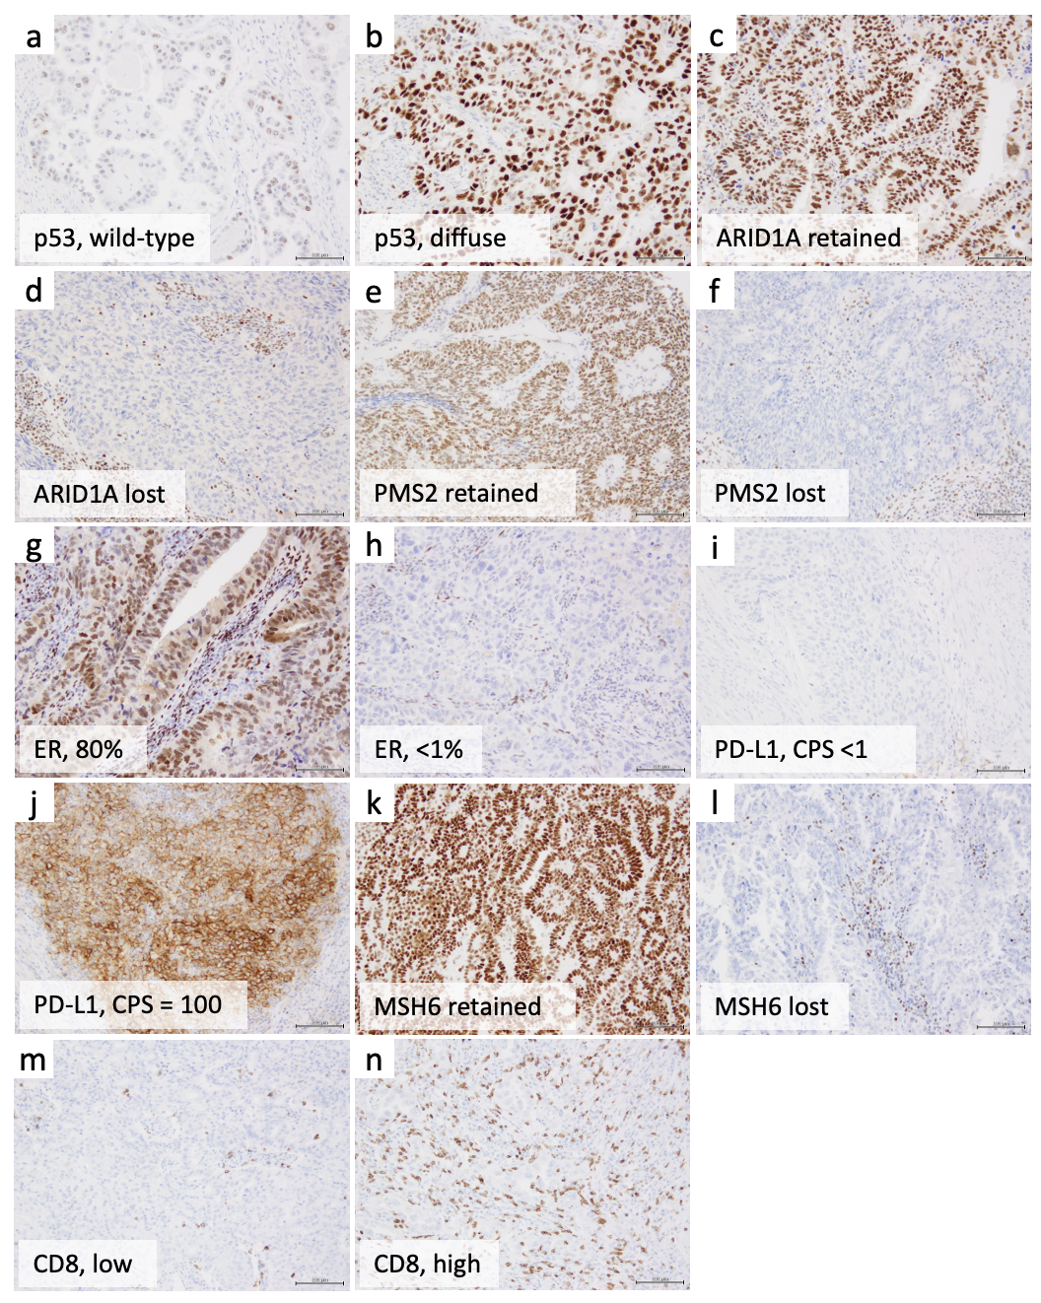
Figure S7. Representative results of immunohistochemical staining
a: p53 wild-type staining pattern. b: Diffuse strong p53 positivity in tumor cells, indicating TP53 gene alteration. c: Retained ARID1A expression in tumor and normal stromal cells. d: ARID1A expression is lost only in tumor cells. e: Retained PMS2 expression in tumor and normal stromal cells. f: PMS2 expression is lost only in tumor cells. g: Estrogen receptor (ER) expression is observed in approximately 80% of tumor cells. h: Less than 1% of tumor cells have ER expression. i: This tumor has a combined positive score (CPS) of less than 1. j: Another tumor with a CPS of 100. k: Retained MSH6 expression in tumor and normal stromal cells. l: MSH6 expression is lost only in tumor cells. m: Scattered peritumoral CD8+ T cells are observed. n: Numerous CD8+ T cells are seen in another tumor. (a–n, ×200, scale bars indicate 100 μm)

Supplementary results and discussions

Clustering of tumors based on gene expression associated with endometrial cell phenotype
We conducted additional clustering, considering the potential usefulness of gene expression associated with the differentiation state or phenotype of endometrial cells for stratifying and classifying high-grade EC. Informed by the analysis of differentiated cells with single cell RNA sequencing^{1,2}, along with the results of initial clustering shown in Figure 4B, we selected 96 genes (Table S3) related to endometrial cell differentiation and stromal traits for additional clustering analysis. We again identified one cluster of normal tissues and three clusters of tumor tissues (Figures S3A and S3B), although the discordance with the initial clustering with 5,000 genes was not negligible (Figure S3C). Still, the observed consistency with the initial clustering suggests the potential feasibility of analyzing genes related to the differentiation state of endometrial cells in the stratification and classification of high-grade EC (Figures S3D).

Clustering of endometrial tumors in The Cancer Genome Atlas Program (TCGA) dataset
To further validate our analysis, we utilized data from TCGA. Gene expression profiles, normalized for batch effects in uterine corpus endometrial carcinoma (UCEC) and uterine carcinosarcoma (UCS), were obtained from University of California, Santa Cruz, Xena³. Analysis was conducted on the basis of the expression of selected marker genes. Dimensionality reduction through t-distributed stochastic neighbor embedding followed by clustering identified three tumor sample clusters and one normal sample cluster (Figure S4A). Cluster T1 included serous carcinoma, Cluster T2 predominantly consisted of endometrioid carcinoma, and Cluster T3 mainly consisted of carcinosarcoma. Similar to the clustering of high-grade EC in this study, a cluster with high expression of genes associated with glandular/lumenal cells (Cluster T1), a cluster with high expression of genes associated with ciliated cells (Cluster T2), and a cluster enriched for carcinosarcoma (Cluster T3) were observed (Figures S4B, S5).
A significant difference was noted when the clustering of the TCGA dataset and the clustering of high-grade ECs in this study were compared; Cluster T1 was dominated by serous carcinoma. This discrepancy can be attributed to the larger sample size and the higher proportion of low-grade endometrioid carcinomas and serous carcinoma in the TCGA dataset, which resulted in a larger contribution of the genes associated with estrogen responsiveness. The relatively higher proportion of clear cell carcinomas in this study is another possible cause of the difference. Despite the incomplete correspondence, Cluster T1, which was associated with a glandular/lumenal phenotype, exhibited a notable elevation in immune response, mirroring findings in high-grade EC. Our findings suggest that classification based on marker genes is feasible within the TCGA dataset. These findings suggest that differences in cell of origin or the potential skewing of phenotypic or differentiation states during cancer progression should be considered for the diagnosis or stratification of EC.

References
1. Wang, W. et al. Single-cell transcriptomic atlas of the human endometrium during the menstrual cycle. Nat Med 26, 1644–1653 (2020).
2. Garcia-Alonso, L. et al. Mapping the temporal and spatial dynamics of the human endometrium in vivo and in vitro. Nat Genet 53, 1698–1711 (2021).
3. Goldman, M. J. et al. Visualizing and interpreting cancer genomics data via the Xena platform. Nat Biotechnol 38, 675–678 (2020).

