Appendix: Supplementary data

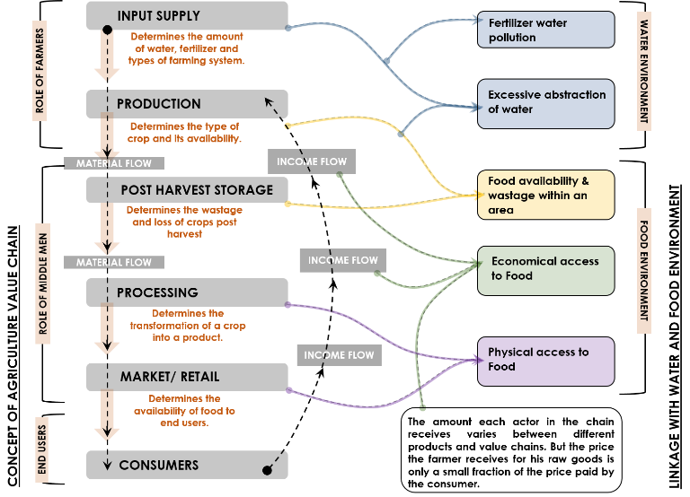
Fig. 1: Agriculture value chain links with Water & Food environments (FAO, 2014)

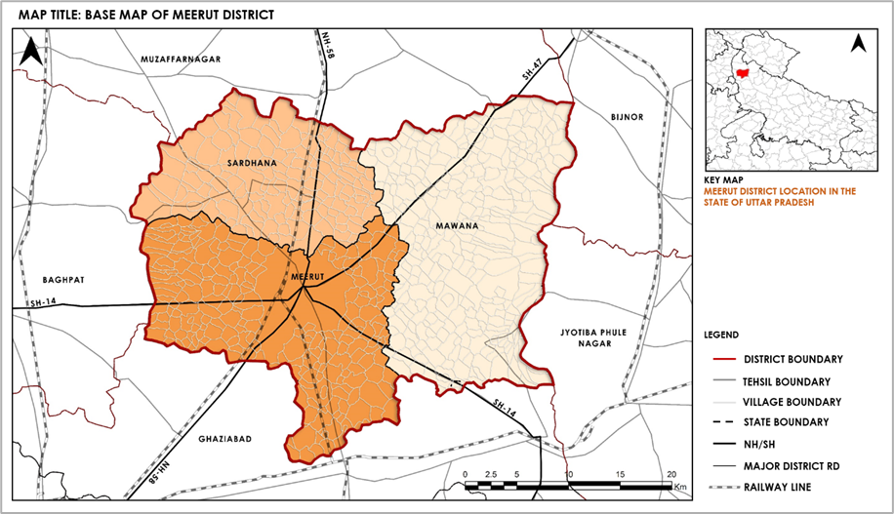
Fig. 2: Base map of Study area – Meerut District

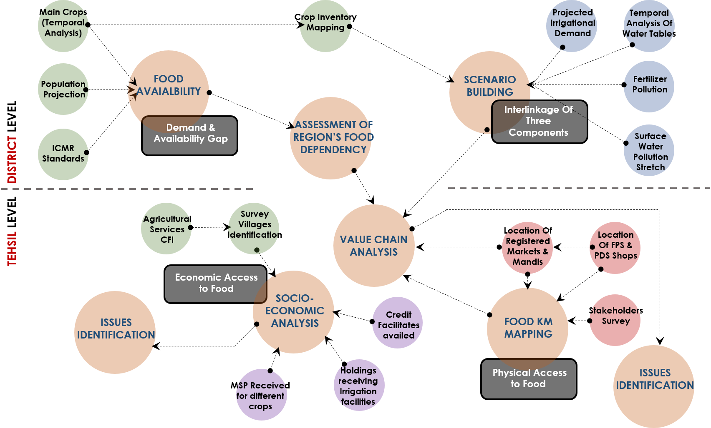
Fig. 3: Data Structuring

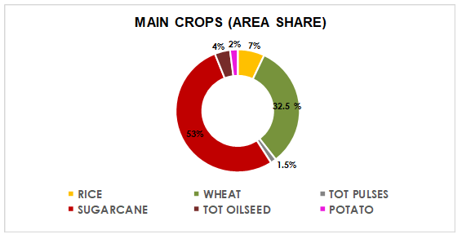
Fig. 4: Area wise share of Main Crops in Meerut District (Agriculture-Department, 2020)
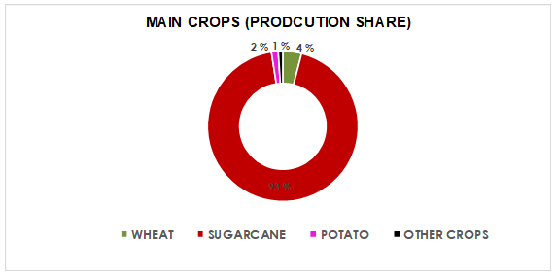
Fig. 5: Production wise share of Main Crops in Meerut District (Agriculture-Department, 2020)

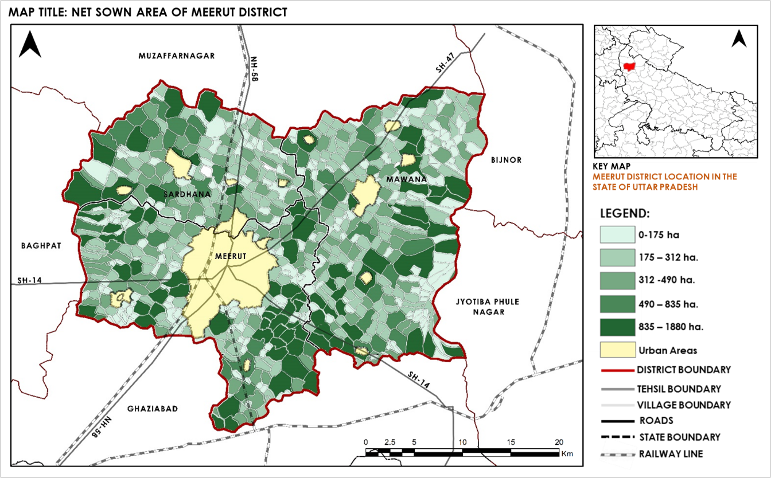
Fig. 6: Net Sown Area, Meerut District (Census, 2011)
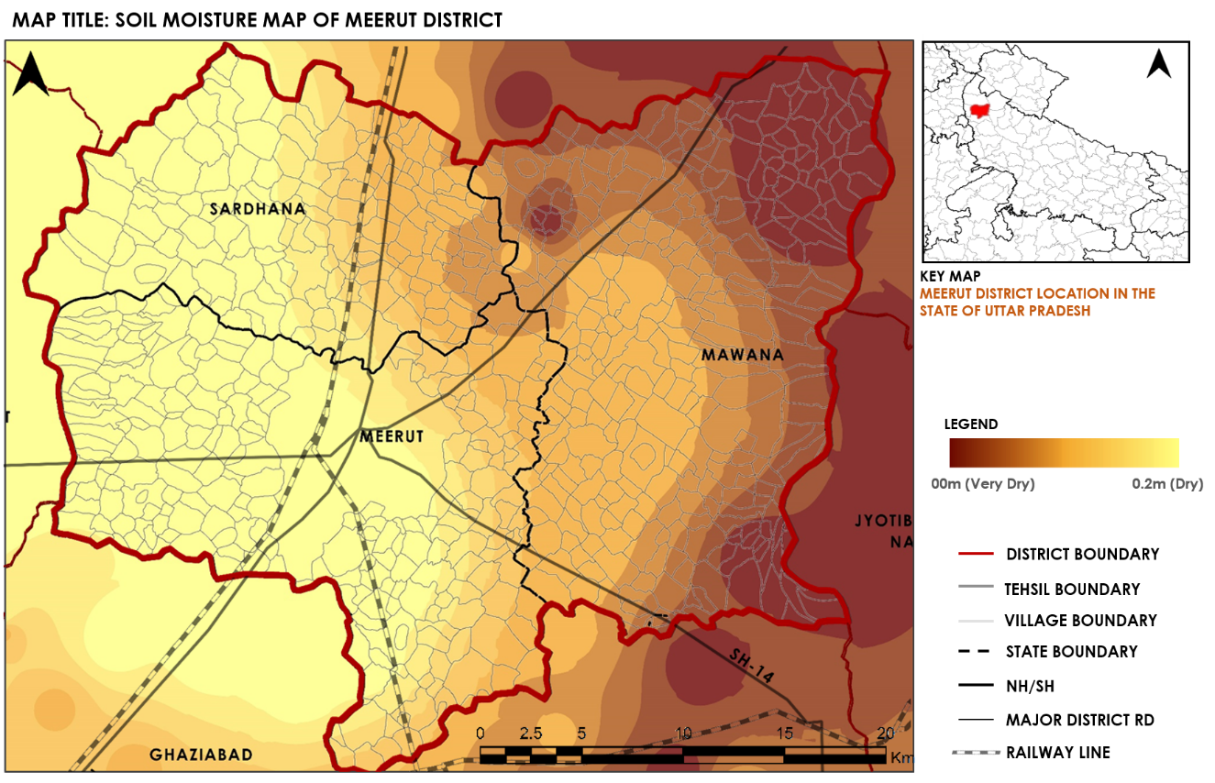
Fig. 7: Soil Moisture Map, Meerut District
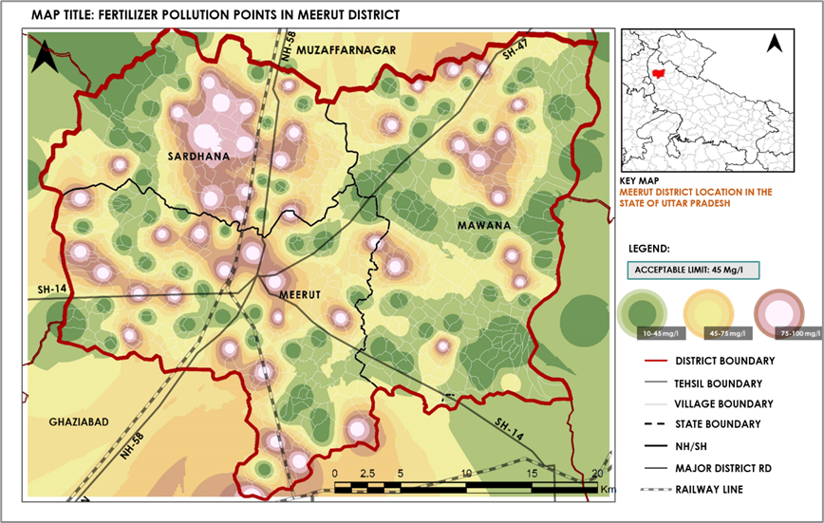
Fig. 8: Fertilizer Pollution points, Meerut District

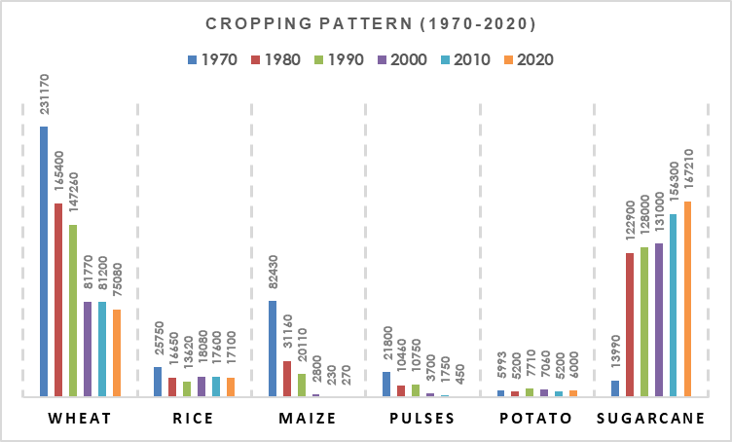
Fig. 9: Cropping Pattern (Area wise), Meerut District
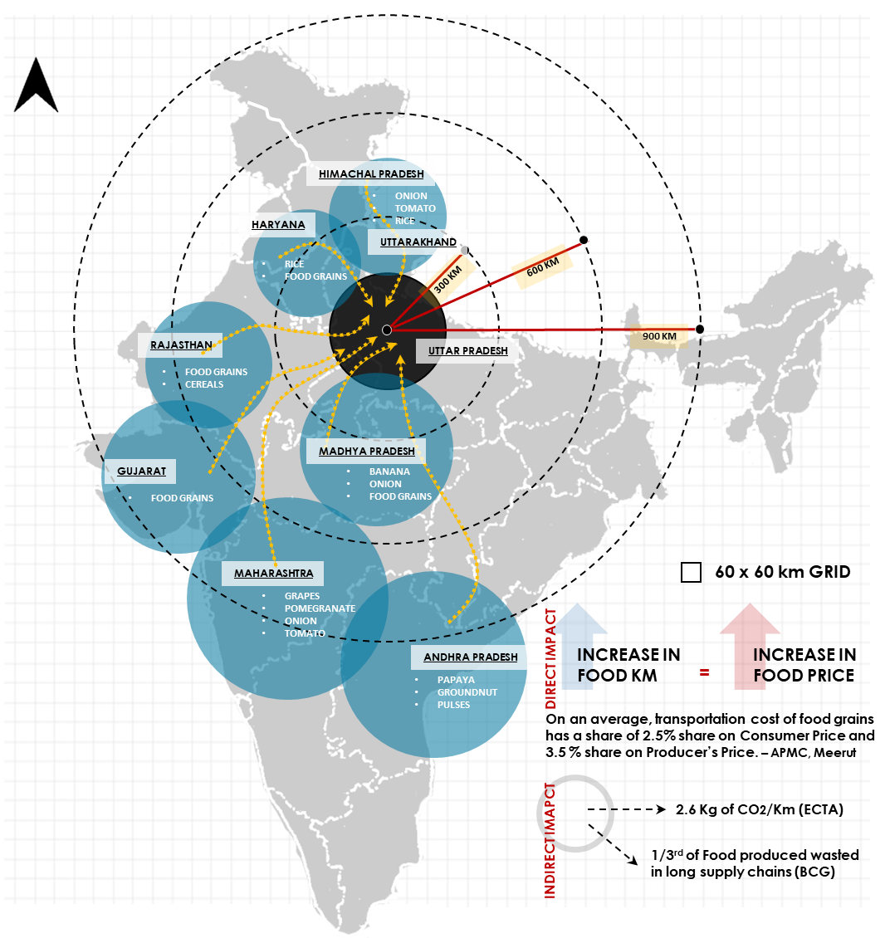
Fig. 10: Food Kilometre mapping, Meerut District

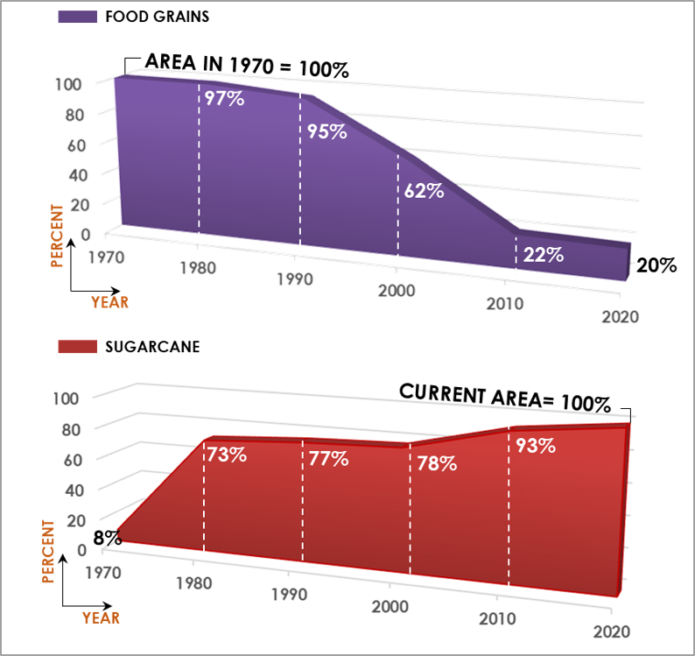
Fig. 11: Comparison of Food grains and Sugarcane Crop area
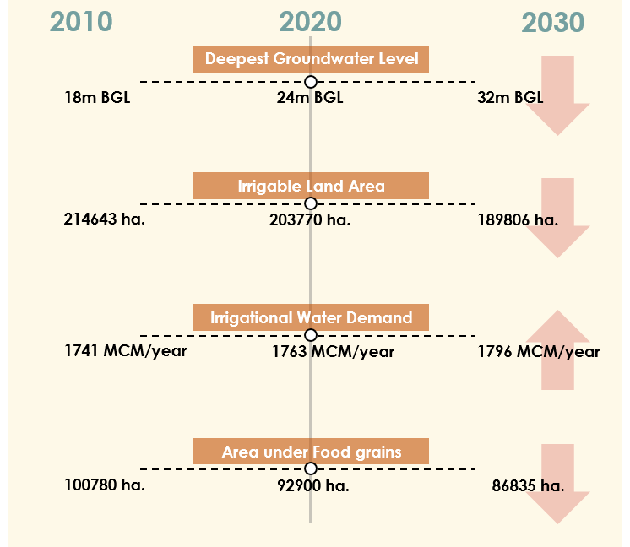
Fig. 12: Projected Scenario of Different Variables

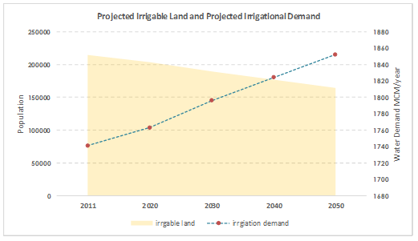
Fig. 13: Projected Irrigational Demand v/s Projected Irrigable Land
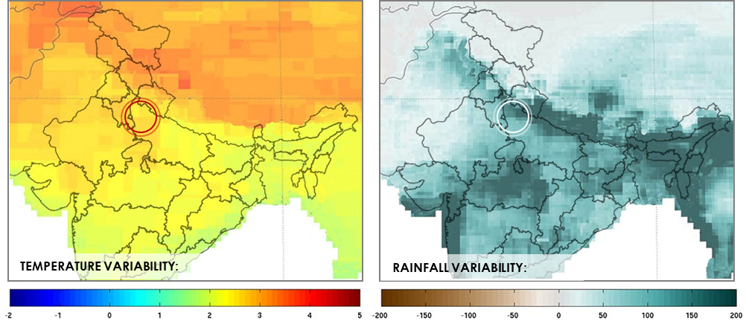
Fig. 14: Median changes in annual (left) temperature (ºC) and (right) total precipitation (mm) for Meerut and surrounding areas in the 2050s compared with the 1980-2010 historical period.

