Supplementary Information

Grain Boundary Cracks Patching and Defect Dual Passivation with Ammonium Formate for High-Efficiency Triple-Cation Perovskite Solar Cells
Yang Ding,^{1,2,†} Yefan Wu, ^{1,2,†} Xiangxiang Feng,^{1,2} Hengyue Li,^{1,2} Erming Feng,^{1,2} Jianhui Chang,^{1,2} Caoyu Long,^{1,2} Yuanji Gao,^{1,2} Junliang Yang^{1,2,3,}*
¹ Hunan Key Laboratory for Super-microstructure and Ultrafast Process, School of Physics, Central South University, Changsha, 410083, China
² Hunan Key Laboratory of Nanophotonics and Devices, School of Physics, Central South University, Changsha, China
³ State Key Laboratory of Powder Metallurgy, Central South University, Changsha, Hunan 410083, China
† These authors contributed equally to this work.
* Corresponding authors: junliang.yang@csu.edu.cn, +86-731-88660256 (J.L. Yang)

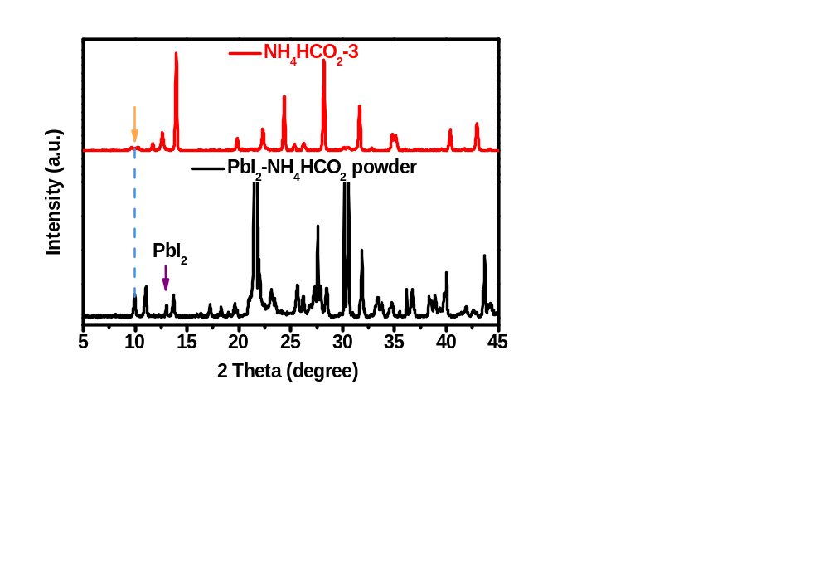
Figure S1. XRD pattern of the NH₄HCO₂-3 treated film and the prepared NH₄HCO₂-PbI₂ complex.

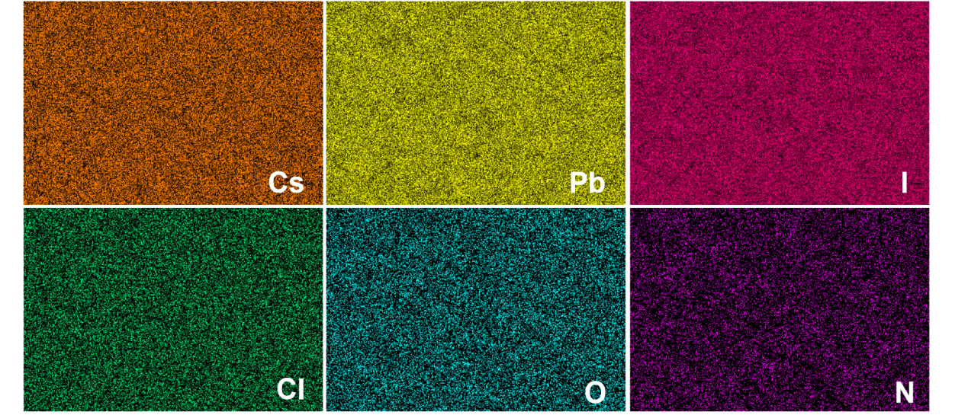
Figure S2. EDS Mapping of NH₄HCO₂-modified perovskite surface.

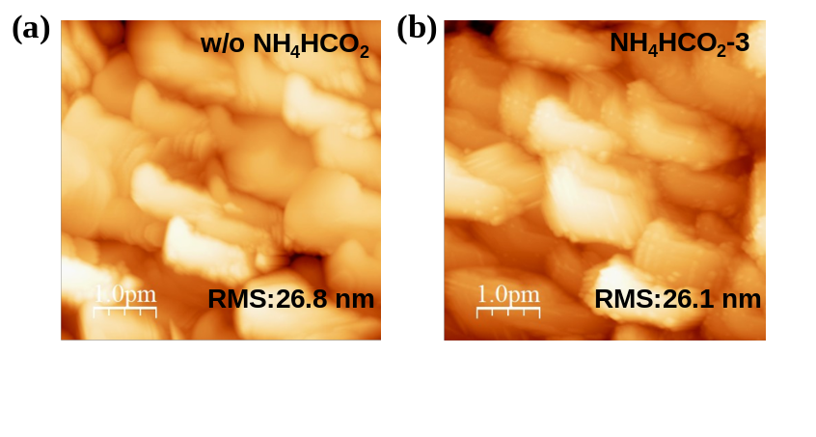
Figure S3. AFM spectrum of perovskite films (a) without and (b) with NH₄HCO₂ modified.

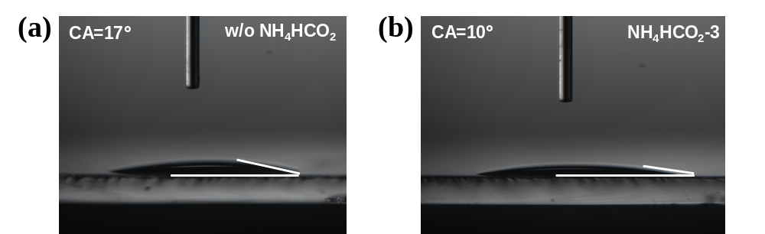
Figure S4. Chlorobenzene (CB) contact angles of perovskite films (a) without and (b) with NH₄HCO₂ modified.
Figure S5. Top-view SEM images of perovskite films modified with different concentrations of NH₄HCO₂ (0, 1, 3, 5 mg/ml, respectively).

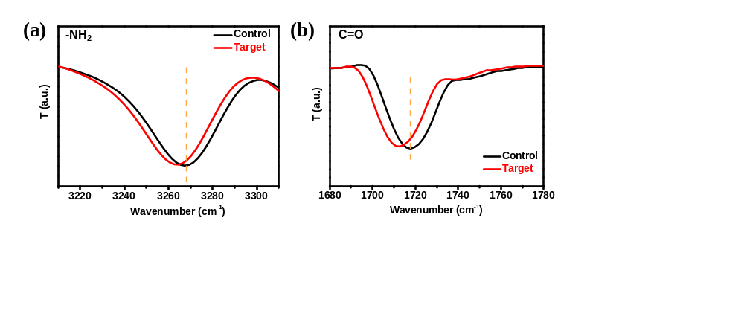
Figure S6. (a-b) FTIR spectra of control (NH₄HCO₂) and target samples (NH₄HCO₂ + perovskite film).

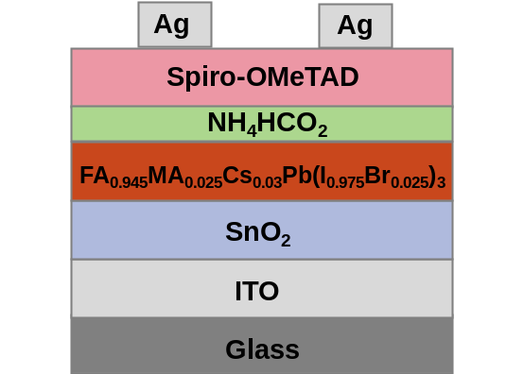
Figure S7. The schematic structure of PSCs with NH₄HCO₂ modification.

Table S1. The fitting parameters of TRPL spectra for control and target (NH₄HCO₂-3) samples.
Samples | A₁ | τ₁ (ns) | A₂ | τ₂ (ns)
Control | 183 | 32 | 180 | 785
NH₄HCO₂-3 | 152 | 26 | 243 | 1613

Table S2. Key photovoltaic parameters of PSCs with different NH₄HCO₂ modification.
Devices | J_{sc} (mA cm⁻²) | V_{oc} (V) | FF (%) | PCE (%)
Control | 24.41 | 1.12 | 80.11 | 21.84
NH₄HCO₂-1 | 24.59 | 1.12 | 82.80 | 22.80
NH₄HCO₂-3 | 24.67 | 1.14 | 83.47 | 23.38
NH₄HCO₂-5 | 24.18 | 1.10 | 80.15 | 21.31

Note S1:
In order to study the carrier dynamics behavior inside the device, the relationship of J_{sc} and V_{oc} as a function of light intensity was fitted using the following formula ^{1,2}: ${\text{J}}_{\text{sc}}\text{∝}{\text{I}}^{\text{α}}\text{(}\text{α}\text{≤1)}$ and ${\text{V}}_{\text{oc}}\text{=} \text{nkT}\text{ln}{\text{(}\text{I}\text{)/q+}}\text{constant}$, where α is a factor related to bimolecular recombination, it can be ignored under a complete ideal situation and the α should be infinitely close to 1. The parameter n is a factor associated with monomolecular recombination, similarly, a smaller n can be obtained when nonradiative recombination is suppressed. k and q are the Boltzmann constant and elementary charge, respectively.

References
¹ C. Xu, L. Cheng, Z. Li, X. Zheng, S. Shan, T. Chen, W. Fu, Y. Yang, L. Zuo, H. Chen, Adv. Energy Mater. 13(17), 2300168 (2023).
² X. Jiang, B. Zhang, G. Yang, Z. Zhou, X. Guo, F. Zhang, S. Yu, S. Liu, S. Pang, Angew. Chem. Int. Ed. 62(22), e202302462 (2023).

