SUPPLEMENTARY TABLES
Supplementary Table 1. Comparison of CH incidence between MM patients and healthy population
Baseline  characteristics | Before matching |  |  | After propensity score matching  (1:4)
 | MM | Healthy | P-value | MM | Healthy | P-value
 | (N=194) | (N=5487) |  | (N=194) | (N=776)
Age | 64.0 [56.0;70.0] | 54.0 [49.0;61.0] | <0.001 | 64.0 [56.0;70.0] | 64.0 [56.0;70.0] | 0.996
Sex |  |  | 0.001 |  |  | 1
F | 80 (41.2%) | 1612 (29.4%) |  | 80 (41.2%) | 322 (41.5%)
M | 114 (58.8%) | 3875 (70.6%) |  | 114 (58.8%) | 454 (58.5%)
any CH (24 genes) |  |  | <0.001 |  |  | <0.001
Y | 79 (40.7%) | 662 (12.1%) |  | 79 (40.7%) | 135 (17.4%)
N | 115 (59.3%) | 4825 (87.9%) |  | 115 (59.3%) | 641 (82.6%)
major2 CH (D+T) |  |  | <0.001 |  |  | <0.001
Y | 46 (23.7%) | 449 (8.2%) |  | 46 (23.7%) | 96 (12.4%)
N | 148 (76.3%) | 5038 (91.8%) |  | 148 (76.3%) | 680 (87.6%)
major3 CH (D+T+A) |  |  | <0.001 |  |  | <0.001
Y | 52 (26.8%) | 503 (9.2%) |  | 52 (26.8%) | 108 (13.9%)
N | 142 (73.2%) | 4984 (90.8%) |  | 142 (73.2%) | 668 (86.1%)
TET2 CH |  |  | <0.001 |  |  | <0.001
Y | 20 (10.3%) | 111 (2.0%) |  | 20 (10.3%) | 26 (3.4%)
N | 174 (89.7%) | 5376 (98.0%) |  | 174 (89.7%) | 750 (96.6%)
DNMT3A CH |  |  | <0.001 |  |  | 0.033
Y | 30 (15.5%) | 350 (6.4%) |  | 30 (15.5%) | 76 (9.8%)
N | 164 (84.5%) | 5137 (93.6%) |  | 164 (84.5%) | 700 (90.2%)
ASXL1 CH |  |  | <0.001 |  |  | 0.008
Y | 11 (5.7%) | 70 (1.3%) |  | 11 (5.7%) | 15 (1.9%)
N | 183 (94.3%) | 5417 (98.7%) |  | 183 (94.3%) | 761 (98.1%)
Abbreviations: CH, clonal hematopoiesis; MM, multiple myeloma

Supplementary Table 2. Odds of VGPR/CR rate in patients with DTA CH
Feature | Univariate  odds ratio (95% CI) | Multivariate  odds ratio (95% CI)
Age
Young (<60) | Reference | Reference
Elderly (≥60) | 0.59 (0.29 – 1.18) | 0.40 (0.16 – 0.98)
ISS stage
I, II | Reference | Reference
III | 0.53 (0.24 - 1.14) | 0.46 (0.18 – 1.18)
High-risk chromosomal abnormality
No | Reference | Reference
Yes | 1.47 (0.60 – 3.53) | 1.23 (0.43 - 3.48)
DTA CH
No | Reference | Reference
Yes | 0.22 (0.10 – 0.47) | 0.28 (0.11 – 0.72)
Abbreviations: CH, clonal hematopoiesis; CI, confidence interval; DTA, DNMT3A, TET2, or ASXL1; VGPR/CR, very good partial response or complete remission

Supplementary Table 3. Clonal hematopoiesis-associated genes analyzed by targeted sequencing
CHIP-associated gene list
ASXL1 | ATM | BCOR | CBL | CHEK2
CREBBP | DNMT3A | EP300 | GNAS | IDH2
JAK2 | KMT2D | KRAS | NOTCH1 | NOTCH2
PPM1D | SETD2 | SF3B1 | SRSF2 | STAG2
STAT3 | TET2 | TP53 | U2AF1

SUPPLEMENTARY FIGURES
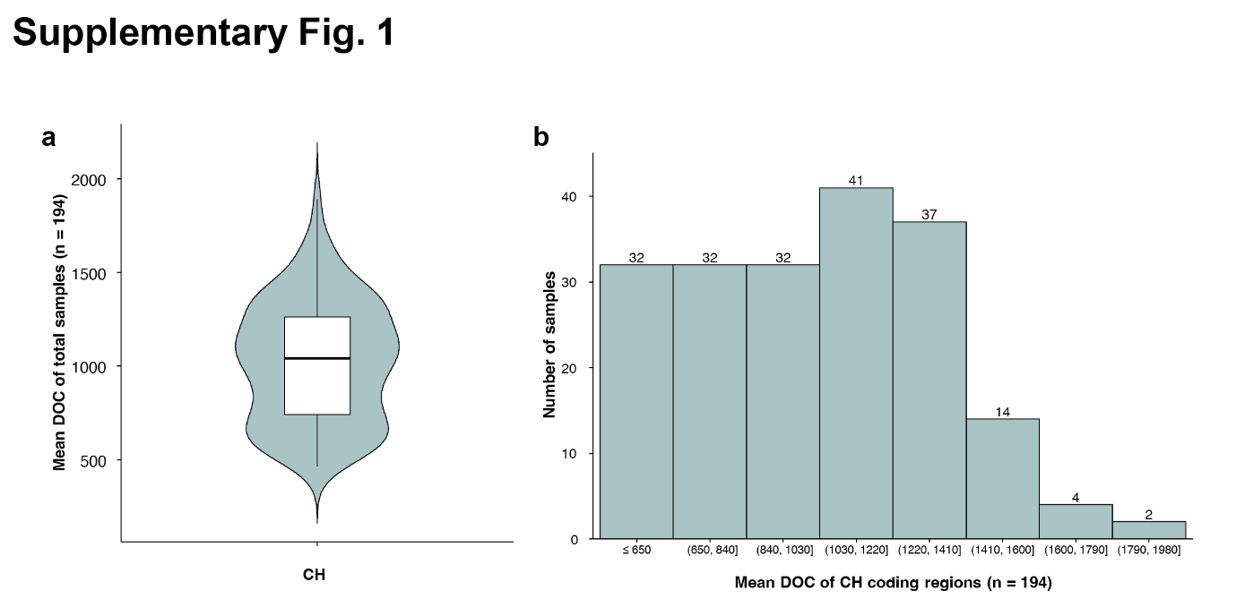
Supplementary Fig. 1. The depth of coverage for coding sequences of CH-associated genes.
a. Violin plot and box plot showing the distribution of mean depth of coverage (DOC) for coding sequences of CH-associated genes. b. Bar plot showing the distribution of mean depth of coverage (DOC) for coding sequences of CH-associated genes.

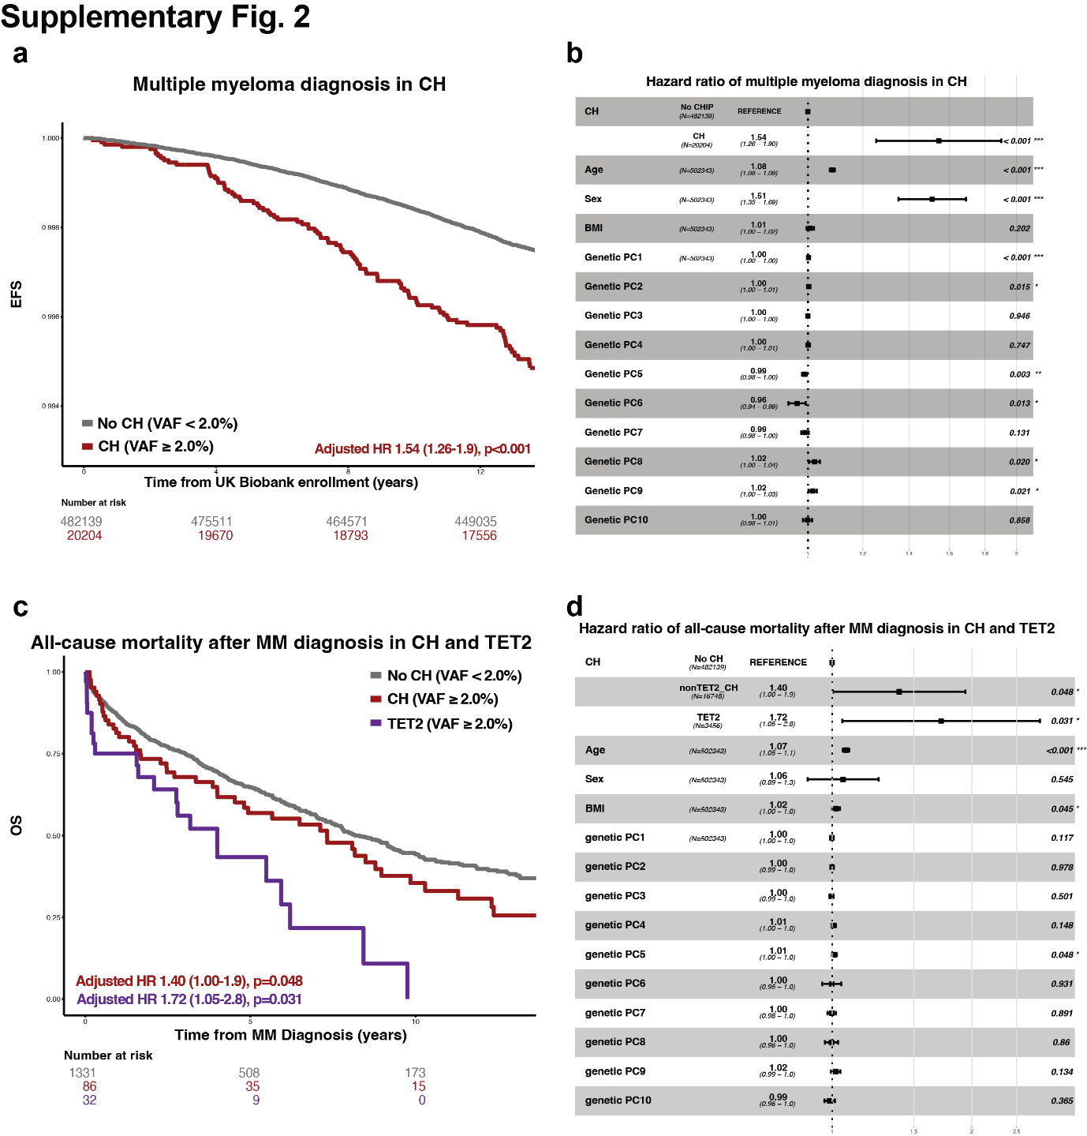
Supplementary Fig. 2. CH increase both MM incidence and all-cause mortality by CH and TET2 specifically.
a. Kaplan-Meier curves showing the MM diagnosis event-free survival according to CH status in UK Biobank cohort. b. Forest plot showing the hazard ratio of MM diagnosis according to CH status in UK Biobank cohort. c. Kaplan-Meier curves showing the all-cause mortality after MM diagnosis according to CH status in UK Biobank cohort. d. Forest plot showing the hazard ratio of the all-cause mortality after MM diagnosis according to CH status in UK Biobank cohort.

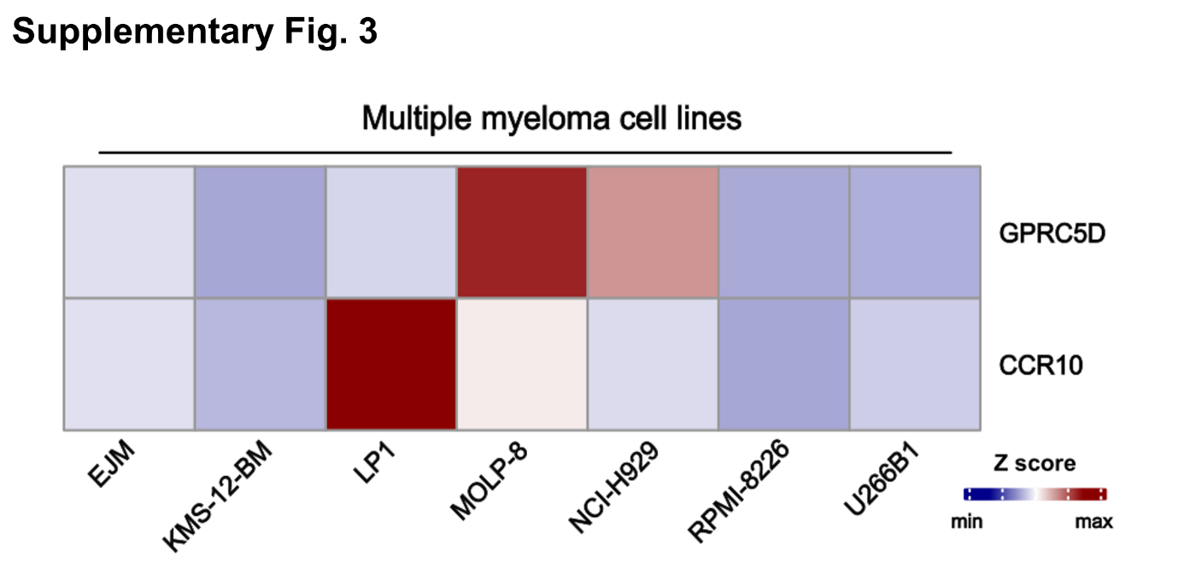
Supplementary Fig. 3. CCR10 and GPRC5D expression in multiple myeloma cell lines from the CCLE database.
RNA expression data of various multiple myeloma cell lines in the CCLE database. MOLP-8 and LP1 shows increased CCR10 and GPRC5D expression level compared to other cell lines.

