Supplementary materials

Table S1 Primers used in this study
Primers | Sequences (single strand: overlapping region, double strand: restriction sites)
gApgfor  gApgrev | 5'-CATTGTATTTTGACATCCGA-3'  5'-ACTTTCGCGCCGCATGTTGTTTTTGTTGTTAA-3'
gAppfor  gApprev | 5'-CCCTTGACCTGCGAAGAGAGACTCGAGTAATT-3'  5'-AGCGGATAACAATTTCAC-3'
gApAfor  gApArev | 5'-AACAACAAAAACAACATGCGGCGCGAAAGT-3'  5'-TTACTCGAGTCTCTCTTCGCAGGTCAAGGGTT-3'
gApfor  gAprev | 5'-ACGAAGCTTAGATCTAGTCGACTGTTGTATCATTCCTGTA-3'  5'-CACACAGGAAACAGCTATGACCATGA-3'
gApgfor  gBpgrev | 5'-CATTGTATTTTGACATCCGA-3'  5'-GAGGATGGCGTGCATGTTGTTTTTGTTGTTAA-3'
gBpBfor  gBpBrev | 5'-AACAACAAAAACAACATGCACGCCATCCTC-3'  5'-GATCTATCGGAATTACGTTCAGGACGCAGCC-3'
gBppfor  gApprev | 5'-GCTGCGTCCTGAACGTAATTCCGATAGATC-3'  5'-AGCGGATAACAATTTCAC-3'
gBpfor  gBprev | 5'-CGCCGGTCGACGTATTGTTGTATCATTCCTGTA-3'  5'-ACCAGGTCGACCATGATTACGCCAAGCTT-3'
hphfor  hphrev | 5'-CGATTTAGAGCCTACCCGTC-3'  5'-TGCTCCATACAAGCCAACCAC-3'

Table S2 Fermentation results of wild-type strain Sb and recombinant strain Sb_{rhlAB} on rhamnose and rapeseed oil
Strain | Biomass  (g/L) | Residual rhamnose  (g/L) | Lactonic glycolipid  (mmol/L) | Total glycolipid  (mmol/L)
Sb | 8.00 | 20.17 | 8.09 | 14.45
Sb_{rhlAB} | 8.50 | 20.99 | 10.17 | 16.20

Figure S1. The construction schematic diagram of recombinant plasmid pRhlAB

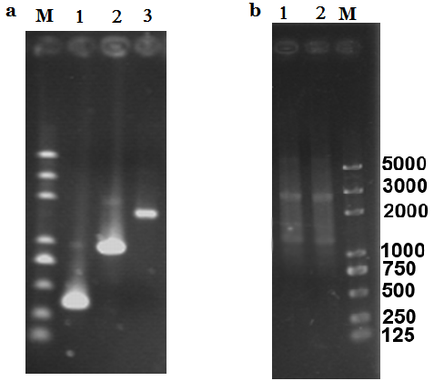

Figure S2. Amplification and fusion of Pgpd from S. bombicola, Tpgk from S. cerevisiae and CDs of rhlA. a. Amplification of Pgpd, Tpgk and CDs of rhlA from P. aeruginosa SH6. M: Trans plus 2k marker; Lane 1: Pgpd from S. bombicola; Lane 2: Tpgk from S. cerevisiae; Lane 3: CDs of rhlA from P. aeruginosa SH6. b. Fusion of Pgpd, Tpgk and CDs of rhlA. Lane 1 and 2: fusion fragment; M: Trans plus 2K marker.

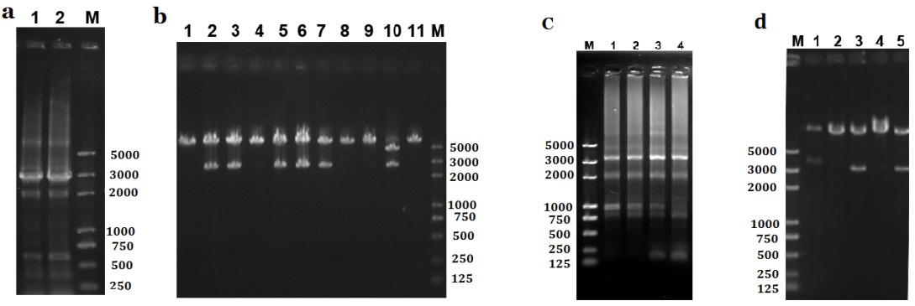
Figure S3. Verification of rhlA/rhlB expression cassettes and the recombinant plasmid pRhlA, pRhlAB a. PCR validation of rhlA expression cassette. Lane 1-2: rhlA expression cassette; M: Trans plus 2K marker. b. PCR verification of plasmid pRhlA digested by Hind Ⅲ. M: Trans plus 2K marker; Lane 1-11: possible recombinant plasmids containing rhlA expression cassette digested by Hind Ⅲ. c. Amplification of rhlB expression cassette. M: Trans plus 2K marker; Lane 1-4: rhlB expression cassette. d. PCR verification of plasmids pRhlAB digested by SalI. M: Trans plus 2K marker; Lane 1-5: possible recombinant plasmids containing rhlB expression cassette digested by SalI.

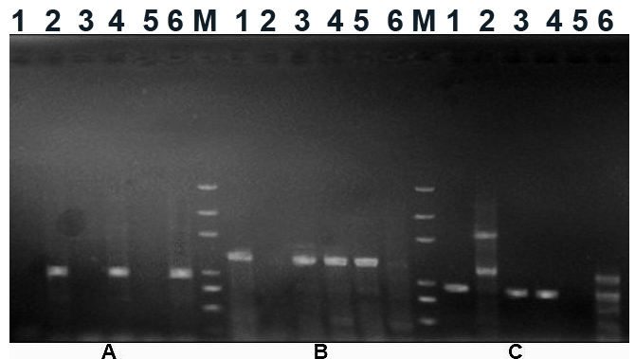
Figure S4. PCR verification of recombinant strain of S. bombicola. (A) to (C) PCR amplification of rhlA, rhlB and hph, respectively. M: Trans plus 2K marker; Lane 1-6: strain 1-6.

