Table 1. Patients baseline characteristics.
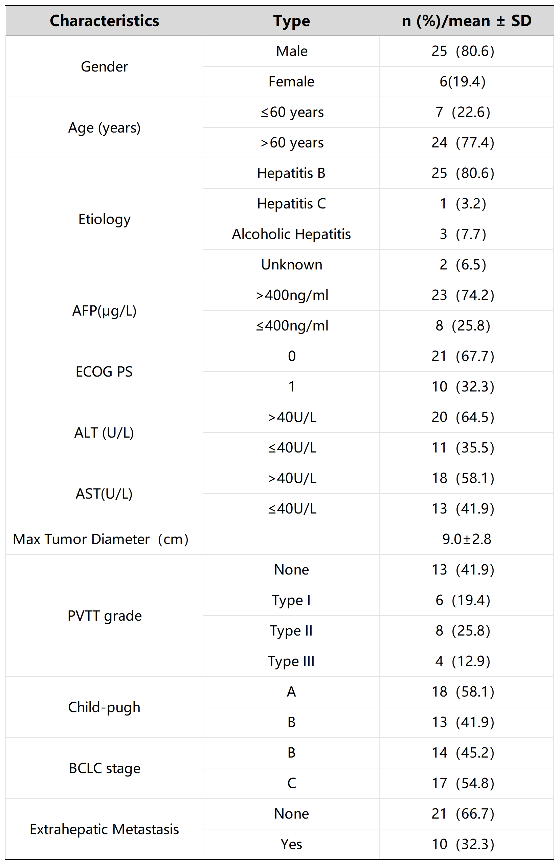
AFP, alpha-fetoprotein; ECOG PS, Eastern Cooperative Oncology Group Performance Status; ALT, alanine aminotransferase; AST, aspartate aminotransferase; PVTT grade, portal vein tumor thrombus grade, BCLC stage, Barcelona Clinic Liver Cancer stage
.
Table 2. The detailed tumor response outcomes.
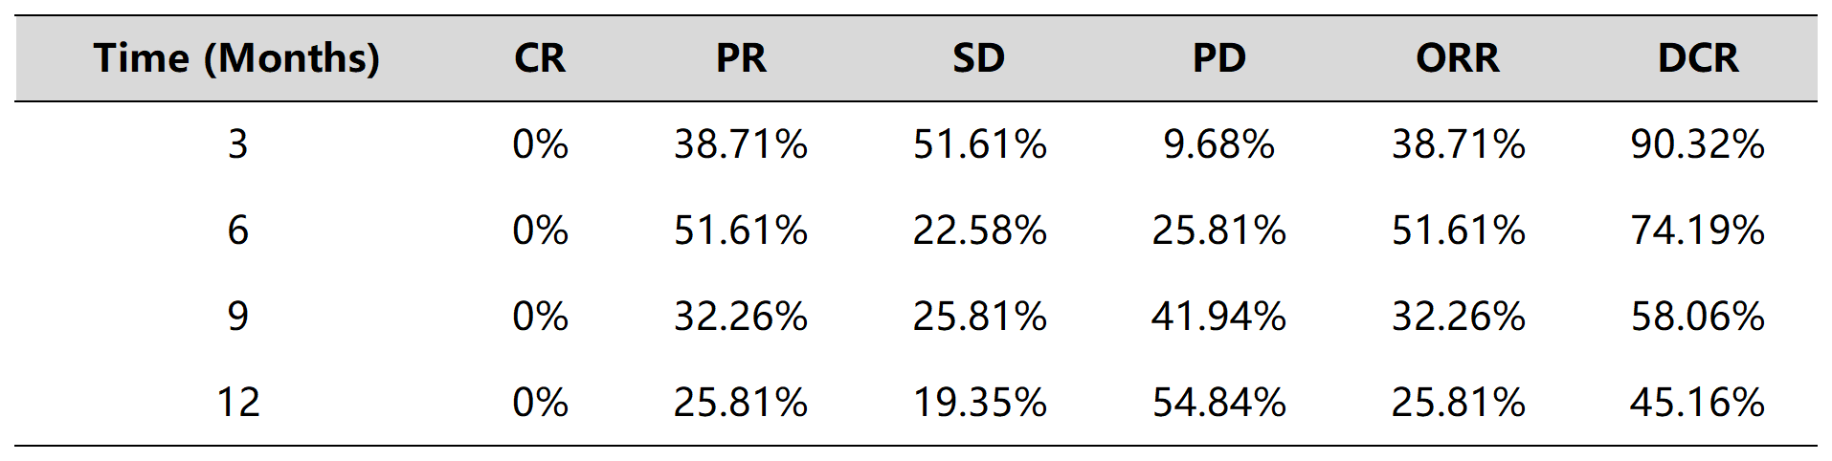
CR, complete response; PR, partial response; SD, stable disease; PD, progressive disease; ORR, objective response rate; DCR, disease control rate.

Table 3. The major AEs observed in patients.
