Urban and non-urban contributions to the social cost of carbon
Francisco Estrada^{1,2,3*}, Veronica Lupi^{2,4}, Wouter Botzen², Richard S.J. Tol^{5,2,6,7,8,9,10}
¹Instituto de Ciencias de la Atmósfera, Universidad Nacional Autónoma de México, Mexico City 04510, México;²Institute for Environmental Studies (IVM), Vrije Universiteit, Amsterdam 1081 HV, the Netherlands; ³Programa de Investigación en Cambio Climático, Universidad Nacional Autónoma de México, Mexico City, Mexico; ⁴Fondazione Eni Enrico Mattei, Milan; ⁵Department of Economics, University of Sussex, UK; ⁶Department of Spatial Economics, Vrije Universiteit, Amsterdam, the Netherlands; ⁷Tinbergen Institute, Amsterdam, the Netherlands; ⁸CESifo, Munich, Germany; ⁹Payne Institute of Public Policy, Colorado School of Mines, Golden, CO, USA; ¹⁰College of Business, Abu Dhabi University, UAE.
*Corresponding author
Email: feporrua@atmosfera.unam.mx

Supplementary Information

Supplementary Figures
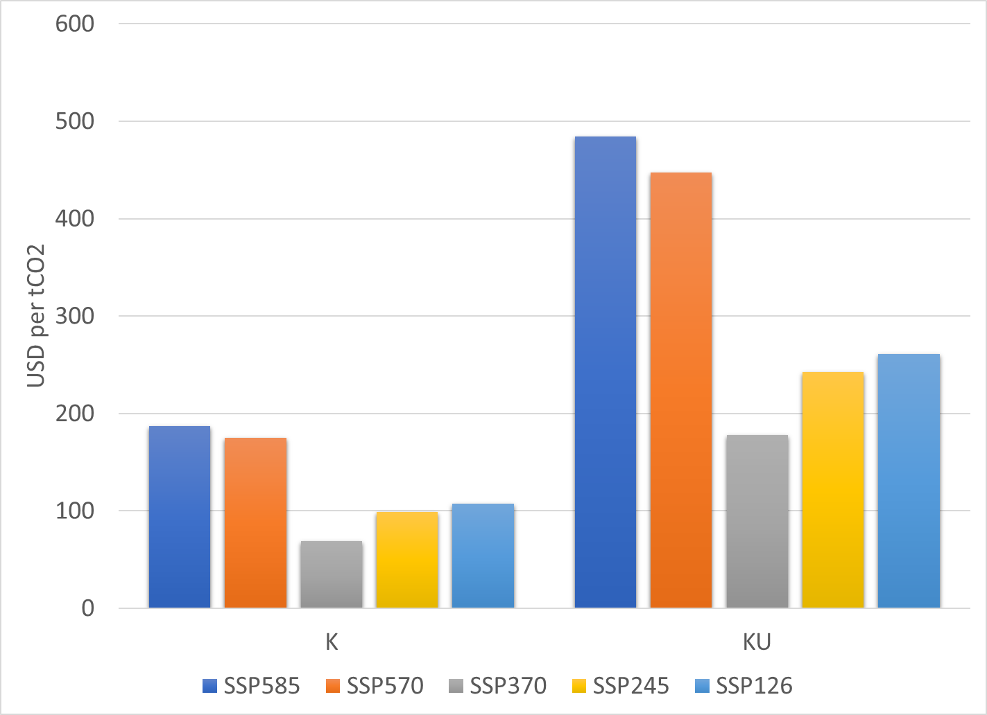
Figure S1. Global SCC values for different SSP scenarios and for the K and KU damage functions. SCC values are shown for the SSP585 (blue), SSP570 (orange), SSP370 (grey), SSP245 (yellow), and SSP126 (light blue).

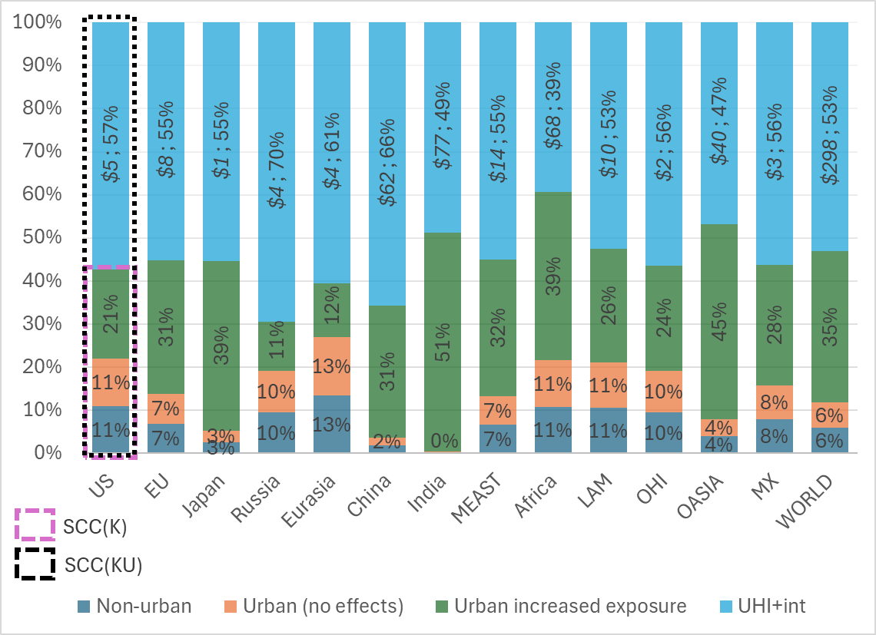
Figure S2. Contributions of non-urban areas, urban exposure, and UHI plus interactions in urban areas to regional and world SCC. Dark blue fill denotes the contribution (in percentages) of non-urban areas to regional/global SCC, orange fill shows the contribution of urban areas to regional/global SCC without considering increased exposure or UHI effects, green fill indicates the additional cost attributable to increased exposure in urban areas, and light blue fill represents the increase in regional/global SCC due to UHI warming and interaction effects with global climate change. The dashed purple rectangle indicates the components that constitute the SCC values that correspond to the R damage function, while the dashed black rectangle indicates those of the RU damage function. Numbers are in percent of total SCC and sum 100% up to rounding errors. For reference, the contribution of UHI-int in dollars are shown in italics. R functions are updated to be consistent with the DICE2016 global DF.

Supplementary Tables
Table S1. Social cost of carbon for the SSP585 and different damage functions in CLIMRISK.
Region | K | KU | R | RU
US | $2.78 (1.49%) | $7.86 (1.62%) | $12.24 (8.94%) | $28.65 (9.83%)
EU | $2.81 (1.5%) | $11.19 (2.31%) | $14.35 (10.48%) | $32.06 (11%)
Japan | $1.84 (0.98%) | $3.22 (0.66%) | $2.57 (1.88%) | $5.75 (1.97%)
Russia | $0.79 (0.42%) | $4.49 (0.93%) | $1.72 (1.26%) | $5.66 (1.94%)
Eurasia | $0.96 (0.51%) | $5.05 (1.04%) | $1.63 (1.19%) | $4.14 (1.42%)
China | $22.98 (12.31%) | $84.76 (17.51%) | $17.48 (12.78%) | $51.07 (17.51%)
India | $49.73 (26.64%) | $126.44 (26.12%) | $24.81 (18.13%) | $48.53 (16.64%)
MEAST | $6.38 (3.42%) | $20.24 (4.18%) | $6.29 (4.6%) | $13.97 (4.79%)
Africa | $42.86 (22.96%) | $110.47 (22.82%) | $27.97 (20.44%) | $45.81 (15.71%)
LAM | $11.92 (6.39%) | $21.57 (4.46%) | $6.18 (4.52%) | $13.01 (4.46%)
OHI | $2.16 (1.16%) | $4.31 (0.89%) | $4.17 (3.05%) | $9.57 (3.28%)
OASIA | $39.47 (21.14%) | $79.62 (16.45%) | $15.74 (11.5%) | $29.54 (10.13%)
MX | $2.01 (1.08%) | $4.82 (1%) | $1.67 (1.22%) | $3.82 (1.31%)
WORLD | $186.68 (100%) | $484.05 (100%) | $136.83 (100%) | $291.58 (100%)
Numbers in parenthesis indicate the fraction of global SCC for each region. Figures are expressed in US2005 dollars. 1.5% discount rate. R functions are updated to be consistent with the DICE2016 global DF.

Table S2. Social cost of carbon for the SSP570 and different damage functions in CLIMRISK.
Region | K | KU | R | RU
US | $2.66 (1.52%) | $7.32 (1.64%) | $10.57 (8.81%) | $25.21 (9.76%)
EU | $2.61 (1.49%) | $10.35 (2.31%) | $12.38 (10.32%) | $28.3 (10.97%)
Japan | $1.63 (0.93%) | $2.92 (0.65%) | $2.24 (1.86%) | $5.14 (1.99%)
Russia | $0.75 (0.43%) | $4.14 (0.93%) | $1.5 (1.25%) | $5.02 (1.94%)
Eurasia | $0.90 (0.51%) | $4.64 (1.04%) | $1.42 (1.18%) | $3.65 (1.41%)
China | $21.42 (12.24%) | $78.68 (17.6%) | $15.51 (12.93%) | $45.76 (17.73%)
India | $47.39 (27.08%) | $117.53 (26.28%) | $22.17 (18.48%) | $43.19 (16.73%)
MEAST | $5.98 (3.41%) | $18.67 (4.18%) | $5.6 (4.67%) | $12.45 (4.82%)
Africa | $39.89 (22.79%) | $101.00 (22.59%) | $24.4 (20.34%) | $40.02 (15.5%)
LAM | $10.72 (6.13%) | $19.65 (4.39%) | $5.39 (4.5%) | $11.57 (4.48%)
OHI | $2.00 (1.14%) | $3.97 (0.89%) | $3.59 (3%) | $8.41 (3.26%)
OASIA | $37.26 (21.29%) | $73.89 (16.52%) | $13.75 (11.46%) | $26.01 (10.07%)
MX | $1.80 (1.03%) | $4.41 (0.99%) | $1.46 (1.21%) | $3.4 (1.32%)
WORLD | $175.01 (100%) | $447.17 (100%) | $119.97 (100%) | $258.12 (100%)
Numbers in parenthesis indicate the fraction of global SCC for each region. Figures are expressed in US2005 dollars. 1.5% discount rate. R functions are updated to be consistent with the DICE2016 global DF.

Table S3. Social cost of carbon for the SSP370 and different damage functions in CLIMRISK.
Region | K | KU | R | RU
US | $1.24 (1.8%) | $2.95 (1.66%) | $4.43 (9.1%) | $9.87 (9.04%)
EU | $1.15 (1.68%) | $4.37 (2.46%) | $5.24 (10.76%) | $12.1 (11.08%)
Japan | $0.67 (0.98%) | $1.26 (0.71%) | $0.94 (1.93%) | $2.26 (2.07%)
Russia | $0.42 (0.61%) | $2.35 (1.33%) | $0.82 (1.68%) | $2.86 (2.62%)
Eurasia | $0.5 (0.72%) | $2.78 (1.57%) | $0.8 (1.65%) | $2.2 (2.02%)
China | $10.24 (14.91%) | $37.84 (21.31%) | $7.36 (15.11%) | $22.24 (20.36%)
India | $16.92 (24.63%) | $41.62 (23.44%) | $7.79 (16%) | $15.39 (14.09%)
MEAST | $3.31 (4.82%) | $9.99 (5.63%) | $3.06 (6.28%) | $7.06 (6.46%)
Africa | $11.17 (16.27%) | $30.69 (17.28%) | $7.68 (15.77%) | $13.34 (12.21%)
LAM | $5.57 (8.11%) | $10.52 (5.93%) | $2.83 (5.81%) | $6.3 (5.77%)
OHI | $0.72 (1.05%) | $1.42 (0.8%) | $1.46 (3%) | $3.2 (2.93%)
OASIA | $15.69 (22.84%) | $28.98 (16.32%) | $5.39 (11.08%) | $10.26 (9.39%)
MX | $1.09 (1.58%) | $2.79 (1.57%) | $0.89 (1.83%) | $2.16 (1.98%)
WORLD | $68.68 (100%) | $177.56 (100%) | $48.68 (100%) | $109.25 (100%)
Numbers in parenthesis indicate the fraction of global SCC for each region. Figures are expressed in US2005 dollars. 1.5% discount rate. R functions are updated to be consistent with the DICE2016 global DF.

Table S4. Social cost of carbon for the SSP245 and different damage functions in CLIMRISK.
Region | K | KU | R | RU
US | $1.45 (1.61%) | $3.03 (1.68%) | $4.82 (8.2%) | $11.65 (8.94%)
EU | $1.42 (1.57%) | $4.19 (2.32%) | $6.19 (10.53%) | $14.8 (11.36%)
Japan | $0.64 (0.71%) | $1.13 (0.63%) | $1.08 (1.83%) | $2.64 (2.03%)
Russia | $0.43 (0.48%) | $1.62 (0.9%) | $0.81 (1.38%) | $2.79 (2.14%)
Eurasia | $0.52 (0.57%) | $2.06 (1.14%) | $0.79 (1.34%) | $2.13 (1.64%)
China | $11.08 (12.24%) | $32.62 (18.07%) | $8.28 (14.09%) | $25.17 (19.32%)
India | $24.61 (27.18%) | $46.94 (26.01%) | $10.95 (18.62%) | $21.34 (16.39%)
MEAST | $3.47 (3.83%) | $7.97 (4.42%) | $3.12 (5.31%) | $6.98 (5.36%)
Africa | $19.45 (21.49%) | $36.73 (20.35%) | $10.79 (18.35%) | $17.96 (13.79%)
LAM | $5.27 (5.82%) | $8.98 (4.98%) | $2.98 (5.06%) | $6.73 (5.16%)
OHI | $1.14 (1.26%) | $1.89 (1.05%) | $1.66 (2.83%) | $4.02 (3.08%)
OASIA | $20.33 (22.46%) | $31.57 (17.5%) | $6.67 (11.34%) | $12.4 (9.52%)
MX | $0.71 (0.79%) | $1.74 (0.96%) | $0.66 (1.12%) | $1.63 (1.25%)
WORLD | $90.52 (100%) | $180.47 (100%) | $58.81 (100%) | $130.24 (100%)

Numbers in parenthesis indicate the fraction of global SCC for each region. Figures are expressed in US2005 dollars. 1.5% discount rate. R functions are updated to be consistent with the DICE2016 global DF.

Table S5. Social cost of carbon for the SSP126 and different damage functions in CLIMRISK.
Region | K | KU | R | RU
US | $1.63 (1.52%) | $3.9 (1.5%) | $4.43 (7.81%) | $10.92 (8.6%)
EU | $1.48 (1.38%) | $5.55 (2.13%) | $5.27 (9.29%) | $13.01 (10.25%)
Japan | $0.81 (0.75%) | $1.59 (0.61%) | $1.05 (1.84%) | $2.67 (2.11%)
Russia | $0.46 (0.43%) | $2.33 (0.89%) | $0.69 (1.22%) | $2.46 (1.94%)
Eurasia | $0.57 (0.53%) | $2.79 (1.07%) | $0.69 (1.23%) | $1.9 (1.49%)
China | $13.83 (12.9%) | $50.12 (19.21%) | $8.4 (14.81%) | $25.8 (20.33%)
India | $30.4 (28.35%) | $69.63 (26.69%) | $11.29 (19.92%) | $21.72 (17.12%)
MEAST | $3.41 (3.18%) | $9.94 (3.81%) | $2.64 (4.65%) | $5.89 (4.64%)
Africa | $22.72 (21.18%) | $54.34 (20.83%) | $10.82 (19.09%) | $17.96 (14.15%)
LAM | $6.04 (5.63%) | $11.62 (4.45%) | $2.69 (4.75%) | $6.31 (4.97%)
OHI | $1.04 (0.97%) | $2.01 (0.77%) | $1.43 (2.52%) | $3.54 (2.79%)
OASIA | $23.8 (22.19%) | $44.22 (16.95%) | $6.53 (11.51%) | $12.75 (10.05%)
MX | $1.06 (0.99%) | $2.81 (1.08%) | $0.77 (1.36%) | $1.98 (1.56%)
WORLD | $107.24 (100%) | $260.86 (100%) | $56.71 (100%) | $126.9 (100%)
Numbers in parenthesis indicate the fraction of global SCC for each region. Figures are expressed in US2005 dollars. 1.5% discount rate. R functions are updated to be consistent with the DICE2016 global DF.

Table S6. Social cost of carbon for the SSP585 and different damage functions in CLIMRISK (3% discount rate).
Region | K | KU | R | RU
US | $1.35 (1.65%) | $3.66 (1.74%) | $5.38 (9.17%) | $12.75 (10.01%)
EU | $1.29 (1.58%) | $5.06 (2.41%) | $6.27 (10.7%) | $14.3 (11.23%)
Japan | $0.85 (1.04%) | $1.53 (0.73%) | $1.18 (2.02%) | $2.74 (2.15%)
Russia | $0.39 (0.48%) | $2.15 (1.02%) | $0.79 (1.35%) | $2.64 (2.08%)
Eurasia | $0.44 (0.53%) | $2.3 (1.09%) | $0.73 (1.25%) | $1.89 (1.48%)
China | $11.33 (13.86%) | $41.61 (19.8%) | $8.33 (14.21%) | $24.59 (19.31%)
India | $21.77 (26.63%) | $54.29 (25.83%) | $10.49 (17.89%) | $20.44 (16.05%)
MEAST | $2.93 (3.58%) | $8.96 (4.26%) | $2.78 (4.75%) | $6.18 (4.85%)
Africa | $16.68 (20.4%) | $42.76 (20.34%) | $10.8 (18.43%) | $17.73 (13.92%)
LAM | $5.29 (6.47%) | $9.68 (4.6%) | $2.72 (4.64%) | $5.85 (4.59%)
OHI | $1 (1.22%) | $1.97 (0.94%) | $1.81 (3.09%) | $4.22 (3.31%)
OASIA | $17.55 (21.47%) | $34.03 (16.19%) | $6.58 (11.23%) | $12.31 (9.67%)
MX | $0.9 (1.1%) | $2.2 (1.05%) | $0.74 (1.26%) | $1.73 (1.36%)
WORLD | $81.76 (100%) | $210.18 (100%) | $58.61 (100%) | $127.37 (100%)
Numbers in parenthesis indicate the fraction of global SCC for each region. Figures are expressed in US2005 dollars. 3% discount rate. R functions are updated to be consistent with the DICE2016 global DF.

Table S7. Social cost of carbon for the SSP570 and different damage functions in CLIMRISK (3% discount rate).
Region | K | KU | R | RU
US | $1.3 (1.68%) | $3.46 (1.76%) | $4.74 (9.07%) | $11.45 (9.98%)
EU | $1.22 (1.58%) | $4.74 (2.41%) | $5.53 (10.58%) | $12.88 (11.23%)
Japan | $0.77 (0.99%) | $1.41 (0.72%) | $1.05 (2.02%) | $2.5 (2.18%)
Russia | $0.37 (0.48%) | $2.01 (1.02%) | $0.7 (1.34%) | $2.39 (2.08%)
Eurasia | $0.41 (0.53%) | $2.14 (1.09%) | $0.65 (1.24%) | $1.69 (1.47%)
China | $10.7 (13.82%) | $39.15 (19.92%) | $7.52 (14.39%) | $22.42 (19.54%)
India | $20.91 (27.01%) | $50.99 (25.95%) | $9.5 (18.18%) | $18.46 (16.09%)
MEAST | $2.78 (3.59%) | $8.37 (4.26%) | $2.52 (4.82%) | $5.6 (4.88%)
Africa | $15.64 (20.21%) | $39.44 (20.07%) | $9.54 (18.26%) | $15.69 (13.68%)
LAM | $4.83 (6.24%) | $8.94 (4.55%) | $2.42 (4.63%) | $5.3 (4.62%)
OHI | $0.93 (1.21%) | $1.84 (0.94%) | $1.59 (3.05%) | $3.78 (3.3%)
OASIA | $16.73 (21.61%) | $31.94 (16.26%) | $5.84 (11.17%) | $11.01 (9.59%)
MX | $0.82 (1.06%) | $2.04 (1.04%) | $0.66 (1.26%) | $1.57 (1.37%)
WORLD | $77.41 (100%) | $196.49 (100%) | $52.27 (100%) | $114.73 (100%)
Numbers in parenthesis indicate the fraction of global SCC for each region. Figures are expressed in US2005 dollars. 3% discount rate. R functions are updated to be consistent with the DICE2016 global DF.

Table S8. Social cost of carbon for the SSP370 and different damage functions in CLIMRISK (3% discount rate).
Region | K | KU | R | RU
US | $0.73 (2.09%) | $1.71 (1.94%) | $2.36 (9.79%) | $5.44 (9.85%)
EU | $0.65 (1.86%) | $2.4 (2.72%) | $2.77 (11.49%) | $6.57 (11.9%)
Japan | $0.39 (1.11%) | $0.74 (0.84%) | $0.54 (2.22%) | $1.33 (2.42%)
Russia | $0.23 (0.66%) | $1.23 (1.39%) | $0.41 (1.71%) | $1.45 (2.64%)
Eurasia | $0.24 (0.7%) | $1.36 (1.53%) | $0.39 (1.63%) | $1.08 (1.96%)
China | $5.62 (16.21%) | $20.64 (23.34%) | $3.88 (16.08%) | $11.85 (21.46%)
India | $8.55 (24.66%) | $20.56 (23.25%) | $3.78 (15.64%) | $7.41 (13.42%)
MEAST | $1.69 (4.88%) | $4.91 (5.55%) | $1.5 (6.22%) | $3.45 (6.25%)
Africa | $4.93 (14.22%) | $13.31 (15.05%) | $3.37 (13.94%) | $5.83 (10.57%)
LAM | $2.77 (7.99%) | $5.28 (5.97%) | $1.39 (5.75%) | $3.16 (5.73%)
OHI | $0.41 (1.17%) | $0.8 (0.9%) | $0.77 (3.18%) | $1.73 (3.14%)
OASIA | $7.94 (22.89%) | $14.09 (15.93%) | $2.54 (10.53%) | $4.81 (8.72%)
MX | $0.54 (1.55%) | $1.4 (1.58%) | $0.44 (1.8%) | $1.07 (1.95%)
WORLD | $34.68 (100%) | $88.43 (100%) | $24.14 (100%) | $55.2 (100%)
Numbers in parenthesis indicate the fraction of global SCC for each region. Figures are expressed in US2005 dollars. 3% discount rate. R functions are updated to be consistent with the DICE2016 global DF.

Table S9. Social cost of carbon for the SSP245 and different damage functions in CLIMRISK (3% discount rate).
Region | K | KU | R | RU
US | $0.86 (1.84%) | $2.09 (1.83%) | $2.53 (8.97%) | $6.22 (9.74%)
EU | $0.83 (1.76%) | $3.14 (2.75%) | $3.17 (11.21%) | $7.69 (12.04%)
Japan | $0.44 (0.94%) | $0.85 (0.75%) | $0.59 (2.1%) | $1.5 (2.34%)
Russia | $0.25 (0.54%) | $1.29 (1.13%) | $0.41 (1.47%) | $1.45 (2.26%)
Eurasia | $0.28 (0.6%) | $1.45 (1.27%) | $0.39 (1.39%) | $1.07 (1.67%)
China | $6.63 (14.17%) | $24.22 (21.17%) | $4.33 (15.34%) | $13.26 (20.76%)
India | $12.26 (26.2%) | $28.88 (25.24%) | $5.05 (17.89%) | $9.81 (15.37%)
MEAST | $1.89 (4.04%) | $5.05 (4.41%) | $1.53 (5.41%) | $3.41 (5.34%)
Africa | $8.77 (18.73%) | $21.41 (18.71%) | $4.52 (16.02%) | $7.52 (11.77%)
LAM | $3.07 (6.56%) | $5.83 (5.1%) | $1.46 (5.16%) | $3.35 (5.25%)
OHI | $0.67 (1.43%) | $1.24 (1.08%) | $0.85 (3.02%) | $2.1 (3.28%)
OASIA | $10.43 (22.28%) | $17.83 (15.59%) | $3.06 (10.84%) | $5.67 (8.87%)
MX | $0.43 (0.91%) | $1.11 (0.97%) | $0.33 (1.16%) | $0.83 (1.3%)
WORLD | $46.81 (100%) | $114.4 (100%) | $28.24 (100%) | $63.86 (100%)
Numbers in parenthesis indicate the fraction of global SCC for each region. Figures are expressed in US2005 dollars. 3% discount rate. R functions are updated to be consistent with the DICE2016 global DF.

Table S10. Social cost of carbon for the SSP126 and different damage functions in CLIMRISK (3% discount rate).
Region | K | KU | R | RU
US | $0.9 (1.75%) | $2.14 (1.71%) | $2.41 (8.54%) | $5.99 (9.31%)
EU | $0.79 (1.54%) | $2.93 (2.34%) | $2.84 (10.07%) | $7.06 (10.97%)
Japan | $0.45 (0.88%) | $0.9 (0.72%) | $0.59 (2.1%) | $1.53 (2.38%)
Russia | $0.26 (0.5%) | $1.27 (1.02%) | $0.38 (1.34%) | $1.35 (2.1%)
Eurasia | $0.28 (0.55%) | $1.41 (1.13%) | $0.37 (1.3%) | $1 (1.55%)
China | $7.48 (14.57%) | $27.07 (21.64%) | $4.56 (16.16%) | $14.06 (21.86%)
India | $14.33 (27.92%) | $32.66 (26.11%) | $5.37 (19.03%) | $10.31 (16.02%)
MEAST | $1.75 (3.41%) | $4.94 (3.95%) | $1.36 (4.81%) | $3.02 (4.7%)
Africa | $9.47 (18.45%) | $22.72 (18.16%) | $4.69 (16.62%) | $7.79 (12.1%)
LAM | $3.03 (5.9%) | $5.85 (4.67%) | $1.38 (4.89%) | $3.27 (5.08%)
OHI | $0.56 (1.09%) | $1.08 (0.86%) | $0.77 (2.72%) | $1.91 (2.97%)
OASIA | $11.49 (22.38%) | $20.69 (16.54%) | $3.11 (11.04%) | $6.02 (9.36%)
MX | $0.54 (1.05%) | $1.43 (1.14%) | $0.4 (1.4%) | $1.03 (1.6%)
WORLD | $51.33 (100%) | $125.1 (100%) | $28.21 (100%) | $64.35 (100%)
Numbers in parenthesis indicate the fraction of global SCC for each region. Figures are expressed in US2005 dollars. 3% discount rate. R functions are updated to be consistent with the DICE2016 global DF.

Table S11. Non-urban and urban SCC and the contributions of exposure and urban characteristics to urban SSC. R functions updated to be consistent with the DICE2016 global DF.
Region | Non-urban | Urban | Urban-noUHI | Inc-Exposure | UHI-int
US | $3.14  ($2.38, $3.92) | $25.51  ($17.11, $38.49) | $9.09  ($6.96, $11.44) | $5.95  ($4.59, $7.52) | $16.41  ($10.14, $27.05)
EU | $2.22  ($1.77, $2.82) | $29.85  ($18.28, $43.54) | $12.13  ($9.18, $15.19) | $9.92  ($7.41, $12.37) | $17.72  ($9.1, $28.34)
Japan | $0.15  ($0.11, $0.18) | $5.6  ($3.81, $7.94) | $2.42  ($1.85, $3.03) | $2.27  ($1.74, $2.85) | $3.18  ($1.96, $4.91)
Russia | $0.54  ($0.42, $0.68) | $5.12  ($2.99, $8.04) | $1.18  ($0.9, $1.47) | $0.64  ($0.48, $0.79) | $3.94  ($2.09, $6.57)
Eurasia | $0.56  ($0.43, $0.7) | $3.59  ($2.27, $5.58) | $1.08  ($0.82, $1.35) | $0.52  ($0.4, $0.64) | $2.51  ($1.45, $4.24)
China | $0.93  ($0.77, $1.18) | $50.14  ($32.4, $72.03) | $16.55  ($12.99, $20.26) | $15.62  ($12.22, $19.09) | $33.58  ($19.41, $51.77)
India | $0.12  ($0.11, $0.15) | $48.41  ($33.47, $66.55) | $24.69  ($20.32, $29.35) | $24.57  ($20.21, $29.2) | $23.72  ($13.15, $37.2)
MEAST | $0.93  ($0.75, $1.09) | $13.04  ($9.02, $19.74) | $5.36  ($4.35, $6.48) | $4.44  ($3.6, $5.39) | $7.68  ($4.67, $13.26)
Africa | $4.98  ($3.91, $6.05) | $41.15  ($27.41, $61.08) | $22.99  ($18.53, $27.92) | $18  ($14.62, $21.87) | $18.17  ($8.88, $33.16)
LAM | $1.37  ($1.05, $1.7) | $11.65  ($7.88, $17.34) | $4.81  ($3.76, $5.96) | $3.44  ($2.7, $4.25) | $6.84  ($4.12, $11.38)
OHI | $0.92  ($0.67, $1.16) | $8.66  ($5.82, $12.77) | $3.25  ($2.51, $4.08) | $2.33  ($1.84, $2.92) | $5.41  ($3.31, $8.69)
OASIA | $1.17  ($0.95, $1.46) | $28.39  ($19.86, $39.47) | $14.57  ($11.5, $17.84) | $13.39  ($10.55, $16.38) | $13.82  ($8.36, $21.63)
MX | $0.3  ($0.23, $0.38) | $3.52  ($2.59, $5.13) | $1.37  ($1.07, $1.68) | $1.07  ($0.85, $1.3) | $2.15  ($1.52, $3.44)
WORLD | $17.34  ($13.54, $21.47) | $274.61  ($182.92, $397.69) | $119.49  ($94.75, $146.06) | $102.14  ($81.21, $124.58) | $155.12  ($88.17, $251.63)

Table S12. Contributions of non-urban areas, urban exposure, and UHI plus interactions in urban areas to regional and world SCC, under different SSP scenarios and the K damage functions.
Numbers are in percent of total SCC and add up to 100%.

Table S13. Contributions of non-urban areas, urban exposure, and UHI plus interactions in urban areas to regional and world SCC, under different SSP scenarios and the R damage functions.
Numbers are in percent of total SCC and add up to 100%.

Table S14. Relation between world regions and countries included in CLIMRISK.
Region | Countries
USA | USA, Puerto Rico
EU | Austria, Belgium, Channel Islands, Cyprus, Czech Republic, Denmark, Estonia, Faeroe Islands, Finland, France, Germany, Greece, Greenland, Hungary, Iceland, Ireland, Italy, Luxembourg, Malta, Netherlands, Norway, Poland, Portugal, Slovakia, Slovenia, Spain, Sweden, Switzerland, Turkey, United Kingdom
JAPAN | Japan
RUSSIA | Russia
EURASIA | Albania, Bosnia and Herzegovina, Bulgaria, Croatia, Romania, TFYR Macedonia, Yugoslavia, Azerbaijan, Armenia, Belarus, Georgia, Kazakhstan, Kyrgyzstan, Latvia, Lithuania, Republic of Moldova, Tajikistan, Turkmenistan, Ukraine, Uzbekistan
CHINA | China, Hong Kong SAR
INDIA | India
MEAST | Bahrain, Occupied Palestinian Terr., Iran (Islamic Republic of), Iraq, Israel, Jordan, Kuwait, Lebanon, Oman, Qatar, Saudi Arabia, Syrian Arab Republic, United Arab Emirates, Yemen
AFRICA | Angola, Botswana, Burundi, Cameroon, Cape Verde, Central African Republic, Chad, Comoros, Congo, Dem. Rep. of the Congo, Benin, Equatorial Guinea, Ethiopia, Eritrea, Djibouti, Gabon, Gambia, Ghana, Guinea, Cote d'Ivoire, Kenya, Lesotho, Liberia, Madagascar, Malawi, Mali, Mauritania, Mozambique, Namibia, Niger, Nigeria, Guinea-Bissau, Reunion, Rwanda, Senegal, Sierra Leone, Somalia, South Africa, Zimbabwe, Swaziland, Togo, Uganda, United Republic of Tanzania, Burkina Faso, Zambia, Algeria, Libyan Arab Jamahiriya, Morocco, Western Sahara, Sudan, Tunisia, Egypt
LAM | Argentina, Bahamas, Barbados, Bolivia, Brazil, Belize, Chile, Colombia, Costa Rica, Cuba, Dominican Republic, Ecuador, El Salvador, French Guiana, Grenada, Guadeloupe, Guatemala, Guyana, Haiti, Honduras, Jamaica, Martinique, Netherlands Antilles, Nicaragua, Panama, Paraguay, Peru, Saint Vincent and the Grenadines, Suriname, Trinidad and Tobago, Uruguay, Venezuela
OHI | Australia, Canada, New Zealand, Republic of Korea, Taiwan
OTHASIA | Afghanistan, Bangladesh, Bhutan, Brunei Darussalam, Cambodia, Dem. People's Rep. of Korea, East Timor, Fiji, French Polynesia, Indonesia, Lao People's Dem. Republic, Malaysia, Mongolia, Myanmar, New Caledonia, Papua New Guinea, Philippines, Samoa, Singapore, Solomon Islands, Thailand, Vanuatu, Viet Nam
MX | Mexico

Table S15. List of individual countries included in CLIMRISK.
Country | UN Code
Australia | 36
New Zealand | 554
China | 156
Hong Kong | 344
Japan | 392
South Korea | 410
Mongolia | 496
Taiwan | 158
Brunei Darussalam | 96
Cambodia | 116
Indonesia | 360
Laos | 418
Malaysia | 458
Philippines | 608
Singapore | 702
Thailand | 764
Vietnam | 704
Bangladesh | 50
India | 356
Nepal | 524
Pakistan | 586
Sri Lanka | 144
Canada | 124
United States of America | 840
Mexico | 484
Argentina | 32
Bolivia | 68
Brazil | 76
Chile | 152
Colombia | 170
Ecuador | 218
Paraguay | 600
Peru | 604
Uruguay | 858
Venezuela | 862
Costa Rica | 188
Guatemala | 320
Honduras | 340
Nicaragua | 558
Panama | 591
El Salvador | 222
Dominican Republic | 214
Jamaica | 388
Puerto Rico | 630
Trinidad and Tobago | 780
Austria | 40
Belgium | 56
Cyprus | 196
Czech Republic | 203
Denmark | 208
Estonia | 233
Finland | 246
France | 250
Germany | 276
Greece | 300
Hungary | 348
Ireland | 372
Italy | 380
Latvia | 428
Lithuania | 440
Luxembourg | 442
Malta | 470
Netherlands | 528
Poland | 616
Portugal | 620
Slovakia | 703
Slovenia | 705
Spain | 724
Sweden | 752
United Kingdom | 826
Switzerland | 756
Norway | 578
Albania | 8
Bulgaria | 100
Belarus | 112
Croatia | 191
Romania | 642
Russian Federation | 643
Ukraine | 804
Kazakhstan | 398
Kyrgyzstan | 417
Armenia | 51
Azerbaijan | 31
Georgia | 268
Bahrain | 48
Iran | 364
Israel | 376
Jordan | 400
Kuwait | 414
Oman | 512
Qatar | 634
Saudi Arabia | 682
Turkey | 792
United Arab Emirates | 784
Egypt | 818
Morocco | 504
Tunisia | 788
Burkina Faso | 854
Cameroon | 120
Cote dIvoire | 384
Ghana | 288
Guinea | 324
Nigeria | 566
Senegal | 686
Togo | 768
Ethiopia | 231
Kenya | 404
Madagascar | 450
Malawi | 454
Mozambique | 508
Rwanda | 646
Tanzania | 834
Uganda | 800
Zambia | 894
Zimbabwe | 716
Botswana | 72
Namibia | 516
South Africa | 710
Angola | 24
Burundi | 108
Cape Verde | 132
Central African Republic | 140
Chad | 148
Comoros | 174
Congo | 178
Dem. Rep. of the Congo | 180
Benin | 204
Equatorial Guinea | 226
Eritrea | 232
Djibouti | 262
Gabon | 266
Gambia | 270
Lesotho | 426
Liberia | 430
Mali | 466
Mauritania | 478
Niger | 562
Guinea-Bissau | 624
Reunion | 638
Sierra Leone | 694
Somalia | 706
Swaziland | 748
Bahamas | 44
Barbados | 52
Belize | 84
Cuba | 192
French Guiana | 254
Grenada | 308
Guadeloupe | 312
Guyana | 328
Haiti | 332
Martinique | 474
Netherlands Antilles | 530
Saint Vincent and the Grenadines | 670
Suriname | 740
Algeria | 12
Occupied Palestinian Terr. | 275
Iraq | 368
Lebanon | 422
Libyan Arab Jamahiriya | 434
Western Sahara | 732
Sudan | 736
Syrian Arab Republic | 760
Yemen | 887
Dem. People's Rep. of Korea | 408
Solomon Islands | 90
Myanmar | 104
Fiji | 242
French Polynesia | 258
New Caledonia | 540
Vanuatu | 548
Papua New Guinea | 598
East Timor | 626
Samoa | 882
Afghanistan | 4
Bhutan | 64
Greenland | 304
Faeroe Islands | 234
Iceland | 352
Channel Islands | 830
Bosnia and Herzegovina | 70
TFYR Macedonia | 807
Yugoslavia | 891
Republic of Moldova | 498
Tajikistan | 762
Turkmenistan | 795
Uzbekistan | 860

Table S16. List of Atmosphere-Ocean General Circulation Model (AOGCM) of the Coupled Model Intercomparison Project (CMIP6) included in CLIMRISK.
ACCESS-CM2 | CNRM-ESM2-1-f2 | GISS-E2-1-G-p1 | MPI-ESM1-2-HR
ACCESS-ESM1-5 | CanESM5-CanOE | GISS-E2-1-G-p3 | MPI-ESM1-2-LR
AWI-CM-1-1-MR | CanESM5-p1 | HadGEM3-GC31-LL-f3 | MRI-ESM2-0
BCC-CSM2-MR | CanESM5-p2 | HadGEM3-GC31-MM-f3 | NESM3
CESM2-WACCM | EC-Earth3-Veg | INM-CM4-8 | NorESM2-LM
CESM2 | EC-Earth3 | INM-CM5-0 | NorESM2-MM
CIESM | FGOALS-f3-L | IPSL-CM6A-LR | UKESM1-0-LL-f2
CMCC-CM2-SR5 | FGOALS-g3 | KACE-1-0-G
CNRM-CM6-1-HR-f2 | FIO-ESM-2-0 | MIROC-ES2L-f2
CNRM-CM6-1-f2 | GFDL-ESM4 | MIROC6

