Additional file 2. Leave-one-out plots, forest plots, and scatter plots
Figure S1. The leave-one-out plot, forest plot, funnel plot, and scatter plot for the association of glycoprotein acetyls and Alzheimer’s disease in primary analysis.
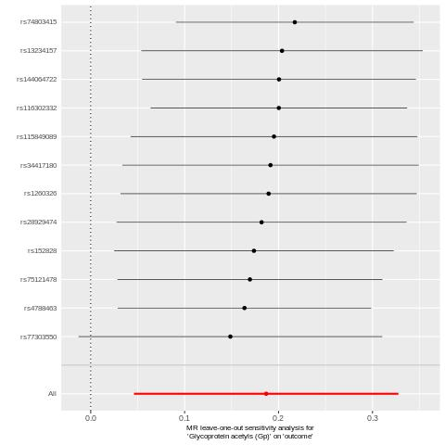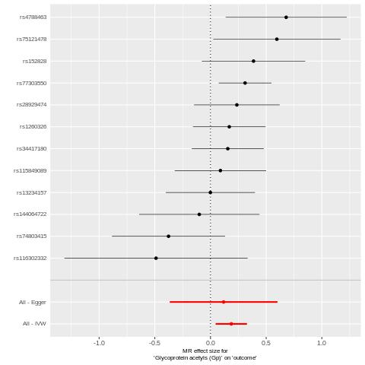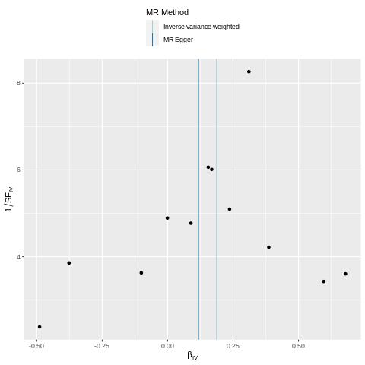
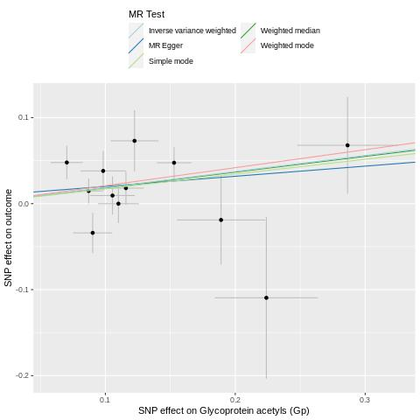

Figure S2. The leave-one-out plot, forest plot, funnel plot, and scatter plot for the association of glutamine and Alzheimer’s disease in primary analysis.
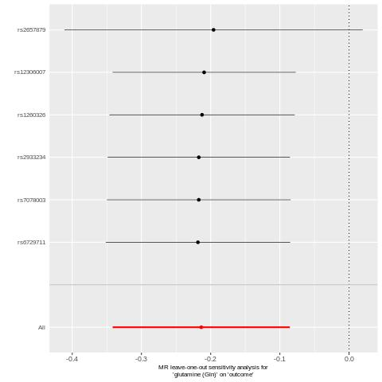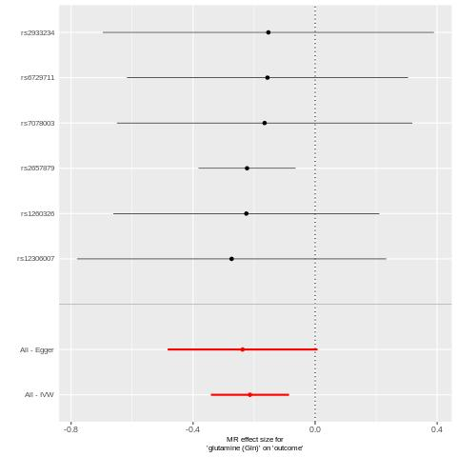
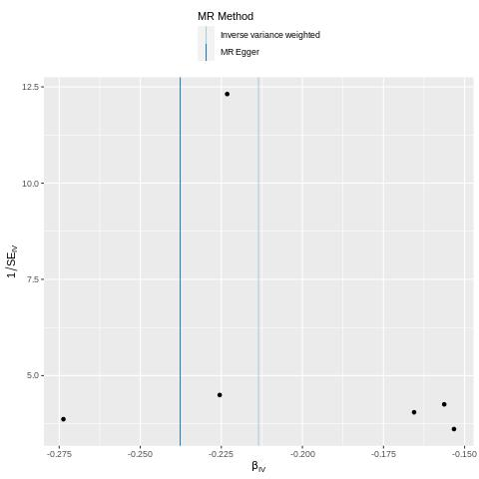
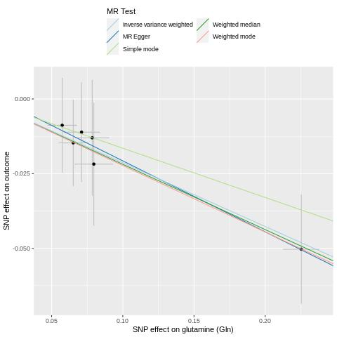

Figure S3. The leave-one-out plot, forest plot, funnel plot, and scatter plot for the association of ApoB and Alzheimer’s disease in primary analysis.
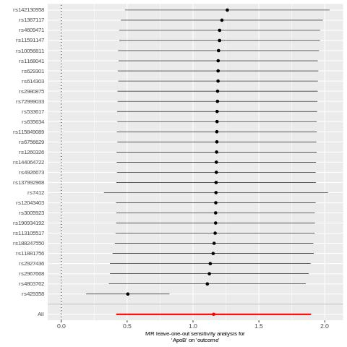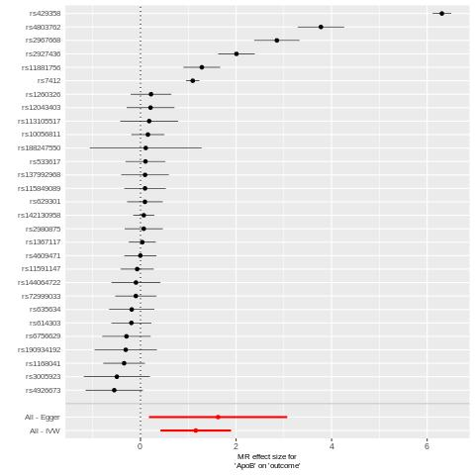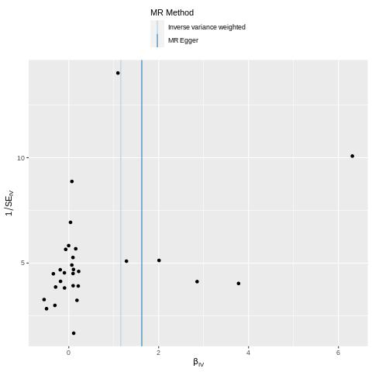
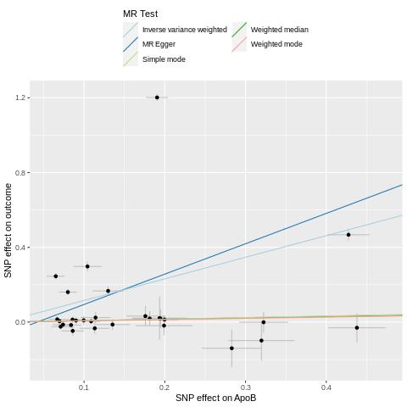

Figure S4. The leave-one-out plot, forest plot, funnel plot, and scatter plot for the association of LDL-C and Alzheimer’s disease in primary analysis.
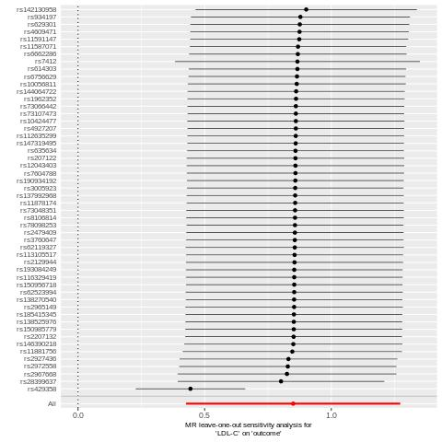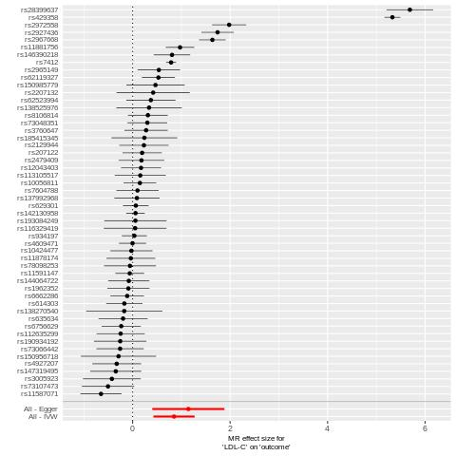
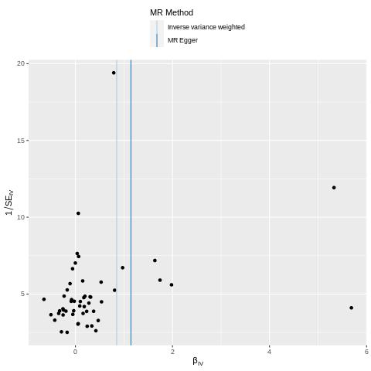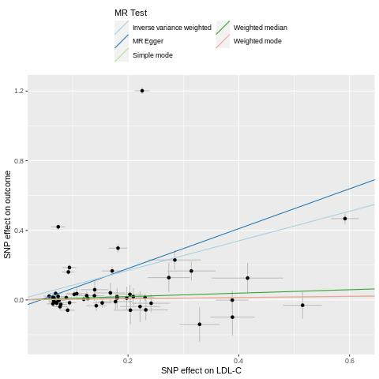

Figure S5. The leave-one-out plot, forest plot, funnel plot, and scatter plot for the association of Serum-C and Alzheimer’s disease in primary analysis.
