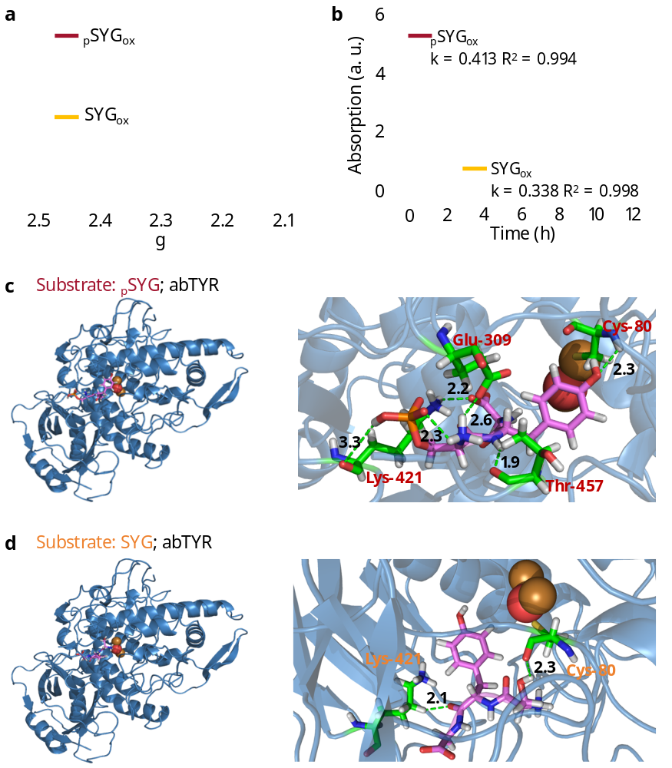
Extended Data Fig. 1. Kinetics of enzymatic production of phosphomelanin. a, EPR spectra of _{p}SYG_{ox} and SYG_{ox}. No significant signals corresponding to the g factor were observed within the range of 2.05 to 2.5, suggesting that the melanin-producing pathway dominated the whole reaction. b, The dynamic curve of _{p}SYG_{ox} and SYG_{ox} that was catalyzed by abTYR (absorbance at 482 nm). Results show that phosphorus-bearing substrates (_{p}SYG) exhibit higher enzymatic reaction efficiency compared to substrates without phosphorus (SYG). Molecular docking and energy analysis between abTYR (PDB ID: 5m6b) and (c) _{p}SYG or (d) SYG. More hydrogen bonds were formed between abTYR and _{p}SYG. That led to stronger affinity of _{p}SYG and abTYR. The protein main chains are displayed as ribbons, and the key amino acid residues are highlighted as sticks.
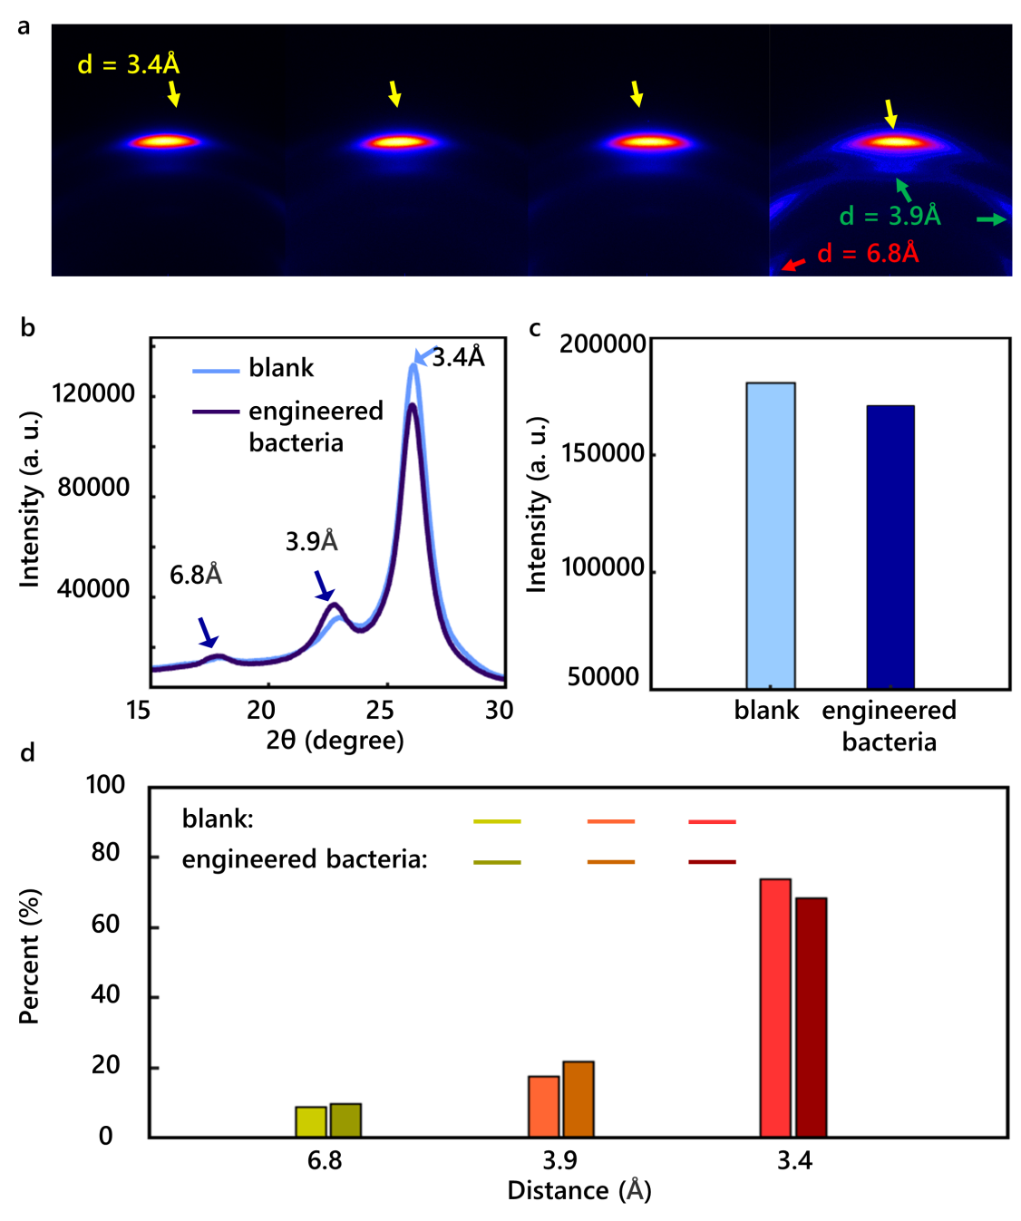
Extended Data Fig. 2. XRD measurements confirmed changes in the crystallographic orientation of the PET film as the degeneration progressed. a-b, The PET film exhibited three distinct intensity peaks, where the in-plane crystallographic orientations were represented by peaks with d-spacings of 6.8 Å and 3.9 Å, and the out-of-plane orientation was indicated by a peak with a d-spacing of 3.4 Å. The results showed a decrease in all three crystallographic orientations during the engineered bacteria-induced degeneration, with the out-of-plane orientation (d = 3.4 Å) demonstrating a more pronounced reduction compared to the in-plane orientations (d = 6.8 Å and d = 3.9 Å). This suggests that the PET polymer films, which are packed perpendicularly to the film plane, are more readily catalyzed by PETase secreted by engineered bacteria. c, Total intensity of crystallographic orientations decreased as degeneration happened, which indicated the PET film turned to disordered as the degeneration went on. d, The statistical analysis of the changes of these three kinds of crystallographic orientations within PET films.
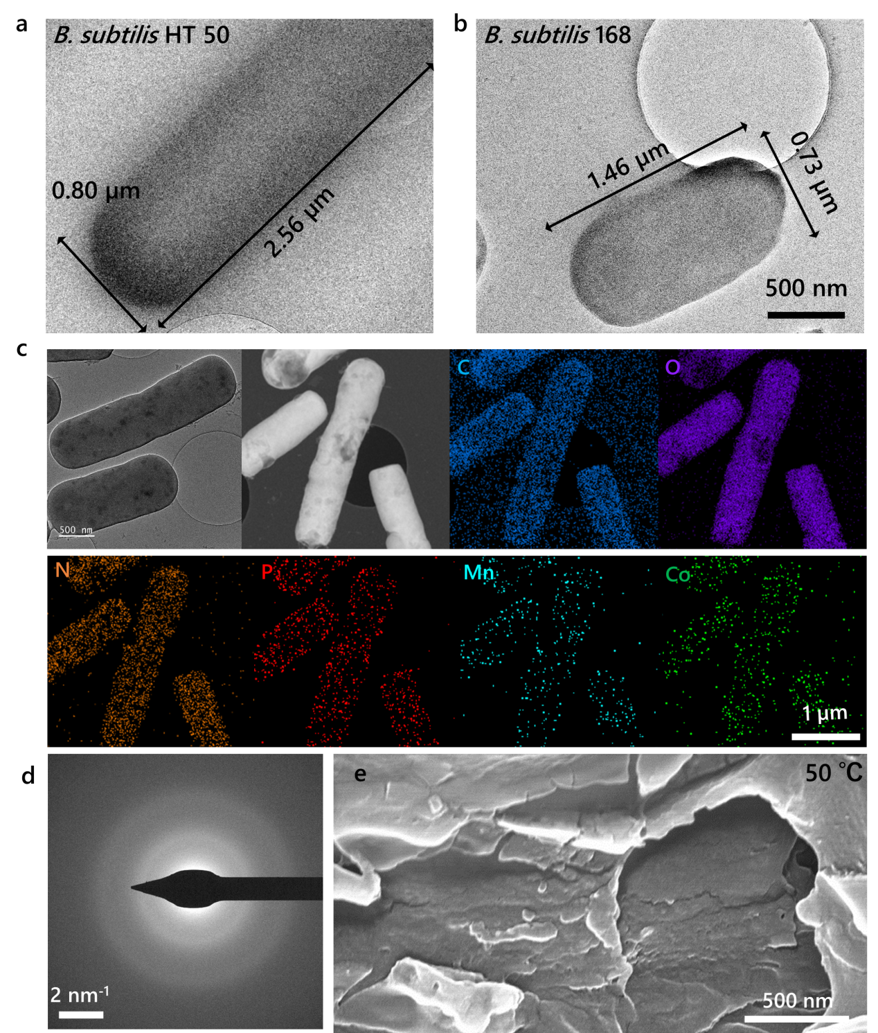
Extended Data Fig. 3. Thermophilic engineered bacteria for metallized plastic waste degradation. The cryo-TEM image of the (a) B. subtilis HT 50 and (b) B. subtilis 168. c-d, The cyro-TEM, EDS, and SAED images of engineered B. subtilis HT 50 bacteria cultured within LB media containing Co^{II} and Mn^{II}. The EDS analysis indicates that these HMs are bonded to phosphorus-containing groups within the bacteria. Furthermore, the SAED images suggest that these HMs did not form inorganic phosphate salts. Collectively, these results confirm that Co^{II} and Mn^{II} were sequestered by organic phosphorus-containing groups derived from phosphomelanin. e, SEM images of PET films treated with engineered thermophilic bacteria over a period of 6 days at a temperature of 50 °C.

