Supporting Information
Novel NiCo₂S₄ nanorods arrays grown on carbon nanofibers as high-performance anodes for sodium ion batteries
Xiaowei Yang¹ • Tongxiang Cai² • Zhongran Yao¹ • Guojie Chao¹
¹ School of Automobile and Traffic Engineering, Wuxi Institute of Technology, Wuxi 214121, China.
² Yadea Technology Group Co., Ltd, Wuxi 214105, China
Corresponding author: Xiaowei Yang
E-mail address: xiaoweiyang215@126.com

Experimental
Materials and Reagents
Polyacrylonitrile (PAN) was purchased from Sigma-Aldrich. Nickel nitrate hexahydrate (Ni(NO₃)₂·6H₂O), cobalt nitrate hexahydrate (Co(NO₃)₂·6H₂O), thiourea, urea and hexamethylenetetramine were purchased from Shanghai Macklin Biochemical Co., Ltd. All reagents were used without further purification.
Preparation of CNF membranes
CNF membranes were synthesized by electrospinning and carbonization process. Typically, 1 g PAN was dissolved in 10 ml DMF with magnetic stirring for 2 h. The electrospinning process was implemented on a vulgaris electrospinning machine. The voltage between the spinneret and the drum-type collector was fixed to 15 kV and the distance was adjusted to 15 cm. After electrospinning, the as-obtained electrospinning membranes were transferred to a tube furnace. These membranes were first pre-oxidized at 200 °C for 2 h in the air atmosphere, then carbonized under the flowing nitrogen atmosphere at 700 °C for 2 h. The CNF membranes were final obtained and marked as CNF.
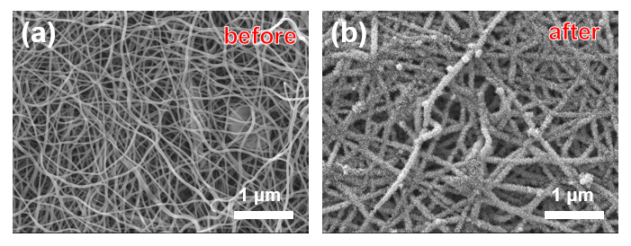
Figure S1 Morphology of carbon fibers before and after hydrothermal treatment.

Table S1 Elemental analysis results of the NiCo₂S₄@CNF from XPS measurements.
Sample | XPS spectra analysis
Sample | C/ at.% | O/ at.% | S/ at.% | Co/ at.% | Ni/ at.%
NiCo₂S₄@CNF | 38.1 | 24.4 | 19.4 | 7.9 | 10.2

Table S2 Comparison of sodium storage performance of NiCo₂S₄@CNF in this work and other related reports in the literatures.
Samples | Structure | Capacity (mAh g⁻¹) | Current density (A g⁻¹) | ICE/% | Ref.
NiCo₂S₄@CNF | nanorods arrays | 683.6 | 0.1 | 90.4 | This work
NiCo₂S₄@CDs | nanosheets | 568.9 | 0.5 | 81.0 | [1]
NiCo₂S₄@MoS₂ | hierarchical | 400 | 0.1 | 66.2 | [2]
NiCo₂S₄@Ni-B | hollow nanospheres | 390.2 | 0.1 | 92 | [3]
NCS@GNs@CNTs | 3D framework | 558.1 | 0.1 | 96 | [4]
NiCo₂S₄ | dodecahedron | 600 | 0.1 | 83.7 | [5]
Flower-like NiCo₂S₄ | flower-like | 748 | 0.1 | 94 | [6]

References
1. Qin, B., Wang, M., Wu, S., Li, Y., Liu, C., Zhang, Y., Fan, H. (2023) Carbon dots confined nanosheets assembled NiCo₂S₄@CDs cross-stacked architecture for enhanced sodium ion storage. Chinese Chem. Lett. 35(7): 108921
2. Liu, B., Kong, D., Wang, Y., Lim, Y. V., Huang, S., Yang, H. Y. (2018) Three-dimensional hierarchical NiCo₂S₄@MoS₂ heterostructure arrays for high performance sodium ion battery. FlatChem. 10:14-21
3. Li, J., Zhou, J., Zhou, Q., Wang, X., Guo, C., Li, M. (2021) Promoting the Na⁺-storage of NiCo₂S₄ hollow nanospheres by surfacing Ni-B nanoflakes. J. Mater. Sci. Technol. 82:114-121
4. Fan, S., Liu, H., Bi, S., Meng, X., Wang, Q., Zhang, K., Chen, Z., Xie, Y. (2023) NiCo₂S₄ nanoparticles anchored in the 3d interpenetrating framework composed of GNs and CNTs toward enhanced sodium storage performance. Electrochim. Acta 441:141760
5. Fan, S., Liu, H., Xie, Y., Bi, S., Meng, X., Zhang, K., Sun, L., Zhang, S., Guo, Z. (2023) Electrolyte engineering on performance enhancement of NiCo₂S₄ anode for sodium storage. Small 19(26): 2300188
6. Miao, Y., Zhao, X., Wang, X., Ma, C., Cheng, L., Chen, G., Yue, H., Wang, L., Zhang, D. (2020) Flower-like NiCo₂S₄ nanosheets with high electrochemical performance for sodium-ion batteries. Nano Res 13(11): 3041-3047

