Phyllosphere microbiome assembly in wild green foxtail: designing synthetic communities for domesticated millet protection
Xiaoyu Zai^{1,2,3,4}, Feng Zhu⁵, Meicheng Zhao^{5,6}, Xianmin Diao⁶, Fusuo Zhang^{1,2,3,4}, Francisco Dini-Andreote^{7,8}, Chrats Melkonian^{9,10}, Marnix H. Medema⁹, Jos M. Raaijmakers^{11,12}, Viviane Cordovez¹¹, Chunxu Song^{1,2,3,4✉}
1 State Key Laboratory of Nutrient Use and Management, College of Resources and Environmental Sciences, China Agricultural University, Beijing, China;
2 National Academy of Agriculture Green Development, China Agricultural University, Beijing, China;
3 Key Laboratory of Plant-Soil Interactions, Ministry of Education, China Agricultural University, Beijing, China;
4 National Observation and Research Station of Agriculture Green Development, Quzhou, Hebei;
5 Key Laboratory of Agricultural Water Resources, Hebei Laboratory of Agricultural Water-Saving, Center for Agricultural Resources Research, Institute of Genetics and Developmental Biology, The Innovative Academy of Seed Design, Chinese Academy of Sciences, 050021 Shijiazhuang, China;
6 Institute of Crop Sciences, Chinese Academy of Agricultural Sciences, 100081 Beijing, China;
7 Department of Plant Science & Huck Institutes of the Life Sciences, The Pennsylvania State University, University Park, PA 16802, USA;
8 The One Health Microbiome Center, Huck Institutes of the Life Sciences, The Pennsylvania State University, University Park, PA, USA;
9 Bioinformatics Group, Wageningen University & Research, 6708 PB Wageningen, the Netherlands;
10 Theoretical Biology and Bioinformatics, Science for Life, Utrecht University, Utrecht, the Netherlands;
11 Department of Microbial Ecology, Netherlands Institute of Ecology, Wageningen, The Netherlands;
12 Institute of Biology, Leiden University, Leiden, the Netherlands
✉e-mail: chunxu.song@cau.edu.cn✉e-mail: chunxu.song@cau.edu.cn

Table S1 Soil and climate factors of seven sampling sites in this study.
 | Fangshan | Luancheng | Shijiazhuang | Taihang  Mountain | Taiyuan | Yangling |  | Zhengzhou
pH | 8.42±0.07 | 9.09±0.05 | 9.12±0.02 | 9.11±0.03 | 8.2±0.03 | 8.23±0.05 |  | 8.52±0.06
NO3⁻-N (mg/kg) | 4.78±3.04 | 35.2±22.2 | 22.66±10.36 | 28.11±11.3 | 10.67±1.15 |  | 13.82±1.49 | 1.75±0.58
NH4⁺-N (mg/kg) | 1.21±0.56 | 3.23±0.83 | 3.42±1.43 | 3.42±1.43 | 2.78±0.77 |  | 3.37±1.4 | 2.85±1.15
AK (g/kg) | 172.28±56.26 | 227.7±25.86 | 235.45±46.32 | 205.65±74.4 | 283.12±3.2 |  | 184.8±5.42 | 85.88±1.46
AP (mg/kg) | 15.69±6.26 | 23.65±8.95 | 17.37±6.04 | 18.73±13.39 | 11.34±1.11 |  | 6.79±0.86 | 10.07±0.22
TK (g/kg) | 17.85±2.05 | 17.27±2.85 | 16.64±1.28 | 17.85±1.37 | 10.33±1.4 |  | 20.54±0.87 | 16.34±0.61
TP (g/kg) | 0.59±0.07 | 0.82±0.26 | 0.69±0.16 | 0.62±0.22 | 0.7±0.05 |  | 0.94±0.03 | 0.61±0.01
TN (g/kg) | 0.07±0.02 | 0.13±0.03 | 0.15±0.05 | 0.19±0.11 | 0.17±0.04 |  | 0.13±0.01 | 0.03±0.01
SOC (g/kg) | 0.73±0.25 | 1.25±0.25 | 1.62±0.61 | 2.06±1.42 | 3.43±0.42 |  | 0.86±0.03 | 0.2±0
Altitude (m) | 39.71±3.33 | 44.38±4.03 | 63.72±0 | 347.84±3.85 | 766.33±0 |  | 417.21±0 | 89.53±0
Longitude | 116.18.01 | 114.69 | 114.53 | 114.25 | 112.43 |  | 108.02 | 113.53
Latitude | 39.77.01 | 37.89 | 38.03 | 37.9 | 37.68 |  | 34.25 | 34.83
MAT (℃) | 11.72 | 13.09 | 10.56 | 13.61 | 10.42 |  | 12.55 | 15.48
AT (℃) | 1956.3 | 2223.7 | 1173.6 | 2273.1 | 1730.3 |  | 1966.7 | 2528
RH (%) | 47.37 | 52.93 | 47.1 | 50.51 | 48.22 |  | 66.55 | 52.75
MAP (mm) | 0.55 | 0.5 | 0.92 | 0.45 | 0.77 |  | 1.21 | 0.79
AS (h) | 1161.3 | 1191.7 | 1256.6 | 1195.4 | 1106 |  | 570.3 | 985.7
AR (MJ/m²) | 3061.906 | 3180.545 | 3177.874 | 3173.428 | 2805.101 |  | 3038.888 | 3210.522
NO₃⁻-N, nitrate nitrogen; NH₄⁺-N, ammonium nitrogen; AK, available potassium; AP, available phosphorus; TK, total potassium; TP, total phosphorus; TN, total nitrogen; SOC, soil organic carbon; MAT, mean annual temperature; AT, accumulated temperature; RH, relative humidity; MAP, mean annual precipitation; AS, accumulated sunshine duration; AR, annual cumulative solar radiation.
Note: Data are mean ± standard deviation (n = 6).
Table S2 The Explained variance of soil and climate factors on phyllosphere microbial community assemblages based on ASVs distance matrices (Bray Curtis dissimilarities) using PERMANOVA partitioning
 | Bacteria |  |  |  | Fungi
 | df | F | R² | P | df | F | R² | P
Group pH | 1 | 5.849 | 0.102 | 0.001 | 1 | 7.93 | 0.126 | 0.001
NO3 | 1 | 2.208 | 0.039 | 0.003 | 1 | 3.62 | 0.057 | 0.001
NH4 | 1 | 1.736 | 0.03 | 0.026 | 1 | 2.566 | 0.041 | 0.008
Group AK | 1 | 3.377 | 0.059 | 0.001 | 1 | 2.231 | 0.035 | 0.026
AP | 1 | 1.651 | 0.029 | 0.02 | 1 | 2.385 | 0.038 | 0.009
TK | 1 | 3.637 | 0.064 | 0.001 | 1 | 1.936 | 0.031 | 0.046
TP | 1 | 2.013 | 0.035 | 0.002 | 1 | 1.479 | 0.023 | 0.116
Group MAT | 1 | 1.661 | 0.029 | 0.025 | 1 | 4.102 | 0.065 | 0.001
MAP | 1 | 2.156 | 0.038 | 0.002 | 1 | 2.846 | 0.045 | 0.001
AR | 1 | 1.978 | 0.035 | 0.004 | 1 | 2.887 | 0.046 | 0.002
Residuals | 31 | NA | 0.541 | NA | 31 | NA | 0.492 | NA
Total | 41 | NA | 1 | NA | 41 | NA | 1 | NA
Group pH includes the factors pH, altitude, latitude, longitude, RH (relative humidity) and AS (accumulated sunshine duration). Group AK (available potassium) includes the factors AK, TN (total nitrogen) and SOC (soil organic carbon). Group MAT includes the factors AT (accumulated temperature) and MAT (mean annual temperature).

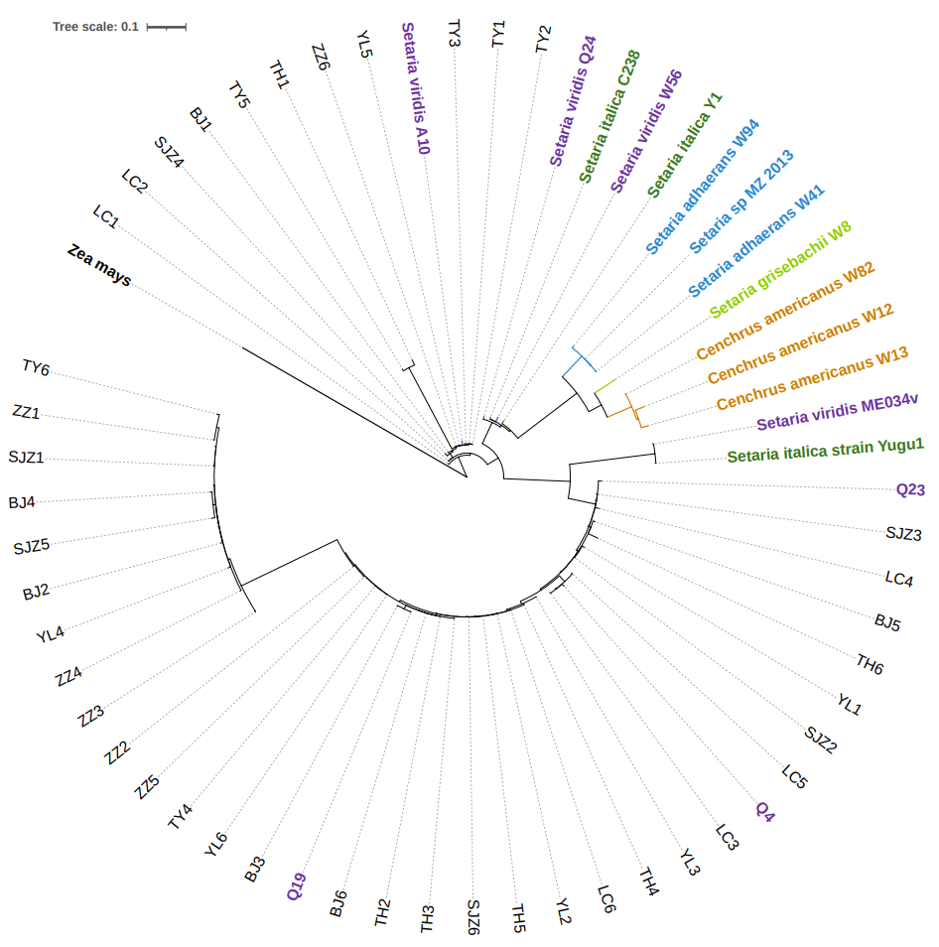
Fig. S1 Phylogeny of Seteria based on the concatenation of 5S rDNA and kn1 gene sequences. Black fonts represent the samples utilized in this study, bold black font represent the outgroup Zea mays, while other colors represent different Seteria genera including S. viridis (green foxtail) colored in purple.
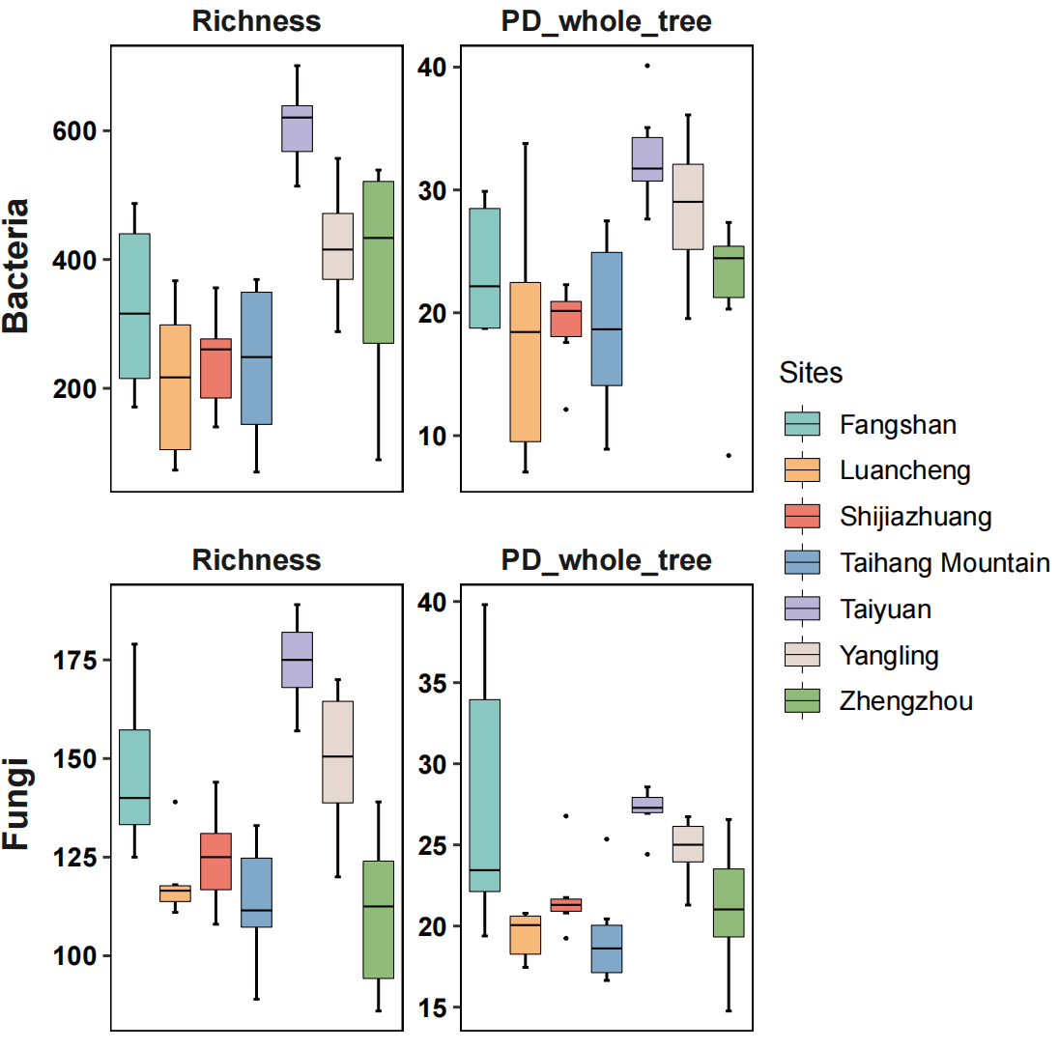
Fig. S2 The alpha diversity including richness and PD_whole_trree. Different colors represent different sites.

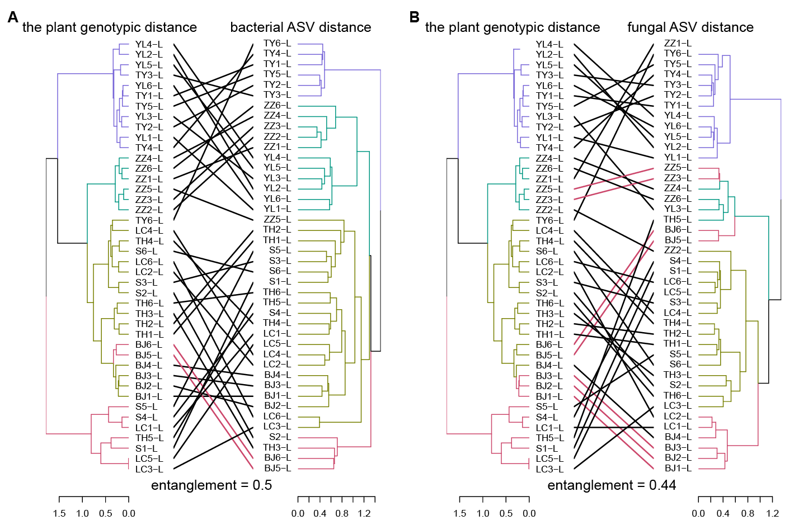
Fig. S3 Correlation between the green foxtail genetic distance and the microbial community composition. A-B Tanglegrams displaying the entanglement between the green foxtail genetic distance based on the SNP analysis and the phyllosphere microbiome based on 16S rRNA gene (bacteria) and ITS1 region (fungi) amplicon analysis across 42 samples from seven sites.

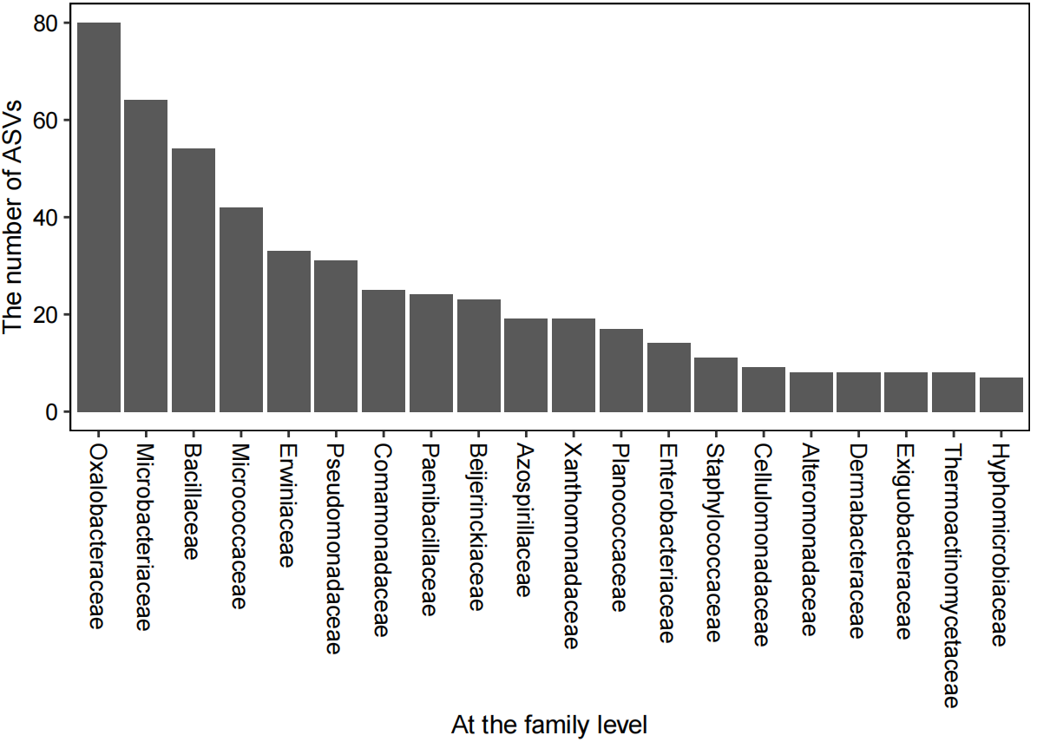
Fig. S4 The number of ASVs belonging to top 20 families of the top 20 bins based on the relative importance to bacterial community assembly. All bacterial ASVs were clustered into 71 groups (bins) with varied relative importance to bacterial community assembly via phylogenetic bin-based null model analysis (“iCAMP” package). The top 20 bins, based on the relative importance to bacterial community assembly, belonged to 75 families. Top 20 families, based on the ASV numbers, were selected to be shown.

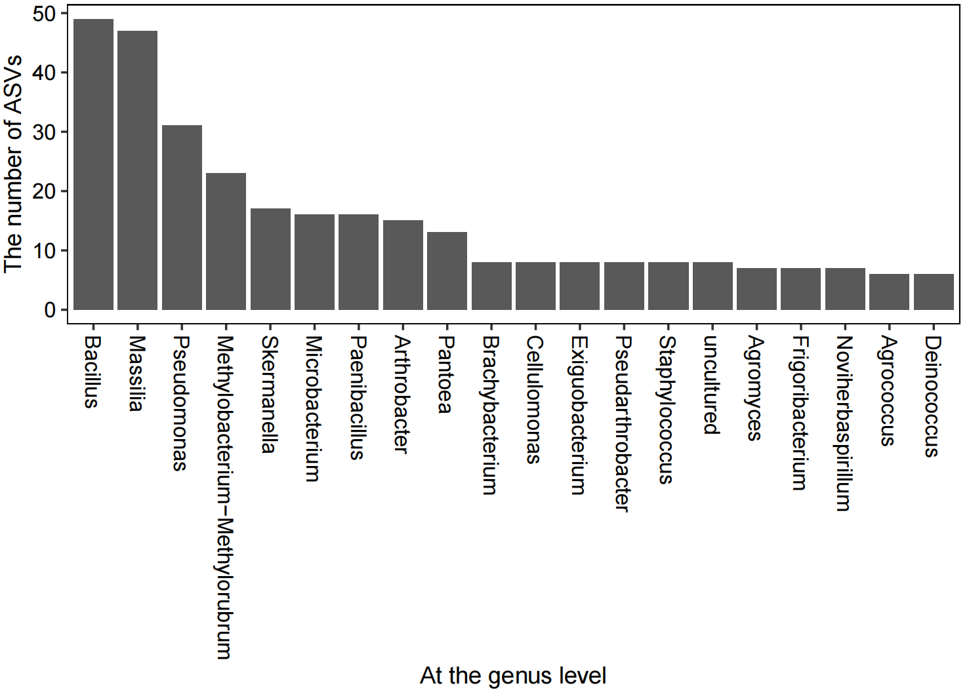
Fig. S5 The number of ASVs belonging to top 20 genera of the top 20 bins based on the relative importance to bacterial community assembly. All bacterial ASVs were clustered into 71 groups (bins) with varied relative importance to bacterial community assembly via phylogenetic bin-based null model analysis (“iCAMP” package). The top 20 bins, based on the relative importance to bacterial community assembly, belonged to 133 genera. Top 20 genera, based on the ASV numbers, were selected to be shown.

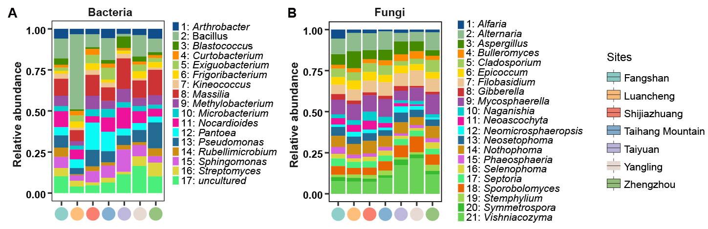
Fig. S6 A, B Dominant bacterial and fungal genera with relative abundance more than 0.01 shown by stacked bar chart. Different colors of the bar represent different genera. Points with different colors on the abscissa represent seven sites.

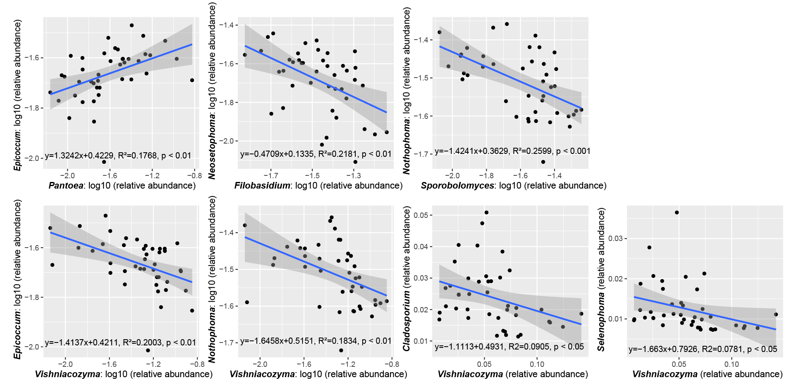
Fig. S7 The correlations between core bacterial as well as yeast genera and putative fungal pathogenic genera shown by fitting linear models.

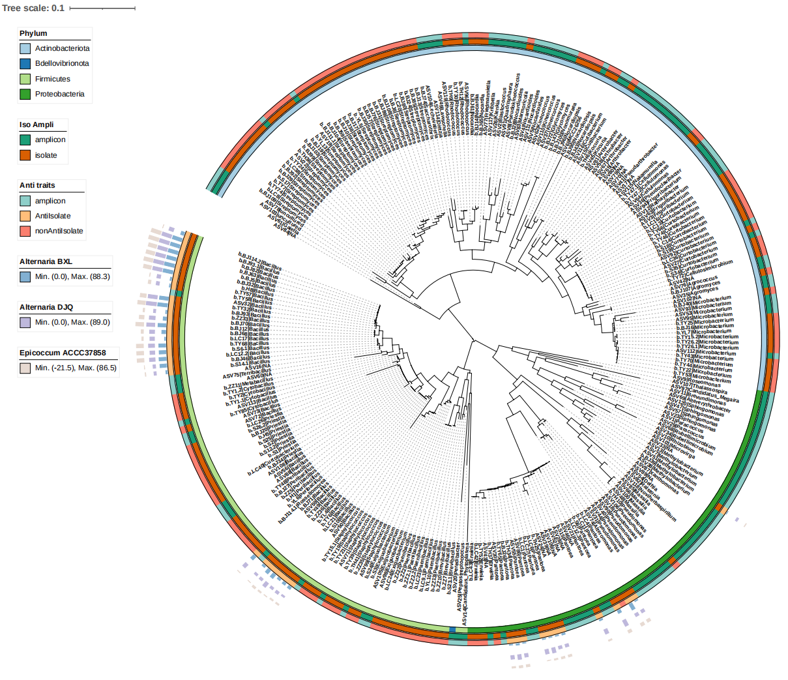
Fig. S8 Phylogenetic tree of 162 bacterial isolates and ASVs occurred in more than 50% samples. From the inside to the outside, the three rings represent “Phylum”, “Iso Ampli”, and “Anti traits”, respectively. Bars represent the value of inhibition percentage against pathogens in dural culture assay. In “Iso Ampli” group, “amplicon” and “isolate” mean ITS sequences obtained via high-throughput sequencing and sanger sequencing, respectively. In “Anti traits” group, “AntiIsolate” and “nonAntiIsolate” mean that isolates used and not used in dural culture assay, respectively. Bars of different colors represent different pathogen strains (Alternaria alternata BXL, A. alternata DJQ and Epicoccum nigrum ACCC37858) used in dural culture assay.

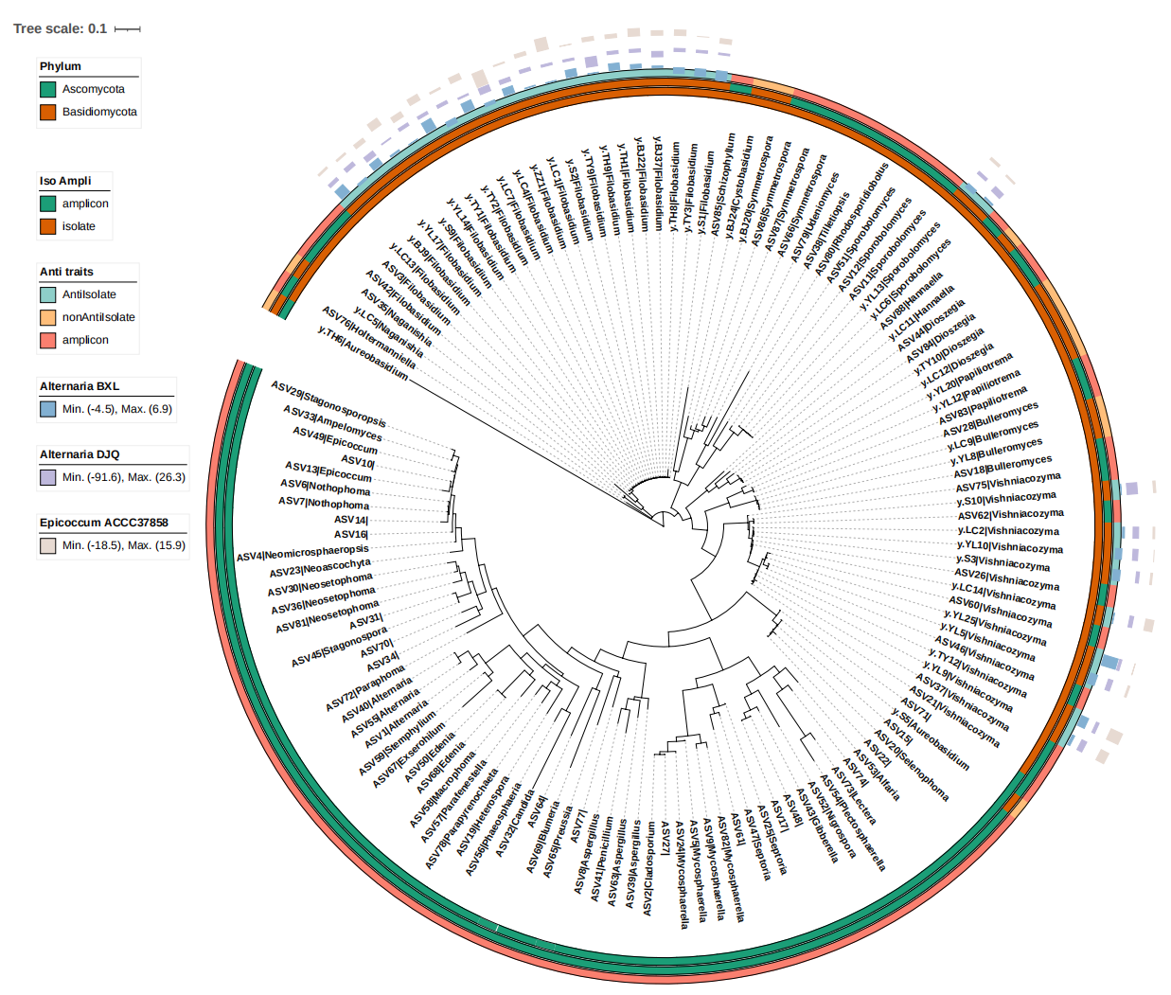
Fig. S9 Phylogenetic tree of 43 yeast isolates and ASVs occurred in more than 50% samples based on ITS sequences. From the inside to the outside, the three rings represent “Phylum”, “Iso Ampli”, and “Anti traits”, respectively. Bars represent the value of inhibition percentage against pathogens in dural culture assay. In “Iso Ampli” group, “amplicon” and “isolate” mean ITS sequences obtained via high-throughput sequencing and sanger sequencing, respectively. In “Anti traits” group, “AntiIsolate” and “nonAntiIsolate” mean that isolates used and not used in dural culture assay, respectively. Bars of different colors represent different pathogen strains (Alternaria alternata BXL, A. alternata DJQ and Epicoccum nigrum ACCC37858) used in dural culture assay.

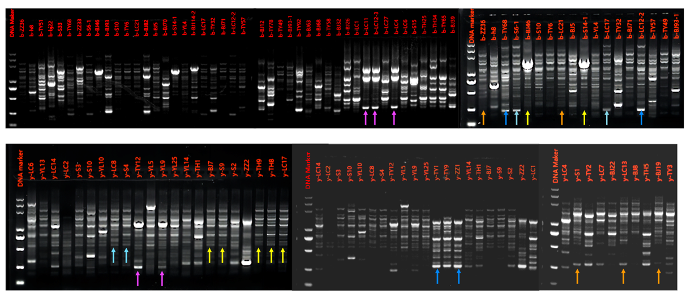
Fig. S10 Fingerprint patterns of the 34 bacterial strains and 23 yeast isolates typed using BOX-PCR. Arrows with the same color represent the same fingerprint pattern of the isolates.
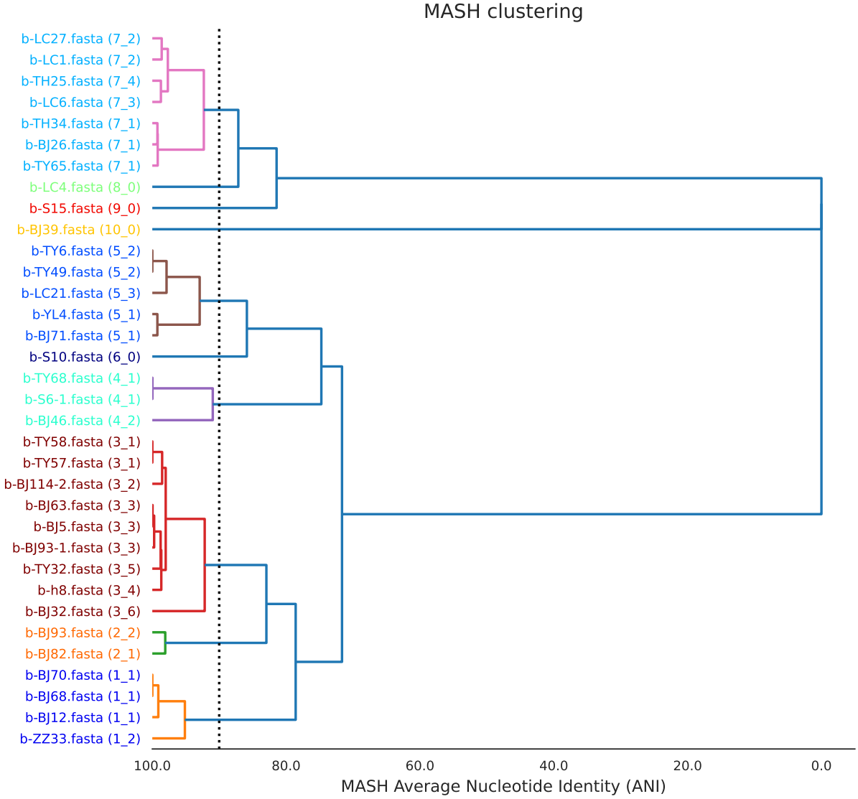
Fig. S11 Average nucleotide identity (ANI)-based phylogenetic tree of 34 bacterial isolates constructed by MASH clustering for the primary clustering dendrogram. The dotted line represents 90% ANI. Different colors represent different primary clusters. The same cluster number in parentheses indicates that the genomes similarity is more than 99% (considered to be the same isolate).

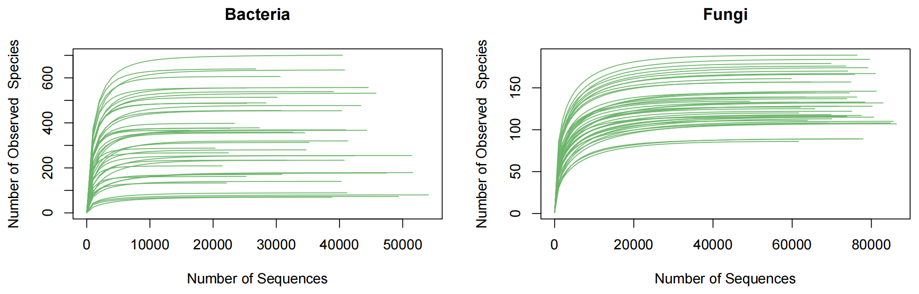
Fig. S12 Rarefaction curves of quality-controlled reads.

