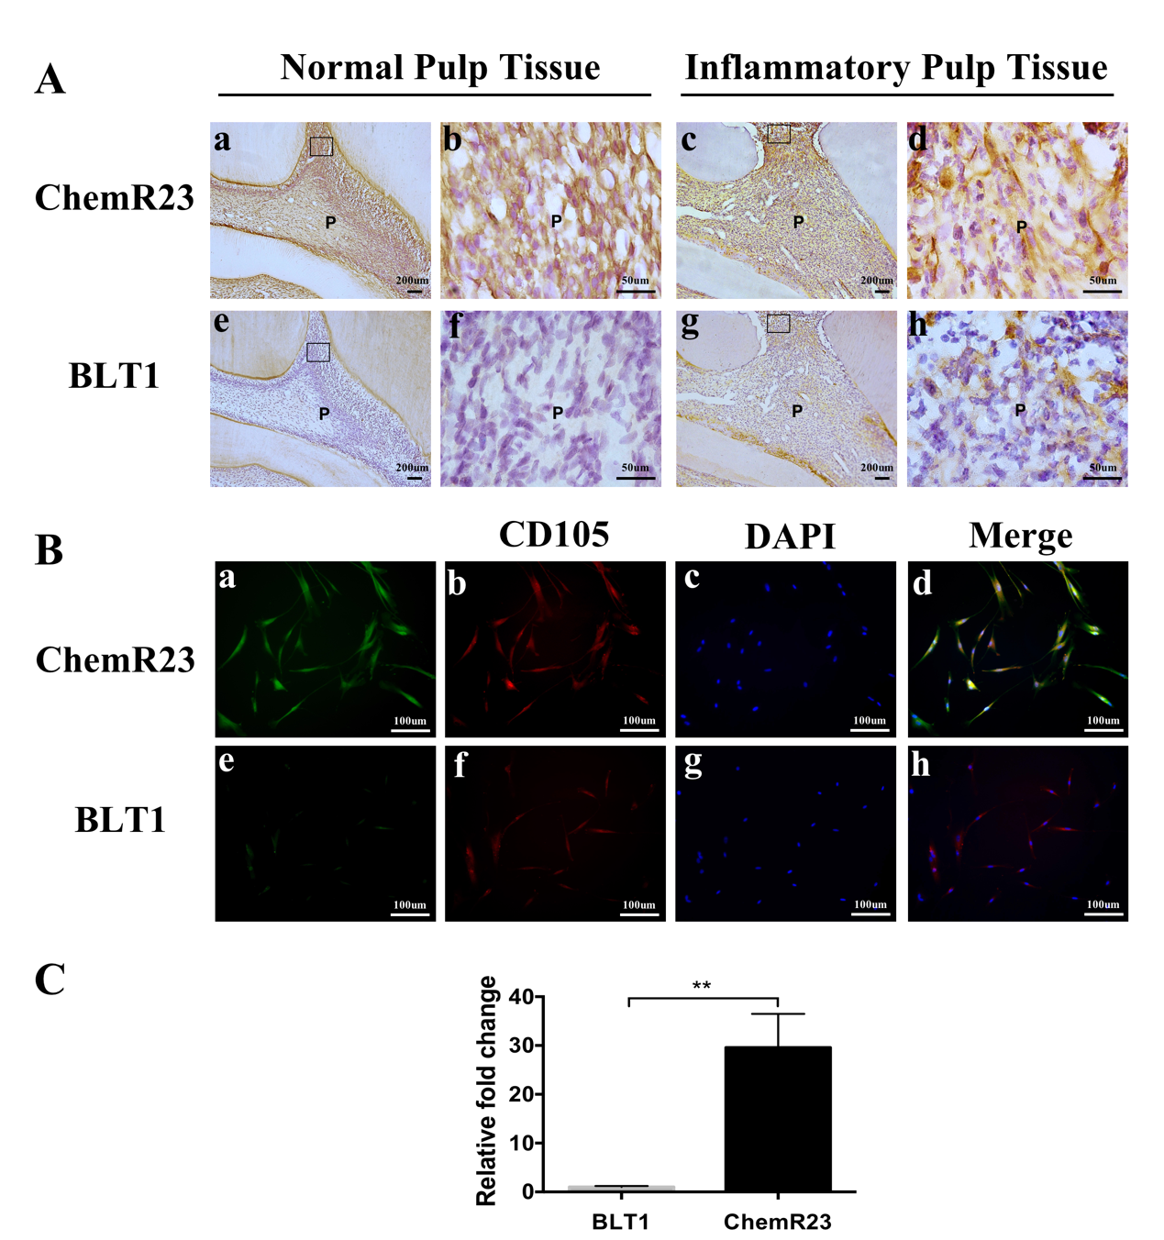

Figure.S1 The expression of the receptors of RvE1 in rat dental pulp tissue and hDPSCs (A, B). Quantification of ChemR23 and BLT1 in hDPSCs (C). (b, d, f, h) Higher-magnification views of boxed areas in panels a, c, e, and g. P, Pulp. **P < 0.01.

