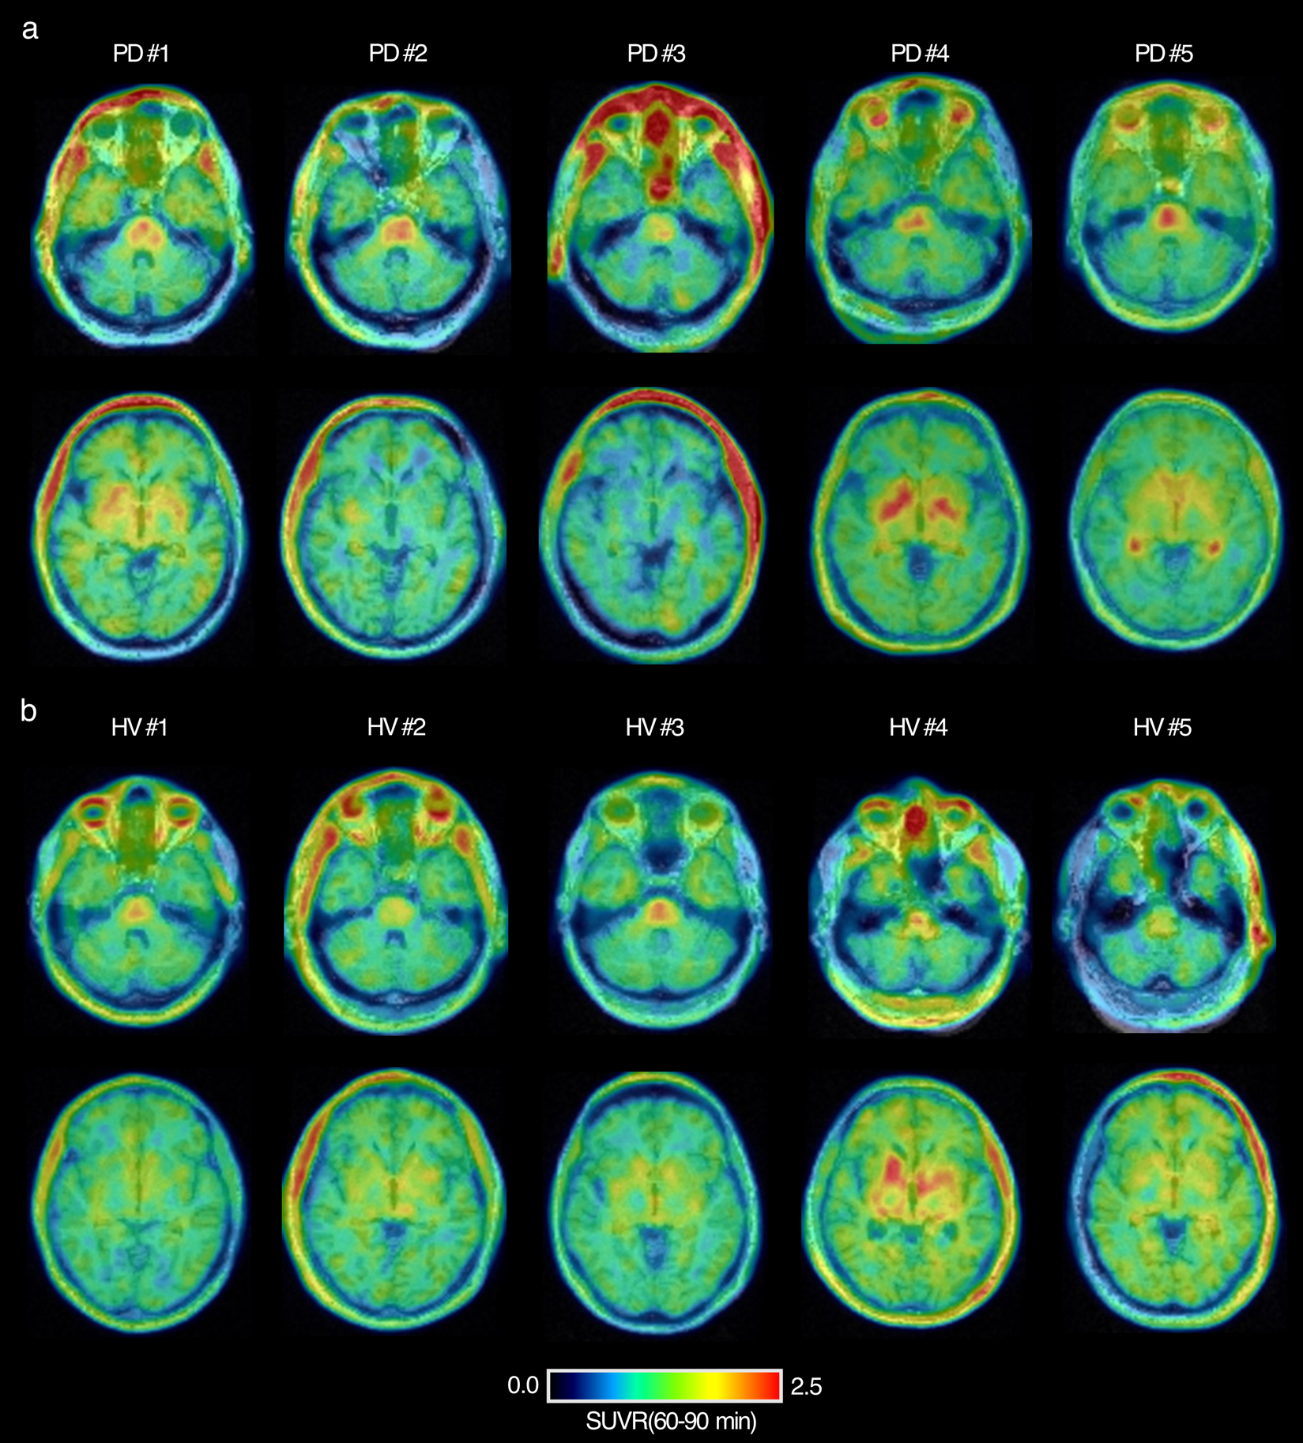

Supplementary Figure 1.
a. Axial images at the level of the MCP (top) and basal ganglia (bottom) for the participants in the Parkinson’s Disease (PD) group. b. Axial images at the level of the MCP (top) and basal ganglia (bottom) for the participants in the healthy volunteers (HV) group.
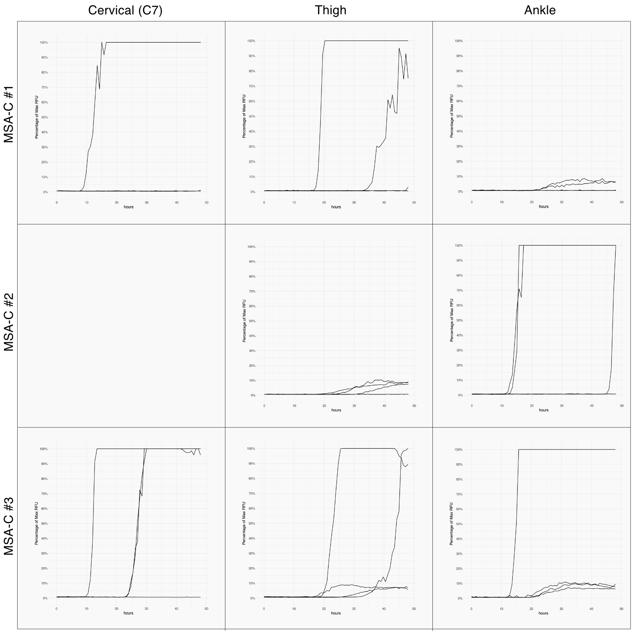

Supplementary Figure 2.
Fluorescence vs time skin ɑSyn-SAA curves for each skin biopsy in the MSA-C group. Subject MSA-C #2 did not consent to a cervical skin biopsy, therefore, only the distal thigh and ankle were biopsied.
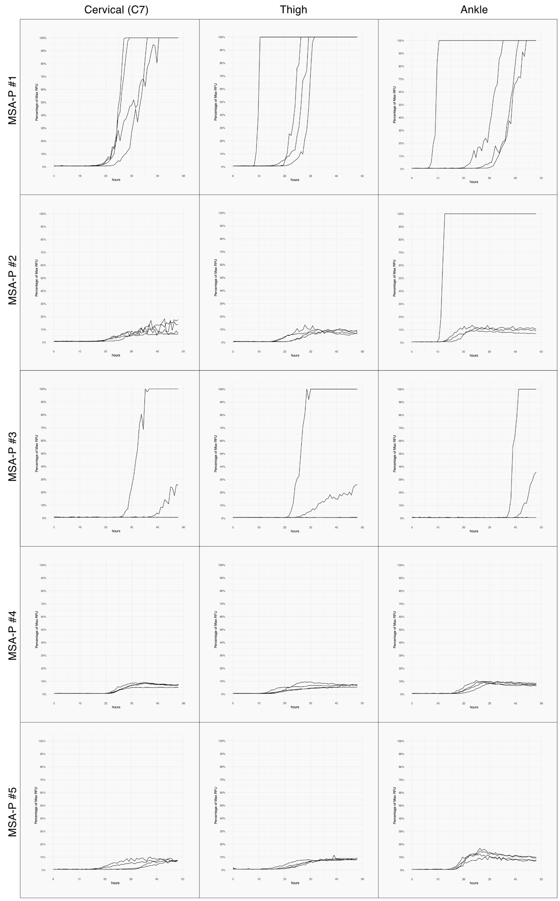

Supplementary figure 3.
Fluorescence vs time skin ɑSyn-SAA curves for each skin biopsy in the MSA-P group.
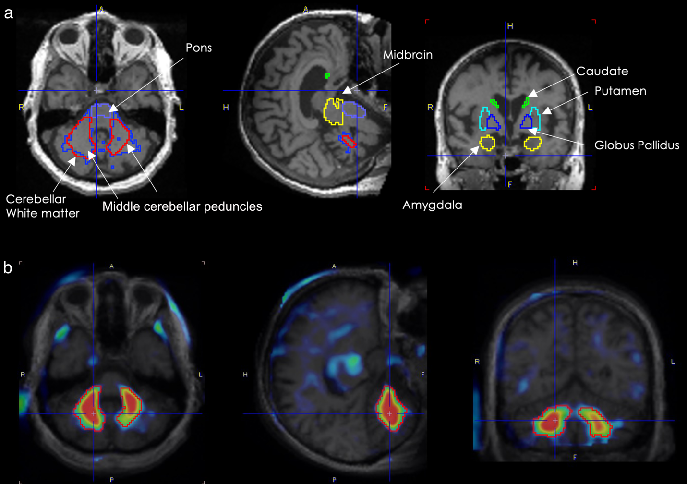

Supplementary figure 4.
a. Key volumes of interest (VOIs) analyzed in [18F]ACI-12589 PET and T1-weighed MR co-registration. b. PET image-derived cerebellar white matter tracts VOI. SUVR (60-90 min) images were averaged for MSA-C (n=3) subjects and healthy volunteer (HV) control (n=5) subjects. An SUVR difference map was created by subtracting the mean images, SUVR (MSA-C) – SUVR (HV). The contouring tool in PMOD was used to generate the cerebellar white matter tract VOI, outlined in red.
Supplementary Table 1
Baseline demographics for all subjects in the study.

Subject | Age | Sex | Diagnostic certainty | Motor onset | MDS UPDRS Total | MDS UPDRS Part III | UMSARS Part I & II | H-Y | MoCA
HV 1 | 43 | Male | - | - | - | - | - | - | 29
HV 2 | 55 | Male | - | - | - | - | - | - | 26
HV 3 | 52 | Female | - | - | - | - | - | - | 29
HV 4 | 74 | Male | - | - | - | - | - | - | 26
HV 5 | 69 | Male | - | - | - | - | - | - | 29
PD 1 | 64 | Male | Idiopathic PD | - | 78 | - | - | 2 | 28
PD 2 | 69 | Male | Idiopathic PD | - | 50 | - | - | 2 | 28
PD 3 | 67 | Male | Idiopathic PD | - | 81 | - | - | 2 | 22
PD 4 | 73 | Male | Idiopathic PD | - | 70 | - | - | 2 | 22
PD 5 | 62 | Female | Idiopathic PD | - | 48 | - | - | 2 | 27
MSA- P 1 | 80 | Male | Probable | 2018 | 84 | 45 | - | 2 | 20
MSA-P 2 | 63 | Male | Probable | 2019 | 60 | 41 | 37.5 | 2 | 30
MSA-P 3 | 71 | Male | Probable | 2017 | 74 | 41 | 37 | 2 | 28
MSA-P 4 | 71 | Female | Probable | 2021 | 122 | 62 | 66 | 5 | 27
MSA-P 5 | 70 | Female | Probable | 2020 | 125 | 66 | 60 | 5 | 21
MSA-C 1 | 80 | Male | Established | 2015 | 95 | 56 | - | 4 | 23
MSA-C 2 | 72 | Female | Probable | 2019 | 56 | 106 | 56 | 5 | 26
MSA-C 3 | 59 | Male | Probable | 2020 | 30 | 36 | 30 | 2 | 24

Supplementary Table 2
Standardized uptake value ratios (SUVRs) for key volumes of interest (VOIs) across all groups. SUVRs were computed over 60-90 minutes after [18F]ACI-12589 injection using the cerebellar cortex as the region of reference.

Subject | Amygdala | Caudate | CWM | MCP | Cerebellum | Midbrain | Pallidum | Pons | Putamen
HV 1 | 1.41 | 1.09 | 1.11 | 1.12 | 1.21 | 1 | 1.19 | 1.64 | 1.15
HV 2 | 1.35 | 1.02 | 1.03 | 1.03 | 1.28 | 1.05 | 1.37 | 1.41 | 1.29
HV 3 | 1.37 | 1.22 | 1.05 | 1.06 | 1.27 | 1.02 | 1.34 | 1.71 | 1.31
HV 4 | 2.05 | 1.39 | 1.21 | 1.2 | 1.74 | 1.19 | 1.98 | 1.99 | 1.83
HV 5 | 1.38 | 1.12 | 1.02 | 0.97 | 1.29 | 1.21 | 1.41 | 1.58 | 1.47
PD 1 | 1.54 | 1.17 | 1.13 | 1.13 | 1.41 | 1.14 | 1.67 | 1.64 | 1.68
PD 2 | 1.33 | 0.69 | 1.14 | 1.15 | 0.98 | 0.98 | 1.04 | 1.75 | 1.05
PD 3 | 1.14 | 0.62 | 0.98 | 0.96 | 0.87 | 0.97 | 0.85 | 1.35 | 0.94
PD 4 | 1.59 | 1.19 | 1.12 | 1.13 | 1.47 | 1.11 | 2.1 | 1.54 | 1.54
PD 5 | 1.62 | 1.34 | 1.13 | 1.13 | 1.42 | 1.04 | 1.58 | 1.93 | 1.47
MSA-P 1 | 1.97 | 1.06 | 1.14 | 1.14 | 1.19 | 1.15 | 1.51 | 1.77 | 1.49
MSA-P 2 | 1.47 | 1.08 | 1.18 | 1.17 | 1.39 | 1.07 | 1.68 | 1.7 | 1.63
MSA-P 3 | 1.54 | 1.04 | 1.13 | 1.13 | 1.42 | 1.08 | 1.46 | 1.87 | 1.47
MSA-P 4 | 1.18 | 0.78 | 1.18 | 1.21 | 1.06 | 0.9 | 1.37 | 1.47 | 1.23
MSA-P 5 | 1.68 | 1.14 | 1.14 | 1.13 | 1.46 | 0.98 | 3.38 | 2.01 | 2.55
MSA-C 1 | 1.47 | 1.52 | 1.54 | 1.65 | 1.47 | 1.21 | 2.06 | 1.73 | 1.87
MSA-C 2 | 1.38 | 1.37 | 1.77 | 1.53 | 1.43 | 0.99 | 1.8 | 1.65 | 1.46
MSA-C 3 | 1.03 | 0.75 | 1.57 | 1.73 | 0.97 | 0.81 | 1.07 | 1.46 | 0.96

Supplementary Table 3
ɑSyn-SAA results and amplification kinetics parameters for all biopsies in the MSA cohort.

Case | Site | Ratio* | Pattern | Lag Time (mean) | Lag Time (SD) | Fluorescence % (mean) | Fluorescence % (SD)
MSA-C #1 | C7 | 0.25 | Negative | NA | NA | NA | NA
MSA-C #1 | Ankle | 0.5 | Negative | NA | NA | NA | NA
MSA-C #1 | Thigh | 0.5 | Negative | NA | NA | NA | NA
MSA-C #2 | Ankle | 0.5 | Negative | NA | NA | NA | NA
MSA-C #2 | Thigh | 0.75 | MSA | 27.75 | 5.41 | 6.93 | 4.19
MSA-C #3 | C7 | 0.75 | PD | 19.5 | 7.79 | 75.21 | 49.59
MSA-C #3 | Ankle | 1 | MSA | 19.125 | 4.64 | 32.20 | 45.23
MSA-C #3 | Thigh | 1 | MSA | 25.3125 | 7.38 | 54.06 | 53.06
MSA-P #1 | Thigh | 1 | PD | 17.25 | 5.91 | 100.00 | 0.00
MSA-P #1 | C7 | 1 | PD | 20.25 | 2.60 | 100.00 | 0.00
MSA-P #1 | Ankle | 1 | PD | 21.9375 | 10.56 | 100.00 | 0.00
MSA-P #2 | Ankle | 1 | MSA | 14.25 | 3.06 | 33.57 | 44.32
MSA-P #2 | C7 | 1 | MSA | 21.75 | 3.00 | 13.43 | 5.48
MSA-P #2 | Thigh | 1 | MSA | 21 | 3.92 | 10.17 | 2.36
MSA-P #3 | Thigh | 0.5 | Negative | NA | NA | NA | NA
MSA-P #3 | Ankle | 0 | Negative | NA | NA | NA | NA
MSA-P #3 | C7 | 0.25 | Negative | NA | NA | NA | NA
MSA-P #4 | C7 | 1 | MSA | 23.625 | 0.75 | 7.99 | 1.78
MSA-P #4 | Thigh | 1 | MSA | 17.625 | 2.49 | 7.46 | 1.66
MSA-P #4 | Ankle | 1 | MSA | 19.5 | 2.21 | 9.89 | 0.57
MSA-P #5 | Ankle | 1 | MSA | 17.4375 | 0.72 | 13.80 | 2.67
MSA-P #5 | C7 | 1 | MSA | 26.8125 | 8.45 | 8.48 | 1.25
MSA-P #5 | Thigh | 1 | Inconclusive | 13.875 | 2.77 | 100.00 | 0.00
Retest
MSA-P#3 | Thigh | 0.25 | Negative | NA | NA | NA | NA
MSA-C #1 | Ankle | 0.5 | Negative | NA | NA | NA | NA
MSA-P #5 | Thigh | 1 | MSA | 20.44 | 2.83 | 9.34 | 1.53

*All samples were tested in quadruplicate and the ratio of positive replicates was calculated as (positive replicates)/4. Biopsies were considered positive when at least 75% (3/4) replicates were positive for ɑSyn amplification. Kinetic parameters (maximal fluorescence and lag time) were computed for biopsies with a positive result. Samples were retested when at least 2/4 replicates were positive in a clinical setting suggestive of a synucleinopathy or when the initial SAA pattern was inconsistent with the clinical diagnosis (in such cases data from all tests was considered for calculation).
MSA Core Clinical Features and Case Descriptions

MSA-C #1
The patient was a 78-year-old man with a past medical history (PMH) of hyperlipidemia and a 40-year history of essential tremor (ET), who presented to the clinic with progressive incoordination and imbalance of five years duration. Prodromal history included a two-year history of RBD, constipation, urinary dysfunction, and orthostatic hypotension. He reported erectile dysfunction for three years. Family history was pertinent for brother and son with ET but no parkinsonism. Risk factors included exposure to chemicals, including lead, during several decades of work as a chemical engineer.

On the initial visit, he was noted to have ataxia with dysarthria, bilateral mild dysmetria on finger-to-nose (FTN) and bilaterally impaired heel-to-shin (HTS) worse on the left, inability to tandem and slightly slowed pursuit, saccadic intrusions, and hypometric saccades. BARS was 9. He had no clear bradykinesia, and the exam was also notable for peripheral neuropathy. Outside DaTscan one year earlier, it was read as possible decreased radiotracer uptake in the left putamen, but not suggestive of parkinsonism and likely normal. Given his ataxia and dysautonomia, further investigation for MSA-C was initiated over the next year. MRI of the brain one year after presentation showed moderate small vessel disease, atrophy of the cerebellum, pons, medulla, and middle cerebellar peduncles (MCPs), and faint pontine hot cross buns sign. The FDG PET brain that year showed cerebellar and brainstem hypometabolism, as well as normal FDG uptake in the cortex, caudate, putamen, and thalami, consistent with MSA-C. Autonomic function testing (AFT) showed widespread autonomic failure and small fiber neuropathy, with autonomic failure disproportionate to the small fiber neuropathy, consistent with a neurodegenerative process affecting the central nervous system (CNS). Over the next three years, his condition worsened; he ambulated only with a walker, required an indwelling urinary catheter, and had significant dysarthria and ataxia. His parkinsonism was unresponsive to up to 800 mg daily levodopa. Based upon his core features of dysautonomia, parkinsonism unresponsive to levodopa, cerebellar syndrome, supportive features of rapidly progressive speech impairment and postural instability within 3 years, as well as MRI markers, his presentation was deemed consistent with clinically established MSA-C. He was enrolled in the study three years after presenting to the clinic and underwent [18F]ACI-12589 PET imaging and ɑSyn-SAA from a skin biopsy. At the screening visit, his UPDRS-III was 56, MDS total score was 96, and BARS was 11.

MSA-C #2
Patient MSA-C #2 was a 70-year-old woman who presented to the clinic with a two-year history of slurred speech, clumsiness while painting and imbalance requiring the use of walking sticks. Her PMH was significant for a 5th right metatarsal injury 5 years ago, requiring a boot for 10 weeks and sequelae of chronic right foot pain, Raynaud’s phenomenon, and tachycardia treated with metoprolol.

On an initial neurological visit, she was noted to have ataxia with impaired FTN and HTS bilaterally (slightly worse on the right), wide-based gait, but also bradykinesia on the right body, and shuffling. Over the next year, she developed RBD and orthostatic hypotension. UMSARS-II motor score at age 71 was 25.5, BARS score was 10. Investigation for MSA-C diagnosis was done over the next year. MRI of the brain showed pontine, MCP, cerebellar atrophy, and pontine hot cross buns sign. Her parkinsonism progressed so that she required a walker and then a wheelchair within 3 years. She became incontinent of urine. Various therapies for putative MSA were tried and all failed, including levodopa escalation to 450 mg daily. She had previously participated in numerous clinical trials for MSA, including Verdiperstat, IVIG, and sodium phenylbutyrate taurursodiol. Due to her core features of dysautonomia, parkinsonism, and ataxia, MRI markers, and supportive clinical features of rapid progression of motor signs and postural instability, she was diagnosed with clinically probable MSA-C. She was enrolled in the study three years after the initial presentation and had [18F]ACI-12589 PET imaging and skin ɑSyn-SAA. At the time of enrollment, the UMSARS I and II combined score was 56, MDS-UPDRS total was 106, UPDRS-III was 59, and BARS was 17.5.

MSA-C #3
MSA-C #3 is a 59-year-old man who presented to the clinic with a three-year history of slurred speech and imbalance. He had PMH of lumbosacral radiculopathy, bilateral carpal tunnel with release procedures, bilateral ulnar transposition procedures, and hypertension. He had no family history of Parkinsonism. Upon presentation, he endorsed RBD for a few years, constipation, and urinary retention and denied hyposmia.

The initial exam showed an MDS-UPDRS-III score of 12 with mild bradykinesia and no rigidity or resting tremor. He exhibited bilateral symmetric ataxia with a BARS score of 6; he had impaired HTS, FTN, dysarthria, and gait disorder. He had sensory loss in the L5 distribution of the left foot and hyporeflexia throughout, with no clonus nor Babinski. Given parkinsonism, dysautonomia, and ataxia, the workup for MSA-C was initiated. MRI brain imaging that year showed mild small vessel disease as well as mild cerebellar volume loss, hyperintensities in the left MCP on Ts/FLAIR, and a questionable putaminal slit sign. Over the year, his urinary retention progressed to require self-catheterization. Given his core features of dysautonomia, parkinsonism, and ataxia, MRI markers, and supportive clinical features of erectile dysfunction before age 60, rapid progression of postural instability, he met the criteria for clinically probable MSA-C. He was enrolled in the study and underwent [18F]ACI-12589 PET imaging and skin ɑSyn-SAA. At the screening visit, the UMSARS I and II combined score was 30, MDS-UPDRS total was 36, UPDRS-III was 11, and BARS was 6.

MSA-P #1
Patient MSA-P1 presented to the clinic at age 78 for lightheadedness and slowness. He had a past medical history significant for coronary artery disease, severe aortic stenosis, hyperlipidemia, and hypothyroidism. At age 72 he noticed his legs felt heavy after running and he was lightheaded. At age 76 he passed out; syncope was attributed to severe aortic stenosis and dehydration, and he underwent total aortic valve replacement. He continued to suffer presyncope and was prescribed midodrine and droxidopa. On the initial visit, he endorsed poor dexterity with fine tasks, slowness, hyposmia, RBD, and erectile dysfunction since age 77. He denied urinary impairment. Family history disclosed a sister with PD in her 70s.

On the initial exam, his MDS-UPDRS-III score was 29 due to symmetric bilateral rigidity, bradykinesia, and gait. No ataxia was observed. MOCA was 20. Levodopa was tried but did not provide benefit. Due to a history of orthostatic hypotension and parkinsonism, the workup for MSA-P was initiated. DaTscan one year earlier had shown reduced uptake in the striata consistent with presynaptic dopamine dysfunction. MRI brain at age 79 showed mild small vessel disease and moderate generalized cerebral atrophy. Due to his orthostatic hypotension and parkinsonism, and supportive feature of small amplitude postural and kinetic tremor, the diagnosis of clinically probable MSA was made. He underwent [18F]ACI-12589 PET imaging and skin ɑSyn-SAA approximately 2 years after initial presentation. At that time, his MDS-UPDRS-III score was 45, and his total UPDRS score was 84. There was no BARS score available at that time, however, he did not have findings suggestive of cerebellar ataxia on examination.

MSA-P #2
Patient MSA-P #2 was a 61-year-old man with a past medical history of hyperlipidemia, hypertension, obstructive sleep apnea, and hearing loss, who presented to the clinic with concern for autonomic failure. He endorsed hoarseness of voice, stiffness, and change in handwriting since three years ago. He developed erectile dysfunction at age 43, REM sleep behavior disorder at age 48, constipation at age 55, and orthostasis at age 58. Autonomic function testing done one year earlier showed dysfunction of the sympathetic nervous system, and orthostatic intolerance, consistent with small fiber or autonomic neuropathy.

He was noted to have subtle parkinsonism on presentation; thus, the workup for MSA-P was initiated. DaTscan that year showed reduced activity in bilateral putamen consistent with dopaminergic degeneration. MRI brain the following year was read as normal except for mild small vessel disease, but our 2D volumetric analysis showed low MCP width in the axial plane compared to previously reported values. ɑSyn-IF test showed abnormal p-S129-ɑSyn deposition in all three skin biopsies. MIBG study showed decreased myocardial sympathetic innervation suggestive of postganglionic sympathetic nerve fiber involvement, an atypical result for MSA. A smell identification test (UPSIT) showed normosmia (score 35 out of 40, which was above the age-adjusted cutoff for hyposmia). By age 62 he exhibited both bradykinesia as well as a cerebellar syndrome. BARS score was 8.5 due to dysmetria and impaired heel-to-shin testing (worse on the left), dysarthria, oculomotor abnormalities, and abnormal gait. UMSARS-II was 17.5 due to bradykinesia (worse on the left), rigidity, action tremor, and postural instability. He met the criteria for clinically probable MSA-P due to neurogenic orthostatic hypotension, urinary dysfunction, ataxia, and parkinsonism, with supportive features of action tremor and early-onset erectile dysfunction. He was enrolled in the study within 2 years of presentation and underwent [18F]ACI-12589 PET imaging and skin ɑSyn-SAA. At that time, the UMSARS I and II combined score was 37.5, total UPDRS was 60, UPDRS-III was 41, and BARS was 9.5.

MSA-P #3
Patient MSA-P-3 was a 69-year-old man who presented to the clinic with bilateral action tremor and imbalance. PMH was significant for hypertension, hyperlipidemia, diabetes mellitus type 2, peripheral neuropathy, diffuse idiopathic skeletal hyperostosis (DISH), cervical spine disease status post C4-5 laminectomy and foraminotomy, and lumbar radiculopathy with multiple lumbar spine surgeries. Family history was pertinent for a sister with PD.

On the initial visit, he denied hyposmia but endorsed urinary frequency and nocturia, several years of erectile dysfunction, and RBD. He reported a 4-year history of progressive action tremor in his hands, imbalance, and presyncope. He underwent AFT one year later, which showed small fiber neuropathy of sensory fibers, confirmed by skin biopsy, no evidence of orthostatic hypotension, but parasympathetic cardiovagal dysfunction. Overall, the dysautonomia in the study was mild and of questionable clinical significance. Cardiac workup, however, did reveal orthostatic hypotension, Holter monitor showed intermittent bradycardia with the heart rate periodically lowering to the 40-50 beats per minute range. MIBG scan on the year of presentation showed normal myocardial sympathetic innervation. The initial exam showed bilateral action tremor in the hands, no resting tremor, mild bradykinesia evaluated as 1 in the MDS-UPDRS scale (bilateral), dysarthria, and mild ataxia on heel-to-shin and finger-to-nose testing. BARS score was 5. Given his history of RBD, orthostatic hypotension, and subtle parkinsonism with ataxia, the workup for MSA was initiated. MRI brain that year showed mild small vessel disease only.

Over the next two years, parkinsonism and ataxia progressed; the UMSARS-II score was 14, UPDRS-III was 26, and BARS was 9. UPSIT at this time was 28/40, age-adjusted percentile of 29%, consistent with moderate hyposmia. Due to core features of urinary dysfunction, orthostatic hypotension, parkinsonism, and ataxia, with supportive features of postural and action tremor, a diagnosis of clinically probable MSA was made. He was enrolled in the study two years after the initial presentation and underwent [18F]ACI-12589 PET imaging and skin ɑSyn-SAA. At the time of enrollment, UMSARS I and II combined score was 37, MDS-UPDRS total score was 74, MDS-UPDRS-III was 41, and BARS was 8. ɑSyn-IF was negative for p-S129-ɑSyn deposition in all three skin biopsies.

MSA-P #4
Patient MSA-P-4 presented at age 70 for evaluation of MSA. PMH was pertinent for rheumatoid arthritis treated with rituximab and IVIG, non-Hodgkin’s lymphoma in remission, hypertension, hyperlipidemia, hypothyroidism, asthma, and coronary artery disease requiring cardiac stents. She denied a family history of parkinsonism. Her initial symptoms were urinary urgency and incontinence, fecal incontinence at age 63; these were initially attributed to a cystocele and rectocele, which were accordingly surgically corrected. Her fecal incontinence resolved postoperatively, but she continued to have urinary dysfunction and constipation. These progressed to requiring self-catheterization 4 to 5 times daily for urinary retention. At age 68 she developed imbalance, stooped posture, slowness, and resting tremors in her upper extremities. She noted the onset of REM sleep behavior disorder and orthostatic hypotension.

Neurological exam upon presentation to our clinic showed left upper extremity (LUE) resting tremor, stooped posture, bradykinesia in all four limbs, postural instability, and left Babinski reflex. On the initial visit, UMSARS-II was 22, UMSARS-I was 20, and BARS was 5.5. UPSIT score was 15/40 (4th age-adjusted percentile), consistent with anosmia. This finding was attributed to a longstanding history of tobacco use. Given her dysautonomia, parkinsonism, and ataxia, the workup for MSA was initiated. That year, an MRI brain showed small vessel disease and a faint hyperintense signal in the middle cerebellar peduncles (MCPs). MIBG did not show cardiac sympathetic nerve dysfunction. ɑSyn-IF test showed abnormal p-S129-ɑSyn deposition in two out of three skin biopsies. Based on her core clinical features of urinary dysfunction, ataxia, and parkinsonism poorly responsive to levodopa, and supportive features of unexplained Babinski sign, significant postural instability within 3 years, and cold discolored extremities, she was diagnosed with clinically probable MSA-P. She was enrolled in the study that same year and underwent [18F]ACI-12589 PET imaging and skin ɑSyn-SAA. At the time of the study, BARS was 5.5, MDS-UPDRS-III was 62, total MDS-UPDRS was 122, and UMSARS I and II combined score was 60.

MSA-P #5
The patient presented as a 68-year-old woman to the outpatient clinic after developing left body slowness the previous year. She first noticed a left frozen shoulder, poor dexterity, rest tremor in the left upper extremity (LUE), then left leg slowness. She endorsed REM sleep behavior disorder (RBD) since age 66, occasional stridor, urinary frequency requiring voiding every 90 minutes, constipation, and orthostatic hypotension concurrent with the advent of parkinsonism. Past medical history included cervical spine surgery as a young adult, hypertension, and remote tobacco use. The family history was negative for synucleinopathy. Risk factors were exposure to solvents, including turpentine, during her work as a painter.

On presentation, the UPSIT score was 35/40, indicative of normosmia. A neurological exam revealed significant bradykinesia worse on the left, rigidity, LUE rest tremor, flexed posture, and slowed gait with en bloc turning. She had mild ataxia on the left with a BARS score of 1. There was hyperreflexia in all limbs with bilateral Hoffman, 3 beats of clonus, and a mute plantar response. Levodopa was prescribed and escalated to 700 mg daily, with minimal benefit and side effects of nausea and headache. Over time, her orthostasis worsened and she required midodrine and pyridostigmine. She developed urinary incontinence and severe constipation requiring an emergency room visit to exclude fecal impaction. Given her symptoms of dysautonomia concurrent with parkinsonism, a diagnosis of MSA was considered, and the following workup was completed over the next year. FDG PET brain showed hypometabolism in bilateral striata with severe hypometabolism in the bilateral putamina, right greater than left, and mild diffuse cerebral cortical hypometabolism sparing the occipital cortex, posterior cingulate gyrus and precuneus, consistent with MSA-P. Autonomic function testing (AFT) performed showed widespread autonomic failure of predominantly central nervous system (CNS) origin. MRI brain that year showed mild cerebral atrophy and minimal white matter disease, with measurements showing decreased pontine ellipse diameter consistent with MSA. MRI C spine did not show significant central or foraminal narrowing to explain hyperreflexia. ɑSyn-IF test showed abnormal p-S129-ɑSyn deposition in one out of three skin biopsies. Over the next two years, her UMSARS-II score progressed from 23 at the presentation to 34 on the most recent exam. BARS progressed to 12.5 two years later. Parkinsonism did not respond to levodopa and MDS-UPDRS part 3 was 55 two years following initial presentation.

Core clinical features were neurogenic orthostatic hypotension, parkinsonism, and ataxia, with supportive features of stridor, kinetic tremor, and rapid progression of postural instability, speech, and swallowing within 3 years of motor onset. She was diagnosed with clinically probable MSA-P. She was screened two years after the initial presentation and underwent [18F]ACI-12589 PET imaging and skin ɑSyn-SAA. At screening, the combined UMSARS score was 60, MDS-UPDRS-III was 66, and total MDS-UPDRS was 125.

