Supplementary Information
Liposomes embedded in layer by layer constructs as simplistic exosome transfer model
Vicente Domínguez-Arca,^{1,2,3} Rui R. Costa,^{2,3} Ana M. Carvalho,^{2,3} Pablo Taboada,⁴ Rui L. Reis,^{2,3,5} Gerardo Prieto,¹ and Iva Pashkuleva^{2,3}
¹ Biophysics and Interfaces Group, Department of Applied Physics, Faculty of Physics, University of Santiago de Compostela, 15782 Santiago de Compostela, Spain
² 3B’s Research Group, I3Bs – Research Institute on Biomaterials, Biodegradables and Biomimetics, University of Minho, Headquarters of the European Institute of Excellence on Tissue Engineering and Regenerative Medicine, AvePark, Parque de Ciência e Tecnologia, Zona Industrial da Gandra, 4805-017 Barco, Guimarães, Portugal
³ ICVS/3B’s, PT Government Associated Laboratory, Braga/Guimarães, Portugal
⁴ Colloids and Polymers Physics Group, Particle Physics Department and Health Research Institute, University of Santiago de Compostela, 15782 Santiago de Compostela, Spain
⁵ The Discoveries Centre for Regenerative and Precision Medicine, Headquarters at University of Minho, Avepark, 4805-017 Barco, Guimarães, Portugal

Supporting Figures
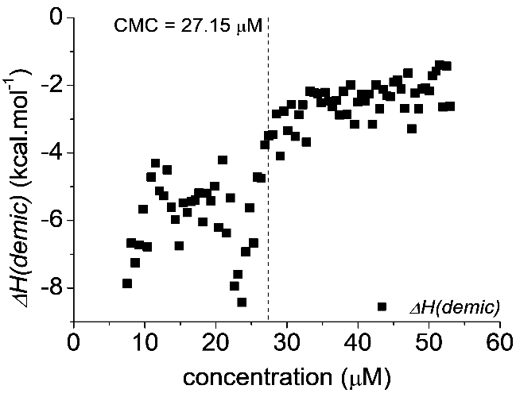
Figure S1. Determination of the CMC of GS14 by Isothermal Titration Calorimetry (ITC). The titrations were monitored and carried out using an isothermal titration microcalorimeter (VP-ITC) from Microcal Inc. (Northampton, MA) at 1 atm. In each run, 2.5 μL aliquots of a solution of 3 mM were sequentially injected from a 0.270 mL automatic syringe into a sample-cell containing water, while stirring at 200 rpm. The concentration of the aliquots is higher than the CMC, so at the beginning, the titrations show demicellization. As the concentration of GS14 in the sample-cell increased, the CMC was reached, and the final titrations measured the dilution of micelles. The inflection in the enthalpy curve gave a value of the 27.15 μM for the CMC of GS14. Samples and water were degassed and thermostated by using a ThermoVac accessory before the titration process. The equilibration time between injections was set at 500 s.
Figure S2. Cryo-TEM of empty liposomes depicting structures with a diameter roughly from 50 to 150 nm. Hexagonal shapes are observed due to artifacts induced by the formation of ice crystals during the freezing process. Cryo-TEM was used to observe frozen hydrated liposomes with intact morphology. The sample was applied to QUANTIFOIL® holey carbon grid (Cu/Rh R 3.5/1). This method was described elsewhere (ref. 21).

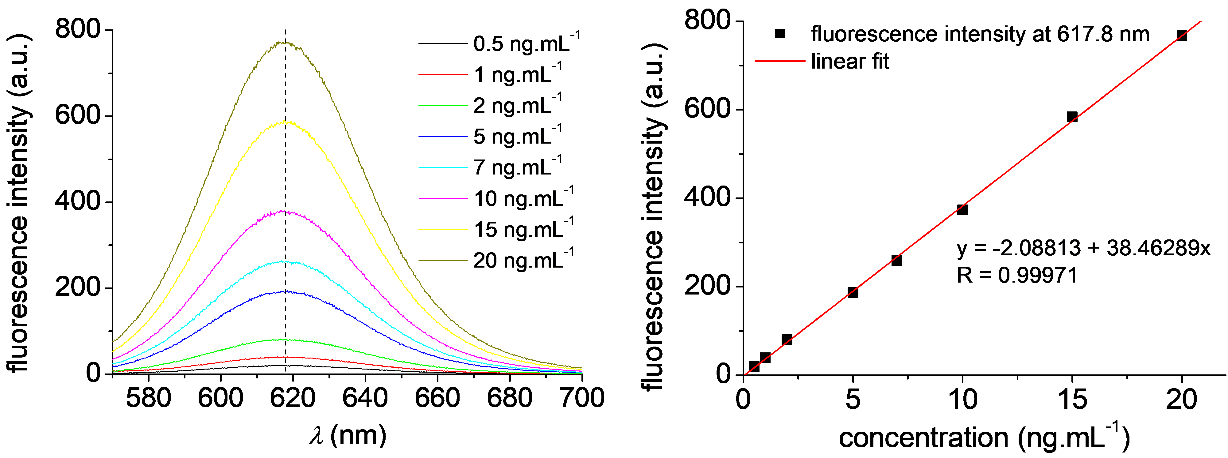
Figure S3. Calibration curve of Nile Red in DMSO. Samples of Nile Red in DMSO were prepared between 2 and 20 ng∙mL⁻¹ to measure the fluorescence emission spectra. The intensities of the fluorescence emission peaks were obtained with an excitation wavelength of 550 nm. The emission spectra were measured with an FP-8500 spectrofluorometer (Jasco Inc., MD, USA) in a quartz cuvette with 200 μL of sample. The maxima of the emission fluorescence intensities were found at 617.8 nm.
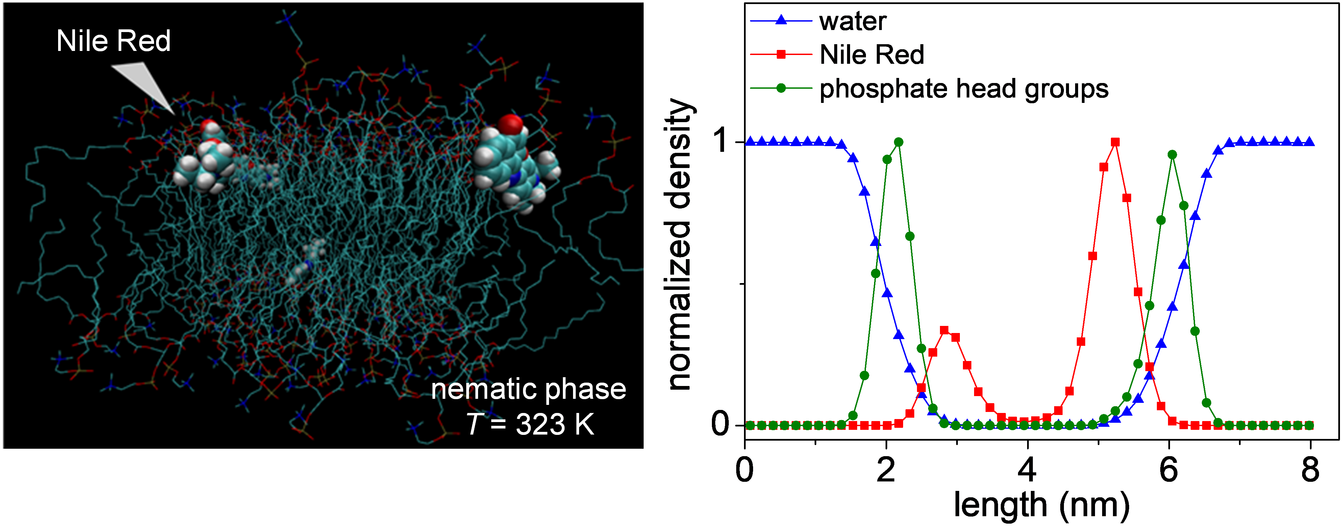
Figure S4. Computational molecular dynamics simulations of the lipid bilayer loaded with Nile Red at 323 K. At this temperature we simulate the nematic phase of the alkyl chains in the lipids. The 3D representation and the density of water molecules, Nile Red, and the phosphate head groups demonstrate that Nile Red is encapsulated in between the phosphate head groups, i.e. in the inner part of the lipid bilayer.

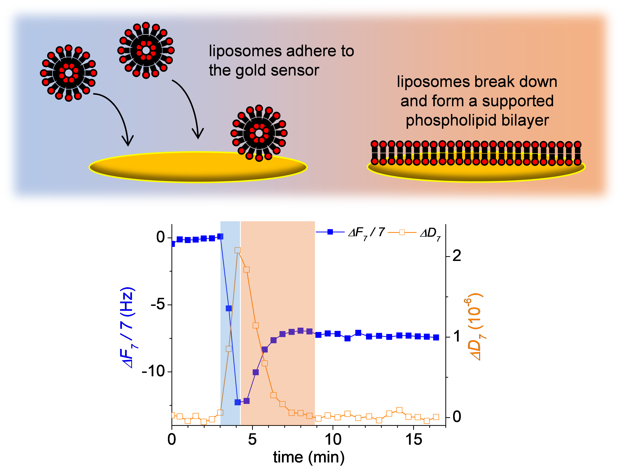
Figure S5. QCM-D demonstration of a supported phospholipid bilayer formation. Three minutes of baseline stabilization are shown. The deposition of the cationic NR-Liposomes on a gold substrate led to the disruption of the liposomes and the formation of the supported lipid bilayer. This is evident from the increase of ΔF and decrease of ΔD after 1 min of NR-Liposomes contacting with the crystal (4 min in the graph) due to the disruption of liposomes and the release of water from the core.
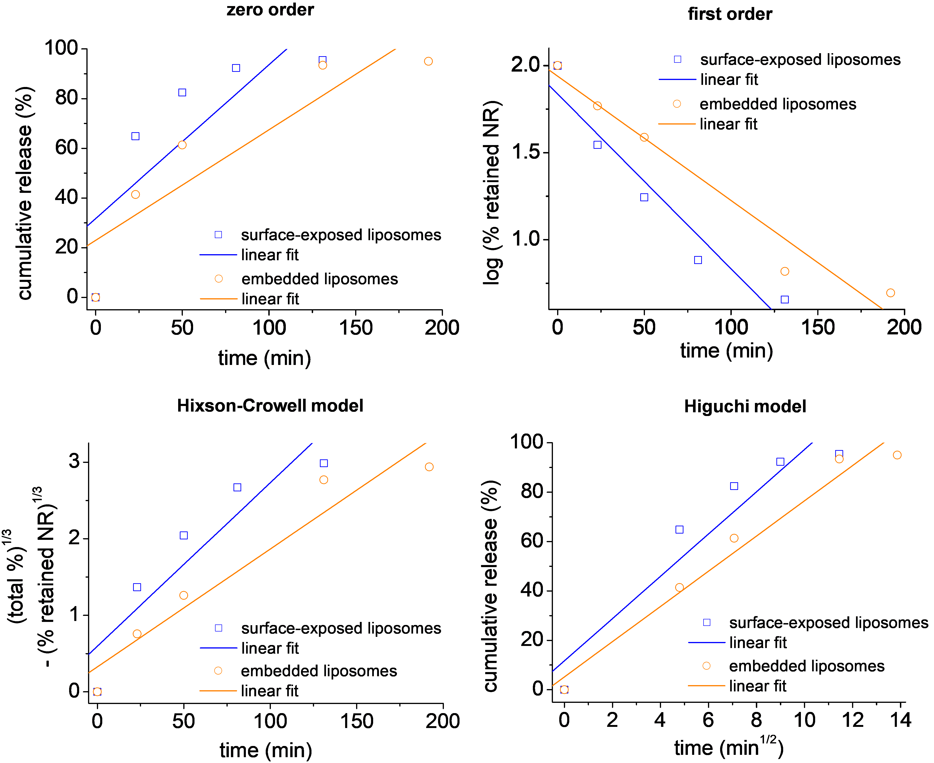
Figure S6. Release profile fittings to zero order, first order, Hixson-Crowell and Higuchi models. In a zero order release type, the cumulative release is represented as a function of time. In a first order release type, the logarithm of the unreleased drug is represented as a function of time. In the Hixson-Crowell model, the cube root of the unreleased drug is subtracted from the cube root of the total initial amount and plotted as a function of time. In the Higuchi model, the cumulative release is plotted as a function of the square root of time. The graphs show the fittings, the functions and the correlation coefficients resulting from the regression analyses with the Nile Red release profiles from surface-exposed liposomes and embedded liposomes.

Table S1. Coefficients of determination calculated from the release profile fittings.
model | coefficient of determination, r²
 | surface-exposed liposomes | embedded liposomes
zero order | 0.65 | 0.81
first order | 0.93 | 0.96
Hixson-Crowell | 0.85 | 0.93
Higuchi | 0.90 | 0.97

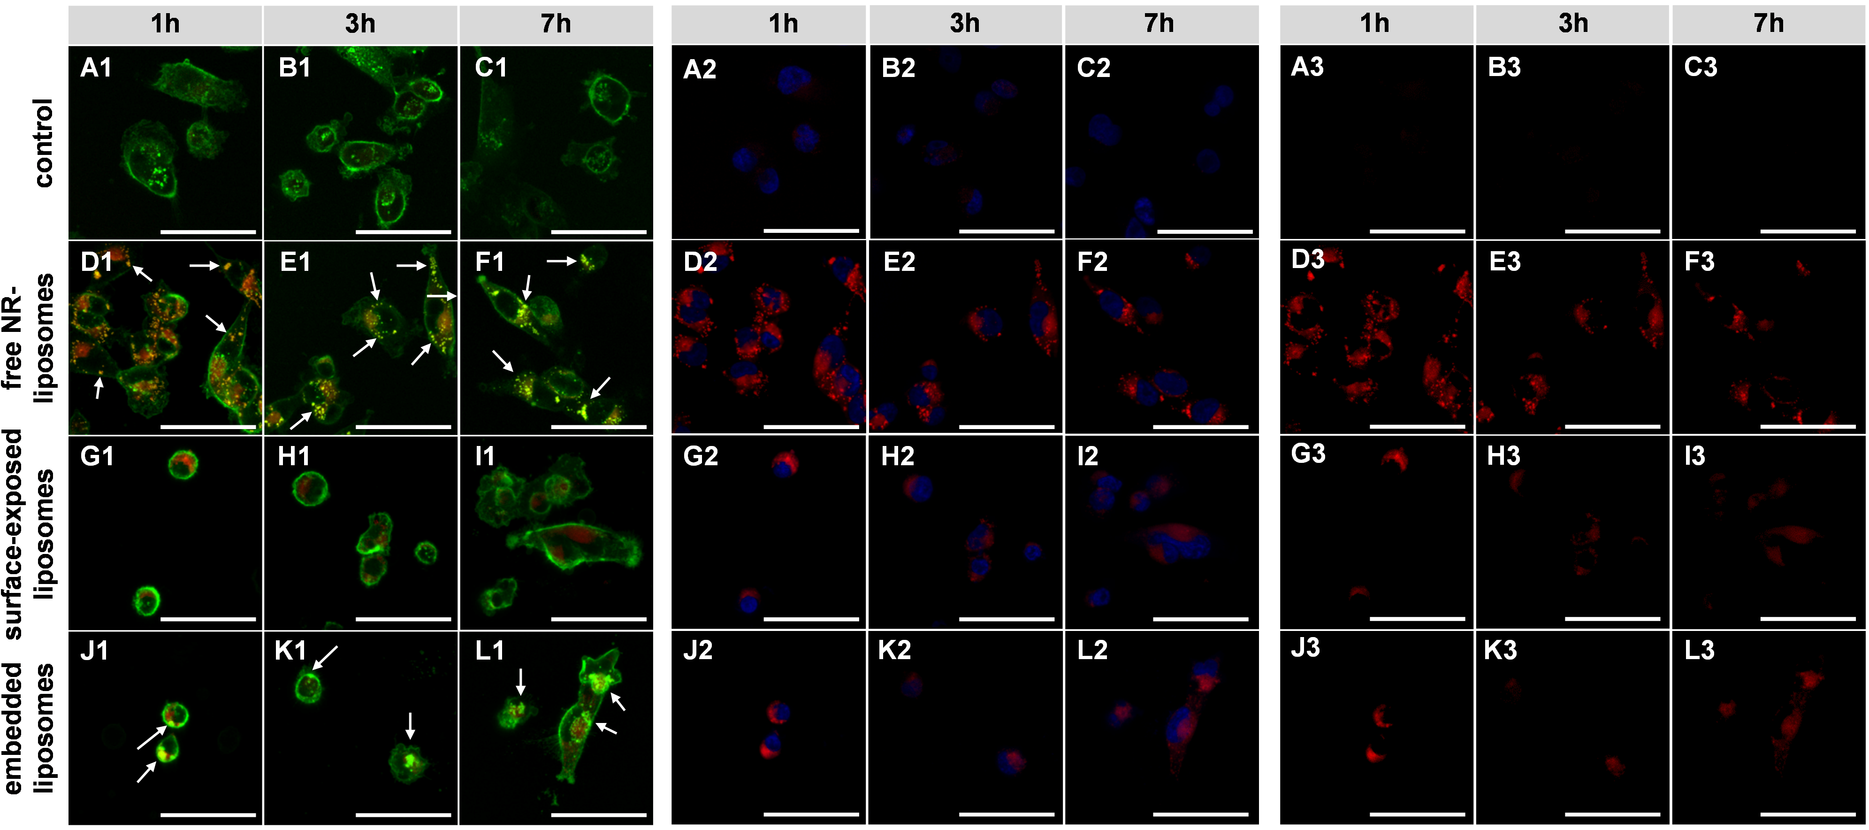
Figure S7. CLSM images of MDA-MB-231 breast cancer cells from Figure 4. Fluorescence channels were selected to also show isolated Nile Red (A3-L3). Scale bar: 50 µm.

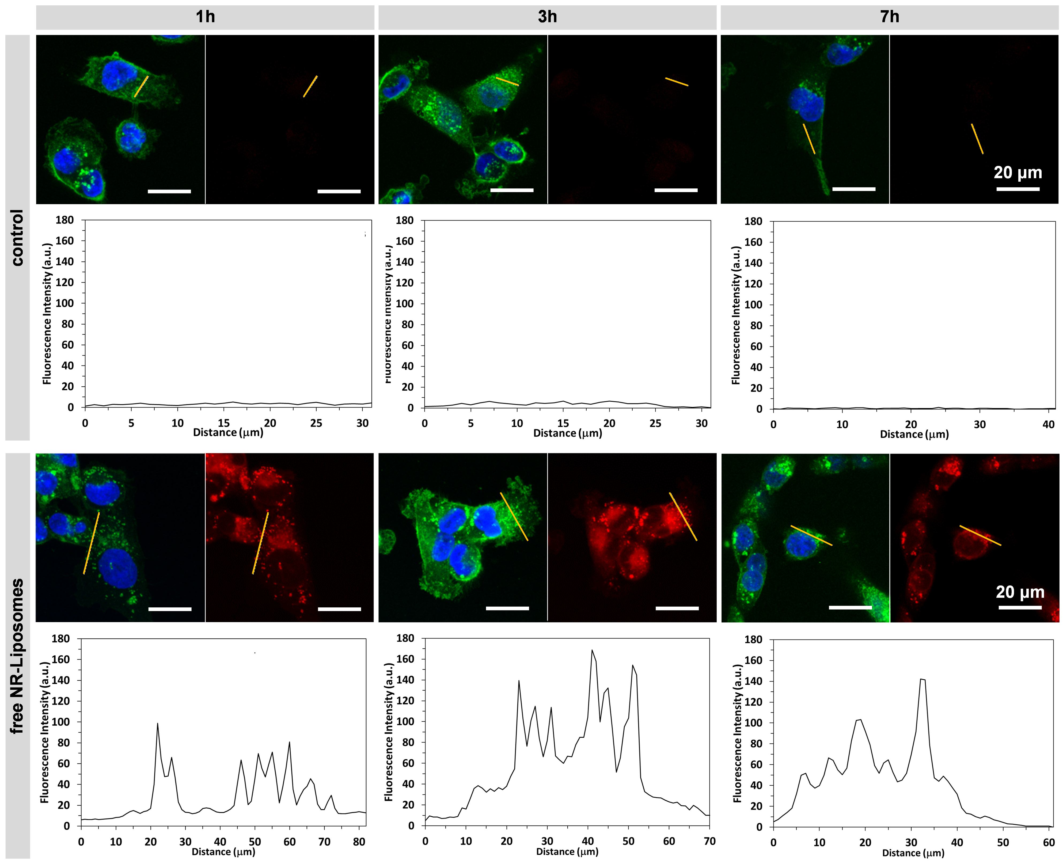
Figure S8. Nile Red intensity distribution profiles in the control and in cells incubated with free NR-Liposomes. The yellow lines represent the traced profile for the quantification of the red intensity. The intensity from the red channel in the control cells is residual. The spikes in the graphs show locations where Nile Red is more concentrated, which agrees with cells taking in NR-Liposomes and with the likely formation of endosomes. The profile lines were traced on the cytoplasm. Images for WGA/DAPI staining and Nile Red alone are shown to confirm that the analyzed region was outside the nucleus. All analysis were made using ImageJ (version 1.53a).

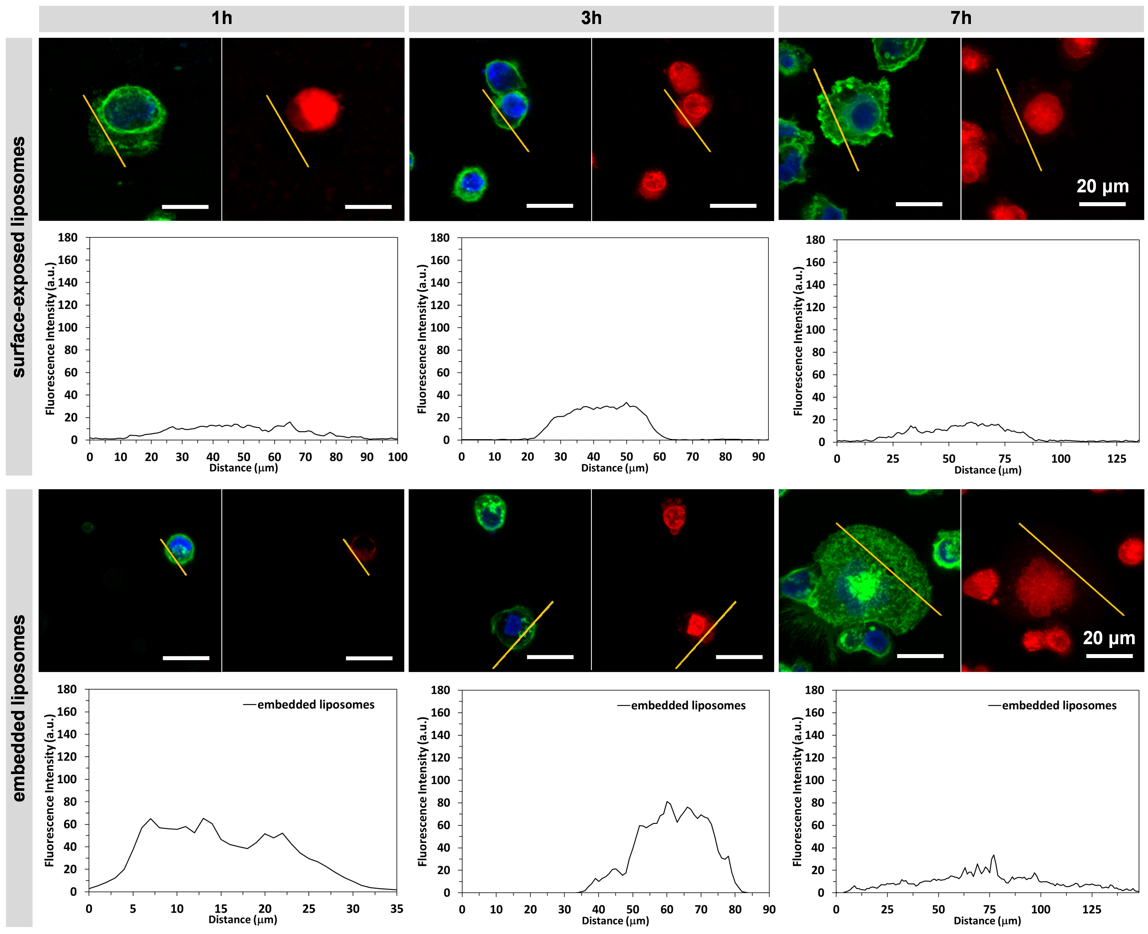
Figure S9. Nile Red intensity distribution profiles in cells seeded on surface-exposed and embedded liposomes. The yellow lines represent the traced profile for the quantification of the red intensity. The distribution of Nile Red is smoother (i.e. no significant spikes are identified) in cells seeded on surface-exposed liposomes, which indicates that Nile Red might be spread in throughout the cytoplasm in free-form. The red intensity profile from cells with embedded liposomes and the observed spikes show that Nile Red is more concentrated in some locations, suggesting the endocytosis of NR-Liposomes.

