SUPPLEMENTARY INFORMATION
Genotype | Severity Increase (%) | Ear performance reduction (%) | RATE
2029 A | 13,7 | 25,6 | 1,87
319 A | 15,0 | 13,8 | 0,91
BR401 | 16,8 | 7,64 | 0,45
2255 A | 13,6 | 5,59 | 0,41
Cubano | 22,8 | 0,25 | 0,01

Was estimated for each genotype, a comparative analysis of the foliar severity of the disease in the R₃ phenological stage, the average percentage reduction in ear productivity for each average percentage increase in foliar severity between the experiments containing the lowest (Exp. II) and the highest amount of disease (Exp. I). as a result, it presents a rate of reduction in productivity, allowing the identification of evidence of tolerance the northern corn leaf blight.
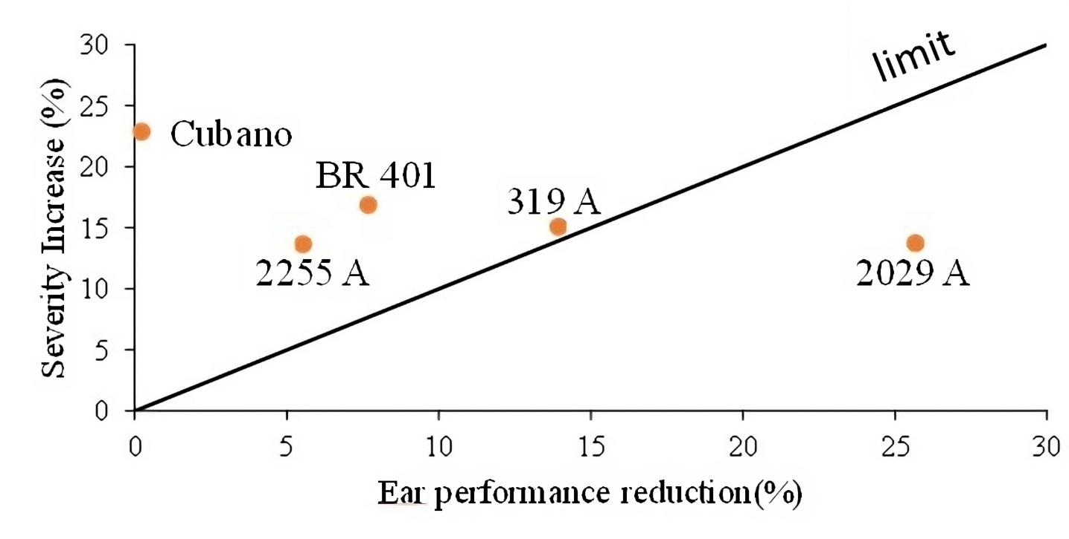
Supplementary file 2 table: Effect of increasing the severity of the disease (% of leaf area with lesion) caused by Exserohilum turcicum on the loss in ear productivity (t ha⁻¹), in sweet corn varieties, for the identification of genotypes tolerant to the disease.

