Supplementary figure
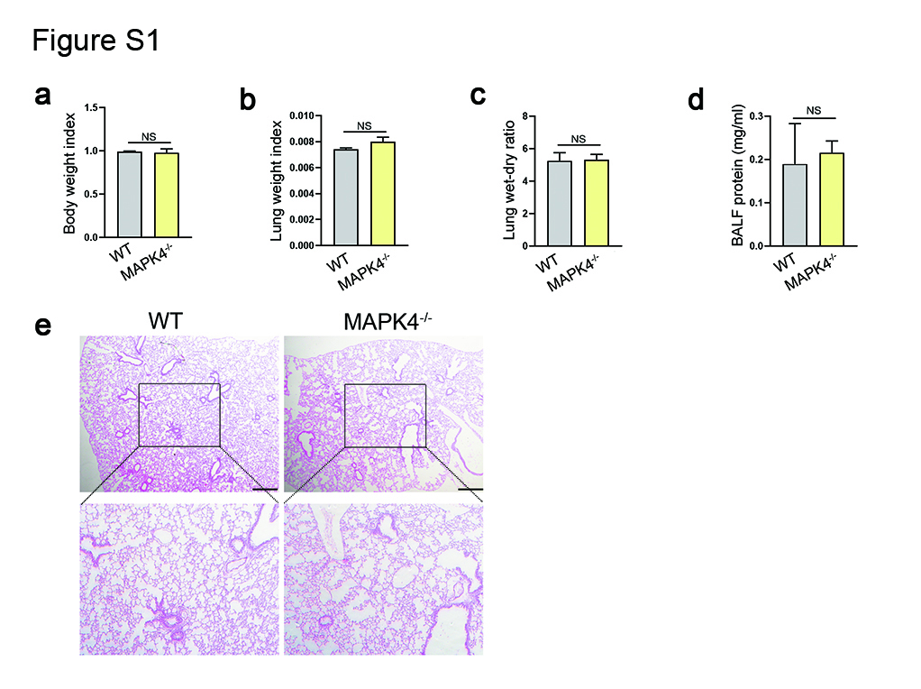
Fig S1. The weight index and histology of lung tissues in MAPK4^{-/-} mice.
WT C57BL/6 mice (n=6) and MAPK4^{-/-} mice (n=6) were sacrificed and the lung was collected. a The weight index, b lung weight index (lung weight/weight) and c lung wet-dry ratio were obtained, respectively. d The protein concentration in BALF was also detected. e The histology of lung tissues was analyzed by HE staining, respectively. Scar bar=50μm. Data were presented as the mean ± SEM. NS, no significance.

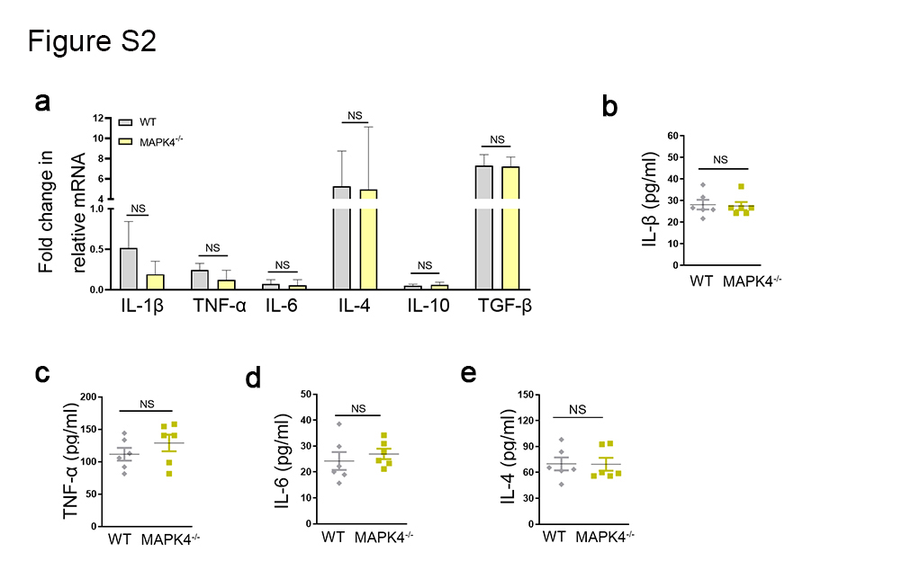
Fig S2. The levels of related inflammatory cytokines in lung tissues of MAPK4^{-/-} mice.
WT C57BL/6 mice (n=6) and MAPK4^{-/-} mice (n=6) were sacrificed and the lung was collected. a The mRNA levels of IL-1β, TNF-α, IL-6, TGF-β, IL-4 and IL-10 in lung tissues were detected by Real-time PCR assay and calculated. b-e The protein levels of IL-1β, TNF-α, IL-6 and IL-4 in BALF were detected by ELISA assay. Data were presented as the mean ± SEM. NS, no significance.

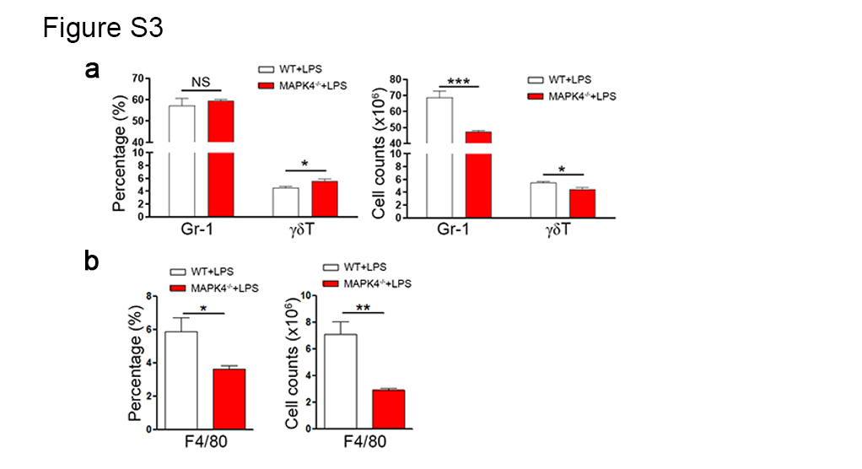
Fig S3. MAPK4 deficiency alters the immune cells composition in spleen of ALI mice.
WT C57BL/6 mice (n=6) and MAPK4^{-/-} mice (n=6) were administered with i.p. 10mg/kg LPS, 24h, respectively. Then, the spleen cells were collected. a The proportions of Gr-1⁺ neutrophils and γδT⁺ cells were analyzed by FCM and the absolute numbers of these cells were calculated, respectively. b The proportion of F4/80⁺ Mφ was analyzed by FCM and the absolute number of Mφ was calculated, respectively. Data were presented as the mean ± SEM. *p<0.05, **p<0.01, ***p<0.001.

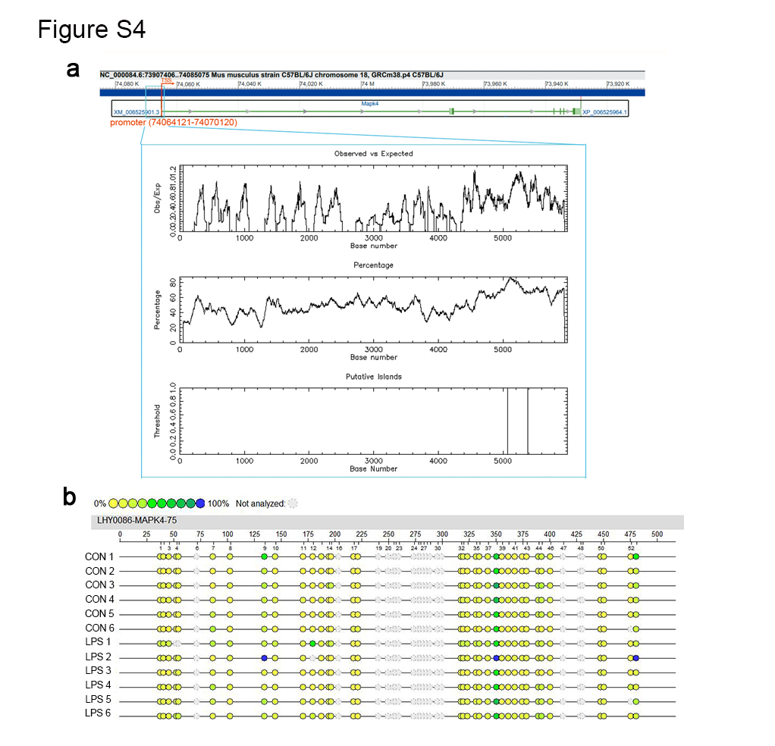
Fig S4. CpG methylation levels of MAPK4 promoter in ALI mice.
WT C57BL/6mice (n=6) were administered with i.p. 10mg/kg LPS or PBS, respectively. After 24h, lung tissues were obtained and DNA was extracted. a The putative CpG island was found in the promoter of MAPK4 at http://www.ebi.ac.uk/Tools/seqstats/emboss_cpgplot/. b Methylation levels of CpG sites in MAPK4 promoter were analyzed by massARRAY assay.

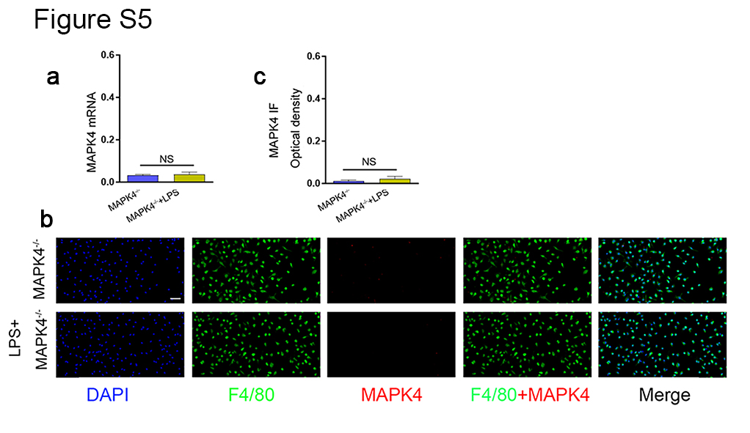
Fig S5. The expression of MAPK4 in MAPK4 deficiency macrophages.
a The mRNA levels of MAPK4 were detected by Real-time PCR assay in MAPK4^{-/-} macrophages and LPS-treated MAPK4^{-/-} macrophages (n=3). b-c The protein levels of MAPK4 in MAPK4^{-/-} macrophages and LPS-treated MAPK4^{-/-} macrophages were detected by immunofluorescence and calculated (n=3). Scar bar=25μm. Data were presented as the mean ± SEM. *p<0.05, **p<0.01.

