SUPPLEMENTAL MATERIAL
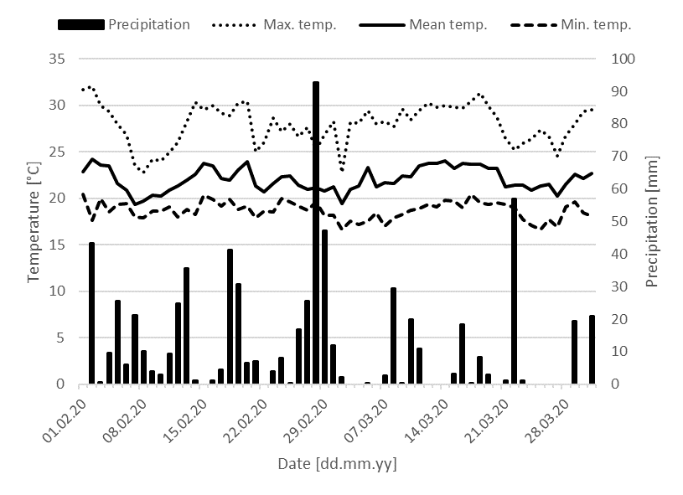FIGURE 1S – Weather data for February and March from the station Araxa, Minas Gerais, Brazil. Source: Instituto Nacional de Meteorologia: https://portal.inmet.gov.br
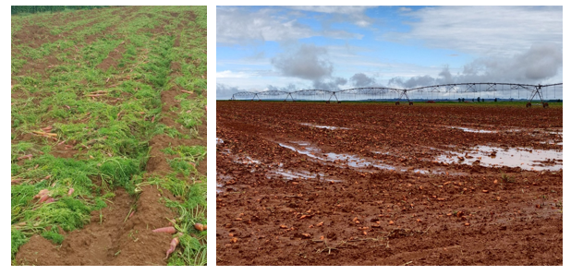
FIGURE 2S – Carrot fields after harvest exhibit crop remains.
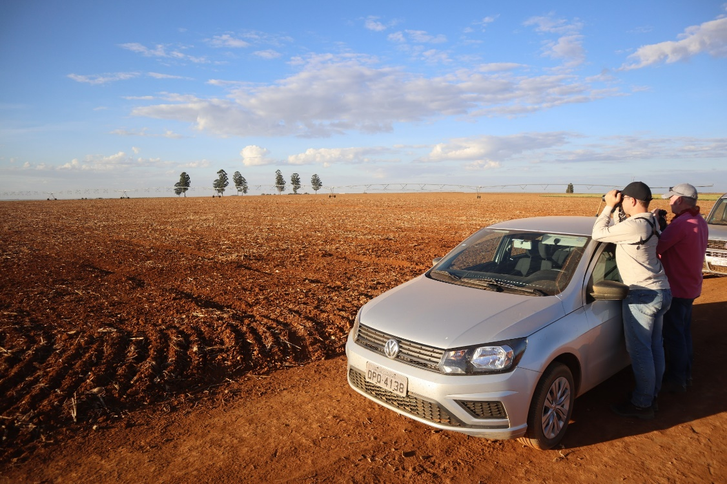FIGURE 3S – Carrot field before seedbed preparation.
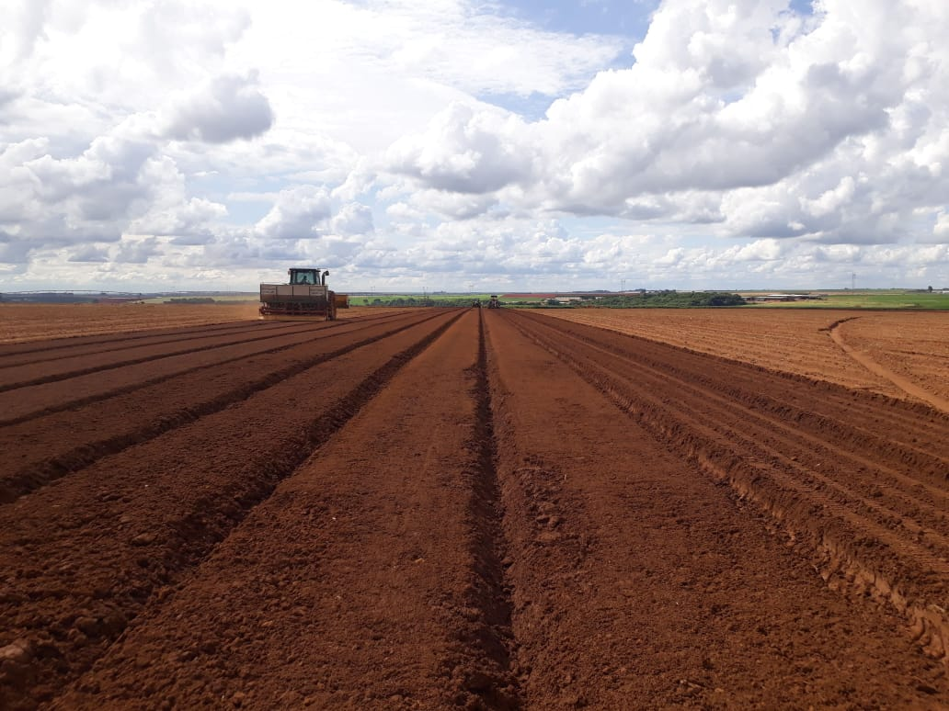
FIGURE 4S – Carrot field after seedbed preparation.
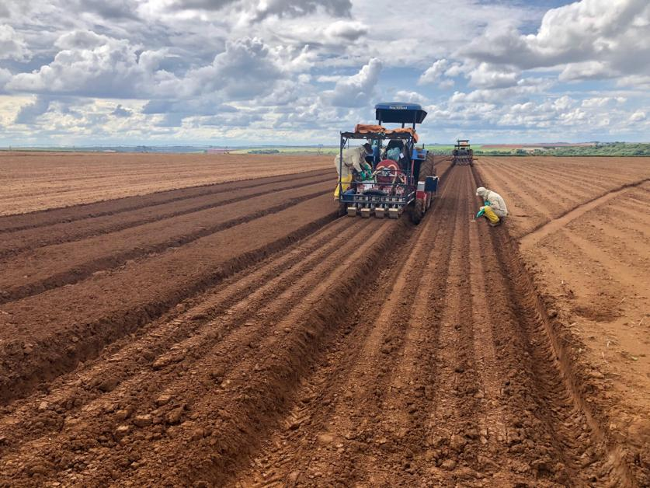FIGURE 5S – Drilling of carrot seeds.
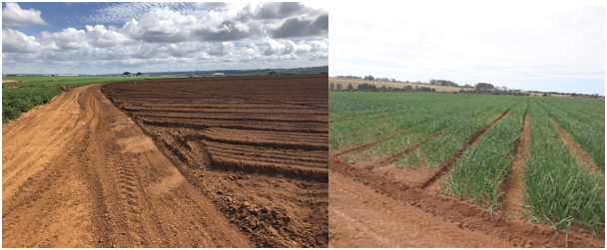
FIGURE 6S – Flattened, leveled (left, carrot), and bunded (right, exemplary photo onion) field border.

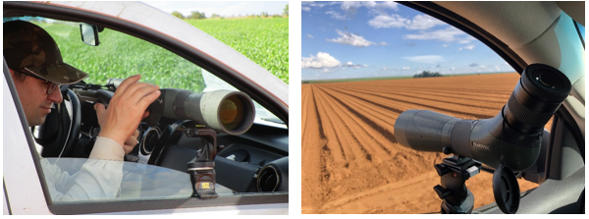
FIGURE 7S – Bird scan sampling from a hide (car, left) and view from the car (right).

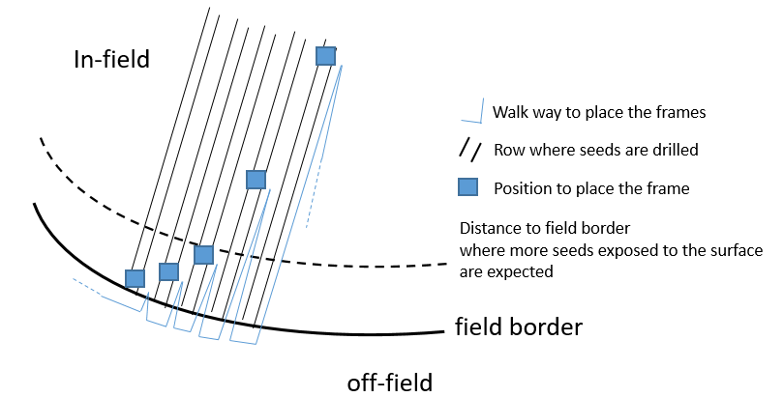
FIGURE 8S – Sketch showing the seed counting procedure.

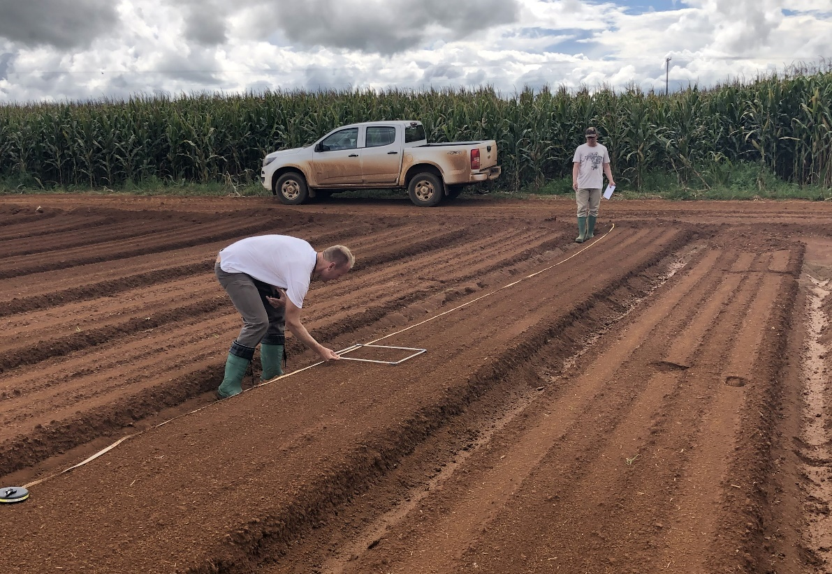FIGURE 9S – Seed exposure assessment. Drilled carrot field (in front) and in the back a corn field in an advanced development stage.
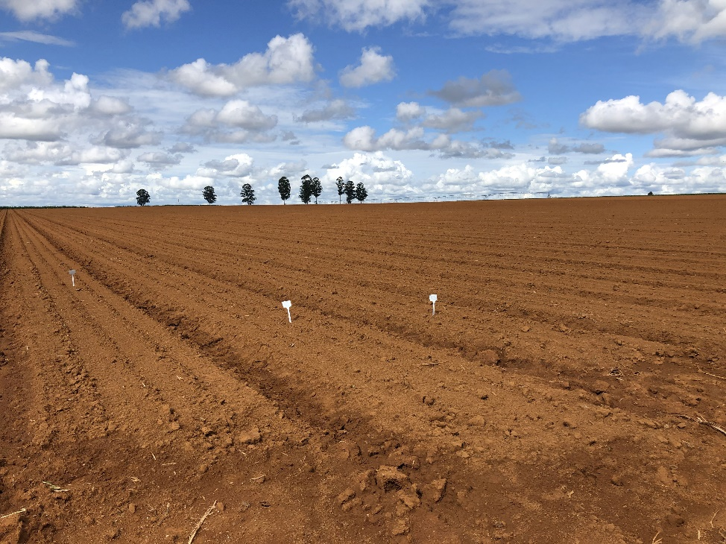FIGURE 10S – Representative carrot field near São Gotardo after drilling.
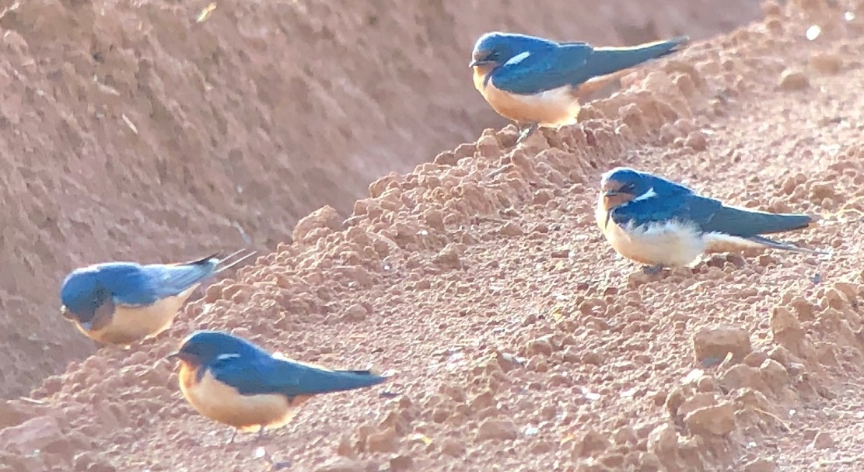FIGURE 11S – Barn swallows resting on carrot field.
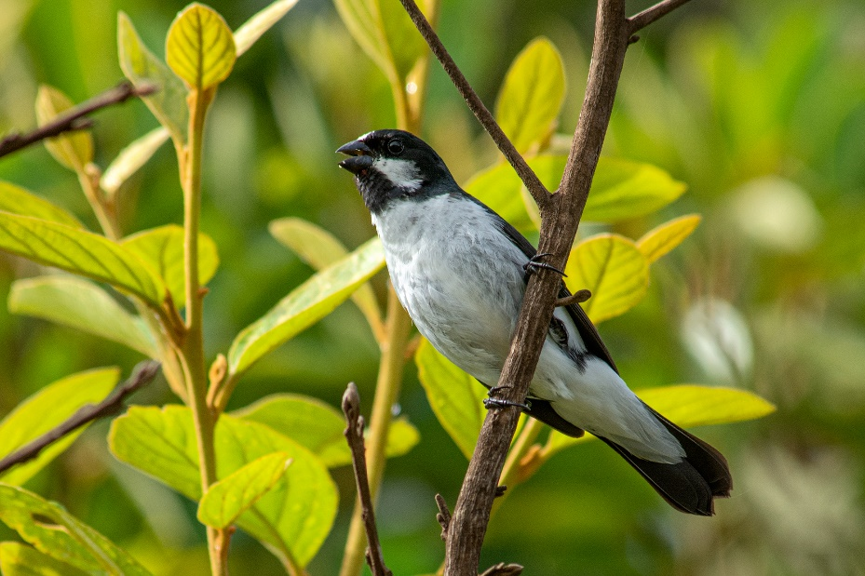FIGURE 12S – Lined seedeater detected during bird counts in adjacent structures but not found on drilled fields during scan sampling.
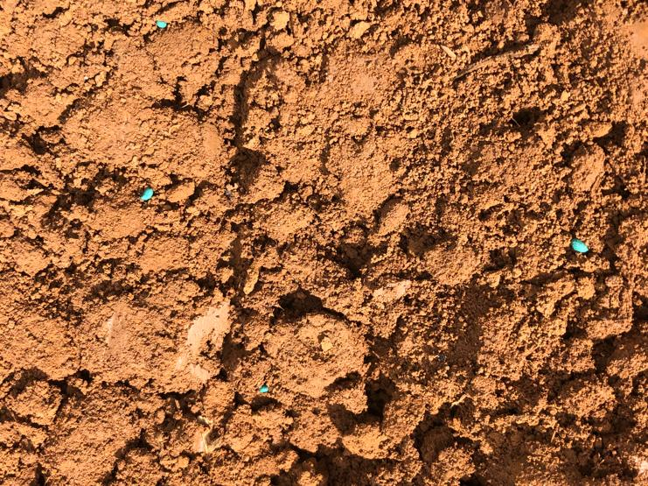
FIGURE 13S – Carrot seeds on the surface detected during seed exposure assessment.
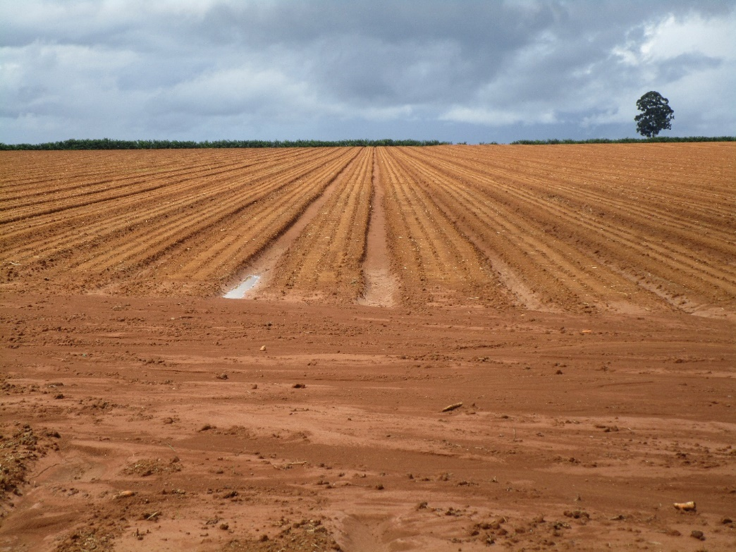FIGURE 14S - Illustration of a representative onion field near São Gotardo.
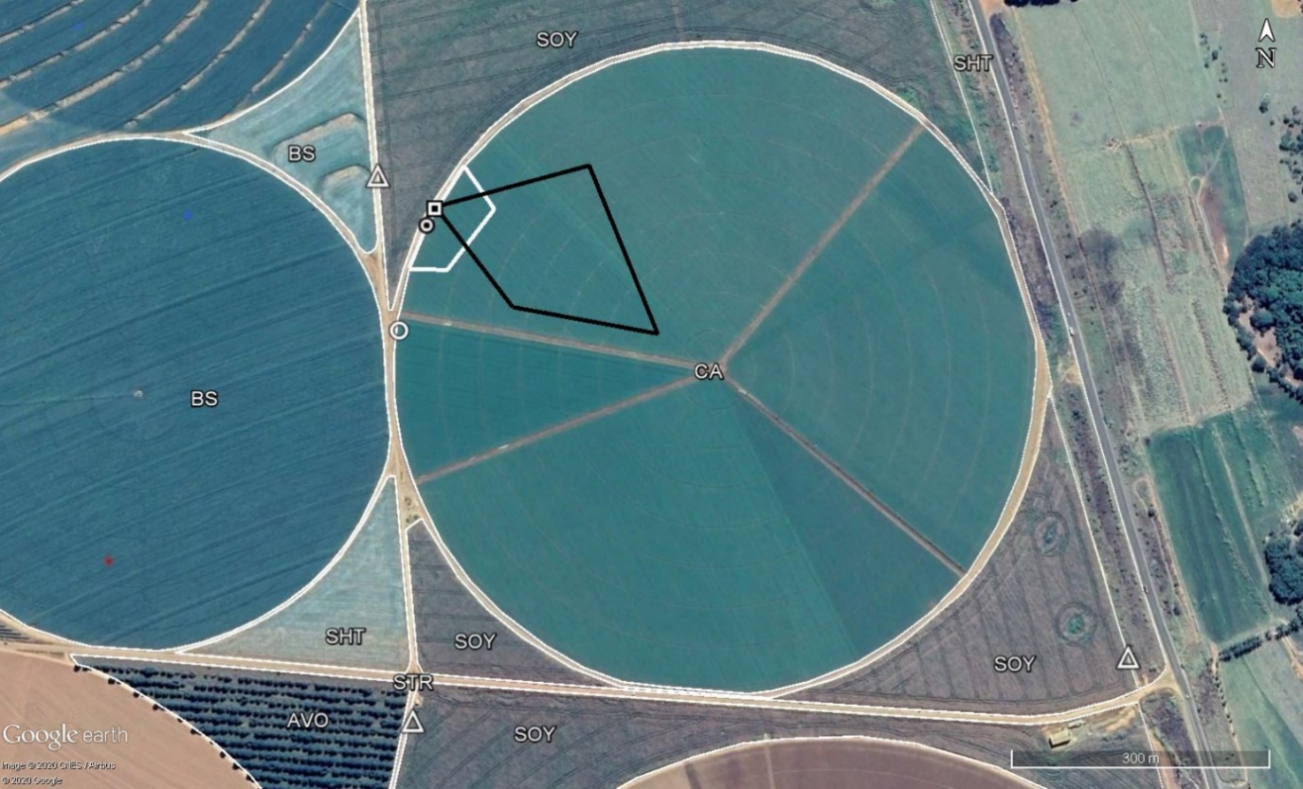FIGURE 15S - Panorama view and a sketch of one carrot study field, thin white lines irrigation circle, and adjacent habitat.
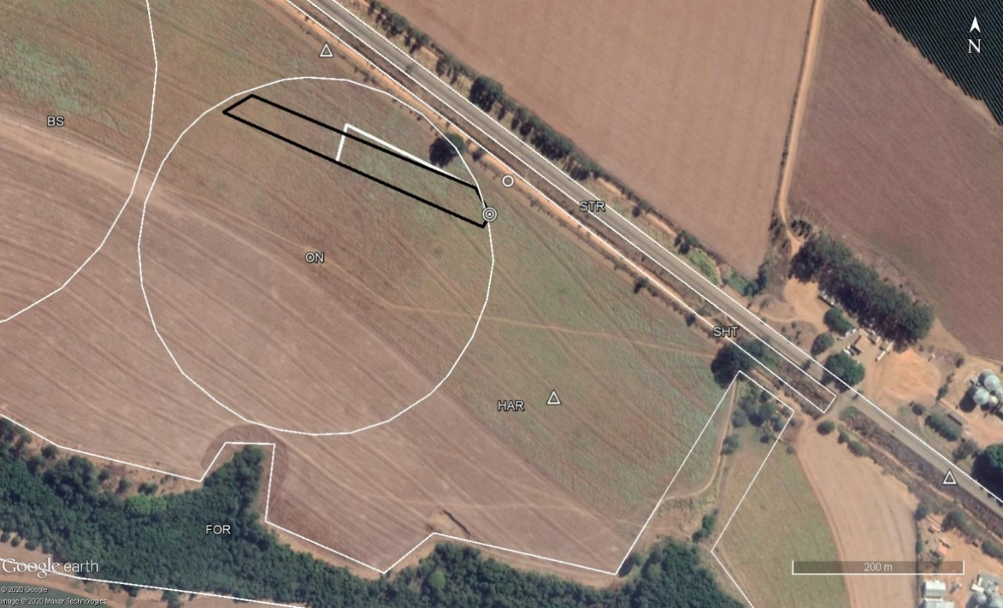
FIGURE 16S - Panorama view and a sketch of one onion study field, thin white lines irrigation circle, and adjacent habitat.

