Supporting Information
Table S1. Number of effort actions and violations found for each actor, violation type, region and species.
Category | Type | Effort | Violations
Actor | Small-scale fisher | 30827 | 3399
Actor | Industrial fisher | 6140 | 125
Actor | Marketers | 5834 | 1575
Actor | No activity listed | 5733 | 207
Actor | Other Actor | 2368 | 599
Actor | Processing plants | 9284 | 802
Actor | Restaurant | 1679 | 633
Actor | Transporter | 11753 | 2962
Violation | Access | 25070 | 3219
Violation | Ban | 15132 | 2544
Violation | Fishing Gear | 615 | 89
Violation | Legal Origin | 7265 | 2162
Violation | Min Size | 4962 | 534
Violation | Quota | 20237 | 1680
Violation | Other | 337 | 74
Region | Arica y Parinacota | 1954 | 175
Region | Tarapaca | 1430 | 213
Region | Antofagasta | 4202 | 1503
Region | Atacama | 2190 | 796
Region | Coquimbo | 3352 | 781
Region | Valparaiso | 5304 | 1128
Region | Metropolitana | 4566 | 1243
Region | Lib B O'Higgins | 1008 | 245
Region | Maule | 2838 | 546
Region | Araucanía | 660 | 173
Region | Biobío | 14483 | 900
Region | Los Ríos | 4424 | 137
Region | Los Lagos | 17356 | 1728
Region | Aysen | 5192 | 285
Region | Magallanes | 4073 | 345
Region | Mobile Unit | 488 | 90
Species | Anchovy and sardine spp | 11441 | 309
Species | Centolla spp | 4908 | 504
Species | Chilean Seabass | 2242 | 102
Species | Clams spp | 5642 | 972
Species | Common Hake | 6429 | 1275
Species | Conger eel | 2756 | 530
Species | Crab spp | 2142 | 261
Species | Gigartina spp | 722 | 21
Species | Hoki | 346 | 0
Species | Jumbo squid) | 1307 | 170
Species | Kelp spp | 5285 | 1865
Species | Limpet spp | 133 | 14
Species | Lobster | 499 | 4
Species | Loco | 4092 | 781
Species | Mackerel | 1470 | 127
Species | Mussell spp | 1998 | 398
Species | Octopus spp | 503 | 55
Species | Others | 1802 | 216
Species | Pomfret | 1801 | 123
Species | Prawns spp | 162 | 5
Species | Salmon spp | 238 | 14
Species | Scallop spp | 810 | 175
Species | Sea urchin | 4533 | 549
Species | Shark spp | 81 | 14
Species | Shrimp spp | 835 | 147
Species | Skate | 216 | 4
Species | Southern Hake | 3801 | 302
Species | Sword fish | 559 | 37
Species | Trophon snail | 674 | 201
Species | Unclear | 5032 | 828
Species | Various | 1159 | 299

Table S2. Description of action and violation category types, as defined by SERNAPESCA.
Category | Type | Description
Actor | Small-scale fisher | Artisanal fishers (boats <18 meters in length), divers and shore gatherers
Actor | Industrial fisher | Industrial boats (>18 meters in length)
Actor | Marketers | Actors who commercialize marine products
Actor | No activity listed | Actors not registered/ no actors found
Actor | Other Actor | Ensamble of minority class actors
Actor | Processing Plants | Actors involved in processing marine products
Actor | Restaurant | Actors selling marine products in restaurants
Actor | Transporter | Actors that transport marine products
Violation | Access | Lack of permits to operate in the fisheries sector, including supply chain
Violation | Ban | Fishing or commercializing products during a reproductive ban
Violation | Fishing Gear | Fishing with prohibited gears
Violation | Legal Origin | Lack of documentation regarding origin of fishing products
Violation | Min Size | Fish products below permitted size
Violation | Quota | Fish products that have been extracted above regulated quotas
Violation | Other | Ensamble of minority class violations

Table S3. Comparison of model performance with wAIC.
Model | Detectability Predictors | Violations Predictors | wAIC
Null model | NA | NA | 24920
Model 1 | time, group size, region, actor, year | species, violation | 21472
Model 2 | time, group size, region, actor | species, violation, year | 22174
Model 3 | time, group size, actor | species, violation, year, region | 22552
Model 4 | time, group size, actor, year | species, violation, region | 22684
Model 5 | time, group size, region, actor, year time*group size | species, violation | 22161
Model 1 with 2nd order Polynomials | time, group size, region, actor, year | species, violation | 23690
Model 1 with 3nd order Polynomials | time, group size, region, actor, year | species, violation | 23161

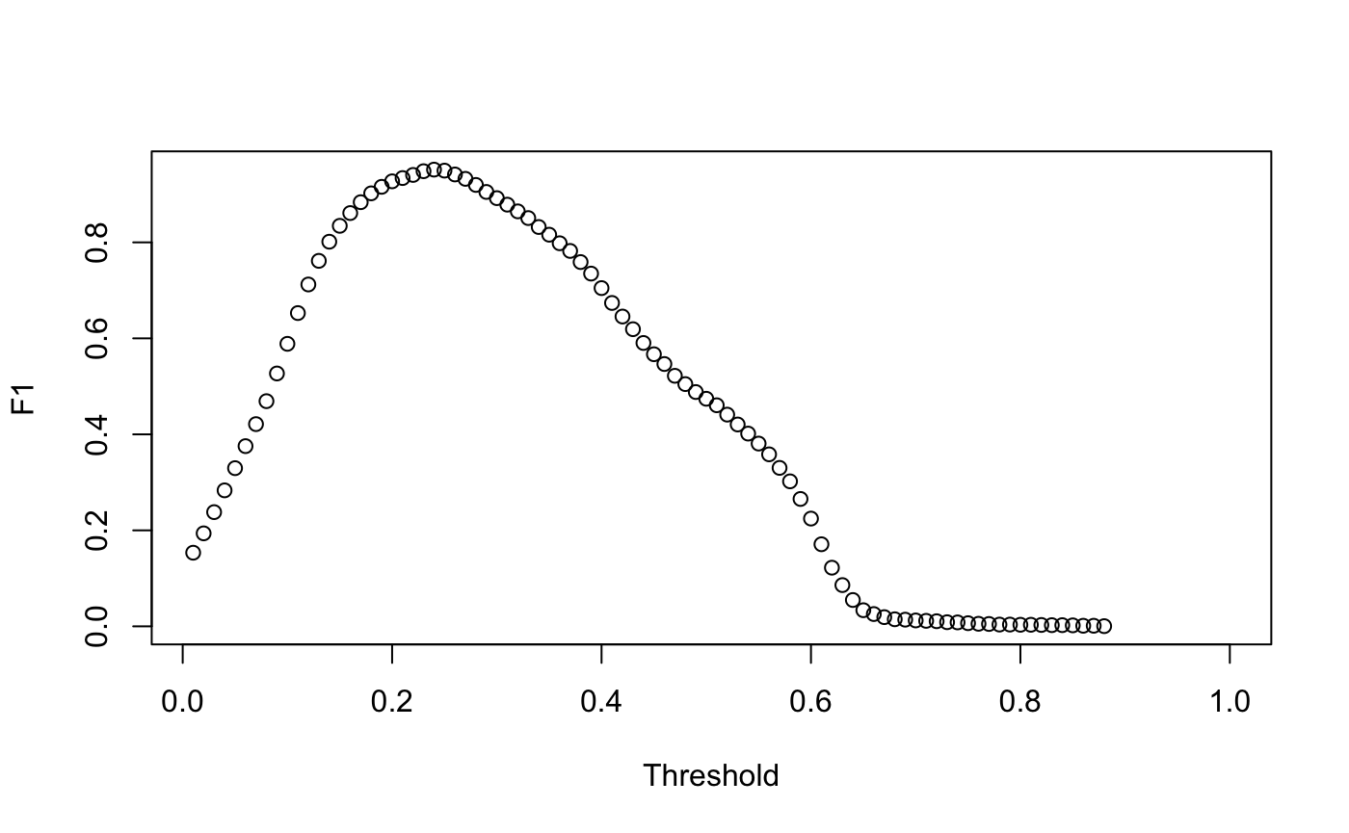Figure S1. Analysis of F1 scores for different thresholds to determine if the probability was assigned as a violation detected or not detected.

