Supporting information:

Chemically induced deceleration of nuclear spin relaxation (CIDER) preserves hyperpolarization
Josh P. Peters¹, Charbel Assaf¹, Arne Brahms², Kolja Them¹, Mirco Gerdsen², Rainer Herges², Jan-Bernd Hövener¹, Andrey N. Pravdivtsev¹
1. Section Biomedical Imaging, Molecular Imaging North Competence Center (MOIN CC), Department of Radiology and Neuroradiology, University Medical Center Kiel, Kiel University, Am Botanischen Garten 14, 24114, Kiel, Germany
2. Otto Diels Institute for Organic Chemistry, Kiel University, Otto-Hahn Platz 4, 24098 Kiel, Germany

- Dendrons
1 General Information
Commercially available solvents and reagents were used as received. Drying of THF was carried out on a Pure Solv MD-5 drying system from Innovative Technologies.
Column chromatography was carried out using 0.040-0.063 mm mesh silica gel from Merck. R_{f} values were determined by thin layer chromatography on Polygram® Sil G/UV₂₅₄ with 0.2 mm particle size from Macherey-Nagel. Identification of spots were carried out with Hanessian’s stain: 0.2 % (m/V) Ce(SO₄), 5 % (m/V) (NH₄)₂Mo₃O₇, 5 % (m/V) konz. H₂SO₄ in H₂O. After immersion, the silica gel plates were carefully dried using a heat gun. Substance spots then appear as blue spots.
NMR-spectroscopy was carried out on an AV 200 (¹H-NMR: 200 MHz), a DRX 500 (¹H NMR: 500 MHz, ¹³C NMR: 125 MHz) or an AV 600 (¹H NMR: 600 MHz, ¹³C NMR: 150 MHz) from Bruker. Further two-dimensional methods for assigning the peaks were used (COSY, HSQC, HMBC). Chemical shift is notated in ppm. ¹H NMR and ¹³C NMR spectra were referenced to solvents from Deutero as follows:

Table S1: Solvent references in ¹H NMR and ¹³C NMR^{[1]}
solvent | ¹H NMR shift [ppm] | ¹³C NMR shift [ppm]
acetone-d₆ | 2.05 | 29.84
CDCl₃ | 7.26 | 77.16
D₂O | 4.79 | 21.03 (acetic acid)

Signal multiplicities were abbreviated as follows:
Table S2: Abbreviations of signal multiplicities
Abbreviation | Meaning
s | singlet
quint. | quintet
m | multiplet

IR-spectroscopy was carried out with a Perkin-Elmer 1600 Series FT-IR spectrometer with an A531-G Golden-Gate-Diamond-ATR-unit. The wave number range was 4000 cm⁻¹ to 400 cm⁻¹. Signal intensities were noted as follows: vs (very strong), s (strong), m (medium), w (weak).
UV/vis spectroscopy was carried out on a Lambda 14 spectrometer from Perkin-Elmer.
Electron impact ionization (EI) was carried with an ionization energy of 70 eV on an AccuTOF GCv 4G mass spectrometer from Jeol. Electro spray ionization (ESI) high resolution (HR) spectra were measured with a Q ExactiveTM Plus mass spectrometer with Hybrid Quadrupole OrbitrapTM from Thermo Fisher Scientific.
2 Synthetic Procedures
Dendrons were synthesized according to Wyszogrodzka et al. (ref [2]) starting with solketal. A double Williamson ether synthesis with methallyl dichloride yields dendron first generation. The resulting molecule must be prepared to build the next generation by undergoing an ozonolysis and reduction to the corresponding alcohol afterwards. The next steps for the next generation then repeats itself. After receiving the protected dendron second generation, deprotection was carried out with acetic acid (Scheme S1).
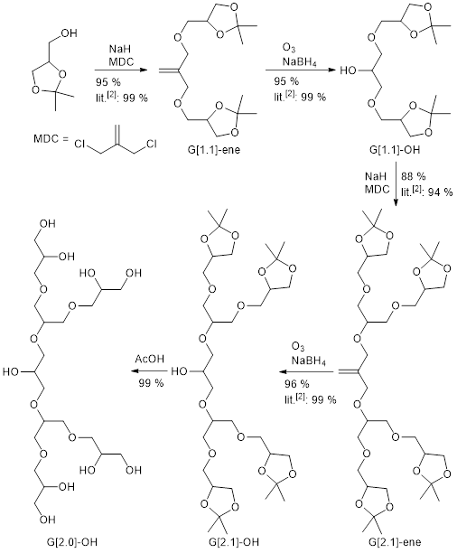
Scheme S1. Repeating steps of Williamson ether synthesis and ozonolysis with reduction in order to build higher generations of glycerol dendrons.

General Procedure A: Synthesis of dendrons G[n.1]-ene
Under a nitrogen atmosphere 3-4 equivalents of sodium hydride were placed in 100-200 mL dry tetrahydrofuran. To the mixture 2 equivalents G[n-1.1]-OH were added dropwise and catalytic amounts of [15]-crown-[5] were added. After stirring for 1 h at 40 °C, 1 equivalent of methallyl dichloride and catalytic amounts of potassium iodide were added. Stirring continued under reflux for 1 d. The reaction was quenched by adding 100 mL water and the phases were separated. The aqueous phase was extracted with dichloromethane and the combined organic phase was dried over magnesium sulfate. Solvent was removed under reduced pressure and the crude product was purified by column chromatography on silica gel.

General Procedure B: Synthesis of dendrons G[n.1]-OH
G[n.1]-ene was dissolved in 100-200 mL dry methanol/dichloromethane 1:1 under a nitrogen atmosphere and cooled to -78 °C. Ozone bubbled through the solution until it turned blue. Excess of ozone was removed by bubbling nitrogen through the solution. The reaction mixture was treated with sodium borohydride and stirred for 16 h while allowing to warm to room temperature. Reaction was quenched with 100 mL water, extracted with dichloromethane and the organic phase was dried over magnesium sulfate. The solvent was removed under reduced pressure and yielded the corresponding G[n.1]-OH.

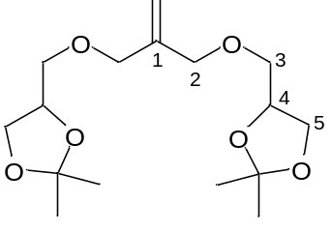G[1.1]-ene

G[1.1]-ene was synthesized as described after general procedure A with solketal nr (7.97 g, 60.3 mmol) and methallyl dichloride nr (3.94 g, 30.9 mmol) in 200 mL dry tetrahydrofuran. Column chromatography was performed with cyclohexane/ethyl acetate 4:1. The product was isolated as a colorless oil.
Yield: 8.85 g (28.0 mmol, 91 %) Lit.^{[2]}: 99 %
FT-IR (ATR): ṽ = 2987 (m), 2871 (m), 1736 (w), 1456 (w), 1371 (s), 1215 (s), 1085 (vs), 1051 (vs), 975 (m), 919 (m), 842 (s), 790 (w), 751 (w), 514 (m) cm⁻¹.
¹H-NMR: (600 MHz, CDCl₃, 298 K): δ = 5.19 (s, 2 H, CH₂), 4.27 (quint., ³J = 6.0 Hz, 2 H, H-4), 4.07-4.02 (m, 6 H, H-2, H-5), 3.75-3.72 (m, 2 H, H-5), 3.57-3.48 (m, 4 H, H-3), 1.42 (s, 6 H, CH₃), 1.36 (s, 6 H, CH₃) ppm.
¹³C-NMR: (150 MHz, CDCl₃, 298 K): δ = 142.1 (C-1), 114.8 (CH₂), 109.6 (C(CH₃)₂), 74.8 (C-4), 72.2 (C-2), 71.3 (C-3), 66.9 (C-5), 26.9 (CH₃), 25.5 (CH₃) ppm.
MS (EI-ToF): m/z (%) = 301.19 (20) [M-CH₃]⁺.
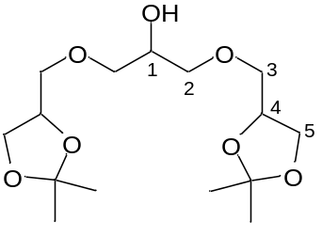G[1.1]-OH

G[1.1]-OH was synthesized as described after general procedure B with G[1.1]-ene (8.50 g, 26.9 mmol) in 200 mL dry methanol/dichloromethane 1:1. The product was isolated as a colorless oil.
Yield: 8.23 g (25.7 mmol, 95 %) Lit.^{[2]}: 99 %
FT-IR (ATR): ṽ = 3475 (br. w), 2986 (m), 2875 (m), 1715 (w), 1456 (w), 1371 (s), 1252 (m), 1212 (s), 1076 (vs), 1049 (vs), 975 (m), 841 (s), 792 (w), 514 (s) cm⁻¹.
¹H-NMR: (500 MHz, CDCl₃, 298 K): δ = 4.31-4.23 (m, 2 H, H-4), 4.07-4.03 (m, 2 H, H-5), 3.99-3.95 (m, 1 H, H-1), 3.74-3.70 (m, 2 H, H-5), 3.59-3.51 (m, 8 H, H-3, H-2), 1.42 (s, 6 H, CH₃), 1.36 (s, 6 H, CH₃) ppm.
¹³C-NMR: (125 MHz, CDCl₃, 298 K): δ = 109.6 (C(CH₃)₂), 74.8 (C-4), 72.9 (C-2), 72.6 (C-3), 69.6 (C-1), 66.7 (C-5), 26.9 (CH₃), 25.5 (CH₃) ppm.
HR-EI-MS: m/z [M+H]⁺ berechnet für C₁₅H₂₉O₇: 321.19133; gefunden: 321.19126 (-0.19 ppm).

G[2.1]-ene
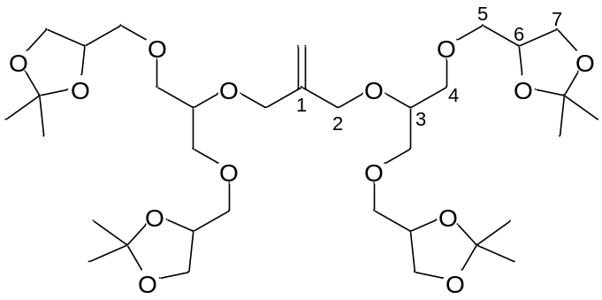

G[1.1]-ene was synthesized as described after general procedure A with G[1.1]-OH (8.08 g, 25.2 mmol) and methallyl dichloride nr (1.57 g, 12.5 mmol) in 100 mL dry tetrahydrofuran. Column chromatography was performed with cyclohexane/ethyl acetate 1:2. The product was isolated as a colorless oil.
Yield: 7.64 g (11.0 mmol, 88 %) Lit.^{[2]}: 94 %
FT-IR (ATR): ṽ = 2986 (m), 2874 (m), 1736 (w), 1457 (w), 1370 (s), 1251 (m),
1213 (s), 1078 (vs), 1051 (vs), 975 (m), 917 (m), 843 (s), 792 (w), 514 (m) cm⁻¹.
¹H-NMR: (200 MHz, Acetone-d₆, 298 K): δ = δ 5.16 (quint., ⁴J = 1.2 Hz, 2 H, CH₂), 4.31-4.11 (m, 8 H, H-2, H-6), 4.09-3.97 (m, 4 H, H-7), 3.76-3.66 (m, 4 H, H-5), 3.66-3.41 (m, 18 H, H-3, H-4, H-5, H-7), 1.36-1.31 (m, 12 H, CH₃), 1.30-1.26 (s, 12 H, CH₃) ppm.
HR-EI-MS: m/z [M+Na]⁺ berechnet für C₃₄H₆₀O₁₄Na: 715.38753; gefunden: 715.38584 (-2.36 ppm).

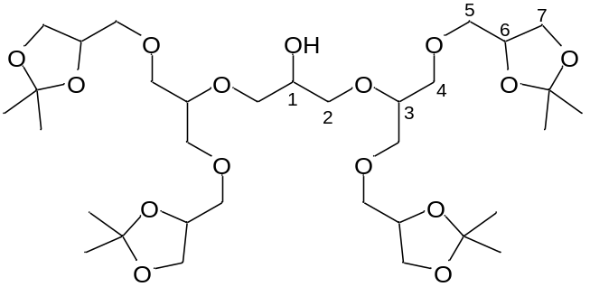G[2.1]-OH

G[1.1]-OH was synthesized as described after general procedure B with G[1.1]-ene (7.64 g, 11.0 mmol) in 100 mL dry methanol/dichloromethane 1:1. The product was isolated as a colorless oil.
Yield: 7.32 g (10.5 mmol, 96 %) Lit.^{[2]}: 99.9 %
FT-IR (ATR): ṽ = 3476 (br. w), 2985 (m), 2921 (s), 2856 (m), 1736 (w), 1457 (m), 1371 (s), 1213 (s), 1051 (vs), 975 (m), 841 (s), 792 (w), 750 (m), 514 (m) cm⁻¹.
¹H-NMR: (500 MHz, Aceton-d₆, 298 K): δ = 4.25-4.17 (m, 4 H, H-6), 4.05-4.00 (m, 4 H, H-7), 3.81-3.77 (m, 1 H, H-1), 3.73-3.69 (m, 4 H, H-5), 3.67-3.63 (m, 4 H, H-4), 3.61-3.47 (m, 18 H, H-2, H-3, H-4, H-5, H-7), 1.34 (s, 12 H, CH₃), 1.28 (s, 12 H, CH₃) ppm.
¹³C-NMR: (125 MHz, Aceton-d₆, 298 K): δ = 109.6 (C(CH₃), 79.5 (C-4), 75.6 (C-6), 73.2 (C-2), 72.8 (C-5), 72.3 (C-3) 70.7 (C-1), 67.4 (C-7), 27.2 (CH₃), 25.8 (CH₃) ppm.
HR-EI-MS: m/z [M+H]⁺ berechnet für C₃₃H₆₁O₁₅: 697.40050; gefunden: 697.39982 (-0.97 ppm).

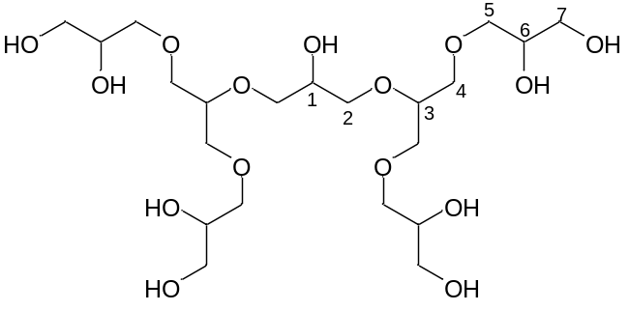G[2.0]-OH

G[2.1]-OH (756 mg, 1.08 mmol) was dissolved in a 50 ml mixture of acetic acid/H₂O/MeOH (2:2:1). After stirring at room temperature solvent was removed under reduced pressure. Product was obtained as a viscous oil.
Yield: 574 mg (1.07 mmol, 99 %)
¹H-NMR: (500 MHz, D₂O, 298 K): δ = 4.01-3.96 (m, 1 H, H-1), 3.92-3-85 (m, 4 H, H-6), 3.82-3.77 (m, 2 H, H-3), 3.76-3.67 (m, 6 H, H-2, H-4), 3.67-3.59 (m, 14 H, H-2, H-4, H-5, H-7), 3.59-3.50 (m, 8 H, H-5, H-7) ppm.
¹³C-NMR: (125 MHz, D₂O, 298 K): δ = 78.5 (C-3), 72.7 (C-7), 71.5 (C-2), 71.0 (C-4), 70.9 (C-6), 70.0 (C-1), 63.2 (C-5) ppm.
Sample for hyperpolarization: We dissolved 261.86 mg (122 mM) of G[2.0]-OH type dendrons (MW 536.57 g/mol) in 4 mL water to yield a concentration of 128 mM and diluted the dendrons for the other experiments by 8 (15.3 mM), 16 (7.6 mM) and 48 (2.5 mM) times.

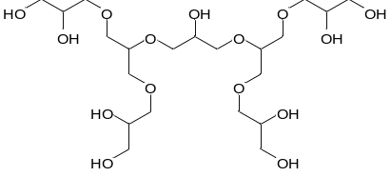
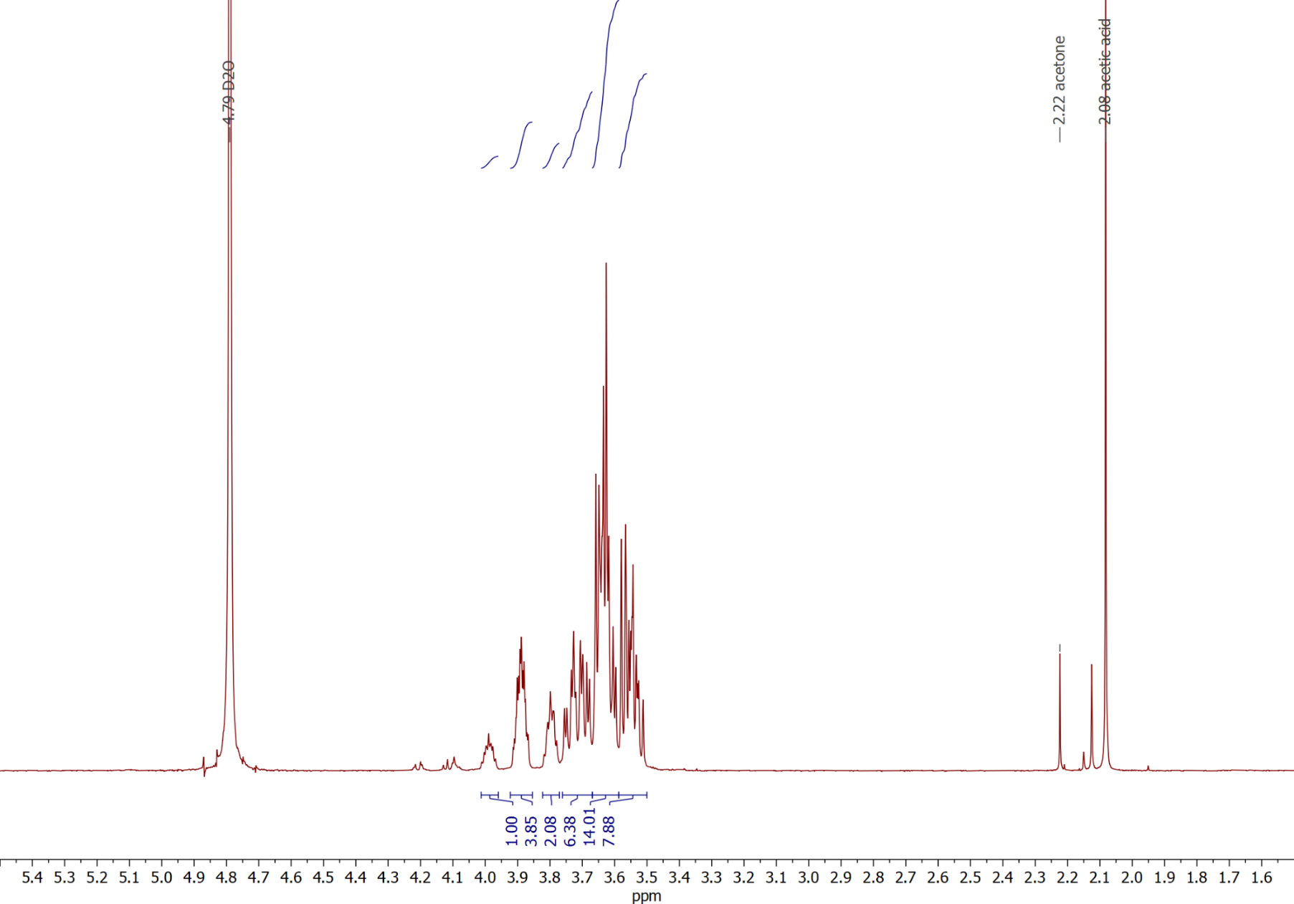
Figure S1: ¹H-NMR of G[2.0]-OH.
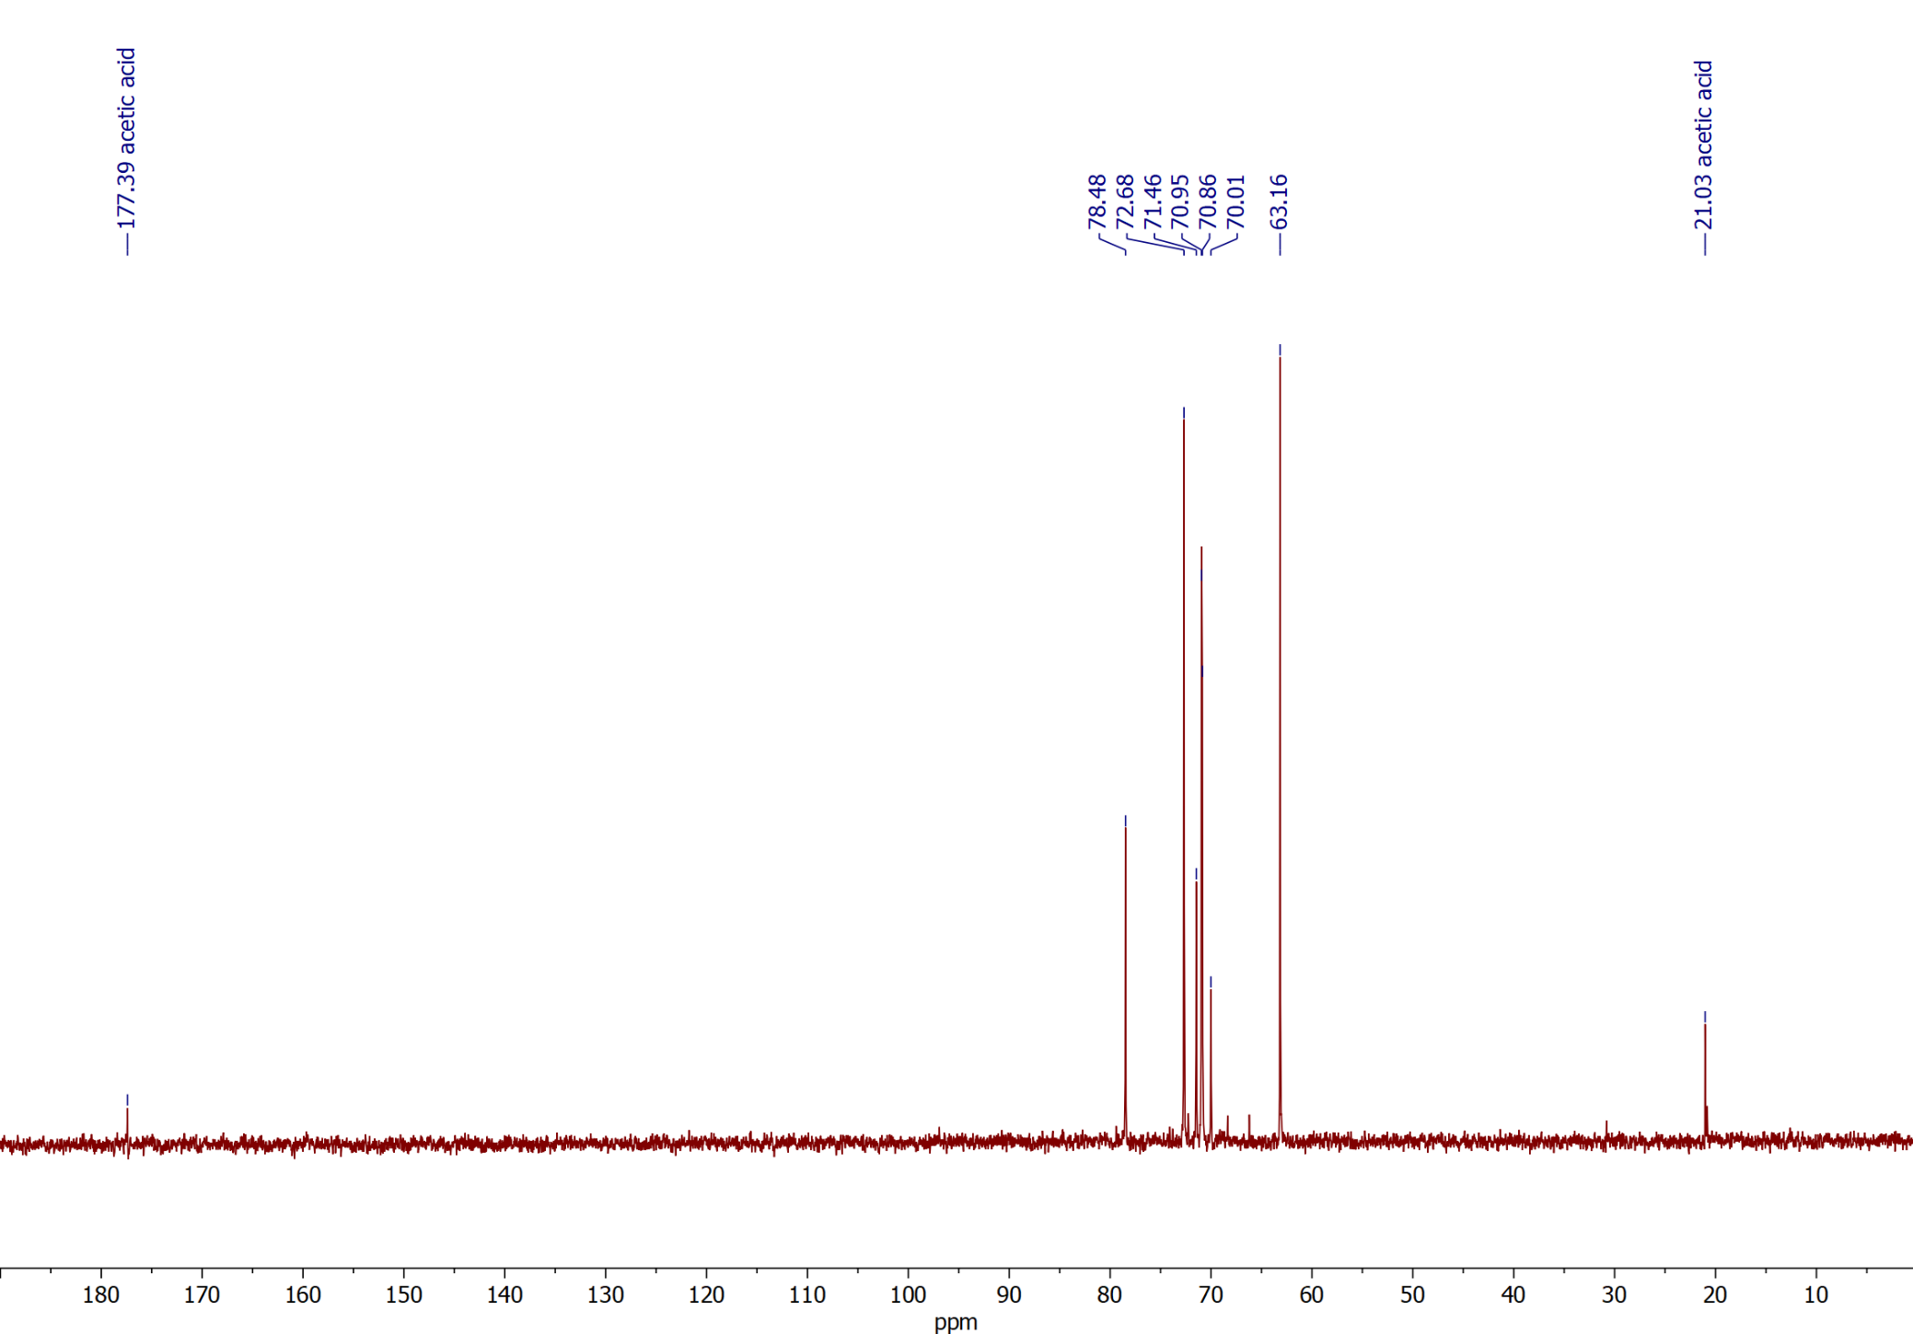
Figure S2. ¹³C-NMR of G[2.0]-OH.
- Spectra of ¹⁵N tracers
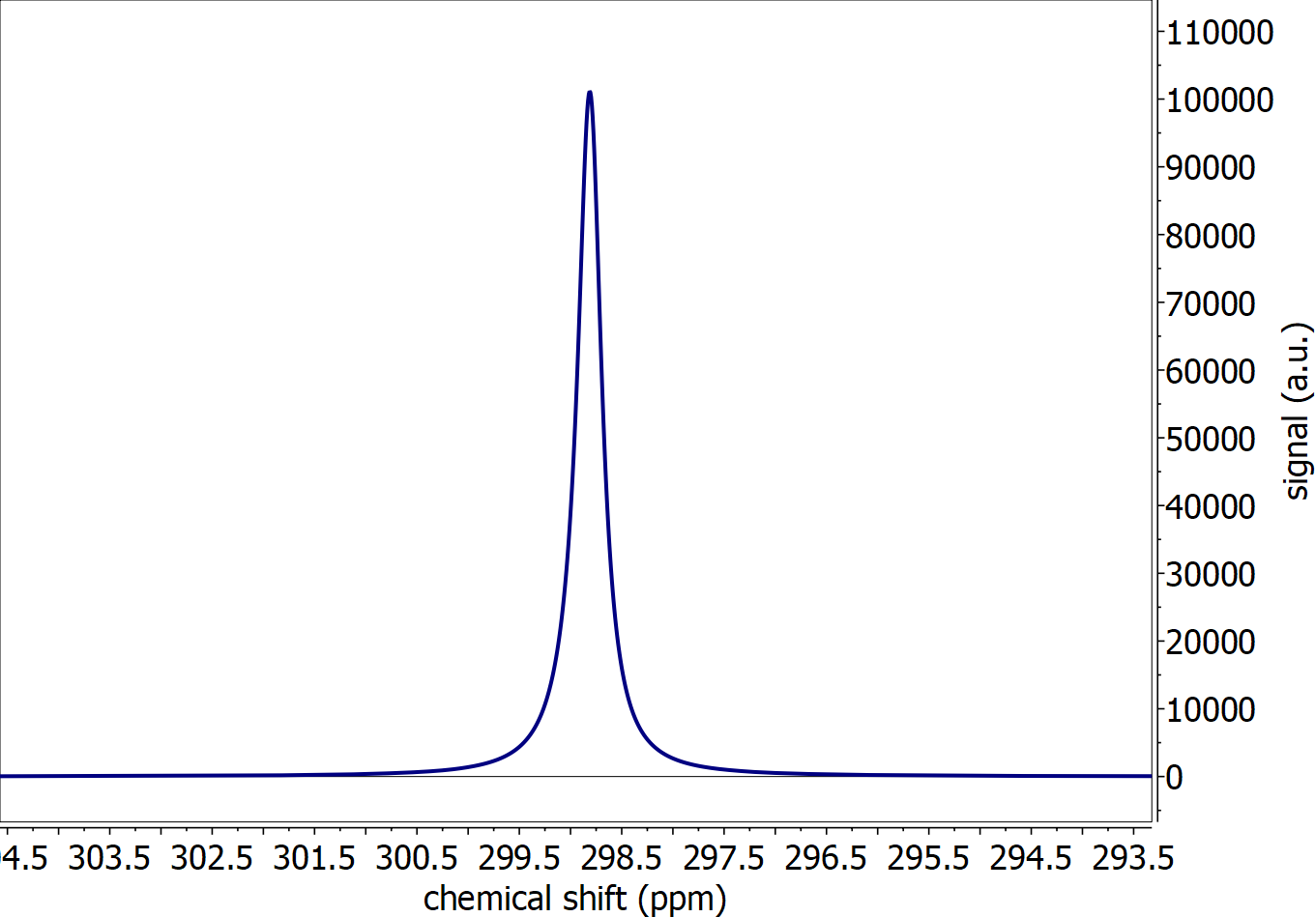
Figure S3: Spectrum of hyperpolarized to 24.6% 1-¹⁵N-nicotinamide, acquired with a 5° flip angle and receiver gain 10.

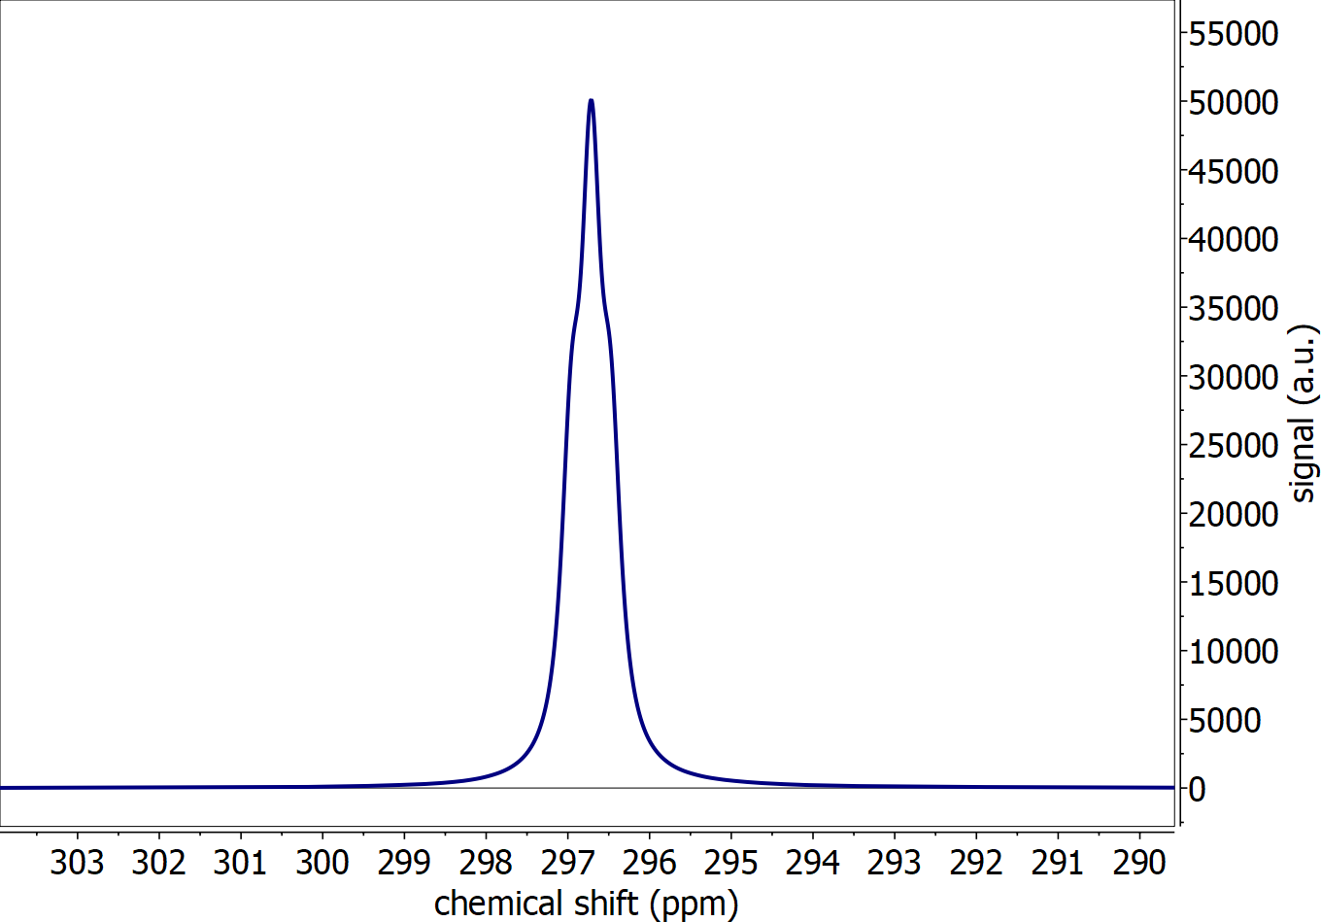
Figure S4: Spectrum of hyperpolarized to 21.1% ¹⁵N-pyridine, acquired with a 5° flip angle and receiver gain 10.

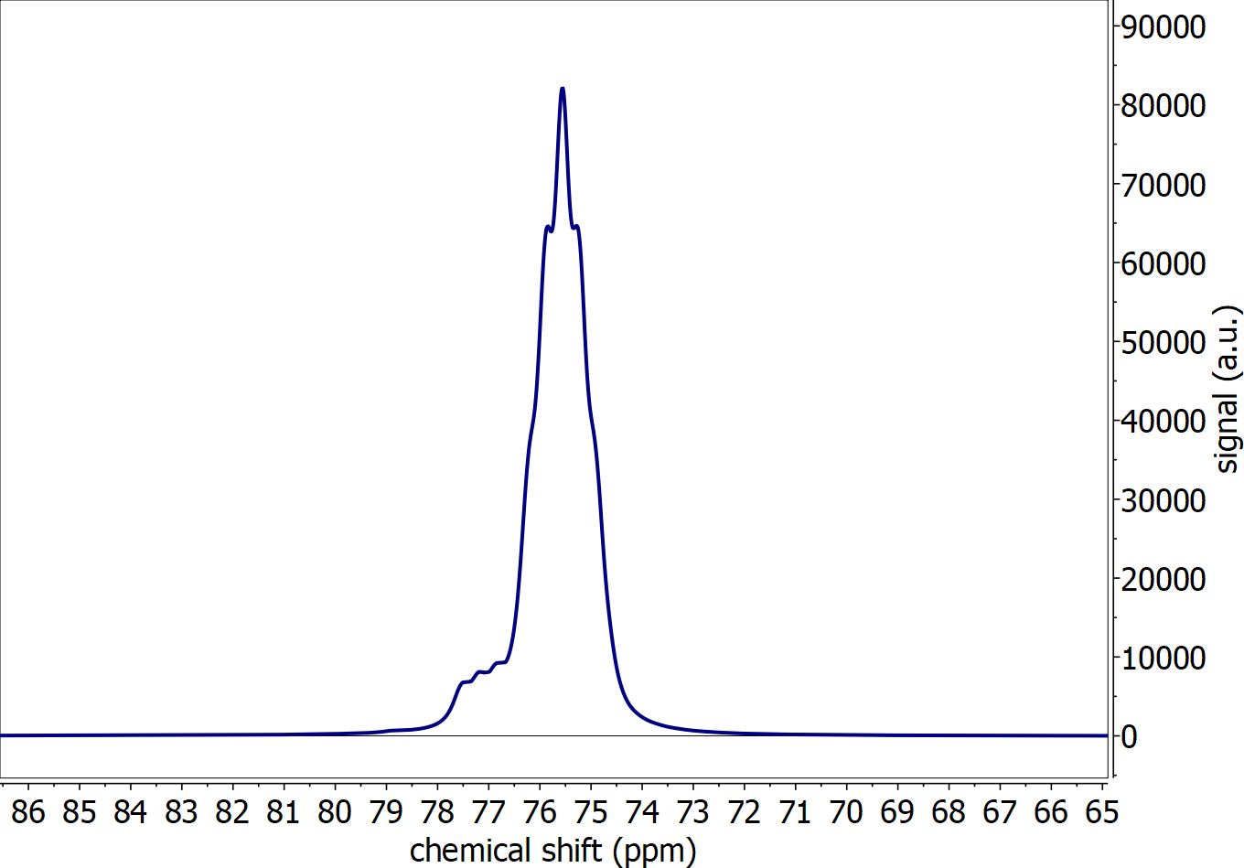
Figure S5: Spectrum of hyperpolarized to 13.7% ¹⁵N₂-urea, acquired with a 5° flip angle and receiver gain 10.

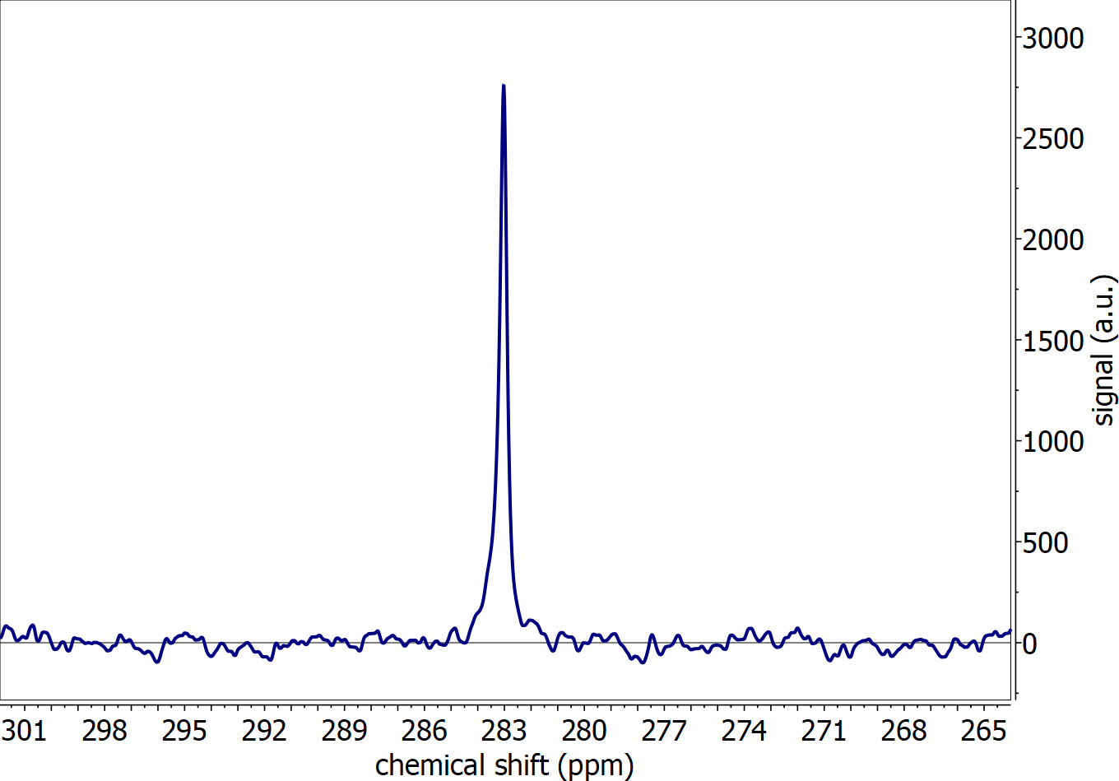
Figure S6: Spectrum of hyperpolarized natural abundant pyrimidine, acquired with a 5° flip angle and receiver gain 101.

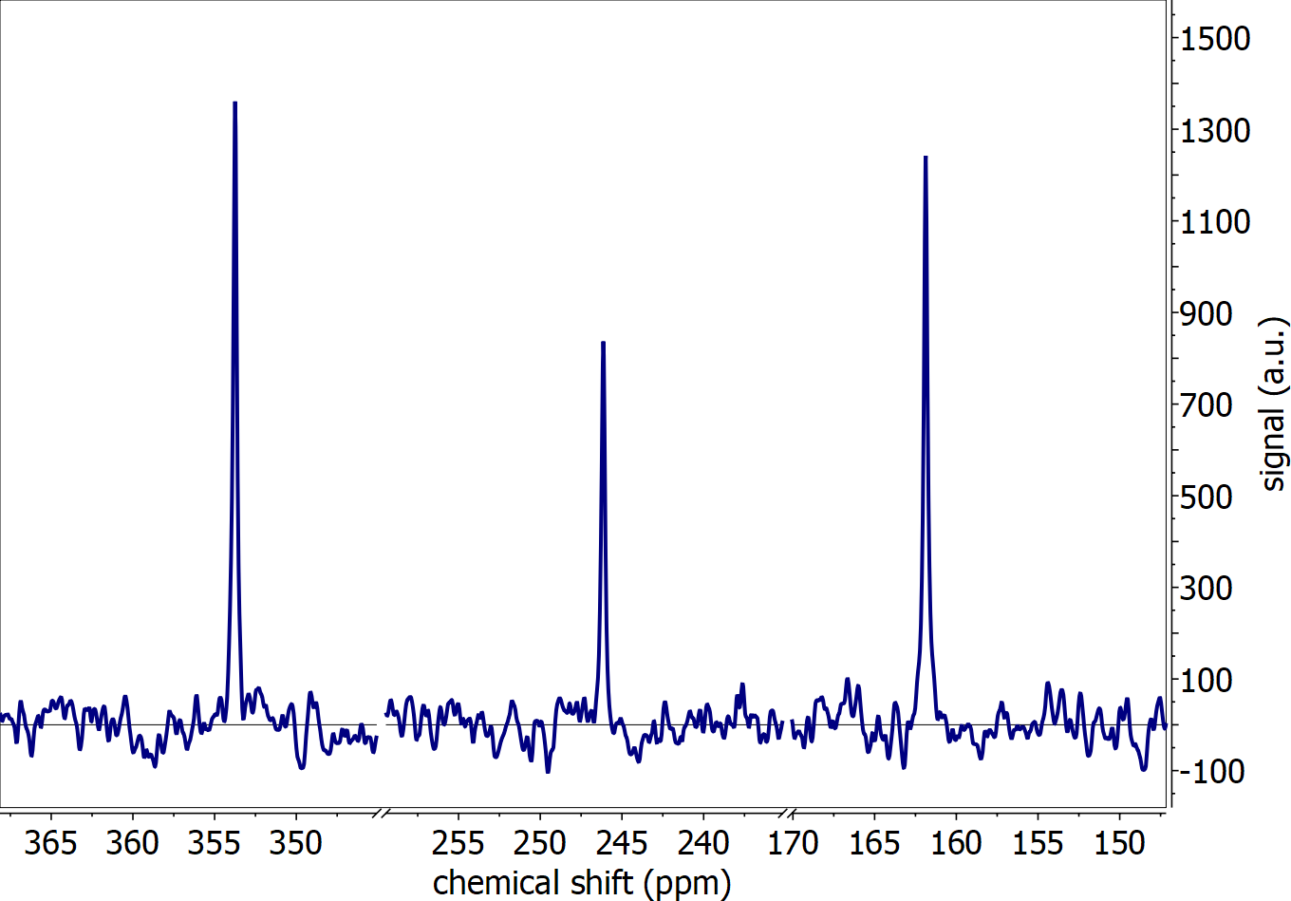
Figure S7: Spectrum of hyperpolarized natural abundant metronidazole, acquired with a 5° flip angle and receiver gain 101.

- Analyzed data of figures
The measured polarization was adjusted to the average transfer time of each table, to have a more representative corrected polarization value: $P_{corrected}=P*exp\left(\frac{transfer-transfer_{avg}}{T_{1}}\right)$. In the case of Table S3 to S6 (Fig. 2 main text) the T₁ at 0.57 T was used due to the more accurate representation of the T₁ during the transfer. However, for Table S7 to S12 (Fig. 3 main text) the T₁ at 9.4 T was used, because due several molecules at natural abundance, the 0.57 T provided too little sensitivity to reliably provide a T₁.
Furthermore, in the case of naturaly abundant tracers (Table S9 to S11), no thermal signal could be acquired with suffient SNR and hence the polarization could not be calculated. Instead, the absolute signal amplitude of the first hyperpolarized signal was taken, corrected using the equation above, and then normalized to the highest signal in the table.

Table S3: Figure 2A with NAM as CIDER agent and 1-¹⁵N-NAM as tracer.
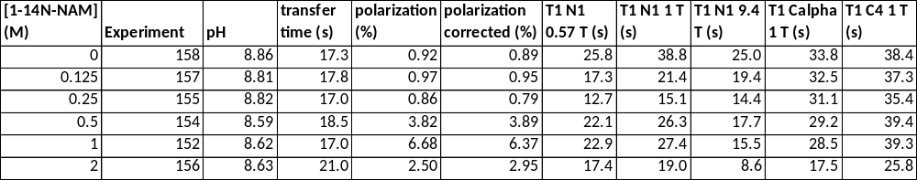

Table S4: Figure 2B with urea as CIDER agent and 1-¹⁵N-NAM as tracer.
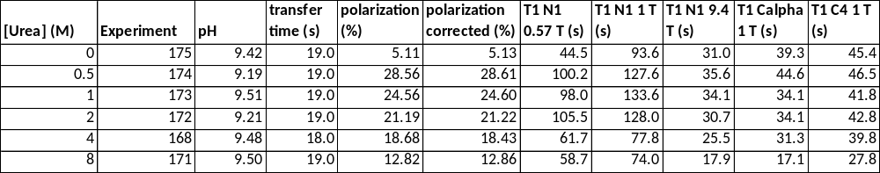

Table S5: Figure 2C with glycerol as CIDER agent and 1-¹⁵N-NAM as tracer.
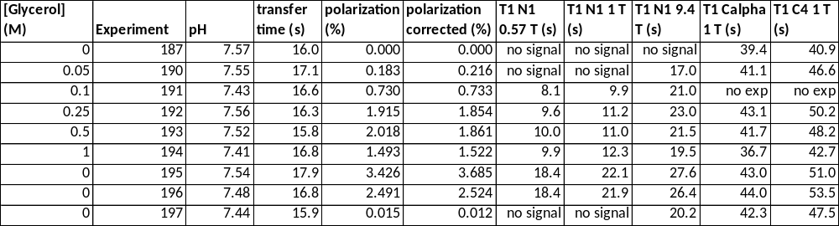
Table S6: Figure 2D with dendrons as CIDER agent and 1-¹⁵N-NAM as tracer.
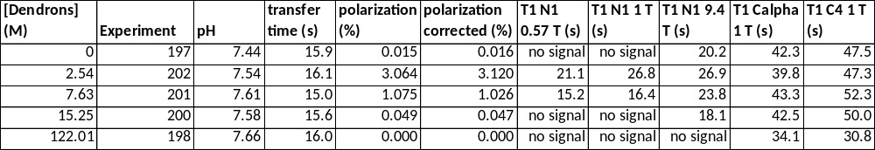

Table S7: Figure 3A with 1-¹⁵N-NAM as tracer.
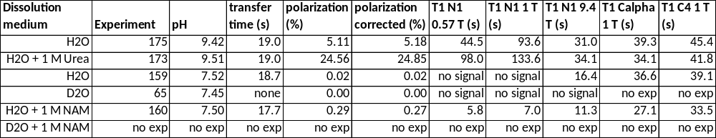

Table S8: Figure 3B with ¹⁵N-pyridine as tracer.
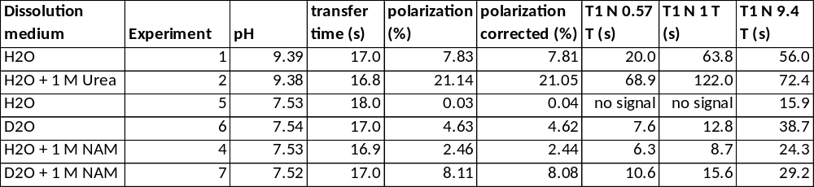

Table S9: Figure 3C with naturally abundant MTZ (N3) as tracer.
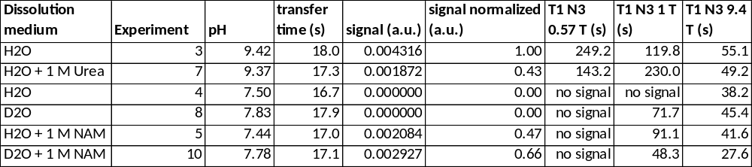

Table S10: Figure 3C with naturally abundant MTZ (NO₂) as tracer.
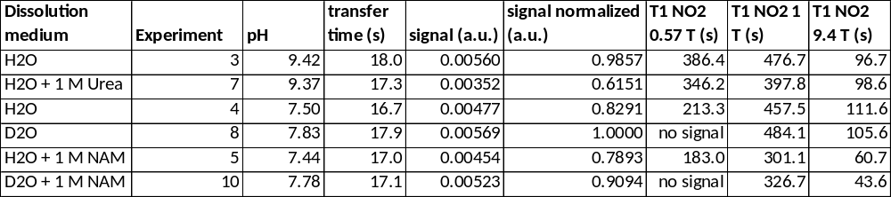

Table S11: Figure 3D with naturally abundant pyrimidine as tracer.
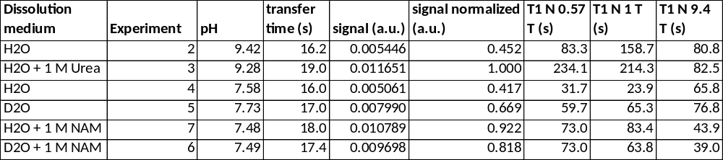

Table S12: Figure 3B with ¹⁵N₂-urea as tracer.
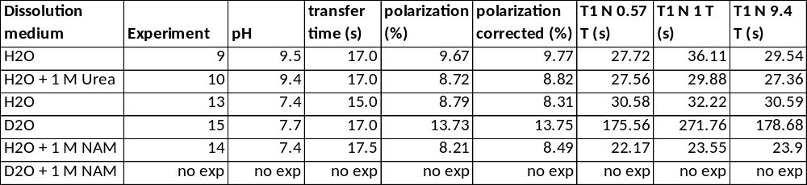

- Other combinations of hyperpolarized molecules with potential CIDER agents
Case 1. We used 2,2’-bipyridine as a CIDER agent with NAM. No significant preservation of polarization was observed. This negative result is likely due to the low solubility of 2,2’-bipyridine in water: 5.5 g/L ~ 35 mM and that it is not a hydrogen bond donor, although 2,2’-bipyridine is an excellent chelating agent with two coordination sites.
Case 2. Ammonia has some loose similarities with urea and very high solubility. However, even at concentrations of 1 M (dissolution medium buffered to pH 7.4, pH 6.8 after dissolution), no significant effect on the preservation of ¹⁵N-pyridine polarization was found. The interaction with pyridine is likely too weak because amide hydrogens of urea or NAM are much better hydrogen donors than protonated ammonia in the case of neutral pH (ammonia pKa 9.24). Since pH values above the pKa of ammonia are not physiological, ammonia does not present a viable CIDER agent in our case. Although varying concentrations of ammonia are produced during the heating of urea inside the dissolution media, the above findings suggest that mostly urea participates in the CIDER effect of the formed solution.
Case 3. Jiang et al. reported T₁ for NAM at pH 5.9 of around 22 s, though also with low polarization of about 1.2% (26). Previously, we could not reproduce the hyperpolarized 1-¹⁵N-NAM signal at this pH as no signal was observed (20). However, we suspect now that the difference in the sample composition can be the reason: Jiang et al. had about 145 mM concentration of DMSO, which can act as a CIDER agent due to its very strong dipolmoment, possibly explaining the difference in findings: instead of DMSO, we used water as a solvent.
Case 4. We used 1 M NAM and urea as CIDER agents trying to preserve the hyperpolarization of 1-¹³C-pyruvate and glucose-d7 – no significant positive effects on the preservation of polarization were found. More experiments are needed to deduct if the CIDER agents make a difference or not. Possibly, the concentration of the CIDER agents was too high or not appropriate for these compounds: similar detrimental effects at high concentrations were discussed for 1-¹⁵N-NAM (Fig. 2 main text). Studies of other agents' effect on pyruvate relaxation are ongoing.

- Literature
[1] G. R. Fulmer, A. J. M. Miller, N. H. Sherden, H. E. Gottlieb, A. Nudelman, B. M. Stoltz, J. E. Bercaw, K. I. Goldberg, Organometallics 2010, 29, 2176-2179.
[2] M. Wyszogrodzka, R. Haag, Chem. Eur. J. 2008, 14, 9202 – 9214.

