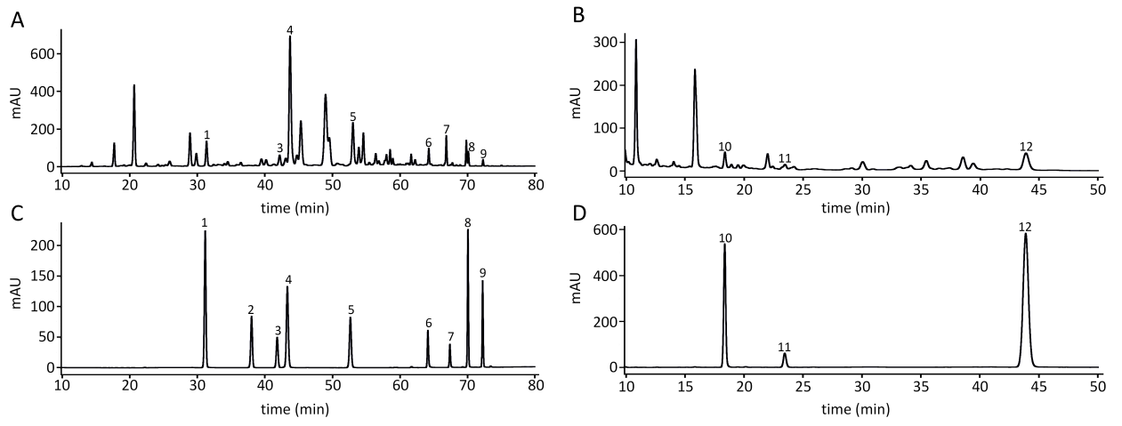
Fig. S1. HPLC for AE and reference substances. (A) HPLC of AE at 350 nm, solvent B: methanol. (B) HPLC of AE at 205nm, solvent B: acetonitrile. (C) HPLC of reference substances at 350nm, solvent B: methanol. (D) HPLC of reference substances at 205nm, solvent B: acetonitrile. 1 scopoletin (80 μg/mL), 2 scoparone (18 μg/mL), 3 isochlorogenic acid B (28 μg/mL), 4 isochlorogenic acid A (134 μg/mL), 5 isochlorogenic acid C (52 μg/mL), 6 luteolin (12 μg/mL), 7 apigenin (16 μg/mL), 8 chrysosplenetin (78 μg/mL), 9 artemisetin (37 μg/mL), 10 artemisinin B (400 μg/mL), 11 artemisinin (1850 μg/mL), 12 artemisinic acid (600 μg/mL).

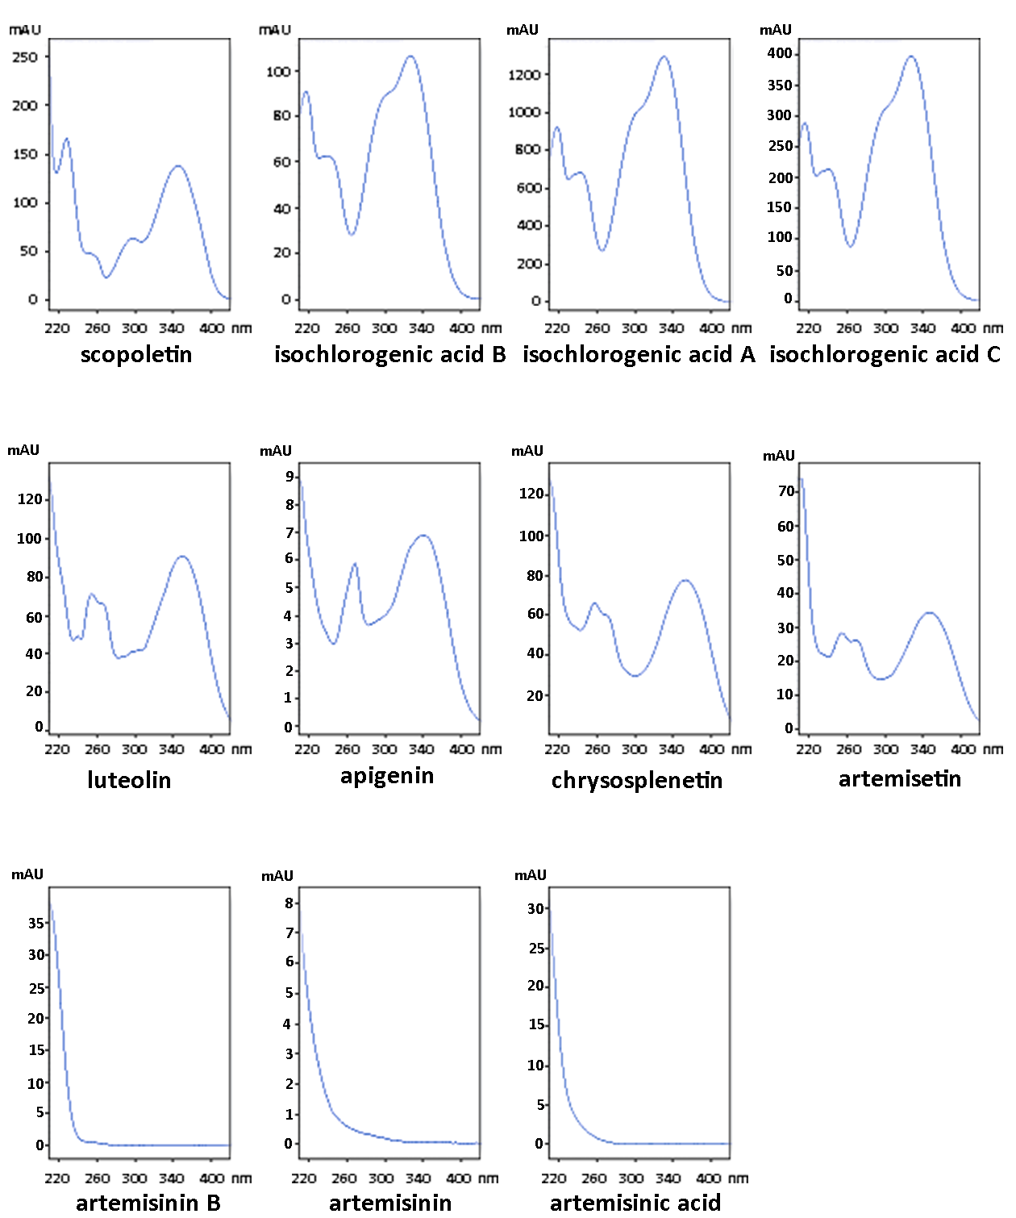
Fig. S2 Ultraviolet spectrum of 11 constituents in AE.
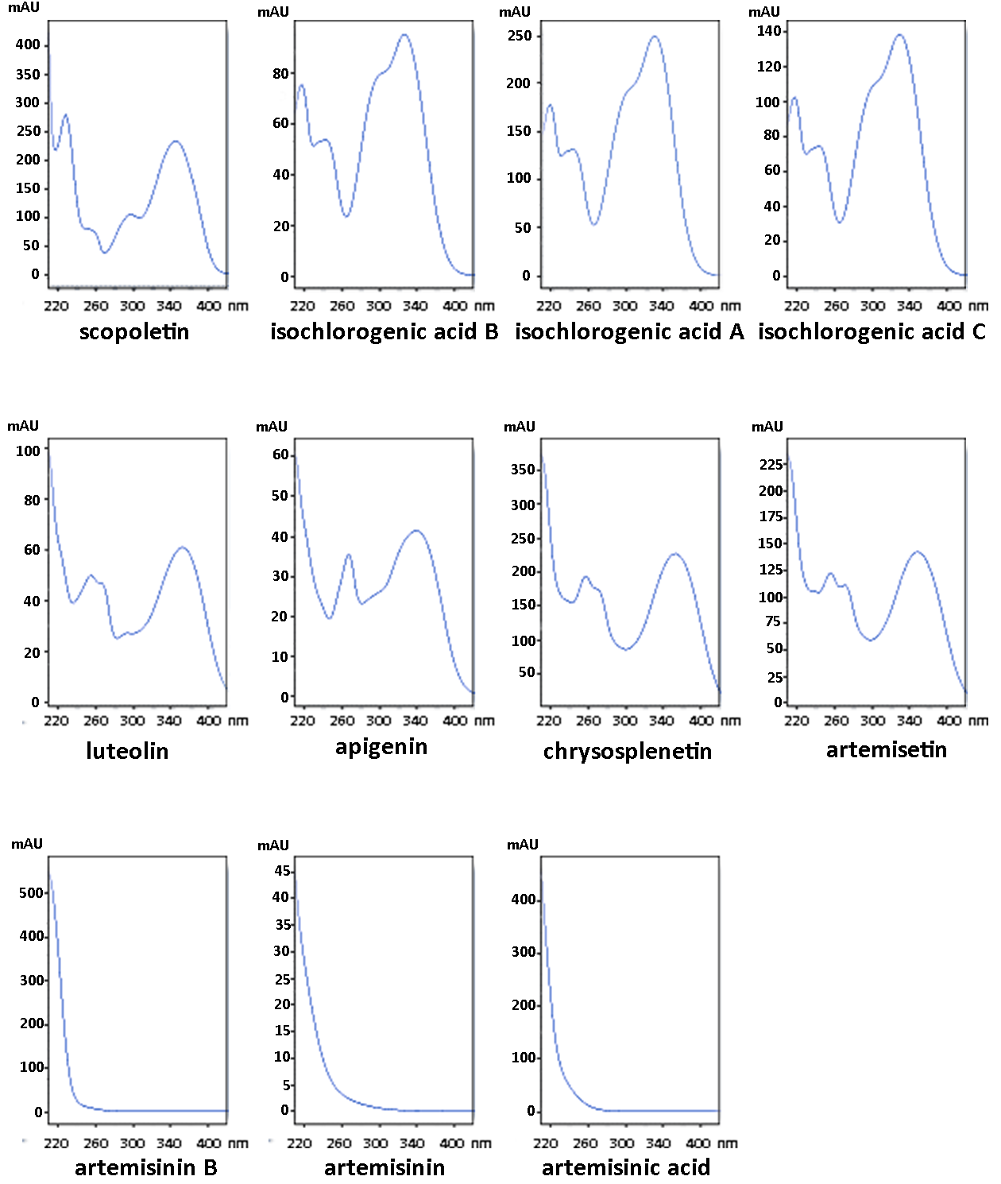
Fig. S3 Ultraviolet spectrum of 11 constituents in reference substances.

