Supplementary Information

A novel spatiotemporal prediction approach to fill air pollution data gaps using sensor, machine learning and citizen science techniques
Arunik Baruah^{1,2}, Dimitrios Bousiotis³, Seny Damayanti³, Alessandro Bigi¹, Grazia Ghermandi¹, O. Ghaffarpasand³, Roy M. Harrison^{3,4}, Francis D. Pope³

¹Dept. of Engineering ‘Enzo Ferrari’, University of Modena and Reggio Emilia, Modena, 41125, Italy
²University School for Advanced Studies IUSS Pavia, Palazzo Del Broletto, Pavia, 27100, Italy
³School of Geography, Earth and Environmental Sciences, University of Birmingham, Birmingham, B15 2TT, United Kingdom
⁴Department of Environmental Sciences, Faculty of Meteorology, Environment and Arid Land Agriculture, King Abdulaziz University, Jeddah 21589, Saudi Arabia

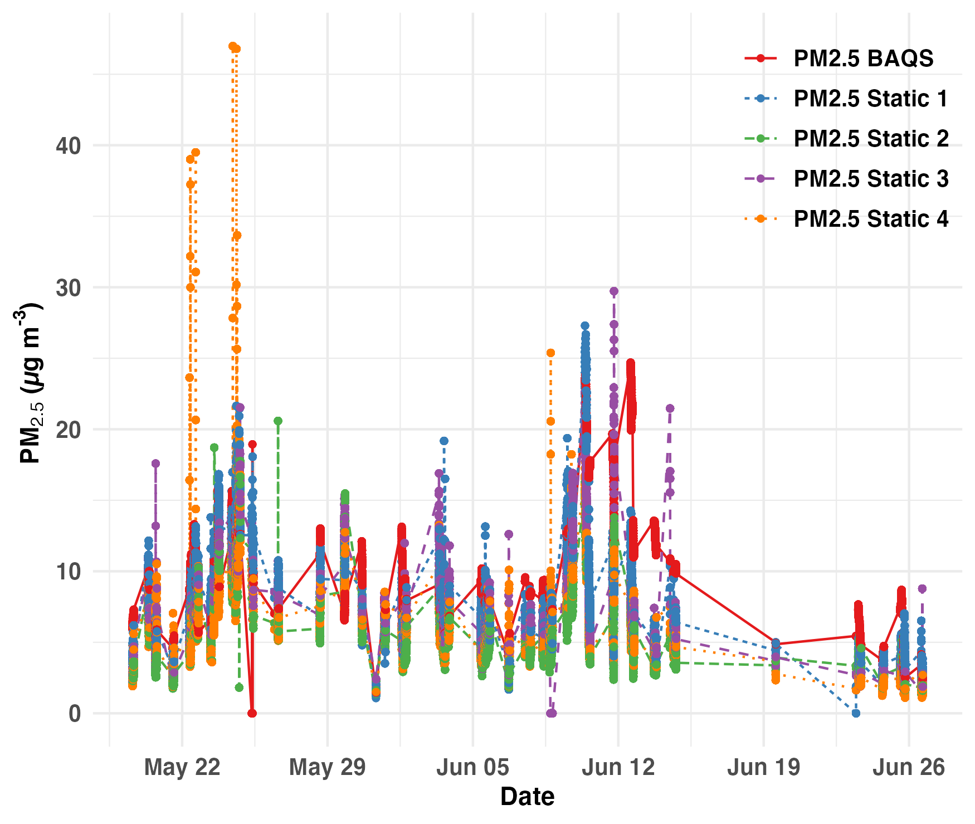
Fig. S1 - Daily PM_{2.5} concentrations recorded by Static Sensors and BAQS

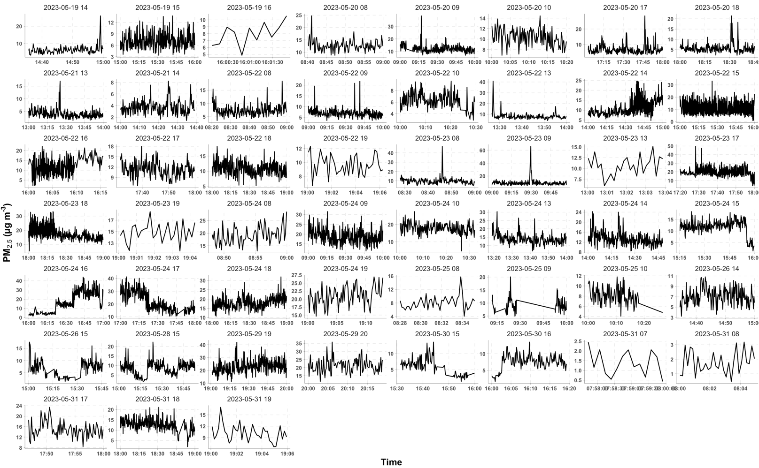
Fig. S2.1 - Daily PM_{2.5} concentrations recorded by Mobile Sensors

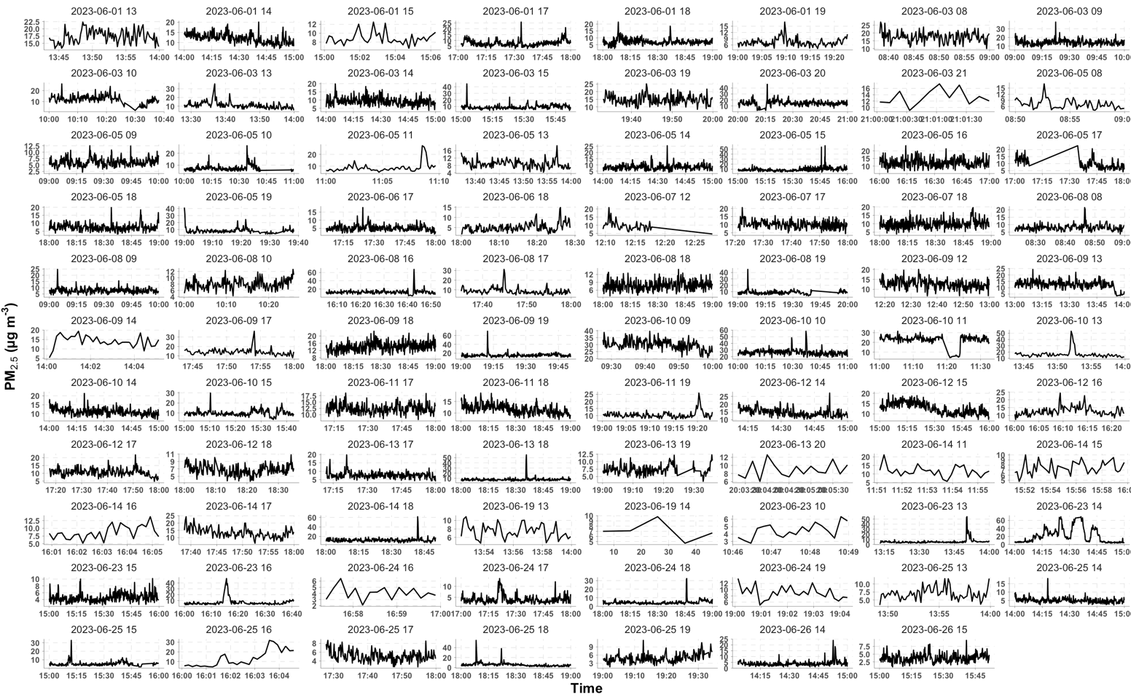
Fig. S2.2 - Daily PM_{2.5} concentrations recorded by Mobile Sensors

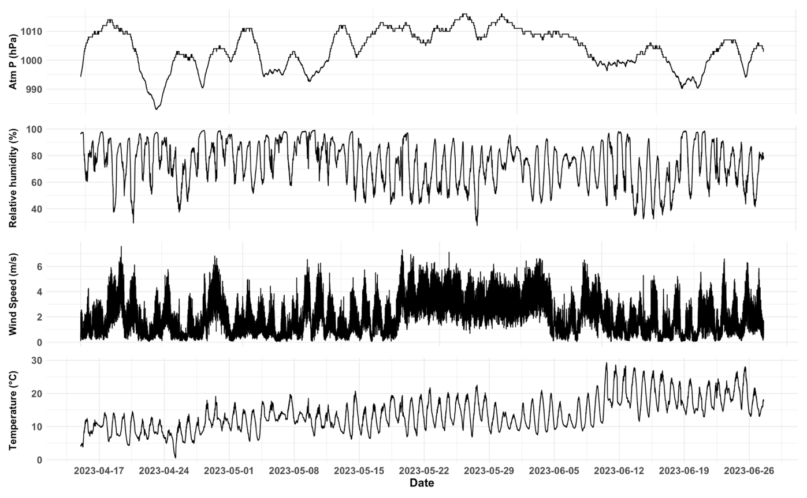
Fig. S3 - Daily Meteorological variables recorded by BAQS
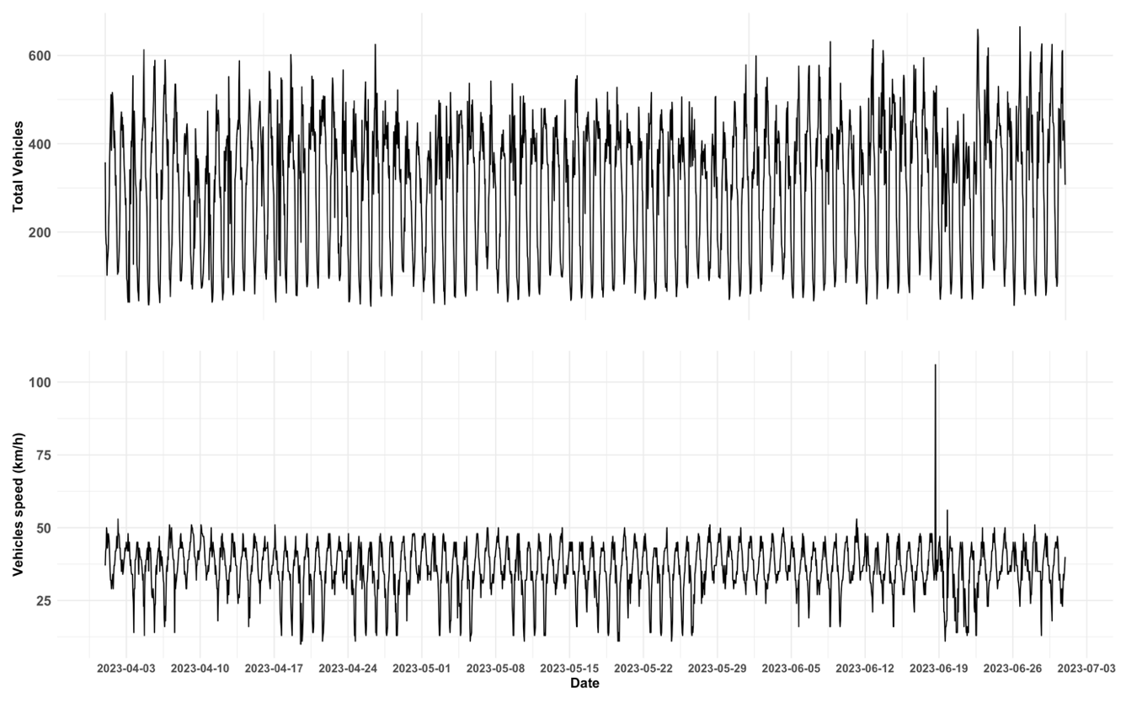Fig. S4 – Time series of traffic variables

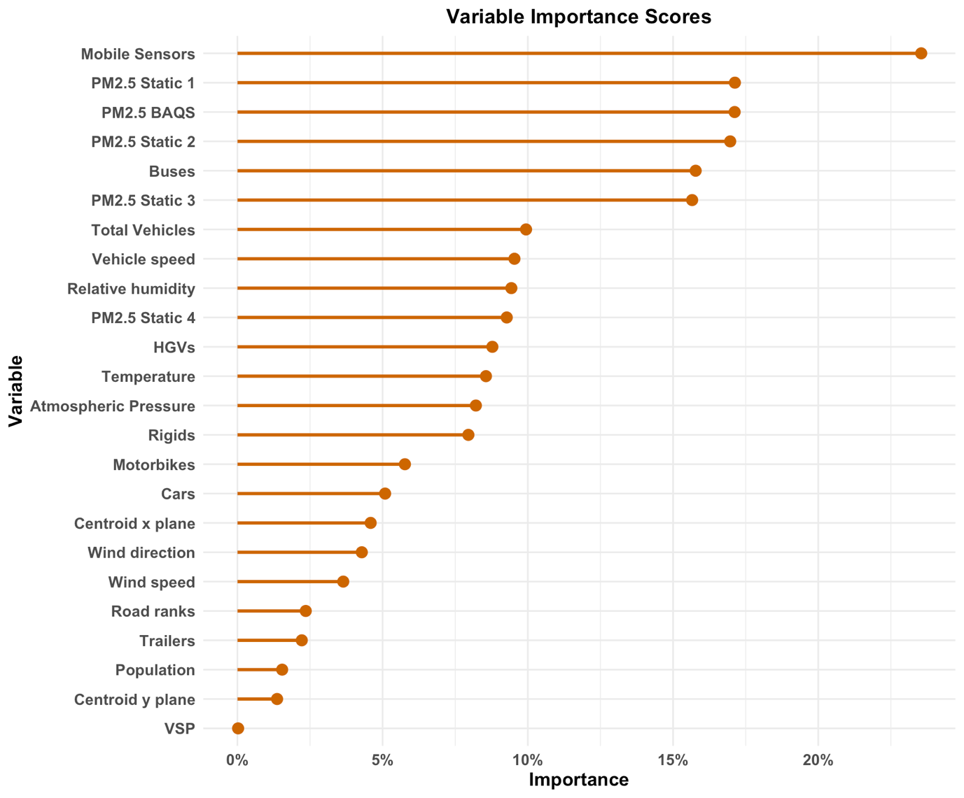Fig. S5 – VIMP including VSP from telematics data
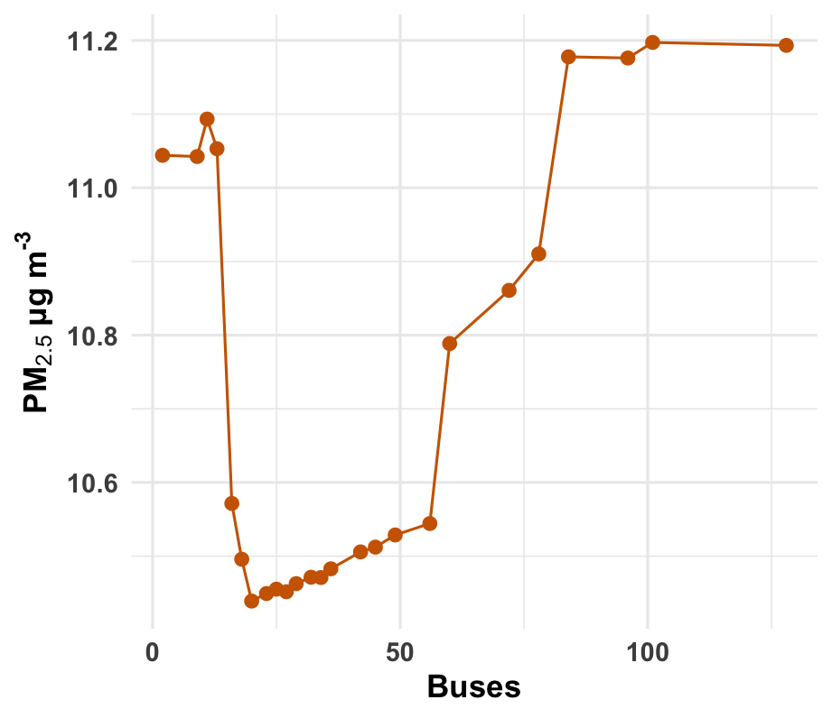
Fig. S6 – Partial Dependence Plots (PDPs) of PM_{2.5} with Buses

Name | Long-Lat
BAQS | POINT (-1.9288547 52.4558581)
University of Birmingham | POINT (-1.930652 52.4500714)
Static Sensor 1 | POINT (-1.932132 52.4436258)
Static Sensor 2 | POINT (-1.9285715 52.4470732)
Static Sensor 3 | POINT (-1.9259056 52.4399999)
Static Sensor 4 | POINT (-1.9336139 52.4458895)
Road network | POLYGON ((-1.9366172 52.4432244, -1.9358233 52.4426489, -1.9343427 52.4416287, -1.9338921 52.4412625, -1.9331626 52.4405692, -1.9324115 52.4398629, -1.9317893 52.439235, -1.9304374 52.43794, -1.9293645 52.4368543, -1.9281629 52.4378746, -1.9271544 52.4387903, -1.9262317 52.4394835, -1.9256095 52.4401376, -1.9253734 52.4406346, -1.9259957 52.4410532, -1.926618 52.4416025, -1.9270686 52.4427012, -1.9273261 52.4445716, -1.9273904 52.4458141, -1.9276265 52.4461149, -1.9276908 52.4471612, -1.9294075 52.4467819, -1.9312957 52.4463111, -1.93342 52.4457094, -1.9342354 52.4452255, -1.9354585 52.4443231, -1.9366172 52.4432244))
Table S1 - Geospatial Coordinates of study area

Detailed Equations for Performance Metrics -

$R^{2}=1-\frac{\sum_{i=1}^{n}{ }{\left({Obs}_{i}-{Pred}_{i}\right)}^{2}}{\sum_{i=1}^{n}{ }{\left({Obs}_{i}-Obs\right)}^{2}}$ (1)

$MBE=\frac{1}{n}\sum_{i=1}^{n}{ }\left({Obs}_{i}-{Pred}_{i}\right)$ (2)

$RMSE=\sqrt{\frac{1}{n}\sum_{i=1}^{n}{ }{\left({Obs}_{i}-{Pred}_{i}\right)}^{2}}$ (3)

$MAE=\frac{1}{n}\sum_{i=1}^{n}{ }\left|{Obs}_{i}-{Pred}_{i}\right|$ (4)

$ρ=1-\frac{6∑{\left({\text{ Rank }}_{{\text{Obs }}_{i}}-{\text{ Rank }}_{{\text{Pred }}_{i}}\right)}^{2}}{n\left(n^{2}-1\right)}$ (5)

