Needle Point Bipolar Ionization (NPBI): Environmental Safety and Inactivation of Airborne Bacteria and Corona Virus

¹Dila Aydın, ²Nurten Tetik, ¹Ülkü Alver Şahin*, ¹Coşkun Ayvaz, ³Elif Nurtop, ⁴Cansel Vatansever, ^{4,5}Füsun Can
¹Istanbul University-Cerrahpaşa, Engineering Faculty, Environmental Engineering Department, Istanbul, Türkiye
²Food Engineering, Faculty of Chemistry and Metallurgy, Yıldız Technical University, Istanbul, Türkiye
³ Unité des Virus Émergents, Aix Marseille University, IRD 190, INSERM U1207, Marseille, France
⁴ Koç University İşbank Center for Infectious Diseases, Istanbul, Türkiye
⁵Koç University, School of Medicine, Department of Medical Microbiology, Istanbul, Türkiye

*ulkualver@iuc.edu.tr

a)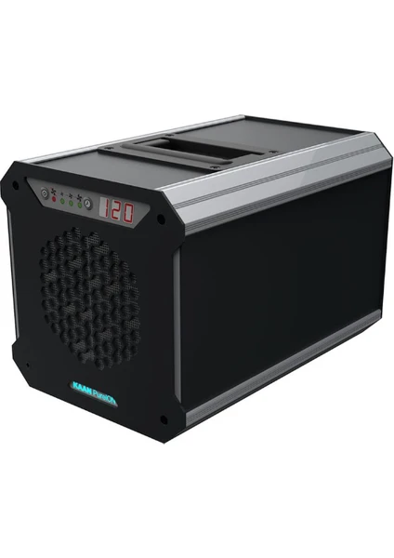b)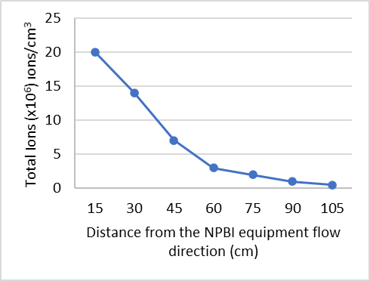
Figure S1. Total ions released (a) at different distance from the NPBI device (b) with WM3 operation condition.

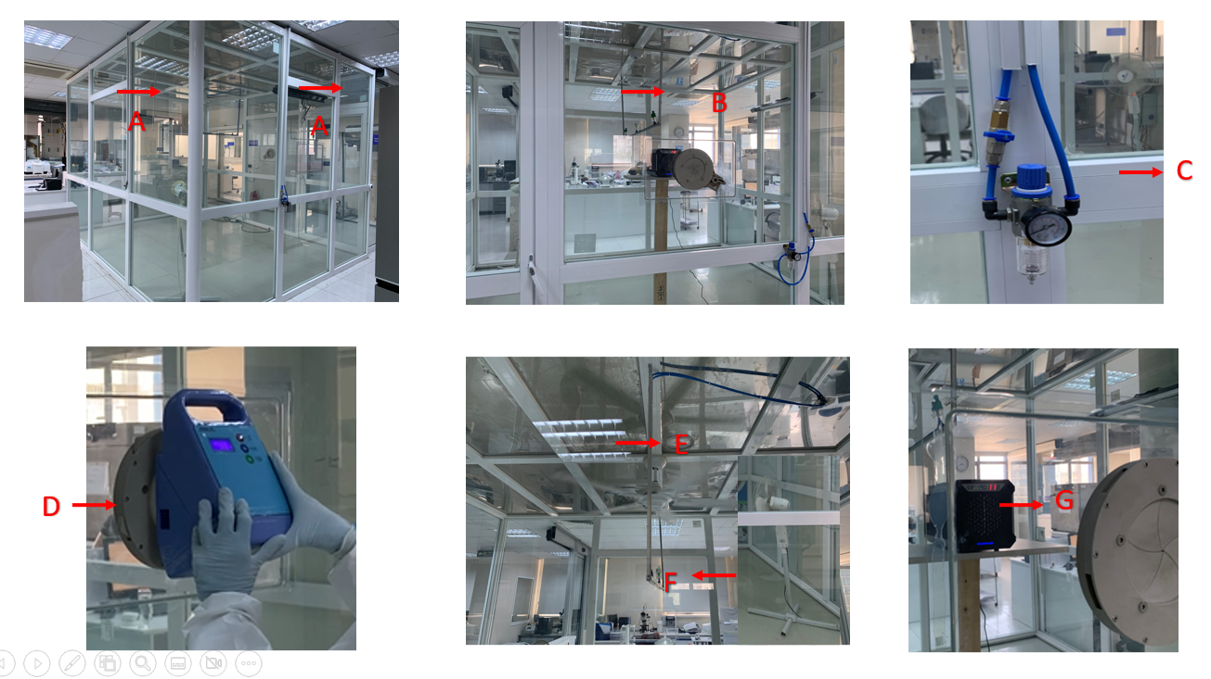

Figure S2: 30m³ aerosol chamber for bacterial test
A: UVC B: Nebulizer C: Bacteria flow D: Sampler E: Ceiling Fan F : Stand fan G: NPBI device

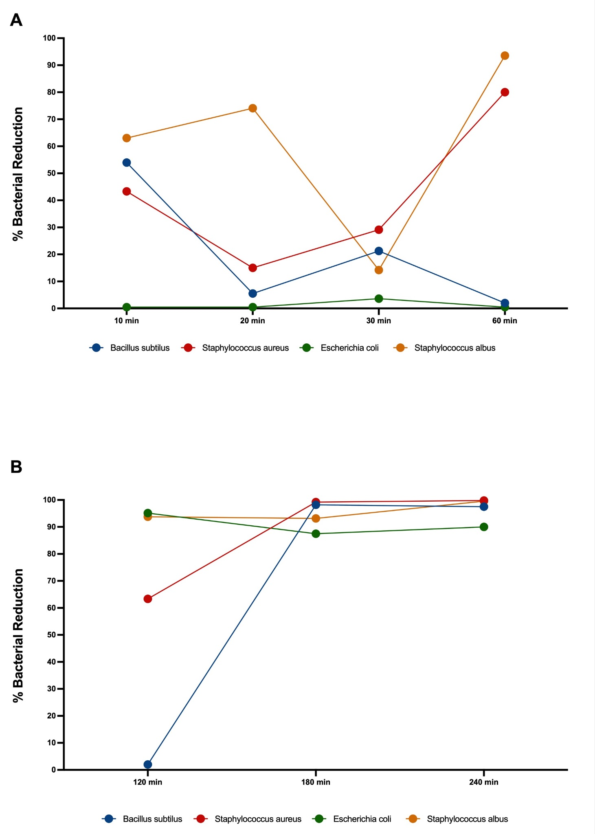
Figure S3. Bacterial reduction rate within 1 hour (A) and between 2 and 4 hours (B) during the operation of NPBI device in comparison with natural decay.

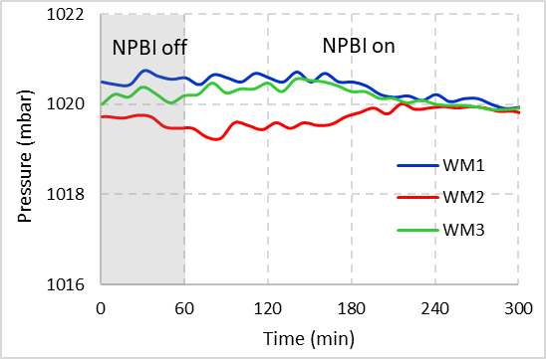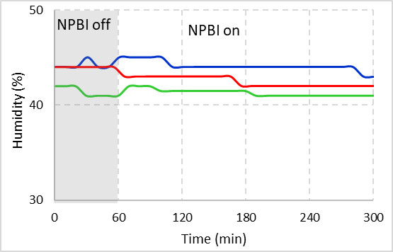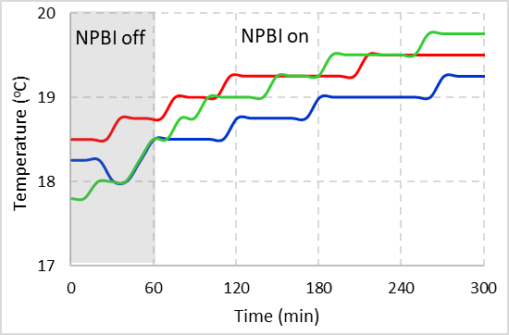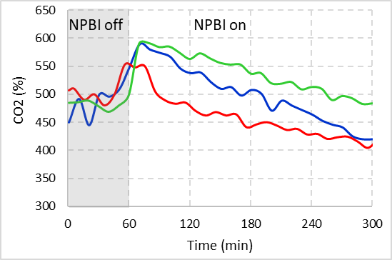

Figure S4. Thermal comfort parameters and CO₂ in the office room before and during the operation of NPBI device WM₁: 2.68 m³/min; WM₂: 3.26 m³/min; WM₃: 3.88 m³/min.

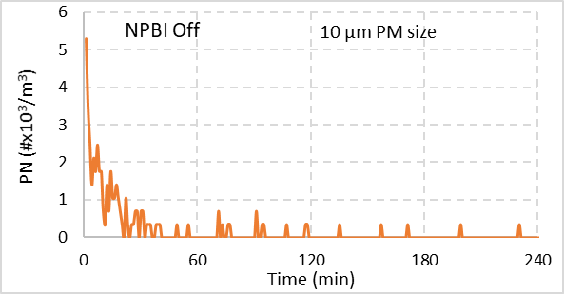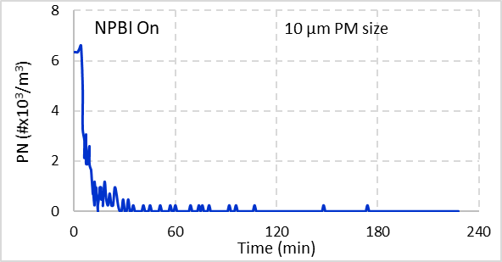
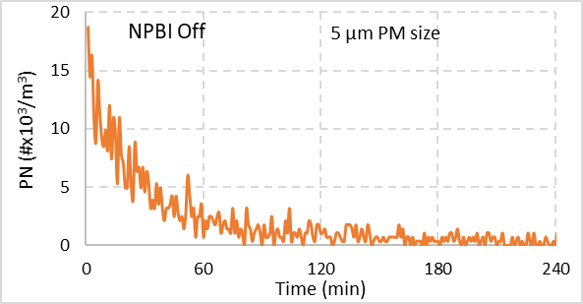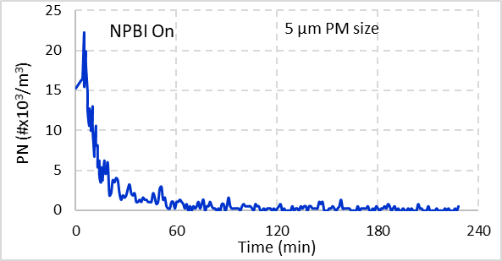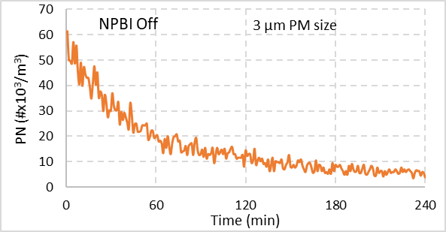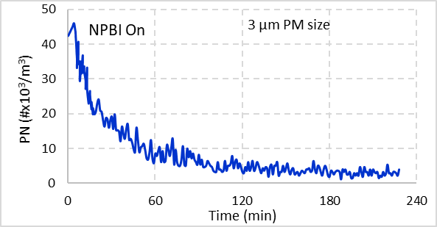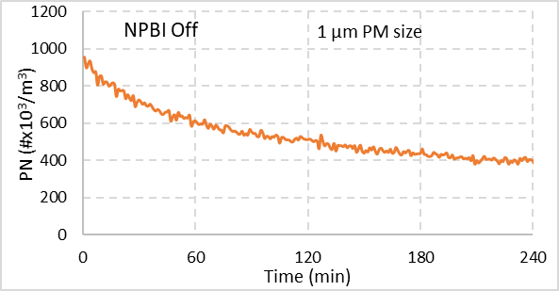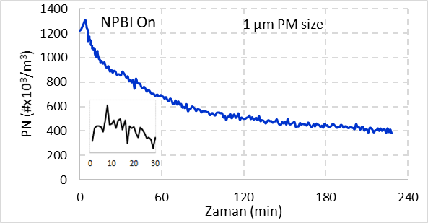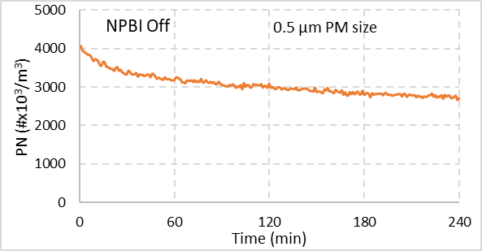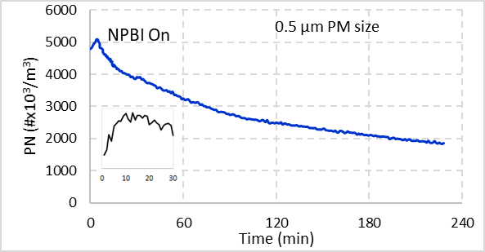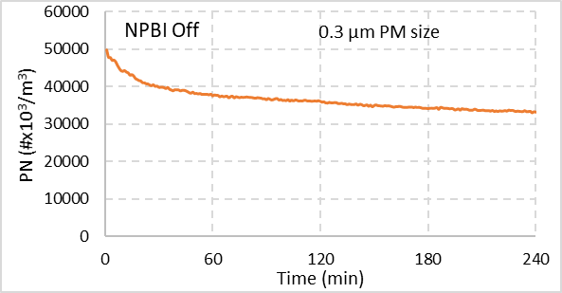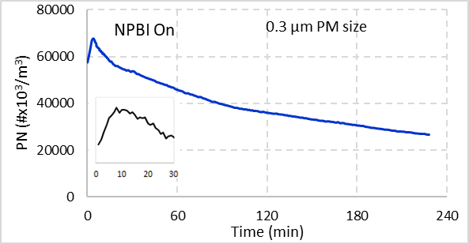

Figure S5. Particle Number Count Change during the NPBI device on (left) and off (right) in the office room. Small graphs for 0.3, 0.5 and 1 um PM sizes on the left side graphs are focusing on the first 30 minutes when NPBI device on.

Table S1: The microbial test results.

Bacteria | Time (minute) | Log10 Mean Natural (NPBI off) | Log10 Mean  (NPBI on)
Bacillus subtilis | 0 | 6.457 | 5.358
Bacillus subtilis | 10 | 6.164 | 4.829
Bacillus subtilis | 20 | 5.735 | 4.709
Bacillus subtilis | 30 | 5.674 | 4.568
Bacillus subtilis | 60 | 5.048 | 4.049
Bacillus subtilis | 120 | 4.496 | 3.811
Bacillus subtilis | 180 | 4.044 | 1.301
Bacillus subtilis | 240 | 3.329 | 1.000
Staphylococcus aureus | 0 | 7.769 | 5.477
Staphylococcus aureus | 10 | 7.403 | 4.618
Staphylococcus aureus | 20 | 7.135 | 4.584
Staphylococcus aureus | 30 | 6.847 | 3.712
Staphylococcus aureus | 60 | 6.719 | 4.151
Staphylococcus aureus | 120 | 6.080 | 3.248
Staphylococcus aureus | 180 | 5.740 | 2.954
Staphylococcus aureus | 240 | 5.348 | 0.523
Escherichia coli | 0 | 6.295 | 5.652
Escherichia coli | 10 | 5.827 | 4.875
Escherichia coli | 20 | 5.619 | 4.799
Escherichia coli | 30 | 5.530 | 4.505
Escherichia coli | 60 | 4.767 | 4.397
Escherichia coli | 120 | 4.169 | 1.845
Escherichia coli | 180 | 3.527 | 1.602
Escherichia coli | 240 | 3.322 | 1.301
Staphylococcus albus | 0 | 6.710 | 5.602
Staphylococcus albus | 10 | 6.635 | 5.195
Staphylococcus albus | 20 | 6.622 | 5.019
Staphylococcus albus | 30 | 5.819 | 4.741
Staphylococcus albus | 60 | 5.718 | 3.518
Staphylococcus albus | 120 | 5.224 | 2.982
Staphylococcus albus | 180 | 5.153 | 2.892
Staphylococcus albus | 240 | 4.857 | 1.000

Table S2: The p values of t-test between the average values of the device-off (during a hour) and for each one hour time spans during the device-on.

Fan Mode of the device | Minutes after the device work on | Parameters
Fan Mode of the device | Minutes after the device work on | Pressure | Temperature | Humidity | CO2 | VOC | PM2.5 | NO2
WM1 | 60-120 | 0.65 | 0.00 | 0.05 | 0.00 | 0.00 | 0.00 | 0.17
WM1 | 120-180 | 0.48 | 0.00 | 0.92 | 0.00 | 0.00 | 0.01 | 0.09
WM1 | 180-240 | 0.01 | 0.00 | 0.30 | 0.61 | 0.00 | 0.05 | 0.00
WM1 | 240-300 | 0.00 | 0.00 | 0.10 | 0.01 | 0.00 | 0.00 | 0.00
WM2 | 60-120 | 0.00 | 0.00 | 0.36 | 0.15 | 0.00 | 0.35 | 0.01
WM2 | 120-180 | 0.03 | 0.00 | 0.08 | 0.00 | 0.00 | 0.01 | 0.18
WM2 | 180-240 | 0.00 | 0.00 | 0.00 | 0.00 | 0.19 | 0.00 | 0.50
WM2 | 240-300 | 0.00 | 0.00 | 0.00 | 0.00 | 0.00 | 0.00 | 0.05
WM3 | 60-120 | 0.02 | 0.00 | 0.23 | 0.00 | 0.00 | 0.00 | 0.00
WM3 | 120-180 | 0.00 | 0.00 | 0.73 | 0.00 | 0.00 | 0.23 | 0.00
WM3 | 180-240 | 0.57 | 0.00 | 0.12 | 0.00 | 0.00 | 0.01 | 0.03
WM3 | 240-300 | 0.00 | 0.00 | 0.06 | 0.02 | 0.00 | 0.00 | 0.31

