Isolable Carbon(I) Species Featuring Cation Radical

Yi-Chen Chan, He-Xin Xiao, Lei Qin, Jiun-Shian Shen, Chen-Rui Yang, Glenn P. A. Yap, Wei-Min Ching, Wen-Ching Chen,* Yun-Wei Chiang,* Gernot Frenking,* Lili Zhao,* and Tiow-Gan Ong*

Email: tgong@gate.sinica.edu.tw
ias_llzhao@njtech.edu.cn
frenking@chemie.uni-marburg.de
ywchiang@mx.nthu.edu.tw
cwc590317@gmail.com

SUPPORTING INFORMATION

Contents
I. General---------------------------------------------------------------------------------------S2
II. Experimental section and characterization-------------------------------------S3-S15
III. Cyclic Voltammetry---------------------------------------------------------------------S16
IV. Electron Paramagnetic Resonance--------------------------------------------S17-S18
V. UV-vis Absorption Spectroscopy------------------------------------------------------S19
VI. X-ray Crystallography-----------------------------------------------------------S20-S27
VII. NMR Spectroscopy---------------------------------------------------------------S28-S57
VIII. Computational Methods and Details----------------------------------------S58-S64
IX. References --------------------------------------------------------------------------------S65

I. General. All air-sensitive manipulations were performed under an atmosphere of nitrogen using Schlenk technique and/or glovebox. ¹H and ¹³C NMR spectra were recorded on Bruker HD 600 (600 MHz ¹H, 151 MHz ¹³C, 565 MHz ¹⁹F), Bruker Avance 500 (500 MHz ¹H, 126 MHz ¹³C) and Bruker Avance 400 (400 MHz ¹H, 101 MHz ¹³C) spectrometer using the residual proton of the deuterated solvent for reference (CD₂Cl₂, ¹H NMR: 5.32 ppm. ¹³C NMR: 54.00 ppm; CDCl₃, ¹H NMR: 7.24 ppm. ¹³C NMR: 77.00 ppm; d⁷-DMF, ¹H NMR: 2.88 ppm. ¹³C NMR: 162.66 ppm). Chemical shifts are reported in ppm (δ), coupling constants, J, are reported in Hz. High resolution mass spectra were obtained with a JEOL, JMS-700 (FAB⁺) spectrometer. Crystals were mounted using viscous oil onto glass fibers and cooled to the data collection temperatures. Data were collected on a Bruker-AXS APEX CCD diffractometer with graphite-monochromated Mo-K_{α} radiation (λ = 0.71073 Å). Unit cell parameters were obtained from 60 data frames, 0.3º ω, from three different sections of the Ewald sphere. CCDC 2365151 (2-Au), CCDC 2365152 ([2-Au]), CCDC 2365153 (4b) and CCDC 2365154 (5a) contain the supplementary crystallographic data for this paper. The data can be obtained free of charge from the Cambridge Crystallographic Data Center www.ccdc.cam.ac.uk/data_request/cif. All reagents were purchased from Acros, Aldrich, and Alfa Aesar without further purification in advance before use. Dichloromethane was dried over CaH₂ before use. Pentane and THF were dried over sodium with benzophenone-ketyl intermediate as indicator.

II. Experimental section and characterization
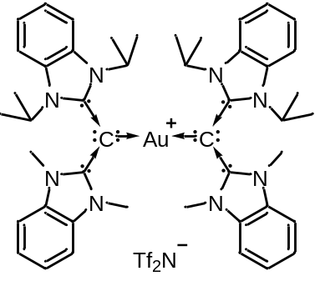Preparation of 2-Au from reaction of 1-CDC with Ph₃P-AuNTf₂. Into a 50 mL vial containing Ph₃P-AuNTf₂ (0.740 g, 1.0 mmol) dissolved in anhydrous THF (8.0 mL), a solution of 1-CDC¹ (0.720 g, 2.0 mmol) in anhydrous THF (10.0 mL) was added dropwise. The reaction mixture was stirred at ambient temperature for 3 h, then pentane was added (10 mL) to the reaction flask affording a precipitate. The precipitate was subsequently filtered and washed with pentane, then dried in vacuo to yield 2-Au quantitatively as a yellow powder. ¹H NMR (600 MHz, CD₂Cl₂) δ 7.54-7.53 (m, 4H), 7.31-7.29 (m, 4H), 7.03-7.02 (m, 4H), 6.86-6.85 (m, 4H), 5.24 (sept, J = 7.1, 4H), 3.44 (s, 12H), 1.49 (d, J = 7.1, 24H); ¹³C NMR (151 MHz, CD₂Cl₂) δ 159.9, 154.2, 135.4, 131.0, 123.8, 121.8, 113.2, 107.1, 78.4, 50.4, 33.5, 20.1; ¹⁹F NMR (565 MHz, CD₂Cl₂) δ -80.6; HR-MS (ESI): calculated for C₄₆H₅₆N₈Au [M-NTf₂]⁺: 917.4294, Found: 917.4288.

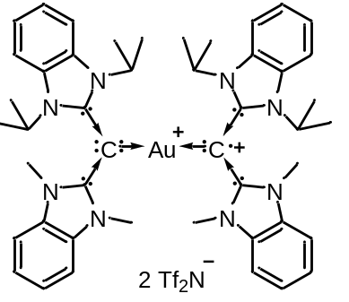Preparation of [2-Au]from reaction of 2-Au with AgNTf₂. Into a 20-mL vial containing complex 2-Au (0.02 g, 0.05 mmol) dissolved in anhydrous CH₂Cl₂ (0.5 mL), a solution of AgNTf₂ (0.06 g, 0.05 mmol) in anhydrous CH₂Cl₂ (1.5 mL) was added dropwise. The reaction mixture was stirred at ambient temperature for 1 h. The resulting dark green solution was filtered, concentrated and subsequently washed with pentane to quantitatively yield [2-Au] as a dark green solid. HR-MS (FAB): calculated for C₅₀H₅₈F₁₂N₁₀O₈S₄Au [M+2H]⁺: 1479.2796, Found: 1479.2788.

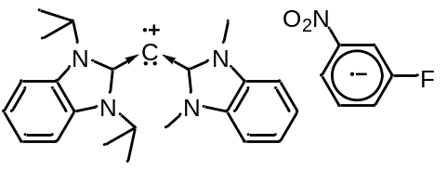Preparation of 4b from reaction of 1-CDC with 1-fluoro-3-nirobenzene. Into a 20 mL vial containing 1-fluoro-3-nitrobenzene (0.564 g, 4.0 mmol) dissolved in anhydrous THF (2.0 mL), a solution of 1-CDC (0.072 g, 0.2 mmol) in anhydrous THF (6.0 mL) was added dropwise. The reaction mixture was stirred at ambient temperature for 3 h. The resulting solution was subsequently filtered and 4a was recrystallized by slow diffusion of pentane into the solution at -25 ℃ to give 4a as dark red crystals (0.25 g, 25%); HR-MS (ESI): calculated for C₂₉H₃₁N₅O₂F [M-H]⁺: 500.24563, Found: 500.24508.

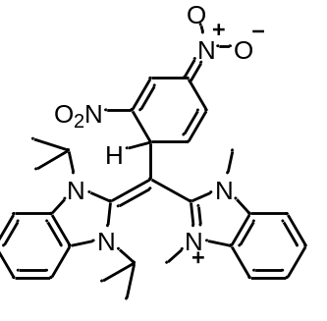Preparation of 5a from reaction of 1-CDC with 1,3-dinirobenzene. Into a 20 mL vial containing 1,3-dinitrobenzene (0.034 g, 0.2 mmol) dissolved in anhydrous THF (1.0 mL), a solution of 1-CDC (0.072 g, 0.2 mmol) in anhydrous THF (3.0 mL) was added dropwise. The reaction mixture was stirred at ambient temperature for 1 h. The resulting precipitate was subsequently filtered, then dried in vacuo to yield 5a as as a dark red solid (0.09g, 84%). ¹H NMR (400 MHz, d⁷-DMF) δ 8.74 (br, 1H), 8.16 (br, 2H), 7.62 (br, 4H), 7.45-7.43 (m, 2H), 6.96 (d, J = 10.1, 1H), 5.91 (dd, J = 10.1, 3.8, 1H), 5.55 (br, 1H), 4.88 (br, 2H), 3.58 (br, 6H), 1.73 (br, 12H); ¹³C NMR (101 MHz, d⁷-DMF) δ 157.7, 157.4, 134.8, 131.4, 129.9, 129.1, 124.7, 124.4, 124.0, 123.8, 121.4, 114.9, 110.4, 62.0, 52.8, 43.5, 34.3, 19.8; HR-MS (ESI): calculated for C₂₉H₃₂N₆O₄Na [M+Na]⁺: 551.23772, Found: 551.23776.

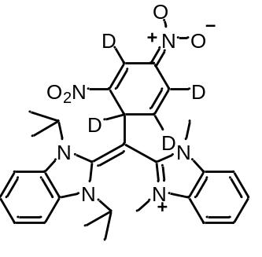Preparation of 5a-d₄ from reaction of 1-CDC with 1,3-dinirobenzene-d₄. Into a 20 mL vial containing 1,3-dinitrobenzene-d₄ (0.017 g, 0.1 mmol) dissolved in anhydrous THF (1.0 mL), a solution of 1-CDC (0.036 g, 0.1 mmol) in anhydrous THF (3.0 mL) was added dropwise. The reaction mixture was stirred at ambient temperature for 1 h. The resulting precipitate was subsequently filtered, then dried in vacuo to yield 5a-d₄ as a dark red solid (0.041g, 77%). ¹H NMR (400 MHz, d⁷-DMF) δ 8.16 (br, 2H), 7.62 (br, 4H), 7.44 (br, 2H), 4.88 (br, 2H), 3.58 (br, 6H), 1.73 (br, 12H); ¹³C NMR (101 MHz, d⁷-DMF) δ 157.7, 157.4, 134.8, 131.4, 129.8, 129.1-128.7(m), 124.7, 124.3, 123.9, 123.5-123.1(m), 121.1 (t, J = 23.3), 114.9, 110.4, 62.0, 52.8, 43.0 (br), 34.2, 19.7; HR-MS (ESI): calculated for C₂₉H₂₈N₆O₄NaD₄ [M+Na]⁺: 555.26283, Found: 555.26215.

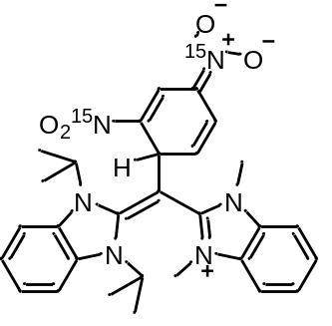Preparation of 5a-¹⁵N₂ from reaction of 1-CDC with 1,3-dinitrobenzene-¹⁵N₂. Into a 20 mL vial containing 1,3-dinitrobenzene-¹⁵N₂ (0.017 g, 0.1 mmol) dissolved in anhydrous THF (1.0 mL), a solution of 1-CDC (0.072 g, 0.2 mmol) in anhydrous THF (3.0 mL) was added dropwise. The reaction mixture was stirred at ambient temperature for 1 h, then diethyl ether (4 mL) was added to afford a precipitation. The solid was filtered off, followed by drying in vacuo to yield 5a-¹⁵N₂ as as a dark red solid (0.04g, 75%). ¹H NMR (400 MHz, d⁷-DMF) δ 8.74 (br, 1H), 8.16 (br, 2H), 7.62 (br, 4H), 7.44 (br, 2H), 6.96 (d, J = 8.9, 1H), 5.91 (d, J = 7.8, 1H), 5.55 (br, 1H), 4.88 (br, 2H), 3.59 (br, 6H), 1.73 (br, 12H); ¹³C NMR (101 MHz, d⁷-DMF) δ 157.7, 157.4, 134.8, 131.3, 129.9 (d, J = 20.2), 129.1, 124.7, 124.3 (d, J = 16.7), 123.94, 123.85, 121.4, 114.9, 110.4, 62.0, 52.8, 43.5, 34.3, 19.7; HR-MS (ESI): calculated for C₂₉H₃₁N₄O₄¹⁵N₂ [M-H]⁺: 529.23420, Found: 529.23409.

- General procedure for C-O bond formation of nitrobenzene derivatives
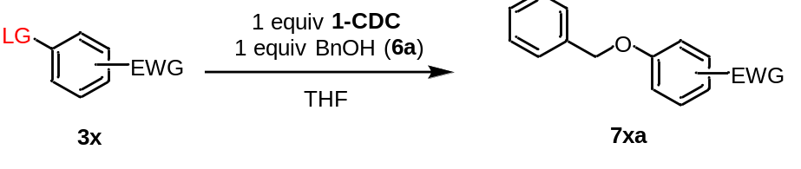
Into a 20 mL vial was placed 1-CDC (0.108 g, 0.3 mmol) and nitrobenzene derivatives 3x (0.3 mmol) in anhydrous THF (2 mL). Subsequently, benzyl alcohol 6a (0.032 g, 0.3 mmol) in anhydrous THF (3 mL) was added dropwise. The reaction mixture was stirred at ambient temperature for 12 h. The resulting solution was filtered and concentrated in vacuo. The crude was then purified by column chromatography using hexanes and DCM or hexanes and ethyl acetate solvent mixture as eluent.

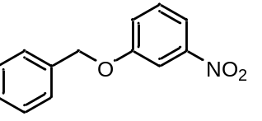(7aa). Substrate: 1,3-dinitrobenzene (3a). 0.0239 g, Yield: 35%. Off white solid. ¹H NMR (400 MHz, CDCl₃) δ 7.83-7.80 (m, 2H), 7.45-7.38 (m, 5H), 7.37-7.32 (m, 1H), 7.29-7.26 (m, 1H), 5.13 (s, 2H); ¹³C NMR (101 MHz, CDCl₃) δ 159.2, 149.2, 135.7, 130.0, 128.7, 128.4, 127.5, 121.9, 116.0, 109.2, 70.6; HR-MS (FAB): calculated for C₁₃H₁₁NO₃ [M+H]⁺: 230.0817. Found: 230.0818.
(7ba). Substrate: 1-fluoro-3-nitrobenzene (3b). 0.0454 g, Yield: 66%. Colorless oil. ¹H NMR (400 MHz, CDCl₃) δ 7.83-7.80 (m, 2H), 7.45-7.38 (m, 5H), 7.37-7.32 (m, 1H), 7.29-7.26 (m, 1H), 5.13 (s, 2H); ¹³C NMR (101 MHz, CDCl₃) δ 159.2, 149.2, 135.7, 130.0, 128.7, 128.4, 127.5, 121.9, 116.0, 109.2, 70.6; HR-MS (EI): calculated for C₁₃H₁₁NO₃ [M]⁺: 229.0739. Found: 229.0734.

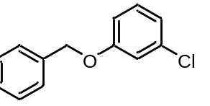(7ca). Substrate: 1-chloro-3-nitrobenzene (3c). 0.0608 g, Yield: 93%. White solid. ¹H NMR (400 MHz, CDCl₃) δ 7.44-7.33 (m, 5H), 7.20 (t, J = 8.1, 1H), 7.00 (t, J = 2.0, 1H), 6.96 (dd, J = 7.9, 1.0, 1H), 6.87 (dd, J = 8.3, 1.8, 1H), 5.05 (s, 2H); ¹³C NMR (101 MHz, CDCl₃) δ 159.5, 136.4, 134.9, 130.2, 128.6, 128.1, 127.4, 121.1, 115.3, 113.3, 70.2; HR-MS (EI): calculated for C₁₃H₁₁ClO [M]⁺: 218.0498, 220.0469. Found: 218.0502, 220.0478.

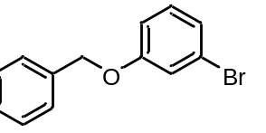(7da). Substrate: 1-bromo-3-nitrobenzene (3d). 0.0569 g, Yield: 73%. Light brown solid. ¹H NMR (400 MHz, CDCl₃) δ 7.43-7.32 (m, 5H), 7.16-7.09 (m, 3H), 6.91 (ddd, J = 7.9, 2.3, 1.3, 1H), 5.03 (s, 2H); ¹³C NMR (101 MHz, CDCl₃) δ 159.5, 136.4, 130.5, 128.6, 128.1, 127.5, 124.0, 122.8, 118.2, 113.8, 70.2; HR-MS (FAB): calculated for C₁₃H₁₁BrO [M]⁺: 261.9993, 263.9973. Found: 261.9988, 263.9969.

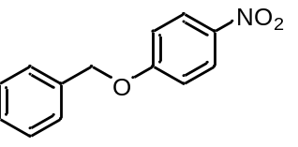(7ea). Substrate: 1,4-dinitrobenzene (3e). 0.0618 g, Yield: 90%. White solid. ¹H NMR (400 MHz, CDCl₃) δ 8.17 (d, J = 9.2, 2H), 7.43-7.34 (m, 5H), 7.01 (d, J = 9.2, 2H), 5.15 (s, 2H); ¹³C NMR (101 MHz, CDCl₃) δ 163.6, 141.6, 135.4, 128.7, 128.4, 127.4, 125.8, 114.8, 70.6; HR-MS (ESI): calculated for C₁₃H₁₁NO₃ [M+Na]⁺: 252.0631. Found: 252.0628.
(7fa). Substrate: 1-fluoro-4-nitrobenzene (3f). Quantitative, Yield: 99%. White solid. ¹H NMR (400 MHz, CDCl₃) δ 8.19 (d, J = 9.2, 2H), 7.42-7.34 (m, 5H), 7.01 (d, J = 9.2, 2H), 5.15 (s, 2H); ¹³C NMR (101 MHz, CDCl₃) δ 163.7, 141.7, 135.5, 128.8, 128.5, 127.5, 125.9, 114.8, 70.7; HR-MS (FAB): calculated for C₁₃H₁₁NO₃ [M+H]⁺: 230.0817. Found: 230.0811.
(7ga). Substrate: 1-chloro-4-nitrobenzene (3g). 0.0644 g, Yield: 94%. White solid. ¹H NMR (400 MHz, CDCl₃) δ 8.18 (d, J = 9.2, 2H), 7.43-7.33 (m, 5H), 7.01 (d, J = 9.2, 2H), 5.15 (s, 2H); ¹³C NMR (101 MHz, CDCl₃) δ 163.6, 141.6, 135.5, 128.8, 128.5, 127.4, 125.9, 114.8, 70.6; HR-MS (FAB): calculated for C₁₃H₁₁NO₃ [M+H]⁺: 230.0817. Found: 230.0811.
(7ha). Substrate: 1-bromo-4-nitrobenzene (3h). 0.0618 g, Yield: 90%. White solid. ¹H NMR (400 MHz, CDCl₃) δ 8.18 (d, J = 9.2, 2H), 7.42-7.33 (m, 5H), 7.01 (d, J = 9.2, 2H), 5.15 (s, 2H); ¹³C NMR (101 MHz, CDCl₃) δ 163.7, 141.7, 135.5, 128.8, 128.5, 127.5, 125.9, 114.8, 70.7; HR-MS (FAB): calculated for C₁₃H₁₁NO₃ [M+H]⁺: 230.0817. Found: 230.0811.

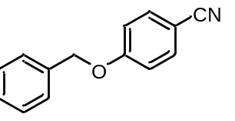(7ia). Substrate: 4-nitrobenzonitrile (3i). 0.0526 g, Yield: 84%. White solid. ¹H NMR (400 MHz, CDCl₃) δ 7.57 (d, J = 8.8, 2H), 7.40-7.32 (m, 5H), 7.00 (d, J = 8.9, 2H), 5.10 (s, 2H); ¹³C NMR (101 MHz, CDCl₃) δ 162.0, 135.7, 134.0, 128.7, 128.4, 127.4, 119.1, 115.6, 104.3, 70.3; HR-MS (FAB): calculated for C₁₄H₁₁NO [M+H]⁺: 210.0919. Found: 210.0917.
(7ja). Substrate: 4-bromobenzonitrile (3j). 0.0558 g, Yield: 89%. White solid. ¹H NMR (400 MHz, CDCl₃) δ 7.56 (d, J = 8.8, 2H), 7.40-7.33 (m, 5H), 7.00 (d, J = 8.8, 2H), 5.10 (s, 2H); ¹³C NMR (101 MHz, CDCl₃) δ 162.1, 135.8, 134.1, 128.9, 128.5, 127.6, 119.3, 115.7, 104.4, 70.4; HR-MS (ESI): calculated for C₁₄H₁₁NO [M+Na]⁺: 232.0733. Found: 232.0727.

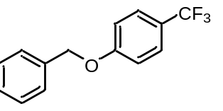(7ka). Substrate: 4-nitrobenzotrifluoride (3k). 0.0567 g, Yield: 75%. White solid. ¹H NMR (500 MHz, CDCl₃) δ 7.55 (d, J = 8.5, 2H), 7.44-7.38 (m, 4H), 7.37-7.33 (m, 1H), 7.03 (d, J = 8.5, 2H), 5.11 (s, 2H); ¹³C NMR (126 MHz, CDCl₃) δ 161.2, 136.2, 128.7, 128.2, 127.4, 126.9 (q, J = 3.5), 124.4 (q, J = 271.5), 123.1 (q, J = 32.8), 114.8, 70.1; HR-MS (EI): calculated for C₁₄H₁₁F₃O [M]⁺: 252.0762. Found: 252.0764.
(7la). Substrate: 4-bromobenzotrifluoride (3l). 0.0098 g, Yield: 13%. White solid. ¹H NMR (400 MHz, CDCl₃) δ 7.53 (d, J = 8.6, 2H), 7.43-7.31 (m, 5H), 7.02 (d, J = 8.6, 2H), 5.10 (s, 2H); ¹³C NMR (101 MHz, CDCl₃) δ 161.2, 136.2, 128.7, 128.2, 127.4, 126.9 (q, J = 3.6), 124.4 (q, J = 271.1), 123.1 (q, J = 32.8), 114.9, 70.2; HR-MS (EI): calculated for C₁₄H₁₁F₃O [M]⁺: 252.0762. Found: 252.0761.

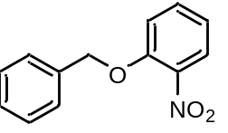(7ma). Substrate: 1,2-dinitrobenzene (3m). 0.0483 g, Yield: 70%. Light yellow oil. ¹H NMR (400 MHz, CDCl₃) δ 7.83 (dd, J = 8.1, 1.5, 1H), 7.50-7.44 (m, 3H), 7.39-7.36 (m, 2H), 7.33-7.29 (m, 1H), 7.10 (d, J = 8.4 Hz, 1H), 7.01 (t, J = 7.8, 1H), 5.21 (s, 2H); ¹³C NMR (101 MHz, CDCl₃) δ 151.8, 140.2, 135.5, 134.0, 128.6, 128.2, 126.9, 125.6, 120.6, 115.1, 71.1; HR-MS (ESI): calculated for C₁₃H₁₁NO₃ [M+Na]⁺: 252.0631. Found: 252.0630.
(7na). Substrate: 1-bromo-2-nitrobenzene (3n). 0.0423 g, Yield: 62%. Brown oil. ¹H NMR (400 MHz, CDCl₃) δ 7.82 (dd, J = 8.1, 1.6, 1H), 7.49-7.43 (m, 3H), 7.39-7.35 (m, 2H), 7.33-7.29 (m, 1H), 7.10 (d, J = 8.4, 1H), 7.01 (t, J = 7.7, 1H), 5.21 (s, 2H); ¹³C NMR (101 MHz, CDCl₃) δ 151.8, 140.3, 135.5, 133.9, 128.6, 128.1, 126.9, 125.6, 120.6, 115.1, 71.1; MS (FAB): m/z = 228 [M⁺–H]. HR-MS (FAB): calculated for C₁₃H₁₀NO₃ [M]⁺: 228.0661. Found: 228.0657.

- General procedure for C-O bond formation of 1-chloro-3-nitrobenzene
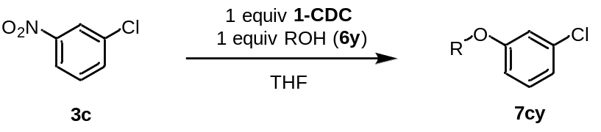
Into a 20 mL vial was placed 1-CDC (0.036 g, 0.1 mmol) and 1-chloro-3-nitrobenzene 3c (0.016 g, 0.1 mmol) in anhydrous THF (2 mL). Subsequently, alcohol 6y (0.1 mmol) in anhydrous THF (2 mL) was added dropwise. The reaction mixture was stirred at ambient temperature for 12 h. The resulting solution was filtered and concentrated in vacuo. The crude was then purified by column chromatography using hexanes and DCM or hexanes and ethyl acetate solvent mixture as eluent.

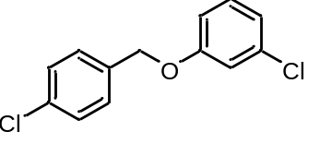(7cb). Substrate: (4-chlorophenyl)methanol (6b). 0.0227 g, Yield: 90%. Yellow oil. ¹H NMR (400 MHz, CDCl₃) δ 7.36-7.32 (m, 4H), 7.17 (t, J = 8.4, 1H), 6.95-6.93 (m, 2H), 6.84-6.81 (m, 1H), 4.99 (s, 2H); ¹³C NMR (101 MHz, CDCl₃) δ 159.2, 134.93, 134.91, 134.0, 130.3, 128.8, 128.7, 121.3, 115.3, 113.3, 69.4; HR-MS (EI): calculated for C₁₃H₁₀Cl₂O [M]⁺: 252.0109, 254.0079, 256.0050. Found: 252.0104, 254.0064, 256.0064.

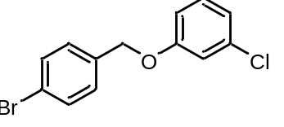(7cc). Substrate: (4-bromophenyl)methanol (6c). 0.0276 g, Yield: 93%. Colorless oil. ¹H NMR (400 MHz, CDCl₃) δ 7.50 (d, J = 8.4, 2H), 7.27 (d, J = 8.5, 2H), 7.18 (t, J = 8.5, 1H), 6.95-6.92 (m, 2H), 6.81 (ddd, J = 8.4, 2.1, 1.2, 1H), 4.98 (s, 2H); ¹³C NMR (101 MHz, CDCl₃) δ 159.2, 135.4, 134.9, 131.8, 130.3, 129.0, 122.1, 121.4, 115.3, 113.3, 69.4; HR-MS (EI): calculated for C₁₃H₁₀BrClO [M]⁺: 295.9604, 297.9574, 297.9583, 299.9554. Found: 295.9595, 297.9571, 299.9559.

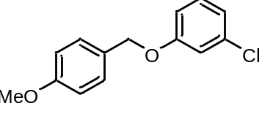(7cd). Substrate: (4-methoxyphenyl)methanol (6d). 0.0210 g, Yield: 85%. White solid. ¹H NMR (400 MHz, CDCl₃) δ 7.33 (d, J = 8.7, 2H), 7.18 (t, J = 8.1, 1H), 6.96 (t, J = 2.1, 1H), 6.93-6.89 (m, 3H), 6.84 (ddd, J = 8.3, 2.4, 0.8, 1H), 4.95 (s, 2H), 3.80 (s, 3H); ¹³C NMR (101 MHz, CDCl₃) δ 159.59, 159.56, 134.8, 130.2, 129.2, 128.4, 121.0, 115.3, 114.1, 113.4, 70.0, 55.3; HR-MS (EI): calculated for C₁₄H₁₃ClO₂ [M]⁺: 248.0604, 250.0575. Found: 248.0606, 250.0565.

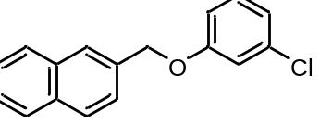(7ce). Substrate: 2-naphthylmethanol (6e). 0.0228 g, Yield: 85%. White solid. ¹H NMR (400 MHz, CDCl₃) δ 7.88-7.83 (m, 4H), 7.53-7.48 (m, 3H), 7.20 (t, J = 8.2, 1H), 7.04 (t, J = 2.1, 1H), 6.95 (dd, J = 7.9, 0.9, 1H), 6.90 (dd, J = 8.3, 1.8, 1H), 5.19 (s, 2H); ¹³C NMR (101 MHz, CDCl₃) δ 159.5, 134.9, 133.9, 133.3, 133.1, 130.2 128.5, 127.9, 127.7, 126.4, 126.3, 126.2, 125.1, 121.2, 115.4, 113.4, 70.3; HR-MS (EI): calculated for C₁₇H₁₃ClO [M]⁺: 268.0655, 270.0625. Found: 268.0651, 270.0626.

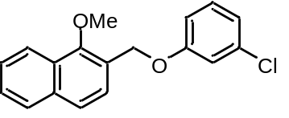(7cf). Substrate: (1-methoxynaphthalen-2-yl)methanol (6f). 0.0278 g, Yield: 93%. White solid. ¹H NMR (400 MHz, CDCl₃) δ 8.14 (d, J = 7.7, 1H), 7.85 (dd, J = 7.4, 2.0, 1H), 7.65, (d, J = 8.5, 1H), 7.55-7.48 (m, 3H), 7.20 (t, J = 8.2, 1H), 7.05 (t, J = 2.2, 1H), 6.94 (ddd, J = 8.0, 1.9, 0.8, 1H), 6.91 (ddd, J = 8.4, 2.4, 0.8, 1H), 5.25 (s, 2H), 3.99 (s, 3H); ¹³C NMR (101 MHz, CDCl₃) δ 159.6, 154.4, 135.0, 134.9, 130.3, 128.1, 127.8, 126.7, 126.5, 126.2, 124.7, 124.5, 122.2, 121.1, 115.4, 113.2, 65.3, 63.1; HR-MS (EI): calculated for C₁₈H₁₅ClO₂ [M]⁺: 298.0761, 300.0731. Found: 298.0756, 300.0738.

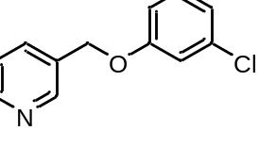(7cg). Substrate: 3-pyridinemethanol (6g). 0.0160 g, Yield: 73%. Yellow oil. ¹H NMR (400 MHz, CDCl₃) δ 8.65 (d, J = 1.5 Hz, 1H), 8.57 (dd, J = 4.7, 0.9, 1H), 7.73 (d, J = 7.9, 1H), 7.30 (dd, J = 7.8, 4.9, 1H), 7.19 (t, J = 7.9, 1H), 6.95-6.93 (m, 2H), 6.84-6.82 (m, 1H), 5.03 (s, 2H); ¹³C NMR (101 MHz, CDCl₃) δ 159.0, 149.6, 148.9, 135.2, 135.0, 131.9, 130.3, 123.5, 121.5, 115.3, 113.2, 67.7; HR-MS (EI): calculated for C₁₂H₁₀ClON [M]⁺: 219.0451, 221.0421. Found: 219.0455, 221.0433.

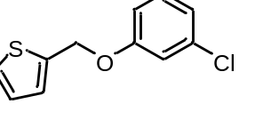(7ch). Substrate: 2-thiophenemethanol (6h). 0.0204 g, Yield: 91%. White solid. ¹H NMR (400 MHz, CDCl₃) δ 7.32 (d, J = 5.0, 1H), 7.19 (t, J = 8.1, 1H), 7.09 (d, J = 3.0, 1H), 7.00-6.93 (m, 3H), 6.85 (d, J = 8.4, 1H), 5.18 (s, 2H); ¹³C NMR (101 MHz, CDCl₃) δ 159.0, 138.6, 134.9, 130.2, 127.1, 126.8, 126.4, 121.4, 115.5, 113.5, 65.2; HR-MS (EI): calculated for C₁₁H₉ClOS [M]⁺: 224.0063, 226.0033. Found: 224.0065, 226.0034.

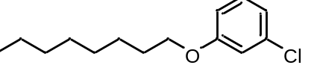(7ci). Substrate: 1-octanol (6i). 0.0168 g, Yield: 70%. Colorless oil. ¹H NMR (400 MHz, CDCl₃) δ 7.16 (t, J = 8.0, 1H), 6.90-6.87 (m, 2H), 6.76 (dd, J = 8.2, 2.0, 1H), 3.91 (t, J = 6.5, 2H), 1.78-1.71 (m, 2H), 1.46-1.39 (m, 2H), 1.36-1.27 (m, 8H), 0.89-0.85 (m, 3H); ¹³C NMR (101 MHz, CDCl₃) δ 159.9, 134.8, 130.1, 120.6, 114.8, 113.1, 68.3, 31.8, 29.3, 29.2, 29.1, 26.0, 22.6, 14.1; HR-MS (FAB): calculated for C₁₄H₂₂Cl [M+H]⁺: 241.1359, 243.1330. Found: 241.1360, 243.1324.

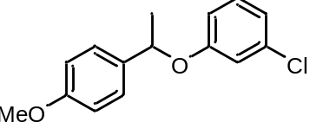(7cj). Substrate: 1-(4-methoxyphenyl)ethanol (6j). 0.0177 g, Yield: 67%. Colorless oil. ¹H NMR (400 MHz, CDCl₃) δ 7.26 (d, J = 8.7, 2H), 7.08 (t, J = 8.1, 1H), 6.87-6.82 (m, 4H), 6.72 (dd, J = 8.3, 1.7, 1H), 5.23 (q, J = 6.4, 1H), 3.77 (s, 3H), 1.59 (d, J = 6.4, 3H); ¹³C NMR (101 MHz, CDCl₃) δ 159.1, 158.8, 134.6, 134.6, 130.0, 126.8, 120.8, 116.6, 114.3, 114.1, 76.0, 55.2, 24.2; HR-MS (EI): calculated for C₁₅H₁₅ClO₂ [M]⁺: 262.0761, 264.0731. Found: 262.0758, 264.0738.

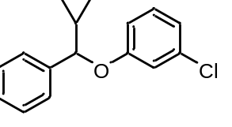(7ck). Substrate: cyclopropyl(phenyl)methanol (6k). 0.0194 g, Yield: 75%. Colorless oil. ¹H NMR (400 MHz, CDCl₃) δ 7.36-7.30 (m, 4H), 7.29-7.24 (m,1H), 7.05 (t, J = 8.1, 1H), 6.84-6.81 (m, 2H), 6.69 (ddd, J = 8.4, 2.2, 0.8, 1H), 4.57 (d, J = 7.5, 1H), 1.38-1.30 (m, 1H), 0.69-0.41 (m, 4H); ¹³C NMR (101 MHz, CDCl₃) δ 158.9, 140.7, 134.6, 130.0, 128.6, 127.7, 126.1, 120.9, 116.7, 114.3, 84.0, 18.2, 3.8, 2.6; HR-MS (EI): calculated for C₁₆H₁₅ClO [M]⁺: 258.0811, 260.0782. Found: 258.0812, 260.0790.

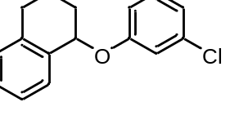(7cl). Substrate: 1,2,3,4-tetrahydronaphthalen-1-ol (6l). 0.0155 g, Yield: 60%. Colorless oil. ¹H NMR (400 MHz, CDCl₃) δ 7.34 (d, J = 7.3, 1H), 7.25 (td, J = 7.3, 1.5, 1H), 7.23-7.20 (m, 2H), 7.17 (t, J = 7.5, 1H), 7.03 (t, J = 2.1, 1H), 6.96 (dd, J = 7.6, 1.3, 1H), 6.91 (dd, J = 8.3, 2.4, 1H), 5.35 (t, J = 4.2, 1H), 2.94-2.87 (m, 1H), 2.81-2.73 (m, 1H), 2.18-2.12 (m, 1H), 2.07-1.96 (m, 2H), 1.84-1.76 (m, 1H); ¹³C NMR (101 MHz, CDCl₃) δ 159.0, 137.7, 135.1, 134.9, 130.3, 129.4, 129.1, 128.1, 126.1, 121.1, 116.6, 114.7, 74.3, 29.0, 27.9, 18.7; HR-MS (FAB): calculated for C₁₆H₁₄ClO [M-H]⁺: 257.0733, 259.0704. Found: 257.0741, 259.0703.

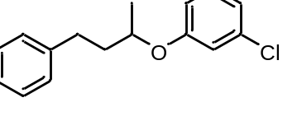(7cm). Substrate: 4-phenyl-2-butanol (6m). 0.0117 g, Yield: 45%. Colorless oil. ¹H NMR (400 MHz, CDCl₃) δ 7.27 (t, J = 7.5, 2H), 7.20-7.13 (m, 4H), 6.90-6.87 (m, 1H), 6.83 (t, J = 2.0, 1H), 6.72 (dd, J = 8.3, 2.3, 1H), 4.31 (sext, J = 6.2, 1H), 2.81-2.66 (m, 2H), 2.09-2.00 (m, 1H), 1.91-1.82 (m, 1H), 1.30 (d, J = 6.0, 3H); ¹³C NMR (101 MHz, CDCl₃) δ 158.9, 141.6, 134.8, 130.2, 128.44, 128.43, 125.9, 120.7, 116.2, 114.2, 73.1, 38.1, 31.7, 19.6; HR-MS (EI): calculated for C₁₆H₁₇ClO [M]⁺: 260.0968, 262.0938. Found: 260.0969, 262.0962.

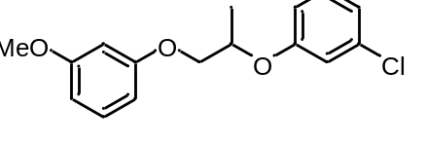(7cn). Substrate: 1-(3-methoxyphenoxy)-2-propanol (6n). 0.0175 g, Yield: 60%. Colorless oil. ¹H NMR (400 MHz, CDCl₃) δ 7.20-7.15 (m, 2H), 6.97 (t, J = 2.1, 1H), 6.95-6.92 (m, 1H), 6.84 (ddd, J = 8.3, 2.2, 0.6, 1H), 6.54-6.46 (m, 3H), 4.71 (sext, J = 5.9, 1H), 4.13 (dd, J = 9.9, 5.9, 1H), 3.99 (dd, J = 9.9, 4.7, 1H), 3.77 (s, 3H), 1.42 (d, J = 6.2, 3H); ¹³C NMR (126 MHz, CDCl₃) δ 160.8, 159.8, 158.6,134.8, 130.2, 129.9, 121.2, 116.5, 114.4, 106.8, 106.7, 101.1, 72.8, 70.8, 55.2, 17.0; HR-MS (EI): calculated for C₁₆H₁₇ClO₃ [M]⁺: 292.0866, 294.0837. Found: 292.0863, 294.0831.

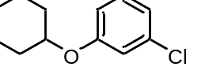(7co). Substrate: cyclohexanol (6o). 0.0044 g, Yield: 21%. Light yellow oil. ¹H NMR (400 MHz, CDCl₃) δ 7.15 (t, J = 8.4, 1H), 6.88-6.86 (m, 2H), 6.76 (dd, J = 8.4, 2.2, 0.9, 1H), 4.20 (sept, J = 4.2, 1H), 1.96-1.93 (m, 2H), 1.81-1.76 (m, 2H), 1.58-1.45 (m, 3H), 1.42-1.24 (m, 3H); ¹³C NMR (101 MHz, CDCl₃) δ 158.6, 134.8, 130.1, 120.6, 116.3, 114.4, 75.7, 31.6, 25.5, 23.7; HR-MS (EI): calculated for C₁₂H₁₅ClO [M]⁺: 210.0811, 212.0782. Found: 210.0807, 212.0794.

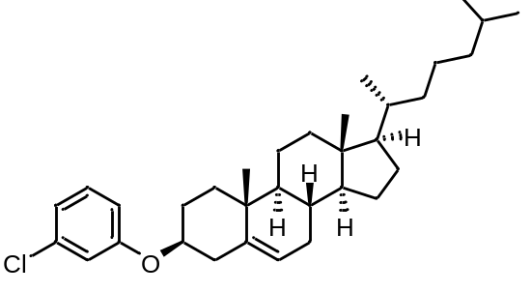(7cp). Substrate: cholesterol (6p). 0.0119 g, Yield: 24%. White solid. ¹H NMR (400 MHz, CDCl₃) δ 7.15 (t, J = 8.0, 1H), 6.89-6.86 (m, 2H), 6.76-6.73 (m, 1H), 5.39-5.38 (m, 1H), 4.07 (sept, J = 5.2, 1H), 2.47-2.33 (m, 2H), 2.03-1.96 (m, 3H), 1.92-1.87 (m, 1H), 1.85-1.77 (m, 1H), 1.70-1.64 (m, 2H), 1.52-1.44 (m, 5H), 1.40-1.29 (m, 4H), 1.18-1.07 (m, 7H), 1.03 (s, 3H), 1.01-0.93 (m, 3H), 0.90 (d, J = 6.5, 3H), 0.85 (dd, J = 6.6, 1.6, 6H), 0.67 (s, 3H); ¹³C NMR (101 MHz, CDCl₃) δ 158.6, 140.1, 134.8, 130.2, 122.6, 120.7, 116.2, 114.3, 56.8, 56.2, 50.2, 42.3, 39.8, 39.5, 38.6, 37.1, 36.8, 36.2, 35.8, 32.0, 31.9, 28.2, 28.1, 28.0, 24.3, 23.8, 22.8, 22.6, 21.1, 19.4, 18.7, 11.9; HR-MS (EI): calculated for C₃₃H₄₉ClO [M]⁺: 496.3472, 498.3442. Found: 496.3470, 498.3463.
- General procedure for C-C bond formation of halo-nitrobenzene derivatives

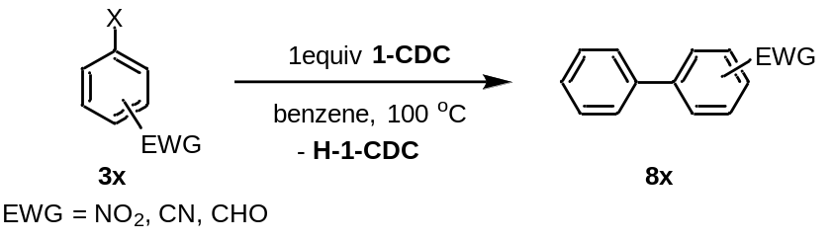

Into a 20 mL vial was placed 1-CDC (0.036 g, 0.1 mmol) and halobenzene derivatives (0.1 mmol) in anhydrous benzene (3 mL). The reaction mixture was stirred at 100 ℃ for 4 or 18 h. The resulting mixture was filtered and washed with THF, then concentrated in vacuo. The crude was then purified by flash column chromatography using hexanes and DCM or hexanes and ethyl acetate solvent mixture as eluent.

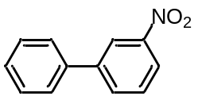(8o) 0.0109g. Yield: 55%. White solid. ¹H NMR (400 MHz, CDCl₃) δ 8.44 (t, J = 2.0, 1H), 8.18 (ddd, J = 8.2, 2.2. 0.9, 1H), 7.90 (ddd, J = 7.7, 1.6, 0.9, 1H), 7.62-7.58 (m, 3H), 7.48 (t, J = 7.5, 2H), 7.42 (t, J = 7.4, 1H); ¹³C NMR (101 MHz, CDCl₃) δ 148.8, 142.9, 138.7, 133.0, 129.7, 129.2, 128.5, 127.2, 122.03, 121.97; HR-MS (EI): calculated for C₁₂H₉NO₂ [M]⁺: 199.0633. Found: 199.0628. (18 h)

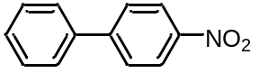(8p) 0.0123g. Yield: 62%. White solid. ¹H NMR (400 MHz, CDCl₃) δ 8.28 (d, J = 8.9, 2H), 7.72 (d, J = 8.9, 2H), 7.61 (d, J = 7.0, 2H), 7.50-7.41 (m, 3H); ¹³C NMR (101 MHz, CDCl₃) δ 147.6, 147.1, 138.8, 129.1, 128.9, 127.8, 127.4, 124.1; HR-MS (EI): calculated for C₁₂H₉NO₂ [M]⁺: 199.0633. Found: 199.0631. (4 h)

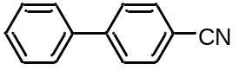(8q) 0.0091g. Yield: 51%. Colorless oil. ¹H NMR (400 MHz, CDCl₃) δ 7.71 (d, J = 8.4, 2H), 7.67 (d, J = 8.4, 2H), 7.57 (d, J = 7.3, 2H), 7.47 (t, J = 7.3, 2H), 7.41 (t, J = 7.3, 1H); ¹³C NMR (101 MHz, CDCl₃) δ 145.7, 139.2, 132.6, 129.1, 128.6, 127.7, 127.2, 118.9, 110.9; HR-MS (EI): calculated for C₁₃H₉N [M]⁺: 179.0735. Found: 179.0738. (4 h)

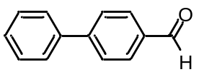(8r) 0.0078g. Yield: 43%. White solid. ¹H NMR (400 MHz, CDCl₃) δ 10.04 (s, 1H), 7.94 (d, J = 8.4, 2H), 7.74 (d, J = 8.2, 2H), 7.62 (d, J = 7.1, 2H), 7.47 (t, J = 7.4, 2H), 7.40 (t, J = 7.3, 1H); ¹³C NMR (101 MHz, CDCl₃) δ 191.9, 147.2, 139.7, 135.2, 130.3, 129.0, 128.5, 127.7, 127.4; HR-MS (EI): calculated for C₁₃H₉O [M]⁺: 182.0732. Found: 182.0725. (18h)

III. Cyclic Voltammetry
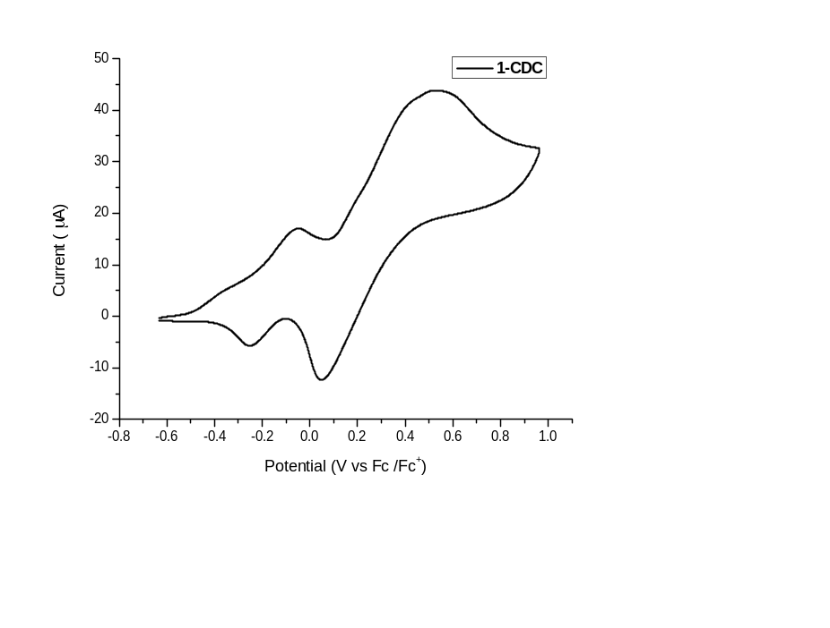
Fig. S1. Cyclic Voltammograms of 1.0 mM 1-CDC in anhydrous THF containing 0.2 M n-Bu₄NPF₆, at sweep rate = 500 mV/s. (E_{redox} = -0.151 V)

Fig. S2. Cyclic Voltammograms of 1.0 mM 2-Au in anhydrous THF containing 0.1 M n-Bu₄NPF₆, at sweep rate = 50 mV/s. (E_{redox} = -0.268 V, -0.0715 V)
IV. Electron Paramagnetic Resonance
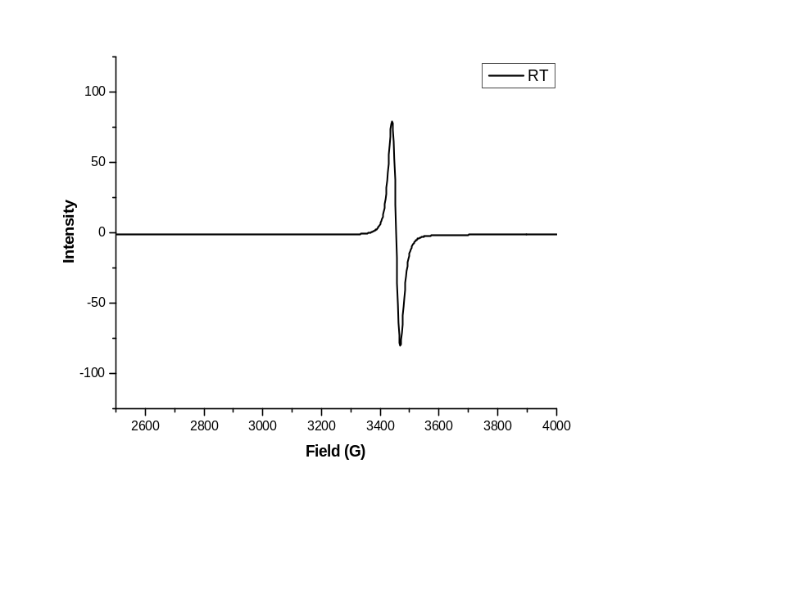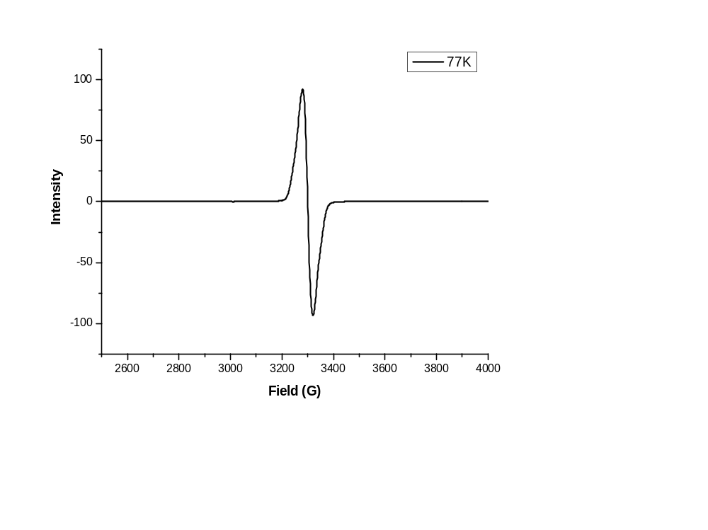

Fig. S3. Continuous-wave X-band EPR spectra of [2-Au]^{•+} in anhydrous DCM measured at ambient temperature (top) and 77 K (bottom).

Fig. S4. Experimental (black line, recorded at 298 K) and simulated (red line) EPR spectra of the mixture of 1-CDC and 3-fluoronitrobenzene in 1:1 ratio in anhydrous THF. Components 1 and 2 correspond to [3b]^{•-} and [1-CDC]^{•+}, respectively.

V. UV-vis spectroscopy
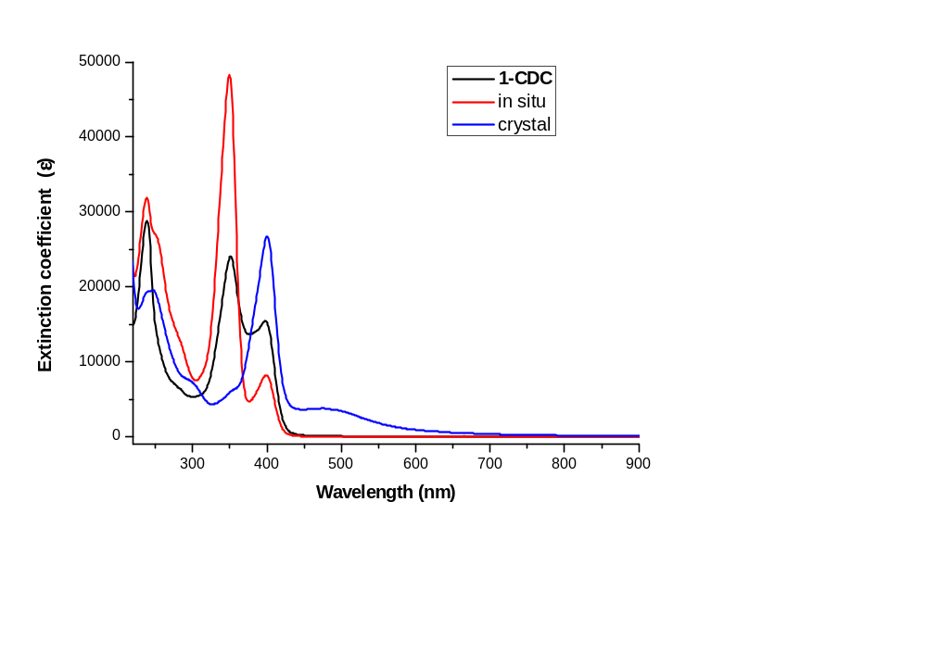
Fig. S5. Combined UV/Vis spectra of 1-CDC (black line), 1-CDC reacted with 3-fluoronitrobenzene (1:1 ratio) in anhydrous THF for 10 min (red line), and solid crystal 4b dissolved in THF at ambient temperature (blue line).

VI. X-ray Crystallography

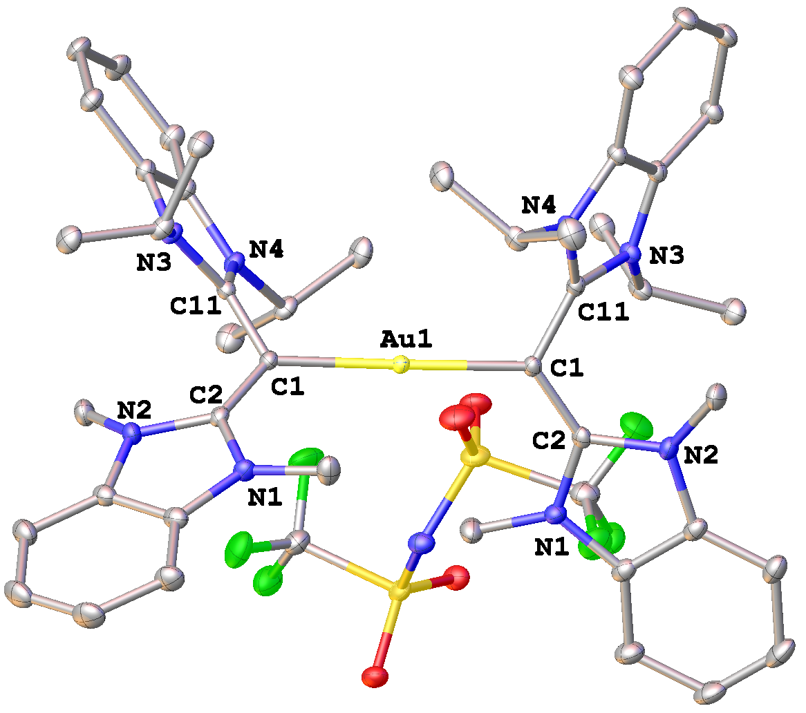
Fig. S6. Molecular diagram of 2-Au with thermal ellipsoids drawn at the 30% probability level. Solvent molecules and hydrogen atoms are omitted for clarity. Selected bond lengths (Å) and angles (deg): Au(1)-C(1) 2.061(3), C(1)-C(2) 1.378(4), C(1)-C(11) 1.423(4), N(1)-C(2) 1.383(4), N(2)-C(2) 1.400(4), N(3)-C(11) 1.373(3), N(4)-C(11) 1.363(4), C(1)-Au(1)-C(1) 178.95(14), C(2)-C(1)-C(11) 117.1(2), C(2)-C(1)-Au(1) 125.6(2), C(11)-C(1)-Au(1) 117.11(19), N(2)-C(2)-N(1) 105.4(2), N(4)-C(11)-N(3) 107.4(2).

Table S1. Crystal data and structure refinement for 2-Au.
Identification code i18943 (CCDC: 2365151)
Empirical formula AuC_{51.5}Cl₇F₆H₆₃N₉O₄S₂
Formula weight 1495.34
Temperature 100 K
Wavelength 0.71073 Å
Crystal system, space group monoclinic, C2/c
Unit cell dimensions a = 16.2506(9) Å, α = 90˚
b = 15.8856(9) Å, β = 100.138(2)˚
c = 24.5298(14) Å, γ = 90˚
Volume 6233.5(6) Å³
Z, Calculated density 4, 1.593 g/cm³
Absorption coefficient 2.795 mm⁻¹
F(000) 3004.0
Crystal size 0.30 x 0.28 x 0.25 mm³
θ range for data collection 1.807 to 27.159˚
Limiting indices -20≤h≤20, -20≤k≤20, -31≤l≤31
Reflections collected / unique 108851 / 6925 [R_{int} = 0.0445, R_{sigma} = 0.0141]
Completeness to θ = 27.159 99.9%
Absorption correction Semi-empirical from equivalents
Refinement method Full-matrix least-squares on F²
Data / restraints / parameters 6925 / 130 / 427
Goodness-of-fit on F² 1.106
Final R indices [I>2σ(I)] R₁ = 0.0281, wR₂ = 0.0759
R indices (all data) R₁ = 0.0291, wR₂ = 0.0767
Largest diff. peak and hole 1.85 and -1.21 e.Å⁻³
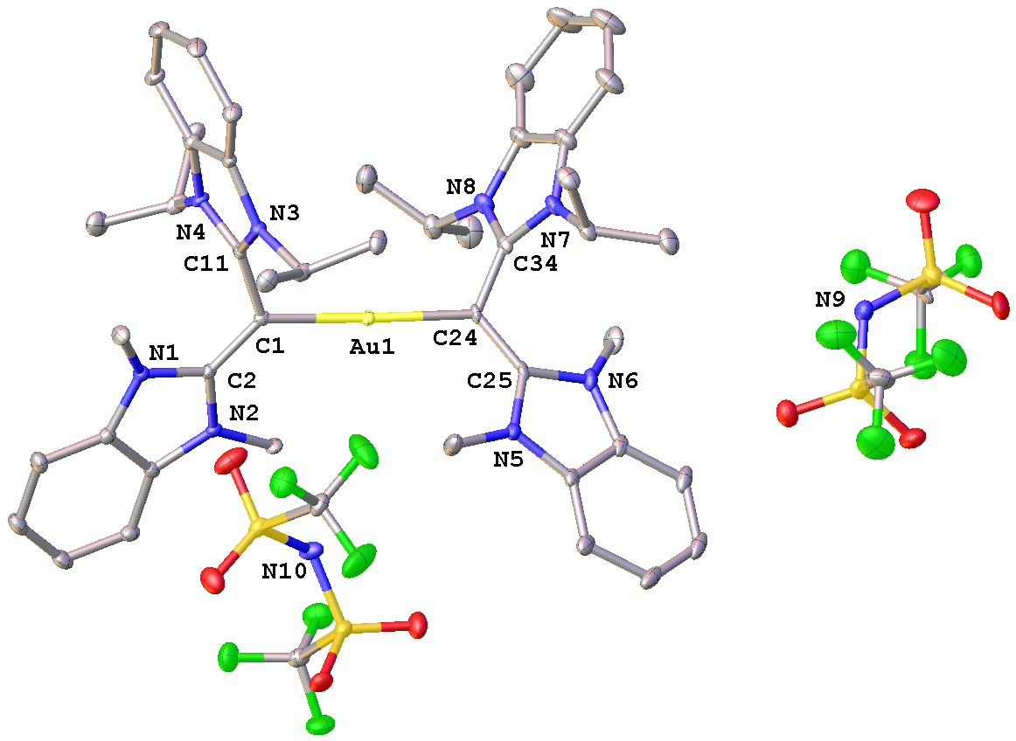
Fig. S7. Molecular diagram of [2-Au] with thermal ellipsoids drawn at the 30% probability level. Solvent molecules and hydrogen atoms are omitted for clarity. Selected bond lengths (Å) and angles (deg): Au(1)-C(1) 2.025(5), Au(1)-C(24) 2.045(5), C(1)-C(2) 1.400(7), C(1)-C(11) 1.458(7), N(1)-C(2) 1.385(7), N(2)-C(2) 1.378(7), N(3)-C(11) 1.346(7), N(4)-C(11) 1.343(7), C(24)-C(25) 1.401(7), C(24)-C(34) 1.460(7), N(5)-C(25) 1.378(7), N(6)-C(25) 1.391(7), N(7)-C(34) 1.371(7), N(8)-C(34) 1.350(8), C(1)-Au(1)-C(24) 176.4(2), C(2)-C(1)-C(11) 117.0(5), C(2)-C(1)-Au(1) 130.8(4), C(11)-C(1)-Au(1) 112.3(3), N(2)-C(2)-N(1) 107.0(4), N(4)-C(11)-N(3) 109.6(4), C(25)-C(24)-C(34) 118.4(5), C(25)-C(24)-Au(1) 125.0(4), C(34)-C(24)-Au(1) 116.3(4), N(5)-C(25)-N(6) 105.7(5), N(7)-C(34)-N(8) 107.5(5).

Table S2. Crystal data and structure refinement for [2-Au].
Identification code i17601 (CCDC: 2365152)
Empirical formula C₅₂H₆₂AuCl₆F₁₂N₁₀O₈S₄
Formula weight 1733.03
Temperature 100 K
Wavelength 0.71073 Å
Crystal system, space group triclinic, P-1
Unit cell dimensions a = 17.426(3) Å, α = 85.450(7) ˚
b = 17.980(3) Å, β = 89.570(7) ˚
c = 21.735(3) Å, γ = 88.868(8) ˚
Volume 6787.5(17) Å³
Z, Calculated density 4, 1.696 g/cm³
Absorption coefficient 2.618 mm⁻¹
F(000) 3468.0
Crystal size 0.20 x 0.20 x 0.20 mm³
θ range for data collection 0.940 to 27.293˚
Limiting indices -22≤h≤22, -23≤k≤23, -27≤l≤27
Reflections collected / unique 367504 / 30276 [R_{int} = 0.0499, R_{sigma} = 0.0223]
Completeness to θ = 27.293 99.2%
Absorption correction Semi-empirical from equivalents
Refinement method Full-matrix least-squares on F²
Data / restraints / parameters 30276 / 192 / 1786
Goodness-of-fit on F² 1.054
Final R indices [I>2σ(I)] R₁ = 0.0552, wR₂ = 0.1468
R indices (all data) R₁ = 0.0642, wR₂ = 0.1553
Largest diff. peak and hole 4.39 and -3.57 e.Å⁻³
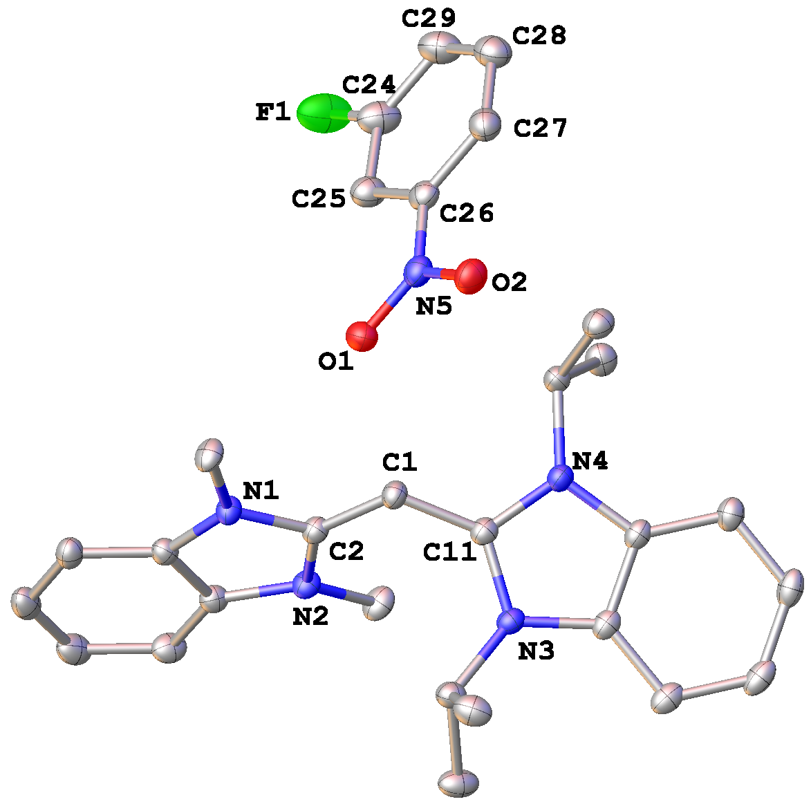
Fig. S8. Molecular diagram of 4b with thermal ellipsoids drawn at the 30% probability level. Solvent molecules and hydrogen atoms are omitted for clarity. Selected bond lengths (Å) and angles (deg): C(1)-C(2) 1.390(3), C(1)-C(11) 1.419(3), N(1)-C(2) 1.368(3), N(2)-C(2) 1.374(3), N(3)-C(11) 1.369(3), N(4)-C(11) 1.364(3), N(5)-O(1) 1.285(3), N(5)-O(2) 1.303(3), C(26)-N(5) 1.384(3), C(24)-C(25) 1.372(4), C(25)-C(26) 1.406(4), C(26)-C(27) 1.392(4), C(27)-C(28) 1.380(4), C(28)-C(29) 1.385(5), C(24)-C(29) 1.377(4), C(2)-C(1)-C(11) 125.9(2), N(2)-C(2)-N(1) 107.18(19), N(4)-C(11)-N(3) 108.57(19).
Table S3. Crystal data and structure refinement for 4b.
Identification code i18888 (CCDC: 2365153)
Empirical formula C₃₇H₄₈FN₅O₄
Formula weight 645.80
Temperature 100 K
Wavelength 0.71073 Å
Crystal system, space group monoclinic, P2₁/n
Unit cell dimensions a = 16.4657(4) Å, α = 90˚
b = 10.4086(3) Å, β = 96.4020(10)˚
c = 20.1302(6) Å, γ = 90˚
Volume 3428.50(16) Å³
Z, Calculated density 4, 1.251 g/cm³
Absorption coefficient 0.086 mm⁻¹
F(000) 1384.0
Crystal size 0.262 x 0.253 x 0.158 mm³
θ range for data collection 2.206 to 27.171˚
Limiting indices -21≤h≤21, -13≤k≤13, -25≤l≤25
Reflections collected / unique 97391 / 7585 [R_{int} = 0.0918, R_{sigma} = 0.0339]
Completeness to θ = 27.171 99.7%
Absorption correction Semi-empirical from equivalents
Refinement method Full-matrix least-squares on F²
Data / restraints / parameters 7585 / 94 / 463
Goodness-of-fit on F² 1.030
Final R indices [I>2σ(I)] R₁ = 0.0658, wR₂ = 0.1770
R indices (all data) R₁ = 0.0949, wR₂ = 0.2045
Largest diff. peak and hole 0.60 and -0.58 e.Å⁻³
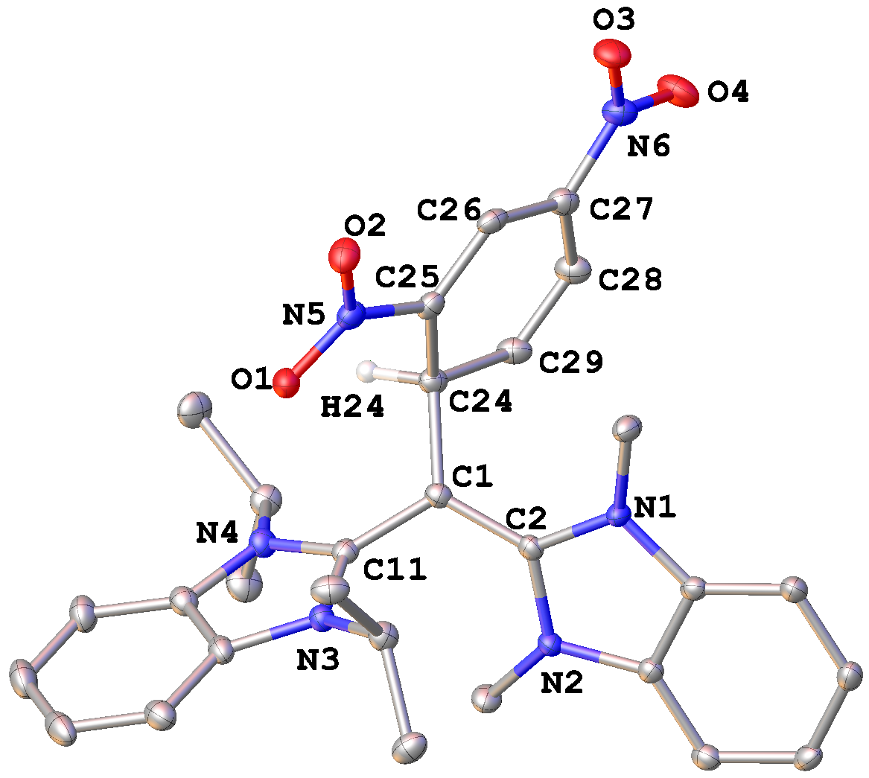
Fig. S9. Molecular diagram of 5a with thermal ellipsoids drawn at the 30% probability level. Solvent molecules and hydrogen atoms are omitted for clarity. Selected bond lengths (Å) and angles (deg): C(1)-C(2) 1.402(4), C(1)-C(11) 1.433(4), C(1)-C(24) 1.544(4), N(1)-C(2) 1.372(4), N(2)-C(2) 1.375(4), N(3)-C(11) 1.365(4), N(4)-C(11) 1.365(4), N(5)-O(1) 1.251(3), N(5)-O(2) 1.266(3), N(6)-O(3) 1.250(3), N(6)-O(4) 1.268(4), C(25)-N(5) 1.398(4), C(27)-N(6) 1.397(4), C(24)-C(25) 1.518(4), C(25)-C(26) 1.379(4), C(26)-C(27) 1.376(5), C(27)-C(28) 1.380(4), C(28)-C(29) 1.385(5), C(24)-C(29) 1.506(4), C(2)-C(1)-C(11) 118.7(3), C(2)-C(1)-C(24) 122.7(3), C(24)-C(1)-C(11) 118.5(3), N(2)-C(2)-N(1) 106.4(3), N(4)-C(11)-N(3) 108.0(2).

Table S4. Crystal data and structure refinement for 5a.
Identification code i19025 (CCDC: 2365154)
Empirical formula C₃₉H₅₂N₆O_{6.5}
Formula weight 708.86
Temperature 100 K
Wavelength 0.71073 Å
Crystal system, space group triclinic, P-1
Unit cell dimensions a = 11.5473(5) Å, α = 77.205(3)˚
b = 11.6164(7) Å, β = 76.299(3)˚
c = 15.7781(9) Å, γ = 65.367(3)˚
Volume 1850.96(18) Å³
Z, Calculated density 2, 1.272 g/cm³
Absorption coefficient 0.088 mm⁻¹
F(000) 760.0
Crystal size 0.12 x 0.08 x 0.05 mm³
θ range for data collection 1.948 to 25.000˚
Limiting indices -13≤h≤13, -13≤k≤13, -18≤l≤18
Reflections collected / unique 79795 / 6516 [R_{int} = 0.2056, R_{sigma} = 0.0720]
Completeness to θ = 25.000 99.9%
Absorption correction Semi-empirical from equivalents
Refinement method Full-matrix least-squares on F²
Data / restraints / parameters 6516 / 642 / 586
Goodness-of-fit on F² 1.034
Final R indices [I>2σ(I)] R₁ = 0.0640, wR₂ = 0.1569
R indices (all data) R₁ = 0.1091, wR₂ = 0.1882
Largest diff. peak and hole 0.50 and -0.37 e.Å⁻³
VII. NMR Spectroscopy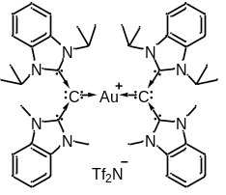
Fig. S10. ¹H and ¹³C NMR spectra of 2-Au
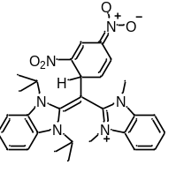
Fig. S11. ¹H and ¹³C NMR spectra of 5a
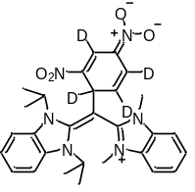
Fig. S12. ¹H and ¹³C NMR spectra of 5a-d₄
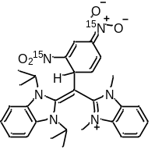
Fig. S13. ¹H and ¹³C NMR spectra of 5a-¹⁵N₂
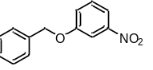
Fig. S14. ¹H and ¹³C NMR spectra of 7aa
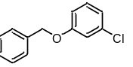
Fig. S15. ¹H and ¹³C NMR spectra of 7ca
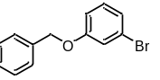
Fig. S16. ¹H and ¹³C NMR spectra of 7da
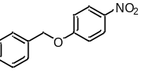
Fig. S17. ¹H and ¹³C NMR spectra of 7fa
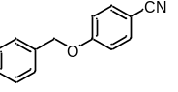
Fig. S18. ¹H and ¹³C NMR spectra of 7ia
Fig. S19. ¹H and ¹³C NMR spectra of 7ka
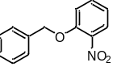
Fig. S20. ¹H and ¹³C NMR spectra of 7ma
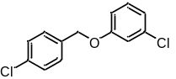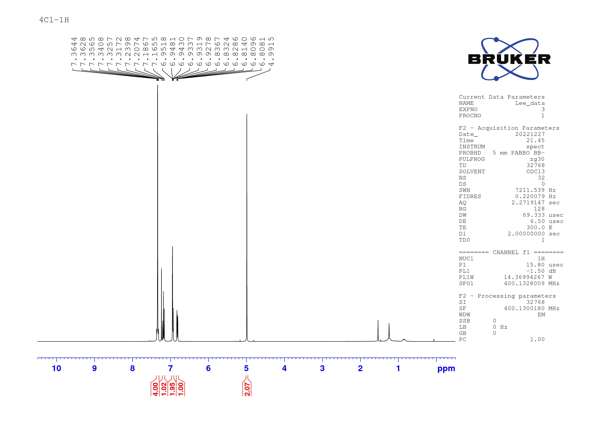
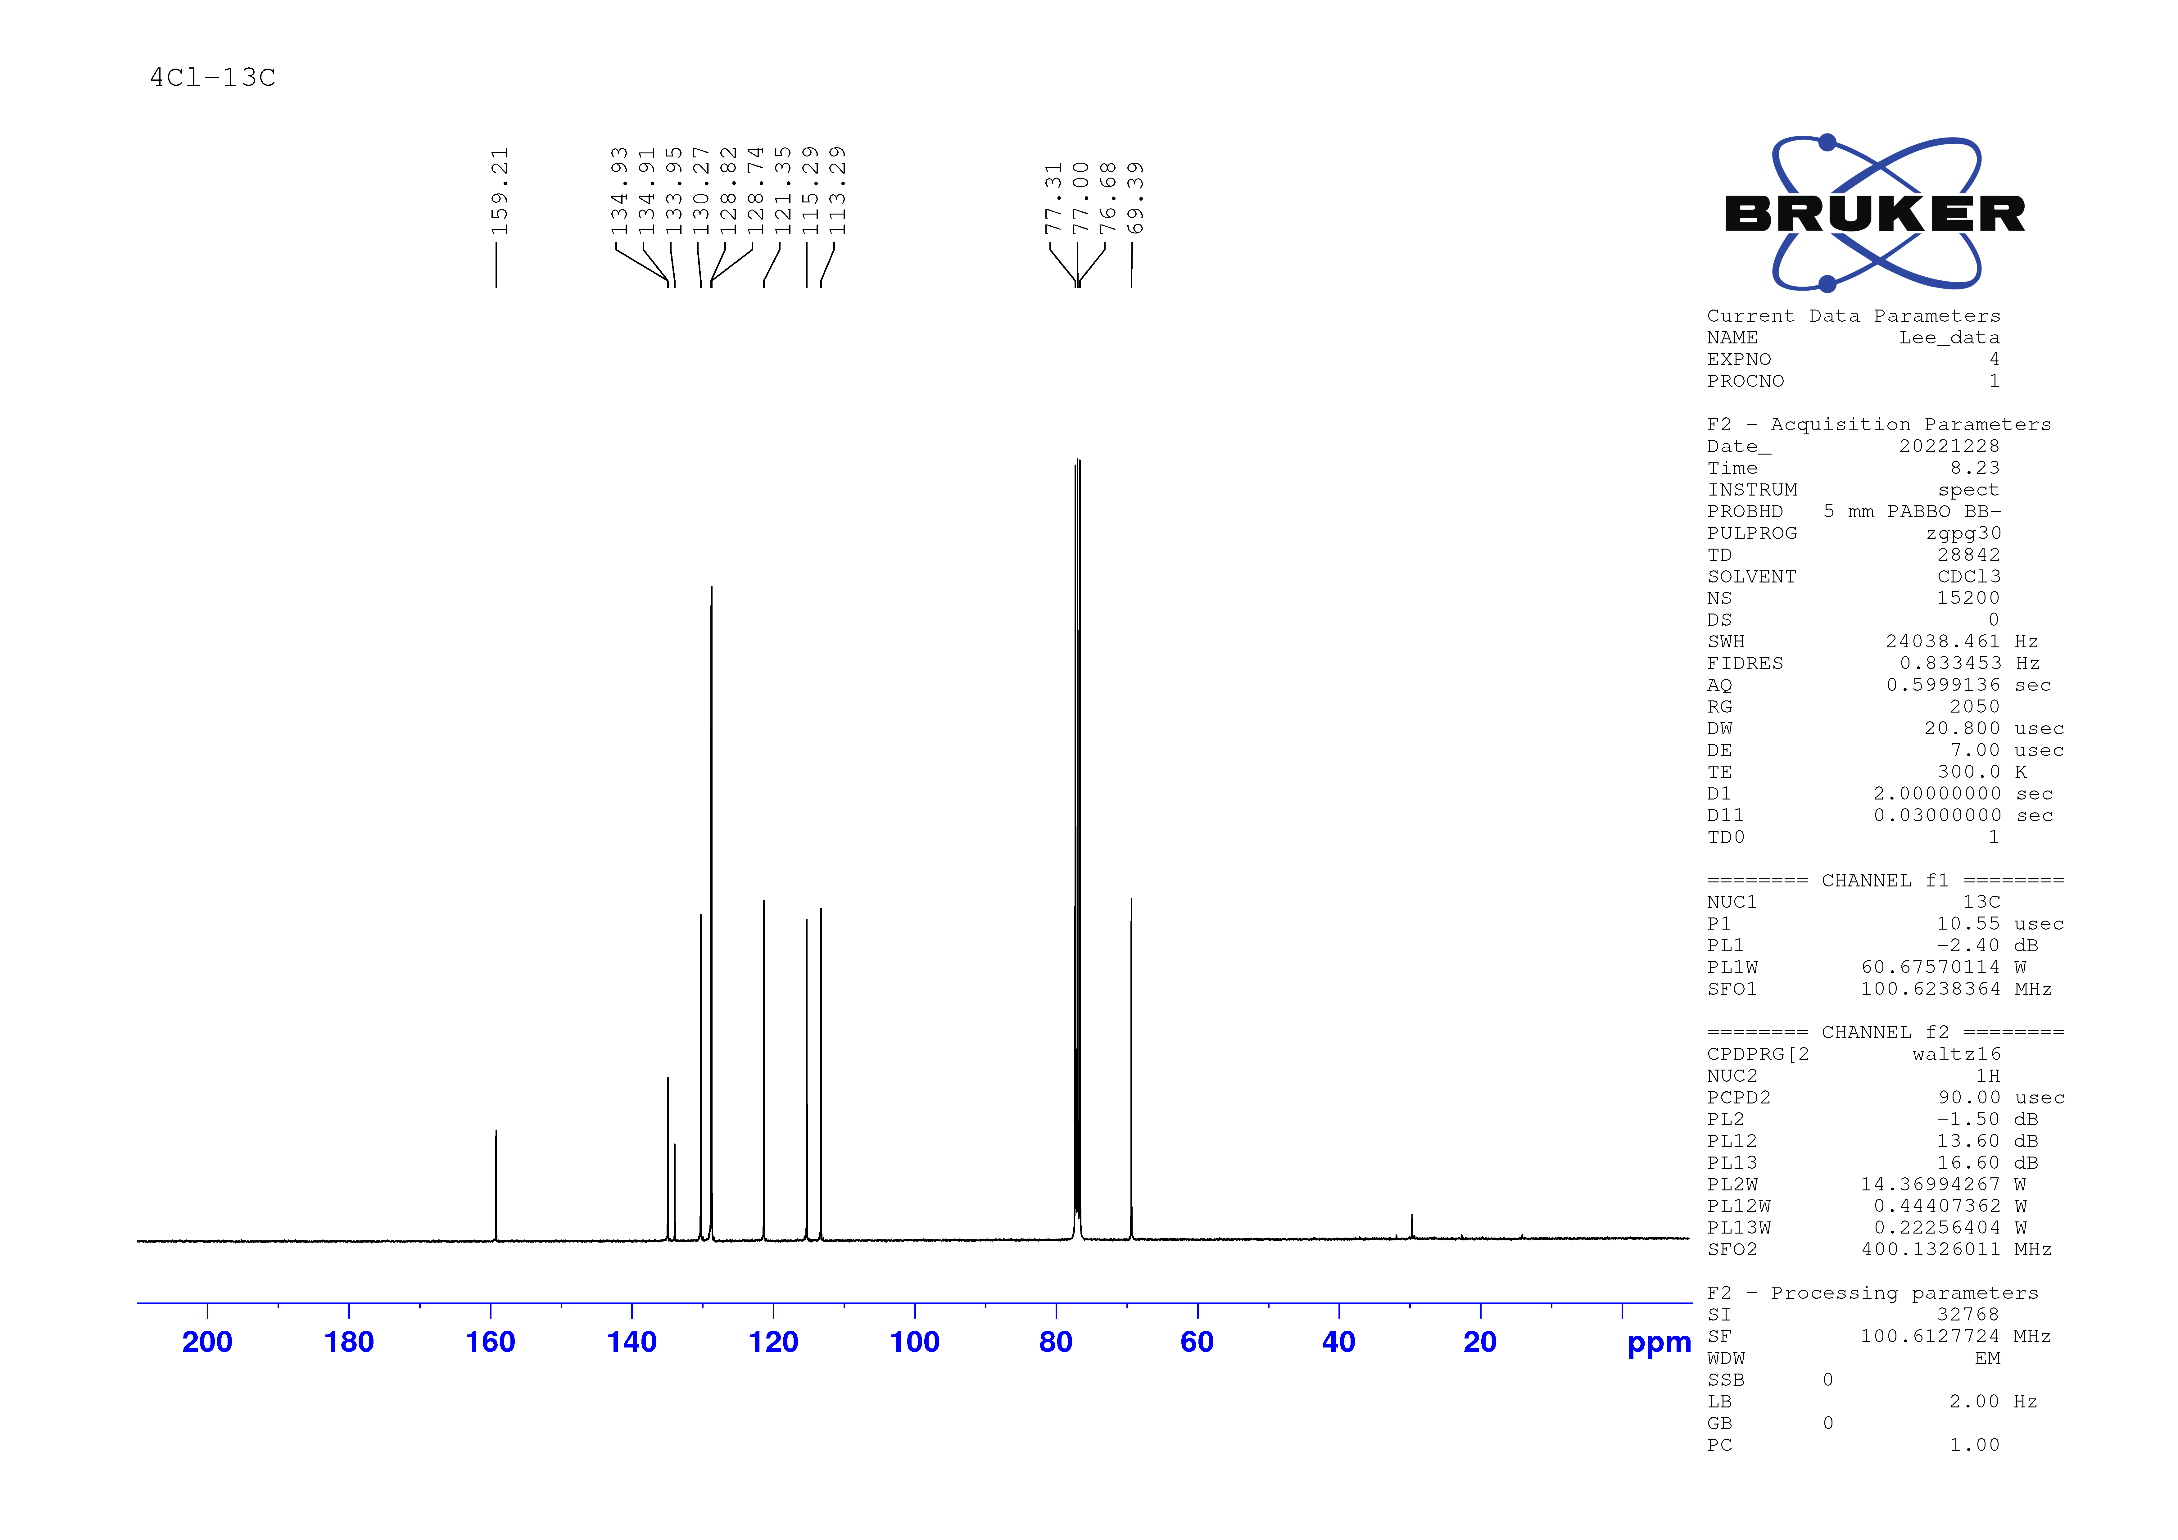
Fig. S21. ¹H and ¹³C NMR spectra of 7cb
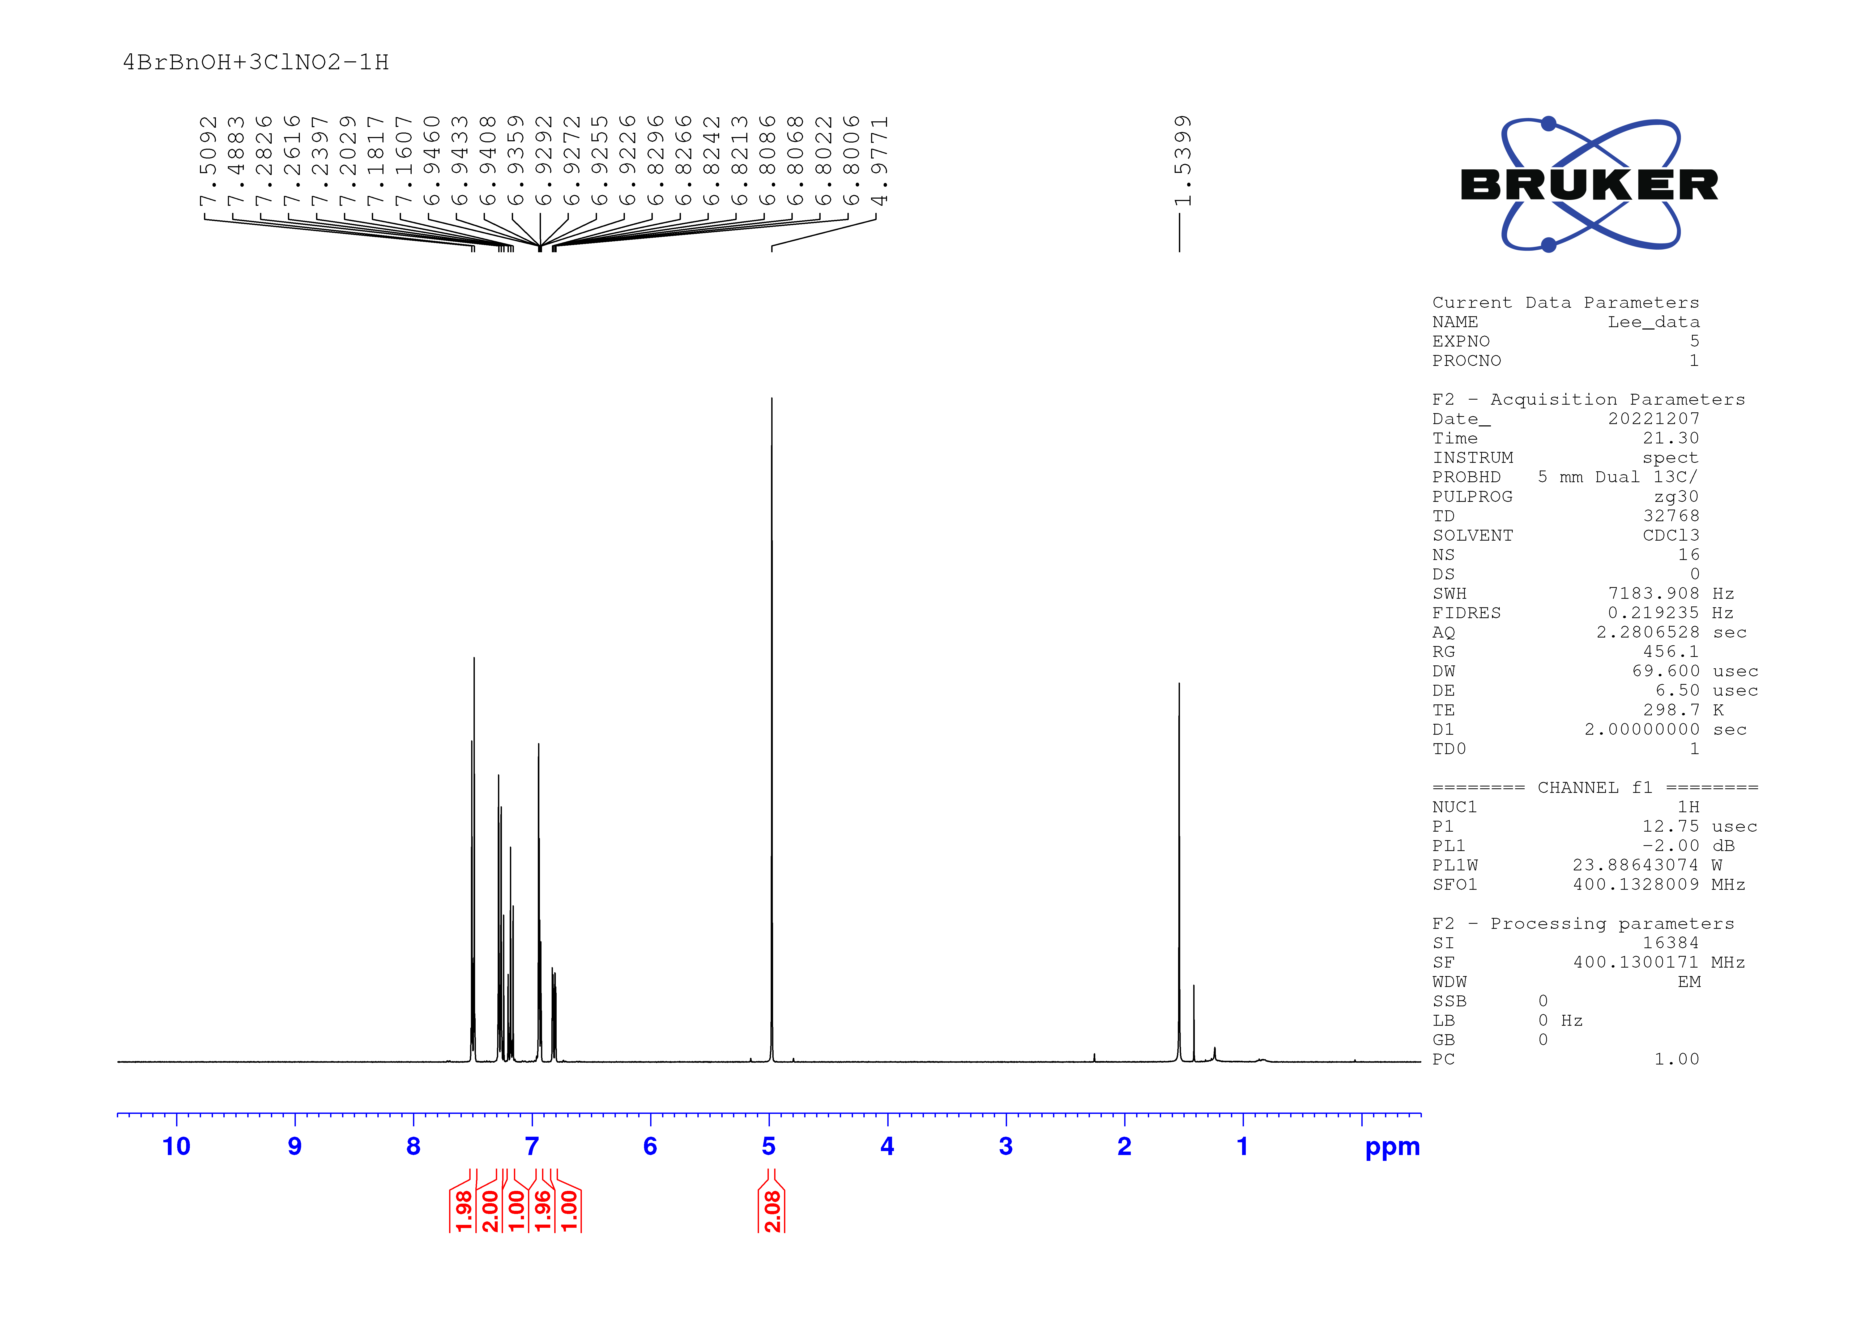
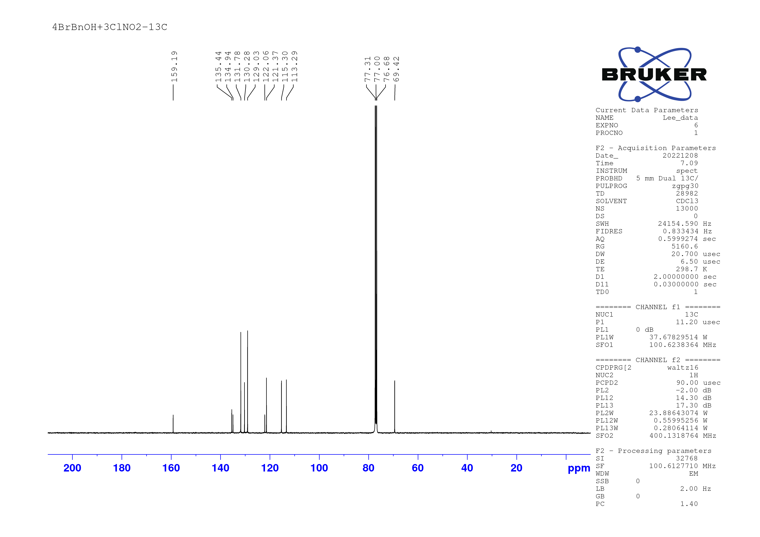
Fig. S22. ¹H and ¹³C NMR spectra of 7cc
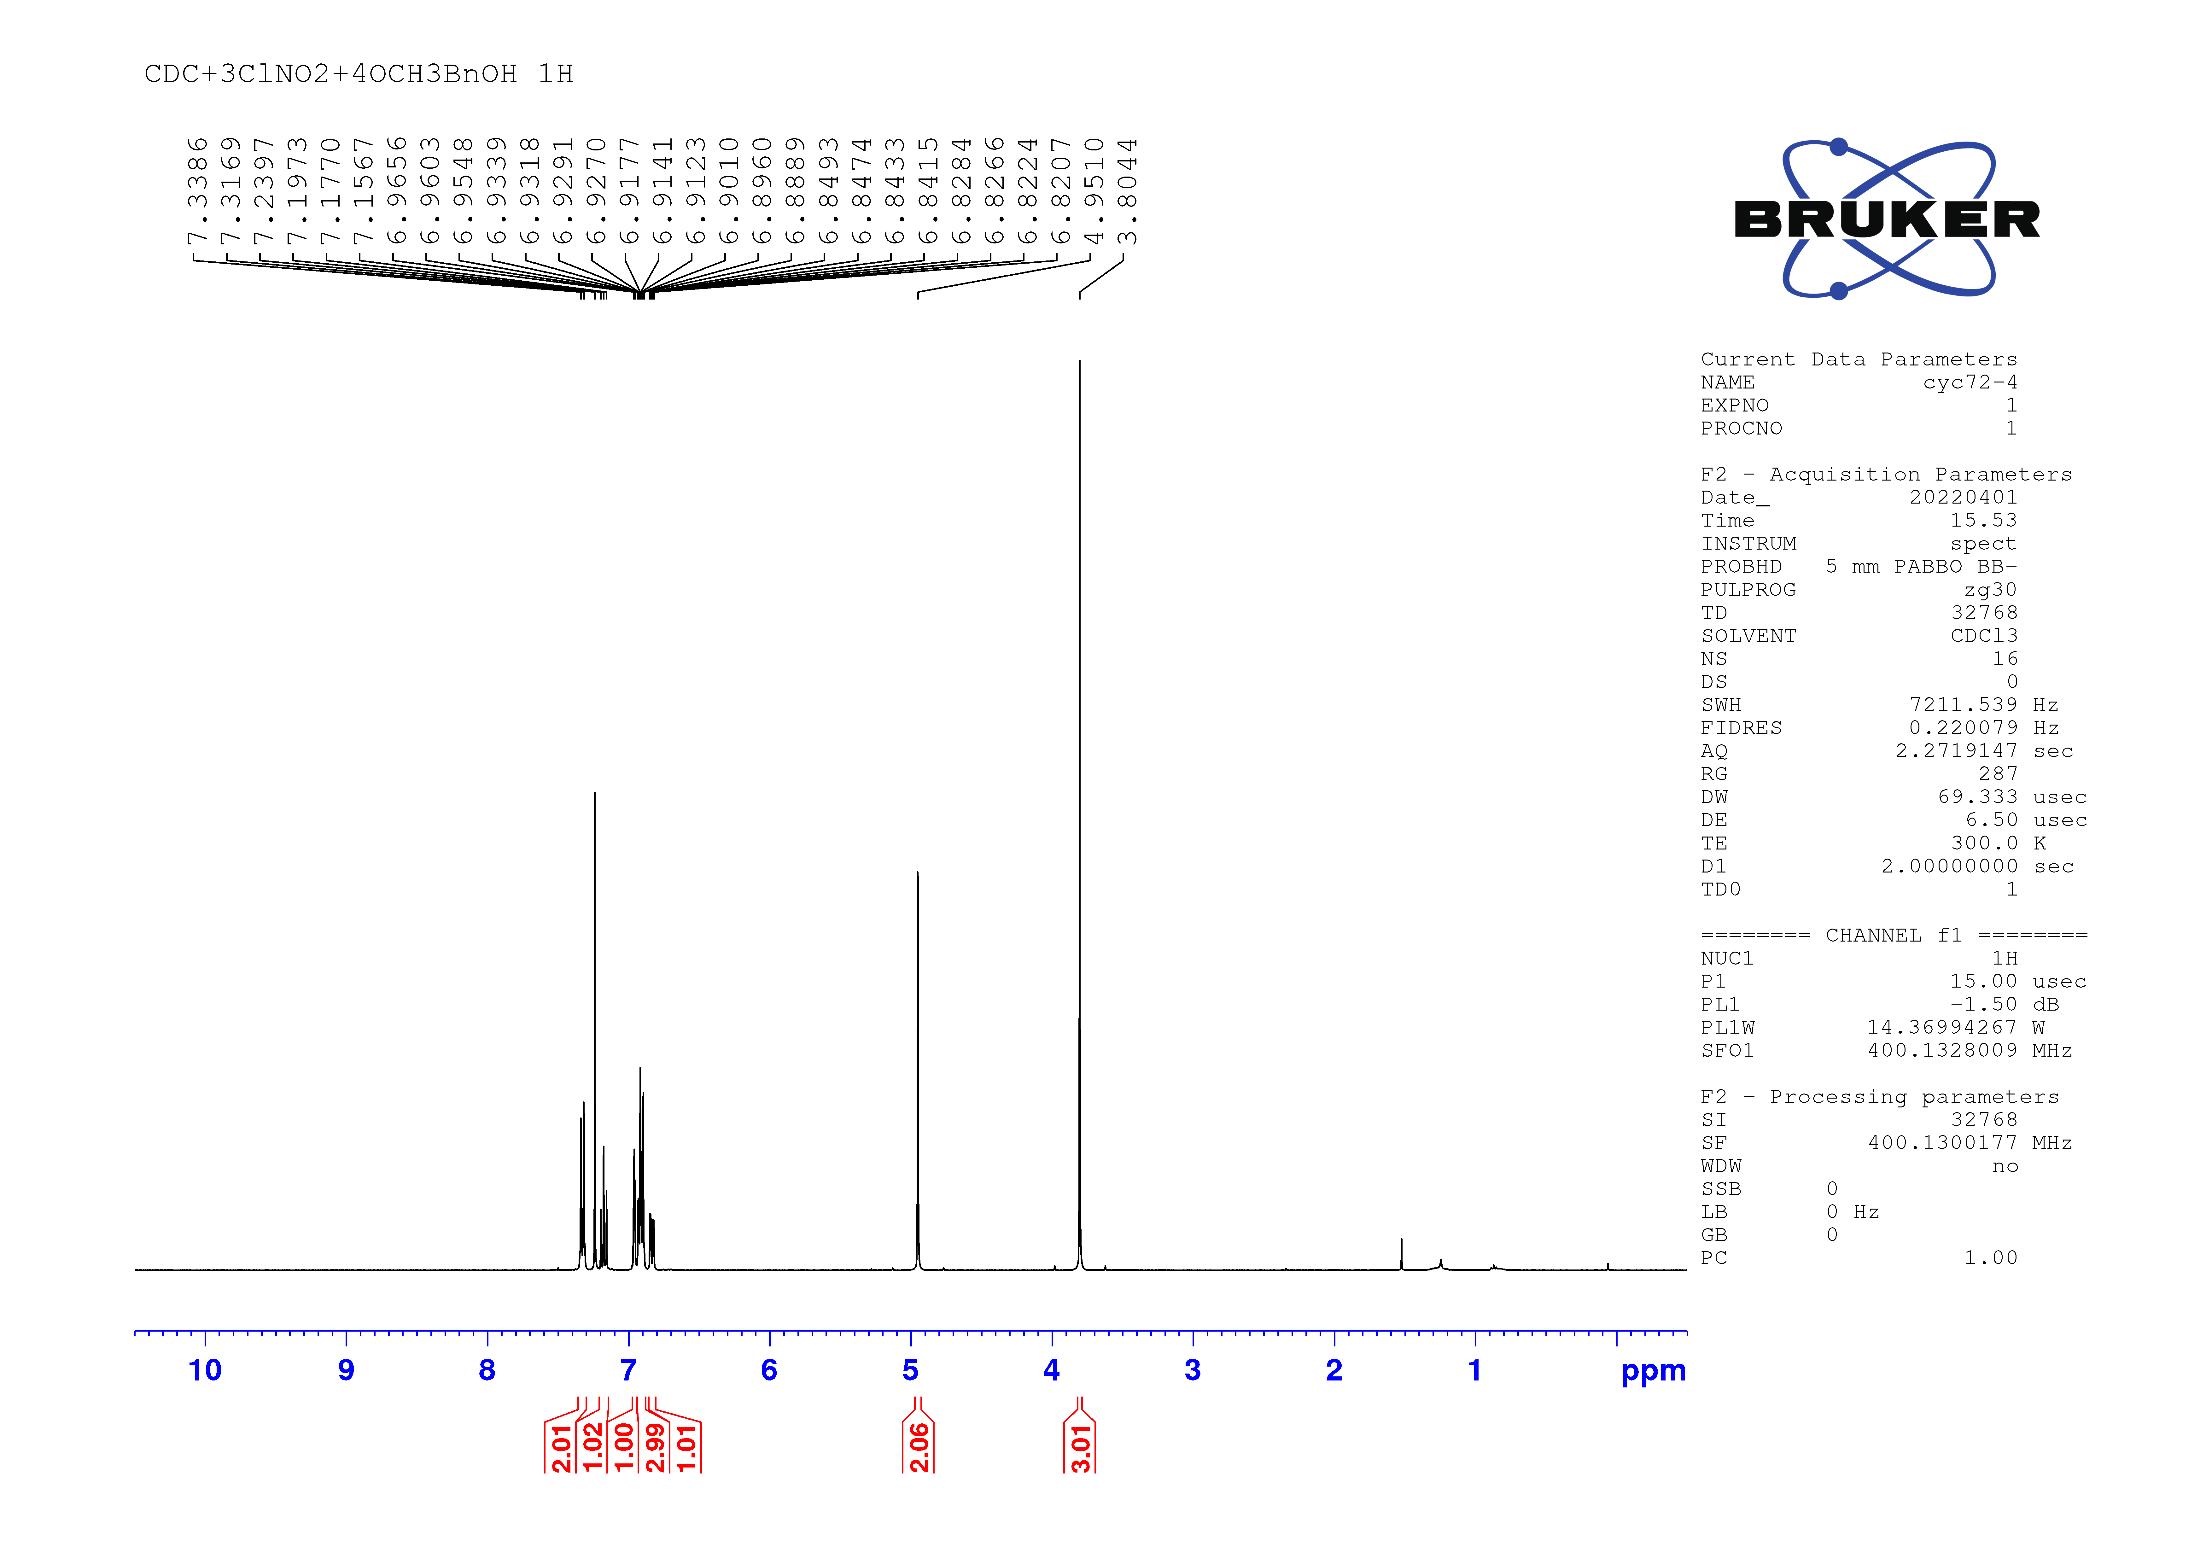
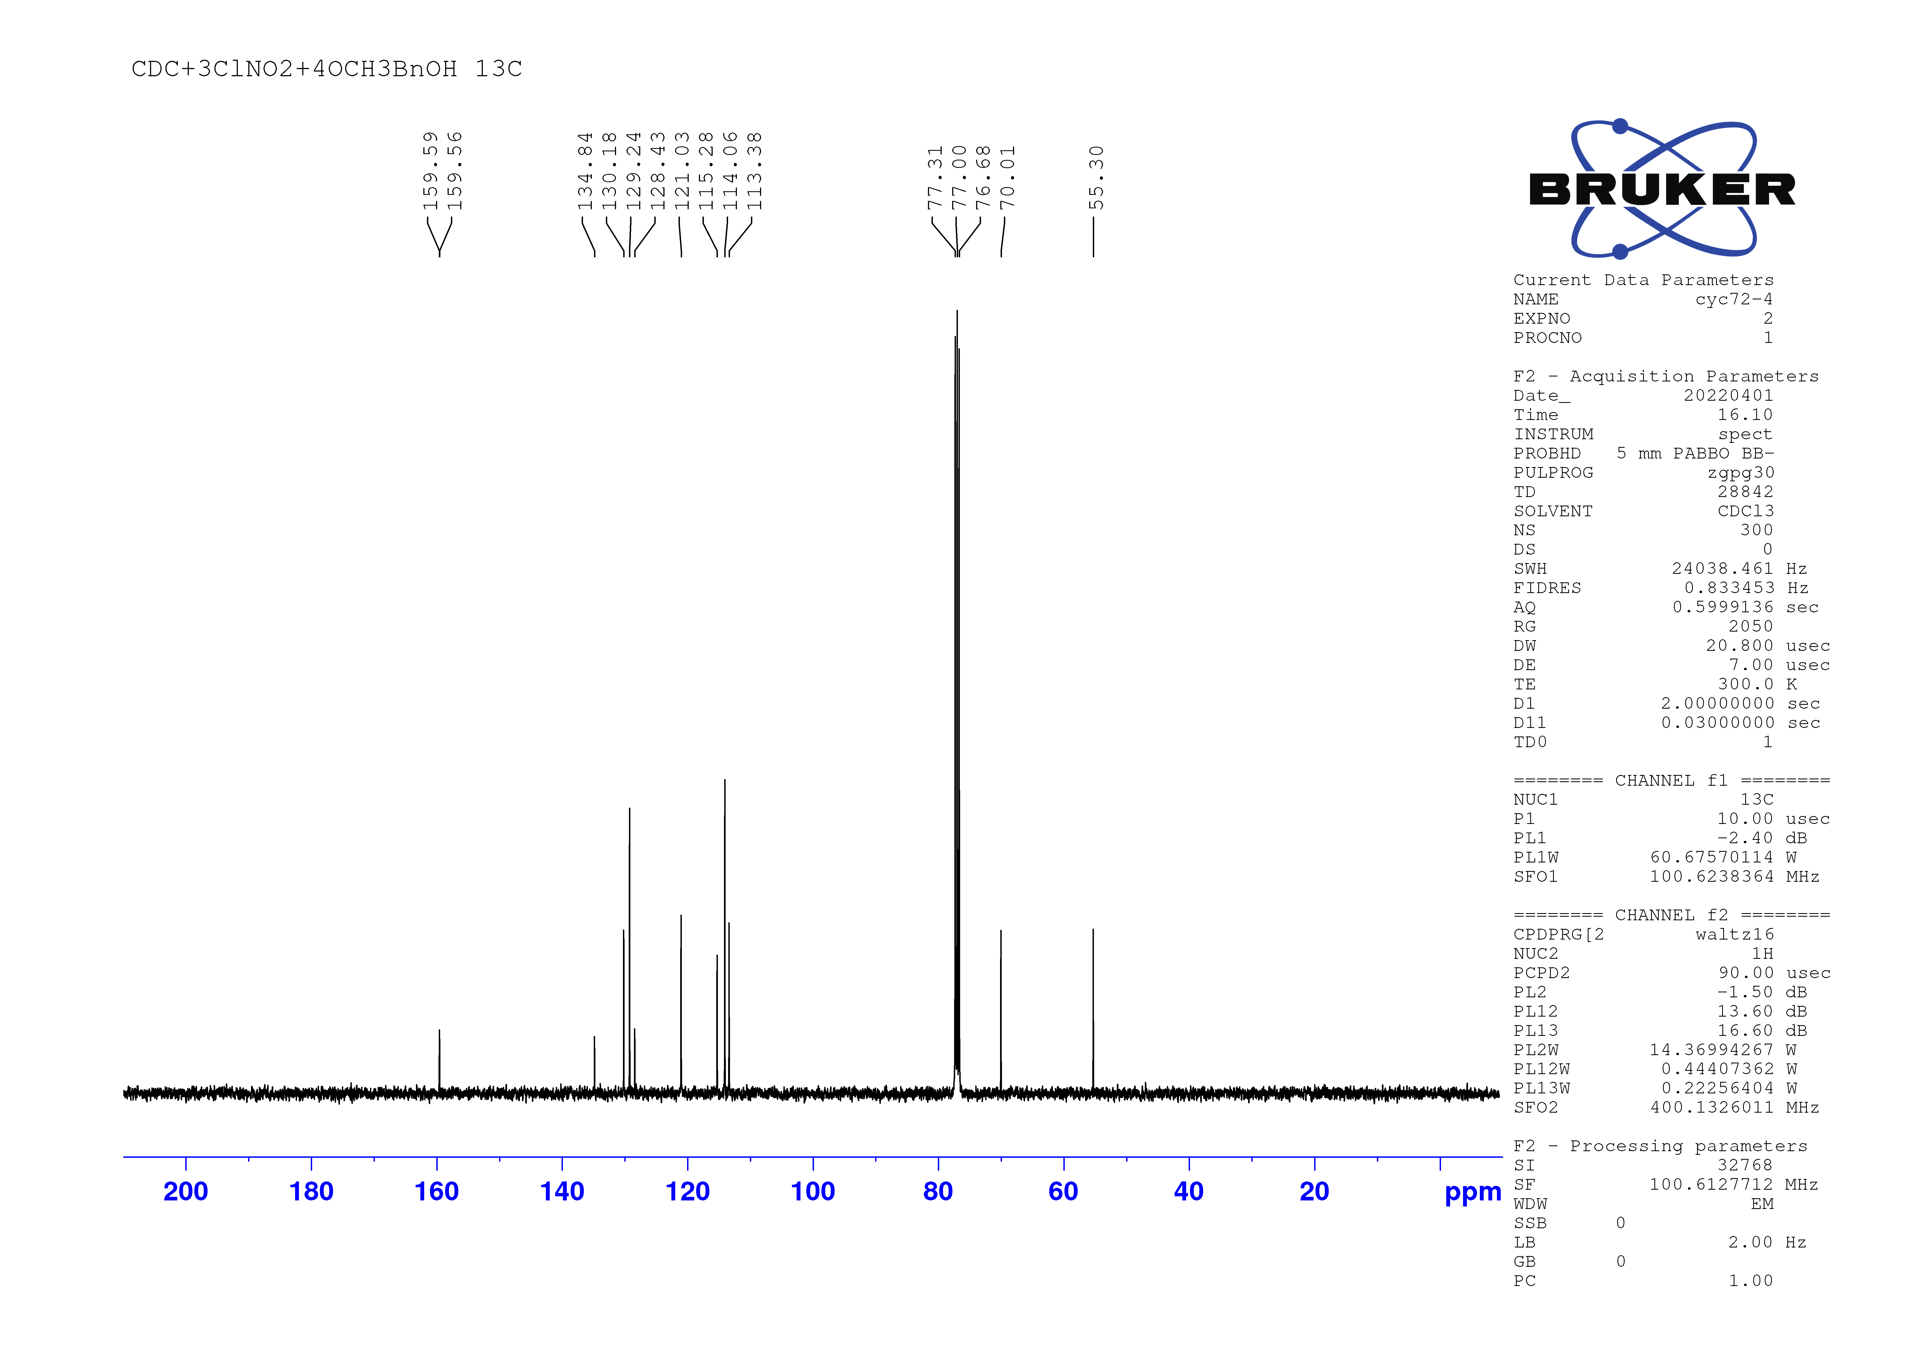
Fig. S23. ¹H and ¹³C NMR spectra of 7cd
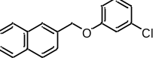
Fig. S24. ¹H and ¹³C NMR spectra of 7ce
Fig. S25. ¹H and ¹³C NMR spectra of 7cf
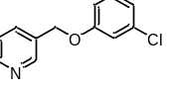
Fig. S26. ¹H and ¹³C NMR spectra of 7cg
Fig. S27. ¹H and ¹³C NMR spectra of 7ch
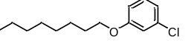
Fig. S28. ¹H and ¹³C NMR spectra of 7ci
Fig. S29. ¹H and ¹³C NMR spectra of 7cj
Fig. S30. ¹H and ¹³C NMR spectra of 7ck
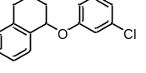
Fig. S31. ¹H and ¹³C NMR spectra of 7cl
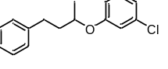
Fig. S32. ¹H and ¹³C NMR spectra of 7cm
Fig. S33. ¹H and ¹³C NMR spectra of 7cn
Fig. S34. ¹H and ¹³C NMR spectra of 7co
Fig. S35. ¹H and ¹³C NMR spectra of 7cp
Fig. S36. ¹H and ¹³C NMR spectra of 8o
Fig. S37. ¹H and ¹³C NMR spectra of 8p
Fig. S38. ¹H and ¹³C NMR spectra of 8q
Fig. S39. ¹H and ¹³C NMR spectra of 8r
VIII. Computational Methods and Details
Geometry ooptimization of all reported structures and frequency calculations were performed with the Gaussian 16 program². The calculations were carried out for all molecules using the meta-generalized gradient approximation (GGA) functional exchange (M06-2X)^{3.} functional with def2-TZVP^{4,5} basis set and dispersion correction by Grimme with DFT-D3⁶ approach, with the solvation effects of the experimentally used solvent (i.e., tetrahydrofuran) were taken into consideration by using the Cramer-Truhlar continuum solvation model dielectric SMD⁷. Vibrational frequency calculations were performed for all stationary points to identify whether they were local minima (no imaginary frequencies). Partial charges q and bond order P were obtained from a single-point calculation of the molecules at the M06-2X+D3/def2-TZVPP level by using NBO 7.0⁸ as implemented with Gaussian 16 program. The Laplacian of the electron density is estimated by the Bader’s quantum theory of atoms-in-molecules (QTAIM) method with the AIMALL program^{9,10}. All presented structures were visualized with CYLView software¹¹. The figure of molecular orbital analysis was prepared by using VMD¹² and Multiwfn¹³.

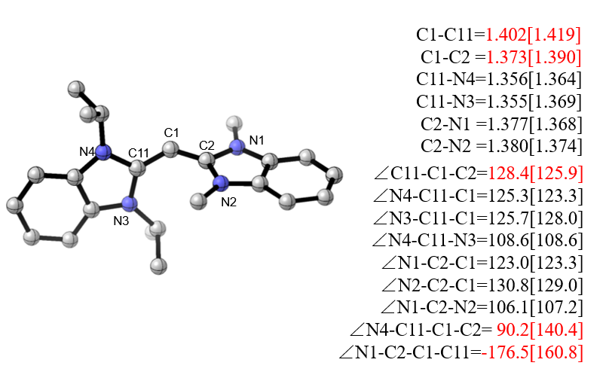

[1-CDC]^{•+}
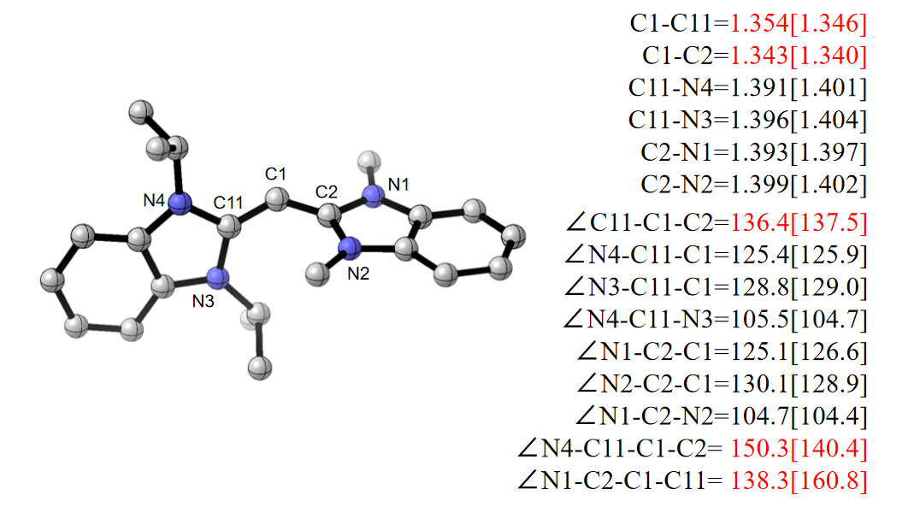

1-CDC

Fig. S40. Optimized geometries of [1-CDC]^{•+} (top) and neutral 1-CDC (bottom) at the M06-2X+D3/def2-TZVP(SMD,THF) level. Bond lengths in Å, bond angles in degree. Experimental values are given in parentheses. Hydrogen atoms are omitted for clarity (color code, C: gray, N: blue).

Table S5. Coordinates and energies (in hartrees) of the calculated structures at the M06-2X(SMD,solvent = THF)-D3/def2-TZVP level

CDC⁺
Energy= -1112.09143618

N -2.738269 -0.030302 1.297529
N -1.903070 -0.041131 -0.742113
N 1.726861 -1.102106 0.328078
N 1.644507 1.097974 0.334710
C -0.324016 -0.076497 1.200265
C -1.555254 -0.049882 0.593737
C -2.865442 -0.019883 2.740966
H -1.869465 -0.040495 3.171977
H -3.427817 -0.896683 3.060933
H -3.387701 0.883987 3.053635
C -3.795356 -0.014693 0.434920
C -5.169469 0.008008 0.664338
H -5.571456 0.021389 1.668359
C -5.983850 0.010509 -0.450356
H -7.057875 0.026544 -0.321246
C -5.453790 -0.009106 -1.753397
H -6.133286 -0.008713 -2.595493
C -4.092410 -0.029943 -1.985467
H -3.686613 -0.048376 -2.987759
C -3.266462 -0.028504 -0.863489
C -1.012295 -0.118208 -1.884589
H 0.006283 0.101512 -1.584531
H -1.325272 0.616849 -2.624791
H -1.057822 -1.115082 -2.323913
C 0.943128 -0.031333 0.601367
C 1.290367 -2.495358 0.508499
H 0.277493 -2.414527 0.904560
C 1.232627 -3.222191 -0.826397
H 0.605450 -2.680259 -1.535895
H 0.806686 -4.214681 -0.676731
H 2.224833 -3.343288 -1.261837
C 2.150455 -3.202989 1.544413
H 3.175502 -3.335551 1.199148
H 1.730903 -4.190011 1.740561
H 2.165614 -2.641541 2.479113
C 2.963277 -0.653040 -0.126525
C 4.100294 -1.329473 -0.546568
H 4.153008 -2.408054 -0.555044
C 5.179643 -0.564105 -0.964576
H 6.080379 -1.062951 -1.297040
C 5.124367 0.829508 -0.968055
H 5.982429 1.396171 -1.304644
C 3.988851 1.508747 -0.550177
H 3.954517 2.588104 -0.564629
C 2.909897 0.745969 -0.124881
C 1.105096 2.452516 0.529957
H 0.121864 2.292748 0.973683
C 0.926927 3.156594 -0.806476
H 1.883577 3.314531 -1.306021
H 0.463508 4.130135 -0.644146
H 0.282431 2.572044 -1.465123
C 1.945908 3.240613 1.522891
H 2.075412 2.678898 2.448561
H 1.433724 4.174627 1.755261
H 2.928534 3.488069 1.123233

CDC⁺(N1-C2-C1-C3 and N3-C3-C1-C2 fixed)
Energy= -1112.08906828

N -2.653610 0.912037 1.010593
N -2.051749 -0.158153 -0.815377
N 1.375921 -0.935143 0.313771
N 2.045233 1.129750 -0.072087
C -0.274624 0.901567 0.598002
C -1.560407 0.526772 0.273096
C -2.607073 1.644232 2.260311
H -2.716522 0.960395 3.102227
H -3.418447 2.369985 2.269390
H -1.649405 2.152505 2.324726
C -3.800116 0.455536 0.422125
C -5.137138 0.559509 0.799218
H -5.428341 1.062574 1.711374
C -6.066969 -0.007739 -0.049832
H -7.117780 0.051482 0.201058
C -5.684984 -0.662384 -1.234350
H -6.450776 -1.092113 -1.866476
C -4.359717 -0.774033 -1.608347
H -4.064390 -1.282376 -2.516386
C -3.419348 -0.207438 -0.752094
C -1.291156 -0.693603 -1.927669
H -0.234088 -0.498654 -1.778629
H -1.615240 -0.213695 -2.851139
H -1.456637 -1.768509 -1.998339
C 0.958199 0.363806 0.226136
C 0.517764 -2.066036 0.699566
H -0.496453 -1.676045 0.661610
C 0.614415 -3.215396 -0.297442
H 0.619421 -2.850085 -1.324328
H -0.253640 -3.862214 -0.165839
H 1.502378 -3.824823 -0.138700
C 0.814726 -2.498134 2.128061
H 1.836381 -2.869274 2.219771
H 0.133976 -3.301540 2.411436
H 0.679725 -1.666738 2.821045
C 2.747739 -0.983792 0.114243
C 3.656546 -2.035355 0.155619
H 3.356560 -3.040883 0.406901
C 4.980246 -1.745138 -0.131658
H 5.710415 -2.543333 -0.110488
C 5.389871 -0.446982 -0.446812
H 6.431698 -0.256774 -0.668542
C 4.491962 0.607112 -0.471722
H 4.821647 1.607945 -0.706419
C 3.163959 0.322773 -0.171508
C 1.981069 2.586543 -0.261428
H 0.942246 2.836421 -0.046016
C 2.281517 2.958951 -1.705616
H 3.308915 2.716639 -1.979684
H 2.140928 4.032311 -1.836264
H 1.607667 2.437958 -2.387316
C 2.864524 3.306036 0.746748
H 2.629198 2.983551 1.761697
H 2.679117 4.378157 0.674874
H 3.924855 3.136857 0.562252

CDC
Energy= -1112.25305510

N -2.648710 0.828678 1.065780
N -2.108115 -0.162526 -0.835250
N 1.399268 -0.952647 0.277773
N 2.062240 1.129653 -0.093344
C -0.283398 0.852204 0.514639
C -1.555921 0.503250 0.264917
C -2.509416 1.527626 2.316540
C -3.827571 0.432454 0.472822
C -5.149645 0.544058 0.860050
C -6.124020 0.030901 -0.002451
C -5.780874 -0.570156 -1.205828
C -4.443190 -0.687322 -1.597616
C -3.482262 -0.185345 -0.742119
C -1.381870 -0.608727 -1.995853
C 0.943909 0.364226 0.218150
C 0.543617 -2.079897 0.641878
C 0.612929 -3.210143 -0.379769
C 0.840410 -2.554886 2.058942
C 2.771065 -0.988804 0.096514
C 3.685873 -2.028592 0.127630
C 5.026005 -1.729781 -0.121792
C 5.433366 -0.430397 -0.390169
C 4.518325 0.622580 -0.409902
C 3.187173 0.331578 -0.157554
C 2.003722 2.577638 -0.270473
C 2.385998 2.978434 -1.689204
C 2.815660 3.301393 0.796095
H 4.850287 1.630399 -0.611313
H 6.478157 -0.223452 -0.582862
H 5.755414 -2.529209 -0.102879
H 3.386792 -3.043010 0.344566
H -4.170252 -1.155005 -2.534930
H -6.557822 -0.955436 -1.853428
H -7.166599 0.108078 0.278279
H -5.427743 1.013353 1.794330
H 0.952056 2.818561 -0.117386
H 0.539054 -2.823722 -1.396711
H 1.532252 -3.788460 -0.296113
H -0.221024 -3.892816 -0.209935
H -0.315258 -0.525291 -1.805017
H -1.620061 -1.651811 -2.211644
H -1.634008 0.000022 -2.868341
H -0.466970 -1.677148 0.620883
H 3.431739 2.758841 -1.907911
H 1.763816 2.452419 -2.415125
H 2.233167 4.050819 -1.819100
H 1.859414 -2.936718 2.141388
H 0.717395 -1.737086 2.770572
H 0.153313 -3.357274 2.331650
H -1.947973 0.928581 3.035585
H -1.977659 2.468595 2.162477
H -3.498215 1.734440 2.719052
H 2.498446 2.987906 1.791848
H 3.884829 3.111717 0.697501
H 2.655360 4.376839 0.707182

5a
Energy= -1753.55906693

O -0.748729 -2.519779 -1.042390
O 0.769172 -3.254834 -2.385373
O 5.345848 -3.047502 -1.059344
O 5.887328 -2.114588 0.806195
N 1.839656 1.630033 -0.043466
N -0.108710 2.335158 0.710827
N -2.002139 0.262572 -0.840526
N -2.208354 -0.874049 1.028967
N 0.442745 -2.670787 -1.349961
N 5.039019 -2.447057 -0.026731
C 0.090693 -0.091251 0.430678
C 0.601788 1.204590 0.360568
C 2.796843 0.887372 -0.839808
H 3.693544 0.657286 -0.267890
H 3.065594 1.492099 -1.706989
H 2.336814 -0.032770 -1.183242
C 1.916885 3.010308 0.063586
C 2.947006 3.886191 -0.227786
H 3.906957 3.531676 -0.579146
C 2.694918 5.242541 -0.041037
H 3.476206 5.959429 -0.256650
C 1.458609 5.693105 0.418412
H 1.296378 6.754306 0.554741
C 0.422532 4.807334 0.702594
H -0.540571 5.160106 1.046623
C 0.678543 3.460007 0.517622
C -1.325985 2.352740 1.495369
H -2.219676 2.271528 0.874051
H -1.363939 3.288216 2.049298
H -1.298638 1.527594 2.205407
C -1.326378 -0.228752 0.229319
C -1.381793 0.850877 -2.043496
H -0.315220 0.859950 -1.833229
C -1.599621 -0.041599 -3.258577
H -2.637458 -0.047485 -3.588725
H -1.295986 -1.066055 -3.039778
H -0.988558 0.336008 -4.079233
C -1.848768 2.283571 -2.259318
H -1.289234 2.715740 -3.089757
H -1.670270 2.895973 -1.374804
H -2.908975 2.333341 -2.508776
C -3.337388 -0.100864 -0.737305
C -4.433408 0.142775 -1.559360
H -4.348869 0.720829 -2.466828
C -5.649303 -0.393600 -1.174000
H -6.519582 -0.226925 -1.794970
C -5.772957 -1.151501 -0.005871
H -6.736970 -1.564170 0.260855
C -4.686651 -1.391564 0.817406
H -4.796683 -1.988814 1.709715
C -3.463775 -0.845938 0.438114
C -1.917342 -1.371797 2.385666
H -0.897754 -1.045000 2.585645
C -1.993375 -2.891708 2.434740
H -3.020403 -3.236818 2.311374
H -1.634006 -3.239510 3.403802
H -1.388166 -3.346999 1.650972
C -2.815697 -0.716288 3.428761
H -2.830999 0.368188 3.318761
H -2.420355 -0.953272 4.417061
H -3.839363 -1.082860 3.385206
C 0.909628 -1.366065 0.720555
H 0.210734 -2.020640 1.246547
C 1.406128 -2.158292 -0.472284
C 2.722333 -2.490418 -0.690161
H 2.988527 -3.054256 -1.572604
C 3.696918 -2.123396 0.219007
C 3.327195 -1.429517 1.430714
H 4.101296 -1.201247 2.150058
C 2.056694 -1.086203 1.662718
H 1.795516 -0.578854 2.585089

4b
Energy= -1648.26487857

F -2.419331 -0.824396 -2.263903
O -3.299918 -0.769510 2.561645
O -4.961225 0.560732 2.805673
N -4.158978 -0.037091 2.123536
C -3.351074 -0.268696 -1.475269
C -3.262494 -0.469323 -0.113436
H -2.459203 -1.052205 0.316760
C -4.233098 0.138874 0.662663
C -5.252774 0.911710 0.136167
H -5.983629 1.367259 0.787357
C -5.302541 1.079922 -1.239608
H -6.090153 1.676762 -1.678862
C -4.347867 0.491590 -2.058092
H -4.366335 0.614563 -3.133069
N 0.453804 -2.657711 0.878040
N 1.761751 -2.130276 -0.828897
N 2.451661 1.382635 0.450983
N 0.523384 2.033528 -0.426359
C 0.620685 -0.280125 0.331168
C 0.945881 -1.568016 0.158448
C -0.423097 -2.563728 2.015638
H -0.691609 -1.519009 2.154772
H 0.069750 -2.930010 2.919190
H -1.329840 -3.148020 1.844879
C 0.887250 -3.838283 0.322774
C 0.645820 -5.151932 0.674859
H 0.024116 -5.397988 1.526125
C 1.231377 -6.149511 -0.112105
H 1.058820 -7.188674 0.136882
C 2.024334 -5.827661 -1.204545
H 2.462118 -6.618651 -1.799811
C 2.272299 -4.495737 -1.556417
H 2.891562 -4.254239 -2.410150
C 1.701091 -3.509690 -0.776387
C 2.306995 -1.350664 -1.910261
H 1.508395 -0.966788 -2.552717
H 2.972893 -1.975090 -2.501411
H 2.876791 -0.507530 -1.521898
C 1.182094 0.928234 0.099192
C 3.438592 0.538336 1.121944
H 3.055895 -0.474459 1.005387
C 4.805667 0.597879 0.449523
H 4.719273 0.482701 -0.631554
H 5.422559 -0.216356 0.832266
H 5.329619 1.530611 0.654279
C 3.507589 0.862081 2.609184
H 3.852892 1.884727 2.771643
H 4.204086 0.184290 3.104844
H 2.525980 0.749023 3.071731
C 2.531461 2.752641 0.260537
C 3.528752 3.674343 0.533244
H 4.458303 3.384725 0.999979
C 3.295546 5.009831 0.200770
H 4.063455 5.744399 0.406070
C 2.099203 5.407081 -0.380316
H 1.941709 6.449023 -0.627546
C 1.085051 4.485687 -0.643551
H 0.150698 4.807903 -1.079893
C 1.312012 3.159800 -0.313408
C -0.837135 1.950187 -0.943040
H -1.068065 0.889109 -0.864437
C -0.911319 2.342117 -2.412011
H -0.690119 3.398461 -2.569270
H -1.919789 2.152231 -2.785090
H -0.209638 1.750069 -3.001864
C -1.819620 2.715044 -0.066807
H -1.763054 2.361353 0.964703
H -2.836255 2.553537 -0.432681
H -1.623553 3.788531 -0.076299

4b( N1-C2-C1-C11 and N4-C11-C1-C2 fixed)
Energy= -1648.26443857

F -2.185893 -1.414283 -2.314694
O -3.053905 -1.824335 2.499453
O -4.951901 -0.875449 2.794265
N -4.049663 -1.270185 2.089720
C -3.226185 -1.149581 -1.511085
C -3.081714 -1.370323 -0.157133
H -2.152147 -1.740774 0.253639
C -4.172561 -1.062981 0.636507
C -5.360560 -0.562906 0.133859
H -6.182039 -0.338355 0.797486
C -5.460314 -0.365283 -1.235358
H -6.378766 0.020536 -1.656107
C -4.389858 -0.654888 -2.070439
H -4.445028 -0.502710 -3.140422
N 1.156847 -2.454134 0.811497
N 2.422109 -1.517071 -0.745255
N 1.973337 2.010196 0.446853
N -0.076185 2.087807 -0.390532
C 0.687443 -0.109039 0.333024
C 1.395489 -1.237242 0.168328
C 0.210567 -2.647783 1.878696
H -0.391868 -1.746760 1.969294
H 0.719888 -2.832859 2.827635
H -0.438120 -3.496632 1.653532
C 1.954028 -3.445316 0.292012
C 2.061458 -4.787540 0.600397
H 1.466341 -5.231497 1.387980
C 2.963802 -5.550786 -0.148998
H 3.067975 -6.606453 0.066440
C 3.720087 -4.979882 -1.163022
H 4.404809 -5.595782 -1.731723
C 3.615301 -3.617411 -1.468049
H 4.204674 -3.175285 -2.260698
C 2.735292 -2.861966 -0.719406
C 2.820938 -0.626399 -1.805501
H 2.192656 -0.761731 -2.691539
H 3.859543 -0.821787 -2.070329
H 2.738505 0.404261 -1.472553
C 0.883991 1.212643 0.100073
C 3.158290 1.484675 1.124962
H 3.074326 0.404014 1.025646
C 4.454509 1.914002 0.446696
H 4.407763 1.757502 -0.631453
H 5.274929 1.314724 0.844081
H 4.692721 2.960456 0.632531
C 3.133903 1.834946 2.607493
H 3.184525 2.914761 2.757503
H 3.989560 1.380914 3.109301
H 2.221167 1.461517 3.074059
C 1.656743 3.347001 0.265448
C 2.355509 4.514037 0.528648
H 3.336799 4.500514 0.978543
C 1.747558 5.727989 0.207125
H 2.277970 6.650343 0.405500
C 0.479167 5.769548 -0.356190
H 0.029072 6.724039 -0.596821
C -0.235004 4.598951 -0.610459
H -1.227038 4.644032 -1.035797
C 0.363377 3.391441 -0.287611
C -1.361313 1.624754 -0.901627
H -1.287889 0.541593 -0.817045
C -1.543704 1.975278 -2.371679
H -1.614467 3.051688 -2.532402
H -2.465109 1.520229 -2.740598
H -0.710316 1.590766 -2.962077
C -2.513933 2.090815 -0.022947
H -2.359035 1.769214 1.008873
H -3.447201 1.653291 -0.384960
H -2.623629 3.176220 -0.033580

IX. References
- Chen, W.-C. et al. Expanding the Ligand Framework Diversity of Carbodicarbenes and Direct Detection of Boron Activation in the Methylation of Amines with CO₂. Angew. Chem. Int. Ed. 54, 15207−15212 (2015).
- Gaussian 16, Revision B.01, Frisch, M. J. G. et al. Gaussian, Inc., Wallingford CT, 2016.
- Zhao, Y. & Truhlar, D. G. The M06 suite of density functionals for main group thermochemistry, thermochemical kinetics, noncovalent interactions, excited states, and transition elements: two new functionals and systematic testing of four M06-class functionals and 12 other functionals. Theor. Chem. Acc. 120, 215−241 (2008).
- Weigend, F. Accurate Coulomb-fitting basis sets for H to Rn. Phys. Chem. Chem. Phys. 8, 1057−1065 (2006).
- Weigend, F. & Ahlrichs, R. Balanced basis sets of split valence, triple zeta valence and quadruple zeta valence quality for H to Rn: Design and assessment of accuracy. Phys. Chem. Chem. Phys. 7, 3297−3305 (2005).
- Grimme, S., Antony, J. Ehrlich, S. & Krieg, H. A consistent and accurate ab initio parametrization of density functional dispersion correction (DFT-D) for the 94 elements H-Pu. J. Chem. Phys. 132, 154104 (2010). doi: 10.1063/1.3382344.
- Marenich, A. V., Cramer, C. J. & Truhlar, D. G. Universal Solvation Model Based on Solute Electron Density and on a Continuum Model of the Solvent Defined by the Bulk Dielectric Constant and Atomic Surface Tensions. J. Phys. Chem. B 113, 6378−6396 (2009).
- Glendening, E. D., Landis, C. R. & Weinhold, F. NBO 7.0: New vistas in localized and delocalized chemical bonding theory. J. Comput. Chem. 40, 2234−2241 (2019).
- AIMAll （Version 19.10.12）， T. A. Keith， TK Gristmill Software， Overland Park KS， USA， 2019 （aim.tkgristmill.com）.
- Bader, R. F. W. Atoms in molecules : a quantum theory. (Oxford University Press, 1990), pp. 438.
- CYLview20; Legault, C. Y. Université de Sherbrooke, 2020 (http://www.cylview.org).
- Humphrey, W., Dalke, A. & Schulten, K. VMD: Visual molecular dynamics. J. Mol. Graph. 14, 33−38 (1996).
- Lu, T. & Chen, F. Multiwfn: A multifunctional wavefunction analyzer. J. Comput. Chem. 33, 580−592 (2012).

