Supporting information
Double Cross-Linking Strategy for High-Performance, Thermally Stable Aerogels: A Breakthrough in Extreme Environment Applications
Si-Jia Renª, Zhi-Jie Liu^{b, c*}, Xin Long^{c, d}, Jia-Xuan Liao^{a,d*}
ª School of Mechanical Engineering, Chengdu University, 2025 Cheng Luo Road, Chengdu, 610106, PR China
^{b} National Engineering Research Center of Electromagnetic Radiation Control Materials, State Key Laboratory of Electronic Thin Film and Integrated Devices, University of Electronic Science and Technology of China, 2006 Xiyuan Road, Chengdu, 611731, PR China
^{c} University of Electronic Science and Technology of China, 2006 Xiyuan Road, Chengdu, 611731, PR China
^{d} The Yangtze Delta Region Institute (Quzhou), University of Electronic Science and Technology of China, Quzhou, Zhejiang 324000, P. R. China

*Corresponding authors: lzjcym1995@163.com; jxliao@uestc.edu.cn.
Fig. S1 Structure of silicon source.

Fig. S2 Structure of monomer 1.

Fig. S3 Structure of monomer 2.

Fig. S4 Structure of cellulose.

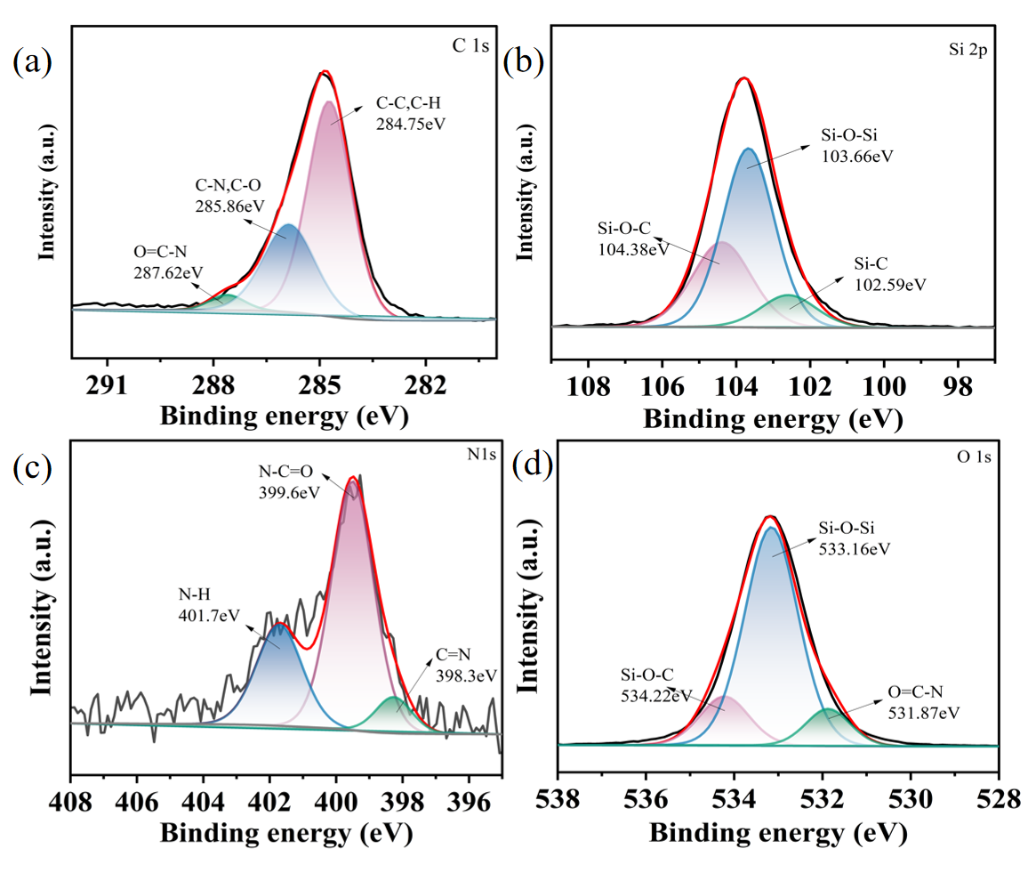
Fig. S5 XPS spectra of CPSA. (a) C1s XPS spectra; (b) Si2p XPS spectra; (c) N1s XPS spectra; (d) O1s XPS spectra.
The XPS results for each element in the CPSA aerogel are presented in Fig. S5. In the C1s spectra, the peaks at 248.75 eV, 285.86 eV, and 287.62 eV binding energies correspond to C-C/C-H, C-N, C-O, and O=C-N, respectively. Three photoelectron peaks located at 102.59 eV, 10 The electronic binding energies of Si-C, Si-O-Si were obtained by fitting Si2p at 3.66 eV, 102.59 eV, and 104.38 eV, respectively. The electronic binding energies of O=C- were determined by fitting O1s at 531.87 eV, 533.16 eV, and 534.22 eV, respectively. The peaks were identified as N1s, Si-O-Si, and Si-O-C, respectively. Three photoelectron peaks were observed at 398.3 eV, 399.6 eV, and 401.7 eV for the N1s spectrum, which correspond to the electronic binding energies of C=N, N-C=O, and N-H, respectively. The reaction between benzoxazine and cellulose resulted in the appearance of the O=C-N functional group, as evidenced by the photoelectron peak located at 401.7 eV, which is the electronic binding energy of C-N···H. This indicates the presence of hydrogen bonding in CPSA. In contrast, the spectrum of N1s in PSA exhibited a single signal peak, which originated from the C-N bond. This further confirmed that the amino group in the monomer reacted with the carboxyl group in cellulose. This stable chemical bonding is the basis for the high compressive strength of aerogels.

