Supporting Information
On-chip graphene photodetectors with a nonvolatile p−i−n homojunction
Ruijuan Tian¹, Yingke Ji¹, Chen Li¹, Yong Zhang², Xianghu Wu¹, Jianguo Wang¹, Shuaiwei Jia³, Liang Liu⁴, Mingwen Zhang¹, Yu Zhang¹, Qiao Zhang¹, Zhuang Xie³, Duorui Gao³, Yan Liu², Jianlin Zhao¹, Zhipei Sun^{5,}*, Xuetao Gan^{1,4,}*
- Key Laboratory of Light Field Manipulation and Information Acquisition, and Shaanxi Key Laboratory of Optical Information Technology, School of Physical Science and Technology, Northwestern Polytechnical University, 710129 Xi’an, P. R. China
- State Key Discipline Laboratory of Wide Band Gap Semiconductor Technology, School of Microelectronics, Xi dian University, Xi’an 710071, P. R. China
- State Key Laboratory of Transient Optics and Photonics, Xi’an Institute of Optics and Precision Mechanics, Chinese Academy of Sciences, Xi’an 710119, P. R. China
- School of Microelectronics, Northwestern Polytechnical University, 710129 Xi’an, P. R. China
- Department of Electronics and Nanoengineering, Aalto University, Tietotie 3, FI-00076 Espoo, Finland
*Email: xuetaogan@nwpu.edu.cn; zhipei.sun@aalto.fi

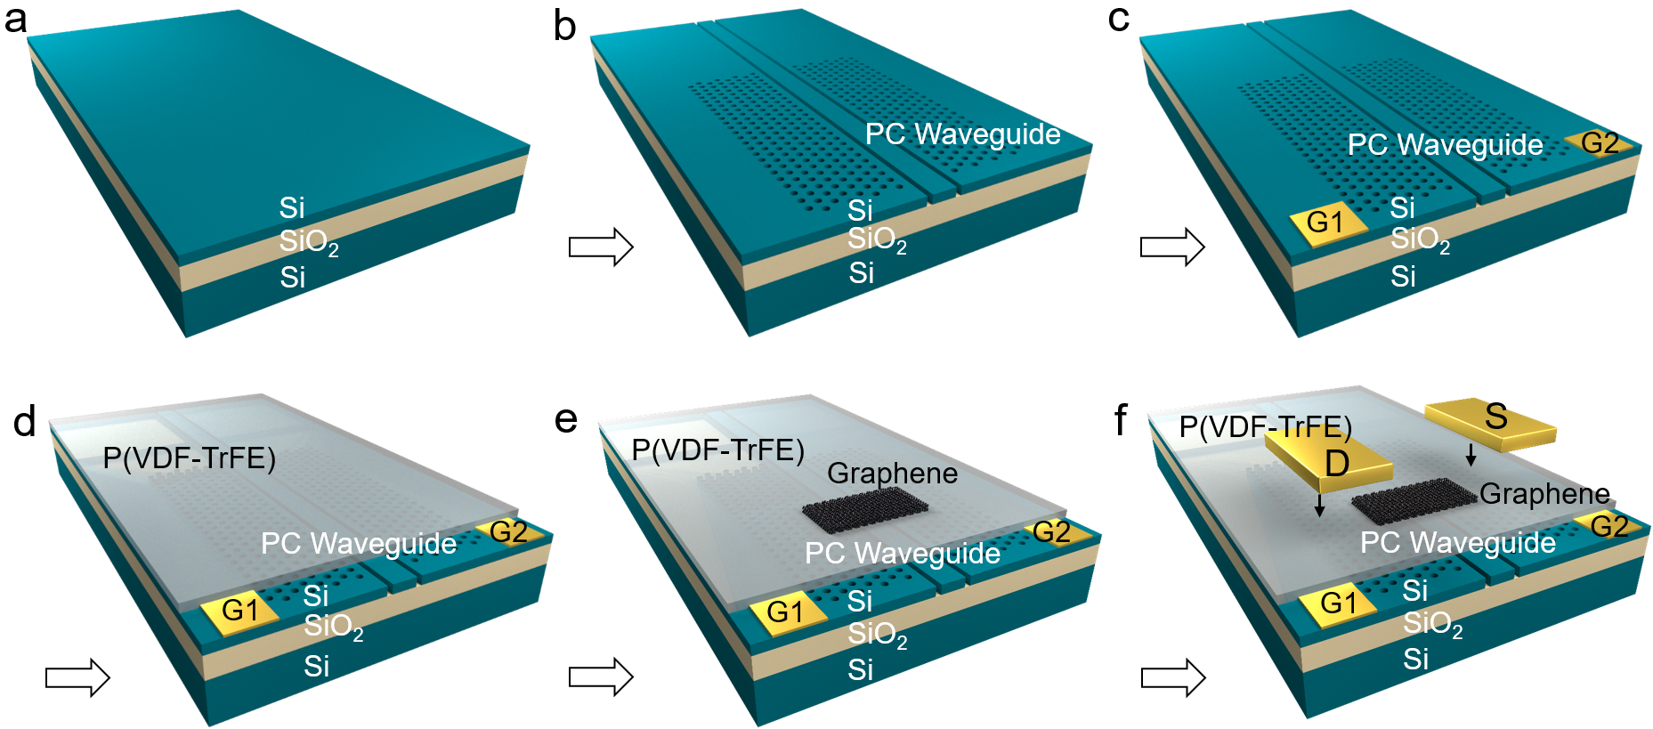
Figure S1 Fabrication flow and structure parameters of the device. a A 220 nm thick silicon-on-insulator wafer was prepared for device fabrication. b PC waveguide is fabricated on the 220 nm thick silicon-on-insulator wafer using the techniques of electron beam lithography and inductively coupled plasma etching. The air-holes of the PC pattern have a lattice constant of 420 nm and a radius of 110 nm. The waveguide is formed by missing one line of air-holes. At the boundary between the air-hole region and the central line-defect, there are two 100 nm wide air-slots, which leave the middle waveguide with a width of 520 nm. c D, S, G1, and G2 electrodes are respectively defined in the four electrically independent parts of the silicon slab divided by the electrically isolated air-slots. d P(VDF-TrFE) (70:30 mol%) ferroelectric polymer was prepared by spin coating on the top of the silicon slab. After that, the P(VDF-TrFE) films were annealed at 135 °C for four hours to improve the crystallinity. e Few-layer graphene was exfoliated and then transferred on the P(VDF-TrFE) film coated on the electrically isolated air-slots PC waveguide. The thickness of the graphene layer was roughly identified by optical contrast, and later confirmed using atomic force microscopy and Raman spectrum. f Finally, Au electrodes with photolithography-defined shape were transferred on both sides of the graphene for drain and source contact.
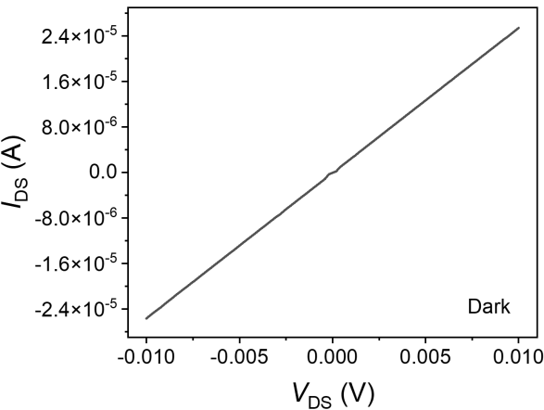
Figure S2 Output characteristic (I_{DS}–V_{DS}) curve of waveguide-integrated nonvolatile graphene p–i–n junction at V_{G1}=V_{G2}=0 V.
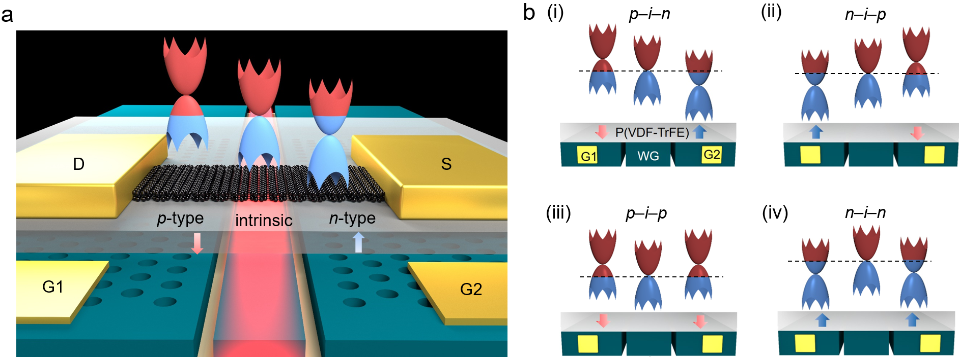
Figure S3 Doping configuration of the device controlled by ferroelectric polarization field. a Schematic of waveguide-integrated nonvolatile graphene p–i–n homojunction configured by the ferroelectric field provided by the P(VDF-TrFE) film. b Four different doping situations of the device. (i) p–i–n configuration, (ii) n–i–p configuration, (iii) p–i–p configuration, (iv) n–i–n configuration.
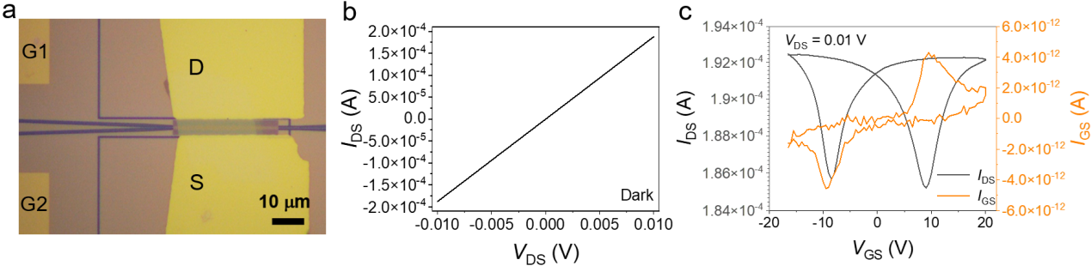
Figure S4 Electrical characteristics of another waveguide-integrated graphene p–i–n homojunction photodetector (marked as Device B). a Optical micrograph of the device. b I_{DS}-V_{DS} curve with V_{G1}=V_{G2}=0 V. c I_{DS}-V_{GS} and I_{GS}-V_{GS} curves when the bottom gates are connected. It has similar symmetrical memory windows with the device of the main text.
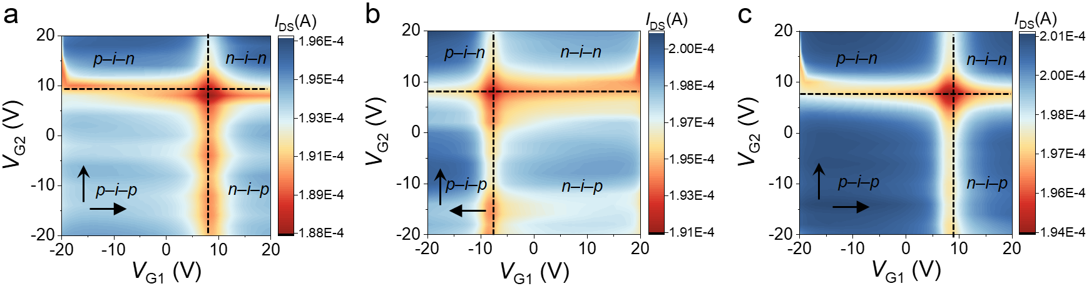
Figure S5 Source-drain current I_{DS} as a function of two independent gate voltages V_{G1} and V_{G2} at a fixed source-drain bias V_{DS} of 0.01 V of Device B. The sweep direction of gate voltage is indicated by the arrows. a Sweep direction of V_{G2} is from –20 V to 20 V while V_{G1} sweeps from –20 V to 20 V. b Sweep direction of V_{G2} is from –20 V to 20 V while V_{G1} sweeps from 20 V to –20 V. c Sweep direction of V_{G2} is from –20 V to 20 V while V_{G1} sweeps from –20 V to 20 V again. Those three current mapping figures with similar on- and off-current states contain more than 9×10⁴ voltage operations, demonstrating excellent endurance property of the device.
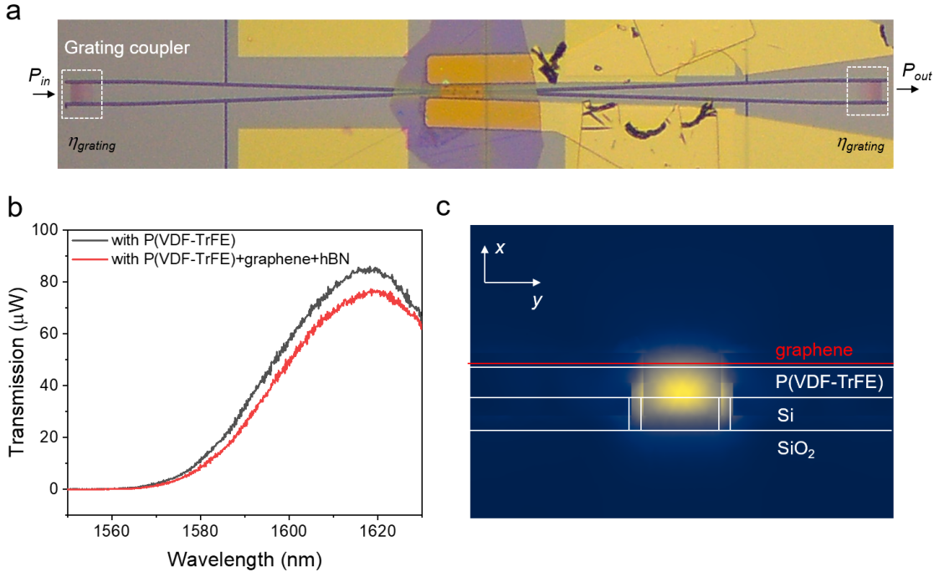
Figure S6 Optical characterizations of the PC waveguide. a Schematic diagram of the proposed waveguide-integrated nonvolatile graphene p−i−n homojunction photodetector under the testing system. The grating couplers were employed for coupling light to one side of the PC waveguide and collecting light from the other side of the PC waveguide. b Transmission spectra of the PC waveguide covered by P(VDF-TrFE) layers before (black line) and after (red line) transferring graphene and h-BN layers. c Cross-sectional view of simulated electric field distributions of the guided mode in the PC waveguide integrated with the P(VDF-TrFE) and graphene layer.
To measure the optical absorption of the integrated graphene on the PC waveguide, the transmission spectra are measured before and after the graphene integration. The schematic diagram of the proposed device is shown in Fig. S6a. There are two grating couplers at the two ends of the PC waveguide. The transmission spectra are measured by sending the laser light from a tunable laser into one grating coupler and collecting the transmission power from the other grating coupler. Figure S6b shows the transmission spectra of the fabricated silicon PC waveguide covered by P(VDF-TrFE) layer before (black line) and after (red line) graphene device preparation. After the device fabrication is finished, the power of transmission spectrum decreases due to the absorption of the few-layer graphene. Here, we calculate the absorption power of graphene by the following method, which is confirmed by our previous work¹.
The output power of the waveguide coated with P(VDF-TrFE) film can be defined as
P_{out1}=P_{in}×η_{g}×η_{g}×(1-α₁) (1)
where P_{in} is the power of incident laser light and η_{g} is the grating coupler efficiency.
The output power of the finished device can be defined as
P_{out2}= P_{in}×η_{g}×η_{g}×(1-α₃) (2)
where α₁ is the waveguide and P(VDF-TrFE) film loss efficiency, α₃ is waveguide, P(VDF-TrFE) film and graphene absorption efficiency. Thus, the absorption power of graphene can be expressed as
P_{abs} = P_{in}×η_{g}×α₂ (3)
where α₁ is the graphene loss efficiency obtained by the difference of α₃ and α₂.
In order to obtain the coupling efficiency of the grating coupler, the transmission spectra before and after transferring graphene device are overlapped, and the coupling efficiency of the grating with spin-coated P(VDF-TrFE) is extracted as 22.4% at the wavelength of 1620 nm. The absorption coefficient of the graphene layer on the waveguide mode is obtained as ~0.23 dB/μm at the wavelength of 1620 nm.
The theoretically anticipated absorption coefficient of graphene on the waveguide is also calculated using FEM software COMSOL. The waveguide supports a single, quasi-TE mode as expected, with the maximum electric field in x-direction. The mode profile is shown in Fig. S6c and the theoretically anticipated absorption of 0.17 dB μm^{–1} is consistent with the experimentally extracted absorption of 0.23 dB μm^{–1} for the few-layer graphene.

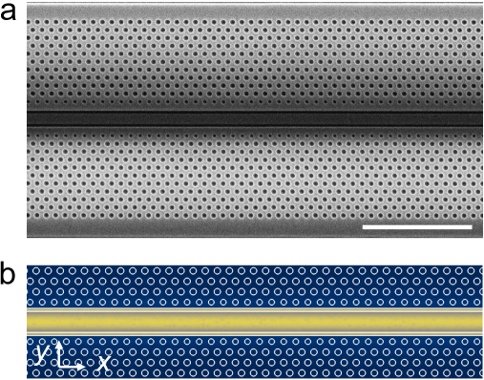
Figure S7 SEM image and simulated electric field distribution of the PC waveguide. a SEM image of the PC waveguide with two air-slots. Scare bar, 5 μm. b Simulated electric field distributions of the guided mode in the PC waveguide.
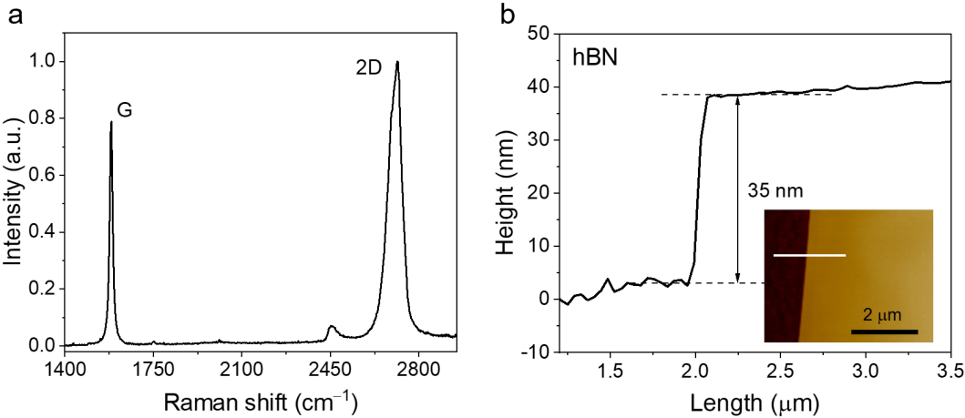
Figure S8 Raman spectra and AFM images of the fabricated device in the maintext. a Raman spectrum of the graphene shows two characteristic peaks: the G peak at ~1582.7 cm⁻¹, and the 2D peak at ~2703.8 cm⁻¹. It shows the bilayer graphene thickness, which is comprehensively determined by the Raman characteristic of G peak intensity, G and 2D peak intensity ratios and 2D peak type². b AFM image of the top hBN flake on top of the graphene layer with a thickness of ~35 nm. Height profiles of hBN flake along the white lines are indicated in the inset.

References
1. Li, C. et al. Waveguide-integrated MoTe₂ p–i–n homojunction photodetector. ACS Nano 16, 20946–20955 (2022).
2. Wu, J., Xu, H. & Zhang, J. Raman spectroscopy of graphene. Acta Chim. Sin. 72, 301–318 (2014).

