Supplementary Material
For
Alkaline-Enhanced Boehmite Catalysts for Catalytic Hydrolysis of Carbonyl Sulfide at Low Temperature

Jia-Yin Lin^{ab*}, Chih-Ying Wangª and Jia-Yu Leeª

ª Semiconductor and Green Technology Program, Academy of Circular Economy, National Chung Hsing University, Nantou 540, Taiwan
^{b} Industrial and Smart Technology Program, Academy of Circular Economy, National Chung Hsing University, Nantou 540, Taiwan

*Corresponding Authors. E-mail addresses: joylin7@dragon.nchu.edu.tw (Jia-Yin Lin)

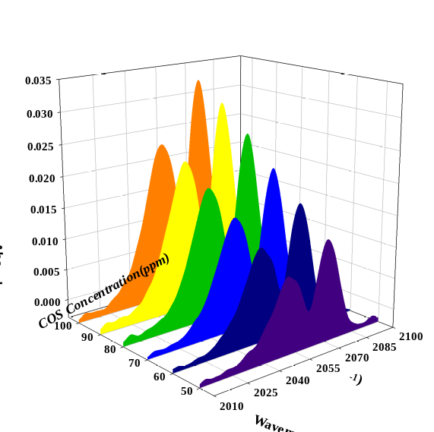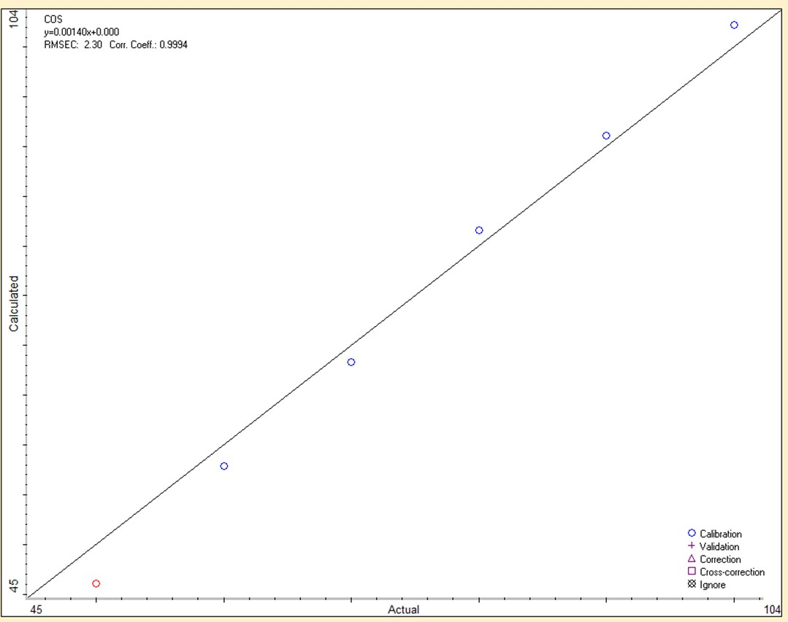
Fig. S1 (a) FTIR spectra of COS between 2010 and 2100 cm⁻¹, (b) Calibration curve of COS, gas balance

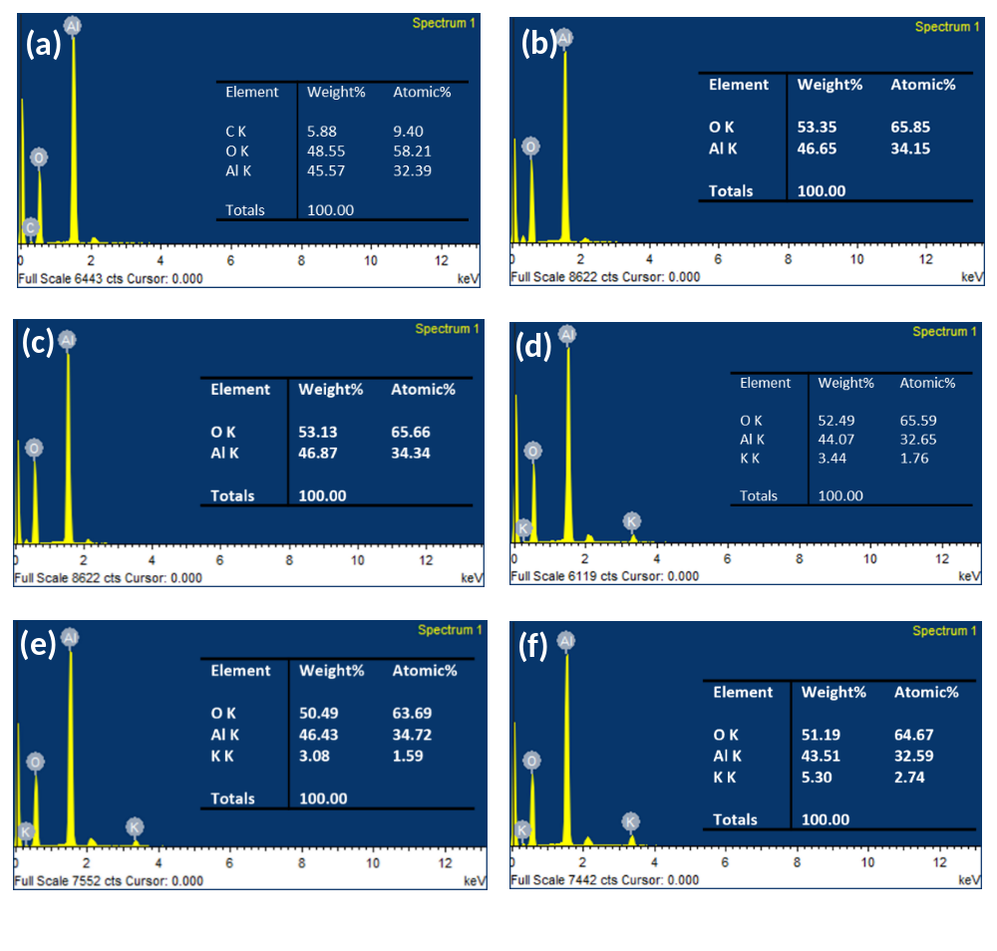 Fig. S2 EDS spectrum of (a) boehmite-1, (b) boehmite-2, (c) boehmite-3, (d) KOH/boehmite-1, (e) KOH/boehmite-2 and (f) KOH/boehmite-3

