Supporting information

Molecular dynamics insight of interaction between Artemisinin and its derivatives and cancer cell membrane

Samaneh Boroomand ª, Delara Mohammad-Aghaie^{a*}, Fatemeh Mohammadpour^{b*}

ª Department of Chemistry, Shiraz University of Technology, 71555-313, Shiraz, Iran
^{b} Department of Physics Education, Farhangian University, P.O. Box 14665-889, Tehran, Iran
*Corresponding author: d_aghaie@sutech.ac.ir (D.M.A)
*Corresponding author: f.mohammadpour@cfu.ac.ir

Contents:
Supporting Figures

Figure S1. Molecular structures of different lipids and cholesterol present in the cancer membrane.
Figure S2. Molecular structure of (A) Artemisinin (B) Artesunate, (C) Dihydroartemisinin, and (D) Artemisone with atom labeling.
Figure S3. (A) Total energy and (B) membrane thickness of the model cancer membrane at 100 ns.
Figure S4. (A-D) Total energy, (E) Density, and (F) RMSDs of the Artemisinin, Dihydroartemisinin, Artesunate, and Artemisone systems at all simulation times (600 ns). Color code: green: Artemisinin, Light blue: Artesunate, orange: Dihydroartemisinin, purple: Artemisone.
Figure S5. Area per lipids for cancer membrane in the systems comprising (A) Artemisinin, (B) Dihydroartemisinin, (C) Artesunate and (D) Artemisone during simulation time. Color code: green: Artemisinin, Light blue: Artesunate, orange: Dihydroartemisinin, purple: Artemisone.
Figure S6. Combined radial/angular distribution functions for hydrogen bonding between O_{A} of Artemisinin molecules with (A) Head groups SM₁₆ (H_{G} atoms), (B) Head groups DOPC (H_{C} atoms), (C) Head groups DOPE (H_{D} atoms) and (D) DOPS (H_{A} atoms) of the different lipids in a cancer membrane.
Figure S7. Combined radial/angular distribution functions for hydrogen bonding between O_{B} of Artesunate molecules with (A) Head groups SM₁₆ (H_{G} atoms), (B) Head groups DOPC (H_{C} atoms), (C) DOPS (H_{A} atoms) Head and (D) groups DOPE (H_{D} atoms) of the different lipids in the cancer membrane.
Figure S8. Average HB existence, ACFs, of intermolecular Hydrogen bond lifetime for Artemisinin and its derivatives with Water and different lipids in cancer cell membrane.
Figure S9. Area per lipid (APL) (A), and cancer cell membrane bilayer thickness (B). Control
Figure S10. Mean-squared displacements of the center of mass of (A) Artemisinin and derivatives and (B) Mean-squared displacements of each lipids of the center of mass in a cancer cell membrane.
Figure S11. Molecular fixed coordinates, $n_{1}$ and $n_{2}$ define bivariate orientation analysis for the Artemisone molecule. Spherical polar angles ($θ,φ$are shown).
Figure S12. Molecular fixed coordinates, $n_{1}$ and $n_{2}$ define bivariate orientation analysis for Dihydroartemisinin. Spherical polar angles ($θ,φ$are shown).
Figure S13. Molecular fixed coordinates, $n_{1}$ and $n_{2}$ define bivariate orientation analysis for Artesunate. Spherical polar angles ($θ,φ$are shown).
Figure S14. Molecular fixed coordinates, $n_{1}$ and $n_{2}$ define bivariate orientation analysis for Artesunate. Spherical polar angles ($θ,φ$are shown).
Figure S15. Atomic density profiles. Atomic density distribution of the membrane components along the membrane normal direction for (A) Artemisinin, (B) Artesunate, (C) Dihydroartemisinin, and (D) Artemisone simulation systems.

Supporting Tables:

TableS1. Number of phospholipids, cholesterol, water molecules, and salt ions in the simulated membrane.
Table S2. Calculated partial atomic charges of Artemisinin.
Table S3. Calculated partial atomic charges of Artemisone.
Table S4. Calculated partial atomic charges of Dihydroartemisinin.
Table S5. Calculated partial atomic charges of Artesunate.
TableS7. Average hydrogen bond lifetimes, 𝜏 (𝐻𝐵) between hydrogen bond donor and acceptor atoms in each system. (DOPS)
TableS8. Average hydrogen bond lifetimes, 𝜏 (𝐻𝐵) between hydrogen bond donor and acceptor atoms in each system. (DOPE)
Table S9. Average hydrogen bond lifetimes, 𝜏 (𝐻𝐵) between hydrogen bond donor and acceptor atoms in each system. (CHL)
Table S10. Average hydrogen bond lifetimes, 𝜏 (𝐻𝐵) between hydrogen bond donor and acceptor atoms in each system. (SM16)
Table S11. Average hydrogen bond lifetimes, 𝜏 (𝐻𝐵) between hydrogen bond donor and acceptor atoms in each system. (DOPC)
Table S12. Average hydrogen bond lifetimes, 𝜏 (𝐻𝐵) between hydrogen bond donor and acceptor atoms in each system. (Water)
Table S13. Average values area per lipid and thickness calculated for Artemisinin and derivations in each system.

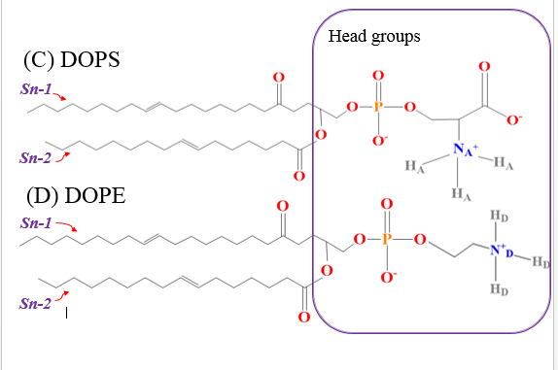
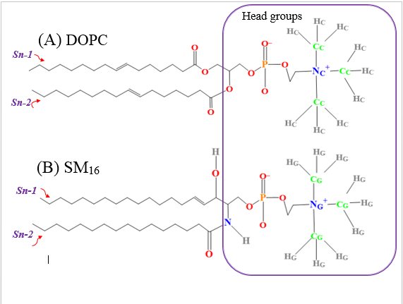
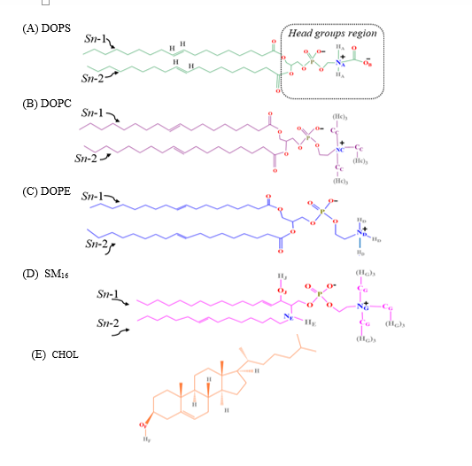
(E) CHL

Figure S1. Molecular structures of different lipids and cholesterol in the cancer membrane.

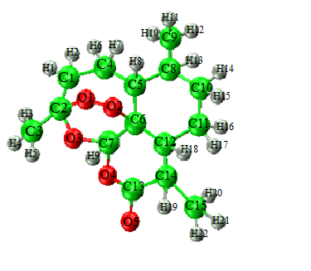
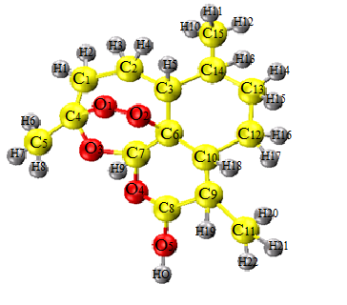
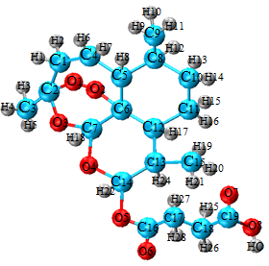
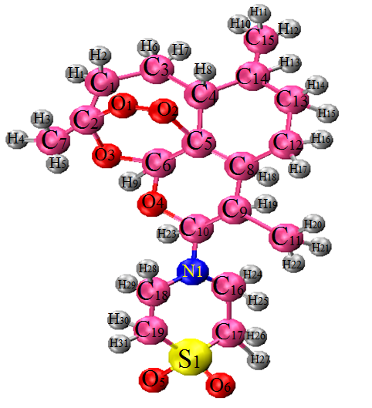
(A)
(B)
(C)
(D)
Figure S2. Optimized molecular structure of (A) Artemisinin (B) Artesunate, (C) Dihydroartemisinin, and (D) Artemisone with atom labeling.

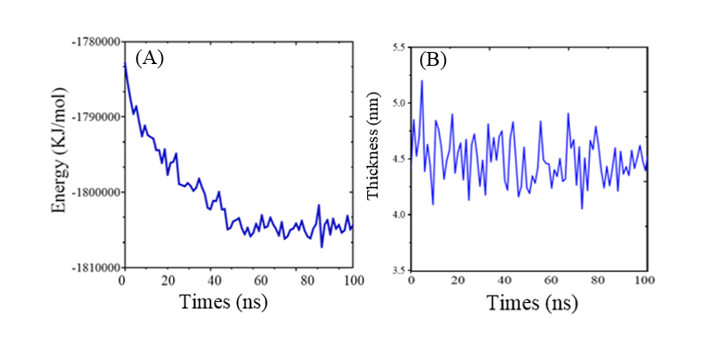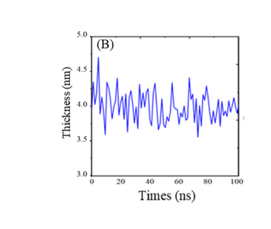
Figure S3. (A) Total energy and (B) membrane thickness of the model cancer membrane at 100 ns.

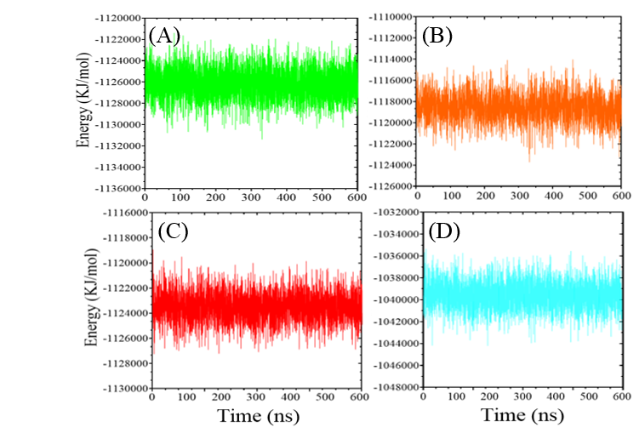
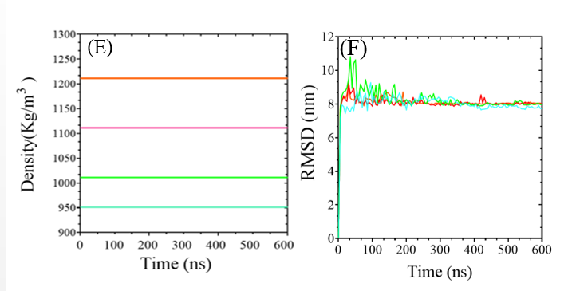
Figure S4. (A-D) Total energy, (E) Density, and (F) RMSDs of the Artemisinin, Dihydroartemisinin, Artesunate, and Artemisone systems at all simulation times (600 ns). Color code: green: Artemisinin, Light blue: Artesunate, orange: Dihydroartemisinin, purple: Artemisone.

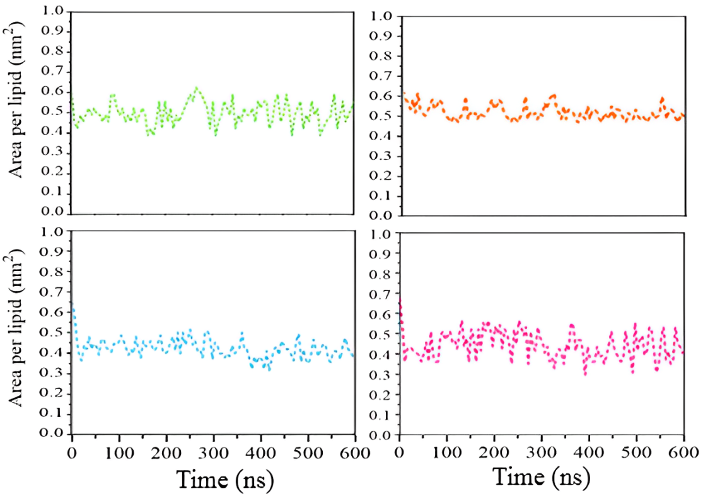
(A)
(B)
(D)
(C)
Figure S5. Area per lipids for cancer membrane in the systems comprising (A) Artemisinin, (B) Artesunate, (C) Dihydroartemisinin and (D) Artemisone during simulation time. Color code: green: Artemisinin, Light blue: Artesunate, orange: Dihydroartemisinin, purple: Artemisone.

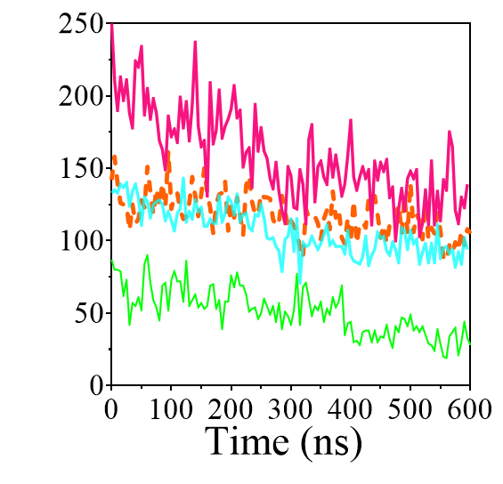
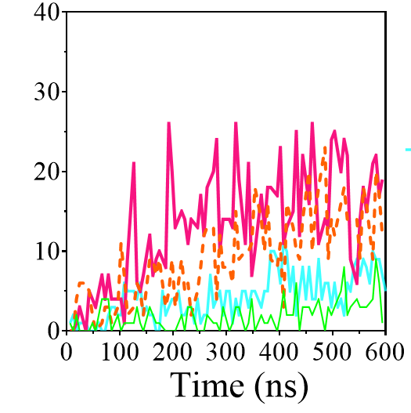
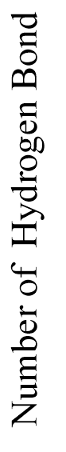
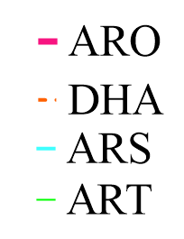
(A)
(B)
Figure S6. Number of hydrogen bonds between Artemisinin and its derivatives with (A) water molecules and (B) model cancer cell membrane over the simulation time. Color code: green: Artemisinin, Light blue: Artesunate, orange: Dihydroartemisinin, purple: Artemisone.

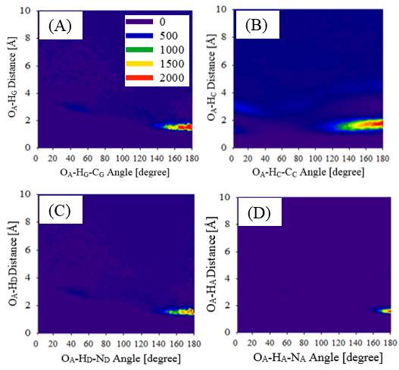
Figure S7. Combined radial/angular distribution functions of OA atom of Artemisinin molecules with (A) SM₁₆ Head groups (H_{G} atoms), (B) DOPC Head groups (H_{C} atoms), (C) DOPE Head groups (H_{D} atoms), and (D) DOPS Head groups (H_{A} atoms) in the cancer membrane.

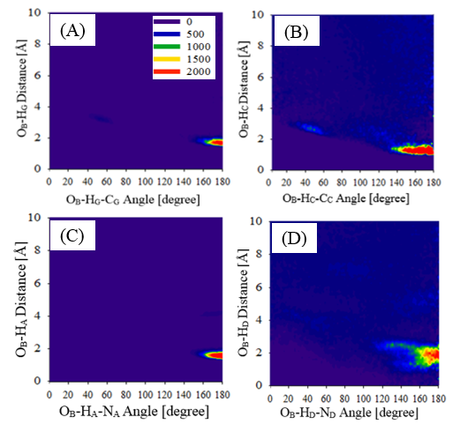
Figure S8. Combined radial/angular distribution functions of O_{B} atoms of Artesunate molecules with (A) SM₁₆ Head groups (H_{G} atoms), (B) DOPC Head groups (H_{C} atoms), (C) DOPE Head groups (H_{D} atoms), and (D) DOPS Head groups (H_{A} atoms) in the cancer membrane.

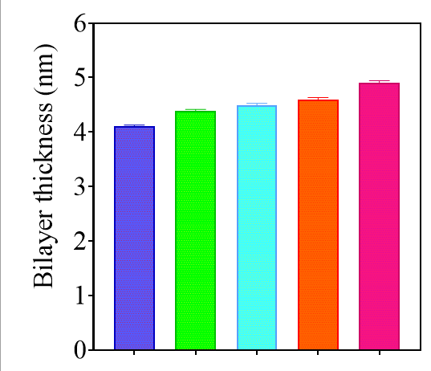
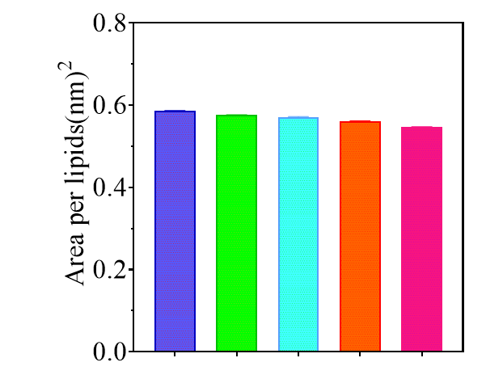
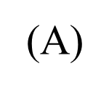
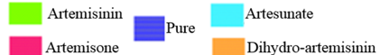
(B)

Figure S9. Area per lipid (APL) (A), and cancer cell membrane bilayer thickness (B). Control refers to the pure cancer cell membrane bilayer without the presence of drugs.

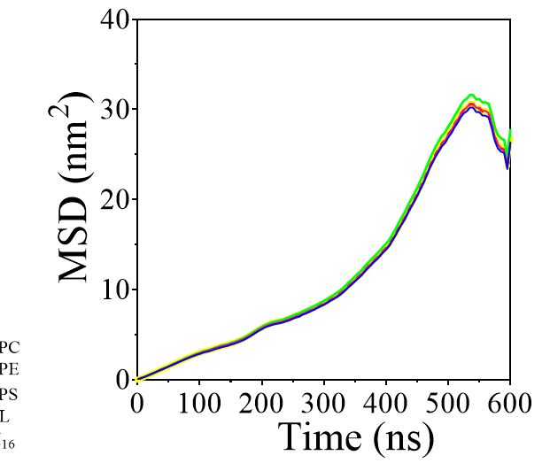
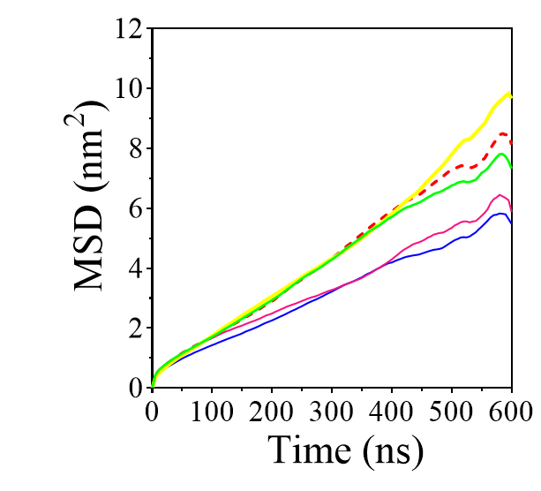
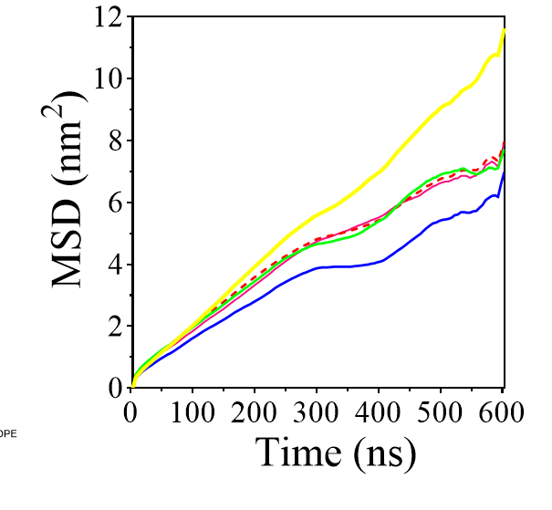
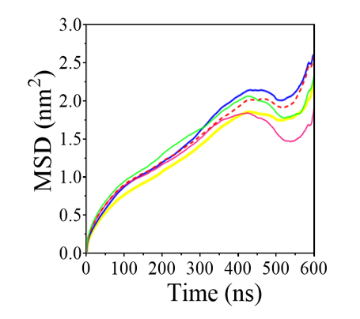
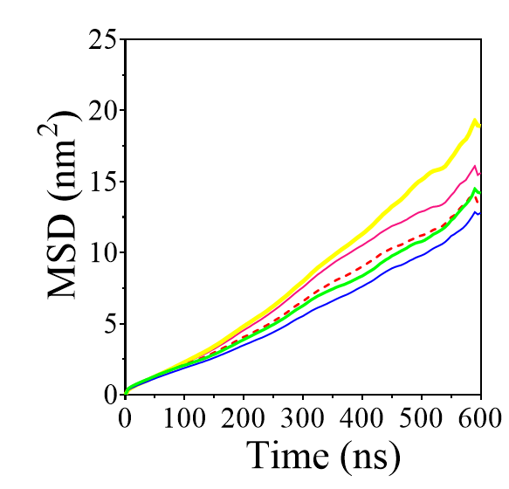
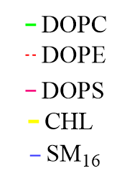
(A)
(B)
(C)
(D)
(E)
Figure S10. Mean-squared displacements of different components of the center cell membrane without drug (A), and in the presence of Artemisinin (B), Artesunate (C), Dihydroartemisinin (D), and Artemisone (E).

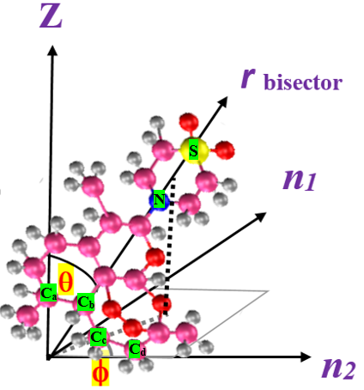
Figure S11. Molecular fixed coordinates, $n_{1}$ and $n_{2}$ define bivariate orientation analysis for the Artemisone molecule. Spherical polar angles ($θ,φ$are shown).

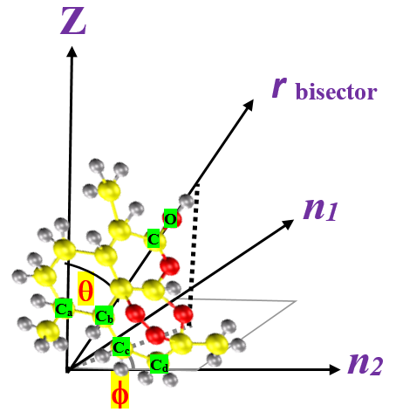
Figure S12. Molecular fixed coordinates, $n_{1}$ and $n_{2}$ define bivariate orientation analysis for Dihydroartemisinin. Spherical polar angles ($θ,φ$are shown).

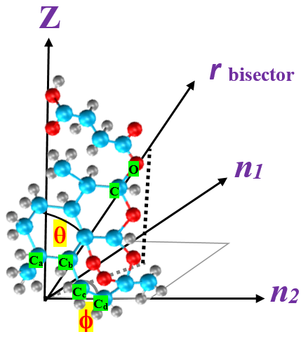

Figure S13. Molecular fixed coordinates, $n_{1}$ and $n_{2}$ define for bivariate orientation analysis for Artesunate. Spherical polar angles ($θ,φ$are shown).

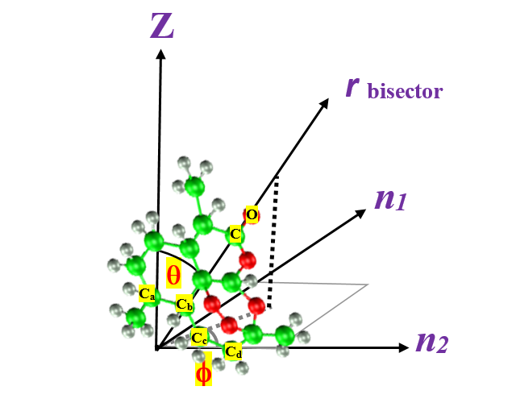
Figure S14. Molecular fixed coordinates, $n_{1}$ and $n_{2}$ define bivariate orientation analysis for Artesunate. Spherical polar angles ($θ,φ$are shown).

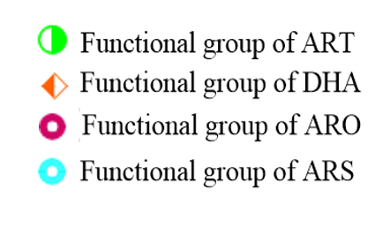
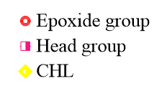

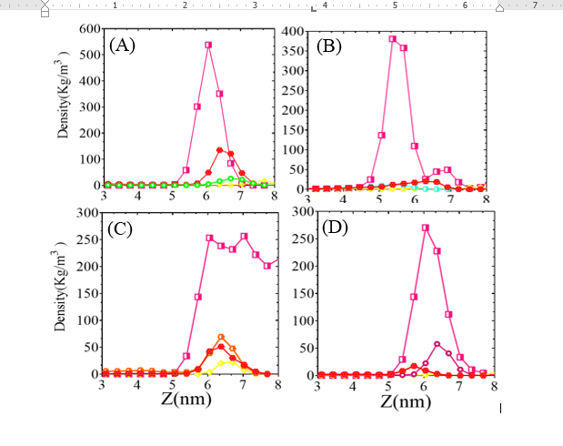

Figure S15. Atomic density distribution of the functional and epoxide group of (A) Artemisinin, (B) Artesunate, (C) Dihydroartemisinin, and (D) Artemisone at the head group region of the cancer cell membrane.

TableS1. Number of phospholipids, cholesterol, water molecules, and salt ions in the simulated membrane.
Components | External leaflet | Internal leaflet
Cholesterol (CHOL) | 37 | 37
Sphingomyelin (SM₁₆) | 19 | 19
1,2-dioleoyl-sn-glycero-3-phosphocholine (DOPC) | 20 | 20
1,2-dioleoyl-sn-glycero-3-phosphoethanolamine (DOPE) | 20 | 20
1,2-dioleoyl-sn-glycero-3-phospho-L-serine (DOPS) | 11 | 11
Water | 8603 | -
Na+ | 54 | -
Cl⁻ | 22 | -

Table S2. Calculated partial atomic charges of Artemisinin.

atoms | q/e  CHELPG | atoms | q/e  CHELPG | atoms | q/e  CHELPG | atoms | q/e  CHELPG
C₁ |  | C₁₂ | -0.556 | H₃ | 0.191 | H₁₄ | 0.197
  -0.223
C₂ |  | C₁₃ | 0.559 | H₄ | 0.205 | H₁₅ | 0.222
  -0.235
C₃ | -0.369 | C₁₄ | -0.426 | H₅ | 0.213 | H₁₆ | 0.216
C₄ |  | C₁₅ |  | H₆ | 0.202 | H₁₇
  -0.383
  -0.383
  0.206
C₅ |  | O₁ | -0.564 | H₇ | 0.221 | H₁₈ | -0.269
  -0.218
C₆ | 0.246 | O₂ |  | H₈ | 0.196 | H₁₉
  -0.557
  0.209
C₇ | -0.560 | O₃ | -0.596 | H₉ | 0.203 | H₂₀
  0.217
C₈ | 0.432 | O₄ |  | H₁₀ | 0.198 | H₂₁ | 0.225
  -0.332
C₉ | 0.829 | O₅ | -0.573 | H₁₁ | 0.172 | H₂₂
  0.213
C₁₀ |  | H₁ | 0.189 | H₁₂ | 0.256
  -0.332
C₁₁ | -0.058 | H₂ |  | H₁₃ | 0.201
  0.212

Table S3. calculated partial atomic charges of Dihydroartemisinin.
atoms | q/e  CHELPG | atoms | q/e  CHELPG | atoms | q/e  CHELPG | atoms | q/e  CHELPG
C₁ |  | C₁₂ | -0.310 | H₃ | 0.239 | H₁₄ | 0.264
  -0.284
C₂ |  | C₁₃ | 0.382 | H₄ | 0.250 | H₁₅ | 0.251
  -0.280
C₃ | -0.467 | C₁₄ | -0.679 | H₅ | 0.256 | H₁₆ | 0.273
C₄ |  | C₁₅ |  | H₆ | 0.249 | H₁₇
  -0.470
  -0.663
  0.216
C₅ |  | O₁ | -0.301 | H₇ | 0.244 | H₁₈ | 0.490
  -0.268
C₆ | 0.210 | O₂ |  | H₈ | 0.253 | H₁₉
  -0.280
  0.234
C₇ | -0.490 | O₃ | -0.599 | H₉ | 0.248 | H₂₀
  0.246
C₈ | -0.525 | O₄ |  | H₁₀ | 0.255 | H₂₁ | 0.241
  -0.589
C₉ | 0.363 | O₅ | -0.764 | H₁₁ | 0.269 | H₂₂
  0.220
C₁₀ |  | H₁ | 0.282 | H₁₂ | 0.236 | H₂₃ | 0.237
  0.529
C₁₁ | -0.692 | H₂ |  | H₁₃ | 0.234 | H_{OH} | 0.490
  0.260

Table S4. Calculated partial atomic charges of Artesunate.

atoms | q/e  CHELPG | atoms | q/e  CHELPG | atoms | q/e  CHELPG | atoms | q/e  CHELPG | atoms | q/e  CHELPG
C₁ |  | C₁₂ | -0.682 | H₄ | 0.267 | H₁₅ | 0.263 | H₂₆ | 0.283
  0.532
C₂ |  | C₁₃ | -0.313 | H₅ | 0.275 | H₁₆ | 0.230 | H₂₇ | 0.271
  -0.505
C₃ | -0.478 | C₁₄ | -0.676 | H₆ | 0.256 | H₁₇ | 0.245 | O₁ | -0.603
C₄ |  | C₁₅ |  | H₇ | 0.226 | H₁₈ | 0.243 | O₂ | -0.302
  -0.277
  0.402
C₅ |  | C₁₆ | 0.827 | H₈ | 0.260 | H₁₉ | 0.258 | O₃ | -0.325
  0.224
C₆ | 0.383 | C₁₇ |  | H₉ | 0.267 | H₂₀ | 0.231 | O₄ | -0.583
  -0.569
C₇ | -0.715 | C₁₈ | -0.541 | H₁₀ | 0.259 | H₂₁ | 0.260 | O₅ | -0.543
C₈ | -0.280 | C₁₉ |  | H₁₁ | 0.252 | H₂₂ | 0.235 | O₆ | -0.582
  0.807
C₉ | -0.481 | H₁ | 0.267 | H₁₂ | 0.251 | H₂₃ | 0.205 | O₇ | -0.597
C₁₀ |  | H₂ |  | H₁₃ | 0.254 | H₂₄ | 0.247 | O₈ | -0.713
  -0.470
  0.255
C₁₁ | -0.267 | H₃ | 0.254 | H₁₄ | 0.252 | H₂₅ | 0.274 | H_{OH} | 0.505

Table S5. Calculated partial atomic charges of Artemisone

atoms | q/e  CHELPG | atoms | q/e  CHELPG | atoms | q/e  CHELPG | atoms | q/e  CHELPG | atoms | q/e  CHELPG | atoms | q/e  CHELPG
C₁ |  | C₁₂ | -0.284 | H₄ | 0.242 | H₁₅ | 0.217 | H₂₆ | 0.260 | O₆ | -0.948
  -0.279
C₂ |  | C₁₃ | 0.283 | H₅ | 0.247 | H₁₆ | 0.255 | H₂₇ | 0.256 | S₁ | 2.124
  -0.273
C₃ | -0.456 | C₁₄ | -0.691 | H₆ | 0.249 | H₁₇ | 0.212 | H₂₈ | 0.265 | N₁ | -0.549
C₄ |  | C₁₅ |  | H₇ | 0.247 | H₁₈ | 0.258 | H₂₉ | 0.250
  -0.465
  -0.285
C₅ |  | C₁₆ | -0.715 | H₈ | 0.232 | H₁₉ | 0.234 | H₃₀ | 0.289
  -0.274
C₆ | 0.221 | C₁₇ |  | H₉ | 0.243 | H₂₀ | 0.242 | H₃₁ | 0.278
  -0.293
C₇ | -0.678 | C₁₈ | 0.539 | H₁₀ | 0.240 | H₂₁ | 0.254 | O₁ | -0.593
C₈ | -0.467 | C₁₉ |  | H₁₁ | 0.245 | H₂₂ | 0.252 | O₂ | -0.593
  -0.694
C₉ | -0.502 | H₁ | 0.259 | H₁₂ | 0.253 | H₂₃ | 0.284 | O₃ | -0.301
C₁₀ |  | H₂ |  | H₁₃ | 0.254 | H₂₄ | 0.289 | O₄ | -0.322
  0.391
  0.234
C₁₁ | -0.624 | H₃ | 0.241 | H₁₄ | 0.260 | H₂₅ | 0.254 | O₅ | -0.955

TableS6. Average values of area per lipid and thickness of the cancer membrane without and in the presence of Artemisinin and its derivations.
Name of the systems | Area per lipid  (nm²) | Thickness  (nm)
Pure cancer membrane | 0.5856±0.0012 | 4.103±0.015
Artemisinin | 0.5756±0.0015 | 4.390±0.018
Artesunate | 0.5710±0.0011 | 4.493±0.130
Dihydroartemisinin | 0.5608±0.0018 | 4.540±0.014
Artemisone | 0.5466±0.0013 | 4.898±0.023

Name of systems | DOPC | DOPS | DOPE | SM16 | CHL
Membrane without Drug | 1.08 | 1.00 | 1.03 | 1.22 | 1.05
Membrane with ART | 3.12 | 3.06 | 3.23 | 3.01 | 3.43
Membrane with ARS | 2.81 | 2.16 | 2.77 | 1.97 | 2.82
Membrane with DHA | 7.48 | 7.85 | 7.42 | 7.26 | 7.95
Membrane with ARO | 12.80 | 12.80 | 12.80 | 12.80 | 12.80

Table S7. Lateral diffusion coefficient (D_{L}) of different components of the cancer cell membarne without and in the presence of Artemisinin and its derivatives. Unit: (D_{L} $×$10⁻⁸ (cm² /s))

